***Review Article***

**Decoding Tumor Heterogeneity: Multi-Omics Approaches to Track Cancer Evolution and Therapy Resistance**

### ****Abstract****

The existence of genetically, epigenetically, and phenotypically distinct cell populations inside and between tumors is known as tumor heterogeneity, and it is one of the main barriers to effective cancer treatment. This intricacy affects the likelihood of metastasis, therapeutic resistance, and disease recurrence, rendering single-omics methods and conventional diagnostics unsuitable for whole tumor profiling. As a result, multi-omics methods which incorporate data from multiple biological layers, such as transcriptomics, proteomics, metabolomics, genomes, and epigenomics have emerged as powerful tools for thoroughly examining intra- and inter-tumoral complexity. This paper explores the ways in which integrated multi-omics has transformed our understanding of clonal dynamics, tumor growth, and resistance mechanisms. The latest methods such as single-cell multi-omics, spatial transcriptomics, and proteogenomics were examined, along with computational frameworks including network-based models, probabilistic inference algorithms, and AI-driven tools that make it easier to integrate high-dimensional data. In order to demonstrate how muli-omics clarifies both intrinsic and acquired resistance mechanisms, case studies from glioblastoma, lung, and breast malignancies are examined. Along with discussing new technologies like in vivo biosensors, organoid-based modeling, and point-of-care omics, the function of the tumor microenvironment, lineage tracing, and liquid biopsies in monitoring the real-time progression of tumors was also discussed. In conclusion, translational hurdles, including cost, complexity, and ethical issues were addressed, while highlighting how important equity and worldwide access are. Multi-omics has great promise for truly personalized oncology by providing the integrated insights required for dynamic monitoring, predictive diagnosis, and tailored therapy design in future cancer care.

Keywords: Tumor, Heterogeneity. Multi-Omics, Cancer

**Introduction**

Cancer is a multifaceted disease with significant tumor heterogeneity rather than a single illness.

This heterogeneity can be viewed in three ways: spatially (differences between primary and metastatic sites or between regions within a tumor), temporally (evolution over time and under therapeutic pressure), and biologically (difference at the genetic, epigenetic, transcriptomic, proteomic, and metabolic levels)(MacDonald et al., 2025). The tumor microenvironment (TME), composed of stromal, immunological, and endothelial cells, further complicates the situation by altering cellular signaling, immune evasion, and resistance mechanisms. According to growing evidence, this multilayered heterogeneity plays a significant role in the disease's progression, metastasis, and most importantly therapy resistance(Biray Avci et al., 2024). Even among malignancies that are histologically comparable, this diversity is clinically associated with poor survival outcomes, high rates of treatment failure, and tumor recurrence(Melariri et al., 2023).

In non-small cell lung cancer, for instance, intra-tumoral clonal. The tumor microenvironment (TME), composed of stromal, immunological, and endothelial cells, further complicates the situation by altering cellular signaling, immune evasion, and resistance mechanisms. According to growing evidence, this multilayered heterogeneity plays a significant role in the disease's progression, metastasis, and most importantly therapy resistance(Altorki et al., 2019). Even among malignancies that are histologically comparable, this diversity is clinically associated with poor survival outcomes, high rates of treatment failure, and tumor recurrence. Diversity, and in triple-negative breast cancer, inter-patient heterogeneity can significantly affect prognosis and treatment response(Ramón y Cajal et al., 2020a). Conventional approaches to tumor research, often based on bulk sequencing and single-omics datasets, have helped to better understand oncogenesis and driver mutations. The minute but crucial distinctions between individual cells and molecular layers are often obscured by these methods. Bulk measurements, which often average out signals from several subpopulations, mask rare clones that may lead to resistance or relapse. Moreover, single-omics studies, whether transcriptomic, proteomic, or genomic, fail to capture the complex connections that drive the development of cancer(G. Sun et al., 2021). In order to adequately evaluate tumor complexity, multi-omics integration is necessary. This method simultaneously analyzes and synthesizes data from multiple biological domains, such as transcriptomics (gene expression), proteomics (protein abundance and variations), metabolomics (metabolic fluxes), genomics (DNA mutations), and epigenomics (chromatin modifications). Combining these datasets can reveal non-linear relationships and causal pathways that are not apparent when examined as distinct layers. Crucially, multi-omics methods offer a dynamic, systems-level viewpoint on tumor progression, adaptive resistance, and microenvironmental crosstalk, offering significant prospects for precision oncology development(Hayes et al., 2024). In an effort to provide a comprehensive overview of the state of the art on tumor heterogeneity, this review focuses on how multi-omics technologies and integrative analytics are transforming our knowledge of cancer biology. We examine therapeutic applications, give typical case studies, talk about current problems and possible directions for the field, and delve at methodological developments(Chen et al., 2023a).

### ****2. Understanding Tumor Heterogeneity****

Tumor heterogeneity involves the extensive biological variability observed within and between tumors, presenting a significant challenge to effective cancer diagnosis and treatment. **The diversity of cancer cells within a single tumor mass is known as intra-tumoral heterogeneity, and it is frequently typified by different genetic, epigenetic, transcriptomic, and phenotypic profiles among subclones**(Proietto et al., 2023)**.**  Inter-tumoral heterogeneity, on the other hand, describes the diversity seen amongst tumors of the same histological subtype, whether within a single patient or between patients with comparable diagnoses. These types of heterogeneity are responsible for differences in tumor behavior, treatment response, and disease prognosis(Ramón y Cajal et al., 2020b). Multiple layers of variation drive tumor heterogeneity at the molecular level. A tumor's overall mutational load is influenced by genetic heterogeneity, which is frequently the consequence of continuous clonal evolution and is defined by changes in somatic mutations, copy number variations, and chromosomal rearrangements. Without changing the DNA sequence, epigenetic heterogeneity which includes differences in histone modifications and DNA methylation patterns affects gene expression and can be quite responsive to environmental stimuli(Dentro et al., 2021). The variety of gene expression profiles, impacted by both internal and external causes, is reflected in transcriptomic variations. Comparably, metabolic heterogeneity represents unique metabolic dependencies and adaptations that support tumor growth under various microenvironmental conditions, whereas proteomic heterogeneity results from differences in protein expression, post-translational modifications, and signaling pathway activation(Ortmayr et al., 2019). Tumor heterogeneity arises and persists due to a number of important reasons. Clonal diversity is fueled by random mutations and structural changes caused by genomic instability. Through paracrine signaling and immunoediting, the tumor microenvironment (TME), which is made up of immune cells, fibroblasts, endothelial cells, and extracellular matrix components, influences the behavior of tumor cells. Resistant clones can survive immune surveillance thanks to immune evasion strategies such interferon signaling reduction or antigen deletion. Additionally, the proliferation of resistant subclones is favored by the strong selective forces exerted by treatment pressures(Marusyk & Polyak, 2010). Tumor heterogeneity has been outlined by three conceptual models. According to Nowell's original description of the clonal evolution concept, tumor development is the consequence of clones with favorable mutations being selected one after the other. According to the cancer stem cell theory, there is a hierarchical structure in place, and heterogeneity and treatment resistance are driven by stem-like cells(Lawal et al., 2024). Finally, according to the Big Bang hypothesis, neutral evolution is widespread since most mutations take place early in the neoplastic process and there are not many selective pressures after that. It is possible for these models to function simultaneously in various tumor situations and they are not exclusive. As illustrated in Figure 1 below, tumor heterogeneity encompasses several molecular levels, ranging from the genome to the metabolome, each of which adds to the complexity of the cancer's phenotype and response to treatment(R. Sun et al., 2018).

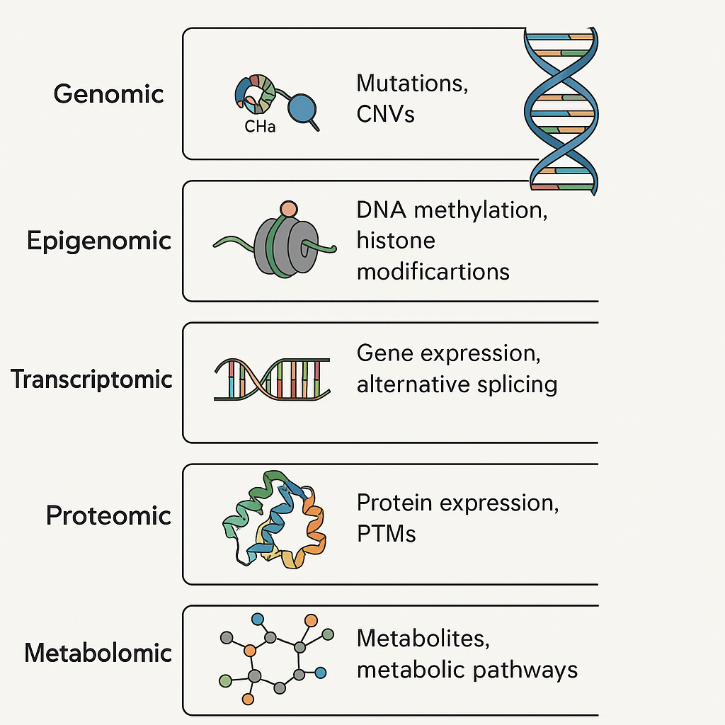

**Figure 1. Layers of Tumor Heterogeneity: From Genome to Metabolome**. This diagram depicts the hierarchical layers genomic, epigenomic, transcriptomic, proteomic, and metabolomic that contribute to tumor heterogeneity. DNA methylation and histone modifications, RNA expression dynamics, protein post-translational modifications (PTMs), metabolite profiles, and mutations and copy number variations (CNVs) at the DNA level are all examples of the unique molecular processes that are contained inside each layer. These levels work together to influence tumor behavior, evolution, and responsiveness to treatment (Li et al., 2023) Histopathologic and proteogenomic heterogeneity reveals features of clear cell renal cell carcinoma aggressiveness. Cancer Cell, 41(1), 139-163.e17. https://doi.org/10.1016/j.ccell.2022.12.001)

### ****3. Multi-Omics Approaches: An Integrated Lens****

Analytical techniques that go beyond the constraints of single-omics profiling are required due to the multifaceted complexity of cancer. To present a thorough molecular picture of malignancies, multi-omics involves the systematic integration of data from several biological layers, from the genome to the metabolome. Multi-omics integration can be defined by two main strategies: vertical integration, which connects various layers across the molecular cascade (e.g., DNA mutations influencing RNA expression and downstream protein activity), and horizontal integration, which combines data from the same omics level but different platforms or modalities (e.g., bulk RNA-seq with single-cell RNA-seq to capture population and cellular resolution). The latter approach offers a systems biology perspective(Cai et al., 2022). Understanding tumor biology is supported by the distinct contributions of each omics layer. Single nucleotide variations (SNVs), copy number variations (CNVs), and structural rearrangements are aspects of the fundamental mutational architecture that are captured by genomics. The patterns of clonal evolution and oncogenic drivers are identified by this layer(Ortega-Batista et al., 2025). Heritable but reversible changes like DNA methylation, histone modifications, and chromatin accessibility are revealed by epigenomics, and techniques like ATAC-seq shed light on the regulatory environment and transcriptional potential of tumor cells. With single-cell RNA-seq (scRNA-seq) collecting cell-specific expression and isoform variety, revealing subclonal states and plasticity, and bulk RNA-seq providing averaged profiles, transcriptomics represents dynamic gene expression programs(Carter & Zhao, 2021). **This knowledge is further enhanced by proteomics, which measures protein abundance, post-translational modifications (PTMs), and signaling network dynamics, usually using methods based on mass spectrometry. The direct impact of proteins on cellular function and pharmacological targets makes this layer crucial. Metabolomics, the last layer of the omics cascade, records metabolic fluxes and rewiring processes, such as the Warburg effect and modifications in the metabolism of lipids and amino acids that support tumor growth and survival in stressful situations**(Birhanu, 2023)**.** It takes advanced computational frameworks to integrate such complex datasets. In order to identify functional modules and regulatory hubs, network-based techniques, such as multi-layered or multiplex networks, map interactions across omics layers. Particularly in high-dimensional, sparse datasets, machine learning and artificial intelligence facilitate feature selection, pattern recognition, and predictive modeling. Probabilistic and unsupervised techniques for identifying latent structures and shared variation across datasets are provided by Bayesian frameworks and matrix factorization techniques (e.g., iCluster, MOFA). When combined, these integrative approaches provide a potent toolkit for revealing the emergent characteristics of malignancies and advancing precision oncology(Wörheide et al., 2021). The integrated multi-omics pathway used for thorough tumor profiling, from sample collection to data integration and computational modeling, is simplified in Figure 2.

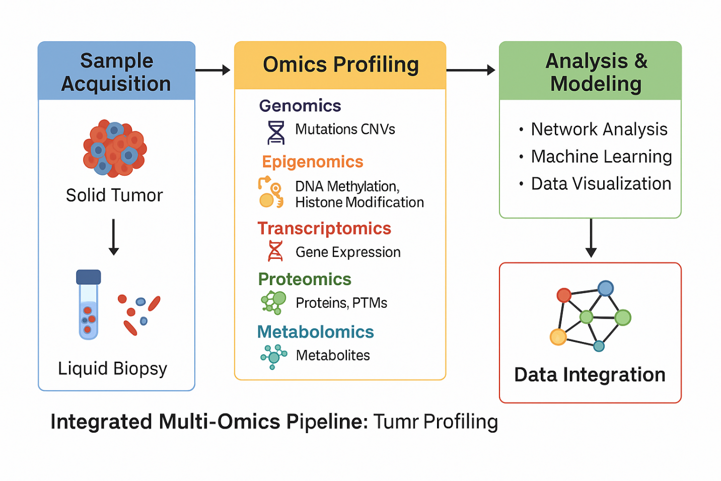**Figure 2. Integrated Multi-Omics Pipeline for Tumor Profiling**. This flowchart illustrates the multi-step pipeline for integrated tumor profiling using multi-omics approaches. The process begins with **sample acquisition** from solid tumors or liquid biopsies, followed by **omics profiling** across multiple layers: genomics (mutations, CNVs), epigenomics (DNA methylation, histone modifications), transcriptomics (gene expression), proteomics (proteins, PTMs), and metabolomics (metabolites). These diverse data types are then subjected to **computational analysis and modeling**, including network analysis, machine learning, and data visualization. Finally, **data integration** frameworks synthesize insights across omics layers to enable a systems-level view of tumor biology. (Heo et al., 2021) Integrative Multi-Omics Approaches in Cancer Research: From Biological Networks to Clinical Subtypes. Molecules and Cells, 44(7), 433–443. https://doi.org/10.14348/molcells.2021.0042

.

Below is a concise overview of the core omics layers, associated technologies, and their respective biological contributions to tumor profiling is presented in Table 1: It highlights how each dimension of molecular data enhances our understanding of cancer complexity and therapeutic response. This table provides an overview of the major omics layers involved in multi-omics studies genomics, epigenomics, transcriptomics, proteomics, and metabolomics alongside the primary technologies used to interrogate each layer. It also highlights the specific biological processes captured and the critical insights each layer contributes to understanding tumor heterogeneity, evolution, and therapy resistance.(Menyhárt & Győrffy, 2021),

**Table 1. Summary of Omics Layers, Representative Technologies, and Key Biological Insights in Tumor Profiling.**

| **Omics Layer** | **Representative Technologies** | **Biological Focus** | **Key Insights** |
| --- | --- | --- | --- |
| **Genomics** | Whole-genome sequencing (WGS), whole-exome sequencing (WES), ctDNA | DNA mutations, copy number variations (CNVs), structural variants | Identifies driver mutations, clonal architectures, resistance-associated alterations |
| **Epigenomics** | Bisulfite sequencing, ChIP-seq, ATAC-seq | DNA methylation, histone modifications, chromatin accessibility | Reveals regulatory plasticity, enhancer hijacking, epigenetic reprogramming |
| **Transcriptomics** | Bulk RNA-seq, scRNA-seq, spatial transcriptomics | Gene expression, alternative splicing, isoform usage | Captures cell states, lineage transitions, immune activation/exclusion signatures |
| **Proteomics** | Mass spectrometry, reverse-phase protein arrays, phospho-proteomics | Protein abundance, post-translational modifications (PTMs) | Uncovers active signaling cascades, resistance networks, proteogenomic biomarkers |
| **Metabolomics** | LC-MS, GC-MS, NMR spectroscopy | Metabolic fluxes, energy pathways, redox state | Reveals tumor-specific metabolic rewiring and adaptation under therapy |

### ****4. Technological Platforms Enabling Multi-Omics****

Recent developments in high-throughput technology have transformed our ability to analyze tumor heterogeneity using multi-omics, providing previously unheard-of resolution in molecular, temporal, and geographic dimensions. The integration of genotype, epigenotype, phenotype, and microenvironmental context is supported by these platforms(Lee et al., 2021). **At the resolution of individual cells, single-cell multi-omics technologies enable the simultaneous investigation of many molecular modalities. Single-cell assay for transposase-accessible chromatin sequencing (scATAC-seq) provides chromatin accessibility landscapes across different cell populations, whereas single-cell RNA sequencing (scRNA-seq) offers insights into transcriptional variation. By concurrently assessing surface protein abundance and transcriptomes, CITE-seq (Cellular Indexing of Transcriptomes and Epitopes by sequencing) improves phenotypic characterization.** More comprehensive techniques like scNMT-seq provide holistic perspectives of the regulatory mechanisms influencing cellular identity and plasticity in malignancies by simultaneously profiling transcriptomes, chromatin accessibility, and DNA methylation(Kim & Takahashi, 2025). **A crucial spatial component is added to tumor profiling by spatial omics platforms. Spatial transcriptomics preserves the contextual link between tumor cells and the surrounding milieu by enabling mapping of gene expression in situ within tissue architecture. Numerous proteins can be detected simultaneously in intact tissue sections using methods like imaging mass cytometry and multiplexed immunofluorescence, which makes high-dimensional cellular phenotyping and microenvironmental mapping easier**(Jin et al., 2024)**.** Figure 3 illustrates the state of the art in terms of single-cell and spatial multi-omics platforms, which allow for fine-scale resolution of microenvironmental and tumor complexity.

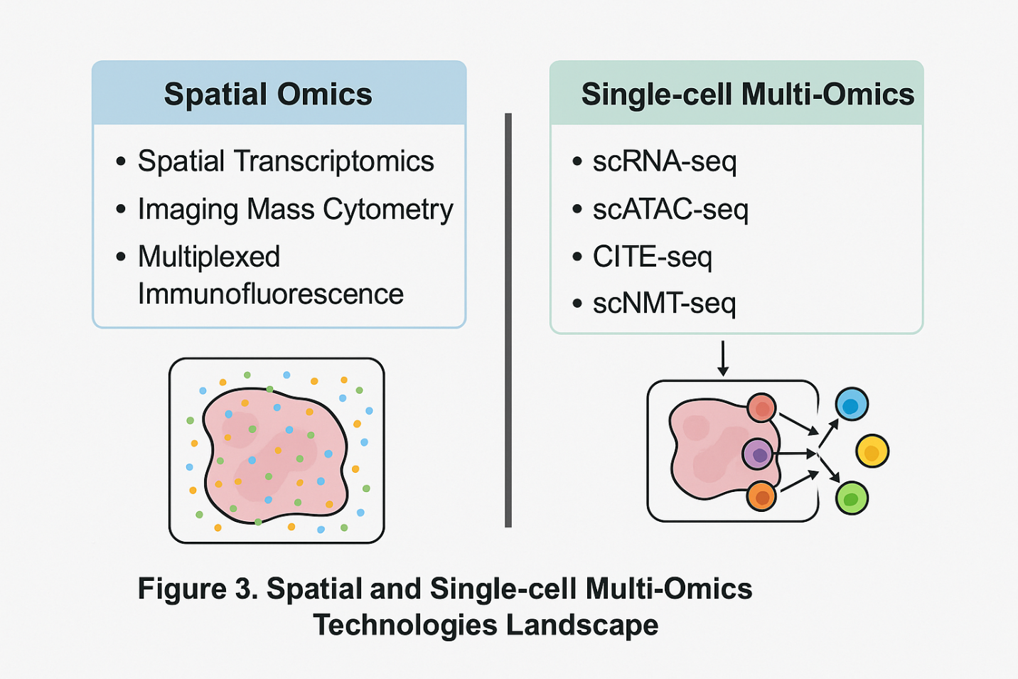

**Figure 3. Spatial and Single-cell Multi-Omics Technologies Landscape**. This figure highlights the functions of important technologies in single-cell multi-omics and spatial omics in addressing tumor heterogeneity by classifying and contrasting them. The localization of molecular characteristics inside intact tissue architecture is made possible by spatial omics techniques including multiplexed immunofluorescence, imaging mass cytometry, and spatial transcriptomics. Single-cell methods, such as scRNA-seq, scATAC-seq, CITE-seq, and scNMT-seq, on the other hand, isolate individual cells for deep molecular profiling, concurrently recording surface protein, transcriptional, and epigenetic information. When combined, these methods enable high-resolution analysis of tumor cell states, lineage hierarchies, and interactions with the microenvironment. (Zhang et al., 2025). Application of spatial and single-cell omics in tumor immunotherapy biomarkers. *LabMed Discovery*, 100076. https://doi.org/10.1016/j.lmd.2025.100076.

**In order to resolve structural variants, repetitive areas, and epigenetic alterations, third-generation sequencing technologies like Oxford Nanopore and Pacific Biosciences (PacBio) offer long-read sequencing capabilities that get beyond the drawbacks of short-read platforms. These methods are especially useful for identifying base alterations like 5-methylcytosine without bisulfite conversion, complicated rearrangements, and oncogenic fusions**(Satam et al., 2023a)**. By combining mass spectrometry-based proteomic data with genomic or transcriptome information, proteogenomics fills the gap between proteomics and genomics. It can be used to discover neoantigens, measure the expression of mutant proteins, and describe signaling cascades that are important for drug targeting. This method has proved crucial in improving treatment approaches for conditions including colorectal and breast cancer**(Sheynkman et al., 2016)**.** It takes strong computational platforms to manage the amount and complexity of multi-omics data. Biomarker identification, batch correction, data integration, dimensionality reduction, and cell-cell interaction modeling are all supported by tools like MOFA (Multi-Omics Factor Analysis), Seurat v4, Harmony, Liger, CellPhoneDB, and iCluster. The analysis of intricate, high-dimensional datasets is powered by these bioinformatics tools, which provide mechanistic insights and translational applications in oncology(Saliba et al., 2024).

### ****5. Tracking Tumor Evolution Using Multi-Omics****

To predict treatment resistance and the course of the disease, it is crucial to comprehend the evolutionary dynamics of tumors. When used longitudinally, multi-omics techniques offer a potent framework for documenting the geographical and temporal trajectories of tumor progression. It is possible to reconstruct clonal architecture and identify subclonal expansions that occur prior to relapse by doing temporal study of clonal dynamics by repeated sampling over time. Circulating free DNA (cfDNA), circulating tumor DNA (ctDNA), and tumor-derived exosomes are examples of liquid biopsies that provide a minimally invasive way to track the progression of tumors over time. These biopsies can record both genomic changes and dynamic transcriptomic or proteomic variations(Zhang & Wang, 2025). Case studies of various tumor types demonstrate how multi-omics can be used to decipher evolutionary pathways. Mechanisms of resistance to HER2-targeted therapy, including compensatory PI3K/AKT pathway activation and epigenetic remodeling, have been identified in HER2-positive breast cancer by integrated investigations that combine genomic profiling, transcriptome changes, and proteomic reprogramming(Roszkowska, 2024). Multi-omics analysis of serial tumor samples in glioblastoma have revealed that IDH1 mutations, which were previously believed to be early and stable occurrences, might change under the influence of treatment, producing genetically distinct subclones that aid in recurrence. **Another classic example is non-small cell lung cancer (NSCLC), where EGFR-mutant tumors treated with tyrosine kinase inhibitors (TKIs) frequently develop secondary resistance mutations (e.g., T790M, C797S)**(Garrett et al., 2021)**. These mutations can be identified by serial ctDNA sequencing and validated by proteomic signaling analysis, which helps guide real-time therapy adjustments. Real-world instances of tumor progression and treatment resistance as shown by multi-omics profiling in lung, brain, and breast malignancies are shown in Figure 4.**

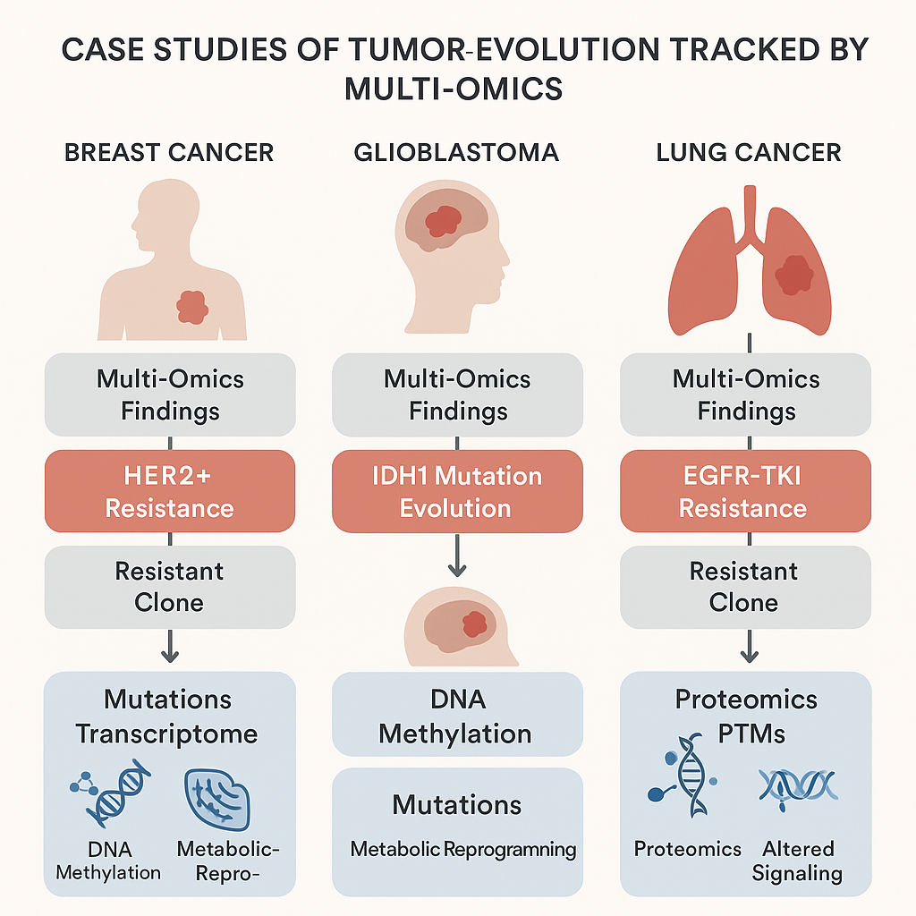

**Figure 4. Case Studies of Tumor Evolution Tracked by Multi-Omics**. Breast cancer, glioblastoma, and lung cancer are the three main cancer types for which this infographic provides three helpful illustrations of how multi-omics methods have revealed the molecular evolution of drug resistance. Clonal selection and metabolic reprogramming in resistant clones were identified in HER2+ breast cancer by means of comprehensive transcriptome and methylation analysis. The development of IDH1 mutations and the corresponding epigenetic reprogramming in glioblastoma was monitored by longitudinal multi-omics profiling. EGFR-TKI resistance was shown in lung cancer by serial liquid biopsies and proteomics, which also highlighted changes in post-translational modifications and bypass signaling pathways. The effectiveness of multi-layered profiling in tracking clonal dynamics and resistance mechanisms throughout time is demonstrated by these case studies. (Malta, et al., 2024) The Epigenetic Evolution of Glioma Is Determined by the IDH1 Mutation Status and Treatment Regimen. Cancer Research, 84(5), 741–756. https://doi.org/10.1158/0008-5472.CAN-23-2093.

**A growing number of lineage tracing techniques are being used to rebuild the lineage links among changing tumor subpopulations. Natural lineage markers can be found in copy number evolution and mitochondrial mutation patterns, whereas synthetic tracking of clonal descent can be achieved by techniques like CRISPR barcoding. From multi-region or multi-timepoint omics data, clonal hierarchies and ancestral links are inferred using phylogenetic reconstruction techniques(Yang et al., 2022). These initiatives are aided by a variety of bioinformatics technologies. By reconstructing clonal evolution from bulk and single-cell genomic data, PhyloWGS, CloneFinder, SciClone, and MACHINA allow the inference of tumor phylogenies and evolutionary bottlenecks. Unmatched resolution into how cancers adapt, resist, and re-emerge is provided by these integrative technologies when used on longitudinal multi-omics datasets. This information is crucial for the planning and development of adaptive therapeutic approaches(Sandmann et al., 2023).**

### ****6. Mechanisms of Therapy Resistance Uncovered by Multi-Omics****

Therapy resistance is still an important challenge in the treatment of cancer, even with advancements in immunotherapy and targeted medicines. Resistance may be acquired, emerging in reaction to therapeutic pressure, or intrinsic, resulting from underlying changes that render a patient insensitive to therapy. By analyzing tumors at several molecular levels, multi-omics techniques offer a thorough framework for revealing the complex and dynamic character of these resistance mechanisms(Garg et al., 2024). Resistance frequently arises at the genetic level as a result of secondary mutations that change drug-binding sites or reactivate downstream pathways. The EGFR T790M mutation in non-small cell lung cancer, which results in resistance to first-generation EGFR inhibitors, is a well-known example. Targeted treatments are ineffectual since bypass signaling is also driven by gene amplifications, such as MET or ERBB2 in different malignancies(Leonetti et al., 2019). **Through chromatin remodeling, histone modification, and enhancer hijacking, epigenomic modifications play a major role in resistance. Without changing the underlying DNA sequence, these occurrences may result in the silencing of tumor suppressor genes or the reactivation of carcinogenic pathways**(Onwuemelem et al., 2025)**. The small-cell transformation of EGFR-mutant lung tumors during TKI treatment demonstrates how this flexibility promotes phenotypic switching and cellular dedifferentiation**(Gu et al., 2024)**.** **Functional adaptations that are not identifiable at the transcriptome or genomic levels are revealed by proteomics. Escape from inhibition is often mediated through post-translational modifications (PTMs) and activation of compensatory signaling pathways, such as PI3K/AKT or MAPK reactivation. Reactivation of the MAPK pathway through different RAF isoforms or upstream RTKs is a typical mechanism of BRAF inhibitor resistance in melanoma**(Hu et al., 2025)**. Through improved nutritional flexibility and stress tolerance, metabolic rewiring promotes resistance. In order to withstand oxidative stress brought on by drugs, tumors can increase glycolysis, glutaminolysis, and antioxidant pathways. In cancers lacking BRCA1/2, for example, resistance to PARP inhibitors may result from either alternative DNA repair mechanisms driven by altered metabolism or regained redox equilibrium**(Schiliro & Firestein, 2021)**.** **The necessity of multi-omics to comprehend the tumor-immune environment is highlighted by immunotherapy resistance. Immune escape is facilitated by mechanisms like epigenetic silencing of antigen-presentation machinery, loss of interferon-γ signaling, and downregulation of MHC class I. Tumor-intrinsic mutations, stromal remodeling, and immune cell depletion work together to compromise immune checkpoint inhibition, according to multi-omics research**(Sari & Rock, 2023)**. Multi-omics reveals the intricate, frequently non-linear processes causing resistance by combining genomic, epigenomic, proteomic, and metabolomic information. This information informs the creation of logical combination medicines and effective treatment plans**(Chen et al., 2023b)**.**

### ****7. Role of Tumor Microenvironment and Multi-Omics Dissection****

Tumor microenvironment (TME) influences immune surveillance, treatment response, and the course of cancer. The TME functions as a physical and physiological niche that promotes tumor heterogeneity and resilience. It is made up of a dynamic network of endothelial and stromal elements, cancer-associated fibroblasts (CAFs), myeloid-derived suppressor cells, and tumor-infiltrating lymphocytes (TILs). The complex cell-cell interactions inside the TME may be decoded using multi-omics technologies, especially when spatially resolved. This reveals the paracrine signaling, immunosuppressive networks, and stromal regulation that underpin tumor adaptability(El-Tanani et al., 2024). **The TME's physical and functional variability has been shown using spatially-resolved multi-omics perspectives. Multiplexed imaging platforms and spatial transcriptomics are two examples of technologies that enable the mapping of cellular niches, the identification of metabolic zonation, hypoxia gradients, and immunological exclusion zones**(Jing et al., 2025)**. For instance, hypoxic tumor cores frequently show downregulated antigen presentation and elevated glycolytic gene expression, which are spatially limited and undetectable to bulk profiling. The response to treatment is significantly impacted by these geographical patterns, particularly with regard to immunotherapies and anti-angiogenic medicines**(Estephan et al., 2025)**.** The microbiome has become an essential facilitator of tumor behavior and immune reactivity, independent of host-derived variables. By producing metabolites and educating the immune system, gut microbiota can affect T cell priming and systemic inflammation(Graham & Xavier, 2023). According to recent data, intratumoral bacteria that live inside cancer cells or the stromal compartment may also alter drug metabolism, resistance mechanisms, and local immunological tone. Certain microbial profiles linked to response to checkpoint inhibitors and chemotherapies have been identified by multi-omics profiling that combines 16S rRNA sequencing, metagenomics, and host transcriptomics(M. Wang et al., 2023). The TME actively contributes to treatment resistance in a number of ways. Stromal shielding, which is made by fibroblasts and ECM components and comprises of physical and metabolic barriers, prevents drug penetration and immune cell trafficking. Although hypoxia-induced signaling promotes metabolic rewiring and epithelial-mesenchymal transition, cytokine networks (such as TGF-β and IL-6) reorganize immune cells toward suppressive phenotypes, enhancing stress survival. To investigate these complex interactions, sophisticated methods including as STARMAP, CODEX, MERFISH, and CellCHAT have been developed(Yuan et al., 2023). By combining spatial resolution, multiplexing, and computational modeling, these systems decode the functional topography of the TME, map ligand-receptor interactions, and reconstruct cell communication networks. Such understanding is necessary to design context-specific medicines that increase anti-tumor immunity and break down stromal barriers(Armingol et al., 2022).

### ****8. Multi-Omics and Precision Oncology: Clinical Applications****

Precision medicine is changing due to the incorporation of multi-omics into clinical oncology, which makes stratified treatment strategies based on thorough molecular profiling possible. Multi-omics enables the discovery of multi-modal biomarkers for prognosis, treatment stratification, and response prediction by examining tumors across genomic, transcriptomic, epigenomic, proteomic, and metabolomic levels(Molla & Bitew, 2024). These composite signatures, in contrast to conventional single-gene biomarkers, provide more reliable and practically useful insights by taking into consideration the functional interactions between several molecular determinants. **Multi-omics biomarker discovery has revealed predictive and prognostic markers that go beyond individual modalities**(Okafor et al., 2025)**. For example, coupled proteogenomic signatures in breast cancer have improved the classification of HER2-negative subgroups with unique treatment vulnerabilities, and combined DNA methylation and transcriptome profiles can identify immunological subtypes in colorectal cancer**(Aerqin et al., 2022)**. Across all cancer types, these integrative biomarkers are proven to be crucial for risk assessment and therapy choice.** By combining exome sequencing and immunopeptidomics, multi-omics makes it possible to identify neoantigens tumor-specific altered peptides resulting from non-synonymous mutations in the context of therapeutic target discovery. Additionally, by combining genomic and transcriptome dependencies, it enables the mapping of synthetic lethality networks and identifies context-dependent vulnerabilities in tumors with particular genetic mutations (e.g., PARP inhibitors in BRCA-mutated malignancies)(Naffaa et al., 2025). Clinical trials are increasingly using multi-omics classifiers to improve patient stratification. Multi-layered molecular data is used in trials like as NCI-MATCH and I-PREDICT to match patients with targeted medicines according to their distinct tumor characteristics. These initiatives highlight the increasing awareness of molecular complexity in medication development and clinical decision-making(Teleanu et al., 2025). A sensitive, non-invasive technique for identifying subclinical disease and new resistance clones for minimal residual disease (MRD) and medication resistance monitoring is provided by the integration of liquid biopsy technology with transcriptome and epigenomic profiling. This dynamic monitoring may help with early intervention and adaptive treatment change(Pandey & Yadav, 2025). There are many obstacles in the way of the therapeutic application of multi-omics, notwithstanding its revolutionary promise. Widespread adoption is restricted by high prices, computational complexity, difficulties integrating data, and regulatory uncertainty(Wu & Xie, 2025). Furthermore, to guarantee reproducibility and usefulness in practical contexts, it is critically necessary to standardize procedures, validate in sizable cohorts, and create clinically interpretable algorithms. Resolving these issues is essential to integrating multi-omics into standard oncologic treatment(Rozera et al., 2025).

### ****9. Challenges and Limitations of Multi-Omics Integration****

Notwithstanding its enormous potential, a number of technical, computational, biological, and ethical obstacles must be carefully overcome before multi-omics integration in cancer research and clinical practice may reach its full potential(Magro et al., 2024a). Technically speaking, problems including inconsistent sample preparation methods, protein and nucleic acid deterioration, and the identification of low-abundance molecules can jeopardize data quality and cross-omics layer comparability. Results are frequently distorted by batch effects and platform-specific biases, necessitating rigorous quality control and normalization processes(Lou & Therkildsen, 2022). **The computational issues are especially important since omics data is diverse, with varying noise levels, scales, and distributions. There are still no standardized procedures for preprocessing, integrating, and interpreting data, which makes it difficult for studies to be repeated. Furthermore, it is possible that the majority of current algorithms do not translate well to multi-modal environments because they were designed**(Magro et al., 2024b)**. An additional level of complexity arises in the understanding of biology. Using observational information to infer causal links between molecular alterations and phenotypic outcomes is intrinsically challenging. Furthermore, multi-omics data sometimes have insufficient temporal resolution, which makes it challenging to discern between initial events and subsequent consequences in treatment resistance and tumor growth**(Clarke et al., 2020)**.** **Privacy and ethical issues are also quite important. Because multi-omics datasets are naturally recognizable, they raise important questions about patient permission, data sharing, and handling incidental findings that may have therapeutic significance. It is crucial to have transparent governance structures and strong anonymization techniques**(Chiruvella & Guddati, 2021)**. Last but not least, one of the biggest obstacles is still the scalability of multi-omics platforms in low- and middle-income (LMIC) nations. The requirement for specialist staff, high expenses, and limited infrastructure restrict access and global equity in cancer research. Strategic investment in local capacity building and affordable, decentralized omics solutions will be necessary to address these inequities**(Nacis et al., 2024)**.**

### ****10. Future Perspectives and Innovations****

The future of **multi-omics in oncology** is poised to be shaped by breakthroughs in technology, data science, and global collaboration, with a common objective of improving precision cancer care more predictive, preventive, and equitable(Luo et al., 2025). **New technologies are pushing the limits of what can be measured and understood. Tools driven by artificial intelligence (AI), including AlphaFold for protein structure prediction and massive language models for biological sequence interpretation, are transforming our capacity to quickly and accurately process omics data**(Lateef Junaid, 2025)**. Nanoscale spatial-omics, on the other hand, is improving subcellular resolution and enabling fine-grained mapping of molecular events in tissue microenvironments. Real-time multi-omics monitoring in vivo biosensors are a promising development for dynamic illness tracking and therapy response evaluation**(R. Wang et al., 2025)**.** With the advent of point-of-care sequencing platforms and ultra-rapid diagnostics, the goal of real-time omics in clinical practice is becoming more and more realistic. This is because it allows for immediate molecular profiling to inform treatment decisions that are time-sensitive, especially in low-resource or oncology emergencies(Satam et al., 2023b). Synthetic multi-omics models, like multi-layered omics profiling and patient-derived organoids combined with CRISPR gene editing, are developing strong platforms for in vitro drug response testing, tumor evolution modeling, and therapeutic regimen personalization. Initiatives centered on accessibility and equity are essential to ensuring global inclusion(Zhu et al., 2025). In low- and middle-income countries (LMICs), initiatives like H3Africa and the Pan-Cancer Analysis of Whole Genomes (PCAWG) collaboration are democratizing access to omics technology and promoting capacity-building(Shaffer et al., 2019). Through the promotion of open-access data, local biobanking, and infrastructure development, these cooperative initiatives seek to lessen inequities in cancer research and outcomes. The future of multi-omics in precision oncology will ultimately be determined by the meeting point of clinical integration, technical innovation, and international collaboration(Gueye et al., 2024).

### ****11. Conclusion****

**In order to decipher the deep complexity of tumor heterogeneity, multi-omics techniques have become indispensable instruments, providing hitherto unheard-of insights into the molecular, geographical, and temporal dynamics of cancer. A systems-level knowledge of cancer evolution, therapeutic resistance, and tumor-immune interactions is made possible by multi-omics, which integrates data from the genomic, epigenomic, transcriptomic, proteomic, and metabolomic levels. This is not possible with single-layer analysis.** Multi-omics' capacity to figure out clonal trajectories, spot actionable weaknesses, and track resistance mechanisms places it at the forefront of next-generation precision oncology. These technologies are changing the field of patient classification, therapeutic target selection, and biomarker discovery with the goal of providing genuinely customized treatment based on the distinct molecular composition of every tumor. Interdisciplinary cooperation, a strong bioinformatics infrastructure, and close attention to accessibility, ethical, and legal issues especially in settings with limited resources are necessary to fulfill this promise. It will be crucial to invest in scalable, affordable platforms and fair international initiatives. Multi-omics integration into standard clinical procedures is not only possible but also inevitable as new technologies and AI-powered analytics develop further. Offering more accurate, flexible, and fair ways to combat cancer, this paradigm shift has the potential to completely transform cancer care.

REFRENCES

Aerqin, Q., Wang, Z.-T., Wu, K.-M., He, X.-Y., Dong, Q., & Yu, J.-T. (2022). Omics-based biomarkers discovery for Alzheimer’s disease. *Cellular and Molecular Life Sciences: CMLS*, *79*(12), 585. https://doi.org/10.1007/s00018-022-04614-6

Altorki, N. K., Markowitz, G. J., Gao, D., Port, J. L., Saxena, A., Stiles, B., McGraw, T., & Mittal, V. (2019). The lung microenvironment: An important regulator of tumour growth and metastasis. *Nature Reviews. Cancer*, *19*(1), 9–31. https://doi.org/10.1038/s41568-018-0081-9

Armingol, E., Baghdassarian, H. M., Martino, C., Perez-Lopez, A., Aamodt, C., Knight, R., & Lewis, N. E. (2022). Context-aware deconvolution of cell–cell communication with Tensor-cell2cell. *Nature Communications*, *13*, 3665. https://doi.org/10.1038/s41467-022-31369-2

Biray Avci, C., Goker Bagca, B., Nikanfar, M., Takanlou, L. S., Takanlou, M. S., & Nourazarian, A. (2024). Tumor microenvironment and cancer metastasis: Molecular mechanisms and therapeutic implications. *Frontiers in Pharmacology*, *15*, 1442888. https://doi.org/10.3389/fphar.2024.1442888

Birhanu, A. G. (2023). Mass spectrometry-based proteomics as an emerging tool in clinical laboratories. *Clinical Proteomics*, *20*, 32. https://doi.org/10.1186/s12014-023-09424-x

Cai, Z., Poulos, R. C., Liu, J., & Zhong, Q. (2022). Machine learning for multi-omics data integration in cancer. *iScience*, *25*(2), 103798. https://doi.org/10.1016/j.isci.2022.103798

Carter, B., & Zhao, K. (2021). The epigenetic basis of cellular heterogeneity. *Nature Reviews. Genetics*, *22*(4), 235–250. https://doi.org/10.1038/s41576-020-00300-0

Chen, C., Wang, J., Pan, D., Wang, X., Xu, Y., Yan, J., Wang, L., Yang, X., Yang, M., & Liu, G. (2023a). Applications of multi‐omics analysis in human diseases. *MedComm*, *4*(4), e315. https://doi.org/10.1002/mco2.315

Chen, C., Wang, J., Pan, D., Wang, X., Xu, Y., Yan, J., Wang, L., Yang, X., Yang, M., & Liu, G. (2023b). Applications of multi‐omics analysis in human diseases. *MedComm*, *4*(4), e315. https://doi.org/10.1002/mco2.315

Chiruvella, V., & Guddati, A. K. (2021). Ethical Issues in Patient Data Ownership. *Interactive Journal of Medical Research*, *10*(2), e22269. https://doi.org/10.2196/22269

Clarke, R., Kraikivski, P., Jones, B. C., Sevigny, C. M., Sengupta, S., & Wang, Y. (2020). A Systems Biology Approach to Discovering Pathway Signaling Dysregulation in Metastasis. *Cancer Metastasis Reviews*, *39*(3), 903–918. https://doi.org/10.1007/s10555-020-09921-7

Dentro, S. C., Leshchiner, I., Haase, K., Tarabichi, M., Wintersinger, J., Deshwar, A. G., Yu, K., Rubanova, Y., Macintyre, G., Demeulemeester, J., Vázquez-García, I., Kleinheinz, K., Livitz, D. G., Malikic, S., Donmez, N., Sengupta, S., Anur, P., Jolly, C., Cmero, M., … Van Loo, P. (2021). Characterizing genetic intra-tumor heterogeneity across 2,658 human cancer genomes. *Cell*, *184*(8), 2239-2254.e39. https://doi.org/10.1016/j.cell.2021.03.009

El-Tanani, M., Rabbani, S. A., Babiker, R., Rangraze, I., Kapre, S., Palakurthi, S. S., Alnuqaydan, A. M., Aljabali, A. A., Rizzo, M., El-Tanani, Y., & Tambuwala, M. M. (2024). Unraveling the tumor microenvironment: Insights into cancer metastasis and therapeutic strategies. *Cancer Letters*, *591*, 216894. https://doi.org/10.1016/j.canlet.2024.216894

Estephan, H., Tailor, A., Parker, R., Kreamer, M., Papandreou, I., Campo, L., Easton, A., Moon, E. J., Denko, N. C., Ternette, N., Hammond, E. M., & Giaccia, A. J. (2025). Hypoxia promotes tumor immune evasion by suppressing MHC-I expression and antigen presentation. *The EMBO Journal*, *44*(3), 903–922. https://doi.org/10.1038/s44318-024-00319-7

Garg, P., Malhotra, J., Kulkarni, P., Horne, D., Salgia, R., & Singhal, S. S. (2024). Emerging Therapeutic Strategies to Overcome Drug Resistance in Cancer Cells. *Cancers*, *16*(13), 2478. https://doi.org/10.3390/cancers16132478

Garrett, M., Fujii, Y., Osaka, N., Ito, D., Hirota, Y., & Sasaki, A. T. (2021). Emerging Roles of Wild-type and Mutant IDH1 in Growth, Metabolism and Therapeutics of Glioma. In W. Debinski (Ed.), *Gliomas*. Exon Publications. http://www.ncbi.nlm.nih.gov/books/NBK570701/

Graham, D. B., & Xavier, R. J. (2023). Conditioning of the immune system by the microbiome. *Trends in Immunology*, *44*(7), 499–511. https://doi.org/10.1016/j.it.2023.05.002

Gu, M., Ren, B., Fang, Y., Ren, J., Liu, X., Wang, X., Zhou, F., Xiao, R., Luo, X., You, L., & Zhao, Y. (2024). Epigenetic regulation in cancer. *MedComm*, *5*(2), e495. https://doi.org/10.1002/mco2.495

Gueye, A., Maroun, B., Zimur, A., Berkovits, T., & Tan, S. M. (2024). The future of collaborative precision oncology approaches in sub-Saharan Africa: Learnings from around the globe. *Frontiers in Oncology*, *14*, 1426558. https://doi.org/10.3389/fonc.2024.1426558

Hayes, C. N., Nakahara, H., Ono, A., Tsuge, M., & Oka, S. (2024). From Omics to Multi-Omics: A Review of Advantages and Tradeoffs. *Genes*, *15*(12), 1551. https://doi.org/10.3390/genes15121551

Hu, S., Xu, J., Cui, W., Jin, H., Wang, X., & Maimaitiyiming, Y. (2025). Post-Translational Modifications in Multiple Myeloma: Mechanisms of Drug Resistance and Therapeutic Opportunities. *Biomolecules*, *15*(5), Article 5. https://doi.org/10.3390/biom15050702

Jin, Y., Zuo, Y., Li, G., Liu, W., Pan, Y., Fan, T., Fu, X., Yao, X., & Peng, Y. (2024). Advances in spatial transcriptomics and its applications in cancer research. *Molecular Cancer*, *23*, 129. https://doi.org/10.1186/s12943-024-02040-9

Jing, S., Wang, H., Lin, P., Yuan, J., Tang, Z., & Li, H. (2025). Quantifying and interpreting biologically meaningful spatial signatures within tumor microenvironments. *NPJ Precision Oncology*, *9*, 68. https://doi.org/10.1038/s41698-025-00857-1

Kim, Y. J., & Takahashi, K. (2025). Emerging technologies of single-cell multi-omics. *Haematologica*, *110*(6), 1269–1277. https://doi.org/10.3324/haematol.2022.282557

Lateef Junaid, M. A. (2025). Artificial intelligence driven innovations in biochemistry: A review of emerging research frontiers. *Biomolecules and Biomedicine*, *25*(4), 739–750. https://doi.org/10.17305/bb.2024.11537

Lawal, O. P., Ahmed, N. K., Ilesanmi, T. A., Anthony, G. I., Nwosu, S. N., Ogungbemiro, F. O., Olaide, Z., Adeniyi, M. M., Okoye, U. L., Olufunmilayo, A. M., Christopher, A. A., & Oseghale, I. D. (2024). The Impact of Antimicrobial Resistance on Cancer Treatment: A Systematic Review of Current Evidence and Future Directions. *Asian Journal of Research in Medical and Pharmaceutical Sciences*, *13*(4), 9–27. https://doi.org/10.9734/ajrimps/2024/v13i4270

Lee, D., Park, Y., & Kim, S. (2021). Towards multi-omics characterization of tumor heterogeneity: A comprehensive review of statistical and machine learning approaches. *Briefings in Bioinformatics*, *22*(3), bbaa188. https://doi.org/10.1093/bib/bbaa188

Leonetti, A., Sharma, S., Minari, R., Perego, P., Giovannetti, E., & Tiseo, M. (2019). Resistance mechanisms to osimertinib in EGFR-mutated non-small cell lung cancer. *British Journal of Cancer*, *121*(9), 725–737. https://doi.org/10.1038/s41416-019-0573-8

Li, Y., Lih, T.-S. M., Dhanasekaran, S. M., Mannan, R., Chen, L., Cieslik, M., Wu, Y., Lu, R. J.-H., Clark, D. J., Kołodziejczak, I., Hong, R., Chen, S., Zhao, Y., Chugh, S., Caravan, W., Naser Al Deen, N., Hosseini, N., Newton, C. J., Krug, K., … Zhang, Z. (2023). Histopathologic and proteogenomic heterogeneity reveals features of clear cell renal cell carcinoma aggressiveness. *Cancer Cell*, *41*(1), 139-163.e17. https://doi.org/10.1016/j.ccell.2022.12.001

Lou, R. N., & Therkildsen, N. O. (2022). Batch effects in population genomic studies with low-coverage whole genome sequencing data: Causes, detection and mitigation. *Molecular Ecology Resources*, *22*(5), 1678–1692. https://doi.org/10.1111/1755-0998.13559

Luo, Y., Li, Y., Fang, M., Wang, S., Shao, L., Zou, R., Dong, D., Liu, Z., Wei, J., & Tian, J. (2025). Multi-omics synergy in oncology: Unraveling the complex interplay of radiomic, genoproteomic, and pathological data. *Intelligent Oncology*, *1*(1), 17–30. https://doi.org/10.1016/j.intonc.2024.10.003

MacDonald, W. J., Purcell, C., Pinho-Schwermann, M., Stubbs, N. M., Srinivasan, P. R., & El-Deiry, W. S. (2025). Heterogeneity in Cancer. *Cancers*, *17*(3), 441. https://doi.org/10.3390/cancers17030441

Magro, D., Venezia, M., & Rita Balistreri, C. (2024a). The omics technologies and liquid biopsies: Advantages, limitations, applications. *Medicine in Omics*, *11*, 100039. https://doi.org/10.1016/j.meomic.2024.100039

Magro, D., Venezia, M., & Rita Balistreri, C. (2024b). The omics technologies and liquid biopsies: Advantages, limitations, applications. *Medicine in Omics*, *11*, 100039. https://doi.org/10.1016/j.meomic.2024.100039

Marusyk, A., & Polyak, K. (2010). Tumor heterogeneity: Causes and consequences. *Biochimica et Biophysica Acta*, *1805*(1), 105. https://doi.org/10.1016/j.bbcan.2009.11.002

Melariri, H., Els, T., Oyedele, O., Suttle, T. K., Bermosky, K. T., De Freitas, A., Murtaza, A., Moosajee, M., & Melariri, P. E. (2023). Prevalence of locoregional recurrence and survival post-treatment of head and neck cancers in Africa: A systematic review and meta-analysis. *eClinicalMedicine*, *59*, 101964. https://doi.org/10.1016/j.eclinm.2023.101964

Menyhárt, O., & Győrffy, B. (2021). Multi-omics approaches in cancer research with applications in tumor subtyping, prognosis, and diagnosis. *Computational and Structural Biotechnology Journal*, *19*, 949–960. https://doi.org/10.1016/j.csbj.2021.01.009

Molla, G., & Bitew, M. (2024). Revolutionizing Personalized Medicine: Synergy with Multi-Omics Data Generation, Main Hurdles, and Future Perspectives. *Biomedicines*, *12*(12), 2750. https://doi.org/10.3390/biomedicines12122750

Nacis, J. S., Kamande, P., Toni, A. T., Mudibo, E., Musyimi, R., Popluechai, S., Dailey-Chwalibóg, T., Voskuijl, W., Dable-Tupas, G., Shahid, A. S. M. S. B., Bascos, N. A., Afroze, F., Chisti, M. J., Singa, B., Ngari, M., Tigoi, C., Mhango, G., Freitag, H., Potani, I., … Gonzales, G. B. (2024). Barriers and enablers to the effective implementation of omics research in low- and middle-income countries. *Nature Biotechnology*, *42*(6), 988–991. https://doi.org/10.1038/s41587-024-02274-4

Naffaa, M. M., Al-Ewaidat, O. A., Gogia, S., & Begiashvili, V. (2025). Neoantigen-based immunotherapy: Advancing precision medicine in cancer and glioblastoma treatment through discovery and innovation. *Exploration of Targeted Anti-Tumor Therapy*, *6*, 1002313. https://doi.org/10.37349/etat.2025.1002313

Okafor, C. E., Egwuatu, E. C., Owosagba, V. A., Njei, T., Adeyemi, B. I., Onuche, P. U. O., Adams, A., Ugwuja, C. B., Chibueze, E. S., & Lawal, O. P. (2025). From Bench to Bedside: Medicinal Chemistry Strategies in the Development of Kinase Inhibitors for Cancer Therapy. *Journal of Cancer and Tumor International*, *15*(2), 79–96. https://doi.org/10.9734/jcti/2025/v15i2294

Onwuemelem, L. A., Orobator, E. T., Onyedum, N. N., Chibueze, E. S., Kanu, I., Christopher, A. A., Lawal, O., & Ben-Anioke, B. (2025). Molecular Mechanisms of Clonal Hematopoiesis in Age-Related Cardiovascular Disease and Hematologic Malignancies: Review Article. *Journal of Pharma Insights and Research*, *3*(2), Article 2. https://doi.org/10.69613/gexxbw35

Ortega-Batista, A., Jaén-Alvarado, Y., Moreno-Labrador, D., Gómez, N., García, G., & Guerrero, E. N. (2025). Single-Cell Sequencing: Genomic and Transcriptomic Approaches in Cancer Cell Biology. *International Journal of Molecular Sciences*, *26*(5), Article 5. https://doi.org/10.3390/ijms26052074

Ortmayr, K., Dubuis, S., & Zampieri, M. (2019). Metabolic profiling of cancer cells reveals genome-wide crosstalk between transcriptional regulators and metabolism. *Nature Communications*, *10*(1), 1841. https://doi.org/10.1038/s41467-019-09695-9

Pandey, S., & Yadav, P. (2025). Liquid biopsy in cancer management: Integrating diagnostics and clinical applications. *Practical Laboratory Medicine*, *43*, e00446. https://doi.org/10.1016/j.plabm.2024.e00446

Proietto, M., Crippa, M., Damiani, C., Pasquale, V., Sacco, E., Vanoni, M., & Gilardi, M. (2023). Tumor heterogeneity: Preclinical models, emerging technologies, and future applications. *Frontiers in Oncology*, *13*, 1164535. https://doi.org/10.3389/fonc.2023.1164535

Ramón y Cajal, S., Sesé, M., Capdevila, C., Aasen, T., De Mattos-Arruda, L., Diaz-Cano, S. J., Hernández-Losa, J., & Castellví, J. (2020a). Clinical implications of intratumor heterogeneity: Challenges and opportunities. *Journal of Molecular Medicine (Berlin, Germany)*, *98*(2), 161–177. https://doi.org/10.1007/s00109-020-01874-2

Ramón y Cajal, S., Sesé, M., Capdevila, C., Aasen, T., De Mattos-Arruda, L., Diaz-Cano, S. J., Hernández-Losa, J., & Castellví, J. (2020b). Clinical implications of intratumor heterogeneity: Challenges and opportunities. *Journal of Molecular Medicine (Berlin, Germany)*, *98*(2), 161–177. https://doi.org/10.1007/s00109-020-01874-2

Roszkowska, M. (2024). Multilevel Mechanisms of Cancer Drug Resistance. *International Journal of Molecular Sciences*, *25*(22), Article 22. https://doi.org/10.3390/ijms252212402

Rozera, T., Pasolli, E., Segata, N., & Ianiro, G. (2025). Machine Learning and Artificial Intelligence in the Multi-Omics Approach to Gut Microbiota. *Gastroenterology*. https://doi.org/10.1053/j.gastro.2025.02.035

Saliba, A., Du, Y., Feng, T., & Garmire, L. (2024). Multi-Omics Integration in Nephrology: Advances, Challenges, and Future Directions. *Seminars in Nephrology*, *44*(6), 151584. https://doi.org/10.1016/j.semnephrol.2025.151584

Sari, G., & Rock, K. L. (2023). TUMOR IMMUNE EVASION THROUGH LOSS OF MHC CLASS I ANTIGEN PRESENTATION. *Current Opinion in Immunology*, *83*, 102329. https://doi.org/10.1016/j.coi.2023.102329

Satam, H., Joshi, K., Mangrolia, U., Waghoo, S., Zaidi, G., Rawool, S., Thakare, R. P., Banday, S., Mishra, A. K., Das, G., & Malonia, S. K. (2023a). Next-Generation Sequencing Technology: Current Trends and Advancements. *Biology*, *12*(7), 997. https://doi.org/10.3390/biology12070997

Satam, H., Joshi, K., Mangrolia, U., Waghoo, S., Zaidi, G., Rawool, S., Thakare, R. P., Banday, S., Mishra, A. K., Das, G., & Malonia, S. K. (2023b). Next-Generation Sequencing Technology: Current Trends and Advancements. *Biology*, *12*(7), 997. https://doi.org/10.3390/biology12070997

Schiliro, C., & Firestein, B. L. (2021). Mechanisms of Metabolic Reprogramming in Cancer Cells Supporting Enhanced Growth and Proliferation. *Cells*, *10*(5), 1056. https://doi.org/10.3390/cells10051056

Shaffer, J. G., Mather, F. J., Wele, M., Li, J., Tangara, C. O., Kassogue, Y., Srivastav, S. K., Thiero, O., Diakite, M., Sangare, M., Dabitao, D., Toure, M., Djimde, A. A., Traore, S., Diakite, B., Coulibaly, M. B., Liu, Y., Lacey, M., Lefante, J. J., … Doumbia, S. O. (2019). Expanding Research Capacity in Sub-Saharan Africa Through Informatics, Bioinformatics, and Data Science Training Programs in Mali. *Frontiers in Genetics*, *10*. https://doi.org/10.3389/fgene.2019.00331

Sheynkman, G. M., Shortreed, M. R., Cesnik, A. J., & Smith, L. M. (2016). Proteogenomics: Integrating Next-Generation Sequencing and Mass Spectrometry to Characterize Human Proteomic Variation. *Annual Review of Analytical Chemistry (Palo Alto, Calif.)*, *9*(1), 521–545. https://doi.org/10.1146/annurev-anchem-071015-041722

Sun, G., Li, Z., Rong, D., Zhang, H., Shi, X., Yang, W., Zheng, W., Sun, G., Wu, F., Cao, H., Tang, W., & Sun, Y. (2021). Single-cell RNA sequencing in cancer: Applications, advances, and emerging challenges. *Molecular Therapy Oncolytics*, *21*, 183–206. https://doi.org/10.1016/j.omto.2021.04.001

Sun, R., Hu, Z., & Curtis, C. (2018). Big Bang Tumor Growth and Clonal Evolution. *Cold Spring Harbor Perspectives in Medicine*, *8*(5), a028381. https://doi.org/10.1101/cshperspect.a028381

Teleanu, M.-V., Schneider, A., Ball, C. R., Leber, M. F., Stange, C., Krieghoff-Henning, E., Beck, K., Heilig, C. E., Kreutzfeldt, S., Kuster, B., Lipka, D. B., & Fröhling, S. (2025). Celebrating Ulrik Ringborg: Multi-Omics-Based Patient Stratification for Precision Cancer Treatment. *Biomolecules*, *15*(5), 693. https://doi.org/10.3390/biom15050693

Wang, M., Yu, F., & Li, P. (2023). Intratumor microbiota in cancer pathogenesis and immunity: From mechanisms of action to therapeutic opportunities. *Frontiers in Immunology*, *14*. https://doi.org/10.3389/fimmu.2023.1269054

Wang, R., Hastings, W. J., Saliba, J. G., Bao, D., Huang, Y., Maity, S., Kamal Ahmad, O. M., Hu, L., Wang, S., Fan, J., & Ning, B. (2025). Applications of Nanotechnology for Spatial Omics: Biological Structures and Functions at Nanoscale Resolution. *ACS Nano*, *19*(1), 73–100. https://doi.org/10.1021/acsnano.4c11505

Wörheide, M. A., Krumsiek, J., Kastenmüller, G., & Arnold, M. (2021). Multi-omics integration in biomedical research – A metabolomics-centric review. *Analytica Chimica Acta*, *1141*, 144–162. https://doi.org/10.1016/j.aca.2020.10.038

Wu, Y., & Xie, L. (2025). AI-driven multi-omics integration for multi-scale predictive modeling of genotype-environment-phenotype relationships. *Computational and Structural Biotechnology Journal*, *27*, 265–277. https://doi.org/10.1016/j.csbj.2024.12.030

Yuan, Z., Li, Y., Zhang, S., Wang, X., Dou, H., Yu, X., Zhang, Z., Yang, S., & Xiao, M. (2023). Extracellular matrix remodeling in tumor progression and immune escape: From mechanisms to treatments. *Molecular Cancer*, *22*, 48. https://doi.org/10.1186/s12943-023-01744-8

Zhang, Y., & Wang, W. (2025). Advances in tumor subclone formation and mechanisms of growth and invasion. *Journal of Translational Medicine*, *23*, 461. https://doi.org/10.1186/s12967-025-06486-3

Zhu, Z., Shen, J., Ho, P. C.-L., Hu, Y., Ma, Z., & Wang, L. (2025). Transforming cancer treatment: Integrating patient-derived organoids and CRISPR screening for precision medicine. *Frontiers in Pharmacology*, *16*. https://doi.org/10.3389/fphar.2025.1563198