***Review Article***

**Why Cancer Immunotherapy Fails: Mechanisms of Resistance and Emerging Reversal Strategies**

### ****Abstract****

Cancer immunotherapy has revolutionized the field of oncology by allowing the human immune system to be capable of targeting and destroying cancer cells. Therapies, such as immune checkpoints inhibitors including PD-1/PD-L1 and CTLA-4 blockade, and chimeric antigen receptor T (CAR-T) have shown unprecedented clinical efficacy, especially in melanoma, non-small cell lung cancer, and hematologic malignancies. These advances have revolutionized the treatment landscape, leading to dramatic improvements in outcomes among some patients. Nevertheless, a significant problem remains unsolved: a significant fraction of patients do not respond (i.e., primary resistance) or relapse after an initial response (i.e., acquired resistance). This resistance strongly blunts the long-term benefit and universal applicability of immunotherapy to tumors of multiple types. In this review, we highlight cancer-intrinsic, immune microenvironment-related, and host-related mechanisms that account for resistance to cancer immunotherapy which includes tumor-intrinsic alterations (antigen loss, MHC down-regulation, oncogenic signaling), immunosuppressive tumor microenvironment (TME), and host factors such as the microbiome, genetics, and host variability. We also discuss novel methodologies to overcome therapy resistance, such as combined therapies, TME-targeted therapeutics, new immune checkpoints, and personalized immunotherapy. By breaking down the complex biology of immunotherapy resistance, and describing the novel experimental approaches that have been initiated to address this challenge, this review is intended to guide future research and clinical practice toward more durable and broadly applicable responses in patients with cancer.

### ****1. Introduction****

Cancers and cancer treatmentsImmuno-oncology – one year in... Immunotherapy for cancer (CIT) has transformed cancer treatment, using the patient's immune system to recognise and destroy cancer cells[1]. Unlike traditional treatments, like chemotherapy and radiation, that attack cancer and healthy tissue, immunotherapy is more precise and may provide a long-lasting attack against the disease. In the past decades, cancer immunotherapy has drawn broad attention, mainly owing to the success of immune checkpoint inhibitors, such as anti-PD-1/PD-L1, and anti-CTLA-4 antibodies. These agents have also shown unique survival advantages in cancers including, amongst others, melanoma, NSCLC, and renal cell carcinoma[2].

Chimeric antigen receptor of T cells (CAR-T) therapy, cancer vaccines, and cytokine (IL-2, IFN-α) based therapy have also broadened the therapeutic armamentarium. Among these CAR-T therapy has been particularly successful in hematologic malignancies, and cancer vaccine and cytokine approaches continue to develop with varied but promising results[3].

However, a significant proportion of patients are refractory to immunotherapy (primary resistance) or have progression of disease after an initial response (acquired resistance). This variability in response underscores the critical need to identify the biological events that lead to failure of immunotherapy[4].

In this article we review the complex ways in which cancer immunotherapy can fail, including both tumor-intrinsic, microenvironmental, and host-related resistance mechanisms. It also addresses emerging approaches to circumvent these challenges, aimed at enhancing patient survival and extending the benefits of immunotherapy to a larger subgroup of patients.

### ****2. Overview of Immunotherapy Modalities****

Immunotherapy has developed as a multi-faceted treatment option that encompasses different modalities, including immune checkpoint inhibitors, CAR-T cell therapy, cancer vaccination, and cytokine immunotherapy. Both modalities work through the immune system by different mechanisms of tumor destruction[5]. A summary of the main immune-based treatments is delineated in Figure 1, depicting the different mechanisms and uses in clinical therapy of the existing treatment options*.*

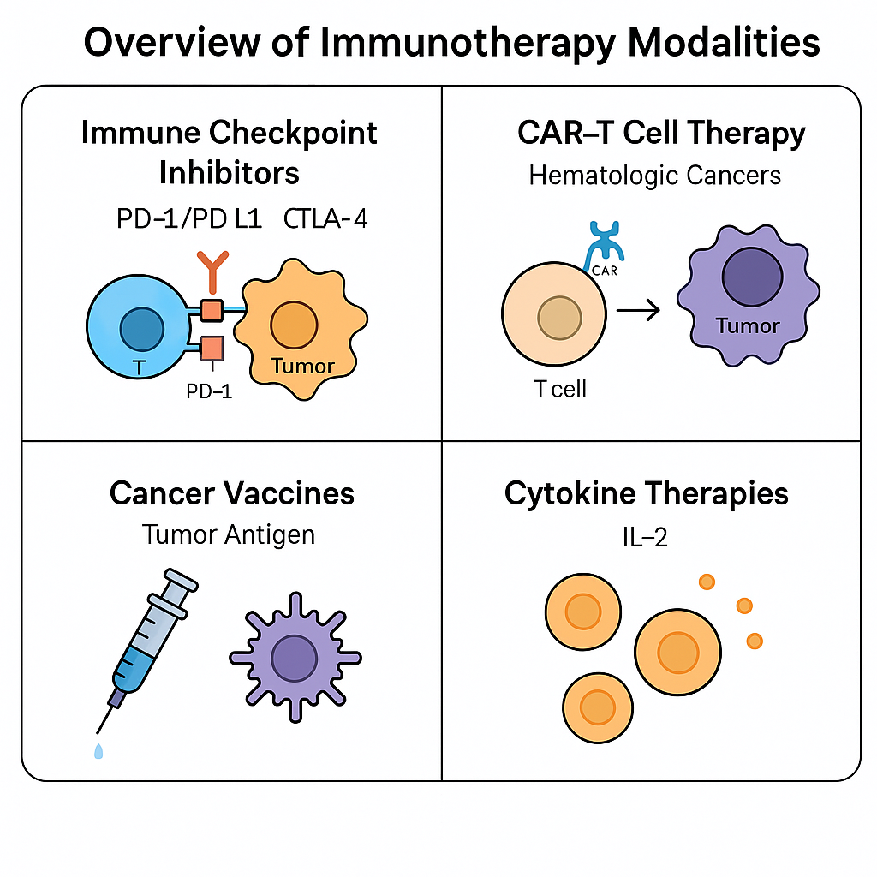Figure 1. Review of the Main Immunotherapy Types. This diagram demonstrates the major categories of cancer immunotherapy, such as immune checkpoint inhibitors (PD-1/PD-L1, CTLA-4), CAR-T cell therapy for blood cancers, cancer vaccines targeting tumor-associated antigens and cytokine therapy like IL-2. Both contribute to antitumor immunity by different mechanisms, upon which modern immuno-oncology strategies are based.

Cancer immunotherapy involves variety of strategies that target to increase the ability of the immune system to detect and kill tumor cells. Most transformative are immune checkpoint inhibitors that hit off-switches which tumors hijack to halt immune attacks. In cancers such as melanoma, non-small cell lung cancer, and urothelial carcinoma, antibodies against PD-1, PD-L1, and CTLA-4 have achieved remarkable clinical success. However, the long-term response rate is favorable only in a proportion of patients, and immunerelated adverse events continue to be a concern[6].

Another game-changer is CAR-T cell therapy, especially in hematologic diseases, such as ALL and some lymphomas. In this approach, patient T-cells are modified to express chimeric antigen receptors directed against selected tumor antigens. Although effective in hematological cancers, CAR-T in solid tumors is challenged by the antigen heterogeneity, inadequate T cell infiltration, and immunosuppressive tumor microenvironment[7].

Vaccines targeting cancer objects to trigger immune response in the body by tumor-specific antigens, but the effectiveness is not satisfactory at present. Additionally, oncolytic viruses are being engineered to preferentially replicate within and lyse tumor cells, while simultaneously inducing systemic immune activation[8].

Alternative approaches also have included adoptive cell therapy (ACT), where ex vivo expanded tumor-infiltrating lymphocytes are infused, and the use of cytokine-based therapies such as interleukin-2 (IL-2) to induce T cell expansion and activation. These strategies have demonstrated certain activity in some restricted occasions, although systemic toxicity and limited efficacy remain challenges[9].

Although immunotherapy has revolutionized cancer treatment, the variability in response and resistance across tumor types warrants refinement and combination strategies.

### ****3. Primary and Acquired Resistance Mechanisms****

Despite its great potential, the clinical benefit of immunotherapy is limited by the fact that a significant proportion of patients are resistant from the beginning (primary resistance) or develop resistance after an initial period of disease control (acquired resistance). These failures are attributed to intricate, multifaceted processes, comprising of tumor-intrinsic features, the tumor microenvironment (TME), and systemic host-related factors[10].

#### ****3.1 Tumor-Intrinsic Mechanisms****

The intrinsic resistance could be the factors in cancer cells to escape from immune surveillance or impair activity of immune cells.

One key mechanism is the generation of antigen loss variants in which tumor cells lose expression or mutate their TAAs, thereby becoming resistant to T cells. This phenomenon has been notably seen with CAR-Ts directed against one antigen such as CD19[11].

Further, MHC downregulation is another major mechanism. Neoplasms have the potential to down-regulate the major histocompatibility complex class I (MHC-I) molecules that are required for the tumor antigen presentation to cytotoxic T cells. In absence of sufficient antigen presentation, there is no immune recognition[12].

Furthermore, tumors frequently overexpress alternative immune checkpoints other than PD-1 and CTLA-4 (including TIM-3, LAG-3, and TIGIT), thus being able to inhibit T cell function with redundant inhibitory signals.

Genetic mutations also play a role in immune escape. For example, mutations in β2-microglobulin (B2M), a component of MHC-I, results in no surface MHC expression. Likewise, the loss-of-function mutations of JAK1/2 suppress the interferon pathway and decrease PD-L1 expression to escape immune surveillance[13].

Finally, the large oncomolecular pathways, including WNT/β-catenin and PI3K-AKT oncomolecular pathways, are also related to low T-cell infiltration and antigen presenting dysfunction. Both pathways regulate tumor immune landscape at a molecular level that affect immune system[14]

#### ****3.2 Tumor Microenvironment (TME)-Mediated Resistance****

The tumor microenvironment is a major facilitator of immune escape, consisting of immune cells, stromal cells, vasculature, and extracellular matrix elements.

One main characteristic is the prevalence of immunosuppressive cells such as Tregs, MDSCs and TAMs. These cells produce cytokines, such as IL-10 and TGF-β, that block inflammation by suppressing effector T cell activation and inducing immune tolerance[15].

Metabolic limitations in the TME are also significantly contributory. Tumours are avid consumers of glucose and oxygen and as a result, they form an hypoxic, acidic and nutrient-starved environment. High concentration of lactic acid as well as low concentration of glucose in turn suppresses metabolism and function of T cells causing them to become exhausted[16].

In certain cancers, fibrotic barriers, such as cancer-associated fibroblasts (CAFs) and a thick extracellular matrix (ECM), mechanically hinder T cell entry and drug delivery. This is most evident in pancreatic and colorectal cancer.

In addition, expression of checkpoint ligands in TME is another resistance mechanism. For instance, chronic exposure to interferon-gamma (IFNγ), produced by activated T cells, can lead to sustained PD-L1 expression on tumor and stromal cells, resulting in an immunosuppressive feedback mechanism[17].

#### ****3.3 Host and Systemic Factors****

In addition, apart from the tumor and microenvironment, host factors also influence the response to immunotherapy.

Recent studies have highlighted the substantial role of the gut microbiome in shaping immunity. Several studies proved that certain bacteria (i.e., Akkermansia muciniphila, Bifidobacterium) promote checkpoint inhibitor efficacy, and that antibiotic administration or dysbiosis can hamper treatment responses[18].

Genetic background, especially HLA polymorphism, determines the range of antigens that can be presented and that the immune repertoire can cover. Patients bearing some HLA alleles might express a more diverse repertoire of tumoral neo-antigens allowing better immune recognition.

Lastly, age, sex as well as comorbidities might have influence on immune competence. The elderly exhibit immune senescence and gender-specific hormonal differences that may affect immune cell function. In addition, other chronic diseases, like diabetes or cardiovascular diseases can reduce the effectiveness of immunotherapy by inducing systemic inflammation or immune suppression[19].

These two mechanisms combined reflect the complexity of immunotherapy resistance. Comprehension and manipulation of each layer, from the genetic make-up of tumor cells to host physiology, will be necessary to establish approaches to enhance and prolong the effects of immunotherapies. Age-related immune senescence, sex-specific characteristics and comorbidities might all affect therapeutic efficacy[20]. Multiple levels of mechanisms contributing to resistance to cancer immunotherapy are shown in a summary in Fig. 2, including tumor-intrinsic factors, tumor microenvironment-contained immunosuppression components, and host factors.

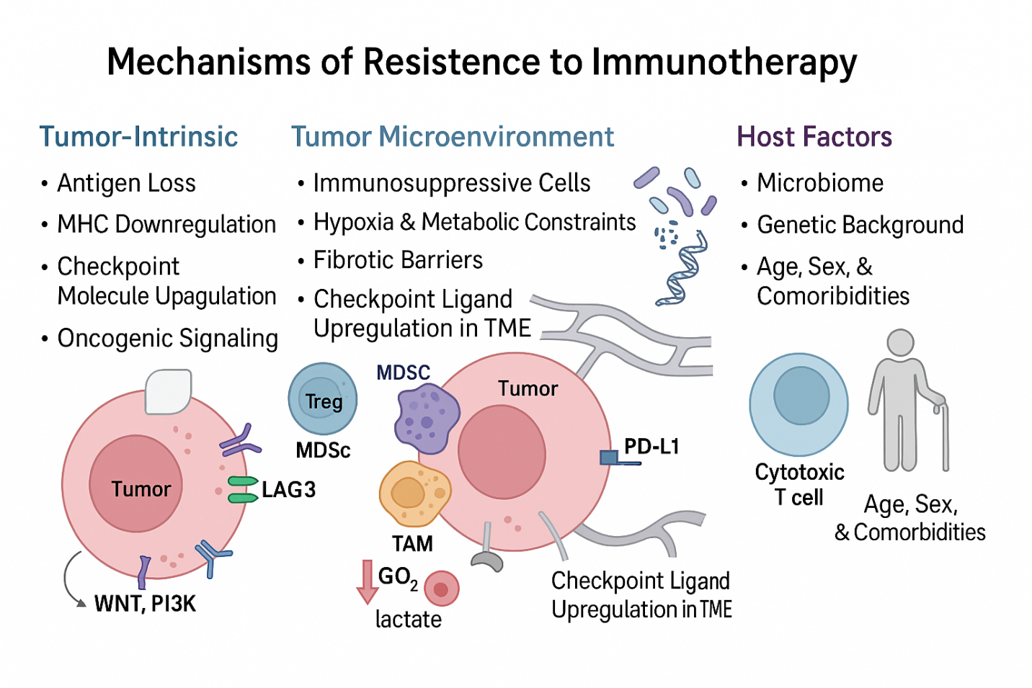Figure 2. Resistance mechanisms to cancer immunotherapy. This image illustrates the key mechanisms of tumors to evade immunotherapy. These involve factors such as tumor-intrinsic factors (antigen loss, MHC class I expression decrease, upregulation of checkpoint molecules, and alterations of tumor signaling), tumor microenvironment-induced resistance (immune suppressive cells, hypoxia, metabolic restrictions, fibrotic blockade, and expression of checkpoint ligands) and host/systemic factors (microbiome disparity, intrinsic genetic property, and co-morbidities). Visual features emphasize cellular and molecular determinants of resistance throughout these strata.

**4. Clinical Evidence of Resistance**

Clinical data in a variety of cancer types have also revealed the difficulty of overcoming not only primary but also acquired resistance to immunotherapy. In cases of NSCLC and melanoma, PD-1/PD-L1 inhibitors have reached a remarkable treatment end, yet, safety net or resistance in still common in the majority of patients. For instance, only 20–30% of unselected patients with non-small cell lung cancer (NSCLC) respond to PD-1 inhibitors while the others show what is called primary resistance, which is frequently associated with lack of T cell infiltration or low level of PD-L1 expression[21].

Although melanoma has been the gold standard in the success of ICI, resistance is still widespread. Although first-line response rates to anti-PD1 therapy can be above 40%, patients often acquire resistance. This has been observed in a subset of participants as JAK1 or JAK2 mutations that block IFN-γ effects and allow cancer to evade immune pressure, despite having been previously sensitive (N=5, one of the 4 analyzed cases was resistant to anti-PD-1 therapy)43[22].

Likewise in RCC, combination immunotherapies like nivolumab plus ipilimumab have led to prolonged survival, but only a minority of patients achieve durable benefit. Such divergent results illustrate the IHC is governed by complex biology[23].

Indeed, tumor mutational burden (TMB) and NeoAg characteristics have been studied as a predictive biomarker, whereby elevated TMB is associated with favorable response overall. Nevertheless there are exceptions and the generation of immunogenic neoantigens might be more important than just the number of mutations[24].

Real-world experience tends to show much more variance than clinical trials, because of factors such as heterogeneity in patients and comorbidities, changing tumor biology, etc. Collectively, these observations highlight the clinical imperative for decoding resistance determinants and rationalizing appropriate therapies[25].

### ****5. Emerging Strategies to Overcome Resistance****

Relapse and refractoriness to current immunotherapies have resulted in the search for effective countermeasures. These therapies range from the development of combinatorial regimens to reprogramming of the TME, discovery of new immune checkpoints and the progress in personalized immunotherapy strategies.

#### ****5.1 Combination Therapies****

Combinations of check point inhibitors have demonstrated greater efficacy than the single ones represented by the simultaneous blockade of several immune inhibitory pathways. One such example is the combination of the anti-PD-1 nivolumab with the anti-CTLA-4 ipilimumab, approved in metastatic melanoma and renal cell carcinoma. Dual checkpoint inhibition results in superior T cell priming and effector function, but leads to an increase in immune-related toxicities that require critical patient selection and monitoring[26].

The combination of checkpoint inhibitors with targeted therapies is another attractive option in tumors with targetable mutations. In BRAF-mutated melanoma, to enhance response rates through the upregulation of tumor antigen expression and T cell recruitment, combinations of BRAF inhibitors (e.g., vemurafenib) and MEK inhibitors (e.g., cobimetinib) have been combined with PD-1/PD-L1 inhibitors[27].

Concurrent chemotherapy and radiotherapy with immunotherapy are being studied in various disease settings (including NSCLC and head and neck squamous cell carcinoma). Chemotherapy and radiation can increase immune visibility by promoting the release of antigens, the upregulation of MHC molecules, and the induction of immunogenic cell death and can therefore complement checkpoint blockade[28].

Another novel approach is to combine immunotherapy with anti-angiogenic agents, such as bevacizumab, which not only leads to tumor vascular disruption but also modifies the tumor microenvironment (TME), decreasing hypoxia and enhancing T cell invasion. This strategy has shown promising results in renal cell carcinoma and is currently being explored in clinical trials for other solid tumors to improve therapeutic efficacy and overcome resistance to immune checkpoint inhibitors[29].

#### ****5.2 Targeting the Tumor Microenvironment****

Reversing immune inhibitory TME is very important in order to overcome local resistance. One strategy is the inhibition of CSF-1R, the upstream activator of TAMs. These agents may inhibit immunosuppressive cytokines and restore antitumor immunity through depleting or reprogramming TAMs[30].

IDO inhibitors have been investigated to overcome T cell anergy mediated by tryptophan metabolism. While early trials (eg, epacadostat) have been disappointing, current research is focused in selecting patients with better chance of response and in combining drugs to counteract tumor escape[31].

TGF-β signaling, in addition to immune-exclusion and fibrosis, is another target. TGF-β inhibitors like galunisertib target to abrogate this immunosuppressive pathway. Preclinical data for dual inhibition of PD-L1 and TGF-β demonstrates promising results, especially in ‘immune excluded’ tumors[32].

Smartened-up advanced ACT approaches are being developed to empower T cells in the unforgiving TME. Modulating TGF-β resistance, metabolic fitness or chemokine receptor expression within T cells enhances their capacity to operate in immune suppressive tumors[33].

#### ****5.3 Novel Immune Checkpoint Targets****

In addition to PD-1 and CTLA-4, emerging targeting strategies are investigating additional inhibitory receptors to drive greater rejuvenation of exhausted T cells. Agents directed against LAG-3, TIM-3, TIGIT, and VISTA are at different stages in clinical development.

For example, relatlimab in combination with nivolumab has shown better progression-free survival for advanced melanoma. Other early-phase trials are evaluating anti-TIGIT and anti-TIM-3 agents, either alone or combined with PD-1 blockade, with early signs of activity[34].

Such novel checkpoints could also reverse resistant phenotypes which up-regulate compensatory mechanisms of immune suppression via plant pathogen responses.

#### ****5.4 Personalized and Precision Immunotherapy****

Customized therapies directed toward tumor-specific markers are emerging. Neoantigen vaccines, derived from sequencing each patient’s unique tumor exome, can induce specific immunity and are currently under examination in early phase trials for melanoma, glioblastoma and lung cancer[35].

TCR-engineered T cells can provide a more specific targeting approach for both intracellular (eg. via MHC-restricted TCRs) and extracellular antigens than CAR T cells, especially in solid tumors. This approach can be used to target shared oncogenic mutations (eg, KRAS-G12D) or patient-specific neoantigens[35].

Liquid biopsy AI-based modeling and multi-omics (omics from multiple biological sources) biomarkers are being developed to match the right therapy and predict resistance. Combining ctDNA and immune profiling serially may provide a basis for on-treatment adjustments and the detection of resistance mechanisms[36].

These are efforts that target a patient’s optimal choice of therapy and personalized care, the ideal path to treatments that will result in more meaningful and durable benefits in the majority of cancer patients.

Together, these are the perspectives of New Era, transitioning from one-size-fits-all immunotherapy to a dynamic, multifaceted one—personalizing treatment based on tumor biology, micro-environmental situation, and patient-related conditions. Enriching use of biomarkers, liquid biopsy and AI to guide patient management may lead to more potent and personalized responses, establishing novel therapeutic strategies currently being under development with the aim to overcome resistance mechanisms and increase the durability of cancer immune therapy are summarized in Figure 3[37].

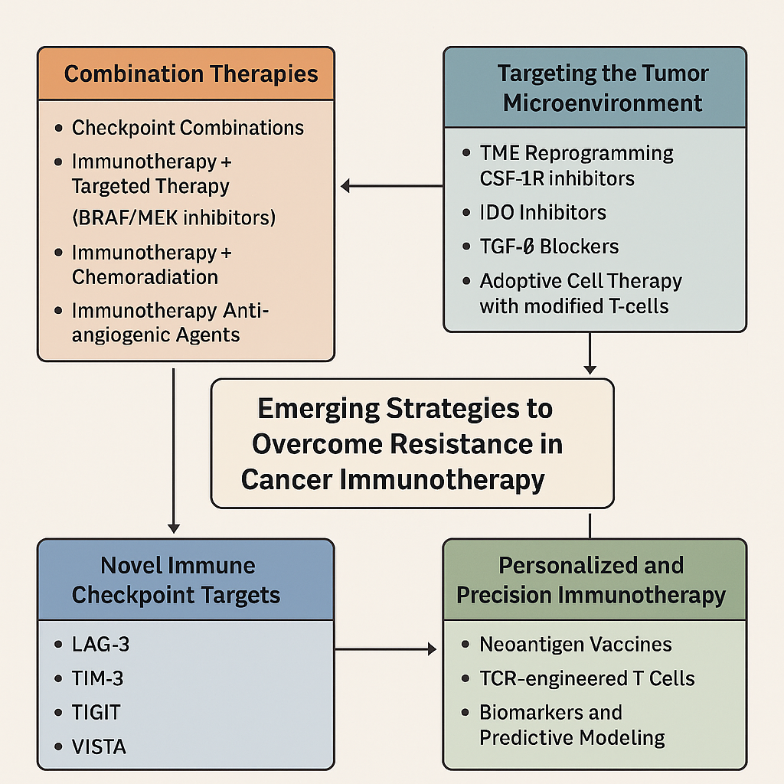

Figure 3. Novel approaches for overcoming resistance in cancer immunotherapy. This infographic outline four key strategic plans on resistance in cancer immunotherapy. We expect that these strategies will encompass combinatorial protocols (e.g., checkpoint blockade plus targeted therapy, chemoradiation, or anti-angiogenic drugs), TME modulation (e.g., anti-CSF-1R, anti-IDO, anti-TGF-β agents, and adoptive cell therapies), new immune checkpoint targets (e.g., LAG-3, TIM-3, TIGIT, VISTA), and personalized approaches to immuno-oncology (e.g., neoantigen vaccines, TCR-engineered T cells, and predictive modelling based on biomarkers). The approaches to increase immune effectiveness and to avoid therapy failure.

### ****6. Challenges and Future Directions****

Immune therapy resistance is of complex nature and is difficult to fight against, and requires a multi-layered and complex treatment strategy. In this complex interplay, tumor-intrinsic mutations, immune preventing stroma and patient related factors participate dynamically and many times, unpredictably. Accordingly, there is no one-size-fits-all answer, and the mechanisms of resistance often differ not only among patients, but even within tumors at different times[38].

One major challenge is the development of clinical trials that are capable of accurately evaluating these multi-leveled interventions. Although combination therapy is effective theoretically, immune-related toxicities are higher and decrease the feasibility. The balance between strong immunostimulation with a risk of autoimmunity is a difficult and not final clinical issue[39].

Such progress in multi-omics, spatial biology, and single-cell profiling will help guide the refinement of treatment strategies, reshaping our cancer-immune system paradigm. These tools can characterize the dynamics of immune cell populations, discover predictive biomarkers, and reveal microenvironmental niches of resistance on a resolution previously not accessible[40].

In addition, real-time monitoring tools, such as liquid biopsies and ctDNA analysis, promise the ability to monitor therapeutic response and detect acquired resistance at an earlier time point. The integration of adaptive trial platforms such as I-SPY and WINTHER enables the more adaptive and personalized evaluation of treatments in response to changing tumor profiles and patient biomarkers[41].

Moving forward, paradigms for the future of cancer immunotherapy will be shaped by systems-level insights into resistance, enabled by data-driven computational approaches and precision-guided therapeutic design. This will entail breaking down silos, new regulatory structures and patient-led innovation.

### ****7. Conclusion****

Cancer immunotherapy has transformed the field of oncology, providing long-lasting responses in cancers traditionally considered untreatable. Nevertheless, there is no doubt that a large number of patients develop intrinsic or acquired resistance, constraining its wide application. Resistance manifests through a variety of mechanisms—both tumor-intrinsic, such as universal cancer mutations, as well as through an immunosuppressive microenvironment, and host factors—which together prevent immune recognition and killing.

To address these challenges, various new strategies are being extensively investigated, such as combination therapy, TME modification, the discovery of immune checkpoint targets and the development of personalized cellular or vaccine therapy. Multi-omics integration, real-time monitoring, and adaptive clinical trial design are now pushing cancer immunotherapy closer to a fine-tuned patient-based paradigm.

Although immunotherapy is a game changer, the ability to help the average patient long-term will need to have individualized, multimodal, and agile strategies. Further investment in translational research, mechanistic understanding, and clinical innovation will be necessary to fully exploit the promise of immune-based treatments for cancer. Understanding the complex biology of resistance will help bring the next generation of immunotherapy closer to delivering on its potential for every patient.

REFERNCES

1. Li Q, Lei X, Zhu J, Zhong Y, Yang J, Wang J, et al. Radiotherapy/Chemotherapy-Immunotherapy for Cancer Management: From Mechanisms to Clinical Implications. Oxid Med Cell Longev. 2023 Feb 2;2023:7530794.

2. Sahu M, Suryawanshi H. Immunotherapy: The future of cancer treatment. J Oral Maxillofac Pathol. 2021;25(2):371.

3. Wudhikarn K, Soh SY, Huang H, Perales MA. Toxicity of Chimeric Antigen Receptor T Cells and its Management. Blood Cell Ther. 2021 Oct 14;4(Spec Edition):S1–7.

4. Schoenfeld AJ, Hellmann MD. Acquired Resistance to Immune Checkpoint Inhibitors. Cancer Cell. 2020 Apr 13;37(4):443–55.

5. Sambi M, Bagheri L, Szewczuk MR. Current Challenges in Cancer Immunotherapy: Multimodal Approaches to Improve Efficacy and Patient Response Rates. J Oncol. 2019 Feb 28;2019:4508794.

6. Naran K, Nundalall T, Chetty S, Barth S. Principles of Immunotherapy: Implications for Treatment Strategies in Cancer and Infectious Diseases. Front Microbiol. 2018 Dec 21;9:3158.

7. Jogalekar MP, Rajendran RL, Khan F, Dmello C, Gangadaran P, Ahn BC. CAR T-Cell-Based gene therapy for cancers: new perspectives, challenges, and clinical developments. Front Immunol. 2022 Jul 22;13:925985.

8. Tian Y, Xie D, Yang L. Engineering strategies to enhance oncolytic viruses in cancer immunotherapy. Signal Transduct Target Ther. 2022 Apr 6;7:117.

9. Feldman SA, Assadipour Y, Kriley I, Goff SL, Rosenberg SA. Adoptive Cell Therapy—Tumor-Infiltrating Lymphocytes, T-Cell Receptors, and Chimeric Antigen Receptors. Semin Oncol. 2015 Aug;42(4):626–39.

10. Garg P, Pareek S, Kulkarni P, Horne D, Salgia R, Singhal SS. Next-Generation Immunotherapy: Advancing Clinical Applications in Cancer Treatment. J Clin Med. 2024 Oct 30;13(21):6537.

11. Yadav RK, Ali A, Kumar S, Sharma A, Baghchi B, Singh P, et al. CAR T cell therapy: newer approaches to counter resistance and cost. Heliyon. 2020 Apr 16;6(4):e03779.

12. Cornel AM, Mimpen IL, Nierkens S. MHC Class I Downregulation in Cancer: Underlying Mechanisms and Potential Targets for Cancer Immunotherapy. Cancers (Basel). 2020 Jul 2;12(7):1760.

13. De Sousa Linhares A, Leitner J, Grabmeier-Pfistershammer K, Steinberger P. Not All Immune Checkpoints Are Created Equal. Front Immunol [Internet]. 2018 Aug 31 [cited 2025 Jun 18];9. Available from: https://www.frontiersin.org/journals/immunology/articles/10.3389/fimmu.2018.01909/full

14. Luke JJ, Bao R, Sweis R, Spranger S, Gajewski TF. WNT/β-catenin pathway activation correlates with immune exclusion across human cancers. Clin Cancer Res. 2019 May 15;25(10):3074–83.

15. Li K, Shi H, Zhang B, Ou X, Ma Q, Chen Y, et al. Myeloid-derived suppressor cells as immunosuppressive regulators and therapeutic targets in cancer. Sig Transduct Target Ther. 2021 Oct 7;6(1):362.

16. Elia I, Haigis MC. Metabolites and the tumor microenvironment: from cellular mechanisms to systemic metabolism. Nat Metab. 2021 Jan;3(1):21–32.

17. Sun C, Mezzadra R, Schumacher TN. Regulation and Function of the PD-L1 Checkpoint. Immunity. 2018 Mar 20;48(3):434–52.

18. Lawal OP, Adekunle JF, Abiodun AV, Orobator ET, Agbo OS, Ugoagwu KU, et al. Modulating Gut Microbiota for Precision Medicine in Diabetes: A Paradigm Shift in Personalized Treatment Strategies. Asian Journal of Research and Reports in Endocrinology. 2025 May 21;8(1):94–109.

19. Williams TM. Human Leukocyte Antigen Gene Polymorphism and the Histocompatibility Laboratory. J Mol Diagn. 2001 Aug;3(3):98–104.

20. Lawal OP, Ahmed NK, Ilesanmi TA, Anthony GI, Nwosu SN, Ogungbemiro FO, et al. The Impact of Antimicrobial Resistance on Cancer Treatment: A Systematic Review of Current Evidence and Future Directions. Asian Journal of Research in Medical and Pharmaceutical Sciences. 2024 Sep 16;13(4):9–27.

21. Wang B, Han Y, Zhang Y, Zhao Q, Wang H, Wei J, et al. Overcoming acquired resistance to cancer immune checkpoint therapy: potential strategies based on molecular mechanisms. Cell Biosci. 2023 Jun 30;13:120.

22. Hassel JC, Zimmer L, Sickmann T, Eigentler TK, Meier F, Mohr P, et al. Medical Needs and Therapeutic Options for Melanoma Patients Resistant to Anti-PD-1-Directed Immune Checkpoint Inhibition. Cancers (Basel). 2023 Jun 30;15(13):3448.

23. Schoenfeld AJ, Hellmann MD. Acquired Resistance to Immune Checkpoint Inhibitors. Cancer Cell. 2020 Apr 13;37(4):443–55.

24. Sha D, Jin Z, Budzcies J, Kluck K, Stenzinger A, Sinicrope FA. Tumor Mutational Burden (TMB) as a Predictive Biomarker in Solid Tumors. Cancer Discov. 2020 Dec;10(12):1808–25.

25. Okafor CE, Egwuatu EC, Owosagba VA, Njei T, Adeyemi BI, Onuche PUO, et al. From Bench to Bedside: Medicinal Chemistry Strategies in the Development of Kinase Inhibitors for Cancer Therapy. Journal of Cancer and Tumor International. 2025 May 10;15(2):79–96.

26. Seidel JA, Otsuka A, Kabashima K. Anti-PD-1 and Anti-CTLA-4 Therapies in Cancer: Mechanisms of Action, Efficacy, and Limitations. Front Oncol. 2018 Mar 28;8:86.

27. Ragusa F, Ferrari SM, Elia G, Paparo SR, Balestri E, Botrini C, et al. Combination Strategies Involving Immune Checkpoint Inhibitors and Tyrosine Kinase or BRAF Inhibitors in Aggressive Thyroid Cancer. International Journal of Molecular Sciences. 2022 Jan;23(10):5731.

28. Xue H, Chen Y, Zhou Y. Radioimmunotherapy: a game-changer for advanced non-small cell lung cancer. Front Immunol [Internet]. 2024 Dec 6 [cited 2025 Jun 18];15. Available from: https://www.frontiersin.org/journals/immunology/articles/10.3389/fimmu.2024.1522508/full

29. Song Y, Fu Y, Xie Q, Zhu B, Wang J, Zhang B. Anti-angiogenic Agents in Combination With Immune Checkpoint Inhibitors: A Promising Strategy for Cancer Treatment. Front Immunol. 2020 Aug 25;11:1956.

30. Khan SU, Khan MU, Azhar Ud Din M, Khan IM, Khan MI, Bungau S, et al. Reprogramming tumor-associated macrophages as a unique approach to target tumor immunotherapy. Front Immunol. 2023 Apr 17;14:1166487.

31. Günther J, Däbritz J, Wirthgen E. Limitations and Off-Target Effects of Tryptophan-Related IDO Inhibitors in Cancer Treatment. Front Immunol [Internet]. 2019 Jul 30 [cited 2025 Jun 18];10. Available from: https://www.frontiersin.org/journals/immunology/articles/10.3389/fimmu.2019.01801/full

32. Gulley JL, Schlom J, Barcellos‐Hoff MH, Wang X, Seoane J, Audhuy F, et al. Dual inhibition of TGF‐β and PD‐L1: a novel approach to cancer treatment. Mol Oncol. 2022 Jun;16(11):2117–34.

33. Ma R, Sun JH, Wang YY. The role of transforming growth factor-β (TGF-β) in the formation of exhausted CD8 + T cells. Clin Exp Med. 2024;24(1):128.

34. Almawash S. Revolutionary Cancer Therapy for Personalization and Improved Efficacy: Strategies to Overcome Resistance to Immune Checkpoint Inhibitor Therapy. Cancers. 2025 Jan;17(5):880.

35. Shafer P, Kelly LM, Hoyos V. Cancer Therapy With TCR-Engineered T Cells: Current Strategies, Challenges, and Prospects. Front Immunol. 2022 Mar 3;13:835762.

36. Di Sario G, Rossella V, Famulari ES, Maurizio A, Lazarevic D, Giannese F, et al. Enhancing clinical potential of liquid biopsy through a multi-omic approach: A systematic review. Front Genet. 2023 Apr 3;14:1152470.

37. Maciejko L, Smalley M, Goldman A. Cancer Immunotherapy and Personalized Medicine: Emerging Technologies and Biomarker-Based Approaches. J Mol Biomark Diagn. 2017 Sep;8(5):350.

38. Giri S, Lamichhane G, Pandey J, Khadayat R, K. C. S, Devkota HP, et al. Immune Modulation and Immunotherapy in Solid Tumors: Mechanisms of Resistance and Potential Therapeutic Strategies. International Journal of Molecular Sciences. 2025 Jan;26(7):2923.

39. Cluxton C, Naidoo J. Prospective Clinical Trials to Advance the Study of Immune Checkpoint Inhibitor Toxicity. Current Oncology. 2023 Jul;30(7):6862–71.

40. Du Y, Ding X, Ye Y. The spatial multi-omics revolution in cancer therapy: Precision redefined. Cell Rep Med. 2024 Sep 17;5(9):101740.

41. Wang H, Zhang Y, Zhang H, Cao H, Mao J, Chen X, et al. Liquid biopsy for human cancer: cancer screening, monitoring, and treatment. MedComm (2020). 2024 May 28;5(6):e564.