**Histomorphology Architecture and Weight Changes Following Long Term Exposure to Marijuana (*Cannabis sativa*) Smoke on the Liver of Wistar Rats**

**Abstract**

Smoking is a practice in which a substance such as, tobacco, marijuana or cannabis is burned and the smoke tasted or inhaled. This study was carried out to assess the effects of marijuana (*Cannabis* *sativa*) smoke on the weight and the histomorphological architecture on the liver of wistar rats. Fifty (50) male wistar rats with weights ranging from 170-250g divided into five groups A-E of ten (10) rats each were used for the study. The rats in the control groups (A and B) were exposed to normal air and smoke from cigarette wrapper respectively, while the rats in groups C, D, and E were exposed to smoke from a completely burnt 1.0g marijuana wrapped with 0.5g of cigarette wrapper once/day, twice/day and thrice/day respectively. The duration of exposure in all the groups was for seven and fourteen days for acute and chronic respectively. The animals were then anesthetized, sacrificed and the livers were obtained from each animal and transferred directly to 10% formal saline for histopathological analysis using Haematoxylin and Eosin (H&E) stain. The weights were also taken at baseline and during the treatment. The results showed that there was a significant increase (p<0.05) in the body weight of wistar rats treated with marijuana (group C, D and E) when compared with control rats (A and B). In the liver tissue of the rats in the control groups (A and B), the histological profile of the livers was preserved, whereas in groups C, D and E the histological outline of the liver tissues obtained revealed disruptive characteristics such as distortion with inflammatory cell, mild sinusoidal congestion and moderate portals congestion and basophilic hepatocytes. Data obtained from this study show that exposure to the smoke extract of marijuana (Cannabis sativa) on the liver have deleterious effects on the cytoarchitecture of these organs in wistar rats. This therefore indicates that Cannabis sativa and its constituents are possible hepatotoxic substances.

**Keywords:** Marijuana, *Cannabis* *sativa*, Smoke, Liver, Histomorphological Architecture,

**Introduction**

Marijuana also known as pot, grass, weed, hemp, blow and puff refers to dried leaves and flowers of cannabis sativa plants (Taiwo *et al*., 2021; Longoria *et al*., 2022). *Cannabis sativa* is an annual plant in the Cannabaceae family. Humans have cultivated this herb throughout recorded history as a source of industrial fiber, seed oil, and food. Humans have long used the plant as a drug, as medicine, and as a spiritual tool. Each part of the plant is harvested differently, depending on the purpose of its use. When so used, preparations of Cannabis sativa are consumed by smoking, vaporizing and oral ingestion (Imran *et al*., 2023). Despite the prohibition of its use in many countries of the world, including Nigeria, Cannabis sativa remains the most widely used illicit natural plant (Ejime *et al*., 2022). In many societies throughout the world, Cannabis has been used by a substantial minority, and in some a majority of young adults (Connor *et al*., 2021). *Cannabis sativa* contains more than 400 chemical compounds, of which about 60 are cannabinoids. The first to be isolated, and the one mainly responsible for the psychoactive properties of the plant, was delta-9-tetrahydrocannabinol (Černe, 2020). The subjective effects of cannabis and its main psychoactive component, delta-9-tetrahydrocannabinol (Δ9-THC), include relaxation, mild euphoria, perceptual changes, intense laughter, and talkativeness (Wolfe *et al*., 2020; Le *et al*., 2022). However, cannabis use can also have adverse effects including impaired memory function and paranoia (Freeman *et al.,* 2015; Kroon *et al*., 2021). Chronic cannabis use may lead to dependence (Hammond *et al*., 2020; Schlag *et al*., 2021) and cessation of chronic use can lead to affective withdrawal symptoms including increased anxiety, irritability, aggression, intense craving for cannabis, difficulty sleeping, and somatic complaints (Millea, 2020; Cooke *et al*., 2021; Adams *et al*., 2022).

Smoking is a practice in which a substance such as, tobacco, marijuana or cannabis is burned and the smoke tasted or inhaled. It is primarily practiced as a route of administration for recreation drug use, as combustion release the active substances in drugs such as nicotine and makes them available for absorption through the lungs. It can be done as a part of rituals to induce trances and spiritual enlightenment (Akintaro, 2015). The reasons for smoking include the inadequate understanding of the harmful effects of smoking; attractive tobacco advertising; the presence of so many other smokers; young people's rebelliousness and lack of mature judgement, inadequate legislation to control smoking, addiction, unhealthy ideas of consumption, the use of tobacco in social life and pleasure (Xiong *et al*., 2020).

Manifestations of the effects of marijuana are seen within seconds and become apparent and full within a few minutes while they typically last for 2-3 hours (Okobi *et al*., 2022; Śmiarowska *et al*., 2022). Marijuana is usually smoked in hand-rolled cigarettes called joints, among other names by its users. Other ways of smoking it are by the use of pipes or water pipes called bongs (Stella *et al*., 2021). It is also used in brewing tea and sometimes, it is mixed with foods (Ejime *et al*., 2022).

The Liver, a vital organ present in vertebrate has a wide variety of high-volume biochemical reaction, including synthesis and breakdown of small and complex molecules, many of which are necessary for normal vital functions (Coman *et al*., 2021; Castera & Cusi, 2023). The functions include carbohydrate metabolism, and amino acid synthesis, protein metabolism, fat metabolism, detoxification, drug metabolism, secretion and excretion of bile, synthesis of clotting factors, (I, II, V, VII, IX, X), synthesis of hormones, phagocytotic activity, storage of glucose, Vitamin A, D, B12, Copper and iron (Coman *et al*., 2021).

The active ingredient in cannabis, delta‐9‐tetrahydrocannabinol (THC), is only found in small portions of the cannabis plant, in the flowering tops and in some of the leaves (Imran *et al*., 2023). After inhalation, delta-9-tetrahydrocannabinol is rapidly absorbed and distributed through the circulation. The initial metabolism takes place in the lungs and liver, with conversion to 11-hydroxy-tetrahydrocannabinol, which is more potent and crosses the haematoencephalic barrier more easily. The metabolism goes further in the liver, where 11-hydroxy-tetrahydrocannabinol is converted into many inactive metabolites. Among these is 11-nor-carboxydelta-9-tetrahydrocannabinol, which can be detected minutes after smoking, abundantly in plasma and urine (Černe, 2020).

Hepatotoxicity is a potential complication from the usage of various illicit drugs, possibly consequent to their liver metabolism, but information on this is scarce in the medical literature (Ahmed *et al*., 2022). Marijuana usage in the form of cigarettes made from dried leaves, flowers and stalks of female Cannabis sativa plants has grown strongly among young people over the last decade (Connor *et al*., 2021). In the past two decades, cannabinoids in Cannabis sativa (marijuana) have emerged as crucial mediators in a variety of pathophysiological conditions. Also, in recent years there has been a dramatic increase in the number of marijuana users and in the long-term health consequences of marijuana use. Cannabis and its constituents can affect certain hepatic enzymes and causing a certain degree of liver dysfunction (Haktanır *et al*., 2025). Cannabinoids are possible hepatotoxic substances associated with hepatic morphologic and enzymatic alterations. Study has shown that it increases the (ALP) activity in both injected rats and human smokers and this will increase with the increase of dose and time but the (ALT) and the (AST) increase at the beginning of consumption then will decrease with time (Nwonuma *et al*., 2021). It has also been reported that in marijuana smokers, the mean GGT activity was 86.6% higher than that of the control group and that of alkaline phosphatase (ALP) was 121.7% higher than that of the non-smokers group (Barré *et al*., 2020). Therefore, this work is to demonstrate the histomorphology architecture and weight changes following long term exposure to marijuana (*Cannabis sativa*) Smoke on the Liver of Wistar Rats.

**Study Area**

This study was carried out in Ambrose Alli University, Ekpoma, Esan- West Local Government Area of Edo State. The town is located at latitude 60.75IN and longitude 60.13IE with an estimated population size of 125,842 people. The inhabitants are mainly students, civil servants and farmers.

**Study Design**

The present study involved the use of both experimental and observational study design. Fifty (50) adult male wistar rats were use for this study for a period of 14 days (7 days for acute and 14 days for chronic)

**Experimental Animals**

Fifty (50) male wistar rats with weights ranging from 170-250g were procured from the laboratory animal house, College of Medicine, Ambrose Alli University Ekpoma, Edo State and were transferred to the Experimental Laboratory Health Affairs Ventures, Ekpoma, where they were allowed two (2) weeks of acclimatization. They were kept in wire mesh cages with tripod that separates the animal from its faeces to prevent contamination. During the period of acclimatization, the rats were fed with growers’ mash and water *ad libitum.* The research was conducted in accordance with the internationally accepted principles for laboratory animal use and care as found in the European Community guidelines (EEC Directive of 1986; 86/609/EEC).

**Substance Preparation**

The sample of Cannabis sativa (marijuana) were obtained from the Nigeria Drug Law Enforcement Agencies (NDLEA), Benin Command, Benin, Edo State, Nigeria and was botanically identified and authenticated at the Herbarium of the Botany Department, Ambrose Alli University, Ekpoma. It was air-dried under standard laboratory conditions. A measure of 1.0 g of the dried marijuana was wrapped with 0.5 g of sterilized wrapper following the protocol of Dubey et al., (2023) and burnt to produce the smoke extract for animal exposure.

**Experimental Design**

The rats were randomized and divided into five groups (A, B, C, D and E) of ten (10) animals each. They were placed in closed glass chambers of approximately 0.1m3, volume (37cm X 54cm X 30cm) with an opening of 2cm in its upper surface, according to the protocol of Massányi et al., (2020).

Group A (Control rats): Exposed to normal air for 5 minutes once per day

Group B: Exposed to smoke of burnt 0.5g of sterilized wrapper for 5 minutes once per day

Group C: exposed to smoke of burnt 1.0g marijuana wrapped with 0.5g of sterilized wrapper once per day (9.00am)

Group D: exposed to smoke of burnt 1.0g marijuana wrapped with 0.5g of sterilized wrapper twice per day (9.00am, 1.00pm)

Group E: exposed to smoke of burnt 1.0g marijuana wrapped with 0.5g of sterilized wrapper thrice per day (9.00am, 1.00pm and 5.00pm).

**Animal Sacrifice**

The animals were sacrificed in 2 stages, after day 7 for acute and after day 14 for chronic after been anesthetized with chloroform. They were laid down on the dissection board in a supine position and their anterior thoraco-abdominal cavities were carefully dissected in the midline to expose the organs of interest (liver). The livers were transferred into 10% formol saline to fix for at least 72 hours before further histological protocol and analysis was performed. Body weights were also measured at baseline and before animals were sacrificed.

**Histological Protocol**

The tissues were processed using automatic tissue processor according to the processing schedule used at AAU, Ekpoma, Edo State. The fixed plastic cassette tissues in 10% formalin were automatically processed by passing them through different grades of alcohol as follows:

70% alcohol 2hrs

80% alcohol 2hrs

90% alcohol 2hrs

90% alcohol 2hrs

95% alcohol 2hrs

Absolute 2hrs

Xylene 1 2hrs

Xylene II 2hrs

Molten paraffin wax 1 2hrs

Molten paraffin Wax II 2hrs

After the last timing, the tissues were removed from their plastic cassettes and placed at the centre of the metallic tissue mould and then filled with molten paraffin wax. They were also left to solidify after which they were now placed in the refrigerator at 5oC for 15 minutes. After the blocks were cool in the refrigerator for the time stated above (15 minutes), the blocks were then removed from the metallic case using a knife and after which the paraffin wax at the side of the blocks were removed.

The blocks were then trimmed and cut serially at 3nm on a rotary microtome. The sections were floated in water bath at 55oC and picked up by the use of a clean frosted end slides. The frosted end slides were now placed on the hot plate for 40 minutes for adequate attachment of the sections on the slides after which the sections were de-waxed, hydrated, air dried and stored in a slide box ready for staining process.

**Staining procedure**

Sections for general tissue structure were stained by Haematoxylin and Eosin technique.

1. The sections were dewaxed in 3 changes of xylene (5 minutes)
2. The sections were hydrated through descending grades of alcohol (absolute, 95%, 80% and 70%).
3. The sections were stained in Cole’s haematoxylin (10 minutes)
4. The sections were rinsed in running tap-water to remove excess stain
5. The sections were differentiated in 1% acid alcohol (3 seconds)
6. The sections were blued in running tap water (10 minutes)
7. The sections were counterstained with 1% eosin (1 minute)
8. Sections were finally rinsed in water, dehydrated in ascending grades of alcohol (70%, 80, 95% and absolute)
9. The sections were cleared in xylene, air-dried and mounted with dibuthylphthalate propylene xylene (DPX).
10. The slides were examined under a light microscope and photomicrographs were taken (As used in AAU, Ekpoma)

**Microscopy and Photomicroscopy**

The well stained sections of the organs were evaluated for pathological changes using Swift binocular microscope with inbuilt lighting system. The slides were photographed using a photomicroscope.

**Method of Data Analysis**

The obtained data were then subjected to statistical analysis using SPSS (version 20). The test groups’ values were compared with the values of the control group using ANOVA at 95% level of confidence. Values were represented as mean± standard error of mean (SEM).

**Results**

Table 1 shows the body weight (g) of control rats (A and B) and test rats (C, D and E) at baseline, acute and chronic phases. The mean±SD weight of group A, B, C, D and E at baseline were 223.40±9.61g, 226.70±6.52g, 223.80±7.87g, 226.50±5.72g and 225.40±6.96g respectively. There was no significant difference (p>0.05) in the body weight among the groups at the baseline. The mean±SD weight of group A, B, C, D and E at acute phase were 227.00±7.42g, 230.10±9.86g, 240.00±25.06g, 246.30±7.76g and 248.90±4.23g respectively. There was a significant increase in the body weight of wistar rats treated with marijuana (group C, D and E) when compared with control rats (A and B). The mean±SD weight of group A, B, C, D and E at chronic phase were 230.80±6.60g, 235.00±7.96g, 247.20±25.36g, 253.20±7.44g and 259.40±4.33g respectively. There was a significant increase in the body weight of wistar rats treated with marijuana (group C, D and E) when compared with control rats (A and B).

Table 2 showed the effects of marijuana smoke on the histology of the liver. An acute phase, the animals in group A and B (control groups) showed normal hepatic cytoarchitecture. Distortion with inflammatory cell was observed in few of the animals in group C while all animals in group D and E showed distortion of inflammatory cell. Animals in group D and E showed mild sinusoidal congestion and the effect was more in group E animals. Moderate portals congestion and basophilic hepatocytes was observed only in group E animals. In chronic phase, the animals in group A and B (control groups) showed normal hepatic cytoarchitecture. Distortion with inflammatory cell was seen in all the group treated with marijuana, mild sinusoidal congestion was observed in group D and E while moderate portals congestion and basophilic hepatocytes was observed in group E only.

**Table 1: Body Weight at Baseline, Acute Phase and Chronic Phase of Wistar Rats Fed with Marijuana and Control Rats**

|  |  |  |  |  |  |  |  |
| --- | --- | --- | --- | --- | --- | --- | --- |
| **Phases** | **Group A**  **Mean±SD**  **weight (g)** | **Group B**  **Mean±SD**  **weight (g)** | **Group C**  **Mean±SD**  **weight (g)** | **Group D**  **Mean±SD**  **weight (g)** | **Group E**  **Mean±SD**  **weight (g)** | **F-value** | **p-value** |
| **Baseline** | 223.40±9.61a | 226.70±6.52a | 223.80±7.87a | 226.50±5.72a | 225.40±6.96a | 0.418 | 0.698 |
| **Acute Phase** | 227.00±7.42a | 230.10±9.86a | 240.00±25.06b | 246.30±7.76b | 250.90±4.23b | 5.805 | 0.004 |
| **Chronic Phase** | 230.80±6.60a | 235.00±7.96a | 247.20±25.36b | 253.20±7.44b | 259.40±4.33b | 7.892 | 0.001 |

**Table 2: The Histological Effects of *Cannabis sativa* on the Liver of Wistar Rats**

|  |  |  |  |  |  |  |  |  |  |  |  |  |  |  |  |  |  |  |  |  |  |  |  |  |  |  |
| --- | --- | --- | --- | --- | --- | --- | --- | --- | --- | --- | --- | --- | --- | --- | --- | --- | --- | --- | --- | --- | --- | --- | --- | --- | --- | --- |
| **Duration** | **Microscopical**  **Observation** | **Group A** | | | | | **Group B** | | | | | **Group C** | | | | | **Group D** | | | | | **Group E** | | | | |
| **Acute**  **(7 Days)** | **Animals** | **1** | **2** | **3** | **4** | **5** | **1** | **2** | **3** | **4** | **5** | **1** | **2** | **3** | **4** | **5** | **1** | **2** | **3** | **4** | **5** | **1** | **2** | **3** | **4** | **5** |
| Normal hepatic cytoarchitecture | + | + | + | + | * | + | + | + | + | + | + | + |  |  |  |  |  |  |  |  |  |  |  |  |  |
| Distortion with inflammatory cell |  |  |  |  |  |  |  |  |  |  | - | - | + | + | / | ++ | ++ | ++ | ++ | ++ | ++ | ++ | ++ | ++ | ++ |
| Mild sinusoidal congestion |  |  |  |  |  |  |  |  |  |  |  |  |  |  |  | - | + | + | + | + | ++ | ++ | ++ | ++ | ++ |
| Moderate portals congestion and basophilic hepatocytes |  |  |  |  |  |  |  |  |  |  |  |  |  |  |  |  |  |  |  |  | + | ++ | ++ | ++ | ++ |
| **Chronic**  **(14 Days)** | Normal hepatic cytoarchitecture | + | + | + | + | + | + | + | + | + | + |  |  |  |  |  |  |  |  |  |  |  |  |  |  |  |
| Distortion with inflammatory cell |  |  |  |  |  |  |  |  |  |  | + | + | + | + | + | + | + | + | + | + | + | + | + | + | + |
| Mild sinusoidal congestion |  |  |  |  |  |  |  |  |  |  |  |  |  |  |  | + | + | + | + | + | + | + | + | + | + |
| Moderate portals congestion and basophilic hepatocytes |  |  |  |  |  |  |  |  |  |  |  |  |  |  |  |  |  |  |  |  | + | ++ | ++ | ++ | ++ |

**KEYS: + = present (mild), - = absent, ++ = moderately present, * = Escaped, /= Dead**

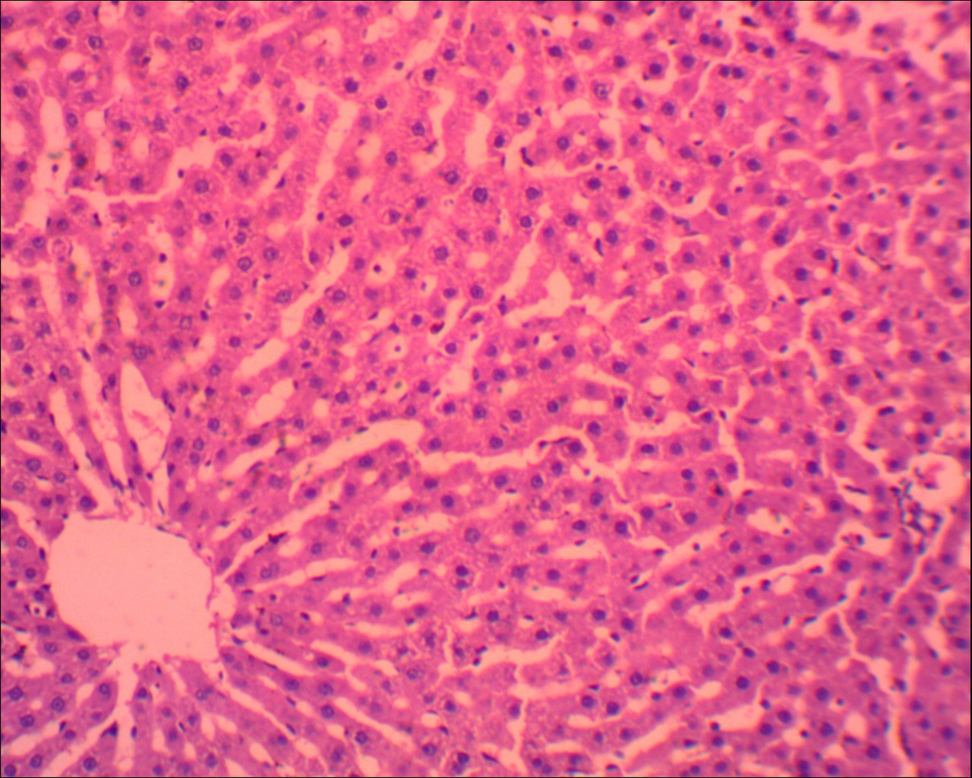

**Figure 1: GROUP A: Control rat liver composed of hepatocytes (thin white arrow) and sinusoids (thin black arrow) and central vein (thick black arrow). (H&E x 400)**

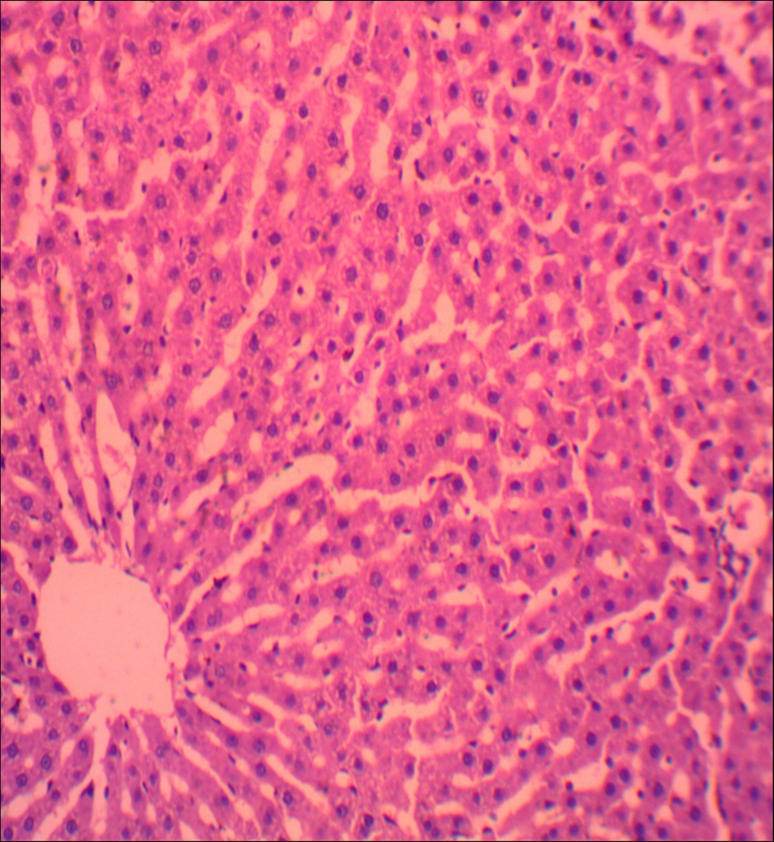

**Figure 2: Group B: Control rat liver composed of hepatocytes (thin white arrow) and sinusoids (thin black arrow) and central vein (thick black arrow). (H&E x 400)**

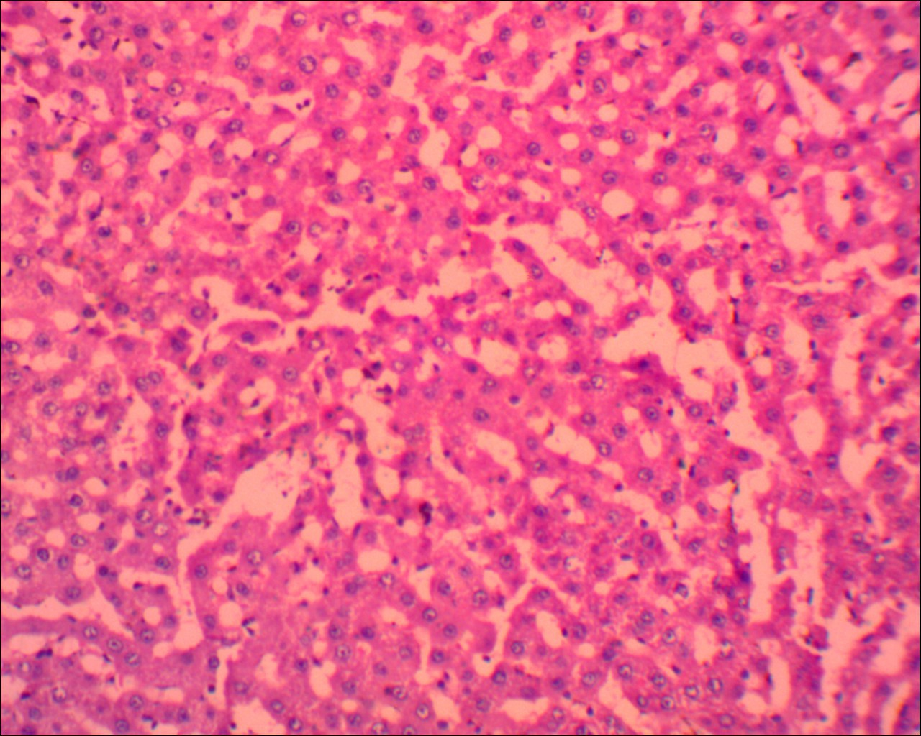

**Figure 3: GROUP C: Rat liver treated with MARIJUANA showing normal hepatocytes (black arrow) and sinusoids (white arrow) (H&E x400)**

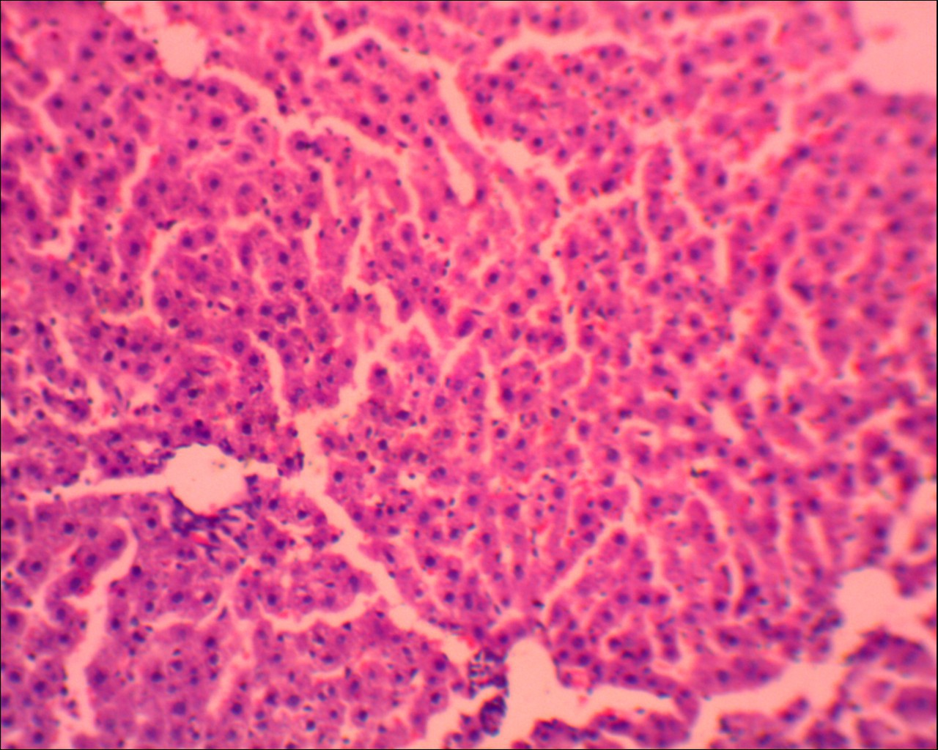

**Figure 4: GROUP D: Rat liver treated with MARIJUANA showing mild tissue sinusoidal congestion (black arrow) and basophilic hepatocytes (white arrow) (H&E, X400)**

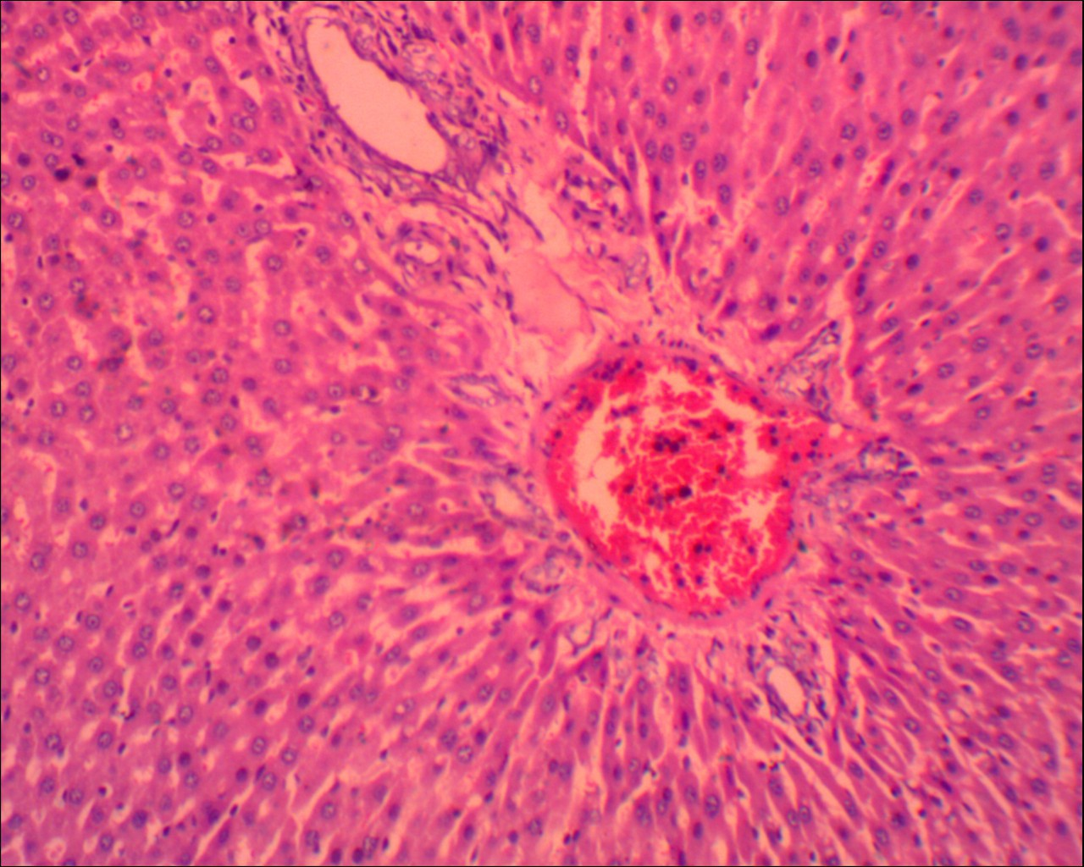

**Figure 5: GROUP E: Rat liver treated with MARIJUANA showing moderate portal congestion (black arrow) and basophilic hepatocytes (white arrow) (H&E, X400).**

**Discussion**

There are several scientific debates on how *Cannabis* affects the various organs of the body. This study was carried out to assess the effects of marijuana on the weight and liver of wistar rats. The findings from this study showed an increase in the body weight of wistar rats treated with marijuana when compared with control rats (Table 1). This was in agreement with the works of Richard et al., (2020) and Goodpaster, (2025) who in their various studies reported increase in the body weight of rat fed with marijuana. The increase in the body weight have be attributed to the fact that marijuana and its multiple chemical components (cannabinoids) as well as substances produced within the body that activate cannabinoid receptors (endocannabinoids) appear to exert specific influences on the regulation of feeding behavior (Goodpaster, 2025). Dörnyei *et al*., (2023), state that the endocannabinoids are important biomediators and metabolic regulators in mammalian physiology, with diverse and ubiquitous modulating actions, including the regulation of body weight. DiPatrizio, (2021) also reported that stimulation of the CB1 receptors in the mammalian cannabinoid system specifically increases food craving and enjoyment, and promotes the deposition of energy as fat into adipose tissues which may be responsible for increase in weight as observed in the present study.

All sections of the liver obtained from animals in group C, D and E have easily recognizable altered histological profiles when compared with the sections from animals in groups A and B. Distortion with inflammatory cell, mild sinusoidal congestion and moderate portals congestion and basophilic hepatocytes are few of the histological derangements seen in the liver sections of cannabis treated animals. This agreed with works of El Ghachi et al., (2025) and Ejime *et al*., (2022). El Ghachi et al., (2025) reported that livers from cannabis treated animals exhibited marked histological damage with increased infiltration of inflammatory cells in pericentral areas, necrotic cells, pyknotic nuclei, marginated chromatin in some nuclei and giant cells, cytoplasmic vacuolation and fatty changes of hepatocytes with sinusoidal dilatation and congestion while Ejime *et al*., (2022) observed degeneration and disruption of the hepatocytes and cells lining the bile ducts with central portal vein occlusions in cannabis treated animals. These histological abnormalities will most likely be accompanied with compromise in the physiological and biochemical activities of the liver. Hepatocytes are known to play very important roles in liver functioning. They frequently contain glycogen and maintain a steady level of blood glucose by the processes of glycolysis, glycogenesis and gluconeogenesis as one of the main sources of energy for use by the body (Gartner, 2020; Lowe *et al*., 2023).Such micro anatomical compromise in the integrity of the hepatocytes, seen in this research work could lead to improper functioning of the liver.

**Conclusion**

The effects of marijuana smoking on human health are serious and, in many cases, deadly. Data obtained from this study show that exposure to the smoke extract of marijuana (*Cannabis sativa*) on the liver have deleterious effects on the cytoarchitecture of this organ in wistar rats. This therefore indicates that *Cannabis sativa* and its constituents are possible hepatotoxic substances.

Considering these effects on the histological integrity of the organ studied in these rats, we therefore recommend that everyone especially our youths, who have become addicts of cannabis need to be made aware and educated on the danger attached to the use of the plant, Indiscriminate cultivation and use of the plant should be discouraged, considering the negative impact it conferred on the studied organs in the treated animals in this investigation and further research should be done to determine the mechanism of histological change caused by marijuana on this vital organ.

**Conflict of Interest**

The authors declare no conflicts of interest. The authors alone are responsible for the content and the writing of the paper.

**Ethical Approval**

Ethical permission for the use of marijuana and wistar rats for this study was obtained from the Research and Ethics Committee of Ambrose Alli University, Ekpoma. The study was conducted according to the protocol approval of the ethical review committees.

**Reference**

Adams, Z. W., Marriott, B. R., Hulvershorn, L. A., & Hinckley, J. (2022). Treatment of adolescent cannabis use disorders. *Child and adolescent psychiatric clinics of North America*, *32*(1), 141.

Ahmed, S. T., Alam, A., Hassan, A., Kamal, S., & Mahmood, M. (2022). Acute Liver Failure Caused by Synthetic Marijuana Use. *American Journal of Therapeutics*, *29*(6), e769-e771.

Akintaro O. A. (2015): The Menace of Tobacco Smoking among Nigerian Adolescents. *Developing Country Studies*. 5(15): 11-15

Barré, T., Nishimwe, M. L., Protopopescu, C., Marcellin, F., Carrat, F., Dorival, C., ... & ANRS/AFEF Hepather study group. (2020). Cannabis use is associated with a lower risk of diabetes in chronic hepatitis C‐infected patients (ANRS CO22 Hepather cohort). *Journal of Viral Hepatitis*, *27*(12), 1473-1483.

Castera, L., & Cusi, K. (2023). Diabetes and cirrhosis: current concepts on diagnosis and management. *Hepatology*, *77*(6), 2128-2146.

Černe, K. (2020). Toxicological properties of Δ9-tetrahydrocannabinol and cannabidiol. *Archives of Industrial Hygiene and Toxicology*, *71*(1), 1.

Coman, L. I., Coman, O. A., Bădărău, I. A., Păunescu, H., & Ciocîrlan, M. (2021). Association between liver cirrhosis and diabetes mellitus: a review on hepatic outcomes. *Journal of clinical medicine*, *10*(2), 262.

Connor, J. P., Stjepanović, D., Le Foll, B., Hoch, E., Budney, A. J., & Hall, W. D. (2021). Cannabis use and cannabis use disorder. *Nature Reviews Disease Primers*, *7*(1), 16.

Cooke, M. E., Gilman, J. M., Lamberth, E., Rychik, N., Tervo-Clemmens, B., Evins, A. E., & Schuster, R. M. (2021). Assessing changes in symptoms of depression and anxiety during four weeks of cannabis abstinence among adolescents. *Frontiers in psychiatry*, *12*, 689957.

DiPatrizio, N. V. (2021). Endocannabinoids and the gut-brain control of food intake and obesity. *Nutrients*, *13*(4), 1214.

Dörnyei, G., Vass, Z., Juhász, C. B., Nádasy, G. L., Hunyady, L., & Szekeres, M. (2023). Role of the endocannabinoid system in metabolic control processes and in the pathogenesis of metabolic syndrome: an update. *Biomedicines*, *11*(2), 306.

Dubey, R. K., Shukla, S., Hussain, Z., & Tasin, M. (2023). A Systematic Review of the Pharmacological and Phytochemical Profiles of Madagascar periwinkle as Potential Dietary Supplement. *Chinese Journal of Applied Physiology*, e20230002.

Ejime, A. C., Chukwuebuka, N. B., Azuka, E. P., Ejiro, O. P., Michael, A. E., Elias, D. T. M., ... & Ebuwa, E. I. (2022). Sperm Quality and Testicular Histological Changes in Wistar rats treated with Cannabis sativa Ethanolic Extract. *NeuroQuantology*, *20*(15), 5228-5236.

El Ghachi, H., Oukhrib, M., Aziz, F., Benrazzouk, K., Gamrani, H., Soulimani, R., & Boukhzar, L. (2025). Exploring the Phytochemical and Toxicological Profile of Moroccan Cannabis Sativa L. Leaves Extract: Behavioral, Histological, and Oxidative Stress Assessments. *Journal of Ethnopharmacology*, 120058.

Freeman, D., Dunn, G., Murray, R.M., Evans, N., Lister, R. and Antley, A. (2015): How Cannabis Causes Paranoia: Using the Intravenous Administration of 9-Tetrahydrocannabinol (THC) to Identify Key Cognitive Mechanisms Leading to Paranoia. *Schizophrenia bulletin*. 41: 391–399.

Gartner, L. P. (2020). *Textbook of histology e-book: Textbook of histology e-book*. Elsevier Health Sciences.

Goodpaster, K. P. (2025). Cannabis, Weight, and Weight-Related Behaviors. *Current Obesity Reports*, *14*(1), 1-9.

Haktanır, A. E., Atalay, F. Ö., Ayyıldız, T., Balaban, S., & Dolar, M. E. (2025). Hepatic Expression of Endocannabinoid Receptors (CB1 and CB2) in Patients with Non-Alcoholic Steatohepatitis and Its Relationship with Metabolic Syndrome. *Uludağ Üniversitesi Tıp Fakültesi Dergisi*, *50*(3), 381-389.

Hammond, C. J., Shirk, S. D., Foster, D. W., Potenza, N. B., Kraus, S. W., Mayes, L. C., ... & Potenza, M. N. (2020). Cannabis use, problem-gambling severity, and psychiatric disorders: Data from the National Epidemiological Survey on Alcohol and Related Conditions. *Psychology of Addictive Behaviors*, *34*(1), 230.

Imran, S., Beenish, H., Anjum, K., & Zaid, H. (2023). A Comparative Histological Study of Effects of Cigarette and Shisha Smoke on Lungs of Mice. *Pakistan Journal of Medical & Health Sciences*, *17*(06), 137-137.

Kroon, E., Kuhns, L., & Cousijn, J. (2021). The short-term and long-term effects of cannabis on cognition: recent advances in the field. *Current Opinion in Psychology*, *38*, 49-55.

Le, A., Han, B. H., & Palamar, J. J. (2022). Underreporting of past-year cannabis use on a national survey by people who smoke blunts. *Substance abuse*, *43*(1), 349-355.

Longoria, V., Parcel, H., Toma, B., Minhas, A., & Zeine, R. (2022). Neurological benefits, clinical challenges, and neuropathologic promise of medical marijuana: A systematic review of cannabinoid effects in multiple sclerosis and experimental models of demyelination. *Biomedicines*, *10*(3), 539.

Lowe, J. S., Anderson, P. G., & Anderson, S. I. (2023). *Stevens & Lowe's Human Histology-E-Book: Stevens & Lowe's Human Histology-E-Book*. Elsevier Health Sciences.

Massányi, P., Massányi, M., Madeddu, R., Stawarz, R., & Lukáč, N. (2020). Effects of cadmium, lead, and mercury on the structure and function of reproductive organs. *Toxics*, *8*(4), 94.

Millea, T. P. (2020). Smoke and Mirrors: The Recreational Marijuana Debate. *The Linacre Quarterly*, *87*(3), 254-258.

Nwonuma, C. O., Osemwegie, O. O., Irokanulo, E. O., Alejolowo, O. O., Kayode, O. T., Olaolu, T. D., ... & Ojo, O. A. (2021). Comparative effects of combined use of alcohol with cannabis and tobacco on testicular function in rats. *Toxicology research*, *10*(4), 761-770.

Okobi O.E., Iyevhobu K.O., Nwanguma A.N., Akinsola Z., Onyechi N.P., Ajibowo A.O., Odedina J. (2022). Effects of Marijuana on Weight Changes, Physical Observation and Histology on the Kidney of Wistar Rats. *International Journal of Healthcare and Medical Sciences, 8*(4), 49-56.

Richard, Z., Sunday, A. S., Umana, U. E., Sadeeq, A. A., & Adamu, P. P. (2020). Effect of n-butanol extract of Cannabis sativa L. extract on the cerebral cortex of adult Wistar rats. *African Journal of Cellular Pathology*, *12*(2), 6-15.

Schlag, A. K., Hindocha, C., Zafar, R., Nutt, D. J., & Curran, H. V. (2021). Cannabis based medicines and cannabis dependence: A critical review of issues and evidence. *Journal of Psychopharmacology*, *35*(7), 773-785.

Śmiarowska, M., Białecka, M., & Machoy-Mokrzyńska, A. (2022). Cannabis and cannabinoids: Pharmacology and therapeutic potential. *Neurologia i neurochirurgia polska*, *56*(1), 4-13.

Stella, B., Baratta, F., Della Pepa, C., Arpicco, S., Gastaldi, D., & Dosio, F. (2021). Cannabinoid formulations and delivery systems: current and future options to treat pain. *Drugs*, *81*, 1513-1557.

Taiwo, O. A., Dosumu, O. A., Ugbaja, R. N., Rotimi, S. O., Owolabi, O. P., & Ojo, O. A. (2021). Oral administration of marijuana produces alterations in serotonin 5-hydroxytryptamine receptor 3A gene (HTR3A) and electrolyte imbalances in brain of male Wistar rats. *Molecular Biology Research Communications*, *10*(1), 5.

Wolfe, D., Corace, K., Rice, D., Smith, A., Kanji, S., Conn, D., ... & Hutton, B. (2020). Effects of medical and non-medical cannabis use in older adults: protocol for a scoping review. *BMJ Open*, *10*(2), e034301.

Xiong, P. S., Xiong, M. J., Liu, Z. X., & Liu, Y. (2020). Prevalence of smoking among adolescents in China: an updated systematic review and meta-analysis. *Public health*, *182*, 26-31.