***Atlas imaging of ovarian mass mimics: Experience from Hassan II UHC in Fez***

***Abstract :***

This article presents a comprehensive imaging review of ovarian mass mimics, emphasizing the differential diagnosis of extra-ovarian lesions in the female pelvis. It highlights the importance of anatomical landmarks and specific imaging signs such as the beak sign and the ovarian vascular pedicle to distinguish true ovarian tumors from conditions like hydrosalpinx, pyosalpinx, adnexal ectopic pregnancy, torsion, and other pelvic pathologies.

***Keywords :*** Ovarian mass mimics, Pelvic pathologies, Extra-ovarian lesions, Radiologic imaging

***Introduction***  
The female pelvis is a complex anatomical region, and many pathologies have nonspecific imaging features that can complicate accurate diagnosis. While early detection of ovarian masses is crucial, it is equally important to identify conditions that mimic ovarian tumors, preventing misdiagnosis and unnecessary surgery.

This article reviews key imaging features that resemble ovarian tumors, equipping radiologists with the tools to accurately differentiate adnexal lesions and formulate appropriate diagnoses.

***Materials and Methods:***

We conducted a retrospective descriptive study over a period of three years, from January 2021 to December 2023, at the Radiology Department of the Mother and Child Hospital, Hassan II University Hospital Center (UHC), Fez, Morocco.

The study included 241 female patients who presented with a pelvic mass suspected to be of adnexal or ovarian origin. All patients underwent at least one cross-sectional imaging modality, including ultrasound (US), computed tomography (CT), or magnetic resonance imaging (MRI), as part of their diagnostic workup.

Inclusion criteria:

* Female patients aged 16 years and older
* Presence of a pelvic mass initially suspected to be ovarian in origin
* Availability of complete imaging data (US, CT, or MRI)
* Histological confirmation or clinical/imaging follow-up allowing diagnostic categorization

Exclusion criteria:

* Known primary ovarian malignancy
* Incomplete imaging records or missing clinical data

All imaging examinations were reviewed by board-certified radiologists with expertise in pelvic imaging. Cases were classified based on radiological findings, supported when available by histopathological confirmation or clinical evolution.

Each lesion was analyzed with regard to:

* Anatomical location (intra- or extra-ovarian)
* Morphological appearance on imaging (shape, margins, internal content)
* Specific imaging signs (e.g., beak sign, vascular pedicle, claw sign)
* Associated features (e.g., ascites, lymphadenopathy, bowel displacement)

The final diagnoses were categorized into benign extra-ovarian conditions mimicking ovarian masses, as outlined in the results section. The goal was to construct a visual atlas to aid radiologists in identifying these mimics.

Ethical approval was obtained from the institutional review board of Hassan II UHC. Patient data were anonymized, and informed consent was obtained for all published images.

***Results:***

Based on histopathological and radiological findings, we will present an imaging atlas for educational purposes that illustrates the various extra-ovarian etiologies classified as ORADS 1 that can mimic ovarian masses: Hydrosalpinx and hematosalpinx (N=13), Pyosalpinx and Tubo-ovarian abscess (N=23), Adnexal Ectopic Pregnancy (N=13), Adnexal torsion (N=27), Peritoneal Inclusion Cyst (N=14), Uterine Vasculature (N=9) Uterine leiomyoma Figo 7 ( N=17), peritoneal carcinomatosis (N=12), Peritoneal tuberculosis (N=8), appendicitis or diverticulitis (N=21), Appendiceal Mucocele (N=10), GIST (N=5), Sigmoid tumor process (N=7), Necrotic lymphadenopathy (N=11), Lymphoma (N=7), Sarcoma (N=3), Neurogenic tumors (N=4), Pelvic pheochromocytoma (N=1), Hematoma (N=23), Lymphocele (N=13).

***Fig 1 : The percentage distribution of the various etiologies identified in our study***

***Discussion***

Adnexal masses have an incidence of 0.17% to 5.9% in asymptomatic women and 7.1% to 12% in symptomatic women, and less than 25% of these masses are diagnosed as malignancy [1].

5.1% of pelvic masses mimicking ovarian masses are found to be an extra-ovarian disease [2]

1. **Anatomy**

Localization of pelvic masses is challenging when anatomical landmarks are obscured. Identifying the ovaries is crucial for distinguishing intraovarian from extra-ovarian lesions. Each ovary is suspended by the mesovarium, ovarian ligament, and suspensory ligament, with variable laxity contributing to their mobility especially postpartum [5]. The ovarian veins, draining into the left renal vein and inferior vena cava, can be traced caudally along the suspensory ligaments to locate the ovaries, with the pelvic ureters serving as additional guides [5].

The pelvis is divided into intraperitoneal and extraperitoneal spaces by the peritoneum, which covers the bladder dome, uterus, and anterior upper rectum (Figure 2) [6]. In females, discontinuities at the oviductal ostia may allow communication between these compartments. The intraperitoneal space, centrally located, includes the vesicouterine space, rectouterine pouch of Douglas (the most dependent peritoneal space), and lateral paravesical recesses, and contains the ovaries, small intestine, colon, and upper rectum [6]. Surrounding this, the extraperitoneal space comprises the bladder, uterus, pelvic ureters, lower rectum, iliac vessels, lymph nodes, and pelvic sidewall, and is subdivided into anterior (prevesical and perivesical spaces), middle (vagina, cervix, uterus), and posterior (perirectal and presacral spaces) compartments [7].

Fig 2 : Axial and sagittal drowing shows the pelvic extraperitoneal compartments that are divided into anterior prevesical and perivesical spaces and posterior perirectal and presacral spaces, while peritoneal reflections create the vesicouterine and rectovaginal pouches, with fatty septa forming the vesicocervical and rectovaginal septa below them

Reference : Forstner, R., Thomassin-Naggara, I., Cunha, T.M. et al. ESUR recommendations for MR imaging of the sonographically indeterminate adnexal mass: an update. Eur Radiol 27, 2248–2257 (2017). <https://doi.org/10.1007/s00330-016-4600-3>

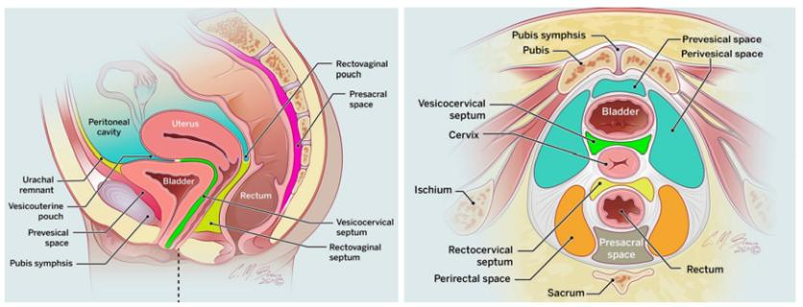

1. **Is the Mass Ovarian or Extra-ovarian in Origin?**

Identification of a normal ipsilateral ovary, as described above, excludes ovarian origin of a mass. In cases of masses abutting the ovary, multiple imaging signs help to assess the origin of the mass.

Several imaging signs suggest an ovarian origin of a pelvic mass (Figure 3). The "beak sign" refers to the formation of a sharp angle between the ovary and the mass, creating a beak-like shape at the ovarian edge. The "ovarian vascular pedicle" sign is characterized by the direct connection of a normal or asymmetrically enlarged gonadal vein to the mass. The "phantom organ" sign is observed when the ovary is not visualized, provided there is no prior history of surgical resection or transposition. Additionally, the "embedded organ" sign occurs when the ovary appears to be incorporated within the mass [3,8,9].

Conversely, certain signs are indicative of an extra-ovarian origin. The "claw sign" and the "bridging vessel" sign are suggestive of a uterine source for the mass. The displacement pattern of surrounding organs can further aid in determining the origin of a pelvic mass. Intraperitoneal masses typically cause lateral or posterior displacement of the uterus, rectosigmoid colon, and iliac vessels. Masses located within the rectouterine pouch of Douglas tend to shift the uterus anteriorly while displacing the rectum posteriorly. In contrast, extraperitoneal masses may result in anterior or central displacement of the uterus, rectosigmoid colon, and iliac vessels, in addition to potentially effacing the pelvic sidewall muscles. Prevesical masses are known to posteriorly displace the bladder [3].

Accurate localization of a pelvic mass as an extraperitoneal lesion effectively excludes an ovarian origin, facilitating a more precise differential diagnosis and guiding appropriate clinical management.

Fig 3 : Differentiation of ovarian versus uterine origin. Beak sign indicating ovarian origin in a benign teratoma (arrows and outlined in a and b). The most important differential diagnosis of a solid adnexal mass includes uterine leiomyoma, which can be differentiated by the claw sign (arrow and outlined in c and d) or in broad-based leiomyomas by bridging vessels (arrow in e and f)

Reference : Forstner, R., Thomassin-Naggara, I., Cunha, T.M. et al. ESUR recommendations for MR imaging of the sonographically indeterminate adnexal mass: an update. Eur Radiol 27, 2248–2257 (2017). https://doi.org/10.1007/s00330-016-4600-3

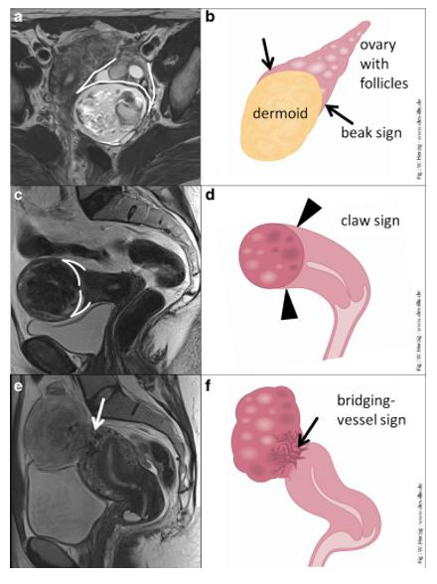

1. **Differential diagnosis to ovarian masses:**
2. *Intraperitoneal lesions*
   1. *Extra-ovarian adnexal lesions.*
      1. *Hydrosalpinx and hematosalpinx*

Hydrosalpinx, most commonly resulting from adhesions due to pelvic inflammatory disease, it can be asymptomatic but may result in infertility or pelvic pain [10]. On ultrasonography, it typically manifests as a C- or S-shaped anechoic fluid-filled structure with a “cogwheel” configuration evident on cross-sectional views due to thickened endosalpingeal folds, while CT and MRI reveal a dilated fallopian tube adjacent to the uterus containing simple fluid with thin, mildly enhancing walls (Figure 4) [11].

Hematosalpinx, which may arise from conditions such as endometriosis, ectopic pregnancy, adnexal torsion, malignancy, or trauma, appears on ultrasound similar to hydrosalpinx but with internal low-level echoes due to blood products. On MRI (Figure 5), it shows variable T1- and T2-weighted signal abnormalities depending on the age of the blood, with the absence of T2 shading helping to differentiate it from an endometrioma [11].

Fig 4: 74 years old, postmenopausal. Admitted for cervical cancer, having undergone external radiotherapy and brachytherapy. (reference: Radiology department of the mother and child hospital, CHU Hassan II, Fez)

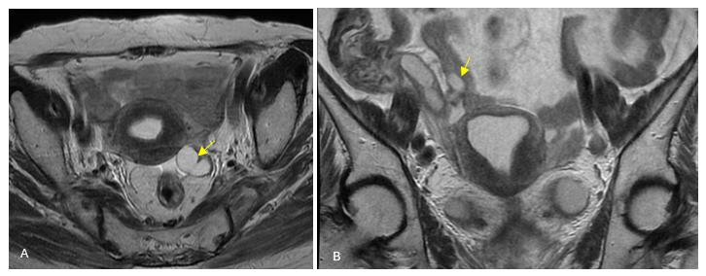

Fig 5: 45 years old. Left lateral uterine mass. (reference : Radiology department of the mother and child hospital, CHU Hassan II, Fez).

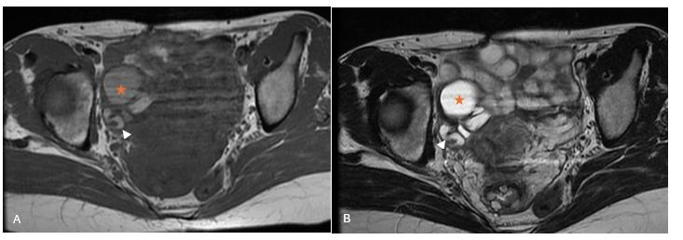

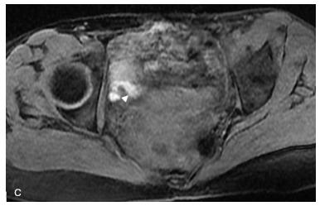

* + 1. *Pyosalpinx, and Tubo-ovarian abscess*

Salpingitis occurs when the ascending infectious process results in a nondilated fallopian tube with wall thickening, hyperenhancement, and adjacent reactive inflammation, and may progress to pyosalpinx when obstruction at the fimbriated end leads to pus accumulation [11].  
On ultrasound, CT, and MRI (Figure 6), pyosalpinx is identified as a thick-walled tubular structure with complex, echogenic or heterogeneous fluid and fluid-debris levels, with surrounding inflammation aiding in its differentiation from hydrosalpinx [11].

Tubo-ovarian abscess, occurring in approximately 20% of pelvic inflammatory disease cases, manifests as a complex adnexal mass with wall thickening, irregular septations, diffusion restriction, and sometimes internal gas, with additional MRI findings of high T1 signal from hemorrhagic or proteinaceous components and postcontrast enhancement of the abscess walls and surrounding inflammatory stranding [12].

Fig 6: 27 years old. No prior medical history. Admitted for pelvic pain persisting for 5 months.(reference : Radiology department of the mother and child hospital, CHU Hassan II, Fez).

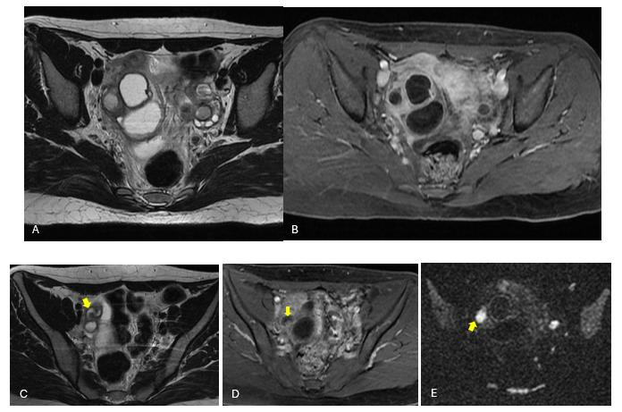

* + 1. *Adnexal ectopic pregnancy*

Ectopic pregnancy is a significant contributor to first-trimester maternal mortality, most commonly occurring in the fallopian tubes and presenting acutely [13]. Ultrasound, the primary imaging modality, typically demonstrates a complex adnexal mass or gestational sac separate from the ovary—with an echogenic peripheral ring or "ring of fire" on color Doppler in unruptured cases, while MRI (Figure 7) is employed when findings are indeterminate; ruptured cases (Figure 8) may lead to pelvic hematoma, and chronic ectopic pregnancies (accounting for 1.7% of pelvic masses mimicking ovarian tumors [1].

Fig 7: 40 years old, G6P5. Presents with 10 weeks of amenorrhea and elevated beta-hCG levels. (reference: Radiology department of the mother and child hospital, CHU Hassan II, Fez).

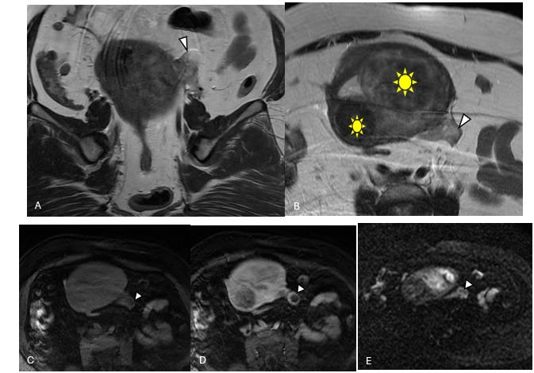

Fig 8 : 43 years old. diabetic, under treatment. Last menstrual period: not specified, elevated beta-hCG levels. She presented with an acute abdominal syndrome, with haemodynamic problems.  
Post-operative follow-up revealed a ruptured ectopic pregnancy.   
(reference: Radiology department of the mother and child hospital, CHU Hassan II, Fez).

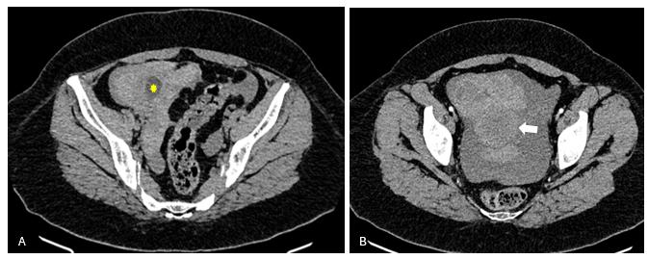

* + 1. *Adnexal torsion*

Although this EPOS primarily addresses extra-ovarian pathologies, adnexal torsion is discussed due to its mechanism of twisting along the fallopian tube and vascular pedicle, leading to vascular compromise [14]. Typically affecting premenopausal women with ovarian cysts or benign neoplasms, torsion initially impairs venous outflow, resulting in edema and, if untreated, subsequently compromises arterial flow, culminating in infarction [15]. Ultrasound findings range from a normal-appearing ovary to one with stromal engorgement and peripheralized follicles, while CT (Figure 9) and MRI commonly reveal an enlarged, medially displaced ovary with a twisted pedicle; infarction is indicated by non-enhancing, hemorrhagic areas on imaging [16].

Fig 9: 21 years old, presenting with acute severe pelvic pain localized to the left side. Surgical exploration revealed a twisted adnexal mass with a healthy ovary, associated with a small amount of hemoperitoneum.  
(reference: Radiology department of the mother and child hospital, CHU Hassan II, Fez).

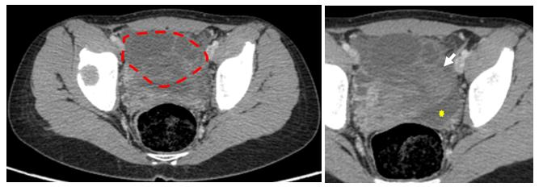

* + 1. *Peritoneal inclusion cyst*

A peritoneal inclusion cyst results from benign serous ovarian fluid accumulating in entrapped reactive mesothelium following an inflammatory process (e.g., surgery, endometriosis, or PID) [17]. These cysts, which can be simple or multilocular, conform to adjacent structures and may envelop the ovary in a “spider web” pattern [18]. On ultrasound, they appear as anechoic cystic structures with mildly thickened, low-resistance septations, while CT and MRI typically reveal an entrapped ovary with follicles(Figure 10) a feature that distinguishes them from ovarian neoplasms, and they lack malignant potential [19].

Fig 10: 42 years old, perimenopausal. Underwent surgery in January 2022 for inter-adnexal hysterectomy (histopathology: leiomyoma).Presenting with right pelvic pain..  
(reference: Radiology department of the mother and child hospital, CHU Hassan II, Fez).

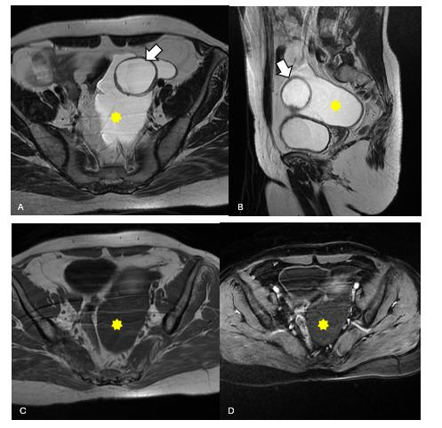

* 1. *Uterine lesions*
     1. *Uterine vasculature*

Dilated uterine vasculature, resulting from venous obstruction or incompetent valves, may mimic a cystic ovarian mass but demonstrates distinct vascularity on color Doppler and enhancement similar to the iliac vessels on CT/MRI (Figure 11), thereby preventing unnecessary biopsy and hemorrhage [20].

Fig 11: 47 years old, underwent a suction curettage for hydatidiform mole in October 2022, with histopathology revealing a complete mole. The clinical course was marked by persistent bleeding and a rise in beta-hCG levels. Ultrasound: enlarged uterus with a heterogeneous image occupying the entire uterine cavity.  
(reference: Radiology department of the mother and child hospital, CHU Hassan II, Fez).

* + 1. *Leiomyoma*

Leiomyomas (fibroids) are benign hormone-responsive tumors with a well-circumscribed, whorled internal architecture; pedunculated or parasitized variants—identified by a connecting stalk (bridging vessel sign) on ultrasound and further characterized by CT/MRI (Figure 12), can pose diagnostic challenges [21].

Fig 12: 47 years old, no medical history. Admitted for the management of pelvic pain.

Pelvic ultrasound : solid right lateral uterine mass.  
(reference: Radiology department of the mother and child hospital, CHU Hassan II, Fez).

* 1. *Peritoneal disease* 
     1. *Peritoneal Carcinomatosis*

Peritoneal carcinomatosis results from metastatic seeding, often from ovarian cancer and appears as small, irregular soft tissue nodules on CT (with mucinous deposits showing low attenuation) and on MRI using DWI and postcontrast sequences, frequently accompanied by proteinaceous ascites that may eventually infiltrate abdominal viscera [22].

* + 1. *Peritoneal Tuberculosis*

peritoneal tuberculosis, which accounts for 37.2% of pelvic masses mimicking ovarian tumors [2], typically arises from reactivation of latent Mycobacterium tuberculosis [23]and presents with similar ascitic findings on ultrasound and CT, including peritoneal nodularity and soft tissue masses with central low attenuation representing tubers (Figure 13) [24].

Fig 13: 22 years old. Presenting with pelvic pain in the context of a deteriorated general.

Peritoneal biopsy consistent with peritoneal tuberculosis.  
(reference: Radiology department of the mother and child hospital, CHU Hassan II, Fez).

* 1. *Gastrointestinal lesions*
     1. *Appendiceal mucocele*

Appendiceal mucocele, a chronic cystic dilation of the mucin-filled appendix, is histologically classified as simple mucocele, mucosal hyperplasia, mucin cystadenoma, or cystadenocarcinoma, typically affecting middle-aged patients and potentially leading to complications such as infection, obstruction, torsion, or rupture [25]. Ultrasound demonstrates a cystic tubular structure, often with the specific “onion skin sign” [26] while CT and MRI further characterize the lesion with features like simple fluid attenuation, calcifications, and wall enhancement suggestive of superinfection or malignancy [4]. Rupture of larger appendiceal cystadenomas or cystadenocarcinomas may seed mucin into the peritoneal cavity (Figure 14), resulting in pseudomyxoma peritonei, a condition that mimics ovarian malignancy, can cause bowel obstruction, and is managed with surgical debulking and intraperitoneal chemotherapy [25].

Fig 14: 62 years old. Admitted for the management of chronic pain in the right iliac fossa.  
(reference: Radiology department of the mother and child hospital, CHU Hassan II, Fez).

* + 1. *Gastro-intestinal stromal tumor*

Gastrointestinal stromal tumor (GIST) is the most common mesenchymal neoplasm of the gastrointestinal tract, accounting for approximately 20% of soft tissue sarcomas, with a peak incidence in individuals aged 50–60 years and a slight male predominance [27]. It most frequently originates in the stomach (70%) or small intestine (25%) and is characterized by KIT receptor expression, which confers resistance to apoptosis [28]. On MRI (Figure 15), larger GISTs often display internal cystic necrosis with high T2 signal and heterogeneous postcontrast enhancement, while smaller lesions enhance homogeneously; features such as large size, cystic changes, and low ADC signals suggest higher malignant potential [29]. Treatment involves surgical resection and/or tyrosine kinase inhibitors, given that 20–30% of GISTs are malignant at diagnosis [29, 30].

Fig 15: 45 years old. No significant medical history. Admitted for the management of a hard, non-mobile hypogastric mass.  
Biopsy results suggest a gastrointestinal stromal tumor (GIST).  
(reference: Radiology department of the mother and child hospital, CHU Hassan II, Fez).

1. *Extraperitoneal lesions*
   1. *Lymphoma.*

Lymphoma typically presents with systemic symptoms such as fever, night sweats, and weight loss, and imaging frequently reveals multi-station adenopathy and splenomegaly, with bulky pelvic masses occasionally mimicking ovarian tumors. On CT, lymphomatous lesions usually manifest as homogeneous masses with mild to moderate enhancement (Figure 16) that encase vessels without compressing them. MRI findings include isointensity on T1-weighted images, iso- to hyperintensity on T2-weighted images, and moderate postcontrast enhancement [31].

Fig 16: 27 years old, G3P3.Recently diagnosed with B-cell lymphoma.  
(reference: Radiology department of the mother and child hospital, CHU Hassan II, Fez).

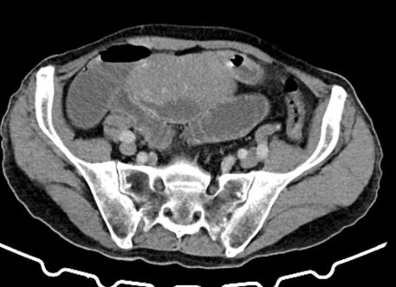

* 1. *Pelvic lymphadenopathy.*

Pelvic lymphadenopathy refers to the enlargement of lymph nodes in the pelvic region, and can mimics an ovarian mass. Several conditions can lead to pelvic lymph node enlargement. Common causes include:

Infection: Bacterial (tuberculosis ++..), viral, or parasitic infections in the pelvic region can cause lymph nodes to enlarge as they work to fight off the infection.

Cancer: Certain types of cancers, such as ovarian, cervical, or prostate cancer, can spread to the pelvic lymph nodes, causing them to swell (Figure 17).

Inflammatory conditions: Conditions like pelvic inflammatory disease (PID) or inflammatory bowel disease (IBD) can lead to lymphadenopathy.

Fig 17: 68 years old, no medical history. Admitted for the management of rectal bleeding for 22 days.

Digital rectal examination: palpable mass with budding appearance, 1 cm from the anal margin, with blood on the glove.  
(reference: Radiology department of the mother and child hospital, CHU Hassan II, Fez).

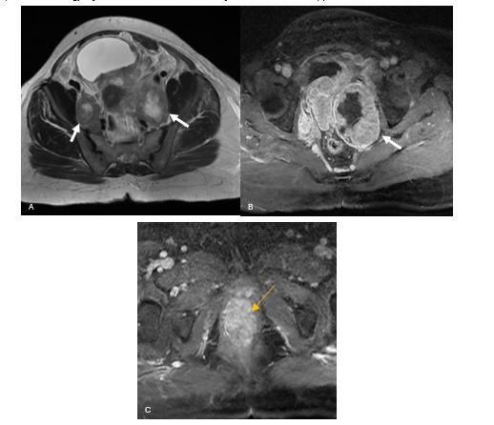

* 1. *Sarcomas*

Soft tissue sarcomas are a heterogeneous group of malignant tumors of mesenchymal origin that originate from the soft tissues rather than bone, and can mimics ovarian masses (Figure 18). They are classified on the basis of tissue seen on histology.

Fig 18: 17 years old, presenting with inguinal pain and difficulty walking.  
(reference: Radiology department of the mother and child hospital, CHU Hassan II, Fez).

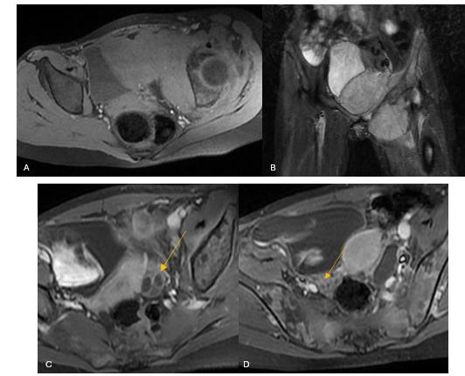

* 1. *Neurogenic tumors*

Pelvic extraperitoneal neurogenic tumors including schwannomas (Figure 19), neurofibromas, ganglioneuromas, and paragangliomas may exhibit cystic degeneration [32]. Extraperitoneal schwannomas are encapsulated lesions that can show calcifications on CT and demonstrate low T1 and high T2 signals with heterogeneous enhancement on MRI, typically managed with surgical resection for symptomatic patients [33]. Neurofibromas, often seen in neurofibromatosis type 1, appear unencapsulated with a characteristic target sign on T2WI and may rarely transform into malignant peripheral nerve sheath tumors [34]. Ganglioneuromas arise from sympathetic ganglia, presenting as well-defined masses with occasional punctate calcifications on CT and a “whorled” appearance on postcontrast MRI [34]. Paragangliomas, or extra-adrenal pheochromocytomas (Figure 20), are well-defined, avidly enhancing masses that may produce catecholamines in nearly 40% of cases, necessitating surgical resection with preoperative alpha-blockade [35].

Fig 19: 52 years old, admitted for cervical tumor. Extension assessment  
(reference: Radiology department of the mother and child hospital, CHU Hassan II, Fez).

Fig 20: 86 years old. Lateral uterine mass.  
(reference: Radiology department of the mother and child hospital, CHU Hassan II, Fez).

1. *Either intraperitoneal or extraperitoneal lesions*
   1. Hematoma

Hematomas, which may result from trauma, surgery, interventional procedures, or aneurysm rupture, can be challenging to differentiate from the ovary based on their location. Their imaging appearance evolves over time: on ultrasound, an acute hematoma appears echogenic before becoming hypoechoic with septations and thickened walls, while on CT it presents as a hyperattenuating collection (Figure 21) that transitions to a cystic appearance over approximately two weeks. On MRI, acute and subacute hematomas demonstrate high signal on fat-suppressed T1-weighted images without postcontrast enhancement, and chronic hematomas may develop a thin peripheral low-signal rim due to hemosiderin with a subjacent bright inner rim; the “concentric ring” sign. Multiphase contrast-enhanced CT or MRI may be necessary to evaluate for active bleeding, and de novo hematomas may require subtraction imaging or follow-up to exclude an underlying lesion [36].

Fig 21: 32 years old. Vaginal delivery two days ago, complicated by postpartum hemorrhage.

Underwent hemostatic hysterectomy with a Hemoglobin level at 5 g/dl.  
(reference: Radiology department of the mother and child hospital, CHU Hassan II, Fez).

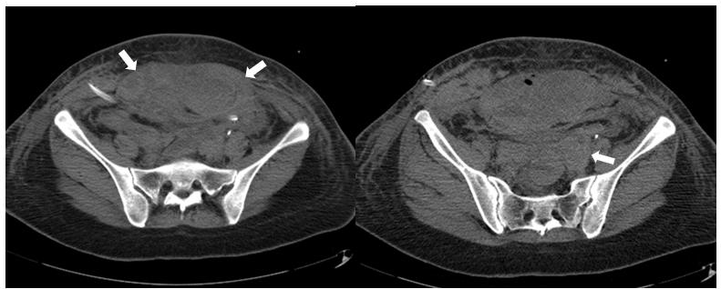

* 1. ***Lymphocele, Seroma, and Urinoma***

Lymphoceles are lymph-containing collections within thin fibrotic walls that typically occur three to eight weeks post-lymphadenectomy or renal transplant, potentially causing lower extremity edema, deep venous thrombosis, or hydroureteronephrosis, and are seen as non-enhancing simple fluid collections along the lymphatic chain [4]. Seromas (Figure 22), resulting from surgery or trauma, similarly present as non-enhancing simple fluid collections with possible mass effect on adjacent pelvic structures. In contrast, urinomas are collections of extravasated urine often due to urinary tract obstruction or iatrogenic causes that appear as anechoic on ultrasound and demonstrate fluid attenuation on CT, with increased attenuation on delayed phases and CT/MR urography pinpointing the site of extravasation [37].

Fig 22: 56 years old. Followed in the radiotherapy department for endometrial adenocarcinoma, post-surgery, having undergone external radiotherapy and brachytherapy.

Underwent total hysterectomy, bilateral adnexectomy, and pelvic and lombo-aortic lymphadenectomy  
(reference: Radiology department of the mother and child hospital, CHU Hassan II, Fez).

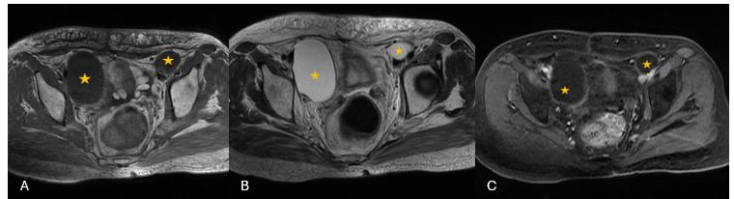

* 1. ***Pelvic abscess***

Pelvic abscesses account for 17.7% of pelvic masses mimicking ovarian tumors and may develop from a variety of etiologies, including tubo-ovarian abscesses, complicated appendicitis, diverticulitis, inflammatory bowel disease, anastomotic leaks, or superinfected fluid collections [2]. Accurate diagnosis necessitates integration of clinical history, prior surgical records, and laboratory findings. Imaging typically reveals thick peripheral wall enhancement, complex internal contents with air (Figure 23) (suggestive of fistulous communication or gas-forming organisms), and adjacent inflammatory changes [4].

Fig 23: 21 years old, no medical history. Fever and right iliac fossa pain at 24 weeks of pregnancy.

Abdominal ultrasound: Collection in the right iliac fossa (RIF) circumscribed by small bowel loops, forming an appearance of an appendiceal mass.  
(reference: Radiology department of the mother and child hospital, CHU Hassan II, Fez).

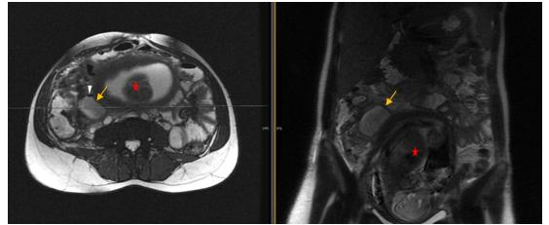

***Conclusion***

Distinguishing between ovarian and extra-ovarian masses is essential to avoid misdiagnosis and unnecessary interventions. Ultrasound is the primary modality for diagnosis of adnexal lesions and MRI is a problem-solving modality, given it superior soft tissue contrast, guiding optimal patient management.

***Data access statement***: All data supporting the findings of this study are included in the article. No additional datasets were generated or analyzed.

***Ethics statement*** : This case report was conducted in accordance with ethical standards. Informed consent was obtained from the patient for the publication of this case and accompanying images.

***References:***

1. Rajkotia, K.; Veeramani, M.; Macura, K.J. Magnetic resonance imaging of adnexal masses. Top. Magn. Reson. Imaging 2006, 17, 379–397.
2. Ozat, M.; Altinkaya, S.O.; Gungor, T.; Ca ˘glar, M.; Zergeroglu, S.; Karaca, M.; Besli, M.; Mollamahmutoglu, L. Extraovarian conditions mimicking ovarian cancer: A single center experience of 15 years. Arch. Gynecol. Obstet. 2011, 284, 713–719.
3. Nougaret, S.; Nikolovski, I.; Paroder, V.; Vargas, H.A.; Sala, E.; Carrere, S.; Tetreau, R.; Hoeffel, C.; Forstner, R.; Lakhman, Y. MRI of Tumors and Tumor Mimics in the Female Pelvis: Anatomic Pelvic Space-based Approach. Radiographics 2019, 39, 1205–1229.
4. Shetty, M. Nonovarian Mimics of Ovarian Malignancy. Semin. Ultrasound CT MRI 2019, 40, 319–331.
5. Saksouk, F.A.; Johnson, S.C. Recognition of the ovaries and ovarian origin of pelvic masses with CT. Radiographics 2004,24 (Suppl. 1), S133–S146.
6. Levy, A.D.; Shaw, J.C.; Sobin, L.H. Secondary tumors and tumorlike lesions of the peritoneal cavity: Imaging features with pathologic correlation. Radiographics 2009, 29, 347–373.
7. O’Connell, A.M.; Duddy, L.; Lee, C.; Lee, M.J. CT of pelvic extraperitoneal spaces: An anatomical study in cadavers. Clin. Radiol.2007, 62, 432–438.
8. Lee, J.H.; Jeong, Y.K.; Park, J.K.; Hwang, J.C. “Ovarian vascular pedicle” sign revealing organ of origin of a pelvic mass lesion on helical CT. Am. J. Roentgenol. 2003, 181, 131–137.
9. Oliveira, J.D.; Cunha, T.M.; Tereso, A. Tumors of the broad ligament: What and when to suspect such rare location. Radiol. Bras. 2020, 53, 349–355.
10. Benjaminov, O.; Atri, M. Sonography of the abnormal fallopian tube. Am. J. Roentgenol. 2004, 183, 737–742.
11. Rezvani, M.; Shaaban, A.M. Fallopian tube disease in the nonpregnant patient. Radiographics 2011, 31, 527–548.
12. Tukeva, T.A.; Aronen, H.J.; Karjalainen, P.T.; Molander, P.; Paavonen, T.; Paavonen, J. MR imaging in pelvic inflammatory disease: Comparison with laparoscopy and US. Radiology 1999, 210, 209–216.
13. Anderson, F.W.; Hogan, J.G.; Ansbacher, R. Sudden death: Ectopic pregnancy mortality. Obstet. Gynecol. 2004, 103, 1218–1223.
14. Dawood, M.T.; Naik, M.; Bharwani, N.; Sudderuddin, S.A.; Rockall, A.G.; Stewart, V.R. Adnexal Torsion: Review of Radiologic Appearances. Radiographics 2021, 41, 609–624.
15. Singh, A.; Danrad, R.; Hahn, P.F.; Blake, M.A.; Mueller, P.R.; Novelline, R.A. MR imaging of the acute abdomen and pelvis: Acute appendicitis and beyond. Radiographics 2007, 27, 1419–1431.
16. Rha, S.E.; Byun, J.Y.; Jung, S.E.; Jung, J.I.; Choi, B.G.; Kim, B.S.; Kim, H.; Lee, J.M. CT and MR imaging features of adnexal torsion. Radiographics 2002, 22, 283–294.
17. Jain, K.A. Imaging of peritoneal inclusion cysts. Am. J. Roentgenol. 2000, 174, 1559–1563.
18. Kim, J.S.; Lee, H.J.; Woo, S.K.; Lee, T.S. Peritoneal inclusion cysts and their relationship to the ovaries: Evaluation with sonography. Radiology 1997, 204, 481–484.
19. Koninckx, P.R.; Renaer, M.; Brosens, I.A. Origin of peritoneal fluid in women: An ovarian exudation product. BJOG Int. J. Obstet. Gynaecol. 1980, 87, 177–183.
20. Umeoka, S.; Koyama, T.; Togashi, K.; Kobayashi, H.; Akuta, K. Vascular dilatation in the pelvis: Identification with CT and MR imaging. Radiographics 2004, 24, 193–208.
21. Rader, J.S.; Binette, S.P.; Brandt, T.D.; Sreekanth, S.; Chhablani, A. Ileal hemorrhage caused by a parasitic uterine leiomyoma. Obstet. Gynecol. 1990, 76, 531–534.
22. Low, R.N. MR imaging of the peritoneal spread of malignancy. Abdom. Imaging 2007, 32, 267–283.
23. Mehta, J.B.; Dutt, A.; Harvill, L.; Mathews, K.M. Epidemiology of extrapulmonary tuberculosis. A comparative analysis with pre-AIDS era. Chest 1991, 99, 1134–1138.
24. Sanai, F.M.; Bzeizi, K.I. Systematic review: Tuberculous peritonitis–presenting features, diagnostic strategies and treatment. Aliment. Pharmacol. Ther. 2005, 22, 685–700.
25. Honnef, I.; Moschopulos, M.; Roeren, T. Appendiceal mucinous cystadenoma. Radiographics 2008, 28, 1524–1527.
26. Caspi, B.; Cassif, E.; Auslender, R.; Herman, A.; Hagay, Z.; Appelman, Z. The onion skin sign: A specific sonographic marker of appendiceal mucocele. J. Ultrasound Med. 2004, 23, 117–121.
27. von Mehren, M.; Joensuu, H. Gastrointestinal Stromal Tumors. J. Clin. Oncol. 2018, 36, 136–143.
28. Lee, C.M.; Chen, H.C.; Leung, T.K.; Chen, Y.Y. Gastrointestinal stromal tumor: Computed tomographic features. World J. Gastroenterol. 2004, 10, 2417–2418.
29. Gangadhar, K.; Mahajan, A.; Sable, N.; Bhargava, P. Magnetic Resonance Imaging of Pelvic Masses: A Compartmental Approach. Semin. Ultrasound CT MRI 2017, 38, 213–230.
30. Jiang, Z.X.; Zhang, S.J.; Peng, W.J.; Yu, B.H. Rectal gastrointestinal stromal tumors: Imaging features with clinical and pathological correlation. World J. Gastroenterol. 2013, 19, 3108–3116.
31. Williams, M.P.; Olliff, J.F. Magnetic resonance imaging in extranodal pelvic lymphoma. Clin. Radiol. 1990, 42, 264–268.
32. Yang, D.M.; Jung, D.H.; Kim, H.; Kang, J.H.; Kim, S.H.; Kim, J.H.; Hwang, H.Y. Retroperitoneal cystic masses: CT, clinical, and pathologic findings and literature review. Radiographics 2004, 24, 1353–1365.
33. Hoarau, N.; Slim, K.; Da Ines, D. CT and MR imaging of retroperitoneal schwannoma. Diagn. Interv. Imaging 2013, 94, 1133–1139.
34. Scali, E.P.; Chandler, T.M.; Heffernan, E.J.; Coyle, J.; Harris, A.C.; Chang, S.D. Primary retroperitoneal masses: What is the differential diagnosis? Abdom. Imaging 2015, 40, 1887–1903.
35. Rha, S.E.; Byun, J.Y.; Jung, S.E.; Chun, H.J.; Lee, H.G.; Lee, J.M. Neurogenic tumors in the abdomen: Tumor types and imaging characteristics. Radiographics 2003, 23, 29–43.
36. Hahn, P.F.; Saini, S.; Stark, D.D.; Papanicolaou, N.; Ferrucci, J.T., Jr. Intraabdominal hematoma: The concentric-ring sign in MR imaging. Am. J. Roentgenol. 1987, 148, 115–119.
37. Titton, R.L.; Gervais, D.A.; Hahn, P.F.; Harisinghani, M.G.; Arellano, R.S.; Mueller, P.R. Urine leaks and urinomas: Diagnosis and imaging-guided intervention. Radiographics 2003, 23, 1133–1147.