**FORMULATION OF FILMS CONTAINING PYROLIGNEOUS EXTRACT AGAINST ORAL CANDIDA ALBICANS STRAINS: AN IN VITRO STUDY**

**ABSTRACT**

Candida spp. are naturally occurring microorganisms in the oral microbiota, yet they can become pathogenic under favorable conditions, with Candida albicans being the most frequently implicated species. Due to the growing challenge of antifungal resistance, novel therapeutic strategies are needed. This study aimed to develop chitosan-based mucoadhesive oral films incorporating pyroligneous extract (PE), alone or enriched with copper (Cu) or silicon (Si), and to evaluate their physicochemical characteristics and antifungal potential. The films were prepared using a solvent evaporation technique with high molecular weight chitosan and six different formulations: pure PE (PLD), PE with 1% or 3% chitosan (PLDQ1%, PLDQ3%), and PE with 3% chitosan enriched with Cu or Si (PLQ3%Cu, PLQ3%Si). The films exhibited homogeneity in thickness (0.05–1.0 mm), smooth surfaces, and notable swelling without degradation. PE addition increased the thickness, and rheological analysis revealed pseudoplastic behavior with high viscosity. Films such as PLDQ3%[2.5], PLQ3%Cu[0.5], and PLQ3%Si[1.5; 2.5] significantly inhibited Candida albicans growth (p < 0.05). These results suggest the potential of PE-enriched chitosan films as promising candidates for the topical management of oral candidiasis.

Keywords: Candida albicans; pyroligneous extract; chitosan; oral films; oral candidiasis

**INTRODUCTION**

Species of the Candida genus are commensal yeasts that typically colonize the oral cavity, gastrointestinal tract, urogenital system, and mucocutaneous surfaces in healthy individuals. However, under predisposing conditions, these microorganisms can become opportunistic pathogens, leading to infections known as candidiasis. It is estimated that over 20 Candida species are associated with such infections, with Candida albicans being the most prevalent, frequently associated with high morbidity and mortality rates1.

Among candidiasis types, oral candidiasis stands out due to the variety of pathological forms in which it can manifest, including pseudomembranous candidiasis, hyperplastic candidiasis, acute and chronic atrophic candidiasis, and angular cheilitis. These conditions can significantly impair the patient's quality of life. Candida albicans is considered the most virulent species and is isolated in over 80% of such lesions2.

The clinical manifestation of oral candidiasis is favored by several factors, including immunodeficiencies such as HIV infection, prolonged use of corticosteroids and antibiotics, uncontrolled diabetes mellitus, xerostomia, radiotherapy, neoplasms, hematologic disorders, continuous use of dental prostheses, poor oral hygiene, aging, and smoking3,4. Signs and symptoms include white patches on the mouth, tongue, and throat which may or may not be removable), erythematous areas, papillary regions, localized inflammation, and sometimes itching or burning sensations4,5. Diagnosis involves visual examination, microscopic analysis, and cell culture.

Conventional antifungal treatment involves agents that act on different fungal metabolic pathways, notably azoles (which inhibit ergosterol biosynthesis), echinocandins (which interfere with cell wall synthesis), and 5-flucytosine (which impairs nucleic acid synthesis). Despite their proven efficacy, the prolonged and extensive use of these drugs—especially fungistatic agents such as azoles—has been linked to increased resistance, including cross-resistance among multiple drug classes6.

For oral infections, topical treatment is usually the first-line choice, depending on clinical presentation, severity, and infection site. Conventional topical pharmaceutical forms—such as suspensions, mouth rinses, gels, and ointments—while effective, present limitations such as poor drug retention at the application site due to saliva flow, swallowing, and removal during application, which compromises bioavailability and therapeutic efficacy. Thus, there is a demand for alternative delivery systems that enhance antifungal agent retention on the oral mucosa6,4.

In this context, the development of chitosan-based films incorporating pyroligneous extract emerges as a promising strategy to control oral infections caused by Candida spp. Natural compounds have gained prominence in biomedical applications due to their recognized antimicrobial activity, lower toxicity, and reduced potential for drug interactions. Several natural extracts, including pyroligneous extract, have demonstrated effectiveness against resistant Candida strains7. Chitosan, a biopolymer derived from chitin, is widely used as an excipient due to its film-forming ability, biocompatibility, and antimicrobial effects8. Pyroligneous extract, a byproduct of wood pyrolysis, is rich in phenolic compounds and organic acids with well-documented antifungal, antimicrobial, and anti-inflammatory activities9,10-11. The combination of these two components aims to enhance antifungal effects while ensuring suitable physicochemical properties for topical application in the form of oral films.

Although pyroligneous extract is widely used in agriculture and the food industry, its application in topical antifungal formulations—especially in delivery systems such as films—has not yet been reported in the literature. Previous studies have demonstrated its antimicrobial effectiveness against oral microorganisms and its low toxicity profile12, justifying its investigation as an innovative alternative for treating oral candidiasis

**2 Materials and Methods**

This in vitro study encompasses the production and chemical/physical characterization of an oral film containing pyroligneous extract (PE), as well as the evaluation of its antimicrobial activity through direct contact testing. All experiments were conducted in the laboratories of the Federal University of Jequitinhonha and Mucuri Valleys – Brazil in collaboration with the Federal University of Pelotas and supported by CAPES.

**2.1. Production and Characterization of the Extract**

The pyroligneous extract (PE) used in this study was developed in partnership between Universidade Federal de Pelotas (UFPel) and EMBRAPA Clima Temperado (RS), which hold the patent for extraction and production of PE (U.S Pat Nº0336854A1).

The extract was obtained by simulating the pyrolysis process of eucalyptus wood under conditions similar to those in conventional charcoal production furnaces. The chemical composition of the extract was then analyzed by techniques such as ¹H and ¹³C{H} NMR spectroscopy, mass spectrometry, and infrared spectroscopy. U.S Pat Nº0336854A1.

The tested groups included the following PE-based formulations: a) PLD: pure pyroligneous extract, at concentrations of 0.5, 1.5, and 2.5%; b) PLDQ1%: PE with 1% chitosan, at concentrations of 0.5, 1.5, and 2.5%; c) PLDQ3%: PE with 3% chitosan, at concentrations of 0.5, 1.5, and 2.5%; d) PLQ3%Cu: PE with 3% chitosan and 20 mg copper, at a concentration of 0.5%; e) PLQ3%Si: PE with 3% chitosan and 20 mg silicon., at concentrations of 1.5, and 2.5%. All formulations were incorporated into chitosan-based biofilms.

**2.2. Preparation of the Chitosan-Based Mucoadhesive Film**

The mucoadhesive films were prepared using the solvent evaporation technique. Initially, 2% high molecular weight chitosan (degree of deacetylation 75.6%) was dispersed in a 2% aqueous acetic acid solution under continuous stirring for 24 hours. The different PE formulations (PLD, PLDQ1%, PLDQ3%, PLQ3%Cu, PLQ3%Si) were then added and homogenized for 30 minutes.

Copper (Cu) was selected based on prior studies demonstrating its antifungal effect via enhanced penetration of lipid membranes. Silicon (Si), according to Pozza et al. (2020)13, contributes to a physical barrier that inhibits fungal invasion and interferes with host-pathogen signaling, leading to more rapid and extensive activation of defense mechanisms. The control group consisted of chitosan-based films without incorporation of any antimicrobial agent. The solutions were poured into Petri dishes (35 mL each) and dried in a ventilated oven at 40 °C for 24 hours. For testing, the films were cut into standardized pieces of 1.5 cm².

**2.3. Film Characterization**

**2.3.1. Qualitative Evaluation of the Films**

Qualitative and dimensional evaluation was performed by measuring the initial thickness of the films using a digital micrometer (Digital Depth Micrometer – Insize 3540). Measurements were taken at three points: two opposing edges and the center of each film, to assess intra- and inter-sample thickness variation.

**2.3.2. pH Analysis**

Potential pH modifications were evaluated to ensure safety for oral mucosa application. Three specimens from each group were submerged in beakers containing 50 mL of phosphate-buffered saline (pH 6.8 ± 0.05) to mimic the oral environment. pH was measured at intervals of 15, 30, 60, 90, and 120 minutes using a pH meter.

**2.3.3. Swelling Index**

Three films from each group were weighed prior to immersion in phosphate-buffered saline (pH 6.8) at 37 °C for 120 minutes. After the immersion period, the films were weighed again to calculate the swelling index. This assay was conducted to evaluate the swelling behavior of the film

**2.3.4. Rheological Analysis**

Rheological behavior was evaluated using a BROOKFIELD DV-III ULTRA viscometer. Three samples prepared on different days were tested using Spindle 63. The viscosity was measured at increasing spindle speeds followed by a decreasing speed cycle to assess pseudoplasticity.

**2.4. In Vitro Antifungal Evaluation via Microbiological Testing**

The microorganism used in this study was Candida albicans ATCC 10231, obtained from the Microbiology Laboratory of the School of Pharmacy at the Federal University of the Jequitinhonha and Mucuri Valleys (UFVJM). The fungal strain was subcultured on BHI agar 48 hours prior to testing and incubated at 37 °C for 24 hours. Following incubation, 15 mL of BHI broth was inoculated using a 0.5 McFarland standard, corresponding to approximately 1 × 10⁸ CFU/mL.

The test was conducted using 96-well microtiter plates in triplicate. For the viability control, wells received only the inoculum without films. For the test groups, chitosan films containing the various pyroligneous extract formulations were placed at the bottom of each well. Then, 10 µL of the standardized inoculum was added to each well.

Plates were incubated at 37 °C for 1 hour. Subsequently, 90 µL of fresh BHI broth was added to each well, and the plates were agitated for 3 minutes. From each well, 30 µL of suspension was removed and subjected to serial dilution (10⁻¹ to 10⁻⁴) by adding 100 µL of BHI broth. From each dilution, 25 µL was plated on solid medium and incubated at 37 °C for 48 hours to allow fungal growth and subsequent colony counting.

**2.5. Data Analysis**

The database for statistical analysis was compiled through the incremental addition of experimental data in order to define variables, conditions, and standardize the model. The analysis of means and standard deviations was performed using SPSS Statistics 22.0 software.

To assess the statistical significance of differences among experimental groups in the in vitro antifungal assay, the Kruskal–Wallis test was applied. When significance was detected, post hoc comparisons were conducted using the Dunn–Bonferroni method to determine which groups exhibited significant differences.

**Results**

**Film Characterization**

The prepared films exhibited uniform coloration. Groups containing pyroligneous extract (PE) showed a brownish tone, contrasting with the control group, which can be attributed to the intrinsic properties of the extract. Macroscopically, all films displayed smooth surfaces and absence of bubbles—features considered important for ensuring the physical and chemical integrity of oral biofilms, as described by Lopes et al. (2013)14. To validate the macroscopic observation of the predominantly smooth surface, pure chitosan films and those incorporated with pyroligneous extract were sputter-coated with a thin layer of gold and examined using a CamScan 3200 LV scanning electron microscope. Additionally, all formulations demonstrated satisfactory handling characteristics during manipulation.

The films were standardized to dimensions of 1.5 cm², in line with the range recommended by Alur et al. (2013)15, who suggest sizes between 1 to 3 cm² for biofilm evaluation.

Film thickness was measured at three distinct points (two opposing edges and the center) using a digital micrometer, following a methodology similar to that described by Li et al. (2017)16. The mean thickness values and standard deviations are shown in Figure 1.

**pH Analysis**

The mean and standard deviation values obtained from the pH measurements of the film formulations are presented in Table 1.

**Swelling Index**

The results of the swelling test are presented in Table 2, indicating the percentage of volume variation after immersion in phosphate-buffered saline at 37 °C.

**Rheology**

The viscosity versus spindle speed (mPa·s vs RPM) data for each formulation are presented in the graphs below. The analysis confirmed pseudoplastic behavior in all groups. (Figure 2)

**In Vitro Antifungal Activity**

Serial dilutions (10⁻¹ to 10⁻⁴) were performed, and the diluted suspensions were plated. Colony-forming units (CFUs) were counted from the 10⁻⁴ dilution.

Quantitative results from the antifungal test are presented in Tables 3 and 4.

Significant differences in antifungal activity compared to the control were observed for the following formulations: PLQ3%Cu[0.5], PLQ3%Si[1.5], and PLQ3%Si[2.5]. The PLDQ3%[2.5] group showed borderline significance.

**Discussion**

The films developed in this study, regardless of pyroligneous extract (PE) concentration, exhibited satisfactory physical, chemical, and biological properties. Among the tested formulations, those showing statistically significant antifungal activity (p < 0.05) included PLQ3%Cu[0.5], PLQ3%Si[1.5], PLQ3%Si[2.5], and PLDQ3%[2.5], suggesting a promising therapeutic potential of the chitosan–PE combination against Candida albicans.

Regarding physical properties, films containing PE showed greater thickness, likely due to the increased solid content in the film-forming solution. Similar findings have been reported in previous studies on oral films14. The thickness values remained within the range recommended for oral applications (0.05–1.0 mm), as noted by Nair et al. (2013). Another important feature observed was the predominantly smooth surface of both control and extract-containing films, indicating good uniformity.

In the swelling test, chitosan-containing films—with or without added PE—exhibited absorption capacity without disintegration after 120 minutes at 37 °C. This behavior can be attributed to chitosan, a cationic polymer with strong adhesiveness, which enhances resistance to mass loss17. Swelling is desirable because it increases polymer–mucosa interpenetration and prolongs mucoadhesion time, an essential property for local drug delivery18.

From a chemical perspective, although PE has an acidic pH (between 2.3 and 3.0), the incorporation of chitosan partially neutralized this acidity. This occurs due to the presence of amino groups in chitosan, which become protonated, reducing the concentration of free protons and helping to balance the final pH19,23.

Rheological analysis showed that all formulations behaved as non-Newtonian pseudoplastic fluids, meaning their viscosity decreased with increasing shear rate. This behavior is favorable for topical formulations, as it facilitates spreading during application while maintaining consistency at rest20. Additionally, the rheological analysis demonstrated that the film-forming solutions exhibited moderate to high viscosity, ranging from approximately 450 to 700 mPa·s. This viscosity profile is considered suitable for mucosal drug delivery systems, as it promotes prolonged contact with the oral epithelium and minimizes accidental swallowing21.

All PE-containing groups demonstrated reduced Candida albicans colony counts compared to the control. The most pronounced effects were seen in groups PLQ3%Cu[0.5], PLQ3%Si[1.5], PLQ3%Si[2.5], and PLDQ3%[2.5], suggesting synergistic antifungal activity between the extract components and the polymer matrix. Besides its structural role, chitosan also contributes antifungal activity. Silicon appears to act as a physical barrier, hindering fungal penetration and enhancing host defense mechanisms17-22. Copper, known for its antimicrobial action, likely contributes by penetrating fungal membranes and disrupting cell integrity.

These findings highlight the potential of chitosan–PE films as a novel topical strategy for managing oral fungal infections. The combination of favorable physical–chemical characteristics and potent antifungal activity—especially in formulations containing metal and silicon additives—supports further development toward clinical applications.

Ongoing studies are investigating the release kinetics of the extract, its in vivo biocompatibility with mucosal tissues, and its clinical efficacy in oral infection models, aiming to support the development of the film as a therapeutic alternative for oral candidiasis. Additionally, formulation customization trials with varying extract concentrations and additives are planned, enabling modulation of antifungal potency and mucosal residence time, thereby contributing to the development of more effective and safer treatment strategies.

**Conclusion**

The results obtained from the film formulations demonstrated appropriate macroscopic, microscopic, physical, and chemical characteristics. In addition, the formulations exhibited significant antifungal activity, particularly in the groups PLQ3%Cu[0.5], PLQ3%Si[1.5], PLQ3%Si[2.5], and PLDQ3%[2.5], indicating potential as therapeutic alternatives. This study provides foundational insights for the development of antifungal drug delivery systems for application in the oral cavity. The findings contribute innovatively to the treatment of oral candidiasis by presenting chitosan–pyroligneous extract films as promising bioactive materials. Furthermore, this work is pioneering in advancing safety evaluations and exploring different applications of PE-based film formulations for the treatment of fungal infections.

**References**

[1] GAD, M. M.; FOUDA, S. M. Perspectivas atuais e o futuro do tratamento da estomatite protética associada a Candida albicans. Dent Med Probl., 57(1):95–102, 2020. <https://doi.org/10.17219/dmp/112861>

[2] TAYLOR, J.; BRIZUELA, M.; RAJA, S. Psychotropic medications and dental management. Dental Clinics of North America, 67(1):121–134, 2023. <https://doi.org/10.1016/j.cden.2022.08.007>

[3] OKONOGI, S. et al. Denture-soaking solution containing Piper betle extract-loaded polymeric micelles: inhibition of Candida albicans, clinical study, and effects on denture base resin. Antibiotics (Basel), 10(4):440, 2021. <https://doi.org/10.3390/antibiotics10040440>

[4] ABUHAJAR, A. et al. Potential of pyroligneous extract of Eucalyptus wood as a preservative of cosmetic and sanitizing products. Waste and Biomass Valorization, 12(3):1220–1232, 2023.

[5] NEVILLE, B. W. Infecções fúngicas e protozoárias. In: Patologia Oral & Maxilofacial. 3rd ed. Rio de Janeiro: Guanabara Koogan, 2009:213–224.

[6] BHATTACHARYA, S.; SAE TIA, S.; FRIES, B. C. Candidiasis and mechanisms of antifungal resistance. Antibiotics, 9(6):312, 2020. <https://doi.org/10.3390/antibiotics9060312>

[7] FEITOSA, M. A.; POLETTO-NETO, V.; TAMIRIS, M.; FREITAG, R. A.; LUND, R. G.; PEREIRA-CENCI, T. Surface Modifications and Antifungal Efficacy of Origanum. The Journal of Contemporary Dental Practice, 25(9), 2024.

[8] PARADOWSKA-STOLARZ, A. et al. The Importance of Chitosan Coatings in Dentistry. Marine Drugs, 21(12):613, 2023. <https://doi.org/10.3390/md21120613>

[9] MOURANT, D. et al. Anti-fungal properties of the pyroligneous liquors from the pyrolysis of softwood bark. Wood and Fiber Science, 37:542–548, 2005.

[10] KIM, D. H. et al. Effects of wood vinegar mixed with insecticides on the mortality of Nilaparvata lugens and Laodelphax striatellus. Journal of Animal Cells and Systems, 12:47–52, 2008.

[11] HO, C. L. et al. Bamboo vinegar decreases inflammatory mediator expression and NLRP3 inflammasome activation by inhibiting reactive oxygen species generation and protein kinase C-α/δ activation. PLOS ONE, 8(10):e75738, 2013. <https://doi.org/10.1371/journal.pone.0075738>

[12] ALMEIDA, R. S. R. et al. Potential of pyroligneous extract of Eucalyptus wood as a preservative of cosmetic and sanitizing products. Waste and Biomass Valorization, 10:1111–1118, 2019.

[13] POZZA, D. F. et al. Evaluation of the mucoadhesive capacity of chitosan-based films incorporated with natural extracts. Int J Biol Macromol, 164:2342–2350, 2020. <https://doi.org/10.1016/j.ijbiomac.2020.08.139>

[14] LOPES, C. M. A. et al. Film-forming systems for mucosal drug delivery: from materials to therapeutic applications. Int J Pharm, 449(1–2):1–20, 2013.

[15] ALUR, H. H.; PUGH, R. J.; CANNON, J. B. Mucoadhesive polymers: means of prolonging drug delivery. Pharm Sci Technol Today, 16(3):137–145, 2013.

[16] LI, J. et al. Mucoadhesive chitosan-based nanocarriers for drug delivery: a review. Carbohydr Polym, 165:216–225, 2017.

[17] MENG-LUND, E. et al. Mucoadhesive buccal tablets of metoprolol for systemic drug delivery. Eur J Pharm Biopharm, 88(3):573–581, 2014.

[18] GOWTHAMARAJAN, K. et al. Buoyant sustained release tablets of metformin HCl: optimization using central composite design. Int J PharmTech Res, 4(2):613–621, 2012.

[19] CAMPOS, M. G. N. Desenvolvimento e caracterização de membranas de quitosana para recobrimento de feridas e liberação controlada de fármacos. 2007. Tese (Doutorado em Engenharia Química) – Universidade Estadual de Campinas.

[20] STEFFE, J. F. Rheological Methods in Food Process Engineering. 2nd ed. Freeman Press, 1996.

[21] CID, Y. P. et al. O uso de filmes poliméricos na liberação controlada de fármacos: uma abordagem científica e tecnológica. Rev Bras Cienc Farm, 45(4):771–779, 2009.

[22] NAIR, A. B. et al. Formulation and evaluation of mucoadhesive buccal films of fluconazole. Indian J Pharm Sci, 75(5):579–585, 2013.

[23] PARADOWSKA-STOLARZ, A. et al. The Importance of Chitosan Coatings in Dentistry. Marine Drugs, 21(12):613, 2023. https://doi.org/10.3390/md21120613

Figure 1- Average Thickness of Chitosan-Based Film Formulations Containing Pyroligneous Extract"

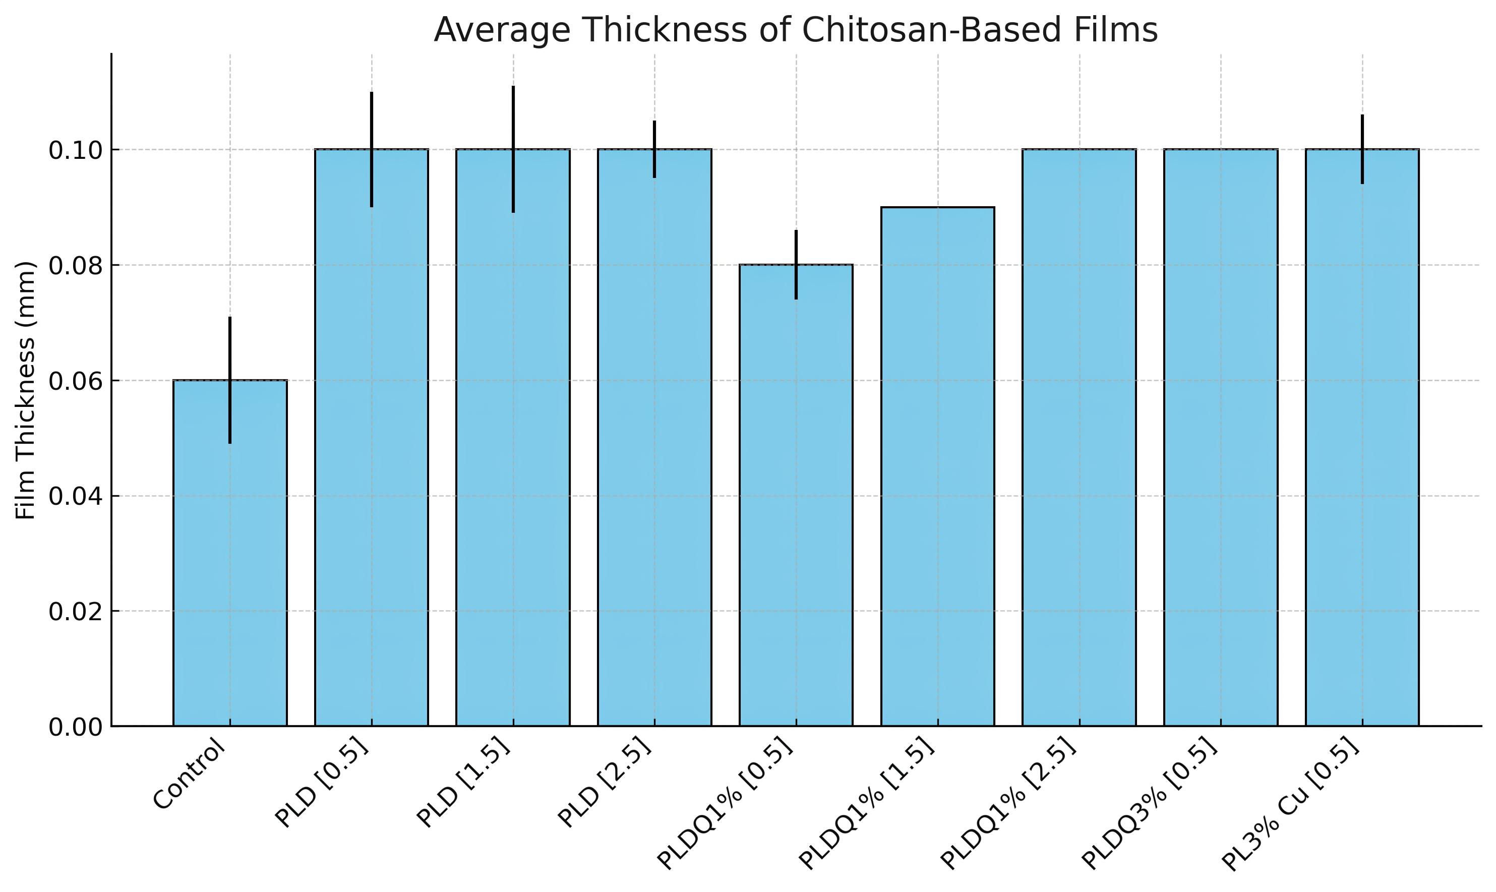

*Average thickness (± standard deviation) of chitosan-based films incorporated with pyroligneous extract. Values represent the mean ± SD of triplicate measurements.

Table 1. pH Values of Film Formulations at All Timepoints and Concentrations

|  |  |  |  |  |  |  |  |
| --- | --- | --- | --- | --- | --- | --- | --- |
| Time (min) | Concentration (%) | Control | PLD | PLDQ1% | PLDQ3% | PL3% Cu | PL3% Si |
| 15 | 0.5% | 6.28 ± 0.01 | 6.26 ± 0.04 | 6.27 ± 0.02 | 6.27 ± 0.01 | 6.25 ± 0.02 |  |
| 30 | 0.5% | 6.28 ± 0.01 | 6.26 ± 0.04 | 6.27 ± 0.03 | 6.27 ± 0.01 | 6.25 ± 0.02 |  |
| 60 | 0.5% | 6.28 ± 0.01 | 6.26 ± 0.04 | 6.27 ± 0.03 | 6.27 ± 0.02 | 6.25 ± 0.04 |  |
| 90 | 0.5% | 6.28 ± 0.03 | 6.25 ± 0.03 | 6.26 ± 0.01 | 6.27 ± 0.03 | 6.24 ± 0.05 |  |
| 120 | 0.5% | 6.28 ± 0.03 | 6.24 ± 0.03 | 6.26 ± 0.02 | 6.26 ± 0.03 | 6.23 ± 0.02 |  |
| 15 | 1.5% | 6.26 ± 0.03 | 6.27 ± 0.04 | 6.27 ± 0.03 |  |  | 6.27 ± 0.04 |
| 30 | 1.5% | 6.26 ± 0.02 | 6.26 ± 0.02 | 6.27 ± 0.03 |  |  | 6.27 ± 0.04 |
| 60 | 1.5% | 6.26 ± 0.01 | 6.26 ± 0.02 | 6.26 ± 0.01 |  |  | 6.26 ± 0.03 |
| 90 | 1.5% | 6.26 ± 0.01 | 6.25 ± 0.03 | 6.26 ± 0.01 |  |  | 6.26 ± 0.04 |
| 120 | 1.5% | 6.26 ± 0.01 | 6.25 ± 0.02 | 6.26 ± 0.02 |  |  | 6.26 ± 0.03 |
| 15 | 2.5% |  | 6.26 ± 0.02 | 6.26 ± 0.03 | 6.26 ± 0.02 | 6.26 ± 0.01 | 6.26 ± 0.01 |
| 30 | 2.5% |  | 6.25 ± 0.03 | 6.26 ± 0.03 | 6.26 ± 0.04 | 6.26 ± 0.03 | 6.26 ± 0.03 |
| 60 | 2.5% |  | 6.25 ± 0.02 | 6.25 ± 0.01 | 6.25 ± 0.02 | 6.26 ± 0.03 | 6.26 ± 0.03 |
| 90 | 2.5% |  | 6.24 ± 0.01 | 6.25 ± 0.04 | 6.25 ± 0.02 | 6.25 ± 0.04 | 6.25 ± 0.04 |
| 120 | 2.5% |  | 6.22 ± 0.03 | 6.24 ± 0.04 | 6.25 ± 0.03 | 6.25 ± 0.04 | 6.25 ± 0.04 |

*Mean pH values (± standard deviation) of chitosan-based film formulations after immersion in saline solution at 37 °C. Results are shown for different concentrations (0.5%, 1.5%, 2.5%) and timepoints (15–120 min). Empty cells indicate that no measurements were conducted for that specific concentration and formulation.

Table 2. Volume Change of Film Formulations After 120 Minutes in Saline at 37 °C

|  |  |  |  |
| --- | --- | --- | --- |
| Formulation | Initial Volume (cm³ ± SD) | Final Volume (cm³ ± SD) | Δ Volume (cm³) |
| Control | 0.029 ± 0.003 | 0.128 ± 0.010 | 0.099 |
| PLD [0.5] | 0.035 ± 0.005 | 0.152 ± 0.016 | 0.117 |
| PLDQ1% [0.5] | 0.040 ± 0.006 | 0.229 ± 0.032 | 0.189 |
| PLDQ3% [0.5] | 0.037 ± 0.002 | 0.170 ± 0.011 | 0.133 |
| PL3% Cu [0.5] | 0.036 ± 0.003 | 0.230 ± 0.015 | 0.194 |
| PL3% Si [0.5] | 0.036 ± 0.003 | 0.230 ± 0.015 | 0.194 |
| PLD [1.5] | 0.036 ± 0.001 | 0.156 ± 0.012 | 0.120 |
| PLDQ1% [1.5] | 0.034 ± 0.006 | 0.155 ± 0.025 | 0.121 |
| PLDQ3% [1.5] | 0.033 ± 0.003 | 0.158 ± 0.056 | 0.125 |
| PL3% Si [1.5] | 0.037 ± 0.005 | 0.173 ± 0.016 | 0.136 |

*Initial and final volume (mean ± standard deviation) and calculated variation (Δ) after immersion in saline solution for 120 minutes at 37 °C.

**Figure2 - Rheological Behavior of Chitosan-Based Film Formulations Containing Pyroligneous Extract**

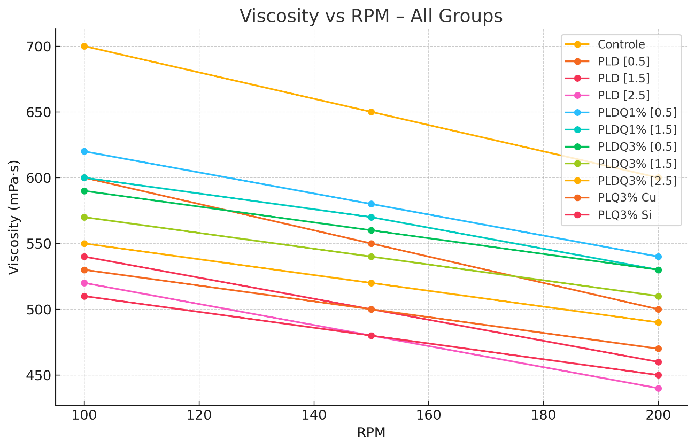

*Rheological behavior of chitosan-based film formulations containing pyroligneous extract. All groups exhibited non-Newtonian pseudoplastic behavior, characterized by a decrease in viscosity with increasing spindle rotation speed (RPM).

Table 3. Descriptive Statistics and Kruskal-Wallis Test Summary

|  |  |  |  |  |  |  |
| --- | --- | --- | --- | --- | --- | --- |
| Group | Mean | Standard Deviation | Minimum | Maximum | Sum of Ranks | N |
| Control | 255.67 | 28.50 | 227 | 284 | 96.0 | 3 |
| PLD | 203.00 | 9.17 | 195 | 213 | 87.0 | 3 |
| PLDQ1% [0.5%] | 31.33 | 4.04 | 27 | 35 | 58.5 | 3 |
| PLDQ1% [1.5%] | 41.00 | 2.00 | 39 | 43 | 74.5 | 3 |
| PLDQ1% [2.5%] | 40.33 | 4.16 | 37 | 45 | 72.5 | 3 |
| PLDQ3% [0.5%] | 25.67 | 6.11 | 19 | 31 | 51.5 | 3 |
| PLDQ3% [1.5%] | 17.33 | 4.51 | 13 | 22 | 37.0 | 3 |
| PLDQ3% [2.5%] | 14.67 | 3.51 | 11 | 18 | 29.5 | 3 |
| PLQ3% Cu [0.5%] | 13.00 | 3.00 | 10 | 16 | 23.5 | 3 |
| PLQ3% Si [1.5%] | 13.33 | 3.21 | 11 | 17 | 25.0 | 3 |
| PLQ3% Si [2.5%] | 4.33 | 1.15 | 3 | 5 | 6.0 | 3 |

*Descriptive statistics and sum of ranks for each experimental group included in the Kruskal-Wallis analysis. The test showed a statistically significant difference between groups (H(10) = 30.36, p = 0.00075).

Table 4. Dunn-Bonferroni Post-Hoc Test – Full Comparisons Against Control

|  |  |  |  |
| --- | --- | --- | --- |
| Comparison | Difference (Mean) | p-value | Significance |
| Control vs PLD | 52.67 | >0.05 | ** |
| Control vs PLDQ1% [0.5%] | 224.34 | >0.05 | ** |
| Control vs PLDQ1% [1.5%] | 214.67 | >0.05 | ** |
| Control vs PLDQ1% [2.5%] | 215.34 | >0.05 | ** |
| Control vs PLDQ3% [0.5%] | 230.00 | >0.05 | ** |
| Control vs PLDQ3% [1.5%] | 238.34 | >0.05 | ** |
| Control vs PLDQ3% [2.5%] | 241.00 | ≈ 0.050 | * |
| Control vs PLQ3% Cu [0.5%] | 242.67 | < 0.05 | ** |
| Control vs PLQ3% Si [1.5%] | 242.34 | < 0.05 | ** |
| Control vs PLQ3% Si [2.5%] | 251.34 | < 0.05 | ** |

*Multiple comparisons between control and treated groups using Dunn's post-hoc test with Bonferroni correction. Asterisks denote statistical significance: * p ≈ 0.05 (borderline), ** p < 0.05 (significant). Differences are based on mean values.