Original Research Article

The Usefulness of Base Deficit (BD) as a Predictor of Severity in Organophosphorus (OP) Poisoning – A retrospective single-center observational study

ABSTRACT

Objective

Organophosphates are chemical agents that originate from derivatives of phosphoric, phosphonic, or phosphinic acid compounds. They are one of the leading causes of death by intentional self-harm worldwide. The objective of the study is to evaluate the utility of Base Deficit as a prognostic indicator of OP poisoning and assess its predictive accuracy for in-hospital mortality.

Methodology
This retrospective single-center observational study analyzed data from adult patients who presented to the emergency department with the history of organophosphorus compound ingestion over a 2-year 6-month period. Relevant clinical history, physical examination details, and biochemical investigations were collected from electronic medical records and entered into appropriate sections on a pre-designed proforma. Patients with a history of co-ingestion of other compounds or carbamates, chronic kidney disease, pre-hospital cardiac arrest, or those discharged against medical advice were excluded.

Results
Data from 122 patients were analyzed. They were stratified into quartiles based on their base deficit values. The most common OP compound ingested was found to be Chlorpyrifos (n=41, 33.6%). The average duration of hospital stay documented in this study was 16 days, and the in-hospital case fatality rate was 15.38%.
In univariate logistic regression, both base deficit (BD) and APACHE II scores were significantly associated with in-hospital mortality. Receiver Operating Characteristic (ROC) analysis showed that when BD was more than 6.42, it predicted mortality with a 73.7% sensitivity and 70.9% specificity, and when APACHE II scores were above 14.5, sensitivity was 73.7% and specificity was 75.7%. Used in conjunction, these markers enhanced predictive accuracy.
Further, multivariate regression analysis confirmed base deficit as an independent predictor of in-hospital mortality (aOR 1.25, p = 0.031). A combined model of base deficit and APACHE II score showed improved predictive performance (AUC = 0.86), supporting their use in early clinical risk stratification.

Conclusion
Our study shows that base deficit is a valuable and accessible marker for early risk stratification in OP poisoning. Particularly when combined with APACHE II scoring, it can guide timely clinical decisions and resource allocation, especially in resource-limited settings.

Keywords: Organophosphate, Base deficit, Prognostication, toxicology

BACKGROUND
Organophosphorus (OP) compounds are widely used insecticides in agriculture. Worldwide, 200,000 annual deaths are attributable to OP poisoning.[1] Hence, it poses a major public health challenge. These compounds are widely used in Intentional Self Harm (ISH) due to their easy availability to farmers in rural areas, who constitute the largest affected population.[2]
OP compounds cause an irreversible inhibition of acetylcholinesterase, resulting in an accumulation of acetylcholine. This accumulation leads to the overstimulation of cholinergic nerve terminals, manifesting as ‘diarrhea, urination, miosis, bradycardia, bronchospasm, emesis, lacrimation, salivation’ (DUMBELS), and muscle weakness with fasciculations. In severe instances, this can lead to hypotension, cardiac failure, respiratory failure, convulsions, and even impaired neurological function and cognition. [3]
Traditionally, the severity of OP poisoning has been predicted using clinical indices such as APACHE II score, Bardin’s criteria, Glasgow Coma Scale, etc. This study aims to include Base Deficit as an additional parameter to enhance the existing predictive models.
Base deficit (BD) is the additional base required to normalize body pH. BD may be used to detect metabolic acidosis due to its linear relationship with serum bicarbonate [4]. Since acidosis majorly affects the clinical outcome in OP poisoning, its detection proves to be of prognostic importance. [5]
Multiple studies have identified BD to be associated with mortality and serve as a prognostic factor in cases of medical illnesses and pesticide poisoning, in addition to being of great use in trauma cases [6–8]. Hence, BD could serve as a reliable prognostic factor in patients with OP poisoning and a higher BD in a patient having ingested an OP compound may indicate a requirement for quick and precise intensive care, promoting a more favorable outcome.

AIM
This study aims to determine the significance of base deficit as a prognostic indicator for morbidity and mortality in OP poisoning.

DESIGN
We used a retrospective single-center observational study method, with data collected from a two-year, six-month period starting from July 2020 up to December 2022. We had a total of n=122 cases which fulfilled our criteria, and data was collected with the help of a predesigned proforma.

METHODS
Ethical considerations:
All data was collected from electronic medical records retrospectively and confidentiality was maintained. The study was initiated only upon approval from Kasturba Medical college and Kasturba Hospital Institutional Ethics Committee 2 - Approval number IEC2: 452/2024.
Subjects:
All the participants were patients above the age of 18, who presented to the Emergency Room at our tertiary care center – Kasturba Hospital, Manipal with a history of consumption of an OP compound. Using the PASS II software based on one sample sensitivity option with 80% power, 50% null sensitivity and 80% alternative sensitivity, 5% level of significance and 20% prevalence of severe organophosphate poisoning, the sample size calculated was 100. By the end of our study period, data from 122 participants were obtained. Our exclusion criteria included participants who had a history of consumption of non-OP compounds, pre-hospital cardiac arrest, discharge against medical advice, chronic kidney disease, or ingestion of carbamates.
Method of study
All patient details were obtained from their electronic medical records. No audio/video recording was involved in this study. Data collection was done by obtaining proper clinical details, history, relevant investigations from the electronic medical records and entering them into a predesigned proforma. Verbal informed consent for participation in this study was obtained via phone from either the patient or, in the case of deceased patients, their family members, due to the distant location of their residence. The study was initiated upon approval from Kasturba Medical college and Kasturba Hospital Institutional Ethics Committee 2 - Approval number IEC2: 452/2024. All the patients selected for the study were classified into different groups based on clinical severity as per Bardin’s classification. [9] The base deficit values derived in each patient from the arterial blood gas analysis were classified into quartiles [8]. APACHE-II scores were also calculated for each participant using the relevant clinical parameters. [10] No additional tests were done. The base deficit values were then compared with the severity of poisoning, mortality as well as with APACHE-II scores to determine its predictive accuracy.
Statistical Analysis:
The data obtained after estimation of the above-mentioned parameters were statistically analyzed using SPSS software version 23 and Python. Descriptive statistics were expressed in the form of mean ± standard deviation or median with interquartile range, as appropriate. Continuous variables were compared across BD quartiles using one-way ANOVA and categorical variables were assessed using the chi-square test.

A univariate logistic regression model was employed to assess the independent association of base deficit and APACHE II scores with in-hospital mortality. A Receiver operating characteristics (ROC) curve was used to determine area under the curve (AUC), sensitivity and specificity for each. A p value of less than 0.05 was considered statistically significant.

Next, a multivariate logistic regression model was constructed to evaluate the predictive ability of base deficit with other variables independently, including APACHE II score, SpO₂, creatinine, GCS, age, pseudocholinesterase levels, and time to treatment. Adjusted odds ratios (aOR) with 95% confidence intervals and p-values were reported. Finally, ROC analysis was performed to compare the full model with a reduced model comprising only of base deficit and APACHE II score, to compare their predictive performance.

RESULTS

The total study population consisted of 122 hospitalized individuals, out of which 68.85% (n=84) were males and 31.15% (n=38) were females. The age range was from 18 to 79 years. A total of 103 patients recovered, while 19 patients succumbed, giving our study an in-hospital case fatality rate of 15.57%.

The median duration between ingestion of the Organophosphorus compound and initiation of therapy was 4 hours, and the average duration of hospital stay was 16 days.
Clinical examination findings:
The mean pulse rate was 106.87 beats/min, the mean systolic and diastolic blood pressures were 126.7mmHg and 77.96mmHg respectively. Mean arterial pressure calculations revealed that 89 patients were normotensive, 10 were hypotensive and 23 were hypertensive. Glasgow Coma Scale values on admission are detailed in Table 1. [11] 10 patients in our study had a ventilator in-situ on admission. Respiratory rates were less than 20 breaths/min in 79.5% (n=97) patients and more than 20 breaths/min in 20.49% (n=25) patients. On admission, 61.48% (n=75) of our patients had an oxygen saturation of greater than 95% on room air and the other 38.52% (n=41) had an oxygen saturation of less than 95%.
Laboratory findings:
Arterial blood gas analysis revealed that among our patients, 22.95% (n=28) had acidosis, 37.7% (n=46) had alkalosis and 39.34% (n=48) had a pH within the normal range. 18% of our patients were anemic (hemoglobin < 12 g/dL). The other investigative findings are presented in Table 1.

Table .1: Relationship between base deficit quartiles with other modalities
Domains | BD Quartiles | Q1 < 3 (n=32) | Q2: 3 – 5.9 (n=39) | Q3: 6 – 9.9 (n=40) | Q4 ≥ 10 (n=11) | Test Statistic (df) / Test Type | p-value
 | Sex (Male) | 18 (56.25%) | 29 (74.35%) | 28 (70%) | 9 (81.81) | χ²(3) = 3.92 | 0.283 (Chi-Square)
Demographic | Age (years) | 41.81 ± 15.77 | 43.56 ± 17.25 | 47.47 ± 16.55 | 50.54 ± 12.82 | F(3, 118) = 1.30 | 0.298
Details | Median duration between ingestion and commencement for treatment (hours) | 3.5 | 3.75 | 4 | 3.5 | F(3, 118) = 0.47 | 0.695
 | Duration of hospital stay (days) | 14.50 ± 6.70 | 16.97 ± 11.77 | 16.08 ± 7.45 | 8.81 ± 7.99 | F(3, 118) = 2.68 | 0.0514*
 | GCS on Admission | 12.8 ± 2.9 | 13.05 ± 3.62 | 11.42 ± 4.47 | 10.09 ± 4.23 | F(3, 118) = 1.69 | 0.169
 | Pulse (beats/min) | 102 ± 25.1 | 106.43 ± 22.4 | 115.12 ± 24.36 | 111 ± 19.63 | F(3, 118) = 2.07 | 0.117
Examination | SBP (mmHg) | 130.9 ± 22.2 | 126.05 ± 21.53 | 128.05 ± 23.27 | 111.82 ± 34.59 | F(3,118) = 2.90 | 0.142
 | RR (breaths/min) | 21.75 ± 4.54 | 22.38 ± 5.07 | 22.27 ± 4.66 | 24.27 ± 3.41 | F(3,118) = 2.64 | 0.496
 | SpO2 (%) | 97.87 ± 3.53 | 95.5 ± 8.98 | 96.59 ± 5.04 | 91.82 ± 11.09 | F(3,118) = 2.34 | 0.0854*
 | pH | 7.37 ± 0.07 | 7.34 ± 0.11 | 7.29 ± 0.11 | 7.16 ± 0.12 | F(3,118) = 20.23 | 7.69 × 10⁻¹¹***
 | Hb (g/dL) | 13.25 ± 2.14 | 14.11 ± 3.48 | 14.44 ± 2.18 | 13.82 ± 2.81 |  | 0.323
 | WBC (In 1000s) | 12.87 ± 4.87 | 13.12 ± 5.35 | 16.09 ± 7.33 | 15.27 ± 7.85 | F(3,118) = 2.14 | 0.0879*
 | HCO3 | 20.89 ± 1.40 | 20.2 ± 1.15 | 17.81 ± 1.90 | 13.94 ± 2.85 | F(3,118) = 35.24 | 3.96× 10⁻³²***
 | Platelets | 262.4 ± 86.54 | 247.62 ± 63.13 | 234.25 ± 81.82 | 291.72 ± 104.55 | F(3,118) = 3.22 | 0.158
Investigations | Pseudocholinesterase | 1533.87 | 1098.13 | 768.26 | 281.3 | F(3,118) = 9.68 | 0.239
 | Creatinine (mg/dL) | 0.81 ± 0.22 | 1.02 ± 0.49 | 1.01 ± 0.40 | 1.78 ± 2.05 | F(3,118) = 4.79 | 0.00211***
 | Urea (mg/dL) | 21.59 ± 8.17 | 21.79 ± 12.69 | 23.92 ± ± 9.50 | 33.36 ± ± 35.59 | F(3,118) = 4.81 | 0.102
 | Sodium (mg/dL) | 139.21 ± 4.21 | 139.41 ± 5.19 | 140.83 ± 5.52 | 136.27 ± 8.7 | F(3,118) = 1.88 | 0.104
 | Potassium (mg/dL) | 4.22 ± 0.88 | 3.97 ± 0.63 | 4.14 ± 0.87 | 3.84 ± 0.53 | F(3,118) = 2.12 | 0.377
 | Albumin (mg/dL) | 4.43 ± 0.50 | 4.39 ± 0.53 | 4.53 ± 0.49 | 4.33 ± 1.07 | F(3,118) = 2.97 | 0.652
 | Apache II score | 9.25 ± 5.08 | 10.36 ± 6.41 | 13.57 ± 7.53 | 19.72 ± 8.15 | F(3,118) = 6.56 | 4.8× 10⁻⁰⁵***
Criteria | Bardin’s | 0.81 ± 0.96 | 1.13 ± 1.08 | 1.17 ± 1.26 | 1.81 ± 1.25 | F(3,118) = 2.30 | 0.0892*
 | Mortality | 1 (3.13%) | 4 (10.26%) | 8 (20.51%) | 5 (45.45%) | χ²(3) = 13.12 | 0.00360*** (Chi-Square)

Legend:
All values are presented as mean ± standard deviation
‘***’ refers to statistical significance at a 1% level,
‘**’ refers to statistical significance at a 5% level,
‘*’ refers to statistical significance at a 10% level.
All continuous variables were analyzed using one-way ANOVA. The F-statistic is denoted as F(3,118), where 3 represents the between-group degrees of freedom (quartiles of base deficit) and 118 denotes the within-group degrees of freedom (total sample size minus number of groups). The total number of patients included was 122.
For Sex and Mortality, ANOVA is not appropriate as they are binary variables; hence, the chi-square test of independence (difference of proportion across quartiles, Null is no difference) is done.

Quartile-Based Analysis:
The patients were split into four categories based on their base deficit quartiles, as shown in Table 1. Statistically significant differences with increasing base deficit quartiles were observed in the following measures:
- SpO₂ (p = 0.0854), WBC count (p = 0.0879), and hospital stay duration (p = 0.0514) at a 10% significance level.
- pH (p = 7.69 × 10⁻¹¹), HCO₃⁻ (p = 3.96 × 10⁻³²), creatinine (p = 0.00211), and Apache II score (p = 4.8 × 10⁻⁵) at a 1% level.
- Mortality was significantly associated with increasing base deficit quartiles (p = 0.00360).

Predictive Performance:
A Receiver Operating Characteristic (ROC) curve was generated from a univariate logistic regression model using Base Deficit as the sole predictor. The area under the curve was 0.726 (95% CI, 0.607-0.845). The cutoff point for base deficit was 6.42. When BD was more than this, the test had 73.7% sensitivity and 70.9% specificity.
Next, an ROC curve was generated using Apache II score as the sole predictor. The cut-off was determined to be 14.5, and area under the ROC curve was found to be 0.755 (95% CI, 0.620-0.891). In addition, when Apache II scores were above 14.5, sensitivity was 73.7% and specificity was 75.7%.

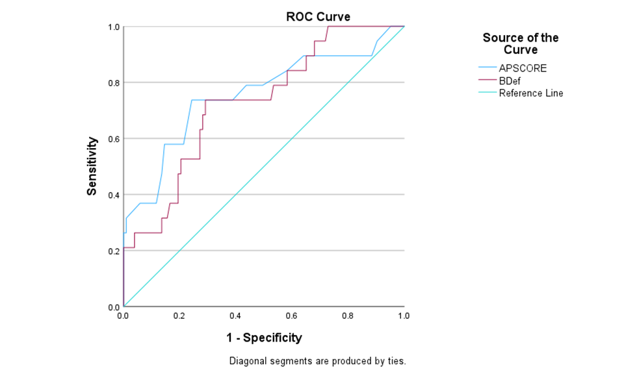
Figure 1: Univariate analyses – curves as indicated by legend

Multivariate Logistic Regression Analysis

A multivariate model was employed to evaluate the independent predictive power of BD and other clinical parameters. The outcome variable was taken as in-hospital mortality. To avoid model overfitting due to a limited number of events, only variables that were statistically significant in univariate analysis or of strong clinical relevance were included in the multivariate model.

Table 2 shows the adjusted odds ratios (aOR), confidence intervals, and p-values. Of the variables included in the multivariate model, only Base Deficit was found to be statistically significant (aOR 1.25, 95% CI: 1.02–1.54, p = 0.031). We believe that the lack of significance among other variables may be due to multicollinearity or insufficient power.
Table 2- The adjusted odds ratios (aOR), confidence intervals, and p-values.

Variable | β Coefficient | Standard Error | Adjusted Odds Ratio (aOR) | p-value | 95% CI
Baseline | -2.35 | 4.79 | 0.10 | 0.62 | [-11.73, 7.03]
Base Deficit | 0.22 | 0.10 | 1.25 | 0.03 | [0.02, 0.43]
APACHE II | 0.13 | 0.09 | 1.14 | 0.13 | [-0.04, 0.31]
GCS | 0.01 | 0.12 | 1.01 | 0.93 | [-0.22, 0.25]
Pseudocholinesterase | -7.66 × 10⁻⁴ | 4.57 × 10⁻⁴ | 1.00 | 0.09 | [-1.66 × 10⁻³, 1.30 × 10⁻⁴]

ROC Curve Analysis: Full vs Reduced Model

The ROC curve for the full logistic regression model yielded an area under the curve of 0.86, depicting good discrimination. A reduced model incorporating only Base Deficit and APACHE II score achieved an AUC of 0.80, comparable to the previous one.

Figure 2 shows the ROC curve comparison of the full and reduced models. This suggests that Base Deficit and APACHE II score, when used in combination, offer a practical and efficient tool for early risk stratification in OP poisoning.

Fig 2-

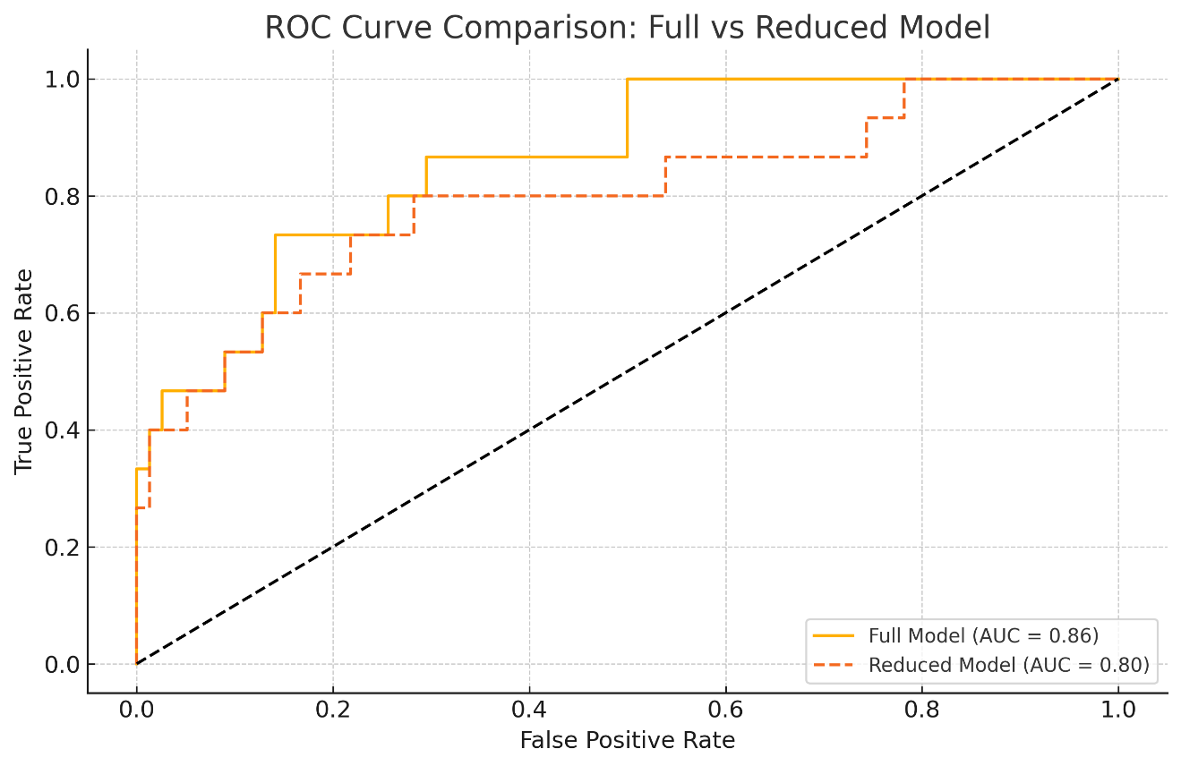

DISCUSSION
Organophosphate compounds are among the most widely used agricultural insecticides worldwide. The World Health Organization (WHO) estimates that approximately 18.2 per 100,000 agricultural workers suffer from occupational related pesticide poisoning annually. [12] With 70% of its land devoted to agriculture, India is burdened with about one-third of the pesticide poisoning cases worldwide, with farmers suffering the worst impact.

Globally, an estimated 200,000 cases of OP poisoning deaths occur each year, with majority reported from low and middle-income countries [1] This high mortality rate in emerging nations poses a serious threat to public health.
The following OP substances are frequently used in agriculture: parathion, malathion, chlorpyrifos, and dimethoate. [13] In a South Indian study by Thunga et. al, WHO class 1b pesticides, particularly Monocrotophos, were most frequently implicated. [14]
OP compounds lead to acute cholinergic toxicity by irreversibly inhibiting the enzyme Acetylcholinesterase, leading to the accumulation of Acetylcholine (ACh) at cholinergic nerve terminals. The resulting overstimulation leads to the muscarinic, nicotinic and central nervous system (CNS) manifestations. Muscarinic effects, which result from excessive glandular and smooth muscle activity, can be remembered using the acronym "DUMBELS” (diaphoresis/diarrhea, urination, miosis, bronchorrhea/bronchospasm/bradycardia, emesis, lacrimation, and salivation’). Nicotinic symptoms include muscle fasciculations, weakness, cramps, and in severe cases, paralysis. Further, CNS effects include confusion, tremors and seizures. [8]

Most exposures occur as intentional self-harm. The leading cause of mortality in OP poisoning patients is respiratory insufficiency. Cardiac toxicity and respiratory distress are other important toxic effects observed. Patients may develop hypotension or hypoperfusion, which is postulated to be the cause of metabolic acidosis, which has emerged as a prognostic factor.[5] Being a surrogate marker for metabolic acidosis, base deficit correlates well with serum bicarbonate levels and is more practical for a quick early assessment.[4] A sodium bicarbonate infusion is employed to correct the metabolic acidosis in these cases, which also enhances the effects of the first-line therapy with atropine and oxime. Animal and preliminary human studies also suggest that alkalinization promotes hydrolysis of the organophosphate ester bond, thereby reducing its toxicity. [15]

BD is the amount of strong base or acid which normalizes the pH of 1 liter of blood to 7.4, at 37 °C and 40 mmHg pCO2. [8] It ranges from +2 to -2 mEq/L. A higher BD correlates with reduced organ perfusion and metabolic acidosis. Multiple studies demonstrate BD, along with blood lactate levels, to be a predictor of multiple organ dysfunction. [6] BD can also serve as a tool for prognosis in critically ill patients and cases of pesticide poisoning. [7,8]

In a study by Dalia et. al, pseudo cholinesterase < 1800, SpO2 < 85% at room air, GCS ≤ 12 and time elapsed after exposure before treatment being 2 hours or more were strong indicators of morbidity.[16] A comparative study between the International Program on Chemical Safety Poison Severity Score (IPCS PSS) and GCS, found the latter to be an equally effective prognostic tool in OP poisoning cases, with an easier clinical applicability.[17] In a retrospective cohort study done by Kim YH et. al, the SOFA score demonstrated higher specificity and accuracy in predicting severity and mortality compared to APACHE II and SAPS II, which is a valuable find, given the challenge and complexity of measuring APACHE II and SAPS II scores in acute settings. [18]

Similarly, Lee S et. al found that higher initial AG and BD levels were indicators of death and necessitated precise intensive care. It was noticed that non-survivors’ BD levels were greater than those of survivors' and that BD and 30-day mortality had a graded association. [19]

In our study, demographic characteristics of age, sex and median duration between ingestion of OP compound and initiation of therapy were uniformly distributed across quartiles. There was a clear trend observed between base deficit and worsening clinical outcomes. In addition, patients with higher BD value had lower pseudocholinesterase levels and higher serum creatinine. In-hospital mortality rate ranged from 3.13% in quartile 1 to 45.45% in quartile 4, highlighting its strong association with BD. Additionally, the univariate ROC analysis showed that although both BD and APACHE II scores had the ability to predict mortality, the combined model performed better. Further, in the multivariate analysis, BD remained a strong independent predictor of in-hospital mortality. These findings prove the utility of base deficit as an effective prognostic indicator in OP poisoning, particularly in resource-limited settings.

Limitations:

Being a single center study greatly limits this study's generalizability along with the small sample size. Its retrospective design may introduce biases due to incomplete or inconsistent documentation. Further, the time from ingestion to treatment was based on medical records or patient reporting, which may not be entirely accurate. Finally, the study was limited to in-hospital mortality with no measurement of functional recovery or long term outcomes.

CONCLUSION

Even today, OP poisoning remains a significant public health issue, particularly in agricultural areas. Since many of these regions are resource constrained, identifying simple, accessible markers that aid in prognostication is of paramount importance. This study tests the potential of base deficit in this role and highlights its potential to provide timely clinical insight into disease severity, thereby helping to optimize care and resource allocation. When combined with the APACHE II scoring system, base deficit can facilitate prompt risk stratification and guide further management. The findings in the study strongly support the use of base deficit in initial evaluation protocols, particularly in resource-limited settings or time-sensitive cases, where rapid and accurate assessment can significantly improve patient outcomes.

REFERENCES:

1. Eddleston M, Buckley NA, Eyer P, Dawson AH: Management of acute organophosphorus pesticide poisoning. Lancet. 2008, 371:597. 10.1016/S0140-6736(07)61202-1
2. Rao CS, Venkateswarlu V, Surender T, Eddleston M, Buckley NA: Pesticide poisoning in south India: Opportunities for prevention and improved medical management. Tropical Medicine and International Health. 2005, 10:581–8. 10.1111/J.1365-3156.2005.01412.X
3. Robb EL, Regina AC, Baker MB: Organophosphate Toxicity. StatPearls. Published Online First: 12 November 2023.
4. Surbatovic M, Radakovic S, Jevtic M, et al.: Predictive value of serum bicarbonate, arterial base deficit/excess and SAPS III score in critically ill patients.
5. Gil HW, Hong M, Lee H, Cho NJ, Lee EY, Park S: Impact of Acid-Base Status on Mortality in Patients with Acute Pesticide Poisoning. Toxics 2021, Vol 9, Page 22. 2021, 9:22. 10.3390/TOXICS9020022
6. Tremblay LN, Feliciano D V., Rozycki GS: Assessment of initial base deficit as a predictor of outcome: mechanism of injury does make a difference. Am Surg. 2002, 68:689–93; discussion 693. 10.1177/000313480206800807
7. Hajjar LA, Nakamura RE, de Almeida JP, et al.: Lactate and base deficit are predictors of mortality in critically ill patients with cancer. Clinics. 2011, 66:2037. 10.1590/S1807-59322011001200007
8. Lee SB, Kang C, Kim DH, et al.: Base deficit is a predictor of mortality in organophosphate insecticide poisoning. Hum Exp Toxicol. 2018, 37:118–24. 10.1177/0960327117694073
9. Nazima SN, Bashir Y, Nabi S, Bashir N: Intensive care management of organophosphorus poisoning patients: an experience from tertiary care centre. International Journal of Advances in Medicine. 2018, 5:257–64. 10.18203/2349-3933.IJAM20180957
10. Vincent JL, Moreno R: Clinical review: Scoring systems in the critically ill. Crit Care. 2010, 14:. 10.1186/CC8204,
11. Jain S, Iverson LM: Glasgow Coma Scale. StatPearls. Published Online First: 12 June 2023.
12. Thundiyil JG, Stober J, Besbelli N, Pronczuk J: Acute pesticide poisoning: a proposed classification tool. Bull World Health Organ. 2008, 86:205. 10.2471/BLT.08.041814
13. Mundhe SA, Birajdar S V., Chavan SS: The clinico-demographic study of morbidity and mortality in patients with organophosphate compound poisoning at tertiary care hospital in rural India. International Journal of Advances in Medicine. 2017, 4:809–18. 10.18203/2349-3933.IJAM20172277
14. Thunga G, Ganna Sam K, Khera K, Pandey S, Vidya Sagar S: Evaluation of incidence, clinical characteristics and management in organophosphorus poisoning patients in a tertiary care hospital. J Toxicol Environ Health Sci. 2010, 2:73–6.
15. Roberts DM, Buckley N: Alkalinisation for organophosphorus pesticide poisoning. Cochrane Database Syst Rev. 2005, 2005:CD004897. 10.1002/14651858.CD004897.PUB2
16. Amin DM, Abaza MT, Azawy DSh El, et al.: Morbidity and Mortality Indicators in Acute Organophosphate Poisoning in Zagazig University Hospital, Egypt: Retrospective Study. Occupational Diseases and Environmental Medicine. 2018, 6:130–40. 10.4236/ODEM.2018.64011
17. Davies JOJ, Eddleston M, Buckley NA: Predicting outcome in acute organophosphorus poisoning with a poison severity score or the Glasgow coma scale. QJM: An International Journal of Medicine. 2008, 101:371–9. 10.1093/QJMED/HCN014
18. Kim YH, Yeo JH, Kang MJ, et al.: Performance assessment of the SOFA, APACHE II scoring system, and SAPS II in intensive care unit organophosphate poisoned patients. J Korean Med Sci. 2013, 28:1822–6. 10.3346/JKMS.2013.28.12.1822
19. Lee SB, Kim DH, Kim T, et al.: Anion gap and base deficit are predictors of mortality in acute pesticide poisoning. Hum Exp Toxicol. 2019, 38:185–92. 10.1177/0960327118788146

