Case report

FETUS PAPYRACEOUS: A RARE CLINICAL ENTITY IN DICHORIONIC-DIAMNIOTIC TWIN PREGNANCY

**ABSTRACT**

Fetus papyraceous, a high order pregnancy complication, is a rare condition in which an intrauterine death of one fetus occurs causing mechanical compression over a period. The most concern for the pregnant woman remains the status of the life fetus and any unforeseeable complications. Rarely, it could result in intrauterine death of the surviving twin, preterm labour, coagulopathy, obstructed labour and postpartum hemorrhage. Hereto, we present a case of a 37 year old female Gravida 3 Para 2 with dichorionic-diamniotic twins who developed fetal papyraceous of one twin.

*Key Words: Fetus Papyraceous, Dichorionic-Diamniotic, Twins*

**1. INTRODUCTION**

Fetus papyraceous, also called mummified fetus, is a rare complication with incidence of 1:12,000 live births and 1:184-1:200 twin pregnancies(1). It typically occurs when there is intrauterine death of one twin in the late first or second trimester with retention of this twin, leading to compression and mummification with eventual appearance like a parchment(dry and paper like, hence the name papyraceous)(2,3). The aetiology is unknown but it is thought to be associated with fetal genetic abnormalities, twin-to-twin transfusion Syndrome (TTTS) and cord abnormalities such as velamentous cord insertion, lethal nuchal cord or true knot(4). Occasionally, it could have both maternal and fetal complications of surviving twin.

**2. CASE PRESENTATION**

A 37 year old Gravida 3 Para 1(dead) + 1TOP, presented for antenatal booking. Her dating ultrasound scan showed Dichorionic-Diamniotic twins, at 12 weeks 3 days with an EDD of 12/03/2024. Antenatal booking bloods were unremarkable. She had a previous neonatal death due to fetal distress occurring in labour, requiring delivery via caesarean section. She had an uneventful antenatal appointment at 16 weeks.

At 20 weeks, an anomaly scan was carried out which showed Dichorionic-Diamniotic twin gestation with demise of leading Twin(Twin A). Twin A also exhibited spalding sign consistent with intrauterine fetal demise and anhydramnios. The estimated gestational age was reported as15weeks + 3days, and estimated fetal weight was 160g. The placenta was anterio-fundal. Twin B was a life fetus with

adequate liquor volume(AFI-10cm), cephalic presentation, estimated gestational age at 22weeks + 5days and estimated fetal weight of 373g. Preterm premature rupture of membranes was ruled out. Patient was counselled about the condition and the risk to the her and the life fetus. She had 2 weekly antenatal monitoring with ultrasound scan, haematological, biochemical and coagulation screen which were all normal. Extensive emotional and psychological support was offered throughout the pregnancy especially given her background of early neonatal death. At the 36weeks appointment, the ultrasound done showed a single intrauterine fetus with estimated fetal weight of 3100g, liquor volume extensively reduced with AFI-2.3cm(only one measurable pool) and normal umbilical artery doppler studies. Preterm premature rupture of membranes was ruled out. CTG done was normal.She was counselled for delivery and an emergency cesarean section was carried out with findings of a life female, with birthweight 2900g and APGARS 8/10 and 9/10 at 1 and 5 minutes. No gross abnormality detected. A fetus papyraceous of approximately 16 weeks gestation with weight 179g and height of 14cm was also delivered(image 1 and 2). Detailed newborn assessment of the surviving twin was done to rule out any congenital malformations and none was found.

**3. DISCUSSION**

If fetal demise of one twin occurs early in the first trimester, it results in intrauterine absorption of the dead fetus leading to vanishing twin but when it occurs in the late first or second trimester, then fetus papyraceous can ensue, where the dead fetus is compressed and mummified into a parchment state(hence it’s name).

Fetus papyraceous is a rare condition of multiple pregnancy occurring after the demise of one twin with retention of this twin for at least 10 weeks, to allow absorption of amniotic fluid, placenta and fluid content of the dead fetus(4). It can occur in both monochorionic and dichorionic twins but it is more common in monochorionic twins, due to shared vascular connections with resultant increase in fetal demise risk by three fold(5). The resultant maternal and fetal complications may include bleeding and miscarriage in the first trimester , preterm premature rupture of membranes, preterm Labour, cord complications, congenital disorders, sepsis and coagulopathy in the second and third trimester. The surviving fetus in Diachronic-Diamniotic twins (DCDA) rarely has complications compared to Monochorionic twins(6), where the risk of cerebral palsy, aplasia cutis and anomalies such as microcephaly, cerebral encephalomalacia or hydrocephalus are high(7,8,9). The pathophysiology is hypothesised to be due to reverse transfer of thromboplastin to the surviving twin leading to disseminated intravascular coagulation and severe intrauterine central nervous system damage(10). If fetus papyrace0us is diagnosed antenatally, close monitoring is of utmost importance. Monitoring of the mother and fetus is done. Severe maternal complications rarely occur and most times, decision to end the pregnancy is due to fetal complications. Mode of delivery is according to local guidelines for management of twin pregnancy with associated fetal complications but majority will require earlier delivery.

**4. CONCLUSION**

Fetus papyraceous, a rare phenomenon in twin gestation can have complications for both the mother and the surviving twin. These complications are vast and close follow up is needed to improve outcome.

**CONSENT**

Written informed consent was obtained from the patient for publication of this case report and accompanying images.

**ETHICAL APPROVAL**

No ethical approval required.

**REFERENCES**

1. Kumar, R., Upreti, P., Malik, N., Kumari, O., & Dagar, N. (2023). Fetus Papyraceous in Diamniotic Dichorionic Twins: A Rare Entity. Journal of South Asian Federation of Obstetrics and Gynaecology, 15(3), 347–348. <https://doi.org/10.5005/jp-journals-10006-2240Dahiya>

2. Dahiya, P., & Bains, R. (2014). Conservative Management of Fetus Papyraceus: A Report of Two Cases. Oman Medical Journal, 29(2), 132–134. https://doi.org/10.5001/omj.2014.32

3. S., L., & K., R. (2019). A rare case of fetus papyraceous presenting in monozygotic biamniotic twins. International Journal of Reproduction, Contraception, Obstetrics and Gynecology, 9(1), 448. <https://doi.org/10.18203/2320-1770.ijrcog20196066>

4. Vashistha, P., Kashyap, P., Kumar, A., Sethi, C. A., & Rana, S. (2020). Fetus papyraceous, a rare complication of twin pregnancy: case report. International Journal of Reproduction, Contraception, Obstetrics and Gynecology, 10(1), 361. <https://doi.org/10.18203/2320-1770.ijrcog20205799>

5. Akbar, M., Saeed, R., Ikram, M., Saeed, M., & Talib, W. (2005). Fetus Papyraceous. The Professional Medical Journal, 12(03), 351–353. <https://doi.org/10.29309/tpmj/2005.12.03.5136>

6. Srinidhi, C., & Jajoo, S. (2023). Fetus papyraceous: a rare clinical image. Pan African Medical Journal, 44. <https://doi.org/10.11604/pamj.2023.44.28.38689>

7. A Case Report: Aplasia Cutis Congenita Secondary to Fetus Papyraceus. (2021). Pediatrics and Neonatal Medicine, 1(1). <https://doi.org/10.33425/2768-0363.1005>

8. Anand, D., Platt, M. J., & Pharoah, P. O. D. (2007). Vanishing Twin: A Possible Cause of Cerebral Impairment. Twin Research and Human Genetics, 10(1), 202–209. <https://doi.org/10.1375/twin.10.1.202>

9. Pharoah, P. O. D. (2007). Prevalence and pathogenesis of congenital anomalies in cerebral palsy. Archives of Disease in Childhood - Fetal and Neonatal Edition, 92(6), F489–F493. <https://doi.org/10.1136/adc.2006.107375>

10. Benirschke, K. (1992). The contribution of placental anastomoses to prenatal twin damage. Human Pathology, 23(12), 1319–1320. <https://doi.org/10.1016/0046-8177(92)90048-8>

IMAGE 1: Normal Placenta on the left, Fe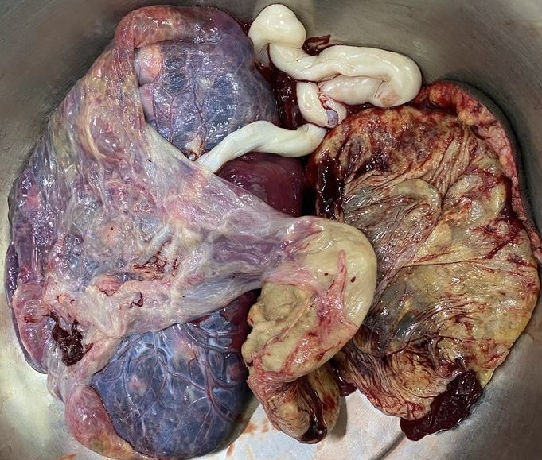tus Papyraceous with it’s placenta on the right

.

IMAGE 2: Fetus Papyraceous

