Case report

SQUAMOUS CELL CARCINOMA OF THE CLAVICLE SECONDARY TO A CERVICAL CANCER: A CASE REPORT

ABSTRACT:

Cervical cancer occurs around the age of 40-45, and can be localized or metastatic.

Metastatic sites vary: lymph nodes, lungs and other sites. Bone metastases are uncommon, and require histological study to confirm their secondary nature, especially in the case of unusual localizations. Case report: we report the case of a young patient followed since 2022 for a moderately differentiated, infiltrating and keratinizing squamous cell carcinoma of the uterine cervix, classified IIb, treated with concomitant radio-chemotherapy. In early 2024, a surveillance thoraco-abdomino-pelvic CT scan showed a mixed lesion of the sternal end of the left clavicle. A PET-FDG scan showed an intense, heterogeneous, hypermetabolic condensing lesion. A biopsy confirmed the diagnosis: bone localization of a moderately differentiated squamous cell carcinoma. The patient was treated with chemotherapy, followed by surgery and local radiotherapy. Conclusion: a clavicular metastasis of a cervical cancer represents a rare entity, especially in the presence of a single secondary lesion, with no other metastases elsewhere.

KEY WORDS: clavicle, bone metastasis, single lesion, cervical cancer.

INTRODUCTION:

Globally, cervical cancer is the second most common cancer in terms of both incidence and mortality in women of reproductive age [1].

It is a squamous cell carcinoma in 80% of cases, adenocarcinoma in 15%, adeno-squamous carcinoma in less than 5%, and rarely an undifferentiated carcinoma [2].

Its incidence is declining in developed countries thanks to screening, but remains a cause for concern in developing countries and constitutes a genuine public health problem [3].

The most common metastatic site for cervical cancer is the lung [4].

Other sites include the bladder, the sigmoid, the brain and the bone [5].

Bone metastases are less frequent than lung lesions, and usually occur in the axial skeleton, mainly the spine, ribs and pelvis [6].

In this article, we describe the occurrence of a clavicular metastasis in a 36-year-old female patient previously treated for a squamous cell carcinoma of cervical cancer.

CLINICAL OBSERVATION:

This is a 36-year-old patient with no particular history, followed up in 2022 for a moderately differentiated, infiltrating and keratinizing squamous cell carcinoma of the uterine cervix, classified IIb, treated with concomitant radio-chemotherapy (06 weeks of radiotherapy with weekly cisplatin at a dose of 70 mg). Then, regular follow-up.

A surveillance cervico-thoraco-abdomino-pelvic CT scan performed in early 2024 showed a mixed lesion of the sternal end of the left clavicle, with no other distant lesions.

Cervicothoracic MRI confirmed the existence of a swelling in the medial end of the left clavicle, without being able to rule out an inflammatory or infectious origin.

The MDP-Tc99m bone scan showed intense hyperfixation at the sternal end of the clavicle, which was suspicious.

We completed the scan with PET-FDG: an intense, heterogeneous, hypermetabolic, condensing lesion of the medial end of the left clavicle, SUVmax = 7.9, suspicious (Fig. 1).

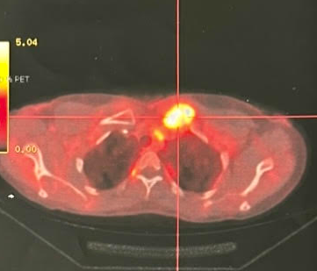 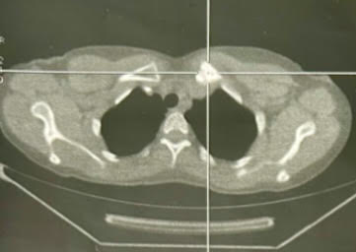

**B**

**A**

Figure 1:

(A): PET-CT axial section showing an intense, heterogeneous hypermetabolic lesion of the left clavicle.

(B): PET-CT axial section (MIP image) showing a pathological hypermetabolic lesion of the left clavicle.

In February 2024, a clavicular biopsy was performed, confirming a bone localization of a poorly to moderately differentiated squamous cell carcinoma already known.

The case was reviewed at a multidisciplinary consultation meeting, and the decision was taken to perform 03 to 06 cycles of paclitaxel + carboplatin chemotherapy, followed by surgery +/- local radiotherapy.

After 03 cycles of chemotherapy, the mass was still stable, with no progression or regression, so chemotherapy was continued until 06 cycles.

The patient underwent surgery in July 2024: resection of the tumor and invaded structures, notably bone (sternal manubrium, sternoclavicular joint, 2/3 of the clavicle and the anterior part of the 1st rib) and a part of the pectoralis major muscle, followed by placement of a muscle flap (pectoralis minor).

Anatomopathological study of the surgical specimen confirmed the bony location of a poorly to moderately differentiated, infiltrating squamous cell carcinoma, and reassured us that the limits of the excision were in healthy areas.

After recovery, we ordered a PET-FDG scan, which showed moderate, diffuse and heterogeneous hypermetabolism in the left supraclavicular region, with a postoperative appearance (Fig. 2).

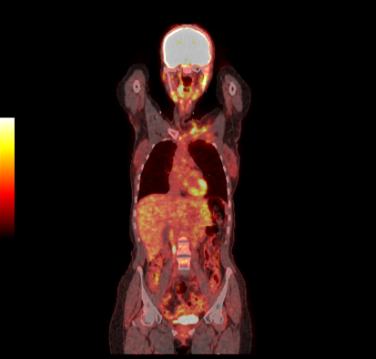 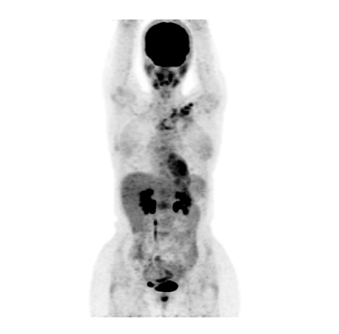

**B**

**A**

Figure 2 :

1. : PET-CT frontal section showing a moderate, diffuse and heterogeneous hypermetabolism in the left supraclavicular region, with a postoperative appearance.
2. : PET-CT (MIP image) in frontal section showing an hypermetabolism in the left supraclavicular area.

The patient was then referred for radiotherapy, with continuous follow-up.

DISCUSSION:

The frequency of bone metastases in cervical cancer does not exceed 7%, and so they are less frequent than pulmonary secondary lesions, which are the primary metastatic site in this disease [7], [8].

The pathophysiological mechanism of tumor cell dissemination to bone is represented as follows: interaction between the stroma and tumor cells in the primary cancer, favoring their migration and escape into the systemic circulation; interaction at this level with erythrocytes, T lymphocytes, neutrophils, and platelets; arrival at the bone marrow, passage within it after extravasation; interaction with resident marrow cells to survive and activate osteoclasts; then formation of a bone metastatic foci [9].

The most common mechanism of bone involvement due to carcinoma of the uterine cervix was extension of the neoplasm from para-aortic nodes, with involvement of adjacent vertebral bodies [10].

In cervical cancer, metastatic spread to the bone is rarer than to the lung, since the latter has the densest capillary bed in the body, and is made up of a network of delicate membranes that easily trap tumor cells [11].

Bone metastases from cervical carcinoma usually occur in the axial skeleton, mainly the thoracic spine, lumbar spine, sarcum, pelvis and ribs. However, extra-skeletal metastases may occur, such us in the tibia or in the humerus [12], [13].

A retrospective cohort analysis of women with cervical cancer metastatic to bone, diagnosed between 2014 and 2015 was undertaken; in this study, the prevalence of bone lesions in the pelvis and lumbar spine was the highest (35%), given the anatomical location, followed by the thoracic spine (28%), sarcum (20%), ribs (16%), and other less frequent (skull, cervical spine, femur...) [14].

Clavicular localizations are rarer than other sites, and a case of clavicular metastasis was described in the same study, using FDG-PET in an asymptomatic patient [14].

In metastatic cervical cancer with multiple metastases, the therapeutic decision is obvious: chemotherapy, bevacizumab and immunotherapy depending on PDL-1 expression by the tumor, the patient's performance status and comorbidities [15], [16].

For patients unsuitable for systemic treatment, management is limited to supportive care [17].

However, in the case of oligo-metastatic disease, or in the case of a single metastasis as in our patient's case, treatment cannot be palliative, or aimed at improving progression-free survival, but must rather be curative [18].

- When local treatment is possible: we have to propose surgical resection with or without external radiotherapy (sometimes high dose external radiation), while discussing chemotherapy [18],[19], [20].

- When local treatment is impossible: therapeutic approaches are similar to those for poly-metastatic disease (chemotherapy, targeted therapy, immunotherapy) [21],[22].

In our patient's case, the disease was certainly oligo-metastatic and qualified for local therapy, but the rarity of this case put us outside the standard, and a medical staff was necessary before deciding on chemotherapy followed by surgery and radiotherapy.

CONCLUSION:

Bone metastases from cervical cancer are often associated with other secondary lymph node, liver and lung localizations, testifying to their late onset during the course of this disease; and thus their presence would be correlated with a poor prognosis.

The particularity of our patient's case was the occurrence of a single bone metastasis, and the exceptional location: the clavicle.

REFERENCES:

[1] J. Wu *et al.*, « Global burden of cervical cancer: current estimates, temporal trend and future projections based on the GLOBOCAN 2022 », *J. Natl. Cancer Cent.*, janv. 2025, doi: 10.1016/j.jncc.2024.11.006.

[2] M. Wang, K. Huang, M. C. S. Wong, J. Huang, Y. Jin, et Z.-J. Zheng, « Global Cervical Cancer Incidence by Histological Subtype and Implications for Screening Methods », *J. Epidemiol. Glob. Health*, vol. 14, no 1, p. 94‑101, mars 2024, doi: 10.1007/s44197-023-00172-7.

[3] R. Hull *et al.*, « Cervical cancer in low and middle-income countries », *Oncol. Lett.*, vol. 20, no 3, p. 2058‑2074, sept. 2020, doi: 10.3892/ol.2020.11754.

[4] S. Zhou et F. Peng, « Patterns of metastases in cervical cancer: a population-based study », *Int. J. Clin. Exp. Pathol.*, vol. 13, no 7, p. 1615‑1623, juill. 2020.

[5] Y. Liu, X. Zhou, H. Peng, F. Fang, et X. He, « A rare metastasis of cervical cancer to the sigmoid colon: a case report and review of the literature », *Gynecol. Pelvic Med.*, vol. 5, no 0, Art. no 0, déc. 2022, doi: 10.21037/gpm-22-13.

[6] K. Karnika *et al.*, « Carcinoma cervix with synchronous isolated pelvic bone metastasis:a case report and review of literature », *Ital. J. Gynaecol. Obstet.*, vol. 36, no 01, p. 60, mars 2024, doi: 10.36129/jog.2023.98.

[7] T. Matsuyama, N. Tsukamoto, M. Imachi, et H. Nakano, « Bone metastasis from cervix cancer », *Gynecol. Oncol.*, vol. 32, no 1, p. 72‑75, janv. 1989, doi: 10.1016/0090-8258(89)90853-6.

[8] S. Abughazaleh, M. Tarawneh, H. Alzghoul, S. Alsakarneh, O. Saleh, et W. A. Y. Mir, « A case report of lung metastasis in a cervical cancer presenting as a consolidation », *Radiol. Case Rep.*, vol. 19, no 3, p. 1144‑1148, mars 2024, doi: 10.1016/j.radcr.2023.11.054.

[9] L. J. Suva, C. Washam, R. W. Nicholas, et R. J. Griffin, « Bone metastasis: mechanisms and therapeutic opportunities », *Nat. Rev. Endocrinol.*, vol. 7, no 4, p. 208‑218, avr. 2011, doi: 10.1038/nrendo.2010.227.

[10] J. G. Blythe, M. H. Cohen, H. J. Buchsbaum, et H. B. Latourette, « Bony metastases from carcinoma of cervix. Occurrence, diagnosis, and treatment », *Cancer*, vol. 36, no 2, p. 475‑484, août 1975, doi: 10.1002/1097-0142(197508)36:2<475::aid-cncr2820360226>3.0.co;2-q.

[11] W. D. Gerull, V. Puri, et B. D. Kozower, « The epidemiology and biology of pulmonary metastases », *J. Thorac. Dis.*, vol. 13, no 4, p. 2585‑2589, avr. 2021, doi: 10.21037/jtd.2020.04.28.

[12] R. M. Cherian, J. Jeba, S. Mukhopadhyay, et S. Backianathan, « Unusual sites of metastases of carcinoma cervix », *BMJ Case Rep.*, vol. 2017, p. bcr2016218897, févr. 2017, doi: 10.1136/bcr-2016-218897.

[13] A. Gioè *et al.*, « Isolated humeral metastasis in cervical cancer: A case report and review of the literature », *J. Cancer Res. Ther.*, vol. 18, no 1, p. 273, mars 2022, doi: 10.4103/jcrt.JCRT_9_20.

[14] J. Butt et M. Botha, « Bone involvement in patients with cervical carcinoma: a single-institution cohort study », *South. Afr. J. Gynaecol. Oncol.*, vol. 11, no 2, p. 31‑37, juill. 2019, doi: 10.1080/20742835.2019.1702299.

[15] S. S. Pang, M. Murphy, et M. J. Markham, « Current Management of Locally Advanced and Metastatic Cervical Cancer in the United States », *JCO Oncol. Pract.*, vol. 18, no 6, p. 417‑422, juin 2022, doi: 10.1200/OP.21.00795.

[16] I. Diaz-Padilla, B. J. Monk, H. J. Mackay, et A. Oaknin, « Treatment of metastatic cervical cancer: future directions involving targeted agents », *Crit. Rev. Oncol. Hematol.*, vol. 85, no 3, p. 303‑314, mars 2013, doi: 10.1016/j.critrevonc.2012.07.006.

[17] D. Schrijvers et N. I. Cherny, « ESMO Clinical Practice Guidelines on palliative care: advanced care planning », *Ann. Oncol.*, vol. 25, p. iii138‑iii142, sept. 2014, doi: 10.1093/annonc/mdu241.

[18] S.-Y. Wu, E.-Y. Huang, et H. Lin, « Optimal treatments for cervical adenocarcinoma », *Am. J. Cancer Res.*, vol. 9, no 6, p. 1224‑1234, juin 2019.

[19] C. Marth, F. Landoni, S. Mahner, M. McCormack, A. Gonzalez-Martin, et N. Colombo, « Cervical cancer: ESMO Clinical Practice Guidelines for diagnosis, treatment and follow-up », *Ann. Oncol.*, vol. 28, p. iv72‑iv83, juill. 2017, doi: 10.1093/annonc/mdx220.

[20] S. Chopra *et al.*, « Management of oligo-metastatic and oligo-recurrent cervical cancer: A pattern of care survey within the EMBRACE research network », *Radiother. Oncol.*, vol. 155, p. 151‑159, févr. 2021, doi: 10.1016/j.radonc.2020.10.037.

[21] N. Colombo *et al.*, « Pembrolizumab for Persistent, Recurrent, or Metastatic Cervical Cancer », *N. Engl. J. Med.*, vol. 385, no 20, p. 1856‑1867, nov. 2021, doi: 10.1056/NEJMoa2112435.

[22] X. B. Tang *et al.*, « The Role of Radiotherapy for Metastatic Cervical Cancer: A Real-World Study », *Clin. Oncol.*, vol. 43, p. 103867, juill. 2025, doi: 10.1016/j.clon.2025.103867.