Original Research Article

**PREVALENCE OF STRESS, ANXIETY AND DEPRESSION IN YOUNG ADULTS IN JAIPUR**

Abstract:

Context: In 2017, one in seven Indians was affected by varying severity of mental disorders, especially impacting the young population and leading to decreased productivity and increased suicide rates among young adults in India.

Aims: To find out the prevalence of stress, anxiety, and depression in students and working professionals in the age group 18 to 30 years in Jaipur.

Settings and Design: A Google form was distributed using WhatsApp and Gmail to conduct a survey study.

Methods and Material: The survey research was carried out using a Google form containing a DASS 21 scale questionnaire, which was distributed to young people aged 18 to 30, males and females, in different areas of Jaipur. Data from 382 participants was gathered through Google form and entered into Google Sheets. The data was then manually computed to determine individual scores for stress, anxiety, and depression based on the DASS-21 Scale scoring.

Statistical analysis used: The statistical analysis was conducted separately for stress, anxiety, and depression to calculate the prevalence percentage.

Results: The prevalence observed in 382 subjects who participated in the survey study of variable Depression was 48.57%, Anxiety was 58.11% and Stress was 25.39%

Conclusions: The research findings indicate that young adults are experiencing a decline in their mental well-being, as evidenced by elevated levels of anxiety and depression compared to stress. Additionally, it is crucial to tackle these mental health issues in these individuals and recommend comprehensive treatment.

Keywords: Stress, Anxiety, Depression, DASS-21, Mental Health

1. Introduction:

Mental health issues are among the leading causes of disability worldwide, according to information obtained from the World Health Organization (WHO). Psychological disorders account for three of the top ten root causes of restriction among people between the ages of 15 and 44, and these disorders often coexist with other causes of impairment. [[1]] It is evident from the WHO's recently released 2013–2020 mental health action plan that a coordinated, evidence-based effort is required to improve mental health. On college campuses, mental health problems are becoming increasingly prevalent and severe. Most communities still struggle to find effective ways to support the mental health of adolescents. [[2]]

According to a report by Sapien Labs Centre for Human Brain and Mind at Krea University on the Mental State of India in 2023, The mental well-being of young people nationwide is a major concern, both in comparison to older generations and on its own. Additionally, the poor mental health of young people seems to be unrelated to their economic status, as it affects individuals across all income levels. The scale and seriousness of this issue cast doubt on the effectiveness of a strategy that focuses solely on managing or treating these conditions. After almost two years since the COVID pandemic, which led to reduced social interaction, increased unemployment, and greater use of the internet and social media, the mental health of the internet-connected population in India has declined compared to 2020. While there are differences in mental health levels among various states when considering all age groups from 18 to 74, almost all states in India show poor mental health outcomes specifically among young people aged 18 to 24. [[3]]

Stress is when environmental demands harm a person's physical or mental health. Anxiety is defined as an unpleasant feeling of uneasiness or worry about future events or apprehension to respond to the present event.Depression is defined as a mood disorder that is characterized by short-term emotional responses to a serious health condition associated with impairment in daily functioning. [[4]]

In 2017, 197.3 million (95% UI 178.4–216.4) people in India had mental disorders, including 45.7 million (42.4–49.8) with depressive disorders and 44.9 million (41.2–48.9) with anxiety disorders. There was a significant, but modest, correlation between the prevalence of depressive disorders and suicide death rate at the state level for both females (r²=0.33, p=0.0009) and males (r²=0.19, p=0.015). The proportional contribution of mental disorders to the total disease burden in India has almost doubled since 1990, and one in seven Indians was affected by mental disorders of varying severity in 2017. [[5]]

1.1IMPACTS OF STRESS, ANXIETY, AND DEPRESSION ON THE BODY

The effects of stress, anxiety, and depression can lead to physical health conditions such as heart disease and stroke. [[6]] These cardiovascular diseases are primarily caused by increased adrenergic stimulation due to stress. Both adrenaline and cortisol, which are increased during stress, can affect heart and blood pressure. Excessive adrenaline can raise blood pressure, making the heart work harder and faster, potentially leading to coronary heart disease, strokes, and sudden cardiac arrest. Studies have shown that stress is a predictor of incidents of coronary heart disease (CHD) and hypertension in both men and women. [[7]]

Stressed individuals often experience disturbed eating habits, acid reflux, diarrhea, or constipation. Stress can also be linked to obesity, which is associated with various health problems. Studies have shown that acute stress negatively affects blood glucose levels in patients with type 1 and type 2

diabetes. [[8]]

Chronic stress can lead to increased blood cholesterol levels, which may cause atherosclerosis and potentially lead to heart attacks. Cortisol also contributes to the accumulation of abdominal fat, leading to obesity. [[9]]

The ongoing activation of the Hypothalamic Pituitary Adrenal (HPA) axis during chronic stress can weaken the immune response, potentially increasing susceptibility to various infections. Research suggests that individuals experiencing chronic stress are more prone to contracting viral illnesses such as the flu and common cold, as well as other infections.

Additionally, aside from its direct impact on health, stress can lead to behavioral changes. Those living in stressful environments may be more likely to engage in unhealthy habits such as smoking, which can lead to respiratory disorders and even cancer. Similarly, individuals under stress may be more vulnerable to alcohol consumption, which can have its own set of negative consequences.[6]

2.Subjects and Methods:

A survey was carried out using a Google form that included the DASS-21 scale. The form was distributed to the target population via WhatsApp and email, and the responses were recorded on Google Sheets. The study included individuals aged 18 to 30, encompassing both students and working professionals. We received 382 completed forms from participants residing in various areas of Jaipur. Upon collection, the scores were manually calculated in accordance with the DASS-21 scale guidelines, and the data was subjected to statistical analysis to determine the prevalence of stress, anxiety, and depression among young adults.

A collection of three self-report measures called the Depression, Anxiety and Stress Scale – 21 Items (DASS-21) is intended to gauge the emotional states of stress, anxiety, and depression. The seven items in each of the three DASS-21 scales are broken down into subscales with comparable content. The depression scale evaluates depressive symptoms such as dysphoria, hopelessness, life devaluation, self-deprecation, lack of interest or involvement, anhedonia, and lethargy. The autonomic arousal, skeletal muscle effects, situational anxiety, and subjective sensation of anxious affect are all evaluated by the anxiety scale. The stress scale is responsive to long-term, non-specific arousal levels. It evaluates having trouble unwinding, anxious arousal, and being quickly irritated, upset, angry, overreactive, and impatient. The sum of the scores for the pertinent items determines the scores for stress, anxiety, and sadness. The dimensional rather than categorical understanding of psychological disease forms the foundation of the DASS-21.[10]

The DASS-21 Scoring is reliable and valid for calculating the levels of stress, anxiety and depression

3.Results:

After the analysis of data DASS-21 questionnaire received from various subjects of different areas of Jaipur, a total of 382 participants' data was received and analyzed. Among these 34.29 % of participants were from age group between 19 to 20 years. The prevalence of variable Depression 48.57%, Anxiety 58.11% and Stress 25.39% was being observed in subjects who participated in the survey study.

**Table 1: - Age distribution table of subjects**

|  |  |  |
| --- | --- | --- |
| **Age Interval** | **N = 382** | **Percentage** |
| 18 years | 60 | 15.70% |
| 19-20 | 131 | 34.29% |
| 21-22 | 89 | 23.29% |
| 23-24 | 62 | 16.23% |
| 25-26 | 15 | 3.92% |
| 27-28 | 12 | 3.14% |
| 29-30 | 13 | 3.40% |

**Table 2: - Frequency distribution of depression of subjects**

|  |  |  |
| --- | --- | --- |
| **Depression** | **n = 382** | **In %** |
| **Normal (0-9)** | 227 | 59.42 |
| **Mild (10-13)** | 55 | 14.39 |
| **Moderate (14-20)** | 68 | 17.80 |
| **Severe (21-27)** | 15 | 3.92 |
| **Extremely Severe (> 27)** | 17 | 4.45 |

**Table 3: Frequency distribution of anxiety of subjects**

|  |  |  |
| --- | --- | --- |
| **Depression** | **n = 382** | **In %** |
| **Normal (0-07)** | 160 | 41.88 |
| **Mild (8-9)** | 59 | 15.44 |
| **Moderate (10-14)** | 85 | 22.25 |
| **Severe (15-19)** | 29 | 7.59 |
| **Extremely Severe (> 19)** | 49 | 12.82 |

**Table 4: Frequency distribution of stress of subjects**

|  |  |  |
| --- | --- | --- |
| **Depression** | **n = 382** | **In %** |
| **Normal (0-14)** | 285 | 74.60 |
| **Mild (15-18)** | 53 | 13.87 |
| **Moderate (19-25)** | 28 | 7.32 |
| **Severe (26-33)** | 13 | 3.40 |
| **Extremely Severe (> 33)** | 3 | 0.78 |

**Table 5: No. of cases and prevalence rate of depression, anxiety, and stress among subjects**

|  |  |  |  |
| --- | --- | --- | --- |
| **Variables** | **Total** | **No. of cases** | **Prevalence (In %)** |
| **Depression** | 382 | 155 | 40.57% |
| **Anxiety** | 382 | 222 | 58.11% |
| **Stress** | 382 | 97 | 25.39% |

4.Discussion:

The aim of the current study was to examine the data collected from the DASS-21 questionnaire, which was completed by respondents from various areas of Jaipur, resulting in a total of 382 responses. This substantial sample size provided a comprehensive overview of mental health challenges within this particular demographic. The age distribution of the participants demonstrated a notable concentration within the younger age groups. Specifically, 34.29% of the respondents were aged between 19 and 20 years, consistent with existing research suggesting that younger populations are more likely to participate in surveys and express concerns about mental health issues. Mental health difficulties among young adults in India have been extensively documented, with growing apprehension about depression, anxiety, and stress. The findings from this study correlate with broader national trends reported by various sources. For instance, a recent UNICEF report emphasized the enduring impact of the COVID-19 pandemic on the mental well-being of children and young people in India, highlighting potential long-term effects on their mental health. The prevalence rates identified in this study was 48.57% for depression, 58.11% for anxiety, and 25.39% for stress, it highlights the urgent necessity for targeted mental health interventions specifically tailored for young adults. These figures are in line with other studies that have reported similar rates of mental health challenges among young people in India. For example, a study highlighted by the Times of India found that depression rates among young people range from 31% to 57%. Additionally, the increasing acknowledgment of mental health issues among Indian youth is reflected in the efforts of organizations such as UNICEF to raise awareness and promote mental well-being. They stress the need to address the stigma surrounding mental health and provide accessible mental health services. Overall, this study adds to the mounting evidence indicating significant mental health challenges faced by young adults in India. The high prevalence of depression, anxiety, and stress among the participants surveyed underscores the necessity for comprehensive mental health programs and policies tailored to the needs of this vulnerable age group. Addressing these issues is critical for improving the overall well-being and future prospects of young adults in Jaipur and across India. [[11]], [[12]]

5. Conclusions

The study results show that young adults are facing a decrease in their mental health, highlighted by increased anxiety and depression levels in relation to stress. Furthermore, it is essential to address these mental health challenges in this group and suggest holistic treatment options.

6.References:

1. Wahed WY, Hassan SK. Prevalence and associated factors of stress, anxiety and depression among medical Fayoum University students. Alexandria Journal of medicine. 2017;53(1):77-84.
2. Ediz B, Ozcakir A, Bilgel N. Depression and anxiety among medical students: Examining scores of the beck depression and anxiety inventory and the depression anxiety and stress scale with student characteristics. Cogent Psychology. 2017 Dec 31;4(1):1283829.
3. <https://sapienlabs.org/wp-content/uploads/2023/11/Mental-State-of-India-Report-October-2023.pdf>
4. Mirzaei M, Ardekani SM, Mirzaei M, Dehghani A. Prevalence of depression, anxiety and stress among adult population: results of Yazd health study. Iranian journal of psychiatry. 2019 Apr;14(2):137
5. Sagar R, Dandona R, Gururaj G, Dhaliwal RS, Singh A, Ferrari A, Dua T, Ganguli A, Varghese M, Chakma JK, Kumar GA. The burden of mental disorders across the states of India: the Global Burden of Disease Study 1990–2017. The Lancet Psychiatry. 2020 Feb 1;7(2):148-61
6. Garvey L, Benson AC, Benger D, Short T, Banyard H, Edward KL. The perceptions of mental health clinicians integrating exercise as an adjunct to routine treatment of depression and anxiety. International Journal of Mental Health Nursing. 2023 Apr;32(2):502-12.
7. Sharma DK. Physiology of stress and its management. J Med Stud Res. 2018;1(001):1-5.
8. Marcovecchio ML, Chiarelli F (2012) The effects of acute and chronic stress on diabetes control.Sci Signal 5:10.
9. Fumio K (2004) Job Stress and Stroke and Coronary Heart Disease. JMAJ 47:222-226
10. Ali AM, Alkhamees AA, Hori H, Kim Y, Kunugi H. The Depression Anxiety Stress Scale 21: Development and Validation of the Depression Anxiety Stress Scale 8-Item in Psychiatric Patients and the General Public for Easier Mental Health Measurement in a Post COVID-19 World. Int J Environ Res Public Health. 2021 Sep 27;18(19):10142.
11. <https://timesofindia.indiatimes.com/blogs/voices/rise-of-depression-amongst-young-adults-in-india/>
12. United Nations Children’s Fund, The State of the World’s Children 2021: On My Mind – Promoting, protecting and caring for children’s mental health, UNICEF, New York, October 2021.

    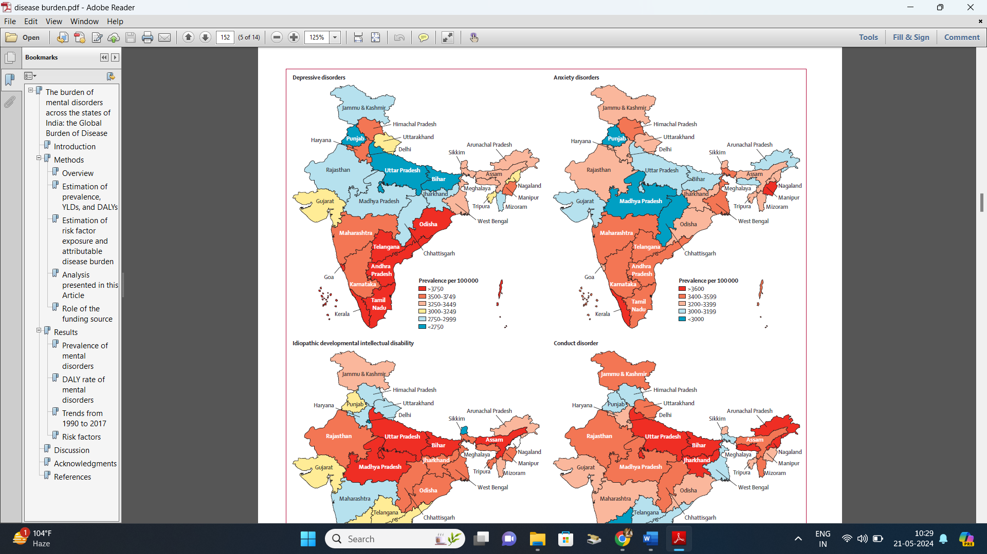

    **Figure 1: - Crude Prevalence of anxiety and depression in states of India, 2017**

    **Figure 2: - Age distribution Chart of subjects**

    **Figure 3: - Prevalence of depression**

    **Figure 4: - Prevalence of Anxiety**

    **Figure 5: - Prevalence of Stress**

    **Figure 6: - Prevalence of Depression, Anxiety and Stress in Percentage** 