**Case report**

**Bardet Biedl Moon Syndrome- A Rare Case with Multi-organ manifestations presenting as Renal failure**

**ABSTRACT**

Bardet-Biedl Syndrome (BBS) is a rare autosomal recessive ciliopathy. We report a 20-year-old male with end-stage kidney disease (ESKD) requiring hemodialysis, diagnosed with BBS exhibiting all six primary diagnostic features. The patient had childhood-onset hypertension (age 12) and congenital renal anomalies (bilateral hydroureteronephrosis, cortical cysts), culminating in ESKD by age 20. Additional manifestations included polydactyly, retinitis pigmentosa, central obesity, intellectual impairment, and hypogonadism. Management involved hemodialysis, antibiotics for E. coli UTI, and hormonal therapy. This case highlights BBS as a critical cause of early-onset renal failure, underscoring the need for antenatal screening in high-risk families and multidisciplinary management of progressive nephropathy.

KEYWORDS

Bardet-Biedl Syndrome, Ciliopathy, Hypogonadism, Polydactyl,Retinitis Pigmentosa

**INTRODUCTION**

Bardet Biedl syndrome (BBS) is a ciliopathy and rare autosomal recessive, monogenic condition affecting several organs.¹ It is caused by an abnormality in the cilia which is present on many cell types in various organ systems.² BBS expression varies both within and between families with a 25% chance in inheritance. It has equal incidence in both sex.³ BBS is characterised by six cardinal primary features - postaxial polydactyly, retinitis pigmentosa, central obesity, mental retardation, hypogonadism, and renal dysfunction ⁴.The diagnosis of BBS requires if at least three primary and two secondary characteristics are present, or if they have at least four primary characteristics as listed in Table 1⁵.

The presence of these clinical criteria has to be periodically verified for a diagnosis of BBS as these manifestations occur as the child grows.

We report the classical case from India of BBS with documented end-stage kidney disease (ESKD) requiring renal replacement therapy.

Literature review showed very few case reports being described from India with all six primary cardinal features.⁶

|  |  |
| --- | --- |
| **PRIMARY CHARACTERISTICS** | **SECONDARY CHARACTERISTICS** |
| Postaxial Polydactyly | Speech disorders |
| Retinitis Pigmentosa | Delayed development/ behavioural disorders |
| Central obesity | Abnormally large production or output of urine (polyuria)  Excessive thirst (polydipsia)  Diabetes insipidus |
| Mental retardation | Dental crowding/hypodontia /small roots/high arched palate  Craniofacial dysmorphism |
| Hypogonadism |  |
| Renal dysfunction |  |

TABLE 1 :- Primary and Secondary Characteristics of BBS.

**CASE PRESENTATION**

A 20 year male born out of second degree consanguinity presented with complaints of fever,burning micturition, productive cough and breathlessness since 2 days.

Past history is significant for undergoing urethroplasty for hypospadias at age 1. He was also diagnosed with hypertension at the age of 12 years and was on Tablet Cilnidipine 10 mg twice daily for the same. Ultrasonography of the abdomen and pelvis during that time revealed bilateral hydroureteronephrosis,multiple cortical cysts in right kidney, bilaterally shrunken kidneys with poorly maintained corticomedullary differentiation and Trabeculated thickened bladder. DMSA ( [Dimercaptosuccinic acid](https://www.google.com/search?client=mobilesearchapp&sca_esv=52a15a4bb9a63dd0&channel=iss&cs=1&hl=en_GB&rlz=1MDAPLB_en-GBIN1073IN1073&v=340.3.689937600&sxsrf=AE3TifPiH7_E6G9-q42str-pDLLiDwAKJg:1749710273813&q=Succimer&si=AMgyJEsgWKLo2JlxUdMZ5hORdNO1106BmnQkysKJM4_WR4UxkzjeSDmgvQA1I4fb50f0MmnloPyAU3MVvB0Z60g5TMmVrII_hyyfh5z8gnRzOfPW_TQmzmCDdx02iVjgtUMzG3Uh9sC8Hv1swTQiZhFebCkCYQ77RGuxdlN8Isi9XbIwI6cft10%3D&sa=X&ved=2ahUKEwiAidLaouuNAxXPh1YBHdULMyEQ3LoBegQIEBAB&biw=1180&bih=796&dpr=2)

scan) revealed bilateral shrunken kidney.Renal artery doppler revealed normal study. Blood urea 57.3 mg/dl and Creatinine was 1.6mg/dl at that time and was advised conservative management.

General physical examination revealed central obesity, gynecomastia and moon like facies, post-axial polydactyly noted in both the upper and lower limb, sparse body & facial hair noted , small testes and microphallus with hypospadias (stretched Penile Length =4.6 CM ) ,urethral tip subcoronal. He also had learning difficulties with Mini Mental Status Examination (MMSE) of 20. On auscultation bilateral fine crepitations were heard , Cardiovascular examination was within normal limits. Echocardiography showed left ventricular hypertrophy with normal ejection fraction.Fundoscopy revealed changes suggestive of Retinitis pigmentosa. Blood investigations showed Anemia of chronic kidney disease with Hemoglobin of 8.2mg/dl, Ferritin of 412 ng/ml. Renal function tests showed creatinine-5 mg/dl , Blood urea-120 mg/dl. Urine analysis revealed macro-albuminuria with proteinuria of nephrotic range. Patient was started on antibiotic ciprofloxacin for urinary tract infection which showed culture isloated E.coli, Total leukocytes were 11,342 cells/mm3 .Hemodialysis was initiated in view of refractory volume overload and metabolic acidosis . Patient gradually improved and Arterio-venous fistula (AVF) was placed for maintenance hemodialysis. Patient was stable on followup two months later and was continued on hemodialysis through Arterio-venous fistula (AVF).

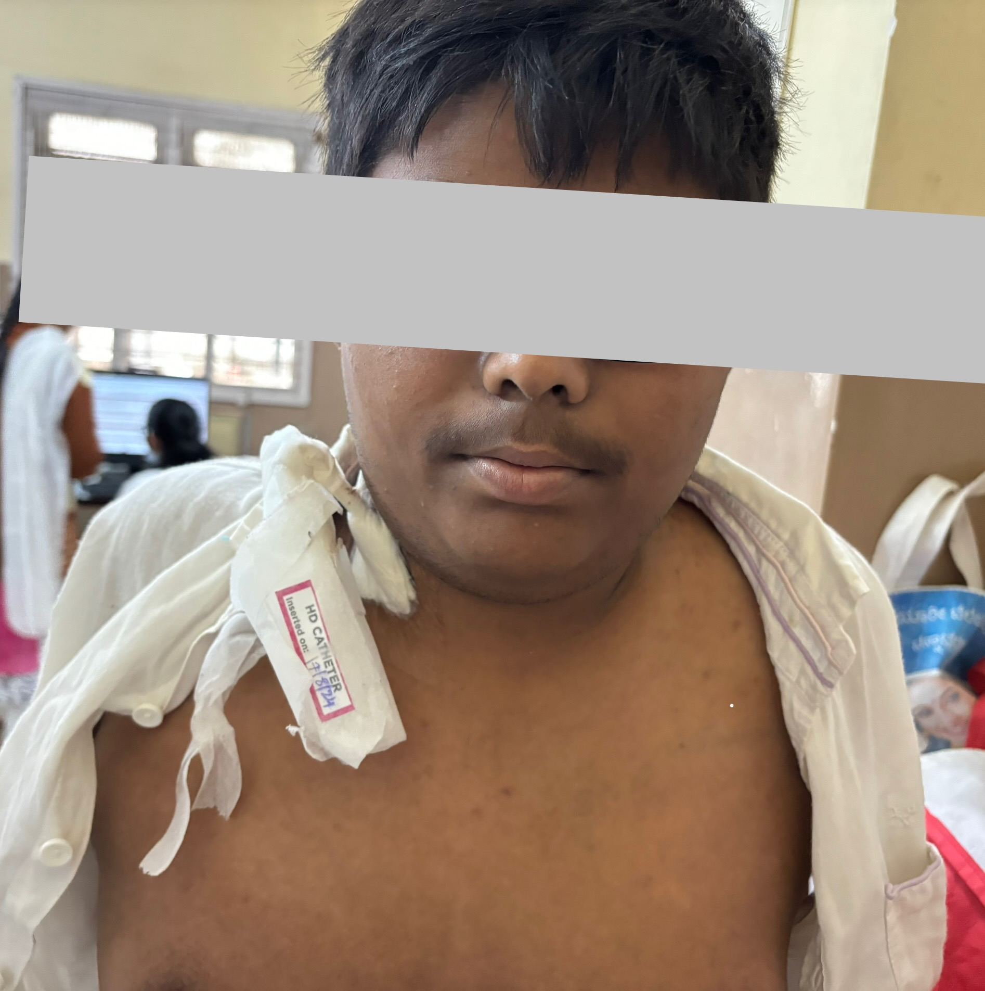

Figure 1- Showing Central Obesity(Moon like facies) - A characteristic of BBS. Right Internal Jugular Vein Hemodialysis Catheter Insitu.

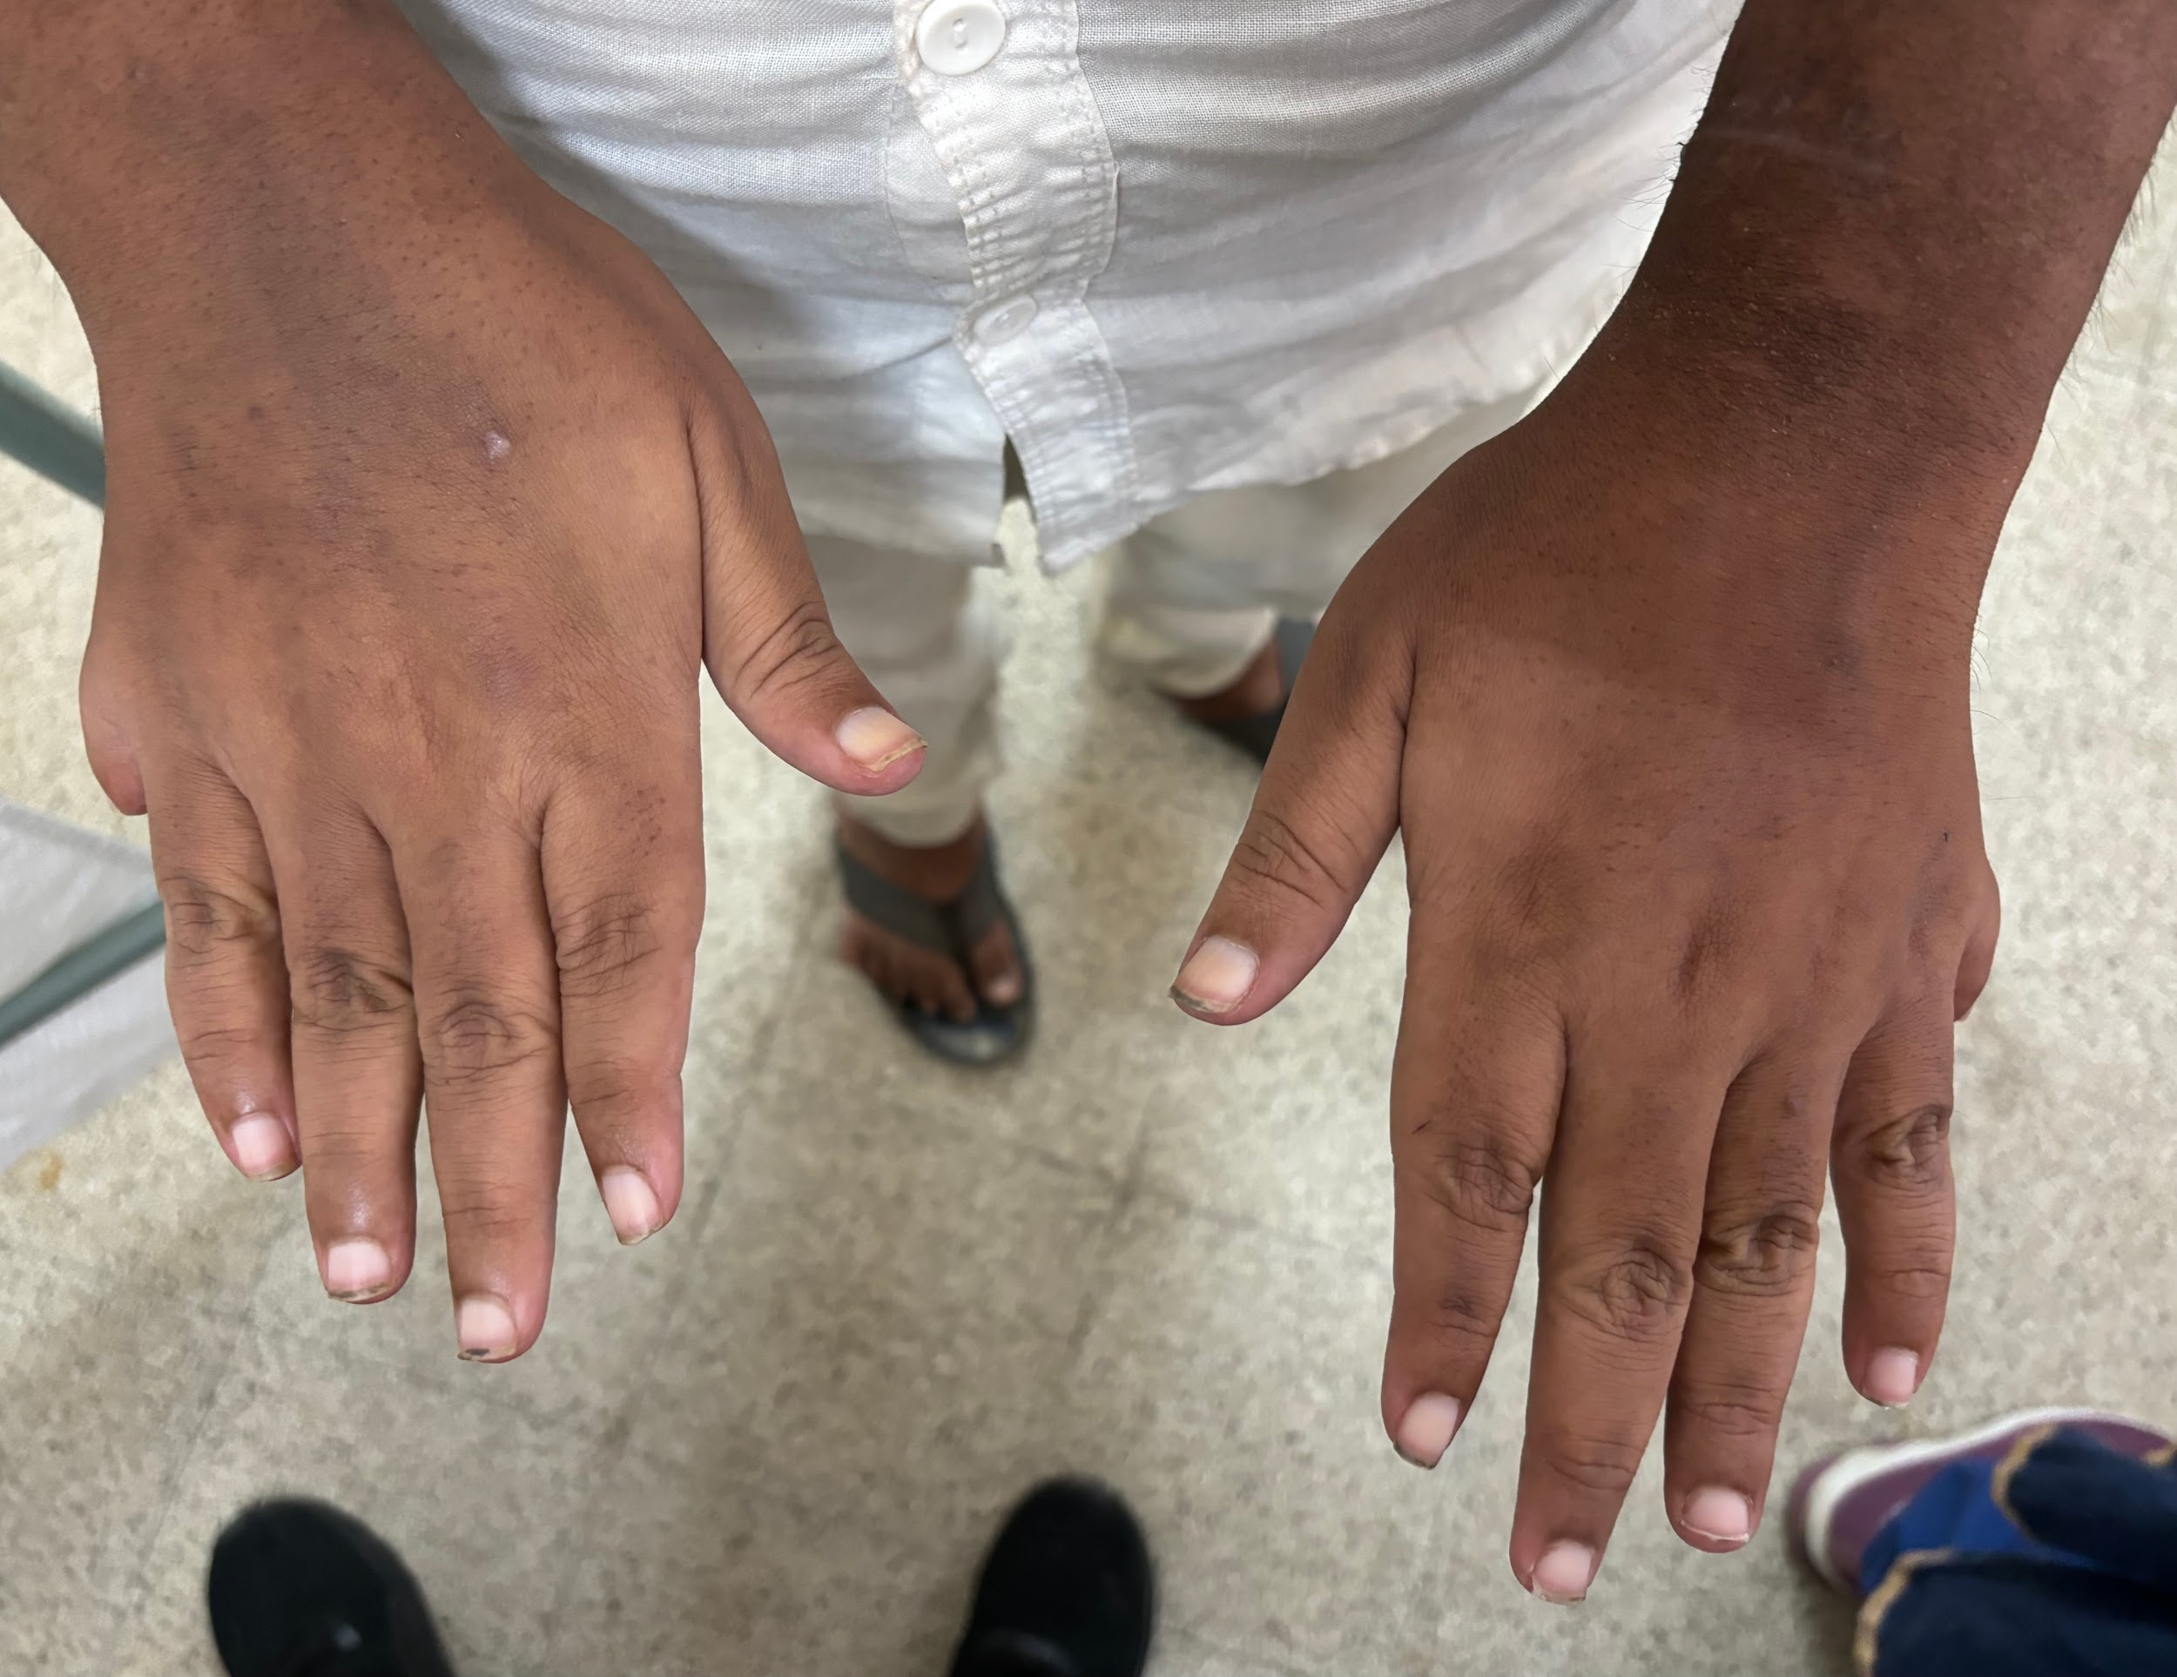

Figure 2- Showing Post Axial Polydactyly, broad stubby fingers.

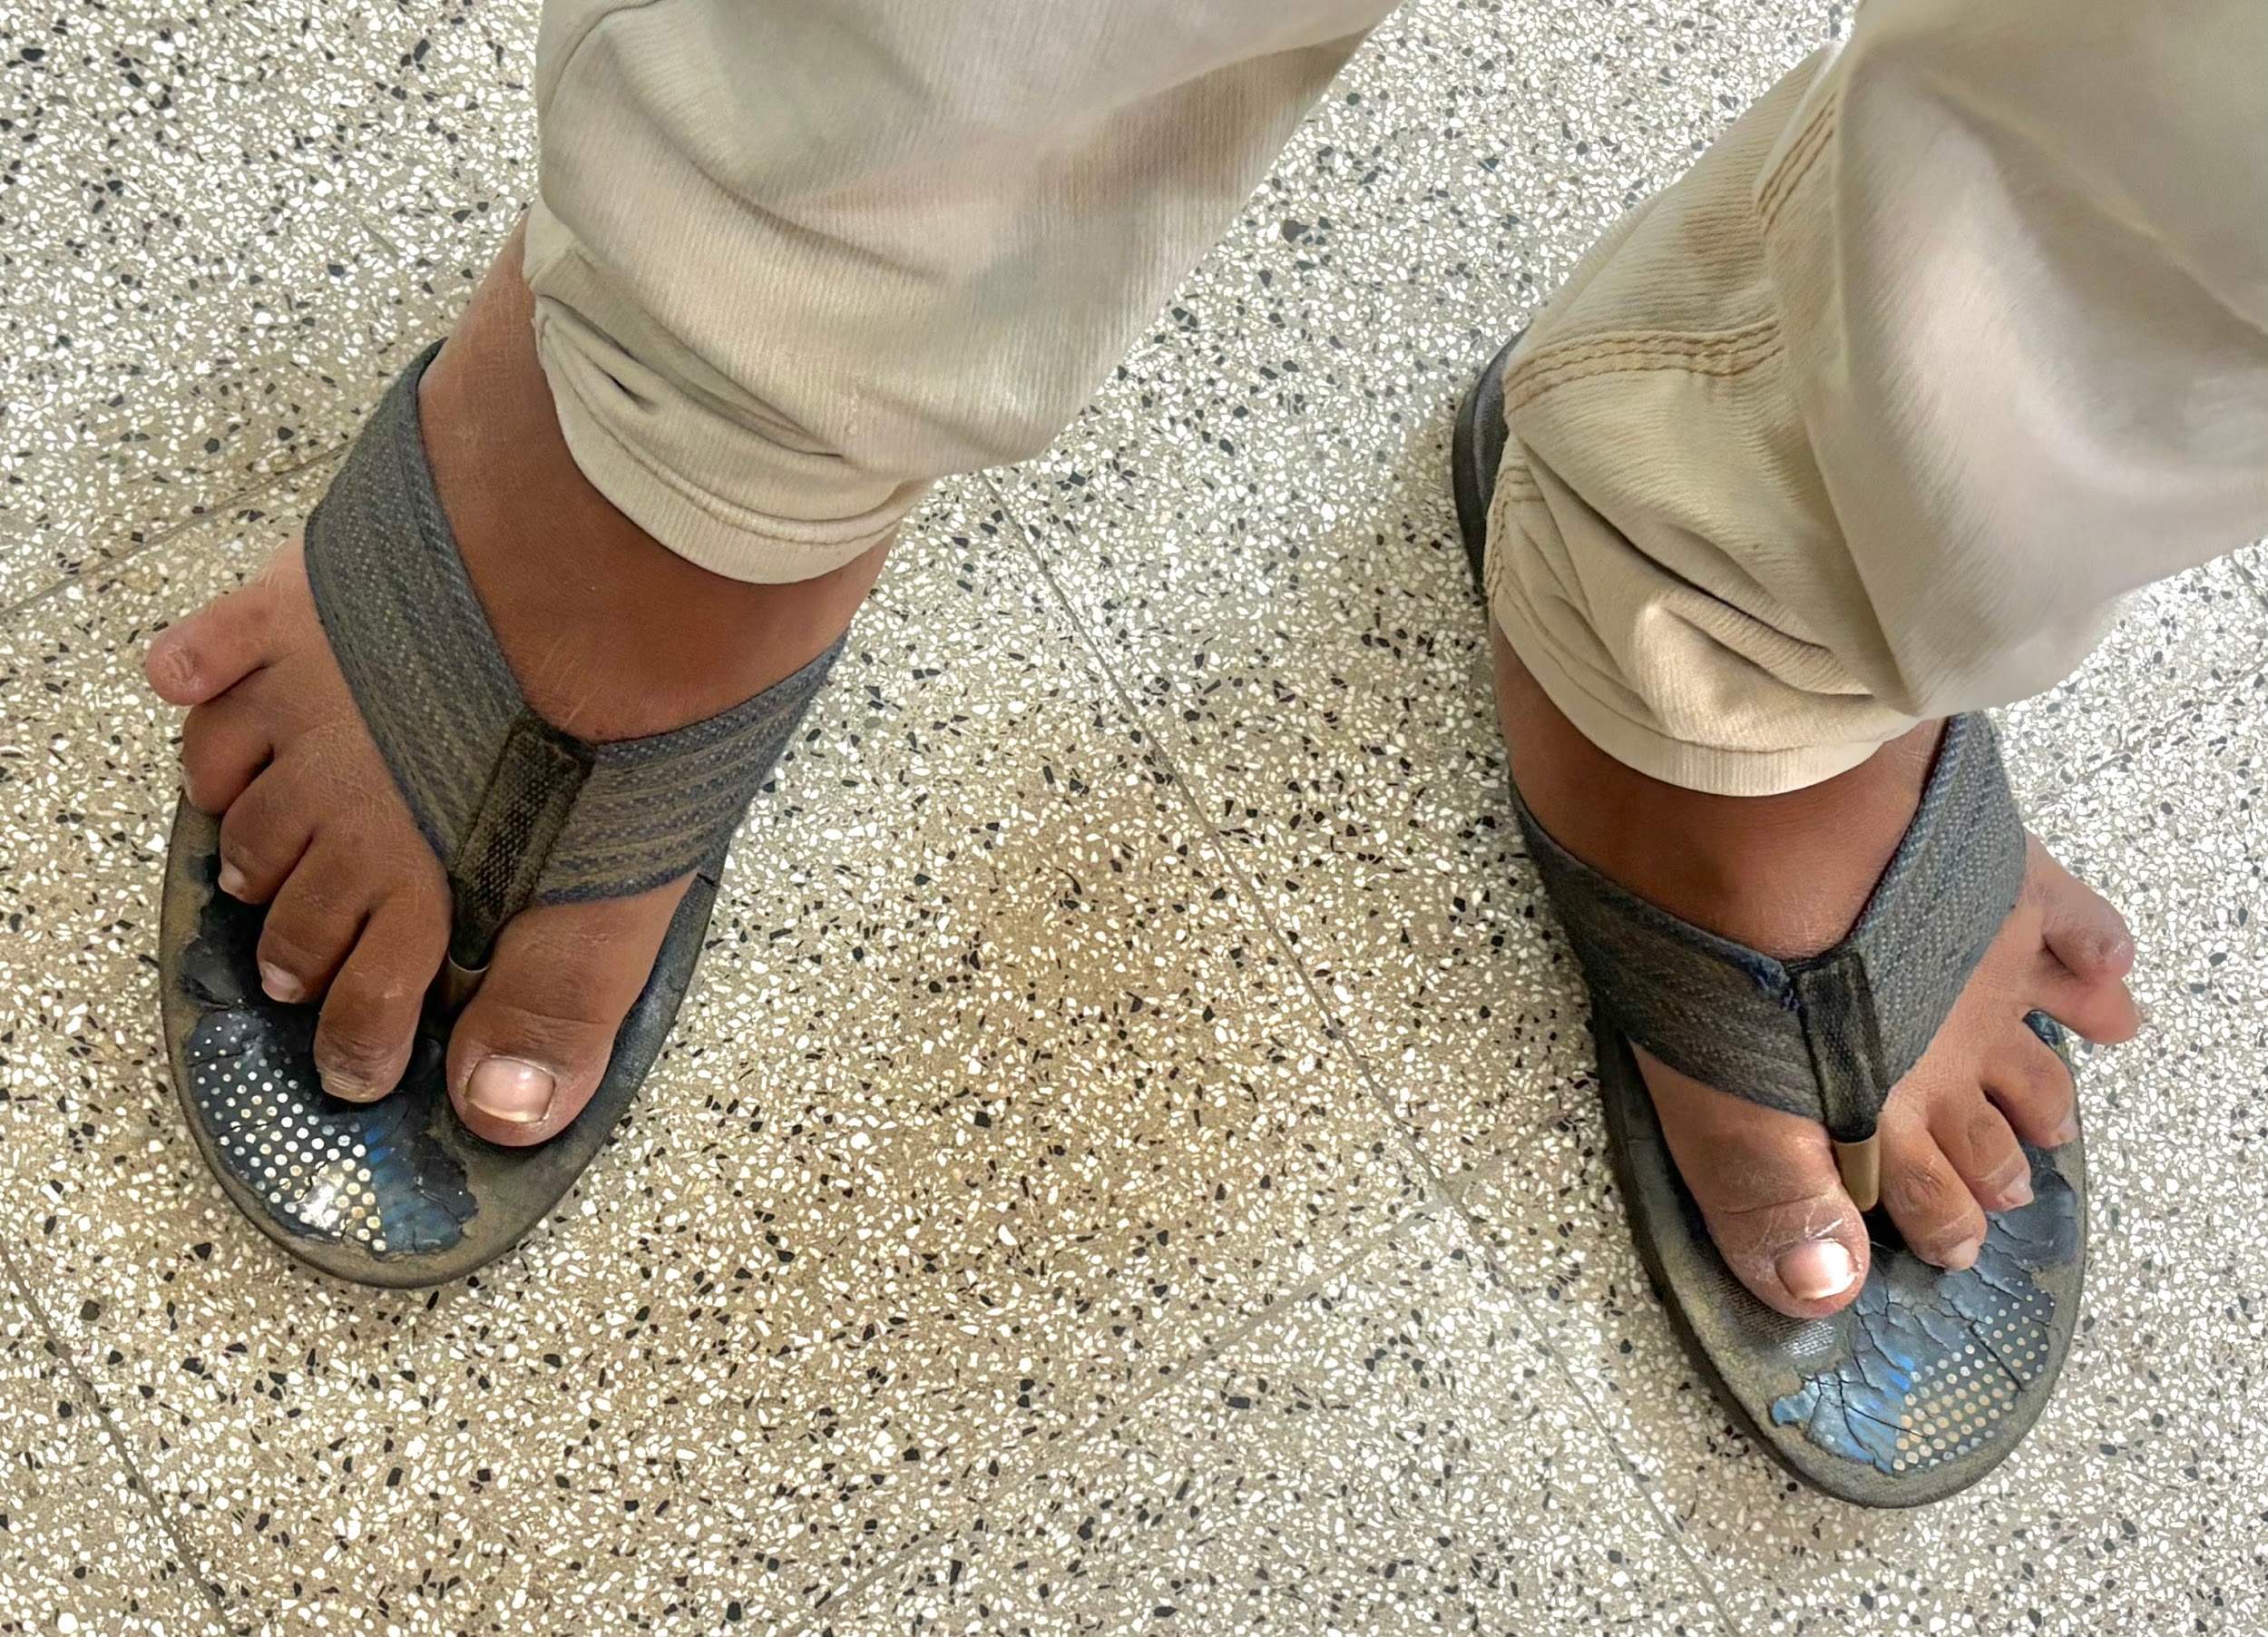

Figure 3- Showing Post Axial Polydactyly with broad toes

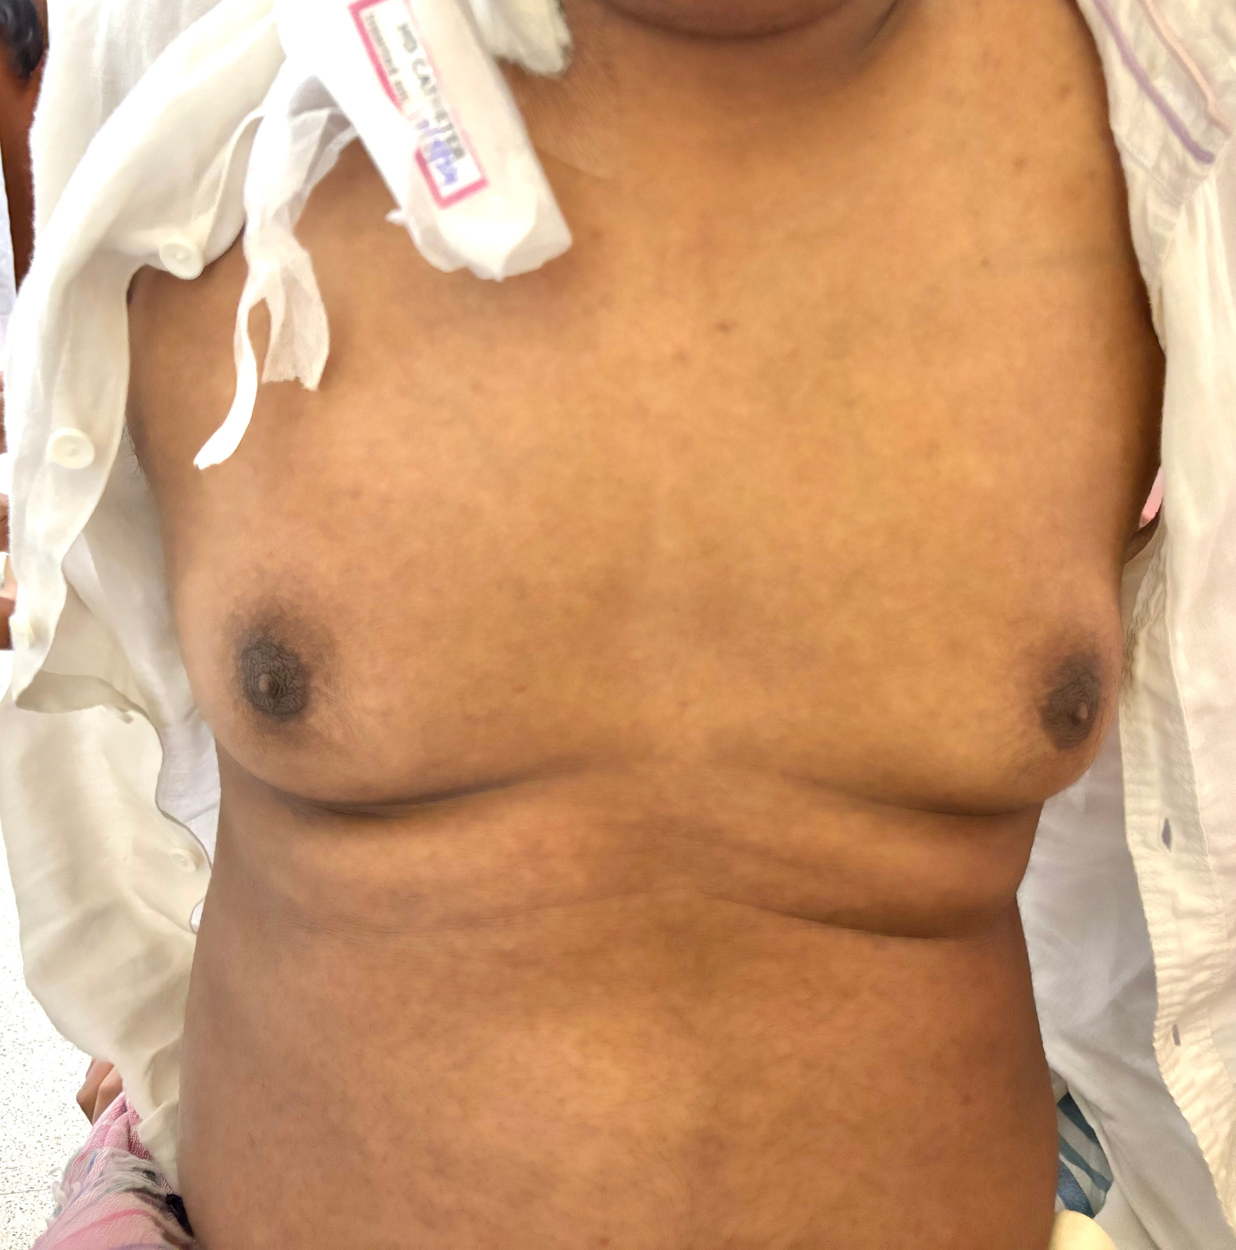

Figure 4- Showing Central Obesity and Gynecomastia

**DISCUSSION**

The diagnosis of BBS requires if at least three primary and two secondary characteristics are present , or if they have at least four primary characteristics as listed in Table 1. So far less than 15 documented cases in India have been published across journals. Our rare case report presents all the classical six cardinal primary features of BBS.

Very few case reports and cases are reported from India which includes all the six cardinal primary features.6Very few cases present in Chronic Kidney stage requiring hemodialysis like in our case. Management was mainly conservative for the Chronic kidney disease similar to other individuals requiring same modalities of renal replacement therapy and additional supplementation of growth and gonadal growth hormone replacement therapy for growth and sexual maturity.

**Conclusion**

BBS is a rare genetic disorder with a poor prognosis if renal system is involved. Antenatal Anomaly Screening (AAS) using the ultrasonography helps early detection while looking for the renal anomalies and polydactyly. No definitive cure is available however promising trials are in place including upcoming AXV-101 gene therapy trial. Management included multidisciplinary approach for the varied manifestations. Family counselling and genetic panel testing must be carried out for other family members.

References

1. Mujahid S, Hunt KF, Cheetham T, et al.

The endocrine and metabolic characteristics of a large Bardet-Biedl syndrome cohort. J Clin Endocrinol Metab 2020;105:e2587-98.

2. Tsyklauri O, Niederlova V, Forsythe E, et al. Bardet-Biedl syndrome as a

chaperonopathy: dissecting therapeutic approaches. Cell Stress Chaperones 2023;28:523-38.

3. Niederlova V, Modrak M, Tsyklauri O, et al.

Meta-analysis of genotype-phenotype associations in Bardet-Biedl syndrome. Hum Mutat 2019;40:2068-87.

4. Forsythe E, Sparks K, Best S, et al. Risk factors for severe renal disease in Bardet-Biedl syndrome. J Am Soc Nephrol 2021;32:2369-81.

5. Alaerts J, De Knijf G, Loeys B, et al. Early genetic diagnosis in Bardet-Biedl syndrome impacts renal outcomes. Pediatr Nephrol 2023;38:2285-94.

6. Sanchez-Alvarez R, Martinez-Urbistondo D, Alegre F, et al. Chronic kidney disease progression in Bardet-Biedl syndrome: a 15-year follow-up study. Nephrol Dial Transplant 2022;37:2356-65.