Case report

Percutaneous hallux valgus correction: a case report

ABSTRACT

|  |
| --- |
| **Aims:** report the case of a percutaneous surgical treatment of hallux valgus in a young patient with bilateral symptoms, highlighting the technique used, the clinical evolution and discussing, based on current scientific literature, the indications, advantages and limitations of the percutaneous procedure compared to other traditional approaches.  **Presentation of Case**: A 34-year-old female patient complaining of bilateral pain with a bony prominence on the medial border of the foot for about 2 years underwent a PECA in early 2025. The procedure was uneventful and the postoperative period was pain-free and quick.  **Discussion:** Halux Valgus, popularly known as a bunion, is a foot deformity characterized by lateral deviation of the hallux and medial deviation of the first metatarsal, usually associated with pain, discomfort when wearing shoes and lack of functionality. It has a multifactorial etiology and predominates in older women. Conservative treatment is usually the first approach. Nowadays, a more recent technique stands out: percutaneous Chevron and Akin (PECA).  **Conclusion:** The success of the operation was attributed to the appropriate indication, surgical planning and professional training. The importance of health education for the patient and for medical training is also highlighted, and the sharing of this case presents the results of this minimally invasive technique and contributes to greater adherence to it. |

*Keywords: Hallux Valgus, PECA technique, percutaneous, minimally invasive surgery*

1. INTRODUCTION

Hallux valgus, lateral angulation of the big toe towards the little toes,

commonly known as bunions, is a complex deformity of the foot and can be considered in three planes: frontal, transverse and sagittal, so that the coronal deformity is characterized by pronation of the first metatarsal and is present in up to 87% of individuals with hallux valgus¹, due to a multifactorial etiology with clinical manifestations between the 3rd and 5th decade of life in 65% of the population². This condition leads to poor balance and increases the risk of falling, increasing the difficulty of fitting into shoes and pain³. Therefore, conservative (non-surgical) interventions, which treat the pain rather than curing the deformity, are generally first-line treatments and if not corrected, surgical treatment is indicated³.

In recent decades, minimally invasive surgery and percutaneous surgical techniques have gained prominence, showing post-operative results with smaller scars, less pain, lower risk of infection and fewer wound complications⁴. In this context, the minimally invasive Percutaneous Chevron and Akin Osteotomy (PECA), belonging to the third generation of percutaneous surgeries for hallux valgus correction, which can be fixed with compression screws, has shown better results when compared to the first and second generation techniques⁴,¹. Thus, there is still debate as to the efficiency of this type of osteotomy and the indication for this minimally invasive technique.

The aim of this article is to report the case of a percutaneous surgical treatment of hallux valgus in a young patient with bilateral symptoms. Surgical treatment of hallux valgus in a young patient with bilateral symptoms, highlighting the technique used, the clinical evolution and discussing, based on current scientific literature, the indications, advantages and limitations of the percutaneous procedure compared to other traditional approaches.

2. Presentation of cAse

A 34-year-old female patient, weighing 59 kg, 150 cm tall and with a BMI (body mass index) of 22.22, in continuous use of contraceptives, and with previous surgery to place a venous catheter (CVL), arrived complaining of pain that had started 2 years ago in a bony prominence on the medial metatarsal border, bilateral, worse on the right, figure 1.

**Fig. 1:** **Radiografias frontal and lateral radiographs and preoperative image (respectively from left to right)**

**Figura**

**1**

**:**

radiographs preoperative image (respectively from left to right)

frontal e lateral e imagem pré

-

operatória

(

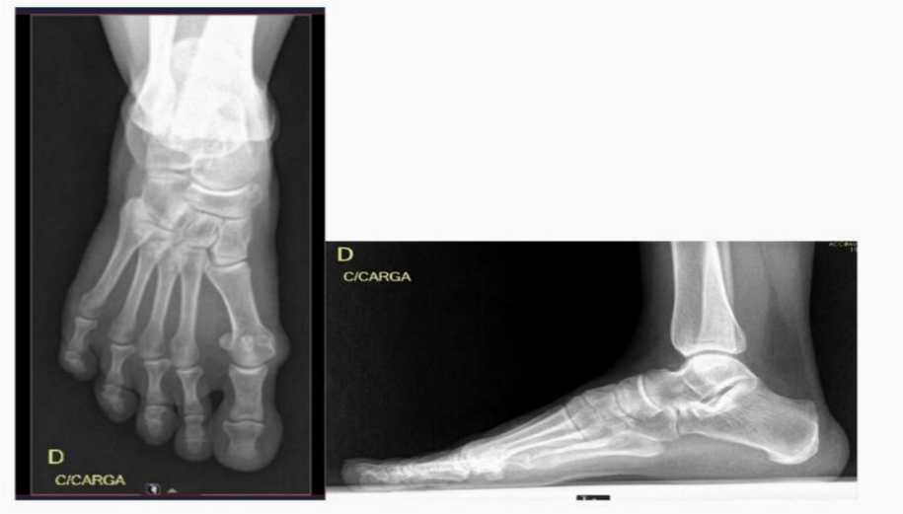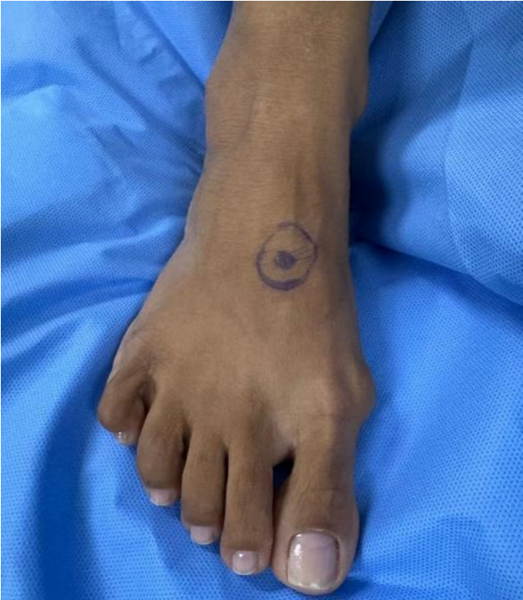

Physical examination showed hypermobility of the first ray, greater on the right, Bunion greater on the right, reducible McBride and good range of motion. Osteotomy of the first metatarsal was performed at the beginning of 2025 with 1 delicate saw blade, lateral sliding and fixation with provisional guide wires, percutaneous fixation with 2 HCS screws (headless bone compression screws) 3.0mm, osteotomy of the proximal phalanx of the hallux (Akin type) and fixation of 1 HCS screw 2.4mm. The procedure was checked by intraoperative scope and finished with skin suturing and occlusive dressing. A total of three HCS screws, three guide wires and a saw blade were used (figure 2).

**Fig. 2:** **Frontal and lateral radiographs and post-operative image (respectively from left to right)**

**Figura**

**2**

**:**

Radiografias

frontal

e

lateral

e

imagem

pós

-

operatória

(

respectivamente

da

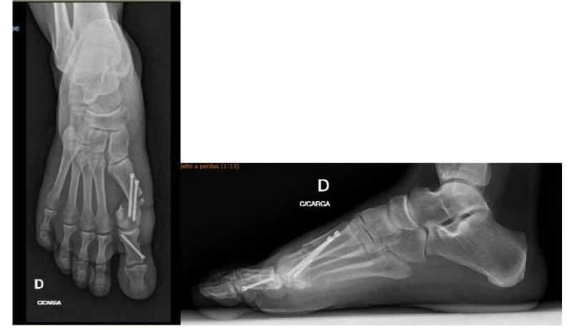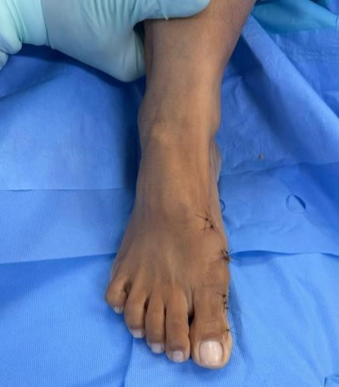

The patient was discharged from hospital walking with a load and on her first return, the patient had no complaints of pain, was wearing an orthopedic boot (Robofoot) and continued to walk with a load. On her return visit, she was still pain-free and wearing a Baruk orthopedic sandal.

3. discussion

Hallux valgus is a common deformity of the forefoot, also known as bunions. It is characterized by lateral deviation of the hallux and medial deviation of the first metatarsal, which can result in pain, functional limitation and difficulty with footwear. Frequently occurring in women, especially from the third decade onwards, and associated with mechanical overload and genetic factors, hallux valgus should be treated surgically when there is severe pain, an impact on quality of life and additional complications for the patient². The case described here shows a young, symptomatic patient with bilateral involvement, with greater severity on the right, which justifies surgical intervention.

In this sense, the choice of the percutaneous PECA technique was appropriate, especially considering the patient's functional demands and the potential aesthetic benefit [5,6]. Recent studies have shown that this minimally invasive approach not only provides satisfactory results in angular correction, but also has advantages such as shorter surgical time, less bleeding, reduced recovery time, less post-operative pain and lower rates of infection and wound complications⁴ʾ¹. In addition, an important functional benefit provided by the PECA is the possibility of early release for mobilization and weight-bearing, which favours faster rehabilitation and early return to daily activities, without compromising the stability of the osteotomy⁴. Thus, the success of the technique depends on the correct indication, and PECA can correct moderate and severe deformities, with good maintenance of the angles in the medium term, as long as the criteria are respected².

It is important to emphasize that reliance on intraoperative fluoroscopy requires adequate equipment and the surgeon's experience to ensure that the osteotomy is performed correctly, which limits its applicability in medical centers that do not have this structure⁴ʾ¹. In addition, there is a potential risk of inadequate fixation or insufficient correction when the technique is not performed by trained professionals². Therefore, even though PECA shows good results in mild to moderate deformities, its effectiveness in severe cases still requires a greater number of studies to consolidate its superiority compared to traditional open techniques².

Thus, in the case reported of the patient who underwent percutaneous hallux valgus surgery, the presence of a reducible bunion and hypermobility of the first ray contributed to appropriate surgical planning [7-10]. Fixation with HCS screws and the inclusion of the Akin-type osteotomy suggest a complete approach to the deformity, aimed not only at angular correction, but also at stability of the metatarsophalangeal joint. Thus, the good post-operative evolution reinforces the viability of the percutaneous technique as a safe and effective alternative, even in young patients with high functional demands¹,³.

4. Conclusion

This report presents the percutaneous correction of hallux valgus using the PECA technique, which proved to be effective, safe and with good post-operative recovery, even in young patients with moderate to severe deformity. In this sense, the choice of technique, together with surgical planning and professional training, was of great importance to the success of the procedure and the patient's rapid recovery.

This case also showed that health education is relevant both for the patient, who needs to patient, who needs to understand their viable therapeutic options, and for medical training, which needs to present the advances, advantages and disadvantages of minimally invasive operations for this type of treatment.

Finally, sharing this knowledge could benefit countless patients who suffer from these orthopaedic deformities, by offering a more up-to-date, safer, less invasive approach that provides a better quality of life in the post-operative period.

Consent (where ever applicable)

With regard to the ICF (Informed Consent Form, from Portuguese TCLE-Termo de Consentimento Livre e Esclarecido), we ask that it be waived, since the surgery has already been carried out and we will not have any intervention from now on and we will not use any data that could identify the patient.

Ethical approval (where ever applicable)

This report was assessed and approved by the Research Ethics Committee - CAAE: 89296125.0.0000.5076, in compliance with the ethical and legal principles established in Resolution 466/2012 and Circular Letter 166/2018.

References

1. Yañez Arauz, J. M., Raimondi, N., Eksarho, A., Lauritto, D., Yañez Arauz, M. E., & Yañez Arauz, J. M. (2021). Minimally invasive chevron surgery and percutaneous Bosch osteotomy in the treatment of hallux valgus. Medium-term results. Comparative radiological study*. Brazilian Journal of Orthopedics. https://doi.org/10.1055/s-0041-1729590

2. FERREIRA, G. F., MATTOS E DINATO, M. C., SANTOS, T. F. D., MIZIARA, P., & PEREIRA FILHO, M. V. (2023). CAN THE PERCUTANEOUS CHEVRON AND AKIN (PECA) TECHNIQUE CORRECT FIRST METATARSAL PRONATION IN HALLUX VALGUS? Acta Ortopédica Brasileira, 31(spe2). https://doi.org/10.1590/1413-785220233102e265206

3. Dias, C. G., Godoy-Santos, A. L., Ferrari, J., Ferretti, M., & Lenza, M. (2024). Surgical interventions for the treatment of hallux valgus and bunions. Cochrane Database of Systematic Reviews, 2024(7). https://doi.org/10.1002/14651858.cd013726.pub2

4. Dragosloveanu S, Popov VM, Cotor DC, Dragosloveanu C, Stoica CI. Percutaneous Chevron Osteotomy: A Prospective Randomized Controlled Trial. Medicine. 2022 Mar 1;58(3):359. <https://doi.org/10.3390/medicina58030359>

5. Bauer, T., de Lavigne, C., Biau, D., De Prado, M., Isham, S., & Laffenétre, O. (2009). Percutaneous hallux valgus surgery: a prospective multicenter study of 189 cases. Orthopedic Clinics of North America, 40(4), 505-514.

6. Bia, A., Guerra-Pinto, F., Pereira, B. S., Corte-Real, N., & Oliva, X. M. (2018). Percutaneous osteotomies in hallux valgus: a systematic review. The Journal of Foot and Ankle Surgery, 57(1), 123-130.

7. Trnka, H. J. (2021). Percutaneous, MIS and open hallux valgus surgery. EFORT Open Reviews, 6(6), 432-438.

Magnan, B., Pezzè, L., Rossi, N., & Bartolozzi, P. (2005). Percutaneous distal metatarsal osteotomy for correction of hallux valgus. JBJS, 87(6), 1191-1199.

8. Lee, M., Walsh, J., Smith, M. M., Ling, J., Wines, A., & Lam, P. (2017). Hallux valgus correction comparing percutaneous chevron/akin (PECA) and open scarf/akin osteotomies. Foot & Ankle International, 38(8), 838-846.

9. Miranda, M. A. M., Martins, C., Cortegana, I. M., Campos, G., Pérez, M. F. M., & Oliva, X. M. (2021). Complications on percutaneous hallux valgus surgery: a systematic review. The Journal of Foot and Ankle Surgery, 60(3), 548-554.

10. Caravelli, S., Mosca, M., Massimi, S., Costa, G. G., Lo Presti, M., Fuiano, M., ... & Zaffagnini, S. (2018). Percutaneous treatment of hallux valgus: What’s the evidence? A systematic review. Musculoskeletal Surgery, 102, 111-117.