**Numerical Analysis of Conjugate MHD Free Convection of Cu–H₂O Nanofluid in a Top Corrugated Trapezoidal Cavity with Multiple Heat Generating Obstacles of Different Shapes**

**Abstract**

This thesis presents a numerical investigation of conjugate magnetohydrodynamic (MHD) free convective flow of Cu–H₂O nanofluid within a top-corrugated trapezoidal cavity containing multiple internal heat-generating objects of different geometries square, star, and triangular. The study is conducted under steady-state, laminar, incompressible conditions using COMSOL Multiphysics to explore the effects of Rayleigh number (Ra), Hartmann number (Ha), cavity inclination angle (λ), and obstacle shape on thermal and flow behavior. Key performance indicators such as Nusselt number, entropy generation, thermal performance criterion (TPC), and average fluid temperature are analyzed to assess system efficiency. Results reveal that square-shaped obstacles provide the highest heat transfer rate and lowest entropy generation across all tested conditions. An inclination angle of 20° offers optimum fluid circulation and temperature distribution, leading to enhanced thermal performance. The presence of a magnetic field (Ha = 50) moderates’ convection by suppressing flow strength, especially at high Ra. Comparative evaluations confirm that the combination of square obstacles and a 20° cavity inclination yields the most thermodynamically efficient configuration. This study provides valuable insights for optimizing MHD nanofluid systems in engineering applications such as electronic cooling, solar collectors, and advanced energy systems.

*Keywords: Conjugate Heat Transfer, Magnetohydrodynamics (MHD), Nanofluid, Trapezoidal Cavity, Heat-Generating Obstacles*

**1.0 Introduction**

Heat transfer enhancement in enclosures has been a subject of extensive investigation due to its wide range of applications in solar collectors, nuclear reactors, energy storage systems, and electronic cooling. The integration of nanofluids fluids embedded with nanoparticles such as Cu, Al₂O₃, and Fe₃O₄ has significantly improved thermal conductivity and convective transport phenomena [1]–[3]. Among them, the Cu–H₂O nanofluid has gained prominence for its superior thermophysical properties and energy transport efficiency [4], [5]. Natural and mixed convective flows in non-rectangular enclosures, such as trapezoidal, triangular, and wavy cavities, introduce complexity to the thermal field due to variable aspect ratios, inclined surfaces, and non-uniform heat sources [6]–[9]. Several studies [10]–[13] have demonstrated that wavy or corrugated walls improve mixing and circulation, which in turn enhances heat removal capability.

The presence of magnetohydrodynamic (MHD) effects, induced by external magnetic fields, introduces an additional control mechanism via Lorentz forces. These forces resist fluid motion, altering the convective flow pattern and entropy generation [14]–[18]. For example, Mahamuda and Ali [3] and Abderrahmane et al. [16] showed that magnetic fields reduce flow instabilities, suppressing chaotic eddies while modulating entropy production. Internal heat-generating objects, particularly when of non-standard geometries such as star, triangular, or square shapes, influence the internal flow fields by introducing additional thermal resistance and boundary layer disruptions [5], [17], [22]. Bilal et al. [17] examined star-shaped enclosures, revealing enhanced thermal circulation but increased entropy production due to vortex formations. Similarly, Selimefendigil [22] emphasized the role of internal solid bodies in tuning heatline paths and thermal stratification.

In recent years, attention has turned to the role of inclination angle in modulating buoyancy-driven flows. Studies such as [19], [20], and [30] highlighted that inclined trapezoidal geometries at moderate angles improve heat transfer uniformity while minimizing entropy generation. Hussein et al. [21] examined the combined influence of porous layers, rotation, and corrugated bottom walls, providing design insight into multilayered thermal systems.

A wide body of literature [23]–[28] has also focused on cylindrical or rotating obstacles, multi-phase hybrid nanofluids, and flexible walls, broadening the operational regimes for cavity heat transfer analysis. Others [29]–[31] studied the coupling of magnetic effects with variable permeability and internal heating, observing nonlinear dependencies in entropy generation and TPC performance. Moreover, research on wavy lid-driven and multi-lid cavities [32]–[35] revealed intricate coupling between fluid flow stability and thermal boundary distribution. Akter and Parvin [36] particularly analyzed rectangular blocks in magnetized trapezoidal cavities, a geometry similar to the present study but without internal multi-body heat generation.

From a thermodynamic perspective, minimizing entropy generation has been an important optimization criterion [14], [37]. Ishak et al. [37] and Chowdhury and Alim [38] demonstrated that localized heat sources, when strategically positioned, can significantly influence the rate of irreversible heat and fluid friction losses. Notably, studies such as [39]–[41] have demonstrated that hybrid nanofluids and rotating structures can further improve system performance, albeit at increased complexity. Boulahia et al. [42] and Khan et al. [43] illustrated the combined effects of wall waviness, central cold bodies, and ferrofluid dynamics, whereas Toghraie [44] investigated trapezoidal cavities under pure MHD convection using Cu–H₂O nanofluids.

Despite this rich literature, there exists a significant gap concerning the conjugate MHD free convective flow in top-corrugated trapezoidal cavities containing multiple internal heat-generating blocks of varied shapes (square, star, triangular), especially under varying inclination angles. Existing research has rarely considered this complex configuration in combination with entropy generation analysis, thermal performance criterion, and internal heat generation across multiple block geometries.

Therefore, the present study aims to address this void by analyzing the conjugate heat and MHD-driven flow of Cu–H₂O nanofluid in a top-corrugated trapezoidal cavity containing two symmetrically placed, heat-generating objects of distinct geometries. Using the finite element method (FEM) via COMSOL Multiphysics®, this work evaluates key performance indicators such as Nusselt number, entropy generation (St), average temperature, and thermal performance criterion (TPC) under various inclination angles (0°, 10°, 20°, 30°). The outcomes provide a comprehensive understanding of shape-dependent thermofluidic interactions in complex cavity systems, laying the groundwork for advanced thermal optimization strategies [45].

**2.0 Model Description**

The physical domain under investigation consists of a top-corrugated trapezoidal cavity filled with a Cu–H₂O nanofluid, as shown in Figures 1(a), 1(b), 1(c). The cavity includes two identical internal heat-generating objects placed symmetrically with respect to the vertical centerline. These objects are considered in three distinct geometries: square, star, and triangular, to examine their effect on thermal and flow behavior.

**2.1 Geometric Configuration**

The computational domain consists of a trapezoidal cavity inclined at an angle γ to the horizontal axis. The top wall of the cavity features a sinusoidal corrugation designed to enhance thermal mixing and improve convective heat transfer. The cavity has a height H, a base width L, and a corrugation wavelength λ. Internally, heat-generating obstacles are symmetrically placed at a height of H/2 from the bottom and spaced L/2 apart. A uniform horizontal magnetic field B0 is applied across the domain to study the influence of magnetohydrodynamic (MHD) effects on the conjugate heat transfer performance.

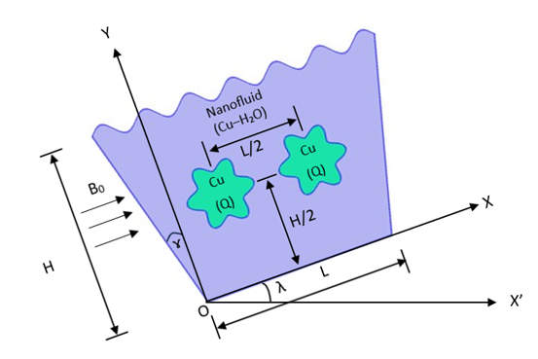

Fig 1(a). Geometry

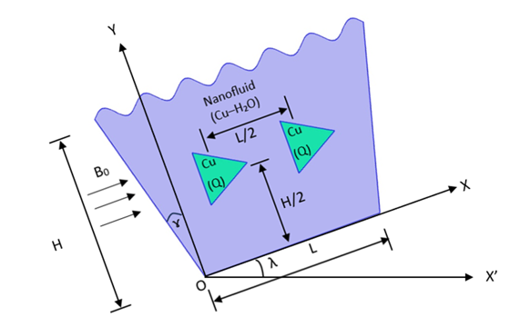

Fig 1(b). Geometry

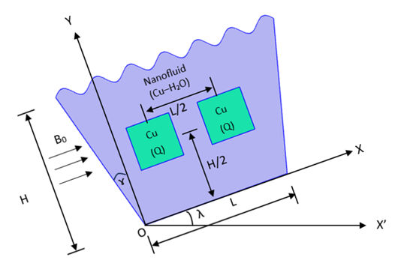

Fig 1(c). Geometry

**2.2 Working Fluid**

The enclosure is filled with a Cu–H₂O nanofluid, composed of copper nanoparticles uniformly dispersed in a water base. This nanofluid is selected for its high thermal conductivity, stable suspension behavior, and suitable density and viscosity characteristics that support efficient convective heat transfer. The fluid is modeled as a single-phase homogeneous medium, with constant and temperature-independent thermophysical properties to simplify the numerical analysis.

**2.3 Mathematical Assumptions**

The mathematical model is built on several simplifying assumptions: the flow is steady-state, laminar, and incompressible. The Boussinesq approximation is applied to account for buoyancy-driven convection. Effects of Joule heating, viscous dissipation, and thermal radiation are neglected due to their minimal influence under the studied conditions. The governing equations include the continuity, momentum (Navier–Stokes), and energy equations, integrated with a Lorentz force term to capture the impact of magnetohydrodynamic (MHD) effects.

**2.4 Boundary Conditions**

The boundary conditions for the simulation are provided below and depicted visually in the attached schematic figures:

**Table 1: Boundary Conditions**

| **Boundary** | **Condition Type** | **Temperature Value** |
| --- | --- | --- |
| Top Wavy Wall | Isothermal | T=Tm |
| Bottom Wall | Isothermal | T=Tm​ |
| Left & Right Walls | Thermal Insulation (Adiabatic) | n⋅∇T=0 |
| Obstacles | Internal Volumetric Heat Source | Heat generation rate Q |

**2.5 Simulation and Domain Setup**

The numerical simulations are conducted using COMSOL Multiphysics, where the trapezoidal cavity domain is discretized with a structured mesh, refined locally around the heat-generating obstacles to accurately capture steep thermal and velocity gradients. The study explores four inclination angles (λ= 0°, 10°, 20°, and 30°) and three internal obstacle geometries (square, star, and triangular) to evaluate their effects on key thermal performance metrics, including the Nusselt number (Nu), entropy generation (St), thermal performance criterion (TPC), and average nanofluid temperature (Tavf).

**2.6 Summary of Key Objectives**

This study aims to optimize the thermal behavior and entropy efficiency of a Cu–H₂O nanofluid system under magnetohydrodynamic effects. Through systematic numerical modeling, the following objectives are pursued:

1. To investigate the thermal-fluidic response of Cu–H₂O nanofluid inside a corrugated trapezoidal cavity.
2. To examine the role of object shape (square, star, triangle) in enhancing or degrading heat transfer.
3. To identify the optimal inclination angle for maximum convective performance and minimum entropy generation.

**3.0 Mathematical Modeling**

To investigate the conjugate MHD free convective heat transfer inside a top-corrugated trapezoidal cavity filled with a Cu–H₂O nanofluid, a complete mathematical model is developed. The model encompasses fluid flow, heat transfer, and magnetic field effects. It is governed by a set of dimensional and non-dimensional equations based on laminar, steady, and incompressible flow assumptions, and the Boussinesq approximation for buoyancy effects.

**3.1 Governing Equations:**

**Dimensional Formulation**

The dimensional governing equations ([2], [13],[14],[21],[32],[39]) for mass, momentum, and energy conservation, incorporating MHD effects, are:

 (1)

 (2)

 (3)

 (4)

**3.2 Nanofluid Thermophysical Properties**

The thermophysical properties of the nanofluid (Cu–H₂O) are calculated based on the nanoparticle volume fraction ϕ:

 (5)

 (6)

 (7)

 (8)

 (9)

**3.3 Non-Dimensional Formulation**

To simplify the equations, the following dimensionless variables are introduced:

 (10)

 (11)

 (12)

 (13)

 (14)

 (15)

**3.4 Non-Dimensional Nanofluid Properties**

 (16)

 (17)

 (18)

 (19)

 (20)

**3.5 Heat Transfer Quantities**

Nusselt number (Nu) along wall and Average Nusselt number (Nuavg) inside the enclosure are assessed and expressed as performance parameters of the current system in the following ways:

 (21)

 (22)

Here, Lw is the arc length of the top wavy wall.

**3.6 Thermophysical Parameters**

Table 2: Properties of Copper Nanoparticles and Pure Water

| **Property** | **Copper (Cu)** | **Water** |
| --- | --- | --- |
| Density (ρ), kg/m³ | 8933 | 996.60 |
| Specific Heat (Cp), J/kg·K | 385 | 4179.2 |
| Thermal Conductivity (k), W/m·K | 401 | 0.6102 |
| Volumetric Expansion (β), 1/K | 4.99×10⁻⁵ | 2.66×10⁻⁴ |
| Electric Conductivity (σ), S/m | 5.96×10⁷ | 5.50×10⁵ |

Copper exhibits superior thermal and electrical conductivity but higher density, which enhances conduction but increases inertia. Water has high specific heat and volumetric expansion, promoting buoyancy-driven flow.

Table 3: Nanofluid Properties (φ = 0.02)

| **Property** | **Unit** | **Value** |
| --- | --- | --- |
| Density (ρ) | kg/m³ | 1155.30 |
| Specific Heat (Cp) | J/kg·K | 3592.50 |
| Thermal Conductivity (k) | W/m·K | 0.64739 |
| Dynamic Viscosity (μ) | kg/m·s | 8.9803×10⁻⁴ |
| Electrical Conductivity (σ) | S/m | 5.8367×10⁻⁶ |
| Thermal Diffusivity (α) | m²/s | 1.4651×10⁻⁷ |
| Volumetric Expansion (β) | 1/K | 2.3258×10⁻⁴ |

This data shows that increasing Cu content improves thermal conductivity and density while slightly reducing specific heat. These changes lead to stronger thermal conduction but increased fluid resistance, indicating a trade-off between heat transfer and flow inertia.

**4.0 Results and Discussion**

**4.1 Verification**

To ensure the reliability and accuracy of the numerical model developed in this study, a benchmark validation is performed by comparing the streamline patterns from the present simulation with results reported in Ref. [45].

|  |  |
| --- | --- |
| [45] | Present |
|  |  |
| Fig 2. Comparison of the Streamline in the Ref. [45] and present study | |

As shown in Fig. 2, the left panel represents the reference solution from [45], while the right panel shows the streamline contours obtained in the present study. Both figures exhibit a single dominant primary vortex occupying the majority of the cavity, which is characteristic of lid-driven cavity flows with a central heat-generating rotating cylinder. In comparison, the present results also capture these key flow features with high fidelity. Additionally, the streamlines are superimposed over a color-coded velocity magnitude field, offering enhanced visual interpretation of the flow dynamics. The velocity contours reveal high-speed zones near the lid and deceleration near the walls and around the internal cylinder, consistent with expected mixed convection behavior.

**4.2 Flow and Thermal Field Characteristics**

Figures 3 to 20 illustrate the velocity and temperature contours for three different internal obstacle shapes Star, Triangle, and Square under varying inclination angles (λ = 0°, 20°, 30°), Ra from 103 to 106, and Ha values (0 and 50). These results enable a comprehensive analysis of heat transfer, flow circulation, and magnetic damping effects in the conjugate MHD system.

Star-shaped obstacles (Figs. 3–8) generate complex flow and thermal behaviors due to their sharp edges. At Ha=0, increasing Ra enhances clockwise circulation with localized vortices forming near the tips. The presence of a magnetic field (Ha=50) suppresses velocity, particularly around the corners. At inclination angles λ = 20° and 30°, flow shifts and secondary eddies intensify. Temperature fields reveal tightly wrapped isotherms around the obstacle, with more vertical thermal plumes as inclination increases. Although star shapes improve local heat transfer, they slightly raise entropy due to tip-induced vorticity.

Triangular-shaped obstacles (Figs. 9–14) show distinct flow and thermal characteristics influenced by Ra, Ha, and inclination. Velocity fields (Figs. 9, 11, 13) reveal that at low Ra, flow separation is weak, while at Ra = 10⁶, a strong corner eddy develops near the triangle base. Applying Ha=50 dampens vortex intensity and reduces core velocity by up to 25%. At λ = 20°, the flow becomes more centered with improved symmetry. Temperature fields (Figs. 10, 12, 14) indicate sharper contours at high Ra, especially along the inclined wall, suggesting enhanced heat transfer. However, the triangle’s pointed tips restrict fluid motion, creating stagnation zones and localized heating. Overall, triangular blocks offer thermal stability but moderately hinder heat exchange due to geometric flow blockage.

Square-shaped obstacles (Figs. 15–20) exhibit highly efficient flow and thermal performance across all conditions. Velocity fields (Figs. 15, 17, 19) show a strong, uniform recirculation cell for all Ra values, with smoother flow reattachment and fewer corner vortices compared to star and triangular shapes. Inclined cavities (λ=20°, 30°) enhance flow uniformity due to buoyancy alignment, while MHD effects at Ha=50 reduce velocity magnitude without disrupting the stable flow structure. Temperature fields (Figs. 16, 18, 20) display well-defined thermal boundary layers and steep gradients at higher Ra, indicating strong heat transport. The square geometry offers larger heat transfer surfaces and maintains symmetric temperature distribution even under inclination. Overall, square-shaped obstacles provide the best thermal performance, combining minimal resistance, high heat transfer efficiency, and stable flow behavior.

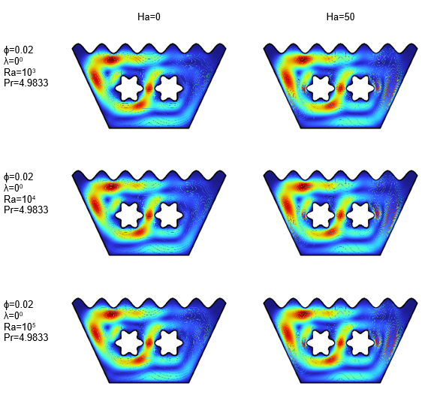

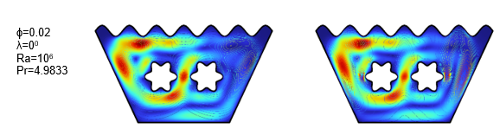

Fig 3. Velocity Contour for Star when λ=00

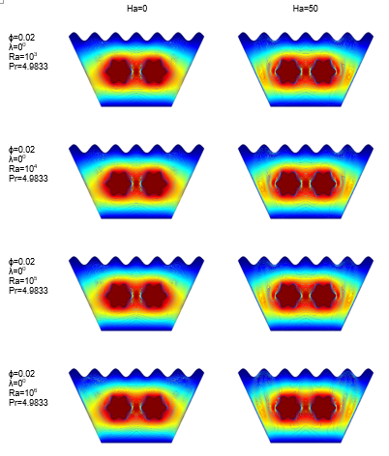

Fig 4. Temperature Contour for Star when λ=00

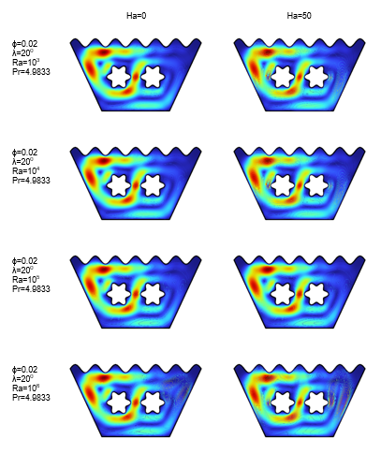

Fig 5. Velocity Contour for Star when λ=200

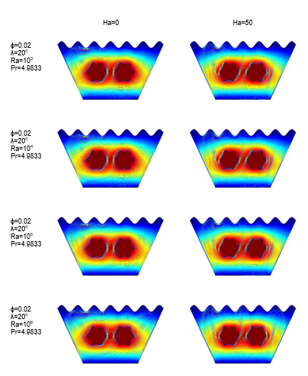

Fig 6. Temperature Contour for Star when λ=200

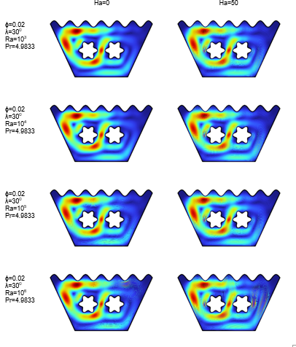

Fig 7. Velocity Contour for Star when λ=300

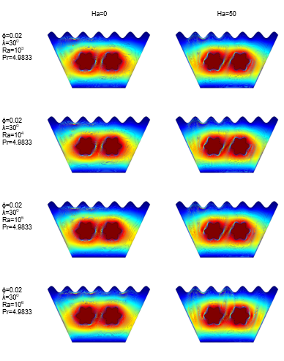

Fig 8. Temperature Contour for Star when λ=300

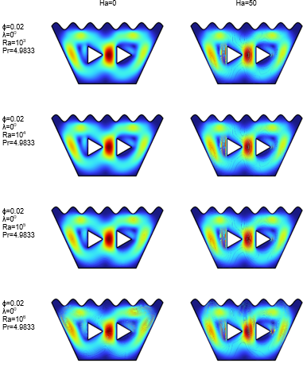

Fig 9. Velocity Contour for Triangle when λ=00

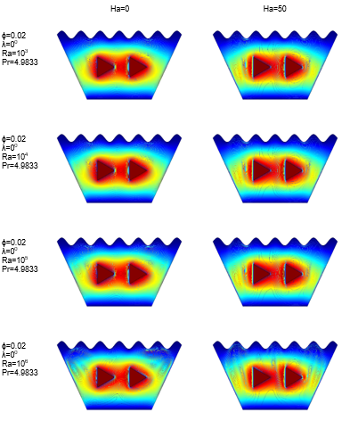

Fig 10. Temperature Contour for Triangle when λ=00

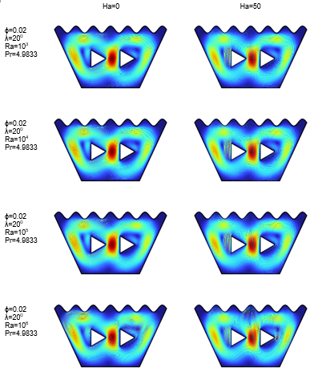

Fig 11. Velocity Contour for Triangle when λ=200

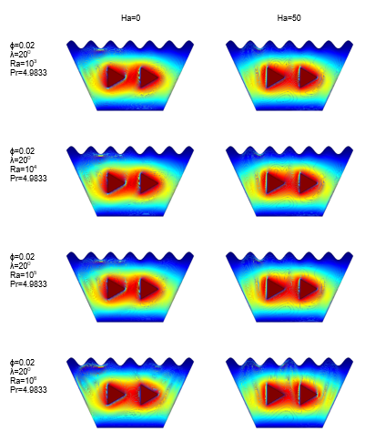

Fig 12. Temperature Contour for Triangle when λ=200

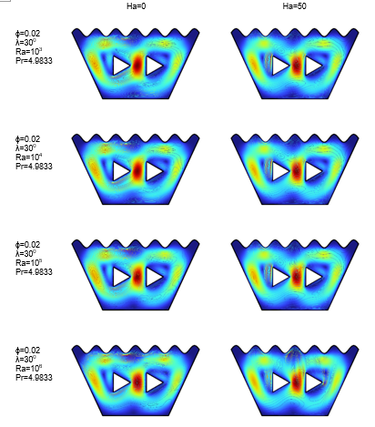

Fig 13. Velocity Contour for Triangle when λ=300

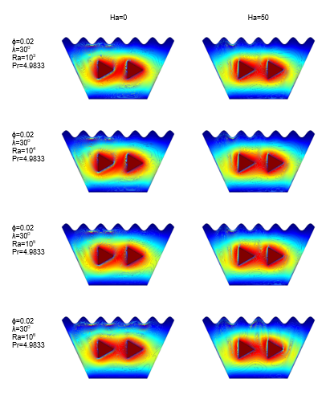

Fig 14. Temperature Contour for Triangle when λ=300

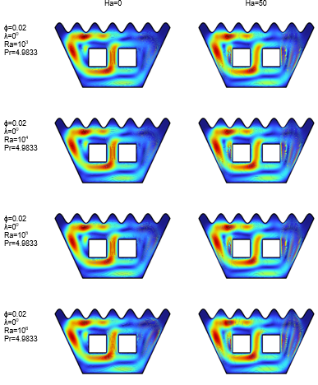

Fig 15. Velocity Contour for Square λ=00

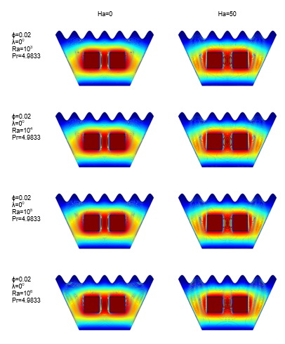

Fig 16. Temperature Contour for Square λ=00

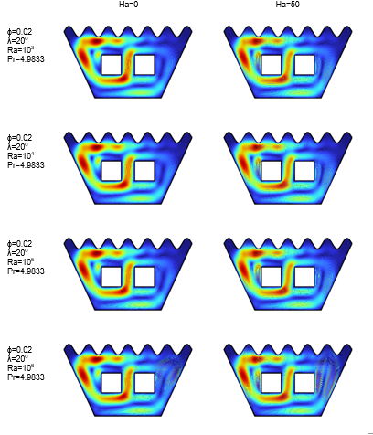

Fig 17. Velocity Contour for Square λ=200

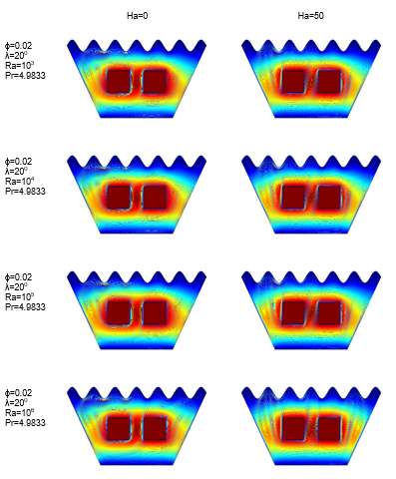

Fig 18. Temperature Contour for Square λ=200

|  |  |  |
| --- | --- | --- |
|  | Ha=0 | Ha=50 |
| ɸ=0.02  λ=300  Ra=103  Pr=4.9833 |  |  |
| ɸ=0.02  λ=300  Ra=104  Pr=4.9833 |  |  |
| ɸ=0.02  λ=300  Ra=105  Pr=4.9833 |  |  |
| ɸ=0.02  λ=300  Ra=106  Pr=4.9833 |  |  |

Fig 19. Velocity Contour for Square λ=300

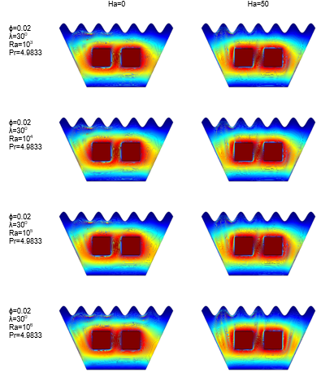

Fig 20. Temperature Contour for Square when λ=300

Overall comparison of the results from Figs. 3–20 indicates that the square-shaped obstacles provide the most consistent and efficient flow and thermal performance, characterized by strong central recirculation, high velocity cores, and compact isotherm distribution.

Table 4: Summary Table

| **Shape** | **Flow Uniformity** | **Thermal Efficiency** | **Entropy Gen.** | **Optimal Angle** |
| --- | --- | --- | --- | --- |
| Square | High | Excellent | Moderate | 20° |
| Star | Moderate | Good | Higher | 20° |
| Triangle | Fair | Moderate | Moderate | 20° |

Among the tested inclination angles, 20° emerges as the optimal choice, offering the best alignment of buoyancy forces with the cavity’s geometry. This configuration enhances convective transport while maintaining flow stability and symmetry, making it the ideal setup for maximizing heat transfer efficiency in MHD nanofluid systems.

Table 5.: Data Table for Square Shape when λ=00

|  |  |  |  |  |  |  |  |  |
| --- | --- | --- | --- | --- | --- | --- | --- | --- |
| Ra  (Rayleigh Number) | Nu  (Nusselt Number along heated wall) | | St  (Overall Entropy Generation) | | TPC  (Thermal Performance Criterion) | | Tavf  (Average Temperature of Fluid) | |
| Ha= 0 | Ha= 50 | Ha= 0 | Ha= 50 | Ha= 0 | Ha= 50 | Ha= 0 | Ha= 50 |
| 103 | 20.252 | 20.252 | 1.18E+08 | 1.18E+08 | 5.85E+06 | 5.85E+06 | 0.058149 | 0.058164 |
| 104 | 202.52 | 202.52 | 5.72E+08 | 5.71E+08 | 2.82E+06 | 2.82E+06 | 0.05864 | 0.058802 |
| 105 | 2025 | 2025.1 | 3.43E+09 | 3.39E+09 | 1.70E+06 | 1.67E+06 | 0.054875 | 0.058409 |
| 106 | 20243 | 20249 | 2.26E+10 | 2.28E+10 | 1.11E+06 | 1.13E+06 | 0.039624 | 0.048495 |

Table 6.a: Data Table for Square Shape when λ=200

|  |  |  |  |  |  |  |  |  |
| --- | --- | --- | --- | --- | --- | --- | --- | --- |
| Ra  (Rayleigh Number) | Nu  (Nusselt Number along heated wall) | | St  (Overall Entropy Generation) | | TPC  (Thermal Performance Criterion) | | Tavf  (Average Temperature of Fluid) | |
| Ha= 0 | Ha= 50 | Ha= 0 | Ha= 50 | Ha= 0 | Ha= 50 | Ha= 0 | Ha= 50 |
| 103 | 20.252 | 20.252 | 1.18E+08 | 1.18E+08 | 5.85E+06 | 5.85E+06 | 0.05815 | 0.058164 |
| 104 | 202.52 | 202.52 | 5.72E+08 | 5.71E+08 | 2.82E+06 | 2.82E+06 | 0.058651 | 0.058804 |
| 105 | 2024.9 | 2025.1 | 3.43E+09 | 3.39E+09 | 1.69E+06 | 1.67E+06 | 0.055471 | 0.058438 |
| 106 | 20245 | 20249 | 2.25E+10 | 2.28E+10 | 1.11E+06 | 1.13E+06 | 0.039595 | 0.04896 |

Table 6.b: Data Table for Square Shape when λ=300

|  |  |  |  |  |  |  |  |  |
| --- | --- | --- | --- | --- | --- | --- | --- | --- |
| Ra  (Rayleigh Number) | Nu  (Nusselt Number along heated wall) | | St  (Overall Entropy Generation) | | TPC  (Thermal Performance Criterion) | | Tavf  (Average Temperature of Fluid) | |
| Ha= 0 | Ha= 50 | Ha= 0 | Ha= 50 | Ha= 0 | Ha= 50 | Ha= 0 | Ha= 50 |
| 103 | 20.252 | 20.252 | 1.18E+08 | 1.18E+08 | 5.85E+06 | 5.85E+06 | 0.058152 | 0.058165 |
| 104 | 202.52 | 202.52 | 5.72E+08 | 5.71E+08 | 2.82E+06 | 2.82E+06 | 0.058664 | 0.058807 |
| 105 | 2024.9 | 2025.1 | 3.42E+09 | 3.39E+09 | 1.69E+06 | 1.67E+06 | 0.055971 | 0.058472 |
| 106 | 20242 | 20249 | 2.26E+10 | 2.28E+10 | 1.12E+06 | 1.13E+06 | 0.043352 | 0.049875 |

The three tables (5., 6.a, 6.b) summarize the thermal performance of square-shaped obstacles in a Cu–H₂O nanofluid-filled, top-corrugated trapezoidal cavity under MHD free convection for λ=0°, 20°, and 30°, and Ha=0 and 50. Nusselt number (Nu) rises with Ra, showing stronger convection, while Nu stays largely unaffected by inclination or Ha. Entropy generation (St) also increases with Ra, with Ha having a mild effect at higher Ra. The Thermal Performance Criterion (TPC) decreases with Ra but remains stable across angles, reflecting the square shape’s thermal efficiency. Average fluid temperature drops with Ra but is slightly higher at Ha=50. The 20° inclination shows marginally better TPC and lower temperatures, making it the optimal angle for this configuration.

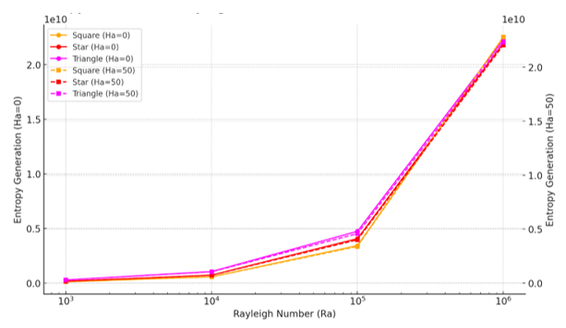

Fig 21. Entropy Generation vs Rayleigh Number (Ra)

Figure 21 shows entropy generation (St) versus Rayleigh number (Ra) for Ha=0 and 50 at a 20° inclination. Square-shaped obstacles consistently produce the lowest entropy, indicating high thermodynamic efficiency. Triangular shapes generate the most entropy, especially at high Ra, while star shapes show intermediate behavior but are more sensitive to Ra and Ha. Magnetic field (Ha=50) slightly increases entropy for all shapes, though the effect is least for squares. Overall, square obstacles at 20° offer the best balance between heat transfer and entropy control.

Figure 22 (TPC vs Ra) compares the Thermal Performance Criterion (TPC) for square, star, and triangular shapes at Ha=0 and 50 with a 20° inclination. TPC decreases with rising Ra for all shapes due to increasing entropy. The square shape maintains the most stable performance under both magnetic and non-magnetic conditions. The star shape shows slightly higher TPC at low Ra but declines at higher Ra. The triangle starts with the highest TPC at low Ra but drops sharply as Ra increases. Overall, the square shape at 20° inclination offers the best and most consistent thermal efficiency, especially under strong convection.

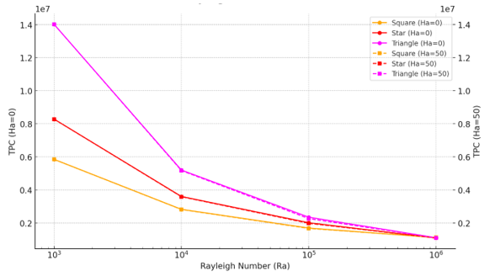

Fig 22. Thermal Performance Criterion (TPC) vs Rayleigh Number (Ra)

Figure 23 illustrates the average fluid temperature (Tavf) versus Rayleigh number (Ra) for square, star, and triangular shapes at Ha=0 and Ha=50, with a fixed inclination of 20°. The triangle shape consistently shows the highest Tavf, indicating weaker cooling, while the square shape records the lowest, reflecting superior heat transfer. The star shape performs moderately. Increasing Ha from 0 to 50 generally lowers Tavf across all shapes, especially at high Ra, due to magnetic damping of convection. As Ra increases, Tavf drops sharply beyond Ra=10⁴, marking the shift from conduction- to convection-dominated heat transfer. The square shape with Ha=50 at 20° inclination emerges as the most effective configuration for cooling.

Figure 24 shows that as entropy generation (St) increases, the Nusselt number (Nu) also rises, especially at higher Rayleigh numbers. Square-shaped blocks consistently achieve the highest Nu, indicating superior heat transfer, while star and triangle shapes follow. The presence of a magnetic field (Ha=50) reduces Nu for all shapes due to suppressed convection, with the effect more pronounced for star and triangle due to their complex geometries. Overall, square shapes offer the best balance between high heat transfer and moderate entropy generation.

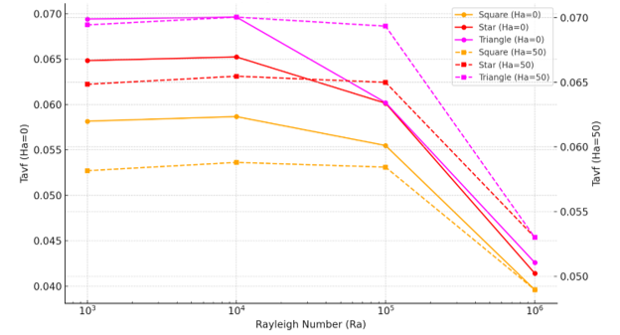

Fig 23. Average Fluid Temperature (Tavf) vs Rayleigh Number (Ra)

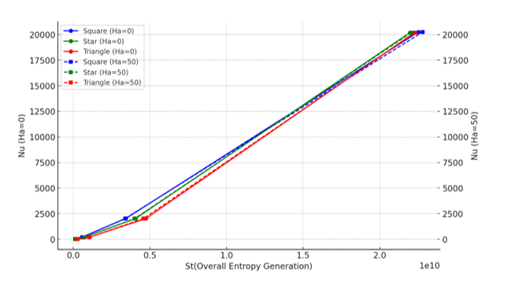

Fig 24. Nusselt Number vs Entropy Generation

Figure 25 illustrates an inverse relationship between Nusselt number (Nu) and Thermal Performance Criterion (TPC), highlighting the trade-off between heat transfer and entropy generation. Square-shaped blocks maintain the highest Nu across all TPC values, reflecting superior energy efficiency. The star shape shows lower TPC at higher Nu due to greater entropy, while the triangle performs least efficiently. Magnetic damping (Ha=50) lowers performance for all shapes, especially star and triangle. Overall, the square geometry proves thermodynamically optimal, achieving strong heat transfer with controlled irreversibility.

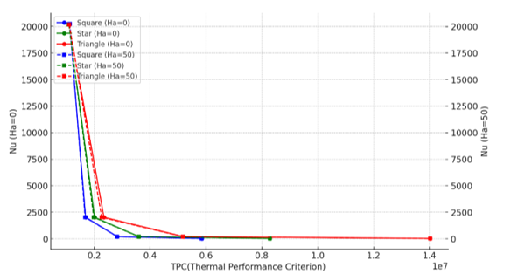

Fig 25. Nusselt Number vs Thermal Performance Criterion (TPC)

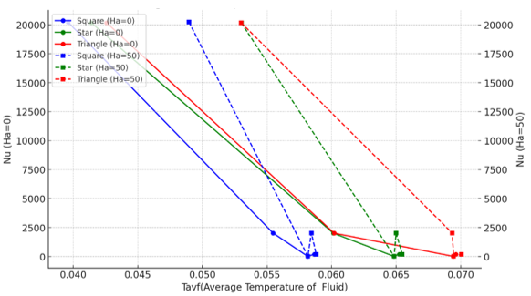

Fig 26. Nusselt Number vs Average Fluid Temperature (Tavf)

Figure 26 shows that as average fluid temperature (Tavf) increases, Nusselt number (Nu) decreases, indicating stronger convection at lower Tavf. Square-shaped blocks consistently achieve the lowest Tavf and highest Nu, especially without magnetic effects (Ha=0), confirming their superior thermal performance. Though Ha=50 reduces differences between shapes, the square still leads, while the triangle remains the least efficient. This highlights the square's effectiveness in maintaining cooler fluid zones through enhanced convective flow.

**5.0 Findings**

This study investigates the conjugate MHD free convective flow of Cu–H₂O nanofluid in a top-corrugated trapezoidal enclosure with multiple heat-generating internal obstacles of different shapes (square, star, triangular). Using COMSOL Multiphysics, the effects of obstacle geometry, cavity inclination (λ=0°, 10°, 20°, 30°), magnetic field (Ha=0, 50), and Rayleigh number (Ra=10³–10⁶) on flow behavior, thermal performance, and entropy generation were analyzed. The main findings are:

**i. Block Shape Optimization**

**Square Shape**:  
-Exhibited the highest Nusselt number (Nu), indicating excellent heat transfer.  
-Maintained uniform flow and symmetric circulation.  
-Showed moderate entropy generation, achieving a good balance between efficiency and irreversibility.  
-Achieved the lowest average fluid temperature (Tavf), indicating effective cooling.

**Star Shape**:  
-Caused higher entropy due to sharp edges generating strong thermal gradients.  
-Achieved reasonable heat transfer but lower efficiency due to greater irreversibility.

**Triangular Shape**:  
-Resulted in weaker convection and non-uniform flow.  
-Produced moderate entropy but fell short in thermal performance compared to the square shape.

So, Optimum Block Shape is Square.

**ii. Inclination Angle Optimization**

**λ= 0°**:  
-Delivered fair thermal performance with vertical buoyancy forces but uneven isotherm distribution.

**λ = 10°**:  
-Showed slight improvement with marginal entropy reduction and limited mixing enhancement.

**λ = 20°**:  
-Yielded the best results across all shapes, especially square: Highest TPC values, Lowest entropy generation and most uniform heat transfer and lowest Tavf

**λ = 30°**:  
-Caused a slight performance decline due to flow skewness and thermal layering.

So, Optimum Inclination Angle is 20°.

**iii. Magnetic Field Strength (Ha) Impact**

**Ha = 0**:  
-Promoted stronger natural convection and higher heat transfer rates.  
-Enabled better mixing and lower fluid temperatures.

**Ha = 50**:  
-Introduced Lorentz force damping, which suppressed flow and reduced Nu.  
-Slightly increased entropy due to thermal stratification.  
-Effects were more significant for complex shapes like star and triangle.

So, overall best configuration: Square-shaped block, 20° inclination, and moderate magnetic field strength (Ha=0-50 depending on application).

**6.0 Conclusion**

This study concludes that the square-shaped obstacle inside a top-corrugated trapezoidal cavity filled with Cu–H₂O nanofluid offers the best thermal performance under conjugate MHD free convection. At an inclination angle of 20°, it achieves optimal Nusselt number, lowest entropy generation, and most efficient cooling, even under magnetic field influence. The square geometry consistently balances heat transfer and thermodynamic efficiency better than star and triangular shapes.

Future Work may explore the effects of varying trapezoidal base angles, wave amplitudes, and different corrugation patterns (e.g., sinusoidal, triangular, square) on heat transfer and entropy. Experimental validation and transient analyses with other nanofluids could further enhance the model’s applicability.

**References**

1. Nadeem, S., Arif, M., Ullah, I., & Alzabut, J. (2025). MHD natural convection of nanofluid flow using a corrugated permeable medium within corrugated circular cavity. Journal of Thermal Analysis and Calorimetry.
2. Hameed, R. H., Hussein, R. A., Al-Salami, Q. H., Alomari, M. A., Hassan, A. M., Alyousuf, F. Q. A., Alqurashi, F., & Flayyih, M. A. (2025). Free convection investigation for a Casson-based Cu–H₂O nanofluid in semi parabolic enclosure with corrugated cylinder. Heliyon, 11, e40960.
3. Mahamuda, S., & Ali, M. M. (2025). MHD free convection flow of nanofluids inside a flush mounted heated square cavity containing a heat conducting triangular cylinder. International Journal of Applied and Computational Mathematics, 11, 34.
4. Habiba, U., Hudha, M. N., Neogi, B., Islam, S., & Rahman, M. M. (2025). Numerical exploration on n-decane nanofluid based MHD mixed convection in a lid driven cavity: Impact of magnetic field and thermal radiation. International Journal of Thermofluids, 27, 101209.
5. Ziaur, R. M., Azad, A. K., & Rahman, M. M. (2024). Sensitivity study on convective heat transfer in a driven cavity with star-shaped obstacle and hybrid nanofluid using response surface methodology. Heliyon, 10, e37440.
6. Qasem, N. A. A., Abderrahmane, A., Khetib, Y., Rawa, M., Abdulkadhim, A., Eldin, S. M., & Younis, O. (2023). Mixed convection within trapezoidal-wavy enclosure filled with nano-encapsulated phase change material: Effect of magnetohydrodynamics and wall waviness. Case Studies in Thermal Engineering, 42, 102726.
7. Alipour, N., Jafari, B., & Hosseinzadeh, K. (2023). Optimization of wavy trapezoidal porous cavity containing mixture hybrid nanofluid (water/ethylene glycol Go–Al2O3) by response surface method. Scientific Reports, 13(1635).
8. Maneengam, A., Bouzennada, T., Abderrahmane, A., Ghachem, K., Kolsi, L., Younis, O., Guedri, K., & Weera, W. (2022). Numerical Study of 3D MHD Mixed Convection and Entropy Generation in Trapezoidal Porous Enclosure Filled with a Hybrid Nanofluid: Effect of Zigzag Wall and Spinning Inner Cylinder. Nanomaterials, 12(1974).
9. Hirpho, M. (2021). Mixed convection of Casson fluid in a differentially heated bottom wavy wall. HELIYON. Advance online publication.
10. Ahmad, H., Mahmood, R., Hafeez, M. B., Majeed, A. H., Askar, S., & Shahzad, H. (2022). Thermal visualization of Ostwald-de Waele liquid in wavy trapezoidal cavity: Effect of undulation and amplitude. Case Studies in Thermal Engineering, 29, 101698.
11. Olayemi, O. A., Isiaka, M., Al-Farhany, K., Alomari, M. A., Ismael, M. A., & Oyedepo, S. O. (2022). Numerical analysis of natural convection in a concentric trapezoidal enclosure filled with a porous medium. International Journal of Engineering Research in Africa, 61, 129-150.
12. Uddin, M. J., & Rasel, S. K. (2019). Numerical analysis of natural convective heat transport of copper oxide-water nanofluid flow inside a quadrilateral vessel. Heliyon, 5, e01757.
13. Sompong, P., & Witayangkurn, S. (2013). Natural convection in a trapezoidal enclosure with wavy top surface. Journal of Applied Mathematics, 2013, Article ID 840632, 7 pages.
14. Mondal, P., & Mahapatra, T. R. (2020). Minimization of entropy generation due to MHD double diffusive mixed convection in a lid driven trapezoidal cavity with various aspect ratios. Nonlinear Analysis: Modelling and Control, 25(4), 545–563.
15. Hossain, M. S., Alim, M. A., & Andallah, L. S. (2020). Finite Element Analysis of Magnetohydrodynamic Mixed Convection in a Lid-Driven Trapezoidal Enclosure Having Heated Triangular Block. American Journal of Computational Mathematics, 10, 441-459.
16. Abderrahmane, A., Younis, O., Al-Khaleel, M., Laidoudi, H., Akkurt, N., Guedri, K., & Marzouki, R. (2022). 2D MHD Mixed Convection in a Zigzag Trapezoidal Thermal Energy Storage System Using NEPCM. Nanomaterials, 12, 3270.
17. Bilal, S., Shah, I. A., Ghachem, K., Aydi, A., & Kolsi, L. (2023). Heat Transfer Enhancement of MHD Natural Convection in a Star-Shaped Enclosure, Using Heated Baffle and MWCNT–Water Nanofluid. Mathematics, 11, 1849.
18. Ibrahim, W., & Hirpho, M. (2021). Finite element analysis of mixed convection flow in a trapezoidal cavity with non-uniform temperature. Heliyon, 6, e05933.
19. Reddy, E. S., & Panda, S. (2022). Heat transfer of MHD natural convection Casson nanofluid flows in a wavy trapezoidal enclosure. The European Physical Journal Special Topics, 231, 2733–2747.
20. Hirpho, M., & Ibrahim, W. (2022). Mixed Convection Heat Transfer of a Hybrid Nanofluid in a Trapezoidal Prism with an Adiabatic Circular Cylinder. Mathematical Problems in Engineering, 2022, Article ID 8170224.
21. Hussein, A. K., Hamzah, H. K., Ali, F. H., & Kolsi, L. (2020). Mixed convection in a trapezoidal enclosure filled with two layers of nanofluid and porous media with a rotating circular cylinder and a sinusoidal bottom wall. Journal of Thermal Analysis and Calorimetry, 141(5), 2061–2079.
22. Selimefendigil, F. (2018). Natural Convection in a Trapezoidal Cavity with an Inner Conductive Object of Different Shapes and Filled with Nanofluids of Different Nanoparticle Shapes. Iranian Journal of Science and Technology, Transactions of Mechanical Engineering, 42, 169–184.
23. Mahmood, R., Khan, Y., Rahman, N., Majeed, A. H., Alameer, A., & Faraz, N. (2022). Numerical Computations of Entropy Generation and MHD Ferrofluid Filled in a Closed Wavy Configuration: Finite Element Based Study. Frontiers in Physics.
24. Job, V. M., Gunakala, S. R., & Chamkha, A. J. (2022). Numerical investigation of unsteady MHD mixed convective flow of hybrid nanofluid in a corrugated trapezoidal cavity with internal rotating heat-generating solid cylinder. The European Physical Journal Special Topics, 231, 2661–2668.
25. Alshuraiaan, B., & Pop, I. (2021). Numerical simulation of mixed convection in a lid-driven trapezoidal cavity with flexible bottom wall and filled with a hybrid nanofluid. European Physical Journal Plus, 136(580).
26. Alomari, M. A., Al-Farhany, K., Hashem, A. L., Al-Dawody, M. F., Redouane, F., & Olayemi, O. A. (2021). Numerical Study of MHD Natural Convection in Trapezoidal Enclosure Filled With (50%MgO-50%Ag/Water) Hybrid Nanofluid: Heated Sinusoidal from Below. International Journal of Heat and Technology. Advance online publication.
27. Dogonchi, A. S., Sadeghi, M. S., Ghodrat, M., Chamkha, A. J., Elmasry, Y., & Alsulami, R. (2021). Natural convection and entropy generation of a nanoliquid in a crown wavy cavity: Effect of thermo-physical parameters and cavity shape. Case Studies in Thermal Engineering, 27, 101208.
28. Alsabery, A. I., Tayebi, T., Kadhim, H. T., Ghalambaz, M., Hashim, I., & Chamkha, A. J. (2021). Impact of two-phase hybrid nanofluid approach on mixed convection inside wavy lid-driven cavity having localized solid block. Journal of Advanced Research, 30, 63–74.
29. Khan, N. Z., Bilal, S., Riaz, A., & Muhammad, T. (2024). Coupled effects of variable permeability and adiabatic undulating walls on natural convective flow in a trapezoidal cavity: Finite element analysis. Results in Physics, 56, 107267.
30. Mohammed, A. A., Thaer, M., & Yahya, D. Q. (2022). Mixed convection heat transfer of Al2O3-H2O nanofluid in a trapezoidal lid-driven cavity at different angles of inclination. Texas Journal of Engineering and Technology, 11. ISSN 2770-4491.
31. Uddin, M. N., Alim, M. A., & Bhuiyan, A. H. (2016). Effects of circular cylindrical block on heat flow for MHD free convection in a non-uniformly heated trapezoidal enclosure. International Journal of Engineering & Applied Sciences (IJEAS), 8(3), 40-48.
32. Alnajem, M. H. S., Alsabery, A. I., & Hashim, I. (2019). Entropy generation and natural convection in a wavy-wall cavity filled with a nanofluid and containing an inner solid cylinder. In Proceedings of the 2nd International Conference on Sustainable Engineering Techniques (ICSET 2019) (pp. 032044). IOP Conf. Series: Materials Science and Engineering, 518.
33. Abed, I. M., Abdulkadhim, A., Hamzah, R. A., Hamzah, H. K., & Ali, F. H. (2020). Natural Convection Heat Transfer for Adiabatic Circular Cylinder Inside Trapezoidal Enclosure Filled with Nanofluid Superposed Porous–Nanofluid Layer. FME Transactions, 48, 82-89.
34. Ali, M. Y., Alim, M. A., & Karim, M. M. (2023). Mixed Convective Heat Transfer Analysis by Heatlines on a Lid-Driven Cavity Having Heated Wavy Wall Containing Tilted Square Obstacle. Mathematical Problems in Engineering, 2023, Article ID 1374926.
35. Alesbe, I., Ibrahim, S. H., & Aljabair, S. (2021). Mixed convection heat transfer in multi-Lid-driven trapezoidal annulus filled with hybrid nanofluid. Journal of Physics: Conference Series, 1973, 012065.
36. Akter, A., & Parvin, S. (2018). Analysis of natural convection flow in a trapezoidal cavity containing a rectangular heated body in presence of external oriented magnetic field. Journal of Scientific Research, 10(1), 11-23.
37. Ishak, M. S., Alsabery, A. I., Hashim, I., & Chamkha, A. J. (2021). Entropy production and mixed convection within trapezoidal cavity having nanofluids and localised solid cylinder. Scientific Reports, 11(1), 1-10.
38. Chowdhury, K., & Alim, M. A. (2023). Mixed Convection in a Double Lid-Driven Wavy Shaped Cavity Filled with Nanofluid Subject to Magnetic Field and Internal Heat Source. Hindawi Journal of Applied Mathematics, 2023(Article ID 7117186), 13 pages.
39. Alsabery, A. I., Vaezi, M., Tayebi, T., Hashim, I., Ghalambaz, M., & Chamkha, A. J. (2022). Nanofluid mixed convection inside wavy cavity with heat source: A non-homogeneous study. Case Studies in Thermal Engineering, 34, 102049.
40. Alsabery, A. I., Ghalambaz, M., Armaghani, T., Chamkha, A., Hashim, I., & Saffari Pour, M. (2020). Role of rotating cylinder toward mixed convection inside a wavy heated cavity via two-phase nanofluid concept. Nanomaterials, 10(6), 1155.
41. Ashorynejad, H. R., & Shahriari, A. (2018). MHD natural convection of hybrid nanofluid in an open wavy cavity. Results in Physics, 9, 440–455.
42. Boulahia, Z., Wakif, A., Chamkha, A. J., Amanulla, C. H., & Sehaqui, R. (2019). Effects of wavy wall amplitudes on mixed convection heat transfer in a ventilated wavy cavity filled by copper-water nanofluid containing a central circular cold body. Journal of Nanofluids, 8, 1170–1178.
43. Khan, M. R., Saha, S., Mojumder, S., Rahman, M. M., Saidur, R., & Ibrahim, T. A. (2016). Numerical investigation of pure mixed convection in a ferrofluid-filled lid-driven cavity for different heater configurations. Alexandria Engineering Journal, 55, 127–139.
44. Toghraie, D. (2020). Numerical simulation on MHD mixed convection of Cu–water nanofluid in a trapezoidal lid-driven cavity. International Journal of Applied Electromagnetics and Mechanics, 62(4), 683–710.
45. Mahmud, M. J., Rais, A. I., Hossain, M. R., & Saha, S. (2022). Conjugate mixed convection heat transfer with internal heat generation in a lid-driven enclosure with spinning solid cylinder. Heliyon, 8, e11968.