**Original Research Article**

**PROPOSAL OF A CONVOLUTIONAL NEURAL NETWORK-BASED PREDICTION MODEL FOR PROSTATE CANCER FROM MRI**

1. **ABSTRACT**

The use of convolutional neural networks (CNNs) in the medical field has revolutionized diagnosis, particularly for prostate cancer, one of the most common cancers in men. Early diagnosis is crucial to improve treatment outcomes. MRI is a key imaging modality, providing detailed information about prostate tissue, but its interpretation can be subject to subjectivity depending on the expertise of radiologists. The application of CNNs for prostate MRI analysis represents a significant advance in diagnosis. This model can thus serve as a decision support tool for radiologists, improving diagnostic accuracy and, potentially, clinical outcomes.

The proposed model demonstrated high predictive power for prostate cancer, with high performance in terms of accuracy, sensitivity, and specificity. ROC curves illustrated good discrimination between positive and negative cases. This approach demonstrates the potential of artificial intelligence in complex medical diagnosis, and future studies could explore the integration of this model into clinical systems for use in real-world settings.

**Keywords:** Artificial intelligence, convolutional neural networks, MRI, prostate cancer, deep learning.

1. **INTRODUCTION**

An image is a visual representation that captures and conveys information, whether it concerns objects, living beings, or abstract concepts. In the medical field, images play a crucial role in diagnosis, particularly through various imaging modalities such as MRI (Magnetic Resonance Imaging). MRI is particularly used for the analysis of internal organs, including the prostate, and is a key tool in the detection of prostate cancer. However, the interpretation of MRI images can be complex, dependent on the experience of radiologists, and often requires decision support tools to ensure early and accurate detection of abnormalities.

The rapid growth of artificial intelligence (AI), particularly convolutional neural networks (CNNs), has led to significant advances in medical imaging (Sarvamangala & Kulkarni, 2022). These technologies enable the analysis of massive volumes of medical images with increased accuracy, facilitating the diagnosis of complex diseases such as cancer, stroke, and cardiac pathologies. The application of deep learning to MRI image analysis has the potential to transform the way radiologists make diagnoses by automating analysis and reducing the time required to detect diseases (Yadav & Jadhav, 2019).

In this context, the implementation of AI models for predicting prostate cancer from MRI images represents a major advance. These models can classify images based on the presence or absence of cancer and better identify suspicious areas for earlier and more accurate diagnosis (Li et al., 2023). The introduction of these technologies into clinical practice could reduce human error, improve patient care, and ultimately save lives (Bhattacharya et al., 2022).

Our research is therefore part of this dynamic, by studying the use of convolutional neural networks for the prediction of prostate cancer from MRI images. The objective is to develop an AI model capable of assisting radiologists in their diagnosis, by providing them with a reliable and rapid tool for interpreting medical images.

1. **ESSENTIALS ABOUT PROSTATE CANCER AND IMAGING**

Prostate cancer is one of the most deadly malignant tumors in men, and its treatment has evolved in recent years. Indeed, the incidence of prostate cancer is increasing, with diagnoses being made in increasingly younger patients.

* 1. **Epidemiology**

Prostate cancer is a major public health problem in men in many countries around the world, with several deaths. It is rare before the age of 40, and the incidence of mortality increases logarithmically with age. Prostate cancer is the third most common cancer after breast and colon cancer (Rawla, 2019). Prostate cancer is the second most common cancer killer and, above all, the most common cancer in men; but its incidence varies from one country to another.

* 1. **Treatment of prostate cancer**

There are several possible ways or solutions for treating cancer:

* **Surgery** to remove the prostate gland in an operation called radical prostatectomy is the first curative treatment for prostate cancer.
* **Radiotherapy** aims to destroy cancer cells located in the prostate using very high-energy rays.
* **Brachytherapy** involves placing radioactive implants inside the prostate. They emit radiation that destroys prostate cancer cells. It is used for certain low-risk cancers.
* **Hormone therapy** helps limit the stimulating action of testosterone on cancer cells, as prostate cancer is hormone- sensitive.
* **Chemotherapy** is a treatment whose action is directed in particular at the mechanisms of cell division.
  1. **Medical imaging**

Medical imaging is a medical specialty that focuses on the study of techniques for obtaining images of the living human body using different types of radiation. These disciplines are means of acquiring and restoring images of the human body based on various physical phenomena.

The goal of medical imaging is to create an intelligible visual representation of medical information. This issue falls more broadly within the framework of scientific and technical imaging: the objective is to be able to represent, in a relatively simple format, a large amount of information from a multitude of measurements acquired using a well-defined method.

### **MATHEMATICAL THEORY OF CONVOLUTION**

* 1. **Continuous convolution**

**Definition 1.1** . Let two functions $f$ and $g$ belong to $L^{1}\left(R\right)$.

Continuous convolution is defined by:

$\left(f*g\right)\left(t\right)=\int_{-∞}^{+∞}{f\left(x\right)g\left(t-x\right)dx} (1.1)$

Or $\left(f*g\right)\left(t\right)=\int_{-∞}^{+∞}{g\left(x\right)f\left(t-x\right)dx (1.2)}$

This operation consists of:

* Overturn $g\left(x\right)→$ becomes $g\left(-x\right)$;
* Translate $g\left(x\right)→$ becomes $g\left(t-x\right)$;
* Multiply point by point with $f\left(x\right)$;
* Integrate everything on $x ∈ R$.

**TABLE 1. Property**

|  |  |  |
| --- | --- | --- |
| **Property** | **Expression** | **Description** |
| Linearity | $$f*\left(ag+bh\right)=a\left(f*g\right)+b(f*h)$$ | The convolution is linear |
| Commutativity | $$f*g=g*f$$ | The order of the functions does not change the result |
| Associativity | $$f*\left(g*h\right)⊂\left(f*g\right)*h$$ | Allows you to combine multiple convolutions |
| Distributivity | $$f*\left(g+h\right)=f*g+f*h$$ | Distribution of the sum |

* 1. **Discrete convolution in 1D (one dimension)**

Given two discrete signals $f\left[n\right] et g[n]$, the discrete convolution is defined by: $\left(f*g\right)\left[n\right]=\sum_{m=-∞}^{+∞}{f\left[m\right].g[n-m]} (1.3)$

* We overturn $g\left[m\right] en g\left[-n\right];$
* Then we shift this signal according to n;
* Then we multiply each value $f\left[m\right]. g\left[n-m\right];$
* Finally we add it all up.
  1. **Convolution in 2D (two dimensions)**

Let:

* A matrix $A(i,j)$ (e.g. an image);
* A kernel $B(m,n)$ (e.g. a filter).

The convolution is given by:

$$\left(A*B\right)\left(i,j\right)= \sum_{m}{\sum_{n}{A\left(i-m, j-n\right), B\left(m,n\right) (1.4)}}$$

In practice, the filter is reversed in rows and columns (if the convolution is mathematical), but in CNN, we do:

$$\left(A*B\right)\left(i,j\right)= \sum_{m}{\sum_{n}{A\left(i+m,j+n\right), B\left(m,n\right) (1.5)}}$$

Is a cross correlation, not a reversal.

1. **Examples**

**Example 1.1.** Convolution of two continuous functions (1D).

Consider two following functions:

$f\left(t\right)=H\left(t\right),$ The Heaviside step function:

$$H\left(t\right)= \left\{\begin{aligned}0, t<0 \\ 1, t≥0\end{aligned}\right. (1.6)$$

$g\left(t\right)= e^{-t}. H(t)$, a decaying exponential function defined for $t≥0$.

Let's calculate the convolution $\left(f*g\right)(t)$

$$\left(f*g\right)\left(t\right)=\int_{-∞}^{+∞}{f\left(x\right). g\left(t-x\right)dx (1.7)}$$

Since $f\left(x\right)=0 si x<0 et g\left(t-x\right)=0 si t-x<0 →x>t,$ the integration limits become $0 à t.$

SO :

$$\left(f*g\right)\left(t\right)=\int_{0}^{t}{1.e^{-\left(t-x\right) }dx= \int_{0}^{t}{e^{-\left(t-x\right) }dx} (1.8)}$$

Let's change the variable:

$s=t-x ⇒dx=-ds,$ When $x=0 ⇒s=x, x=t ⇒s=0$

$$\left(f*g\right)\left(t\right)=\int_{t}^{0}{e^{-s}.(-ds)}$$

$$=\int_{t}^{0}{e^{-s} dx}$$

$$={[{-e}^{-s}]}_{0}^{t}$$

$$=1-e^{-t}$$

SO $\left(f*g\right)\left(t\right)=1-e^{-t}, t≥0$.

**Example 1.2.** Discrete convolution in 1D

Either $f\left[n\right]=\left[2,1,3\right] et g\left[n\right]=\left[1,0,-1\right]$

Let's calculate $\left(f*g\right)\left[n\right]$

Indeed,

* Result size: $N+M-1 ⊂3+3-1=5$
* We overturn $g :g\left[-n\right]=\left[-1, 0, 1\right]$
* We drag this filter onto $f$:

Table 2: Position, Alignment and Product and Sum

|  |  |  |
| --- | --- | --- |
| **Position $n$** | **Alignment** | **Product and sum** |
| $$0$$ | $$-1, 0, 1, sur [2, 1, 3]$$ | $$-1*2=-2$$ |
| $$1$$ | $$0, -1, 0, sur [2, 1, 3]$$ | $$-1*1=-1$$ |
| $$2$$ | $$1, 0, -1, sur [2, 1, 1]$$ | $$1*2+0*1+\left(-1\right)*3=-1$$ |
| $$3$$ | $$1, 0, sur [1, 3,2]$$ | $$1*1=1$$ |
| $$4$$ | $$1, sur [3, 1, 2]$$ | $$1*3=3$$ |

TABLE 2.

SO $\left(f*g\right)\left[n\right]=[-2, -1, -1, 1,3]$

**Example 1.3.** 2D convolution (matrix/image)

Let us consider a 3*3 image: given by the matrix:

$$A=\left({\begin{matrix}1 & 2 & 0\end{matrix} \atop \begin{aligned}\begin{matrix}3 & 1 & 1\end{matrix} \\ \begin{matrix}0 & 2 & 1\end{matrix}\end{aligned}}\right),$$

And a 2*2 kernel (filter):

$$B=\left(\begin{matrix}1 & 0 \\ 0 & -1\end{matrix}\right)$$

Let's calculate $A*B$

1. Output size = 2*2
2. Calculation of positions:

* Top left corner $\left(0,0\right) :$
$$\left(\begin{matrix}1 & 2 \\ 3 & 1\end{matrix}\right)* \left(\begin{matrix}1 & 2 \\ 3 & 1\end{matrix}\right)=1*1+2*0+3*0+1*\left(-1\right)=0$$

* Top right corner $\left(0,1\right) :$
$$\left(\begin{matrix}2 & 0 \\ 1 & 1\end{matrix}\right)* \left(\begin{matrix}1 & 0 \\ 0 & -1\end{matrix}\right)=2*1+0*0+1*0+1*\left(-1\right)=1$$

* Bottom left corner $\left(1,0\right) :$
$$\left(\begin{matrix}3 & 1 \\ 0 & 2\end{matrix}\right)* \left(\begin{matrix}1 & 0 \\ 0 & 1\end{matrix}\right)=3*1+1*0+0*0+2*\left(-1\right)=1$$

* Lower right corner $\left(1,1\right) :$

$$\left(\begin{matrix}1 & 1 \\ 2 & 1\end{matrix}\right)* \left(\begin{matrix}1 & 0 \\ 0 & -1\end{matrix}\right)=1*1+1*0+2*0+1*\left(-1\right)=0$$

SO $A*B= \left(\begin{matrix}0 & 1 \\ 1 & 0\end{matrix}\right)$

1. **PREDICTION USING MACHINE LEARNING METHODS**
   1. **Machine learning**

Machine learning is one of the fields of study of artificial intelligence, is the scientific discipline concerned with the development, analysis and implementation of automatable methods that allow a machine (in the broad sense) to evolve through a learning process, and thus to fulfill tasks that are difficult or impossible to be carried out by more classic algorithmic means.

Machine learning has several ways of learning from data depending on the problems to be solved and the data available. The figure below shows the most well-known types of machine learning.

Reinforcement Learning

MACHINE LEARNING

Supervised Apprenticeship

Classification

Regression

Unsupervised Apprenticeship

Segmentation (Clustering)

*Figure 1: The type of artificial learning*

* 1. **Convolutional neural network**

Convolutional neural networks ( CNNs) are a type of neural network specialized for processing data with a grid-like topology. Examples include time series data, which can be viewed as a 1D grid by taking its samples at regular time intervals, and image data, which can be viewed as a 2D grid of pixels. Convolutional networks have achieved considerable success in practical applications. The name " convolutional neural network " indicates that the network employs a mathematical operation called convolution.

Convolutional networks are simply neural networks that use convolution instead of matrix multiplication in at least one of their layers. They have wide applications in image and video recognition, recommendation systems, and natural language processing.

* 1. **Application of the model**

There are several tools available for performing artificial learning. In this work, we used the Python language with the Anaconda IDE. To learn better, the model needs data with which we will run all possible tests to highlight the different behaviors and to better capture the underlying phenomena in a more technical way.

This is the most important step in machine learning because it is highly data-dependent. The better the data you have, the better your predictions will be.

For prediction we collected our data from one site and other data retrieved from HJ Hospital the data is categorized.

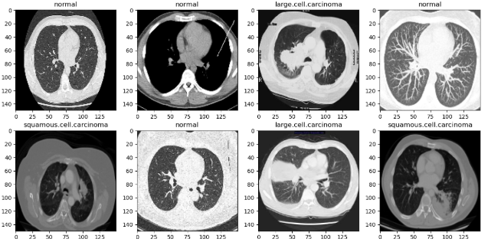

*Figure 2: Raw Dataset*

* + 1. **Library imports**

A library is a collection of functions and routines that can be easily reused. Python is an open-source programming language with many libraries.

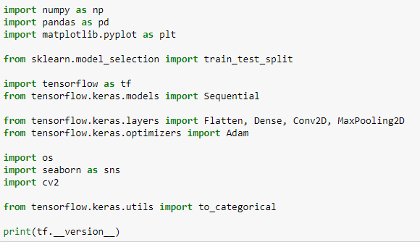

# *Figure 3: Importing the libraries used*

*Source: Author*

* + 1. **Data preparation**

This data preparation or preprocessing step involves processing data before implementing a learning algorithm; because raw data is often unreliable. To perform this step, we will start by loading the data.

* + - 1. **Loading data**



# *Figure 4: Training data recovery*

*Source: Author*

* + - 1. **Creating a function**

This function allows you to retrieve images from the training and test folder.

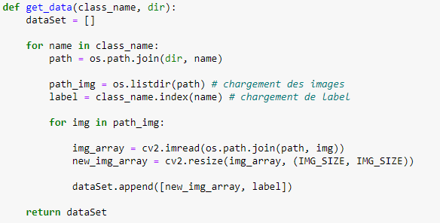

# 

# *Figure 5: Creating a function*

*Source: Author*

This function allows you to split the dataset into a matrix X (of image pixels) and a vector (y)

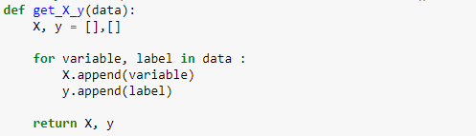

This class allows you to see the type of prostate cancer we manage



# *Figure 6: Type of cancer to be predicted*

*Source: Author*

* + 1. **Construction of the Convolutional Neural Network Model**

**Sequential ()** model is appropriate for a simple stack of layers where each layer has exactly one input tensor and one output tensor.

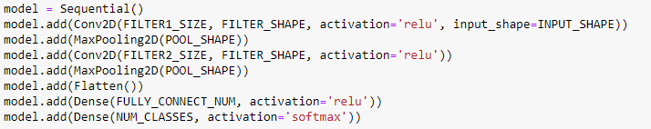

# Figure 7: Creating the Model

*Source: Author*

* **Conv2D** : is a 2D convolution layer, this layer creates a convolution kernel which is wrapped with the input layers, resulting in an output tensor. In the first layer **Conv2D() we learn a total of 32 filters with the** convolutional window size as 3x3.

**input_shape** parameter specifies the shape of the input. This is a necessary parameter for the first layer of the entire neural network. We will use the **ReLu activation function** . The rectified linear activation function, or ReLu for short, is a piecewise linear function that directly outputs the input if it is positive, otherwise it outputs zero.

* **MaxPooling2D** : is a subsample, the input representation taking the maximum value in the window defined by **POOL_SHAPE** for each image in an array along the feature axis. The **POOL_SHAPE** is 2x2 in our model.
* **Flatten ()** : Is used to convert the data into a one-dimensional array for feeding into the next layer.
* **Dense()** : is the regular layer of the deep neural network. The output layer is also a dense layer with 4 neurons because we are predicting a probability for classes.
  + - 1. **Model training**

To compile, adjust, and train the model, we were able to use 50 interaction numbers to adjust the model, on the entire data set provided. **validation_data** is the data set on which we evaluate the error and any model metrics at the end of each frame. With **metrics** = [' **accuracy** '], the model will be evaluated based on accuracy.

1. **Compiling the model**

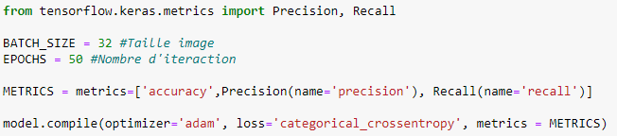

# *Figure 8: Model training code*

*Source: Author*

1. **Model Training Result**



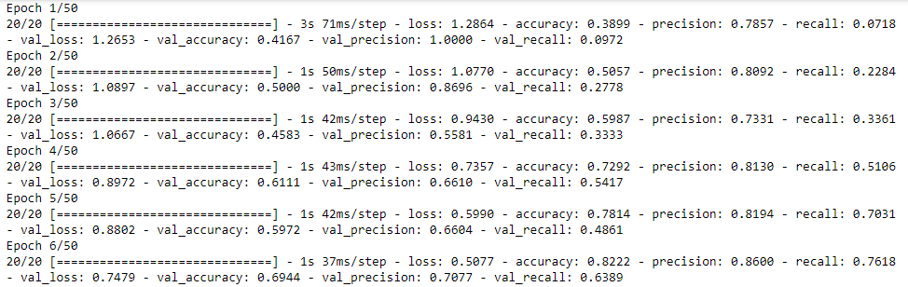

# *Figure 9: The training process*

*Source: Author*

Once the model is trained, we will try to assign some parameters to it:

* **Epoch** : refers to the total number of iterations (the number of times the model goes through the data);
* **Loss** : refers to the error rate;
* **Val_accuracy** : refers to the accuracy rate.

We can see that the network trained for 50 epochs and we achieved high accuracy (92.68%) and low loss following the training loss.

1. **Analysis of error function and precision curves**

We visualize the result of the prediction by a graph.

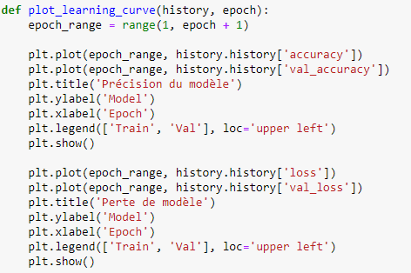

# *Figure 10: Accuracy and Loss Model Graph Display Code*

*Source: Author*

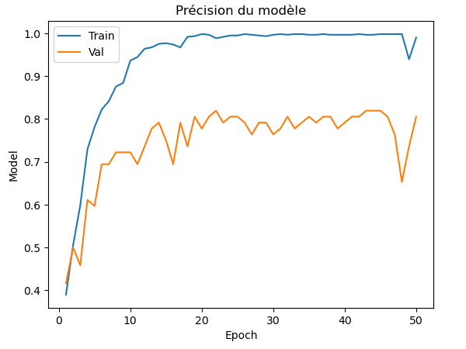

*Figure 11: Model Accuracy Graph*

*Source: Author*

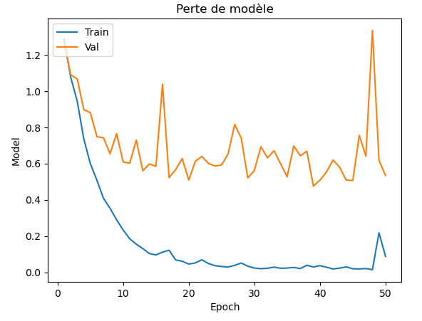

# *Figure 12: Model Loss Graph*

*Source: Author*

1. **Model evaluation on the test dataset**

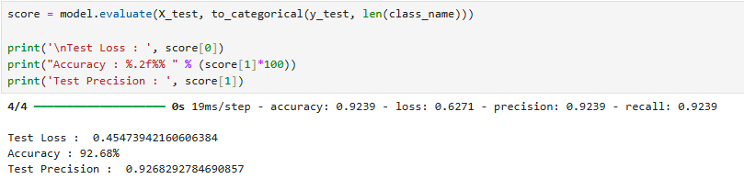

# *Figure 13: Model evaluation*

*Source: Author*

1. **Confusion matrix**

The first way to evaluate a prediction model is to compare the observed values of the target variable with the predicted values provided by this model. In the case of binary classification, we define, knowing that these definitions are easily extendable to other cases:

* VP (Number of True Positives): the data of the positive class and whose class is predicted as positive;
* VN (Number of True Negatives): data of negative class and whose class is predicted as negative;
* FP (Number of False Positives): data of negative class and whose class is predicted as positive;
* FN (Number of False Negatives): Data of positive class and whose class is predicted as negative. This information can be visualized in a table called “Confusion Matrix”.

|  |  |  |  |
| --- | --- | --- | --- |
| Predicted Class | Positive | Negative | Total |
| Positive | VP | FN | VP + FN |
| Negative | FP | VN | FP + VN |
| Total | VP + FP | FN + VN | VP+VN+FP+FN |

*Table 3. Confusion matrix*

From this matrix, we can deduce a certain number of indicators:

* Precision: represents the proportion of true positives (respectively negatives) compared to the data classified as positive (respectively negative) by the model.
* For the positives: $p=\frac{VP}{VP+FP}$
* For negatives: $p=\frac{VN}{VN+FN}$
* Recall: represents the proportion of true positives (respectively negatives) compared to truly positive (respectively negative) data.
* For positives (Specificity): $r=\frac{VP}{VP+FN}$
* For negatives (Sensitivity): $r=\frac{VN}{VN+FP}$
* False Positive Rate (False Negative Rate): represents the proportion of false positives (respectively negatives) compared to truly negative (respectively positive) data.
* False Positive Rate: $TFP=\frac{FP}{VN+FP}$
* False Negative Rate: $TFN=\frac{FN}{VP+FN}$
* The error rate: represents the probability that the prediction model does not classify a piece of data correctly. It is worth:
$$ε=\frac{FP+FN}{Total}$$

* The accuracy rate: represents the probability that the prediction model correctly classifies a piece of data. It is worth:

$$T_{p}=\frac{VP+VN}{Total}$$

The confusion matrix evaluates the performance of the model. We have y and y_predict , the numbers of images that belong to a class whose model predicted them in the same class or the model made a mistake.

The confusion matrix represents the quality measure of a classification system, and which reflects the learning performance.

The confusion matrix is a two-way table. The rows express the predictions relative to the different defined classes. The columns express the actual labels relative to the reference cancer types.

1. **Representation of Confusion Matrix**

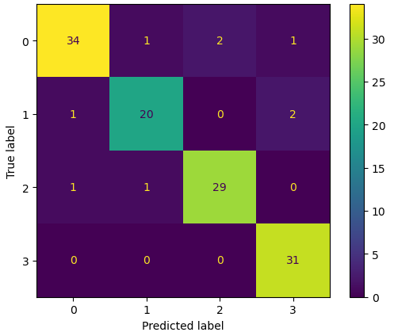

# *Figure 14: Code and Image of Confusion Matrix*

*Source: Author*

**CONCLUSION**

The objective of this paper is to propose a convolutional neural network prediction model of prostate cancer from magnetic resonance imaging. After analysis, the model training result has an accuracy of 92.68% success, this result gives a high training accuracy of the proposed model.

The result of this study will attempt to inform radiologists, based on MRI findings, about the advantages of the convolutional neural network-based prediction model for prostate cancer from MRI and the need to use it.

Given the magnitude of artificial neural networks, particularly convolutional neural networks, to process a large amount of data, especially the effect of taking into account the correlation between the pixels of an image and also being invariant to transformations of the input, these also allow to increase the precision.

**REFERENCES**

[1] A. CORNUEJOLS, L. MICLET 2018, Artificial Learning, Deep Learning, Concepts and Algorithms, 3rd edition , Editions Eyrolles , Paris.

[2] A. DIAMANT et al. “ Deep Learning in head & neck Cancer out come prediction” Scientific report (2019).

[3] A. DURAN (2022), Artificial intelligence for the characterization of prostate cancer by aggressiveness in multiparametric MRI Doctoral thesis from the University of Lyon of INSA.

[4] A. GRIDI [2020]; A Deep Learning tool for textual data, End of study dissertation Presented for obtaining the Master 2 Diploma, at the University l'arbi ben m' hidi-oum el bouaghi .

[5] American Cancer Society. What Is Cancer? [Internet]. [Accessed 16 June 23]. Available at: https://www.cancer.org/cancer/cancer-basics/what-is-cancer.html

[6] E. BANAYAN. (2010). Contribution of multiparametric prostate MRI with surface antenna in the pre-biological assessment of prostate cancer. Doctoral thesis. Paris Descartes University; 117

[7] M. Birmingham (2015), Building Machine Learning Systems with Python. Packt Publishing Ltd., United Kingdom.

[8] N. MALKI. (2018/2019). Automatic classification of texts by convolutional neural networks. (UL m' hidio.eb , Ed.) Mathematics and computer science: Doctoral thesis.

[9] SJ DROUIN, M. ROUPRET (2009). Epidemiology, diagnosis and prognosis of localized prostate cancer. State of play progress in urology, 9(2): 0081-0089.

[10] Matthes , E. Python Crash Course: Learn to program in Python by focusing on project development. No Starch Publishing Press . Paris. 2019.

[11] Sarvamangala, D. R., & Kulkarni, R. V. (2022). Convolutional neural networks in medical image understanding: a survey. *Evolutionary intelligence*, *15*(1), 1-22.

[12] Yadav, S. S., & Jadhav, S. M. (2019). Deep convolutional neural network based medical image classification for disease diagnosis. *Journal of Big data*, *6*(1), 1-18.

[13] Li, S., Wang, K. X., Li, J. L., He, Y., Wang, X. Y., Tang, W. R., ... & Wang, X. P. (2023). AI-predicted mpMRI image features for the prediction of clinically significant prostate cancer. *International urology and nephrology*, *55*(11), 2703-2715.

[14] Bhattacharya, I., Khandwala, Y. S., Vesal, S., Shao, W., Yang, Q., Soerensen, S. J., ... & Sonn, G. A. (2022). A review of artificial intelligence in prostate cancer detection on imaging. *Therapeutic advances in urology*, *14*, 17562872221128791.

[15] Rawla, P. (2019). Epidemiology of prostate cancer. *World journal of oncology*, *10*(2), 63.