***In vitro* evaluation of natural farming inputs, botanicals and bio agents against foot rot disease of finger millet caused by *Sclerotium rolfsii* SAAC**

**Abstracts**

Finger millet is one of the important millet crops widely cultivated across India. Although, finger millet found to be a hardy crop, it is also affected by many diseases, among them foot rot caused by *Sclerotium rolfsii* has become a major threat especially in irrigated and heavy rainfall areas. In the present *in vitro* study during among different natural inputs evaluated through poison food technique, the results revealed that shuntiastra at 10 per cent was recorded 100 per cent inhibition against *Sclerotium rolfsii* followed by Jeevamruta at 10 per cent shows 90.78 per cent inhibition. Among different plant extracts evaluated, Neem leaf extract and Pongamia leaf extract at higher concentration of 10 per cent and Combination of leaf extracts viz., Neem, Pongamia, Yekka, Tulsi and cow urine at 5 per cent recorded 100 per cent inhibition of the pathogen. Among the bio agents, *Trichoderma sp.* showed 72.11 per cent inhibition while the least inhibition was recorded by carbendazime (0.1%) with 18.33 per cent inhibition over control. Under greenhouse condition, the plants showed wilting symptoms, no disease was observed in T5 (Seedling treatment and drenching with Mancozeb 75 WP at 0.25%) followed by T4(Seedling treatment and drenching with *Trichoderma* @ 5%) recorded 20 per cent PDI which is on par with T3(Seedling treatment with beejamruta + drenching with shuntiastra 10% @ 30 days interval) with PDI of 25 per cent.

**Introduction**

Finger millet (*Eleusine coracana* (L.) Gaertan, is commonly referred to as "ragi" in various regions, plays a crucial role as a staple crop in parts of Eastern Africa and Asia originated to Ethiopia. It is often referred to as a "nutritious millet," is rich in proteins, calcium, minerals, fiber, and essential vitamins. Its high calcium content makes it especially beneficial for infants and the elderly, while its fiber aids in preventing constipation, lowering cholesterol, and reducing the risk of intestinal cancer. As a gluten-free grain packed with nutrients, it plays a key role in combating malnutrition. Additionally, finger millet supports rural livelihoods by providing both a staple food source and income-generating opportunities, thereby promoting nutrition and economic stability. People suffering from diabetes are advised to eat finger millet and other small millets instead of rice (Malleshi and Haddimani 1993) [8].

It is a resilient crop believed to have originated in the Ethiopian highlands, is now extensively cultivated across Africa, Madagascar, Sri Lanka, Malaysia, China, Japan, and especially India. In India alone, it spans approximately 10.04 lakh hectares, yielding around 17.55 lakh tonnes with an average productivity of 1,747 kg per hectare. In India major finger millet-producing states of Karnataka, Tamil Nadu, Andhra Pradesh, Odisha, Maharashtra, Uttar Pradesh, Bihar, and Gujarat together contribute over 95 per cent of the country’s total production (Sonnad, 2005) [15].

Where as in Karnataka it has covers more than 6.41 lakh ha mainly in the districts of Tumkuru Bangalore rural, Kolar, Chikkaballapura, Mandya, Mysore, Chamarajanagara, Hasan Chitradurga, and Davanagere (Ashoka and Halikatti, 1997) with a production of 11.64 lakh tonnes and a productivity of 1816 kg ha-1. (<http://indiastat.com>, 2020)

Coleman (1920) was the first in India to record the occurrence of *Sclerotium rolfsii* from the then princely state of Mysore. Loss up to 50 per cent was recorded at Rampur, Nepal (Basta and Tamang, 1983).The disease appears randomly in the field. The infection occurs around the collar region, the infected area being restricted to two to three inches above ground level, initially symptoms appears as water soaked lesion. Later on it turns brown and subsequently dark brown with a concomitant shrinking of the stem in the affected region. Profuse white cottony mycelial growth occurs in this area. Soon small roundish white velvety grain like structures starts appearing in the fungal matrix. They grow, become mustard seed like, turn brown and are the sclerotial bodies of the fungus. Meanwhile the leaves lose their lustre, droop and dry. Ultimately, the plant dries up prematurely

*Sclerotium rolfsii* causes foot rot which belongs to a corticoid fungus in the family athelcea (Kwon *et al.,* 2017) and having teleomorphic stage *Athelia rolfii* Tu & Kimbrough. It is destructive soil borne plant pathogenic fungus with a wide host range. Several scientists have already discovered this pathogen in India and elsewhere. This pathogen infects about 500 different crop and has a wide host range (Aycock, 1966) like ground nut, chickpea, onion, chilly, barley, wheat, ragi, soybean, potato and other plant( Desai and schlosser, 1999) and cause grain yield loss upto 27.40 % and 23.31% in fodder yield (Pawar*et al,* 2013)

Foot rot which has been reported to cause more than 50 per cent yield loss. As the disease was minor and sporadic in nature, extensive systematic studies have not been carried out, but it is increasing in the recent past; particularly under in high rainfall situations (Nagaraja and Reddy, 2009) [11]. The present research work was conducted to investigate the combinations of various treatments including chemicals, bio-agents and organic amendments to manage the disease to minimum level and to obtain the maximum yield.

The effectiveness of natural farming inputs (Jeevamrutha and Shuntiastra), plant-based extracts (from Neem, Pongamia, Yekka, and Tulsi leaves), and biological control agents (Trichoderma species and *Pseudomonas fluorescens*) against the growth of the pathogen was evaluated using poisoned food technique and inhibition zone assay methods.

**Material and methods**

**Jeevamrutha preparation:**

Jeevamrutha was prepared by combining 10 kg of desi cow dung, 10 liters of cow urine, 2 kg of jaggery, 2 kg of gram flour, and a handful of farm soil. These ingredients were thoroughly mixed in a 200-liter plastic drum, and the volume was adjusted to 200 liters with water. The mixture was stirred vigorously in a clockwise direction and kept in a shaded area, covered with a moist jute sack. To ensure proper fermentation, the solution was stirred in the morning, afternoon, and evening each day for seven consecutive days. After this period, the preparation was used for soil application.

**Preparation of Shuntiastra**

**List 1 : Composition of shuntiastra**

|  |  |
| --- | --- |
| Desi cow milk | 2 liters, |
| Ginger | 200 gram |
| Water | 200 liters |

**Preparation**

To prepare the formulation, 200 grams of dried ginger was weighed and ground into a powder. This powder was then mixed with 2 liters of water and boiled until the volume was reduced by half. Separately, 2 liters of desi cow milk were boiled in another vessel, and the cream layer was removed. The reduced ginger extract and the milk were then combined in a separate container and kept in a shaded area for 24 hours. During this period, the mixture was stirred in a clockwise direction three times a day.

**Preparation of plant extracts and evaluation by poison food technique**

**Preparation of plant extracts**

Freshly collected leaves of Neem, Pongamia, Tulsi, and Yekka were shade-dried at room temperature, then chopped using a mortar and pestle and ground into a coarse powder using an electric blender. The powdered samples were stored in separate sealed containers for extraction. For each extract, 200 g of the powder was soaked in 80% analytical-grade methanol and gently agitated on an electronic shaker for five days. The resulting mixtures were filtered through Whatman No. 1 filter paper, and the filtrates were concentrated using a rotary evaporator. The dried extracts were weighed and re-dissolved in sterile double-distilled water to obtain concentrations of 25 mg/ml and 50 mg/ml. These solutions were stored under refrigeration until used in the experiments.

The poisoned food technique was employed to assess the efficacy of fungitoxicants and bio-organic agents against *Sclerotium rolfsii*. In this method, the test fungus is allowed to grow on a nutrient medium amended with the test substances. All glassware used in the experiment was sterilized prior to use. Potato Dextrose Agar (PDA) was prepared, sterilized at 15 lbs per square inch for 15 minutes using an autoclave, and distributed into 250 ml conical flasks. The required concentrations of each fungicide and bio-organic agent were added to the flasks, thoroughly mixed with the medium, and poured into sterile Petri plates. Each treatment was replicated three times.

A 4–5-day-old culture of *Sclerotium rolfsii* grown on PDA, prior to sclerotia formation, was used for inoculation. Fungal discs (0.5 cm in diameter) were aseptically cut using a sterile cork borer and placed at the center of each Petri plate containing the poisoned medium. PDA plates without any fungicide or bio-organic agents but inoculated with fungal discs served as controls. All plates were incubated at 28 ± 1°C, and observations on colony diameter were recorded until the mycelium in the control plates completely covered the surface.

The efficacy of the fungicides was expressed as per cent inhibition of mycelial growth over control, which was calculated by using the formula given by Vincent (1947).

$$I=\frac{C-T}{C}×100$$

Where,

I = per cent inhibition

C = pathogen growth in control plate

T = pathogen growth in treatment plate

**Dual culture technique for evaluation of bio agents**

To evaluation of fungal and bacterial biocontrol agents, 20 ml of sterilized, cooled Potato Dextrose Agar (PDA) was poured into sterile Petri plates and allowed to solidify. To assess fungal antagonists, a mycelial disc of the test pathogen was placed at one end of the Petri plate, while a disc of the antagonistic fungus was placed at the opposite end. For bacterial antagonists, the bacterium was streaked from one end of the Petri plate toward the center one day prior to inoculating the test fungus, which was then placed at the opposite end. All plates were incubated at 27 ± 1°C. The zone of inhibition was determined by measuring the clear distance between the margins of the test fungus and the antagonist. Colony diameter of the pathogen in control plates (without any antagonist) was also recorded. The percentage inhibition of mycelial growth was calculated using the formula described by Vincent (1947) [16].

$$I=\frac{C-T}{C}×100$$

Where,

I = per cent inhibition

C = Growth of the pathogen in control plate

T = Growth of the pathogen treatment plate

**Table 1: Treatment details on *in vitro* evaluation of Natural farming inputs, Plant extracts and bio agents against *Sclerotium rolfsii***

|  |  |  |
| --- | --- | --- |
| **Treatments** | | **Concentrations** |
| T1 | Shuntiastra (*Zingiber officinale*) | 3% |
| T2 | Shuntiastra (*Zingiber officinale*) | 5% |
| T3 | Shuntiastra (*Zingiber officinale*) | 10% |
| T4 | Neem leaf extract *(Azadirachta indica)* | 3% |
| T5 | Neem leaf extract *(Azadirachta indica)* | 5% |
| T6 | Neem leaf extract *(Azadirachta indica)* | 10% |
| T7 | Pongamia leaf extract *(Pongamia pinnata)* | 3% |
| T8 | Pongamia leaf extract *(Pongamia pinnata)* | 5% |
| T9 | Pongamia leaf extract *(Pongamia pinnata)* | 10% |
| T10 | Tulsi leaf extract (*Ocimum gratissimum)* | 3% |
| T11 | Tulsi leaf extract (*Ocimum gratissimum)* | 5% |
| T12 | Tulsi leaf extract (*Ocimum gratissimum)* | 10% |
| T13 | Yekka leaf extract [*(Calotropis gigantea)*](https://en.wikipedia.org/wiki/Calotropis_gigantea) | 3% |
| T14 | Yekka leaf extract [*(Calotropis gigantea)*](https://en.wikipedia.org/wiki/Calotropis_gigantea) | 5% |
| T15 | Yekka leaf extract [*(Calotropis gigantea)*](https://en.wikipedia.org/wiki/Calotropis_gigantea) | 10% |
| T16 | Combinations (Neem+Pongamia+Tulsi+Yekka+Desi cow urin) | 5% |
| T17 | Jeevamruta | 3% |
| T18 | Jeevamruta | 5% |
| T19 | Jeevamruta | 10% |
| T20 | Desi cow urin | 5% |
| T21 | Desi cow urin | 10% |
| T22 | *Pseudomonas fluorescence* |  |
| T23 | *Trichoderma sp.*(Maddur isolate) |  |
| T24 | Carbendazime (Standard check() | 0.2 % |
| T25 | Control | water |

**Table 2: *Invitro* evaluation of under greenhouse condition**

|  |  |
| --- | --- |
| **Treatments details** | |
| T1 | Absolute control |
| T2 | Seedling treatment with beejamruta + drenching and spraying with shuntiastra 10% at 30,45 and 60 DAT |
| T3 | Soil drenching with Combinations of plant extracts (Neem+Pongamia+Tulsi+Yekka)+ Desi cow urine 5% at 30,45 and 60 DAT |
| T4 | Seedling treatment and drenching with *Trichodermasp*. 5% at 30,45 and 60 DAT |
| T5 | Seedling treatment and drenching with Mancozeb 75 WP at 0.25% (Check) |

**Results and discussions**

In the present in vitro study, various natural inputs were evaluated using the poisoned food technique, and the results are summarized in Table 2.

The results revealed among natural farming inputs, shuntiastra at 10 per cent shows significantly superior and recorded 100 % inhibition against *Sclerotium rolfsii* followed by Jeevamruta at 10 per cent shows 90.78 per cent inhibition and Shuntiastra(5%) recorded 89.89 per cent inhibition. The least inhibition was recorded by jeevamrutha (3%) recorded 73 per cent over control.

Similar results were obtained by Sneha *et al.,*(2016)[18] showed that aqueous extracts of Ginger(5%) recorded 51.5 per cent inhibition of the *Sclerotium rolfsii* while at lower concentration viz., 1- 4% were less effective. However, Suleiman and Emua, (2009) also showed 100% inhibition against root rot fungus by ginger extract.

The antifungal and antibacterial properties of ginger are primarily attributed to bioactive compounds such as gingerol and shogaol, which are present in its ethanolic extracts. (Atai *et al*., 2009)[5]

Among the various plant extracts tested, Neem leaf extract and Pongamia leaf extract at a higher concentration of 10 per cent and a combination of leaf extracts (Neem, Pongamia, Yekka, Tulsi) with cow urine at 5 per cent showed complete inhibition (100%) of the pathogen. Pongamia leaf extract at 5 per cent concentration also demonstrated strong inhibition, recording 96.67 per cent pathogen suppression. The lowest inhibition, 57.44 per cent, was observed with Yekka leaf extract at 5 per cent. These results are consistent with findings by Madhavi, who reported that neem leaf extract (*Azadirachta indica*) caused significant mycelial growth inhibition (80.74%) against *Sclerotium rolfsii* in vitro. Similarly, Muhammad (2010) observed maximum inhibition of 73.8 per cent by *Azadirachta indica* against the same pathogen.

Among the bioagents tested, *Trichoderma* species exhibited the highest inhibition of mycelial growth at 72.11 per cent, followed by *Pseudomonas fluorescens*, which showed 48.22 per cent inhibition. Similar observations were reported by Basamma (2008) and Kulkarni [11], who recorded 59.81 per cent and 53.33 per cent inhibition of *Sclerotium rolfsii* mycelial growth by *Trichoderma harzianum*. These findings suggest that *Trichoderma* isolates exert their antagonistic effects through competition, mycoparasitism, and lytic activity against the pathogen. This may be attributed to the production of antibiotic compounds such as gliotoxin and viridin, as well as cell wall–degrading enzymes, which can diffuse through air-filled pores and inhibit *S. rolfsii* growth, as reported by Brain (1951). These results also align with those of Karthikeyan (1996) and Mukherjee (2001), who demonstrated that *T. harzianum* inhibits *S. rolfsii* by penetrating the pathogen’s hyphae at points of contact.

However, the present findings also showed that poor inhibitory effect of synthetic fungicide carbendazim (0.1%) was recorded 18.33 per cent over Absolute control.

**Table 3: Percent inhibition of *Sclerotium rolfsii* under *in vitro* condition**

|  |  |  |
| --- | --- | --- |
| **Treatment details** | | **Per cent Inhibition** |
| T1 | Shuntiastra 3% | 79.89 |
| T2 | Shuntiastra 5% | 89.89 |
| T3 | Shuntiastra 10% | 100.00 |
| T4 | Neem leaf extract 3% | 89.22 |
| T5 | Neem leaf extract 5% | 94.00 |
| T6 | Neem leaf extract 10% | 100.00 |
| T7 | Pongamia leaf extract 3% | 88.44 |
| T8 | Pongamia leaf extract 5% | 96.67 |
| T9 | Pongamia leaf extract 10% | 100.00 |
| T10 | Tulsi leaf extract 3% | 88.11 |
| T11 | Tulsi leaf extract 5% | 94.44 |
| T12 | Tulsi leaf extract 10% | 94.44 |
| T13 | Yekka leaf extract 3% | 57.44 |
| T14 | Yekka leaf extract 5% | 82.67 |
| T15 | Yekka leaf extract 10% | 86.44 |
| T16 | Combinations @ 5% (Neem, Pongamia, Tulsi, Yekka leaf extract with Desi cow urin) | 100.00 |
| T17 | Jeevamruta @3% | 73.11 |
| T18 | Jeevamruta @5% | 77.11 |
| T19 | Jeevamruta @10% | 90.78 |
| T20 | Desi cow urin @5% | 66.22 |
| T21 | Desi cow urin @10% | 84.78 |
| T22 | *Pseudomonas fluorescence* | 48.22 |
| T23 | *Trichoderma sp.* | 72.11 |
| T24 | Standard check | 18.33 |
| T25 | Absolute control | 1.11 |
| S.Em | | 2.04 |
| CD (1%) | | 7.6 |

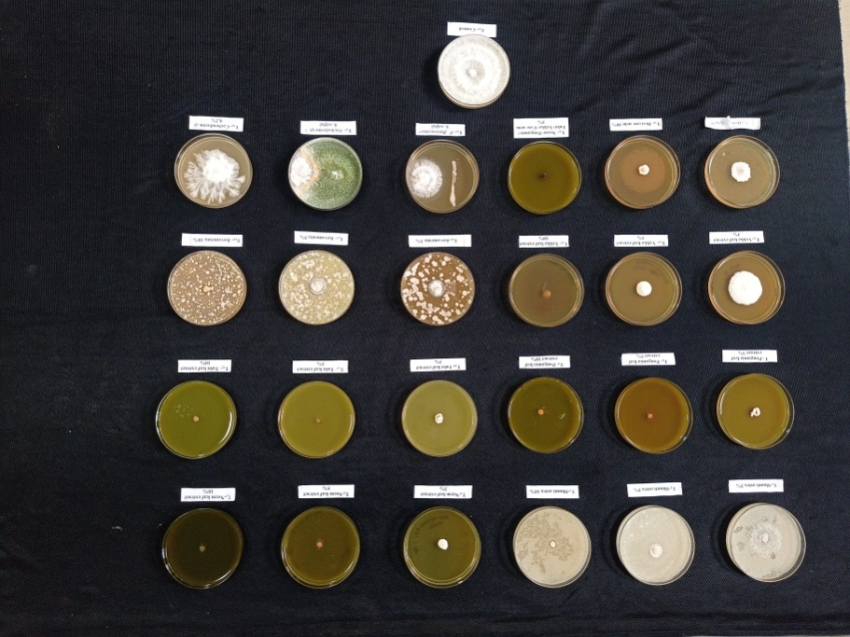

**Plate 1: *In vitro* evaluation of Natural farming inputs, Plant extracts and bio agents against *Sclerotium rolfsii***

***Invitro* evaluation under greenhouse condition**

Under greenhouse condition, the finger millet plants showed wilting symptoms, no disease was observed in T5 (Seedling treatment and drenching with Mancozeb 75 WP at 0.25%) followed by T4 (Seedling treatment and drenching with Trichoderma @ 5%) recorded 20 per cent PDI which is on par with T3[Combinations of plant extracts (Neem+Pongamia+Tulsi+Yekka)+Desi cow urine at 5%] with PDI of 25 per cent followed by T2(Seedling treatment with beejamruta + drenching and spraying with shuntiastra10% at 30,45 and 60 DAT) with PDI of 45 per cent over absolute control showed 100 per cent wilting of the plants.

**Table 4: Percent disease index on foot rot of finger millet caused by *Sclerotium rolfsii* under greenhouse condition**

|  |  |  |  |
| --- | --- | --- | --- |
| **Treatment details** | | **Mean PDI** | **Percent reduction of disease over control** |
| T1 | Absolute control | 100 |  |
| T2 | Seedling treatment with beejamruta + drenching and spraying with shuntiastra10% at 30,45 and 60 DAT | 45 | 55.00 |
| T3 | Soil drenching with Combinations of plant extracts (Neem+ Pongamia+ Wild Tulsi+ Yekka)+ Desi cow urine 5% at 30,45 and 60 DAT | 25 | 75.00 |
| T4 | Seedling treatment and drenching with *Trichoderma sp.* 5% at 30,45 and 60 DAT | 20 | 80.00 |
| T5 | Seedling treatment and drenching with Mancozeb 75 WP at 0.25% (Check) | 0 | 100.00 |
|  | S.Em | 3.16 |  |
|  | CD at5% | 9.53 |  |

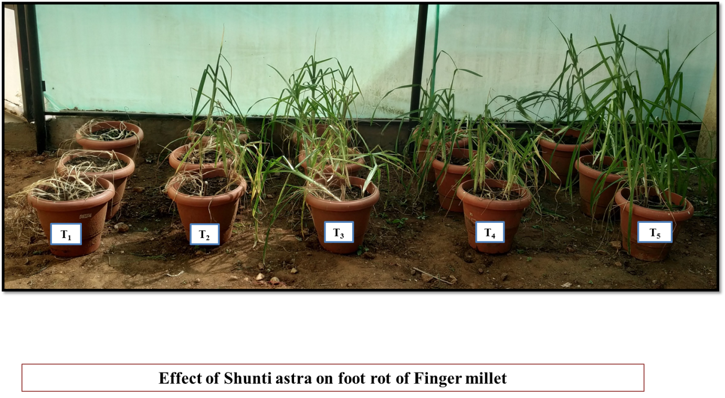

**Plate 2: Wilting symptoms of Finger millet recorded due to foot rot caused by *Sclerotium rolfsii* under green house*.***

**Figure 1: Graphical representation of *in vitro* evaluation of Natural farming inputs, Plant extracts and bio agents against *Sclerotium rolfsii***

**Conclusions**

Among the natural farming inputs tested, Shuntiastra at 10% concentration demonstrated complete (100%) inhibition of *Sclerotium rolfsii*. Within the plant extracts category, higher concentrations of Neem leaf extract, Pongamia leaf extract, and a combination of various plant extracts showed the greatest inhibitory effects against the pathogen. Among the bioagents, *Trichoderma* species exhibited the highest inhibition of *Sclerotium rolfsii*. However, to validate these findings, further evaluation of these natural farming inputs, plant extracts, their combinations, and bioagents under field conditions is recommended.

**Reference:**

1. Abdel-Hafez, S.I.I., Abo-Elyousr K.A.M. and Abdel-Rahim, I.R.,2013 Effect of certain plant extracts to control purple blotch disease of onion plants (*Allium cepa* L.). *J. Plant Physiol. Pathol*., 1(4).
2. Anonymous, 2016 District-wise estimated area, production and yield of ragi (Small millet) in Konkan division of Maharashtra. Support Team. Districtsofindia.com, 2016
3. Anonymous, 2020, http://indiastat.com
4. Ashokha, M.B. and Hallikatti, S. I., 1997, Response of finger millet genotypes to time of sowing in northern transitional tract of Karnataka, *Karnataka J. Agric. Sci*,, **10**: 292-297
5. Atai, Z., Atapour, M.,and Mohseni, M., 2009 Inhibitory effect of Ginger Extract on Candida Albicans. *Am. J. Applied Sci.,***6(6)**: 1067-1069.
6. Ayock. R. 1966, Stem rot and other diseases caused by *Sclerotium rolfsii* or the status of *S. rolfsii* fungus after70 years. *North Carolina Agri. Exp. St. Tech. Bulletine.,***733**:93
7. Basamma, 2008, Integrated management of sclerotium wilt of potato caused by *Sclerotium rolfsii* sacc. M.Sc. (Agri.) thesis, Uni. Agric. Sci, Dharwad.
8. Batsa, B.K. and Tamang, D.B., 1983, Preliminary report on the study of millet diseases in Nepal. In : Maize and finger millet, *10th summer workshop 23-28 Jan*. 1983, Rampur, Chitwan
9. Brain PW, 1951 Antibiotics produced by fungi. *Bot Rev*;**17:**357-370.
10. Coleman, L.C**.,** 1920 The cultivation of ragi in Mysore. *Bull. Dep. Agric. Mysore. Gen. Ser*. 11-12.
11. Desai, S. and Schlosser, E., 1999 Parasitism of *S. rolfsii* by *Trichoderma. Indian Phytopathol.,*52;47-50
12. Kulkarni, V. R., 2007 Epidemiology and integrated management of potato wilt caused by *Sclerotium rolfsii* SACC. Ph.D. thesis, *Univ Agric Sci,* Dharwad.
13. Karthikeyan, A., 1996 Effect of organic amendments, antagonist *Trichoderma viride* and fungicides on seed and collar rot of groundnut. *Plant Dis Res*;**11:** 72-74.
14. Malleshi, N. G., and Hadimani. N. A., 1993 Nutritional and technological characteristics of small millets and preparation of value added products from them. In: Advances in small millet proceedings of second International small millet workshop, Zimbabwe, *Oxford and IBH Publishing Co Pvt. Ltd*, 271–287
15. Mukharjee, S., Tripathi, H.S., Rathi Y. P. S., 2001 integrated management of wilt complex in French bean (*Phaseolus vulgaris* L.). *J. Mycol. Plant Pathol*; **31**: 213-215.
16. Nagraja, A. and Reddy B,. 2009Foot rot of Finger millet-an increasing disease problem in Karnataka. *Crop Res.,* **38(2):**224-225.
17. Pawar. Dnyaneshwar, M and Sabalpara, A. N. 2013, Management of foot rot (*S. rolfsii)* of finger millet (*Eleusine coracana* (L.) Gaertan). Thesis, Navsari Agric. Univ., Navsari, Gujarat.pp:150.
18. Sneha. S., Maurya S., and Choudhary, A.K., 2016 Antifungal efficacy of garlic and ginger against *Sclerotium rolfsii, International J. of Agric. Sci. and Res.* **6***:*419-424
19. Sonnad S.K., 2005 Stability analysis in white ragi (*Eleusine coracann* Gaertn) genotypes. M.Sc. (Ag.) thesis submitted to *University of Agricultural Sciences*, Dharwad.
20. Vincent, J. M., 1947, Distortion of fungal hypae in the presence of certain inhibitors. Nature, **159**: 239-241.