*Original Research Article*

Studies on Efficacy of Plant Extracts and Fungicides on *Bipolaris bicolor* Inciting Leaf Blight of Kodo Millet (*Paspalum scrobiculatum* L.) and their Effect on Conidial Characters (*in vitro*).

**ABSTRACT**

|  |
| --- |
| The study was conducted during September, 2023–September, 2024 at Department of Plant Pathology, Jawaharlal Nehru Krishi Vishwa Vidyalaya, Jabalpur (M.P.). The current experiment was to study the efficacy of plant extracts and fungicides at different concentrations to inhibit the growth of the fungus in-vitro using poisoned food technique. Kodo millet (*Paspalum scrobiculatum* L.) which is a very ancient crop, now days have gained a lot of attention due to its rich nutritive contents and health benefits suffered from a number of diseases. Major disastrous being leaf blight of kodo millet caused by *Bipolaris bicolor*. Different plant extracts included garlic (*Allium sativum*), ginger (*Zingiber officinale*), *Aloe vera*, Marigold (*Tegetes erecta*), turmeric (*Curcuma longa*), Neem (*Azadiracta indica*), Congress grass (*Parthenium hysterophorus*) and Aak (*Calotropis procera*) along with the control. Among these plant extracts garlic gave the best results at 5% (40.1%) and 10% (50.0%) when compared to control (84.0 mm and 80.3 mm) at 5% and 10% respectively. Whereas, on the other hand seven fungicides viz., Tebuconazole 5.36%, Metalaxyl 35% WS, Carbendazim 50% WP, Carboxin 37.5%+Thiram 37.5% DS, Carbendazim 12%+Mancozeb 63% WP, Metalaxyl 8%+Mancozeb 64% WP and Difenoconazole 25% EC along with the control were evaluated in-vitro, among these fungicides Difenoconazole 25% gave best inhibition at 100ppm (78.4%) and 250ppm (83.7%) but Tebuconazole 5.36% gave best inhibition at 500ppm (87.5%) when compared to control (84.0 mm, 86.1 mm and 85.6 mm) at 100, 250 and 500 ppm respectively. |

*Keywords: Kodo millet, plant extracts, fungicides, sporulation, inhibition, management*

1. INTRODUCTION

Kodo millet (*Paspalum scrobiculatum* L.) an ancient crop which originated in Africa but was domesticated in India approximately 3000 years ago. A principal member of “Sri Anna” of family Poaceae and is mostly grown by farmers of low-income resource group under the traditional systems; genus *Paspalum* includes around 400 species [1,2]. It has chromosome number of 2x=4x=40 and is a self-pollinated crop [3]. Different vernacular names viz., Kodra in Punjabi, Marathi, Varagu in Tamil, Harka in Kannada and Malayalam, Arika/Arikelu in Telugu, Kodon in Hindi and Gujarati and Kodua in Oriya. All over the world, crop is grown in tropical and subtropical regions. In India, it is grown in parts of Madhya Pradesh, Tamil Nadu, Gujarat, Maharashtra, Chhattisgarh, Telangana, Jharkhand, Uttar Pradesh and Karnataka [4]. Kodo is fertilizer responsive, grown in various ecological conditions and cropping systems, also being C4 plant it has high efficiency of utilizing the CO2 naturally [5].

Kodo's high nutritional content has health benefits, and agronomic qualities have drawn a lot of interest in recent years. It is high in fiber, minerals and carbohydrates and a good source of protein, micronutrients and vitamins. In specific, kodo millet contains 8.3 g of proteins, 65.9 g of carbohydrates, 1.4 g of fat, 9.0 g of crude fiber, 37.8 g of dietary fibres, 1292.85 g of energy, 135 mg of phytin P, 2.6 g of mineral, 27 mg of Ca, 0.5 mg of Fe, 0.7 mg of Zn and 188 mg of P [6]. Lecithin, which is abundant in grain, helps to strengthen nervous system. Kodo grains are suitable for those with gluten intolerance because of gluten-free capacity. Hyperglycemia, an indication of diabetes mellitus, characterized by alterations in glucose, protein and lipid metabolism. Consuming grains of kodo has been reported to lessen the long-term effects of diabetes mellitus [7]. Grains’ distinct qualities which include low glycaemic index and high content of antioxidants like polyphenols. Consuming kodo lowers risk of cardiovascular diseases and alleviates constipation, bloating, cramping in stomach and flatulence [8,9].

Despite all its advantages, something known as "kodo poisoning" restricts the use of kodo. According to some reports, cereals in some cases that had occurred in certain of the kodo-growing districts of North India, particularly Uttar Pradesh and Madhya Pradesh, the majority of the grain was toxic and unfit for human consumption. A number of investigations on this topic have come to the conclusion that seeds' infection with fungus that produces mycotoxin was the only cause. Till now, no research has demonstrated that kodo grains have any inherent toxins that might cause poisoning [10].

The sustainable yield of kodo millet is restricted by a number of plant pathogens which includes fungus, bacteria, viruses, nematodes and phanerogamic partial root parasites, which are known to cause diseases at different phases of crop growth stage [11]. Fungal infections include *Alternaria alternata* (leaf blight), *Ephelis oryzae* (Udbatta), *Puccinia substriata* (rust), *Rhizoctonia solani* (banded leaf blight) and *Sporisorium paspali thunbergii* (head smut) and it has been observed that number of *Helminthosporium* species (*Dreschlera* spp., *Bipolaris* spp., *Cochliobolus* spp.) [12] is also infecting the crop and in favourable climatic conditions it can result in huge economic loss in grain yield [13]. *Alternaria* and *Helminthosporium* species-incited leaf blight was once thought to be a minor disease in kodo, but now it’s a major concern in the crop [14]. Few studies on the disease management have been conducted; nevertheless, further research is required on several facets of the pathogen and disease. Thus, the current experiment was to study the efficacy of plant extracts and fungicides at different concentrations to inhibit the growth of the fungus.

1. methodology
   1. **Collection and Identification of the disease**

The study was conducted during September, 2023–September, 2024 at Department of Plant Pathology, Jawaharlal Nehru Krishi Vishwa Vidyalaya, Jabalpur (M.P.). The samples were collected from AICRP on small millets from Rewa district (latitude – 24.530727º North, longitude – 81.299110º South) of Madhya Pradesh and brought to Department of Plant Pathology, Jawaharlal Nehru Krishi Vishwa Vidyalaya, Jabalpur (M.P.) for further studies. Major symptom seen was blightening of the leaves, which began at the apical (tip) region and progressed downwards (older) portions during sample collection. The leaves' edges were visible as burned, which was straw-coloured to pale brown. When the infection was first developing, this pathogen causes tiny, dispersed lesions on the leaves. As the disease progressed, the dispersed lesions merged together to create the appearance of burns. The distinguishing symptom that was utilized to diagnose the pathogen's infection was the burnt appearance of the leaves on the edges.

**2.2 Preparation of media for the fungus**

Potato dextrose agar medium (PDA) was used to isolate the targeted pathogen. Potatoes were carefully peeled and sliced; they were cooked in distilled water for ten to fifteen minutes. The extract was then filtered through double-layered cheesecloth. Another 500 ml of distilled water was mixed with 20 g of agar-agar thoroughly agitated to prevent lumps and for appropriate agar dissolution, followed by the addition of 20 g of dextrose. The potato extract and agar solution were then well combined, and to guarantee adequate mixing, they were slightly heated over a flame. Distilled water was added to bring the final volume up to 1000 ml. PDA was added to the conical flasks, which were then securely sealed with non-absorbent cotton plugs and aluminium foil then tightly packed up with tying the rubber bands to avoid entry of other pathogen and prevent contamination. At last, medium was sterilized by autoclaving in the autoclave for 20 min at 121 ºC and 15 psi.

**2.3 Isolation of the fungus**

Freshly infected kodo millet leaves were used to isolate the pathogen as soon as it was bought in to the lab. After bringing the sample to the lab, tiny fragments of the diseased area were chopped down to 2–3 mm using a sterile sterile blade. After that, the samples are cleaned for 20 to 30 s using a 0.1% sodium hypochlorite solution (NaOCl). These samples underwent three or four rounds of washing in distilled water. This specific procedure was carried out two or three times. PDA was supplemented with streptomycin sulfate powder (100 ppm) to prevent bacterial contamination.

10 ml of PDA was added to a 90 mm sterile Petri plate and it was left for a sometime to harden or solidify. Each Petri plate had four uniformly spaced pieces of small, surface-sterilized leaf samples. The work described above was completed in an aseptic environment or condition. For six days, the plates were incubated in a BOD incubator for 27±2 ºC while the colony development and expansion were also observed. The pathogen was identified and its colonies were located via microscope analysis. The colony was targeted and then very carefully it was sub cultured using hyphal tip method. The pathogen's pure culture was kept in Petri dishes and on PDA slants. For long-term storage, the stock cultures were kept in slants and then refrigerated at 4 ºC.

**2.4 In vitro evaluation of plant extracts and fungicides against Bipolaris bicolor**

Eight available plants viz., garlic (*Allium sativum*), ginger (*Zingiber officinale*), *Aloe vera*, Marigold (*Tegetes erecta*), turmeric (*Curcuma longa*), Neem (*Azadiracta indica*), Congress grass (*Parthenium hysterophorus*) and Aak (*Calotropis procera*) were tested for their anti-fungal properties against the tested pathogen at 5% and 10% concentrations. Each plant's 100 g of parts viz., cloves, leaves, flowers or rhizomes were collected, cleaned two or three times with distilled water and then let it dry at room temperature before being crushed in 100 ml of distilled water with a pestle and mortar. The extract was aseptically filtered through two layers of muslin fabric cloth. The poisoned food technique proposed by Nene and Thaplial in 1993 was used. 95 and 90 ml of PDA were mixed with stock solutions of 5% and 10%, respectively, to get 5% and 10% plant extract in PDA medium. 10 ml of PDA enriched with various plant extracts were added to each sterilized Petri plate and the plates were left to solidify. A 5 mm disc of the test fungus was then placed in the middle of the plates. Control plates were kept for comparison. Every treatment was carried out thrice. After that, the plates were incubated in a biological oxygen demand (BOD) incubator at 27±2 ºC. After 48 hrs of incubation, the fungus's radial mycelial growth was measured in millimetres at 24 hrs intervals.

The following single and combination fungicides were tested for their effectiveness against the leaf blight of kodo millet: Tebuconazole 5.36%, Metalaxyl 35% WS, Carbendazim 50% WP, Carboxin 37.5%+Thiram 37.5% DS, and Carbendazim 12%+Mancozeb 63% WP, Metalaxyl 8%+Mancozeb 64% WP and Difenoconazole 25% EC, were utilized along with the control. Fungicides were evaluated in vitro at 100 ppm, 250 ppm, and 500 ppm for their impact on test pathogen development using the poisoned food approach [15]. To make the stock solution, the necessary amount of fungicides was dissolved in sterile water. After that, the sanitized PDA was mixed with the proper amount of stock solution to obtain the necessary concentration in a dextrose agar medium. To ensure that the fungicides were evenly distributed throughout the PDA, the flasks containing the PDA were shaken gently. 90 mm Petri dishes were filled with 10 to 15 ml of poisoned PDA, which was then let to solidify. Using a cork borer, the actively growing of a seven-day-old fungal pathogen culture was carefully cut under aseptic circumstances and positioned in the middle of each Petri plate. Control plates were kept for comparison. Every treatment was carried out thrice. After that, the plates were incubated in a biological oxygen demand (BOD) incubator at 27±2 ºC. After 48 hrs of incubation, the fungus's radial mycelial growth was measured in millimetres at 24 hrs intervals.

The per cent inhibition of the radial growth was calculated using the formula given by Vincent (1947) [16]

Where,

I = Per cent inhibition.

C = Radial growth of the fungus in control.

T = Radial growth of the fungus in treatment.

**2.5 Counting and measurements of conidia**

After 168 and 144 hrs of incubation in the evaluation of plant extracts and fungicides, the conidia microscopic-1 field (100X) were counted; the length and width of the conidia was measured. Number of longitudinal and transverse septa in 25 conidia was recorded. Micrometry was done to ensure proper details regarding length and width of the pathogen in the treatments which showed spore count microscope (Leica Company) and software (Leica Application Suite) at 100X.

**2.6 Statistical Analysis**

The data have been evaluated using OPSTAT online software in completely randomized design (CRD).

1. results and discussion
   1. **Isolation and identification of the pathogen**

The process of isolation and purification of the targeted pathogen was done in PDA. Infected leaf samples from Rewa district (Madhya Pradesh) showed greenish brown culture. Straight, cylindrical somewhere curved conidia with pseudosepta were observed under compound microscope. Light brown enormous conidia measuring 52.78×13.96 µm were recorded. The pathogen was identified as *Bipolaris* spp. on the basis of cultural and morphological characters. Later molecular approach was used that revealed it as *Bipolaris bicolor*.

**3.2 In vitro evaluation of plant extracts and fungicides against Bipolaris bicolor**

***3.2.1 Plant extracts***

Eight of the aqueous plant extracts were evaluated for their fungi toxic potential against the pathogen i.e., *Bipolaris bicolor* causing leaf blight in kodo millet. Result on radial growth of fungi, per cent inhibition, sporulation and conidial characteristics as influenced by 5% plant extracts, presented in table 1, figure 1 and plate 1 after 168 hrs of incubation. Least growth and maximum inhibition was observed in garlic extract (50.3mm with 40.1%) followed by turmeric extract (69.3 mm with 17.5%). Sporulation was not observed in garlic, *Aloe vera*, marigold, turmeric, neem and *Calotropis* extract. However, fair sporulation was recorded in the treatment of *Parthenium* and poor sporulation in garlic extract. In control, sporulation was good. Conidial length varied from 28.84 to 63.32 µm with a mean of 47.57 µm and width varied from 11.33 to 14.47 µm with a mean of 13.20 µm was recorded in the treatment of garlic extract. Whereas in the *Parthenium* extract, conidial length was 40.19 to 51.61 µm with a mean of 47.47 µm and conidial width was 10.88 to 16.13 µm in a mean of 13.89 µm. In control plates, the conidial length was 39.37 to 50.14 µm with a mean of 45.30 µm and width was 12.52 to 13.83 µm with a mean of 12.97 µm. Transverse septa were recorded 3 to 7, 3 to 5 and 4 to 5 in the treatments of garlic, *Parthenium* and control respectively (Table 2 and plate 2).

At 10% concentration of plant extracts, per cent inhibition in mycelial growth of *B. bicolor* after 168 hrs of incubation was 0.3 to 50.0 % (table 1, figure 2 and plate 1). Minimum growth and maximum inhibition were recorded in garlic extract (40.1 mm with 50.0%) followed by neem (47.5 mm with 40.8%), *Calotropis* (54.8 mm with 31.7%) and turmeric (57.8 mm with 28.0%). Whereas minimum inhibition was in ginger rhizome extract followed by marigold (79.1 mm with 1.4%) and *Aloe vera* (77.0 mm with 4.1%). Sporulation was not recorded in any treatment except control, where sporulation was fair and average conidial length was 47.40 µm in a range of 31.04 to 69.54 µm and avg. conidial width was 15.71 µm in a range of 12.89 to 15.71 µm. Number of transverse septa were 3 to 6 in control. (Table 3).

**Table 1. Effect of plant extracts (5% and 10%) on mycelial growth of *Bipolaris bicolor***

|  |  |  |  |  |  |  |  |
| --- | --- | --- | --- | --- | --- | --- | --- |
|  | | 5% | | | 10% | | |
| S. No. | Botanicals | Radial growth (mm) after (hrs) | Per cent Inhibition | Sporulation Index | Radial growth (mm) after (hrs) | Per cent Inhibition | Sporulation Index |
| 168 (hrs) | 168 (hrs) |
| 1. | Garlic | 50.3 | 40.1% | + | 40.1 | 50.0% | - |
| 2. | Ginger | 81.8 | 3.5% | - | 80.0 | 0.3% | - |
| 3. | *Aloe vera* | 82.6 | 1.6% | - | 77.0 | 4.1% | - |
| 4. | Marigold | 83.0 | 1.1% | - | 79.1 | 1.4% | - |
| 5. | Turmeric | 69.3 | 17.5% | - | 57.8 | 28.0% | - |
| 6. | Neem | 82.8 | 1.4% | - | 47.5 | 40.8% | - |
| 7. | *Parthenium* | 78.3 | 6.7% | ++ | 72.5 | 9.7% | - |
| 8. | *Calotropis* | 81.0 | 3.5% | - | 54.8 | 31.7% | - |
| 9. | Control | 84.0 | - | +++ | 80.3 | - | ++ |
|  | SEm± | 0.71 |  |  | 1.15 |  |  |
|  | CD (*P*=0.05) | 2.13 |  |  | 3.45 |  |  |

**Fig. 1. Effect of plant extracts (5%) on mycelial growth of *B. bicolor***

**Fig. 2. Effect of plant extracts (10%) on mycelial growth of *B. bicolor***

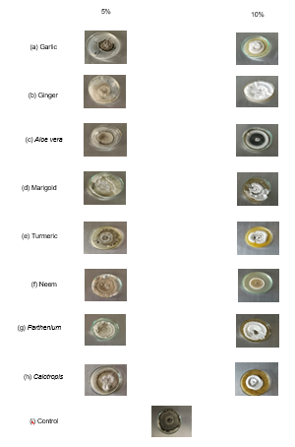

**Plate 1. Effect of plant extracts 5% and 10% on mycelial growth of *B. bicolor***

**Table 2. Conidial characteristics of *Bipolaris bicolor* as influenced by (5%) of plant extracts**

|  |  |  |  |  |  |  |
| --- | --- | --- | --- | --- | --- | --- |
| S. No. | Botanicals | Length of conidia (µm) | | Width of conidia (µm) | | Range of septa |
| Range | Mean | Range | Mean |
| 1 | Garlic | 28.84–63.32 | 47.57 | 11.33–14.47 | 13.20 | 3–7 |
| 2 | Ginger | - | - | - | - | - |
| 3 | *Aloe vera* | - | - | - | - | - |
| 4 | Marigold | - | - | - | - | - |
| 5 | Turmeric | - | - | - | - | - |
| 6 | Neem | - | - | - | - | - |
| 7 | *Parthenium* | 40.19–51.61 | 47.47 | 10.88–16.13 | 13.89 | 3–5 |
| 8 | *Calotropis* | - | - | - | - | - |
| 9 | Control | 39.37–50.14 | 45.30 | 12.52–13.83 | 12.97 | 4–5 |

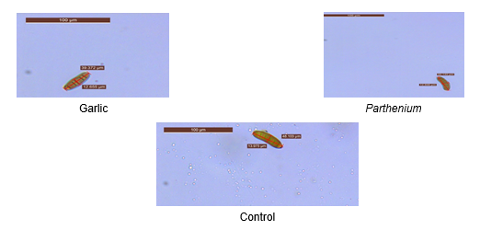

**Plate 2. Conidial characterization of *B. bicolor* as influenced by plant extracts (5%) (10×10 X)**

**Table 3: Conidial characteristics of *Bipolaris bicolor* as influenced by (10%) of plant extracts**

|  |  |  |  |  |  |  |
| --- | --- | --- | --- | --- | --- | --- |
| S. No. | Botanicals | Length of conidia | | Width of conidia | | Range of septa |
| Range | Mean | Range | Mean |
| 1 | Garlic | - | - | - | - | - |
| 2 | Ginger | - | - | - | - | - |
| 3 | *Aloe vera* | - | - | - | - | - |
| 4 | Marigold | - | - | - | - | - |
| 5 | Turmeric | - | - | - | - | - |
| 6 | Neem | - | - | - | - | - |
| 7 | *Parthenium* | - | - | - | - | - |
| 8 | *Calotropis* | - | - | - | - | - |
| 9 | Control | 31.04–69.54 | 47.70 | 12.89–15.71 | 15.71 | 3–6 |

***3.2.2 Fungicides***

Seven fungicides were evaluated at three different concentrations viz., 100 ppm, 250 ppm and 500 ppm to assess their effects on colony diameter, sporulation and conidial characterisation of *Bipolaris bicolor*. Figure 3, plate 3 and table 4 shows the results obtained at a concentration of 100 ppm. After 144 hrs of incubation, various treatments showed radial mycelial growth and mycelial inhibition ranging from 18.1 mm to 83.0 mm and 1.1% to 78.4%. The two fungicides that reduced the most mycelial growth with highest inhibition out of the seven were Difenoconazole 25% (18.1 mm with 78.4%) followed by Metalaxyl 8%+Mancozeb 64% (20.3 mm with 75.8%) and Tebuconazole 5.36% (20.5 mm with 75.0%). Mycelial inhibition for the remaining fungicides ranged from 1.1 to 60.1% with least effective in Metalaxyl 35% and Carboxin 37.5%+Thiram 37.5% (83.0 mm with 1.1% of inhibition). Treatment with Tebuconazole 5.36%, Carbendazim 12%+Mancozeb 63% and Difenoconazole 25% resulted in poor sporulation. Metalaxyl 35%, Carbendazim 50% and Metalaxyl 8%+Mancozeb 64% did not exhibit any sporulation. Carboxin 37.5%+Thiram 37.5% had fair sporulation, while the control group had good sporulation. *B. bicolor* conidial characterisation as impacted by fungicides at 100 ppm was studied. Studies show that the size and septation of the conidia vary. Tebuconazole 5.36% (51.17 µm and 18.31 µm), Carbendazim 50% (40.03 µm and 16.80 µm), Carboxin 37.5%+Thiram 37.5% (58.06 µm and 15.13 µm), Carbendazim 12%+Mancozeb 63% (69.11 µm and 16.18 µm) and Difenoconazole 25% (57.82 µm and 14.83 µm) were the average conidia lengths and widths, respectively. Transverse septa numbers in the various treatments ranged from 2–4, 3–5, 5–6 and 4–6 in last 3 treatments respectively (Table 5 and plate 4).

Radial mycelial growth and inhibition at 250 ppm fungicide concentration (16.0 mm with 81.1%, 63.8 mm with 24.9%, 45.0 mm with 47.0%, 22.3 mm with 73.7%, 20.3 mm with 76.1%, 18.5 mm with 78.2%, 13.8 mm with 83.7%). Tebuconazole 5.36%, Metalaxyl 35%, Carbendazim 50%, Carboxin 37.5%+Thiram 37.5%, Carbendazim 12%+Mancozeb 63%, Metalaxyl 8%+Mancozeb 64% and Difenoconazole 25% as compared to control (86.1 mm) respectively after 144 hrs of incubation. Carboxin 37.5%+Thiram 37.5% and Metalaxyl 35% showed fair sporulation. However, Tebuconazole 5.36%, Carbendazim 50%, Carbendazim 12%+Mancozeb 63%, Metalaxyl 8%+Mancozeb 64%, and Difenoconazole 25% did not exhibit any sporulation. In the control, good sporulation was noted. (Figure 4, Table 4 and Plate 3). Table 6 and Plate 5 show the conidial features of *Bipolaris bicolor* under various treatments. The mean conidial length was measured at 45.12 µm for Metalaxyl 35%, 51.59 µm for Carboxin37.5%+Thiram 37.5%, and 55.29 µm for the control. Carboxin 37.5%+Thiram 37.5% had the highest average conidial width (16.48 µm), followed by control (15.72 µm), while Metalaxyl 35% had the lowest conidial width (14.69 µm). Transverse septation in Metalaxyl 35%, Carboxin 37.5%+Thiram 37.5%, and control were ranging from 3 to 4, 3 to 6, and 3 to 5 respectively.

The data pertaining to *Bipolaris bicolor* mycelial growth and sporulation from the seven fungicides that were examined at 500 ppm concentrations, shown in Table 4, Figure 5 and Plate 3 after 144 hrs of incubation. Nonetheless, mycelial growth ranged from 5.0 to 22.2 mm and inhibition ranged from 36.3% to 87.5% across the various therapies. Tebuconazole 5.36% had the lowest mycelial growth and highest mycelial inhibition (10.6mm with 87.5%), followed by Difenoconazole 25% (20.1 mm with 85.7%) and Carboxin 37.5%+Thiram 37.5% (17.0 mm with 80.0%). Minimal mycelial growth and minimum inhibition was shown by Carbendazim 50% (54.1 mm with 36.3%), while other fungicides showed 21.3 mm with 74.9%, 18.0 mm with 78.8% and 22.2 mm with 79.7% effectiveness in Metalaxyl 35%, Metalaxyl 8%+Mancozeb 64%, and Carbendazim 12%+Mancozeb 63%, respectively. At 500 ppm, sporulation was totally suppressed in every fungicidal treatment. The control showed good sporulation, while the control showed 2 to 5 transverse septa and an average conidial length of 37.91 µm in the range of 30.86 to 47.92 µm and width of 13.46 µm in the range of 11.89 to 14.62 µm (table 7).

**Table 4. Effect of fungicides (100, 250 and 500 ppm) on mycelial growth of *Bipolaris bicolor***

|  |  |  |  |  |  |  |  |  |  |  |  |  |
| --- | --- | --- | --- | --- | --- | --- | --- | --- | --- | --- | --- | --- |
|  |  | 100 ppm | | | 250 ppm | | | | 500 ppm | | | |
| S. No. | Fungicides | Radial growth (mm) after (hrs) | Per cent Inhibition | Sporulation Index | Radial growth (mm) after (hrs) | Per cent Inhibition | Sporulation Index | Radial growth (mm) after (hrs) | | Per cent Inhibition | Sporulation Index |
| 144 (hrs) | 144 (hrs) | 144 (hrs) | |
| 1. | Tebuconazole 5.36% | 20.5 | 75.0% | + | 16.0 | 81.1% | - | 10.6 | | 87.5% | - |
| 2. | Metalaxyl 35% | 83.0 | 1.1% | - | 63.8 | 24.9% | ++ | 21.3 | | 74.9% | - |
| 3. | Carbendazim 50% | 54.0 | 35.7% | - | 45.0 | 47.0% | - | 54.1 | | 36.3% | - |
| 4. | Carboxin 37.5%+Thiram 37.5% | 83.0 | 1.1% | ++ | 22.3 | 73.7% | ++ | 17.0 | | 80.0% | - |
| 5. | Carbendazim 12%+Mancozeb 63% | 33.5 | 60.1% | + | 20.3 | 76.1% | - | 22.2 | | 79.7% | - |
| 6. | Metalaxyl 8%+Mancozeb 64% | 20.3 | 75.8% | - | 18.5 | 78.2% | - | 18.0 | | 78.8% | - |
| 7. | Difenoconazole 25% | 18.1 | 78.4% | + | 13.8 | 83.7% | - | 20.1 | | 85.7% | - |
| 8. | Control | 84.0 | - | +++ | 86.1 | - | +++ | 85.6 | | - | +++ |
|  | SEm± | 0.74 |  |  | 0.63 |  |  | 0.85 | |  |  |
|  | CD (*P*=0.05) | 2.25 |  |  | 1.92 |  |  | 2.56 | |  |  |

**Fig. 3. Effect of fungicides (100 ppm) on mycelial growth of *B. bicolor***

**Fig. 4. Effect of fungicides (250 ppm) on mycelial growth of *B. bicolor***

**Fig. 5. Effect of fungicides (500 ppm) on mycelial growth of *B. bicolor***

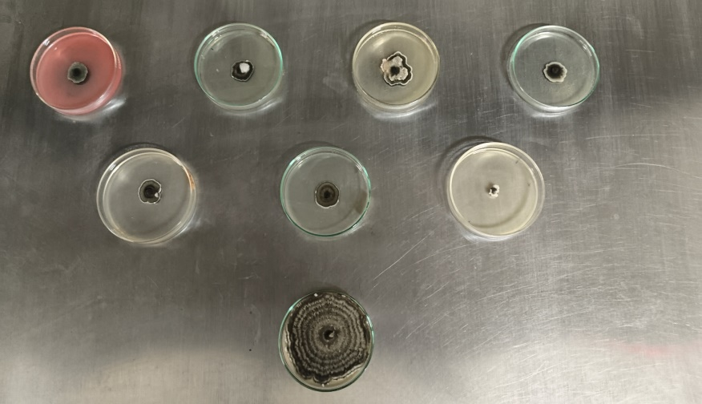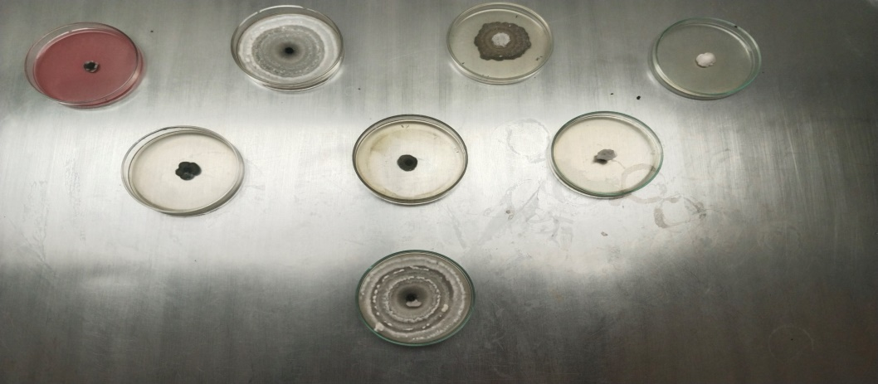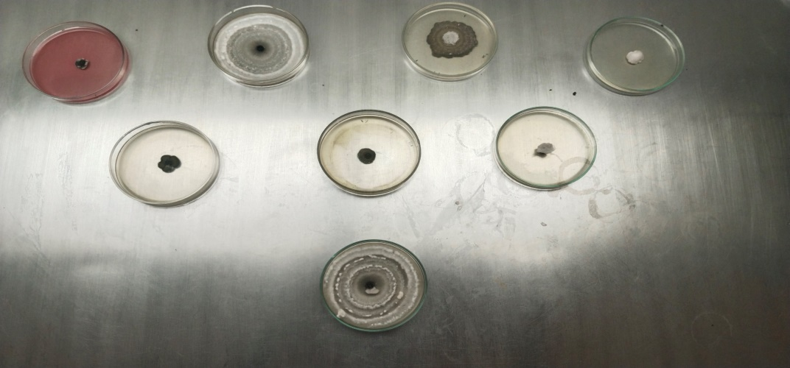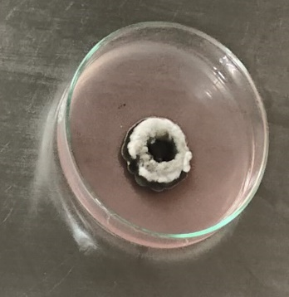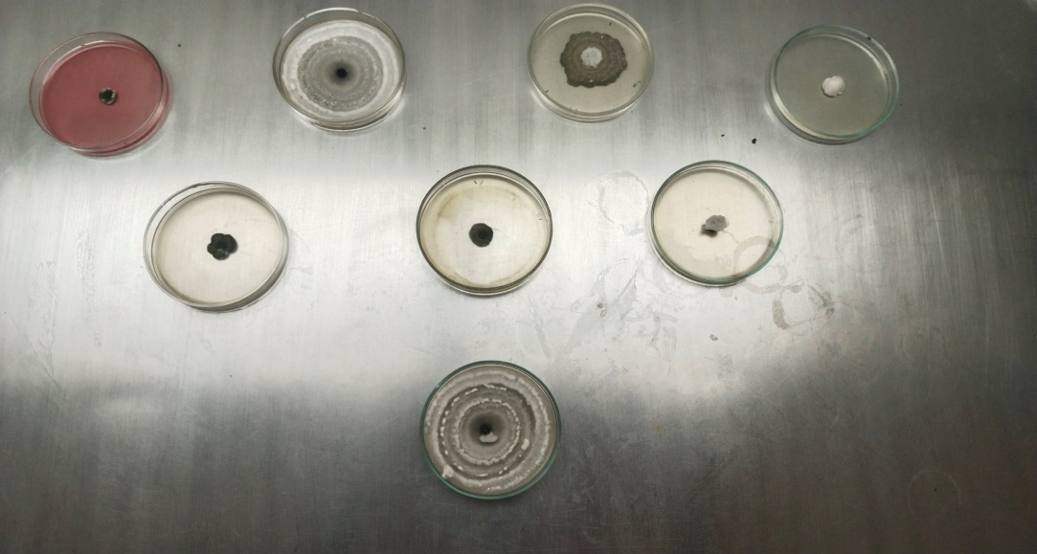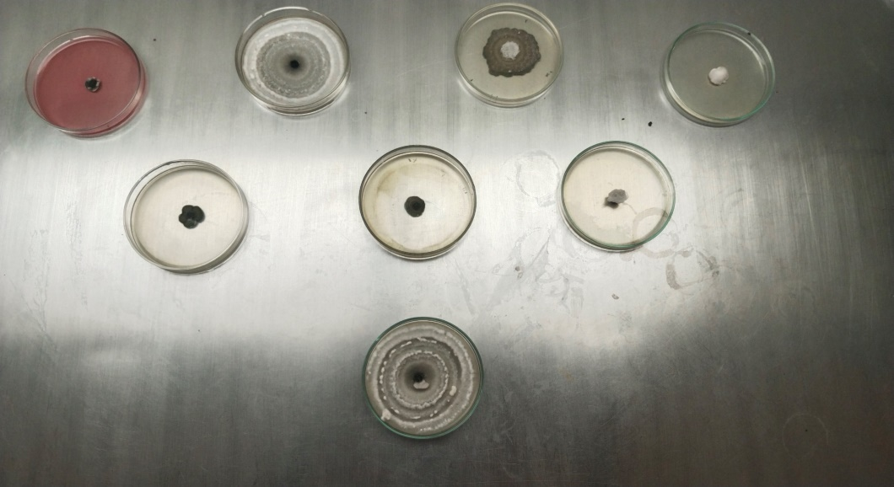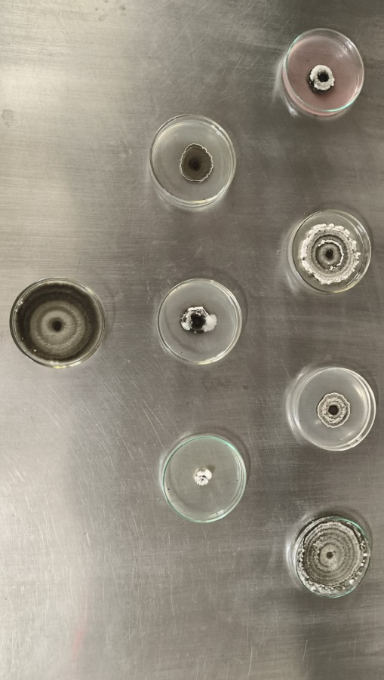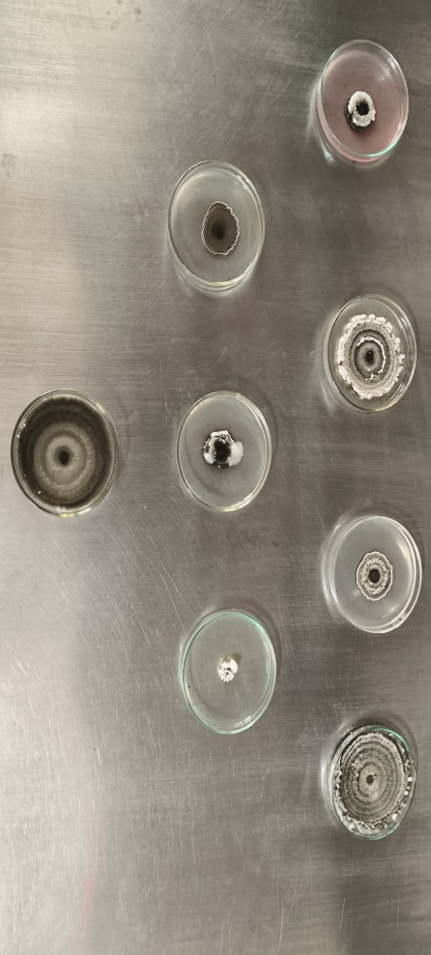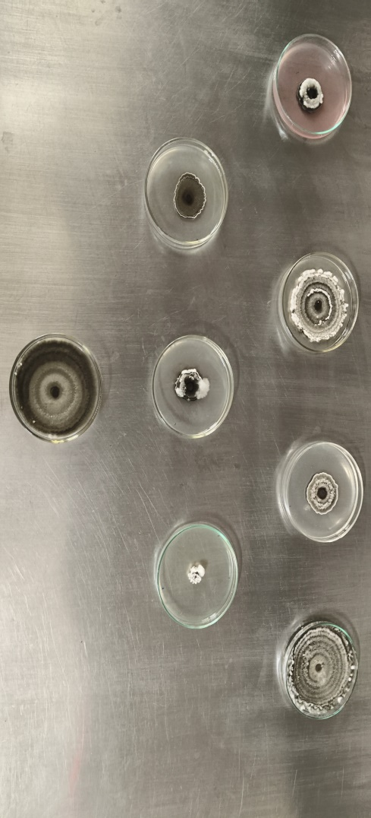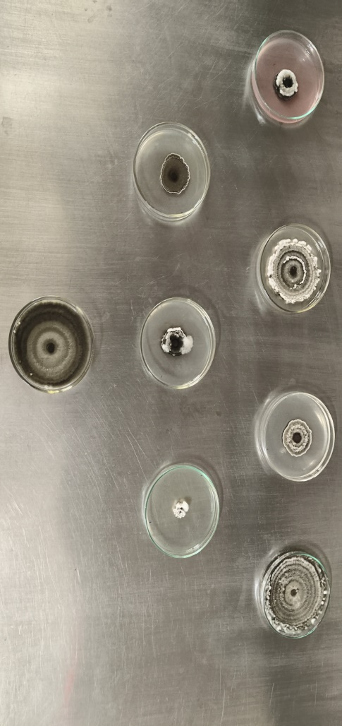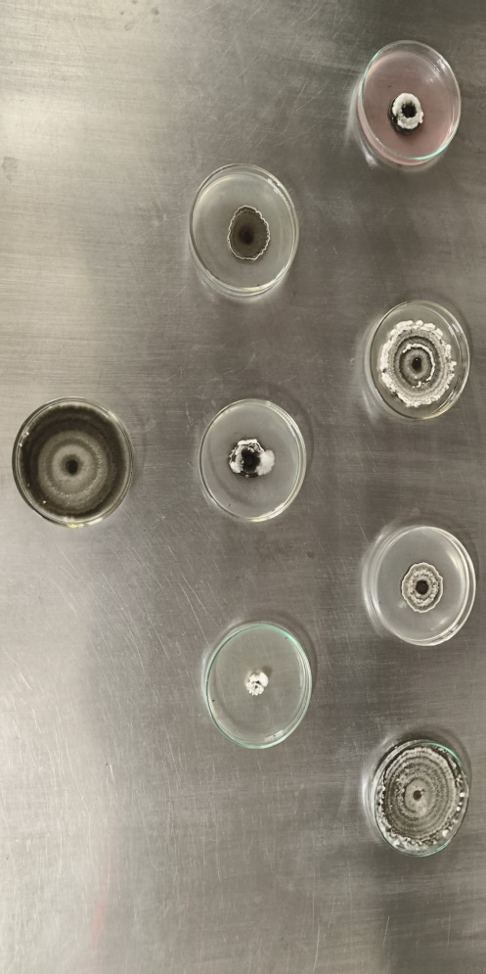

(a) Tebuconazole 5.36%

(f) Metalaxyl 8% + Mancozeb 64%

(e) Carbendazim 12% + Mancozeb 63%

(d) Carboxin 37.5% + Thiram 37.5%

(c) Carbendazim 50%

(b) Metalaxyl 35%

(g) Difenoconazole 25%

(h) Control

250 ppm

100 ppm

500 ppm

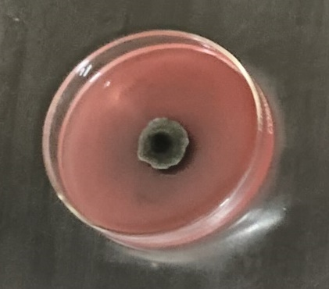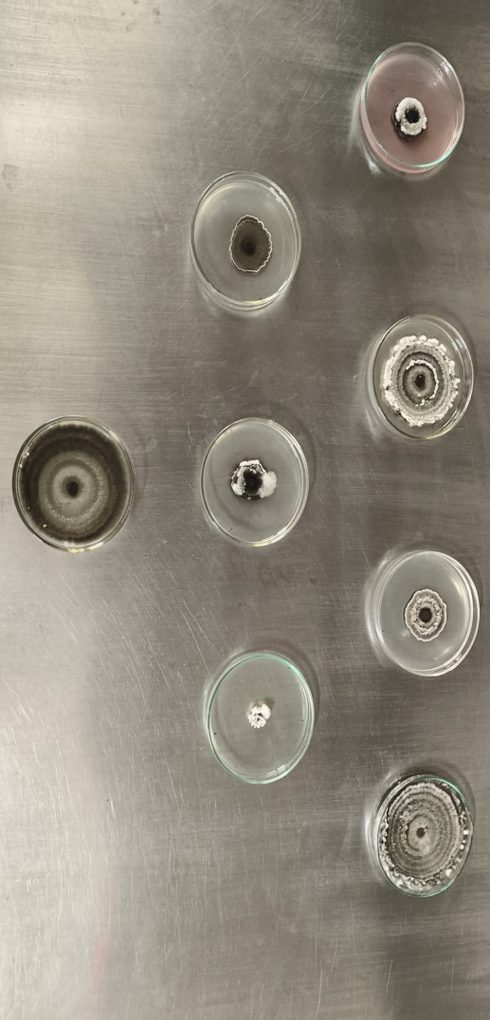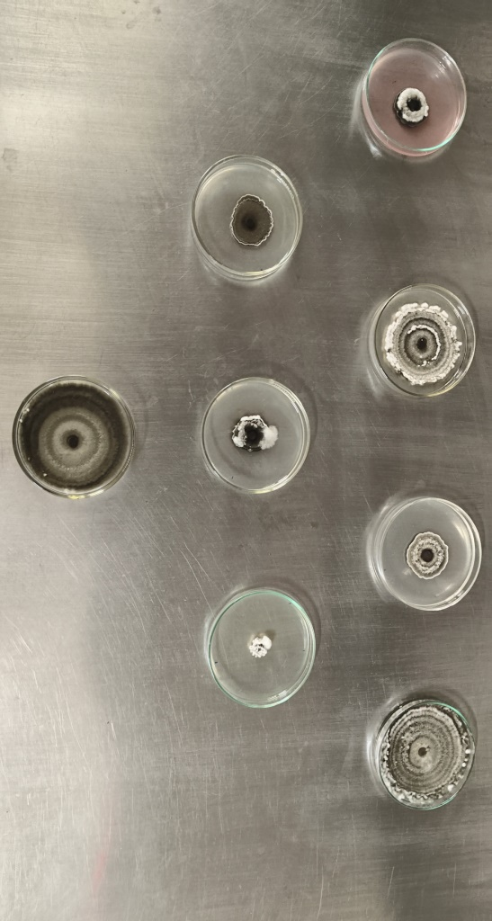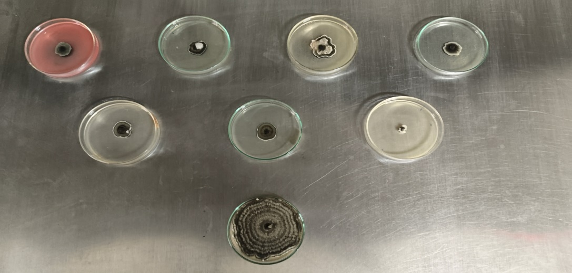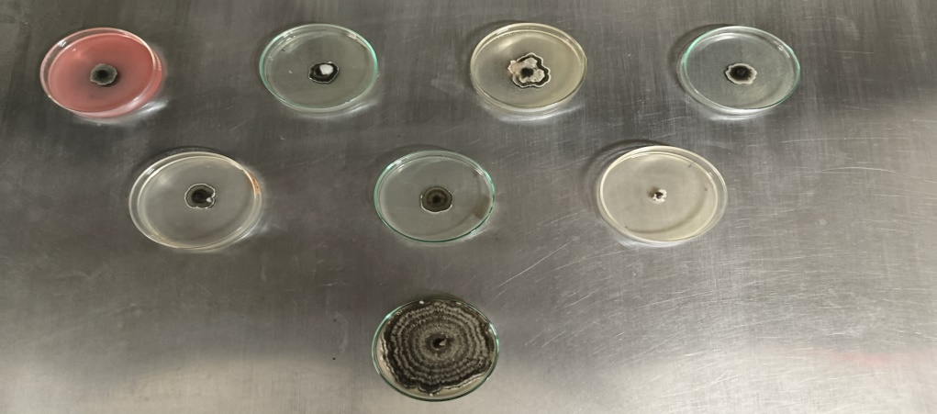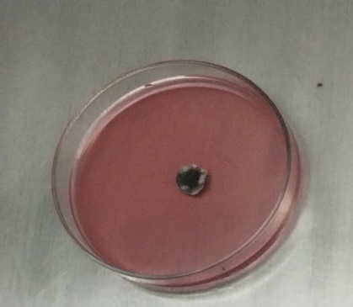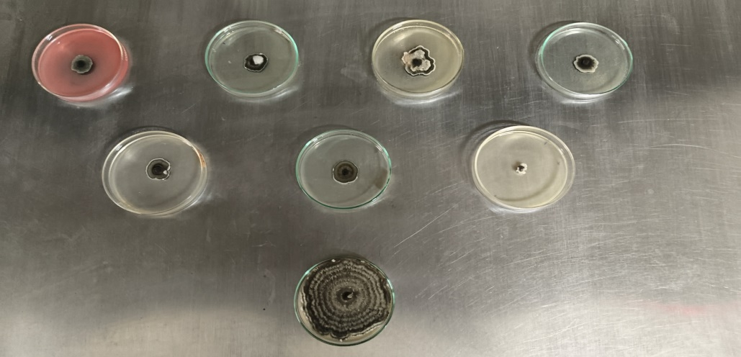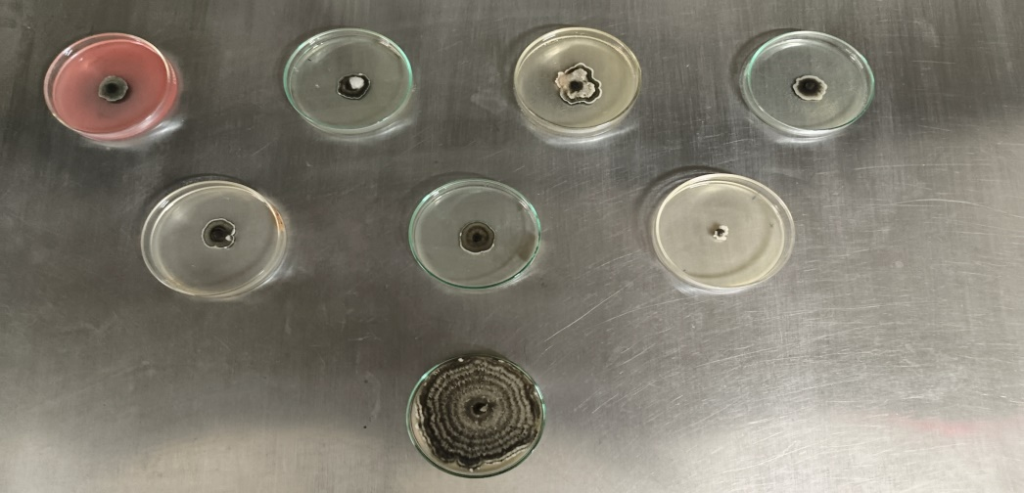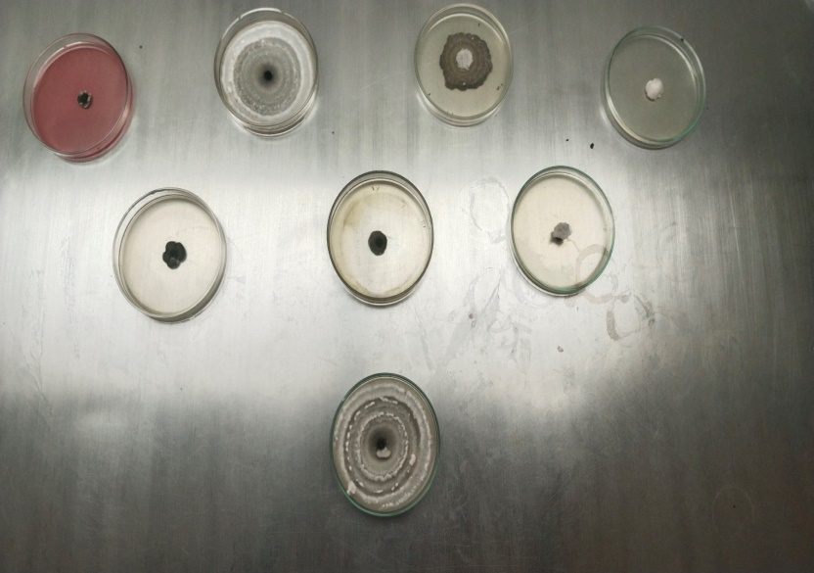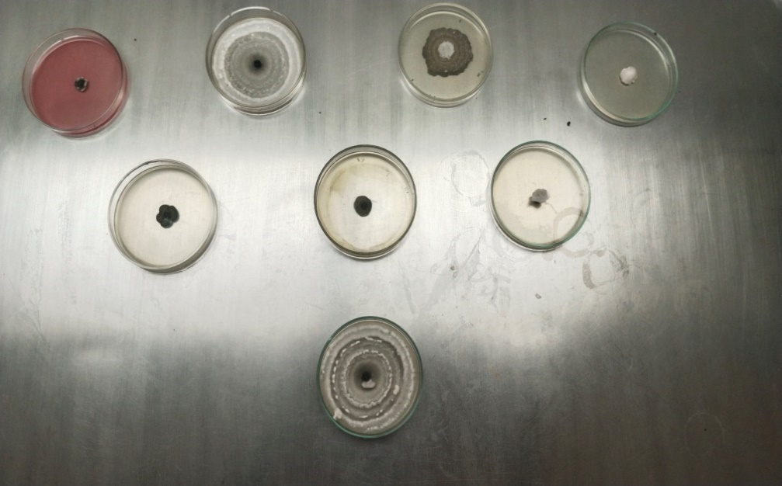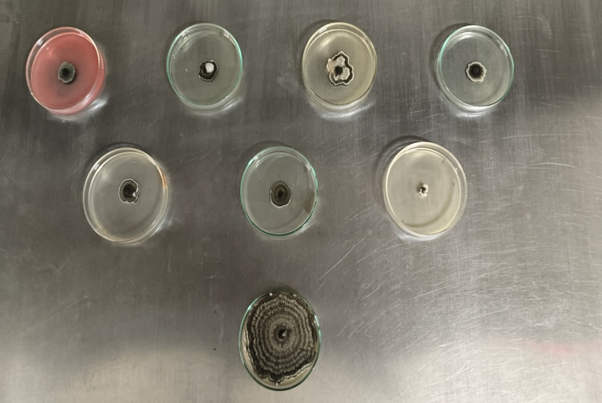

**Plate 3: Effect of fungicides (100 ppm, 250 ppm and 500 ppm) on growth of *B. bicolor***

**Table 5. Conidial characteristics of Bipolaris bicolor as influenced by (100 ppm) of fungicides**

|  |  |  |  |  |  |  |
| --- | --- | --- | --- | --- | --- | --- |
| S. No. | Fungicides | Length of conidia (µm) | | Width of conidia (µm) | | Range of septa |
| Range | Mean | Range | Mean |
| 1 | Tebuconazole 5.36% | 47.34–54.96 | 51.17 | 14.32–22.96 | 18.31 | 2–4 |
| 2 | Metalaxyl 35% | - | - | - | - | - |
| 3 | Carbendazim 50% | 29.58–57.37 | 40.03 | 15.03–20.88 | 16.80 | 3–5 |
| 4 | Carboxin 37.5%+Thiram 37.5% | 48.91–67.25 | 58.06 | 13.13–19.34 | 15.13 | 5–6 |
| 5 | Carbendazim 12%+Mancozeb 63% | 64.78–73.49 | 69.11 | 14.88–17.77 | 16.18 | 4–6 |
| 6 | Metalaxyl 8%+Mancozeb 64% | - | - | - | - | - |
| 7 | Difenoconazole 25% | 50.12–63.15 | 57.82 | 13.04–16.22 | 14.83 | 4–6 |
| 8 | Control | 47.43–72.28 | 57.93 | 11.15–15.03 | 13.23 | 4–6 |

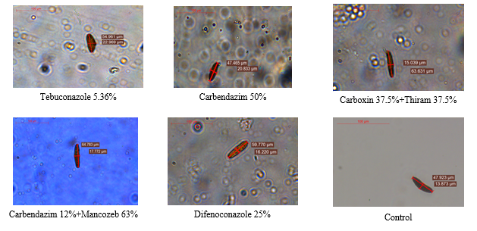

**Plate 4. Conidial characterization of *B. bicolor* as influenced by 100 ppm of fungicides (10×10 X)**

**Table 6. Conidial characteristics of *Bipolaris bicolor* as influenced by (250 ppm) of fungicides**

|  |  |  |  |  |  |  |
| --- | --- | --- | --- | --- | --- | --- |
| S. No. | Fungicides | Length of conidia (µm) | | Width of conidia (µm) | | Range of septa |
| Range | Mean | Range | Mean |
| 1 | Tebuconazole 5.36% | - | - | - | - | - |
| 2 | Metalaxyl 35% | 40.28–57.56 | 45.12 | 14.22–15.36 | 14.69 | 3–4 |
| 3 | Carbendazim 50% | - | - | - | - |  |
| 4 | Carboxin 37.5%+Thiram 37.5% | 43.07–75.51 | 51.59 | 16.06–16.98 | 16.48 | 3–6 |
| 5 | Carbendazim 12%+Mancozeb 63% | - | - | - | - | - |
| 6 | Metalaxyl 8%+Mancozeb 64% | - | - | - | - | - |
| 7 | Difenoconazole 25% | - | - | - | - | - |
| 8 | Control | 48.91–67.25 | 55.29 | 13.13–19.34 | 15.72 | 3–5 |

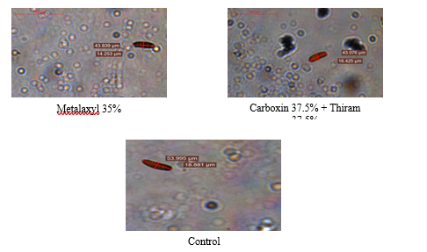

**Plate 5. Conidial characterization of *B. bicolor* as influenced by 250 ppm of fungicides (10×10 X)**

**Table 7: Conidial characteristics of *Bipolaris bicolor* as influenced by (500 ppm) of fungicides**

|  |  |  |  |  |  |  |
| --- | --- | --- | --- | --- | --- | --- |
| S. No. | Fungicides | Length of conidia (µm) | | Width of conidia (µm) | | Range of septa |
| Range | Mean | Range | Mean |
| 1 | Tebuconazole 5.36% | - | - | - | - | - |
| 2 | Metalaxyl 35% | - | - | - | - | - |
| 3 | Carbendazim 50% | - | - | - | - |  |
| 4 | Carboxin 37.5%+Thiram 37.5% | - | - | - | - | - |
| 5 | Carbendazim 12%+Mancozeb 63% | - | - | - | - | - |
| 6 | Metalaxyl 8%+Mancozeb 64% | - | - | - | - | - |
| 7 | Difenoconazole 25% | - | - | - | - | - |
| 8 | Control | 30.86–47.92 | 37.91 | 11.89–14.62 | 13.46 | 2–5 |

Congress grass (*Parthenium hysterophorus*), Aak (*Calotropis procera*), turmeric (*Curcuma longa*), neem (*Azadiracta indica*), garlic (*Allium sativum*), ginger (*Zingiber officinale*), *Aloe vera* and marigold (*Tegetes erecta*) were eight plants that were tested for their antifungal activity against the tested pathogen, i.e., *Bipolaris* bicolor at 5% and 10% concentrations. Garlic was the most effective botanical amongst all those examined because it inhibited the radial development of *B. bicolor*. Due to the presence of several sulfur compounds, including ajoene, alien, sallycysteine, vinyldithiines, allicin and others. It was clearly evident that garlic had antifungal activity against the tested fungus. Along with enzymes like myrosinase, allinase and peroxidases, there were minerals like selenium which were also having antifungal activity. Similar findings were reported by [17, 18, 19 & 20]. In addition to this, among seven fungicides tested viz., Tebuconazole 5.36%, Metalaxyl 35% WS, Carbendazim 50% WP, Carboxin 37.5%+Thiram 37.5% DS, Carbendazim 12%+Mancozeb 63% WP, Metalaxyl 8%+Mancozeb 64% WP and Difenoconazole 25% EC, Difenoconazole 25% EC gave best results at 100 and 250 ppm whereas Tebuconazole 5.36% gave best results at 500 ppm. Both the fungicides i.e., Difenoconazole 25% EC and Tebuconazole 5.36% belongs to azole group of fungicides which is dimethylase inhibitor (DMI) which interferes in process of building the structure of fungal cell wall, finally inhibiting the reproduction and further growth. Same findings were reported by [21,22]Kumar et al. (2013) and Verma et al. (2023).

4. Conclusion

Garlic extract was most effective and inhibited the maximum mycelial growth at 5% (40.1%) and 10% (50.0%) respectively. Whereas, difenoconazole 25% was effective at 100 ppm (78.4%) and 250 ppm (83.7%) however tebuconazole 5.36% was most effective in inhibiting the mycelial growth at 500ppm (87.5%).

DISCLAIMER (ARTIFICIAL INTELLIGENCE)

Author(s) hereby declares that no generative ai technologies such as large language models (ChatGPT, COPILOT, etc) and text-to-image generators have been used during writing or editing of manuscripts.

**COMPETING INTERESTS**

The authors have no conflict of interest to declare.

References

1. de Wet, J.M., Prasad Rao, K.P., Mangesha, M.H., & Brink, D.E. (1983). Diversity in Kodo Millet, *Paspalum scrobiculatum*. Economic Botany, 37(2), 159–163. <https://doi.org/10.1007/BF02858779>.
2. Ravikesavan, R., Jeeva, G., Jency, J.P., Muthamilarasan, M., & Francis, N. (2023). Kodo millet (*Paspalum scorbiculatum* L.). In: Neglected and underutilized crops. Academic Press, 279–304. <https://doi.org/10.1016/B978-0-323-90537-4.00019-3>.
3. Kasule, F., Diack, O., Mbaye, M., Kakeeto, R., & Econopouly, B.F. (2024). Genomic resources, opportunities, and prospects for accelerated improvement of millets. Theoretical and Applied Genetics, 137, 273. <https://doi.org/10.1007/s00122-024-04777-9>.
4. Hariprasanna, K. (2023). Small millets in India: Current scenario and way forward. Indian farming 73(1), 38–41.
5. Khalkho, A., Jain, A.K., Bhatt, J., Shyam, M. & Kharte, S. (2025). *In-vitro* efficacy of plant extracts and fungicides on *Alternaria tenuissima* inciting leaf blight of Kodo millet (*Paspalum scrobiculatum* L.) and their effect on conidial characters. International Journal of Advanced Biochemistry Research 9(4), 1076–1087. <https://www.doi.org/10.33545/26174693.2025.v9.i4m.4247>.
6. Hegde, P.S., Rajasekaran, N.S., & Chandra, T.S. (2005). Effects of the antioxidant properties of millet species on oxidative stress and glycemic status in alloxan

induced rats. Nutrition Research, 25(12), 1109–1120. doi:10.1016/j.nutres.2005.09.020.

1. Dey, S., Saxena, A., Kumar, Y., Maity, T., & Tarafdar, A. (2022). Understanding the antinutritional factors and bioactive compounds of kodo millet (*Paspalum scrobiculatum*) and little millet (*Panicum sumatrense*). Journal of Food Quality 2022 (1), 1578448. <https://doi.org/10.1155/2022/1578448>.
2. Anonymous, 2013. Role of millets in nutritional security of India. In: Policy paper No. 66. National Academy of Agricultural Sciences, New Delhi, 16. Available from: <https://www.millets.res.in/books/Policy66.pdf>. Accessed On: 30th April 2025.
3. Sharma, S., & Saxena, J. (2016). Evaluation of antioxidant potential of grains of Paspalum scrobiculatum Linn. American Journal of PharmTech Research, 6(5), 305–312.
4. Deepika, C., Hariprasanna, K., Das, I. K., Jacob, J., Ronanki, S., Ratnavathi, C. V., Bellundagi, A., Sooganna, D., & Tonapi, V. A. (2022). ‘Kodo poisoning’: cause, science and management. Journal of food science and technology, 59(7), 2517–2526. <https://doi.org/10.1007/s13197-021-05141-1>.
5. Nagaraja, A., Kumar, J., Jain, A.K., Narasimhudu, Y., Raghuchander, T., Kumar B., & Hanumanthe Gowda, B. (2007). Compendium of small millets diseases. Project coordinating cell, AICRP on small millets, UAS, Bengaluru, 1–76.
6. Debnath, D., Chakraborty, S., & Mahapatra, S. (2021). Spot blotch: A journey from minor to major threat of wheat. Journal of Cereal Research, 13(3), 255–269. <http://doi.org/10.25174/2582-2675/2022/112851>.
7. Kumar, B., & Srivastava, J.N. (2020). Kodo Millet or Kodo (*Paspalum scorbiculatum* L.) Diseases and Their Management Strategies. In: Diseases of Field Crops Diagnosis and Management. Apple Academic Press, 273–290. <https://doi.org/10.1201/9780429321849>.
8. Nagaraja, A., Kumar, B., Jain, A.K., & Sabalpara, A.N. (2016). Emerging Diseases: Need for Focussed Research in small millets. Journal of Mycopathological Research, 54(1), 1–9.
9. Nene, Y.L., & Thaplial, P.N. (1993). Fungicides in Plant Disease Control (3rd Ed.). Oxford and IBH Publishing Company Pvt. Ltd., Calcutta, 144–146.
10. Vincent, J.M. (1947). Distortion of fungal hyphae in the presence of certain inhibitors. Nature, 159, 850.
11. Alice, D., & Rao, A.V. (1987). Antifungal effects of plant extracts on *Dreschlera oryzae* in rice. International Rice Research Newsletter, 12(2), 28.
12. Bisht, G.S., & Khulbe, R.D. (1995). *In vitro* efficacy of leaf extracts of certain indigenous medicinal plants against brown leaf spot pathogen of rice. Indian Phytopathology, 48(4), 480–482.
13. Hasan, M.M., Ahmed, F., Islam, M.R., & Murad, K.F.I. (2012). *In vitro* effect of botanical extracts and fungicides against *Bipolaris sorokiniana*, causal agent of leaf blotch of barley. Journal of Agroforestry and Environment, 6(1), 83–87.
14. Magar, P.B., Baidya, S., Koju, R., & Adhikary, S. (2020). *In vitro* evaluation of botanicals and fungicides against *Bipolaris sorokiniana*, causing spot blotch of wheat. Journal of Agriculture and Natural Resources, 3(2), 296–305. <https://doi.org/10.3126/janr.v3i2.32534>.
15. Kumar, A.K., Nagaraja, A., Raghavendra, B.T., & Ravikumara, B.M. (2013). Evaluation of fungicides against *Drechslera setariae* causing brown leaf spot of foxtail millet *Setaria italica* (L.). Environment and Ecology 31(2A), 801–803. <https://www.cabidigitallibrary.org/doi/full/10.5555/20133255912>.
16. Verma, B., Biswas, S.K., Pratap, G., Kumar, N., Kumar, S., & Singh, V. (2023). Inhibitory effect of nano-fungicides and fungicides on radial mycelial growth of Bipolaris sorokiniana causing spot blotch of wheat under *in vitro* condition. International Journal of Plant & Soil Science, 35(20), 1069-1075. <https://doi.org/10.9734/IJPSS/2023/v35i203903>.