**Smart irrigation systems using Internet of Thing and its applications in farming system**

**Abstract**  
Water management in agriculture has been transformed by smart irrigation systems that use the Internet of Things (IoT) to maximize resource use and boost crop yields. IoT-based irrigation, which reduces waste and improves sustainability in the face of growing water scarcity, combines sensors, actuators and real-time data analytics to deliver accurate water flow. The use of IoT in agriculture is reviewed in this paper, which also covers AI-driven decision-making algorithms and communication technologies like LoRa, Zigbee and Wi-Fi. IoT-based irrigation has drawbacks despite its benefits, including costly upfront costs, complicated technology and cyber security threats. The use of self-powered sensors, AI-powered predictive irrigation and blockchain-enhanced data security are some of the upcoming trends. Smart irrigation systems have the ability to transform precision agriculture and guarantee both environmental preservation and food security by removing implementation obstacles.

**Keywords:** IoT, Smart Irrigation, Precision Agriculture, Water Management, Sensor Technology, AI Integration

**Introduction**

A vital resource for agricultural production, water is becoming scarcer as a result of population expansion, climate change and conflicting demands from the industrial and urban sectors. There are various ways to distribute water in irrigated agriculture, which is the term for agricultural practices that require water inputs. The various alternatives offer varying degrees of effectiveness and in certain situations, a particular crop should be treated as a particular type. Although, various types for irrigation, we can group them into the following categories: We can think about (i) Sprinkler irrigation (ii) localized irrigation (iii) sub surface irrigation and (iv) aerosol therapy when it comes to the distribution of water.

The following options are available when sensing systems are present (i) uncontrolled watering, in which insufficient irrigation estimated & calculated (ii) planned watering, in which irrigation supply based on evaluation for given period of time (iii) irregular watering, in which quantity determined by calibration of sensors and (iii) scheduled watering the irrigation supply approximately for given phase time. To determine water requirements, the great majority of them work in tandem with sensors to assess ambient conditions (Gracia et al., 2020). Conventional irrigation techniques are ineffective and can waste a lot of water because they frequently need physical labour and set timetables (Kumar & Singh, 2019). In this regard, incorporating (IoT) mechanism into irrigation orders presents viable path guarantee sustainable farming methods and improve water use efficiency (Friha et al. ,2021). Agriculture is the most significant economic sector in such nations, which reflects the significance of taking good care of water resources to guarantee the sustainability of the industry. Rice fields cover ten percent of India's geographical area.

Apart from that, 15% of Indians suffer from food insecurity and 20% are below the poverty line. Consequently, the economy and population are both affected by poor food production. Rainy season generates highest number of rainfalls recently in 125 years in year 2002. Rice production was diminished because of water scarcity. Shortage of water by surface water abnormality was calculated by using the Standardised Precipitation Evapotranspiration Index (SPEI) (Gracia et al., 2020). The concept of the IoT that materials is linked to the internet so they can exchange, gather & analyze streaming data. IoT has been applied in agriculture in various fields, such as precision farming, pest control and yield monitoring (Hassan et al., 2020). Because of their ability for optimize irrigation utilization & enlarge crop production, smart watering methods have gained much interest among these applications (Kumar & Singh, 2019). A combination of sensors, actuators & information are employed advanced irrigation types for monitor weather, water requirements of plants and soil humidity. Through the adjustment of irrigation schedules automatically according to real-time information, these systems are able to make sure that the cultivation get proper quantity irrigation on perfect time period (Gupta & Reddy, 2018). Smart irrigation systems conserve water and increases sustainability in agricultural work by reducing water loss and reducing the risk of over- or under-irrigation (Vallejo et al., 2023). Installation of the smart irrigation system is not an easy task despite the promised advantages. Technical issues in the form of sensor precision, data communication and system integration integrity must be addressed (Gupta & Reddy, 2018).

Adoption of such systems is also thwarted by the initial high capital outlay and technical requirements, especially in low-resource settings (Lee & Kim, 2020). Sensitivity of agricultural information also makes it vulnerable to security and privacy threats (Chen & Wang, 2019). Concepts and technologies employed in smart irrigation systems will be addressed, along with system design and deployment and the advantages and disadvantages of adopting them (Kumar & Singh, 2019; Hassan et al., 2020).

**An Overview of Agriculture and IoT**

**IoT Definition and Elements**

Kevin Ashton anticipated that IoT-enabled items with RFID and sensors will become commonplace in the future. IoT refers to the streaming data transmission between sensors put on various items over the Internet. Internet of Things could be utilised for information analysis, on-demand-computing and more variety of businesses (Baseca et al., 2019, Kim et al., 2020, Kaundal et al., 2025). Actual data collection, exchange & analysis allowed through IoT which is a revolutionary technology that links physical objects online. IoT systems in agriculture are made up of three main parts: (1) sensors that obtain data (such as earth wetness, weather & moisture); (2) actuators that carry out actions (such as controlling irrigation valves); and (3) communication networks (such as Wi-Fi, LoRa and Zigbee) that send data to cloud platforms or centralized systems (Kumar & Singh, 2019).

Together, these elements produce a smooth information flow that allows farmers to remote surveillance & manage farming activities (Hassan et al., 2020). Precision farming, where data informed decision making for optimization of consumption & boost productivity, has been made possible by the integration of internet of things in farming (Gupta & Reddy, 2018). IoT and cloud technology convergence initiatives have shown a huge rise in futuristic technologies that guarantee the sustainable production development of IoT applications like smart cities, smart transportation, smart healthcare and other applications.

These real-time applications are using information and communication technology as an effective tool to facilitate an industry-wide strategy that allows any device to easily communicate with various cyber-physical systems and exchange data. Despite the fact that the combination of cloud and IoT provides resilient pervasive computing scenarios that can produce a composite service with excellent quality and a reasonable cost, it may encounter a number of difficulties and problems in both performance and architecture (Ali et al., 2020).

**IoT Applications in Agriculture**

In agriculture IoT has been widely employed in agriculture to enable better farming and redefine conventional practices. One of the necessary applications is monitoring crops, in which farmers control growing conditions by using IoT sensors to track environmental states as moisture of soil, weather condition & luminosity (Vallejo et al., 2023).

Another necessary application is monitoring livestock, in which IoT sensors monitor fitness & behaviour of the animal, eliminating the risk of disease outbreaks and enhancing overall management of the herd (Zhang & Liu, 2019). To maximize freshness and prevent post-harvest losses, IoT is highly utilized for monitoring the location & quality to produce during transit (Fernandez & Garcia, 2021). In irrigation, IoT systems automate the supply of water through real-time data, promoting optimal water consumption and minimizing wastage (Lee & Kim, 2020). The issue of feeding the globe without increasing pollution or resource depletion will be made more difficult by the economy and conflicting claims on labour, fresh water and land. It is anticipated that IOT in each "thing" which is individually identifiable, outfitted with sensors and instantly connected to the internet. The growing need for food, both in terms of quantity and quality, has made it more important than ever to modernize and improve the farming industry. Internet of Things very promising family innovations may offer a variety of options for modernizing agriculture.

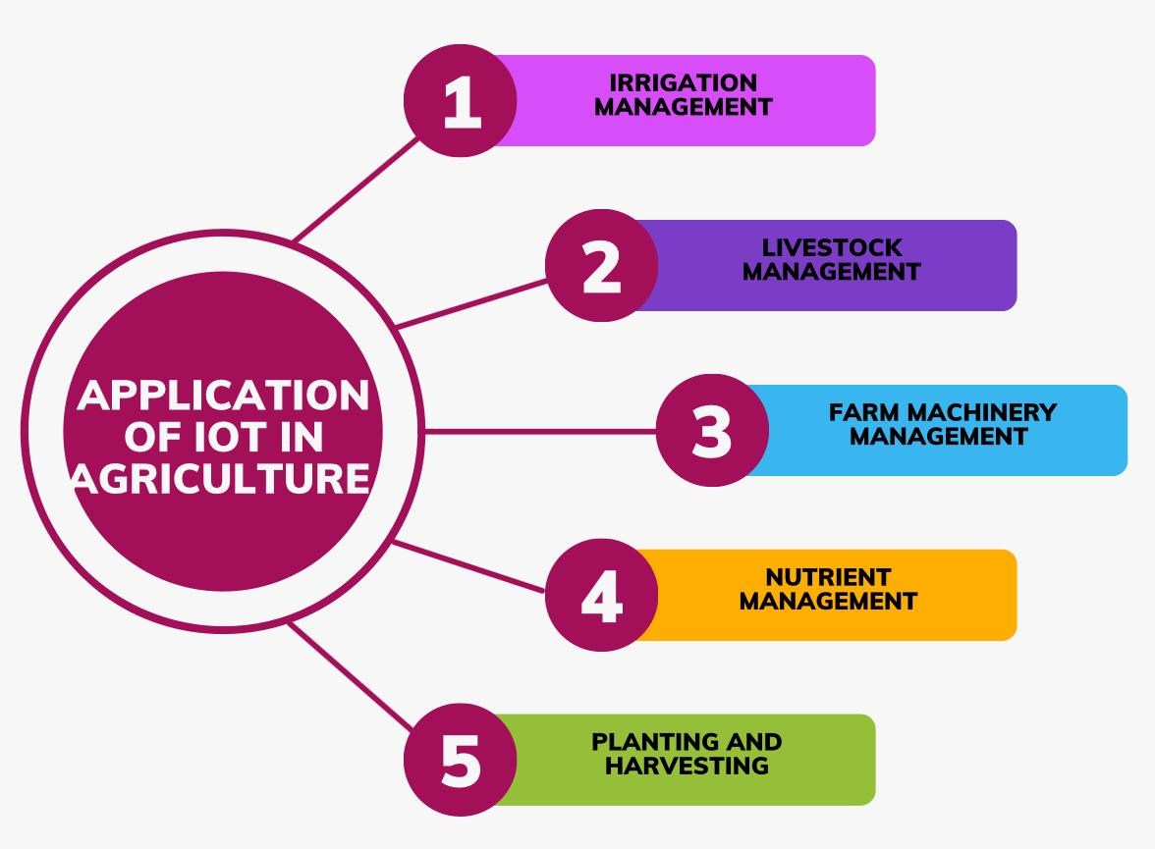

`  
Fig.1: Applications of IoT in Agriculture

In order to supply the agriculture industry's stakeholders with an expanding number of IoT goods and, once IoT becomes a widely utilized technology, lay the foundation for a unique position, the industry, research institutes and scientific associations are competing.

Fog computing and cloud computing, which are already extensively employed,gives enough supply & compound for tackling, examine enormous number on data created through Internet of Things tool (Tzounis et al., 2017). Precision agriculture (PA), in particular, is a modern agricultural technique that can boost crop yields. In order to guarantee high levels of output and reduce the adverse environmental effects of farming, PA promises to make agriculture extremely efficient. Additionally, PA positive tactics have a major effect on greenhouse gas emissions. Thanks to advanced technologies like WSN, sensors, RFID, actuators, etc., precision agriculture which optimizes field and internal farming requirements can use less harmful growth regulators. In recent years, low-cost, low power sensors have advanced. Sensor data is examined using data analysis techniques to support decision-making systems, create more accurate forecasting models and extract more information. Furthermore, PA is thought of as a data-driven approach. To solve complex issues and generate predictions, researchers employ data mining techniques such as classification, clustering, regression and others (Abbasi et al., 2019). Evolution of diverse communication technologies which is expected to lead to future applications of faster and more extensive IoT technologies to a variety of agricultural activities (Kaundal et al., 2024).

Agriculture using Internet of Things & a communication mechanism customized to every farming setting aid in the advancement of farming automation by lowering labour costs & improving crop quality & yield expenses (Kim et al., 2020). Precision farming and green technologies brought about by using (IoT) to transformed the farming industry. IoT-based irrigation systems ensure efficient agricultural irrigation by reducing water waste through the use of soil moisture sensors and meteorological data (Khongdet et al., 2022). To improve operational efficiency, IoT-based smart machinery automates planting and harvesting tasks and provides performance data (Navarro et al., 2020). In order to improve cattle management through early intervention, wearable sensors detect temperature, feeding and activity patterns and health parameters. Furthermore, IoT enables site-specific nutrient management by evaluating soil condition to guide the accurate application of fertilizers to maximize output while minimizing environmental harm (Senoo et al., 2024).

**IoT Advantages for Irrigation Systems**

Increased agricultural yields, cost savings and water conservation are just a few benefits of using IoT in irrigation systems. By using soil moisture sensors and meteorological data to deliver water exactly when and where it is needed, IoT-based solutions can reduce over-irrigation and water waste (Kumar & Singh, 2019). This precision conserve water in addition to enhances crop health & produced by preventing water stress or waterlogging (Hassan et al., 2020). Furthermore, IoT devices reduce labor costs by automating irrigation processes, allowing farmers to focus on other crucial tasks (Chen & Wang, 2019). Furthermore, it provides ease and flexibility for remotely controlling and monitoring irrigation, particularly for big farms (Singh & Kumar, 2022). IoT-based irrigation systems generally promote sustainable agriculture by optimizing resource use and mitigating environmental effect (Friha et al., 2021). The introduction of multi-intelligent control system to manage agricultural water resources when water shortages grew worse (Hadipour et al. 2020). By tracking usage and reservoir levels, the proposed system leverages IoT to manage water supplies. With claims of up to 60% water savings, the technology has provided an appropriate solution for agricultural water management (Kim et al 2020). Precision farming uses Internet of Things based watering system to make effective use of water resources (Goap et al. 2018).

To give the land the ideal amount of water, numerous experiments on Internet of Things-based irrigation systems have been conducted (Muhammad et al. 2016). Real-time soil water content monitoring is possible with automatic sprinkler systems. Through managing sprinkler in response to water content facts gathered by an Internet of Things real-time sensor, this technique was employed for predetermined depth of soil dampness without need for a user. By remotely controlling the sprinklers according to weather forecasts, IoT elements are included in autonomous sprinklers to reduce overwatering and plant death (Chowdhury and Raghukiran, 2017).

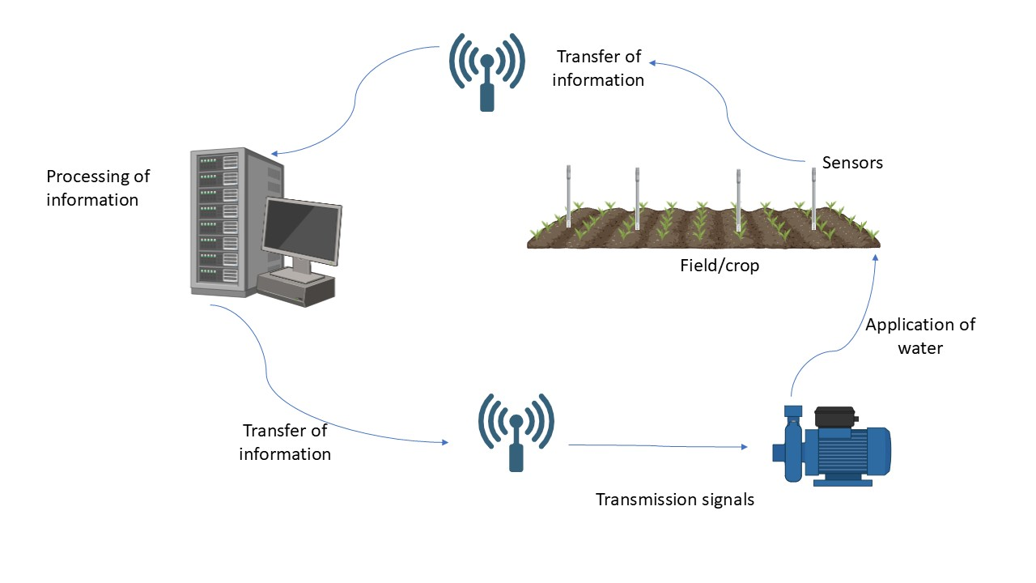

Fig 2: IoT in Irrigation Management

The internet-based interconnectedness of large number of gadgets known as IoT. Using a unique identity, each object associated with the others for the purpose of transmit data without need for human-to-human interaction. It permits creation some strategies for improved to management of naturally resources. The Internet of Things idea states that smart gadgets with sensors integrated into them enable communication the rational & physical realms. This research proposes an IoT-based system that employs figure inputs in actual time period. the farm automation watering system through android mobiles to remotely monitor and manage drips using a wireless sensor network. Zigbee is used for communication between the sensor nodes and the base station. Real-time sensed data is handled and displayed on the server using a web-based Java graphical user interface. Android mobiles may be used to keep an eye on field watering systems, which removes the importance of human involvements.

Cloud computing is an enticing solution to the enormous amount of data generated by wireless sensor networks. This study proposes and evaluates a cloud-based wireless communication system to monitor and operate a group of sensors and actuators to ascertain the water requirements of plants (Saraf et al., 2017). Precision agriculture (PA) in greenhouse-based vegetation using WSN is a technique where the soil performs better rather than harder. It is related to work that combines PA and IoT for decision and control, where data is gathered and shared for IoT-based decision making. Consequently, it relates complex inputs to water requirements and handles unexpected events (Nawandar et al., 2019).

One IoT in precise watering technique that automate irrigation by detecting soil moisture and climate factors (such rainfall). It provides water in the field at the right time, quantity and location—all of which are essential for plant growth. Additionally, remote water management can be challenging, especially when there is a water deficit that could still damage the crop. By employing sensors to measure moisture, rain and other climate and soil variables, it is easy to adjust the water supply for irrigation. Soil moisture sensors intelligently determine the soil's moisture content, allowing for autonomous field irrigation with minimal human interventions. It will also be very beneficial to farmers. Watering a far-off location from home will be easier and more enjoyable. Additionally, it will protect the farmer from extreme heat and freezing weather while also saving them time commuting to and from the field (Kumar A et al., 2017).

**Intelligent Watering Systems: Theories and Innovations**

**The meaning and salient characteristics of intelligent irrigation systems:**

Smart irrigation systems are innovative technological solutions incorporating automation and real-time data for best utilization of water in agriculture there are sensor-based IoT systems employing actuators, communication networks and decision algorithms to deliver water efficiently as per crop need and climatic requirement. Automatic control, real-time monitoring, decision-making through data and remote access are some of the striking characteristics of smart irrigation systems (Kumar and Singh 2019). Smart irrigation systems are a main component of precision agriculture as these utilize these features to decrease wastage of water, minimize labour cost and improve crop production.

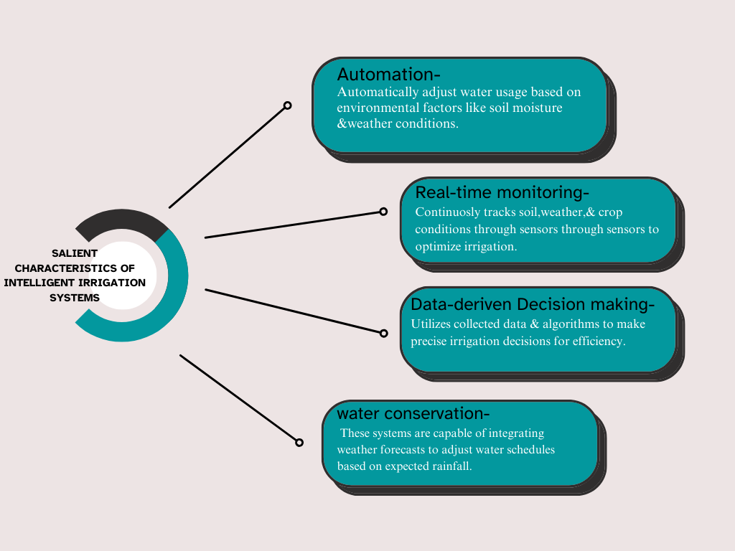

Fig 3-The meaning and salient characteristics of intelligent irrigation systems

Agricultural production can be totally transformed by means of sensors and the IoT in agriculture. These tools are accessible to farmers. Look into every dimension of the weather, like temperature, wind speed, soil water content and even cases of smoke or fire that have burnt their crops. Farmers can utilize these to make easy use of SA sensors to detect trouble spots, keep an eagle eye on crop health and determine when to plant, irrigate, fertilize and harvest. All these actions cause waste, augmented efficiency and output and limited environmental damage. The farmers are able to gather data with ease, save it and analyse in real time as a result of cloud technologies, which store information received by cloud layer as shown in fig 3.0 (Et-taibi et al., 2024)

**Actuators and Sensors in Intelligent Irrigation**

The basic structural components of smart irrigation systems are actuators and sensors, enabling the collection of crucial information and the implementation of irrigation operations. Soil temperature sensors and atmospheric temperature sensors, atmospheric humidity sensors and soil sensors for monitoring water content in the soil (Gupta & Reddy, 2018) are some of the most popular sensors. Weather stations and rain sensors also provide information regarding evapotranspiration and rainfall intensities, which become easier to use for optimization of the irrigation schedule (Vallejo et al., 2023). Pump controllers and solenoid valves are actuators for sufficient supply of water for the control of water supply based on instructions from the control system. Coupling of these modules enables the creation of a fully automated and responsive watering system (Fernandez & Garcia, 2021). The world's population and economy raise the demand for the available freshwater supply. But for this, the world has plunged into a series of problems, including the global water crisis, drought and shortage of freshwater supplies. Though the nature of them is high water consumption, most farmers across the globe use conventional irrigation systems to avoid this issue. Therefore, irrigated agriculture needs to be improved for water consumption efficiency.

This can be made possible through the implementation of advanced control mechanism & IOT for monitoring irrigated farmland and improving irrigated farmland control. Outcomes of extensive literature review on advanced control systems and irrigation monitoring are discussed in this paper with emphasis on new studies published over the last four years. Innovative control methods and accurate irrigation monitoring studies are emphasized in the recent studies. The purpose of this study is to provide informative content to everyone interested in the increased monitoring and control potential of irrigated agriculture and to researchers interested in being updated with the most recent research and determining potential research areas (Ghareeb et al., 2023).

**Technologies for communication (Wi-Fi, Zigbee and LoRa)**

When it comes to linking the many parts of smart irrigation systems, communication technologies are essential. Large agricultural fields can benefit from LoRa's less energy usage & long-range capabilities (Zhang & Liu, 2019). Another popular protocol is Zigbee, which is well-known for its affordability and capacity to build mesh networks that improve connectivity in challenging settings (Lee & Kim, 2020). Wi-Fi provides high-speed data transfer and is frequently used in smaller settings or locations with pre-existing internet infrastructure. Real-time irrigation process monitoring and control are made possible by these technologies, which facilitate smooth data transmission between sensors, actuators and central control systems (Chen & Wang, 2019). Wi-Fi helps in acknowledged among high and widely utilised & effective link technology because of its ease of access. This also determined inexpensive Internet of Things devices available now to primarily contribute Wi-Fi, which, has limits & thought as an effective overall strategy (M. Soto-Garcia et al., 2013).

This research compares four popular transmission technologies that are suitable for mobile robots operating in challenging environments. With a focus on important factors including signal strength, noise resistance and data transfer efficiency, the study aims to identify the best communication approach in hostile environments. The study explores the nuances of signal-to-noise ratio (SNR) and received signal strength indication (RSSI), revealing particular features and trade-offs between the technologies. The essay examines the effects of barriers, energy consumption dynamics and possible real-world applications while navigating the complexities of frequency ranges, modulation types and communication topologies.

In addition to contributing to the fields of robotics and communication, the study offers valuable insights for stakeholders searching for reliable and efficient transmission strategies for mobile robotic systems. These findings provide useful guidance for technology selection for cooperative mobile robot operations under challenging conditions. The basis for future developments in robotic communication is laid by this work, which emphasizes the significance of selecting the most effective transmission mechanism for mission-critical applications in hostile situations (Abderrahmane et al., 2024).

|  |  |  |  |  |
| --- | --- | --- | --- | --- |
| Technology | Range | Power Consumption | Key Features | References |
| LoRa (Long Range) | Long-range (several km) | Low | Ideal for large agricultural fields, low-power wide-area network (LPWAN) | Zhang & Liu, 2019; Kanimozhi et al., 2023 |
| Zigbee | Short to medium (10-100m) | Low | Mesh network support, cost-effective, suitable for smart buildings | Lee & Kim, 2020; Ali et al., 2019 |
| Wi-Fi | Short to medium (~100m) | High | High-speed data transfer, widely used in IoT devices, real-time monitoring | Chen & Wang, 2019; M. Soto-Garcia et al., 2013 |
| GSM | Long-range (global) | Moderate to High | Cellular-based communication, requires a mobile plan, widely available | Obaideen et al., 2022 |
| MQTT | Varies (Depends on network) | Low | Message queuing telemetry transport, efficient data transfer, used in IoT systems | Obaideen et al., 2022 |

Table 1- Technologies for communication

In this experimental project, a communication system utilizing the ZigBee and LoRa protocols is designed, developed and tested. A relay unit, a central receiving unit with LoRa and ZigBee transceiver modules, a microprocessor, a wireless sensor card with temperature and humidity sensors and other parts make up the system. Temperature and humidity data may be sent from the sensor to the central receiving unit using ZigBee or LoRa transceiver modules and the sensor card's relay can be managed remotely or online.

The microcontroller was configured and programmed using the Kiel vision Integrated Development Environment (IDE) and the evaluation version of STM32CubeMX (Ali et al., 2019). The LoRa and ZigBee wireless sensor network described in this article may be incorporated into smart building energy management systems. The performance parameters of the communication network are specified and examined in light of test results from various configurations and every aspect of the design and execution is described. By integrating the recommended embedded system into smart settings, a variety of environmental factors, such as lighting, moisture and room temperature, may be automatically monitored and managed. The embedded code of Internet of Things (IoT) apps may be altered for new uses due to their adaptability. Wireless technologies like those in the Internet of Things considerably facilitate the exchange of information. The Internet of Things enables both long-range and short-range connection. These IoT communications make use of ZigBee and LoRa technologies. These technologies are advantageous to the agriculture industry because they make it possible to monitor environmental conditions more precisely, which increases yields within a certain range. Technologies such as NB-IoT and LoRa enable long-distance communications. To enable low-power long-distance communication, a low-power wide-area network is being developed. Two locations employ LoRa to monitor environmental factors. To gather data, LoRa devices are placed in various locations. [Kanimozhi and others, 2023].

**Data Analytics and Decision-Making Algorithms**

The brains of the intelligent irrigation systems are automated making of decision and analysis of information, which transform raw data into meaningful insights. To determine the optimal schedules for irrigation, advanced algorithms analyze sensor readings and weather forecasts, considering factors such as crop phase, soil type and weather (Singh & Kumar, 2022). To ensure these predictions are as accurate as possible, machine learning methods like decision trees and neural networks are being used more and more (Hassan et al., 2020).

Moreover, large volumes of data can be calculated and stored on cloud-based systems, which makes it easier to determine trends as well as conduct long-term analysis. These technologies guarantee that smart irrigation systems operate in the best possible way and react accordingly to fluctuating environmental conditions (Friha et al.,2021). Predictive analytics software and automated decision support other than predictive algorithms will inevitably become ubiquitous and have an impact on society. Some of the times it seems to have a negative impact, i.e., discrimination and other times it's positive. Man-algorithm interaction, or ICT, in moral decision-making is the solution which this research is striving towards. A human decision-maker might be able to assist with the explicit cognitive processes, as predictive analytics can arguably generate a great deal of implicit information. This is one way to imagine a potentially beneficial interaction between humans and algorithms. There doesn't appear to be much existing research on ethical decision-making and predictive analytics within the framework of this human-algorithm interaction as of yet (Persson & Kava Hatzopoulos, 2018).

Data science is the act of constructing intelligent solutions end-to-end, including data collection pipelines, business decision-making and solution maintenance with human involvement. To enhance quality in data-driven decisions, details production is an operations process with feature transformations, gathering, refinement and producing more knowledgeable heuristic measures from domain idiosyncrasies and iterations. The process of mapping data to business decisions is known as business decision making. Based on business limitations, the mappers are usually machine learning algorithms that are optimized to provide best performance within a specified research time. Quality and quantity of the data and sub-data are used to optimize the mappers (Meyers et al., 2019).

**Intelligent Irrigation System Design and Implementation**

**IoT Device Integration**

The use of IoT devices is a crucial step in the deployment of smart irrigation systems. Sensors including weather stations, temperature sensors and soil moisture sensors are placed across the field to capture data in real time (Fernandez & Garcia, 2021). A central control unit, to which the sensors are attached, decodes the data and instructs actuators. A microcontroller or single-board computer, such as an Arduino or Raspberry Pi, is frequently used as this central control device (Lee & Kim, 2020). Actuators, such as solenoid valves and pump controllers, carry out irrigation tasks in accordance with the system's decisions (Chen & Wang, 2019).

Cloud systems and mobile apps are frequently combined to provide remote monitoring and control and to give farmers real-time alerts and updates (Singh & Kumar, 2022). The smooth integration of many components will enable the system to function effectively and adjust to shifting environmental conditions (Friha et al., 2021). These days, the number of connected IoT devices is expanding quickly. Sensors, cameras, wearable technology, smartphones and other internet-enabled devices found in homes, cars and industrial facilities make up the billions of Internets of Things (IoT) devices. We present a novel Autonomic Global IoT Device Discovery and Integration Service (aGIDDI) in this work that enables IoT applications to locate and integrate IoT devices that are owned and operated by other IoT parties, also referred to as IoT device providers and pay them for their data observations (Dawod et al., 2022).

**Examples of Effective Implementations**

Illustrations of Successful Implementations, the effective use of intelligent irrigation systems in many agricultural environments is demonstrated by a number of case studies. An Indian study, for example, demonstrated how IoT-based smart irrigation may be used to grow wheat, leading to a 20% increase in crop output and a 30% decrease in water consumption (Kumar & Singh, 2019). Using LoRa communication technology, a smart irrigation system was implemented in a Spanish vineyard, increasing water efficiency and lowering operating expenses by 25% (Fernandez & Garcia, 2021). For instance, a machine learning algorithm is used in an American smart maize irrigation system to improve plant health and deliver precise watering (Zhang & Liu, 2019).

These ideas demonstrate how intelligent irrigation systems might boost agricultural yields in response to water scarcity (Hassan et al., 2020).

|  |  |  |  |  |
| --- | --- | --- | --- | --- |
| **Case Study** | **Technology Used** | **Impact on Water Usage** | **Impact on Crop Yield** | **Reference** |
| **Wheat Cultivation (India)** | IoT-based smart irrigation | 30% reduction | 20% improvement | Kumar & Singh, 2019 |
| **Vineyard (Spain)** | LoRa communication technology | Improved water efficiency | 25% cost reduction | Fernandez & Garcia, 2021 |
| **Maize Cultivation (America)** | Machine learning-based irrigation | Accurate watering | Enhanced plant health | Zhang & Liu, 2019 |
| **General Agricultural Use** | IoT sensor-based monitoring | Optimized water use | Increased efficiency | Hassan et al., 2020 |
| **Global IoT Device Discovery** | aGIDDI service for IoT integration | Efficient data sharing | Enhanced automation | Dawod et al., 2022 |

Table 2-Key implementations of smart irrigation systems along with their technology

**Merits & Demerits**

Water Efficiency and Conservation Smart irrigation systems based on the Internet of Things have shown great promise in increasing irrigation effectiveness and preserving water. To ensure optimal water usage, reduce waste and ensure precise irrigation, these systems integrate real-time data from weather, crop water needs and soil moisture sensors. Research claims that when compared to traditional methods, IoT-based irrigation systems can save up to 30% on water usage (Gracia et al., 2020).

Additionally, by predicting irrigation needs based on historical and present data, machine learning algorithms further enhance water saving. The accuracy of these systems is ultimately impacted by environmental factors such as soil heterogeneity and sensor location, which can alter sensor quality and data (Zhang et al., 2018). Due to dryness, increased development and demographic or economic shifts, water depletion is a significant issue in the arid tropics. In most metropolitan locations, home customers only have a yearly reading of the quantity available to base logical or educated judgments on required or needless use, thus even while educational initiatives have reduced urban interior water-use, wasteful outside waste still happens. The average customer, for example, will water lawns within a certain, unconstrained time frame. They are applied randomly, i.e., based on sight or time limitations. Water loss can occasionally occur due to oversaturation, automatic sprinklers that are unable to detect rain, incorrect spray direction placement, etc.

More advanced monitoring systems, water may be switched off when a grass section has gotten enough watering to optimize outdoor water usage efficiency. In an effort to enable dynamic decisions on water release for lawns and fruit trees, this study details the development of an intelligent information and water management system that integrates Web-based data with real-time sensed data. As demonstrated, the first pilot-prototype combines the Internet of Things and Semantic Technologies to lower outdoor water usage in urban areas and educate residents about water conservation best practices (Myers et al., 2017).

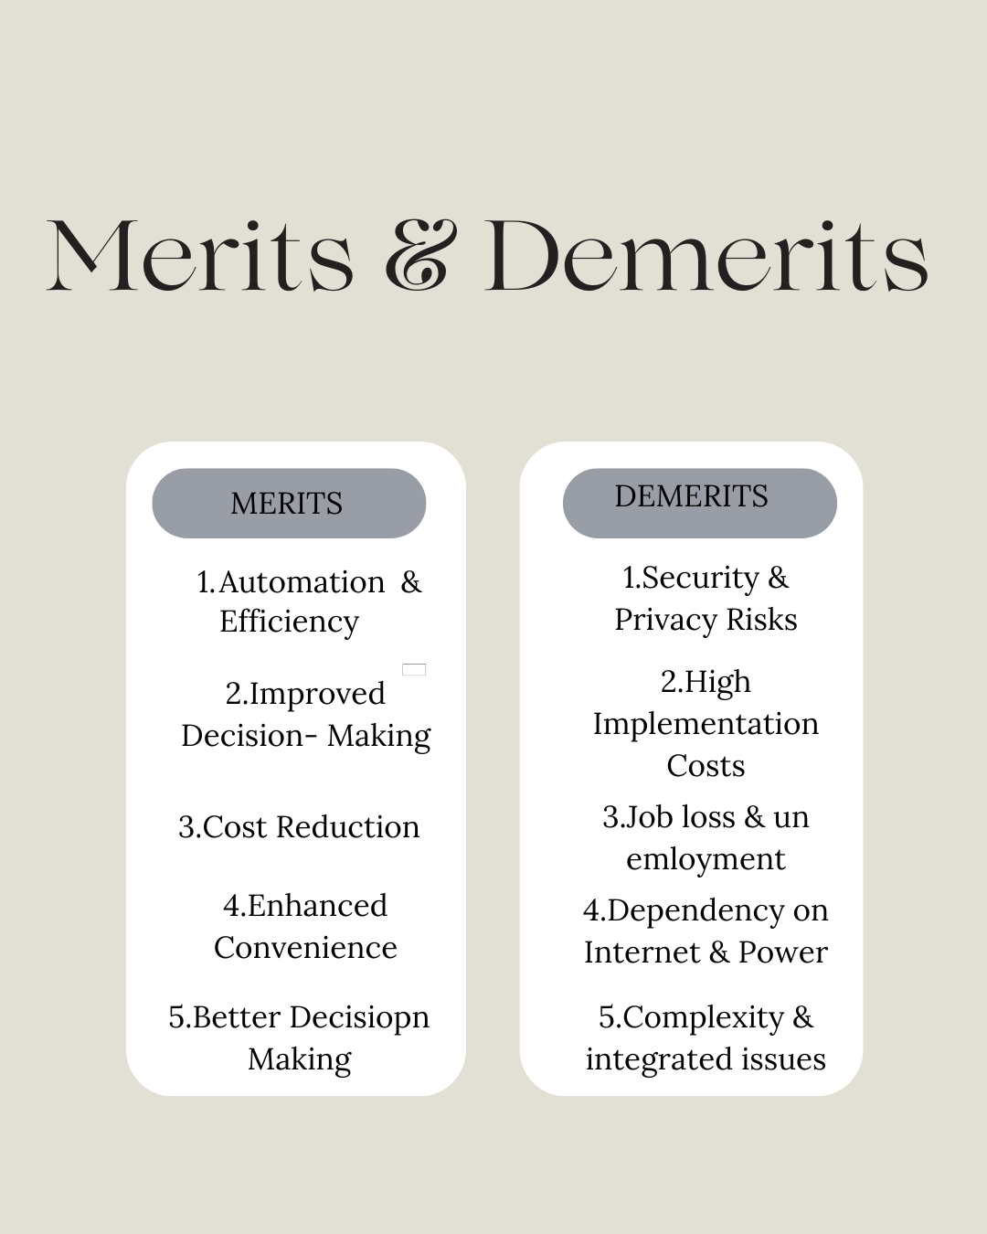

Fig 4. Merits & Demerits of IoT

Scalability and Economical: Since IoT-based smart irrigation systems consume less water and energy, they end up saving money in the long run (Li et al., 2020). The initial cost of IoT infrastructure, including sensors, connectivity modules and data processing units, may be beyond the means of small farmers. However, because to their scalability, the systems can be used by both small and large agricultural organizations. Broader deployment is now conceivable due of significant cost savings afforded by cloud-based platforms and open-source IoT technologies (Dugama & Bai 2024). However, in settings with limited resources, the cost of IoT device repair and maintenance continues to be a problem (Dhillon & Moncur 2023).

**Challenges in Technology and Operations**

Various technological and operational barriers exist against the implementation of IoT-based intelligent irrigation systems. They are, among others, a requirement of an uninterrupted source of power, reliance on sensor networks and data transmission issues at far-flung locations (Singh et al., 2020). Moreover, technical expertise to interface IoT devices with prevailing agriculture practices would be required, which may not readily be available in rural localities. Further, incompatibilities can occur because there are no well-defined protocols for IoT devices, hindering smooth operation (Rao et al., 2021).

**Privacy and Security Issues**

The dependence of smart irrigation systems on IoT devices and cloud-based platforms raises significant security and privacy concerns. Unauthorized access to IoT networks can result in irrigation schedule manipulation, data breaches and even agricultural operations being sabotaged. To reduce these dangers, encryption and secure communication protocols are crucial, but putting them into practice can be expensive and difficult (Khan et al., 2021). Furthermore, farmers have privacy concerns about the gathering and storing of sensitive agricultural data, which makes strong data protection measures necessary (Gupta et al., 2022).

**Research Directions and Future Trends**

**Developments in Sensor Technology:**

The advancement of sensor technology is essential to progress of IoT-based smart irrigation systems in the future. More precise and fast information on yield condition, aliment content is anticipated to be provided by new sensors, such as nano sensors and hyperspectral imaging tools (Smith et al., 2021). Agribusiness sufficient to make substantial use of them due to their declining cost and energy requirements (Jones et al., 2022).

The intricate subsystem of linked parts known as Wireless Sensor Networks (WSNs) keeps an eye on and reports on various situations. These elements—"sensing units, communication units, processing units and power sources"—all are of utmost significance to WSN's capacity to perform in complicated ways and execute such tasks as the gathering of information, processing and transmission of the same, functions which are essential for applications running the gamut from structural analysis to monitoring ecologically (Mira & Aramice, 2024). Furthermore, one of the potential trends that can solve power supply issues in remote locations is the creation of self-powered sensors that tap environmental energy, i.e., solar or kinetic energy (Kumar et al., 2023). To ensure compatibility and reliability, more research is essential before the integration of such advanced sensors in conventional IoT frameworks (Zhang et al., 2022).

**Machine Learning & Artificial Intelligence role**

Machine Learning & Artificial Intelligence have the potential to revolutionize the development of intelligent irrigation systems. High number of figures from Internet of Things detectors can be examine by Artificial Intelligence blueprints to irrigation requirements, optimize water use and identify abnormalities in crop health (Li et al., 2021). For instance, deep learning models have been successfully utilized to minimize water loss by predicting soil moisture accurately (Wang et al., 2022). Furthermore, research into adaptive irrigation systems that learn and improve over time is being explored with reinforcement learning techniques (Garcia et al., 2023). Big data technologies and high-performance computers have led to machine learning that has created avenues for data-driven research in Agri-technology, a cross-disciplinary arena. Yield prediction, disease discovery, weed identification, crop quality and crop species identification were among the categories of applications classified under crop management. Livestock management containing applications on livestock production and animal welfare, as well as water management and soil management, constituted other categories. (Liakos et al., 2018).

**Possibility of Combining Other Intelligent Farming Technologies**

The integration of IoT-based smart irrigation systems with other smart agriculture technologies, including drones, automated equipment and precision agriculture, is an important future trend. For instance, combining drone-based agricultural analysis with IoT irrigation systems could result in a solution that manages both water and fertilizer (Guebsi et al., 2024).

Likewise, the incorporation of blockchain technology with IoT information can enhance farm supply chain traceability and transparency (Demestichas et al., 2020). Absent the development of interoperable platforms through which different smart farming devices are able to communicate freely, the complete potential of IoT in agriculture cannot be reached. Nevertheless, technical, economic and legal challenges must be surmounted to attain this integration (Hou et al., 2021). Agricultural cropping is as critical to industry as to food production; in fact, a major portion of many countries' economy depends on such crops as gum, cotton and rubber. Additionally, production of biofuels from crop-based foods has begun to develop just recently. Already, by the time only a decade elapsed, only 110 million tons of coarse grains (only around 10% of overall output) were devoted to the making of alcohol. Food security is under risk as a result of the growing use of food crops for the production of biofuel, bioenergy and other industrial uses. The strain on already limited agricultural resources is rising as a result of these demands.

A thorough analysis is conducted on IoT devices and communication methods related to wireless sensors that are used in agricultural applications. The sensors available for certain agricultural applications, i.e., crop health, irrigation, tillage of the soil and detection of insects and pests, are listed. The benefits of this technology for farmers are examined at each stage of the crop's life cycle, including planting, harvesting, packing & transportation. Additionally, this article discusses the application of unmanned aerial vehicles to observe crops and for other beneficial applications like increasing the yield of the crop. Where required, pioneering IoT-based systems and structures employed in agriculture are demarcated as well (Ayaz et al., 2019). Live data collection by IoT devices enable remote monitoring and evidence-based decision-making. With proactive management of weed infestations, the method minimizes the application of chemical pesticides and protects the environment. This emerging solution maximizes biodiversity conservation while optimizing agriculture yield through synergistic employment of machine learning approaches and hardware components. The results are important and show how technology can be harnessed to merge environmental factors and farm production for sustainable agriculture (Raman et al., 2023).

**Conclusion**

The integration of IoT in smart irrigation systems has significantly improved agricultural water management, optimized resource use while enhancing crop productivity. By utilizing sensors, real-time data analysis and automated control mechanisms, these systems minimize water wastage and ensure precise irrigation, making farming more sustainable. The adoption of IoT-based irrigation, however, faces challenges such as high initial costs, technical complexities and security concerns. Advancements in sensor technology, artificial intelligence and blockchain integration hold promise for overcoming these barriers, leading to more efficient and secure smart farming solutions. Future research should focus on enhancing interoperability among IoT devices, improving decision-making algorithms and developing cost-effective solutions for small-scale farmers. With continuous innovation and widespread adoption, IoT-driven smart irrigation has the potential to address global food security concerns while preserving water resources, creating a more sustainable and technologically advanced agriculture industry.

**References**

Abbasi, M., Yaghmaee, M. H., & Rahnama, F. (2019, April). Internet of Things in agriculture: A survey. In *2019 3rd International Conference on Internet of Things and Applications (IoT)* (pp. 1-12). IEEE.

Abderrahmane, T., Nourredine, A., & Mohammed, T. (2024). Experimental analysis for comparison of wireless transmission technologies: Wi-Fi, Bluetooth, ZigBee and LoRa for mobile multi-robot in hostile sites. *International Journal of Electrical and Computer Engineering (IJECE)*, *14*(3), 2753-2761.

Ali, A. I., Partal, S. Z., Kepke, S., & Partal, H. P. (2019, June). ZigBee and LoRa based wireless sensors for smart environment and IoT applications. In *2019 1st Global Power, Energy and Communication Conference (GPECOM)* (pp. 19-23). IEEE.

Ali, Z. H., & Ali, H. A. (2021). Towards sustainable smart IoT applications architectural elements and design: opportunities, challenges and open directions. *The Journal of Supercomputing*, *77*(6), 5668-5725.

Ayaz, M., Ammad-Uddin, M., Sharif, Z., Mansour, A., & Aggoune, E. H. M. (2019). Internet-of-Things (IoT)-based smart agriculture: Toward making the fields talk. *IEEE access*, *7*, 129551-129583.

Baseca, C. C., Sendra, S., Lloret, J., & Tomas, J. (2019). A smart decision system for digital farming. Agronomy, 9(5), 216. [https://doi.org/10. 3390/agronomy9050216](https://doi.org/10.%203390/agronomy9050216).

Chen, L., & Wang, P. (2019). Security and privacy issues in IoT-based smart irrigation systems. *Journal*

Chowdhury, B. S., & Raghukiran, N. (2017). Autonomous sprinkler system with Internet of Things. International Journal of Applied Engineering Research, 12(16), 5430–5432.

Dawod, A., Georgakopoulos, D., Jayaraman, P. P., Nirmalathas, A., & Parampalli, U. (2022). IoT device integration and payment via an autonomic blockchain-based service for IoT device sharing. *Sensors*, *22*(4), 1344.

Demestichas, K., Peppes, N., Alexakis, T., & Adamopoulou, E. (2020). Blockchain in agriculture traceability systems: A review. *Applied Sciences*, *10*(12), 4113.

Dhillon, R., & Moncur, Q. (2023). Small-scale farming: A review of challenges and potential opportunities offered by technological advancements. *Sustainability*, *15*(21), 15478.

Duguma, A. L., & Bai, X. (2024). How the internet of things technology improves agricultural efficiency. *Artificial Intelligence Review*, *58*(2), 63.

Et-taibi, B., Abid, M. R., Boufounas, E. M., Morchid, A., Bourhnane, S., Hamed, T. A., & Benhaddou, D. (2024). Enhancing water management in smart agriculture: A cloud and IoT-Based smart irrigation system. *Results in Engineering*, *22*, 102283.

Fernandez, M., & Garcia, A. (2021). Case studies of IoT-based smart irrigation systems in different crops. *Precision Agriculture, 22*(4), 789-805. <https://doi.org/10.1007/s11119-021-09808-9>

Friha, O., Ferrag, M. A., Shu, L., Maglaras, L., & Wang, X. (2021). Internet of things for the future of smart agriculture: A comprehensive survey of emerging technologies. *IEEE/CAA Journal of Automatica Sinica*, *8*(4), 718-752.

García, L., Parra, L., Jimenez, J. M., Lloret, J., & Lorenz, P. (2020). IoT-based smart irrigation systems: An overview on the recent trends on sensors and IoT systems for irrigation in precision agriculture. *Sensors*, *20*(4), 1042.

García, L., Parra, L., Jimenez, J. M., Lloret, J., & Lorenz, P. (2020). IoT-based smart irrigation systems: An overview on the recent trends on sensors and IoT systems for irrigation in precision agriculture. Sensors, 20(4), 1042.

Garcia, M., et al. (2023). "Reinforcement Learning in Adaptive Irrigation Systems." *Journal of Intelligent Systems*, 32(1), 45-58.

Ghareeb, A. Y., Gharghan, S. K., Mutlag, A. H., & Nordin, R. (2023). Wireless sensor network-based artificial intelligent irrigation system: challenges and limitations. *Journal of Techniques*, *5*(3), 26-41.

Goap,A., Sharma, D., Shukla, A., & Krishna, C. R.(2018). An IoT based smart irrigation management system using machine learning and open-source technologies. Computers and Electronics in Agriculture, 155, 41–49. https://doi.org/10.1016/j.compag.2018. 09.040.

Guebsi, R., Mami, S., & Chokmani, K. (2024). Drones in precision agriculture: A comprehensive review of applications, technologies and challenges. *Drones*, *8*(11), 686.

Gupta, R., et al. (2022). "Privacy Concerns in IoT-based Agricultural Data Collection." *Journal of Information Security and Applications*, 60, 102853.

Gupta, S., & Reddy, K. (2018). Sensor technologies for smart irrigation: A review. *Sensors and Actuators A: Physical, 270*, 1-15. <https://doi.org/10.1016/j.sna.2018.01.015>

Hadipour, M., Derakhshandeh, J. F., & Shiran, M. A. (2020). An experimental setup of multi-intelligent control system (MICS) of water management using the Internet of Things (IoT). ISA Transactions, 96,309–326. <https://doi.org/10.1016/j.isatra.2019.06.026>.

Hassan, R., Qamar, F., Hasan, M. K., Aman, A. H. M., & Ahmed, A. S. (2020). Internet of Things and its applications: A comprehensive survey. *Symmetry*, *12*(10), 1674.

Hou, L., Liao, R., & Luo, Q. (2021). IoT and blockchain-based smart agri-food supply chains. *Handbook of smart cities*, 1109-1130.

Jones, A., et al. (2022). "Energy-Efficient Sensors for IoT-based Agriculture: A Review." *Sensors*, 22(8), 3012.

Kanimozhi, T., Sangeethaa, S. N., Manimekalai, M. A. P., Malathi, P., & Deepak, A. (2023, February). Performance comparison of Zigbee and LoRa wireless networks in a building environment. In *2023 Fifth International Conference on Electrical, Computer and Communication Technologies (ICECCT)* (pp. 1-5). IEEE.

Kaundal, M., Ojha, S., Singh, V., & Bharti, B. (2024). Natural farming potential to mitigate climate change for sustainable agriculture: A comprehensive review. International *Journal of Advanced Biochemistry Research* 8(7), 714-717.

Kaundal, M., Seth, M., Singh, A., Sharma, K., Anand, H., Gantait, A., and Sharma, V. (2025). An Extensive Analysis of Unmanned Aerial Vehicle Technology and Its Effect on Agriculture. *Ecology Environment and Conservation* 30 (4) :1907-1912.

Khan, S., et al. (2021). "Secure Communication Protocols for IoT-based Agriculture." *IEEE Communications Magazine*, 59(3), 78-84.

Kim, W. S., Lee, W. S., & Kim, Y. J. (2020). A review of the applications of the internet of things (IoT) for agricultural automation. *Journal of Biosystems Engineering*, *45*, 385-400.

Kim, W. S., Lee, W. S., & Kim, Y. J. (2020). A review of the applications of the internet of things (IoT) for agricultural automation. *Journal of Biosystems Engineering*, *45*, 385-400.

Kumar, A., & Singh, P. (2019). Smart irrigation systems: A comprehensive review. *Agricultural Water Management, 215*, 78-95. <https://doi.org/10.1016/j.agwat.2019.01.012>

Kumar, A., Kumar, A., & Sharma, P. K. (2017). Smart irrigation system using IoT: SIS. *international journal of Engineering & Technology (IJERT)*, *6*, 103-7.

Kumar, R., et al. (2023). "Self-Powered Sensors in Smart Irrigation: Opportunities and Challenges." *Renewable and Sustainable Energy Reviews*, 170, 112890.

Lee, S., & Kim, T. (2020). Challenges and opportunities in the adoption of smart irrigation systems. *Journal of Cleaner Production, 258*, 120-135. <https://doi.org/10.1016/j.jclepro.2020.120135>

Li, H., et al. (2021). "AI-driven Smart Irrigation: A Comprehensive Review." *Artificial Intelligence in Agriculture*, 5, 1-15.

Liakos, K. G., Busato, P., Moshou, D., Pearson, S., & Bochtis, D. (2018). Machine learning in agriculture: A review. *Sensors*, *18*(8), 2674.

M. Soto-Garcia, P. Del-Amor-Saavedra, B. Martin-Gorriz, V. Martínez-Alvarez, The role of information and communication technologies in the modernisation of water user associations’ management, Comput. Electron. Agric. 98 (2013) 121–130

Meyers, T. D., Vagner, L., Janoskova, K., Grecu, I., & Grecu, G. (2019). Big data-driven algorithmic decision-making in selecting and managing employees: Advanced predictive analytics, workforce metrics and digital innovations for enhancing organizational human capital. *Psychosociological Issues in Human Resource Management*, *7*(2), 49-54.

Miry, A. H., & Aramice, G. A. (2024). Agriculture Based on Wireless Sensor Network: Literature Survey. Wasit Journal of Engineering Sciences, 12(4), 171-190

Moon, A., Kim, J., Zhang, J., & Son, S. W. (2018). Evaluating fidelity of lossy compression on spatiotemporal data from an IoT enabled smart farm. Computers and Electronics in Agriculture, 154,304 313. <https://doi.org/10.1016/j.compag.2018.08.045>.

Muhammad, A., Haider, B., &Ahmad, Z. (2016). IoT enabled analysis of irrigation rosters in the Indus basin irrigation system. Procedia Engineering, 154,229–235. https://doi.org/10.1016/j.proeng.2016. 07.457.

Myers, T., Mohring, K., & Andersen, T. (2017, November). Semantic IoT: Intelligent water management for efficient urban outdoor water conservation. In *Joint International Semantic Technology Conference* (pp. 304-317). Cham: Springer International Publishing.

Navarro, E., Costa, N., & Pereira, A. (2020). A systematic review of IoT solutions for smart farming. *Sensors*, *20*(15), 4231.

Nawandar, N. K., & Satpute, V. R. (2019). IoT based low cost and intelligent module for smart irrigation system. *Computers and electronics in agriculture*, *162*, 979-990.

Obaideen, K., Yousef, B. A., Al Mallahi, M. N., Tan, Y. C., Mahmoud, M., Jaber, H., & Ramadan, M. (2022). An overview of smart irrigation systems using IoT. *Energy Nexus*, *7*, 100124.

Patel, S., et al. (2023). "Challenges in Implementing AI for Smart Irrigation: A Review." *Precision Agriculture*, 24(3), 567-582.

Persson, A., & Kavathatzopoulos, I. (2018). How to make decisions with algorithms: Ethical decision-making using algorithms within predictive analytics. *ACM SIGCAS Computers and Society*, *47*(4), 122-133.

Phasinam, K., Kassanuk, T., & Shabaz, M. (2022). Applicability of internet of things in smart farming. *Journal of Food Quality*, *2022*(1), 7692922.

Raman, R., Parvathy, P. R., Sapra, P., Sonule, V. B., & Murugan, S. (2023). Robotic weed control and biodiversity preservation: IoT solutions for sustainable farming. In *2023 7th International Conference on Electronics, Communication and Aerospace Technology (ICECA)* (pp. 112-117). IEEE.

Rao, V., et al. (2021). "Operational Challenges in IoT-based Agriculture: A Review." *Precision Agriculture*, 22(4), 987-1002.

Saraf, S. B., & Gawali, D. H. (2017, May). IoT based smart irrigation monitoring and controlling system. In *2017 2nd IEEE international conference on recent trends in electronics, information & communication technology (RTEICT)* (pp. 815-819). IEEE.

Senoo, E. E. K., Anggraini, L., Kumi, J. A., Luna, B. K., Akansah, E., Sulyman, H. A., ... & Aritsugi, M. (2024). IoT solutions with artificial intelligence technologies for precision agriculture: definitions, applications, challenges and opportunities. *Electronics*, *13*(10), 1894.

Singh, P., et al. (2020). "Technical Challenges in IoT-based Smart Irrigation Systems." *Journal of Irrigation and Drainage Engineering*, 146(5), 04020015.

Smith, J., et al. (2021). "Emerging Sensor Technologies for Smart Irrigation Systems." *Journal of Agricultural Engineering*, 46(2), 145-156.

Tzounis, A., Katsoulas, N., Bartzanas, T., & Kittas, C. (2017). Internet of Things in agriculture, recent advances and future challenges. *Biosystems engineering*, *164*, 31-48.

Vallejo-Gomez, D., Osorio, M., & Hincapie, C. A. (2023). Smart irrigation systems in agriculture: A systematic review. *Agronomy*, *13*(2), 342.

Wang, E., Attard, S., Linton, A., McGlinchey, M., Xiang, W., Philippa, B., & Everingham, Y. (2020). Development of a closed-loop irrigation system for sugarcane farms using the Internet of Things. Computers and Electronics in Agriculture, 172, 105376. https:// doi.org/10.1016/j.compag.2020.105376.

Wang, X., et al. (2022). "Deep Learning for Soil Moisture Prediction in Smart Irrigation Systems." *IEEE Transactions on Geoscience and Remote Sensing*, 60(4), 1-12.

Yeturu, K. (2020). Machine learning algorithms, applications and practices in data science. In *Handbook of statistics* (Vol. 43, pp. 81-206). Elsevier.

Zhang, H., & Liu, J. (2019). Data analytics and decision-making in smart irrigation systems. *Agricultural Systems, 173*, 1-12. <https://doi.org/10.1016/j.agsy.2019.01.001>

Zhang, Y., et al. (2022). "Integration of Advanced Sensors in IoT-based Irrigation Systems." *Computers and Electronics in Agriculture*, 190, 106432.