***Original Research Article***

**Biological Suppression of Tomato Fusarium Wilt Using Indigenous *Trichoderma* and *Bacillus* Isolates by *In Vitro* and Molecular Approaches**

**ABSTRSCT**

Fusarium wilt of tomato, caused by *Fusarium oxysporum* f.sp. *lycopersici* (Fol), poses a serious threat to tomato cultivation worldwide. The present study focused on the isolation, characterization, and evaluation of native antagonistic microbes—*Trichoderma* spp. and *Bacillus* spp.—for their biocontrol potential against Fol under in vitro conditions. Ten *Trichoderma* isolates and ten *Bacillus* isolates were obtained from rhizosphere soils of healthy tomato plants across Tamil Nadu and characterized morphologically, biochemically, and molecularly. Dual culture assays and poisoned food technique revealed significant variation in antagonistic efficiency among isolates. Among fungi, *Trichoderma asperellum* Ta-02 exhibited the highest inhibition of Fol growth (73.43% in dual culture; 100% in poisoned food assay). Among bacteria, *Bacillus subtilis* Bs-06 recorded the highest suppression (70.56% in dual culture; 98% in poisoned food assay). ITS and 16S rRNA sequencing confirmed the identity of selected potent isolates, and sequences were submitted to GenBank (e.g., PV242065.1 for Ta-02 and OR985767.1 for Bs-06). The study highlights the promise of indigenous *Trichoderma* and *Bacillus* strains as eco-friendly alternatives to chemical fungicides for the sustainable management of tomato wilt.

**Keywords:** *Fusarium oxysporum* f.sp. *lycopersici*, *Trichoderma asperellum*, *Bacillus subtilis*, *In-vitro* assay, Molecular identification.

1. **INTRODUCTION**

Fusarium wilt of tomato, caused by the soil-borne fungal pathogen *Fusarium oxysporum* f. sp. *lycopersici* (Fol), remains one of the most economically devastating vascular wilt diseases impacting global tomato (*Solanum lycopersicum* L.) production (Agrios, 2005; Gohil et al., 2025). The pathogen infiltrates the host through root tips or wounds and colonizes the xylem tissues, leading to disruption in water and nutrient translocation. Infected plants exhibit characteristic symptoms such as chlorosis, unilateral wilting, stunted growth, vascular browning, and premature senescence, ultimately resulting in plant death (Beckman, 1987; Jarvis, 1988). The persistence of Fol in the form of long-lived chlamydospores and its ability to exist asymptomatically in various plant hosts contribute to its difficult eradication and recurring field infestations (Fravel et al., 2003). Moreover, the emergence of multiple physiological races and adaptive pathogenic variability renders chemical fungicides and resistant cultivars partially ineffective, and often unsustainable under field conditions. In tropical and subtropical regions, including major tomato-producing areas in India, the disease has been reported to cause yield losses exceeding 70–80%, especially under conducive environmental conditions and monoculture systems (Jones et al., 2014). Recent genomic insights into Fol further emphasize its complexity, including the presence of effector genes on accessory chromosomes and horizontal gene transfer events that enhance its virulence and host specificity (Gohil et al., 2025). In view of the limitations associated with conventional control practices, the application of biological control agents (BCAs) has gained momentum as an environmentally sound and agronomically sustainable approach for managing soil-borne pathogens (Papavizas, 1985; Harman et al., 2004). Among the widely studied BCAs, *Trichoderma asperellum* and *Bacillus subtilis* have demonstrated remarkable efficacy against a broad range of phytopathogens, including Fol. Trichoderma asperellum has garnered significant attention due to its well-documented antagonistic properties against a wide range of phytopathogens. T. asperellum operates through multiple mechanisms, including competition for nutrients and space, mycoparasitism, and the secretion of cell wall-degrading enzymes such as chitinases and glucanases. Additionally, it produces secondary metabolites with strong antifungal activity and has the capacity to induce systemic resistance in host plants (Howell, 2003; Harman et al., 2004; Kubicek et al., 2001). In this context, *Bacillus subtilis*, a well-known plant growth-promoting rhizobacterium (PGPR), has emerged as a promising biocontrol agent due to its multifaceted mechanisms of action (Kloepper et al., 2004). *B. subtilis* is capable of colonizing the rhizosphere efficiently and exerts antagonism against a broad range of phytopathogens by producing antimicrobial compounds, including lipopeptides such as surfactin, iturin, and fengycin, as well as volatile organic compounds that inhibit fungal growth (Ongena & Jacques, 2008). Moreover, it can trigger induced systemic resistance (ISR) in host plants, enhancing their defense capabilities without direct contact with the pathogen. The present investigation was undertaken with the aim of isolating native strains of *T. asperellum* and *B. subtilis* from tomato rhizosphere soils, followed by detailed morphological and molecular characterization to confirm species identity. Molecular identification was performed using internal transcribed spacer (ITS) region amplification for *Trichoderma* and 16S rRNA gene sequencing for *Bacillus*, with subsequent phylogenetic analysis conducted using MEGA X software (Kumar et al., 2018). In vitro antagonistic activity of the isolates was assessed against a virulent isolate of *F. oxysporum* f. sp. *lycopersici* using standard dual culture and poisoned food techniques to evaluate their potential as effective biocontrol agents (Dennis & Webster, 1971; Grover & Moore, 1962). This study provides an integrative framework for the potential application of *T. asperellum* and *B. subtilis* in sustainable management of Fusarium wilt under tomato cultivation systems.

1. **MATERIALS AND METHODS**
   1. **Isolation of Antagonistic Fungi and Bacteria**

To identify potential antagonists against *Fusarium oxysporum* f. sp. *lycopersici* (Fol), soil samples were collected from the rhizosphere of healthy tomato plants in disease-prone fields across five districts of Tamil Nadu, India. The samples were placed in sterile polyethylene bags, labeled, and transported under cool conditions to the laboratory for immediate processing.

* + 1. **Isolation of *Trichoderma asperellum* (Ta-01 to Ta-10)**

One gram of rhizospheric soil was suspended in 9 mL of sterile distilled water and serially diluted up to 10⁻⁵. From each dilution, 0.1 mL was plated onto Trichoderma Selective Medium (TSM) (Elad et al., 1981), which was supplemented with Rose Bengal (0.05 g/L) and streptomycin sulfate (50 mg/L) to suppress bacterial growth. The plates were incubated at 28 ± 2°C for 5–7 days. Colonies showing rapid growth with greenish pigmentation and concentric ring patterns were sub-cultured on Potato Dextrose Agar (PDA) to obtain pure isolates. Based on morphological traits such as conidiophore branching, phialide arrangement, and conidial shape under light microscopy, ten presumptive *Trichoderma asperellum* isolates were selected and designated as Ta-01 to Ta-10.

* + 1. **Isolation of *Bacillus subtilis* (Bs-01 to Bs-10)**

For bacterial isolation, 1 g of soil was diluted serially up to 10⁻⁶ using sterile distilled water, and 0.1 mL aliquots from each dilution were plated onto Nutrient Agar (NA). The plates were incubated at 30°C for 24–48 hours. Colonies displaying typical *Bacillus* morphology—flat, rough, opaque with irregular margins—were selected. Each isolate was streaked thrice for purification and confirmed by Gram staining and endospore staining. Ten distinct isolates were maintained and designated as Bs-01 to Bs-10. Cultures were stored on NA slants at 4°C and preserved as 20% glycerol stocks at –80°C for long-term use.

All isolated fungi and bacteria were regularly sub-cultured and preserved for further studies, including antagonism assays, biochemical, and molecular characterization.

* 1. **Morphological Characterization of Antagonistic Isolates**

The preliminary identification of fungal (*Trichoderma asperellum*, Ta-01 to Ta-10) and bacterial (*Bacillus subtilis*, Bs-01 to Bs-10) isolates was performed based on their colony morphology and microscopic characteristics.

* + 1. **Colony Morphology**

Fungal isolates were grown on Potato Dextrose Agar (PDA) at 28 ± 2°C for 5 days, while bacterial isolates were incubated on Nutrient Agar (NA) at 30°C for 24 hours. Colony features such as shape, pigmentation, elevation, and margin were visually assessed.

* + 1. **Microscopic Observation**

For microscopic characterization of *Trichoderma asperellum* isolates, small mycelial bits were taken from the growing edge of 5-day-old cultures on PDA, stained with Lactophenol Cotton Blue (LPCB), and mounted on clean glass slides. The structural features such as conidiophores, phialides, and conidia were observed under a EUROMAX® Digital Microscope at 40× magnification in the Department of Plant Pathology, Faculty of Agriculture, Annamalai University, Chidambaram. For *Bacillus subtilis*, a loopful of culture was heat-fixed on glass slides, stained using Gram staining and endospore staining protocols, and viewed under the same microscope. Rod-shaped, Gram-positive, spore-forming characteristics confirmed the identity of *Bacillus* spp.

* 1. **Genomic DNA Extraction of Antagonistic Isolates**

Genomic DNA was isolated from both fungal and bacterial isolates for molecular identification and phylogenetic analysis.

* + 1. **DNA Extraction from *Trichoderma asperellum* (Ta-01 to Ta-10)**

Fresh fungal mycelium was harvested from 5-day-old cultures grown in Potato Dextrose Broth (PDB) at 28°C on a rotary shaker at 120 rpm. The biomass was filtered using sterile Whatman No. 1 filter paper, blotted dry, and ground in liquid nitrogen. Genomic DNA was extracted using the HiPurA™ Fungal DNA Purification Kit (HiMedia®, Cat. No. MB533) following the manufacturer’s protocol. DNA purity and concentration were evaluated using a NanoDrop™ 2000 spectrophotometer (Thermo Scientific, USA).

* + 1. **DNA Extraction from *Bacillus subtilis* (Bs-01 to Bs-10)**

Bacterial cultures were grown in Nutrient Broth (NB) at 30°C for 24 h with constant shaking. A 1.5 mL aliquot of each culture was centrifuged at 10,000 rpm for 10 minutes. The pellet was used for genomic DNA extraction using the **HiPurA™ Bacterial Genomic DNA Purification Kit** (HiMedia®, Cat. No. MB505). The DNA was eluted in nuclease-free water and quantified using NanoDrop™ 2000. Quality was assessed by agarose gel electrophoresis (1%).

* + 1. **PCR Amplification and Sequencing**

PCR amplification of the Internal Transcribed Spacer (ITS) region was carried out for *Trichoderma asperellum* using primers ITS1 (5’-TCCGTAGGTGAACCTGCGG-3’) and ITS4 (5’-TCCTCCGCTTATTGATATGC-3’) (White et al. 1990), while the 16S rRNA gene of *Bacillus subtilis* was amplified using primers 27F (5’-AGAGTTTGATCCTGGCTCAG-3’) and 1492R (5’-GGTTACCTTGTTACGACTT-3’). Each 25 µL PCR reaction mixture contained 12.5 µL of Taq PCR Master Mix, 1 µL of each primer (10 µM), 1 µL template DNA, and 9.5 µL nuclease-free water. The PCR cycling conditions included an initial denaturation at 95°C for 5 min, followed by 35 cycles of 95°C for 30 sec, 55°C for 30 sec, 72°C for 1 min, and a final extension at 72°C for 10 min. PCR products were visualized on 1.5% agarose gel and purified using a PCR purification kit (Qiagen, Germany) and submitted for Sanger sequencing. The sequences obtained were compared using NCBI BLAST, and phylogenetic trees were constructed using MEGA 12 software (Tamura et al. 2021).

* 1. **In Vitro Evaluation of Antagonistic Activity Against Fusarium oxysporum f. sp. lycopersici**
     1. **Dual Culture Assay**

The antagonistic potential of the isolated strains of *Trichoderma asperellum* (Ta-01 to Ta-10) and *Bacillus subtilis* (Bs-01 to Bs-10) against *Fusarium oxysporum* f. sp. *lycopersici* (Fol-04) was assessed by dual culture technique on Potato Dextrose Agar (PDA) medium as described by Dennis and Webster (1971). A 5 mm mycelial disc of the Fol isolate was placed at one end of a sterile Petri dish (90 mm), approximately 1 cm from the edge. Oppositely, a 5 mm disc of *Trichoderma asperellum* was placed at the same distance from the opposite edge. For *Bacillus subtilis*, a loopful of fresh culture was streaked parallel to the pathogen. The plates were incubated at 25 ± 2°C for 7 days. Radial growth of the pathogen towards the antagonist was measured and compared with control plates (Fol alone). Percent inhibition of mycelial growth was calculated using the formula:

PROC % = $\frac{C-T}{C}$ ×100

where **C** is the radial growth of Fol in the control and **T** is the radial growth in the presence of the antagonist.

Each treatment was performed in triplicate, and the experiment was repeated twice to confirm reproducibility.

* + 1. **Poisoned Food Technique**

The antifungal efficacy of cell-free culture filtrates of *Trichoderma asperellum* (Ta-01 to Ta-10) and *Bacillus subtilis* (Bs-01 to Bs-10) against *Fusarium oxysporum* f. sp. *lycopersici* (Fol-04) was evaluated using the poisoned food technique, following the method described by Grover and Moore (1962). For this assay, Potato Dextrose Agar (PDA) was prepared and sterilized. After cooling to approximately 45–50°C, it was amended with filter-sterilized culture filtrates (Whatman No. 1, 0.22 µm syringe filter) of each antagonist at concentrations of 5%, 10%, and 15% (v/v). The amended medium was poured into sterile Petri plates (90 mm) and allowed to solidify. A 5 mm mycelial disc of actively growing *Fusarium oxysporum* (Fol-04) was placed at the center of each plate. Plates containing unamended PDA served as controls. All treatments were replicated three times and incubated at 25 ± 2°C for 7 days. The radial growth of the pathogen was measured, and the percentage inhibition over control was calculated using the formula:

PROC % = $\frac{C-T}{C}$ ×100

where **C** = radial growth of the pathogen in the control and **T** = radial growth in the treatment.

* 1. **Statistical Analysis**

All experiments were conducted with three biological replicates and each treatment was assessed in three technical replicates to ensure reproducibility and accuracy. The quantitative data obtained from in vitro assays, including dual culture and poisoned food technique, were statistically analyzed using one-way Analysis of Variance (ANOVA) to determine the significance of differences among treatments. The Tukey’s Honest Significant Difference (HSD) test was employed as a post-hoc analysis to compare mean values at a significance level of *p* < 0.05. All statistical analyses and graph visualizations were performed using GraphPad Prism version 9.0 (GraphPad Software, San Diego, CA, USA). Results were presented as mean ± standard error (SE), and treatments with statistically significant differences were appropriately indicated in the graphical outputs.

1. **RESULTS**
   1. **Isolation and Characterization of Antagonistic Fungi and Bacteria**
      1. **Isolation and Morphological Characterization of *Trichoderma* Isolates**

A total of ten *Trichoderma* isolates were obtained from the rhizosphere soils of healthy tomato plants collected from different agroclimatic zones of Tamil Nadu. All the isolates showed characteristics typical of *Trichoderma asperellum*, including rapid colony expansion, dense aerial mycelium, and variations in green pigmentation. Distinct differences in colony morphology were observed among the isolates. The isolate Ta-02, collected from Palacode, produced light green colonies with dense sporulation, indicating high sporogenic potential and antagonistic strength. Ta-03 (Karimangalam) developed dark green colonies with concentric ring patterns suggestive of rhythmic conidiation. Ta-04 displayed olive-green, fluffy colonies with a raised center, while Ta-08 formed compact colonies with rough margins. Microscopic analysis revealed variation in conidial size across isolates, ranging from 2.45 to 3.52 µm in length and 2.00 to 3.22 µm in width. The morphological diversity observed may reflect the isolates’ ecological adaptability and potential biocontrol efficacy. **(Table.1)**

* + 1. **Isolation and Biochemical Characterization of *Bacillus* Isolates**

Ten rhizobacterial isolates were recovered and presumptively identified as *Bacillus subtilis* based on colony morphology, which typically appeared dry, rough, and cream-colored, along with Gram-positive staining reactions. The isolates were further subjected to a suite of biochemical tests. All isolates tested positive for starch hydrolysis, confirming their ability to secrete extracellular amylases that may contribute to pathogen inhibition. Siderophore production was observed in all ten isolates, suggesting a mechanism of iron sequestration to limit pathogen proliferation. Gelatin liquefaction, indicative of proteolytic activity, was present in eight isolates but absent in Bs-03 and Bs-07. None of the isolates produced indole. However, production of indole acetic acid (IAA) ranged from 17.4 to 22.1 µg/ml, with Bs-05 exhibiting the highest level, suggesting strong potential as a plant growth-promoting rhizobacterium (PGPR). **(Table.2)**

* 1. **In Vitro Antagonistic Studies**
     1. **Dual Culture Assay with *Trichoderma* Isolates**

The dual culture technique was employed to evaluate the antagonistic potential of *Trichoderma* isolates against *Fusarium oxysporum* f.sp. *lycopersici* (Fol). The percentage inhibition of pathogen growth ranged from 50.21% to 73.43%. Ta-02 showed the highest antagonistic efficacy with 73.43% inhibition, restricting Fol growth to 23.91 mm. This was followed by Ta-03 (65.50%), Ta-05 (64.20%), and Ta-04 (61.50%). The least inhibition was observed in Ta-10 (50.21%), which still allowed mycelial progression up to 44.81 mm. The variations among isolates may be attributed to differences in secondary metabolite production, enzyme secretion, and mechanisms such as mycoparasitism. Statistical analysis revealed a significant difference among treatments (CD = 12.12 mm), confirming that the observed variations were not due to chance. **(Table.3)**

* + 1. **Dual Culture Assay with *Bacillus* Isolates**

The antagonistic potential of *Bacillus* isolates was assessed through dual confrontation with Fol. The percentage inhibition ranged from 39.21% to 70.56%. Bs-06 was the most effective isolate, achieving 70.56% inhibition, followed by Bs-05 (64.44%), Bs-03 (63.21%), and Bs-04 (61.33%). Bs-10 exhibited the lowest inhibition (39.21%), indicating comparatively weaker antagonism. The suppressive activity is likely attributed to the production of antibiotics (such as surfactin and fengycin), siderophores, and lytic enzymes. Based on Duncan’s Multiple Range Test (DMRT), Bs-06 was classified in the ‘a’ group, significantly different from other isolates (CD = 10.82; SE(m) = 12.15). **(Table.4)**

* + 1. **Effect of *Trichoderma* Culture Filtrates**

The poisoned food technique evaluated the inhibitory effects of *Trichoderma* culture filtrates at concentrations of 10%, 20%, and 30%. A dose-dependent inhibition of Fol was observed. At 30%, Ta-02 completely suppressed pathogen growth (100% inhibition), followed by Ta-05 (95.20%), Ta-06 (92.80%), and Ta-03 (91.30%). Ta-10 recorded the lowest inhibition (74.65%) at the highest concentration. At 10% concentration, inhibition ranged between 23.80% and 44.00%, while at 20%, it ranged from 40.37% to 70.00%. The increasing inhibition with concentration highlights the role of metabolite dosage in antifungal efficacy. Statistically significant differences were observed among the isolates (CD = 5.32–6.67), confirming the variation in their bioactivity. **(Table.5)**

* + 1. **Effect of *Bacillus* Culture Filtrates**

Similar to *Trichoderma*, the *Bacillus* isolates also showed concentration-dependent inhibition in the poisoned food assay. At 30% concentration, Bs-06 exhibited the maximum inhibition of 98.00%, followed by Bs-03 (95.22%), Bs-01 (88.00%), and Bs-04 (86.13%). The least inhibition was recorded by Bs-10 (71.66%). At 10% and 20% concentrations, the inhibition ranged from 32.00% to 46.33% and 52.22% to 62.33%, respectively. The results clearly establish that *Bacillus* isolates secrete effective antifungal compounds that hinder the growth of *F. oxysporum* under in vitro conditions. The statistical analysis validated the significance of the observed differences among the treatments. **(Table.6)**

* 1. **Molecular Identification of Antagonistic Isolates**
     1. **Molecular Confirmation of *Trichoderma* Isolates**

Molecular characterization through ITS sequencing confirmed the identity of selected fungal isolates. Ta-02 and Ta-08 were identified as *Trichoderma asperellum*, while Ta-05 was found to be *T. atroviride*. Ta-03, Ta-06, and Ta-09 were identified as *T. harzianum*. The amplified products ranged from 583 bp to 670 bp in size. The sequences were submitted to GenBank, with accession numbers such as PV242065.1 for Ta-02. The molecular identification reinforced the morphological data, providing taxonomic accuracy and validating their potential for further use as biocontrol agents. **(Table.7)**

* + 1. **Molecular Confirmation of *Bacillus* Isolates**

The 16S rRNA gene sequencing was carried out for six potential antagonistic *Bacillus* isolates to confirm their taxonomic identity. Amplified products ranged from approximately 700 to 1200 bp in size. Sequence alignment and BLAST analysis revealed that Bs-01 and Bs-06 shared 99–100% similarity with *Bacillus subtilis*, while Bs-03 was identified as *Bacillus amyloliquefaciens*. Isolates Bs-04 and Bs-09 showed high similarity with *Bacillus cereus*, and Bs-05 aligned closely with *Bacillus thuringiensis*. The sequences were submitted to the NCBI GenBank database and accession numbers were obtained for all six isolates: Bs-01 (OR985763.1), Bs-03 (OR985764.1), Bs-04 (OR985765.1), Bs-05 (OR985766.1), Bs-06 (OR985767.1), and Bs-09 (OR985768.1). The sequence confirmation further substantiated the morphological and biochemical findings, validating their role as promising biocontrol agents against *Fusarium oxysporum* f.sp. *lycopersici*. **(Table.8)**

**Table 1. Morphological characterization of *Trichoderma* spp. isolates**

|  |  |  |  |  |
| --- | --- | --- | --- | --- |
| S. No | Isolate Code | Locality | Colony Characters | Conidia Size (µm) |
| 1 | Ta-01 | Denkanikottai | Green compact colony, white margin | 2.63–3.41 × 2.11–3.12 |
| 2 | Ta-02 | Palacode | Light green with dense sporulation | 2.57–3.39 × 2.03–3.05 |
| 3 | Ta-03 | Karimangalam | Dark green concentric ring formation | 2.45–3.28 × 2.00–3.01 |
| 4 | Ta-04 | Athimugam | Olive green, fluffy and raised | 2.66–3.52 × 2.13–3.22 |
| 5 | Ta-05 | Dharapuram | Pale green with white mycelial ring | 2.61–3.38 × 2.09–3.10 |
| 6 | Ta-06 | Mecheri | Deep green colony with aerial mycelium | 2.59–3.35 × 2.05–3.08 |
| 7 | Ta-07 | Oddanchattram | Dense dark green with radial arrangement | 2.60–3.45 × 2.08–3.13 |
| 8 | Ta-08 | Vedasandur | Compact green colony, rough margin | 2.54–3.31 × 2.01–3.00 |
| 9 | Ta-09 | Kamachipuram | Emerald green with dense spores | 2.62–3.46 × 2.10–3.20 |
| 10 | Ta-10 | Vadugapatti | Light green with cottony growth | 2.58–3.37 × 2.04–3.09 |

**Table 2. Biochemical characterization of *Bacillus* spp*.* isolates**

|  |  |  |  |  |  |  |  |  |
| --- | --- | --- | --- | --- | --- | --- | --- | --- |
| S. No | Isolate Code | Locality | Gram Staining | Indole Production | Starch Hydrolysis | Gelatin Liquefaction | IAA (µg/ml) | Siderophore Production |
| 1 | Bs-01 | Thalaivasal | + | – | + | + | 17.4 | + |
| 2 | Bs-02 | Dharapuram | + | – | + | + | 21.3 | + |
| 3 | Bs-03 | Kelamangalam | + | – | + | – | 19.8 | + |
| 4 | Bs-04 | Kadathur | + | – | + | + | 20.5 | + |
| 5 | Bs-05 | Veppampatti | + | – | + | + | 22.1 | + |
| 6 | Bs-06 | Vazhapadi | + | – | + | + | 18.9 | + |
| 7 | Bs-07 | Dharmapuri | + | – | + | – | 20.7 | + |
| 8 | Bs-08 | Kombai | + | – | + | + | 19.3 | + |
| 9 | Bs-09 | Oddanchattram | + | – | + | + | 21.8 | + |
| 10 | Bs-10 | Varatanapalli | + | – | + | + | 20.2 |  |

**Table.3. Screening of *Trichoderma* spp. for Mycelial Suppression of Tomato Wilt Pathogen under *In Vitro* Conditions**

|  |  |  |  |  |
| --- | --- | --- | --- | --- |
| S. No. | Isolate Code | Trichoderma asperellum (mm) | *Fusarium oxysporum* f.sp. *lycopersici* mycelial growth (mm) | PROC (%) |
| 1 | Ta-01 | 52.43 ± 0.5 | 37.57 ± 0.6 | 58.26 ± 0.4 |
| 2 | Ta-02 | 66.09 ± 0.4 | 23.91 ± 0.5 | 73.43 ± 0.3 |
| 3 | Ta-03 | 58.95 ± 0.3 | 31.05 ± 0.7 | 65.50 ± 0.6 |
| 4 | Ta-04 | 55.35 ± 0.6 | 34.65 ± 0.5 | 61.50 ± 0.5 |
| 5 | Ta-05 | 57.77 ± 0.5 | 32.23 ± 0.6 | 64.20 ± 0.4 |
| 6 | Ta-06 | 56.31 ± 0.4 | 33.69 ± 0.6 | 62.57 ± 0.4 |
| 7 | Ta-07 | 52.97 ± 0.5 | 37.03 ± 0.7 | 58.85 ± 0.6 |
| 8 | Ta-08 | 50.29 ± 0.6 | 39.71 ± 0.5 | 55.87 ± 0.5 |
| 9 | Ta-09 | 48.41 ± 0.6 | 41.59 ± 0.4 | 53.79 ± 0.6 |
| 10 | Ta-10 | 45.19 ± 0.4 | 44.81 ± 0.5 | 50.21 ± 0.5 |
| 11 | Control | – | 90.00 ± 0.3 | – |
|  |  |  | CD | 12.12 |
|  |  |  | SE(m) | 14.11 |

**Table.4. In vitro antagonistic activity of *Bacillus* isolates against *Fusarium oxysporum* f.sp. *lycopersici* using dual culture method**

|  |  |  |  |
| --- | --- | --- | --- |
| S. No. | Isolate Code | *Fusarium oxysporum* f.sp. *lycopersici* mycelial growth (mm) | Percent Inhibition (PROC %) |
| 1 | Bs-01 | **38.55 ± 0.5** | 57.17 ± 0.4 |
| 2 | Bs-02 | **36.05 ± 0.6** | 59.94 ± 0.5 |
| 3 | Bs-03 | **33.11 ± 0.5** | 63.21 ± 0.4 |
| 4 | Bs-04 | **34.80 ± 0.6** | 61.33 ± 0.5 |
| 5 | Bs-05 | **31.99 ± 0.4** | 64.44 ± 0.4 |
| 6 | **Bs-06** | **26.50 ± 0.5** | **70.56 ± 0.3** |
| 7 | Bs-07 | **39.91 ± 0.5** | 55.66 ± 0.6 |
| 8 | Bs-08 | **42.70 ± 0.6** | 52.56 ± 0.5 |
| 9 | Bs-09 | **45.25 ± 0.5** | 49.72 ± 0.6 |
| 10 | Bs-10 | **54.71 ± 0.6** | 39.21 ± 0.5 |
| 11 | Control | **90.00 ± 0.3** | – |
|  | **CD (P ≤ 0.05)** |  | 10.82 |
|  | **SE(m)** |  | 12.15 |

**Table.5. Effect of culture filtrates of *Trichoderma* isolates on mycelial growth of *Fusarium oxysporum* f.sp. *lycopersici* using poisoned food technique at different concentrations**

|  |  |  |  |  |  |  |  |
| --- | --- | --- | --- | --- | --- | --- | --- |
| S.No | Isolate | Mycelial Growth (mm) – 10% | Inhibition (%) | Mycelial Growth (mm) – 20% | Inhibition (%) | Mycelial Growth (mm) – 30% | Inhibition (%) |
| 1 | Ta-01 | 62.55 ± 0.5 | 30.50 ± 0.4 | 45.45 ± 0.5 | 49.50 ± 0.4 | 15.93 ± 0.6 | 82.63 ± 0.5 |
| 2 | Ta-02 | 50.40 ± 0.5 | 44.00 ± 0.4 | 27.00 ± 0.5 | 70.00 ± 0.4 | **0.00 ± 0.3** | **100.00 ± 0.0** |
| 3 | Ta-03 | 55.80 ± 0.5 | 38.00 ± 0.4 | 35.55 ± 0.5 | 60.50 ± 0.4 | 7.83 ± 0.5 | 91.30 ± 0.5 |
| 4 | Ta-04 | 66.24 ± 0.5 | 26.40 ± 0.4 | 49.41 ± 0.5 | 45.10 ± 0.4 | 19.17 ± 0.4 | 78.70 ± 0.4 |
| 5 | Ta-05 | 53.55 ± 0.4 | 40.50 ± 0.4 | 31.05 ± 0.5 | 65.50 ± 0.4 | 4.32 ± 0.4 | 95.20 ± 0.4 |
| 6 | Ta-06 | 54.45 ± 0.5 | 39.50 ± 0.4 | 34.02 ± 0.4 | 62.20 ± 0.4 | 6.48 ± 0.4 | 92.80 ± 0.3 |
| 7 | Ta-07 | 64.35 ± 0.5 | 28.50 ± 0.4 | 47.79 ± 0.6 | 46.90 ± 0.4 | 17.46 ± 0.4 | 80.60 ± 0.4 |
| 8 | Ta-08 | 60.30 ± 0.6 | 33.00 ± 0.5 | 41.49 ± 0.5 | 53.90 ± 0.5 | 12.87 ± 0.5 | 85.70 ± 0.4 |
| 9 | Ta-09 | 58.95 ± 0.5 | 34.50 ± 0.4 | 39.38 ± 0.5 | 56.25 ± 0.4 | 11.25 ± 0.5 | 87.50 ± 0.4 |
| 10 | Ta-10 | 68.57 ± 0.6 | 23.80 ± 0.5 | 53.66 ± 0.6 | 40.37 ± 0.5 | 22.84 ± 0.6 | **74.65 ± 0.5** |
| 11 | Control | 90.00 | – | 90.00 | – | 90.00 | – |
|  | CD | – | 5.32 | – | 6.67 | – | 5.91 |
|  | SE(m) | – | 2.35 | – | 2.94 | – | 2.61 |

**Table.6. Effect of culture filtrates of *Bacillus* isolates on mycelial growth of *Fusarium oxysporum* f.sp. *lycopersici* using poisoned food technique at different concentrations**

|  |  |  |  |  |  |  |  |
| --- | --- | --- | --- | --- | --- | --- | --- |
| S.No | Isolate | Growth @10% (mm) | Inhibition % | Growth @20% (mm) | Inhibition % | Growth @30% (mm) | Inhibition % |
| 1 | BS-01 | 54.0 ± 0.6 | 40.00 ± 1.12 | 35.9 ± 0.4 | 60.12 ± 1.35 | 10.8 ± 0.6 | 88.00 ± 1.47 |
| 2 | BS-02 | 59.3 ± 0.5 | 34.11 ± 1.14 | 41.4 ± 0.6 | 54.00 ± 1.30 | 24.9 ± 0.7 | 72.42 ± 1.50 |
| 3 | BS-03 | 52.2 ± 0.7 | 42.00 ± 1.12 | 36.1 ± 0.6 | 59.85 ± 1.35 | 4.3 ± 0.5 | 95.22 ± 1.47 |
| 4 | BS-04 | 56.5 ± 0.7 | 37.22 ± 1.12 | 37.8 ± 0.7 | 58.00 ± 1.35 | 12.4 ± 0.5 | 86.13 ± 1.47 |
| 5 | BS-05 | 60.5 ± 0.5 | 32.78 ± 1.12 | 41.7 ± 0.5 | 53.66 ± 1.35 | 15.5 ± 0.7 | 82.78 ± 1.47 |
| 6 | BS-06 | 48.3 ± 0.5 | 46.33 ± 1.12 | 33.9 ± 0.6 | 62.33 ± 1.35 | 1.8 ± 0.4 | 98.00 ± 1.47 |
| 7 | BS-07 | 58.7 ± 0.6 | 34.78 ± 1.10 | 39.3 ± 0.5 | 56.33 ± 1.30 | 16.5 ± 0.6 | 81.67 ± 1.48 |
| 8 | BS-08 | 55.4 ± 0.6 | 38.44 ± 1.10 | 38.0 ± 0.5 | 57.77 ± 1.34 | 18.9 ± 0.5 | 79.00 ± 1.46 |
| 9 | BS-09 | 58.5 ± 0.6 | 35.00 ± 1.12 | 39.1 ± 0.5 | 55.90 ± 1.3 | 13.8 ± 0.6 | 84.66 ± 1.47 |
| 10 | BS-10 | 61.2 ± 0.7 | 32.00 ± 1.13 | 43.0 ± 0.6 | 52.22 ± 1.33 | 25.5 ± 0.7 | 71.66 ± 1.49 |
| 11 | Control | 90.00 | – | 90.00 | – | 90.00 | – |
|  | CD | – | 8.24 | – | 6.58 | – | 11.19 |
|  | SE(m) | – | 3.64 | – | 2.91 | – | 4.95 |

**Table.7. Molecular identification of *Trichoderma* isolates based on ITS sequencing and their respective GenBank accession numbers**

|  |  |  |  |  |  |  |
| --- | --- | --- | --- | --- | --- | --- |
| S. No. | Isolate Code | Identified Species | GenBank Accession | No. of Base Pairs | Source | Location |
| 1 | Ta-02 | *Trichoderma asperellum* | PV242065.1 | 614 bp | Rhizosphere soil | India |
| 2 | Ta-03 | *Trichoderma harzianum* | PV242068.1 | 670 bp | Rhizosphere soil | India |
| 3 | Ta-05 | *Trichoderma atroviride* | PV242067.1 | 589 bp | Rhizosphere soil | India |
| 4 | Ta-06 | *Trichoderma harzianum* | PV242069.1 | 660 bp | Rhizosphere soil | India |
| 5 | Ta-08 | *Trichoderma asperellum* | PV242066.1 | 589 bp | Rhizosphere soil | India |
| 6 | Ta-09 | *Trichoderma harzianum* | PV242070.1 | 583 bp | Rhizosphere soil | India |

**Table.8. Molecular identification of *Bacillus* isolates based on 16S rRNA sequencing and their respective GenBank accession numbers**

|  |  |  |  |  |  |
| --- | --- | --- | --- | --- | --- |
| S. No. | Isolate Code | Identified Species | GenBank Accession | No. of Base Pairs | Source Location |
| 1 | Bs-01 | *Bacillus subtilis* | PV234069.1 | 1200 bp | Tomato rhizosphere, India |
| 2 | Bs-03 | *Bacillus amyloliquefaciens* | PV234066.1 | 1038 bp | Tomato rhizosphere, India |
| 3 | Bs-04 | *Bacillus cereus* | PV234067.1 | 1038 bp | Tomato rhizosphere, India |
| 4 | Bs-05 | *Bacillus thuringiensis* | PV234071.1 | 880 bp | Tomato rhizosphere, India |
| 5 | Bs-06 | *Bacillus subtilis* | PV234070.1 | 700 bp | Tomato rhizosphere, India |
| 6 | Bs-09 | *Bacillus cereus* | PV234068.1 | 894 bp | Tomato rhizosphere, India |

1. **DISCUSSION**
   1. **Isolation and Characterization of Antagonistic Fungi and Bacteria**

The isolation of ten distinct Trichoderma isolates from rhizosphere soils of healthy tomato plants highlights the rich fungal diversity present in different agroclimatic zones of Tamil Nadu. The observed morphological variations such as differences in pigmentation, sporulation, and colony architecture are consistent with previous studies, which emphasize the phenotypic plasticity of Trichoderma spp. in adapting to specific environmental conditions (Gams and Bissett, 1998; Harman et al., 2004). Notably, Ta-02 exhibited superior sporulation and radial growth, features commonly associated with competitive colonization and mycoparasitic activity (Mastouri et al., 2010).

Similarly, the biochemical characterization of Bacillus isolates revealed strong PGPR traits and antagonistic potential. The consistent ability of all isolates to produce siderophores and hydrolytic enzymes such as amylase and proteases aligns with findings by Radhakrishnan et al. (2017), who demonstrated the contribution of such metabolites to the suppression of phytopathogens. The high levels of IAA produced by Bs-05 further suggest a dual role in plant growth promotion and disease control, as shown by Idris et al. (2007).

* 1. **In Vitro Antagonistic Studies**

The dual culture assay results confirm the significant antagonistic activity of both Trichoderma and Bacillus isolates against Fusarium oxysporum f.sp. lycopersici (Fol). The superior inhibitory effect of Ta-02 and Bs-06 may be attributed to their aggressive colonization and the secretion of lytic enzymes and antibiotics. Previous work by Elad et al. (1983) and Vinale et al. (2008) corroborates the efficacy of Trichoderma in producing antifungal compounds like gliotoxin and peptaibols. Likewise, Bacillus species have been shown to produce a wide array of antimicrobial compounds such as surfactin, engyci, and engycins (Ongena and Jacques, 2008), likely contributing to the high suppression rates observed in Bs-06 and Bs-05.

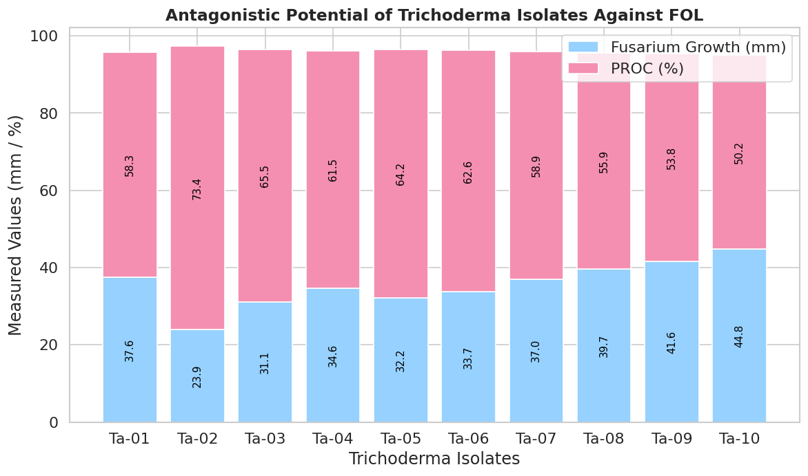

**Figure .1.** Stacked bar chart illustrating the antagonistic activity of *Trichoderma* isolates against *Fusarium oxysporum f.sp. lycopersici* (Fol) based on dual culture assay. The chart shows the radial mycelial growth of the pathogen and the corresponding percentage reduction over control (PROC %). Ta-02 demonstrated the highest inhibition with minimum pathogen growth.

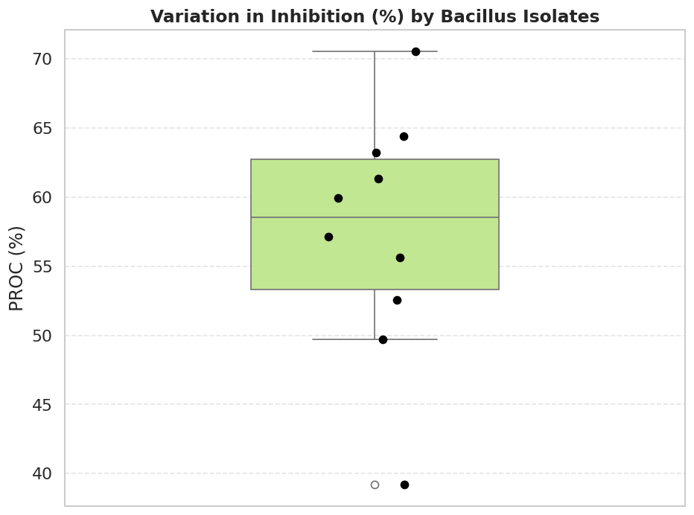

**Figure 2.** Box plot showing the distribution and variability of inhibition percentages (PROC %) exhibited by *Bacillus* isolates against *F. oxysporum*. Bs-06 showed the maximum inhibition, while Bs-10 recorded the lowest. The box plot highlights median, interquartile range, and outliers, revealing significant differences among isolates.

* 1. **Poisoned Food Technique**

The poisoned food technique reinforced the dual culture findings by demonstrating a dose-dependent suppression of Fol by the culture filtrates of both antagonists. The complete inhibition observed in Ta-02 at 30% concentration mirrors the reports by Sharma et al. (2009), who linked metabolite concentration with antifungal potency. The inhibition patterns among Bacillus isolates also suggest the presence of stable and diffusible metabolites that inhibit mycelial growth effectively, as also reported by Kloepper et al. (2004).

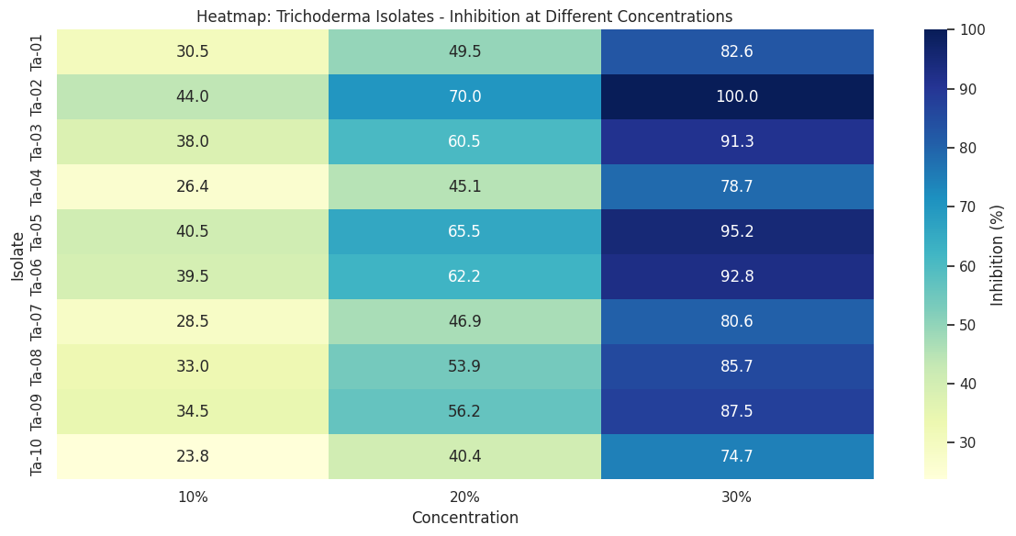

**Figure 3.** Heatmap representing the percentage inhibition of *Fusarium oxysporum f. sp. lycopersici* by *Trichoderma* isolates at three different culture filtrate concentrations (10%, 20%, and 30%). Ta-02 exhibited complete inhibition (100%) at 30%, followed by Ta-05, Ta-06, and Ta-03. Inhibition increased with concentration, indicating a dose-dependent antifungal effect.

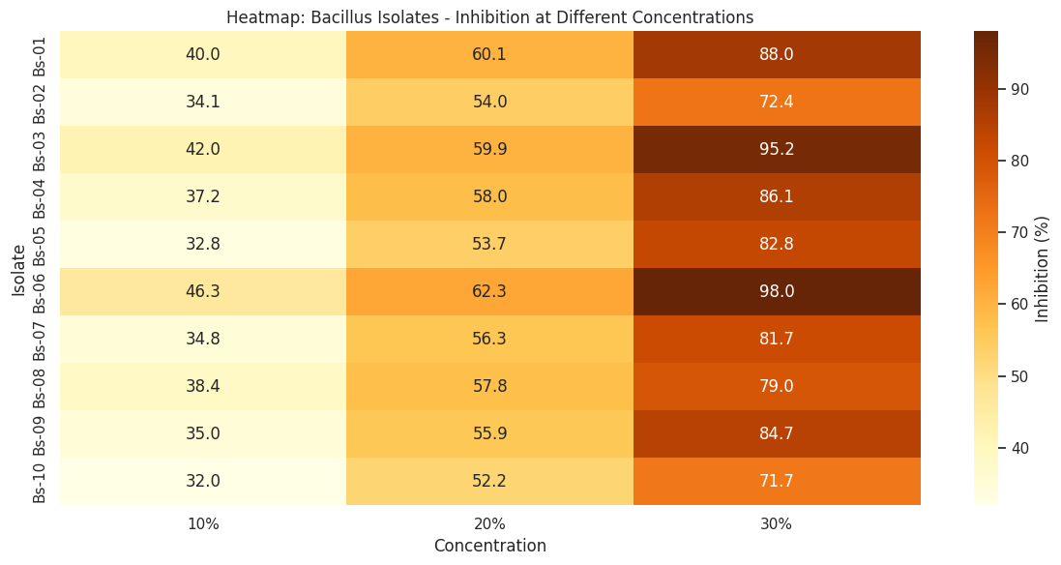

**Figure 4.** Heatmap showing the inhibition efficiency of *Bacillus* isolates against *F. oxysporum* at 10%, 20%, and 30% filtrate concentrations. Bs-06 demonstrated the highest inhibition (98%) at 30%, followed by Bs-03 and Bs-01. A concentration-dependent trend is evident across all isolates, with Bs-10 being the least effective.

* 1. **Molecular Identification of Antagonistic Isolates**

The molecular identification provided taxonomic confirmation of the isolates, validating earlier morphological and biochemical observations. The ITS-based identification of Trichoderma isolates as T. asperellum, T. atroviride, and T. harzianum is consistent with their established roles as biocontrol agents (Kubicek et al., 2011). The high sequence similarity (99–100%) with reference strains confirms their identity and supports their use in sustainable disease management.

Similarly, 16S rRNA gene sequencing of Bacillus isolates provided definitive identification, revealing a predominance of B. subtilis and related species, including B. amyloliquefaciens, B. cereus, and B. thuringiensis. These findings align with earlier studies emphasizing the efficacy of these Bacillus species in biological control (Borriss, 2011). The assigned GenBank accession numbers further authenticate the molecular data and facilitate future reference and application.

Overall, the integrated morphological, biochemical, molecular, and in vitro evaluations confirm the potential of these Trichoderma and Bacillus isolates as biocontrol agents against Fusarium wilt of tomato. Their ability to inhibit Fol through multiple mechanisms supports the development of effective bioformulations for sustainable agriculture.

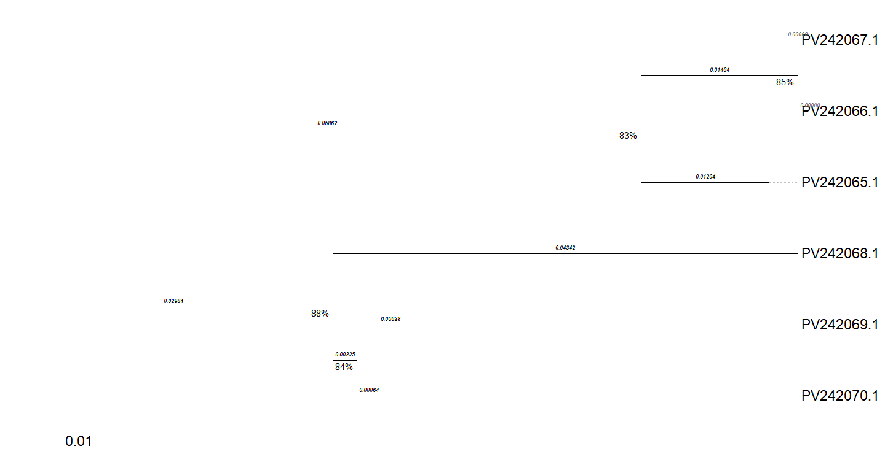

**Figure.5.** The image shows a phylogenetic tree of *Trichoderma* species constructed using the Neighbor-Joining method. It displays six isolates (e.g., PV242065.1, PV242067.1) with bootstrap support values and evolutionary distances, highlighting genetic relationships among *T. asperellum*, *T. harzianum*, and *T. atroviride* strains.

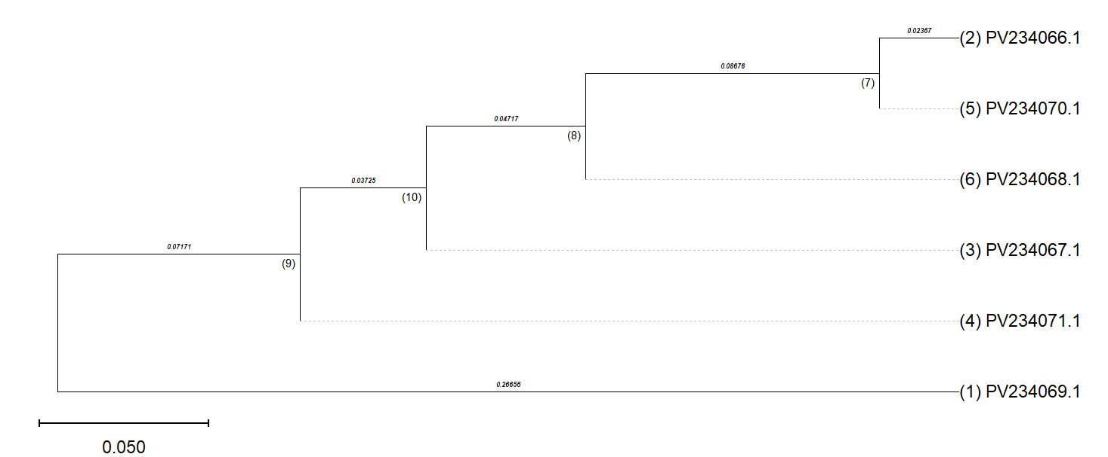

**Figure.6.** The image shows a phylogenetic tree of *Bacillus* species constructed using the Neighbor-Joining method. It illustrates the evolutionary relationships among six *Bacillus* isolates (e.g., PV234066.1 to PV234071.1), based on sequence divergence, with branch lengths representing genetic distances.

1. **CONCLUSION**

This study conclusively demonstrated the biocontrol efficacy of native *Trichoderma* and *Bacillus* isolates against *Fusarium oxysporum* f.sp. *lycopersici* under controlled in vitro conditions. The antagonistic activity varied significantly among isolates, with *T. asperellum* Ta-02 and *B. subtilis* Bs-06 emerging as the most effective candidates. The integration of morphological, biochemical, and molecular characterization confirmed their identity and potential for practical application. These findings support the use of these isolates in the development of bioformulations for tomato wilt management, offering a sustainable and environmentally sound alternative to chemical pesticides.

**Future Scope**

Further research is warranted to evaluate the efficacy of Ta-02 and Bs-06 under greenhouse and field conditions to assess their performance in diverse soil and climatic environments. Formulation development, shelf-life studies, and compatibility with other agro-inputs should also be investigated. Additionally, molecular studies focusing on the expression of biocontrol-related genes and metabolite profiling can unravel the precise mechanisms of antagonism. Integration of these strains into integrated disease management (IDM) programs may pave the way for their commercialization as biofungicides in tomato cultivation and potentially other solanaceous crops.

**REFERENCES**

1. Agrios, G. N. (2005). *Plant Pathology* (5th ed.). Academic Press.
2. Beckman, C. H. (1987). *The Nature of Wilt Diseases of Plants*. APS Press.
3. Borriss, R. (2011). Use of plant-associated *Bacillus* strains as biofertilizers and biocontrol agents in agriculture. In D. K. Maheshwari (Ed.), *Bacteria in Agrobiology: Plant Growth Responses* (pp. 41–76). Springer.
4. Dennis, C., & Webster, J. (1971). Antagonistic properties of species-groups of *Trichoderma* I. Production of non-volatile antibiotics. *Transactions of the British Mycological Society*, 57(1), 25–39.
5. Elad, Y., Chet, I., & Katan, J. (1983). *Trichoderma harzianum*: A biocontrol agent effective against *Sclerotium rolfsii* and *Rhizoctonia solani*. *Phytopathology*, 73(5), 694–698.
6. Fravel, D., Olivain, C., & Alabouvette, C. (2003). *Fusarium oxysporum* and its biocontrol. *New Phytologist*, 157(3), 493–502. <https://doi.org/10.1046/j.1469-8137.2003.00700.x>
7. Gams, W., & Bissett, J. (1998). Morphology and identification of *Trichoderma*. In G. E. Harman & C. P. Kubicek (Eds.), *Trichoderma and Gliocladium* (Vol. 1). Taylor & Francis.
8. Grover, R. K., & Moore, J. D. (1962). Toximetric studies of fungicides against the brown rot organisms *Sclerotinia fructicola* and *S. laxa*. *Phytopathology*, 52, 876–880.
9. Harman, G. E., Howell, C. R., Viterbo, A., Chet, I., & Lorito, M. (2004). *Trichoderma* species—opportunistic, avirulent plant symbionts. *Nature Reviews Microbiology*, 2(1), 43–56. <https://doi.org/10.1038/nrmicro797>
10. Howell, C. R. (2003). Mechanisms employed by *Trichoderma* species in the biological control of plant diseases: The history and evolution of current concepts. *Plant Disease*, 87(1), 4–10. <https://doi.org/10.1094/PDIS.2003.87.1.4>
11. Idris, E. E. S., Iglesias, D. J., Talon, M., & Borriss, R. (2007). Tryptophan-dependent production of indole-3-acetic acid (IAA) affects level of plant growth promotion by *Bacillus amyloliquefaciens* FZB42. *Molecular Plant-Microbe Interactions*, 20(6), 619–626.
12. Jarvis, W. R. (1988). *Fusarium* crown and root rot of tomatoes. *Phytoprotection*, 69(2), 49–64.
13. Jones, J. B., Jones, J. P., Stall, R. E., & Zitter, T. A. (2014). *Compendium of Tomato Diseases and Pests* (2nd ed.). APS Press.
14. Kloepper, J. W., Ryu, C. M., & Zhang, S. (2004). Induced systemic resistance and promotion of plant growth by *Bacillus* spp. *Phytopathology*, 94(11), 1259–1266.
15. Kubicek, C. P., Mach, R. L., Peterbauer, C. K., & Lorito, M. (2001). *Trichoderma*: From genes to biocontrol. *Journal of Plant Pathology*, 83(2), 11–23.
16. Kubicek, C. P., Komon-Zelazowska, M., & Druzhinina, I. S. (2011). Fungal genus *Trichoderma*: From agricultural applications to cytotoxic compounds for cancer therapy. *Biotechnology Advances*, 29(2), 210–219.
17. Kumar, S., Stecher, G., Li, M., Knyaz, C., & Tamura, K. (2018). MEGA X: Molecular evolutionary genetics analysis across computing platforms. *Molecular Biology and Evolution*, 35(6), 1547–1549. <https://doi.org/10.1093/molbev/msy096>
18. Mastouri, F., Björkman, T., & Harman, G. E. (2010). Seed treatment with *Trichoderma harzianum* alleviates biotic, abiotic, and physiological stresses in germinating seeds and seedlings. *Phytopathology*, 100(11), 1213–1221.
19. Ongena, M., & Jacques, P. (2008). *Bacillus* lipopeptides: Versatile weapons for plant disease biocontrol. *Trends in Microbiology*, 16(3), 115–125. <https://doi.org/10.1016/j.tim.2007.12.009>
20. Papavizas, G. C. (1985). *Trichoderma* and *Gliocladium*: Biology, ecology, and potential for biocontrol. *Annual Review of Phytopathology*, 23(1), 23–54.
21. Radhakrishnan, R., Hashem, A., & Abd_Allah, E. F. (2017). *Bacillus*: A biological tool for crop improvement through bio-molecular changes in adverse environments. *Frontiers in Physiology*, 8, 667. <https://doi.org/10.3389/fphys.2017.00667>
22. Sharma, P., Sharma, M., & Sharma, R. (2009). *Trichoderma*: The bio-control agent. *Asian Journal of Plant Sciences*, 8(3), 102–110.
23. Vinale, F., Sivasithamparam, K., Ghisalberti, E. L., Marra, R., Woo, S. L., & Lorito, M. (2008). *Trichoderma–plant–pathogen* interactions. *Soil Biology and Biochemistry*, 40(1), 1–10.