Studies on storage of encapsulated somatic embryos of Santalum album Linn. – progressing towards in vitro conservation and mass production

ABSTRACT
Santalum album Linn. is one of the most valuable tree species owing to its high essential oil content in heartwood and roots. In this study, synthetic seeds were developed from artificially encapsulated somatic embryos of S. album using sodium alginate and calcium chloride, with the aim of increasing their germination rate. Encapsulated embryos showed maximum germination of 55%, which was observed in 2% sodium alginate. This was followed by 3% alginate which exhibited 40% sprouting. Least sprouting (10%) was observed in high concentration of alginate i.e., at 4%. Synthetic seeds stored at 4°C in dark for 5 days, showed 83.7% germination. The germination percentage decreased with increase in storage time. It was also observed that synthetic seeds in WPM solid media showed 100% germination as compared to liquid WPM medium, where germination of synthetic seeds was low (45%). The synthetic seed technology reported herein is useful for short and long term conservation of rare, endangered and commercially important forestry species by maintaining valuable germplasm, and also for clonal propagation since its genetic constitution remains the same.

Keywords: Sandalwood, synthetic seeds, encapsulation, somatic embryos, sodium alginate.

- INTRODUCTION
Progress in biotechnological research such as plant propagation using synthetic seeds have opened new vistas and provides greater scope for the improvement of crops, forest trees and other important plant species in the field of agriculture, horticulture and forestry. Synthetic seed technology is a highly promising tool for the management of transgenic, cryopreservation/ germplasm conservation and seedless plant species, polyploid plants with elite traits and plant lines that are difficult to propagate through conventional propagation methods (Sharma et al., 2013). Synthetic seed technology which started from the mid 1980’s in industrially important crops, involves the use of artificially encapsulated somatic embryos from different explants such as shoot buds, cell aggregates or any other tissue for sowing as a seed and convert it into a whole plant under in vitro or ex vitro conditions (Capuano et al., 1998, Reddy et al., 2012). Synthetic seeds were used for plant preservation and multiplication particularly for no-seed producing plants, as plants do not produce viable seeds or require vegetative propagation for maintaining desirable and superior characteristics. This technology includes many advantages such as reducing cost and space, germplasm conservation of rare and economically important plants, easy to handle, continuous and seasonal independent multiplication of genetically stable elite plant species (Abbas and Alhasan, 2022). Several reports have been published on axillary buds and shoot tips as encapsulation propagules in Morus spp. (Pattnaik et al., 1995; Kavyashree et al., 2004, 2006), Simmondsia chinensis (Hassan, 2003), somatic embryos in Saccharum officinarum (Sanchez et al., 2019), Mangifera indica (Ara et al., 1999), Dendrocalamus strictus (Mukunthakumar and Mathur, 1992), S. album (Bapat, 1993; Rangaswamy, 2007), nodal segments in Dalbergia sissoo (Singh and Chand, 2010).
Most forest trees are propagated through seeds. Seeds of superior genotypes are produced in seed orchards, which takes approximately 20-30 years to produce large quantities of seeds for reforestation. Somatic embryogenesis has great potential to reduce this time period dramatically (Gupta and Kreitinger, 1993). Millions of somatic embryos can be produced under laboratory conditions irrespective of the season, and embryos can also be stored and germinated as and when required. The tissue culture of East Indian sandalwood (Santalum album L.) has been extensively studied, mainly for its rapid propagation technology. S. album is believed to be the first woody species for which somatic embryogenesis was reported (Swamy, 2021; Teixeira da Silva et al, 2016). It plays an important role in many industries such as pharmaceutical, cosmetic, soap and perfume industries etc. Plantlet regeneration from encapsulated somatic embryos of sandalwood was reported by Bapat and Rao (1988; 1992) and Bapat (1993). A somatic embryo is regarded as a bipolar structure as it possesses shoot and root poles at the same time (Standardi and Piccioni, 1998). Among various propagules used by several workers, somatic embryos being bipolar in nature, have been found to be the best suited entity for synthetic seed technology. Considering the advantages of somatic embryos over other propagules and also the importance of sandalwood plant production, the present study was undertaken to increase the germination percentage of encapsulated embryos and also the storage period to aid in short term conservation of S. album.

- MATERIALS AND METHODS
2.1 Production and encapsulation of somatic embryos
Callus of S. album established from adventitious explants viz., leaf and internode were used for somatic embryo induction. The protocol developed by Rangaswamy (2007) was followed for callus induction, proliferation and somatic embryo induction. Somatic embryos obtained from the embryogenic callus of S. album, were used for synthetic seed production and further germination. To encapsulate somatic embryos in calcium alginate matrix, late torpedo to bipolar shaped embryos were mixed with 3% sodium alginate solution (prepared in MS liquid basal salts medium). The somatic embryos were initially suspended in 3% sodium alginate solution for 2 minutes, after which they were dropped into 100mM calcium chloride solution, one at a time using a Pasture pipette. The resulting beads were kept for 40-45 mins in shaker at 85rpm. After the formation of beads, remaining calcium chloride solution was decanted and the coated somatic embryos were rinsed 3 to 4 times with sterile distilled water and dried on filter paper. Encapsulated seeds were either stored at 4°C or inoculated on agar gelled WPM medium for germination. All the steps for encapsulation were done under aseptic conditions.
An experiment was performed to study the effect of different concentrations of sodium alginate (2%, 3% & 4%) on germination of the synthetic seeds. Encapsulated embryos were transferred to sterile petri plates with filter paper soaked in MS basal medium in aseptic condition. Petri plates were sealed with parafilm and stored in refrigerator at 4ºC for different duration such as 0, 1, 3, 5, 7 and 10 days, after which the encapsulated embryos were used for germination.
2.2 Germination of synthetic seeds
The encapsulated embryos were inoculated on solid WPM, liquid WPM and liquid MS medium, in order to study the effect of gelling and nutrient medium constituents. The cultures were incubated in dark at a temperature of 25±2 ºC for germination.
2.3 Statistical analysis
The experiments were performed following a completely randomised design, with 5 replicates for each treatment, and each replicate consisted minimum of 5 synthetic seeds. Observation mean for all the experiments were taken from five replicates which were repeated twice. The response percentage for embryo germination or sprouting, was calculated after 8 weeks of culture.

- RESULTS AND DISCUSSION
3.1 Encapsulation of somatic embryos
About 150-200 synthetic seeds were formed using late torpedo to bipolar shaped embryos (Fig 1 A). The beads formed differed morphologically with respect to size, shape and transparency (depending on concentration of sodium alginate) and with diameters ranging from 4.5 to 6 mm (Fig 1 B). Encapsulated seeds were inoculated on WPM medium fortified with GA₃ 1.5 mg/L + IAA 0.5mg/L, with or without activated charcoal at 100mg/l for germination (Fig 1 C).

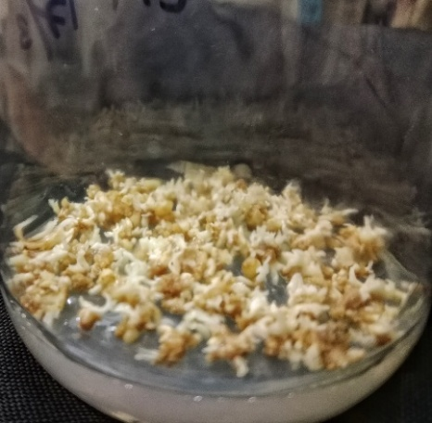  A | 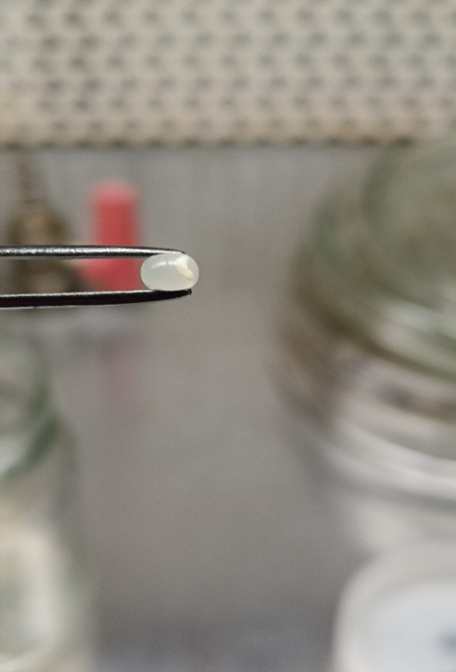  B | 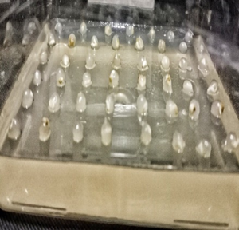  C
Fig 1: Synthetic seeds from somatic embryos of Santalum album; A: Non encapsulated somatic embryos, B: Encapsulated somatic embyo, C: Synthetic seeds inoculated on nutrient medium.

3.1.1 Varying concentrations of sodium alginate
The permeability, hardness or rigidity of the alginate beads and the success of encapsulation mainly depend on concentration of alginate and calcium chloride used, and also the curing time which may vary with different propagules and with different plant species (Sharma et al, 2013). Hence, the concentration of sodium alginate was optimized for the formation of an ideal bead. Amongst the various concentrations of sodium alginate tested (Fig 2), 2% concentration of sodium alginate with 100mM calcium chloride solution resulted in 55% sprouting in S. album. This was followed by 3% alginate with 40% sprouting. Least sprouting (10%) was observed in high concentration of alginate (4%) which might be due to hard nature of beads resulting in the delay of embryo sprouting. The control somatic embryos without encapsulation showed highest germination percentage of about 85% within 8 weeks period. On the other hand, Rangaswamy (2007) observed that 3% proved the best with 36.73% normal plantlets, followed by 2% with 28.37% germination in S. album.
In contrast to our results, complexion of 3% sodium alginate for 20 to 30 minutes with 75 mM calcium chloride was found to be optimum for proper bead hardening in orchid spp. (Saiprasad and Polisetty, 2003). Ganapathi et al (1992) reported plant regeneration in 3% of sodium alginate which was from encapsulated shoot tips of banana. Encapsulation of somatic embryos from two cell lines of Q. robur using 4% concentration of sodium alginate showed increased germination rate in one cell line, as reported by Prewein and Wichelm (2003). The addition of activated charcoal (100mg/l) in the germination medium increased the sprouting rate of encapsulated embryos in S. album. Similar observation was made by ArunKumar et al. (2005) in O. sativa (rice), wherein the inclusion of 1.25% activated charcoal improved the conversion frequency of encapsulated somatic embryos.
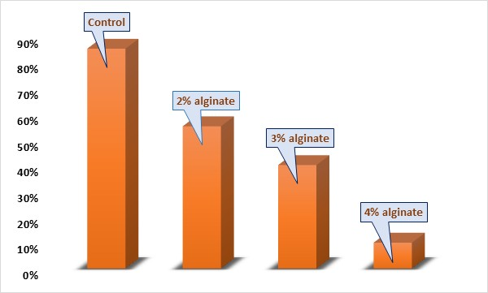
Fig 2: Germination percentage of S. album encapsulated using varied concentrations of sodium alginate

3.1.2 Storage of encapsulated embryos
Storage of encapsulated plant parts are mainly useful in germplasm conservation for seedless, endangered or extinct plants. Hence, the effect of different duration of storage on the germination rate of the synthetic seeds was studied. Germination was recorded with emergence of the tap root. Maximum germination of about 90% was seen during immediate transfer (0 day), followed by 83.7% germination when synthetic seeds were stored for 5 days at 4°C in dark; whereas, synthetic seeds stored for 1 day showed only 55% germination (Fig 3). In control (non-encapsulated embryos), faster germination and growth than those of other treatments (encapsulated embryos) was observed. With the increase in duration of storage, the sprouting of synthetic seeds decreases in S. album (Fig 4). Similar to our findings, Rangaswamy (2007) also reported that the synthetic seeds conversion frequency was high (about 36.66%) in S. album immediately after encapsulation, followed by 15 days of storage which produced 32.10% normal plants.
On the contrary, Kumar and Chand (2010) reported maximum germination percentage in D. sissoo with 43.3% in half strength MS medium containing 2% sucrose, after 20 days of culture when stored at 4ºC. In comparison to our findings, Sundararaj et al. (2010) observed 100% re-growth of Z. officinale synthetic seeds when incubated at 25°C, while storage at 4°C resulted in no re-growth. Encapsulated shoot tips of K. senegalensis also survived longer at 25°C than at 4°C, with 73-88% viability after 8 weeks (Hung and Trueman, 2011). Enhanced regrowth frequency of encapsulated K. senegalensis explants was noticed up to 12 months when the storage conditions were 14°C and darkness. This clearly implies that encapsulated somatic embryos of sandalwood can be stored at lower temperatures and revived later, showing high potential for its in vitro conservation.
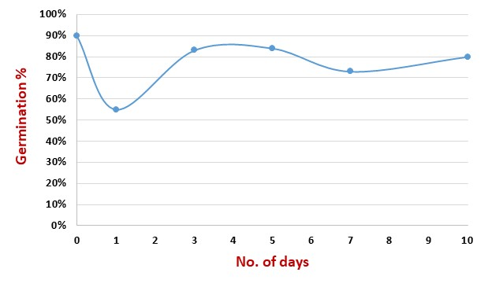
Fig 3: Effect of storage duration on germination of synthetic seeds of S. album

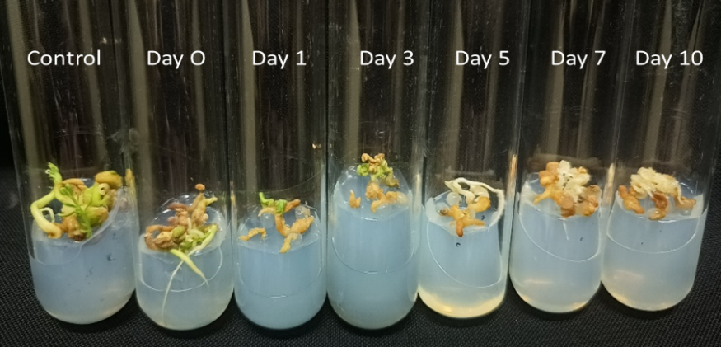
Fig 4: Germination of synthetic seeds of S. album stored for different duration

3.2 Germination of synthetic seeds
In order to study the effect of gelling and the nutrient medium components, encapsulated embryos were inoculated on both solid and liquid medium containing MS or WPM constituents. The results revealed that 100% germination of encapsulated embryos was obtained in WPM solid medium. This was followed by liquid WPM medium, where the germination was only 45%. Whereas, synthetic seeds in liquid MS medium did not show any germination (Fig 5). Hence, it is inferred that liquid medium is not suitable for germination of artificial seeds of sandalwood, as compared to solid medium. In contrast to our findings, Sundararaj et al. (2010) reported 86% conversion of dehydrated synthetic seeds in liquid nutrient medium containing various concentrations of sucrose; higher concentrations of sucrose (0.50 M and 0.75 M) resulted in no conversion in Z. officinale. In vitro sown synthetic seeds which result in maximum sprouting of 91.30% and better growth of the plants in a semi-solid MS basal medium with 3% sucrose was reported by Hegde et al. (2021) in Cassava plants. Ganapathi et al. (1992) observed that the use of White’s medium resulted in 100% conversion of encapsulated shoot tips of banana into plantlets, which was then successfully transferred to soil for further growth and development.
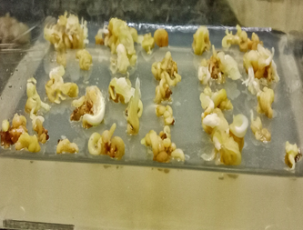  A | 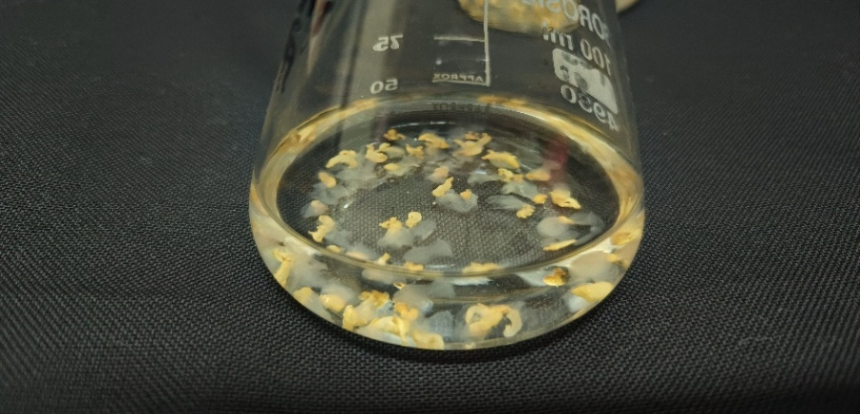  B | 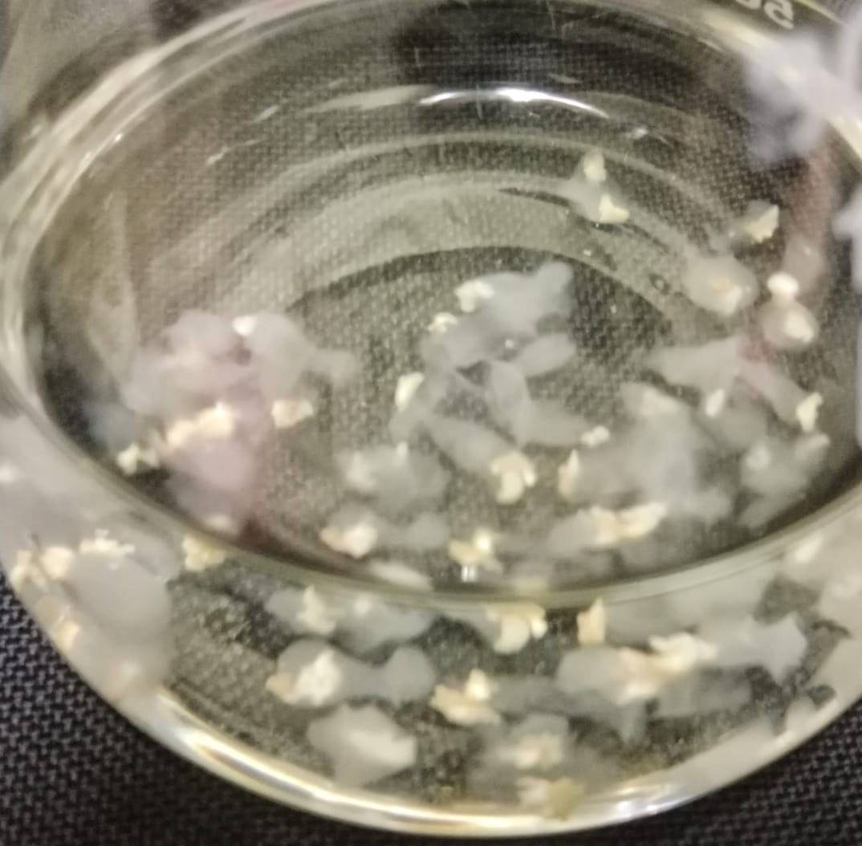  C
Fig 5: Germination of encapsulated somatic embryos of S. album in,
A: solid WP media, B: liquid WP media, and C: liquid MS media

- CONCLUSION
Synthetic seed technology offers a reliable and efficient method for propagation and sustainable production, or conservation of genetic potential of economically valuable species. The findings of our study also indicate that encapsulation and storage of somatic embryos has great potential for in vitro conservation of the valuable germplasm of an important endangered species like S. album. This technique overcomes several limitations associated with conventional seed propagation, including low seed viability, poor and inconsistent seed germination and the vulnerability to diseases. In particular, the success of synthetic seed production in sandalwood demonstrated herein, is practically advantageous for field planting, and allows easy handling, storage and transportation of genetically uniform planting material, with improved viability and germination compared to true seeds. In conclusion, synthetic seed technology of S. album can be integrated into conservation and propagation methods, with significant potential to ensure its long term survival.

REFERENCES
- Abbas, M. K., & Alhasan. (2022). Production of synthetic seeds in vegetable crops: a review. Conf Series Earth Environ Science, 1060, 1-13.
- Ara, H., Jaiswal, U., & Jaiswal, V. S. (1999). Germination and plantlet regeneration from encapsulated somatic embryos of mango (Mangifera indica L.). Plant Cell Reports, 19, 166–170.
- ArunKumar, M. B., Vakeswaran, V., & Krishnasamy, V. (2005). Enhancement of synthetic seed conversion to seedlings in hybrid rice. Plant Cell Tissue and Organ Culture, 81(1), 97-100.
- Bapat, V. A. (1993). Studies on synthetic seeds of sandalwood and mulberry. In K. Redenbaugh (Eds.), Synthetic seeds: application of synthetic seeds to crop improvement. (pp. 381-384). CRC Press, Boca Raton.
- Bapat, V. A., & Rao, P. S. (1988). Sandalwood plantlets from synthetic seeds. Plant Cell Reports, 7, 434-436.
- Bapat, V. A., & Rao, P. S. (1992). Plantlet regeneration from encapsulated and non-encapsulated desiccated somatic embryos of forest tree: Sandalwood (Santalum album L.). Journal of Plant Biochemistry and Biotechnology, 1(2), 109:113.
- Capuano, G., Piccioni, E., & Standardi, A. (1998). Effect of different treatments on the conversion of M26 apple rootstock synthetic seeds obtained from encapsulated apical and axillary micropropagated buds. Journal of Horticultural Science and Biotech, 73, 299:305.
- Ganapathi, T. R., Suprasanna, P., Bapat, V. A. et al. (1992). Propagation of banana through encapsulated shoot tips. Plant Cell Reports, 11(11), 571-575.
- Gupta, P. K., & Kreitinger, M. (1993). Synthetic seeds in forest trees. In M. R. Ahuja (Eds.), Micropropagation of Woody Plants (pp. 107-119). Kluwer Academic Publishers.
- Hassan, N. S. (2003). In vitro propagation of Jojoba (Simmondsia chinensis L.) through alginate-encapsulated shoot apical and axillary buds. Int. J. Agric. Biol., 5, 513-516.
- Hegde, V., Kumar, M. T., Sheela, M. N., Koundinya, A. V. V., Senthilkumar, K. M., & Mohan, C. (2012). Cassava (Manihot esculenta) Synthetic Seed Production for Germplasm Exchange. Indian J. Plant Genet. Resour. 34(3), 404-410.
- Hung, C. D., & Trueman, S. J. (2011). Encapsulation technology for short-term preservation and germplasm distribution of the African mahogany Khaya senegalensis. Plant Cell Tissue Organ Culture, 107, 397–405.
- Kavyashree, R., Gayatri, M. C., & Revanasiddaiah, M. H. (2004). Regeneration of apical buds of mulberry variety S54 (Morus indica L.). Seriocologia, 44, 83-89.
- Kavyashree, R., Gayatri, M. C., & Revanasiddaiah, M. H. (2006). Propagation of mulberry S54 by synthetic seeds of axillary buds. Plant Cell Tiss. Org. Cult., 84, 245-249.
- Kumar, A., & Chand, S. (2010). Plant regeneration from alginate-encapsulated somatic embryos of Dalbergia sissoo Roxb. Indian Journal of Biotechnology, 9, 319-324.
- Mukunthakumar, S., & Mathur, J. (1992). Artificial seed production in the male bamboo Dendrocalamus strictus L. Plant Sci., 87, 109-113.
- Pattnaik, S. K., Sahoo, Y., & Chand, P. K. (1995). Efficient plant retrieval from alginate encapsulated vegetative buds of mature Mulberry trees. Sci Hortic, 61(3-4), 227-239.
- Prewein, C., & Wilhelm, E. (2003). Plant regeneration from encapsulated somatic embryos of pedunculate oak (Quercus robur L.). In Vitro Cell Dev Biol -Plant, 39(6), 613-617.
- Rangaswamy, M. (2007), Studies on somatic embryogenesis for rapid and mass production of high-quality planting material of sandal (Santalum album L.) and red XXIII sanders (Pterocarpus santalinus L.), evaluation of genetic fidelity and field performance. Ph.D. thesis, Forest Research Institute Dehradun, pp. 264.
- Reddy, M.C., Murthy, K.S., & Pullaiah, R. (2012). T. Synthetic seeds: A review in agriculture and forestry. African Journal of Biotechnology, 11(78), 14254–14275.
- Saiprasad, G. V. S., & Polisetty, R. (2003). Propagation of three orchid genera using encapsulated protocorm-like bodies. In Vitro Cellular and Developmental Biology – Plant, 39(1), 42–48.
- Sanchez, G. F. A., García, S. S., Lopez, D. J. P., Espinoza, L. C. L., Laurel, H. O., & Sanchez, S. C. (2019). Artificial seed viability of sugarcane (Saccharum officinarum L. cv. Mex 69-290) under conditions of Huimanguillo-Tabasco, Mexico. Rev. FCA UNCUYO, 51(2), 27-41.
- Shiwali Sharma., Anwar Shahzad., & Teixeira da Silva, J. A. (2013). Synseed technology—A complete synthesis. Biotechnology Advances, 31(2), 186–207.
- Singh, A. K., & Chand, S. (2010). Plant regeneration from alginate encapsulated somatic embryos of Dalbergia sissoo Roxb. Indian Journal of Biotechnology, 9, 319-324.
- Standardi, A., Piccioni, E. (1998). Recent perspectives on synthetic seed technology using nonembryogenic in vitro-derived explants. International journal of plant science, 159(6), 968–78.
- Sundararaj, S. G., Agrawa,l A., & Tyagi, R. K. (2010). Encapsulation for in vitro short-term storage and exchange of ginger (Zingiber officinale Rosc.) germplasm. Sci Hortic, 125, 761–766.
- Swamy, M. K. (2021). Tissue Culture Studies in Sandalwood (Santalum album L.). In Pullaiah T, Das S. C, Bapat V. A, Swamy M. K, Reddy V. D, & Murthy K. S. R (Eds.), Sandalwood: Silviculture, Conservation and Applications. Springer, Singapore.
- Teixeira da Silva, J. A., Kher, M. M., Soner, D., Page, T., Zhang, X., Nataraj, M., & Ma, G. (2016). Sandalwood: basic biology, tissue culture, and genetic transformation. Planta, 243, 847-887.

