**VALVULAR MORPHOLOGY and morphometry of the tricuspid valves in sheep AND GOAT**

**ABSTRACT**

The tricuspid valve was the largest of all cardiac valves in both sheep and goat. The fibrous ring that formed the annulus of the right atrio ventricular orifice was nearly elliptical in sheep but circular in goat. The annulus helped in the attachment of all the three leaflets *viz.,* anterior, posterior and septal leaflets of the tricuspid valve. These leaflets were roughly triangular in shape and has commissure inbetween them. The largest leaflet was the anterior leaflet as in humans and the smallest was the septal leaflet in both species. The free edge mean length of the posterior and septal leaflets, mean depth of all the three leaflets and the mean height of the anterio-septal and septo-posterior commissures were significantly higher in goat. The mean thickness of all the three leaflets was similar in both the species.

Histomorphological features of the tricuspid valve were similar in sheep and goat. Histochemical reactions for carbohydrates were positive for Periodic acid schiff and Alcian blue in the connective tissue layers of this valve. Alkaline phosphatase activity was weak. The reaction for lipids was negative for Oil red O and cholesterol activity. The endothelial linings of the valve were moderate for Succinic dehydrogenase activity in both species. These anatomical similarities of tricuspid valve in goat may help address the valvular pathologies of tricuspid valve regurgitation (TR) and stenosis (TS) for its prevention and intervention in humans.

Key word: tricuspid valve, morphology, morphometry, histochemistry, sheep, goat.

**INTRODUCTION**

The fibrous skeleton of heart in animals comprises four major openings and are guarded by thin fibrous valves *viz.,* right atrio-ventriculo ‘tricuspid’ valve, left atrio-ventricular ‘mitral’ or bicuspid valve, semilunar aortic and pulmonary valves (Dyce *et al*., 2010). The right atrio-ventricular orifice is oval in shape and is guarded by tricuspid valve in domestic animals (Sisson and Grossmann, 1975). Morphological anatomy of this tricuspid valve in animals revealed that it is the largest of all valves, almost triangular and possess anterior/angular, posterior/parietal and septal leaflets as in humans (Nam *et al.,* 2014). The anterior leaflet is most mobile, the posterior leaflet is variable while the septal leaflet is least mobile (Yucel, 2020).

The unidirectional flow of venous blood from right atrium to right ventricle is regulated by this valve. This is brought about by the well-orchestrated interplay of the three leaflets. These three leaflets coapt and closes the orifice during ventricular systole and opens to allow the blood to pass during diastole (Meador *et al.,* 2020). Pathologies of this valves results from diseases such as rheumatoid endocarditis, syphilitic endocarditis, bacterial endocarditis, and lithification etc., and are the third common valvular disease encountered in humans. These valvular pathologies often leads to conditions such as Tricuspid valve regurgitation (TR), Tricuspid valve stenosis (TS) and malformations causing Atresia and Ebstein anomaly etc., (Nam *et al.,* 2014). Valvular insufficiency due to Congenital Dysplasia affects animals and is a common anomaly in dogs (Labrodor retriever and German shepherd), cats and has also been reported in a pygmy goat (Gardner *et al.,* 1992).

Although valvular research to understand the molecular mechanisms of their development and disease in humans are extensively done on experimental animal models, detailed anatomical studies of the valves in these animals are still limited. This current study is therefore one of our effort to address indepth on valvular morphology, morphometry, histology, histometry and the histochemical characteristics of the tricuspid valve in sheep and goats.

**MATERIALS AND METHODS**

**Gross Morphology and morphometry:**

The heart for this study were collected from the slaughtered sheep and goat that were apparently healthy. Six number of hearts each for sheep and goat were utilised. These hearts immediately after collection were removed of their peritoneum and were washed with saline to remove extraneous blood. The chambers of the heart were then opened carefully without damaging the valves and were washed with normal saline before observations. The valves of the right atrio-ventricular orifice were observed for their shape, location and topography in both these species. Their Morphometric measurements such as annular diameter, valvular length at their free edge, leaflet depth, commissural height and thickness of the valves were recorded with the help of vernier calliper and by scale and thread method (Vijaya kumar *et al.,* 2024). All the measurements were recorded as mean ± standard error.

**Histology:**

The valves were meticulously dissected and were washed in normal saline before fixing them in 10% NBF (Singh and Sulochana, 1997) for paraffin embedded tissue sectioning. Microsections of 4-5µm thickness were cut with microtome and were stained by the following methods for histological analysis: Hematoxylin and Eosin method for micro-architecture, Van Gieson‟s method for collagen fibers, and Wilder‟s method for reticular fibers (Singh and Sulochana, 1997), Verhoeff‟s method for identification of elastic fibers (Culling, 1974), Masson‟strichrome method to differentiate muscle and Connective tissue (Luna, 1968).

**Histochemistry**

Cryosections of 10 – 15 µm and paraffin sections from these specimens were also utilized for histochemical analysis using: PAS reaction to demonstration glycogen, PAS–AB method for acid and neutral muco polysaccharides, Gomori‟s method for localization of ACP enzyme, Gomori‟s Cobalt method for localization of ACP enzyme, Oil red-O in propylene glycol method for demonstration of fats, Tris Buffer (Gomori) Method for demonstration of succinic dehydrogenase enzyme (Singh and Sulochana, 1997) and Schutz‟s method for cholesterol (Carleton *et al*., 1980) respectively. All the stained sections were photomicrographed with Nikon H600L Photomicroscope (Japan) and Histomorphometric measurements on the valvular thickness were done using a calibrated ocular micrometer.

**Statistical analysis**

All the morphometric measurements made (Gross and micrometry) were tabulated with values of Mean and Standard Error and the statistical significance (p<0.05) between groups were analysed by ANOVA, with Tukey HSD test for multiple comparisons using SPSS software.

**RESULTS AND DISCUSSION**

**Gross morphology**

The tricuspid valve in sheep and goat was situated between the right atrium and right ventricle at the atrioventricular orifice as reported by Motabagani (2006), Misfeld and Sievers (2007) and Dyce *et al*., (2010) in humans and animals. It was the largest of all cardiac valves in both these species as in humans (Montabagani, 2006). The atrio-ventricular myocardial tissue surrounded and supported the tricuspid valves. The annulus was a fibrous ring surrounding this orifice and was nearly elliptical in sheep, while it was circular in goat. In both species it gave attachment to three of its leaflets *viz.,* anterior/angular, posterior/parietal and septal. In all the specimens examined there were only three cusps in sheep and goat (Fig 1) as reported by Komala and Jayanthi (2015) in cow, human, sheep, goat and pig. Whereas, Skwarek *et al*., (2004) reported that 4-cuspidal structure of this orifice was most common and may be related to the volume and force of blood to be allowed through the right atrio-ventricular orifice.

All the three leaflets were roughly triangular in shape (Fig. 1) as in camels and monkey (Motabagani, 2006) humans (Yucel, 2020). In addition to triangular form, they have also reported semicircular leaflets in these species. In wild boar, the anterior and posterior cusps were rectangular in shape while the septal cusp was semicircular (Ates *et al.,* 2017). He also reported the presence of supernumerary/accessory/ additional cusps in this species. In this present study, the anterior leaflet was the largest of all the three leaflets and was located between the conus arteriosus and atrio-ventricular orifice. The posterior cusp was the intermediate cusp and was connected to the posterior aspect of the right ventricle at the annulus. The Septal cusp was the smallest and was found attached to the atrio-ventricular septum in both these species. The leaflets did not showed any major folds and scallops in both these species (Fig 1). They presented commissures between them. The leaflets at their free edge were anchored by 9 to 11 chordae tendinae, which were thread like fibrous cords that inserted mostly at the free margin and sometimes at the middle of the leaflet on the ventricular surface (Fig.1) as reported by Aktas *et al.,* (2004) and Misfeld and Sievers (2007) in humans.

**Morphometry**

The diameter of the annulus was comparatively larger than the annular diameter of the bicuspid valves in both these species. The circumferential diameters were 2.2 ± 0.06 cms and 2.2 ± 0.05 cms in sheep and goat respectively. Similar to this finding Barszcz *et al.,* (2023) found that the dimension of the right atrioventricular orifice in goat ranged from 15 to 39 mms and averaged 29.7 ± 3.5 mms. This annulus was comparatively larger, less stiffer and more likely to get dilated with ventricular contraction (Yucel, 2020). The mean length of the free edge of anterior leaflet in sheep and goat was 2.5 ± 0.07 cms and 2.5 ± 0.03 cms respectively and this difference was insignificant between these species. The mean length of the free edge of posterior leaflet in sheep and goat was 2.1 ± 0.04 cms and 2.3 ± 0.03 cms respectively. This was the second biggest leaflet as reported by ( Lomala and Jayanthi, 2015) in cow, human, sheep, goat and pig. The free edge mean length of the septal leaflet in sheep was 2.0 ± 0.03 cms and was the smallest. However, in goat it measured 2.3 ± 0.04 cms and was similar to the posterior leaflet. The difference in the mean length of posterior and septal leaflet’s free edges were highly significant (P < 0.01) between sheep and goat (Fig 2).

The Mean depth of anterior leaflet in sheep and goat was 1.6 ± 0.03 cms and 1.7 ± 0.03 cms and that of posterior leaflet was 1.4 ± 0.03 cms and 1.5 ± 0.02 cms respectively. There was a high significant difference in the mean anterior and posterior leaflet depths between sheep and goat (P < 0.01) (Fig 2). The mean depth of septal leaflet in sheep and goat was 1.2 ± 0.02 cms and 1.2 ± 0.04 cms respectively and this difference was insignificant between species (Fig 2). The mean height of antero-septal commissure in sheep and goat was 0.6 ± 0.03 cm and 0.8 ± 0.03 cm respectively and showed a high significant (P < 0.01) difference. Difference in the mean height of postero-anterior commissure in sheep and goat was 0.7 ± 0.03 cm and was insignificant between species. The mean height of septal-posterior commissure in sheep and goat was 0.7 ± 0.03 cm and 0.8 ± 0.05 cm respectively and was significantly different (P < 0.05) between species (Fig. 2).

**Histology and Histometry**

Valvular histology in both these species revealed a connective tissue core ie., lamina radialis with an endothelial lining over the atrial and ventricular surfaces (Fig 3) as observed by Motabagani (2006) in humans and camels. The auricular surface of the lining endothelium was seen smooth and the ventricular surface was rough with outgrowths in both this species as reported by (Khavatov and Shchipakin 2020) in anglo-nubian goat. These endothelial cells during early development had pores (Saho *et al.,* 2021) in sheep and (Sizer *et al.,* 2020) in Saanen goat. They were smaller, medium and larger in size and measured 513.83±31.16nm, 1.61±0.07 µ and 3.06±0.15µ respectively at 120 days of gestation. The valves were found attached to the atrial and ventricular myocardium by densely arranged collagen bundles that formed the annulus (Fig. 3). Each Leaflet showed a lamina spongiosa on its atrial side and lamina fibrosa towards ventricular side. The lamina spongiosa was formed of loose connective tissue rich in elastic fibers (Fig 4), glycoseaminoglycans and contained numerous blood vessels as reported by (Khavatov and Shchipakin, 2020) in anglonubian goat. The Lamina fibrosa was formed predominatly by collagen fibers and was thicker at the base of the leaflet (Fig 3). This provided tensile strength to the valves (Sacks and Yoganathan, 2007). At the base of the leaflet the lamina fibrosa merged with sub-endothelial collagenous tissue of the atrial and ventricular walls. The Subendothelial region or lamina radialis comprised few reticular fibers (Fig 5) as reported by Vijayakumar et al 2024 in the bicuspid valves of sheep and goat. Whereas in humans and camel the presence of reticular fibers were not reported by (Montabagani, 2007). In this present study, muscle fibers existed in the regions of septal attachment with the annulus and ventricular myocardium (Fig. 3). Molecular evidence suggest that each leaflet of this valve possessed distinct structural and biomechanical characteristics (Hinton and Yutzey, 2011). Any micro-anatomical changes in these valvular components results in valvular pathologies such as tricuspid stenosis, tricuspid regurgitation, and tricuspid endocarditis etc.,(Nam *et al.,* 2014)

The mean thickness of the anterior leaflet in sheep and goat were 445 ± 6.6 µm and 443.7 ± 6.4 µm respectively. It is the thickest leaflet and the posterior leaflet was 438.2 ± 5.0 µm and 438.4 ± 5.7 µm respectively while the mean thickness of septal leaflet in sheep and goat recorded 438.1 ± 5.0 µm and 438.3 ± 6.6 µm respectively. No significant difference in the mean thickness were observed between the three leaflets in both the species (Fig 2). It was found that the thickness of all the three leaflets of the tricuspid valve were lesser than bicuspid valves in sheep. But, the valvular thickness for the posterior leaflet in goat is comparatively higher than the value for posterior leaflet of bicuspid valve as reported by Vijaya kumar et al., (2024) in goats.

**Histochemistry**

In the present study, mild PAS activity was observed in the connective tissue of tricuspid valve in both the species and indicated the presence of neutral mucopolysaccharides (Fig. 5b). Moderate activity for alcian blue was noticed in the endothelium of atrial and ventricular surfaces whereas. This reaction was strong in lamina fibrosa and was weak in lamina spongiosa thus indicated the presence of acid mucopolysaccharides (Fig.6). The endothelial and sub-endothelial regions showed negative reaction for AKP whereas a weak activity was observed in lamina radialis and fibrosa. Oil red O and cholesterol were negative which indicated the absence of lipids and cholesterol respectively in healthy valves. A moderate SDH activity was observed in the endothelial surfaces of the tricuspid valve in both the species .

**CONCLUSION:**

The tricuspid valve in sheep and goat guarded the right atrioventricular orifice. The annulus was elliptical in sheep and circular in goat. Both species possessed only three leaflets *viz.,* anterior/angular, posterior/parietal and septal that were triangular in shape. No supernumerary/accessory/ additional cusps were seen present in this study. The anterior leaflet was the largest, posterior was intermediate while the septal leaflet was the smallest. The free edge mean length of the posterior and septal leaflet, Leaflet mean depth of anterior and posterior leaflet, commissural mean height of Anterio-septal and septo-posterior commissures were significantly different in goat. Valvular histology and valvular thickness were similar between species. The valvular endothelium was positive for SDH activity and the connective tissue cells were positive for neutral and acid mucopolysaccharides in both these species. Our study is fundamental and will be of need for the researchers, veterinary clinicians and pathologist to understand the anatomic basis of valvular development, function and their derangements in developing animal models of tricuspid valvular diseases.

**REFERENCE:**

Aktas, E.O., Govsa, F., Kocak, A., Boydak, B., and Yavuc, I.C. (2004). Variations in the papillary muscles of normal tricuspid valves and their clinical relevance in medicolegal autopsies. *Saudi Medical Journal.* 25, 1176-1185.

Ates, S., Karakurum, E., Takci, L., Basak, F., and Kurtul, I., (2017). Morphology of the atrioventricular valves and related intraventricular structures in the wild pig (*Sus scrofa*). *Folia Morphologica.* 76, (4) 650–659

Barszcz, K., Szaluś-Jordanow, O., Buczyński, M., Czopowicz, M., Moroz-Fik, A., Mickiewicz, M., Mądry, W., and Kaba, J., (2023). Morphometry of the heart orifices and morphometry and topography of the coronary ostia in the goat. *Morphologica.* ISSN: 0015-5659

Carleton, H.M., Drury, R. and Wallington, E.A. (1980).*Carleton‟s Histological Techniques,* 5th Edition.,Oxford Medical Publications, U.K.

Culling. (1974). *Handbook of Histopathological and Histochemical Techniques*, 3rd Edition., Elsevier limited.

Dyce, K.M., Sack, W.O. and Wensing, C.J.G. (2010).*Text book of Veterinary Anatomy.* 4th edition..Philadelphia: Saunders publications ,227-231.

Gardner SY, Reef VB, Palmer JE, Reimer JM, and Sweeney RW. (1992). Echocardiographic diagnosis of an anomaly of the tricuspid valve in a male pygmy goat. *Journal of the American Veterinary Medical Association*. 200(4) 521-523.

Hinton, R.B., and Yutzey, K.E. (). Heart valve structure and function in development and disease. *Annual Review of Physiology.* 2011 ; 73: 29–46.

Komala, N., and Jayanthi, K.S., (2015). Comparative anatomical study of the tricuspid valve –complex in human, sheep, goat, cow and pig. *International Journal Of Current Research.* 7 (06) pp.17036-17039

Khvatov, V., and Shchipakin, M., (2020). Histological features of Anglo-nubian goats heart valves. International Transaction *Journal of Engineering, Management, & Applied Sciences & Technologies.* 11 (16). 1-9

Luna, L.G. (1968). *Manual of Histological Staining methods of the armed forces,* Institute of pathology. 3rd edn., McGraw Hill Book Co., New York.

Meador, W.D., Mathur, M., Sugerman, G.P., Malinowski, M., Jazwiec, T., Wang, X., Lacerda, C.M.R., Timek, T.A., and Rausch, M.K., (2020).The tricuspid valve also maladapts as shown in sheep with biventricular heart failure. eLife;9:e63855. DOI: https://doi.org/10.7554/eLife.63855

Misfeld, M., and Sievers, H., (2007). Heart valve macro and microstructure. *Philoslosophical Transactions of the Royal Society of London Biological Sciences,* 362, 1421-1436.

Motabagani, A.B. (2006). Comparative anatomical, Morphometric and Histological studies of the tricuspid valve complex in human and some mammalian hearts. *Journal of the Anatomical Society of the India.* 55, (1) 1-23.

Nam, C. H., Kim, H.Y., Lin, C., and Yon J.M., (2014). Comparative anatomical characteristics of cardiac valves in animals. *Journal of Biomedical Research,* 15(1):19-23.

Sahu, S.K., Mishra, U.K and Sathapathy, S. (2021) Scanning electron microscopic studies on the Auricular and Atrio-Ventricular valvular architecture pre-natal non-descript sheep. *Indian Journal of Animal Research,* B-4481:1-6

Sacks, M. S, and Yoganathan, A. P. (2007). Heart valve function: a biomechanical perspective. *Philoslosophical Transactions of the Royal Society of London Biological Sciences*. 362:1369–1391.

Singh, U.B. and Sulochana, S. (1997). *Handbook of histological and histochemical techniques*, Premier publishing house, Hyderabad.

Sisson, S.S.B. and Grossmann, G.J.D. (1975).*The anatomy of the domestic animals*. 4th edition. pp.626-629.

Sizer, S.S., Kabak, Y.B. and Kabak, M. (2020). Light and scanning electron microscopic examination of the Saanen goat heart. *Turkish Journal of Veterinary and Animal Sciences.* 44: 1172-1180.

Skwarek, M., Hreczecha, J., Gryzbiak, M. and Kosinki, A. (2004). Unusual anatomical features of the right atrio-ventricular valve. *Folia Morphologica.* 64, 183-7.

Vijaya Kumar, R., Senthamil Selvan, P.,Purushotham, G., & Rajendranath, N. (2024). Comparative Anatomical Features of the Bicuspid Valve in Sheep and Goat. *Indian Journal of Veterinary Science and Biotechnology.* 20(5), 72-76

Yucel, E., Bertrand, P. B., Churchill, J.L., Namasivayam, M., (2020). The tricuspid valve in review: anatomy, pathophysiology and echocardiographic assessment with focus on functional tricuspid regurgitation. *Journal of Thoracic Disease,* 12(5):2945-2954

Figure 1: Photograph of the dissected heart showing the morphology of tricuspid valve in sheep and goat

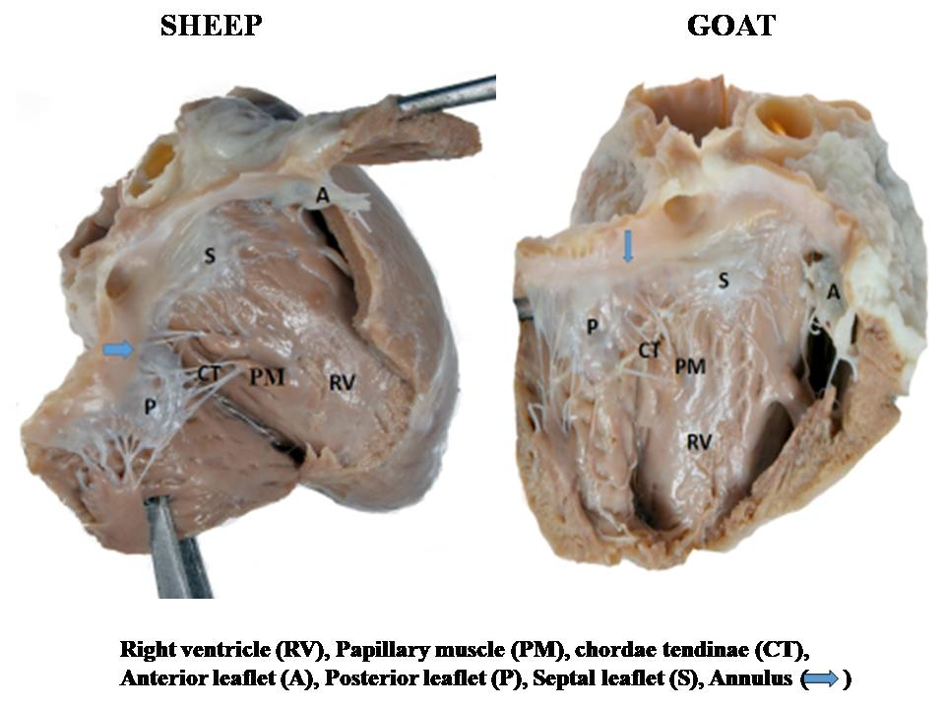

Fig 2: Comparative Valvular morphometry of the tricuspid valves in Sheep and Goat.

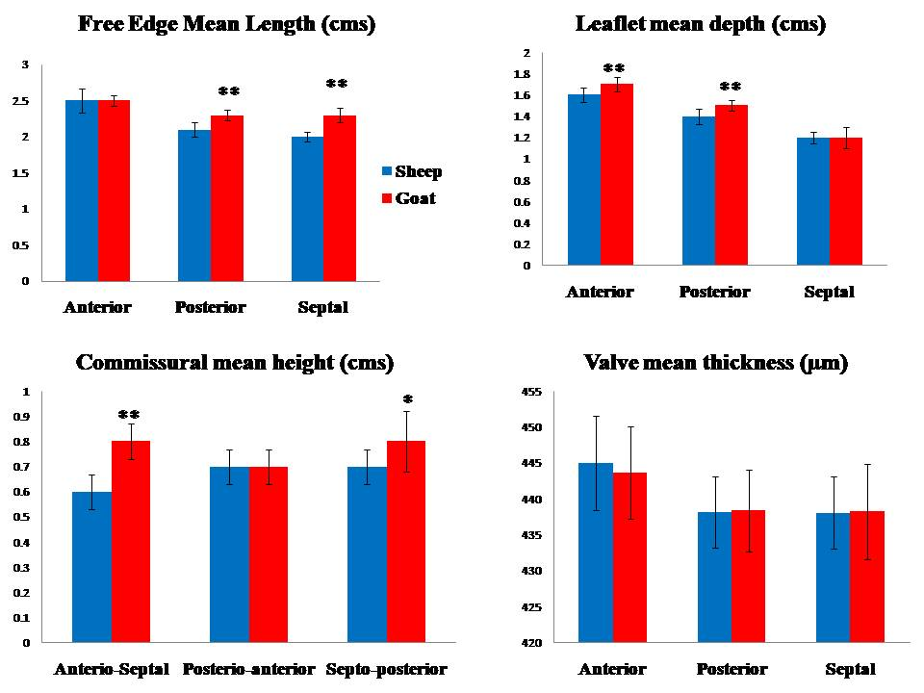

Figure 3: Photomicrograph of the tricuspid valve in goat showing the annulus (Van Gieson’s – 4X) and distribution of collagen fibers in the valves ( Masson’s trichrome- 40X)

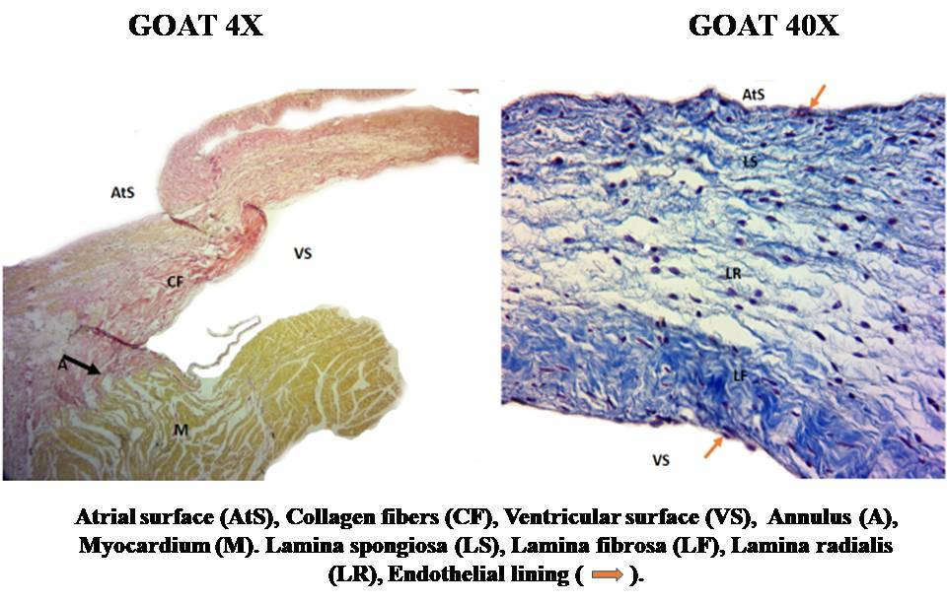

Figure 4: Photomicrograph of the tricuspid valve in sheep showing its surfaces (H and E – 10X) and distribution of elastic fibers (Verhoeff”s – 40X)

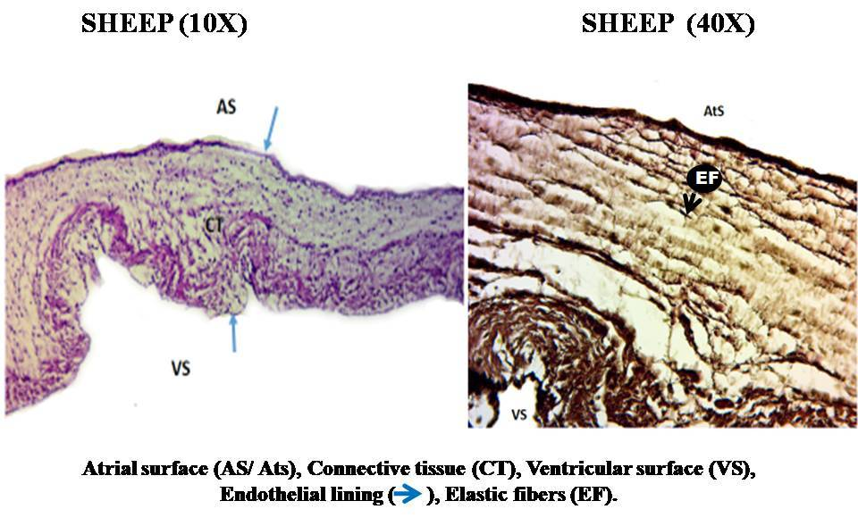

Figure 5: Photomicrograph of the tricuspid valve in sheep showing distribution of reticular fibers (Wilder”s - 40X) and PAS activity (PAS – 40X)

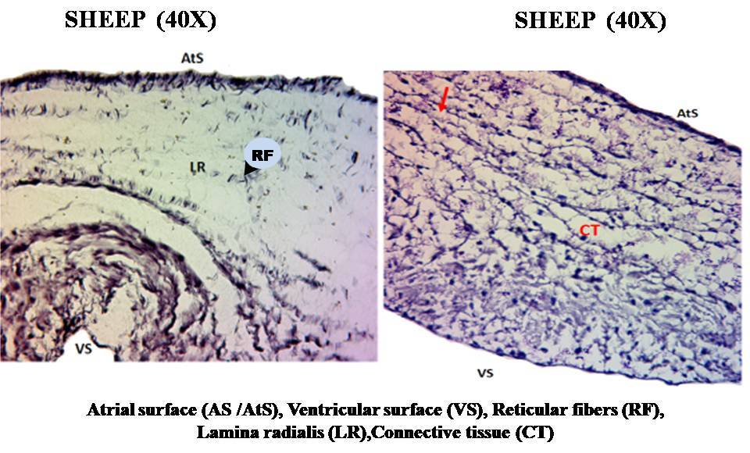

Figure 6: Photomicrograph of the tricuspid valve in sheep showing PAS AB activity (40X )

