***Original Research Article***

**Identification of Powdery Mildew-Resistant Urdbean Genotypes through Field Assessment**

**Abstract :**

Powdery mildew caused by *Erysiphe polygoni* (DC)is one of the most economically important diseases in urdbean, and it occurs at later stages of crop growth, resulting yield loss to be 20-50%. It is a common foliar disease of urdbean, particularly in the cool, dry season. Powdery mildew control strategies include the use of chemicals. But due to the cost of chemicals, farmers rarely practice such control measures, and the usage of such fungicides will negatively affect the environment and especially human health. Therefore, the most effective way to control powdery mildew is the use of resistant varieties. Keeping this in view, disease screening studies were made to understand the identification of powdery mildew disease. Since powdery mildew may inflict heavy losses to the crop in the Telangana state at present, cultivars are none of the cultivars are resistant to this disease; therefore, this study was initiated to evaluate available urdbean germplasm for identification of resistance sources to breed disease-resistant cultivars. In Rabi 2024-25, forty-nine genotypes were screened against powdery mildew diseases under field conditions along with susceptible and resistant checks. Out of 49 genotypes, none of the genotypes showed immune or resistant, five genotypes showed moderately resistant, remaining genotypes showed moderately susceptible to highly susceptible.

**Keywords:** Urdbean, Powdery mildew, Susceptible, Resistant, Percent disease index.

**Introduction:**

Urdbean (*Vigna mungo* (L.) Hepper) is one of the most important pulse crops of Asia, due to its nutritional quality and suitability to cropping systems, and known as “poor man’s meat” because of its cheapest source of protein for the poor (Duffus and Slaughter, 1980). It contains about 26 percent protein, which is almost three times that of cereals. India is the largest producer and consumer of urdbean in the world (Veni *et al*., 2015). The urdbean production of India was 2.05 million tonnes from an acreage of 3.21 million hectares with a productivity of 640 kg ha-1. (Annual Progress Report on Kharif Pulses 2023-24). In India, major Urdbean growing areas are Andhra Pradesh, Gujarat, Karnataka, Madhya Pradesh, Maharashtra, Orissa, Punjab, Rajasthan, Sikkim, Telangana, Tamil Nadu, and Uttar Pradesh. The production of Urdbean is affected by biotic and abiotic factors (Nene, 1972). Among biotic stresses, powdery mildew, cercospora leaf spot, and mungbean yellow mosaic virus (MYMV), Anthracnose, Bacterial leaf blight, Powdery mildew (*Erysiphe polygoni*), Root rot and leaf blight, Rust, Macrophomina blight, Leaf crinkle disease (Leaf crinkle virus), attack the urdbean crop regularly. Yield loss in urdbean is significant due to several viral and fungal disease infestations, among them, powdery mildew is one of the predominant diseases because of its cosmopolitan distribution (Kanimozhi *et al*., 2021). Among all the diseases, Powdery mildew caused by *Erysiphe polygoni* DC is one of the most economically important diseases in urdbean, and it occurs at later stages of crop growth, resulting yield loss to be 20-50% due to reduction in photosynthetic activity and physiological changes (Legapsi *et al*., 1978 and Nisar *et al*., 2006).

Powdery mildew is a serious disease affecting the cultivation of Urdbean in India and other countries (Abbaiah, 1993). Symptoms appear as white powdery or floury circular to irregular spots, specks, or patches on the upper surface or lower surface, or both surfaces of the leaves. When the disease progresses, leaves become smaller and chlorotic with stunting, distortion, and premature leaf fall due to infection of *Erysiphe polygoni*. The disease is generally noticed on aerial parts of the plant, leaves, stems, and pods. In India, the disease is present in almost all states of the country and becomes severe in the dry season (Pandey *et al*., 2009). It causes both qualitative and quantitative loss of grains.

Powdery mildew generally appears from the early flowering to the pod maturity stage, and its development depends upon the cultivars used, the growing period, and environmental conditions. Under field conditions, temperature played an important role in the disease development. The pathogen flourishes with dewy nights and warm days, with the optimum temperature for conidial germination being 20°C. Moreover, *Erysiphe polygoni* is an obligate biotroph that grows and propagates through haustoria by redirecting the host’s metabolism without causing the death of the host (Perfect and Green, 2001). Although the disease was reported to cause major loss, it is necessary to examine morphological characters and identification of the pathogen, investigate the influence of environmental factors on disease development, evaluation of urdbean genotypes for resistance against powdery mildew. The use of synthetic fungicides to reduce yield losses is the major practice by urdbean growers, which has serious implications for human health and is a growing threat to the environment. Therefore, the most effective way to control powdery mildew is the use of resistant varieties. The selection of powdery mildew-resistant sources is a prerequisite for the development of stable powdery mildew-resistant and high-yielding blackgram cultivars. Keeping this in view, disease screening studies were made to understand the incidence and development of powdery mildew disease.

**Materials and Methods :**

The present experiment was carried out in the rabi season, during 2024-25. Field studies were conducted at the Regional Agricultural Research Station, Siddhapur Farm, Warangal District. A total of 49 genotypes were collected from IIPR, Kanpur and ARS, madira and this experiment was laid out in Randomised Block Design (RBD) with two replications. The reaction of the entries to powdery mildew was recording the severity at 30, 45, 60 DAS till one week before harvesting, using a disease rating scale developed by AICRP, MULLaRP (2023). (Table-1)

The per cent disease index (PDI) was computed from the above scale by using the following formula (Wheeler, 1969)

# Percent Disease Index = Sum of individual disease rating

X 100

# No. of observations × max. disease grade

.

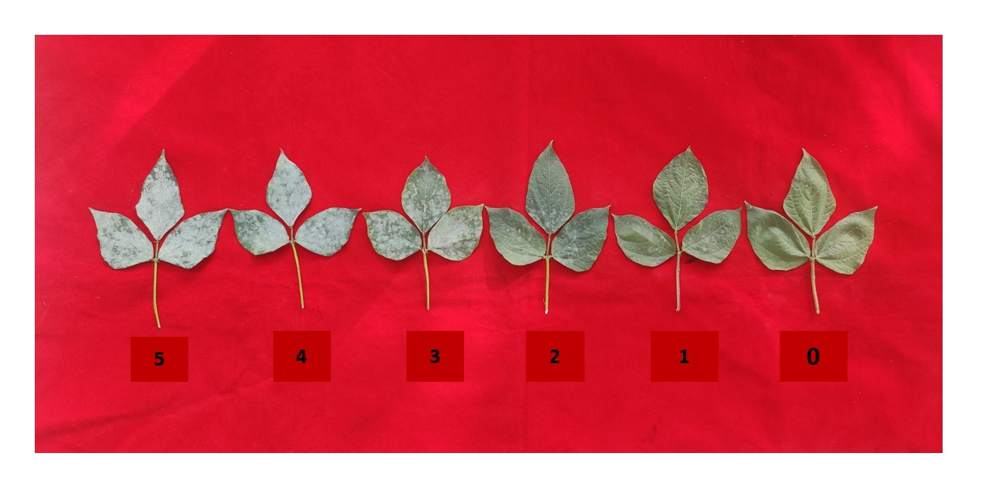

Figure-1: Disease scale rating of powdery mildew in urdbean- AICRP on MULLaRP scale, 2023. **(0 – Disease Free (DF); 1 – Resistant (R); 2 – Moderately Resistant (MR); 3 – Moderately Susceptible (MS);4 – Susceptible (S); 5 – Highly Susceptible (HS))**

**Results and Discussions :**

**Screening of urdbean genotypes against powdery mildew**

Among various strategies to manage the diseases, cultivation of resistant varieties is an eco-friendly, practically feasible, and economically viable method. Therefore, the most effective way to control powdery mildew is the use of resistant varieties.

The data from Table 2 shows screening of urdbean genotypes against powdery mildew under field conditions. The data is collected at 30DAS, 45DAS, and 60DAS by using a rating scale from AICRP on the MULLaRP scale, 2023. Based on disease reaction, Urdbean genotypes were grouped into Disease free (F), Resistant(R), Moderately Resistant (MR), Moderately Susceptible (MS), Susceptible (S), and Highly Susceptible (HS) (Figure 1) (Table 2). Among the 49 genotypes evaluated, none of the genotypes showed disease-free or immune. At 30 Days after sowing seven genotypes namely IPU 2-43 (10%), MBG 1134(4%), MBG 1169(6%), MBG 1171(8%), MBG-11(10%), MBG 1123(10%) and DBG 12-1(10%) showed resistant reaction with 4-10% range of percent disease index. Resistance reaction is due to the incompatible reaction of disease and the leaf area of genotype, and the genotypes that are resistant can tolerate the powdery mildew disease. Two genotypes, LBG 922(24%), VBG 17-021(22%), showed a moderately susceptible reaction with a 20.1-30% range of PDI. The remaining forty genotypes mostly showed a moderately resistant (MR)reaction with a range of 10.1-20%. Initially at 30 DAS, LBG 922 and VBG 17-021 showed a moderately susceptible later at 45 DAS susceptible reaction, as the disease progress at 60 DAS, showed highly susceptible reaction. All genotypes differed in their response to powdery mildew disease at different growth stages.

At 45 Days after sowing, two genotypes showed resistant reaction namely MBG 1134(10%), MBG 1169(10%) and four genotypes namely MBG 1171(12%), DBGV-51(18%), MBG-1123(16%), DBG 32-1(14%) were reported Moderately resistant (MR) reaction against powdery mildew with range of % disease incidence from 10.1-20%. 11 genotypes viz., IPU 2-43 (22%), PBG 276 (24%), MBG-8(30%), MBG-11(22%), MBG-12(26%), MBG-13(22%), AKU 12-3(26%), OBG 102(26%), VBG 17-026(28%), Pusa B 35(24%) and LBG 922(26%) were reported moderately susceptible reaction(figure-2). Initially, these 11 genotypes are resistant to moderately resistant, up to 30 days later, after 45 days, these genotypes showed a moderately susceptible reaction. Thirteen genotypes namely MBG 1070(56%), MBG 1194(56%), MBG 1206(58%), VBN-21-018(58%), TU-512(58%), LBG 1006(58%), LBG 1001(64%), KKB 15-052(56%), IPU 19-6(56%), IPU 19-2(56%), DBG 24-11(56%), IPU 19-56(54%) and VBN-8(56%) were showed highly susceptible reaction with 50-100% range of PDI. The Susceptibility of the genotypes is due to a compatible reaction between the disease(pathogen) and the leaf area of the genotype. (Table-2)

At 60 Days after sowing, none of the genotypes were resistant to powdery mildew. Five genotypes MBG 1134(20%), MBG 1169(18%), MBG 1171(20%), MBG 1123(20%), DBG 32-1(18%) were Moderately Resistant (MR) against powdery mildew(figure-2), two genotypes MBG-8(26%), VBG 17-026(30%) were Moderately Susceptible (MS), seventeen genotypes IPU 2-43(44%), MBG 1164(48%), MBG 1080(50%), MBG 1110(50%), PBG-276(38%), MBG 1183(40%), MBG 12(32%), VBG 20-100(38%), LBG 941(36%), ACM 16-017(48%), VBN-8(32%), OBG 102(36%), Pusa B 35(48%), DBGV-51(46%), VBG 20-008(46%), LBG 922(44%), VBG 17-021(36%) were Susceptible(S) with 30.1-50% range of PDI, remaining twenty five genotypes IBTBG-15(54%), MBG 1070(58%), MBG 1194(54%), PU 31(72%), LBG 787(60%),MBG 1206(60%), MBG 1133(58%), MBG 1167(56%), VBN-10(52%), VBN-21-018(60%), TU-512(78%), TU-40(54%), LBG 1006(58%), LBG 1001(54%), KKB 15-052(52%), IPU 19-6(56%), IPU 19-2(64%), DBG 24-11(52%), LBG 1172(52%), MBG-11(54%),MBG-13(62%), TU 1-1(62%), DBG 61(60%), IPU 19-56(64%), AKU 12-3(60%) are highly susceptible(HS) and none was resistant to powdery mildew. (Table 3).

When the progress of the disease increases, the reaction of genotypes also changes from resistant, moderately resistant, and moderately susceptible, to highly susceptible after 60 DAS. They showed different responses against powdery mildew disease from flowering to pod filling and the maturity stage. The genotypes MBG1169, MBG1134 initially showed resistant reaction at 30 and 45 DAS, but they became moderately resistant after 60 DAS. The MBG-11 genotype was initially reported to be resistant (10%) at 30 DAS, later on, at 45 DAS it showed a moderately susceptible (22%) reaction, and after 60 DAS it was found to be a highly susceptible (54%) genotype. The genotypes, namely MBG 1171, MBG 1123, DBG 32-1, were initially shown to be resistant at 30 DAS, later on at 45 and 60 DAS reported as moderately resistant. (Table 2).

Overall, the reaction of the genotypes against powdery mildew disease varies from resistant to highly susceptible. In those five genotypes, namely MBG 1134, MBG 1169, MBG 1171, MBG 1123, DBG 32-1, were expressed moderately resistant, two moderately susceptible genotypes, MBG-8, VBG 17-026, seventeen genotypes viz., IPU 2-43, MBG 1164, MBG 1080, MBG 1110, PBG-276, MBG 1183, MBG 12, VBG 20-100, LBG 941, ACM 16-017, VBN-8, OBG 102, Pusa B 35. DBGV-51, VBG 20-008, LBG 922, VBG 17-021 were showed susceptible reaction(S) and twenty five genotypes namely IBTBG-15, MBG 1070, MBG 1194, PU 31, LBG 787, MBG 1206, MBG 1133, MBG 1167, VBN-10, VBN-21-018, TU-512, TU-40, LBG 1006, LBG 1001, KKB 15-052, IPU 19-6, IPU 19-2, DBG 24-11, LBG 1172, MBG-11, MBG-13, TU 1-1, DBG 61, IPU 19-56, AKU 12-3 were reported as highly susceptible reaction against the powdery mildew disease(Table-3)(figure-4).

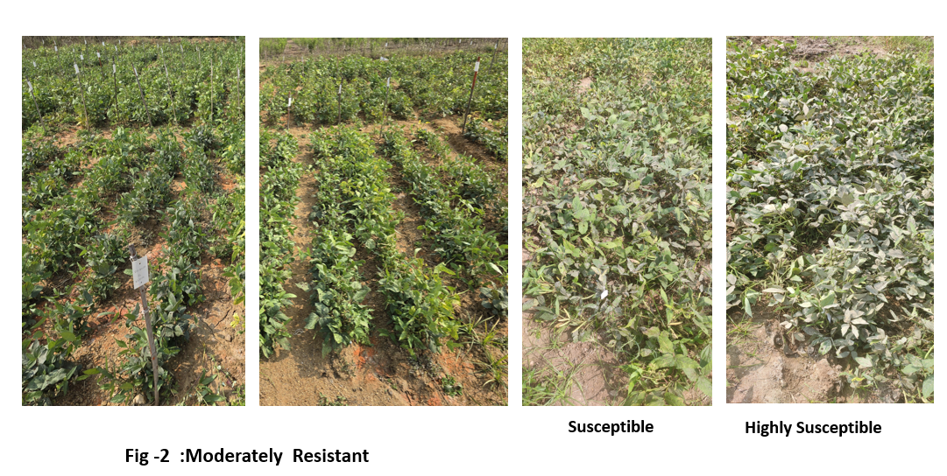

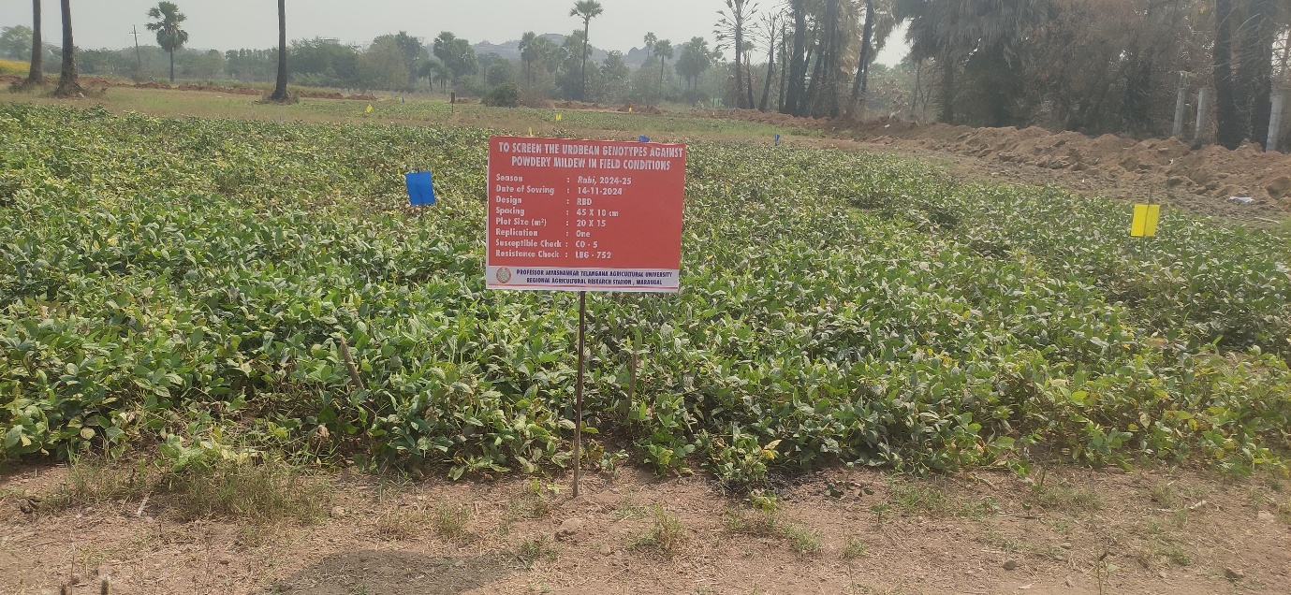

Figure -3: View of field experiment on screening of powdery mildew disease in urdbean during rabi, 2024

In a similar study, Raguchander *et al*. (2001) reported that PDU and IC12/2 exhibited partial resistance and had the lowest per cent mildew severity. In the present study, similarly, we identified five moderately resistant genotypes that showed the lowest percent disease index at the maturity stage(after 60DAS) against powdery mildew. Prashanthi *et al*. (2010) evaluated fifteen blackgram genotypes during kharif 2007 and found LBG-623 and LBG-648 as resistant sources against powdery mildew disease. Akthar *et al*. (2014) screened during kharif 2008 and 2009 out of 14 genotypes of blackgram, only three genotypes viz., BS 2-3, IPU 02-43, and B 3-8-8 showed resistant or highly resistant response against powdery mildew. Tirupathiswamy *et al*. (2014) reported that out of three blackgram cultivars, LBG 17 was resistant to powdery mildew. Channaveeresh *et al*. (2014) revealed that out of 126 genotypes screened, three genotypes, viz., LBG17, LBG-685, and LBG-685×VT (F2-F3), were found to be resistant to powdery mildew. Tulasi and Manoj (2018) during kharif, 2015, reported KUP-1 as immune, two genotypes KUP-30 and KUP-40 as highly resistant, and ten genotypes moderately resistant. During rabi, 2015-16, they reported two highly resistant genotypes, namely RUP-6, RUP-9, and moderately resistant RUP-7, against powdery mildew of urdbean. Similarly, in this study, we also reported five moderately resistant genotypes against powdery mildew during Rabi 2024-25; none of the genotypes showed resistance or high resistance. Contradictively, several reports given by the above research workers those genotypes were resistant due to their special resistant characters. Identifying and utilizing resistant cultivars is a crucial step to develop disease-resistant varieties, which helps to reduce the reliance on chemical fungicides and mitigate the negative impact of the disease on urdbean production (Punithavathy *et al*., 2024). In this present study reported five moderately resistant genotypes were MBG 1134, MBG 1169, MBG 1171, MBG 1123, DBG 32-1, which may be employed in crop development programmes after additional testing, and these findings are supported by prior studies. After screening of different genotypes against powdery mildew, these moderately resistant germplasm can become a source to breed disease-resistant cultivars and be utilized in crop development programmes.

**Conclusion**

In the present study, 49 genotypes were screened against powdery mildew in field conditions during Rabi 2024. The results concluded that among 49 genotypes, five genotypes, MBG 1134, MBG 1169, MBG 1171, MBG 1123, and DBG 32-1 were recorded as moderately resistant against powdery mildew disease. These genotypes showed resistance at 30 DAS, 45 DAS, and at the maturity stage after 60 DAS are moderately resistant; these able to tolerate the powdery mildew disease. Hence, these identified genotypes can be used as potential donors for a resistance breeding programme against powdery mildew in urdbean. These resistant or moderately resistant cultivars need further biochemical mechanism studies to depict variable disease reactions.

**References:**

Abbaiah, K. 1993. Development of powdery mildew epidemics in urdbean in relation to weather factors. *Indian Journal of Pulse Research*, 6: 186-188.

Agarwal, S. G., Sushma, N. and Nema, S. 1989. Resistance in mungbean and urdbean against powdery mildew. *Indian Journal of Pulse Research*, 2: 76-77.

Akhtar, J., Lal, H. C., Yogesh Kumar., Singh, P. K., Jyotirmoy Ghosh., Singh, P. K., Zakauallah Khan and Gautam, N. K. 2014. Multiple disease resistance in greengram and blackgram germplasm and management through chemicals under rainfed conditions. *Legume Research*, 37: 101-109.

Channaveeresh, T. S., Kulkarni, S. and Vijaykumar, A. G. 2014. Evaluation of black gram genotypes for resistance to powdery mildew caused by *Erysiphe polygoni* DC*. Karnataka Journal of Agricultural Sciences*, 27(1): 85-87.

Duffus, C. M. and Slaughter. 1980. Seed and their uses. Wiley and sons Chichester. New York. USA. 60-64.

Kanimozhi, S., Kumaresan, V. and Latha, T. K. S. 2021. Morphological and biochemical characteristics associated with powdery mildew resistance in M3 population of blackgram (*Vigna mungo* (L.) Hepper). Electronic Journal of Plant Breeding, 12(3): 983-989.

Kaushal, R. P. and Singh, B. M. 1989. Genetics of resistance in blackgram to powdery mildew caused by *Erysiphe polygoni. Indian Journal of Agriculltural Sciences*, 59: 684-685.

Tulasi, k. and Manoj. 2018. Screening urdbean Genotypes under Field Conditions against Powdery Mildew Disease. *International Journal of Science and Research*, 7: 855-859.

Legaspi, B. M., Catipon, E. M. and Hubbell, J. N. 1978. AVRDC Philippine outreach program mungbean studies. In The First International Mungbean Symposium, 220-223.

Nene, Y. L. 1972. A survey of the viral diseases of pulse crops in Uttar Pradesh. *First Annual Report,* FG-IN-358, Uttar Pradesh Agricultural University. 1-25.

Pandey, S., Sharma, M., Kumari, S., Gaur, P. M., Chen, W., Kaur, L., Macleod, W., Basandrai, A., Basandrai, D., Bakr, A., Sandhu, J. S., Tripathi, H. S. and Gowda, C. L. 2009. Integrated foliar diseases management of legumes. *Indian Journal of Pulse Research*, 143-161.

Perfect, S. and Green, J. R. 2001. Infection structures of biotrophic and hemi biotrophic fungal plant pathogens. *Molecular Plant Pathology*, 2: 101- 108.

Prashanthi, L., Reddy, B. V. B., Rani, R., Rajeswari, T., Sivaprasad, Y. and Reddy, K. R. 2010. Screening blackgram genotypes under artificially inoculated conditions and based on molecular markers for powdery mildew resistance. *Legume Research*, 33: 17-22.

Punithavathy, P., Kumaresan, D., Manivannan, N., Manikanda Boopathi, N. and Senthilraja, G. 2024. Genetics of powdery mildew disease resistance in blackgram [*Vigna mungo* (L.) Hepper]. *Electronic Journal of Plant Breeding*, 14(4): 1421-1424.

Raguchander, T. and Rajappan, K. 1995. Relationship between powdery mildew and meterological factors in urdbean. *Plant Disease Research*, 10: 5-9.

Ramakrishnan, C. K. D. and Savithramma, D. L. 2014. Screening of urdbean germplasm for powdery mildew disease resistance*. International Journal of Agronomy and Agricultural Research*, 4: 16-21.

Tirupathiswamy, N., Rosaiah, K. B. and Srinivasa, R. K. 2014. Screening blackgram genotypes against powdery mildew. *Annals of Plant Sciences*, 3: 594-599.

Veni, k., Murugan, E and Radhamani, T. 2015. Correlation and path co-efficient analysis of grain quality attributes in black gram (*Vigna mungo* L. Hepper). *Electronic Journal of Plant Breeding,* 6(3): 715-722.

Wheeler, B. E. J. 1969. An Introduction to Plant Diseases. John Wiley, London. 301.

Table 1: Disease scoring for Powdery mildew in Urdbean – AICRP on MULLaRP scale, 2023.

|  |  |  |  |
| --- | --- | --- | --- |
| **Grade** | **Description** | **Reaction** | **Designation** |
| 0 | Plants are free from infection | Disease Free | DF |
| 1 | Plants showing traces of 10% infection on leaves, stems free from the disease | Resistant | R |
| 2 | Slight infection with a thin coating of powdery growth on leaves covering 10.1-20% leaf area, slight infection on the stem, and pods usually free | Moderately  resistant | MR |
| 3 | Dense powdery coating on leaves covering 20.1-30 % leaf area, moderate infection on pods | Moderately  susceptible | MS |
| 4 | Dense powdery coating covering 30.1-50% leaf area, stems heavily, and pods moderately infected. The infected portion turns grayish. | Susceptible | S |
| 5 | Severe infection with dense powdery growth covering > 50% area of the whole plant, including pods, stems, etc., resulting in premature defoliation and drying. | Highly Susceptible | HS |

|  |  |  |  |  |  |  |  |
| --- | --- | --- | --- | --- | --- | --- | --- |
| S.no.  **Table – 2: Phenotypic reaction of Urdbean genotypes against Powdery mildew caused by *Erysiphe polygoni*** | Variety | PDI at 30DAS | Host Reaction | PDI at 45 DAS | Host Reaction | PDI at 60 DAS | Host Reaction |
| s.no | genotype | PDI at 30DAS | Host reaction | PDI at 45 DAS | Host reaction | PDI at 60 DAS | Host reaction |
| 1 | IPU2-43 | 10 (18.342) | R | 22(27.348) | MS | 44(41.526) | S |
| 2 | IBTBG 15 | 12 (20.26) | MR | 40(39.031) | S | 54(47.292) | HS |
| 3 | MBG 1070 | 20 (26.554) | MR | 56(48.622) | HS | 58(49.929) | HS |
| 4 | MBG 1194 | 16 (23.407) | MR | 56(48.532) | HS | 54(47.442) | HS |
| 5 | PU 31 | 18(25.062) | MR | 50(44.982) | S | 72(58.029) | HS |
| 6 | LBG 787 | 18(25.062) | MR | 48(43.821) | S | 60(50.748) | HS |
| 7 | MBG 1206 | 14(21.914) | MR | 58(49.587) | HS | 60(50.828) | HS |
| 8 | MBG 1164 | 18(25.062) | MR | 38(38.035) | S | 48(43.802) | S |
| 9 | MBG 1133 | 14(21.914) | MR | 43(40.918) | S | 58(49.587) | HS |
| 10 | MBG 1080 | 14(21.489) | MR | 44(41.526) | S | 50(44.982) | S |
| 11 | MBG 1167 | 16(23.407) | MR | 44(41.431) | S | 56(48.532) | HS |
| 12 | MBG 1134 | 4(8.212) | R | 10(17.551) | R | 20(26.527) | MR |
| 13 | MBG 1110 | 18(25.062) | MR | 34(35.575) | S | 50(44.982) | S |
| 14 | VBN-10 | 18(25.062) | MR | 40(39.031) | S | 52(46.191) | HS |
| 15 | VBN-21-018 | 18(25.062) | MR | 58(49.618) | HS | 60(51.089) | HS |
| 16 | TU-512 | 16(23.569) | MR | 58(49.682) | HS | 78(62.212) | HS |
| 17 | TU-40 | 18(25.062) | MR | 38(37.987) | S | 54(47.292) | HS |
| 18 | PBG 276 | 20(26.445) | MR | 24(29.002) | MS | 38(37.886) | S |
| 19 | MBG 1169 | 6(13.978) | R | 10(18.342) | R | 18(25.062) | MR |
| 20 | LBG 1006 | 20(26.554) | MR | 58(49.783) | HS | 58(50.416) | HS |
| 21 | LBG 1001 | 18(25.062) | MR | 64(53.228) | HS | 54(47.372) | HS |
| 22 | KKB 15-052 | 18(25.062) | MR | 56(48.427) | HS | 52(46.191) | HS |
| 23 | IPU 19-6 | 18(25.062) | MR | 56(48.438) | HS | 56(48.622) | HS |
| 24 | IPU 19-2 | 14(21.914) | MR | 54(47.442) | HS | 64(53.109) | HS |
| 25 | DBG 24-11 | 14(21.914) | MR | 56(48.427) | HS | 52(46.143) | HS |
| 26 | MBG 1183 | 12(20.26) | MR | 34(35.195) | S | 40(39.216) | S |
| 27 | MBG 1171 | 8(15.896) | R | 12(19.996) | MR | 20(26.554) | MR |
| 28 | MBG-8 | 14(21.489) | MR | 30(32.048) | MS | 26(30.629) | MS |
| 29 | LBG 1172 | 14(21.914) | MR | 36(36.341) | S | 52(46.162) | HS |
| 30 | MBG-11 | 10(18.342) | R | 22(27.348) | MS | 54(47.372) | HS |
| 31 | MBG-12 | 16(23.407) | MR | 26(30.212) | MS | 32(34.395) | S |
| 32 | MBG-13 | 14(21.914) | MR | 22(27.938) | MS | 62(51.928) | HS |
| 33 | TU 1-1 | 20(26.554) | MR | 48(43.802) | S | 62(51.928) | HS |
| 34 | DBG 61 | 20(26.554) | MR | 40(38.874) | S | 60(50.748) | HS |
| 35 | IPU 19-56 | 24(29.245) | MS | 54(47.323) | HS | 64(53.138) | HS |
| 36 | VBG 20-008 | 22(27.752) | MS | 38(38.035) | S | 46(42.687) | S |
| 37 | VBG 20-100 | 14(21.489) | MR | 34(34.848) | S | 38(37.49) | S |
| 38 | LBG 941 | 18(25.062) | MR | 36(36.826) | S | 36(36.736) | S |
| 39 | ACM 16-017 | 20(26.445) | MR | 32(33.702) | S | 48(43.802) | S |
| 40 | AKU 12-3 | 24(29.245) | MS | 26(30.212) | MS | 60(50.748) | HS |
| 41 | VBN-8 | 22(27.752) | MR | 56(48.427) | HS | 32(34.436) | S |
| 42 | OBG 102 | 18(24.791) | MR | 26(30.629) | MS | 36(36.855) | S |
| 43 | VBG 17-026 | 18(25.062) | MR | 28(31.705) | MS | 30(33.186) | MS |
| 44 | Pusa B 35 | 20(26.554) | MR | 24(29.322) | MS | 48(43.836) | S |
| 45 | DBGV-51 | 18(25.062) | MR | 18(25.062) | MR | 46(42.522) | S |
| 46 | LBG 922 | 24(29.245) | MS | 26(30.212) | MS | 44(41.342) | S |
| 47 | VBG 17-021 | 22(27.938) | MS | 34(35.43) | S | 36(36.826) | S |
| 48 | MBG-1123 | 10(18.342) | R | 16(23.569) | MR | 20(26.554) | MR |
| 49 | DBG 32-1 | 10(18.342) | R | 14(21.914) | MR | 18(25.062) | MR |
| 50 | CO-5 (S) | 28.83(32.462) | MS | 61.54(51.662) | HS | 86.25(68.239) | HS |
| 51 | LBG-752 (R) | 7(15.298) | R | 13(21.112) | MR | 18(25.086) | MR |
|  | C.D | 8.762 |  | 25.482 |  | 23.687 |  |
|  | S.E (m) | 3.075 |  | 8.944 |  | 8.314 |  |
|  | S.E(d) | 4.349 |  | 12.649 |  | 11.758 |  |
|  | C.V | 26.475 |  | 33.572 |  | 24.634 |  |

Table 3: Grouping of Urdbean genotypes against powdery mildew disease during Rabi, 2024 (AICRP, MULLaRP)

|  |  |  |
| --- | --- | --- |
| Percent of leaf area infected | Reaction | Genotypes |
| 0% | Free | None |
| 1-10% | Resistant | None |
| 10.1-20% | Moderately Resistant | MBG 1134, MBG 1169, MBG 1171, MBG 1123, DBG 32-1 |
| 20.1-30% | Moderately Susceptible | MBG-8, VBG 17-026 |
| 30.1-50% | Susceptible | IPU 2-43, MBG 1164, MBG 1080, MBG 1110, PBG-276, MBG 1183, MBG 12, VBG 20-100, LBG 941, ACM 16-017, VBN-8, OBG 102, Pusa B 35. DBGV-51, VBG 20-008, LBG 922, VBG 17-021 |
| 50.1-100% | Highly Susceptible | IBTBG-15, MBG 1070, MBG 1194, PU 31, LBG 787, MBG 1206, MBG 1133, MBG 1167, VBN-10, VBN-21-018, TU-512, TU-40, LBG 1006, LBG 1001, KKB 15-052, IPU 19-6, IPU 19-2, DBG 24-11, LBG 1172, MBG-11, MBG-13, TU 1-1, DBG 61, IPU 19-56, AKU 12-3 |

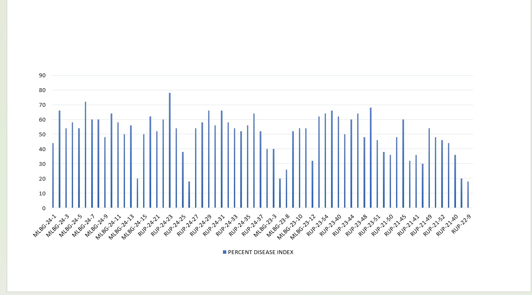

Figure-4: Graphical representation of the Percent Disease Index of Urdbean genotypes