Short Research Article

CLINICAL AND HISTOPATHOLOGICAL FEATURES OF IRRITANT CONTACT DERMATITIS IN DOGS

ABSTRACT

Aim:
The aim of this study was to investigate the incidence, clinical presentation, and histopathological characteristics of irritant contact dermatitis in dogs, with a focus on irritant-induced cases, and to identify common causative agents.
Studydesign:
A cross-sectional observational study was conducted over a six-month period from February to July 2024 at the dermatology unit of Madras Veterinary College, Chennai.
Methodology:
Out of 4,972 dogs presented to the outpatient unit during the study period, dogs suspected to have contact dermatitis were selected. Detailed history, clinical examination, hematological and biochemical profiles, and histopathological evaluations were performed. Data on breed, age, coat type, exposure to potential irritants, and lesion distribution were recorded.
Results:
A total of 32 cases (0.64%) were diagnosed with contact dermatitis. The condition was more prevalent in male dogs aged between 1–3 years and among medium-coated breeds. Common irritants included floor disinfectants (phenols, bleach), antiseptic solutions (chlorhexidine), shampoos, and fertilizers. Lesions primarily affected sparsely haired areas such as the abdomen, groin, paws, and axilla. Clinical signs included erythema, alopecia, scaling, and papulopustular eruptions. Hematological analysis showed stress leukograms; biochemistry revealed hypoalbuminemia and mild ALT elevation. Histopathology showed epidermal hyperplasia, parakeratosis, spongiosis, and dermal infiltration with mononuclear cells.
Conclusion:
Irritaant contact dermatitis in dogs, presents with distinct clinical and histopathological features. A systematic approach involving exposure history, lesion distribution, and histopathology is essential for accurate diagnosis and effective management. Increased awareness among pet owners and veterinarians is key to prevention and early intervention.

Keywords: Canine Irritant Contact Dermatitis, disinfectants, erythema, histopathology

1. INTRODUCTION

Inflammation of the skin through direct contact with an irritating substance is known as irritant contact dermatitis. The difference between immune and non-immune causes is becoming less evident and are of two types, irritant contact dermatitis (ICD) and allergic contact dermatitis (ACD). In certain circumstances, the condition mimics topical or permanent drug reactions, necessitating histology for diagnosis.
Classic contact allergic dermatitis is a type IV hypersensitivity reaction mediated by T-cells and caused by tiny chemical compounds called haptens. These haptens cannot provoke an allergic response on their own; they must first bind to skin proteins before causing sensitization. In veterinary medicine, contact allergy is defined as a condition caused by a cell-mediated immunological system (Nixon et al., 2020)
Animals frequently develop primary irritant contact dermatitis (ICD), which occurs without prior exposure. The intensity, and length of contact with the irritant will determine the severity of the condition. Strong chemicals, such as acids or alkalis which affects the skin and cause irritation that may result from repeated exposure to milder irritants such as shampoos, soaps, insecticides, flea collars, disinfectants, or grooming products. Skin lesions like redness, itching, scaling can also be caused by non-chemical irritants including heat, UV light, certain plants, and germs, particularly in areas of less hair. Like people, dogs and cats can develop ICD. ICD is a rare to uncommon, non-immune-mediated inflammatory skin illness caused by direct exposure to irritants at high enough levels to cause skin damage. The reaction arises from direct cytotoxic harm to epidermal cells and can be termed a mild type of chemical burn. Inflammatory dermatoses may predispose affected animals. Documented cases include pinnal dermatitis from contact with plastic objects, resolving after removal of the source (Gross et al., 2008)
Factors influencing ICD include contact time, concentration, and total dose. While once thought distinct from allergic contact dermatitis (ACD), differentiation has become conceptually blurred, as potent allergens can simultaneously initiate sensitization and elicitation. The authors, along with others (Scott et al., 2001), urge caution in interpreting veterinary ICD reports due to diagnostic uncertainty. Early ICD lesions appear clinically as erythema and papules, which proceed to exudation, scaling, and crusting. Chronic exposure can result in lichenification, hyperpigmentation, and baldness. Lesions often affect glabrous or sparsely haired areas such as the ventral belly, perianal region, genitalia, axillae, paw pads, and pinnae, and are often well delineated. Pruritus is variable.
ICD is generally more readily resolved than ACD due to easier identification and removal of the irritant. No consistent breed, age, or sex predispositions are noted. Although clinically similar to ACD, features favoring ICD include single exposures and occurrence in multiple animals within the same environment. Chronic ICD may resemble other dermatoses, but localization to hairless skin strongly supports a contact origin (Gross et al., 2008)
The abdomen, chest, axillae, flanks, interdigital spaces, legs, perianal area, and ventral surface of the tail were the most susceptible areas. Patches of erythema and papules represented primary lesions. Vesicles were rarely present in dogs and cats. As the disease progressed, crusts, excoriations, hyperpigmentation, and lichenification occurred. Intense pruritus might promote severe scratching and biting. Pyotraumatic dermatitis and eventual ulceration might obliterate primary lesions. Single episodes were common in primary irritant contact dermatitis, as in scrotal involvement from soap that was not rinsed off. Seasonal recurrence resulted from exposure to plants, lawn fertilizer, herbicides, and ice-melting substances (Miller et al., 2013)
ICD is characterized by direct damage to keratinocytes, typically seen as epidermal degeneration. Acute ICD lesions may display spongiosis, vesiculation with neutrophils, and epidermal necrosis, sometimes extending into hair follicles. Chronic ICD is more commonly encountered and often complicated by self-trauma, making diagnosis difficult. Histological indicators of irritant reactions include confluent parakeratosis—especially in glabrous skin—acanthosis, neutrophilic inflammation, crusting, and ulceration. Severe cases may resemble chemical burns, considered the extreme end of ICD. Rare extreme responses, such as pinnal reactions to plastic surfaces, exhibit epidermal edema, parakeratosis, vesiculation, and keratinocyte death. clinical context and exposure history are critical in identifying ICD from other dermatoses that have similar histopathologic features. (Gross et al., 2008)
2. MATERIAL AND METHODS
The dogs with skin disorders were presented to the Small Animal Clinics-Dermatology unit of Madras Veterinary College Teaching Hospital, Chennai were chosen for the study (February to July 2024).

2.1 Hematology and Serum Biochemistry
About 2.0 ml of blood was extracted aseptically from the affected dogs' saphenous or cephalic veins and transferred to an EDTA-coated tube for haematological analysis. Haemoglobin, packed cell volume, total erythrocyte, total leucocyte, platelet, and differential counts. All the above haematological estimations were carried out using auto analyser Mindray BC-2800. Blood (2 mL) was obtained using clot activator tubes. Serum was collected using centrifugation at 1500 rpm for 15 minutes. Biochemical parameters such as total protein, albumin, ALT, and ALP were measured using an A15 Biosystems autoanalyzer.
2.2 Skin punch biopsy.
The tissue samples collected by punch biopsy of 4mm and 6mm sizes were collected in 10% neutral buffered formalin, processed by routine paraffin embedding method and the cut sections were stained by hematoxylin and eosin for histopathological studies. Curved scissors were used to trim the hairs on the biopsied area, and a marking was used to indicate the intended lesion. Local anaesthetic (1% lignocaine hydrochloride) was injected at the site. In cases of minor lesions, the anaesthetic was injected either directly into the lesions (Craft et al., 2023).
2.3 Biopsy procedure
The skin surrounding the biopsy sites was stretched with the thumb and index finger of the nondominant hand perpendicular to the lines of least skin tension. The punch biopsy instrument was held vertically over the skin and rotated downwards using a twirling motion created by the first 2 fingers on the dominant hand. Once the instrument had penetrated the dermis into the subcutaneous fat, or once the instrument reached the hub, it was removed. Using scissors, the specimen was released from the subcutaneous tissues using the dominant hand. The incision was made below the dermis and closed with one or two interrupted sutures. Bandages and antibiotic ointment were administered (Craft et al.,2023).
2.4 Histopathological examination
The tissue samples collected by punch biopsy as well as collected during necropsy were fixed in 10% neutral buffered formalin, processed by routine paraffin embedding method, the cut sections were stained with hematoxylin and eosin and subjected to histological studies (Craft et al.,2023).
3. RESULTS AND DISCUSSION
This study focuses on the clinical, epidemiological, and pathological aspects of Irritant Contact Dermatitis and flea bite allergy in dogs, emphasizing the importance of environmental exposure and diagnostic techniques. The Study was conducted at the Dermatology Unit of the Small Animal Clinics at Madras Veterinary College Teaching Hospital in Chennai during February to July 2024. Out of 4,972 clinical dog cases presented 87 dogs had allergic skin issues in which 55 dogs (1.11%) were flea bite allergies and 32 dogs (0.64%) were contact allergic dermatitis.
Irritant Contact Dermatitis was more common in young, medium-coated male canines, most likely because to increased environmental interaction and sensitivity to sparsely haired areas (Miller and Griffin, 2013; Hnilica and Patterson, 2017). Among the 32 dogs, the most affected age for contact dermatitis were between 1–3 years (50%), followed by under 1 year (21.9%), 10 years (9.4%), and 7–9 years (6.2%). The prevalence was highest among medium-coated dogs (78.1%), followed by short-coated dogs (12.5%) and long-coated dogs (9.4%). Males (59.4%) were affected more than females (40.6%). The affected dogs breeds were Labrador Retrievers, German Shepherds, Pugs, Golden Retrievers, Beagles, Dachshunds, Siberian Huskies, Boxers, Shih Tzu and non-descript breeds.
The majority of dogs were exposed to irritating substances. Domestic chemicals were the leading cause (14 cases; 43.8%), floor disinfectants (8 cases; 25.0%), antiseptic sprays (4 cases; 12.5%) and carpet powders (2 cases; 6.3%). Shampoos and Conditioners 11 cases (34.4%). Outdoor chemicals, such as weed killers (1 case; 3.1%) and fertilizers (2 cases; 6.3%) for three cases (9.4%). Six cases (18.8%) by contact with surfaces such as cement flooring (2 cases; 6.3%) and rubber food bowl bases (4 cases; 12.5%). This study findings supported by the findings of (Scott et al., 2001; Griffin and DeBoer, 2001) who reported that Household chemicals and grooming products were common irritants, with lesions typically presenting on the abdomen (Fig 1b), paws (Fig 1a) and muzzle as erythema (Fig 1c), scaling, and mild inflammation, often without intense pruritus, distinguishing them from immune-mediated allergies. Dogs primarily developed skin sores on hairless areas such the face, inner thighs, paws and ventral abdomen. there was mild to no pruritus, those lesions were characterized by redness (Fig 1d), swelling, scaling and mild pain. The majority of dogs had apparent food and water intake, but some dogs occasionally had a behaviour of licking and having subtle symptoms of pain. A recent history of environmental exposure with classical lesions of allergy suggested of irritant contact dermatitis. The hematobiochemical analysis revealed hemoglobin (9.47 g%) and packed cell volume (21.38%) both decreased, showing inflammatory response. Low lymphocyte counts (12.71%), elevated 83% neutrophils and a total white blood cell count of 19.28 /cmm indicated a stress leukogram, which were frequently observed in acute inflammation and an immunological response to stress. The inflammatory response was not allergic, as indicated by the normal levels of monocytes (4.28 ± 0.18%) and eosinophils (1.71 ± 0.18%) as per Miller et al. (2013). Serum biochemical analysis, showed hypoalbuminemia (2.67 ± 0.18 g/dL). This could be due to higher globulin levels, total protein (7.3 ± 0.13 g/dL). The moderately elevated ALT level (65.14 ± 1.4 U/L) could be due to hepatic stress, which might be due to the absorption of systemic irritants as per Miller et al. 2013. There were no liver or coagulation abnormalities, as the platelet count (3.20 ± 0.48 lakhs/cu.mm) and ALP (115.43 ± 3.2 U/L) were within normal levels.
Histopathologic examinations revealed parakeratosis, vesiculation, and intraepidermal hyperplasia (Fig 2a) were found. Lymphocytes, neutrophils, and eosinophils had spread throughout the superficial dermis (Fig 2d). Mild parakeratosis (Fig 2c), spongiosis (Fig 2b), crusting, ulceration, and acanthosis, particularly in glabrous skin, and dermal edema (Fig 2a) were also observed. Histopathological findings of the present study were in concordance with the findings of Mason and Ruutu, (2023), who also reported intraepidermal pustules with eosinophils in spongiotic epidermal hyperplasia and lymphocyte exocytosis. The superficial dermis was diffusely infiltrated with a mixture of eosinophils and lymphocytes.

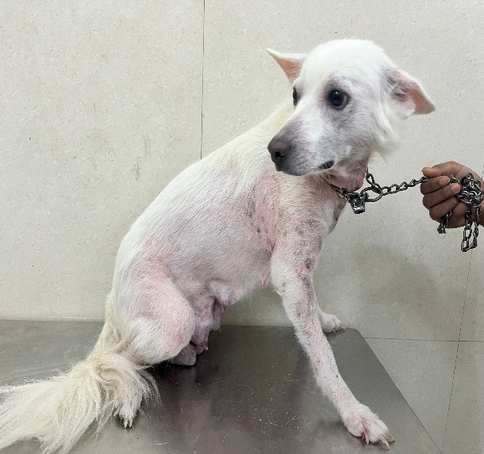  Fig 1a. Hair loss and redness on the neck, chest, and forelimbs. | 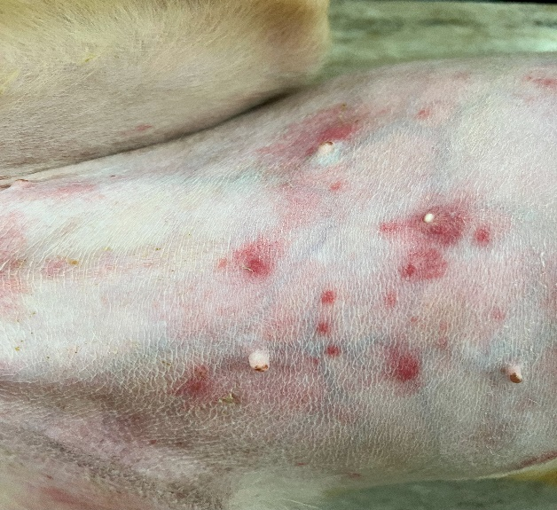  Fig 1b. Ventral abdomen showing red papules and pustules
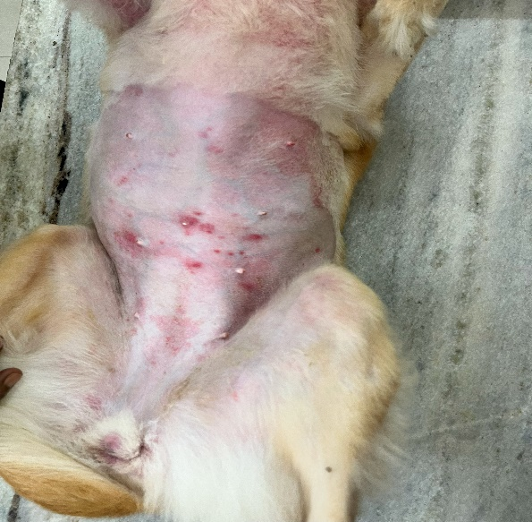  Fig 1c. Redness, papules, and pustules on the abdomen | 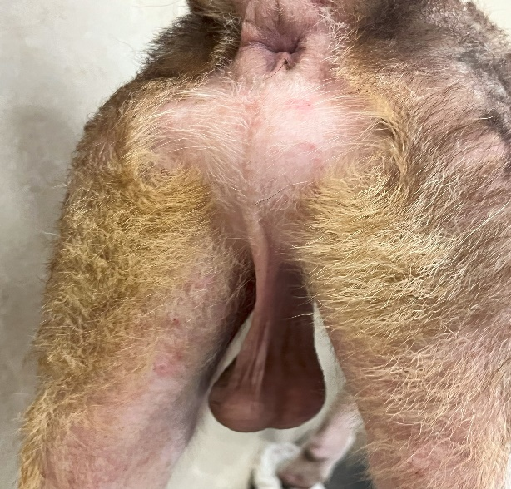  Fig 1d. Hair loss and mild redness around the groin area

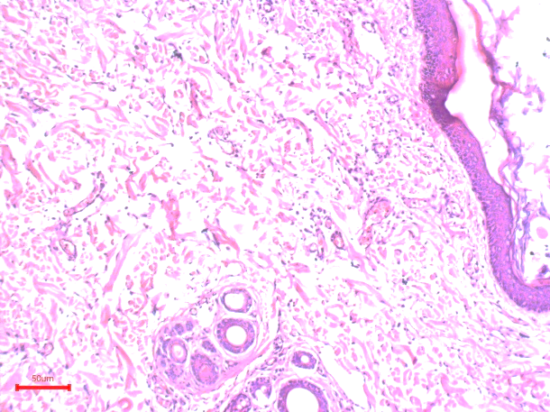  Fig 2a. Epidermal hyperplasia, dermal edema, and inflammatory cell infiltration, H&E 100x | 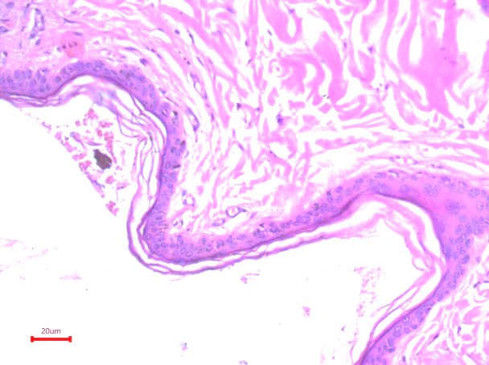  Fig 2b. Spongiosis (intercellular edema) and mild acanthosis, H&E 200x
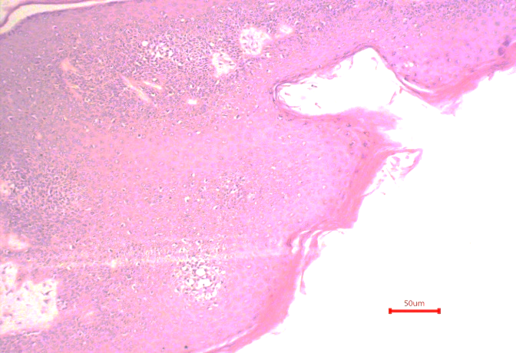  Fig 2c. Mild parakeratosis and mild spongiosis, H&E 100x | 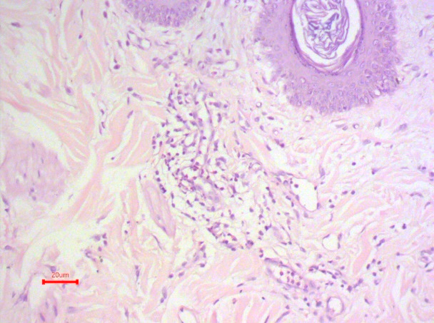  Fig 2d. Perivascular infiltration of inflammatory cells in the dermis, H&E 200x

4. Conclusion
The study provides an overview of clinical and pathological aspects of irritant contact dermatitis in dogs, the findings denotes that allergic dermatitis is still a widespread dermatological problem in dogs, often connected with environmental allergens, ectoparasites, and food hypersensitivity. Clinically, affected dogs showed lesion like itching, erythema, alopecia and other chronic skin lesions, while histological examination revealed typical characteristics such as acanthosis, hyperkeratosis, and perivascular inflammatory infiltrates. The study emphasizes the significance of clinical lesions, a complete dermatological examination, and histology to accurately diagnose and distinguish allergic dermatitis from other cutaneous conditions. Additionally, breed predilection and age-related sensitivity were observed, implying a genetic component.

Consent (where ever applicable)

"All authors declare that ‘written informed consent was obtained from the patient (or other approved parties) for publication of this case report and accompanying images. A copy of the written consent is available for review by the Editorial office/Chief Editor/Editorial Board members of this journal."

Ethical approval (where ever applicable)

NOT APPLICABLE

References
Craft, W.F., R. Marsella and A. Rodrigues-Hoffmann, 2023. Skin biopsy guidelines: tips and advice from veterinary pathologists to practitioners. J. Am. Vet. Med. Assoc. 261(S1): S114-S121.
Griffin, C. E., & DeBoer, D. J. (2001). The ACVD task force on canine atopic dermatitis (XXVII): Allergic contact dermatitis. Veterinary Immunology and Immunopathology, 81(3–4), 239–249. https://doi.org/10.1016/S0165-2427(01)00368-2
Gross, T. L., Ihrke, P. J., Walder, E. J., & Affolter, V. K. (2008). Skin diseases of the dog and cat: Clinical and histopathologic diagnosis (2nd ed.). John Wiley & Sons.
Hnilica, K. A., & Patterson, A. P. (2017). Small animal dermatology: A color atlas and therapeutic guide (4th ed.). Elsevier.
Mason, K., & Ruutu, M. (2023). Canine dermatitis on contacting grass leaf: A case series. Veterinary Dermatology, 34(2), 115–124. https://doi.org/10.1111/vde.13015
Miller, W. H., Griffin, C. E., & Campbell, K. L. (2013). Muller and Kirk’s small animal dermatology (7th ed.). Elsevier.
Nixon, R. L., Allnutt, K. J., & Diepgen, T. L. (2020). Contact dermatitis. In A. W. Burks, S. T. Holgate, R. O’Hehir, D. H. Broide, & L. B. Bacharier (Eds.), Middleton’s allergy: Principles and practice (9th ed., pp. 553–561). Elsevier.
Olivry, T., & DeBoer, D. J. (2001). Allergic skin diseases of dogs and cats: A review. Veterinary Dermatology, 12(4), 163–176. https://doi.org/10.1046/j.0959-4493.2001.00299.x
Scott, D. W., Miller, W. H., & Griffin, C. E. (2001). Muller and Kirk’s small animal dermatology (6th ed.). W.B. Saunders.

