**Rejuvenating Aging Orchards: A Path to Renewed Productivity and Profitability**

**Abstract**

The worldwide fruit industry is a mainly depends on agricultural sector that significantly contributes to food security and rural livelihoods. However, a considerable proportion of fruit orchards globally contain old, dead and senile trees. These trees can typically demonstrate full and leafy canopies, poor light interception, inefficient photosynthesis, and fruit yield and quality that is exceptionally low enough to be unattractive to consumers. These trees alone present a sustainable and economically concerning challenge to the future of the fruit industry. The existing process for uprooting, archiving and planting an orchard in this context is both a long-term and high-capital cost option. Hence, rejuvenating senile orchards is now a feasible, cost-effective, and fast option to restore productive value. This review paper presents the need for orchard revitalization, techniques used, effects on tree physiology and productivity, issues, and potential of this technology.

**Keywords:** Orchard Rejuvenation, Pruning, Top-working, Canopy Management, Senility, Productivity, Fruit Crops, Reinvigoration.

**1. Introduction**

An orchard, like any living system, has a productive lifespan. An orchard may gradually undergo a stage of "senility" wherein there is a notable decline in vigour and productivity due to their life history (Baba et al., 2011). Orchards are a long-term investment (Singh & Meghwal, 2021). They require meticulous care and management over their productive lifespan, which can span several decades. There are some reasons for this decline:

* **Physiological Aging:** After many years of continuous cropping activity, there will be physiological aging and the growth processes in the trees decrease, thus leading to a decrease in the tree's ability to take up and translocate nutrients.
* **Canopy Density:** Canopies in an orchard can become very dense and overlapping when there is little to no supporting pruning and training. When canopies become overgrown this means less light can penetrate to the inner portions of the trees thereby modifying the available photosynthetic area and reducing the number of productive shoots.
* **Accident and Infection by Pests and Diseases**: Older trees seem to have a greater incidence of diseases and insect pests hence, they become stressed and weakened.
* **Decreased Healthy Productive Shoots**: Nearly continuous cropping on older wood or wood that is too old (e.g. each shoot did not originate on wood less than two or three years old) will produce fewer healthy, fruit yielding shoots.
* **Nutrient and Soil Degradation:** Continuous farming of soil without the support of a solid soil strategy can allow nutrient depletion and pathogens to accumulate in the soil.
* **Varietal Obsolescence:** Many older orchards represent varietal obsolescence that does not get grown because there is little or no market for the old or antiquated varieties or newer strains that are resistant to new diseases.

Instead of uprooting and replanting an entire orchard, which is a time-consuming and expensive process, rejuvenation offers a cost-effective and efficient alternative (Suklabaidya & Mehta, 2019). Rejuvenation involves a series of horticultural practices aimed at restoring the health and productivity of existing trees (Singh, 2011). It is a strategic approach that allows farmers to revitalize their assets and continue to generate income from their land.

**1.1 Why this is important for farmers**

In our country, a lot of fruit farmers are saddled with unproductive, aging orchards and low-quality, uneconomical fruit. The most obvious solution—uprooting and replanting—is quite time-consuming and pricy (Ushkempirova et al., 2023). This is compounded by the cost of getting new orchards going and the long juvenile phase when they don't have a return. Thus, the large number of unproductive orchards threatens the economic viability of fruit farming.

**What is rejuvenation**

Rejuvenation is process of pruning and after pruning management of plants to make them productive by utilizing the existing root system for support and absorption and existing branch system to rebuilt the productive canopy.

There are many reasons which reduce the productivity of orchard such as unsuitable location and climate, intercropping, insufficient nutrient level, attack of pest and diseases and other biotic and abiotic problems.

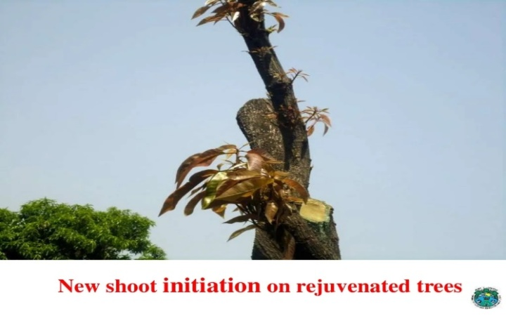

**Fig 1. Mango tree showing shoot initiation upon rejuvenation**

**1.2 Need to rejuvenation of orchards**

1. The surface area of photosynthesis is reduced.
2. Insect pest attack is increased in old orchard.
3. There is lack of productive branches.
4. Less penetration of sunlight in the orchard which cannot develop good color in the fruits.

**2. The Science and Practice of Rejuvenation**

Orchard rejuvenation is a multi-faceted process that requires a comprehensive approach. The primary objective is to restore the balance between vegetative growth and fruiting, while improving tree health and vigor. The key practices involved are:

**2.1 Pruning**

Pruning is the most critical step in orchard rejuvenation. Its main goals are:

* **Removal of Dead, Diseased, and Damaged Branches:** This helps to improve air circulation and sunlight penetration, reducing the risk of disease.
* **Canopy Reduction:** Removing excess branches and limbs helps to reduce the tree's height and spread, making it more manageable. This also encourages the growth of new, productive wood.
* **Renewal Pruning:** This involves removing older, unproductive branches to stimulate the growth of new shoots that will bear fruit.
* Pruning can involve a number of techniques, which include heading back, thinning, and dehorning based on the level of tree health and intended number of productive wood limbs. If the tree is overgrown, you could dehorn or skeletal prune by cutting large limbs back to the main trunk of the tree. A dehorning or skeletal prune type of cutting of several branches will invigorate the tree and encourage strong new growth.

**2.2 Top-working or Frame working**

This technique involves grafting a new, desirable scion variety onto the existing rootstock and trunk of an old tree. This is an excellent option for farmers who want to switch to a new, high-yielding, or disease-resistant variety without having to uproot the old trees. The established root system provides a strong foundation, allowing the new scion to grow rapidly and bear fruit much earlier than a newly planted tree. This process, also known as "top-grafting" or "frame-working," can significantly reduce the time to first harvest.

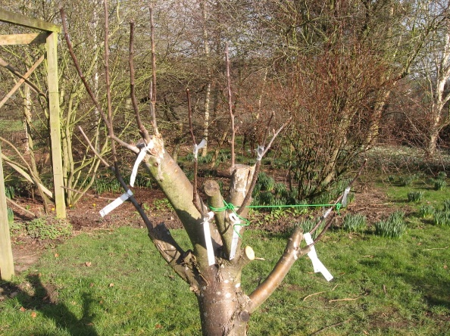

**Fig 2. Top working in apple**

**Advantages**

* Increase old orchard productivity.
* Convert old and senile orchards into productive orchards.
* Possibility of grafting several varieties on the same plant.

**2.3 Heading back**

The heading back pruning technique is a distinct method of pruning existing orchards to markedly improve fruit quality and production quantity and extend the growing productive life of the orchard by 25-30 years. The essence of the technique is to stabilize farmer income and fruit production. In this technique, the tree's main trunk was cut back to 1.5m from the ground. The control trees underwent annual, routine pruning, with 6-7 nodes left on the current season shoots. The heading back trees, in the following year were allowed to produce 6 of the strongest shoots. In standard combination, the shoots were chosen and headed back to 30cm, 60cm, 90cm, and 120 cm in height. This rigorous method primarily seeks to alter tree structure and canopy size. The new shoots that are produced by the regeneration after the pruning is clear that they have the potential to reproduce flower and fruit during the following season. This sequential periodic pruning was carried out annually for shaping trees and regularly producing high-quality fruit. Ultimately, the standardized renewal technology substantially increases orchard income and orchard yield.

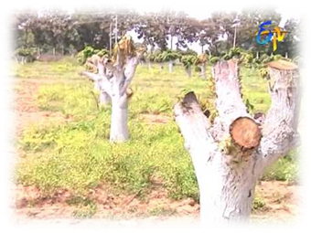

**Fig 3. Heading back of mango**

**2.4 Soil Management and Nutrition**

A healthy soil is the foundation of a healthy orchard. Rejuvenation efforts must be complemented by a robust soil management plan.

* **Soil Testing:** Conducting a soil test is crucial to determine nutrient deficiencies and pH imbalances.
* **Nutrient Application:** Based on the soil test results, a balanced application of macro and micronutrients is essential. Organic manure, compost, and biofertilizers can also be incorporated to improve soil health and structure.
* **Weed Management:** Controlling weeds reduces competition for water and nutrients.
* **Irrigation:** Ensuring adequate and timely irrigation is vital for tree health and fruit development.

**2.5 Pest and Disease Management**

Rejuvenated trees are initially more susceptible to pests and diseases due to the stress of pruning. A proactive and integrated pest management (IPM) strategy is crucial. This includes:

* **Sanitation:** Removing and destroying pruned branches to prevent the spread of diseases.
* **Monitoring:** Regular monitoring for signs of pests and diseases.
* **Targeted Spraying:** Applying appropriate fungicides and pesticides at the right time.

**2.6 Use of Plant Growth Regulators (PGRs)**

PGRs can be used to control growth and promote fruiting. For example, certain PGRs can be used to induce flowering and fruit set in rejuvenated trees, helping to accelerate the return to productivity.

**3. Canopy management**

Older plantations of seedling origin which have become senile can be adopted for top worked by grafting (budding) with scion of superior varieties to upgrade seedling plantation with superior commercial varieties. There is a tendency of over lapping of canopy between 10 and 12 years of age depending on the nature of variety unless the canopy is maintained by trimming and thinning. Plantations which have overlapping branches. This is possible by hedging of branches followed by shoot management to modify the tree structure and maintain canopy size.

* **Most common way of rejuvenation used by farmers:**

The process can be started in the month of December -January. Select unproductive orchard, mark the branches behead them keeping 30cm stubs on 3-6 major limbs. A clean cut should be given to the limbs with a sharp saw to avoid bark splitting. Start beheading from base to the top. Paste cow dung slurry or copper oxychloride paste (dissolve 2 kg of copper sulphate in 15 liters of water, mix 3 kg of quick lime in 2-3 liters of water and then add the remaining 12-13 liters of water, mix the two concentrated solutions)on cut portion. If the old trees are infected with fungi, do not behead the limbs since the stubs may not sprout. Several sprouts will come up on these stubs. Plough the orchard and prepare it for inter crops. Make basins below the plants. Irrigate the plant and apply 1 kg urea per tree. Control stem borer if it has appeared. Remove weeks sprouts, control foliage feeding insect pests and grow summer season inter crop. Take proper care of inter crop and sprouts.

Select the best one or two sprouts on each stub and graft them with the desired cultivar. Remove the rest of the sprouts gently by giving a clean-cut close to the stub so that these may not re-sprout. If any of these shoots are left, they will overpower the newly sprouted grafts. This way one will have 6-12 grafted shoots. These grafts sprout within 20 days of grafting. The shoot above the sprouted graft should be headed back by keeping only one whorl of old leaves in November. These leaves provide food to the newly sprouted graft. Newly sprouted grafts should be covered with rice trash or plastic bags to save the grafts from frost or severe winters in December. The covers may be removed in February-March. While removing the covers, the polythene sheet used for tying the graft union should also be gently removed.

* **After care of orchard rejuvenation:**
* Manuring
* Inter Cropping Cultivation
* Irrigation
* Repairing of wounds
* Thinning and filling of gaps

**Rejuvenation Techniques for Specific Crops**

The specific techniques and their respective effectiveness can vary widely among fruit crops.

* **Mango rejuvenation**

Successful orchard management requires a science-driven integrated approach involving a number of key cultural practices. These include cutting back branches and pasting them with cow dung (presumably to protect the cuts), removing unwanted shoots, as well as proper nutrient and water management. If your original varieties of trees are poor quality or do not have good pollinizers, you should consider top-working with elite clones. Top-working is simply grafting a better variety on to existing tree stock. Freshly worked trees usually begin fruiting sometime in the third year.

For best nutrition, the following fertilizers are recommended:

1. 2.5 kg Urea
2. 3 kg Single Super Phosphate (SSP)
3. 1.5 kg Muriate of Potash
4. 120 kg well-decomposed Farm Yard Manure (FYM)

**When and how to apply them:**

Late February- Apply half of Urea, all of SSP and Muriate of Potash. Late June - Apply remaining urea. First week of July - Apply full amount of FYM per tree (120 kg). Whenever possible, you should apply all of the manures and fertilizers within the basins you prepared around the trees.

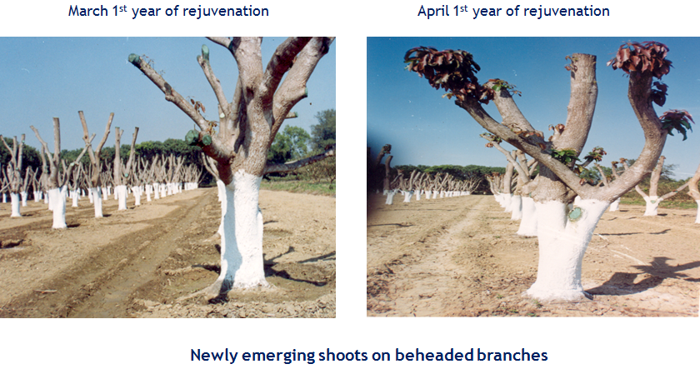

**Fig 4. showing rejuvenation in Mango orchard**

* **Anola rejuvenation**

This rejuvenation technique involves the practice of pruning method of heading back or topping of limbs of the tree. This process is performed in the months of December and January. The limbs are cut at 2.5m to 3.0m from the ground, depending on tree build and structure. Prior to rejuvenation pruning the limbs to be cut, are marked with white chalk in the form of a ring.

The actual cutting process occurs in two stages:

1. An initial cut, at least 10cm deep, is made from the underside of the selected limb. Then, the final cut is made from the top side of the limb.
2. Cow dung or copper oxychloride is then pasted onto the exposed limb where the wounds take place, to protect the wounds.

Only the shoots that develop outward from the limbs should be allowed to develop to ensure that the tree starts developing new limbs and encourages a productive canopy. The purpose of this method is to rejuvenate the older trees by enabling a new growth cycle.

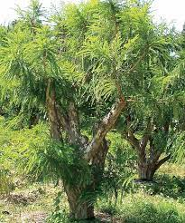

**Fig 5: Anola rejuvenated orchard**

* **Litchi rejuvenation**

**Spacing and Planting System:** Traditionally, plantations have been made in square systems, with 9-10 meters between plants and rows. Based on science, starting from the will in England, it has been shown that a double hedgerow spacing of 4.5 x 4.5 x 9 meters is much better than a square in terms of yield and equal quality fruit. With this planting system, there are approximately 329 of these plants in a hectare. Therefore, better and more fruit can be produced with a comparable quality.

**Training & Pruning:** Pruning is one of the most important factors for maintaining tree health, productivity and capacity. The following are examples of that: Remove non-fruit producing and unproductive branches from the inside of the tree canopy. Most people can identify and eliminate dried, diseased, and scissor-shaped branches. These should be removed periodically as necessary for prevention purposes and air circulation. Light pruning after harvest, like much of horticulture, allows for better growth, better fruiting, and better productivity. When removing fruit for harvesting, we would always recommend to try to remove the fruit panicle with 8 - 10 (it seems like the authors scribbled too much here, which we hope to learn more about - leaves as well as a specified length of length of stem).

* **Citrus rejuvenation**

1. **Pruning and Disease Prevention (Post-Harvest**): As soon as fruit harvest is over, prune off all dried branches. Directly after this, spray with Carbendazim at 1 gram/L. This will probably be a fungicidal treatment to reduce the potential of disease entry through the pruning wounds.
2. **Pest Control:** Bark-eating caterpillar control - Treat larval tunnels by applying Dichlorovas (0.1% concentration, 3-5 mL per tunnel) or insert a cotton tipped swab soaked in insecticide into the tunnel. Citrus psylla control - Spraying with Imidacloprid at 0.3 ml per L solution or Monocrotophos at 0.5 ml per L solution. Mites - Spray with Dicofol at 1.5 ml per L of water.
3. **Disease Controls**:

**Gumming (Gummosis)** - Scrape the oozing gum off the tree and apply Metalaxyl paste to the wound. Phytophthora - Spray with Metalaxyl MZ 72- 2.75 grams per l of water.

**Trunk protection**- Apply Bordeaux paste to the trunk of the tree two times each year, first before the monsoon season and secondly after the monsoon season.

**4.** **General Orchard Practices:** Irrigation - Utilize the double ring method or drip irrigation in the orchard area. Be sure that proper drainage exists to avoid water logging. Nutrition - Apply defined doses of fertilizers in addition to micro nutrients.

**4. Economic Feasibility and Benefits**

The rejuvenation of an orchard offers several significant economic benefits over the traditional method of uprooting and replanting:

* **Reduced Costs:** It is far less expensive than replanting, as it avoids the costs of uprooting, land preparation, and purchasing new saplings.
* **Faster Return on Investment (ROI):** Rejuvenated trees can start bearing fruit within 1-2 years, whereas new plantations can take 5-7 years to reach commercial bearing. This significantly shortens the payback period.
* **Continuity of Income:** The farmer does not have to wait for several years for a new orchard to mature.
* **Improved Fruit Quality:** With proper management, rejuvenated trees produce larger, better-quality fruit due to improved light penetration and nutrient uptake.
* **Increased Yield:** Rejuvenation can lead to a significant increase in yield, often surpassing the previous productivity of the old trees.

**5. Challenges and Future Prospects**

Despite the proven success of rejuvenation, some challenges remain:

* **Physiological Apprehension:** Growers may be reluctant to practice heavy pruning because they are afraid that the old trees will die or take a long time to recover. Coordinated large-scale field demonstrations are needed to address these limitations.
* **Scientific Advancement:** More experimental studies on the physiology of shoot growth and bearing in heavy pruned trees are necessary to improve the pruning process and cultural practices for various fruit crops and agro-climatic conditions.
* **Varietal and Rootstock Compatibility:** Compatibility of the scion and rootstock is a key factor for top-working that will always need research.
* **Adoption and Extension**: Greater distribution of the technology via formal training programs and extension services is critical to improve the rate of adoption.

**6**. **Conclusion**

The revitalization of aged and senile orchards is an impactful, cost-effective technology capable of renewing the productive capacity of declining fruit plantations. By using heavy pruning, top-working, and integrated management strategies, farmers can restore old and unproductive trees to dynamic, high-yielding trees. This technology contributes to both the increased profitability of existing orchard operations and aids in sustainability and affordability in the entire fruit supply chain. Research and adoption of this technology has the potential to unlock new productive capacity for perennial fruit crops and also contribute to a sustainable future for horticulture.

**Reference**

Baba, J. A., Akbar, P. I., & Kumar, V. (2011). Rejuvenation of old and senile orchards: a review. *Annals of Horticulture*, *4*(1), 37-44.

Kumar M, Singh S And Yadav B S.2020. Standardization of rejuvenation techniques in ber cv. kaithali for semi-arid conditions. *Agriculture research***57**(5): 801-804.

Singh A K, Singh C P and Ram S.2019. Rejuvenation of senile and overcrowded mango trees in orchard. *Progressive horticulture***51**(1):53-57.

Singh G.2011. Technology for rejuvenation of old and senile orchard of guava. *Progressive horticulture*. **43**(1):11-17.

Suklabaidya A and Mehta K 2019. Rejuvenation of senile horticultural plantations for improved productivity and quality. *International journal of Horticulture, Agriculture and Food science*. **3**(4).

Baba, J. A., Akbar, P. I., & Kumar, V. (2011). Rejuvenation of old and senile orchards: a review. Annals of Horticulture, 4(1), 37-44.

Singh, A., & Meghwal, P. R. (2021). Rejuvenation of Old and Senile Orchards. In Horticulture Based Integrated Farming Systems (pp. 83-90). CRC Press.

Suklabaidya, A., & Mehta, K. (2019). Rejuvenation of senile horticultural plantations for improved productivity and quality. Int. J. Hortic. Agric. Food Sci, 3(4).

Singh, G. (2011). Technology for rejuvenation of old and senile orchard of guava. Progressive Horticulture, 43(1), 11-17.

Ushkempirova, G., Urazayeva, M., Kazybayeva, S., & Yefremova, Y. (2023). Influence of rejuvenating pruning on the potential productivity of the apple tree. Research on Crops, 24(3), 515-522.