**Biological and Morphometry Studies of Sugarcane Whitefly, *Aleurolobus barodensis* (Maskell)**

**ABSTARCT:**

*Aleurolobus barodensis* Mask. is an important pest of sugarcane attaining serious proportions in the recent years in parts of North Karnataka. Studies on biology of sugarcane whitefly, *Aleurolobus barodensis* (Maskell)revealed that, its life cycle is composed of egg, three nymphal instar, pre pupa and adult. The mean number of eggs per row was observed to be ranging from 7 to 22. It is noted that, the egg period varied from 8 to 9.5 days with an average of 8.68 ± 0.52 days and the hatching per cent was 95 under laboratory conditions. The first, second, third nymphal instar and pre pupal period ranged from 4 to 5.5, 3 to 5, 3 to 5.5 and 10 to 12 days, respectively. The total nymphal period ranged from 20 to 26 days with an average of 24.10 ± 1.95 days. Longevity of adult female was longer which ranged from 4 to 6 (4.81 ± 0.39) days as compared to male 3 to 4 (3.47 ± 0.42) days. The pre-oviposition, oviposition and post oviposition period ranged from 1 to 1.33, 1 to 2 and 2 to 2.5 days, respectively. The egg laying capacity of the female varied from 27 to 63 eggs with an average of 52.25 ± 8.20 eggs. The total life cycle of sugarcane whitefly, *A. barodensis* from egg to death of male adult ranged from 32 to 39.5 days with a mean of 36.24 ± 2.20 days. Whereas, total life cycle from egg to death of female adult ranged from 33 to 41 days with a mean of 37.59 ± 2.28 days.

**Key words**: *Aleurolobus barodensis, longevity, instar, incubation period, oviposition etc.*

**INTRODUCTION:**

Sugarcane (*Saccharum officinarum* L.) is an important commercial crop predominantly grown in tropical and subtropical regions. It was originated in New Guinea and later on, it spread to many parts of the world. Sugarcane supplies raw materials to the sugar industry which is the second largest agro based industry after textile. Food (sucrose, jaggery, and syrups), fibre (cellulose), fodder (green leaves and cane tops), energy, chemicals (bagasse, molasses, and alcohol), and fertiliser (press mud and spent wash) are all abundant in sugarcane. Sugarcane is the main source of sugar which accounts for 80 per cent of sugar production in the world and more recently it is a replacement for fossil fuel for motor vehicles.

The cane yield of sugarcane is markedly influenced by many factors such as biotic and abiotic stresses, soil, variety and cultural practices. Insect pests are known to inflict considerable losses in yield as well as sugar output up to 20-40 per cent and sugarcane is attacked by as many as 288 species of insect pests from germination to harvest (Anon., 2013). Due to monoculture of sugarcane, availability of food throughout the year, staggered planting, soft and high sugar varieties and favourable climatic conditions. The following are the major insect pests in sugarcane ecosystem *viz.,* Early shoot borer: *Chilo infuscatellus* Snell, Internode borer: *Chilo sacchariphagus indicus* Kapur, Top shoot borer: *Scirpophaga excerptalis* Walker, Root borer: *Emmalocera depressella* (Swinhoe), Root grubs: *Holotrichia serrata* Fabricus, Mealy bugs: *Saccharicoccus sacchari* Cockerell, Termites: *Odentotermes assmuthi*, Pyrilla (leaf hopper): *Pyrilla purpusilla* Walker. Some minor insect pests like whitefly: *Aleurolobus barodensis* Maskell, scale insects: *Melanaspis glomerata* Green and woolly aphid, *Ceratovacuna lanigera* Zehnter are attaining the status of major pests causing notable losses (Shruthi *et al.,* 2018).

Whiteflies are generally small insects belonging to order Hemiptera and the family Aleyrodidae and super family, Aleyrodoidea. Among the species of whiteflies, only three species are known to infest the sugarcane, *viz.,* *Aleurolobus barodensis* Maskell, *Neomaskellia bergii* Signoret and *Neomaskellia andropogonis* Corbett of which the latter two species are sporadic in occurrence and only *Aleurolobus barodensis* (Maskell) is reported to occur in serious proportions under stress conditions (*viz.,* drought and water logging conditions). Severe infestation of *Aleurolobus barodensis* (Maskell) results in both qualitative and quantitative losses in sugarcane and the losses reaches up to 86 per cent and reduction in sugar recovery up to 1.4-1.8 per cent (Bhavani, 2020). The sugarcane whitefly, *Aleurolobus barodensis* (Maskell) had thought to be serious proportions on sugarcane in Andhra Pradesh, Bihar, Gujarat, Haryana, Karnataka, Maharashtra, Punjab, Tamil Nadu and Uttar Pradesh in India. The life cycle consists of egg, nymph and adult. The adults are small and yellow in colour which measures about 3 mm long. The nymphs are ovate and body with black and grey coating. There are four nymphal instars and often the fourth nymph stage is referred as puparium. The nymphs of whiteflies suck the sap from the under surface of the leaves. As a result, the leaves turn to yellow colour, in severe cases of infestation it turns to pinkish and gradually dry up. It starts its activity in July, but the peak of population is reached during September and October (Kunjadia, 1988). Heavily infested leaves are covered by the sooty mould, *Capnodium* sp. which adversely affects the photosynthesis. High infestation causes stunted crop growth and reduces juice quality. There is a loss of 30 to 40 per cent in sucrose in whitefly affected canes (Singh *et al.,* 1956). Severe whitefly infestation may result in reduction in cane yield up to 24 per cent and loss in sugar up to 22.9 units (Bhargava, 2020).

The plant and ratoon crops are similarly affected by this insect pest under nitrogen deficient condition. Water logging coupled with low levels of nitrogen causes severe outbreak of this pest. Leaching of nitrogen due to heavy rains also results in heavy pest build-up. Earlier, before the advent of organic insecticides clipping of leaves infested with whitefly was considered as an effective measure for suppressing the population of the pest. In case of severe infestation however, this practice becomes uneconomical and therefore cannot be advocated. Several insecticidal recommendations have been advocated in the past by various workers for the control of this pest at different places (Bhavani and Rao, 2013). Because of climatic change, the incidence of whitefly has increased in recent years. In recent years, Bagalkot and Vijayapur, two of Northern Karnataka's major sugarcane growing districts, have experienced severe sugarcane whitefly severity. The prevalence and peak incidence of the whitefly as well as the pest's weaker life stages can be determined by studying the biology on this insect nuisance.

2. **MATERIALS AND METHODS**

The study on biology of sugarcane whitefly, *A. barodensis* was conducted in the Department of Agricultural Entomology, College of Agriculture, Vijayapur, Karnataka, India under laboratory conditions during the year 2021.

**2.1 Rearing technique**

In controlled caged condition, the sugarcane plants (Variety: Co-86032) were raised in Insect Biodiversity Park at College of Agriculture, Vijayapura, for rearing of whiteflies. Initial culture was raised by collecting adult sugarcane whiteflies from the infested cane field with the help of aspirator or brush and released them to caged sugarcane plants. Selected leaves of caged plants were covered with polythene bags to prevent escape of released insects (for aeration pin holes were made). For continuous observation the insects were removed and eggs laid on leaves were counted. Freshly laid eggs on leaves were marked individually by drawing a circle around them and observed for the study of life history of *Aleurolobus barodensis*.

**2.2 Egg distribution, site and pattern of laying**

The eggs laid on the leaves of caged plants were examined daily for their shape, colour and their morphological changes under microscope. Sizes of the freshly laid eggs were measured using image analyser which is attached to stereo microscope. The incubation period was noted by counting number of freshly laid eggs daily till hatching. The egg was considered as hatched when nymph came out from it. Hatching percentage was calculated from the number of eggs hatched out of total number of eggs kept under observation.

To study the distribution and site of egg-laying the eggs laid on different parts of sugarcane plant were counted. For counting the number of eggs, the total length of egg strips was recorded and then converted into number of eggs, by multiplying the length of the strip with number of eggs in one centimetre. Twenty leaves of sugarcane along with eggs laid on them were selected from the infested field. On each of these leaves’ eggs were observed randomly at five spots measuring one square centimetre each for determining egg-laying pattern.

**2.3 Nymph**

To determine the nymphal instar, nymphs were observed during the period from hatching of eggs to pupation daily by placing them against light under microscope, to confirm their moulting. The moulting was confirmed from the presence of exuvae on the leaf. The shape, size and colour of each nymphal instar were also studied. The morphometry of different nymphal instars were measured using image analyser which is attached to stereo zoom microscope.

**2.4 Puparium & Adult**

The puparium was studied for their shape, size, colour and pupal period. The length and breadth was measured using image analyser which is attached to stereo microscope. The pupal period was calculated from the date of formation of puparium and the date of emergence of adult from that puparium. Adults emerged in the laboratory were observed under microscope to study their shape, size, colour and the sex difference. Measurements of the adults were measured using image analyser which is attached to stereo microscope.

**2.5 Oviposition**

To study the oviposition period, leaves of sugarcane infested with puparia were kept in wooden cages having 32 cm in length and 32 cm height, lower end of the leaf was wrapped with cotton soaked in water so as to maintain its turgidity for longer period. Every day in the morning freshly emerged males and females were paired and such pairs were confines separately in wooden cages. Each pair was provided sugarcane leaf with water to maintain its turgidity for longer period. The leaf served as a source of food as well as provided site for egg-laying. Oviposition period was studied in three parts, *viz.,* pre-oviposition, oviposition and post-oviposition period. A period between the time of emergence of the female and the time of starting of egg-laying was considered as pre-oviposition period. A period between starting of egg-laying and stopping of egg-laying was noted as oviposition period. A period between stopping of egg-laying and the death of the female was considered as post-oviposition period.

**2.6 Fecundity & Adult Longevity**

During the course of the study of oviposition period, number of eggs laid daily by each female was recorded till the death of the female and average fecundity was calculated. Longevity of male and female was calculated separately from the date and time of emergence and the date and time of death of the adult.

**3. RESULTS AND DISCUSSION**

**3.1 Distribution and site of egg laying**

The distribution and site of egg laying was conducted on variety Co-86032, under field conditions. During field observations on 20 randomly selected canes, it was found  
that eggs were laid on top tender leaves and the maximum number of eggs were confined to the top three opened leaves, but the number decreased drastically on the subsequent leaves. The high density of eggs were found on lower surface of the leaf irrespective of distal, middle and proximal region of a leaf. However, eggs laid on distal and middle region were high as compared to the proximal region of a leaf. The egg laying was confined only to leaf lamina, not a single egg was laid on other parts of the cane like leaf sheath, midrib, *etc.* These results are in accordance with findings of Balikai *et al*. (1998) who reported that, large number of nymphs and puparia are observed on the under surface of the leaves and a greater number of eggs masses were concentrated on the top two leaves. Kunjadia (1988) reported that eggs were laid on leaf lamina, not a single egg was laid on leaf sheath and midrib.

**3.2 Egg**

The eggs were often laid in a single strip or line by the mature female whitefly, but in a few unusual instances, they were also laid in a double row. Freshly laid eggs of the whitefly were creamy yellow in colour, changing to light brownish after a few hours, and finally turning lustrous black. The eggs were conical in shape with a round base The mean number of eggs per row was observed to be 13.74 ± 3.47, ranging from 7 to 22. Laboratory observations of 20 eggs revealed that, the egg period varied from 8 to 9.5 days with an average of 8.68 ± 0.52 days (Table 1). The mean length and breadth of eggs were 0.21 ± 0.02 and 0.12 ± 0.03 mm, respectively (Table 2). The observations of 20 eggs showed that 95 percent of them hatched under laboratory conditions.

These results are in confirmation with Kunjadia (1988) who observed that the egg period varied from 8 to 9 days. Garg and Chaudhary (1979) reported that *A. barodensis* female lays eggs in a single line. Similar findings are made by Charernsom and Ard (2017) who reported that the female adult lays eggs in single rows on both sides of the leaf blades, the average number of eggs per row was 15.15 ± 3.61 ranged from 12 to 20. The incubation period was 8.95 ± 0.88 days with average dimensions of eggs were 0.19 ± 0.01 mm in length and 0.12 ± 0.01 mm in width.

**3.3 Nymphal period**

The freshly emergedfirst instar nymphs were small, oval and pale yellow in colour with three pairs of legs. The first instar nymphal period varied from 4 to 5.5 days with a mean of 4.78 ± 0.44 days (Table 1). The average length and breadth of first instar was 0.36 ± 0.01and 0.18 ± 0.03 mm, respectively (Table 2). These newly emerged nymphs are mobile and after choosing an appropriate feeding site for their development, their oval-shaped body gradually begin to flatten, which leads them to settle on the leaf surface and continuing the rest of their life cycle in the same leaf.

The freshly moulted second instar nymphs are flat with a slightly convex dorsum. They are light yellow in colour before changing to black. There is a white wax secretion across its dorsum that resembles a two pair of white speaks, and there is a white fringe all the way around their body. The second instar nymphal period varied from 3 to 5 days with a mean of 3.93 ± 0.69 days (Table 1). The average length and breadth of first instar was 0.54 ± 0.05 and 0.30 ± 0.03 mm, respectively (Table 2).

The third instar nymphs are pale yellowish in colour subsequently turns into black and starts the secretion of white wax all over their body. They are slightly larger than the second instar nymphs having bulged convex dorsum from which the pre pupa emerges (Plate 1). The nymphal period varied from 3 to 5.5 days with a mean of 4.35 ± 0.84 days. The average length and breadth of third instar was 1.21 ± 0.02 and 0.62 ± 0.03 mm, respectively (Table 1 and 2).

Similar observation was made by Charernsom and Ard (2017) in Thailand noticed that the nymphal period of first, second and third instar ranged from 1 to 2 (1.61 ± 0.67), 5 to 8 (5.24 ± 0.67) and 4 to 8 (5.77 ± 1.13) days, respectively. The average dimensions of first, second and third instar nymphs were 0.29 ± 0.01, 0.52 ± 0.04 and 0.98 ± 0.12 mm in length and 0.15 ± 0.01, 0.26 ± 0.01 and 0.47 ± 0.06 mm in width, respectively.

**3.4 Pre pupal period**

The pre pupae are bigger than the third instar nymphs. Firstly, they are transparent white in colour with flat body as time passes turns into golden yellow bulged convex body with a pair of prominent brick red colored compound eyes and there is a white fringe all the way around their body. Meanwhile, it begins to produce the wax from the top of the body contains a long crystal-like rod of glassy wax. The adults emerge with a T- shaped opening of exuviae. The pre pupal period varied from 10 to 12 days with a mean of 11.05 ± 0.79 days. The average length and breadth of pre pupa was 2.03 ± 0.28 and 0.95 ± 0.23 mm, respectively (Table 1   
and 2). Similar observation was made by Kunjadia (1988) who noticed that the pre pupal period varied from 10 to 12 (10.67 ± 0.98) days with measurements of 2.04 ± 0.39 mm in length and 0.98 ± 0.19 mm in breadth, respectively. Charernsom and Ard (2017) results are in line with present findings, the pre pupal period ranged from 13 to 17 (14.08 ± 1.16) days. The mean length and width of pre pupa was 1.9 ± 0.33 and 0.88 ± 0.15 mm, respectively.

**3.5 Adult longevity**

The both male and female adults have pale yellow coloured body with a pair of dark red compound eyes, a pair of antennae, three pairs of legs, two pairs of wings covered with white waxy powder. The males had a sharply pointed abdomen and were smaller than the females. However, females have a silver-coloured wax strips on their abdomen. Longevity of adult female was longer which ranged from 4 to 6 (4.81 ± 0.39) days as compared to male 3 to 4 (3.47 ± 0.42) days. With respect to size of adult female was bigger (length 1.79 ± 0.18 mm and breadth 0.64 ± 0.06 mm) than adult male whitefly (length 1.24 ± 0.08 mm and breadth 0.27 ± 0.05 mm) (Table 1 and 2). These results are slightly deviating with Kunjadia (1988) who reported the longevity of adult female and adult male was 1.30 to 1.41 and 1.08 to 1.45 days respectively. This deviation may be due to variation in study location, weather parameters *etc.* Charernsom and Ard (2017) reported that the adults lived for 2 to 4 (2.85 ± 0.67) days. The measurements of adult male and female of *A. barodensis* was 1.79 ± 0.18 and 1.24 ± 0.08 mm in length and 0.64 ± 0.06 and 0.27 ± 0.05 mm in breadth, respectively (Table 2). Kunjadia (1988) made similar findings of the mean length and breadth of *A. barodensis* with adult male (1.18 ± 0.09 and 0.26 ± 0.03 mm, respectively) and adult female (1.71 ± 0.12 and 0.66 ± 0.04 mm, respectively). Charernsom and Ard (2017) have reported that the average size of female and male adults was 2.1 ± 0.13 and 1.65 ± 0.07 mm in length, respectively.

**3.6 Pre-oviposition, Oviposition and Post oviposition period**

The pre-oviposition, oviposition and post oviposition period ranged from 1 to 1.33, 1 to 2 and 2 to 2.5 days, respectively with an average of 1.18 ± 0.17, 1.43 ± 0.29 and 2.20 ± 0.25 days, respectively (Table 1). These present findings are in conformity with Kunjadia (1988) in past, who recorded pre-oviposition, oviposition and post-oviposition period ranged 0.8 to 1, 1.16 to 1.33 and 2 to 2.5 days, respectively with a fecundity of 24 to 69 eggs per female.

**3.7 Fecundity and Total life cycle**

The egg laying capacity of the female varied from 27 to 63 eggs with an average of 52.25 ± 8.20 eggs (Table 1). The total life cycle of sugarcane whitefly, *A. barodensis* from egg to death of male adult ranged from 32 to 39.5 days with a mean of 36.24 ± 2.20 days. Whereas, total life cycle from egg to death of female adult ranged from 33 to 41 days with a mean of 37.59 ± 2.28 days under laboratory condition (Table 1). The results of the present findings are in collaborative with the findings of David and Ramamurthy (2017) reported the total life cycle of *A. barodensis* was completed within 32 to 44 days. Further, similar results are reported by Charernsom and Ard (2017) who noticed the total life cycle of whitefly, *A. barodensis* was 41.65 ± 2.39 days.

4. **CONCLUSION**

Laboratory observations of 20 eggs revealed that the egg period varied from 8 to 9.5 days with an average of 8.68 ± 0.52 days. The first, second, third nymphal instar and pre pupal period ranged from 4 to 5.5, 3 to 5, 3 to 5.5 and 10 to 12 days, respectively. The total nymphal period ranged from 20 to 26 days. Longevity of adult female was longer which ranged from 4 to 6 days as compared to male 3 to 4 days. The pre-oviposition, oviposition and post oviposition period ranged from 1 to 1.33, 1 to 2 and 2 to 2.5 days, respectively. The egg laying capacity of the female varied from 27 to 63 eggs with an average of 52.25 ± 8.20 eggs. The total life cycle of sugarcane whitefly, *A. barodensis* from egg to death of male adult ranged from 32 to 39.5 days. Whereas, the total life cycle from egg to death of female adult ranged from 33 to 41 days.

**REFERENCES**

Anonymous. (2013) Status paper on sugarcane. Directorate of sugarcane development, Government of India, Lucknow, pp. 09.

Balikai RA, Lingappa S, Biradar AP and Teggelli RG. (1998). Incidence of sugarcane whitefly in Karnataka. *Karnataka Journal of Agricultural Sciences*, **11**(3): 820-821.

Bhargava CN. (2020). Seasonal incidence and management of sugarcane whitefly, *Aleurolobus barodensis* (Maskell). *M.Sc. (Agri.) Thesis*, College of Agriculture, University of Agricultural Sciences, Dharwad, Karnataka, India.

Bhavani B and Rao CVN. (2013). Management of sugarcane whitefly (*Aleurolobus barodensis* Mask.) in North coastal districts of Andhra Pradesh, India. *International Journal of Social Science*, **2**(9): 112-115.

Bhavani B. (2020). First report of rugose spiraling whitefly, *Aleurodicus rugioperculatus* Martin, an invasive pest on sugarcane in Andhra Pradesh, India.

Charernsom K and Ard WS. (2017). Sugarcane whitefly *Aleurolobus barodensis* Maskell and its parasites in Thailand. National Biological Control Research Centre (NBCRC), Bangkok, Thailand.

David BV and Ramamurthy VV. (2017).  *Elements of economic entomology* (8th ed.). Brillion Publishing.

Garg DO and Chaudhary JP. 1979. Insect pests of sugarcane in Punjab and their control in sucking pests. *Indian Sugar*, **28**(10): 697-701.

Kunjadia Chimanlal Durlabhji. (1988). Biology and control of sugarcane whitefly (*Aleurolobus barodensis* Mask.). *M.Sc. (Agri.) Thesis*, Agricultural Entomology Department, N. M. College of Agriculture, Gujarat Agricultural University, Navasari-396 450.

Shruthi N, Biradar AP and Syed M. (2018). Occurrence of insect pests and activity of selected natural enemies on sugarcane crop in Northern dry zone of Karnataka. *International Journal of Plant Protection*,**11**(1): 80-86.

Singh H, Kalra AN and Sandhu JS. (1956). Sugarcane whitefly (*Aleurolobus barodensis* Mask.) and its control. *Indian Sugar*, **5**: 689-696.

**Table 1: Biology of sugarcane whitefly, *Aleurolobus barodensis* (Maskell), under laboratory conditions**

|  |  |  |
| --- | --- | --- |
| **Stage** | **Mean ± SD\*** | **Range\*** |
| Egg (Incubation period) Days | 8.68 ± 0.52 | 8 to 9.5 |
| **Nymphal period (Days)** | | |
| First instar | 4.78 ± 0.44 | 4 to 5.5 |
| Second instar | 3.93 ± 0.69 | 3 to 5 |
| Third instar | 4.35 ± 0.84 | 3 to 5.5 |
| Pre pupal period | 11.05 ± 0.79 | 10 to 12 |
| **Total nymphal period (Days)** | 24.10 ± 1.95 | 20 to 26 |
| **Adult longevity (Days)** | | |
| Male | 3.47 ± 0.42 | 3 to 4 |
| Female | 4.81 ± 0.39 | 4 to 6 |
| Fecundity (Number of eggs) | 52.25 ± 8.20 | 27 to 63 |
| **Total life cycle (Days)** | | |
| Male | 36.24 ± 2.20 | 32 to 39.5 |
| Female | 37.59 ± 2.28 | 33 to 41 |
| Pre-oviposition | 1.18 ± 0.17 | 1 to 1.33 |
| Oviposition | 1.43 ± 0.29 | 1 to 2 |
| Post oviposition | 2.20 ± 0.25 | 2 to 2.5 |

SD-Standard Deviation, *Mean of 20 observations

**Table 2: Morphometry of different life stages of sugarcane whitefly, *Aleurolobus barodensis* Maskell**

|  |  |  |
| --- | --- | --- |
| **Stage** | **Length (mm)\*** | **Breadth (mm)\*** |
| **Mean ± SD** | **Mean ± SD** |
| Egg | 0.21 ± 0.02 | 0.12 ± 0.03 |
| **Nymphal stages** | | |
| First instar | 0.36 ± 0.01 | 0.18 ± 0.03 |
| Second instar | 0.54 ± 0.05 | 0.30 ± 0.03 |
| Third instar | 1.21 ± 0.02 | 0.62 ± 0.03 |
| Pre pupa | 2.03 ± 0.28 | 0.95 ± 0.23 |
| **Adult** | | |
| Male | 1.24 ± 0.08 | 0.27 ± 0.05 |
| Female | 1.79 ± 0.18 | 0.64 ± 0.06 |

*Average of five observations

**Fig. 1. Biology of sugarcane whitefly, *Aleurolobus barodensis* (Maskell), under laboratory conditions**

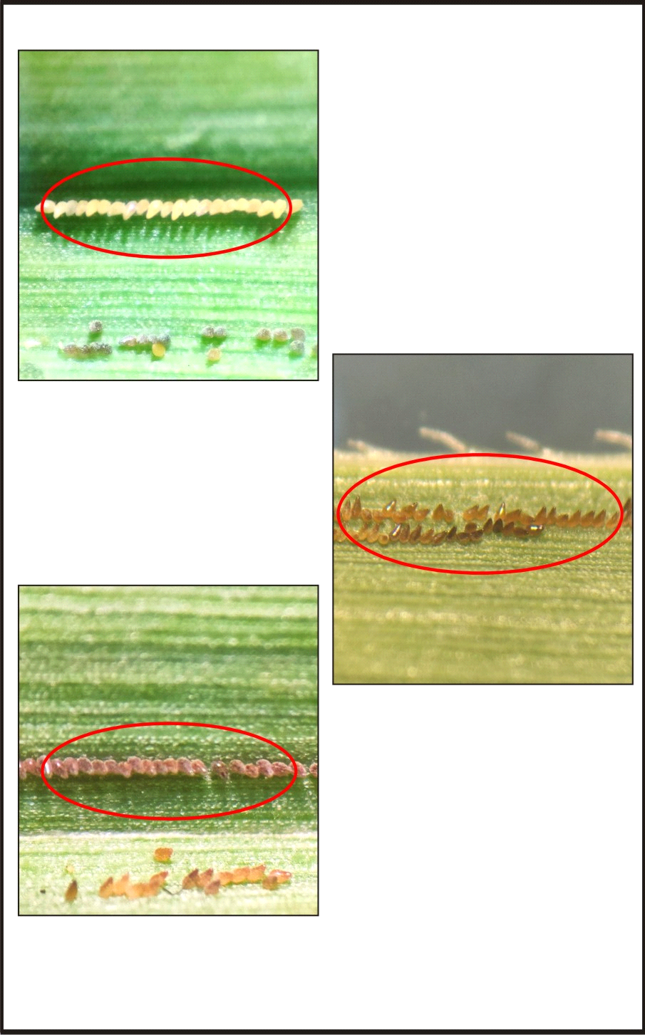

**Different stages of eggs**

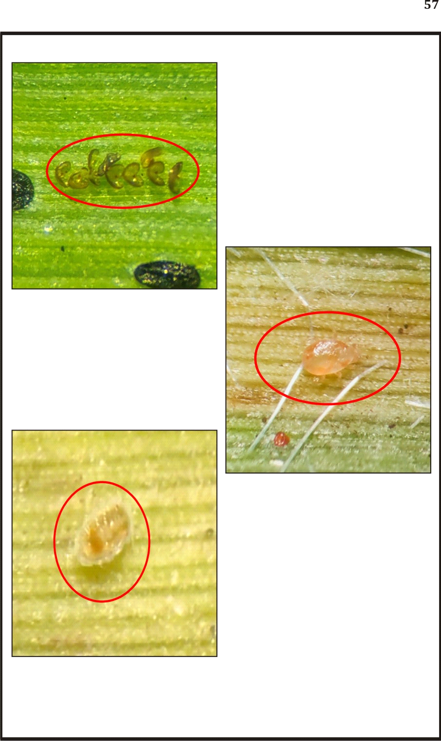

**Hatching stages of eggs**

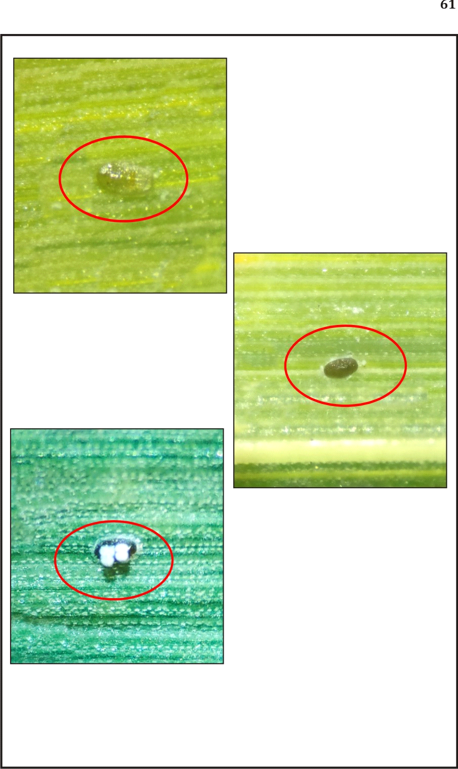

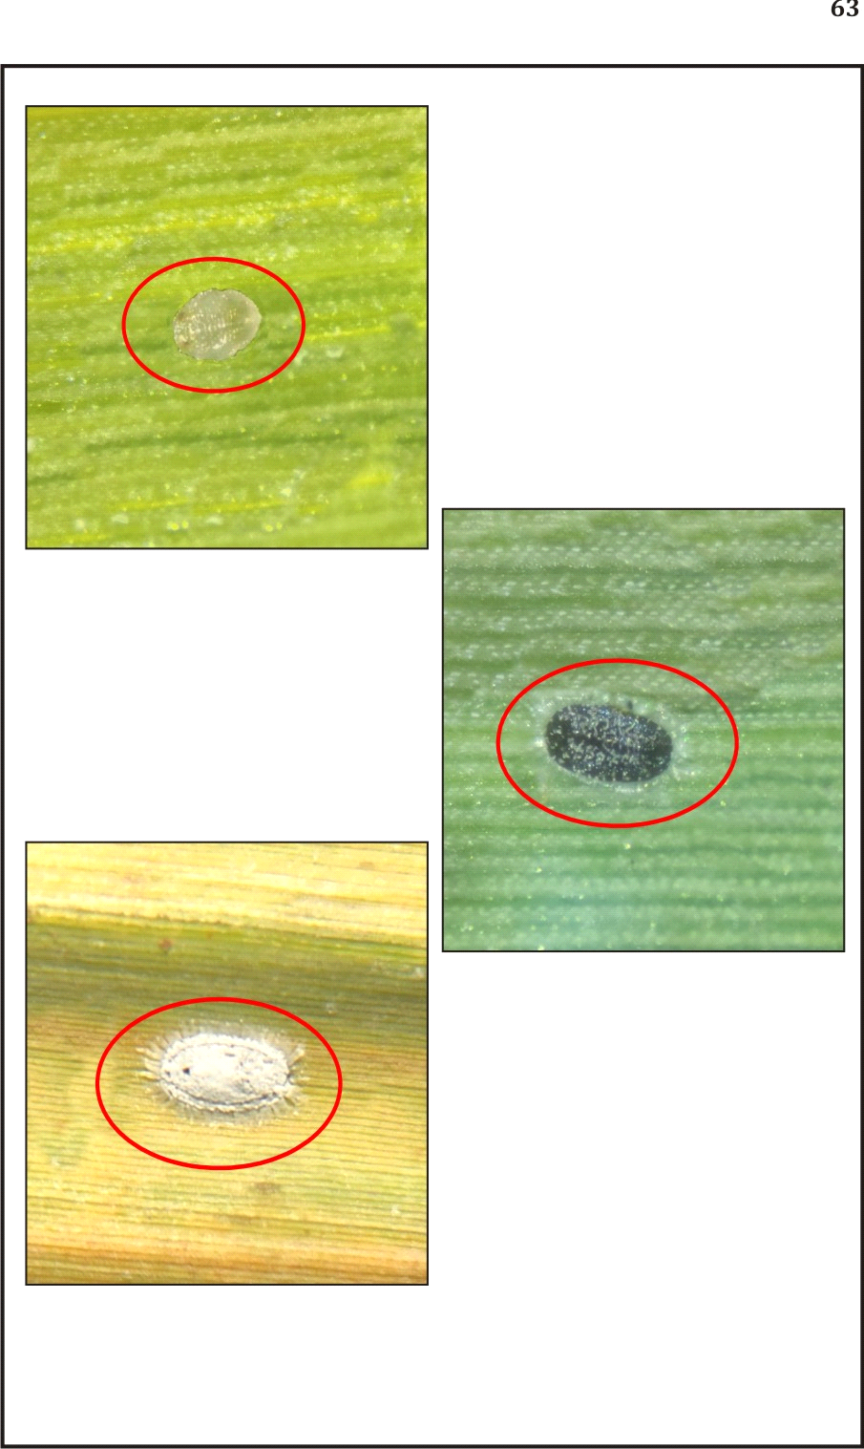

**Different nymphal stages**

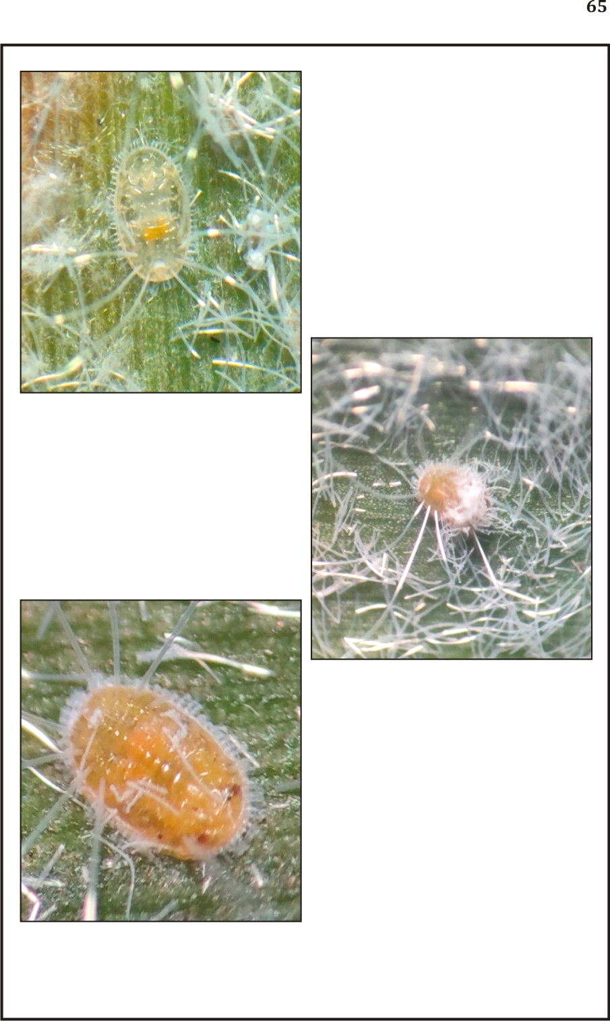

**Pre pupal stages**

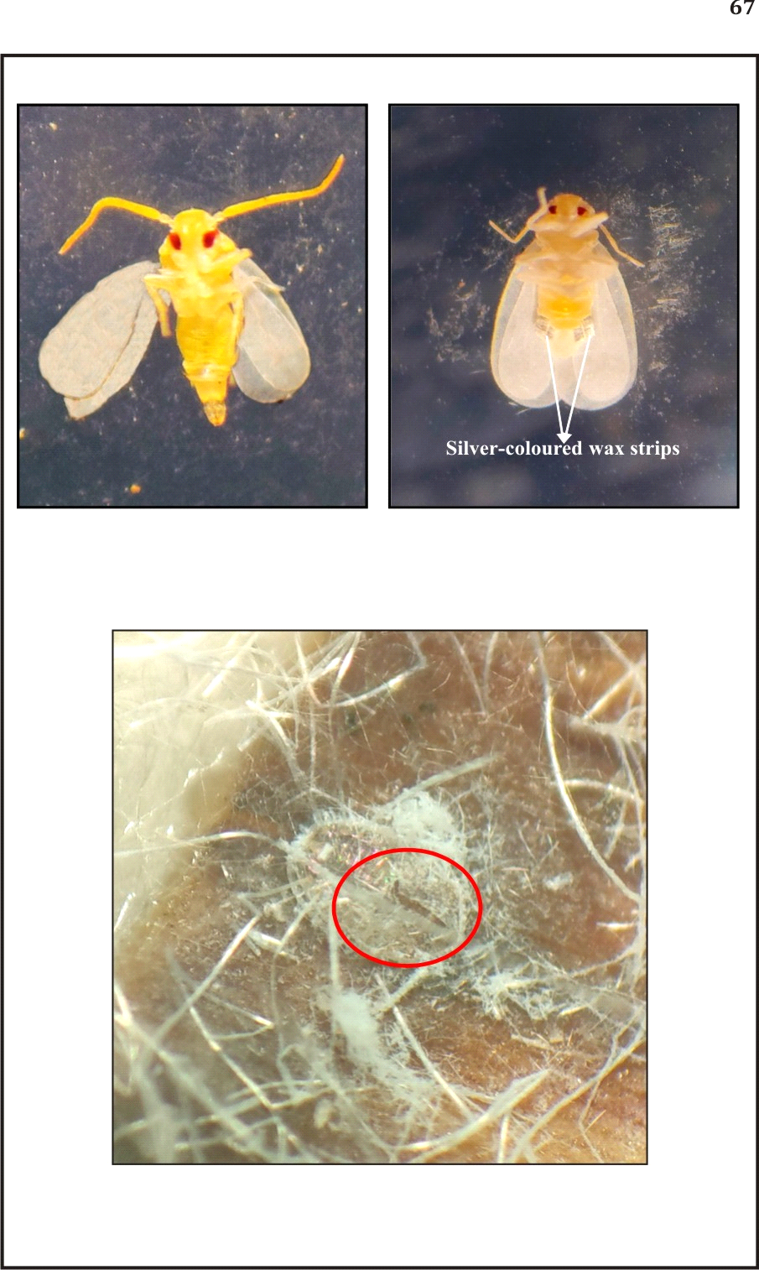

**T-shaped slit of pre pupa for adult emergence**