**Sun Basking Behaviour and Ecological Significance of Banbakri Antelope (*Boselaphus tragocamelus*, Pallas 1766), India**

**ABSTRACT**

India is home to the majestic white footed Banbakri antelope (*Boselaphus tragocamelus*), one of the most remarkable antelope species in the world. However, this species has not received the attention given to other charismatic fauna. Basking behaviour plays an important role in animal survival and physiological fitness. While sun basking has been observed in various mammalian species, no prior reports document this behaviour in *Boselaphus tragocamelus*. The present study aimed to observe and analyze sun basking behaviour in free-ranging Banbakri antelopes in Bihar using direct sighting methods. During the winter season, these antelopes frequently engaged in sunbathing, likely to regulate body temperature, eliminate ectoparasites, and enhance muscle performance and immunity. The average maximum sun basking time recorded in winter was 15.01 ± 2.46 minutes, while the minimum in summer was 10.06 ± 1.86 minutes. This seasonal difference may be attributed to environmental temperatures, with winter temperatures ranging from 7.85 ± 2.09°C(minimum) to 26.38 ± 1.71°C (maximum), and summer temperatures ranging from 23.28 ± 4.31°C (minimum) to 40.18 ± 2.00°C (maximum). As temperatures increased during summer, basking time decreased, and antelopes were observed resting in the shade of trees to avoid direct sunlight during peak heat hours. Banbakri antelopes maximize the uptake of radiant heat by adjusting their basking positions to increase the surface area of their body exposed to the sun, while simultaneously minimizing predation risk by keeping basking periods relatively short. This study provides the first evidence of thermoregulatory basking behaviour in *Boselaphus tragocamelus* under free-ranging conditions in Bihar, India.

**Keywords:** *Boselaphus tragocamelus*, thermoregulation, behaviour, adaptation, basking

**INTRODUCTION**

Sun-bathing or basking is a behaviour observed in many higher vertebrates for various reasons (Boyer, 1965; Warnecke et al., 2010; Smith et al., 2017; Chishty and Choudhary, 2020). The Banbakri antelope (*Boselaphus tragocamelus*), commonly known as the nilgai, belongs to the family Bovidae, sub-family Bovinae, and tribe Boselaphini. This species exhibits unique ecological functions and mutualistic relationships with humans (Leslie, 2008; Prasad & Ahmad, 2016; Estes, 2025). This wild mammal has successfully adapted to life under contrasting conditions of extreme heat and cold. It is found in a free-roaming condition across 18 Indian states and all districts of Bihar (Bohra, et al., 1992; Prasad, 2022; Prasad et al., 2023). It has also colonized semi-forest regions, plains, grasslands, deserts, and areas close to human settlements (Chauhan, 2011; Meena et al., 2014; Prasad et al., 2020). The Banbakri is categorized as a species of Least Concern on the IUCN Red List (Mallon, 2008). From a conservation perspective, the Indian Banbakri antelope is protected under Schedule III of the Indian Wildlife (Protection) Act, 1972. However, due to significant crop damage, many Indian state governments have declared this free-roaming antelope as vermin. The central government has since reclassified it under Schedule V, permitting controlled culling in favor of protecting agricultural interests (Prasad et al., 2023).

Sun-basking behavior is performed by many vertebrate species, including humans, birds, reptiles, and insects (Boyer, 1965; Geiser et al., 2002; Bharos, et al., 2025). Sunbathing not only helps in maintaining body temperature and thermal energetics (Warnecke et al., 2010) but also plays a vital role in promoting muscle function, maintaining healthy skin, and enhancing mobility for food and water foraging. Basking is considered important for the evolution of mammalian endothermy (Geiser et al., 2002). It is also crucial for the survival of warm-blooded animals like birds and reptiles, especially in dry and cold environments. As noted on the National Geographic website by Jani Hall (2022), animals ranging from reptiles and amphibians to butterflies and hippos rely on sunbathing to meet their biological needs. Reptiles, in particular, are well-known for basking behavior to maintain their body temperature and ward off disease. Sun-basking is also an important adaptive behavior in endothermic birds, aiding in plumage maintenance, thermoregulation, and hygiene through sun and water bathing (Slessers, 1970; Chishty and Choudhary, 2020; Blank and Yaoming, 2022). Numerous studies have explored the energy demands of organisms for various physiological activities. Some researchers have focused specifically on basking and thermoregulatory behaviors, which enable endothermic animals to survive in arid and cold conditions (Schmidt-Nielsen, 1964; Scholander, 1955; Scholander et al., 1955; Irving et al., 1955; Nagel et al., 1999; Ruban, 1995; Speakman and Thomas, 2002; Schwimmer and Haim, 2009). However, no prior studies or reports are available on the sunbathing behavior of the Banbakri antelope (*Boselaphus tragocamelus*), particularly in relation to environmental temperature.

In this context, the present study documents the **first report** of sun-basking behavior in the Banbakri antelope. It also highlights the species’ interactions with humans in agricultural landscapes, its role in local wildlife ecology, and its broader ecological and cultural significance. This study provides detailed observations on how environmental factors such as temperature and season influence the sun-basking behavior of this elegant, white-footed antelope (*B. tragocamelus*).

**MATERIALS AND METHODS**

***Study Area – Animal Ecology***

An intensive investigation was conducted in Dumraon, Buxar, located in the Shahabad region of southeastern Bihar, India, from January 2023 to December 2024. The study area lies between 25°18' to 25°45' North latitude and 84°20' to 84°40' East longitude, encompassing a part of the Gangetic plain with a total area of 1,624 km² (as shown on Google Maps). Dumraon is a sub-division of Buxar district, covering approximately 162,380 hectares, and supports a substantial population of free-living wild mammals, including the Banbakri antelope (*Boselaphus tragocamelus*) (Prasad et al., 2019). The ambient temperature in this region ranges from 4.0°C during winter to 45°C in the peak of summer. The area receives approximately 85–90% of its annual rainfall (1,021 mm) during the monsoon season, which extends from June to October (CGWB, 2013).

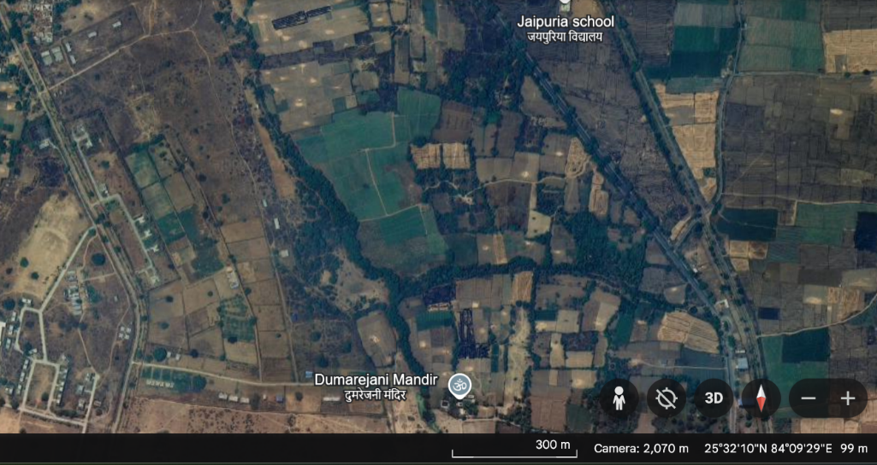

**Figure 1: Google map showing the study area of Dumraon, Buxar**

The forest cover in Buxar district is minimal, and the unused open areas of Dumraon are characterized by undulating sandy soil and sparse forest vegetation. The region is interspersed with canals, the River Kao, and human settlements, creating a unique landscape with contrasting ecological features (Prasad et al., 2020). Most of the area lies above the flood level, with only a small flat plain to the east of Dumraon town where kharif and rabi crops are predominantly cultivated. The onset of summer is typically marked by westerly winds and dust storms around mid-March. Ambient temperatures rise significantly during May–June, reaching up to 45°C. Winter sets in around mid-October, with minimum temperatures dropping to 4°C during January–February. The region receives an average annual rainfall of 1,021 mm, with approximately 85% of the precipitation attributed to the southwest monsoon, active from June to September (CGWB, 2013).

***Methodology and Data Analysis***

The methodology employed was direct sighting, involving close-range behavioral observation of the wild Banbakri antelope (*Boselaphus tragocamelus*). Observations were supported by first-hand visual records using a Sony digital still camera (30x optical zoom, model DSC-WX500), with photographs taken to document behaviors. Observations were analyzed based on the behavioral categorization method outlined by Altmann (1974). Data were collected from early morning to late evening on selected days. Fieldwork was conducted using a motorcycle for accessible routes, while walking was necessary in more rugged, undulating terrain where no footpaths existed. For the study of sun-basking behavior, two Banbakri herds were monitored. The collected data were analyzed using Microsoft Excel 2010. Results were presented as mean ± standard deviation, using box-and-whisker plots and simple tabular analysis.

**RESULTS AND DISCUSSION**

Our study demonstrates the importance of basking as a thermoregulatory behavior in the Banbakri antelope (*Boselaphus tragocamelus*). The observed sunbathing behavior appears to serve multiple functions: aiding in the cleaning of the body, eliminating ectoparasites (including ectozoons), and maintaining the flexibility of limbs. These functions collectively contribute to maintaining a healthy body condition. In the present study, Banbakri antelopes were often observed basking in groups comprising calves, juveniles, adult males, and females. Occasionally, solitary males were also recorded basking alone, suggesting that the behavior may also serve a social function (Fig. 4). Similar observations have been reported by Fall, 1972; Gehlot, 2006). Whereas, Prasad *et al.,* 2025, reported that preorbital gland opening in White footed Banbakri antelope (*B. tragocamelus*) under stress, starvation or sexual maturity context and may serve as an essential behavioural indication to communicate with others member Banbakri antelope. The Banbakri antelope exhibits diurnal activity patterns. They spend a significant amount of time foraging during the cooler parts of the day typically in the morning and afternoon when ambient temperatures are lower (Das and Dutta, 2024). Their peak activity often coincides with sunrise as environmental temperatures begin to rise. Simultaneously, human activity also increases in nearby towns and villages, paralleling the onset of Banbakri activity (Gautam and Bissa, 2015). Banbakri antelopes are sexually dimorphic. Adult males typically display a dark iron-grey coloration, which may vary from bluish to brownish-grey. In contrast, females, younger males, and calves exhibit a pale brown coloration. These antelopes are social animals and are generally observed either in all-male herds or in mixed-sex (bisexual) herds (Prasad and Ahmad, 2016).

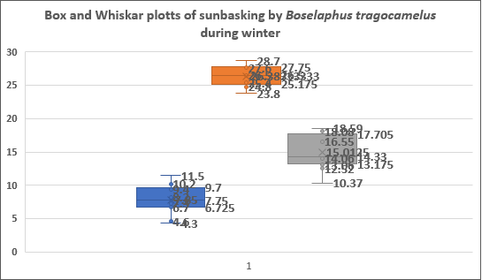

**Fig. 2. Graph showing time spent basking by *Boselaphus tragocamelus*, during winter**

According to Cade, the sunbathing behavior observed in certain raptors such as wing-spreading is associated not only with thermoregulation but also with feather maintenance, cleanliness, and preserving the elasticity of flight muscles (Cade, 1973; Mosher, 1976). Our study provides the first direct evidence that Banbakri antelope may use basking to facilitate rewarming from torpor. Interestingly, the different basking postures observed between the two herds of Banbakri antelope yielded unexpected results. Most individuals were found basking in groups, including calves, juveniles, adult males, and females, with some members observed guarding the herd (Fig. 4). Some adults were also found basking alone in a flattened posture, maintaining a state of alertness in unfamiliar surroundings. In other instances, individuals were observed basking while standing. It appears that Banbakri antelopes maximize the uptake of radiant heat by adjusting their basking positions to increase the surface area of their body exposed to the sun, while simultaneously minimizing predation risk by keeping basking periods relatively short (Fig. 4). Similar thermoregulatory behaviors aimed at achieving thermal comfort and conserving energy have been documented in other mammals (Bartholomew and Rainy, 1971). Many bird species also adopt specialized postures during sunning, such as spreading their feathers, flattening their bodies on the ground, and exposing either their dorsal or ventral sides to the sun (Campbell and Elizabeth, 2013; Chishty and Choudhary, 2020). For example, long-billed vultures spend considerable time in sunlight for preening, sunbathing, wing-drying, and general thermoregulation (Chishty and Choudhary, 2020). Similarly, sun basking behavior in the white-footed antelope (*Boselaphus tragocamelus*) is predominantly observed during the morning hours and warmer parts of the day, especially in cloudy or winter seasons.

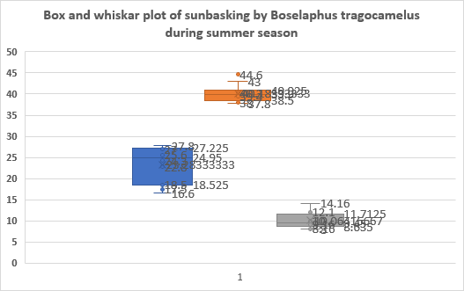

**Fig. 3, Graph showing time spent basking by (*Boselaphus tragocamelus)*, during summer**

These antelopes are commonly found basking in rural landscapes, including rabi crop fields and open non-crop areas. Their basking behavior typically includes both sitting and standing postures, often in groups. Individuals are frequently observed facing opposite directions with their heads turned toward the sunlight, maximizing exposure for thermoregulation. Sunbathing behavior was also observed in developing 5-month-old calves, maturing juveniles, and young adults. Similar thermoregulatory strategies are seen in other species. For example, the antelope ground squirrel (*Ammospermophilus leucurus*) reduces its body temperature (Tb) by about 6°C at night, and basking is estimated to account for 20% of the energy required to elevate Tb in the morning (Chappell et al., 1981). Likewise, basking behavior in relation to energy usage and food availability has been studied in one of the smallest marsupials, *Planigale gilesi*, by Warnecke et al. (2010). Chishty, and Choudhary, (2020) documented sunbathing behavior in long-billed vultures, where individuals were observed extending their wings in various postures at different times of the day. In the present study, the maximum ambient temperature was recorded in May 2024, while the minimum was observed in December 2024 (figure 2 & 3).

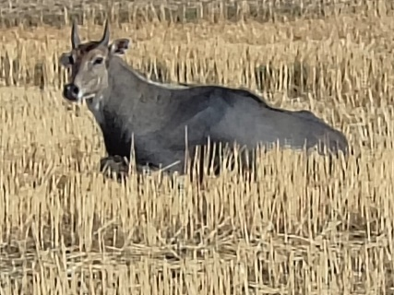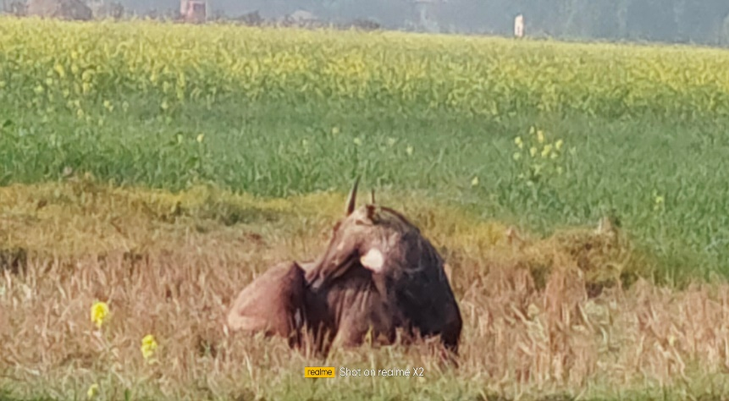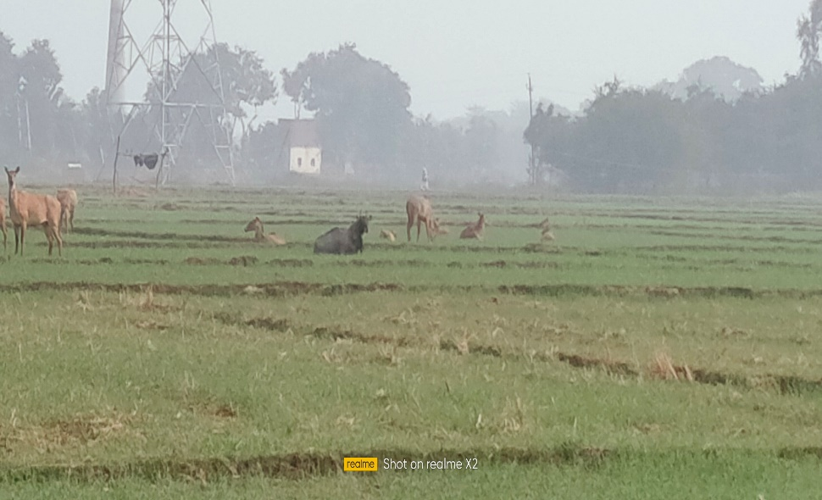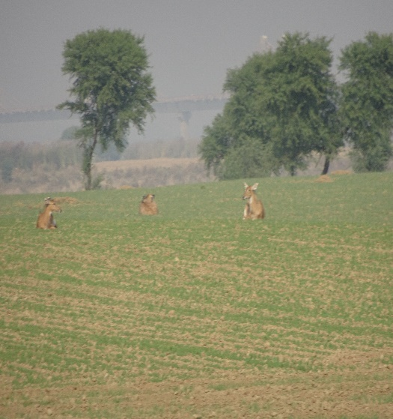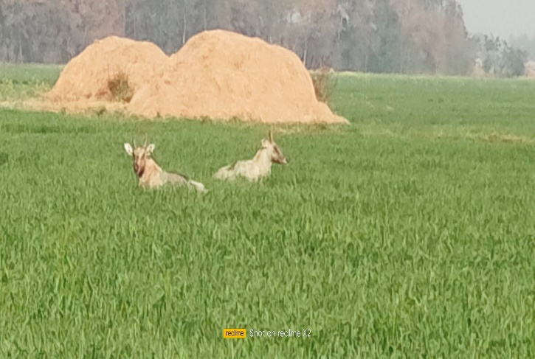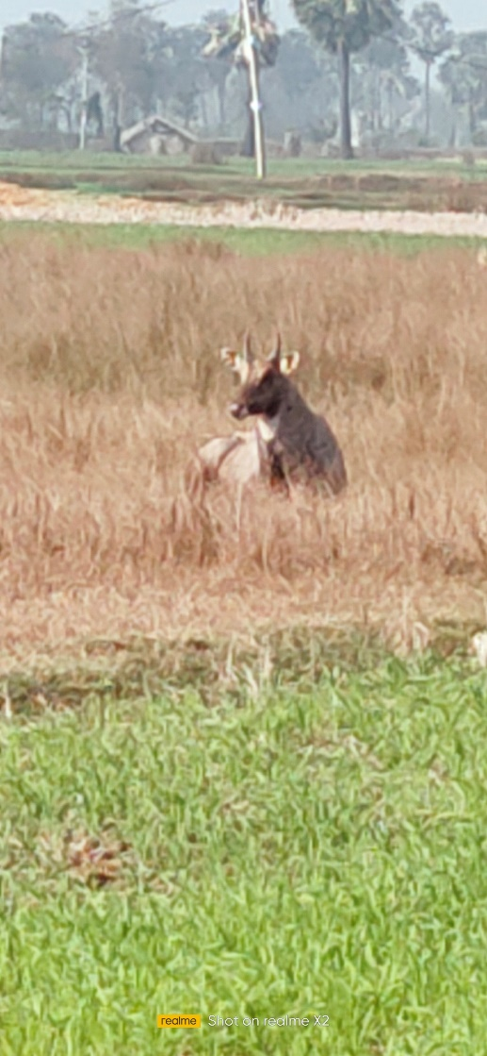

**b**

**a**

**d**

**c**

**f**

**e**

**Fig. 4.a. A male (Boselaphus tragocamelus) was observed basking with its back side exposed to the sun to raise its body temperature.**

**b. A male was also seen basking with the front portion (head side) of its body exposed to sunlight to increase body warmth.**

**c. A solitary male was observed basking in the sun for comfort and relaxation, similar to human behavior.**

**d. Two adult males of B. tragocamelus were seen basking with their heads facing in opposite directions, likely as a strategy to guard against predators.**

**e. A herd of Banbakri antelopes, including calves, juveniles, males, and females, were seen basking in the sun while one member kept watch as a guard.  
f. A herd of female Banbakri antelopes was observed basking in an alert posture.**

Sunbathing duration was found to be influenced by environmental and climatic conditions such as temperature, rainfall, humidity, wind velocity, and sunshine duration (Chishty and Choudhary, 2020). The average basking time for the white-footed antelope (*Boselaphus tragocamelus*), commonly known as Banbakri, was 15.01 ± 2.46 minutes during the winter season and 10.06 ± 1.86 minutes during the summer season (figure 2 & 3). These findings are in agreement with earlier studies on mammals and other species from various regions. Boyer (1965), Geiser et al. (2002), Heidrich et al. (2018), and Warnecke et al. (2010) reported similar basking behaviors in freshwater turtles, terrapins, mammals (including humans), nocturnal marsupials, and even insects. These species often emerge from nocturnal torpor in the morning and bask to raise their body temperature close to the upper threshold of thermal tolerance (Geiser, 2021). Inevitable animals such as ring-tailed lemurs, roadrunners, and Alpine ibexes use sunlight to conserve energy during cold mornings or when food is scarce. For instance, ibexes are known to bask in the winter sun on frigid mountain slopes, where limited grass availability leaves them with little fuel (Bharos *et al.,* 2025). Some species even enter temporary states of reduced metabolism and lowered body temperature to conserve energy. A study on dunnarts, a small marsupial species, revealed that by soaking up sunlight, they could survive on only a quarter of their usual food and water intake, as solar warmth reduces the metabolic effort needed to maintain body temperature. In birds, sunbathing is known to aid in eliminating pests and bacteria, and in regulating moisture. However, the full range of benefits that sunbathing provides to fur-covered animals remains largely underexplored (Chishty and Choudhary, 2020). Similarly, Bharos, *et al.,* 2025, reported an observation of a pack of golden jackals basking in the sun within their zoo enclosure in Istanbul, Turkey.

These sun-bathing behaviors underscore the significance of sunlight for thermoregulation and energy conservation across a wide array of species. In freshwater turtles, for example, the purpose of basking has drawn special interest some nocturnal species adopt basking-like postures at night, yet studies have shown that certain individuals do not significantly raise their body temperatures while sunning, ruling out thermoregulation as a primary motive.

**CONCLUSION**

Our observations, supported by literature and previous studies, present the first documented evidence of sunbathing behavior in the Banbakri antelope (*Boselaphus tragocamelus*). These behaviors appear to serve several adaptive functions, including thermoregulation, parasite removal, and energy conservation. While this initial study provides valuable insight, further research is necessary to better understand the ecological and physiological significance of basking in this elegant species. The *Boselaphus tragocamelus* offers a unique opportunity to promote appreciation for wildlife particularly those thriving outside protected areas. By fostering awareness of their behaviors and adaptations, especially among younger generations, we may contribute to more inclusive and community-based conservation efforts.

**REFERENCES**

Altman J. 1974. Observational study of behaviour sampling methods. Behaviour. 40:227-26

Bartholomew GA, Rainy M (1971) Regulation of body temperature in the hyrax, *Heterohyrax brucei*. J Mammal 52:81–95.

Bharos, A M K., Akhilesh, A., Bharos, Thakur, P., and Nihlani, G., 2025. Observations on Sun Basking, Dust Bath Behaviour of Golden Jackal (Canis aureus) and other Canidae species. *Uttar Pradesh Journal of Zoology* 46 (08):195-202.

Blank, D., Yaoming, L. I., 2022. Antelope adaptations to counteract overheating and water deficit in arid environments, J Arid Land, 14(10): 1069–1085.

Bohra H C, Goyal S P, Ghosh P K, et al. 1992. Studies on ethology and eco-physiology of the antelopes of the Indian desert. Annals of Arid Zone, 31(2): 83–96.

Boyer, Don R. (1965). "Ecology of the Basking Habit in Turtles". Ecology. 46 (1/2): 99–118. [Bibcode](https://en.wikipedia.org/wiki/Bibcode_(identifier)):[1965Ecol...46...99B](https://ui.adsabs.harvard.edu/abs/1965Ecol...46...99B). [doi](https://en.wikipedia.org/wiki/Doi_(identifier)):[10.2307/1935262](https://doi.org/10.2307%2F1935262). [JSTOR](https://en.wikipedia.org/wiki/JSTOR_(identifier)) [1935262](https://www.jstor.org/stable/1935262).

CGWB, 2023. Ground water Information Booklet, Central Ground Water Board, Govt. of India, Ministry of Water Resource, District Buxar, Patna, Bihar. 1-17.

Cade T. J., 1973. Sun-Bathing as a thermoregulatory aid in birds. *The Condor* 75: 106-133. Available at: https://digitalcommons.usf.edu/condor/vol75/iss1/12

Campbell, Bruce; Lack, Elizabeth *(*2013). A Dictionary of Birds. A & C Black. pp. 569–560.

Chappell, Mark A. ; Bartholomew, George A, 1981. Activity and thermoregulation of the antelope ground squirrel *Ammo Spermophilus leucurus* in winter and summer Physiological Zoology, (Vol.54 (2), p.215-223.

Chauhan NPS (2011) Agricultural crop depredation by nilgai antelope (*Boselaphus tragocamelus*) and mitigation strategies: challenges in India. 8th European Vertebrate Pest Management Conference 432.104 pp. 190-191. DOI: 10.5073/jka.2011.432.104.

Chishty, N., and Choudhary, N. L. 2020. Seasonal Fluctuation in Thermoregulatory Behaviour of Long-Billed Vulture (*Gyps indicus*) by Wing Stretching at Southern Rajasthan, India, Current World Environment, 15, (2): 353-362.

Das, M. and Dutta, A. 2024. Activity pattern and time budget analysis of nilgai (*Boselephus tragocamelus*) in captivity at Alipore Zoological Garden, Kolkata, India. Intern. J. Zool. Invest. 10(2):1445-1461, **https://doi.org/10.33745/ijzi.2024.v10i02.146**

Estes, R. 2025, Nilgai / Habitat, Diet and Conservation, Britanica, update January, 28, 2025, [www.britanica.com](http://www.britanica.com).

Fall B. A. 1972. On social organization and behaviour of Nilgai Antelope, *Boselaphus tragocamelus* (Pallas) in South Texas, M.S. thesis, Texas A & M Univ. College Station.

Gautam, R, and Bissa P (2015) Population dynamics, ecology, breeding biology and pest status of Nilgai (*Boselaphus tragocamelus*) in Shekhawati Region of Thar Desert. Ph.D. Thesis submitted, M.G.S. University, Bikaner (Rajasthan).

Gehlot, H. S. (2006) Social organization, behavioural and resources selection patterns in Antelope cervicapra and Gazelle bennetti of thar Desert. PhD thesis, JN Vyas University, Jodhpur, Rajasthan. 195pp. DOI**:** 10.12691/aees-9-4-1.

Geiser, F.; Goodship, N.; Pavey, C. (2002). *"Was basking important in the evolution of mammalian endothermy? ".*Naturwissenschaften.89(9):412–414.

Geiser, F. (2021). Ecological physiology of Daily Torpor and Hibernation. Book 01-305. DOI:  [10.1007/978-3-030-75525-6](http://dx.doi.org/10.1007/978-3-030-75525-6)

Heidrich, Lea; Friess, Nicolas; Fiedler, Konrad; Brändle, Martin; Hausmann, Axel; Brandl, Roland; Zeuss, Dirk (2018). "The dark side of Lepidoptera: Colour lightness of geometrid moths decreases with increasing latitude". Global Ecology and

Irving, L., and Krog, H. 1955. Temperature of skin in the Arctic as a regulator of heat. *Journal of Applied Physiology.* 7: 355-364.

Mosher, J. A. (1976). Raptor Energetic: A Review. *Journal of Raptor Research.*10(4): 97-107.

Leslie DM (2008) *Boselaphus* *tragocamelus* (Artiodactyls: Bovidae) Mammalian species American society of Mammologist. 813: 1-16. 1–16, [doi.org/10.1644/813.1](https://doi.org/10.1644/813.1).

Meena M (2017) Agriculture crop damage by antelope (*Boselaphus tragocamelus*) and management strategies: Challenges in India. International Journal of Zoology Studies2(6): 157-160. ISSN: 2455-7269.

Mallon D. P. 2008. Boselaphus tragocamelus. IUCN 2013.IUCN red list of threatened species. version 2013.

Nagel, KA, Girard IA, Brown TK (1999) Energetics of free-ranging mammals, reptiles, and birds. Annu Rev Nutr 19:247–277.

Prasad S (2022) High Time of Pacing Nilgai Antelope (*Boselaphus tragocamelus*) into Mainstream as Community Conservation for Influencing Macroeconomics. Asian Journal of Research in Zoology. 5(1): 21-30.DOI**:**[10.9734/ajriz/2022/v5i130128](https://doi.org/10.9734/ajriz/2022/v5i130128).

Prasad S, Ahmed R (2016) The Indian Antelope Nilgai (*Boselaphus* *tragocamelus*) for all interests; A Now hope in Indian Farming. Progressive Research. An International Journal 11(sp-x): 6638-6641.

Prasad S, Kumar A, Ahmed R, Sah RK (2023) The Indian antelope Nilgai (*Boselaphus tragocamelus*): A Succeeding economic pretender of nation. (Footprints of Biodiversity in the Indian Peninsula), Edited by: Saxena VL, Jaiswal K & Mishra S. Narendra Publishing House, Delhi, India. 155-169. ISBN: 978-93-56511-98-9.

Prasad S, Prabhakar, C. S., Kumar, A., Nath, P. Ahmed, R. (2025). Documentation of Scent Marking with the Preorbital Gland in Banbakri Antelope (*Boselaphus tragocamelus*), *Uttar Pradesh Journal of Zoology, 46,(7), 136-143,*  DOI: https://doi.org/10.56557/upjoz/2025/v46i74870

Prasad S, Singh DK, Choudhary SK (2020) Residential population structure and abundance of Nilgai (*Boselaphus tragocamelus*) in Bihar, India. Current Journal of Applied Science and Technology P39(13): 110-117.DOI:[10.9734/cjast/2020/v39i1330687](https://doi.org/10.9734/cjast/2020/v39i1330687).

Prasad S, Singh DK, Kumar U, Kumar S (2020) Biodiversity and Ecology of Wild Mammals in Dumraon, Buxar, Bihar. J. exp. 2001. India. 23(1): 643-648.

Ruben J (1995). The evolution of endothermy in mammals and birds: from physiology to fossils. *Annu Rev Physiol* 57:69–95

Schmidt-Nielsen K. 1964. Desert animals: Physiological problem of heat and water. Clarendon Press, Oxford.

Scholander P. F., Hock, R., Walters, V., Johnson, F. and Irving, L.1955. Heat regulation in some arctic and tropical mammals and birds. *Biology Bulletin.*; 99: 237-258.

Scholander, P. F.. 1955. Evolution of climatic adaptation in homeotherms. *Evolution.*; 9: 15-26.

Schwimmer, H., Haim, A., 2009. Physiological adaptations of small mammals to desert ecosystems, Integrative Zoology 4(4):357-66.  doi: 10.1111/j.1749-4877.2009.00176.x.

Slessers, M. 1970. Bathing behaviour of land birds, rhea. *Auk* 1970; 87: 91-99.

Smith, Kimberly G.; Neal, Joseph C.; and Reynolds, J. C. (2017) Sun-bathing by Greater Roadrunners – A Neglected Aspect of Their Range Extension," Journal of the Arkansas Academy of Science: 71,(37).: 208-2010. <https://doi.org/10.54119/jaas.2017.7112>

Speakman JR, Thomas DW (2002) Physiological ecology and energetics of bats. In: Kunz TH (ed) Ecology of bats. II. Academic Press, New York (in press)

Warnecke, L., Schleicher, E., Geiser, F., 2010. Basking behaviour in relation to energy use and food availability in one of the smallest marsupials, Physiology & Behavior, 101: 389-393.