**The Qualitative Assessment of Plankton Diversity in Different Sites of Upper Lake, Bhopal (M.P)**

**Abstract:**

Studies conducted for 4 month from Oct. 2024 to Jan. 2025 in Bhoj tal, Upper Lake, Bhopal, M.P revealed plankton biodiversity. There were 10 species of phytoplankton and 09 species of zooplankton. The average plankton population was 33- 464 units l-1 in terms of phytoplankton and 27.5 - 265.5 units l-1 in terms of zooplankton throughout the study. Phytoplankton populations were found to be dominated by cyanobacteria (*Microcystis sp*.), indicating nutrient enrichment and the onset of eutrophic conditions, particularly in site A1. Zooplankton diversity was relatively higher and more balanced in site A3, with Cyclops, Daphnia, and Moina emerging as the most dominant genera. Diversity indices (Shannon-Weiner and Simpson’s) varied significantly across sites. The site A3 showing the highest range (0.55–0.74) and it is more resilient and evenly distributed zooplankton community, likely due to consistent resource availability and environmental conditions These variations highlight the ecological complexity and dynamic nature of the lake system. Study of various physico-chemical and biological parameters revealed that have medium productivity and if achieved appropriately, production at all the trophic levels can be improved.

**Keywords:** Biodiversity, Enrichment, Nutrient, Food web, Abundance and Sustainability

**1.0 Introduction**

Upper Lake, also known as Bhojtal, is a prominent freshwater lake in Bhopal, India. The lake is approximately 1.4 km long and 0.8 km wide, with a maximum depth of 9.5 meters (**MP Pollution Control Board, 2019**). The lake is an important source of water for drinking, irrigation, and industrial purposes. However, the lake is facing severe environmental pressures due to rapid urbanization and industrialization, leading to concerns about its water quality and ecosystem health **(Basima, 2006).**

Plankton may be defined as the diverse group of tiny organisms inhabiting major water bodies and which cannot swim against a running current. The organisms making up plankton are referred to as plankters. They supply the major diet to many large water animals including fish and whales **(Thakur, 2013).**

Similar to freshwater plankton which are organisms living in lakes and rivers. First, most of them move along the currents; secondly, there are those that move slowly and cannot counteract the currents **(Amorim *et al.,* 2021).**

Plankton can be classified into two sections like phytoplankton and the zooplanktons. This convenient division is not without its problems, for in actual fact, many of the planktonic organisms in question belong to a group known as the protists that may be better described as belonging to the plant kingdom but which are now being increasingly classified as animals as well **(Kumari, 2008).** As to the lower limit of its size range, it is determined by the aperture of the finest cloth used to make plankton nets. This water organism is larger than phytoplankton but small enough to get through all the nets and it includes forms of a size less than 0.05mm. Phytoplanktonic organisms are however predominant in the nannoplankton class of size **(Shirke, 2014).** The planktonic foraminiferans and the radiolarians are most prolific and extensive that the shells of these organisms contribute to four-fifth of the bottom deposits of large areas of the ocean **(Udayashankara, 2013)**. Large number of freshwater rotifers can at times be reported in the plankton especially when the season is warm, some of the organisms that circulate through all the latitudes both in surface water and in abyssal depths are the marine arrowworms for instance the sagitta, planktonic carnivorous animals. Gill-bearing molluscs such as oysters, mussels, other marine bivalves and snails, all start in the sea as planctonic larvae. The members under the wing snails (Pteropoda) was remain as plankton throughout their life span **(Willen, 2000).**

.

**2.0 Materials and Methods**

Water samples were collected once a month from three sites, A1 (centre of the lake), A2 (Lake shore near the Boater’s Club) and A3 (downstream of the lake) within Upper Lake, Bhopal, during the period from October 2024 to January 2025. Plankton was gathered by means of plankton net with a 25 µm mesh and the samples were fixed in 10ml of Lugol’s Iodine solution. Planktons were identified and marked by drop count method **(Needham and Needham, 1962)**, using a compound microscope to sort them into groups such as Cyanophyceae, Chlorophyceae, Zygnematophyceae and different kinds of zooplankton like Rotifers, Cladocerans, Copepods and Protozoa or Dinoflagellates **(Adoni, 1985).**

**2.1 Qualitative Plankton Analysis**

Identification of phytoplankton and zooplankton was carried out based on their morphological characteristics using standard taxonomic keys and references such as **Adoni (1985), APHA (2017)**, and **Needham & Needham (1962)**.

**2.2 Drop Count Method for phytoplankton and Zooplankton**

**Formula**

Organisms L-1 =

Where, A = number of organisms per drop

v = volume of one drop (ml)

n = total volume of the concentrated sample (ml)

L = volume of the original sample (L)

**2.3 Shannon-Weiner Diversity Index**

The index is calculated using the formula:

$$H= -\sum_{i=1}^{S}{\left(p_{i}\ln{p_{i}}\right)}$$

**Where**:

* H = Shannon–Weiner diversity index
* S = Total number of species (species richness)
* pi = Proportion of the total sample represented by the ith species
* ln = Natural logarithm

2.4 **Simpson’s Diversity Index**

**Formula**

$$D= \sum_{i=1}^{S}{p_{i}^{2}}$$

Or alternatively,

$$D= \sum{\left(\frac{n_{i}\left(n_{i}-1\right)}{N\left(N-1\right)}\right)}$$

Where:

* D = Simpson’s Index
* pi = Proportion of individuals in the ith species
* ni = Number of individuals of the ith species
* N = Total number of individuals of all species
* S = Total number of species

**2.5 Water Quality Parameters**

Standard methods were used to measure pH, temperature, total dissolved solids (TDS), dissolved oxygen (DO) and total alkalinity (**APHA, 2017**).

**3.0 Results and discussion**

**3.1 Composition and distribution of Plankton**

The monthly occurrence or distribution of phytoplankton’s measured from different sites *i.e* A1, A2 and A3 were given in tables 1, 2 and 3 respectively. A total of 9 phytoplankton species were found in site A1, 7 phytoplankton species were found in site A2 and 5 phytoplankton species in site A3.

The monthly variations of the overall phytoplankton density in sites A1, A 2 and A3 are given in fig 1. The total phytoplankton densities in site A1 were observed to be ranged from 33 to 464 individuals L-1. The lowest and highest phytoplankton density was recorded in Jan 30, 2025 and Nov 13, 2024 respectively. The main species that contributed in the density for Site A1 were *Microcystis sp.* (62.3%), *Microspora sp.* (20.3%), *Stigeoclonium* (0.1), *Volvox* (0.1%), *Pediastrum* *simplex* (0.04%), *Ulothrix* (0.6%), *Gonatozygon* (2.1%), *Cosmarium* (0.1%) and *Chlorella* (14.5%). In site A2, the density was between 26.5 to 234 indviduals L-1. The lowest and highest density in Site A2 is between Jan 30, 2025 and Nov 6, 2024. The main species contributing to the density of Site A2 were *Microcystis* *sp*. (64.1%), *Microspora* *sp*. (27.9%), *Volvox* (0.08%), *Ulothrix* (0.6%), *Cosmarium* (0.08%), *Chlorella* (7.2%) and *Actinastrum* (0.12%). In site A3, the phytoplankton density ranged from 59.5 to 202.5 individuals L-1 and the lowest and highest values were recorded to be between Jan 30, 2025 and Oct 15, 2024. The main species that contributed to the density of site A3 were *Microcystis* *sp*. (65.9%), *Microspora* *sp*. (26.1%), *Volvox* (0.09%), *Ulothrix* (0.05%), *Cosmarium* (0.05%) and *Chlorella* (7.8%)**.**

The monthly occurrence of zooplanktons in site A1, A2 and A3 are shown in Tables 4, 5 and 6 respectively. A total the monthly variation of the overall zooplankton density in sites A1, A2 and A3 are given in fig 2. The total zooplankton density in site A1 was found to be ranging from 27.5 to 265.5 individuals L-1. For site A2 it varied from 81.5 to 261.5 individuals L-1. For site A3, the zooplankton density varied from 93 to 263.5 individuals L-1. The highest and lowest zooplankton density in site 1 was recorded in 9 Dec, 2024 and 6 Nov, 2024 respectively. In site A2, the highest and lowest zooplankton density was recorded in 9 Dec, 2024 and 13 Nov, 2024. In site A3 the highest and lowest zooplankton density was recorded in 20 Jan, 2025 and 13 Nov, 2024. The main species that contributed to the zooplankton density in Site A1 were *Trichocerca* *longiseta* (0.6%), *Keratella* (0.4%), *Branchionus* *falcatus* (0.4%), *Branchionus* *quadridentata* (0.5%), *Branchionus* *calyciflorus* (3.1%) *Moina* (26.7%), *Daphnia* (30%), *Cyclops* (38.3%) and *Ceratium* (0.07%). In Site A2, the main species contributing to the density were *Trichocerca* *longiseta* (0.4%), *Keratella* (0.2%), *Branchionus* *falcatus* (0.2%), *Branchionus* *quadridentata* (0.2%), *Branchionus* *calyciflorus* (0.5%), *Moina* (21%), *Daphnia* (37.3%), *Cyclops* (39.8%) and *Ceratium* (0.4%). In Site A3, the main species contributing to the density were *Trichocerca* *longiseta* (0.3%), *Keratella* (0.5%), *Branchionus* *falcatus* (0.8%), *Branchionus* *quadridentata* (0.2%), *Branchionus* *calyciflorus* (1.4%), *Moina* (29%), *Daphnia* (26.2%), *Cyclops* (41.6%) and *Ceratium* (0.1%). The analysis of sample sites shows that seasonal and spatial variations in phytoplankton and zooplankton populations were driven by the surrounding environment and nutrient changes. Site A1 showed the greatest diversity in phytoplankton population, ranging from 33 to 464 individuals/L and achieving its peak in November 2024. As a result, it is likely that the plants flower en masse in the dry season when extra nutrients wash in and more light becomes available. Phytoplankton numbers in Site A2 varied from 26.5 to 234 individuals per liter and the maximum was noted in November. Although Site A3 demonstrated the smallest variation in density (59.5–202.5 individuals/L), the peak occurred earlier in October, suggesting that physical conditions at this site such as how much light reaches algae, the level of grazing or nearby nutrients, were important for breaking bloom cycles. These trends support **Sommer *et al.* (1986)** proposal that increased nutrient levels after the monsoon foster blooms in phytoplankton.

Additional evidence from species composition indicates that eutrophic to hypereutrophic conditions exist at all the first sites. In every location, over 60% of the phytoplankton was made up of the cyanobacterium *Microcystis sp*. which is famous for causing algal blooms. Having high nutrients, an alkaline water chemistry and low disturbance in the water are often what allows them to dominate **(Paerl and Otten, 2013)**. *Microspora sp.* shows that the site has experienced moderate organic pollution, according to **Bellinger and Sigee (2010)**. *Chlorella* and *Ulothrix* were observed in moderate numbers and adapted well to different nutrient and light conditions. The low range of species within *Pediastrum*, *Cosmarium* and *Volvox* may be because dominant forms can take over when nutrients are abundant.There were seasonal changes in zooplankton numbers, with December being the period of greatest density in Sites A1 and A2, suggesting they responded to the phytoplankton bloom several weeks later. At Site A3, we observed the highest zooplankton density in January of 2025 when phytoplankton diversity was at its minimum. *Cyclops* might be causing this decoupling, as they are strong enough to do well even when food is scarce. Of all sites, *Cyclops*, *Daphnia* and *Moina* were the commonest types, accounting for more than 85% of the overall zooplankton population. The main advantage of *Cyclops* is adapting to many pH and oxygen levels and being common in well-nourished waters. *Daphnia* and *Moina* are found in high numbers due to eutrophic conditions and may also be responsible for grazing on the phytoplankton community (**Ghadouani** ***et*** ***al*.** **2003;** **Lampert** **and** **Sommer**, **2007**).

**3.2 The Shannon and Simpson diversity indices**

The Shannon Weiner Index ‘H’, for phytoplankton in site A1, A2 and A3 is given in fig 3. In site A1, the Shannon Weiner Index varied from 0.267 to 1.16, the highest being recorded on 6 Nov, 2024 and the lowest value recorded on 15 Oct, 2024. In Site A2, the index ranged from 0.511 to 0.804, the highest value being recorded on 6 Nov, 2024 and lowest on 30 Jan, 2025. In Site A3, the index varied from 0.362 to 0.973. the highest value is recorded on 20 Jan, 2025 and lowest on 30 Jan, 2025. The Shannon Weiner Index ‘H’ for zooplanktons in site A1, A2 and A3 is given in fig 4. In Site A1, the Shannon Weiner Index ranged from 0.791 to 1.44 with the highest value recorded on 13 Nov, 2024 and lowest value on 15 Oct, 2024. In Site A2, the index ranged from 0.825 to 1.25. The highest value is recorded on 2 Dec, 2024 and the lowest value on 6 Nov, 2024. In Site A3, the index ranged from 0.931 to 1.48 with the highest value recorded on 2 Dec, 2024 and the lowest value on 30 Jan, 2025.

The monthly variations in Simpson’s Diversity Index ‘D’ for Phytoplankton’s in site A1, A2 and A3 is given in fig 5. In Site A1, it ranges from 0.12 to 0.63 with the highest value recorded on 2 Dec, 2024 and lowest on 15 Oct, 2024. In Site A2, the index ranges from 0.34 to 0.52 with the highest value recorded on 6 Nov, 2024 and the lowest on 30 Jan, 2025. In Site A3, the index ranges from 0.21 to 0.59. The highest value is recorded on 20 Jan, 2025 while the lowest value is recorded on 30 Jan, 2025.The Simpson’s Diversity Index ‘D’ for Zooplanktons in site A1, A2 and A3 is given in fig 6. In Site A1, it ranges from 0.51 to 0.71 with the highest value recorded both on 13 Nov and 2 Dec of 2024 and lowest value recorded both on 15 Oct and 6 Nov of 2024. In Site A2, the index ranges from 0.52 to 0.69 with the highest value recorded on 2 Dec, 2024 and the lowest on 6 Nov, 2024. In Site A3, the index ranges from 0.55 to 0.74. The highest value is recorded on 2 Dec, 2024 while the lowest value is recorded on 30 Jan, 2025.In Site A1, the Shannon-Weiner index (H) values for phytoplankton varied from 0.267 to 1.16 and the highest diversity was recorded in November 2024, after the nutrients reached their highest levels. Diversity at Site A2 remained fairly the same over time (0.511–0.804), surpassed only by Site A3 which peaked at 0.973 in January 2025. In general, Zooplankton diversity was greater than that of Phytoplankton and at Site A3, the difference was most noticeable, with an index of 1.48. As a result, the community may have remained even in its diversity, thanks to less predation from fish or a better ability to adapt to variations in its environment, this study supported by **Srinivas and Aruna (2018).** Diversity of phytoplankton was very different among the sites, as measured by the Simpson’s Diversity Index (D). Here in Site A1, species dominance fluctuated between 0.12 and 0.63, probably as a result of blooms in the water column. Site A3 saw numbers from 0.21 to 0.59, much like the other sites. Because *Microcystis* dominates during these fluctuations, it can affect other species and reduce the level of evenness in the community. In comparison, the zooplankton Simpson’s Index values were higher and remained more constant, with Site A3 once more recording the broadest range (0.55–0.74). Because resources and the environment rarely change in these areas, the zooplankton community is probably more stable and balanced **(Mukherjee *et al.,* 2010; Margalef,** **1963).**

**3.3 Water Quality Parameters**

The monthly variations in water quality parameters for Site A1, A2 and A3 are given in the figs 7, 8 and 9 respectively. In Site A1, the pH range is recorded to be between 8.2 to 9.86. The Total Dissolved Solids (TDS) varied from 82 mg/l to 137 mg/l. The air temperature varied from 16.8℃ to 28℃. The water temperature varied from 16.6℃ to 27.8℃. The Dissolved Oxygen (D.O) ranged from 6.8 mg/l to 8.8 mg/l. The Total Alkalinity varied from 70 mg/l of CaCO3 to 260 mg/l of CaCO3. n Site A2, the pH ranges between 8.2 to 10.2. The Total Dissolved Solids (TDS) varied from 110 mg/l to 141 mg/l. The air temperature varied from 16.8℃ to 28.3℃. The water temperature varied from 16.5℃ to 27.9℃. The Dissolved Oxygen (D.O) ranged from 6.36 mg/l to 9.32 mg/l. The Total Alkalinity varied from 71 mg/l of CaCO3 to 210 mg/l of CaCO3. In Site A3, the pH ranges from 8.1 to 9.5. The Total Dissolved Solids (TDS) varied from 114 mg/l to 145 mg/l. The air temperature varied from 17.2℃ to 28.4℃. The water temperature varied from 16.9℃ to 28℃. The Dissolved Oxygen (D.O) ranged from 6.04 mg/l to 7.18 mg/l. The Total Alkalinity varied from 83 mg/l of CaCO3 to 275 mg/l of CaCO3.Additional perspective on community dynamics can be gained by considering the environmental conditions. The highest measured pH at Site A1 was 10.2, with DO ranging from 6.8 to 8.8 mg/L and TDS between 82 and 137 mg/L. At Site A2, the highest DO values showed the highest activity from aquatic organisms. Site A3 recorded the highest values of both TDS and alkalinity (at 145 mg/L and 275 mg/L of CaCO₃, respectively), but it’s DO levels were low (between 6.04 and 7.18 mg/L) which may stop some aerobic processes. The proliferation of *Microcystis* occurs in these conditions because it can concentrate its carbon in an alkaline environment (**Paerl** **and** **Paul,** **2012**). Elevated levels of TDS and alkalinity at Site A3 may provide beneficial conditions for zooplankton regulation of salts in their bodies (**Wetzel,** **2001; Willen, (2000)**). In general, Site A1 shows strong productivity but its community is not stable, with many instances of high phytoplankton activity and changing diversity values. Site A2 is a system that grows well and is in balance and Site A3 shows lower productivity from phytoplankton and greater diversity and stability in zooplankton populations. They indicate that maintaining ecosystem health largely depends on supervising nutrient levels and environmental factors. According to established models, the kinds of patterns remarked upon are due to relations between nutrients, who dominates and how species are distributed within different parts of the water system.

**4.0 Conclusion**

The study of Plankton Diversity in Upper Lake, Bhopal shed light on the amount, distribution and types of plankton present in the lake depending on its main water parameters. Plankton density and diversity were different at each sample site and *Microcystis* phytoplankton and *Cyclops* zooplankton were mostly abundant. The Shannon-Weiner and Simpson’s Index showed that changes in species were caused by both season and the unique on-site environment. Changes in pH, dissolved oxygen, total alkalinity, temperature and TDS seemed to impact both the location and makeup of plankton communities. The study points out that plankton show significant promise as bioindicators for the health of freshwater ecosystems.

**Availability of data and Materials**

The data will be provided upon request to the journal.

**Ethical Statement:**

In the present study, silver carp were collected from the School of School, Sanjeev Agrawal Global Educational (SAGE) University, and Bhopal India). Ethical approval, specimen collection, and maintenance were performed in strict agreement with all the recommendations India.

**Disclaimer (Artificial Intelligence)**

Author(s) hereby declare that NO generative AI technologies such as Large Language Models (ChatGPT, COPILOT, etc.) and text-to-image generators have been used during the writing or editing of this manuscript.

**References**

**Anonymous, (2019).** MP Pollution Control Board. <https://www.mppcb.mp.gov.in/proc/E-Waste-AR-2018-19.pdf>.

**Adoni, A.D (1985).** *Work book on limnology.* Pratibha Publishers, Sagar, pp. 1126

**Amorim, C. A., and do Nascimento Moura, A. (2021).** Ecological impacts of freshwater algal blooms on water quality, plankton biodiversity, structure, and ecosystem functioning*. Science of the Total Environment,* 758, 143605.

**American Public Health Association (APHA). (2017).** *Standard methods for the examination of water and wastewater* (23rd ed.). American Water Works Association and Water Environment Federation.

**Basima, L. B., Senzanje, A., Marshall, B., and Shick, K. (2006).** Impacts of land and water use on plankton diversity and water quality in small man-made reservoirs in the Limpopo basin, *Zimbabwe: A preliminary investigation. Physics and Chemistry of the Earth, Parts A/B/C*, 31(15-16), 821-831.

**Bellinger, E. G., & Sigee, D. C. (2010).** *Freshwater Algae: Identification and Use as Bioindicators*. Wiley-Blackwell.

**Ghadouani, A., Pinel-Alloul, B., & Prepas, E. E. (2003)**. Effects of experimentally induced cyanobacterial blooms on crustacean zooplankton communities. *Freshwater Biology*, 48(2), 363–377.

**Kumari, P., Dhadse, S., Chaudhari, P. R., and Wate, S. R. (2008).** A biomonitoring of plankton to assess quality of water in the lakes of Nagpur city. In Proc. of Taal. *The 12th World Lake Conference* (pp. 160-164).

**Lampert, W., & Sommer, U. (2007)**. *Limnoecology: The Ecology of Lakes and Streams* (2nd ed.). Oxford University Press.

**Margalef, R. (1963)**. On certain unifying principles in ecology. *American Naturalist*, 97(897), 357–374.

**Mukherjee, B., Nivedita, M., and Mukherjee, D. (2010).** Plankton diversity and dynamics in a polluted eutrophic lake, Ranchi. *Journal of Environmental Biology*, 31(5), 827.

**Needham, J. G., & Needham, P. R. (1962).** *A guide to the study of freshwater biology* (5th ed.). San Francisco, CA: Holden-Day.

**Paerl, H. W., & Otten, T. G. (2013)**. Harmful cyanobacterial blooms: Causes, consequences, and controls. *Microbial Ecology*, 65(4), 995–1010.

**Paerl, H. W., & Paul, V. J. (2012)**. Climate change: Links to global expansion of harmful cyanobacteria. *Water Research*, 46(5), 1349–1363.

**Shirke, S., Phand, S., Kruthika, D. L., Sai, S., and Venkatesh, C. (2014).** Plankton diversity and water quality assessment of two lakes in Vellore district (Tamil Nadu, India) with special reference to planktonic indicators*. International Journal of Advanced Technology in Engineering and Science,* 2(9), 186-194.

**Sommer, U., Gliwicz, Z. M., Lampert, W., & Duncan, A. (1986)**. The PEG-model of seasonal succession of planktonic events in fresh waters. *Archiv für Hydrobiologie*, 106, 433–471.

**Srinivas, M., and Aruna, M. (2018).** Diversity of Phytoplankton and Assessment of water in two lakes of Telangana state, India. *International Journal of Scientific Research in Science and Technology*, 4(10), 245-256.

**Thakur, R. K., Jindal, R., Singh, U. B., and Ahluwalia, A. S. (2013)**. Plankton diversity and water quality assessment of three freshwater lakes of Mandi (Himachal Pradesh, India) with special reference to planktonic indicators*. Environmental monitoring and assessment,* 185, 8355-8373.

**Udayashankara, T. H., Anitha, K. G., Rao, S., Shifa, A., and Shuheb, M. (2013).** Study of water quality and dynamic analysis of phytoplanktons in four fresh water lakes of Mysore, India. *International Journal of Innovative Research in Science, Engineering and Technology,* 2(7), 2600-2609.

**Wetzel, R. G. (2001)**. *Limnology: Lake and River Ecosystems* (3rd ed.). Academic Press.

**Willen, E. (2000).** Phytoplankton in water quality assessment–an indicator concept. *Hydrological and limnological aspects of lake monitoring,* 2, 58-80.

|  |  |  |  |  |  |  |  |  |  |
| --- | --- | --- | --- | --- | --- | --- | --- | --- | --- |
| **Type of Phytoplankton** | **Genus** | **Oct 6** | **Oct 15** | **Nov 6** | **Nov 13** | **Dec 2** | **Dec 9** | **Jan 20** | **Jan 30** |
| **Cyanophyceae** | ***Microcystis*** | + | + | + | + | + | + | + | + |
| **Chlorophyceae** | ***Microspora*** | + | - | + | + | + | - | - | - |
| ***Stigeoclonium*** | + | - | + | - | - | - | - | - |
| ***Volvox*** | - | + | + | - | - | - | - | - |
| ***Pediastrum simplex*** | - | - | - | - | + | - | - | - |
| ***Ulothrix*** | - | - | - | + | - | - | - | - |
| ***Chlorella*** | - | - | + | + | + | + | + | + |
| ***Actinastrum*** | - | - | - | - | - | - | - | - |
| **Zygnematophyceae** | ***Gonatozygon*** | + | + | + | - | - | - | - | - |
| ***Cosmarium*** | - | + | + | - | - | - | - | - |
| **Total** | | 4 | 4 | 7 | 4 | 4 | 2 | 2 | 2 |

**Table 1: Occurrence of different phytoplankton in site A1, Upper Lake**

|  |  |  |  |  |  |  |  |  |  |
| --- | --- | --- | --- | --- | --- | --- | --- | --- | --- |
| **Type of Phytoplankton** | **Genus** | **Oct 6** | **Oct 15** | **Nov 6** | **Nov 13** | **Dec 2** | **Dec 9** | **Jan 20** | **Jan 30** |
| **Cyanophyceae** | ***Microcystis*** | + | + | + | + | + | + | + | + |
| **Chlorophyceae** | ***Microspora*** | + | + | + | + | + | - | + | - |
| ***Stigeoclonium*** | - | - | - | - | - | - | - | - |
| ***Volvox*** | - | - | - | - | + | + | - | - |
| ***Pediastrum simplex*** | - | - | - | - | - | - | - | - |
| ***Ulothrix*** | - | - | - | + | - | - | - | - |
| ***Chlorella*** | - | - | - | - | - | - | - | - |
| ***Actinastrum*** | - | - | - | + | - | - | + | - |
| **Zygnematophyceae** | ***Gonatozygon*** | - | + | + | - | + | + | - | + |
| ***Cosmarium*** | - | - | - | - | + | + | - | - |
| **Total** | | 2 | 3 | 3 | 4 | 5 | 4 | 3 | 2 |

**Table 2: Occurrence of different phytoplankton in site 2, Upper Lake.**

|  |  |  |  |  |  |  |  |  |  |
| --- | --- | --- | --- | --- | --- | --- | --- | --- | --- |
| **Type of Phytoplankton** | **Genus** | **Oct 6** | **Oct 15** | **Nov 6** | **Nov 13** | **Dec 2** | **Dec 9** | **Jan 20** | **Jan 30** |
| **Cyanophyceae** | ***Microcystis*** | + | + | + | + | + | + | + | + |
| **Chlorophyceae** | ***Microspora*** | + | + | - | + | + | - | + | - |
| ***Stigeoclonium*** | - | - | - | - | - | - | - | - |
| ***Volvox*** | - | - | - | - | - | + | - | - |
| ***Pediastrum simplex*** | - | - | - | - | - | - | - | - |
| ***Ulothrix*** | - | - | - | - | - | - | - | - |
| ***Chlorella*** | - | - | - | - | - | - | - | - |
| ***Actinastrum*** | - | + | - | - | - | - | + | - |
| **Zygnematophyceae** | ***Gonatozygon*** | - | - | + | + | - | + | - | + |
| ***Cosmarium*** | - | - | - | - | - | - | - | - |
| **Total** | | 2 | 3 | 2 | 3 | 2 | 3 | 3 | 2 |

**Table 3: Occurrence of different phytoplankton in site 3, Upper Lake.**

|  |  |  |  |  |  |  |  |  |  |
| --- | --- | --- | --- | --- | --- | --- | --- | --- | --- |
| **Type of Zooplankton** | **Genus** | **Oct 6** | **Oct 15** | **Nov 6** | **Nov 13** | **Dec 2** | **Dec 9** | **Jan 20** | **Jan 30** |
| **Rotifera** | ***Trichocerca longiseta*** | - | - | + | + | + | + | - | + |
| ***Keratella*** | - | - | - | - | + | + | + | + |
| ***Branchionus falcatus*** | - | + | - | + | - | - | - | - |
| ***Branchionus quadridentata*** | - | - | - | + | - | - | - | - |
| ***Branchionus calyciflorus*** | - | - | - | + | + | + | + | - |
| **Cladocera** | ***Moina*** | + | + | - | + | + | + | + | + |
| ***Daphnia*** | + | - | + | + | + | + | + | + |
| **Copepoda** | ***Cyclops*** | + | + | + | + | + | + | + | + |
| **Protozoa** | ***Ceratium*** | - | - | + | - | - | - | + | - |
| **Total** | | 3 | 3 | 4 | 7 | 6 | 6 | 6 | 5 |

**Table 4: Occurrence of different Zooplanktons in Site 1, Upper Lake.**

|  |  |  |  |  |  |  |  |  |  |
| --- | --- | --- | --- | --- | --- | --- | --- | --- | --- |
| **Type of Zooplankton** | **Genus** | **Oct 6** | **Oct 15** | **Nov 6** | **Nov 13** | **Dec 2** | **Dec 9** | **Jan 20** | **Jan 30** |
| **Rotifera** | ***Trichocerca longiseta*** | + | - | - | - | - | + | + | + |
| ***Keratella*** | - | - | - | - | + | - | + | + |
| ***Branchionus falcatus*** | - | - | + | - | - | - | - | - |
| ***Branchionus quadridentata*** | - | + | - | - | - | - | - | - |
| ***Branchionus calyciflorus*** | - | - | - | - | + | - | - | + |
| **Cladocera** | ***Moina*** | + | + | - | + | + | + | + | + |
| ***Daphnia*** | + | + | + | + | + | + | + | + |
| **Copepoda** | ***Cyclops*** | + | + | + | + | + | + | + | + |
| **Protozoa** | ***Ceratium*** | + | + | + | + | + | - | - | - |
| **Total** | | 5 | 5 | 4 | 4 | 6 | 4 | 5 | 6 |

**Table 5: Occurrence of different Zooplanktons in Site 2, Upper Lake.**

|  |  |  |  |  |  |  |  |  |  |
| --- | --- | --- | --- | --- | --- | --- | --- | --- | --- |
| **Type of Zooplankton** | **Genus** | **Oct 6** | **Oct 15** | **Nov 6** | **Nov 13** | **Dec 2** | **Dec 9** | **Jan 20** | **Jan 30** |
| **Rotifera** | ***Trichocerca longiseta*** | + | - | + | - | + | - | - | + |
| ***Keratella*** | - | - | - | + | + | + | + | + |
| ***Branchionus falcatus*** | - | - | - | - | + | + | - | - |
| ***Branchionus quadridentata*** | - | - | - | - | - | - | + | - |
| ***Branchionus calyciflorus*** | - | - | + | - | + | + | + | - |
| **Cladocera** | ***Moina*** | + | + | + | + | + | + | + | + |
| ***Daphnia*** | + | + | + | + | + | + | + | + |
| **Copepoda** | ***Cyclops*** | + | + | + | + | + | + | + | + |
| **Protozoa** | ***Ceratium*** | - | + | - | + | - | - | - | - |
| **Total** | | 4 | 4 | 5 | 5 | 7 | 6 | 6 | 5 |

**Table 6: Occurrence of different Zooplanktons in Site 3, Upper Lake.**

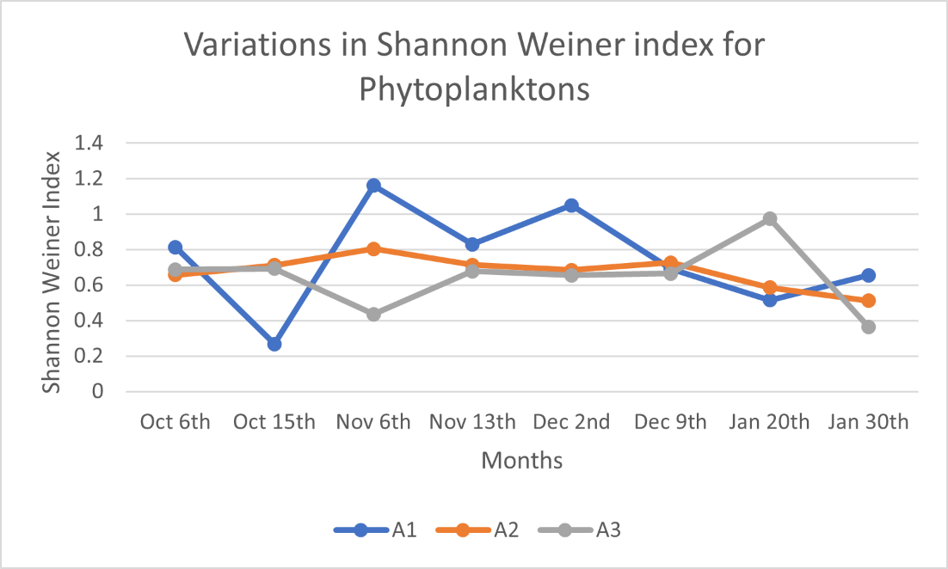

**Fig 1:** **Monthly Variation in Shannon Weiner Index for Phytoplankton’s**

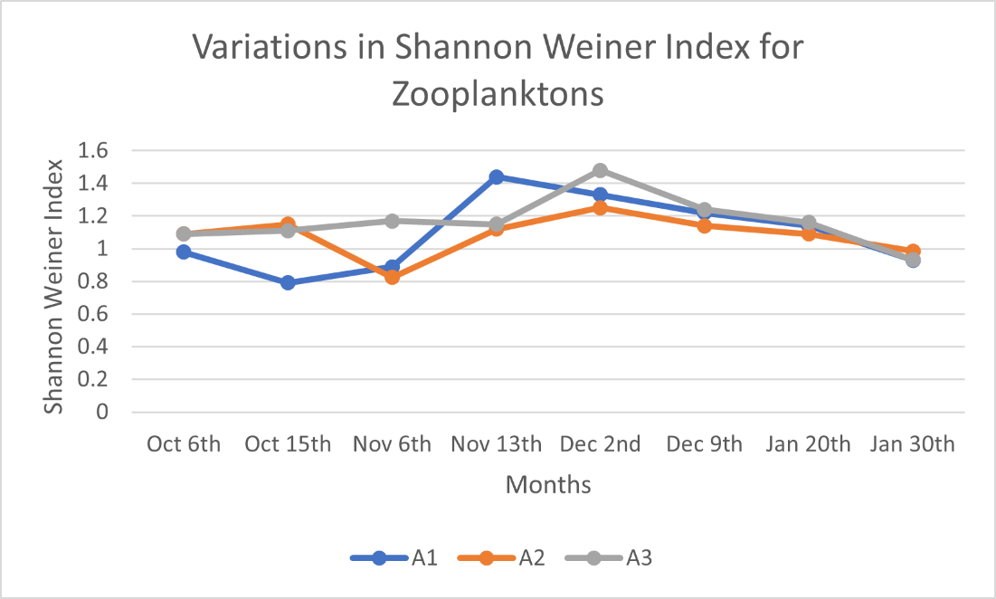

**Fig 2:** **Monthly variations in Shannon Weiner Index for Zooplanktons**

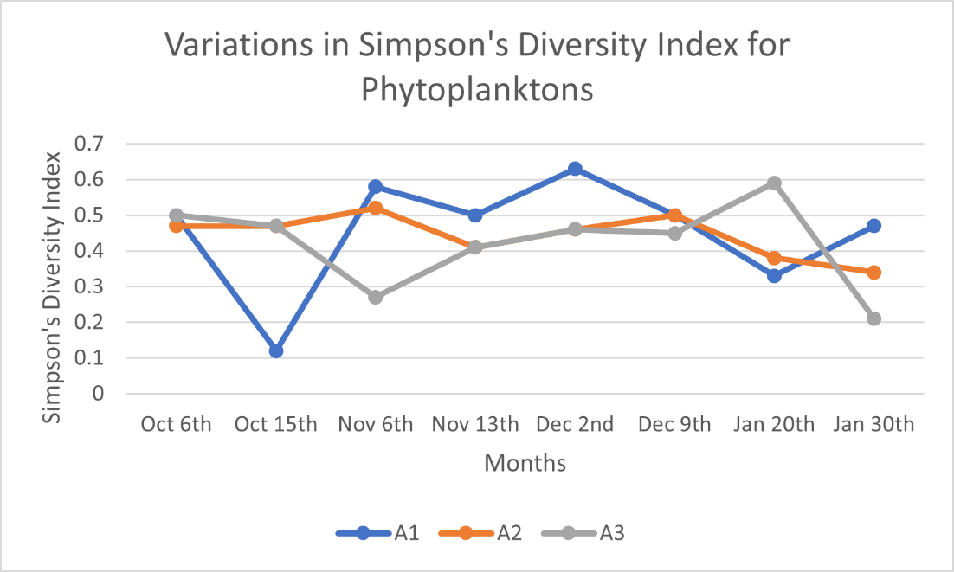

**Fig 3:** **Monthly Variations in Simpson’s Diversity Index for Phytoplankton’s**

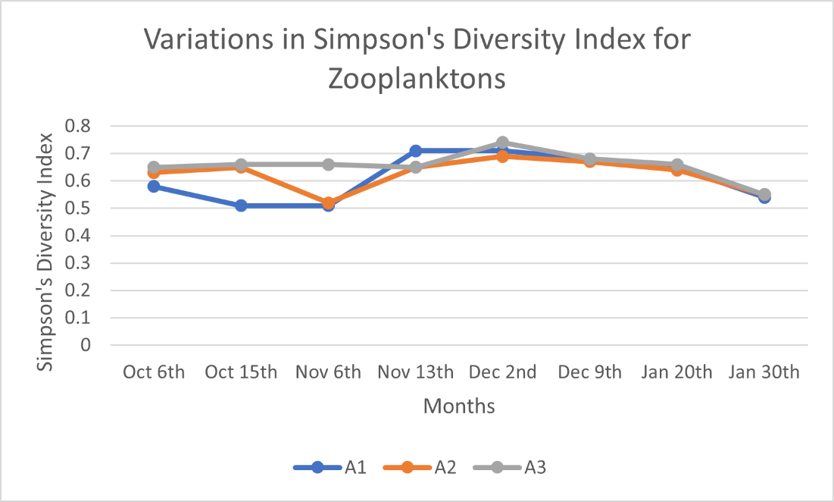

**Fig 4: Monthly Variations in Simpson’s Diversity Index for Zooplanktons**

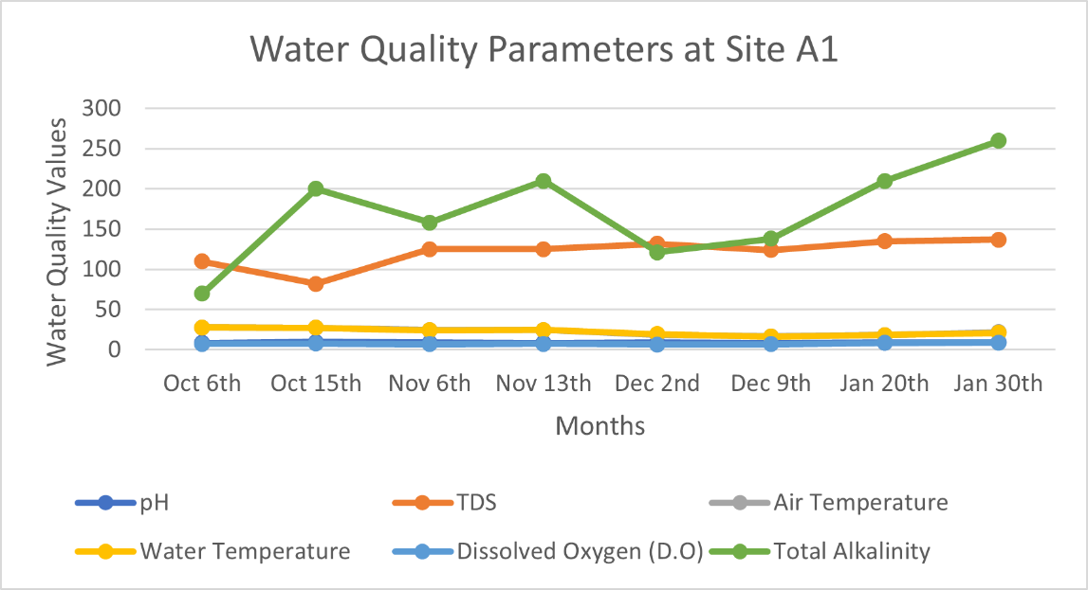

**Fig 5:** Monthly Variations in Water Quality Parameters in Site 1.

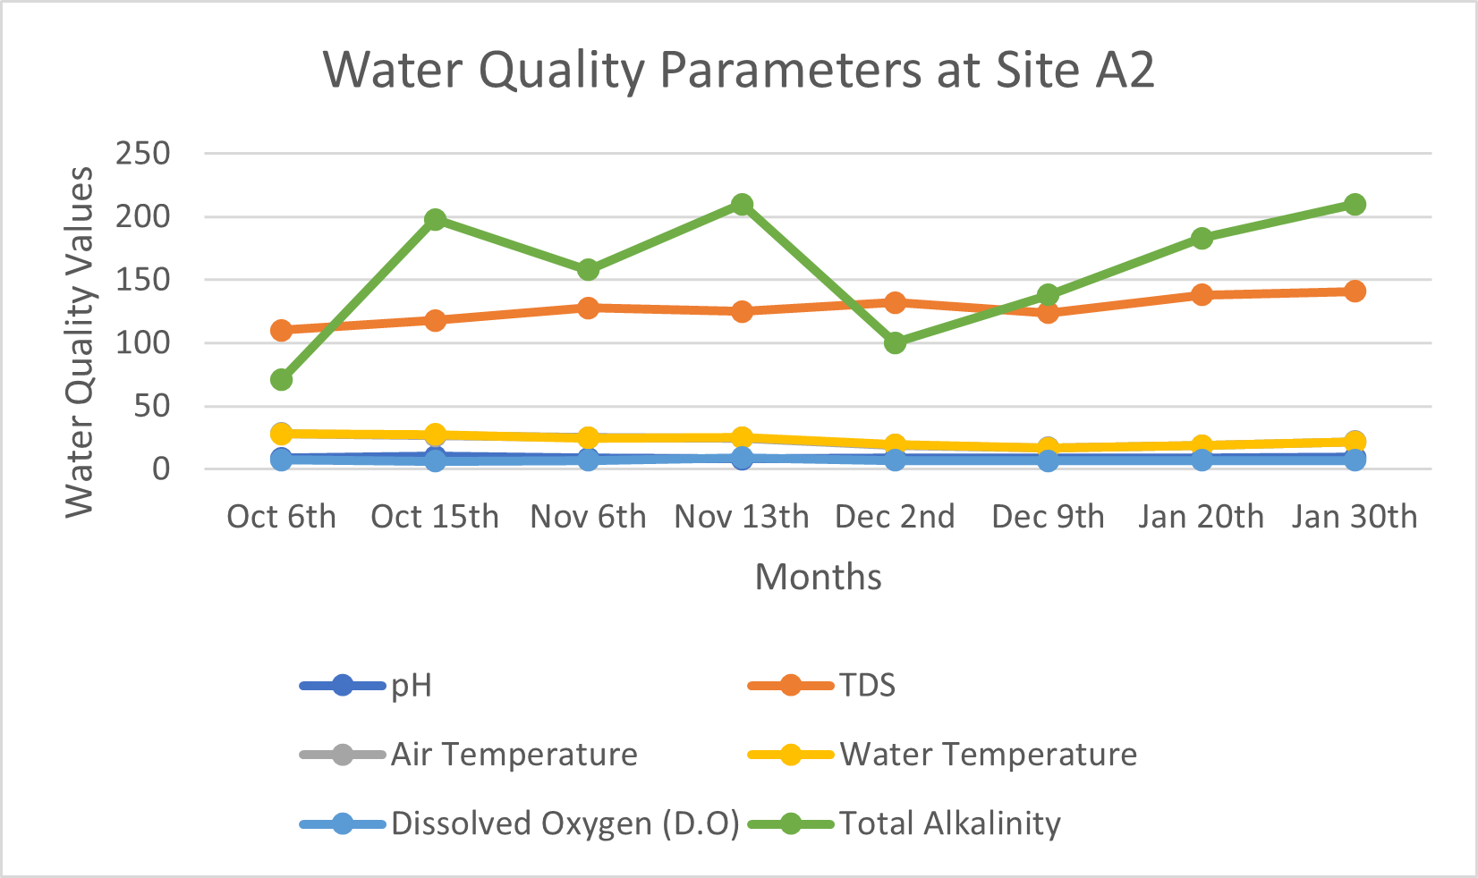

**Fig 6:** Monthly Variations in Water Quality Parameters in Site 2.

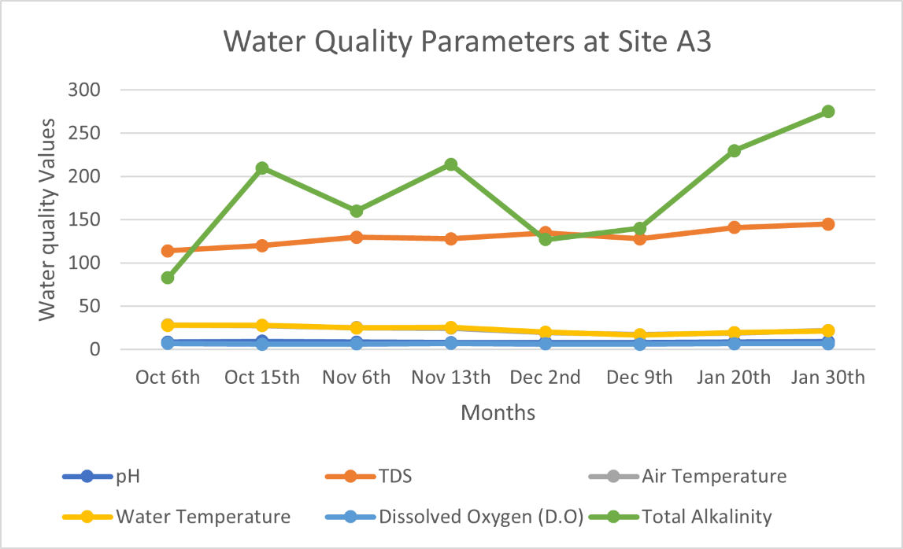

**Fig 7:** Monthly Variations in Water Quality Parameters in Site 3.