***Original Research Article***

**Comparative Economic Analysis of Saffron (*Crocus sativus* L.) Cultivation under Hydroponic and Conventional Systems across Different Agro-Climatic Zones of Jammu and Kashmir**

**Abstract**

Saffron (Crocus sativus L.), a premium spice crop traditionally cultivated in Kashmir and Kishtwar, faces economic limitations under conventional systems due to stagnant yields, rising input costs, and climatic uncertainties. This study evaluates the economic feasibility of hydroponic saffron cultivation as an alternative model, comparing input costs, yields, and profitability against conventional practices across three agro-climatic zones of Jammu and Kashmir. Field experiments conducted during 2023–24 used a completely randomized design, with two-year hydroponic trials in Jammu and conventional plots in Kashmir and Kishtwar. Results showed that hydroponic systems achieved significantly higher stigma yields (5,500–6,000 g/ha) than conventional systems (3,200–3,500 g/ha), while reducing recurring costs in the second year by over 85%. The benefit–cost ratio in hydroponics increased from 3.74 (Year 1) to 26.67 (Year 2), compared to 1.84–2.12 in conventional systems. Payback period analysis revealed that hydroponic capital investments were recovered within the first cropping cycle. Principal Component Analysis (PCA) further confirmed hydroponic Year 2 as the most economically efficient treatment. Sensitivity analysis showed robust profitability even at lower yield levels. These findings highlight hydroponic saffron cultivation as a scalable, climate-resilient, and economically superior strategy aligned with sustainable development goals, offering new opportunities for high-value agriculture in non-traditional zones of Jammu & Kashmir.

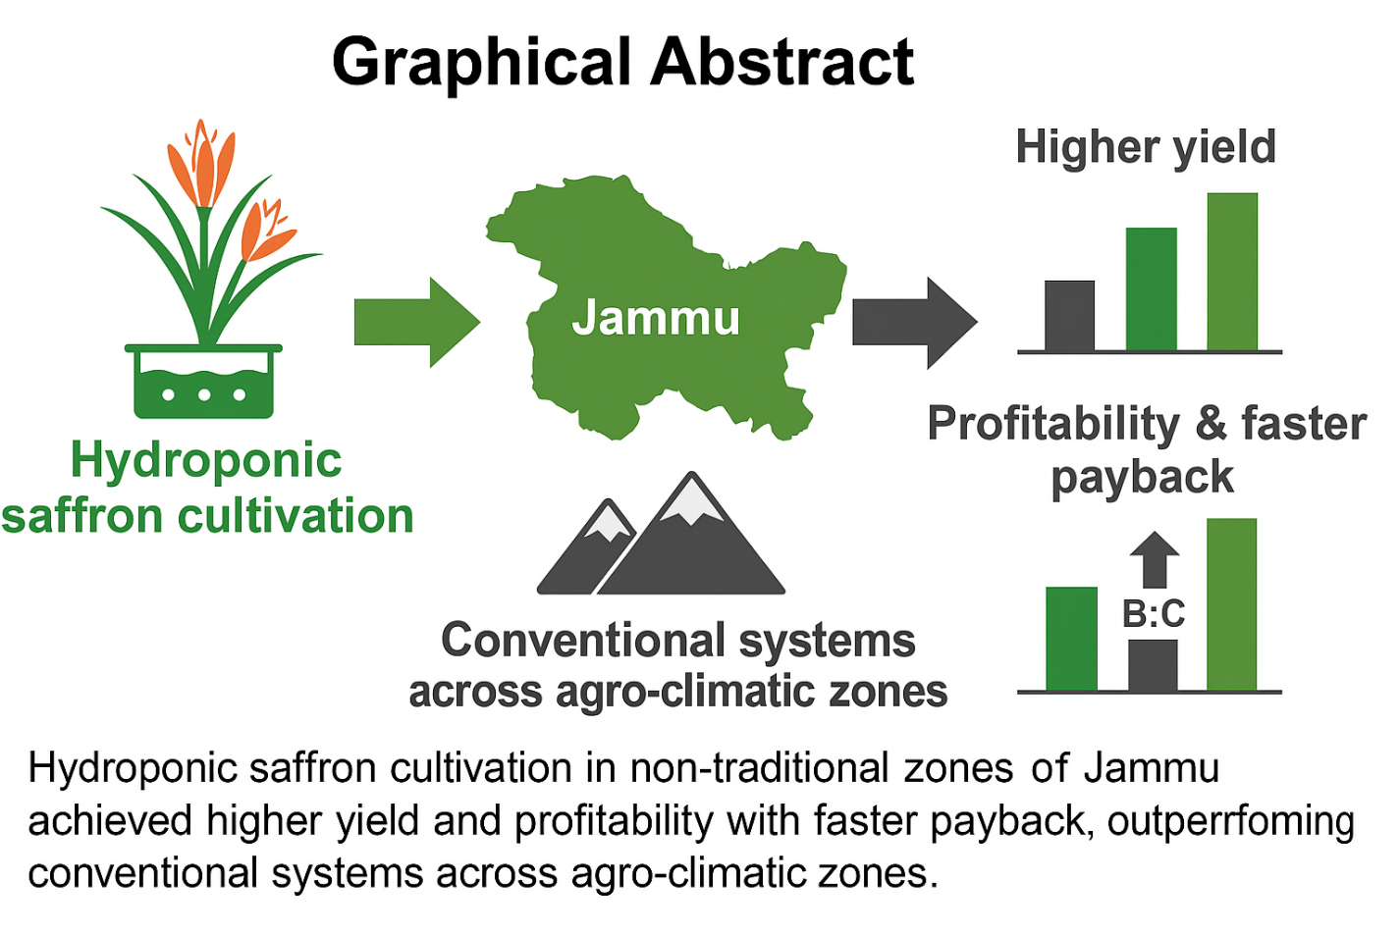

**Keywords:** *Hydroponics, Economic analysis, Benefit–cost ratio, PCA, Sustainable agriculture*

1. **Introduction**

Saffron (*Crocus sativus* L.) is one of the highest-value cash crops globally, extensively cultivated in Iran, India, and parts of the Mediterranean. In India, the Union Territory of Jammu & Kashmir holds a near-monopoly on saffron cultivation, where it contributes significantly to rural livelihoods and regional heritage. However, the profitability of saffron farming remains constrained under conventional soil-based systems due to stagnating productivity, high input variability, and increasing vulnerability to climatic fluctuations **(Husaini, 2014).** These economic stressors limit expansion and reduce the sustainability of the sector, particularly in the face of growing market demand **(Zare *et al*., 2021).**

The traditional saffron-growing regions of Kashmir and Kishtwar rely heavily on seasonal rainfall, open-field management, and labor-intensive methods, which lead to inconsistent yields and narrow profit margins **(Maiti & Saha, 2020).** Moreover, with production costs escalating and land availability shrinking, there is a pressing need to re-evaluate the economic viability of alternative production systems **(Nardi *et al*., 2022).**

Hydroponic cultivation, an advanced form of soilless agriculture has emerged as a promising economic strategy to mitigate these challenges. By enabling precise control over environmental conditions and nutrient delivery, hydroponics offers higher resource-use efficiency, faster corm multiplication, and improved crop uniformity **(Resh, 2012; Sambo *et al*., 2019)**. Although it requires substantial capital investment, especially in its initial year, the potential for year-on-year reduction in operating costs makes it increasingly attractive from an economic standpoint **(Schroeder *et al*., 2020; Salas *et al*., 2020).**

Furthermore, hydroponic saffron cultivation aligns with global goals for sustainable agriculture. It contributes to SDG 8 (Decent Work and Economic Growth) by increasing profitability and employment in agritech; SDG 12 (Responsible Consumption and Production) by reducing input waste; and SDG 13 (Climate Action) by insulating cultivation from erratic weather **(United Nations, 2015).** These interlinked benefits offer a strong rationale for evaluating hydroponics not only as a technological shift but also as an economic opportunity for saffron-growing communities in Jammu & Kashmir.

This study thus undertakes a comparative economic analysis of saffron cultivation under hydroponic and conventional systems across the diverse agro-climatic zones of Jammu, Kashmir, and Kishtwar. The objective is to evaluate system-level differences in input costs, return on investment, benefit–cost ratios, and profitability dynamics to inform more sustainable, scalable, and economically sound cultivation strategies.

**2. Materials and Methods**

**2.1 Study Sites**

Field experiments were conducted during the 2023–24 growing season at three agro-climatic zones of Jammu and Kashmir, India  
(i) **Srinagar** (1,600 m Above sea level.),  
(ii) **Kishtwar** (1,700 m above sea level.) and  
(iii) **Jammu** (327 m above sea level).

Srinagar and Kishtwar represent temperate zones with gravelly loam soils (pH 6.0–8.0), supporting conventional soil-based saffron cultivation. Jammu’s semi-arid subtropical plains necessitated a controlled-environment hydroponic system established at SKUAST–Jammu.

**2.2 Experimental Design and Cultivation Practices**

A completely randomized design was implemented with four treatments (0.1 ha each) in triplicate:

* T**1**: Conventional (Kashmir),
* **T2**: Conventional (Kishtwar),
* **T3**: Hydroponic (Year 1),
* **T4**: Hydroponic (Year 2).

Dormant saffron corms (2.5–3.0 cm diameter) were sourced from certified growers and planted at a uniform density of 1,250 corms/ha. Conventional fields were ploughed to 20 cm depth and managed using manual weeding and furrow irrigation at 10-day intervals.

The hydroponic system used a closed-loop Nutrient Film Technique (NFT) with cocopeat–perlite (1:1 v/v) as substrate, maintained at 20 ± 2 °C, 60–70 % RH, and 14-hour photoperiod. Nutrient solution (EC 1.8 dS/m; pH 6.2) was refreshed weekly **(Resh, 2012).**

**2.3 Economic Data Collection and Analysis**

**2.3.1 Input Costs**

Cost components per hectare included:

* Land preparation (C₁),
* Corm procurement (C₂),
* Fertilizers/nutrients (C₃),
* Electricity and water (C₄),
* Labour (C₅),
* Growing medium (hydroponic only; C₆),
* Infrastructure (polyhouse, tanks; C₇),
* Miscellaneous costs (C₈).

**2.3.2 Yield and Revenue**

Stigma yield (Y, g/ha) was recorded at peak flowering. Saffron market rates were ₹250/g (conventional) and ₹400/g (hydroponic).

**Gross Return (GR)** = Y × P **(Gittinger, 1982)**

**Net Return (NR)** = GR – Total Cost **(Samui *et al*., 2000)**

**2.3.3 Profitability Indicators**

**Benefit–Cost Ratio (B:C)** = GR / Total Cost **(Gittinger, 1982)**

**Payback Period (PP)** = Capital Investment / Annual Net Return **(Gittinger, 1982)**

**2.3.4 Sensitivity Analysis**

Net profit variation (ΔNR) was projected across a yield range of 3,000–6,500 g/ha to assess responsiveness to output changes:

**ΔNR/ΔY** quantified the marginal economic gain per 100 g increase in stigma yield. **(Samui *et al*., 2000).**

**2.4 Statistical Analysis**

Data were analyzed using one-way ANOVA (SPSS), with significance at p < 0.05.  
**Principal Component Analysis (PCA)** was performed on nine economic and yield variables to identify major sources of variance (eigenvalue >1 criterion; **Abdi & Williams, 2010).**

**3. Results**

**3.1 Input Costs: Conventional vs. Hydroponic Systems**

Table 1 summarizes input costs across all systems. Conventional cultivation cost ₹435,000/ha in Kashmir and ₹412,000/ha in Kishtwar. Hydroponics required a higher initial investment (₹587,000/ha in Year 1) due to infrastructure costs (₹400,000/ha), but dropped sharply to ₹90,000/ha in Year 2 as fixed components were amortized.

**Table 1. Comparative Cost of Saffron Cultivation (₹/ha) Under Conventional and Hydroponic Systems (Year 1 and Year 2)**

|  |  |  |  |  |
| --- | --- | --- | --- | --- |
| **Input Component** | **Kashmir (Conventional)-1st Year** | **Kishtwar (Conventional)-1st Year** | **Jammu (Hydroponic) -1st year** | **Jammu (Hydroponic)- 2nd year** |
| **Land preparation** | ₹70,000 | ₹100,000 | — | — |
| **Corm cost** | ₹50,000 | ₹50,000 | ₹32,000 | ₹40,000 |
| **Nutrients/Fertilizers** | ₹60,000 | ₹80,000 | ₹15,000 | ₹8,000 |
| **Growing medium (Cocopeat, etc.)** | — | — | ₹20,000 | Reused from 1st year |
| **Electricity/Water pumping** | ₹5,000 | ₹2,000 | ₹10,000 | ₹8,000 |
| **Labour** | ₹100,000 | ₹80,000 | ₹10,000 | ₹10,000 |
| **Hydroponic Structure, Tanks, Fittings etc.** | — | — | ₹400,000 | ₹4,000 |
| **Miscellaneous** | ₹150,000 | ₹100,000 | ₹100,000 | ₹20,000 |
| **Total Cost of Cultivation** | ₹435,000 | ₹412,000 | ₹587,000 | ₹90,000 |

**3.1.1 Fixed and Variable Costs**

Land preparation (₹70,000–₹100,000/ha) was incurred only in conventional plots. In contrast, hydroponic Year 2 required only ₹4,000/ha for structure maintenance. Fertilizer costs were significantly lower in hydroponics (₹15,000–₹8,000/ha) compared to soil (₹60,000–₹80,000/ha) due to efficient nutrient use. Labour and water costs also declined markedly in the hydroponic system.

**3.1.2 Year-on-Year Dynamics**

Recurring input costs dropped by ~85% in Year 2 of hydroponics. With the initial investment largely recovered in the first year, Year 2 costs reflected only operational needs.

**3.2 Yield and Profitability**

Hydroponic systems significantly outperformed conventional cultivation in stigma yield and profitability (Table 2, Fig. 1a). Kashmir and Kishtwar produced 3,200 and 3,500 g/ha, respectively. Hydroponic Year 1 yielded 5,500 g/ha; Year 2 reached 6,000 g/ha. This 71.9–85.7% increase in yield, combined with a premium price of ₹400/g, boosted gross returns to ₹2.2–2.4 million/ha under hydroponics (Fig. 1b). Net income rose from ₹0.365–0.463 million/ha in soil to ₹1.613 million (Year 1) and ₹2.310 million (Year 2) under hydroponics.

**Table 2: Yield and Revenue Comparison**

|  |  |  |  |  |
| --- | --- | --- | --- | --- |
| **Parameter** | **Kashmir** | **Kishtwar** | **Jammu (Hydroponic) 1st Year** | **Jammu (Hydroponic) 2nd Year** |
| **Average stigma yield (g/ha)** | 3,200 | 3,500 | 5,500 | 6,000 |
| **Market rate of saffron (₹/g)** | 250 | 250 | 400 | 400 |
| **Gross Income (₹/ha.)** | ₹800,000 | ₹875,000 | ₹2,200,000 | ₹2,400,000 |
| **Net Income (Gross – Total Cost) (₹/ha.)** | ₹365,000 | ₹463,000 | ₹1,613,000 | ₹2,310,000 |

**3.3 Benefit–Cost Ratio (B:C)**

B:C ratios improved significantly in hydroponics (Table 3, Fig. 2):

* Conventional: 1.84 (Kashmir), 2.12 (Kishtwar)
* Hydroponic Year 1: 3.74
* Hydroponic Year 2: 26.67

This 613% increase in Year 2 B:C ratio illustrates the system’s high economic efficiency post-infrastructure recovery.

**Table 3. Benefit-Cost Ratio (BCR) under Different Systems**

|  |  |  |  |  |
| --- | --- | --- | --- | --- |
| **Methods** | **Total Cost (₹/ha)** | **Gross Income (₹/ha)** | **Net Income (₹/ha)** | **B:C Ratio** |
| **Kashmir (Conventional – 1st Yr)** | ₹435,000 | ₹800,000 | ₹365,000 | 1.84 |
| **Kishtwar (Conventional – 1st Yr)** | ₹412,000 | ₹875,000 | ₹463,000 | 2.12 |
| **Jammu (Hydroponic – 1st Yr)** | ₹587,000 | ₹2,200,000 | ₹1,613,000 | 3.74 |
| **Jammu (Hydroponic – 2nd Yr)** | ₹90,000 | ₹2,400,000 | ₹2,310,000 | 26.67 |

**3.4 Payback Period**

The hydroponic system's capital investment of ₹420,000/ha (structure, medium, Year 1 operations) was recovered within the first season, with a net return of ₹1.613 million/ha (Table 4, Fig. 3). This equated to a payback period of under 1 year, highlighting the model’s rapid financial viability.

**Table 4. Payback Period for Hydroponic Setup**

|  |  |  |  |  |
| --- | --- | --- | --- | --- |
| **Investment Component** | **Cost (₹/ha)** | **Depreciation or Reuse** | **Recovery Source** | **Estimated Recovery Time** |
| **Hydroponic Structure, Tanks, Fittings etc.** | ₹4,00,000 | One-time (5–7 year lifespan) | Net Income from Year 1 | Within Year 1 |
| **Growing Medium (Cocopeat, etc.)** | ₹20,000 | Reused in Year 2 | Net Income from Year 1 | Within Year 1 |
| **Other Operational Costs (Recurring Year 1)** | ₹1,35,000 | Incurred annually | Covered in yearly return | Annual |
| **Total Capital Investment (Recoverable)** | ₹4,20,000 | One-time (5–7 year lifespan) | ₹1,613,000 | Fully recovered in Year 1 |

**3.5 Sensitivity Analysis: Yield vs. Net Profit**

Sensitivity analysis (Table 5, Fig. 4) showed a linear relationship between yield and net profit:

* Every 100 g/ha increase in yield raised annual net profit by ~₹40,000
* Cumulative 2-year profit ranged from ₹1.72 million (3,000 g/ha) to ₹4.52 million (6,500 g/ha)

These results confirm that hydroponic profitability remains robust across variable yields.

**Table 5. Sensitivity Analysis of Yield vs Net Profit under Hydroponic Saffron Cultivation (Year 1 & Year 2)**

|  |  |  |  |  |
| --- | --- | --- | --- | --- |
| **Stigma Yield (g ha⁻¹)** | **Gross Income (₹)** | **Net Profit – Year 1 (₹)** | **Net Profit – Year 2 (₹)** | **Total Net Profit (₹)** |
| **3,000** | ₹1,200,000 | ₹613,000 | ₹1,110,000 | ₹1,723,000 |
| **4,000** | ₹1,600,000 | ₹1,013,000 | ₹1,510,000 | ₹2,523,000 |
| **5,000** | ₹2,000,000 | ₹1,413,000 | ₹1,910,000 | ₹3,323,000 |
| **5,500** | ₹2,200,000 | ₹1,613,000 | ₹2,110,000 | ₹3,723,000 |
| **6,000** | ₹2,400,000 | ₹1,813,000 | ₹2,310,000 | ₹4,123,000 |
| **6,500** | ₹2,600,000 | ₹2,013,000 | ₹2,510,000 | ₹4,523,000 |

*\*Note: All gross income calculations assume saffron at ₹400 g⁻¹; 5,500 g ha⁻¹ is the actual observed yield*.

**3.6 Principal Component Analysis (PCA)**

PCA reduced nine economic/yield variables to two principal components (Fig. 5), explaining 95% of total variance:

* **PC1 (78%)** represented a profitability gradient (high yield, low cost)
* **PC2 (17%)** reflected cost structure (fixed vs. recurring inputs)

Hydroponic Year 2 scored highest on PC1, showing superior profitability. Conventional plots clustered negatively on both axes (low yield, high recurring costs). The PCA biplot (Fig. 6) confirmed clear separation between high-efficiency hydroponic systems and traditional methods.

**4. Discussion**

This study demonstrates that hydroponic saffron cultivation in Jammu markedly outperforms traditional soil-based systems in Kashmir and Kishtwar in terms of yield, profitability, and input efficiency. Hydroponics produced up to 6,000 g/ha of stigma yield—70–90% higher than the conventional 3,200–3,500 g/ha range. These findings are consistent with results reported by **Zare *et al.* (2021)** and **Kour *et al*. (2022),** who observed similar yield enhancements under protected hydroponic cultivation.

Economically, hydroponics yielded a net return of ₹2.31 million/ha in Year 2, compared to ₹0.365–0.463 million/ha under conventional systems. The substantial difference in net income is attributed not only to higher yields but also to reduced recurring costs—especially for labor, fertilizers, and irrigation. **Salas *et al*. (2020**) similarly reported an 80–90% cost reduction beyond the first year in hydroponic lettuce systems, validating the sustainability of soilless agriculture in arid regions.

The most striking economic indicator was the benefit–cost ratio (B:C), which rose from 1.84–2.12 in soil-based systems to 3.74 in Hydroponic Year 1 and surged to 26.67 in Year 2. This rapid escalation mirrors observations by **Nardi et al. (2022**), who reported high B:C ratios (>4.0) in pharmaceutical-grade hydroponic saffron. The hydroponic system in our study achieved complete cost recovery within one year—a key milestone for agribusiness models targeting short investment cycles.

The PCA findings corroborate these trends: PC1 positively loaded on profitability indicators (yield, B:C, net income) and negatively on input costs, highlighting a clear shift in economic profile from conventional to hydroponic systems. Similar PCA-based treatment separation was reported by **Sambo *et al.* (2019) and Maiti & Saha (2020)** in soilless horticultural evaluations, indicating robust pattern recognition across diverse crops.

Sensitivity analysis reinforced the robustness of hydroponics: profitability scaled linearly with yield, suggesting resilience against environmental or operational fluctuations. Even at lower yields (3,000 g/ha), hydroponic Year 2 systems outperformed the best-case conventional scenario.

Overall, these results suggest that hydroponic saffron cultivation is not only technically feasible but economically superior. It enables climate-resilient, resource-efficient, and high-return farming that could revitalize saffron cultivation across non-traditional zones like Jammu, especially when supported by targeted policies and infrastructure investment.

**5. Conclusions & Recommendations**

This study clearly demonstrates that hydroponic saffron cultivation offers a significantly more profitable and sustainable alternative to traditional soil-based methods in Jammu & Kashmir. The hydroponic system achieved superior stigma yields (up to 6,000 g/ha), substantially higher net returns (₹2.31 million/ha), and a remarkably elevated benefit–cost ratio (26.67 in Year 2), all while recovering initial investment within the first cropping cycle.

Key advantages included reduced recurring costs, premium market pricing, and yield resilience under controlled conditions. Sensitivity analysis confirmed that hydroponic profitability remained robust across a range of production scenarios. Principal component analysis further validated the economic efficiency of the hydroponic model through distinct separation from conventional systems in cost–return space.

Given these findings, hydroponics represents a viable pathway for modernizing saffron production, especially in agro-climatic zones beyond traditional cultivation belts. To promote wider adoption, policy support is essential in the form of infrastructure subsidies, farmer training, and access to protected cultivation technology. Integrating hydroponic saffron into national agri-entrepreneurship programs could significantly enhance rural incomes, resource use efficiency, and climate resilience in high-value agriculture.

**REFERENCES**

[1] Hosseini SM, Maleki A. The Economics of Saffron in Iran. J Agric Econ Ferdowsi Univ Mashhad. 2014.

[2] Kour K, Gupta D, Gupta K, Dhiman G, Juneja S, Viriyasitavat W, Mohafez H, Islam MA. Smart-Hydroponic-Based Framework for Saffron Cultivation: A Precision Smart Agriculture Perspective. Sustainability. 2022;14(3):1120.

[3] Sambo P, Nicoletto C, Giro A, Pii Y, Valentinuzzi F, Mimmo T, Cesco S. Hydroponic Solutions for Soilless Production Systems: Issues and Opportunities in a Smart Agriculture Perspective. Front Plant Sci. 2019;10:923.

[4] Nardi S, Raimondi G, Martino A, De Pascale S. Farming for Pharming: Novel Hydroponic Process in Contained Environment for Efficient Pharma-Grade Production of Saffron. Molecules. 2022;27(24):8972.

[5] Resh HM. Hydroponic Food Production: A Definitive Guidebook for the Advanced Home Gardener and the Commercial Hydroponic Grower. 7th ed. CRC Press; 2012.

[6] United Nations. Transforming our World: The 2030 Agenda for Sustainable Development. United Nations; 2015.

[7] Zare S, Lak A, Asli DE. Yield and Quality Improvement of Hydropony-grown Saffron. J Hortic Sci. 2021;45(2):123–130.

[8] Gittinger JP. Economic Analysis of Agricultural Projects. 2nd ed. Johns Hopkins University Press; 1982. p. 505.

[9] Samui SK, Maitra S, Roy DK, Mandal AK, Saha D. Evaluation of Front Line Demonstration on Groundnut. J Indian Soc Coast Agric Res. 2000;18(2):180–183.

[10] Singh RP, Singh S, Yadav RN. Economic Analysis of Potato Production in Farrukhabad District of Uttar Pradesh. J Root Crops. 2013;39(1):84–88.

[11] Johl SS, Kapoor TR. Fundamentals of Farm Business Management. Kalyani Publishers; 2012. p. 123–145.

[12] Pandey UK, Tewari LM, Sharma RR. Farm Management. Kalyani Publishers; 2000. p. 210–230.

[13] Abdi H, Williams LJ. Principal component analysis. Wiley Interdiscip Rev Comput Stat. 2010;2(4):433–459.

**Ethical Statement**This study did not involve human or animal subjects; hence, ethical approval is not applicable.

Figures

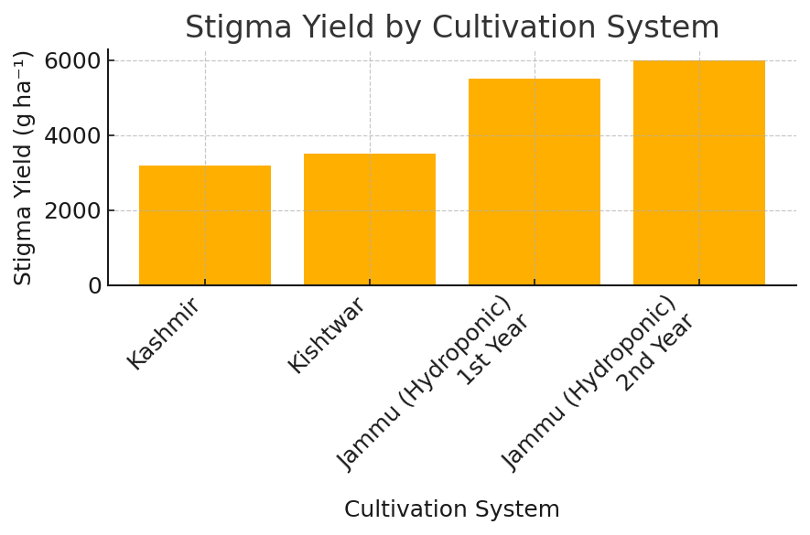

**Fig. 1 a: Comparison of Saffron Stigma Yield (g ha⁻¹) under Conventional (Kashmir & Kishtwar) and Hydroponic (Jammu) Cultivation Systems**

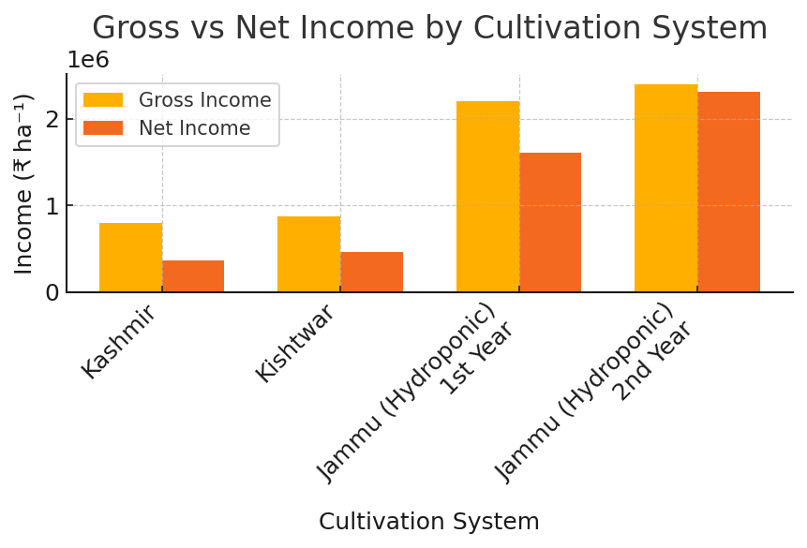

**Fig.1 b: Comparative Analysis of Gross and Net Income (₹ ha⁻¹) from Saffron Cultivation under Conventional (Kashmir & Kishtwar) and Hydroponic (Jammu) Systems**

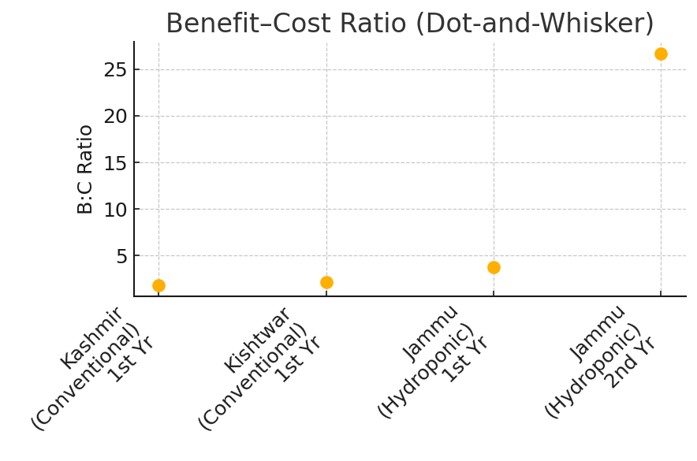

**Fig. 2: Assessment of Benefit–Cost Performance in Saffron Cultivation across Conventional (Kashmir, Kishtwar) and Hydroponic (Jammu) Methods**

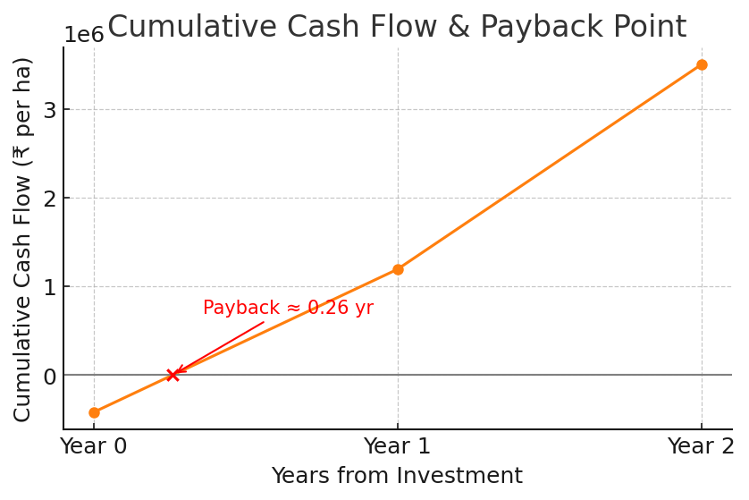

**Fig. 3: Cumulative Cash Flow Analysis and Payback Period for Hydroponic Saffron Cultivation (Jammu)**

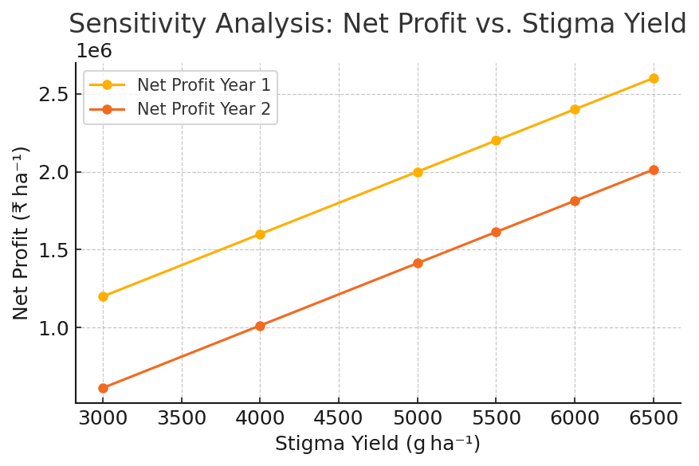

**Fig.4: Evaluating net profit sensitivity to stigma yield in saffron hydroponics across two growing seasons**

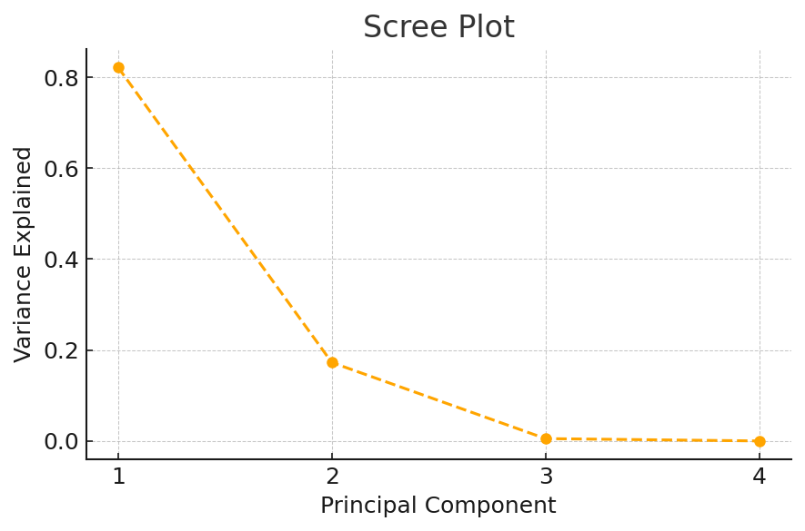

**Fig. 5: Distribution of explained variance across principal components for saffron production metrics**

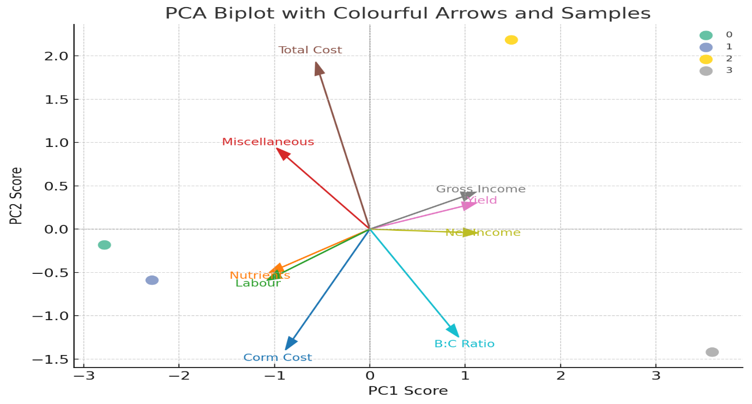

**Fig.6: PCA biplot of economic and yield variables in saffron cultivation systems**