Assessment of Bacillus thuringiensis var. kurstaki Compatibility with Selected Insecticides in Integrated Pest Management Strategies

ABSTRACT
This study investigates the compatibility of selected insecticides with Bacillus thuringiensis var. kurstaki (Bt), a widely used microbial biopesticide, to assess their suitability for incorporation into integrated pest management (IPM) strategies. Compatibility was determined by evaluating Bt colonies and percentage inhibition following exposure to three different concentrations of each insecticide (10⁵, 10⁷, and 10⁹ cfu/ml). The results revealed a consistent trend in colony development and inhibition across all concentrations. Among the insecticides tested, Chlorantraniliprole 18.5 % SC exhibited the highest compatibility at 10⁹ CFU/ml, supporting the maximum Bt colony growth (12.67 Cfu/ml) and showing the lowest inhibition (4.73 %). Flubendiamide 39.35 % SC and Emamectin benzoate 5 % SG followed with colony growths of 11.33 and 10.77 Cfu/ml and inhibition percentages of 14.81 % and 19.02 %, respectively. Conversely, Profenophos 50 % EC showed the lowest compatibility, with a significantly reduced colony growth (3.67 Cfu/ml) and the highest inhibition rate (72.40 %). These findings highlight the importance of compatibility assessments in IPM programs, ensuring that chemical and microbial agents can be effectively combined without compromising the efficacy of beneficial biocontrol organisms. Such evaluations are essential for promoting sustainable pest management practices and enhancing the performance of Bt based formulations in the field.
Key words: Bacillus thuringiensis var. kurstaki; Biopesticides; Chlorantraniliprole; Compatibility; Profenophos
1. INTRODUCTION
The global shift towards sustainable agriculture has heightened interest in environmentally friendly alternatives to conventional chemical pesticides. Among these, biopesticides derived from natural sources such as plants, microbes and other biological organisms have gained prominence for their high specificity, ecological safety and minimal impact on non-target organisms (Koul et al., 2008; Supriya et al., 2025). Within the category of microbial biopesticides, Bacillus thuringiensis (Bt), a gram-positive, spore-forming bacterium, stands out as the most widely adopted and effective agent in pest control (). It is naturally present in a variety of habitats and is known for producing a range of insecticidal proteins namely Cry, Cyt and Vip that target specific insect orders such as Lepidoptera, Coleoptera and Diptera (Kumar et al., 2021). These toxins, once ingested by susceptible insects, are activated in the alkaline midgut environment, where they bind to epithelial cell receptors, disrupt gut integrity through pore formation and ultimately cause insect mortality (Vachon et al., 2012; Gupta et al., 2021). This targeted mode of action, coupled with safety for humans and non-target species, has led to widespread use in both foliar sprays and genetically modified crops. Among the various strains of Bt, B. thuringiensis var. kurstaki has demonstrated exceptional efficacy against a range of lepidopteran pests, including Helicoverpa armigera, Plutella xylostella, Ostrinia nubilalis, Agrotis ipsilon, and Spodoptera exigua (George and Crickmore, 2012; Vimala Devi et al., 2020). Currently, over 40,000 Bt strains have been identified, comprising 39 serotypes and producing more than 800 cry genes grouped into 75 families, 40 cyt genes across three groups, and 146 vip genes within four groups (Lambert and Perferon, 1992; Crickmore et al., 2020).
Despite its proven success, the over-reliance on chemical insecticides in crop protection programs has led to critical challenges such as the development of insect resistance, resurgence of pest populations, and increased incidence of secondary pests (Togola et al., 2018; Gowtham et al., 2022). To counter these issues, Integrated Pest Management (IPM) strategies advocate for the judicious combination of biological and chemical control agents. However, the interaction between Bt and various insecticides can be complex and variable, ranging from synergistic to antagonistic effects (Gupta et al., 2019). In this context, understanding the compatibility of Bt with commonly used insecticides is essential for designing effective and sustainable IPM strategies. The present study was therefore undertaken to evaluate the compatibility of B. thuringiensis var. kurstaki with selected insecticides. This research aims to identify combinations that maintain the efficacy of Bt while enhancing overall pest control efficiency, thereby contributing to sustainable and ecologically sound pest management practices.
2. MATERIALS AND METHODS
The study was conducted in 2024 at Entomology Laboratory, Crop Protection Section, ICAR-Indian Institute of Oilseeds Research (ICAR-IIOR), Hyderabad, to evaluate the compatibility of a native strain of Bacillus thuringiensis var. kurstaki (DOR-Bt 127) with selected insecticides. The bacterial strain was cultured in nutrient broth (NB) under sterile conditions and incubated at 28 ± 1 °C with continuous shaking at 150 rpm to ensure optimal growth and sporulation. Eight insecticides representing different chemical classes Chlorantraniliprole 18.5 % SC, Flubendiamide 39.35 % SC, Emamectin Benzoate 5 % SG, Spinosad 48 % SC, Imidacloprid 18.5 % SL, Profenophos 50 % EC, Diafenthiuron 50 % WP, and Spinetoram 11.7 % SC were selected for the study. Nutrient agar medium (100 mL) was prepared and poured aseptically into sterile Petri dishes, with each insecticide incorporated at its field-recommended concentration before solidification. Plates without insecticides served as controls. A serial dilution of the Bt culture was performed, and 50 µL of the 10⁻⁶ dilution was aseptically inoculated onto each plate to ensure uniform bacterial distribution. All plates were incubated at 25 ± 1 °C for 48 hours, after which bacterial growth was assessed by counting colony-forming units (cfu/ml) at three dilution levels 10⁵, 10⁷, and 10⁹. Colony counts were used as a quantitative measure to determine the compatibility of each insecticide with Bt. The per cent compatibility was calculated by the formula
Per cent inhibition (%) = $\frac{Growth in control-Growth in treatment}{Growth in control}$ × 100

3. RESULTS AND DISCUSSION
A consistent trend was observed in colony-forming units (Cfu/ml) and percent inhibition of Bacillus thuringiensis var. kurstaki (Bt) across all three tested concentrations (10⁵, 10⁷, and 10⁹ Cfu/ml), indicating a steady inhibitory response exerted by the insecticides (Table 1). At the highest concentration of 10⁹ Cfu/ml, Chlorantraniliprole 18.5% SC demonstrated the highest compatibility with Bt, supporting the maximum colony growth of 12.67 Cfu/ml and showing the lowest inhibition percentage (4.73 %). Flubendiamide 39.35 % SC and Emamectin benzoate 5% SG followed, with colony counts of 11.33 and 10.77 Cfu/ml and inhibition rates of 14.81 % and 19.02 %, respectively. Moderate levels of compatibility were recorded for Spinetoram 11.7 % SC and Spinosad 48 % SC, which resulted in colony growths of 9.67 and 8.67 Cfu/ml and inhibition percentages of 27.29 % and 34.81 %, respectively. In contrast, Imidacloprid 18.5 % SL and Diafenthiuron 50 % WP caused significant reductions in colony formation, with colony counts of 7.33 and 6.09 Cfu/ml and corresponding inhibition percentages of 44.88 % and 54.21 %, respectively. Among all the treatments, Profenofos 50 % EC exhibited the strongest inhibitory effect on Bt, with the lowest colony growth (3.67 Cfu/ml) and the highest inhibition rate (72.40 %), indicating poor compatibility (Fig 1). These results align well with those reported by Amizadeh et al., (2015) who observed that among various insecticides evaluated in combination with Bt, only chlorantraniliprole significantly enhanced Bt colonization, whereas others had neutral or negative effects. Supporting this, Supriya et al., (2025) reported that the combination of Bt kurstaki with chlorantraniliprole (18.5 % SC at 30 g a.i./ha; 10⁸ CFUs/ml + 4.08 ml/l) resulted in only 3.56% inhibition compared to the control, indicating strong compatibility. Similarly, a combination with flubendiamide (39.35 % SC at 24 g a.i./ha; 10⁸ CFUs/ml + 0.13 ml/l) exhibited zero inhibition, further affirming its complete compatibility with Bt. Agostini et al., (2014) also found Spiromesifen to be compatible with recommended concentrations of Bt kurstaki. In another study, Pinto et al., (2012) reported that Thiamethoxam and Lambda-Cyhalothrin, when applied at recommended doses, did not inhibit the growth of Bt colonies, indicating no adverse interaction. However, contrasting results were found by de Souza et al., (2020), who reported that Thiamethoxam, Lambda-Cyhalothrin, Acetamiprid, and Bifenthrin were incompatible with both Bt kurstaki and Bt aizawai, suggesting that compatibility may vary depending on the formulation, concentration, or environmental conditions. Further, Shashikala et al., (2023) demonstrated the synergistic potential of Bt with chlorantraniliprole, where a half dose of chlorantraniliprole 18.5% SC (1 kg, 62.5 ml/ha) significantly reduced the larval population (0.20 larvae) with a 93.11% reduction, supporting the utility of this combination in integrated pest management (IPM) strategies. Ansari et al., (2005) also investigated the compatibility of Bt with newer insecticides and found it remained compatible with Lufenuron 5 % EC (0.4 l/ha), Thiamethoxam 25 WG (100 g/ha), and Methomyl 40 SP (1.0 kg/ha), whereas Ethion 50 EC (1.5 l/ha) was completely incompatible, entirely suppressing colony growth. Interestingly, Mashtoly et al., (2020) demonstrated enhanced efficacy of Bt formulations (Dipel, XenTari, and Agree) when combined with Lambda-Cyhalothrin against Tuta absoluta, increasing larval mortality by 3.67–10.08 times. Crucially, this combination did not adversely affect the viability or physicochemical stability of Bt strains, highlighting the potential of certain insecticide-biopesticide combinations for improved pest control without compromising microbial efficacy. Similarly, Anandhi et al., (2025) evaluated the impact of mixing B. thuringiensis (Bt) isolates with commonly used insecticides. The study found that most insecticides were compatible with Bt at field-recommended doses, indicating they could be applied together without significantly compromising the efficacy of either component. However, exceptions were noted with acetamiprid, DDVP, and imidacloprid, which showed incompatibility with Bt. Aronson et al., (2005) reported that B. thuringiensis and Beauveria bassiana are among the most extensively researched biopesticides, known for their ability to infect and eliminate insect hosts through the production of toxic secondary metabolites. Sharma et al., (2024) reported that the biopesticides B. thuringiensis var. kurstaki, Beauveria bassiana, and Metarhizium anisopliae used in their bioassay experiment were compatible with the chemical insecticide Barazide.

Table 1. Evaluation of CFUs/mL and Percent inhibition of Bacillus thuringiensis var. kurstaki on Nutrient Agar Supplemented with Insecticides at Recommended Field Concentrations
Insecticide | Dosage per 100ml of media  (ml/l) | 10⁵  (Cfu/ml) | Per cent inhibition (%) | 10⁷  (Cfu/ml) | Per cent inhibition (%) | 10⁹  Cfu/ml | Per cent inhibition (%)
Chlorantraniliprole 18.5 % SC | 0.03 | 15.67 (4.08ᵃᵇ) | 11.31 | 14.36(3.91ᵃᵇ) | 9.79 | 12.67 (3.69ᵃ) | 4.73
Flubendiamide 39.5% SC | 0.02 | 14.33 (3.91ᵇᶜ) | 18.90 | 12.67 (3.68ᵇᶜ) | 20.41 | 11.33 (3.51ᵃᵇ) | 14.81
Emamectin benzoate 5% SG | 0.04 | 13.67 (3.82ᵇᶜᵈ) | 22.63 | 11.33 (3.50ᶜᵈ) | 28.83 | 10.77 (3.41ᵇ) | 19.02
Spinetoram 11.7 %SC | 0.07 | 13.33 (3.77ᵇᶜᵈ) | 24.56 | 11.26 (3.51ᶜᵈ) | 29.27 | 9.67 (3.26ᵇᶜ) | 27.29
Spinosad 48% SC | 0.04 | 12.33 (3.65ᶜᵉ) | 30.22 | 10.69 (3.41ᶜᵉ) | 32.85 | 8.67 (3.10ᶜᵈ) | 34.81
Imidacloprid 18.5 % SL | 0.03 | 11.67 (3.55ᵈᵉ) | 33.95 | 9.63 (3.26ᵈᵉ) | 39.51 | 7.33 (2.88ᵈᵉ) | 44.88
Diafenthiuron 50 % WP | 0.075 | 10.75 (3.41ᵉ) | 39.16 | 8.72 (3.10ᵉ) | 45.22 | 6.09 (2.62ᵉ) | 54.21
Profenophos 50 % EC | 0.20 | 6.66 (2.76ᶠ) | 62.30 | 5.75 (2.57ᶠ) | 63.88 | 3.67 (2.23ᶠ) | 72.40
Control | 0.00 | 17.67 (4.31ᵃ) | - | 15.92 (4.12ᵃ) | - | 13.30 (3.78ᵃ) | -
C.D. (P = 0.01) |  | 0.291 |  | 0.299 |  | 0.27
SEm(±) |  | 0.097 |  | 0.100 |  | 0.09
C.V. (%) |  | 4.55 |  | 5.00 |  | 4.92

** Values mentioned in parenthesis are square root transformed mean values. Means followed by same letter indicates no significant difference between the treatment according to Duncan’s Multiple Range Test (P=0.01)

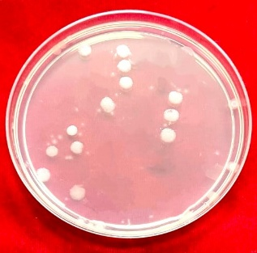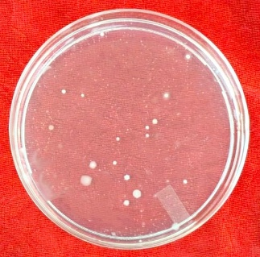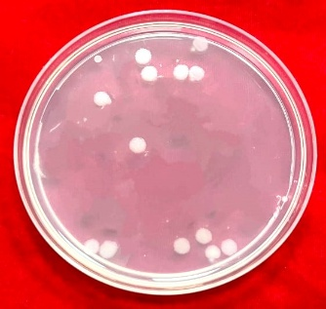
Chlorantraniliprole 18.5 % SC
Spinetoram 11.7 % SC
Flubendiamide 39.35 % SC

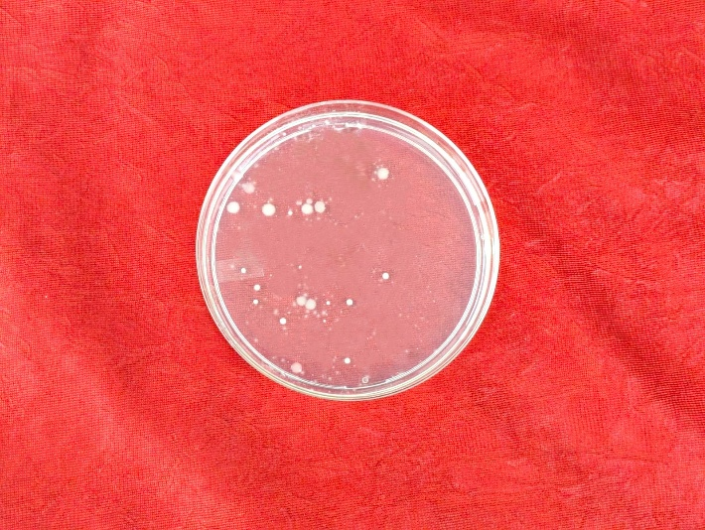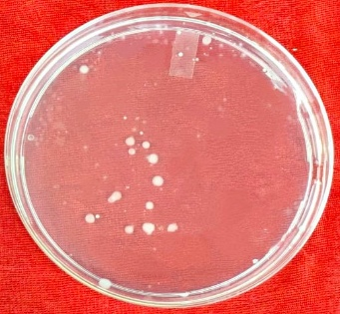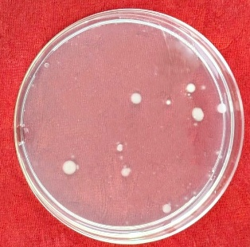
Emamectin benzoate 5 % SG

Imidacloprid 18.5 % SL

Spinosad 48% SC

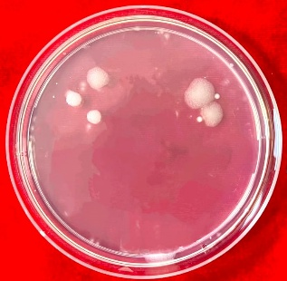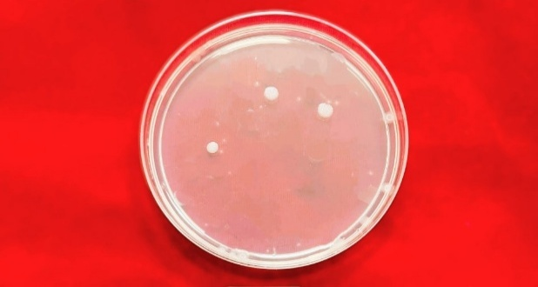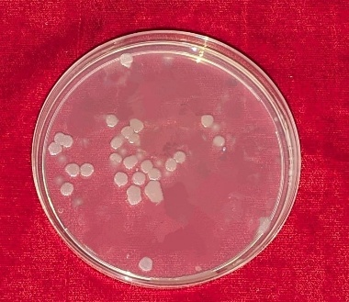
Diafenthiuron 50 % WP
Control
Profenophos 50 % EC

Fig. 1 Effect of different insecticides on the growth of B. thuringiensis var. kurstaki.

4. CONCLUSION
The findings of this study confirm that the compatibility of insecticides with Bacillus thuringiensis var. kurstaki (Bt) varies significantly, influencing the viability and effectiveness of Bt as a microbial biopesticide. Among the tested insecticides, Chlorantraniliprole 18.5 % SC exhibited the highest compatibility, supporting maximum Bt colony growth with minimal inhibition. Flubendiamide 39.35 % SC and Emamectin benzoate 5% SG also showed favorable compatibility, whereas Profenophos 50 % EC demonstrated strong inhibitory effects, indicating poor suitability for combined use with Bt. These results highlight the importance of compatibility assessments when integrating chemical and microbial agents in pest management programs. Using insecticides that are compatible with Bt can enhance the efficacy of biocontrol strategies and support the development of more sustainable and environmentally friendly IPM approaches.
DISCLAIMER (ARTIFICIAL INTELLIGENCE)
Author(s) hereby declares that NO generative AI technologies such as Large Language Models (ChatGPT, COPILOT, etc) and text-to-image generators have been used during writing or editing of this manuscript.
COMPETING INTERESTS
Authors have declared that no competing interests exist
REFERENCES
Agostini, L. T., Duarte, R. T., Volpe, H. X. L., Agostini, T. T., de Carvalho, G. A., Abrahão, Y. P., & Polanczyk, R. A. (2014). Compatibility among insecticides, acaricides and Bacillus thuringiensis used to control Tetranychus urticae (Acari: Tetranychidae) and Heliothis virescens (Lepidoptera: Noctuidae) in cotton fields. Afr J Agric Res, 9, 941-949.
Amizadeh, M.J. Hejazi, G. Niknam, M. Arzanlou, Compatibility and interaction between Bacillus thuringiensis and certain insecticides: perspective in management of Tuta absoluta (Lepidoptera: gelechiidae). (2015). Biocontrol Sci. Technol, 25, 671–684.
Anandhi, P., Elamathi, S., Ahila Devi, P., Yashoda, P., Elenchezhiyan, K., Leena, G., & Velmurugan, S. (2025). Efficacy of Native Bacillus thuringiensis Berliner Isolates against Diamond Back Moth, [Plutella xylostella (Linnaeus)] and Its Compatibility with Common Insecticides. Asian Journal of Current Research, 10(1), 56-64.
Ansari, M. M., & Sharma, A. N. (2005). Compatibility of Bacillus thuringiensis and Beauveria bassiana with new insecticides recommended for insect pest control in soybean. Pestology, 29(9), 18-20.
Aronson, A. I., & Shai, Y. (2001). Why Bacillus thuringiensis insecticidal toxins are so effective: unique features of their mode of action. FEMS microbiology letters, 195(1), 1-8.
Crickmore, N., Berry, C., Panneerselvam, S., Mishra, R., Connor, T.R and Bonning, B.C. (2020). A structure-based nomenclature for Bacillus thuringiensis and other bacteria derived pesticidal proteins. Journal of Invertebrate Pathology, 107438.
De Souza Loureiro, E., Pessoa, L. G. A., Putrick, T. C., de Andréa Pantaleão, A., & Dias, P. M. (2020). In vitro compatibility between insecticides and the commercial bioinsecticide Agree® WG. Revista de agricultura neotropical, 7(1), 49-52.
George Z, Crickmore N. (2012) Bacillus thuringiensis applications in agriculture. In: Sansinenea E (ed) Bacillus thuringiensis Biotechnology. Springer, Netherlands, 19–39.
Gowtham, V., Muthuswami, M., Sathiah, N., Geetha, S., Varanavasiappan, S and Uma, D. 2022. Assessing the single and combined toxicity of chlorantraniliprole with Bacillus thuringiensis against maize fall armyworm S. frugiperda (J E Smith) (Lepidoptera: Noctuidae) under laboratory conditions. International Journal of Plant and Soil Science, 41–49.
Gupta, G., & Dikshit, A. (2019). Biopesticides: An ecofriendly approach for pest control. J Biopestic, 12(2), 81-84.
Gupta, M., Kumar, H., & Kaur, S. (2021). Vegetative insecticidal protein (Vip): a potential contender from Bacillus thuringiensis for efficient management of various detrimental agricultural pests. Frontiers in microbiology, 12, 659736.
Koul, O., Walia, S., and Dhaliwal, G. S. (2008). Essential oils as green pesticides: Potential and constraints. Biopestic Int, 4(1), 63-84.
Kumar, P., Kamle, M., Borah, R., Mahato, D.K and Sharma, B. (2021). Bacillus thuringiensis as microbial biopesticide: uses and application for sustainable agriculture. Egyptian Journal of Biological Pest Control, 31: 95.
Lambert, B and Perferon, M. (1992). Insecticidal promise of Bacillus thuringiensis. BioScience, 42: 112–122.
Mashtoly, T. A., El-Beltagi, H. S., Almujam, A. N., & Othman, M. N. (2022). The potential of a novel concept of an integrated bio and chemical formulate based on an entomopathogenic bacteria, Bacillus thuringiensis, and a chemical insecticide to control tomato leafminer, Tuta absoluta ‘(Meyrick)’(Lepidoptera: Gelechiidae). Sustainability, 14(17), 10582.
Pinto, L.M.N., Dorr, N.C., Ribeiro, A.P.A., Salles, S.M., Oliveira, J.V., Menezes, V.G., Fiuza, L.M. (2012). Bacillus thuringiensis monogenic strains: screening and interactions with insecticides used against rice pests. Brazilian Journal of Microbiology, 43(2), 618-626.
Sharma, A., Thakur, N., Hashem, A., Dawoud, T. M., & Abd_Allah, E. F. (2024). Insecticidal potential of Bacillus thuringiensis, Beauveria bassiana and Metarhizium anisopliae individually and their synergistic effect with barazide against Spodoptera litura. Heliyon, 10(17).
Shashikala, M., Gaur, N., Purwar, J. P., & Jayanth, B. V. (2023). Compatibility of Bacillus thuringiensis (Berliner) with insecticides against Helicoverpa armigera (Hubner) infesting chickpea. Journal of Experimental Zoology India, 26(2).
Supriya, K., Varma, N., Babu, T. K., Upendhar, S., & Lingaiah, N. (2025). Compatibility of Bacillus thuringiensis var. kurstaki and Pseudomonas fluorescens with pesticides recommended for rice pest management at drone and Taiwan spraying concentrations. Journal of Biological Control, 398-405.
Togola, A., Meseka, S., Menkir, A., Badu-Apraku, B., Boukar, O and Tamo, M. (2018). Measurement of pesticide residues from chemical control of the invasive S. frugiperda (Lepidoptera: Noctuidae) in a maize experimental field in Mokwa, Nigeria. International Journal of Environmental Research and Public Health, 15, 849–860.
Vachon, V., Laprade, R., & Schwartz, J. L. (2012). Current models of the mode of action of Bacillus thuringiensis insecticidal crystal proteins: a critical review. Journal of invertebrate pathology, 111(1), 1-12.
Vimala Devi, P. S., Duraimurugan, P., Poorna Chandrika, K. S. V., Vineela, V., & Hari, P. P. (2020). Novel formulations of Bacillus thuringiensis var. kurstaki: an eco-friendly approach for management of lepidopteran pests. World Journal of Microbiology and Biotechnology, 36, 1-14.

