Optimization and Comparative Assessment of Xylitol Production by Candida tropicalis and Saccharomyces cerevisiae

Abstract
This study focuses on optimizing xylitol production via fermentation using two yeast strains, Saccharomyces cerevisiae MTCC 172 and Candida tropicalis MTCC 230, utilizing hemicellulose as the substrate. The impact of agitation speed (rpm) and fermentation duration (hours) on xylose utilization and xylitol yield was systematically assessed. Among the tested conditions, Candida tropicalis MTCC 230 at 200 rpm for 120 hours exhibited the highest xylose conversion rate (76.16%) and xylitol concentration (16.54 g/L), outperforming Saccharomyces cerevisiae MTCC 172, which showed lower conversion efficiency. The superior performance of C. tropicalis was attributed to its higher tolerance to fermentation inhibitors and efficient xylose metabolism under limited nutrient and agitation conditions. These findings highlight the potential of C. tropicalis MTCC 230 as a robust candidate for industrial-scale xylitol production from renewable hemicellulosic biomass, offering an eco-friendly and cost-effective alternative to chemical synthesis.
Keywords- Xylitol production; Saccharomyces cerevisiae MTCC 172; Candida tropicalis MTCC 230; Xylose bioconversion; Agitation speed; Fermentation optimization; Asynchronous cell growth; Industrial fermentation;
INTRODUCTION
Humans have long sought to harness the benefits of nature, particularly in food production. However, the final decade of the 20th century marked a notable shift in food technology, largely driven by advancements in biological research (Mathur et al., 2023). These developments were primarily influenced by changes in population lifestyles and a growing consumer awareness regarding food products. Among the most commonly used food ingredients today is sugar, typically referring to sucrose, or table sugar. Sucrose, a disaccharide carbohydrate, belongs to a larger classification of carbohydrates that also includes monosaccharides (like glucose, fructose, and galactose), disaccharides (such as lactose and maltose), as well as oligosaccharides and polysaccharides (Kumar et al., 2022). The human diet is rich in monosaccharides and disaccharides, which are readily fermentable by acidogenic oral bacteria—one of the primary contributors to dental caries (Queiroz et al., 2022).
In light of the growing incidence of health problems associated with excessive sugar intake—such as dental cavities, obesity, and diabetes—a multi-billion-dollar industry has developed around sugar substitutes, also known as sugar-free sweeteners. These alternatives encompass both nutritive (caloric) and non-nutritive (non-caloric) compounds, which can be either chemically synthesized or naturally derived. Among these, sugar alcohols, or polyols, form a major category (Estrada-Ávila et al., 2022). Although they are structurally carbohydrates and possess a sweet taste, polyols are neither classified as traditional sugars nor as alcohols. They occur naturally in small amounts in various fruits, vegetables, and mushrooms. Sugar alcohols are classified according to their source: those derived from polysaccharides (such as hydrogenated starch hydrolysates), disaccharides (including isomaltitol, lactitol, maltitol, and trehalose), and monosaccharides (such as erythritol, mannitol, sorbitol, and xylitol) (Ding & Yang, 2021). The U.S. Food and Drug Administration (FDA) has classified these compounds as "Generally Recognized as Safe" (GRAS) for use in food products. Because sugar alcohols are only partially absorbed in the intestines, they provide fewer calories and have little effect on blood glucose and insulin levels (Umai et al., 2022). As a result, they are frequently blended with other sweeteners to enhance flavor and sweetness. The portion that remains unabsorbed is fermented by gut microbiota in the large intestine, which can sometimes lead to mild gastrointestinal discomfort (Park et al., 2016; Santos et al., 2025).
Widely used polyols such as xylitol, sorbitol, erythritol, maltitol, lactitol, mannitol, and isomalt are commonly employed in the food and pharmaceutical industries, owing to their advantageous physicochemical characteristics (Rice et al., 2019). Among these, xylitol stands out as a five-carbon sugar alcohol naturally present in a variety of fruits, berries, and mushrooms. First discovered in the late 19th century, xylitol appears as a white crystalline carbohydrate and is commonly used in low-carbohydrate food products (El-Marakby et al., 2017). While it is considered non-toxic to humans and most animals, xylitol is highly toxic to dogs and must be used with caution in households with pets (Benahmed et al., 2020). Given its wide application and potential health benefits, this review aims to provide a comprehensive overview of the production, health effects, and utilization of xylitol (Suhartini et al., 2022).
Chemistry
The term “xylitol” is derived from the Greek word “xylo”, meaning wood, combined with the suffix “-ol”, commonly used for sugar alcohols. As noted by Ortiz et al. (2013), xylitol is an alcohol-based compound that naturally occurs in plants and is also produced by certain bacteria and fungi. It is classified as a polyol or sugar alcohol and has the chemical formula CH₂OH(CHOH)₃CH₂OH, consisting of a five-carbon backbone (Saha and Kennedy, 2022). According to Baptista et al. (2021), xylitol is commercially extracted mainly from birch wood and other plant sources used in the production of food additives and pharmaceuticals. One of its notable benefits is its ability to inhibit the growth of harmful oral microorganisms, making it a popular ingredient in preventive dental care products due to its antibacterial properties. Clinical studies have demonstrated that xylitol is effective in reducing dental caries, leading to its widespread use by dental professionals to prevent cavities and promote oral health. During World War II, Scandinavian countries faced a significant sugar shortage and began using xylitol as a substitute. Today, xylitol is recognized as a suitable sugar alternative, especially for individuals with diabetes who follow low-carbohydrate diets. Unlike regular sugars, xylitol can enter cells without the need for insulin, making it a safe and effective energy source for diabetic patients (Jofre et al., 2021).
Properties
Xylitol provides approximately 2.43 kilocalories (kcal) per gram, which is significantly lower than the 3.87 kcal found in one gram of regular sugar. Its chemical characteristics are outlined in Table 1. Xylitol is known for its clean, sweet taste without any aftertaste and is often promoted as a safe alternative for individuals with diabetes or hyperglycemia. This safety is largely attributed to its minimal effect on blood glucose levels—xylitol has a glycemic index (GI) of just 7, in contrast to glucose, which has a GI of 100 (Godswill, 2017).
Sugar alcohol | Xylitol
Formula | C₅H₁₂O₅
Molecular weight (Da) | 152
Melting point (ºC) | 94
Degree of sweetness (%) | 100
Energy Kcal/g | 3.5-4.0
Solubility in Water (30 ºC) (%) | 67
State | White crystal of powder
Crysta1 system | (i) rhombic, stab1e  (ii)monoclinic,metastab1e
Odour | None
Table 1: Chemical properties of Xylitol Source: Ding and Yang, 2021
History
Prior to the discovery of its potential use in dentistry and medicine, xylitol's history was largely uneventful. Production methods were created and enhanced, and some applications had already enhanced the patent literature up until the 1970s. A word xylitol is German word taken from the Greek word xylon which derived from the English word xylem. The German chemistry professor Emil Herman Fischer and his assistant Rudolf Stahel, 1890 extracted the xylitol from beech chips (Fischer and Stahel, 1891). Later, Dr. Fischer received the Nobel Prize in chemistry in 1902 in recognition of his numerous scientific accomplishments. Further, the French chemist M.G. Bertrand succeeded in isolating xylitol syrup by processing wheat and oat straw almost simultaneously with Fischer (Bertrand, 1891). Therefore, the credit for "discovery" of xylitol was shared by two research teams. The next fifty years there was very little progress was seen in xylitol related studies. However, Dr. Oscar Touster, who practiced medicine in Nashville, Tennessee, in the 1950s, discovered the relation between pentosuria and human xylitol metabolism. For the first 50–60 years following its initial discovery in 1891, xylitol remained relatively obscure in scientific literature. A reflection of this uneventful period is found in an early statement by Carr and Krantz (1945), who remarked that "these compounds \[pentitols] have never been studied physiologically." This status changed significantly with the work of Dr. Touster. In the mid-1950s, he and his research team discovered that the human body is capable of producing xylitol.
According to Dr. Touster, essential pentosuria is caused by the accumulation and subsequent excretion of a metabolite that is readily eliminated in affected individuals but not in those without the condition. Further analysis led to the isolation and identification of this metabolite as xylitol (Touster and Shaw, 1962). Additional research related to xylitol is summarized in Table 2.
Table 2: The occurrence and manufacture of xylitol
Year | Study | Scientist/References
1891 | Xylitol is prepared as a syrup | Bertrand, 1891 and Fischer and Stahel, 1891
1942 | Hydrogenation of highly purified xylose to obtain crystalline xylitol | Wolfrom and Kohn, 1942
1943 | Describes the forms of xylitol: the stable rhombic and the unstable monoclinic crystalline forms | Carson et al. (1943)
1958 | Produced xylitol from xylose by Penicillium chrysogenum | Chiang et al. (1958)
1961 | Use as a sweetener in diabetic diets | Mellinghoff (1961)
1966 | Produced xylitol from xylose by using microbial source (yeasts) | Onishi and Suzuki (1966)
1969 | Produced from glucose through intermediate compounds such as D-arabitol and D-xylulose by specific yeast strains. | Onishi and Suzuki (1969)
1971-1979 | Study the metabolic behavior of xylitol in parenteral nutrition | Horecker et al., 1969; Brian and Miller, 1974; Thomas et al., 1974; Ritzel and Brubacher, 1976; Ylikahri, 1979
1975 | The first large-scale production of xylitol was initiated in Kotka, Finland, at the sucrochemical facility operated by the Finnish Sugar Co. Ltd., based in Helsinki. | --

Source of xylitol production
Although xylitol occurs naturally, it is typically found in very low concentrations—generally less than 1%—rendering direct extraction from natural sources commercially unfeasible. The highest natural sources of xylitol include fruits and vegetables such as plums, strawberries, raspberries, cauliflower, various berries, corn husks, oats, and mushrooms (Sharma et al., 2025). It is also present in certain agricultural and forestry residues, including hardwoods like birch and beech, wood shavings, cottonseed peels, nuts, straw, plant stems, corncobs, and sugarcane bagasse, the latter of which commonly contains 20–35% xylan (Bianchini et al., 2023). Additionally, bio-waste materials such as discarded birch bark and pulp can serve as feedstocks for xylitol production. The human body naturally synthesizes between 5 to 15 grams of xylitol daily as part of normal metabolic processes (Kumar et al., 2022).
Commercial production of xylitol typically involves the catalytic hydrogenation of xylose in a three-phase process using a metal catalyst, most commonly Raney nickel (Palladino et al., 2021). This reaction takes place in an aqueous medium under elevated hydrogen pressure and moderately high temperatures. Depending on the source and processing of the biomass, approximately 50–60% of the xylan content can be recovered as xylitol, which corresponds to about 8–15% of the initial raw material. When using pure xylose as the substrate, the process can achieve xylitol yields of up to 98% (Zhu et al., 2021).
The selection of raw materials is a critical factor in the economic feasibility of xylitol production. Ideal feedstocks are abundant and possess a relatively high xylan content. However, many alternative materials tend to be bulky and have low density, which complicates processing and transport. Moreover, xylan content varies depending on plant species, the specific plant part used, as well as collection, storage, and pre-treatment methods (West, 2021).
Despite its high yield potential, the chemical method for xylitol synthesis faces several challenges. These include high energy consumption due to the elevated reaction temperature and pressure requirements, as well as the complexity of downstream separation and purification steps. Additionally, the sensitivity and high cost of the metallic catalysts further increase overall production expenses (Queiroz, et al., 2025).
- Significance of Microbial Xylitol Production
Xylitol is a naturally occurring rare sugar found in small quantities in various fruits, vegetables, mushrooms, and lichens. Due to the feasibility of industrial-scale production, xylitol can also serve as a precursor for the biosynthesis of other rare sugars. For instance, xylitol can be oxidized to L-xylulose by the enzyme xylitol dehydrogenase. L-xylulose can subsequently be converted to L-lyxose or L-xylose via the action of L-rhamnose isomerase (Singh et al., 2024). Additionally, L-xylulose may be isomerized to L-ribulose, which can then be transformed into L-arabinose through L-arabinose isomerase.
The biotechnological production of xylitol has been extensively explored as a sustainable alternative to chemical synthesis, with a focus on elucidating the metabolic pathways involved in microbial growth on non-conventional substrates. Yeast strains from the genera Candida, Pichia, Debaryomyces, and Pachysolen are particularly efficient at converting D-xylose into xylitol through a series of metabolic reactions, yielding varying conversion efficiencies (Kaur et al., 2023).

Xylose Transport in Yeast Cells
Until recently, it was assumed that Saccharomyces cerevisiae lacked specific transporters for xylose and exhibited poor growth when xylose was the sole carbon source. However, recent studies have shown that S. cerevisiae is capable of slow growth under aerobic conditions using xylose. Yeasts represent highly promising microbial platforms for xylitol production due to their robustness and adaptability. They can thrive in both chemically defined and low-cost renewable media, such as those derived from hemicellulose. Research has further highlighted the significant influence of agitation speed (rpm) and fermentation duration (hours) on both xylitol yields and yeast growth dynamics, underlining the importance of process optimization for enhanced biotechnological outcomes.
Material and Methods
Plant material and microbial culture
The raw material, specifically corn waste, was collected from local farms and roadside vendors in Solan, Himachal Pradesh, India, during the period from August to October, 2023–2024. Hemicellulose was then extracted using the method described by Sharma et al. (2025).
The lyophilized yeast strains used for xylitol production through fermentation—Saccharomyces cerevisiae MTCC 172 and Candida tropicalis MTCC 230—were obtained from the Microbial Type Culture Collection and Gene Bank (MTCC), CSIR-Institute of Microbial Technology, Chandigarh. The cultures were maintained on Yeast Extract Peptone Dextrose (YEPD) and Xylose Yeast Extract (XYE) agar media (Dasgupta et al., 2022).
Revival of yeast cultures
Media preparation
All components listed in Table 3, except agar, were weighed in the specified quantities and dissolved in distilled water to prepare the broth medium. The pH was adjusted to 6.5 for Saccharomyces cerevisiae MTCC 172 and 5.5 for Candida tropicalis MTCC 230. After pH adjustment, agar was added and mixed thoroughly. The prepared medium was then dispensed into conical flasks and sealed with cotton plugs. Following the standard procedure outlined by Sherman (1991), the culture media, along with petri plates, vials, beakers, and flasks required for the experiment, were sterilized by autoclaving at 121 ± 2 °C for 20 minutes (Vardhan et al., 2024).
Table 3 Composition for Yeast extract peptone dextrose (YEPD)
Composition | Quantity
 | Saccharomyces cerevisiae MTCC 172 | Candida tropicalis MTCC 230
Dextrose (g) | 20.00 | 50.00
Peptone (g) | 20.00 | 20.00
Yeast extract (g) | 10.00 | 10.00
Agar (g) | 15.00 | 15.00
Distilled water (L) | 1.00 | 1.00
Preparation of inocula
Inocula of Saccharomyces cerevisiae MTCC 172 and Candida tropicalis MTCC 230 were prepared for hemicellulose fermentation using four separate slants (15 mL each). The cultures were incubated for 48 hours at 25 ± 1 °C and 30 ± 1 °C, respectively, in a BOD incubator (Khera Model No. KI-216). The pH of the inoculum was adjusted to 5.00. To maintain culture viability, fresh inocula were prepared every two weeks by repeating the same procedure (Sharma, 2024).
Production of xylitol from hemicellulose
Fermentation
Freshly prepared inoculum was combined with pre-pasteurized hemicellulose in a conical flask, following the procedure described by Banerjee et al. (2019). The mixture was incubated in a BOD incubator (Khera Model No. KI-216) at temperatures specific to each yeast strain, with varying agitation speeds (rpm) to enhance the bioconversion of xylose into xylitol. Samples were collected at regular 6-hour intervals throughout the fermentation process to monitor the concentrations of xylose and xylitol. Fermentation was considered complete when the xylitol concentration stabilized.
After fermentation, the collected data were analyzed to assess the efficiency of the process as per the methodology of Mardawati et al. (2018). The fermentation broth containing xylitol was centrifuged at 5000 rpm for 20 minutes using a Remi-Research Centrifuge to separate the yeast biomass. The resulting clear supernatant was transferred into pre-sterilized glass bottles and stored at refrigerated conditions (8 ± 2 °C) for subsequent analysis.
.Xylose Content (g/L) and Xylitol Content (g/L)
Xylose Content Determination
The xylose content in the samples was estimated following the method outlined by Horecker (1974), with minor modifications. A standard calibration curve was prepared using varying volumes of xylose solution ranging from 10 µL to 50 µL. To each test tube, 0.2 mL of borate buffer and 0.01 mL of D-xylose were added. The mixture was thoroughly mixed and incubated at 37 ± 2 °C for 1 hour. Following incubation, 1.0 mL of distilled water, 6 mL of sulfuric acid, 0.2 mL of cysteine solution, and 0.2 mL of carbazole solution were added sequentially with thorough mixing after each addition. The reaction mixtures were then left to stand at room temperature for 2 hours. The optical density (OD) was measured at 540 nm using a spectrophotometer. Xylose concentrations were calculated from the standard curve and expressed in g/L.

Xylitol Content Determination
Xylitol concentration in the fermented samples was quantified using the method described by Bassler (1974), with slight modifications. A standard curve was constructed using xylitol solutions ranging from 10 µL to 50 µL. In each test tube, 1 mL of Tris buffer and 1 mL of the sample were mixed, followed by the addition of a reaction mixture consisting of 0.10 mL NAD solution and 0.8 mL distilled water. The solution was mixed thoroughly, and 0.02 mL of standard sorbitol dehydrogenase (sDH) solution was added. After zeroing the spectrophotometer, the absorbance was recorded at 340 nm. Xylitol concentrations were calculated based on the standard curve and expressed in g/L.
Process performance
The process performance, including yeast growth (expressed as specific growth rate), product yield, and xylose substrate utilization, was evaluated using the formulas provided by Mardawati et al. (2018).
Here,
- X0X_0X0​ and XXX represent the initial and final cell concentrations, respectively.
- S0S_0S0​ and SSS denote the initial and final substrate concentrations.
- P0P_0P0​ and PPP correspond to the initial and final product concentrations.
The specific growth rate (μ\muμ) was calculated using the following formula:
μ=ln⁡X−ln⁡X0t−t0\mu = \frac{\ln X - \ln X_0}{t - t_0}μ=t−t0​lnX−lnX0​​
The biomass yield (YX/SY_{X/S}YX/S​) in g/g, representing the ratio of biomass produced to substrate consumed (xylose), was determined from the growth curve of dry cell weight using the equation:
YX/S=X−X0S0−SY_{X/S} = \frac{X - X_0}{S_0 - S}YX/S​=S0​−SX−X0​​
The product yield (YP/SY_{P/S}YP/S​) in g/g of xylitol was calculated as:
YP/S=P−P0S0−SY_{P/S} = \frac{P - P_0}{S_0 - S}YP/S​=S0​−SP−P0​​
The product yield per cell biomass (YP/XY_{P/X}YP/X​) in g/g, defined as the amount of xylitol produced per unit biomass at the end of fermentation, was expressed as:
YP/X=P−P0X−X0Y_{P/X} = \frac{P - P_0}{X - X_0}YP/X​=X−X0​P−P0​​
Xylose utilization (%) was calculated by comparing the amount of xylose consumed during fermentation to the initial xylose concentration, reflecting the proportion of substrate utilized by the yeast for biomass and product formation.
Results and Discussion
Optimization of Conditions for Xylitol Production by Saccharomyces cerevisiae MTCC 172 and Candida tropicalis MTCC 230
The effect of agitation speed (rpm) and fermentation time (hours) on xylose consumption and xylitol production was investigated using two yeast strains: Saccharomyces cerevisiae MTCC 172 and Candida tropicalis MTCC 230.
For S. cerevisiae MTCC 172, among the different agitation speeds tested, the greatest reduction in xylose concentration was observed at 200 rpm (treatment T2), where xylose levels decreased from 20.35 to 11.17 g/L after 96 hours. This was followed by 150 rpm (T1), which showed a decrease to 13.50 g/L after 114 hours. The smallest reduction was recorded at 250 rpm (T3), with xylose decreasing to 14.06 g/L after 78 hours. Correspondingly, the highest xylitol production was also noted at 200 rpm, reaching 9.23 g/L at 96 hours, followed by 7.26 g/L at 150 rpm and 6.28 g/L at 250 rpm. Thus, treatment T2 (200 rpm and 96 hours) yielded the highest xylose-to-xylitol conversion efficiency in the shortest fermentation period and was selected for further research.
Similarly, for C. tropicalis MTCC 230, the most significant reduction in xylose concentration occurred at 200 rpm (T2), where levels dropped from 20.35 to 4.85 g/L after 120 hours. This was followed by reductions to 7.84 g/L at 150 rpm (T1, 144 hours) and to 8.50 g/L at 250 rpm (T3, 114 hours). The corresponding xylitol yields were highest at 200 rpm, reaching 16.54 g/L, followed by 13.48 g/L at 150 rpm and 11.37 g/L at 250 rpm. Again, treatment T2 (200 rpm and 120 hours) showed the highest bioconversion rate within the shortest effective fermentation time.
Overall, both yeast strains demonstrated the most efficient conversion of xylose to xylitol at agitation speeds between 150 and 200 rpm. Beyond this range, conversion efficiency decreased, likely due to suboptimal conditions for yeast metabolism and cell growth. Lower agitation speeds tend to promote better biomass accumulation and longer reaction times, which are favorable for xylose conversion. These observations are consistent with findings reported in previous studies, such as those involving Candida guilliermondii in rice hydrolysate fermentation (Gurpilhares et al., 2009) and metabolic activity variations linked to asynchronous cell growth (de Arruda et al., 2011).
Based on the results, treatment T2 (200 rpm) was identified as optimal for both S. cerevisiae MTCC 172 (at 96 hours) and C. tropicalis MTCC 230 (at 120 hours), demonstrating the highest xylose-to-xylitol bioconversion within the shortest fermentation periods and was chosen for further investigation.
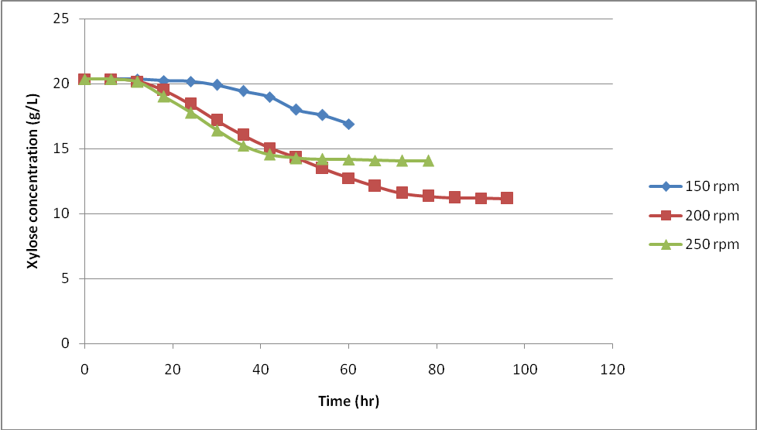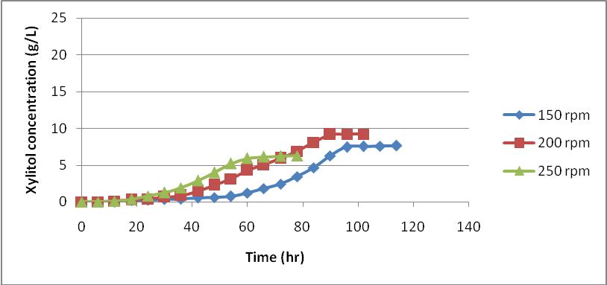
(a) xylose concentration (b) xylitol production
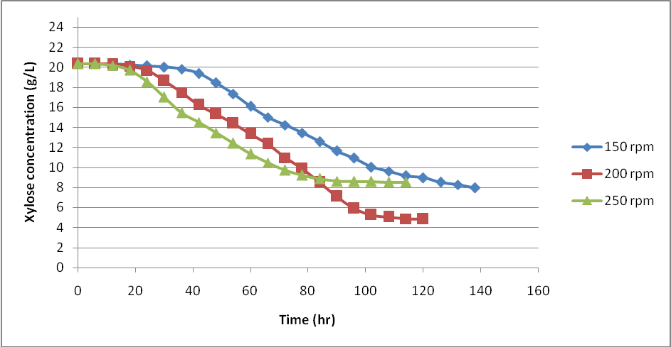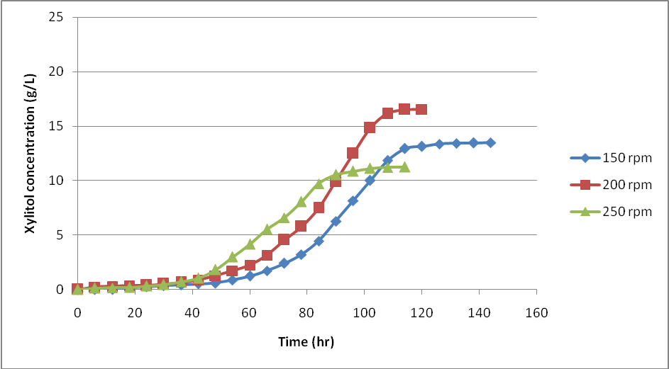
(c) xylose concentration (d) xylitol production

Figure 1: Effect of agitation speed and fermentation time on by Saccharomyces cerevisiae MTCC 172 (a) total xylose concentration (b) xylitol production and (c) total xylose concentration (d) xylitol production by Candida tropicalis MTCC 230
Impact of Fermentation Conditions on the Growth of Microorganisms
After a 4-hour adaption period, the Saccharomyces cerevisiae MTCC 172 fermentation demonstrated a logarithmic growth phase from the 12th to the 96th hour. The fermenting process required 102 hours to complete. The logarithmic phase for Candida tropicalis MTCC 230 spanned from the 12th to the 108th hour, and the adaption phase similarly lasted 4 hours.
S. cerevisiae MTCC 172 had a specific growth rate (μ) of 0.0039 h⁻¹, but C. tropicalis MTCC 230 had a higher specific growth rate of 0.056 h⁻¹ (Table 4). According to these findings, the growth rate of C. tropicalis MTCC 230 was noticeably higher than that of S. cerevisiae MTCC 172.
Minimal cell development during fermentation is suggested by the low or almost nil specific growth rate that was observed. Under circumstances of high initial cell concentration, microbial cells may preferentially use carbohydrates to generate metabolites, which could explain this delayed growth. Inhibited cell development under these high-cell-density fermentation conditions may also be caused by low oxygen supply.
Table 4: Fermentation product of microbial strains after fermentation
Products | Types of microbial hydrolysis
Products | Sacchromyces cerevisiae MTCC 172 | Candida tropicalis MTCC 230
Initial Xylose Concentration (g/L) | 20.35±0.600 | 20.35±0.600
Final Xylose Concentration (g/L) | 11.17±0.140 | 4.85±0.200
Xylose utilization (%) | 45.11±2.900 | 76.16±1.450
Initial Xylitol Concentration (g/L) | 0.00±0.000 | 0.00±0.000
Final Xylitol Concentration (g/L) | 9.20±0.170 | 16.54±0.130
Initial cell concentration (g cell/L) | 0.163±0.900 | 0.163±0.900
Final cell concentration (g cell/L) | 0.013±0.100 | 0.031±0.110
Specific growth rate (h⁻¹) (µ) | 0.0056±0.00 | 0.039±0.00
L* (Lightness) | 83.62 | 87.62
a* (Redness- Greenness) | -5.37 | -6.14
b*(Yellowness- Blueness) | 16.51 | 21.01
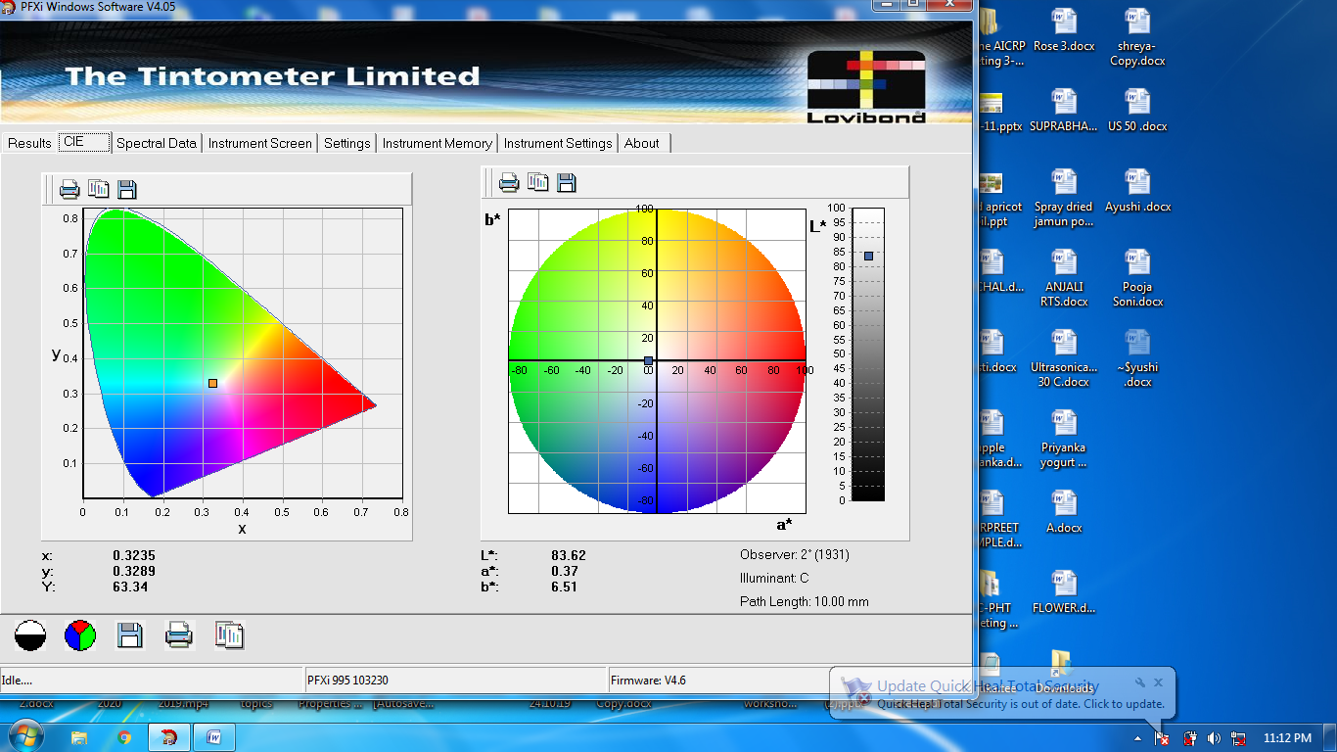
(a)
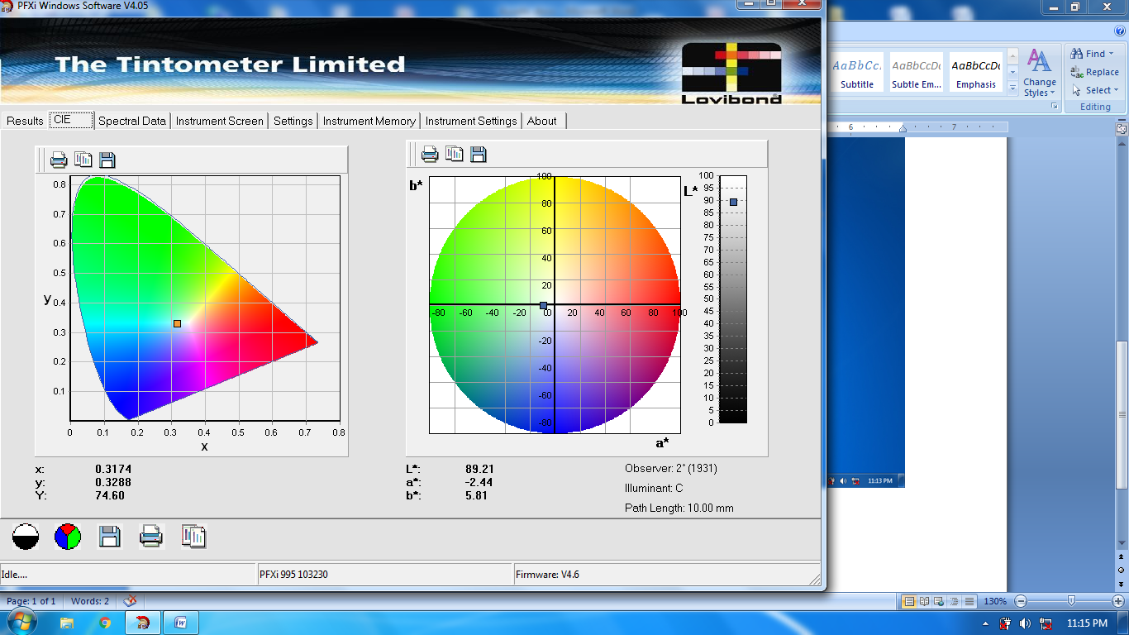
(b)
Figure 2: Color value (L*a*b*) of xylitol fermentation broths (a) Sacchromyces cerevisiae MTCC 172 (b) Sacchromyces cerevisiae MTCC 172
The fermentation process's conversion of xylose to xylitol is shown in Table 3. The starting and final xylose concentrations for Saccharomyces cerevisiae MTCC 172 were 20.35 ± 0.60 g/L and 11.77 ± 0.14 g/L, respectively. By contrast, the initial and final xylose concentrations of Candida tropicalis MTCC 230 were 20.35 ± 0.60 g/L and 4.85 ± 0.20 g/L, respectively. The final xylitol concentrations for S. cerevisiae MTCC 172 and C. tropicalis MTCC 230 were 9.20 ± 0.17 g/L and 16.54 ± 0.13 g/L, respectively, after starting at 0.00 ± 0.00 g/L for both strains.
For S. cerevisiae MTCC 172 and C. tropicalis MTCC 230, the overall xylose utilization during fermentation was 45.11 ± 2.90% and 76.16 ± 1.45%, respectively. Candida tropicalis MTCC 230 produced the most xylitol out of the two yeast strains. This strain demonstrated a higher capacity to consume xylose at low agitation rates and in nutrient-limited conditions. The slow rise in xylitol concentration during fermentation suggests that C. tropicalis MTCC 230 is not affected by inhibitory compounds. This is probably because it is more resistant to xylose fermentation, toxicity, and inhibitors that are frequently found in hemicellulosic hydrolysates (Prakasham et al., 2009). The strain's effective metabolic pattern is demonstrated by the steady bioconversion over time, which supports good xylose fermentability and produces significant xylitol yields.
Saccharomyces cerevisiae MTCC 172, on the other hand, demonstrated significantly reduced xylose-to-xylitol conversion at all agitation speeds. This could be explained by the way it breaks down xylose into furfural, which then breaks down into acetic and formic acids, which are lethal to microbes and severely reduce the production of xylitol (Jia et al., 2016). Comparable results have been documented for the fermentation of xylitol utilizing C. tropicalis with synthetic media (Wang et al., 2015) or sugarcane bagasse (Tizazu et al., 2018).
As yeasts can adapt to various conditions with different nutrient levels, pH, inhibitors, and types of sugar, microbial sources provide a cost-effective way to produce xylitol using xylose-rich substrates without the need for detoxification, yeast cell recycling, and high xylose-to-xylitol yields, productivity, reduced energy consumption, simplified downstream purification, and the use of fermentation media derived from industrial by-products (Yewale et al., 2017). Misra et al. (2012) observed similar results with Hibiscus rosa-sinensis nectar, and Rao et al. (2006) used corn fiber to produce xylitol. As a result, Candida tropicalis MTCC 230 was optimized and chosen for additional research using agitation speed of 200 rpm for 120 hours.
Conclusion
The synthesis of xylitol from xylose by two yeast strains, Saccharomyces cerevisiae MTCC 172 and Candida tropicalis MTCC 230, was successfully assessed and optimized in the present investigation. Candida tropicalis MTCC 230 outperformed the other one, obtaining more xylose consumption and a larger output of xylitol, particularly when agitated at 200 rpm for 120 hours of fermentation. The strain exhibited strong tolerance to fermentation inhibitors commonly present in hemicellulosic hydrolysates, contributing to its efficient bioconversion and stable xylitol production. In contrast, Saccharomyces cerevisiae MTCC 172 showed lower conversion rates, likely due to the production of toxic degradation products during fermentation. The findings highlight Candida tropicalis MTCC 230 as a robust and promising microbial candidate for cost-effective and sustainable xylitol production using xylose-rich substrates without the need for detoxification or complex processing. This research lays the groundwork for scaling up xylitol bioproduction through optimized fermentation conditions, which can be applied in industrial settings to utilize agricultural residues and industrial by-products efficiently.
Future Perspective
Building on the promising results obtained with Candida tropicalis MTCC 230, future research should focus on scaling up the fermentation process to pilot and industrial levels, ensuring consistency and economic viability. Genetic and metabolic engineering approaches could be explored to further enhance the strain’s xylose assimilation and xylitol production efficiency while increasing its tolerance to potential inhibitors. Additionally, integrating renewable and low-cost lignocellulosic biomass sources, such as agricultural residues and industrial waste streams, could improve the sustainability and cost-effectiveness of xylitol production. Developing continuous or fed-batch fermentation systems may optimize productivity and reduce fermentation time. Moreover, comprehensive studies on downstream processing techniques are needed to improve xylitol recovery and purification. Overall, these advances would contribute significantly to the commercialization of microbial xylitol production as an eco-friendly alternative to chemical synthesis.

Ethical Statement
This study did not involve any human participants or animal subjects and therefore did not require ethical approval. All microbial strains used in this research were obtained from authorized culture collections and handled in accordance with institutional biosafety and ethical guidelines.
References
Sharma, R., Vaidya, D., Kaushal, M., Gupta, A., Shavnam, & Thakur, C. (2025). Valorization of corn waste for hemicellulose extraction and xylitol production: Comparative study of different extraction methods. Biofuels, Bioproducts and Biorefining.
Mathur, S., Kumar, D., Kumar, V., Dantas, A., Verma, R., & Kuca, K. (2023). Xylitol: Production strategies with emphasis on biotechnological approach, scale up, and market trends. Sustainable Chemistry and Pharmacy, 35, 101203.
Kumar, K., Singh, E., & Shrivastava, S. (2022). Microbial xylitol production. Applied Microbiology and Biotechnology, 106(3), 971-979.
Queiroz, S. S., Jofre, F. M., Mussatto, S. I., & Felipe, M. D. G. A. (2022). Scaling up xylitol bioproduction: Challenges to achieve a profitable bioprocess. Renewable and Sustainable Energy Reviews, 154, 111789.
Estrada-Ávila, A. K., González-Hernández, J. C., Calahorra, M., Sánchez, N. S., & Peña, A. (2022). Xylose and yeasts: A story beyond xylitol production. Biochimica et Biophysica Acta (BBA)-General Subjects, 1866(8), 130154.
Santos, H., & Guillen-Lambea, S. (2025). Environmental assessment of xylitol production routes for thermal energy storage applications: A critical review. Renewable and Sustainable Energy Reviews, 214, 115532.
Umai, D., Kayalvizhi, R., Kumar, V., & Jacob, S. (2022). Xylitol: bioproduction and applications-a review. Frontiers in Sustainability, 3, 826190.
Suhartini, S., Rohma, N. A., Mardawati, E., Hidayat, N., & Melville, L. (2022). Biorefining of oil palm empty fruit bunches for bioethanol and xylitol production in Indonesia: A review. Renewable and Sustainable Energy Reviews, 154, 111817.
Saha, B. C., & Kennedy, G. J. (2021). Optimization of xylitol production from xylose by a novel arabitol limited co-producing Barnettozyma populi NRRL Y-12728. Preparative Biochemistry & Biotechnology, 51(8), 761-768.
Baptista, S., Romani, A. P., & Domingues, L. (2021). Biotechnological advancements, innovations and challenges for sustainable xylitol production by yeast.
Jofre, F. M., Hernández-Pérez, A. F., dos Santos, J. C., & de Almeida Felipe, M. D. G. (2021). Use of dry yeast biomass as a new approach for detoxification of hemicellulosic hydrolysates aiming to xylitol production. Industrial Crops and Products, 170, 113812.
Bianchini, I. D. A., Jofre, F. M., Queiroz, S. D. S., Lacerda, T. M., & Felipe, M. D. G. D. A. (2023). Relation of xylitol formation and lignocellulose degradation in yeast. Applied microbiology and biotechnology, 107(10), 3143-3151.
Kumar, K., Singh, E., & Shrivastava, S. (2022). Microbial xylitol production. Applied Microbiology and Biotechnology, 106(3), 971-979.
Palladino, F., Rodrigues, R. C., Cadete, R. M., Barros, K. O., & Rosa, C. A. (2021). Novel potential yeast strains for the biotechnological production of xylitol from sugarcane bagasse. Biofuels, Bioproducts and Biorefining, 15(3), 690-702.
Zhu, Y., Zhang, J., Zhu, L., Jia, Z., Li, Q., Xiao, W., & Cao, L. (2021). Minimize the xylitol production in Saccharomyces cerevisiae by balancing the xylose redox metabolic pathway. Frontiers in Bioengineering and Biotechnology, 9, 639595.
West, T. P. (2021). Xylitol production by Candida species from hydrolysates of agricultural residues and grasses. Fermentation, 7(4), 243.
Queiroz, S. S., Campos, I. S., Silva, T. F., & Felipe, M. D. G. A. (2025). Xylitol bioproduction by Candida tropicalis: effects of glucose/xylose ratio and pH on fermentation and gene expression. Brazilian Journal of Microbiology, 56(1), 105-116.
Singh, A. K., Pandey, A. K., Kumar, M., Paul, T., & Gaur, N. A. (2024). Improved xylitol production by the novel inhibitor-tolerant yeast Candida tropicalis K2. Environmental Technology, 45(1), 1-15.
Kaur, S., Guleria, P., & Yadav, S. K. (2023). Evaluation of fermentative xylitol production potential of adapted strains of Meyerozyma caribbica and Candida tropicalis from rice straw hemicellulosic hydrolysate. Fermentation, 9(2), 181.
Dasgupta, D., Sidana, A., Sarkar, B., More, S., Ghosh, D., Bhaskar, T., & Ray, A. (2022). Process development for crystalline xylitol production from corncob biomass by Pichia caribbica. Food and Bioproducts Processing, 133, 45-56.
Vardhan, H., Sasmal, S., & Mohanty, K. (2024). Detoxification of areca nut acid hydrolysate and production of xylitol by Candida tropicalis (MTCC 6192). Preparative Biochemistry & Biotechnology, 54(1), 61-72.
SHARMA, R. (2024). VALORIZATION OF CORN WASTE FOR THE PRODUCTION OF XYLITOL (Doctoral dissertation, Dr. YASHWANT SINGH PARMAR UNIVERSITY OF HORTICULTURE AND FORESTRY).
Sherman F. 1991. Getting started with yeast. In Methods in Enzymology. 194(1):3-21.
Banerjee M, Lazzell AL, Romo JA, Lopez-Ribot JL and Kadosh D. 2019. Filamentation is associated with reduced pathogenicity of multiple non-albicans Candida species. Msphere. 4(10): 11-28.
Mardawati E, Andoyo R, Syukra KA, Kresnowati MTAP and Bindar Y. 2018. Production of xylitol from corn cob hydrolysate through acid and enzymatic hydrolysis by yeast. Earth and Environmental Science. 141(4): 12-19.
Horecker BL. 1974. D-xylulose and D-xylose determination with D.-xylose isomerase. In: methods of enzymatic Analysis (11th ed) Vol.3. H.u. Bergmeger. New York. 1371p.
Bassler KH. 1974. Xylitol. In & Methods of Enzymatic Analysis. (3rd ed). Academic Press, H.O. Bergmeyer, New York.1381p
Prakasham RS, Rao RS and Hobbs PJ. 2009. Current trends in biotechnological production of xylitol and future prospects. Current Trends in Biotechnology and Pharmacy. 3(1): 8-36.
Wang S, Li H, Fan X, Zhang J, Tang P and Yuan Q. 2015. Metabolic responses in Candida tropicalis to complex inhibitors during xylitol bioconversion. Fungal Genetics and Biology. 82(1): 1-8.
Jia H, Shao T, Zhong C, Li H, Jiang M, Zhou H Wei P. 2016. Evaluation of xylitol production using corncob hemicellulosic hydrolysate by combining tetrabutylammonium hydroxide extraction with dilute acid hydrolysis. Carbohydrate Polymers. 151: 676-83.
Tizazu BZ, Roy K and Moholkar VS. 2018. Mechanistic investigations in ultrasound-assisted xylitol fermentation. Ultrasonics Sonochemistry. 48: 321-28.
Yewale T, Panchwagh S, Sawale S, Jain R and Dhamole PB. 2017. Xylitol production from non-detoxified and non-sterile lignocellulosic hydrolysate using low-cost industrial media components. Biotech. 7(1): 68-84.
Rao RS, Jyothi CP, Prakasham RS, Sarma PN Rao LV. 2006. Xylitol production from corn fiber and sugarcane bagasse hydrolysates by Candida tropicalis. Bioresource Technology. 97(15): 1974-78.
Misra S, Raghuwanshi S and Saxena RK. 2012. Fermentation behavior of an osmo tolerant yeast D. hansenii for xylitol production. Biotechnology Progress. 28(6): 1457-65.

