***Original Research Article***

***In vitro* and *in vivo* evaluation of plant growth-promoting traits of bacterial isolates from *Piper nigrum* and *Piper colubrinum***

**___________________________________________________________________**

**ABSTRACT**

Black pepper (*Piper nigrum* L.) is a valuable commercial crop of India, particularly in Kerala, with Wayanad district serving as a major hub for its cultivation, where farmers in these hilly regions heavily rely on chemical fertilizers to maintain crop productivity. However, prolonged use of these fertilizers can degrade soil health, disturb the microbial balance, and limit nutrient availability over time. In the pursuit for eco-friendly alternatives, plant growth-promoting bacteria (PGPB) have gained attention for their ability to enhance plant health while preserving soil integrity. The present study explored the potential of bacterial isolates from both wild and cultivated *Piper* species as PGPB. Many of the bacterial isolates exhibited multiple beneficial traits, including nitrogen fixation, phosphate and zinc solubilization, production of phytohormones such as indole-3-acetic acid (IAA) and gibberellic acid (GA), and ACC deaminase activity. Based on these characteristics, seven strains primarily belonging to the genus *Bacillus*, including *Bacillus* sp., *B. amyloliquefaciens*, *B. drentensis*, *B. velezensis*, and *B. subtilis* were selected and formulated into microbial consortia. *In vivo* evaluations revealed that the consortium derived from *Piper colubrinum* (PCCB) significantly enhanced plant growth metrics, indicating its superior efficacy. These findings underscore the potential of native bacterial isolates as bioinoculants for sustainable black pepper cultivation, particularly in challenging environments like the hill ecosystems of Kerala.

*Keywords: Black pepper, plant growth promoting bacteria, Bacillus, Piper colubrinum*

**1.INTRODUCTION**

Black pepper (*Piper nigrum* L.), a member of the family Piperaceae and order Piperales, is one of the most widely traded spices, often referred to as the “King of Spices”. India ranks among the world’s top five producers of black pepper, contributing approximately 64,816 tons annually (FAOSTAT, 2023). Native to the Western Ghats region of India, Black pepper holds immense commercial importance, particularly for the state of Kerala (Kumar et al., 2021). To meet the crop's nutritional demands and to maintain black pepper yields, farmers continue to rely heavily on fertilizer application (da Silva et al., 2024). Yet, long-term reliance on chemical fertilizers may lead to soil acidification, which in turn hampers nutrient absorption by plant roots. Additionally, the heavy and consistent rainfall in Kerala, particularly in the hilly regions, where most black pepper farms are situated, exacerbates nutrient leaching. This can contribute to both surface and groundwater contamination due to nitrate runoff (Lau et al., 2020). As a result, farmers are compelled to pay more for the cost of fertilizers to ensure continued productivity. These challenges have collectively driven a shift in yield sustainability strategies in black pepper cultivation, moving away from sole dependence on chemical inputs and increased use of eco-friendly alternatives. In this context, plant-associated microbes, particularly Plant Growth Promoting Rhizobacteria (PGPR) offer a promising solution. They have the potential to enhance crop growth through improved nutrient acquisition and hormone production, and also strengthen plant’s resilience against environmental stresses.

Bacteria found in the rhizosphere and the internal parts of tissues of the stem, roots, and leaves of both susceptible *Piper nigrum* and *Phytophthora*-resistant *Piper colubrinum* exhibit plant growth-promoting characteristics (Anju et al., 2023). These bacteria play a vital role in enhancing plant growth and represent a valuable resource for the development of sustainable agricultural inputs (Chauhan et al., 2021; Lugtenberg and Kamilova, 2009). Their beneficial effects are mediated through mechanisms such as indole-3-acetic acid (IAA) production, nitrogen fixation, phosphorus solubilization, nutrient mobilization, and antagonistic activity against pathogens via the production of siderophores, cellulase, and glucanase (Kumar, 2016). The application of plant-associated bacteria has been widely reported to promote growth in *Piper* species (Hyder et al., 2020; da Silva et al., 2024; Lau et al., 2020). Most studied plant growth-promoting bacteria (PGPB) include species belonging to the genera *Bacillus*, *Pseudomonas*, and *Arthrobacter*. These bacteria have been reported as effective biological agents for enhancing plant growth and managing *Phytophthora capsici* in various agricultural crops (Zohara et al., 2016; Nguyen et al., 2020; Kollakkodan et al., 2020). The present study characterized bacterial isolates from *Piper* species based on their plant growth-promoting traits and did evaluate their potential effects on plant growth through both *in vitro* and *in vivo* assays. The results seeks to contribute to the development of microbial inoculants as sustainable biofertilizers for black pepper cultivation.

**2.MATERIALS AND METHODS**

**2.1 Bacterial isolates**

The bacterial strains used in the present study are listed in Table 1. A total of 73 strains were isolated from the rhizosphere soil, stems, leaves, and roots of *Piper nigrum* and *Piper colubrinum*, following the methodology of Abarna and Anith (Unpublished). From these, 20 morphologically distinct isolates with notable antagonistic activity were selected for evaluating their plant growth-promoting traits. The selected strains were preserved as pure cultures in nutrient broth supplemented with 60% glycerol and stored at -80°C.

**2.2 *In vitro* plant growth promoting traits**

**2.2.1 Nitrogen fixation**

The ability of the bacterial isolates to fix nitrogen was examined qualitatively by streaking it on nitrogen-free malate agar plates that were enriched with bromo thymol blue (BTB). The plates were incubated at 30°C for 7 days. A colour change from apple green to blue on the plates signifies a positive result for nitrogen fixation. For quantitative assay, 24-hour-old bacterial culture was inoculated into 100 mL of nitrogen-free malate bromothymol blue (NFB) broth and incubated at 28±2°C for seven days. The quantitative estimation of nitrogen was done by micro-kjeldahl method and the total nitrogen in the sample was expressed in μg mL-1 (Backera et al., 2021).

**2.2.2 Phosphate solubilization**

The ability of the bacterial isolates to solubilize tricalcium phosphate was evaluated using a plating method. A 10 µl aliquot of a 24-hour bacterial culture was spotted onto National Botanical Research Institute's phosphate growth medium (NBRIP) medium, while a 5 mm mycelial plug of the fungal isolates was placed on the same medium. The plates were incubated at 28±2°C for 48 hours. Following incubation, the areas where clear zones formed around the inoculation spots were considered indicative of phosphate solubilization, as described by Paul and Sinha (2017). The efficiency of phosphate solubilization was subsequently measured.

$$Phosphate solubilizing ability= \frac{Halozone diameter}{Colony diameter}× 100$$

The phosphorus solubilizing ability of selected bacterial isolates was quantitatively evaluated using the procedure outlined by Clescerie *et al*. (1998). 24 h-old bacterial cultures and fully grown fungal endophytes were inoculated into 50 mL of sterile Pikovskaya's broth and incubated for 10 days at 28±2°C under continuous shaking at 110 rpm. Following centrifugation, 5 mL of the supernatant was transferred to a screw-capped vial and mixed with an equal volume of Vanadomolybdate reagent. The mixture was adjusted to a final volume of 25 mL and incubated overnight to allow for the development of a yellow color. The absorbance was then measured at 430 nm using a spectrophotometer. Uninoculated broth was used as the control. Each treatment was replicated twice, and the phosphorus solubilization per 5 g of tricalcium phosphate added to one liter of broth was determined using a standard phosphorus curve, with the results expressed in mg L-1.

**2.2.3. Zinc solubilization**

The ability of bacterial and fungal isolates to solubilize zinc was evaluated using a plating assay. To assess solubilization efficiency, 10 µl of bacterial suspension was inoculated onto Bunt and Rovira medium supplemented with zinc oxide, while in the case of fungal isolates, a 5 mm mycelial plug of was placed on the same medium. The inoculated plates were incubated at 28±2°C for 48 hours. Following incubation, colonies that produced a clear zone around them were identified as zinc-solubilizing (Saravanan *et al*., 2003). The solubilization efficiency was measured as outlined in a previously described method (Section 3.5.2.1).

$$Zinc solubilizing ability= \frac{Halozone diameter}{Colony diameter}× 100$$

**2.2.4 IAA production**

The isolates were introduced into test tubes containing 5 mL of sterilized nutrient broth supplemented with 0.1% tryptophan. The cultures were incubated for 48 hours at 28±2°C under shaking conditions at 120 rpm. Following incubation, the cells were separated by centrifugation at 12,000 rpm for 10 minutes, and the supernatant was used for qualitative assessment of IAA. 500 μL supernatant was mixed with 50 μL of 0.1 mM ortho-phosphoric acid and 2 mL of Salkowski reagent (prepared by dissolving 1 mL of 0.5 M FeCl3 in 50 mL of 35% perchloric acid). This mixture was kept in the dark for 20 minutes to allow color development, with the appearance of a pink to red hue indicating IAA production by the bacterial isolates. IAA produced by the isolates was quantified using spectrophotometric method by measuring absorbance at 535 nm. The concentration of IAA was then determined using a standard curve prepared with 0.5–10 µg of IAA (Sigma-Aldrich). IAA concentration was determined from a standard curve and expressed in μg/mL, following the protocol of Myo *et al*. (2019).

**2.2.5 GA production**

Bacterial isolates were inoculated into 10 mL of sterile Nutrient broth in triplicate, followed by incubation at 30°C for 7 days. After the incubation period, the broth cultures were centrifuged at 10,000 rpm for 10 minutes, following the protocol of Restu *et al*. (2019). To the resulting supernatant, 2 mL of zinc acetate solution (prepared by dissolving 21.9 g of zinc acetate in 80 mL of distilled water, adding 1 mL of glacial acetic acid, and adjusting the volume to 100 mL with distilled water) was added. After 2 minutes, 2 mL of potassium ferrocyanide solution was added, allowing the mixture to settle. The samples were again centrifuged at 10,000 rpm for 10 minutes. Subsequently, 5 mL of 30% hydrochloric acid was added to 5 mL of the supernatant, and the mixture was incubated at 20°C for 75 minutes, while 5% HCl was used as a blank control. The absorbance of the samples was measured at 254 nm using a UV-Vis spectrophotometer. A standard curve of gibberellic acid (GA) was constructed using concentrations of 20, 40, 60, 80, and 100 µg/mL of GA (Himedia).

**2.2.6 1-Aminocyclopropane 1-carboxylate-deaminase** (**ACC deaminase) activity**

The qualitative analysis was performed by streaking bacterial isolates into DF (Dworkin and Foster) salts minimal medium and incubating them at 28±2°C for 48 h. Bacteria that grew during incubation were considered positive. For the quantitative analysis of ACC deaminase activity, the procedure established by Penrose and Glick (2003) was followed. Bacterial cells were grown in 15 mL of NA broth and incubated overnight in a shaker at 200 rpm. The resultant biomass was collected through centrifugation at 8000 g for 10 minutes at 4°C. After discarding the supernatant, the cells were washed with 5 mL of DF salts minimal medium. An additional centrifugation at 8000 g for 10 minutes at 4°C was performed, and the cells were then suspended in 7.5 mL of DF salts minimal medium in a fresh culture tube. 45 mL of a 0.5 M 1-aminocyclopropane-1-carboxylic acid (ACC) solution was added to achieve a final ACC concentration of 3.0 mM. After 24 hours of incubation, bacterial biomass was again collected by centrifugation at 16,000 rpm for 5 minutes. The cells were washed with 0.1 M Tris-HCl (pH 7.6) and resuspended in 600 μL of 0.1 M Tris-HCl (pH 8.5). Following the wash, 30 μL of toluene was added to lyse the cells, and the mixture was vortexed for 30 seconds. A 200 μL aliquot of the toluenized cell suspension was incubated with 20 μL of 0.5 M ACC at 30°C for 15 minutes. After incubation, 1 mL of 0.56 N HCl was introduced, mixed via vortexing, and cell debris was removed through centrifugation at 16,000 rpm for 5 minutes. Next, 1 mL of the culture supernatant was combined with 800 μL of 0.56 N HCl and 300 μL of freshly prepared DNPH reagent (0.1 g of 2,4-dinitrophenyl hydrazine in 100 mL of 2 N HCl). The resulting mixture was vortexed and incubated at 30°C for 30 minutes. After the incubation period, 2 mL of 2 N NaOH was added, and the absorbance was measured at 540 nm using a spectrophotometer. The amount of μmoles of α-ketobutyrate produced was quantified by comparison with a standard curve ranging from 0.1 to 1 mM.

**2.3 Selection of potent isolates**

Based on the assessment of *in vitro* plant growth-promoting attributes, seven efficient bacterial isolates exhibiting desirable characteristics were selected and consortium was formulated for green house experiment.

**2.4 Plant growth assessment in black pepper**

A study was conducted under naturally ventilated greenhouse conditions at the Department of Microbiology, College of Agriculture, Vellayani. Healthy, two-node cuttings of the black pepper variety Panniyur 1 were planted in polybags (20 cm x 10 cm) filled with a potting mixture of sand, soil, and farmyard manure (FYM) in a 1:2:1 ratio, with four cuttings per bag. The experiment followed a Completely Randomized Design CRD with six treatments and 4 replication each. The number of plants per replication was five.

Cross-streaking of bacterial isolates was performed on NA plates, followed by incubation at 28°C for 1 to 2 days to allow the bacteria to reach their maximum log phase of growth. After the incubation period, the bacterial cultures were harvested from the Petri dishes by scraping using sterile water to create a uniform suspension of the bacterial cells. The optical density (OD) of this suspension was standardized to 1.00 at 600 nm, ensuring an approximately uniform concentration of bacterial cells.

The basal ends of Panniyur 1 black pepper cuttings were immersed in the respective bacterial and IBA (1000 ppm) solution for 30 minutes prior to planting. Control plants did not receive any treatment.

**2.4.1 Biometric observations**

Biometric measurements were taken at one-month intervals. The observations included the number of days taken for sprouting, shoot length (cm), plant height (cm), number of leaves, and number of branches per plant. After 180 days destructive sampling was done and fresh and dry weights of the shoots (g), fresh and dry weights of the roots (g), root length (cm) and root volume (cm3) were recorded. To determine the dry weights, the samples were dried at 60°C using a hot air oven till a constant weight was obtained.

**2.5 Statistical analysis**

Greenhouse trials were conducted with three biological replicates to assess the impact of different bacterial strains on black pepper growth. A completely randomized design (CRD) was adopted for the experiment. Statistical analysis was carried out using ANOVA, incorporating both F-test and Student’s t-test. Additionally, ANOVA was employed to analyze the significant differences among bacterial treatments for various plant growth-promoting traits, including nitrogen fixation, phosphate and zinc solubilization, ACC deaminase activity, and the production of indole acetic acid (IAA) and gibberellic acid (GA). These analyses were performed using the Kerala Agricultural University’s GRAPES (General R-shiny based Analysis Platform Empowered by Statistics) software (<https://www.kaugrapes.com>), maintaining a significance level of 0.05.

**3.Results:**

**3.1 *In vitro* plant growth promoting assays**

**3.1.1 Nitrogen estimation**

Among the 20 bacterial isolates tested on NFB medium, growth was observed for strains PNS1, PNS2, PNS8, PNS14, PNS19, PNS21, PNL4, PCS9, and PCRO5 (Table 1, Fig 1A). In the quantitative nitrogen estimation using the micro-Kjeldahl method, isolates PNS19 and PCS9 demonstrated the highest nitrogen content, followed by PNS1, whereas PNL4 exhibited the lowest nitrogen release (Fig 1B).

**3.1.2 Phosphorus and Zinc solubilization**

All the isolates except PNS1, PNS2, PNS14, PNS17, PNS21, and PCS9 exhibited solubilization zones (Tables 1, Fig 1C). In the quantitative analysis, among the 20 bacterial endophytes tested, PCRO6 exhibited the highest phosphate solubilization (32.67 mgL⁻¹), followed by PNS8 (27.52 mgL⁻¹) and PNRS8 (27.19 mgL⁻¹), whereas PCRS1 demonstrated the lowest solubilization (0.32 mgL⁻¹) (Table 1).

The capability of bacterial isolates to solubilize zinc was evaluated based on their ability to dissolve the inorganic form of zinc, specifically zinc oxide (Fig 1D). Among the 20 bacterial isolates examined, the highest zinc solubilization efficiency was observed with PCRS5 (258.3%), followed closely by PCRO1 (253.3%) and PNS1 (241.7%). In contrast, the isolate PCRO6 exhibited no zinc solubilization activity, indicating a negative result (Table 1).

**3.1.3 IAA and GA production**

IAA production by bacterial isolates varied between 13.91 μg mL⁻¹ and 25.26 μg mL⁻¹. Among bacterial isolates, PCRS5 exhibited the highest IAA production (25.26 μg mL⁻¹), whereas isolate PNS8 recorded the lowest (13.91 μg mL⁻¹), as presented in Table 1. A statistically significant variation was observed in the IAA production levels among the isolates.

The quantification of gibberellic acid (GA₃) produced by the bacterial isolates associated with *Piper* spp. are presented in Table 1. Among the 20 isolates examined, PNRO6 exhibited the highest GA₃ production, reaching 210.7 µg mL⁻¹, followed by PNS17 with 199.5 µg mL⁻¹. In contrast, the lowest gibberellic acid synthesis was observed in *Bacillus licheniformis* PNS2, which produced 18.0 µg mL⁻¹. Statistical analysis revealed that the variation in GA₃ production among the bacterial isolates cultured in the presence of potassium ferrocyanide was significantly different at a 5% level of significance.

**3.1.4 ACC deaminase activity**

Among the 20 isolates examined, PCRS4 exhibited the highest ACC deaminase activity, measuring 23.4 µmol mL⁻¹. This was followed by PNRS8, which recorded an activity of 22 µmol mL⁻¹. No statistically significant variation was observed among the isolates PNS17, PCS9, and PCRO6. Conversely, the lowest ACC deaminase activity was detected in PNS21, with a value of 5.5 µmol mL⁻¹. All other isolates demonstrated statistically significant differences at a 5% significance level (Table 1).

**3.2 *In vivo* plant growth assessment**

Based on the evaluation of plant growth-promoting traits, seven promising bacterial isolates were selected and used to formulate different treatments. These included consortia composed of *Piper colubrinum* isolates, that from *Piper nigrum*, a combination of both, and control (without any treatment), as detailed below:

T1 – *Piper colubrinum* bacterial consortium (PCCB)  
T2 – *Piper nigrum* bacterial consortium (PNCB)  
T3 – Combined bacterial consortium of *P. colubrinum* and *P. nigrum* (PCCB + PNCB)  
T4 – Indole-3-butyric acid (IBA) at 1000 ppm  
T5 – Control

Biometric parameters, including the number of days required for sprouting, shoot length (cm), root length (cm), plant height (cm), shoot fresh weight (g), number of leaves, root fresh weight (g), shoot dry weight (g), root dry weight (g), and the number of branches per plant, are presented in Table 2. The results revealed a significant difference in growth parameters in cuttings treated with a consortium of *Piper* spp. isolates compared to those treated with indole-3-butyric acid (IBA) and the untreated control (Fig 2). The bacterial treatments exhibited similar results to those of the IBA-treated plants, and in some parameters even h superior performance.

Treatments T2 (PNCB) and T1 (PCCB) showed early sprouting at 38 and 39 days after planting (DAP), whereas sprouting in all other treatments was observed at 40 to 41 DAP. Among the evaluated parameters, cuttings treated with promising *Piper* spp. isolates (treatment T1) demonstrated superior performance, with a shoot length of 60.67 cm, root length of 12.3 cm, plant height of 72.97 cm, number of leaves totalling 12, root volume measuring 0.79 cm³, shoot fresh weight of 20.61 g, root fresh weight of 0.86 g and root dry weight 0.41 g. Additionally, treatment T3 (PCCB&PNCB) recorded the highest shoot dry weight (5.22). In contrast, the control group (treatment T5) recorded the lowest values across all parameters.

**4.Discussion**

Researchers around the world have dedicated studying different farming environments to find native microorganisms that help plants grow. Wild plants often support distinct microbial communities that are different from those associated with cultivated plants, which undergo intensive breeding and frequent agrochemical treatments (El-Sayed et al., 2014). In this study, rhizobacteria and endophytic bacteria isolated from both wild black pepper (*Piper colubrinum*) and cultivated (*Piper nigrum*) varieties were evaluated for their plant growth-promoting properties. Plant growth promoting bacteria have grabbed global attention due to their important role in enhancing soil nutrient availability, facilitating plant nutrient uptake, improving soil structure, and producing extracellular compounds (Bulgarelli et al., 2015).

The twenty bacterial strains used in the study displayed a range of *in vitro* plant growth-promoting (PGP) traits, including nitrogen fixation, mineral solubilization, production of indole-3-acetic acid (IAA) and gibberellic acid (GA), as well as ACC deaminase (ACCD) activity. The nitrogen-fixing ability was observed in 45% of the bacterial isolates, with 58.3% from *Piper nigrum* plants. Biological nitrogen fixation (BNF) carried out by soil microorganisms is recognized as a key process through which plants gain advantages from their association with microbial partners (Soumare et al., 2020). Numerous plant growth-promoting rhizobacteria (PGPR) have been identified for their ability to fix atmospheric nitrogen (Gopalakrishnan et al., 2015, 2018). *Kosakonia* isolates of black pepper roots have been reported to possess nitrogen-fixing ability (da Silva et al., 2024). Thanh and Tram (2018) observed that the rhizospheric bacteria of *Piper nigrum*, belonging to the *Bacillus* genus, demonstrated excellent nitrogen-fixing ability. According to a report by Backera et al. (2021), actinobacteria isolated from the rhizospheric soil of black pepper demonstrated significantly higher nitrogen fixation.

One of the key nutrient acquisition abilities of PGPB is their capacity to solubilize complex inorganic and organic mineral compounds (Fanai et al., 2024). In a soil ecosystem, nutrients essential for the plant growth engage in a complex and fluctuating state of balance between available and unavailable forms. This balance is governed by soil acidity or alkalinity which is often modified by microbial communities, thereby influencing the availability of nutrients for plant root uptake. Although natural soils typically lack sufficient soluble phosphorus and zinc, microorganisms have the remarkable ability to solubilize or mobilize their insoluble forms, making them accessible to plants (Kumari et al., 2024). In our study, out of the twenty bacterial strains tested, thirteen demonstrated the ability to solubilize the primary form of insoluble inorganic phosphorus, tri-calcium phosphate in the plate assays (Table 1). The quantitative analysis of phosphate solubilization in broth cultures supported the findings, as the same strains successfully converted tri-calcium phosphate into its soluble form in liquid medium. They mainly produce organic acids that either lower soil pH or chelate mineral ions, releasing bound phosphorus and zinc for plant absorption (Walia et al., 2017). The results were consistent with study conducted by Puri et al. (2020), that the plant growth promoting bacteria solubilize the organic and inorganic phosphate in both plate and broth assay.

Plant hormones such as IAA and GA3 are crucial for promoting growth by stimulating cell division and regulating various developmental processes. The growth-promoting effects observed in many PGPR are often attributed to their ability to produce these hormones (Lotfi et al., 2022). Plant growth-promoting bacteria (PGPB), whether residing in the rhizosphere or as endophytes, can effectively utilize plant-derived tryptophan to produce IAA, and synthesize GA3, thereby playing a crucial role in enhancing plant growth. In this study, we found that all bacterial isolates, except four, could produce GA3. Moreover, every strain tested was able to convert tryptophan, metabolically expensive amino acid for bacteria, yet abundantly present in plant tissues and root exudates, into IAA. Lau et al., (2020) found that production of IAA by *Bacillus* and *Pseudomonas* have greatly influenced the black pepper root development. Another study has shown that *Pseudomonas* strains isolated from apple and pear produce high levels of GA, which play a significant role in promoting stem elongation, seed germination, breaking dormancy, influencing sex expression, and accelerating fruit aging (Sharma et al., 2018). Yet another hormone for the plant growth is ethylene, but its overproduction in plants have been shown to inhibit root elongation and thus hinder overall plant development (Torbaghan et al., 2017). ACC acts as a precursor to ethylene, a key hormone involved in plant growth regulation. When ACC deaminase-producing bacteria are present, they help convert ACC into less harmful compounds, effectively lowering ethylene concentrations during the sowing stage of black pepper cuttings and encouraging their growth (Singh et al., 2015). In our study, it was revealed that all the strains were capable of producing the ACC deaminase enzyme, as evidenced by the formation of α-ketobutyrate following the cleavage of ACC. Patil et al (2016) reported that ACC deaminase activity is found in bacteria such as *Pseudomonas aeruginosa*, *Stenotrophomonas maltophilia*, and *Bacillus subtilis*. The greenhouse experiments conducted to evaluate the plant growth-promoting effects of a combination of seven effective bacterial strains showed highly promising results. These bacteria were applied as a consortium to evaluate their ability to promote plant growth under *in vivo* conditions. In vegetatively propagated crops such as black pepper, bacterial isolates need to persist on the cuttings for 30 to 45 days until roots begin to form. In this study, the bacterial isolates from *Piper* species were applied to the plant before the cuttings were placed in polybags for further observation (Aravind et al., 2012). In our study, when *Bacillus* sp. were applied together, they significantly improved the growth of black pepper plants in pot experiments showing increases in the number of leaves, fresh weight, shoot and root lengths, and leaf surface area compared to the untreated control plants. Moreover, the plants treated with the bacterial consortium exhibited growth responses that were either equivalent to or better than those treated with indole-3-butyric acid (IBA) at 1000 ppm, a commonly used synthetic rooting hormone. This indicates that the bioinoculants not only mimic the effects of synthetic hormones but may also provide additional advantages through multifaceted mechanisms such as ACC deaminase-mediated ethylene regulation and enhanced nutrient solubilization. Similar results on the bacterization on black pepper increased the root and shoot growth has been reported by Anju et al. (2023). Vyshakhi and Anith (2021) also observed that several endophytic *Bacillus* species enhanced seedling growth in vegetable crops.

**5.Conclusion**

The present study assessed the 20 rhizospheric and endophytic bacterial strains isolated from *Piper* spp. for their plant growth-promoting attributes, including the production of indole-3-acetic acid (IAA) and gibberellic acid (GA), ACC deaminase activity, nitrogen fixation, and the solubilization of phosphate and zinc. Among them, seven efficient *Bacillus* strains were selected for *in vivo* evaluation. When applied as a consortium, these isolates significantly enhanced the growth of black pepper plants—improving parameters such as the number of leaves and branches, shoot and root length, and overall biomass—compared to untreated control plants. These results suggest that the selected isolates hold promise for biofertilizer development, offering an eco-friendly and sustainable alternative to synthetic fertilizers while reducing environmental impact.

**REFERENCES**

Anju, A. B., Natarajan, C., Preetha, R., Rajan, S. A., Soumya, V. I., & Anith, K. N. (2023). Bacterization with endospore-forming *Bacillus* spp. promotes plant growth and suppresses foot rot disease in black pepper (*Piper nigrum* L.) in the nursery. *J. Pure Appl. Microbiol*, 17(2), 8181.

Aravind, R., Kumar, A., & Eapen, S. J. (2012). Pre-plant bacterization: A strategy for delivery of beneficial endophytic bacteria and production of disease-free plantlets of black pepper (Piper nigrum L.). *Archives of Phytopathology and Plant Protection*, 45(9), 1115–1126.

Backera, R., Girija, D., Gopal, S., Vijayaraghavan, R., & Beenav, I. (2021). Plant growth promoting actinobacteria from rhizosphere soils of black pepper in Wayanad. *Journal of Biotechnology and Bioprocessing*, 2(5).

Bulgarelli, D., Garrido-Oter, R., Münch, P. C., Weiman, A., Dröge, J., Pan, Y., McHardy, A. C., & Schulze-Lefert, P. (2015). Structure and function of the bacterial root microbiota in wild and domesticated barley. *Cell Host & Microbe*, 17(3), 392–403.

Chauhan, A., Saini, R., & Sharma, J. C. (2021). Plant growth promoting rhizobacteria and their biological properties for soil enrichment and growth promotion. *Journal of Plant Nutrition*, 45(2), 273–299.

Clesceri, L. S., Greenberg, A. E., & Eaton, A. D. (1998). *Standard methods for examination of water and wastewater* (20th ed.).

Da Silva, A. M., Da Cruz Paula Neves, P., Costa, S. S., Silva, A., Schneider, M. P. C., Das Graças, D. A., Da Silva, J. K. D. R., & Baraúna, R. A. (2024). Assessment of plant-growth promoting potential of bacteria isolated from Amazonian black pepper roots. *Journal of Soil Science and Plant Nutrition*, 24(2), 2825–2837.

El-Sayed, W. S., Akhkha, A., El-Naggar, M. Y., & Elbadry, M. (2014). In vitro antagonistic activity, plant growth promoting traits and phylogenetic affiliation of rhizobacteria associated with wild plants grown in arid soil. *Frontiers in Microbiology*, 5, 651.

Fanai, A., Bohia, B., Lalremruati, F., Lalhriatpuii, N., Lalmuanpuii, R., & Singh, P. K. (2024). Plant growth promoting bacteria (PGPB)-induced plant adaptations to stresses: An updated review. *PeerJ*, 12, e17882.

FAOSTAT. (2023). In: Food and Agriculture Organization of the United Nations. *FAOSTAT Database*. Retrieved July 25, 2023, from <https://www.fao.org/faostat/en/#data/QCL/visualize>

Gopalakrishnan, S. V., Srinivas, A., Vemula, S., Samineni, A., & Rathore, A. (2018). Influence of diazotrophic bacteria on nodulation, nitrogen fixation, growth promotion and yield traits in five cultivars of chickpea. *Biocatalysis and Agricultural Biotechnology*, 15, 35–42.

Gopalakrishnan, S., Srinivas, V., Prakash, B., Sathya, A., & Vijayabharathi, R. (2015). Plant growth-promoting traits of *Pseudomonas geniculata* isolated from chickpea nodules. *3 Biotech*, 5, 653–661.

Hyder, S., Gondal, A. S., Rizvi, Z. F., Ahmad, R., Alam, M. M., Hannan, A., Ahmed, W., Fatima, N., & Inam-ul-Haq, M. (2020). Characterization of native plant growth promoting rhizobacteria and their anti-oomycete potential against *Phytophthora capsici* affecting chilli pepper (*Capsicum annuum* L.). *Scientific Reports*, 10(1), 13859.

Kollakkodan, N., Anith, K. N., & Nysanth, N. S. (2020). Endophytic bacteria from *Piper colubrinum* suppress *Phytophthora capsici* infection in black pepper (*Piper nigrum* L.) and improve plant growth in the nursery. *Archives of Phytopathology and Plant Protection, 54*(1), 86–108.

Kumar, B. M., Sasikumar, B., & Kunhamu, T. K. (2021). Agroecological aspects of black pepper (Piper nigrum L.) cultivation in Kerala: A review. *AGRIVITA Journal of Agricultural Science*, 43(3), 648–664.

Kumar, V. V. (2016). Plant growth-promoting microorganisms: interaction with plants and soil. *Plant, Soil and Microbes: Volume 1: Implications in Crop Science*, pp. 1–16.

Kumari, A., Sharma, H., Kumari, A., Sharma, P., Pathak, N., Singh, R., Al-Tawaha, A. R., Pandey, D. K., Shekhawat, M. S., & Mandal, S. (2024). Current understanding and interface between micro-and macronutrients in the plant–soil system: An overview. *Essential Minerals in Plant-Soil Systems*, pp. 53–92.

Lau, E. T., Tani, A., Khew, C. Y., Chua, Y. Q., & San Hwang, S. (2020). Plant growth-promoting bacteria as potential bio-inoculants and biocontrol agents to promote black pepper plant cultivation. *Microbiological Research*, 240, 126549.

Lotfi, N., Soleimani, A., Çakmakçı, R., et al. (2022). Characterization of plant growth-promoting rhizobacteria (PGPR) in Persian walnut associated with drought stress tolerance. *Scientific Reports*, 12, 12725.

Lugtenberg, B., & Kamilova, F. (2009). Plant-growth-promoting rhizobacteria. *Annual Review of Microbiology*, 63(1), 541–556.

Mukhtar, T., Rehman, S. U., Smith, D., Sultan, T., Seleiman, M. F., Alsadon, A. A., Amna, Ali, S., Chaudhary, H. J., Solieman, T. H., & Ibrahim, A. A. (2020). Mitigation of heat stress in *Solanum lycopersicum* L. by ACC-deaminase and exopolysaccharide producing *Bacillus cereus*: Effects on biochemical profiling. *Sustainability*, 12(6), 2159.

Myo, E. M., Ge, B., Ma, J., Cui, H., Liu, B., Shi, L., Jiang, M., & Zhang, K. (2019). Indole-3-acetic acid production by *Streptomyces fradiae* NKZ-259 and its formulation to enhance plant growth. *BMC Microbiology*, 19, 1–14.

Nguyen, S. D., Trinh, T. H. T., Tran, T. D., Nguyen, T. V., Chuyen, H. V., Ngo, V. A., & Nguyen, A. D. (2020). Combined application of rhizosphere bacteria with endophytic bacteria suppresses root diseases and increases productivity of black pepper (Piper nigrum L.). *Agriculture*, 11(1), 15.

Patil, C., Suryawanshi, R., Koli, S., & Patil, S. (2016). Improved method for effective screening of ACC (1-aminocyclopropane-1-carboxylate) deaminase producing microorganisms. *Journal of Microbiological Methods*, 131, 102–104.

Paul, D. & Sinha, S. N. (2017). Isolation and characterization of phosphate solubilizing bacterium Pseudomonas aeruginosa KUPSB12 with antibacterial potential from river Ganga, India. *Annals of Agrarian Science*, 15(1), 130–136.

Penrose, D. M., & Glick, B. R. (2003). Methods for isolating and characterizing ACC deaminase-containing plant growth-promoting rhizobacteria. *Physiologia Plantarum*, 118(1), 10–15.

Puri, A., Padda, K. P., & Chanway, C. P. (2020). In vitro and in vivo analyses of plant-growth-promoting potential of bacteria naturally associated with spruce trees growing on nutrient-poor soils. *Applied Soil Ecology*, 149, 103538.

Restu, M., Bachtiar, B., & Larekeng, S. H. (2019). Gibberellin and IAA production by rhizobacteria from various private forest. *IOP Conference Series: Earth and Environmental Science*, 270, 012018.

Saravanan, T., Muthusamy, M., & Marimuthu, T. (2003). Development of integrated approach to manage the fusarial wilt of banana. *Crop Protection*, 22(9), 1117–1123.

Sharma, S., Sharma, A., & Kaur, M. (2018). Extraction and evaluation of gibberellic acid from Pseudomonas sp.: Plant growth promoting rhizobacteria. *Journal of Pharmacognosy and Phytochemistry*, 7(1), 2790–2795.

Singh, R. P., Shelke, G. M., Kumar, A., et al. (2015). Biochemistry and genetics of ACC deaminase: a weapon to “stress ethylene” produced in plants. *Frontiers in Microbiology*, 6, 937.

Soumare, A., Diedhiou, A. G., Thuita, M., Hafidi, M., Ouhdouch, Y., Gopalakrishnan, S., & Kouisni, L. (2020). Exploiting biological nitrogen fixation: A route towards a sustainable agriculture. *Plants*, 9(8), 1011.

Thanh, D. T. N., & Tram, D. T. T. (2018). Isolation and characterization of plant growth promoting rhizobacteria in black pepper (*Piper nigrum* L.) cultivated in Chon Thanh and Loc Ninh districts of Binh Phuoc province, Vietnam. *International Journal of Innovations in Engineering and Technology*, 10(1), 1–10.

Torbaghan, M. E., Lakzian, A., Astaraei, A. R., et al. (2017). Measurement of ACC-deaminase production in halophilic, alkalophilic and haloalkalophilic bacterial isolates in soil. *International Biological and Biomedical Journal*, 3(4), 194–202.

Vyshakhi, A. S., & Anith, K. N. (2021). Co-inoculation with the root endophytic fungus *Piriformospora indica* and endophytic bacteria improves growth of solanaceous vegetable seedlings. *International Journal of Vegetable Science*, 27(6), 536–551.

Walia, A., Guleria, S., Chauhan, A., & Mehta, P. (2017). Endophytic bacteria: Role in phosphate solubilization. In D. K. Maheshwari & K. Annapurna (Eds.), *Endophytes: Crop productivity and protection* (pp. 61–93). Springer, Cham.

Zohara, F., Akanda, M. A. M., Paul, N. C., Rahman, M., & Islam, M. T. (2016). Inhibitory effects of *Pseudomonas* spp. on plant pathogen *Phytophthora capsici* in vitro and in planta. *Biocatalysis and Agricultural Biotechnology*, 5, 69–77.

**Table 1. *In vitro* plant growth promoting assessment of bacterial isolates of *Piper* spp.**

|  |  |  |  |  |  |  |  |
| --- | --- | --- | --- | --- | --- | --- | --- |
| **Isolates** | **Total Nitrogen (µg mL-1)** | **Quantity of P solubilized (mgL-1)** | **Zn Solubilizing efficiency (%)** | **IAA (µg mL-1)** | | **GA (µg mL-1)** | **ACCD (µmol mL-1)** |
| **without tryptophan** | **with tryptophan** |
| PNS-1 | 0.0165±0.001ab | 0h | 241.7±8.3ab | 14.82±1.03cdef | 15.27±0.71fg | 33.4±1.8m | 8.5±0.7ghi |
| PNS-2 | 0.0135±0.003bc | 0h | 218.8±6.25bcd | 13.73±0.78ef | 14.82±0.62g | 18.0±0.2n | 6.5±0.3ij |
| PNS-8 | 0.015±0.001abc | 27.52±0.5b | 210.0±10cdef | 13.03±0.47ef | 13.91±0.56g | 125.6±0.4j | 7.8±0.6ghij |
| PNS-14 | 0.012±0.001cd | 0h | 237.5±12.5abc | 13.01±0.21ef | 15.77±1.83fg | 0±0.0o | 6.9±0.6hij |
| PNS-17 | - | 0h | 142.9±0h | 13.41±0.09ef | 19.53±0.31cde | 199.5±1.6b | 12.6±1.9e |
| PNS-19 | 0.018±0.001a | 17.25±0.6e | 160.7±10.7gh | 15.57±0.54bcde | 19.70±0.24cd | 104.9±2.6k | 11.4±0.4ef |
| PNS-21 | 0.015±0.001abc | 0h | 188.9±11.1defg | 12.00±0.19fg | 15.47±0.67fg | 0±0.0o | 5.5±0.7j |
| PNL-4 | 0.0085±0.001d | 0h | 168.6±14.7gh | 13.92±0.6ef | 19.39±0.93cde | 0±0.0o | 7.8±0.6ghij |
| PCS-9 | 0.018±0.001a | 0h | 187.5±12.5efg | 14.15±1.05ef | 15.30±0.25fg | 167.7±2.9e | 12.2±0.9e |
| PNRO-1 | - | 22.57±0.1d | 214.3±14.3bcde | 18.04±2.32abc | 23.74±0.31ab | 158.3±1.5f | 7.6±0.8ghij |
| PNRO-6 | - | 5.30±0.3g | 187.5±12.5efg | 14.57±1.29def | 19.20±0.31cde | 210.7±1.1a | 9.3±0.9fgh |
| PCRO-1 | - | 7.83±0.6f | 253.3±13.3a | 17.52±0.20abcd | 18.36±0.41def | 138.1±0.2h | 18.4±0.6cd |
| PCRO-5 | 0.0096±0.001d | 22.09±0.2d | 220.0±20bcd | 16.14±3.59bcde | 22.47±1.98a | 173.9±0.4d | 9.9±1.3efg |
| PCRO-6 | - | 32.67±2.5a | 0.00±0i | 17.70±2.91abcd | 20.80±0.66bcd | 190.7±2.7c | 12.2±1.0e |
| PCRO-7 | - | 22.52±0.2d | 200.0±0def | 9.62±0.16g | 15.58±0.16fg | 0±0.0o | 20.2±0.1bc |
| PNRS-3 | - | 25.45±0.1c | 179.5±8.0fg | 13.01±1.40ef | 19.45±0.53cde | 196.8±1.4b | 8.6±0.8ghi |
| PNRS-8 | - | 27.19±1.0bc | 212.5±12.5bcde | 13.02±1.15ef | 16.25±1.19efg | 108.4±0.5k | 22.0±1.1ab |
| PCRS-1 | - | 0.32±0.01h | 165.7±5.7gh | 13.46±1.02ef | 16.28±0.08efg | 147.2±1.3g | 16.4±0.4d |
| PCRS-4 | - | 9.13±0.1f | 200.0±0def | 18.19±0.10ab | 18.44±0.27def | 59.9±1.1l | 23.4±1.1a |
| PCRS-5 | - | 16.13±0.11e | 258.3±8.3a | 20.30±0.53a | 25.26±0.69a | 131.0±1.9i | 10.0±1.7efg |

*\*Values with similar letters within a column, representing means ± standard errors, indicate no significant difference based on the LSD test at P < 0.05. Since the P-value in ANOVA table is < 0.05, there is a significant difference between atleast a pair of treatments. PNS – Piper nigrum stem, PCS – Piper colubrinum stem, PNL – Piper nigrum leaf, PNRO – Piper nigrum root, PCRO – Piper colubrinum root, PNRS – Piper nigrum Rhizospheric soil, PCRS – Piper colubrinum Rhizospheric soil.*

**Table 2. Effect of combined application of bacterial isolates of *Piper* spp. on plant growth parameters in green house study**

|  |  |  |  |  |  |  |  |  |  |  |
| --- | --- | --- | --- | --- | --- | --- | --- | --- | --- | --- |
| **Treatments** | **Days required for sprouting** | **Shoot length (cm)** | **Root length (cm)** | **Plant height (cm)** | **No. of leaves** | **Root volume (cu cm)** | **Fresh root weight (g)** | **Fresh shoot weight (g)** | **Dry root weight (g)** | **Dry shoot weight (g)** |
| T1 - PCCB | 39 | 60.67±3.43a | 12.3±0.75a | 72.97±5.38a | 12 | 0.79±0.23a | 0.86±0.05a | 20.61±1.2a | 0.2±0.02a | 4.14±0.24b |
| T2 - PNCB | 38 | 51.28±2.37b | 10.27±0.68b | 61.55±2.59b | 10 | 0.25±0.11c | 0.48±0.04c | 15.5±0.86c | 0.13±0c | 2.71±0.23c |
| T3 - PCC&PNB (B) | 41 | 56.87±4.93ab | 9.73±0.32c | 66.6±5.71ab | 11 | 0.37±0.08b | 0.69±0.04b | 20.55±1.23a | 0.14±0.01c | 5.22±0.41a |
| T4 - IBA 1000 ppm | 40 | 50.82±3.85b | 11.3±0.79ab | 62.12±1.76b | 10 | 0.08±0.06d | 0.55±0.02c | 17.9±1.31b | 0.18±0.01b | 4.32±0.1b |
| T5 - CONTROL | 40 | 35.42±1.42c | 6.25±0.53d | 41.67±1.59c | 9 | 0.24±0.23c | 0.2±0.02d | 13.15±0.28d | 0.06±0d | 2.39±0.14c |

*\*Values with similar letters within a column, representing means ± standard errors, indicate no significant difference based on the LSD test at P < 0.05. Since the P-value in ANOVA table is < 0.05, there is a significant difference between atleast a pair of treatments.*

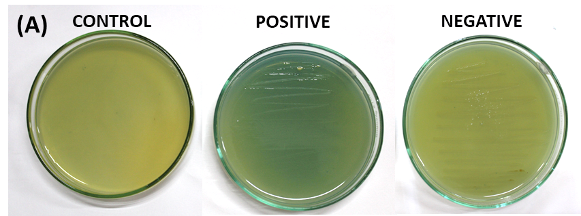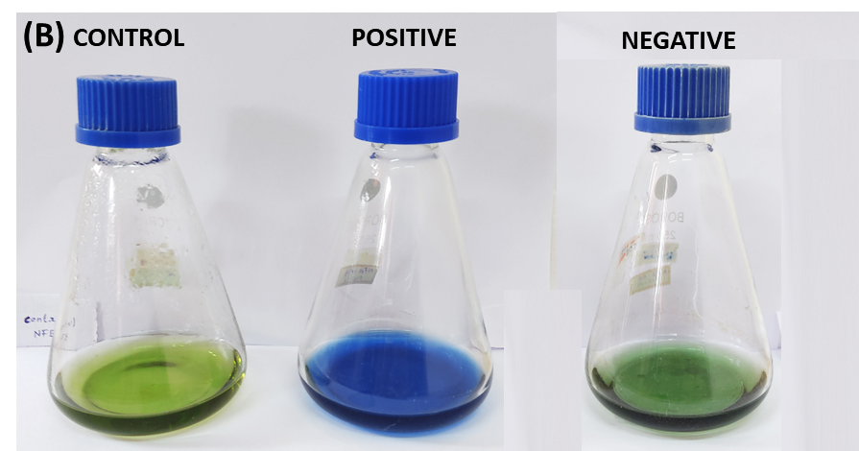

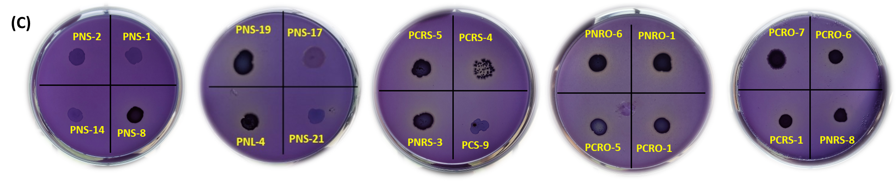

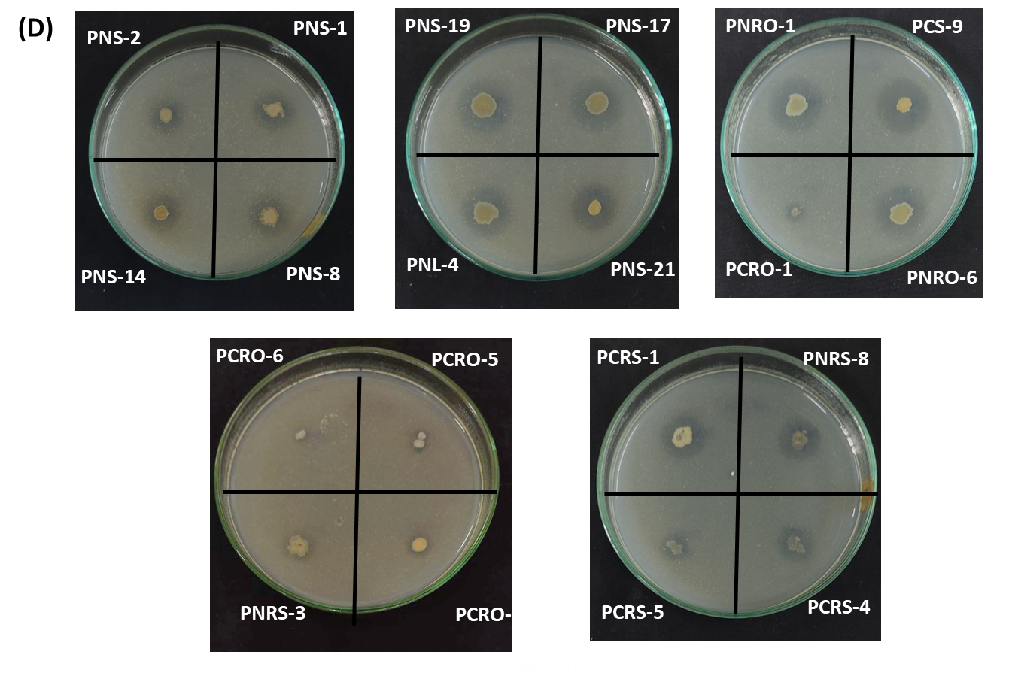

**Fig. 1. *In vitro* plant growth promoting traits of bacterial isolates of *Piper nigrum* and *Piper colubrinum***

(A) Qualitative biological Nitrogen fixation assay of bacterial isoalates in Nitrogen free malic acid media plate (B) Quantitative biological nitrogen fixation assay in NFB (Nitrogen free malic acid broth) (C) Phosphate solubilization assay in NBRIP medium with Tri calcium phosphate as inorganic phosphorus (D) Zinc solubilization assay in Bunt and Rovira medium with Zinc oxide as Zn source

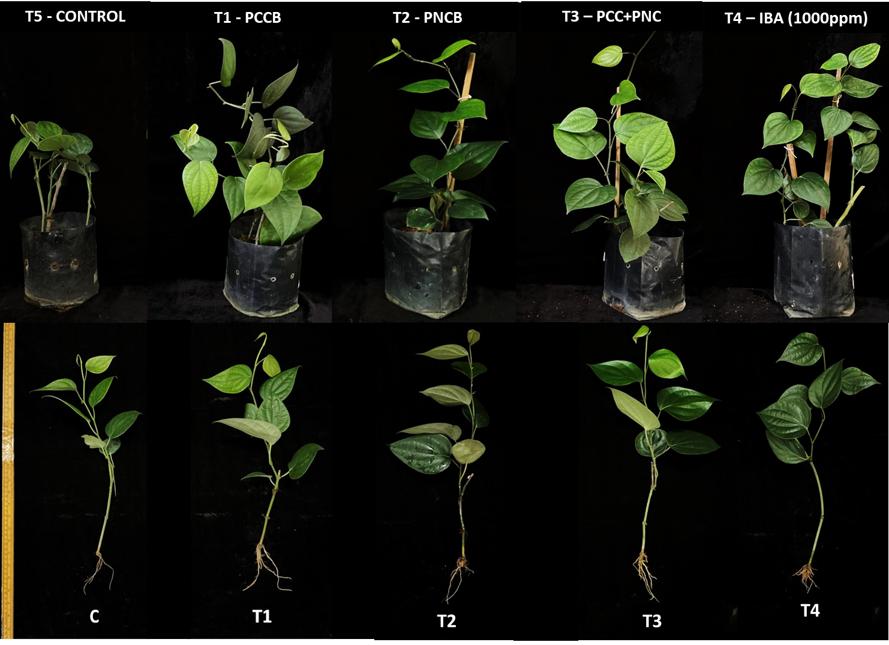

**Fig. 2. Biometric parameters of black pepper plants treated with *Piper nigrum* and *Piper colubrinum* bacterial consortia under green house conditions**