Original Research Article

PERFORMANCE OF ZINNIA (Zinnia elegans L.) GENOTYPES FOR GROWTH, FLOWERING, QUALITY AND YIELD IN NORTH KARNATAKA REGION

Abstract: The present experiment, entitled “Performance of Zinnia (Zinnia elegans L.) Genotypes for growth, Flowering, Quality and Yield in North Karnataka Region” was conducted in the summer (Febravary to April 2023) at the Department of Floriculture and Landscaping, Kittur Rani Channamma College of Horticulture, Arabhavi, Gokak, Belagavi, Karnataka, to identify the suitable genotypes for commercial cultivation under North Karnataka region, the experiment was laid out in Randomized Block Design (RBD) with fifteen genotypes replicated twice. The highest plant height was recorded in the genotype Zinnia Orange King (35.60 cm), genotype Zinnia Double Zahara Salmon and Zinnia Double Red recorded the highest Plant spread in N-S and E-W direction (25.10 cm and 26.25cm, respectively) and leaf area (2000.05 cm²). Dreamland ivory recorded the highest stem girth (7.15 mm), highest number of primary branches plant⁻¹ (18.10) were recorded in the genotype Zinnia Double Zahara Salmon. However the minimum duration to first flower initiation and days for 50% flowering (14.15 cm and 32.15, respectively) were recorded in the genotype Zinnia Double Zahara Salmon, flower diameter and stalk girth was highest in Dreamland Ivory (7.15 cm and 4.45 mm, respectively) and stalk length and vase life was maximum in Zinnia Double Zahara Salmon (11.15 cm and 7.35 days, respectively).however Zinnia Double Zahara Salmon genotype recorded maximum number of flower plant⁻¹ (18.05) and Dreamland Ivory recorded maximum Individual flower weight, yield plant⁻¹ and ha⁻¹ (54.67g and 6.07t, respectively).

Keywords: zinnia elegans l, zinnia, genotype, randomized block design (rbd), north karnataka region.

Introduction

Zinnia (Zinnia elegans L.), a vibrant summer annual from the Asteraceae family, is native to Mexico and Central America (Riaz et al., 2014). Known for its solitary, long-stemmed, brightly colored flowers, Zinnia has gained popularity in ornamental horticulture. The genus was named in honor of German botanist Johann Gottfried Zinn. Zinnia elegans, commonly called “youth-and-age,” is typically grown from seed and thrives in fertile, humus-rich, well-drained soils with full sun. It is referred to in Spanish as “mal de ojos” ("sickness of the eyes") due to its bright, eye-catching colors.
Zinnias are widely used in beds, borders, containers, and as cut flowers. They also attract birds and butterflies and are sometimes intercropped with tomatoes to manage nematodes. Medicinally, white Zinnia is used to treat kidney ailments, swelling, and body aches (Yassen et al., 2010). As annuals, they complete their life cycle within one growing season and produce flowers in various shapes and colors, including white, yellow, red, pink, purple, and multicolored. Flower forms can be single, semi-double, or double, resembling daisies or dahlias.
Through hybridization of wild species, hundreds of garden Zinnia cultivars have been developed, differing in plant height (15–100 cm), flower size, and bloom form. Leaves are rough, opposite, usually stalkless (sessile), and range from linear to ovate. The genus includes 22 species, with Z. elegans and Z. angustifolia being the most commonly cultivated. Other species like Z. acerosa, Z. grandiflora, Z. haageana, Z. linearis, and Z. peruviana are also used in breeding efforts.
Successful selection of Zinnia cultivars is vital for enhancing flower yield and quality. Cultivars adapted to local climates show improved resistance to pests, diseases, and environmental stresses, and have stronger stems that tolerate wind. High temperatures in spring and summer favor Zinnia growth, but performance varies by genotype and growing conditions (Saleem et al., 2015). Thus, identifying cultivars with longer vase life and better adaptability is necessary for commercial success (Kumar and Marwein, 2018).
As consumer preferences evolve, genetic improvement programs play a key role in developing new Zinnia genotypes with diverse growth habits, colors, bloom structures, and improved quality. Zinnia’s ease of cultivation, early blooming, and season-long flower production make it an excellent choice for ornamental use, especially in the cut-flower industry. Selecting the right genotype is essential for increasing both yield and flower size (Pasha et al., 2015). With growing demand for high-quality flowers, expanding Zinnia cultivation has strong commercial potential.
Considering these factors, the present study titled "Performance of Zinnia (Zinnia elegans L.) Genotypes for Growth, Flowering, Quality and Yield in North Karnataka Region" aims to identify suitable varieties for commercial cultivation under regional conditions. The objectives are to evaluate different Zinnia genotypes for their growth and yield attributes and to assess their flowering characteristics and flower quality to recommend the best-performing cultivars for the North Karnataka region.

Materials and methods

The present experiment, titled “Performance of Zinnia (Zinnia elegans L.) Genotypes for growth, Flowering, Quality and Yield in North Karnataka Region” was conducted in summer (February to may 2024) at the Department of Floriculture and Landscaping, Kittur Rani Channamma College of Horticulture, Arabhavi, Gokak, Belagavi, Karnataka, India. The site is in the Northern Dry Zone (Zone-III) of Karnataka, with coordinates approximately 16°14' North latitude and 74°81' East longitude, at an elevation of 640 meters above sea level. The experiment was laid out in a Randomized Block Design (RBD) with fifteen genotypes: Dreamland Coral, Dreamland Pink, Dreamland Red, Dreamland Yellow, Dreamland Rose, Dreamland Ivory, Dreamland Scarlet, Zinnia Purple, Zinnia Pink, Zinnia Liliput Mix, Zinnia Double Red, Zinnia Orange King, Zinnia Double Zahara Salmon, Zinnia Double Zahara Mix and Zinnia Oklahoma Mix, which were selected for evaluation. The seeds were procured from different private companies and raised in protrays. The well-grown seedlings of Zinnia genotypes were transplanted into the main field with a spacing of 30 × 30 cm. During transplanting, a handful of Farmyard Manure (FYM) was applied to each pit. Light irrigation was provided immediately after transplanting the seedlings. Observations were made on various vegetative growth and flowering parameters. The data were collected and analyzed using statistical methods.
From each treatment, five plants were randomly selected to record all vegetative growth, flowering, quality and yield attributes, such as plant height, plant spread (North-South and East-West directions), number of primary branches plant⁻¹, stem girth, days to first flower initiation, days to 50% flowering, flower diameter, stalk length, stalk girth, vase life, number of flowers plant⁻¹, individual flower weight, yield plant⁻¹ and plot⁻¹ and flower color codes, which were determined using the RHS color chart. Growth parameters were recorded at 15-day intervals from planting until 60 Days After Planting (DAP), while quality parameters were recorded at 60 DAP. Yield data were recorded by harvesting flowers every alternate day at the mature stage.

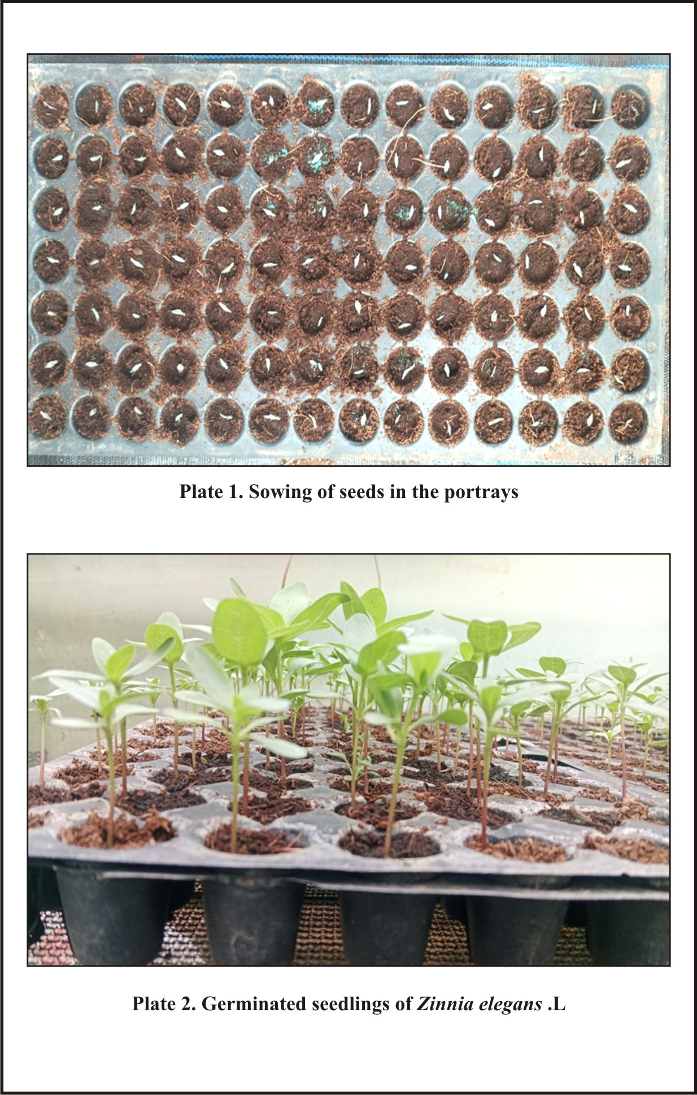

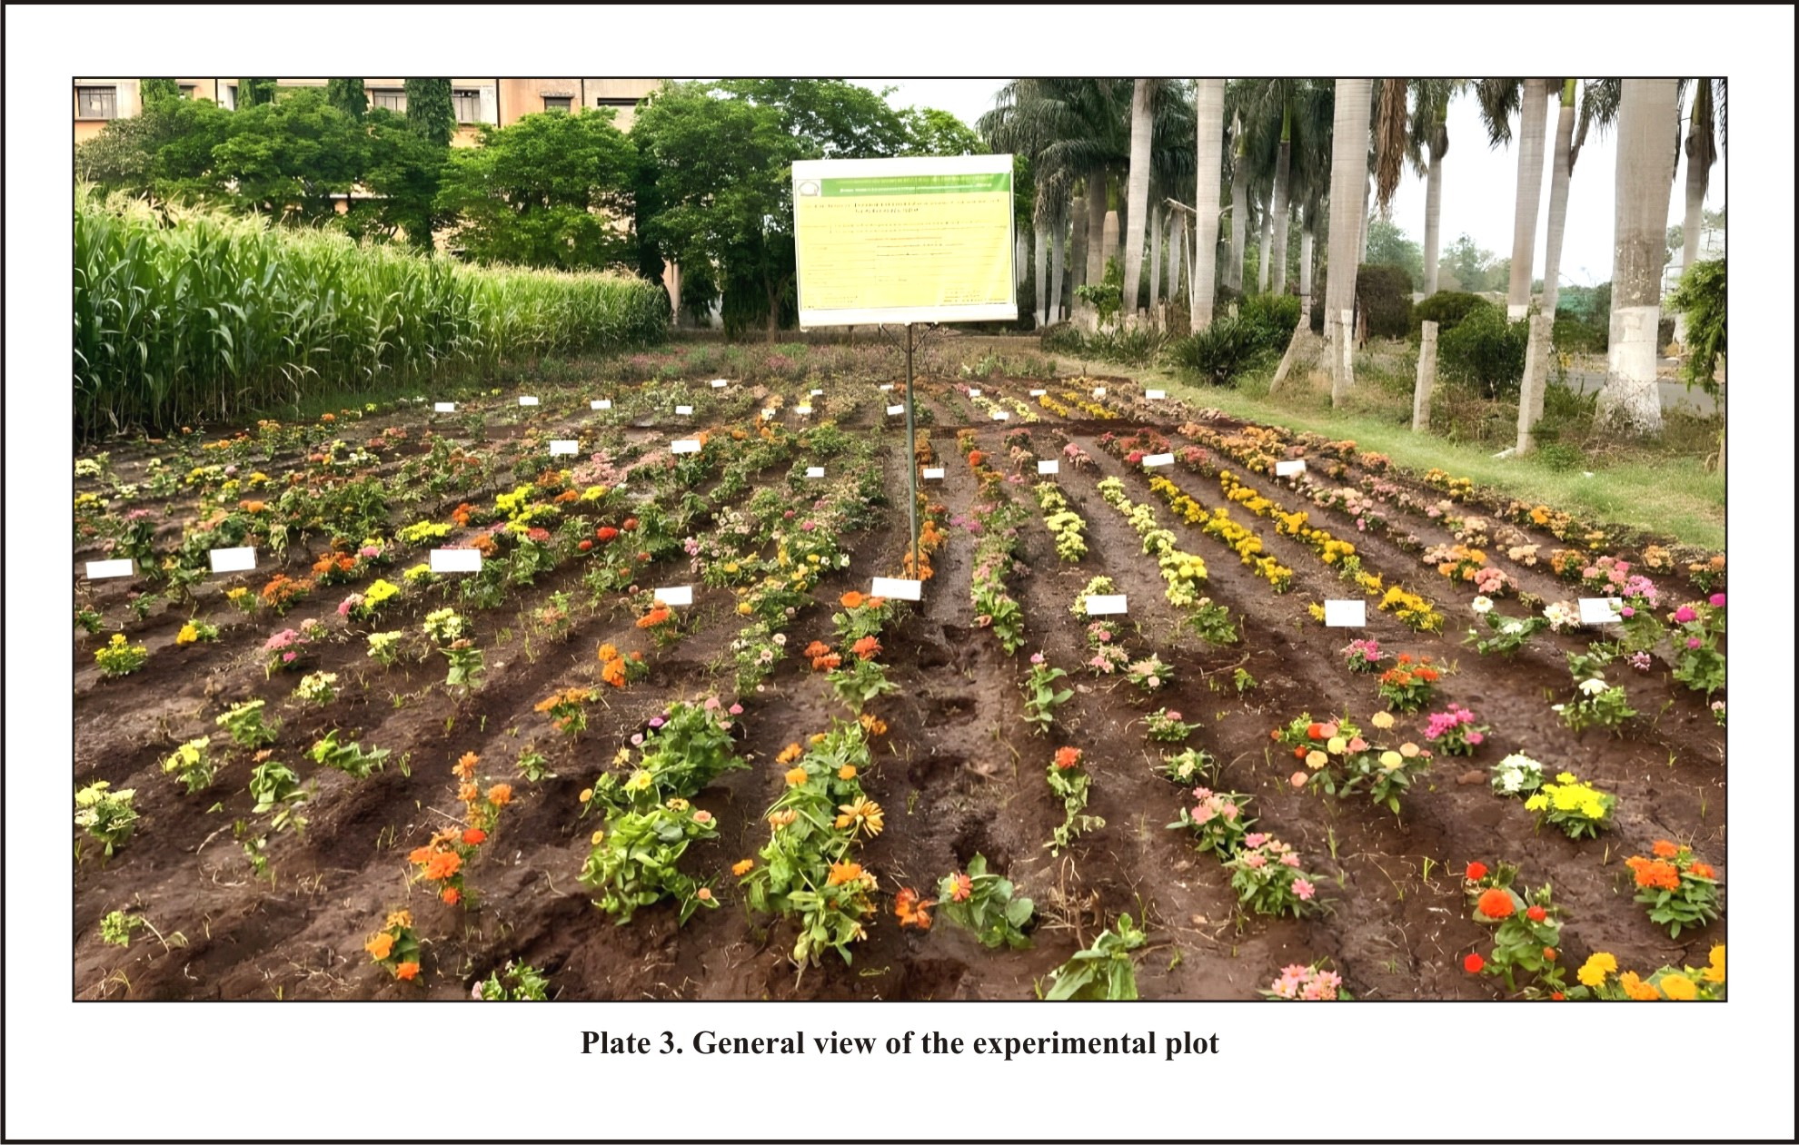
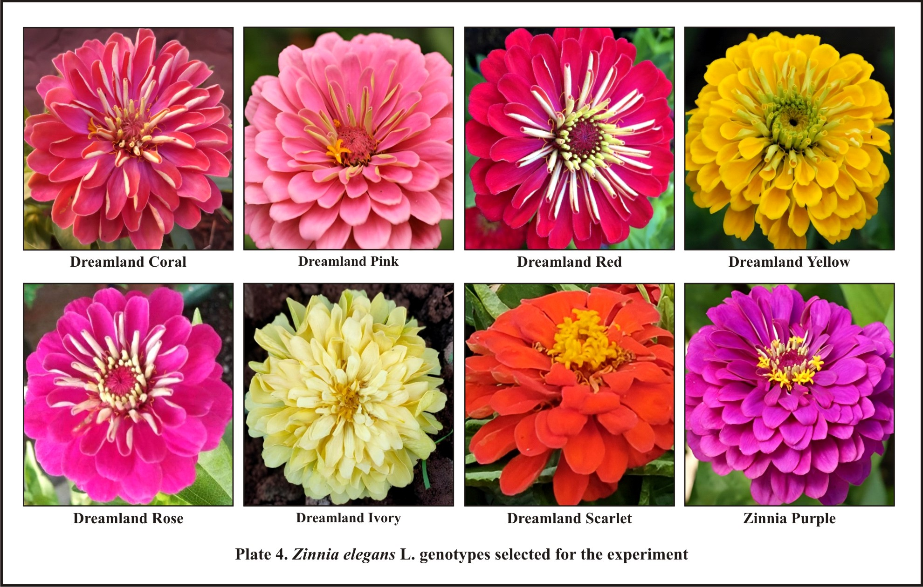
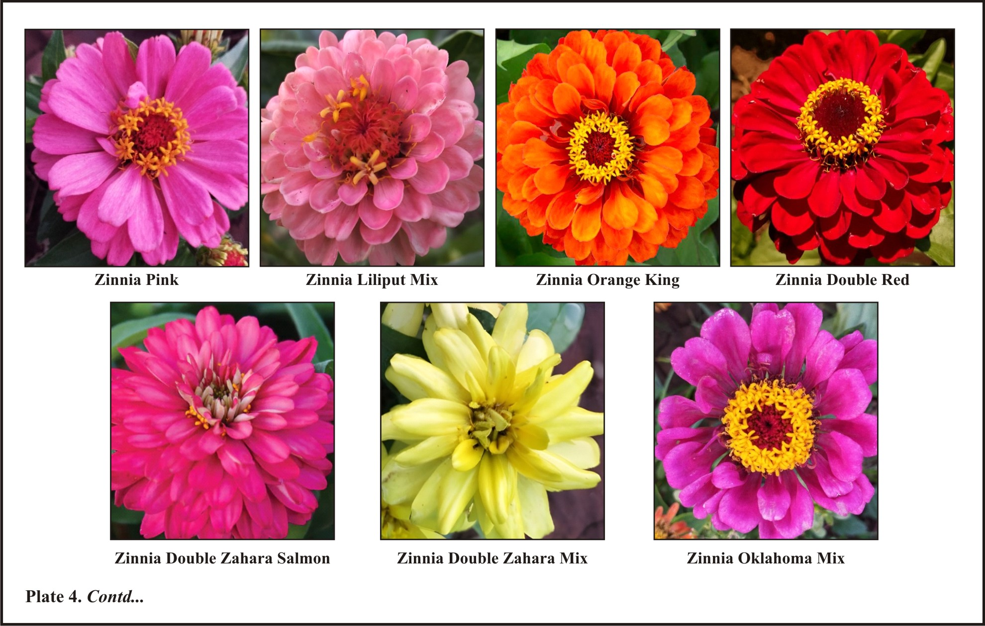

Results and discussion

Vegetative parameters

Plant height (cm)
The genotype Zinnia Orange King recorded the maximum height of 35.60 cm, followed by Zinnia Oklahoma Mix (33.95 cm) and Zinnia Double Red (31.45 cm), while the minimum height was observed in Zinnia Double Zahara Salmon (19.80 cm). These height differences can be attributed to genetic factors and genotype-specific traits, which interact with environmental conditions like light, temperature and nutrients to influence plant growth. Similar variations in height were noted by Pasha et al. (2015), Kumar and Marwein (2018), Kharjana and Fatmi (2022).
    - Plant spread in N-S and E-W direction (cm)
Regarding plant spread, Zinnia Double Zahara Salmon exhibited the highest spread in both the North-South (25.10 cm) and East-West (25.30 cm) directions, while Zinnia Dreamland Coral had the least spread (16.10 cm and 16.60 cm, respectively). The larger spread in Zinnia Double Zahara Salmon is likely due to its greater number of branches and larger, more abundant leaves. These factors contribute to overall plant spread, as supported by Deka and Talukdar (2015) and Mahender et al. (2017), who suggested that variations in plant spread are influenced by varietal characteristics.
    - Stem girth (mm)
For stem girth, Zinnia Dreamland Ivory recorded the highest value (7.15 mm), followed by Zinnia Double Zahara Salmon (6.85 mm), while Zinnia Oklahoma Mix had the smallest girth (4.10 mm). Variations in stem girth are influenced by genetic traits affecting growth patterns, as well as hormonal levels, which impact cell elongation and stem thickness. Environmental factors like nutrient uptake and soil quality also play a role in stem development. Similar findings were reported by Talukdar et al. (2003), Rajiv et al. (2007), Lakshmi et al. (2015) and Suvija et al. (2016) in chrysanthemums.
    - Number of primary branches
Zinnia Double Zahara Salmon also recorded the highest number of primary branches (18.10), followed by Zinnia Double Zahara Mix (14.90), while Zinnia Oklahoma Mix had the least (5.90). This variation in branching is primarily due to genetic differences affecting branching patterns, with hormones and environmental factors like light, water and nutrients playing a role. Additionally, genotypes differ in how resources are allocated between branching and other growth processes, leading to varied branching behaviors, as observed in chrysanthemums by Rajiv et al. (2007), Kishan et al. (2007) and Parul et al. (2011).

Table 1. Vegetative parameters of different genotypes of Zinnia elegans L.

Genotypes | Plant height (cm) | Plant spread in N-S direction (cm) | Plant spread in E-W direction (cm) | Stem girth (mm) | Number of primary branches
Dreamland Coral | 24.30 | 16.10 | 16.60 | 4.50 | 7.25
Dreamland Pink | 22.30 | 18.05 | 18.60 | 5.30 | 6.90
Dreamland Red | 23.10 | 16.85 | 16.95 | 5.55 | 7.30
Dreamland Yellow | 24.45 | 19.05 | 19.20 | 5.15 | 7.05
Dreamland Rose | 26.05 | 17.10 | 17.40 | 6.45 | 7.75
Dreamland Ivory | 25.25 | 22.05 | 22.30 | 7.15 | 8.45
Dreamland Scarlet | 25.05 | 20.05 | 20.20 | 5.15 | 6.25
Zinnia Purple | 29.20 | 21.05 | 21.30 | 5.65 | 7.95
Zinnia Pink | 30.20 | 19.85 | 20.20 | 5.45 | 6.90
Zinnia Liliput Mix | 28.35 | 21.10 | 21.30 | 5.25 | 6.70
Zinnia Orange King | 35.60 | 21.15 | 21.45 | 5.65 | 7.20
Zinnia Double Red | 31.45 | 22.55 | 26.25 | 6.25 | 7.60
Zinnia Double Zahara Salmon | 19.80 | 25.10 | 25.30 | 6.85 | 18.10
Zinnia Double Zahara Mix | 21.50 | 22.95 | 23.20 | 5.95 | 14.90
Zinnia Oklahoma Mix | 33.95 | 19.10 | 20.6 | 4.10 | 5.90
Mean | 26.70 | 20.14 | 20.72 | 5.62 | 8.41
S.Em± | 1.06 | 0.68 | 0.89 | 0.30 | 0.17
CD @ 5% | 3.22 | 2.07 | 2.71 | 0.89

Flowering and quality parameters

Days to first flower initiation
The genotype Zinnia Double Zahara Salmon took the least time to form the first flower (14.15 days), followed by Zinnia Double Zahara Mix (16.35 days). In contrast, Zinnia Orange King took the longest time (23.85 days). The time to first flower appearance is crucial for determining whether a plant is an early or late bloomer, affecting flower availability. The observed variations in flower initiation can be attributed to genetic differences, as well as interactions with environmental conditions, such as soil quality, water availability and light intensity. These findings are consistent with Dilta et al. (2005), Srilatha et al. (2015) and Suvija et al. (2016) in chrysanthemums.
    - Days taken for 50% flowering
For 50% flowering, Zinnia Double Zahara Salmon had the shortest time (32.15 days), like Zinnia Pink (32.25 days). The longest times were recorded by Zinnia Double Red (39.05 days) and Zinnia Orange King (38.55 days). These differences are influenced by genetic factors like flowering pathways and photoperiod sensitivity, as well as environmental factors such as temperature and soil conditions. This aligns with the findings of Rajiv et al. (2007) and Kishan et al. (2007) in chrysanthemums.
    - Flower diameter (cm)
Flower diameter varied across genotypes, with Dreamland Ivory having the largest flowers (7.15 cm), followed by Dreamland Rose (6.40 cm). The smallest flowers were from Zinnia Lilliput Mix (3.55 cm) and Zinnia Oklahoma Mix (3.70 cm). Larger flowers likely result from genetic traits that lead to more disc and ray florets, contributing to flower size. This is in line with Prajapati et al. (2017), Singh et al. (2017) and Ganorkar et al. (2017) in gerbera.
    - Stalk length (cm)
Stalk length also varied, with Zinnia Double Zahara Salmon having the longest stalk (11.15 cm), while Dreamland Yellow and Dreamland Coral had the shortest (6.35 cm and 6.45 cm, respectively). Longer stalks store more food, which can extend flower vase life. This genetic variation in stalk length is consistent with the work of Lagamanna et al. (2015), Prajapati et al. (2017), Singh et al. (2017), Ganorkar et al. (2017) and Soni and Godara (2017) in gerbera.
    - Stalk girth (mm)
Stem girth showed notable differences as well. Dreamland Ivory had the largest stem girth (4.45 mm), followed by Dreamland Yellow (3.85 mm) and Zinnia Pink (3.70 mm). The smallest girth was observed in Zinnia Lilliput Mix (2.55 mm). These differences are due to genetic factors and favorable growing conditions, which impact the postharvest performance of flowers. This is supported by Lagamanna et al. (2015), Prajapati et al. (2017), Singh et al. (2017) and Chavan et al. (2021) in gerbera.

Table 2. Flowering and quality parameters of different genotypes of Zinnia elegans L.
Genotypes | Days to first flower initiation | Days taken for 50% of flowering | Flower diameter  (cm) | Stalk length (cm) | Stalk girth (mm) | Vase life  (days)
Dreamland Coral | 18.35 | 35.45 | 5.45 | 6.45 | 2.65 | 5.75
Dreamland Pink | 19.05 | 34.05 | 6.05 | 6.65 | 3.15 | 4.95
Dreamland Red | 19.15 | 36.05 | 5.50 | 7.35 | 3.45 | 5.95
Dreamland Yellow | 18.35 | 35.65 | 5.40 | 6.35 | 3.85 | 5.05
Dreamland Rose | 18.95 | 38.05 | 6.40 | 9.05 | 3.35 | 5.25
Dreamland Ivory | 19.55 | 37.35 | 7.15 | 8.95 | 4.45 | 6.95
Dreamland Scarlet | 18.65 | 38.55 | 5.75 | 7.25 | 3.52 | 4.65
Zinnia Purple | 20.05 | 37.25 | 4.20 | 7.95 | 3.55 | 5.50
Zinnia Pink | 19.75 | 32.25 | 4.70 | 8.15 | 3.70 | 5.35
Zinnia Liliput Mix | 20.25 | 33.55 | 3.55 | 7.85 | 2.55 | 4.85
Zinnia Orange King | 23.85 | 38.55 | 5.20 | 8.65 | 3.35 | 5.15
Zinnia Double Red | 21.15 | 39.05 | 5.35 | 8.95 | 2.90 | 5.75
Zinnia Double Zahara Salmon | 14.15 | 32.15 | 3.95 | 11.15 | 2.75 | 7.35
Zinnia Double Zahara Mix | 16.35 | 34.55 | 4.15 | 9.85 | 3.20 | 6.05
Zinnia Oklahoma Mix | 22.85 | 36.55 | 3.70 | 8.45 | 3.10 | 4.45
Mean | 19.36 | 35.92 | 5.10 | 8.20 | 3.30 | 5.53
S.Em± | 0.27 | 0.22 | 0.21 | 0.31 | 0.13 | 0.11
CD @ 5% | 0.83 | 0.67 | 0.64 | 0.94 | 0.39 | 0.33

    - Vase life (days)
Finally, Zinnia Double Zahara Salmon had the longest vase life (7.35 days), followed by Dreamland Ivory (6.95 days). The shortest vase life was recorded in Zinnia Oklahoma Mix (4.45 days). Vase life is influenced by factors such as water uptake, transpiration, ethylene production and stalk girth, which help stabilize the flower's carbohydrate content. These differences are mainly due to genetic makeup and environmental conditions affecting flower freshness, like findings in chrysanthemums by Joshi et al. (2009).
  - Flower colour
Table 3. shows the Royal Horticultural Society colour chart for the different zinnia genotypes grown under present study.
Flower colour was recorded with the help of RHS colour charts. Variability in the flower colour for these genotypes has been observed and further these can be divided into different colour groups. As evident from table of RHS colour chart, reference number for petal colour of different cultivars were as follows Dreamland Coral (Orange red group 32-B), Dreamland Pink (Red purple group N 74-C), Dreamland Red (Red group 45-B), Dreamland Yellow (Yellow orange group 14- A), Dreamland Rose (Red purple group 73-B), Dreamland Ivory (Green yellow group 1-B), Dreamland Scarlet (Orange red group 34-C), Zinnia Purple (Red-purple group N66-B), Zinnia Pink (Red purple group 73-A), Zinnia Liliput Mix (Red group 49- A), Zinnia Orange King (Orange red group N 30-A), Zinnia Double Red (Red group 44-A), Zinnia Double Zahara Salmon (Red purple group 58-B), Zinnia Double Zahara Mix (Yellow group 9-A) and Zinnia Oklahoma Mix (Red group 54-B).
The observed differences in flower color across these genotypes are primarily due to genetic variation in the synthesis of pigments such as anthocyanins and carotenoids, which determine the color characteristics of flowers. Environmental factors such as soil pH, temperature and light intensity also play a significant role in influencing the expression of these pigments, leading to variability in flower color under different growing conditions. Flower color is thus a complex trait that results from the interaction of both genetic makeup and environmental influences (Maleka et al., 2013).
  - Yield parameters
    - Numbers of flowers plant⁻¹
There were notable variations among genotypes regarding the number of flowers produced plant⁻¹. The genotype Zinnia Double Zahara Salmon produced the highest number of flowers (18.05), followed by Zinnia Double Zahara Mix and Zinnia Liliput Mix (16.13 and 12.15, respectively). In contrast, Zinnia Orange King produced the fewest flowers (4.10). The higher flower production in these genotypes can be attributed to robust growth, including taller plant heights, more leaves and a greater number of primary branches, which enhance photosynthesis and flower yield. Favourable environmental conditions during growth, such as optimal temperature, light and nutrients, also support better flowering. Flower yield and quality are key factors for determining a genotype's commercial suitability. Similar trends were observed in chrysanthemums (Poonam & Ashoka, 2008 and Parul et al., 2011).
Table 3. Flower colour codes according to RHS colour chart
Genotype | RHS group and code | Flower colour
Dreamland Coral | Orange red group 32-B | Strong reddish orange
Dreamland Pink | Red purple N74-C | Deep purplish pink
Dreamland Red | Red group 45-B | Vivid red
Dreamland Yellow | Yellow orange group 14-A | Vivid yellow
Dreamland Rose | Red purplish group 73-B | Strong purplish pink
Dreamland Ivory | Green yellow group 1-B | Brilliant greenish yellow
Dreamland Scarlet | Orange red group 34-C | Strong reddish orange
Zinnia Purple | Red purplish group N66-B | Vivid purplish pink
Zinnia Pink | Red purple group 73-A | Strong purplish pink
Zinnia Liliput Mix | Red group 49-A | Strong pink
Zinnia Orange King | Orange red group N30-A | Vivid reddish orange
Zinnia Double Red | Red group 44-A | Vivid red
Zinnia Double Zahara Salmon | Red purple group 58-B | Strong purplish red
Zinnia Double Zahara Mix | Yellow group 9-A | Vivid yellow
Zinnia Oklahoma Mix | Red group 54-B | Deep purplish pink

    - Individual flower weight (g)
Significant differences in individual flower weight were observed among zinnia genotypes. Dreamland Ivory and Dreamland Coral recorded the highest weights (6.75 and 5.95 g, respectively), while Zinnia Double Zahara Salmon and Zinnia Double Zahara Mix had the lowest weights (2.75 and 2.90 g). These variations are due to genetic differences among the genotypes, affecting their performance in varying environmental conditions, as noted by Joshi et al. (2009) and Suvija et al. (2016) in chrysanthemum.
    - Yield plant⁻¹ (g)
Flower yield per plant varied significantly among genotypes. Dreamland Ivory produced the highest yield (54.67 g), followed by Zinnia Lilliput Mix and Zinnia Double Zahara Salmon (54.06 and 49.63 g, respectively). Zinnia Orange King had the lowest yield (21.92 g). Variations in yield are influenced by genetic factors, including flower number and size, as well as environmental adaptations such as temperature, light, and soil conditions. Nutrient utilization efficiency and disease resistance also play a role, as shown in Joshi et al. (2009) and Suvija et al. (2016) in chrysanthemum.
    - Yield hectare⁻¹ (t)
There were also significant differences in flower yield hectare⁻¹. Dreamland Ivory achieved the highest yield (6.07 tonnes ha⁻¹), followed by Zinnia Lilliput Mix (6.00 tonnes ha⁻¹). Zinnia Orange King recorded the lowest yield (2.43 tonnes ha⁻¹). Yield hectare⁻¹ is influenced by a genotype's growth potential, environmental adaptability, nutrient utilization efficiency and resistance to pests and diseases. Additionally, factors such as plant density, canopy structure and management practices like irrigation and fertilization contribute to yield variations. This pattern aligns with findings from Joshi et al. (2009) and Suvija et al. (2016) in chrysanthemum.

Table 04. Yield parameters of different genotypes of Zinnia elegans L.

Genotypes | Numbers of flowers plant⁻¹ | Individual flower weight (g) | Yield plant⁻¹ (g) | Yield hectare⁻¹ (t)
Dreamland Coral | 7.10 | 5.95 | 42.23 | 4.69
Dreamland Pink | 5.05 | 5.75 | 29.05 | 3.22
Dreamland Red | 5.45 | 5.05 | 27.52 | 3.05
Dreamland Yellow | 6.15 | 5.45 | 33.50 | 3.72
Dreamland Rose | 5.40 | 5.70 | 30.77 | 3.41
Dreamland Ivory | 8.10 | 6.75 | 54.67 | 6.07
Dreamland Scarlet | 6.15 | 4.77 | 29.33 | 3.25
Zinnia Purple | 7.20 | 4.95 | 35.65 | 3.96
Zinnia Pink | 10.05 | 3.75 | 37.68 | 4.18
Zinnia Liliput Mix | 12.15 | 4.45 | 54.06 | 6.00
Zinnia Orange King | 4.10 | 5.35 | 21.92 | 2.43
Zinnia Double Red | 6.15 | 5.05 | 31.03 | 3.44
Zinnia Double Zahara Salmon | 18.05 | 2.75 | 49.63 | 5.51
Zinnia Double Zahara Mix | 16.13 | 2.90 | 46.77 | 5.19
Zinnia Oklahoma Mix | 6.15 | 4.45 | 27.35 | 3.03
Mean | 8.23 | 4.87 | 36.74 | 4.08
S.Em± | 0.21 | 0.35 | 0.08 | 0.06
CD @ 5% | 0.65 | 1.06 | 0.34 | 0.18

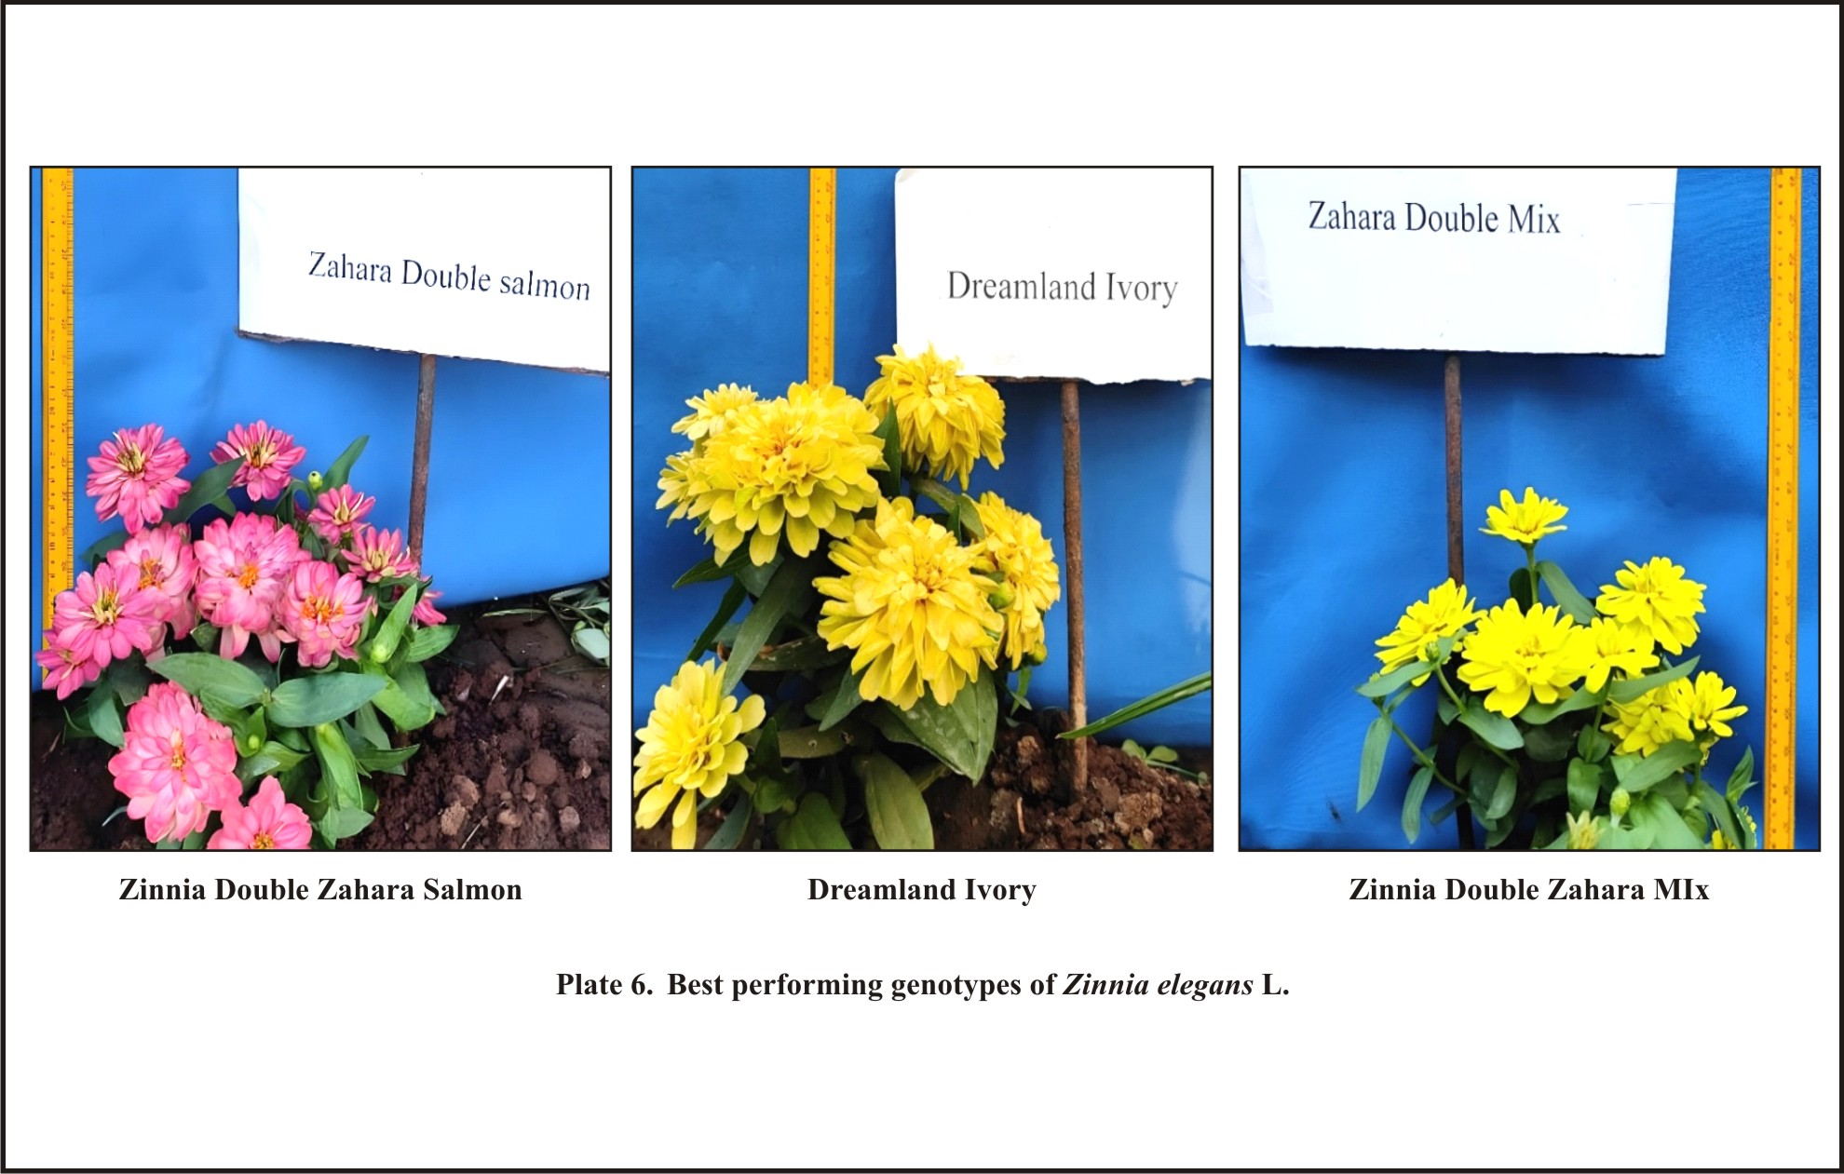
Plate 5. Best performance genotype of Zinnia elegans L.

Conclusion

Among the fifteen genotypes evaluated in North Karnataka, Zinnia Double Zahara Salmon proved superior, showing the highest flower yield plant⁻¹ and hectare⁻¹, earliest flowering, most primary branches, thickest stalk and longest vase life. Dreamland Ivory and Zinnia Double Zahara Mix also performed well, making them suitable for cultivation in the region. These three genotypes, with their vibrant flower colors and strong agronomic traits, are recommended for growers seeking diverse and high-performing zinnia varieties in North Karnataka.
- Further Research
Research can focus on evaluating the performance of the recommended zinnia genotypes across different seasons and agro-climatic zones of Karnataka to assess stability and adaptability. Studies on pest and disease resistance, nutrient management, and post-harvest handling can further enhance cultivation practices. Additionally, exploring hybrid development and molecular characterization could improve breeding efficiency.

Reference
Deka, K., Talukdar, M.C., 2015. Evaluation of gerbera (Gerbera jamesonii Bolus) cultivars for growth and flower characters under Assam conditions. Journal of Agriculture and Veterinary Science 8(4), 28-30.
Dilta, B.S., Sharma, Y.D., Verma, V.K., 2005. Evaluation of chrysanthemum cultivars under sub-tropical region of Himachal Pradesh. Journal of Ornamental Horticulture 8(2), 149-151.
Ganorkar, A., Badge, S., Jagdale, A., Taksande, N., Tayade, M., 2017. Response of gerbera varieties to yield and quality parameters under naturally ventilated polyhouse. Journal of Soils and Crops 27(1), 92-95.
Joshi, M., Varma, LR., Masu, MM., 2009. Performance of different varieties of chrysanthemum on flower yield under North Gujarat condition. Journal of the Maharashtra Agricultural Universities 34(2), 170-172.
Kharjana, E., Fatmi, U., 2022. Performance of different varieties/hybrids of zinnia (Zinnia elegans L.) under Prayagraj agro-climatic conditions. International Journal of Plant & Soil Science 34(22), 956-961.
Kishan, S., Prasad, KV., Raju, DVS., 2007. Evaluation of chrysanthemum (Dendranthema grandiflora Tzvelev) germplasm in winter season under Delhi conditions. Journal of Ornamental Horticulture 11(1), 58-61.
Kumar, S., Marwein, B., 2018. Evaluation of zinnia (Zinnia elegans L.) genotypes under west garo hills district, Meghalaya, India. International Journal of Current Microbiology and Applied Sciences 7(5), 2319-7706.
Lagamanna, RK., Balappa, RK., Devi, S., Vivek, K., Digender, S., 2015. Evaluation of recent varieties of gerbera for yield parameters grown under net house conditions. Journal of Environment and Ecology 33(4), 1542-1543.
Lakshmi, S., Balaji, KS., Laxman, K., Patil, CP., Sumangala, K., 2015. Morphological and molecular characterization of chrysanthemum (Dendranthema grandiflora Tzvelev) genotypes. M. Sc. (Hort.) Thesis, Univ. Horti. Sci., Bagalkot (India).
Mahender, B., Ashwini, D., Sreeja, K., 2017. Evaluation of different cultivars of gerbera (Gerbera jamesonii) under naturally ventilated polyhouse in Northern Telangana region. Agriculture Update 12(3), 867-870.
Maleka, MF., Albertyn, J., Spies, JJ., 2013. The floriculture industry and flower pigmentation–a review. Philosophical Transactions of the Royal Society B: Biological Sciences 2, 55-110.
Parul, P., Rao, VK., Sharma, SK., 2011. Evaluation of different chrysanthemum (Chrysanthemum morifolium Ramat) genotypes under mid hill conditions of Garhwal Himalaya. Indian Journal of Agricultural Sciences. 81(9), 830-833.
Pasha, MFK., Ahmad, HM., Qasim, M., Javed, I., 2015. Performance evaluation of zinnia cultivars for morphological traits under the agro-climatic conditions of Faisalabad. European Journal of Biotechnology and Bioscience 3(1), 35-38.
Poonam, Ashok, K., 2007. Garden beauty - A promising chrysanthemum (Dendranthema grandiflora Tzvelev) cultivars for garden decoration. Journal of Ornamental Horticulture 10(3), 165-168.
Prajapati, P., Singh, A., Jadhav, PB., 2017. Studies on growth, flowering and yield parameters of different genotypes of gerbera (Gerbera jamesonii Bolus). International Journal of Current Microbiology and Applied Sciences 6(4), 1770-1777.
Rajiv, K., Yadav, DS., Roy, AR., 2007. Performance of chrysanthemum (Dendranthema grandiflora Tzvelev) cultivars under subtropical mid hills altitude of Meghalaya. Environmental Ecology 255(34), 941-944.
Riaz, A., Farooq, U., Younis, A., Karim, A., Riaz, TA., 2011. Growth responses of zinnia to different organic me Singh dia. In: International Symposium on Organic Matter Management and Compost Use in Horticulture 1018, 565-571.
Saleem, AM., Ahmad, I., Ziaf, K., Khan, MAS., Qasim, M., Mazhar, MS., 2015, Substrates affect plant growth, flower yield and quality of stock (Matthiola incana L.) and Zinnia (Zinnia elegans Jacq.). Life 13(3), 126-131.
Singh, B., Pinder, R., Srivastava, R., Yadav, H., 2017. Varietal evaluation of gerbera cultivars under shade net conditions. Chemical Science Review and Letters 6(21), 500-504.
Srilatha, V., Sunil, KK., Deepthi, KY., 2015. Evaluation of chrysanthemum (Dendranthema grandiflora Tzvelev) varieties in southern zone of Andhra Pradesh. Agricultural Science Digest 35(2), 155-157.
Suvija, NV., Kannan, M., Suresh, J., Subesh, RK., 2016. Evaluation of chrysanthemum (Chrysanthemum morifolium Ramat) genotypes for loose flower, cut flower and pot mums. International Journal of Innovative Research and Advanced Studies 3(4),100-103.
Talukdar, MC., Mahanta, S., Sharma, B., Das, S., 2003. Extent of genetic variation for growth and floral characters in chrysanthemum cultivars under Assam condition. Journal of ornamental horticulture 6(3), 201-211.
Yassen, AA., Habib, AM., Zaghloul, SM., Khaled, SM., 2010. Effect of different sources of potassium fertilizers on growth yield and chemical composition of Calendula officinalis. Journal of American Science 6(12), 1044-1048.

