Original Research Article
First report of Fusarium acutatum as the causal agent of Pokkah boeng disease of sorghum in northern Karnataka

Abstract
Aim: To identify the causal agent of Pokkah boeng disease of sorghum in northern Karnataka using a combination of morphological and molecular techniques.
Place and Duration of Study: The study was conducted during kharif 2024 in the fields of Main Agricultural Research Station and Department of Plant Pathology of UAS, Dharwad, Karnataka, India.
Methodology: Infected sorghum leaf samples were collected and the pathogen was isolated on potato dextrose agar (PDA). Genomic DNA was isolated for molecular analysis. Morphological observations were taken both macroscopically and microscopically. PCR amplification was done using ITS and TEF primers, and sequenced. A phylogenetic tree was constructed in MEGA software using the sequences obtained for ITS as well as TEF. SDT analysis was also done to understand the identities between the isolate and reference species used.
Results: Pathogenicity test confirmed the isolate’s ability to induce disease symptoms in healthy sorghum seedlings, fulfilling Koch’s postulates. The isolate showed white, fluffy growth and had long, curved spores with three septations, as well as oval spores without sections, which are typical features of Fusarium. Molecularly, DNA was extracted, and the internal transcribed spacer (ITS) and translation elongation factor 1-alpha (TEF) regions were sequenced. The obtained sequences of ITS and TEF genes showed 99.75 and 99.81 per cent identity, respectively, to the Fusarium acutatum in the FUSARIOID-ID database, thus confirming the identity. The phylogenetic analysis using the Maximum Likelihood method clustered the isolate with F. acutatum strains, supported by high bootstrap values. Pairwise identity of nucleotide and amino acid sequences of ITS and TEF genes, calculated between isolate and reference species.
Conclusion: This study marks the first report of F. acutatum as the causal agent of Pokkah boeng disease in sorghum in northern Karnataka, differing from prior reports indicating other Fusarium species.
Keywords: Pokkah boeng, Sorghum, Fusarium species, Characterization

- Introduction
Sorghum (Sorghum bicolor L. Moench), known as great millet or jowar, is the fifth most important cereal crop globally, following wheat, rice, maize, and barley. Originating in Africa and domesticated around 8000 BC in Ethiopia and Sudan, it serves as a staple food for over 500 million people in arid and semi-arid regions of Asia and Africa, providing grain, fodder, and bioenergy. Globally, with Nigeria being the top producer, sorghum is cultivated in approximately 39.85 million hectares, producing 57.3 million tonnes with an average productivity of 1437.8 kg/ha (Anon., 2024). In India, sorghum is a key millet crop for small and marginal farmers in semi-arid regions, serving as food, fodder, and feed. Major grain sorghum producing states include Maharashtra, Karnataka, Gujarat and Rajasthan. In 2022-23, India cultivated sorghum in 4.30 million hectares, producing 5.26 million tonnes with a productivity of 1224 kg/ha (Anon., 2024a). In Karnataka, sorghum is grown in 6.16 million hectares producing 0.943 million tonnes with an average productivity of 12.15 t/ha.
A broad range of diseases affect sorghum which is the major constraint to its production. The most destructive sorghum diseases reported are incited by fungal pathogens, which are widespread globally and result in huge losses in yields both in terms of the quantity and quality of the grains (Sharma et al., 2015). Grain mold (Fusarium, Curvularia, Alternaria, Phoma), charcoal rot (Macrophomina phaseolina), Fusarium root and stalk rot (Fusarium moniliforme), ergot (Claviceps sorghi), downy mildew (Peronosclerospora sorghi) and rust (Puccinia purpurea) are the major diseases of sorghum (Anahosur, 1992). Pokkah boeng, which is a major disease in sugarcane, has now become one of the emerging diseases of sorghum, gaining importance in India (Anita et al., 2020).
Pokkah boeng, a Javanese term that denotes distorted top, was first reported from the state of Tamil Nadu and later from Maharashtra (Ramakrishnan, 1941; Garud et al., 1990), who noticed the linking up of diseased plant leaves to form arches. A pokkah boeng-infected plant generally develops symptoms on the leaf that include chlorosis, leaf twisting, top rotting, and occasionally, on the stem (Das et al., 2019). In Maharashtra, an increase in incidence up to 35 per cent was observed (Das et al., 2011). The yield losses were reported to be from 19.9 to 31.4 per cent, which makes Pokkah boeng an emerging threat to sorghum (Garud et al., 1990).
Pokkah boeng is known to be caused by the Fusarium species complex, wherein in sorghum, the disease is reported to be caused by Fusarium moniliformae (Khambalkar et al., 2014). As much research was not conducted on the etiology and symptoms of sorghum in Karnataka, the objective of the present work was to identify the causal organism of sorghum Pokkah boeng using morphological as well as molecular methods.
- Material and methods
  - Collection of the isolate
Sorghum leaf samples showing typical symptoms of Pokkah boeng disease (Fig.1) were collected from the fields at the Main Agricultural Research Station (MARS), UAS, Dharwad, Karnataka, India during 2024 kharif in appropriate conditions.

  - Isolation of the pathogen
The diseased samples (infected leaves) were cleaned under running tap water to remove soil particles before being cut into small 5 mm pieces, including healthy and diseased portions of the leaf. Further, surface sterilized for 30 seconds with 1.0 per cent sodium hypochlorite, then thoroughly rinsed in three changes of sterile distilled water immediately and kept on clean tissue paper for two minutes before transfer to PDA medium containing 100 ppm streptomycin sulphate in Petri plates. The plates were incubated for three days at 28 ± 1⁰C. The single spore method (Johnston & Booth, 1983) or hyphal tip technique (Pathak, 1972) were used to obtain pure cultures of the isolate.
  - Pathogenicity test
To demonstrate pathogenicity, sorghum seedlings were raised under glasshouse condition and sprayed with spore suspensions of fungal inoculum. After 20-30 days of planting, the leaves were carefully washed using sterilized distilled water and sprayed with spore suspension. For inoculation, spore suspension (2×10⁶ spores/ml) was prepared from a 10-day old culture in PDB. Plants inoculated were observed for 12 days to ensure fungal penetration into host tissue. Regular observations were made for the appearance and development of symptoms. After the symptom expression, the pathogen was re-isolated from diseased plants to confirm its identity with original culture to prove Koch’s postulates (Supriya, 2024).

  - Morphological identification
The cultural and morphological characters of the test pathogen viz., colour, texture, pigmentation and conidia were used to identify the pathogen under a high-power objective, 10x and 40x microscopic field. The size and shape of micro and macroconidia and the cultural characteristics of the isolate was used to identify Fusarium spp. “The Fusarium Laboratory Manual” was used to validate the identification of Fusarium spp. (Leslie & Summerell, 2006).

  - Molecular identification
The genomic DNA was isolated using CTAB extraction method (Doyle & Doyle, 1987). DNA quality was checked using 0.8% agarose gel electrophoresis and visualised using UV transilluminator gel doc system. The primers namely ITS-1 (TCCGTAGGTGAACCTGCGG), ITS-2 (TCCTCCGCTTATTGATATGC) and TEF FP(ATGGGTAAGGAAGACAAGAC), TEF RP (GGAGGTACCAGTGCATCATGTT) were used for the amplification of genes, ITS and TEF, respectively (White et al., 1990). After amplification, the PCR product was sequenced by Sanger method in ABI 3500xl genetic analyser at Eurofins Genomics India Pvt. Ltd. Bengaluru. The resultant sequence was compared with the NCBI database using BLAST analysis (Altschul et al., 1990) (https://www.ncbi.nlm.nih.gov) and type species from FUSARIOID-ID database for species determination (Crous et al., 2021).

  - Identification and Phylogenetic tree construction
To identify and analyze the sequence of Fusarium spp. isolate, alignment was carried out by comparing with the reference sequences deposited in the FUSARIOID-ID database. The sequences of the isolate were aligned along with the reference sequences using the CLUSTALW multiple alignments Version 1.8. Amino acid sequence identity was obtained using Bioedit software version 5.0.9 (Hall, 1990). Evolutionary analysis of the sequence data of the ITS and TEF regions were performed in MEGA 12 (Molecular Evolutionary Genetics Analysis, Version 12.0.11) (Kumar et al., 2018) and iTOL version 7.2 (Interactive Tree of Life) (Letunic & Bork, 2024). The maximum likelihood method was performed to construct the phylogenetic tree. For analysis, 1000 bootstrap replicates using Tamura-Nei model was performed to find the statistical support for branch stability. A pairwise identity plots and colour-coded distance matrices was produced using a computer software, Sequence Demarcation Tool (SDT) (Muhire et al., 2014) for nucleotide sequences of both ITS and TEF genes.

- . Results and Discussion
  - Morphological identification
Fungal growth on PDA was observed after 2-3 days. Pure culture was obtained by hyphal tip method.The obtained culture had a white, and fluffy appearance, with a dense, cottony texture (Fig. 2a) that dominated the surface of the agar as described by Leslie and Summerell (2006). This aerial mycelium, characterized by its soft and velvety consistency, imparted a uniform and vibrant white colouration to the colony. The colonys’ growth pattern was extensive, with a radially symmetrical spread, indicative of vigorous vegetative development under the provided environmental conditions. Slight yellow pigmentation was observed on the reverse of the colony indicating the characteristic pigments formed by Fusarium.
The macroconidia were notably falcate and displayed a crescent-shaped morphology (Fig. 2b) that is characteristic of certain fungal genera described by Leslie and Summerell (2006). These structures were slow in their growth, and multicellular and possessed three septa. The falcate macroconidia exhibited a smooth, thin-walled surface, with tapered ends that conferred a slightly curved, sickle-like appearance.
In contrast, the microconidia were smaller and simpler in structure, showing an oval to elliptical shape (Fig. 2c). These conidia were aseptate, thus distinguishing them from their macroconidial counterparts. The microconidia were unicellular, with a smooth exterior and a compact, streamlined form.

  - Molecular identification and Phylogenetic tree construction
The amplified PCR product showed the expected band size of 550 bp when amplified by ITS primers, while amplification with TEF-1α showed a band size of 650 bp. The obtained ITS sequences were analyzed using the Basic Local Alignment Search Tool (BLAST) available through the National Center for Biotechnology Information (NCBI) database. The ITS sequence exhibited 99.75 per cent identity to Fusarium acutatum, while the TEF sequence showed 99.61 per cent to the same species. The sequence obtained, as well as the type species sequences from FUSARIOID-ID database was subjected to multiple sequence alignment performed using CLUSTALW, a widely adopted tool for aligning DNA or protein sequences. The isolate showed nucleotide sequence identity of 99.75 and 99.81 per cent to ITS and TEF sequences of F. acutatum reference isolate, respectively, in the FUSARIOID-ID database. The amino acid sequence identity was obtained using Bioedit software version 5.0.9, which showed 97.34 and 95.45 per cent for ITS and TEF, respectively (Tables 1 & 2). A phylogenetic tree was constructed using the Maximum Likelihood method in MEGA 12, based on the aligned ITS and TEF sequences, with the Tamura-Nei model and 1,000 bootstrap replicates. The isolate, labelled "Fusarium acutatum (Sorghum PB 4)-Dharwad", clustered within a well-supported clade containing F. acutatum strain (Fig. 3 & 5). Pairwise alignment was done using SDT to obtain a colour-coded identity matrix for both ITS and TEF sequences (Figs. 4 & 6).
Das et al. (2015) developed artificial inoculation techniques for screening sorghum genotypes for Pokkah boeng resistance. Also, certain cultivars like CSV 19SS were found to be resistant to the disease during a study conducted on popular rabi cultivars (Das et al., 2019). Khambalkar et al. (2014) collected isolates from three different regions of Maharashtra and identified F. moniliforme as the causal organism. F. acutatum has been reported as a pathogen in various crops, including fruits, vegetables, and ornamentals (Bhat et al., 2023), its association with sugarcane or sorghum diseases remains underexplored.
- Conclusion
This study focussed on the causal organism that causes Pokkah boeng disease of sorghum in northern Karnataka which is a major issue in regions that grow sorghum. In contrast to previous studies on sorghum Pokkah boeng disease, which showed Fusarium moniliforme to be the disease-causing organism, this study used both morphological and molecular methods to identify F. acutatum as the causative agent.
References:
- Anonymous (2024). Area, production and productivity of sorghum. www.fao.org/faostat.
- Anonymous (2024a). Area, production and productivity of sorghum in India. www.indiastat.com
- Sharma, I., Kumari, N., & Sharma, V. (2015). Sorghum fungal diseases. In Lichtfouse, E. (Eds.), Sustainable agriculture reviews (1st ed., pp. 141–172). Switzerland: Springer Cham.
- Anahosur, K.H. (1992). Sorghum diseases in India: Knowledge and research needs. In de Milliano, W.A.J., Frederiksen, R.A. & Bengston, G.D. (Eds.), Sorghum and millets diseases: A second world review, (pp. 45-56). India.
- Anitha, K., Das, I.K., Holajjer, P., Sivaraj, N., Reddy, C.R. & Balijepalli, S.B. (2020). Sorghum Diseases: Diagnosis and Management. In: Tonapi, V.A., Talwar, H.S., Are, A.K., Bhat, B.V., Reddy, C.R., Dalton, T.J. (eds) Sorghum in the 21st Century: Food – Fodder – Feed – Fuel for a Rapidly Changing World. Singapore: Springer. https://doi.org/10.1007/978-981-15-8249-3_23
- Ramakrishnan, T. S. (1941). Top rot (twisted top or pokkah boeng) of sugarcane, sorghum and cumbu. Current Science, 10: 406-408.
- Garud, T. M., Kohire, O. D. & Choudari, S.D (1990). Pokkah Boeng or twisted top: A new disease to rabi sorghum in Maharashtra. Journal of Maharashtra Agricultural University, 15:127-128.
- Das, I. K., Kumar, S., Kannababu, N., & Tonapi, V. A. (2019). Pokkah boeng resistance in popular rabi sorghum cultivars and effects of the disease on leaf chlorophyll. Indian Phytopathology, 72(3), 421–426. https://doi.org/10.1007/s42360-019-00146-5
- Das, I. K., Talwar, H. S., & Rakshit, S. (2011). Pokkah boeng disease of sorghum. Jowar Samachar, 8:3-4.
- Khambalkar, P. B., Bharose, A. A., Gawande, N. D., & Manape, T. K. (2014). Identification, characterization and molecular validation of Pokkah boeng disease causal organism (Fusarium moniliforme) of Sorghum bicolor in Maharashtra. Trends in Biosciences, 7(17): 2578-2582.
- Johnston, A. & Booth, C. (1983). In: Plant Pathologist’s Pocket Book. Oxford and IBH Publishing, New Delhi, India, pp. 439.
- Pathak, V. N. (1972). In: Essentials in Plant Pathology. Prakash Publishers, Jaipur, India, pp. 448.
- Supriya (2024). Investigations on Pokkah boeng disease of maize caused by Fusarium spp. PhD thesis, University of Agricultural sciences, Dharwad, Karnataka, India.
- Leslie, J. F., & Summerell, B. A. (2006). The Fusarium Laboratory Manual. Ames: John Wiley and Sons. doi: 10.1002/9780470278376
- Doyle, J. J. & Doyle, J. L. (1987). A rapid DNA isolation procedure for small quantities of fresh leaf tissue. Phytochemical Bulletin, 19: 11-15.
- White, T. J., Bruns, T. D., Lee, S. & Taylor, J. (1990). Amplification and direct sequencing of fungal ribosomal RNA genes for phylogenetics. Mycologia, 18: 315-322.
- Altschul, S. F., Gish, W., Miller, W., Myers, E. W. & Lipman, D. J. (1990). Basic local alignment search tool. Journal of Molecular Biology, 215(3): 403-410.
- Crous, P. W., Lombard, L., Sandoval-Denis, M., Seifert, K. A., Schroers, H., Chaverri, P., et al. (2021). Fusarium: More than a node or a foot-shaped basal cell. Studies in Mycology, 98(1): 1-184. https://doi.org/10.1016/j.simyco.2021.100116
- Hall, T. A. (1999) Bioedit: A user-friendly biological sequence alignment editor and analysis program for Windows 95/98/NT. Nucleic Acids Symposium Series: 41, 95-98.
- Kumar, S., Stecher, G., Li, M., Knyaz, C. & Tamura, K. (2018). MEGA X: Molecular Evolutionary Genetics Analysis across computing platforms. Molecular Biology & Evolution, 35(6):1547-1549.
- Letunic, I., & Bork, P. (2024). Interactive Tree of Life (iTOL) v6: Recent updates to the phylogenetic tree display and annotation tool. Nucleic Acids Research, 52(W1), W78-W82. https://doi.org/10.1093/nar/gkae268
- Muhire, B. M., Varsani, A. & Martin, D. P. (2014). SDT: A virus classification tool based on pairwise sequence alignment and identity calculation. PLoS One, 9(9): e108277.
- Das, I., Rakshit, S., & Patil, J. (2015). Assessment of artificial inoculation methods for development of sorghum Pokkah boeng caused by Fusarium subglutinans. Crop Protection, 77: 94-101. https://doi.org/10.1016/j.cropro.2015.07.020
- Bhat, G., Rajakumara, A., Bhangigoudra, S., Karthik, G. U., Shivakumar, G., Madalageri, B., et al. (2023) Fusarium acutatum is a major pathogen contributing to basal rot of onion in India. New Disease Reports, 47(2): 1-4.

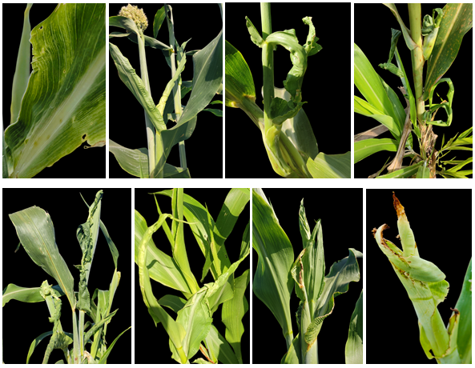
Fig. 1: Symptoms of Sorghum Pokkah boeng disease such as chlorosis, wrinkling, twisting and top rot

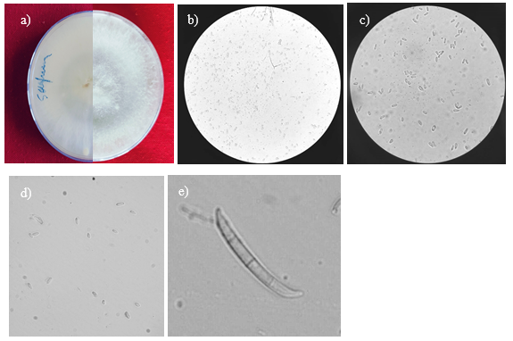
b)
c)
a)
d)
e)
Fig. 2: Morphological characteristics of F. acutatum causing sorghum pokkah boeng (a) Culture plate with left-rear view and right- front view, (b) Microconidia and macroconidia under microscope- 10x, (c, d) Microconidia, oval shaped with no septa- 40x, (e) Macroconidia, falcate shaped with three septa- 40x.

Table 1. Nucleotide and amino acid sequence identity of F. acutatum causing sorghum Pokkah boeng disease based on ITS with other reference species along with strain numbers and accession numbers
Sl. No. | Species | Strain Number ª | Accession Number | Nucleotide sequence identity (%) | Amino acid sequence identity (%)
1 | Fusarium andiyazi | CBS 119857 | KR071651 | 93.55 | 86.40
2 | Fusarium acutatum | CBS 401.97 | KR071685 | 99.75 | 97.34
3 | Fusarium brevicatenulatum | CBS 404.97 | U61675 | 94.04 | 85.60
4 | Fusarium bulbicola | CBS 220.76 | U61676 | 93.80 | 86.40
5 | Fusarium circinatum | CBS 405.97 | KC464617 | 93.55 | 86.40
6 | Fusarium fujikuroi | CBS 221.76 | AB725607 | 99.51 | 97.21
7 | Fusarium fujikuroi | LC13633 | MW016432 | 99.26 | 96.41
8 | Fusarium fujikuroi | LC13634 | MW016433 | 99.51 | 97.21
9 | Fusarium inflexum | NRRL 20433 | U34577 | 91.81 | 83.87
10 | Fusarium neocosmosporiellum | CBS 101957 | LR583797 | 88.12 | 62.70
11 | Fusarium nygamai | CBS 749.97 | MH862671 | 98.53 | 93.65
12 | Fusarium oxysporum | JW 11005 | MZ890536 | 92.31 | 84.68
13 | Fusarium oxysporum | JW 257006 | MZ890537 | 92.31 | 85.60
14 | Fusarium pseudoanthophilum | CBS 414.97 | MH862655 | 94.04 | 86.40
15 | Fusarium pseudonygamai | NRRL13592 | U34563 | 93.80 | 86.40
16 | Fusarium redolens | CBS 248.61 | MH858041 | 98.77 | 96.83
17 | Fusarium redolens | NL19-003007 | MZ890545 | 98.77 | 96.83
18 | Fusarium sacchari | LC1058 | MW016504 | 93.80 | 86.40
19 | Fusarium sacchari | CBS 223.76 | KU604026 | 93.80 | 86.40
20 | Fusarium subglutinans | NRRL 22016 | U34559 | 93.80 | 86.40
21 | Fusarium succisae | NRRL13613 | U34561 | 93.55 | 86.40
22 | Fusarium thapsinum | CBS 777.96 | MH862618 | 98.77 | 93.65
23 | Fusarium thapsinum | LC13688 | MW016515 | 98.77 | 93.65
24 | Fusarium verticillioides | JW 145017 | MZ890483 | 87.56 | 75.20
25 | Fusarium verticillioides | LC13653 | MW016464 | 93.80 | 86.40
26 | Fusarium xylarioides | CBS 258.52 | NRRL 25486 | 98.53 | 97.21
(a: sequences obtained from FUSARIOID-ID database)
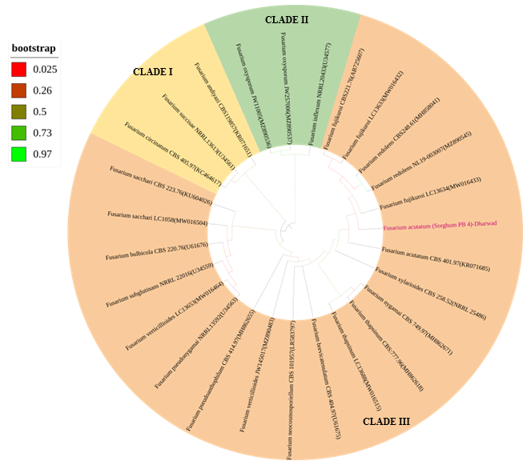
Fig. 3: Phylogenetic tree of F. acutatum causing Pokkah boeng disease of sorghum based on ITS sequences. The bootstrap consensus tree inferred from 1,000 replicates is taken to represent the evolutionary history of the taxa analyzed where branches corresponding to partitions reproduced in less than 50% of replicate trees are collapsed. The percentage of replicate trees in which the associated taxa clustered together (1,000 replicates) is shown next to the branches. The tree was constructed using Maximum-likelihood method with Tamurai-Nei model.
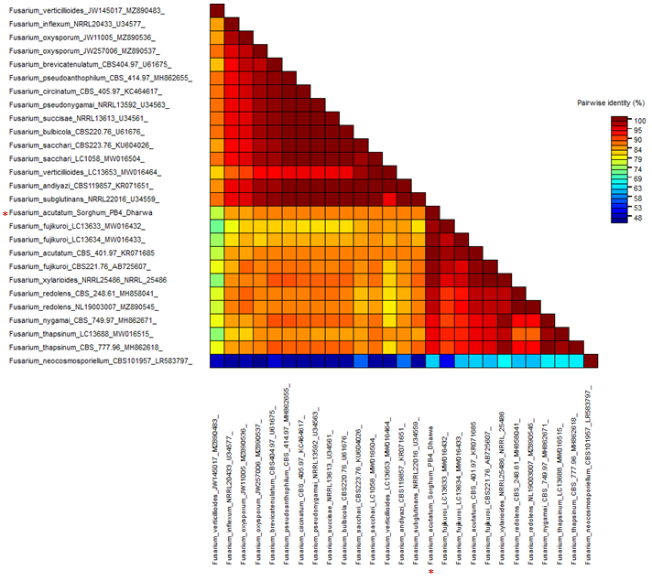

Fig. 4: Pairwise identity matrix of ITS sequences of F. acutatum causing Pokkah boeng disease of sorghum with reference sequences using SDT (Sequence Demarcation Tool)

Table 2. Nucleotide and amino acid sequence identity of F. acutatum causing sugarcane Pokkah boeng disease based on TEF with other reference species along with strain numbers and accession numbers
Sl. No. | Species | Strain Number ª | Accession Number | Nucleotide sequence identity (%) | Amino acid sequence identity (%)
1 | Fusarium andiyazi | CBS 119857 | LT996092 | 95.34 | 79.87
2 | Fusarium acutatum | CBS 401.97 | KR071755 | 99.81 | 95.45
3 | Fusarium brevicatenulatum | CBS 404.97 | MT011005 | 95.73 | 77.78
4 | Fusarium bulbicola | CBS 220.76 | AF160294 | 95.90 | 81.05
5 | Fusarium circinatum | CBS 405.97 | JAAQPE010000100 | 95.51 | 78.29
6 | Fusarium fujikuroi | CBS 221.76 | AB725605 | 93.15 | 76.32
7 | Fusarium fujikuroi | LC13633 | MW580472 | 93.54 | 76.97
8 | Fusarium fujikuroi | LC13634 | MW580473 | 93.54 | 76.97
9 | Fusarium inflexum | NRRL 20433 | AF008479 | 94.02 | 81.82
10 | Fusarium neocosmosporiellum | CBS 101957 | LR583676 | 80.50 | 58.39
11 | Fusarium nygamai | CBS 749.97 | MT011009 | 96.51 | 90.91
12 | Fusarium oxysporum | JW 11005 | MZ921881 | 94.40 | 76.43
13 | Fusarium oxysporum | JW 257006 | MZ921883 | 94.40 | 76.43
14 | Fusarium pseudoanthophilum | CBS 414.97 | MW402128 | 94.89 | 76.32
15 | Fusarium pseudonygamai | NRRL13592 | AF160263 | 95.15 | 79.22
16 | Fusarium redolens | CBS:248 | MT409453 | 90.82 | 71.52
17 | Fusarium redolens | NL19-003007 | MZ921898 | 90.23 | 70.25
18 | Fusarium sacchari | LC1058 | MW580544 | 93.99 | 82.05
19 | Fusarium sacchari | CBS 223.76 | AF160278 | 93.99 | 80.77
20 | Fusarium subglutinans | NRRL 22016 | HM057336 | 94.53 | 67.76
21 | Fusarium succisae | NRRL13613 | AF160291 | 95.51 | 77.12
22 | Fusarium thapsinum | CBS:777.96 | MW928844 | 93.93 | 78.95
23 | Fusarium thapsinum | LC13688 | MW580555 | 93.57 | 77.92
24 | Fusarium verticillioides | JW 145017 | MZ921825 | 94.75 | 85.06
25 | Fusarium verticillioides | LC13653 | MW580504 | 94.55 | 85.06
26 | Fusarium xylarioides | CBS 258.52 | AY707136 | 96.11 | 88.16

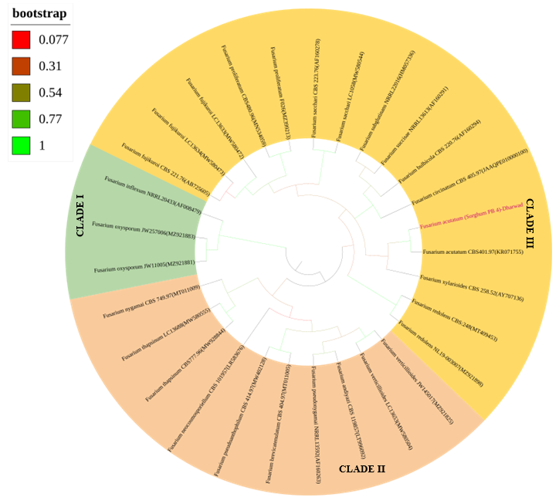
CLADE II

Fig. 5: Phylogenetic tree of F. acutatum causing Pokkah boeng disease of sorghum based on TEF sequences. The bootstrap consensus tree inferred from 1,000 replicates is taken to represent the evolutionary history of the taxa analyzed where branches corresponding to partitions reproduced in less than 50% of replicate trees are collapsed. The percentage of replicate trees in which the associated taxa clustered together (1,000 replicates) is shown next to the branches. The tree was constructed using Maximum-likelihood method with Tamurai-Nei model.

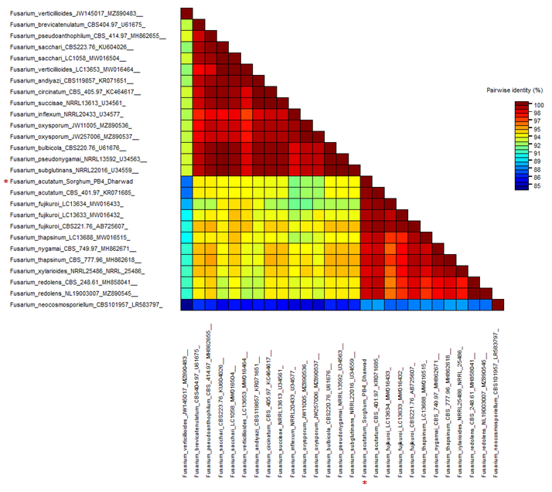
Fig. 6: Pairwise identity matrix of TEF sequences of F. acutatum causing Pokkah boeng disease of sorghum with reference sequences using SDT (Sequence Demarcation Tool).

