**Application of BAP and IAA for *in vitro* callus formation of rose (*Rosa indica cv*. Ganganagri Gulab)**

**Abstract-** A callus is a mass of undifferentiated cells capable of producing secondary metabolites. In this study, callus induction in Rosa spp. was evaluated using different concentrations of 6-Benzylaminopurine (BAP) and Indole-3-acetic acid (IAA) across the first, second, and third nodal segments under in vitro conditions. Callus formation was consistently observed in all tested combinations, with response rates ranging from 60% to 90% within 18.6 to 29 days of incubation. The highest callus induction was recorded in the third nodal segment, where a combination of 2.0 mg/L BAP + 2.0 mg/L IAA resulted in an 85% response rate and 0.93 g of callus weight in 18.6 days. A similar trend was noted in the second nodal segment, where 1.5 mg/L BAP + 1.5 mg/L IAA produced a 90% response rate and 0.93 g of callus weight in 20.6 days. The results indicated that equal concentrations of BAP and IAA yielded the highest callus induction across all nodal segments, with progressively increasing response rates and callus biomass from the first to the third nodal segment. Lower concentrations of IAA (0.5 mg/L) resulted in reduced callus formation, whereas higher concentrations (2.0 mg/L IAA) enhanced both the frequency of response and callus biomass.

**Key words:** *in vitro propagation, callus induction, BAP, IAA, nodal segments, plant growth regulators, tissue culture*

# INTRODUCTION

Plant tissue culture, commonly referred to as micropropagation, is a vital technique for large-scale propagation of plants through the in vitro culture of plant cells or tissues under controlled, sterile conditions (George *et al.*, 2008). This method creates a suitable microenvironment for plant development and has diverse applications in agriculture, horticulture, and plant biotechnology (Thorpe, 2007). It not only facilitates commercial-scale multiplication of plants but also serves as a fundamental tool for research in plant cell biology, genetics, and biochemistry (Reed, 2008). Tissue culture techniques encompass the culture of cells, anthers, ovules, embryos, protoplast isolation and fusion, cell selection, and meristem and bud culture (Rout *et al.*, 2006). In particular, in vitro propagation has gained popularity as an alternative to conventional methods, especially in the floriculture and horticulture industries (Debnath *et al.*, 2006). Its advantages include a high multiplication rate within a relatively short time, year-round production, and the generation of genetically uniform, healthy, and pathogen-free plants (Bhojwani & Razdan, 1996).

The Ganganagri Gulab, a traditional or desi rose variety identified for cultivation in Rajasthan, has attracted attention due to its distinct fragrance, preserved in value-added products such as rose oil and rose water (Sharma *et al..*., 2014). This rose grows up to 2–3 meters tall and possesses numerous hard and sharp prickles, providing natural defense against herbivores. Its well-developed vascular cambium aids in water conservation by reducing evapotranspiration losses from aerial parts (Singh & Dwivedi, 2017). The plant thrives in arid and semi-arid climates, particularly in the Sri Ganganagar region of Rajasthan, where it is traditionally cultivated (Kumar *et al*., 2013). Callus formation is a critical step in tissue culture protocols, serving as a precursor for plant regeneration and genetic transformation (Ikeuchi *et al.*, 2013). The induction of callus is largely influenced by the balance between auxins and cytokinins, with specific combinations essential for optimal growth. Among the most commonly used growth regulators, indole-3-acetic acid (IAA), an auxin, and 6-benzylaminopurine (BAP), a cytokinin, have been extensively studied for their roles in promoting cell division and callus initiation (Skoog & Miller, 1957; Pierik, 1997). In rose tissue culture, equal concentrations of IAA and BAP have been shown to promote substantial callus development from nodal segments (Kumar & Reddy, 2015).

Furthermore, the addition of secondary metabolites to the culture medium has been reported to enhance callus induction, possibly by stimulating cellular activity and metabolic responses (Ramachandran *et al.*, 2010). This study aims to investigate the application of BAP and IAA in callus induction in the Ganganagri Gulab rose variety, with a focus on identifying optimal hormone concentrations and evaluating the effect of metabolic enhancers on callus formation.

# MATERIAL AND METHODS

# The present research investigation was conducted in the Micropropagation Laboratory, Division of Plant Breeding and Genetics, Swami Keshwanand Rajasthan Agricultural University (SKRAU), Bikaner. The experiment was laid out in a Complete Randomized Design (CRD) with three replications. Stem cuttings of rose (Rosa spp.) were collected from the Agricultural Research Station, Bikaner, and used as the source of explants. After the formation of nodal segments, they were utilized as explants for callus induction. Two different concentrations of plant growth regulators (PGRs) were employed to initiate callus formation. Prior to the culture initiation, the required hormones and vitamins were added to the protocol medium as per standard requirements. The pH of the culture medium was adjusted to 5.8 before sterilization in a microwave oven. Culture bottles containing the medium were autoclaved at 121°C under 15 psi pressure for 20 minutes. For in vitro culture initiation, the culture containers were transferred to a growth chamber maintained at 25 ± 2°C with a 16/8 hours light/dark photoperiod. Illumination was provided by cool white fluorescent tubes with a light intensity of approximately 2000 lux.

# Sterilized rose explants were taken from regenerated plantlets for callus induction. The prepared stem segments were washed thoroughly with sterilized distilled water under a laminar airflow cabinet, and all subsequent handling was done under sterile conditions. Surface sterilization of explants was performed using 70% ethanol for 1 minute, followed by treatment with 0.1% mercuric chloride (HgCl₂) for approximately 5 minutes. The explants were then rinsed three times with sterilized distilled water to remove traces of disinfectant.

# RESULT AND DISCUSSION

**Callus induction from different PGR combination of 1.5 BAP+IAA (0.5-2.0 mg/L)**

Callus formation was consistently observed across all tested combinations of BAP and IAA in the first, second, and third nodal segment explants, with response frequencies ranging from 60% to 90% within 20 to 29 days of incubation. In the first nodal segment, the combination of 1.5 mg/L BAP + 1.0 mg/L IAA produced a 60% response rate with 0.63 g of callus weight in 17 days. Other combinations of 1.5 mg/L BAP with IAA concentrations ranging from 0.5 to 2.0 mg/L resulted in 60–65% response rates and callus weights between 0.53 g and 0.54 g. In the second nodal segment, the highest response rate (85%) and callus weight (0.89 g) were obtained with 1.5 mg/L BAP + 1.5 mg/L IAA in 20.4 days, followed by 1.5 mg/L BAP + 2.0 mg/L IAA (80% response, 0.77 g in 22.1 days) and 1.5 mg/L BAP + 1.0 mg/L IAA (80% response, 0.76 g in 23.5 days). The lowest response in this segment (75%) was recorded with 1.5 mg/L BAP + 0.5 mg/L IAA, yielding 0.61 g in 23.7 days.

In the third nodal segment, all combinations also resulted in successful callus induction, with the most effective being 1.5 mg/L BAP + 1.5 mg/L IAA, which produced the highest response rate (90%) and maximum callus weight (0.93 g) in 20.6 days. This was followed by the combination of 1.5 mg/L BAP + 2.0 mg/L IAA, yielding an 85% response rate and 0.54 g of callus in 22.8 days. The treatment with 1.5 mg/L BAP + 1.0 mg/L IAA showed an 80% response rate and 0.82 g callus weight in 23.7 days, while the lowest response (70%) was observed with 1.5 mg/L BAP + 0.5 mg/L IAA, producing 0.61 g in 25.4 days. These results indicate that equal concentrations of BAP and IAA are most effective for callus induction, with progressively higher response rates and biomass observed from the first to the third nodal segment.

**Table 1: Effect of BAP and IAA in callus development on different explants of rose**

**First nodal segment**

|  |  |  |  |
| --- | --- | --- | --- |
| **IAA**  **mg/L** | **BAP(1.5mg/L)** | | |
| **Mean days taken in**  **Callus initiation** | **Fresh weight of**  **callus(g)** | **Response (%)** |
| 0.5 | 27.1 | 0.59 | 60 |

|  |  |  |  |
| --- | --- | --- | --- |
| 1.0 | 25.3 | 0.63 | 60 |
| 1.5 | **24.3** | **0.77** | **70** |
| 2.0 | 25.8 | 0.54 | 65 |

**Second nodal segment**

|  |  |  |  |
| --- | --- | --- | --- |
| **IAA**  **mg/L** | **BAP(1.5mg/L)** | | |
| **Mean days taken in**  **Callus initiation** | **Fresh weight of**  **callus(g)** | **Response (%)** |
| 0.5 | 23.7 | 0.61 | 75 |
| 1.0 | 23.5 | 0.76 | 80 |
| 1.5 | **20.4** | **0.89** | **85** |
| 2.0 | 22.1 | 0.77 | 80 |

**Third nodal segment**

|  |  |  |  |
| --- | --- | --- | --- |
| **IAA**  **mg/L** | **BAP(1.5mg/L)** | | |
| **Mean days taken in**  **Callus initiation** | **Fresh weight of**  **callus(g)** | **Response (%)** |
| 0.5 | 25.4 | 0.61 | 70 |
| 1.0 | 23.7 | 0.82 | 80 |
| 1.5 | **20.6** | **0.93** | **90** |
| 2.0 | 22.8 | 0.54 | 85 |

**Callus induction from different PGR combination of 2.0 BAP+IAA (0.5-2.0 mg/L)**

Callus induction from first and second nodal segments was consistently observed across all tested concentrations of BAP and IAA. In the first nodal segment, the most effective treatment was 2.0 mg/L BAP + 2.0 mg/L IAA, which yielded the highest response rate of 65% and a callus weight of 0.67 g after 21.8 days. This was followed by the combination of 2.0 mg/L BAP + 1.5 mg/L IAA, which produced a 60% response rate and 0.54 g of callus in 23.8 days. The treatment with 2.0 mg/L BAP + 1.0 mg/L IAA showed a 55% response rate and resulted in 0.43 g of callus after 26.4 days, while the lowest response (50%) was recorded with 2.0 mg/L BAP + 0.5 mg/L IAA, producing 0.39 g of callus in 27.2 days. Similarly, in the second nodal segment, the highest callus response (70%) and callus weight (0.88 g) were obtained with 2.0 mg/L BAP + 2.0 mg/L IAA in 20.3 days. Equal effectiveness was observed with 2.0 mg/L BAP + 1.5 mg/L IAA, which also showed a 70% response and yielded 0.73 g in 22.0 days. Lower responses were recorded with 2.0 mg/L BAP + 1.0 mg/L IAA (65%, 0.69 g in 23.6 days) and 2.0 mg/L BAP + 0.5 mg/L IAA (60%, 0.51 g in 25.8 days).

In the third nodal segment, all treatments resulted in successful callus induction, with higher response rates and fresh weights than the first and second segments. The combination of 2.0 mg/L BAP + 2.0 mg/L IAA was the most effective, producing the highest response rate (85%) and the maximum callus weight (0.93 g) in just 18.6 days. This was followed closely by 2.0 mg/L BAP + 1.5 mg/L IAA, which also had an 85% response rate and generated 0.86 g of callus in 22.5 days. The combination of 2.0 mg/L BAP + 1.0 mg/L IAA yielded an 80% response rate with 0.73 g of callus in 22.8 days. The lowest response (75%) in this segment was observed with 2.0 mg/L BAP + 0.5 mg/L IAA, which produced 0.65 g of callus in 23.6 days. These findings confirm that equal concentrations of BAP and IAA are optimal for callus induction, particularly in the third nodal segment, which consistently demonstrated higher efficiency in terms of both response rate and callus biomass.

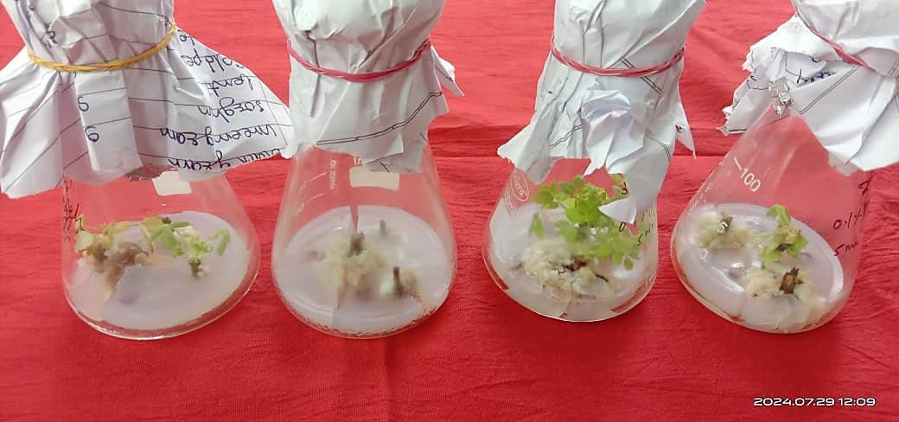

**Fig 1. Callus induction in second third nodal segment of rose**

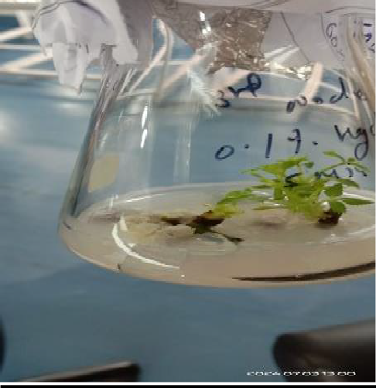

**Fig.2. Callus induction from first nodal segment of rose**

**Table 2. Effect of BAP and IAA in callus development on different explants of rose**

**First nodal segment**

|  |  |  |  |
| --- | --- | --- | --- |
| **IAA**  **mg/L** | **BAP(2.0mg/L)** | | |
| **Mean days taken in**  **Callus initiation** | **Fresh weight of**  **callus(g)** | **Response (%)** |
| 0.5 | 27.2 | 0.39 | 50 |
| 1.0 | 26.4 | 0.43 | 55 |
| 1.5 | 23.8 | 0.54 | 60 |
| 2.0 | **21.8** | **0.67** | **65** |

**Second nodal segment**

|  |  |  |  |
| --- | --- | --- | --- |
| **IAA**  **mg/L** | **BAP(2.0mg/L)** | | |
| **Mean days taken in**  **Callus initiation** | **Fresh weight of**  **callus(g)** | **Response (%)** |
| 0.5 | 25.8 | 0.51 | 60 |
| 1.0 | 23.6 | 0.69 | 65 |
| 1.5 | 22.0 | 0.73 | 70 |
| 2.0 | **20.3** | **0.88** | **70** |

**Third nodal segment**

|  |  |  |  |
| --- | --- | --- | --- |
| **IAA**  **mg/L** | **BAP(2.0mg/L)** | | |
| **Mean days taken in**  **Callus initiation** | **Fresh weight of**  **callus(g)** | **Response (%)** |
| 0.5 | 23.6 | 0.65 | 75 |
| 1.0 | 22.8 | 0.73 | 80 |
| 1.5 | 22.5 | 0.86 | 85 |
| 2.0 | **18.06** | **0.93** | **85** |

# CONCLUSION

The combined effect of benzylaminopurine (BAP) and indole-3-acetic acid (IAA) on callus induction in rose plants was investigated. Three nodal segments were used in the experiment, and the following combinations of BAP and IAA concentrations were tested: BAP 1.5 mg/L + IAA 1.0, 1.5, 2.0 mg/L, and BAP 2.0 mg/L + IAA 1.0, 1.5, 2.0 mg/L. The most efficient results were observed when both BAP and IAA were combined at equal concentrations, particularly in the third nodal segment of rose. The combination of 1.5 mg/L BAP and 1.5 mg/L IAA produced the highest response rate (90%), with a callus weight of 0.93g after 20.6 days. Similarly, the combination of 2.0 mg/L BAP and 2.0 mg/L IAA resulted in a response rate of 85%, with a callus weight of 0.93 g after 18.6 days. These findings suggest that balanced concentrations of both BAP and IAA are effective in enhancing callus induction in rose explants, with slightly higher concentrations of BAP and IAA promoting faster callus growth

# REFRENCE

Bhojwani, S. S., & Razdan, M. K. (1996). Plant tissue culture: Theory and practice (1st ed.). Elsevier.

Debnath, S. C., Malik, S. K., & Bisen, P. S. (2006). Micropropagation: A tool for the production of elite plant material. Current Science, 90(10), 1234–1242.

George, E. F., Hall, M. A., & De Klerk, G.-J. (2008). Plant propagation by tissue culture: Volume 1. The background (3rd ed.). Springer.

Ikeuchi, M., Sugimoto, K., Iwase, A., & Seo, M. (2013). Plant callus: Mechanisms of induction and repression. The Plant Cell, 25(9), 3159–3173. <https://doi.org/10.1105/tpc.113.116053>

Kumar, A., & Reddy, M. P. (2015). Optimization of plant growth regulators for callus induction and shoot regeneration in Rosa indica. Journal of Applied and Natural Science, 7(1), 120–125.

Kumar, S., Meena, M. L., & Sharma, R. (2013). Performance of some desi rose varieties in arid region of Rajasthan. Indian Journal of Horticulture, 70(4), 564–567.

Pierik, R. L. M. (1997). In vitro culture of higher plants (2nd ed.). Springer.

Ramachandran, V., Ramesh, M., & Gopalaswamy, G. (2010). Role of phenolic compounds in plant tissue culture. Biotechnology Advances, 28(2), 150–158. <https://doi.org/10.1016/j.biotechadv.2009.11.005>

Reed, B. M. (2008). Plant cryopreservation: A practical guide. In B. M. Reed (Ed.), Plant cryopreservation: A practical guide (pp. 1–22). Springer.

Rout, G. R., Samantaray, S., & Das, P. (2006). Tissue culture of ornamental pot plant: A critical review. Plant Cell, Tissue and Organ Culture, 64(2), 105–114. <https://doi.org/10.1023/A:1010623203553>

Sharma, R., Meena, M. L., & Shekhawat, R. S. (2014). Evaluation of rose (Rosa spp.) genotypes under arid conditions. Journal of Ornamental Horticulture, 17(1–2), 23–28.

Singh, B., & Dwivedi, S. (2017). Physiological mechanisms of drought resistance in rose. International Journal of Horticulture, 7(3), 1–6.

Skoog, F., & Miller, C. O. (1957). Chemical regulation of growth and organ formation in plant tissues cultured in vitro. Symposia of the Society for Experimental Biology, 11, 118–130.

Thorpe, T. A. (2007). History of plant tissue culture. Molecular Biotechnology, 37(2), 169–180. <https://doi.org/10.1007/s12033-007-0031-3>

Wylie, A. P. (1954). The history of garden roses – Part 1. J. R. Horticsoc79:555-571

.