Standardization of sterilization techniques and suitable explants for aseptic establishment in Mulberry (Morus spp.) tissue culture

Abstract
Mulberry (Morus spp.) cv. Thar Lohit, a high-yielding and resilient cultivar, is pivotal for sericulture, fruit production and medicinal applications. This study aimed to standardize explant selection and sterilization techniques for efficient micropropagation to support sustainable mulberry cultivation. Using a completely randomized design, explants such as meristem tips, apical buds and nodal segments from field-grown Thar Lohit plants were subjected to various sterilization treatments involving 70% ethanol and 0.1%–0.2% mercuric chloride (HgCl₂) at different time durations. Nodal segments, particularly the third node, exhibited the lowest contamination rate (34.67%) and highest survival rate (65.33%), outperforming meristem tips (49.33% contamination, 50.67% survival) and apical buds (42.67% contamination, 57.33% survival). The optimal sterilization protocol, combining 70% ethanol (1 min) with 0.2% HgCl₂ (10 min) achieved the lowest contamination (18.33%) and highest survival (81.67%). These findings highlighted the superior regenerative capacity of nodal segments and the efficacy of combined sterilants and consistent with prior research. This standardized protocol ensures reproducible, high-yield production of disease-free mulberry plants, enhancing sericulture, genetic conservation and commercial cultivation.

Keywords: Mulberry, Thar Lohit, micropropagation, explant selection, sterilization, nodal segments, sericulture, tissue culture

Introduction
Mulberry (Morus spp. L.), belonging to the family Moraceae, is a perennial tree crop cultivated globally for its foliage, fruit, fuel wood and medicinal properties. Additionally, it plays a significant role in sericulture and various industrial applications (Zaki et al., 2011). The genus Morus is widely distributed and thrives under diverse agro-climatic conditions worldwide (Rahman and Islam, 2024). Mulberry trees are cultivated as a plantation crop in over 50 countries, generally distributed in tropical, subtropical, temperate and sub-artic areas (Chowdhuri et al., 2006). Their widespread cultivation reflects their adaptability and economic significance in various agricultural systems (Taha et al., 2020). The mulberry tree is believed to have originated in China, Japan and the Himalayan foothills (Sanchez, 2000). It is widely distributed across tropical, subtropical, temperate and sub-arctic regions, demonstrating remarkable adaptability. Historical records indicate that mulberry cultivation in India began around 140 BC, suggesting that its native range lies in either India or China. While over 150 species of mulberry have been identified worldwide, botanists generally consider only 10-16 species to be of significant importance (Datwyler et al., 2004). The mulberry plant can grow up to 24 meters (80 feet) in height, developing a broad, rounded canopy (Rana et al., 2022). Most cultivated varieties are diploid and monoecious, flowering in August with fruit setting beginning in early September. Morus indica is recognized as an economically valuable species, commercially cultivated for its edible fruit and foliage which serves as the primary feed for silkworms (Bombyx mori L.) (Gogoi et al., 2017) and domesticated animals (Shukla et al., 2019). In addition to its edible berries (Ercisli and Orhan, 2007), mulberry is also a source of pharmaceutically important compounds (Rahman and Islam, 2021). Mulberry leaves have been studied for their potential role in managing neurodegenerative disorders, including Alzheimer's and Parkinson's disease (Butt et al., 2008). Mulberry leaves are indispensable to the sericulture industry, serving as the primary feed for silkworms which produce high-quality silk during their larval stage (Rahmathulla, 2012). In India, sericulture has evolved into a significant agro-industry across various states, playing a vital role in economic development. Beyond silk production, this industry generates valuable by-products, including fodder, fuel and manure which benefit farmers by enhancing agricultural sustainability (Kumar and Haldhar, 2021). Conventional mulberry (Morus spp.) propagation faces significant challenges, including high contamination rates from microbial pathogens, slow propagation through cuttings or grafting, and genetic variability leading to inconsistent plant quality (Vijayan et al., 2011). These methods are season-dependent, resource-intensive, and prone to disease transmission, limiting scalability and sustainability for sericulture and other applications. Micropropagation offers a solution by enabling rapid, disease-free and genetically uniform mulberry plant production in a controlled, year-round environment (Thomas, 2003). It ensures high-quality planting material, conserves elite genotypes and reduces resource use, making it ideal for large-scale sericulture needs (Taha et al., 2020). Mass and standard quality mulberry production using biotechnological methods are possible with propagation in vitro conditions (Sajeevan et al. 2011).
The total area under mulberry cultivation in India exceeds 253.13 thousand hectares (https://www.statista.com., 2023). Major mulberry-growing states include Punjab, Haryana, Himachal Pradesh, West Bengal, Karnataka, Andhra Pradesh, and Tamil Nadu (Anonymous, 2020). Among these, Karnataka is the leading producer of mulberries. The mulberry plantation area in India reached over 253.13 thousand hectares in the financial year 2023, marking an increase from the previous fiscal year (Anonymous, 2024). In Rajasthan, significant mulberry cultivation is found in Dausa and Jaipur districts (Anonymous, 2022), while other districts like Sikar (including the villages of Palsana, Ringus, Laxamangarh, and Khatu), Rajsamand (including Kumbhalgarh, Nathdwara, Haldighati, Oglat, Older, and Vardada), and Udaipur (including Jhadol and Kakad) also contribute to the production of mulberries. These regions are home to diverse local landraces of Italic morus species. Additionally, Rajasthan Armed Constables (RAC) in Bikaner and Govt. UP School in Bithiya, Jalore are engaged in propagating mulberry varieties, particularly Italic morus indica and Italic morus laevigata, as part of an on-farm conservation initiative for these species under managed habitats (Rao et al., 2011).
Plant tissue culture, also referred as micropropagation is an advanced and highly efficient biotechnological technique that facilitates the regeneration of a complete plant from a small tissue sample or even a single cell in controlled and aseptic sterile environment. This technique allows for the efficient isolation and propagation of beneficial variants within a short time frame and in a limited space (Hussain et al., 2012). This approach ensures consistency in plant quality and accelerates large-scale propagation for commercial and research applications (Rahman and Islam, 2024). In vitro micropropagation techniques has emerged as a powerful tool for rapid multiplication of large number of mulberry genotypes, production of disease-free planting material and conservation of genetic diversity in a significantly reduced time frame. Morus alba was produced from the axillary bud in vitro conditions by Ohyama [1970], and then different studies were carried out on this subject (Balakrishnan et al. 2009; Rao et al. 2010; Lalitha et al. 2013). Different results were obtained from different explant sources such as axillary bud or nodal explant (Sajevan et al. 2011; Zaki et al. 2011). Selection of proper explant and surface sterilization is the most important steps in preparing explants for micropropagation. However, challenges such as high contamination rates due to fungal and bacterial contamination of woody plants from field sources and low explant survival often hinder success, primarily due to inadequate sterilization and improper explant selection (Pranjić et al.,2013; Rezadost et a.,2013). Standardizing these techniques is critical to enhance the efficiency and reproducibility of mulberry tissue culture.

Materials and Methods
Plant Materials
Mulberry (Morus spp.) is a vital plant for sericulture with applications in fruit production, wood and medicine. Thar Lohit cultivar of mulberry had been used for the present investigation to facilitate rapid propagation and genetic improvement through micropropagation. The ICAR-Central Institute for Arid Horticulture (ICAR-CIAH) in Bikaner has developed the Thar Lohit mulberry cultivar, notable for its robust adaptability and high-yield potential. This variety exhibits a spreading growth habit and reaches a height of 3.07 meters. Its deep red fruits mature within 32–36 days after fruit set, offering an impressive yield of 12.4 to 26.5 kg per tree. Thar Lohit thrives across extreme temperature conditions, ranging from -20°C to 49°C, demonstrating remarkable resilience. The fruit is rich in nutrients, boasting a Total Soluble Solids (TSS) of 20.8° Brix, an acidity level of 1.6%, and a Vitamin C content of 11.2 mg per 100g, making it a valuable addition to mulberry cultivation.
Present research investigation was performed in Completely randomized design at Plant Micropropagation Lab, Department of Genetics and Plant Breeding, College of Agriculture, Swami Keshwanand Rajasthan agricultural University, Bikaner.

Explant Used
Different type of explants like meristem tip, apical bud and nodal segments of 1-2 cm were collected from healthy mulberry trees grown at ICAR-CIAH, Bikaner (Table 1). In this experiment, five different types of explants meristem tip, apical bud, first, second and third nodes from the shoot apex and those removed from the mature, field-grown mulberry cv. Thar Lohit plant were employed.

Surface Sterilization of Explants
Explants were washed with running tap water and then with Tween 20 liquid detergent for 5–10 minutes to remove all soil particles, dust, durt and other materials. After this these explants were washed using double distilled water for three to four times. After washing with detergent explants were again washed with running tap water to remove any trace of detergent for 5 minutes. Afterwards, the explants were sterilized using surface sterilizing agents namely ethanol (70%) and mercuric chloride (HgCl₂) at various concentrations, both individually and in combination for different durations (1, 5 and 10 minutes) (Table 2). The explants were thoroughly washed 4-5 times with sterilized double distilled water to remove the traces of surface sterilization chemicals. Every explant was seeded into MS medium that had various BAP and IAA in different concentrations and combinations. Explants were routinely subculture three to four times in the same media; the first subculture was necessary within 24 hours due to phenol exudation. A standardized sterilization protocol for field-grown nodal explants involved the following steps:
- Explants were washed with running tap water for 1–2 hours to remove debris.
- Explants were treated with 5% (v/v) liquid detergent for 10–15 minutes followed by rinsing with distilled water.
- Then, these explants were immersed in Ethanol 70% for 1 minutes.
- Sterilization with 0.1% (w/v) mercuric chloride (HgCl₂) for 10 minutes was done.
- Rinsing thoroughly with sterile distilled water (3–5 times) to remove residual sterilants was carried out.

Statistical analysis
The data recorded from the experiments were conducted according to completely randomized design (CRD). Each experiment was replicated three times. The goal of the study was to find a significant difference between the treatment means. On the basis of critical difference, the treatment means were classified as significant or non-significant (CD).

Result and Discussion
Standardizing explant and sterilization techniques is critical for achieving high success rates in mulberry tissue culture. Young, healthy explants such as shoot tips and nodal segments, are preferred due to their lower load of endophytic microorganisms and higher regenerative potential. The results obtained from present study are discussed under the following subheading.
Effect of sterilizing agents on percentage contamination
Sterilization efficacy is a critical factor in plant tissue culture, influencing both explant viability and contamination control. This study evaluated the effectiveness of various surface sterilization treatments including 70% ethanol, 0.1% mercuric chloride (HgCl₂), 0.2% HgCl₂ and their combinations to determine optimal protocols for minimizing microbial contamination while ensuring explant survival. The findings indicated significant variability in contamination rates across treatments (Table 3) (Plate:1). The highest contamination rate (82.33%) was recorded in A₁ (70% ethanol for 1 min.) demonstrating limited efficacy of ethanol as a standalone sterilization agent. In contrast, the A₉ treatment (1+10 min. of 70% ethanol + 0.2% HgCl₂) exhibited the lowest contamination level (18.33%) proving to be the most effective sterilization method. Additionally, A₈ (70% ethanol + 0.2% HgCl₂ for 1+5 min.) at 29.67% and A₇ (1+10 min. of 70% ethanol + 0.1% HgCl₂) at 38% showed considerable improvement over ethanol alone. The data further suggested that A₆ (1+5 min. of 70% ethanol + 0.1% HgCl₂) at 54.67% while moderately effective, did not surpass the efficacy of A₉. A clear trend emerges in which increasing exposure time and combining ethanol with mercuric chloride significantly enhances sterilization effectiveness. This aligns with prior research by Eliwa et al. (2024), Niratker et al. (2015) who reported no contamination while using a sterilization solution of 20% sodium hypochlorite on axillary buds. However, in the present study ethanol-based treatments exhibited higher contamination rates than alternative chemical sterilization methods.

Effect of sterilizing agents on percentage survival of explants
The evaluation of explant survival rates as presented in (Table 3) (Plate:2), underscored the critical role of optimized sterilization protocols in mulberry (Morus spp.) cv. Thar Lohit tissue culture. The A₉ treatment, combining 70% ethanol (1 min) with 0.2% mercuric chloride (10 min), achieved the highest survival rate of 81.67%, establishing it as the most effective sterilization method. The A₈ treatment (70% ethanol + 0.2% HgCl2 for 1+5 min) followed closely with a survival rate of 70.33%, demonstrating significant efficacy but falling short of A₉. Treatments A₇ (1+10 min of 70% ethanol + 0.1% HgCl₂) and A₆ (1+5 min of 70% ethanol + 0.1% HgCl2) yielded survival rates of 62.00% and 45.33%, respectively, indicating moderate effectiveness but statistical inferiority to A₉ and A₈. In contrast, the A₁ treatment (70% ethanol for 1 min) recorded the lowest survival rate at 17.67%, highlighting its inadequacy as a standalone sterilant. These results align with previous studies, which emphasize the synergistic efficacy of combining ethanol and mercuric chloride to enhance sterilization efficiency while preserving explant viability (Taha et al., 2020, Yadav et al., 2021, Kavyashree 2007). The extended exposure durations in A₉ and A₈ likely contribute to their superior performance by effectively eliminating contaminants without compromising tissue integrity. These findings confirmed that a combined sterilization approach, particularly with higher concentrations and longer durations of mercuric chloride, significantly improves explant survival and culture success. Adopting such optimized protocols ensures reproducible, high-yield micropropagation, facilitating large-scale production of disease-free mulberry plants for sericulture and other applications.

Effect of explant on percentage contamination and percentage survival of explants
Explant selection is a fundamental aspect of plant tissue culture as it directly influences both contamination resistance and survival rates which are crucial for successful regeneration. This study systematically evaluates the effectiveness of various explants including meristem tip, apical bud and nodal segments to determine the optimal candidate for mulberry propagation (Plate:3).The results indicated significant differences in contamination resistance and survival rates across explant types, highlighting the superior performance of nodal segments over shoot tips and meristematic tissues. Among all treatments B₅ (Third node) exhibited the lowest contamination rate (34.67%) and the highest survival rate (65.33%), affirming its viability as the most effective explant for initiating tissue culture (Table 4). Comparatively, B₄ (Second node) showed 36.33% contamination and 63.33% survival while B₃ (First node) recorded 39.33% contamination and 60.67% survival. Although these explants performed well, they did not surpass the efficacy of B₅. The B₂ (Apical bud) demonstrated intermediate contamination control (42.67%) and survival (57.33%) whereas B₁ (Meristem tip) exhibited the highest contamination (49.33%) and lowest survival (50.67%) reinforcing its vulnerability to microbial contamination and reduced viability. These findings align with previous studies conducted by Bahu and Wakhlu (2003) and Zaki et al. (2011) who reported that nodal segments consistently exhibited better responses compared to shoot tips or axillary buds in mulberry tissue culture applications. Their observations emphasized the higher regenerative capacity of nodal segments, making them more suitable for propagation. Anis et al. (2003) established that nodal segments demonstrated the highest frequency of explant regeneration, surpassing the regeneration rates recorded for axillary buds. Further supporting this trend, Taha et al. (2020) noted that nodal segments exhibited superior survival rates and lower contamination compared to apical shoot buds reinforcing their advantage in tissue culture protocols.
The findings from this study suggested a distinct trend favoring nodal segments particularly the third node as the optimal explants for mulberry tissue culture. Their superior contamination resistance and regeneration potential underscore their importance in establishing efficient propagation techniques. Integrating nodal segment-based protocols into tissue culture methodologies can enhance reproducibility, success rates and overall efficiency in mulberry micropropagation, providing a scientifically validated framework for plant regeneration and conservation efforts.

Conclusion
Mulberry (Morus spp. L.) is a globally cultivated perennial tree crop that holds significant agricultural, industrial, and medicinal value. Its adaptability across diverse agro-climatic conditions, coupled with its economic importance in sericulture, pharmaceutical applications and animal fodder production, underscores its role in sustainable agriculture. This study established a robust protocol for explant selection and sterilization in micropropagation of mulberry (Morus spp.) cv. Thar Lohit, a high-yielding, resilient cultivar critical for sericulture, fruit production and medicinal applications. Nodal segments, particularly the third node, outperformed other explants, exhibiting the lowest contamination rate and highest survival rate compared to meristem tips contamination and apical buds. The optimized sterilization protocol, combining 70% ethanol (1 min) with 0.2% mercuric chloride (10 min), achieved the lowest contamination (18.33%) and highest explant survival (81.67%), significantly surpassing ethanol-only treatments (82.33% contamination, 17.67% survival). These results corroborate prior studies emphasizing the superior regenerative capacity and contamination resistance of nodal segments and the efficacy of combined sterilants. By addressing challenges like microbial contamination and low survival rates, this standardized protocol ensures efficient, reproducible and scalable production of disease-free mulberry plants. Implementing these findings in tissue culture practices will enhance mulberry propagation, supporting sustainable sericulture, genetic conservation and commercial cultivation of this economically vital crop.

REFERENCES
- Anis M, Faisal M, Singh SK. Micropropagation of mulberry (Morus alba L.) through in vitro culture of shoot tip and nodal explants. Plant Tissue Cult. 2003;13(1):47–51.
- Balakrishnan V, Latha MR, Ravindran KC, Robinson JP. Clonal propagation of Morus alba L. through nodal and axillary bud explants. Bot Res Int. 2009;2(1):42–49.
- Bhau BS, Wakhlu AK. Rapid micropropagation of five cultivars of mulberry. Biol Plant. 2003;46:349–55.
- Butt MS, Nazir A, Sultan MT, Schoën K. Morus alba L.—nature’s functional tonic. Trends Food Sci Technol. 2008;19:505–12.
- Chowdhuri SR, Rahman MS, Ghosh MK. Studies on floral characters and pollen behaviour at different levels of ploidy in mulberry (Morus spp.). Indian J Genet Plant Breed. 2006;66(2):167–8.
- Datwyler SL, Weiblen GD. On the origin of the fig: phylogenetic relationships of Moraceae from NDHF sequences. 2004;767–77. (Note: Add journal or book title if available.)
- Eliwa GI, El-Dengawy G, Gawish MS, Yamany MM. Comprehensive study on in vitro propagation of some imported peach rootstocks: in vitro explant surface sterilization and bud proliferation. Sci Rep. 2024;14:5586.
- Ercisli S, Orhan E. Chemical composition of white (Morus alba), red (Morus rubra) and black (Morus nigra) mulberry fruits. Food Chem. 2007;103(4):1380–4.
- Gogoi G, Borua PK, Al-Khayri JM. Improvement micropropagation and in vitro fruiting of Morus indica L. (K2 cultivar). J Genet Eng Biotechnol. 2017 Jan;15(1):249–56.
- Gulzar B, Mujib A, Malik MQJ, Rukaya S, Zafar N. Transgenic technology-based value addition in plant biotechnology. 2020;25–49. (Note: Add book or journal title if available.)
- Hussain A, Qarshi IA, Nazir H, Ikram UI. Plant tissue culture: current status and opportunities. London (UK): IntechOpen; 2012. p. 1–28.
- Kavyashree R. A repeatable protocol for in vitro micropropagation of mulberry variety S54. Indian J Biotechnol. 2007;6:385–8.
- Kumar K, Haldhar SM. Suitable genotypes of under-utilized fruit crops for pest management. In: Haldhar SM, Maheshwari SK, editors. Pest management in dryland horticultural crops. New Delhi: Biotech Books; 2021. p. 155–71.
- Lalitha N, Kih S, Banerjee R, Chattopadhya S, Saha AK, Bindroo BB. High frequency multiple shoot induction and in vitro regeneration of mulberry (Morus indica L. cv. S-1635). Int J Adv Res. 2013;1:22–6.
- Niratker C, Preeti, Singh M. Effect of different type of media on in vitro regeneration of mulberry (Morus indica): an economically important tree. Ann Biol Res. 2015;6(1):22–6.
- Ohyama K. Tissue culture in mulberry tree. Jpn Agric Res Q. 1970;5(1):30–4.
- Pranjić A, Čmelik Z, Puškar B, Jurković Z. In vitro sterilization procedures for micropropagation of ‘Oblačinska’ sour cherry. J Agric Sci. 2013;58(2):117–26.
- Rahman MS, Islam SMS. Studies on food, health and environmental perspectives in mulberry (Morus spp.): a review. J Bio-Sci. 2021;29(1):163–80.
- Rahman MS, Islam SS. Rapid multiplication by nodal segment and shoot tips through in vitro micropropagation of six mulberry (Morus alba) genotypes. Plant Tissue Cult Biotechnol. 2024;34(2):105–14.
- Rahmathulla VK. Management of climatic factors for successful silkworm (Bombyx mori L.) crop and higher silk production: a review. Psyche J Entomol. 2012;2012:1–12.
- Rana MS, Amin MN, Azad MAK. In vitro regeneration protocol for mulberry Morus alba L. through tissue culture techniques. Int J Res Innov Soc Sci. 2022;6(1):124–8.
- Rao AA, Chauhan SS, Radhakrishnan R, Tikader A, Borpuzari MM, Kamble CK. Variation and conservation of mulberry (Morus spp.) genetic resources in the arid zone of Rajasthan, India. Bioremediation Biodivers Bioavailab. 2011;5(1):52–62.
- Rao PJSVVNH, Nuthan D, Krishna KS. A protocol for in vitro regeneration of rain fed mulberry varieties through callus phase. Eur J Biol Sci. 2010;2:80–6.
- Rezadost HM, Sohan MM, Hatamzadeh A, Mirzai RM. In vitro regeneration of sour orange (Citrus aurantium L.) via direct organogenesis. Plant Knowl J. 2013;2:150–6.
- Sajeevan RS, Jeba SS, Nataraja KN, Shivanna MB. An efficient in vitro protocol for multiple shoot induction in mulberry, Morus alba L variety V1. Int Res J Plant Sci. 2011;2(8):254–61.
- Sánchez MD. World distribution and utilization of mulberry, potential for animal feeding. FAO Electronic Conference on Mulberry for Animal Production (Morus L). 2000;1–11.
- Shukla P, Ramesha AR, Kangayam MP, Rohela GK, Aftab A, Ghosh MK, Mishra RK. Selection of suitable reference genes for quantitative real-time PCR gene expression analysis in mulberry (Morus alba L.) under different abiotic stresses. Mol Biol Rep. 2019;46(1):1–9.
- Taha H, Ghazy UM, Gabr AMM, El-Kazzaz AAA, Ahmed EAMM, Haggag KM. Optimization of in vitro culture conditions affecting propagation of mulberry plant. Bull Natl Res Cent. 2020;44:1–9.
- Thomas TD. Thidiazuron induced multiple shoot induction and plant regeneration from cotyledonary explants of mulberry. Biol Plant. 2003;46:529–33.
- Vijayan K, Tikader A, da Silva JAT. Application of tissue culture techniques for propagation and crop improvement in mulberry (Morus spp.). Tree For Sci Biotechnol. 2011;5(1):1–13.
- Zaki M, Kaloo ZA, Sofi MS. Micropropagation of Morus nigra L. from nodal segments with axillary buds. World J Agric Sci. 2011;7(4):496–503.

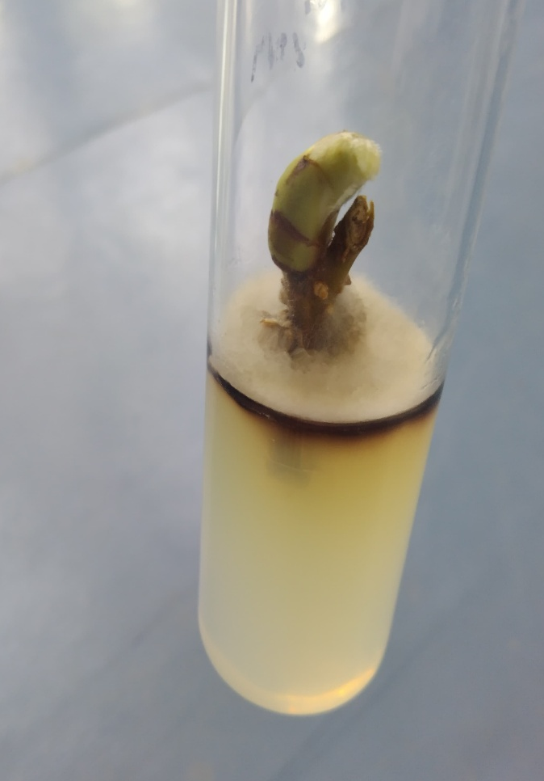  A | 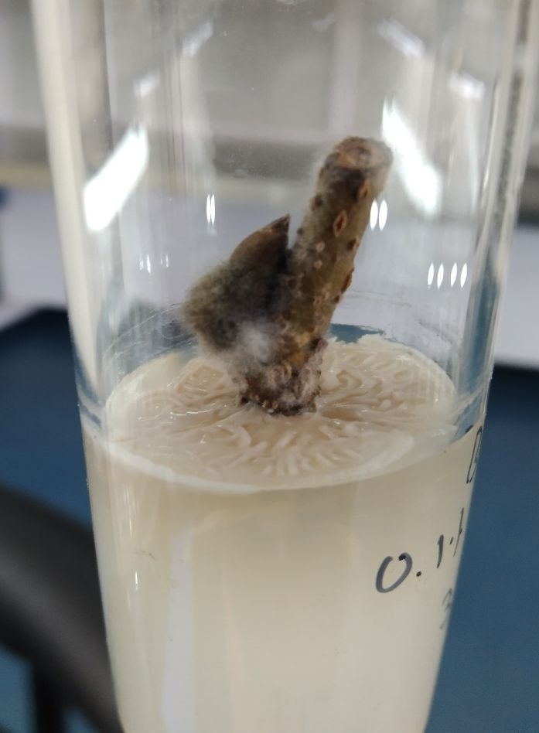  B

Plate:1. Effect of sterilizing agents on percentage contamination (A. Ethanol 70% for 1 min. and B. HgCl₂ 0.1% for 5 min.)

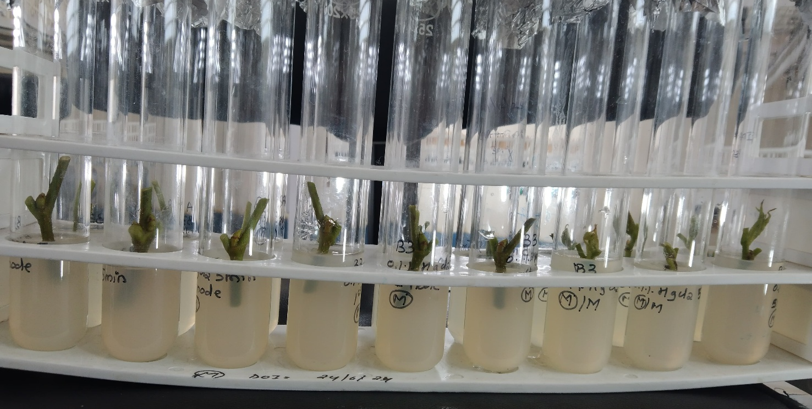
A
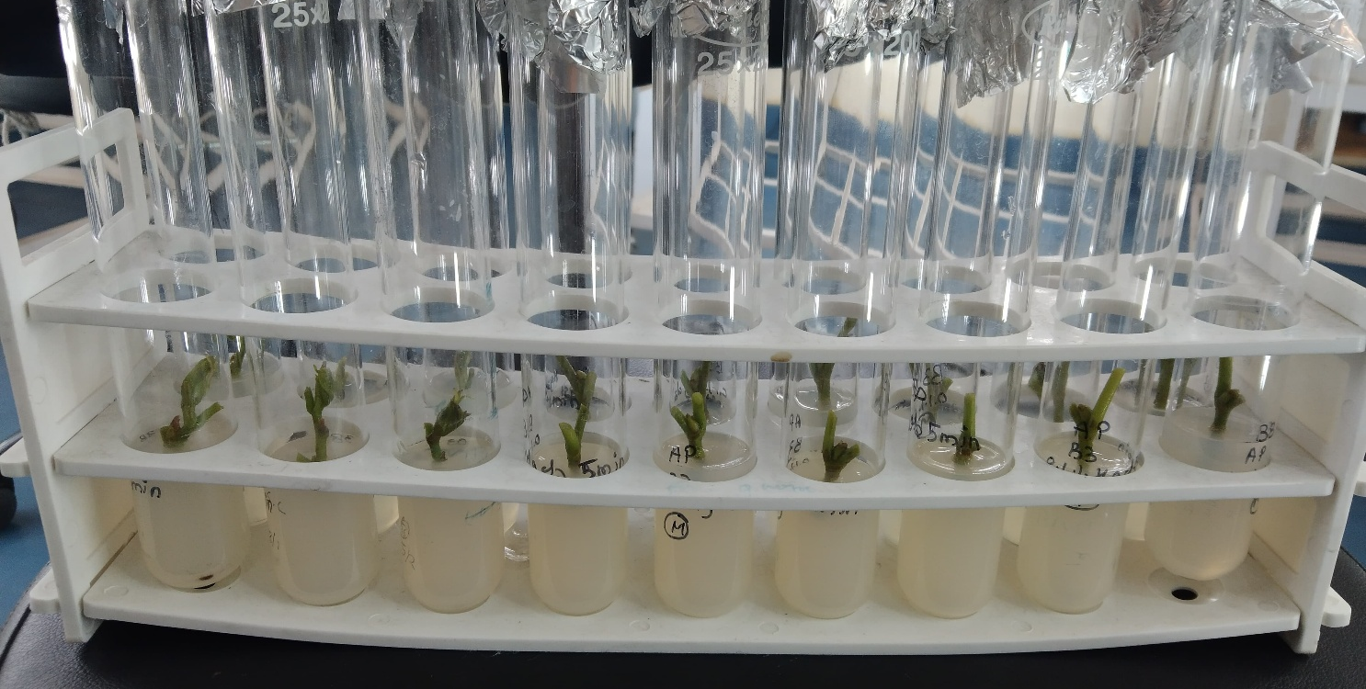
B

Plate:2. Effect of sterilizing agents on percentage survival of explants (A. Ethanol 70% + HgCl₂ 0.1% and B. Ethanol 70% + HgCl₂ 0.2%)

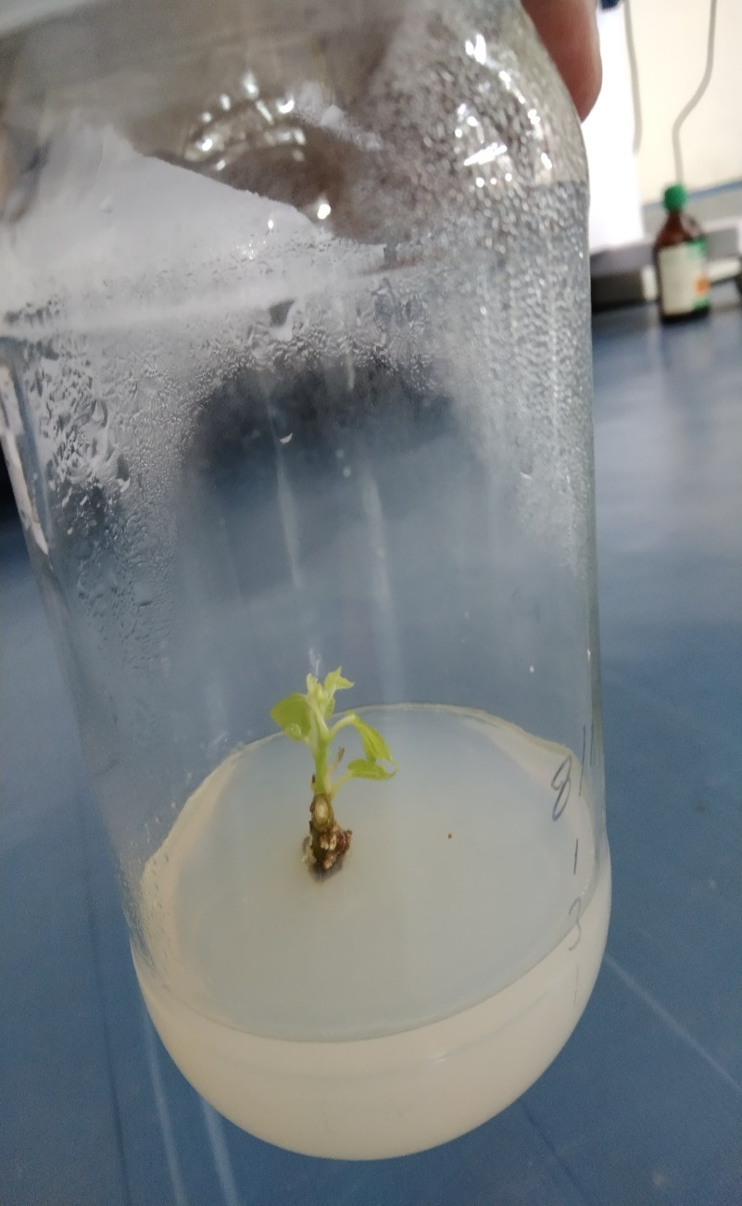  A | 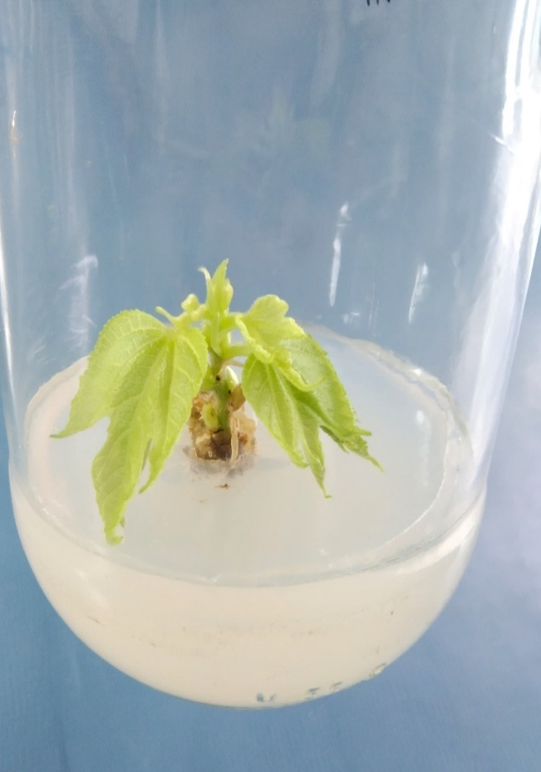  B
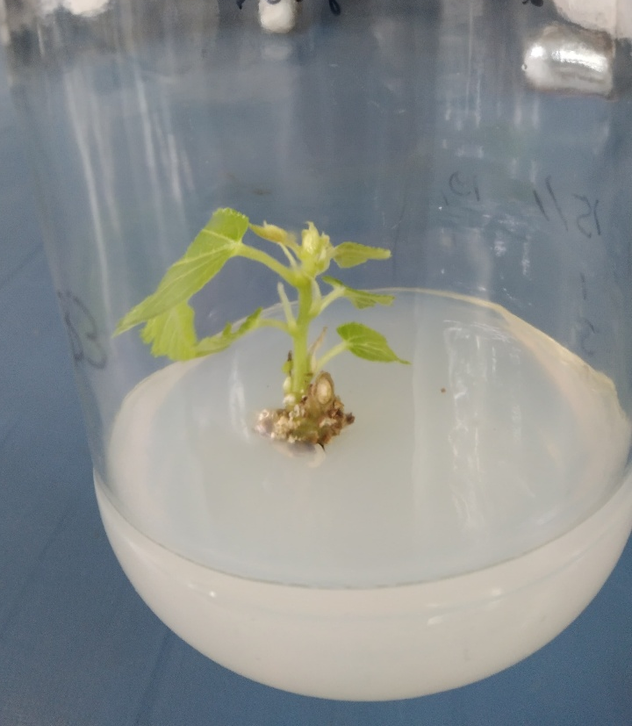  C | 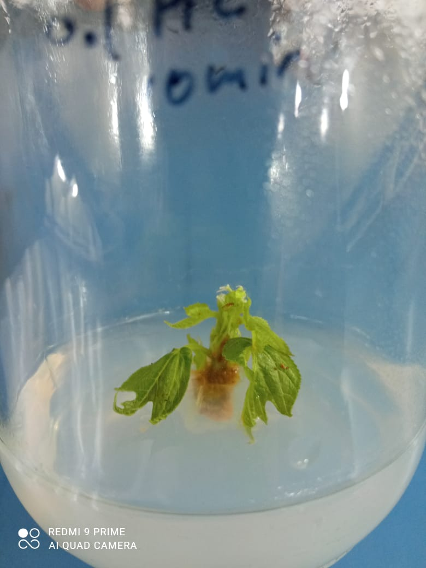  D

Plate:3. Effect of Sterilization agents on explants (A. Apical bud, B. First Node, C. Second node and D. Third node ) at Ethanol 70% + HgCl₂ 0.2% for 1+ 10 min.

Table:1. Explant used for sterilization
Treatments | Explants
A1 | Meristem tip
A2 | Apical bud
A3 | First Node
A4 | Second Node
A5 | Third node
Table:2. Different sterilizing agents, concentration and duration for explant sterilization
Treatment | Concentration | Meristem tip | Apical bud | First Node | Second Node | Third Node
Ethanol | 70% | 1 min | 1 min | 1min | 1 min | 1 min
HgCl₂ | 0.1 % | 5 min | 5 min | 5 min | 5 min | 5 min
HgCl₂ | 0.1 % | 10 min | 10 min | 10 min | 10 min | 10 min
HgCl₂ | 0.2% | 5 min | 5 min | 5 min | 5 min | 5 min
HgCl₂ | 0.2% | 10min | 10 min | 10 min | 10 min | 10 min
Ethanol ₊  HgCl₂ | 70%  +  0.1% | 1+5 min | 1+5 min | 1+5 min | 1+5 min | 1+5 min
Ethanol ₊  HgCl₂ | 70%  +  0.1% | 1+10 min | 1+10 min | 1+10 min | 1+10 min | 1+10 min
Ethanol ₊  HgCl₂ | 70%  + 0.2% | 1+5 min | 1+5 min | 1+5 min | 1+5 min | 1+5 min
Ethanol ₊  HgCl₂ | 70%  + 0.2% | 1+10 min | 1+10 min | 1+10 min | 1+10 min | 1+10 min
Table:3. Effect of sterilizing agents on percentage contamination and percentage survival of explant
Treatments | Sterilization agent | Duration | Percentage contamination of explant (%) | Percentage survival of explant (%)
A₁ | 70% Ethanol | 1 min. | 82.33 | 17.67
A₂ | 0.1% HgCl₂ | 5 min | 74.00 | 26.00
A₃ | 0.1% HgCl₂ | 10 min | 69.33 | 30.67
A₄ | 0.2% HgCl₂ | 5 min | 64.67 | 35.33
A₅ | 0.2% HgCl₂ | 10 min | 60.00 | 40.00
A₆ | 70% Ethanol+ 0.1% HgCl₂ | 1+5 min | 54.67 | 45.33
A₇ | 70% Ethanol+ 0.1% HgCl₂ | 1+10 min | 38.00 | 62.00
A₈ | 70% Ethanol+ 0.2% HgCl₂ | 1+5 min | 29.67 | 70.33
A₉ | 70% Ethanol+ 0.2% HgCl₂ | 1+10 min | 18.33 | 81.67
SE(m) ± |  |  | 0.72 | 0.50
C.D. (5%) |  |  | 2.14 | 1.94

Table:4. Effect of explant on percentage contamination and percentage survival of explant
 | Explant | Percentage explant contamination | Percentage explant survival
B₁ | Meristem tip | 49.33 | 50.67
B₂ | Apical bud | 42.67 | 57.33
B₃ | First node | 39.33 | 60.67
B₄ | Second node | 36.33 | 63.33
B₅ | Third node | 34.67 | 65.33
SE(m) ± |  | 0.33 | 0.33
C.D. (5%) |  | 1.42 | 0.97

