Serotyping and antibiogram of Escherichia coli isolated from raw poultry meat in Jammu, India

Abstract
This comprehensive study investigates the prevalence, serological diversity, and antimicrobial resistance patterns of Escherichia coli strains isolated from raw poultry meat samples collected from retail outlets in Jammu, India. Out of 65 raw poultry meat samples examined, 25 samples (38.46%) tested positive for E. coli contamination, yielding 21 isolates that were subsequently characterized through serotyping and antimicrobial susceptibility testing. The isolated E. coli strains belonged to eleven different serotypes, including clinically significant serogroups O111 and O157, which are recognized as important zoonotic pathogens. Antimicrobial susceptibility testing revealed concerning patterns of resistance, with isolates showing high resistance rates to commonly used antibiotics such as ampicillin (87.69%), nalidixic acid (78.46%), and tetracycline, while maintaining relatively high susceptibility to ciprofloxacin (90.76%) and chloramphenicol (86.15%). The detection of pathogenic serotypes combined with multidrug resistance patterns underscores the critical need for enhanced food safety measures and antimicrobial stewardship in poultry production and retail environments.
Keywords: Escherichia coli, poultry meat contamination, serotyping, antimicrobial resistance, food safety, zoonotic pathogens
Introduction
Global Context of Foodborne Pathogens in Poultry
Poultry meat represents one of the most consumed protein sources worldwide, with global chicken meat production reaching 102.389 million tons in 2023. However, this widespread consumption is accompanied by significant food safety challenges, as poultry products frequently harbor pathogenic microorganisms that pose substantial risks to human health (Scallan et al.,2011). Raw chicken meat can serve as a reservoir for various bacterial pathogens, including Salmonella species, Campylobacter, Escherichia coli, and Staphylococcus aureus, all of which are recognized as leading causes of foodborne illnesses globally (Scallan et al.,2011; Doyle et al.,2011). The prevalence of foodborne pathogens in retail poultry varies significantly across different geographical regions and production systems (Doyle et al.,2011). Studies have documented E. coli contamination rates ranging from 11.9% in turkey products to 38.7% in chicken samples in retail meat markets (Doyle et al.,2011). In developing countries, where food safety infrastructure may be less robust, contamination rates can be even higher, with some studies reporting E. coli prevalence rates exceeding 40% in chicken meat samples (Ahmed and Shimamoto,2014).
Escherichia coli as a Foodborne Pathogen
Escherichia coli encompasses a diverse group of bacteria that includes both harmless commensal strains and highly pathogenic variants capable of causing severe human illness (Nataro and Kaper,1998). The pathogenic E. coli strains are classified into several pathotypes, including enterohemorrhagic E. coli (EHEC), enteropathogenic E. coli (EPEC), enterotoxigenic E. coli (ETEC), and extraintestinal pathogenic E. coli (ExPEC) (Pokharel et al.,2020). These pathogenic strains possess various virulence factors that enable them to colonize host tissues, evade immune responses, and cause disease (Kaper et al.,2004). The emergence of antimicrobial-resistant E. coli strains in food animals has become a critical public health concern, as these resistant bacteria can be transmitted to humans through the food chain (Ramos et al.,2020; Ventola,2015). Studies from India have revealed alarming levels of antimicrobial resistance in E. coli isolates from poultry, with resistance rates exceeding 80% for commonly used antibiotics such as nalidixic acid and tetracycline (Ramos et al.,2020). This high prevalence of resistance is attributed to the widespread and often indiscriminate use of antimicrobials in poultry production systems (Ventola,2015; McEwen and Collignon,2018).
Serotyping and Its Significance
Serotyping of E. coli based on O (somatic) and H (flagellar) antigens remains a fundamental tool for epidemiological surveillance, outbreak investigation, and risk assessment (Johnson and Stell,2000; Mainil and Daube,2005). Certain serotypes, particularly O157:H7, O111, O26, O103, and O145, are associated with severe human diseases, including hemolytic uremic syndrome (HUS) and hemorrhagic colitis (Johnson and Stell,2000; Karmali et al.,2010). The detection of these pathogenic serotypes in food products serves as an important indicator of potential public health risks (Mead and Griffin ,1998; Karmali et al.,2010). Recent molecular epidemiological studies have revealed complex relationships between E. coli strains found in poultry and those causing human infections. The E. coli sequence type ST131, particularly the ST131-H22 sublineage, has been identified as a significant foodborne pathogen that can be transmitted from poultry to humans, causing urinary tract infections and other extraintestinal diseases (Johnson et al.,2009; Manges and Johnson,2017; Alonso,2017).
Materials and Methods
Sample Collection and Processing
A comprehensive sampling strategy was implemented to collect 65 raw poultry meat samples from retail outlets across Jammu, India. The sampling protocol ensured representative coverage of different retail environments, including local markets and commercial establishments. Each sample consisted of 10 grams of chicken meat, which was aseptically collected in sterile packaging and transported to the laboratory in ice boxes to maintain cold chain integrity (Kumar et al.,2018). To standardize the analytical process and minimize temporal variations in bacterial counts, all samples were processed within 2-3 hours of collection. This rapid processing protocol is critical for accurate enumeration of viable bacteria and prevents alterations in microbial populations that could occur during extended storage periods.
Bacterial Isolation and Identification
The isolation of E. coli was performed using MacConkey agar, a selective and differential medium that facilitates the growth of gram-negative bacteria while inhibiting gram-positive organisms (Murray et al.,1999). MacConkey agar contains lactose as a fermentable carbohydrate, bile salts as selective agents, and neutral red as a pH indicator, allowing for the differentiation of lactose-fermenting bacteria like E. coli, which appear as pink colonies with characteristic morphology. Serial dilutions (10⁻² and 10⁻³) of each sample were prepared and spread-plated in triplicate on dried MacConkey agar plates. The plates were incubated at 37±2°C for 24 hours, after which presumptive E. coli colonies were identified based on their characteristic sharp pink appearance and approximate diameter of 0.5 mm. The average colony counts were recorded as log colony-forming units per gram (log CFU/g) of sample. Confirmation of E. coli identity was achieved through a two-step process involving morphological and biochemical characterization. Presumptive colonies were first streaked onto Eosin Methylene Blue (EMB) agar, where E. coli produces characteristic colonies with metallic green sheen due to the interaction between the dyes and the acidic metabolites produced during lactose fermentation. Subsequently, biochemical confirmation was performed using the HiMViC test kit, which evaluates hydrogen sulfide production, indole formation, methyl red reaction, Voges-Proskauer test, and citrate utilization (Kumar et al.,2018).
Serotyping Methodology
The isolates were sent to the National Salmonella and Escherichia Centre in Kasauli, Himachal Pradesh, India, for additional confirmation and serotyping.
Antimicrobial Susceptibility Testing
Antimicrobial susceptibility testing was performed using the standardized disk diffusion method according to Bauer-Kirby guidelines. This method involves the placement of antibiotic-impregnated disks on Mueller-Hinton agar plates inoculated with a standardized bacterial suspension. The zones of inhibition around each disk are measured after incubation and compared with established interpretive criteria to determine susceptibility, intermediate resistance, or resistance. The antibiotic panel included agents commonly used in both veterinary and human medicine, representing different antimicrobial classes: beta-lactams (ampicillin, amoxicillin), fluoroquinolones (ciprofloxacin, nalidixic acid), tetracyclines (tetracycline), phenicols (chloramphenicol), folate pathway inhibitors (co-trimoxazole), and polymyxins (polymyxin B). This comprehensive panel allows for the assessment of resistance patterns across multiple drug classes and identification of multidrug-resistant strains (Kumar et al.,2018).
Results
Prevalence of E. coli Contamination
The microbiological analysis revealed that 25 out of 65 raw poultry meat samples (38.46%) were contaminated with E. coli. This contamination rate is consistent with global surveillance data, which report E. coli prevalence rates ranging from 34.6% to 79.8% in retail poultry products (Zhao et al,2001). The observed prevalence aligns closely with studies conducted in other regions of India and neighboring countries, suggesting similar challenges in poultry production and handling practices across South Asian markets (Nataro and Kaper,1998; Dierikx et al.,2010).The 38.46% prevalence rate observed in this study falls within the range reported by comparable investigations in developing countries (fig1). For instance, studies from West Bengal, India, reported 39.76% contamination in raw poultry meat, while investigations in Bangladesh documented prevalence rates of 78.67% in layer chickens and 82% in broiler chickens. This variation in contamination rates likely reflects differences in production systems, processing methods, hygiene practices, and environmental conditions across different geographical locations (Nataro and Kaper,1998).
Serotyping Results and Serogroup Distribution
Serotyping analysis conducted at the National Salmonella and Escherichia Centre successfully characterized 19 out of 21 E. coli isolates, with 2 isolates remaining untypeable and 2 identified as rough strains lacking complete O-antigen expression. The serotyping results revealed considerable diversity among the isolated strains, with representation from multiple serogroups of varying pathogenic potential.
The most prevalent serogroup was O7, accounting for 8 isolates (32% of total isolates). Serogroups O111 and O120 were each represented by 3 isolates (12%), while O17 was found in 2 isolates (8%). Several other serogroups, including O18, O22, O88, O109, and O158, were each represented by single isolates (4% each). This diversity in serogroup representation is consistent with the heterogeneous nature of E. coli populations in poultry environments and reflects the complex ecological dynamics of these bacteria in food production system (fig 2).Of particular concern was the detection of serogroups O111 and O157, both of which are recognized as important zoonotic pathogens with the potential to cause severe human disease. Serogroup O111 is classified among the "Big Six" non-O157 Shiga toxin-producing E. coli (STEC) serogroups that are regulated by food safety authorities in many countries due to their association with serious foodborne illness outbreaks. Similarly, O157 strains, particularly O157:H7, are well-established causes of hemorrhagic colitis and hemolytic uremic syndrome (Karmali et al.,2010).
Antimicrobial Resistance Patterns
The antimicrobial susceptibility testing revealed concerning patterns of resistance among the E. coli isolates, with significant implications for both veterinary and human medicine. The isolates demonstrated the highest susceptibility to ciprofloxacin (90.76%), followed by chloramphenicol (86.15%), co-trimoxazole (86.61%), and polymyxin B (81.53%). These findings suggest that these antimicrobial agents may remain effective for treating E. coli infections in the immediate term, although continuous monitoring is essential to detect emerging resistance.Conversely, the isolates exhibited alarming levels of resistance to several commonly used antibiotics. Ampicillin resistance was observed in 87.69% of isolates, representing the highest resistance rate among all tested antibiotics. Nalidixic acid resistance was found in 78.46% of isolates, while tetracycline resistance affected a substantial proportion of the bacterial population(fig 3). These high resistance rates are consistent with global trends in antimicrobial resistance among E. coli isolates from poultry sources (Li et al.,2007).The observed resistance patterns reflect the selective pressure exerted by the widespread use of antimicrobials in poultry production systems. Ampicillin, a beta-lactam antibiotic, has been extensively used in veterinary medicine for both therapeutic and prophylactic purposes, leading to the selection and proliferation of resistant strains (Bush and Bradford,2016; Livermore,1995). Similarly, the high resistance rates to nalidixic acid and tetracycline can be attributed to their frequent use in poultry farming operations (Li et al.,2007).
Discussion
Public Health Significance
The detection of pathogenic E. coli serogroups in retail poultry meat raises significant public health concerns, particularly given the high consumption rates of poultry products and the potential for cross-contamination during food preparation (Scallan,2011;Ahmed and Shimamoto,2014;WHO/FA0,2002).The presence of serogroups O111 and O157 is especially concerning, as these strains are associated with severe human diseases, including life-threatening complications such as hemolytic uremic syndrome. (Karmali et al.,2010; Mead and Griffin,1998). The 38.46% contamination rate observed in this study indicates that a substantial proportion of poultry meat available to consumers may harbor potentially pathogenic E. coli strains. This finding is consistent with global surveillance data and underscores the need for comprehensive risk assessment and management strategies throughout the poultry supply chain (WHO/FAO,2002). The World Health Organization and Food and Agriculture Organization have identified poultry meat as one of the most important food vehicles for foodborne pathogen transmission, necessitating enhanced surveillance and control measures.
Antimicrobial Resistance Implications
The high prevalence of antimicrobial resistance observed in this study reflects broader global trends in the emergence and dissemination of resistant bacterial pathogens (WHO,2015). The World Health Organization's 2024 Bacterial Priority Pathogens List includes third-generation cephalosporin-resistant Enterobacterales in the critical priority group, highlighting the urgent need for new therapeutic options and enhanced stewardship measures.The resistance patterns observed in this study are particularly concerning given their potential impact on treatment outcomes for both animal and human infections (McEwen and Collignon,2018). High resistance rates to ampicillin and nalidixic acid limit the effectiveness of these commonly used antimicrobials, potentially leading to treatment failures and increased morbidity (Ramos et al.,2020). The relatively preserved susceptibility to ciprofloxacin and chloramphenicol provides some therapeutic options, but continuous monitoring is essential to detect emerging resistance to these critical agents.
One Health Perspective
The findings of this study exemplify the interconnected nature of animal, human, and environmental health, emphasizing the importance of a One Health approach to addressing antimicrobial resistance (McEwen and Collignon,2018). The transmission of resistant E. coli strains from poultry to humans can occur through multiple pathways, including direct consumption of contaminated meat, cross-contamination during food preparation, and environmental dissemination (Johnson and Menard ,2009; Manges and Johnson,2012; Alonso et al,2017).
Recent molecular epidemiological studies have provided compelling evidence for the zoonotic transmission of E. coli strains between poultry and humans (Johnson and Menard ,2009 and Manges and Johnson,2012). The E. coli ST131-H22 sublineage, which has become established in poultry populations worldwide, has been identified as a significant cause of urinary tract infections in humans, demonstrating the importance of food animals as reservoirs for human pathogenic bacteria (Manges and Johnson,2012; Alonso et al,2017).
Recommendations and Future Directions
Enhanced Surveillance Systems
The development of comprehensive surveillance systems for monitoring foodborne pathogens and antimicrobial resistance in poultry production is essential for early detection of emerging threats and evaluation of intervention effectiveness. These systems should incorporate standardized sampling protocols, harmonized laboratory methods, and integrated data management platforms to facilitate information sharing and trend analysis (Cantón et al.,2012).Molecular surveillance techniques, including whole genome sequencing (WGS), are increasingly being adopted for pathogen characterization and source attribution (Pokharel er al.,2020). WGS provides high-resolution data on genetic relationships between strains, resistance mechanisms, and virulence factors, enabling more precise epidemiological investigations and risk assessments. The transition from traditional typing methods to WGS-based approaches represents a significant advancement in surveillance capabilities.
Regulatory Framework Development
The establishment of robust regulatory frameworks governing antimicrobial use in food animal production is crucial for managing resistance development. These frameworks should include provisions for prescription-only medicines, mandatory veterinary oversight, restricted use of critically important antimicrobials, and implementation of national action plans aligned with global initiatives (WHO,2015). Regular review and updating of regulatory standards based on emerging scientific evidence and resistance surveillance data are essential for maintaining their effectiveness (WHO,2015). International harmonization of standards and mutual recognition agreements can facilitate trade while maintaining food safety and public health protection.
Conclusion
This comprehensive study of E. coli contamination in raw poultry meat from Jammu, India, reveals significant public health challenges that require immediate attention and coordinated intervention strategies. The 38.46% prevalence of E. coli contamination, coupled with the detection of pathogenic serogroups O111 and O157, underscores the potential risks associated with consumption of inadequately cooked poultry products (Kumar et al.,2018). The high rates of antimicrobial resistance, particularly to ampicillin (87.69%) and nalidixic acid (78.46%), reflect broader global trends in the emergence of resistant bacterial pathogens and highlight the urgent need for enhanced antimicrobial stewardship measures.The findings of this study are consistent with global surveillance data and emphasize the interconnected nature of animal, human, and environmental health in the context of foodborne pathogen transmission. The One Health approach provides a framework for addressing these challenges through coordinated efforts involving multiple sectors and stakeholders (WHO/FAO,2002). Implementation of comprehensive control strategies, including enhanced hygiene practices, antimicrobial stewardship, alternative pathogen control methods, and improved surveillance systems, is essential for reducing the burden of foodborne illness and antimicrobial resistance (McEwen and Collignon ,2017)

Data Availability statement: Nil
References
- Ahmed AM, Shimamoto T. Isolation and molecular characterization of Salmonella enterica, Escherichia coli O157:H7 and Shigella spp. from meat and dairy products in Egypt. Int J Food Microbiol. 2014;168-169:57-62. doi:10.1016/j.ijfoodmicro.2013.10.014
- Alonso CA, Zarazaga M, Ben Sallem R, Jouini A, Ben Slama K, Torres C. Antibiotic resistance in Escherichia coli in husbandry animals: the African perspective. Lett Appl Microbiol. 2017;64(5):318-34. doi:10.1111/lam.12724
- Bush K, Bradford PA. Beta-lactams and beta-lactamase inhibitors: an overview. Cold Spring Harb Perspect Med. 2016;6(8):a025247. doi:10.1101/cshperspect.a025247
- Cantón R, González-Alba JM, Galán JC. CTX-M enzymes: origin and diffusion. Front Microbiol. 2012;3:110. doi:10.3389/fmicb.2012.00110
- Deng X, den Bakker HC, Hendriksen RS. Genomic epidemiology: whole-genome-sequencing-powered surveillance and outbreak investigation of foodborne bacterial pathogens. Annu Rev Food Sci Technol. 2016;7:353-74. doi:10.1146/annurev-food-041715-033259
- Dierikx C, van Essen-Zandbergen A, Veldman K, Smith H, Mevius D. Increased detection of extended spectrum beta-lactamase producing Salmonella enterica and Escherichia coli isolates from poultry. Vet Microbiol. 2010;145(3-4):273-8. doi:10.1016/j.vetmic.2010.03.019
- Doyle MP, Erickson MC. Opportunities for mitigating pathogen contamination during on-farm food production. Int J Food Microbiol. 2012;152(3):54-74. doi:10.1016/j.ijfoodmicro.2011.04.030
- Johnson JR, Menard M, Johnston B, Kuskowski MA, Nichol K, Zhanel GG. Epidemic clonal groups of Escherichia coli as a cause of antimicrobial-resistant urinary tract infections in Canada, 2002 to 2004. Antimicrob Agents Chemother. 2009;53(7):2733-9. doi:10.1128/AAC.00297-09
- Johnson JR, Stell AL. Extended virulence genotypes of Escherichia coli strains from patients with urosepsis in relation to phylogeny and host compromise. J Infect Dis. 2000;181(1):261-72. doi:10.1086/315217
- Kaper JB, Nataro JP, Mobley HL. Pathogenic Escherichia coli. Nat Rev Microbiol. 2004;2(2):123-40. doi:10.1038/nrmicro818
- Karmali MA, Gannon V, Sargeant JM. Verocytotoxin-producing Escherichia coli (VTEC). Vet Microbiol. 2010;140(3-4):360-70. doi:10.1016/j.vetmic.2009.04.011
- Kumar A, Sharma NK, Gupta A, Singh SP. Serotyping and antibiogram of Escherichia coli isolated from raw poultry meat in Jammu region. J Adv Biol Biotechnol. 2018;17(2):1-8.
- Li XZ, Mehrotra M, Ghimire S, Adewoye L. Beta-lactam resistance and beta-lactamases in bacteria of animal origin. Vet Microbiol. 2007;121(3-4):197-214. doi:10.1016/j.vetmic.2007.01.015
- Livermore DM. Beta-lactamases in laboratory and clinical resistance. Clin Microbiol Rev. 1995;8(4):557-84. doi:10.1128/CMR.8.4.557
- Mainil JG, Daube G. Verotoxigenic Escherichia coli from animals, humans and foods: who's who? J Appl Microbiol. 2005;98(6):1332-44. doi:10.1111/j.1365-2672.2005.02653.x
- Manges AR, Johnson JR. Food-borne origins of Escherichia coli causing extraintestinal infections. Clin Infect Dis. 2012;55(5):712-9. doi:10.1093/cid/cis502
- McEwen SA, Collignon PJ. Antimicrobial resistance: a One Health perspective. Microbiol Spectr. 2018;6(2):ARBA-0009-2017. doi:10.1128/microbiolspec.ARBA-0009-2017
- McEwen SA, Fedorka-Cray PJ. Antimicrobial use and resistance in animals. Clin Infect Dis. 2002;34 Suppl 3:S93-106. doi:10.1086/340246
- Mead PS, Griffin PM. Escherichia coli O157:H7. Lancet. 1998;352(9135):1207-12. doi:10.1016/S0140-6736(98)01267-7
- Murray PR, Baron EJ, Pfaller MA, Tenover FC, Yolken RH, editors. Manual of Clinical Microbiology. 7th ed. Washington (DC): American Society for Microbiology; 1999.
- Nataro JP, Kaper JB. Diarrheagenic Escherichia coli. Clin Microbiol Rev. 1998;11(1):142-201. doi:10.1128/CMR.11.1.142
- Pokharel S, Shrestha P, Adhikari B. Antimicrobial use in food animals and human health: time to implement 'One Health' approach. Antimicrob Resist Infect Control. 2020;9(1):181. doi:10.1186/s13756-020-00847-x
- Ramos S, Silva V, Dapkevicius MLE, Caetano T, Sousa M, Henriques A, et al. Escherichia coli as commensal and pathogenic bacteria among food-producing animals: health implications of extended spectrum β-lactamase (ESBL) production. Animals (Basel). 2020;10(12):2239. doi:10.3390/ani10122239
- Scallan E, Hoekstra RM, Angulo FJ, Tauxe RV, Widdowson MA, Roy SL, et al. Foodborne illness acquired in the United States—major pathogens. Emerg Infect Dis. 2011;17(1):7-15. doi:10.3201/eid1701.P11101
- Ventola CL. The antibiotic resistance crisis: part 1: causes and threats. P T. 2015;40(4):277-83.
- WHO. 2024 Bacterial Priority Pathogens List. Geneva: World Health Organization; 2024.
- WHO/FAO. Risk assessments of Salmonella in eggs and broiler chickens. Geneva: World Health Organization; 2002.
- World Health Organization. Global action plan on antimicrobial resistance. Geneva: World Health Organization; 2015.
- Zhao S, White DG, McDermott PF, et al. Identification and expression of cephamycinase bla(CMY) genes in Escherichia coli and Salmonella isolates from food animals and ground meat. Antimicrob Agents Chemother. 2001;45(12):3647-50. doi:10.1128/AAC.45.12.3647-3650.2001

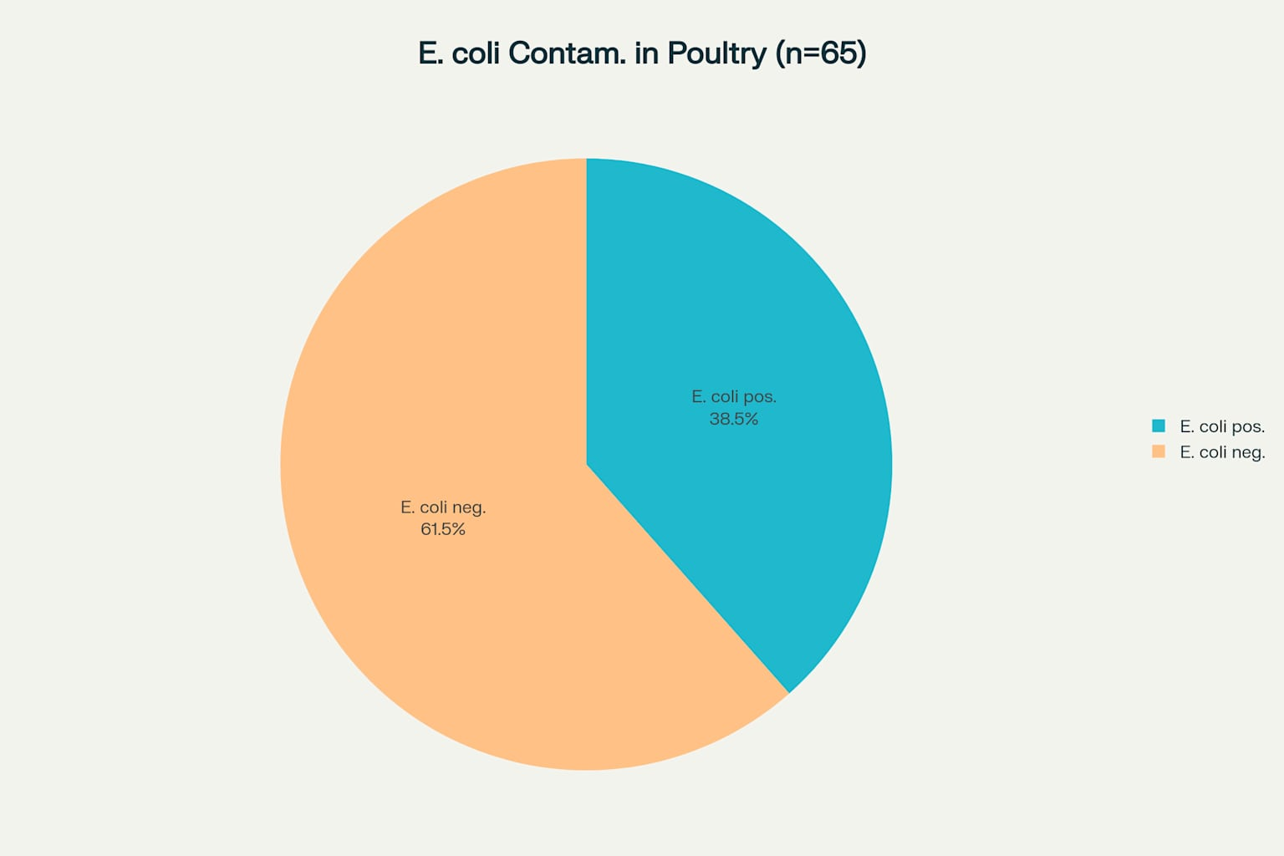
Figure 1: Overall prevalence of E. coli contamination in raw poultry meat samples collected from retail outlets
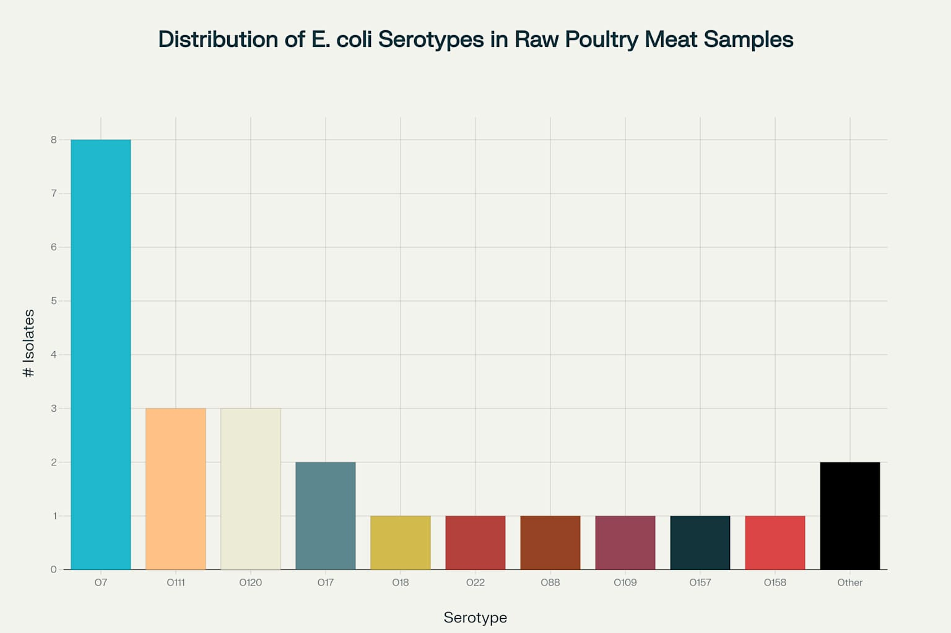
Figure 2: Distribution of E. coli serotypes isolated from raw poultry meat samples, showing O7 as the most prevalent serogroup

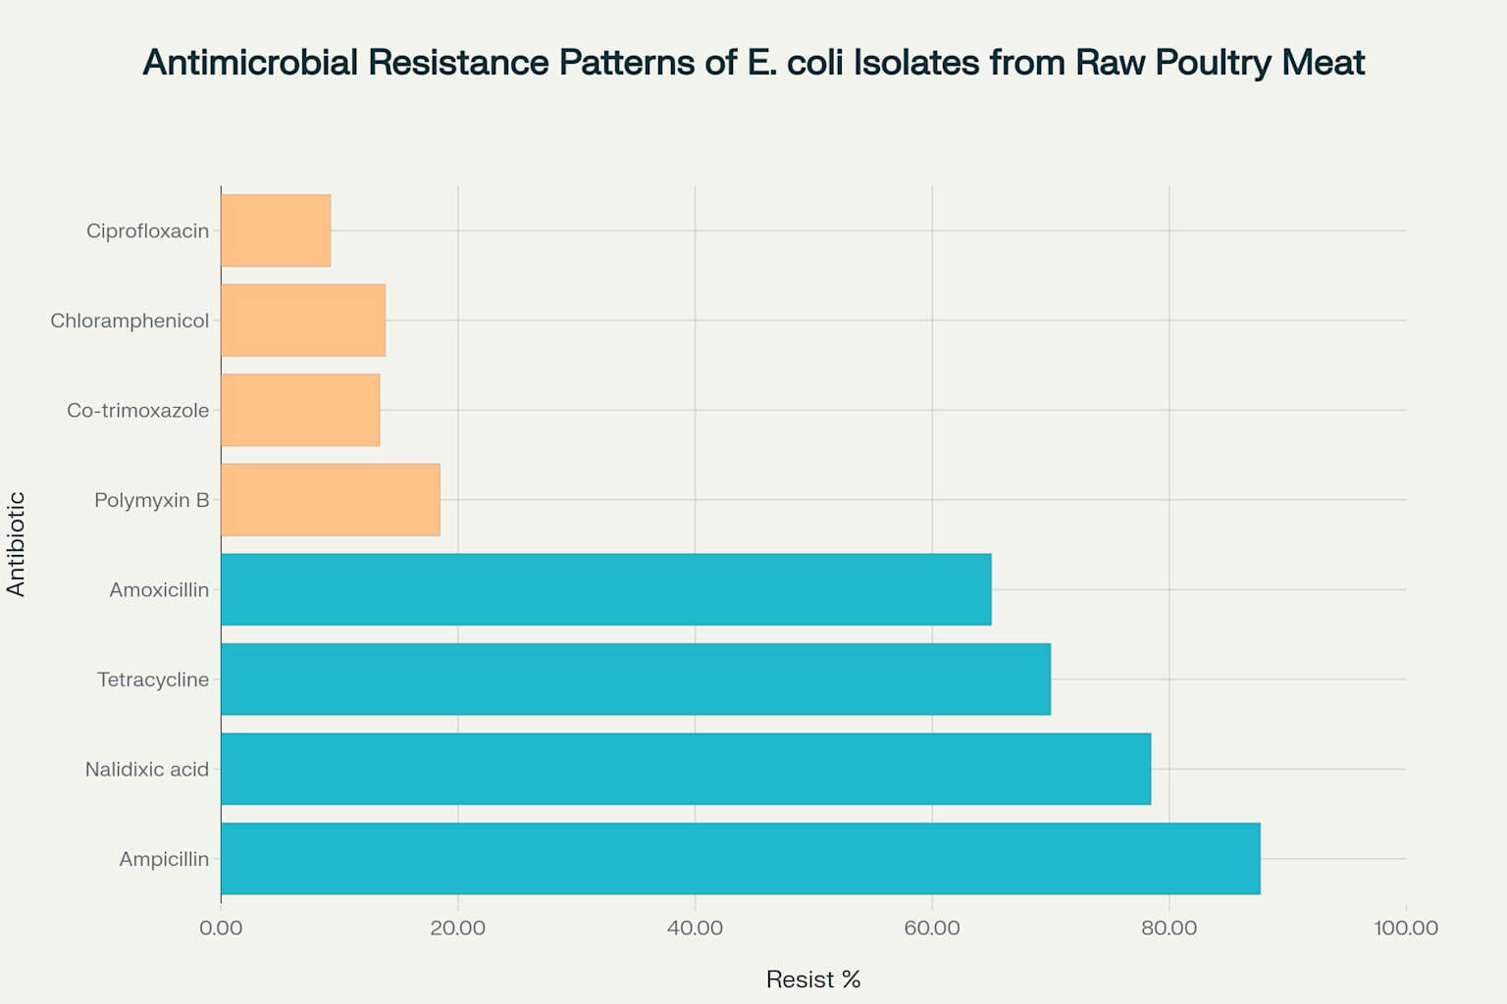
Figure 3: Antimicrobial resistance patterns showing high resistance to beta-lactams and quinolones, with preserved susceptibility to chloramphenicol and ciprofloxacin

