**Alternate substrates for mushroom production.**

**ABSTRACT**

Mushroom farming is gaining worldwide increasing recognition as an establishment of nutritional, therapeutic and economic importance. The biotechnological procedure utilizes various organic resources as substrates for the production of edible and therapeutically active fungal biomass. Traditionally, sawdust, composted manure and wheat straw were the essential substrates. Nevertheless, increasing demand for cheaper production and fungal-mediated bioremediation warrants the utilization of alternative substrates. In addition, using unconventional farming inputs with parameters: agricultural residues (rice husk, corn stover, sugarcane bagasse) or industrial by-products (spent grains, coffee husks, brewery waste) or organic waste materials (food scraps, garden waste) can free up some precious resources. These are principles of sustainable agriculture and the circular economy, including resource conservation, reduced environmental contamination and higher mushroom production. Nevertheless, issues like pollutants, compositional heterogeneity, invasive plants, and potentially pathogenic microorganisms can be encountered and must be addressed prior to substrate utilization e.g., through fermentation, steaming, or chemical pre-treatments to improve substrate safety and efficiency (Balsora et al., 2021). Although established substrates have demonstrated efficacy, availability and resource recycling, they also share drawbacks like competition with other applications, seasonal availability, contamination threats, higher prices and ecological impacts. In the case of mushrooms, using alternative substrates comes with economic and costs benefits while being considered more sustainable, but there remain some other essential sustainability parameters like optimal growth condition, quality and variability of substrate and cost effective feasibility that needs thorough research and refinement of this strategy on large scale for transitioning from established mushroom species production with convention substrate to sustainable production practice by using alternative substrate.

**KEYWORDS:** Mushroom, Substrates; Lignocellulosic; By-products

1. **Introduction**

Mushroom farming has gained worldwide attention due to its various nutritional, therapeutic and economic benefits. The use of the broad range of organic materials (substrates) to produce edible and therapeutically important fungal mass (Chang & Wasser, 2017). The process is purely biotechnological. Traditionally mushrooms are cultivated on nutrient substrates such as sawdust and composted manure and wheat straw, which the fungus grows on and uses to rip-through the substrate to reach maturity. Because of the increasing demand for low-cost and sustainable production, the need for cost-effective and fungal mediated bioremediation is warranted to be investigated of alternative substrates. Some resources can be conserved and environmental contamination minimised during the procuring of unconventional farming inputs (Sanchez, 2010) and consequently these can boost the yield of mushroom.

Substrates are the major sources of carbon, nitrogen and other compounds for mushroom production and thus are important for mushroom growth. According to Behnam (2017), the substrate in mushroom production has a critical impact on mushroom growth rate and product quality. Conventional substrates are often based on regionally available agriculture waste; however, these are restricted by seasonality and limitations. Moreover, their sustainability and cost-effectiveness may be limited by the competition from other industrial and agricultural uses (Carrasco et al., 2018). Researchers are now investigating new substrates, including synthetic, municipal organic waste, and by-products from agriculture and industry.

Bunch of agricultural waste like rice husk, corn stover, sugarcane bagasse and banana leaves have previously been shown to be used as substrates to grow mushrooms. Kourotsios state that rich in lignocellulosic constituents that promote biomass degradation and fungal enzymes (2014). Like spent grains and brewery waste, byproducts of the industrial food chain like coffee husks could also serve as substitutes. They also supply suitable nutrients and engage in waste valorisation, re-utilising organic waste material which would otherwise lead to environmental pollution (Phan & Sabaratnam, 2012).

Subquery substrates also stay in line with sustainable agriculture and the circular economic climate. This research includes the use of more organic byproducts, such as food scrap and garden waste than mushrooms being grown on classified rubbish. Used properly, they can also contribute to reducing greenhouse gas emissions, reducing waste to landfills and ecological sustainability (Zied et al. 2011). However, issues like pollutants, compositional heterogeneity and potential pathogenic microorganisms need to be addressed to guarantee safety and effectiveness of such substrates (Sridhar et al., 2019). Pre-treatment methods have had recent advances relative to different substrates in terms of fermentative and steaming or chemical pre-treatments to enhance digestibility and availability of nutrients in other substrates (Vikrant, 2019). Fermentation, on the other hand, has been shown to increase the bioavailability of important nutrients which makes it possible to break down complex lignocellulosic structures (Samtiya et al., 2021) .Similarly, nitrogen sources were added to substrate, investigated minerals and studied microbial inoculants (Atila, 2017). This being said, there are significant barriers to the large-scale implementation of alternate substrates around these technologies. However, the aspects such as variability with respect to quality of substrate, cost-effective feasibility and optimum condition for growth etc. will all still need to be ascertained via future studies (Royse et al., 2017). Mushroom cultivation had been based on organic ingredients that encouraged fungi growth and even fruiting for centuries. Substrate is a critical component of mushroom production, as it provides moisture, binds nutrients and structural support for the growth of the fruiting body and the colonisation of mycelium (Sanchez, 2010). Because of their availability and nutrients composition, as well as proven ability to stimulate mushroom growth, some traditional substrates (mostly sawdust, wheat straw, composted manure and other plant matter waste) were used widely (Royse et al. 2017).

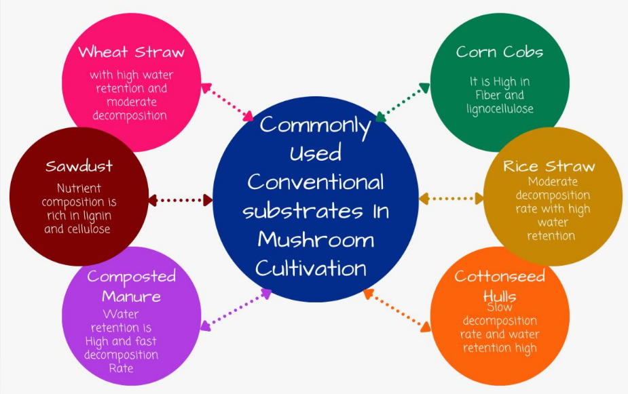**2. Commonly Used Conventional Substrates in Mushroom Cultivation**

**Figure. 1: Common Substrates for Growing Mushrooms**

**2.1** **Wheat Straw**

One of the most common substrates for mushroom cultivation is wheat straw, particularly for species such as the *Pleurotus ostreatus* (oyster mushroom) and *Agaricus bisporus* (button mushroom) (Carrasco et al., 2018). Fungi metabolize these lignocellulosic substrates, which contain substantial amounts of cellulose, hemicellulose and lignin, as the source of carbon. And many grains, such as wheat, are abundant in many areas and offer plenty of potential for both aeration and structure supported mycelial colonisation. Nitrogen sources are easily supplemented for yield gain completion (Suwannarach et al., 2022).

**2.2 Sawdust**

Commonly cultivated wood-decay fungus, e.g. *Lentinula edodes* (shiitake mushroom) and *Ganoderma lucidum* (reishi mushroom) are usually cultivated on sawdust as a substrate (Samtiya et al., 2021). Sometimes, the cereal is fortified with wheat bran to boost its nutritional benefits. Sawdust has many advantages such as a rich lignocellulosic landscape beneficial for wood-degrading fungi, native moisture content and substrate composition, and potential of being used alone or mixed with other ingredients to enhance yields (Koutrotsios et al., 2014).

**2.3 Composted Manure**

For example, button mushrooms or *Agaricus bisporus*, are typically cultivated on composted manure—often from chickens and other poultry or horses. Farmers and make it with straw and organic materials in order to create a nutrient-rich media. Composted manure is rich in nitrogen and other important nutrients, carries a lower microbial risk, and provides a more stable substrate more appropriate for large scale commercial mushroom cultivation (Kourotsios et al., 2014).

**2.4 Corn Cobs**

*Pleurotus spp.*could grow very well on maize cobs because they are high in cellulose and hemicellulose and could be broken down by soil fungi, and by far corn cobs are the most common conventional substrate for mushrooms and *Flammulina velutipes* (enoki mushrooms). They are a pervasive byproduct of corn-processing, they have fibrous structure which makes for great aeration. You can use these on their own or combined with other materials you may have. However, corn cobs are not available everywhere, need to be hydrated and supplemented to achieve good results and can get contaminated if not pasteurised (Philippoussis et al., 2009).

**2.5 Rice Straw**

Rice straw is one of the most made and economical substrates for mushroom culture particularly in Asia, where the cultivated crop is often bogey, rice. It is frequently used for *Pleurotus spp*. cultivation and *Volvariella volvacea*, or paddy straw mushrooms. It is very a lot for rice-producing area, having high cellulose for colonization of mycelium, so it's advantageous be used alone or on the other hand with other organic resources. But rice straw is low in nitrogen that needs supplement and rapidly decomposes which might cause lack of nutrients and must be soaked and pasteurised to remove competing microbes. (Sanchez,2010).

**2.6 Cottonseed Hulls**

Cottonseed hulls, a byproduct of the cotton industry that contain high levels of carbon and moderate levels of nitrogen, make them a fantastic substrate for genera of fungi (particularly *Pleurotus species* and *Lentinula edodes*, or shiitake mushrooms). In addition, help in balance nutritional content of gluten, even though the content of protein, sugar, fat and other nutrients found in this easy to extract fiber. But cottonseed hulls, unlike other agricultural byproducts, can be costly or hard to find if a region doesn’t grow cotton, they need to be supplemented to boost nitrogen levels and they’re pricier to begin with. Due in part to its high carbon and moderate nitrogen content (both ideal for fungal metabolism), cottonseed hulls—a byproduct of the cotton industry—make an excellent substrate for species in the genus Pleurotus and for *Lentinula edodes* (i.e., shiitake mushrooms). These are used alone or in combination with wheat bran or gypsum, therefore provide a good nutrition, stimulate high yield and biological efficiency. Nevertheless, cottonseed hulls are expensive or not available in non-cotton growing regions that they have to be supplemented to increase nitrogen content and high initial cost compared to other agricultural residues (Royse et al., 2017).

**2.7 Wood Chips**

Two well-known species produce on chips from hardwoods, such as beech or oak, as this yields for a slow decomposition rate and nutrients which are beneficial to fungal growth. They give form and structure for mycelium to grow in and are good for long-term mushroom production because they can be broken down over time. Also, they are eco-friendly as they can be made from forestry waste. Only some species contains inhibitory compounds, and wood chips can take time to fully colonise mycelial cells completely, and they need to be hydrated and supplemented properly (Samtiya et al., 2021).

**2.8 Coffee Grounds**

Spent coffee grounds, because of their rich nutrient content, have been studied for their possible ability to act as a substrate for mushroom cultivation; but for other mushrooms in general, particularly *Pleurotus spp*. Well the secret to an increasing demand for this type of agriculture and industrial waste, was their ability to create sustainability through making use of an easy and widely produced, if not used, waste product collected from any number of urban outdoor coffee shops and processing companies, as well as being a high nitrogen substrate that greatly increases the speed in which the applied fungal mycelium can grow and colonize. Spent coffee grounds, however, should and must be mixed with other materials to promote aeration, are easily contaminated due to their high microbial activity and root out competing bacteria and fungi (Carrasco et al., 2018).

|  |  |  |  |  |  |
| --- | --- | --- | --- | --- | --- |
| **Substrate** | **Nutrient Composition** | **Water Retention Capacity** | **Decomposition Rate** | **Suitable Mushroom Species** | **Citations** |
| Wheat Straw | High cellulose hemicellulose; moderate lignin | High | Moderate | Pleurotus ostreatus (Oyster Mushroom) | (Suwannarach et al., 2022) |
| Sawdust | Rich in lignin, cellulose and low nitrogen | Medium | Slow | Lentinula edodes (Shiitake) | (Suwannarach et al., 2022) |
| Compost Manure | High nitrogen and organic matter | High | Fast | Agaricus bisporus (Button Mushroom) | (Cunha zaid et al., 2020) |
| Corn Cobs | High in fiber and lignocellulose | Medium to High | Slow to Moderate | Pleurotus ostreatus (Oyster Mushroom) | (Suwannarach et al., 2022) |
| Rice Straw | High cellulose and lignin | High | Moderate | Pleurotus ostreatus (Oyster Mushroom) | (Suwannarach et al., 2022) |
| Cottonseed Hulls | High cellulose and protein | High | Slow | Pleurotus ostreatus (Oyster Mushroom) | (Suwannarach et al., 2022) |
| Wood Chips | High in lignin; low nitrogen | Low to Medium | Very Slow | Lentinula edodes (Shiitake) | (Suwannarach et al., 2022) |
| Coffee Grounds | High nitrogen and residual caffeine | Medium to High | Fast | Pleurotus ostreatus (Oyster Mushroom) | (Cunha zaid et al., 2020) |

**Table 1: Commonly used conventional substrates and their advantages (Suwannarach et al., 2022,Cunha zaid et al., 2020).**

1. **Benefits and Limitations of Conventional Substrates**

**3.1 Benefits of Conventional Substrates**

Mushrooms have been successfully grown on conventional substrates for several decade from consistent yield and high biological efficiency (Royse et al., 2017). Convenient substrates provide basic nutrients for the fruit body development and metabolism of the fungus, with widely available and standard procedures on its preparation, sterilisation and supplementation (Sanchez, 2010: Koutrotsios et al., 2014). Widely used conventional substrates such as sawdust, manure and wheat straw are easily available on many sites and most of them are either agricultural or forestry byproducts therefore help in recycling of resources and minimization of waste (Carrasco et al., 2018).

**3.2 Limitations of Conventional Substrates**

Conventional substrates have benefits, but also come with downsides. Others compete with other grains such as maize cobs and wheat straw and also with livestock feed (Suwannarach et al., 2021). Some substrates, like cottonseed hulls or rice straw, may be seasonally limited (Philippoussis et al., 2009) while there is a risk of bacterial contamination due to the ineffectiveness of pasteurisation or sterilisation (Farooq et al., 2015). Pricing Due to the fact that a few of the components, including a particular hardwood sawdust, could also be comparatively expensive or troublesome to find (Royse et al., 2017), could even be a concern. Finally, an over-dependence on traditional substrates may lead to deforestation of trees (when the substrate is wood-based) or excessive production of organic waste (Carrasco et al., 2018).

1. **Modern Substrates for Mushroom Production**

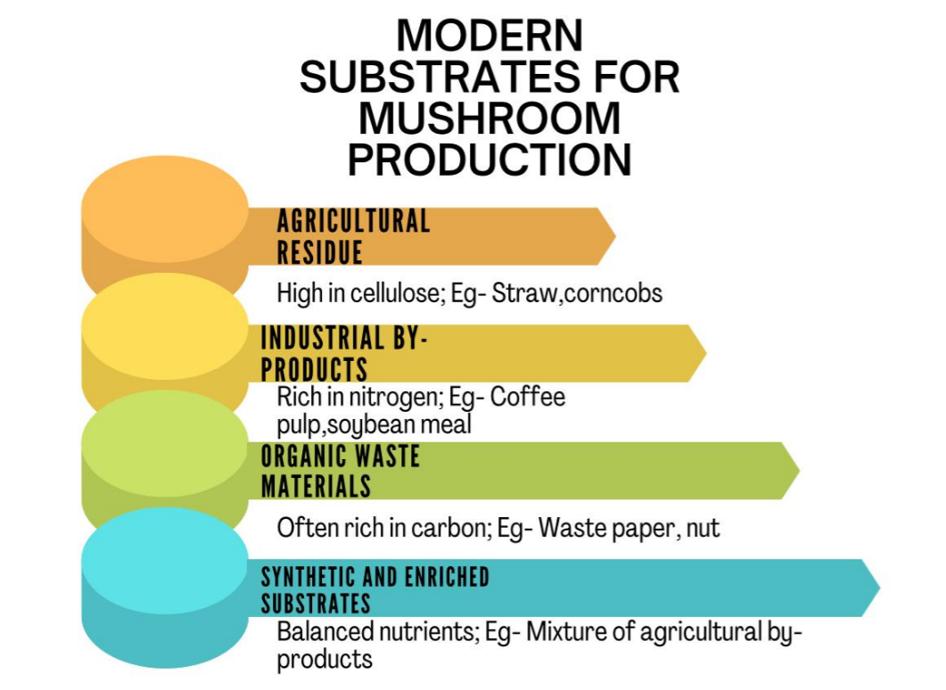

**Figure.2 Modern Substrates for Mushroom Culture**

Over time, mushroom agriculture has been developed as both farmers and scholars experimented with diverse substrates to maximize productivity and sustainability while minimizing costs. Other than that, we had unmatched potential in mushroom substrates. These options not only bypass the restrictions of conventional substrates such as wood logs and sawdust but also aid in waste management and resource efficiency (Zhang et al., 2019).

**4.1 Agricultural Residues**

Thus, we have attracted our attention to local agricultural wastes as substrates for mushroom growth, such as rice husk, corn stover and sugarcane bagasse. And there is such kind of resource is abundantly available here, it is also cheaper and mushroom required for their culture on ligno cellulosic based agricultural wastes. In this regard, high contents of cellulose and hemicellulose make the cultivation of Pleurotus species a lot easier (Zhang et al., 2019), especially in rice husk. Agaricus bisporus and Ganoderma lucidum, similarly, have a positive association with its growth influenced by sugarcane bagasse and maize stover (Koutrotsios et al., 2018; Sanchez, 2020).

**4.2 Industrial By-products**

Spent grains, coffee husk and brewery waste, to name a few,l have been increasingly used as substrates for mushroom cultivation, since they are industrial by-products. These compounds are rich in nutrients and organic matter so that they are prone to forming fungi. Pleurotus ostreatus has been cultivated on coffee husk and demonstrated good biological growth efficiency and nutritional composition. Moreover, Lentinula edodes growth has been increased through the utilization of brewery waste like spent grains, which are also high in proteins and carbohydrates. The use of such agro-industrial waste products can lower the amount of industrial waste, as well as offer a cheaper substrate substitute for mushroom farmers (Fanadzo et al., 2018; Shi et al., 2021).

**4.3 Organic Waste Materials**

This has inspired several methods for generating mushroom substrate utilizing organic waste materials, such kitchen and yard waste. There is plenty of such material that fungi can live on, which can be composted to form a kind of environment for more fungi. Mushroom cultivation using fruit and vegetable peels (*Pleurotus species*) is one of the most difficult areas of research with great potentials for production. Biomass the waste resources of organic material, is consistent with the idea of circular economy and waste valorisation (Grimm & Wosten, 2018).

**4.4 Synthetic and Enriched Substrates**

Synthetic and improved diet substrates is closely based on the need to create the most suitable nutritional conditions for the growth and development of flesh fungi. To enhance yield and quality, miners, nitrogen sources and other chemicals are in these substrates. Synthetic substrates supplemented with wheat bran and soybean meal have been used in the cultivation of Pleurotus eryngii, which improved its biological efficiency and chemical composition (Wang et al., 2017). Besides, *Agaricus bisporus* has been successfully cultivated on enriched surfaces of gypsum and calcium carbonate (Zied et al., 2020). In addition to the naturally occurring nutrients, these substrates provide the mushrooms with a reproducible and controlled growth environment, which can be adjusted or optimized to deliver a certain target composition, giving reliable results as shown in table 2.

|  |  |  |  |  |
| --- | --- | --- | --- | --- |
| **Substrate Category** | **Examples** | **Nutrient Composition** | **Suitable Mushroom Species** | **Citations** |
| Agricultural Residues | Straw (wheat, rice), Corncobs, Cottonseed hulls, Water hyacinth biomass | High in cellulose, hemicellulose and lignin | Pleurotus ostreatus (Oyster Mushroom), Pleurotus cystidiosus | (Ha Thi Hoa et al., 2015) |
| Industrial By-products | Brewer's grain, Coffee pulp or grounds, Soybean meal | Rich in nitrogen and organic matter | Pleurotus ostreatus (Oyster Mushroom) | (Diamantopoulou et al., 2023) |
| Organic Waste Materials | Waste paper, Coffee grounds, Nut and seed hulls | Variable; often rich in carbon and nitrogen | Pleurotus ostreatus (Oyster Mushroom) | (Ejigu et al., 2022) |
| Synthetic and Enriched Substrates | Mixtures of agricultural by-products with synthetic additives (grain-based or sawdust-based substrates) | Balanced nutrients with controlled composition | Lentinula edodes (Shiitake) | (Muswati et al., 2021) |

Table 2 Modern substrates for mushroom production their nutrient composition and suitability for various mushrooms (Diamantopoulou et al., 2023; Ejigu et al., 2022; Muswati et al., 2021; Ha Thi Hoa et al., 2015)

1. **Benefits and Challenges of Alternative Substrates for Mushroom Production**

Such alternative substrates for fruiting mushrooms have been of great interest as they could potentially provide economic, nutritional and environmental benefits. While these have obvious benefits, there are many challenges that need to be addressed before they can be deployed effectively. Here, we discuss the economic and technical challenges of alternative substrates as well as their feasibility, nutritional value, and eco-sustainability (Zhang et al., 2019).

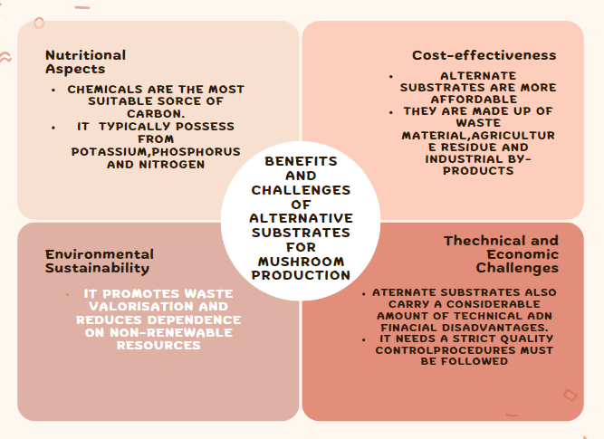

**Figure. 3. Advantages and Disadvantages of Alternative Substrates for Cultivation of Mushroom**

**5.1 Nutritional Aspects**

Lignocellulosic chemicals serve as the most appropriate carbon source for the growth and production of mushroom and are extensively available in alternative substrates such as agro-industrial wastes. The substrates often contain the specific nutrients from potassium, phosphorus, and nitrogen to sustain both the growth of the mycelium as well as the fruiting body. For instance, it has proven that high-quality mushroom would produce in meaningful quantities by capable of receiving rice husk and sugarcane bagasse as nutrient from the grow substrate by species like *Pleurotus spp* (Zhang et al., 2019; Sanchez, 2020). To enhance growth, the nutritional composition of these substrates can vary considerably, requiring the supplementation of nitrogen-enriched materials such as wheat bran or soybean meal (Wang et al., 2017).

**5.2 Cost-effectiveness**

The biggest benefit is that the other substrates are cheaper. Because they are made from waste materials, industrial by-products and agricultural residues can sometimes be low-cost or even free. Some species, such as *Pleurotus ostreatus* and *Lentinula edodes* have already been successfully cultivated on plant waste, such as the coffee husks and low-grade brewery waste with a significant reduction of the production cost, respectively (Fanadzo et al., 2018; Shi et al., 2021). But, the initial investment for procurement of processing equipment and substrate preparation can be a challenge for small-scale farmers. Additionally, the variations in substrate quality may lead to the need for additional treatments increasing the total costs (Grimm & Wösten, 2018).

**5.3  Environmental Sustainability**

This is beneficial from an environmental sustainability perspective, as using alternative substrates promotes waste valorisation and reduces reliance on non-renewable resources. For example: observing how food waste/garden waste is converted into mycelium and grown produces mushrooms that recycle nutrients while reducing the bulk mass of waste remaining that is transported to landfills (Rahi et al., 2020). Crop burning and its related deleterious environmental impacts could also be lessened with agricultural wastes like corn stover and sugarcane bagasse (Koutrotsios et al., 2018). Nevertheless, the environmental benefits of these substrates depend on management strategies that prevent contamination and ensure efficient use (e.g., sterilisation and composting) (Zied et al., 2020).

**5.4 Technical and Economic Issues**

While there are benefits of alternative substrates, they also bring plenty of technical and financial downsides. This is because variations in substrate composition affect mushroom production (Sanchez, 2020) and therefore should be strictly controlled. Moreover, some substrates will require pre-treatment steps like enrichment, sterilization, or composting, which could complicate and increase the production costs (Wang et al., 2017). In addition, the absence of standardised protocols for substrate preparation and application limits the attractiveness of widespread use (Grimm & Wösten, 2018). Further economic challenges relate to the need for infrastructural investment and potential competition for substrates from other sectors, such as bioenergy and animal feed (Zervakis et al., 2018).

1. **Recent Advances and Innovations in Substrate Utilization for Mushroom Production**

The demand for efficient and eco-friendly production methods has spurred significant innovations in substrate utilization in mushroom agriculture. Recent advances are mainly focused on pre-treatment techniques, substrate supplementation and biodegradation capacity of various substrates. These developments aim to improve substrate utilization, improve mushroom quantity and quality and promote environmental sustainability. This segment takes a deep dive into these developments, supported by recent research.

**6.1 Pre-treatment Methods**

Before they can be used to grow mushrooms, substrates must be pre-treated to boost their nutritional value and make them more suitable for mushroom cultivation. Recent advancements in pre-treatment methods include fermentation, chemical treatment and heat processing.

**6.1.1   Fermentation:** Microbial consortia have been used extensively in solid-state fermentation to improve the biodegradability of lignocellulosic substrates. As an example, fungal treatment of wheat straw with Aspergillus niger noted high compatibility for *Pleurotus ostreatus* production, where a reduced content of lignin and a greater content of sugar available were observed. Similarly, co-fermentation of rice straw with *Trichoderma reesei* and *Bacillus subtilis* enriched substrate nutritional characteristics for *Volvariella volvacea* (Puentes-Téllez & Falcao Salles, 2018)

**6.1.2 -Chemical Treatment:** Lignin and hemicellulose are often removed by alkali and acid pre-treatments A 25% yield improvement of *Ganoderma lucidum* culture was achieved by the 2% sodium hydroxide treated maize cobs (Xiaoping, Yufeng, Ziping, et al., 2022). Chemical controls need to be applied properly to avoid residual toxicity (Chen et al., 2022).

**6.1.3 Thermal processing:** Innovations in thermal processing, such as microwave and ultrasonic treatments, have attracted interest due to their effectiveness and potential for energy savings. Factors that decrease processing time in half and increase substrate compatibility for *Pleurotus eryngii* were improved by pre-treating sugarcane bagasse in a microwave. Ultrasonic treatment also enhanced water retention this allowed the mycelial to develop better in coffee husks (Kumar et al., 2021).

**6.2  Substrate types and supplementation**

An important strategy to increase mushroom yield and quality is supplementation of substrates with different nutrients or chemicals. Recent studies have explored the inclusion of innovative additives like biochar, microbial inoculants and nano-fertilizers.

**6.2.1 Nitrogen Sources:** It remains common practice to incorporate nitrogen rich materials, soybean meal Singh et al (2022) found that the protein content of *Pleurotus ostreatus* increased by 15% when rice straw was supplemented with 10% soybean meal. Additionally, the use of poultry manure as a supplement resulted in a 20% increase in *Agaricus bisporus* output (Patel et al., 2021).

**6.2.2 Mineral Additives**: 5% biochar addition to wheat straw substrates enhanced the production of *Pleurotus eryngii* growth by better substrate aeration and nutrients retention (Zhang et al., 2021). Just as well, it has been shown that the use of nano-fertilizers, such as zinc oxide nanoparticles, can enhance mycelial growth and mushroom production (Karlsson et al., 2025).

**6.2.3  Microbial Inoculants**: Beneficial bacteria such as Azotobacter and Pseudomonas, have been tried for enhancing substrate quality . Inoculating sugarcane bagasse with Azotobacter chroococcum increased nitrogen fixation, leading to an 18% increase in yield of *Pleurotus ostreatus* (dos Reis et al., 2024).

1. **Biodegradation Potential of Various Substrates**

Biodegradable substrates for mushroom growing One of the essential aspects of choosing substrates for growing mushrooms is their biodegradability. Recent studies focusing on the enzymatic activity of the mushrooms and ability to degrade complex substrates.

**7.1 Agricultural Residues**: It has been found that agricultural wastes such as maize cobs and rice straw are broken down effectively with ligninolytic enzymes such as laccase and manganese peroxidase to yield *Pleurotus species*. Besides promoting mushroom growth, using these leftovers as substrates contributes to trash management (Huang et al., 2021)

**7.2 Industrial By-products**: The biodegradability of industrial wastes such as coffee husks and brewery spent grains is high due to their large organic content. *Lentinula edodes* mushrooms were also found to degrade brewery waste grains to generate high-protein food (Fernandes et al., 2022).

**7.3 Natural Waste Materials**: The biodegradation potential of organic garden and food waste is being looked into increasingly. Research has shown that composting these substrates together with microbial inoculants renders them more suitable for mushroom cultivation. As an example, com-posting food waste with Bacillus amyloliquefaciens enhanced its biodegradability, which stimulated the growth of *Pleurotus ostreatus* (Wang et al., 2022).

1. **Future Prospects and Research Directions**

Mushroom production has received much attention for its nutritional, therapeutic and environmental benefits. But there's a problem with sustainability, cost and availability using conventional substrates like sawdust, rice husks and wheat straw. Focusing not only on new materials, the role of biotechnology and implications for industry and politics, this section explores the outlook and research avenues of alternative substrates for fungi production (Patel et al., 2020).

1. **Emerging Materials for Substrates**

The search for alternative substrates has led to the study of many biological, industrial and agricultural waste products. Other possible viable substrates where new materials were found for mushroom production included seaweed, coffee grounds, banana leaves and some agro-industrial residual products (cotton waste and sugarcane bagasse) (Zhang et al., 2021; Patel et al., 2020). They not only enhance the nutritional value of mushrooms but also serve as potential waste management strategies (Koutrotsios et al., 2019). The high phenolic content of coffee grounds, for instance, has been found to enhance *Pleurotus spp. 's* antioxidant properties (Li et al., 2022). Marine-derived substrates such as seaweed have also shown promise in enhancing mushroom yield and bioactivity compounds, given its high level of minerals and polysaccharides (Rathore et al., 2017).

Besides, the underutilised and abundant lignocellulosic materials such as sunflower seed hulls and maize cobs have been investigated in studies (Sanchez, 2010) Prior to their use as substrates, it might be necessary to pre-treat such materials physically, chemically, or biologically to render them more digestible to the mushroom mycelium (Elisashvili et al., 2019). Moreover, one novel area that could revolutionise substrate efficiency entirely is the use of nanotechnology in substrate preparation, as in the use of nano-sized lignocellulosic particles (Kumar et al., 2021).

1. **Role of Biotechnology in Substrate Enhancement**

Biotechnology is essential for further maximizing the substrate composition and improving the yield and quality of the mushroom. Use of molecular breeding and genetic engineering approaches to enhance ligninolytic enzyme production in order to develop mushroom strains for the higher degradation potential of complex substrates. The lignin-degrading genes of Pleurotus ostreatus have been used to enhance substrate utilisation using CRISPER-CAS9 technology (Zhang Versus et al., 2018).

In order to facilitate substrate degradation, bioaugmentation and microbial consortia are being explored. Incorporation of certain bacteria or fungi can expedite the degradation of lignocellulosic materials and render them more accessible to mushroom mycelium (Huang et al., 2021). Moreover, the supplementation of different types of enzymes, such as cellulases and laccases, has been shown to enhance mushroom yield and substrate digestibility (Wang et al., 2019).

1. **Policy and Industrial Implications**

Switching to different substrates for mushroom cultivation can have important industrial and policy ramifications. Government and regulatory authorities need to encourage the use of industrial and agricultural waste to cultivate mushrooms through subsidies, tax breaks and research funding (Royse et al., 2017). The policies that favor circular economy models can outline the close-up partnership between industry and mushroom producers (Grimm & Wösten, 2018).

Standardisation of substrate preparation and quality monitoring is important for the codified system of industrial mushroom production. If commercially-viable, affordable and scalable technologies for substrate preparation and sterilisation are developed, smallholder farmers will have greater opportunities to grow mushrooms (Chang & Miles 2004). The quality and the safety of mushroom products can also be guaranteed by increasing the traceability and transparency of the supply chain through integrating blockchain technology (Kamilaris et al., 2019);

**CONCLUSION**

Modern substrates utilized in mushroom production accelerate the development and outperform wood-based Material, at the same time, aid in waste management and resource utilization. These include extensive low-cost agricultural waste substrates, such as rice husk, as well as substrates based on corn stover and sugarcane bagasse that are sufficient for the cultivation of the species of Pleurotus and Ganoderma lucidum and Agaricus bisporus. Utilizing industrial by-products (spent grains, coffee husk, and brewery residue) becomes twofold and this brings great value to waste management initiatives. It’s following the principles of circular economy environment, where organic waste materials come from people’s kitchen and gardens, which are composted to build up a suitable fungal habitats. Further studies need to delineate the factors that influence substrate quality and explore cost-effective production strategies and appropriate cultivation conditions for synthetic and augmented substrates. Only with a balance of economic sustainability and environmental responsibility can PURPOSE prevail! Current research on substrate improvement processes focuses on maximizing both yield of mushroom products as well as the nutrients available for healthy soil and sustainable farming practices.

REFERENCES

1. Atila, F (2017). The effects of different nitrogen sources on the yield and quality of Pleurotus ostreatus. *Scientia Horticulturae*, *225*, 31-37.
2. Carrasco, J., Preston, G. M., & Mingo, S (2018). Biodegradation of lignocellulosic biomass in mushroom cultivation. *Applied Microbiology and Biotechnology*, *102*(7), 2997-3010.
3. Carrasco, J., Zied, D. C., Pardo, J. E., Preston, G. M., & Pardo-Giménez, A (2018). Supplementation in mushroom crops and its impact on yield and quality. AMB Express, 8(1), 146.
4. Chang, S. T., & Miles, P. G (2004). Mushrooms: Cultivation, Nutritional Value, Medicinal Effect and Environmental Impact. CRC Press.
5. Chang, S. T., & Wasser, S. P (2017). The role of culinary-medicinal mushrooms on human welfare with a pyramid model for human health. *International Journal of Medicinal Mushrooms*, *19*(2), 93-108.
6. Chen, Y., Zhang, X., & Li, H (2022). Alkali pre-treatment of corn cobs for *Ganoderma lucidum* cultivation: Effects on yield and substrate digestibility. *Journal of Agricultural Science*, 14(3), 45-52.
7. Cunha Zied, D., Sánchez, J. E., Noble, R., & Pardo-Giménez, A (2020). Use of spent mushroom substrate in new mushroom crops to promote the transition towards a circular economy. *Agronomy*, *10*(9), 1239.
8. Diamantopoulou, P., Fourtaka, K., Melanouri, E. M., Dedousi, M., Diamantis, I., Gardeli, C., & Papanikolaou, S (2023). Examining the impact of substrate composition on the biochemical properties and antioxidant activity of Pleurotus and Agaricus mushrooms. *Fermentation*, *9*(7), 689.
9. dos Reis, G. A., Martínez-Burgos, W. J., Pozzan, R., Pastrana Puche, Y., Ocán-Torres, D., de Queiroz Fonseca Mota, P., ... & Soccol, C. R (2024). Comprehensive Review of Microbial Inoculants: Agricultural Applications, Technology Trends in Patents and Regulatory Frameworks. *Sustainability*, *16*(19), 8720.
10. Ejigu, N., Sitotaw, B., Girmay, S., & Assaye, H (2022). Evaluation of oyster mushroom (Pleurotus ostreatus) production using water hyacinth (Eichhornia crassipes) biomass supplemented with agricultural wastes. *International Journal of Food Science*, *2022*(1), 9289043.
11. Elisashvili, V., Kachlishvili, E., & Penninckx, M. J (2019). Effect of nutrient medium composition on ligninolytic enzyme production by white-rot basidiomycetes. Journal of Industrial Microbiology & Biotechnology, 46(5), 689-701.
12. Fanadzo, M., Zireva, D. T., & Dube, E (2018). Evaluation of various substrates and supplements for biological efficiency of *Pleurotus ostreatus*. *Journal of Applied Microbiology*, 125(3), 853-862.
13. Farooq, J., Sharma, R. K., Rastogi, A., & Barman, K (2015). Effect of replacement of wheat straw with maize cobs with or without physico-chemical treatment on degradation of dry matter, truly digestible organic matter and production of microbial biomass of composite ration in vitro using goat rumen liquor. *Journal of Animal Research*, *5*(3), 501.
14. Fernandes, T., Silva, R., & Oliveira, M (2022). Biodegradation of brewery spent grains by *Lentinula edodes*: Nutritional and enzymatic perspectives. *Waste Management*, 135, 120-128.
15. Grimm, D., & Wösten, H. A. B (2018). Mushroom cultivation in the circular economy. *Applied Microbiology and Biotechnology*, 102(18), 7795-7803.
16. Ha Thi Hoa, H. T. H., Wang ChunLi, W. C., & Wang ChongHo, W. C (2015). The effects of different substrates on the growth, yield and nutritional composition of two oyster mushrooms (Pleurotus ostreatus and Pleurotus cystidiosus).
17. Huang, L., Wang, Y., & Liu, X (2021). Enzymatic degradation of rice straw by *Pleurotus ostreatus*: Role of ligninolytic enzymes. *Biotechnology for Biofuels*, 14(1), 1-12.
18. Kamilaris, A., Fonts, A., & Prenafeta-Boldú, F. X (2019). The rise of blockchain technology in agriculture and food supply chains. Trends in Food Science & Technology, 91, 640-652.
19. Karlsson, M., Jönsson, H. L., & Hultberg, M (2025). Inclusion of biochar in mushroom substrate influences microbial community composition of the substrate and elemental composition of the fruiting bodies. *Science of The Total Environment*, *968*, 178914.
20. Koutrotsios, G., Mountzouris, K. C., Chatzipavlidis, I., & Zervakis, G. I (2014). Bioconversion of lignocellulosic residues by Agrocybe cylindracea and Pleurotus species for the production of specialty food with enhanced functional and nutritional attributes. Food Chemistry, 161, 127-135.
21. Koutrotsios, G., Mountzouris, K. C., Chatzipavlidis, I., & Zervakis, G. I (2018). Bioconversion of lignocellulosic residues by *Agrocybe cylindracea* and *Pleurotus ostreatus* mushroom fungi – Assessment of their effect on the final product and spent substrate properties. *Food Chemistry*, 216, 188-195.
22. Koutrotsios, G., Mountzouris, K. C., Chatzipavlidis, I., & Zervakis, G. I (2019). Bioconversion of lignocellulosic residues by Agrocybe cylindracea and Pleurotus ostreatus mushroom fungi—Assessment of their effect on the final product and spent substrate properties. Food Chemistry, 216, 322-331.
23. Kumar, A., Singh, A. K., & Chandra, R (2021). Nanotechnology in lignocellulosic biomass pretreatment: A review. Bioresource Technology Reports, 15, 100752.
24. Li, X., Wang, Y., & Zhang, X (2022). Coffee grounds as a substrate for enhancing antioxidant properties of Pleurotus spp. Journal of Food Science and Technology, 59(3), 1123-1132.
25. Muswati, C., Simango, K., Tapfumaneyi, L., Mutetwa, M., & Ngezimana, W (2021). The effects of different substrate combinations on growth and yield of oyster mushroom (Pleurotus ostreatus). *International Journal of Agronomy*, *2021*(1), 9962285.
26. Patel, R., Singh, P., & Kumar, A (2021). Poultry manure supplementation for *Agaricus bisporus* cultivation: Yield and nutrient analysis. *Journal of Horticultural Science*, 96(2), 234-240.
27. Patel, S., Goyal, A., & Singh, A (2020). Agro-industrial wastes as substrates for mushroom cultivation: A review. Journal of Applied Microbiology, 128(5), 1234-1247.
28. Phan, C. W., & Sabaratnam, V (2012). Potential uses of spent mushroom substrate and its associated lignocellulosic enzymes. *Applied Microbiology and Biotechnology*, *96*(4), 863-873.
29. Philippoussis, A., Zervakis, G., & Diamantopoulou, P (2009). Bioconversion of agricultural lignocellulosic wastes through the cultivation of the edible mushrooms Agrocybe aegerita, Pleurotus spp.and Lentinula edodes. World Journal of Microbiology and Biotechnology, 25(8), 1463-1470.
30. Puentes-Téllez, P. E., & Falcao Salles, J (2018). Construction of effective minimal active microbial consortia for lignocellulose degradation. *Microbial ecology*, *76*, 419-429.
31. Rahi, D. K., Rahi, S., & Pandey, A. K (2020). Utilization of agro-industrial residues for the cultivation of *Pleurotus* spp. *Journal of Applied Biology & Biotechnology*, 8(3), 1-8.
32. Rathore, H., Prasad, S., & Sharma, S (2017). Mushroom nutraceuticals for improved nutrition and better human health: A review. Journal of Food Science and Technology, 54(11), 3365-3377.
33. Royse, D. J., Baars, J., & Tan, Q (2017). Current overview of mushroom production in the world. In D. J. Royse, J. Baars, & Q. Tan (Eds.), *Edible and Medicinal Mushrooms: Technology and Applications* (pp. 5-13). Wiley-Blackwell.
34. Royse, D. J., Baars, J., & Tan, Q (2017). Current overview of mushroom production in the world. *Edible and Medicinal Mushrooms*, 5-13.
35. Royse, D. J., Baars, J., & Tan, Q (2017). Current overview of mushroom production in the world. Edible and Medicinal Mushrooms: Technology and Applications, 5-13.
36. Samtiya, M., Aluko, R. E., Puniya, A. K., & Dhewa, T (2021). Enhancing micronutrients bioavailability through fermentation of plant-based foods: A concise review. *Fermentation*, *7*(2), 63.
37. Sánchez, C (2010). Cultivation of Pleurotus ostreatus and other edible mushrooms. Applied Microbiology and Biotechnology, 85(5), 1321-1337.
38. Sanchez, C (2010). Lignocellulosic residues: Biodegradation and bioconversion by fungi. Biotechnology Advances, 27(2), 185-194.
39. Sánchez, C (2020). Cultivation of *Pleurotus ostreatus* and other edible mushrooms on lignocellulosic substrates. *Applied Microbiology and Biotechnology*, 104(12), 5201-5212.
40. Shi, L., Zhang, H., & Liu, T (2021). Utilization of brewery waste for mushroom cultivation: A review. *Journal of Cleaner Production*, 290, 125-135.
41. Singh, A., Kumar, V., & Sharma, S (2022). Soybean meal supplementation for *Pleurotus ostreatus* cultivation: Effects on protein content and yield. *Journal of Food Science and Technology*, 59(6), 2345-2352.
42. Sridhar, S., Bhat, R., & Vyas, D (2019). Influence of alternative substrates on mushroom yield. *Journal of Environmental Management*, *240*, 351-357.
43. Suwannarach, N., Kumla, J., Zhao, Y., & Kakumyan, P (2022). Impact of cultivation substrate and microbial community on improving mushroom productivity: A review. *Biology*, *11*(4), 569.
44. Wang, H., Li, X., & Zhang, Y (2022). Composting food waste with *Bacillus amyloliquefaciens* for *Pleurotus ostreatus* cultivation. *Waste Management*, 140, 90-98.
45. Wang, X., Feng, J., & Zhang, X (2017). Effects of different substrates on the growth and nutritional composition of *Pleurotus eryngii*. *Journal of Food Science and Technology*, 54(5), 1234-1242.
46. Wang, Y., Zhang, J., & Li, Y (2019). Enzyme supplementation in mushroom cultivation: A review. Journal of Agricultural and Food Chemistry, 67(12), 3345-3356.
47. Zervakis, G. I., Koutrotsios, G., & Katsaris, P (2018). Composted versus raw olive mill waste as substrates for the production of medicinal mushrooms: An assessment of selected cultivation and quality parameters. *Biomed Research International*, 2018, 1-12.
48. Zhang, L., Wang, J., & Liu, H (2021). Biochar supplementation for *Pleurotus eryngii* cultivation: Effects on substrate aeration and nutrient retention. *Journal of Cleaner Production*, 320, 128-135.
49. Zhang, X., Li, Y., & Wang, Y (2018). Genetic engineering of ligninolytic enzymes in mushrooms. Biotechnology Advances, 36(4), 1071-1082.
50. Zhang, Y., Geng, W., & Shen, Y (2019). Rice husk as a substrate for mushroom cultivation: A review. *Journal of Agricultural Science and Technology*, 21(4), 1-10.
51. Zhang, Y., Li, X., & Wang, Y (2021). Emerging materials for mushroom cultivation: A review. Journal of Cleaner Production, 280, 124456.
52. Zied, D. C., Pardo-Giménez, A., & Pardo-González, J. E (2011). The use of organic residues in mushroom production. *Agricultural Sciences*, *2*(3), 250-257.
53. Zied, D. C., Pardo-Giménez, A., & Savoie, J. M (2020). Optimization of substrate composition for *Agaricus bisporus* cultivation. *Mushroom Science*, 22(1), 45-52.