**Electro- agriculture: A Sustainable Alternative to Traditional Food Production Through CO2 Electrolysis**

**Abstract**

Electro-agriculture is a newly emerging field where CO₂ electrolysis and electroculture are put together to change food production through the use of a green replacement for traditional farming. This practice addresses global food security problems through the destruction of the dependency on land-wasting, wasteful photosynthesis agriculture.CO₂ electrolysis produces atmospheric carbon dioxide into acetate, which is a direct source of carbon that can be utilised by plants, algae, yeast, and fungi to carry out sunlight-independent food synthesis. Electroculture induces plant growth by means of electrical stimulation that increases the uptake of nutrients and health of the soil. Together, these technologies offer a promising pathway towards sustainable agriculture, especially in resource-scarce environments such as arid regions and outer space-based ecosystems. Despite its potential, electro-agriculture is plagued by a set of challenges such as high energy demand, infrastructure cost, and limitation on the assimilation of acetate. Catalyst efficiency optimisation, balancing microbial pathways, and use of renewable energy sources such as solar and wind power are essential to the achievement of scalability and economic viability. Genetic alteration studies can increase plant resistance further to acetate-based growth. Support, financing, and multi-disciplinary integration in science, engineering, and policy must also occur for widespread application. Beyond food security, electro-agriculture offers potential to slow down climate change through sequestering atmospheric CO₂, keeping agricultural emissions minimal, and water and land maximisation. With the rising demand for food worldwide, research on this front has the potential to transform conventional agriculture into a more efficient, sustainable, and climate-resistant mode. More research needs to be directed towards the achievement of greater system performance, cost savings, and exploration in space agriculture and climate-stricken areas. Joining the bandwagon of interdisciplinarity innovation, electro-agriculture has the potential to revolutionize the face of agriculture to deliver food in a definite and sustainable way for years to come.

**Keywords**

Electro-agriculture, CO₂ electrolysis, Electroculture, Carbon fixation, Artificial photosynthesis

1. **Introduction**

The food demand worldwide has increased with a remarkable population increase between 2020 and 2024, and it is estimated that there will be a need to provide food for almost 9.7 billion individuals by 2050 (World Bank, 2020). The demand has also been fuelled by the decline of cultivable land by climate change and urbanization, which constrains agricultural expansion (FAO, 2017). Further, increasing atmospheric carbon dioxide levels pose a threat to agricultural production, with the necessity of novel solutions such as carbon sequestration to improve soil fertility and agricultural output. Because of the constraints of traditional methods of food production improvement, such as intensification of cropping, creation of land for cultivation, and yield improvement, among other environmental limitations, novel solutions to address increasing global food requirements are necessary. Global food demand is on the rise, but food production is limited by the energy conversion efficiency of photosynthesis in the end. As a result, improving the energy efficiency of food production systems is critical to meet these growing demands while ensuring sustainable practices (Blankenship *et al.,* 2011; Ort *et al.,* 2015).

Nearly half of the Earth's habitable surface is already used for agriculture, and food production accounts for one-third of total anthropogenic greenhouse gas emissions globally (Crippa *et al.,* 2021; Ellis *et al.,* 2010). The environmental impact of food production will rise as the world population keeps growing and developing countries adopt western diets. Artificial photosynthesis is one possible means of overcoming the limitations of biological photosynthesis, namely its inefficiency in carbon fixing and the utilization of solar energy. Recent advances in electrolysis have demonstrated the reduction of CO₂ and H₂O to reduced carbon molecules, including CO (carbon monoxide), formate (a salt or ester of formic acid), methanol, and H₂ (Liu *et al.,* 2016). Gas-liquid mass transfer resistance constrains scalability of some bacteria, even if they can convert some of such molecules into fuel and chemicals in gas-phase fermentation (Haas *et al.,* 2018). The production of hazardous intermediates like formaldehyde also restrains the usage of formate and methanol in fermentation due to their potential generation (Yishai *et al.,* 2016). Electrochemically synthesized substrates to date have been unfavourable to the growth of most food-producing organisms. Acetate, however, is a two-carbon, soluble molecule that is easier for a wide variety of organisms to metabolise. It can also be synthesized well by CO₂ electrolysis, providing new possibilities for food production not based on biological photosynthesis (Luc *et al.,* 2019).

Most crop plants convert sunlight and CO₂ into biomass with an energy conversion efficiency of only ~1% or less (Blankenship *et al.,* 2011). This low efficiency requires extensive areas of land for cultivation in order to harvest adequate solar energy for agriculture. Although vertical farming has been popular, its large-scale application is constrained by the energy-intensive cost of artificial lighting. Despite this, new developments in CO₂ electrolysis, breeding, and genetic improvement have spurred a revolutionary change in farming called electro-agriculture (electro-ag). Electro-ag has two different strategies: CO₂ electrolysis-based food production and electroculture. The first strategy CO₂ electrolysis uses renewable energy to power the electrochemical reduction of CO₂ into reduced carbon molecules, e.g., acetate, which can be utilized as a feedstock to produce food-making organisms. In contrast to traditional photosynthesis-based agriculture, this process allows food to be produced in the dark, minimizing dependence on sunlight. In addition, it does away with the necessity of large lighting and HVAC (Heating, Ventilation, and Air Conditioning) systems, which contribute 30–50% of the energy losses in conventional vertical farms for heat dissipation (Adhikari *et al.,* 2020; Engler and Krarti, 2021). CO₂ electrolysis, through enhanced solar-to-biomass conversion efficiency, provides a more resource-effective food production scheme, solving both sustainability and increasing global food needs.

The second method, electroculture, uses direct application of electrical fields to seeds, plants, soil, or water to increase growth, boost yields, and lower the need for chemical fertilizers. First practiced in the 18th century, the method has proved that electrical stimulation could enhance the germination of seeds, hasten plant development, and promote pest and disease resistance (Christianto & Smarandache,2021). Further research is ongoing on its possibilities for use in contemporary agriculture. In spite of advances in genetic engineering and breeding to improve photosynthetic efficiency, gains have been modest and restricted to some food crops (Ort *et al.,* 2015).

Enhancing the overall energy efficiency of food production is essential for meeting global food needs sustainably. By combining CO₂ electrolysis and electroculture, electro-agriculture offers novel solutions that maximize food production while reducing resource use and environmental footprint. Electro-agriculture, particularly in the case of nations like the Middle East and North Africa (MENA), is an attractive solution to rising water scarcity. Countries in MENA are beset by hot temperatures, low rainfall, and scarce water resources and hence struggle to sustain agricultural productivity. Traditional irrigation systems that have high freshwater usages are out of the question in such countries because of a lack of sufficient water (Abou-Shady & El-Araby, 2021). Electro-agriculture, however, offers a modern solution to feeding the population of arid and semi-arid countries by way of harnessing renewable energy as power for the electrochemical activities that reduce CO₂ into functional carbon molecules as used in carbon-based agriculture to promote plant life. This approach offers a sustainable substitute for the large amounts of water often needed for crop irrigation. Through incorporating electro-agriculture into agricultural production, MENA countries could overcome the constraints brought about by water scarcity, increase efficiency in food production, and reduce the environmental impact of agriculture. Furthermore, electro-agriculture can enable the cultivation of crops in an enclosed environment, which is particularly valuable in locations with harsh climatic conditions and uncertain rains, enhancing food security against a changing climate (Abou-Shady & El-Araby, 2021).

1. **Foundational Principles of Electricity-Driven Electro-Agriculture**

The agricultural sector consumes about 75% of our potable water, and current desalination and wastewater treatment methods are insufficient to meet this demand. To address this, innovative desert development projects using electro-agricultural technology have been proposed to reclaim desert land by focusing on key elements like water, soil, organic matter, and plants, ultimately aiming to create new farmland and communities. Electro-agriculture utilizes direct current (DC) electrical fields, particularly in arid regions, and while high temperatures and intense sunlight present challenges, they can also be leveraged. Solar cell units, or agro-photovoltaic energy sources, can be installed on farms to provide the necessary energy for this technology (Abou-Shady, 2017).

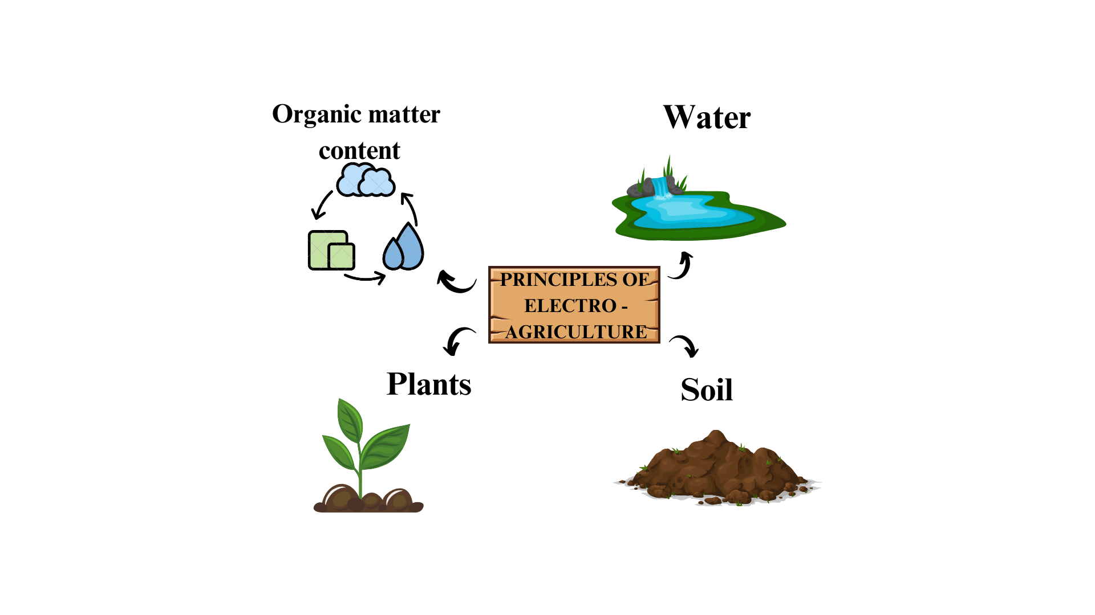

**Figure 1**: Principle of electro-agriculture

* 1. **Water:** The MENA (Middle East and North Africa) area faces a significant water shortage, which has prompted nations to adopt robust water management plans based on values like openness, responsibility, and community engagement (Shevah, 2014). Integrated Water Resources Management (IWRM) is a crucial strategy that emphasises developing efficient water regulations, controlling demand, implementing equitable water pricing, enhancing agricultural policies, encouraging public-private partnerships, and developing skills through training initiatives (Shevah, 2019). Simultaneously, developments in electro-agricultural technology highlight the significance of minimising groundwater consumption, handling industrial effluent with care, and resolving desalination's constraints for agriculture (Abou-Shady, 2017). The goal of these coordinated initiatives is to increase the region's water use's sustainability and efficiency.
  2. **Soil:** For so long, the solutions to the water crisis offered by decision-makers often neglected the soil. Adaptation of the soil is an essential step towards optimum utilization of the treated water generated through nonconventional methods. There are three important concepts in managing arid and semi-arid region soils, as recommended by the experts: using electrokinetic (SEK) techniques for reclaiming salt-affected soils, remediation of polluted soils, and management of the net charge of the soil during irrigation; that is, zeta potential (Abou-Shady *et al.,* 2018 a, b, c). These will provide qualitative soil management while ensuring water-use sustainability.
  3. **Organic Matter Content:** Desert soils, such as those found in arid and semi-arid nations, usually contain very little organic matter (OM). While the annual input of organic matter to the soil is relatively moderate, the high temperatures in these regions accelerate the breakdown of OM *(*Carabassa *et al.,* 2018). After organic and inorganic contaminants have been properly remedied, treated sewage sludge, which has a high proportion of organic matter (OM) (50–70%), can be used to address this difficulty (Buta *et al.,* 2021). Organic matter is crucial for strengthening the soil's total net charges, improving its water-holding capacity, and enhancing its general physical and chemical qualities**.**
  4. **Plants:** Under the fourth section of the Sophisticated Desert Development Project (SDDP) framework, we emphasize the need to implement critical strategies that would enhance sustainable plant agriculture. The first step in this regard is funding studies that will improve drought resistance in plants, which will enable more effective water usage. Consider rice (*Oryza sativa L.),* one of the most widely consumed staple crops in the world (Panda *et al.,* 2012). Traditional rice farming in Egypt is largely based on field flooding during the growing period. However, upgrading breeding and using genetic engineering and transgenic approaches offers promising prospects for the development of a drought-resistant rice cultivar with similar traits as that of barley (*Hordeum vulgare*) (Sallam *et al.,* 2019). These efforts can be supplemented with electro-agriculture technologies that would render rice cultivation less water-demanding and more sustainable.

|  |  |  |  |
| --- | --- | --- | --- |
| **Category** | **Key Issues** | **Proposed Solutions** | **References** |
| Water | Water scarcity in the MENA region | Implement Integrated Water Resources Management (IWRM), reduce groundwater consumption, improve desalination methods | (Shevah,2014, 2019); (Abou-Shady, 2017). |
| Soil | Poor soil adaptation in arid regions | Use electrokinetic (SEK) techniques, remediate polluted soils, manage zeta potential during irrigation | (Abou-Shady *et al.,* 2018 a, b, c) |
| Organic Matter | Low organic matter in desert soils due to high temperatures | Use treated sewage sludge (50–70% OM) to improve soil structure and water retention | (Carabassa *et al.,* 2018); (Buta *et al.,* 2021). |
| Plants | High water demand for crops like rice | Develop drought-resistant crops using genetic engineering and transgenic techniques; integrate electro-agriculture to reduce water needs | (Panda *et al.,* 2012), (Sallam *et al.,* 2019). |

**Table 1**: Key Principles and Solutions in Electricity-Driven Electro-Agriculture

1. **Design and Validation of a CO₂ Electrolysis-Based Electro-Agriculture**

A vast array of single-carbon and multi-carbon compounds can be produced from CO₂ by electrochemical pathways. Many of these substances, however, are not appropriate for use in biological settings because they are ineffective at stimulating growth, hostile to living things, or necessitate intricate metabolic processes that are challenging to include in novel biological systems. For example, CO₂ electrolysis can selectively produce ethylene with relatively high efficiency but no known organisms can utilize ethylene as a direct carbon or energy source due to the absence of natural biological pathways that metabolise it (Liu *et al.,* 2022). In contrast, chemolithotrophic (organisms that use inorganic substances to generate energy) bacteria such as *Cupriavidus necator* can metabolise carbon monoxide (CO) and hydrogen (H₂), two potent electrochemical byproducts. However, these extremophilic bacteria primarily produce raw proteins or biochemicals rather than directly consumable food products (Heijstra *et al.,* 2019; Simpson & Tran, 2015). One of the major drawbacks of using CO and H₂ in biological systems is their poor solubility in water, which makes it difficult to have effective mass transfer to microbial cultures unless pressurization is applied to enhance their availability in aqueous environments (Sivalingam *et al.,* 2021).

Other carbon dioxide-derived compounds, including formate, methanol, and methane, are also metabolised by acetogenic bacteria. Methane has a low aqueous solubility, which limits its effective transfer to microorganisms capable of converting it into methanol and subsequently metabolizing it through similar pathways (Cotton *et al.,* 2020). The use of methanol as a carbon source adds another set of challenges due to the presence of formaldehyde as an intermediate that is significantly toxic, halting cellular growth, and if in high concentrations, it could be lethal. Similarly, formate is lethal to microorganisms and results in an extended lag phase before its growth is noticeable (Cotton *et al.,* 2020). Besides, formate is relatively metabolised by acetogens at slow rates and is less efficient as a substrate for large-scale biochemical or food production. Propanol is another well-known substrate that can also be produced via electrochemical CO₂ reduction (Peng *et al.,* 2021). However, a major obstacle lies in achieving high Faradaic efficiency and current density of propanol formation through electrolysis of CO or CO₂. (Wang *et al.,* 2022). Despite progress in electrochemical synthesis, these products, including CO, H₂, formate, methanol, and methane, have limited direct application in food production because the organisms capable of metabolizing them are not naturally consumed by humans.

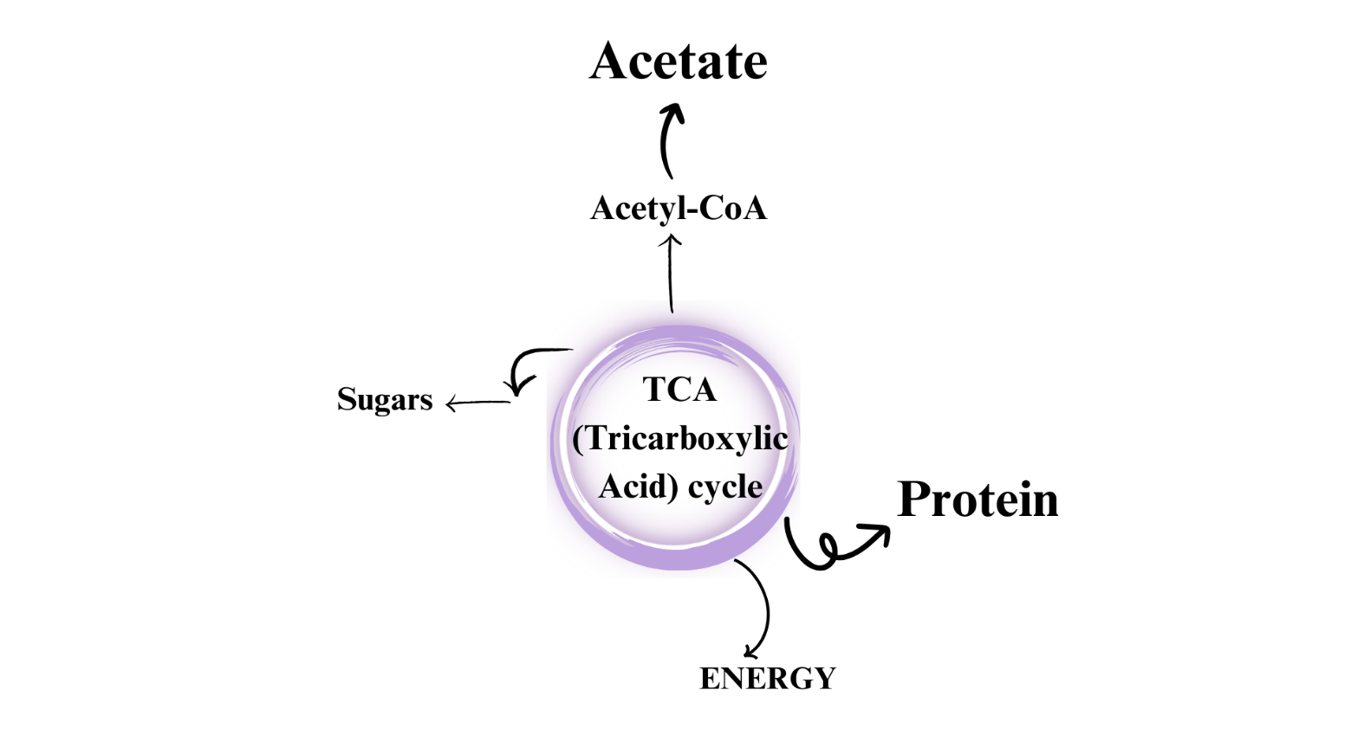

**Figure 2**: Role of Acetyl-CoA in the TCA Cycle

Ethanol and acetate, in contrast, are among the most promising carbon-based products of CO₂ electrolysis. Ethanol and acetate are easily broken down by many organisms, including those already used in food production, and can be produced efficiently (Overa *et al.,* 2022). In the environment, ethanol is converted with the various help enzymes of alcohol dehydrogenase and acetaldehyde dehydrogenase to acetate. Both ethanol and acetate have been proven to grow typically edible eukaryotic organisms like yeast and edible fungi, particularly in the species producing mushrooms. Some green algae also require acetate to grow, strictly using it as the sole available carbon and energy source. Acetate, especially, is very useful because it very well dissolves in water and easily undergoes conversion to a key intermediate in many metabolic pathways—acetyl-CoA. Acetyl-CoA is a central intermediate in energy production and biomass formation. Thus, the acetate appears to be an ideal substrate for food production. Recent studies have shown electrochemically synthesized acetate has been proven to increase crop production where four times more solar-to-food efficiency in comparison to traditional photosynthetic agricultural systems is achieved (Hann *et al.,* 2022). Since acetate can be absorbed and metabolised by plants through direct means, it appears to be one of the most efficient CO₂-derived feedstocks for the application of electro-agriculture.

Since most human food is derived from plants, an electro-agriculture system must necessarily focus on intensive crop production. Mature crop plants are naturally photoautotrophic, meaning that they produce biomass through photosynthesis. An electro-agriculture system would, however, demand that they grow heterotrophically by utilizing acetate as an exogenous carbon source. Mature plants, however, are not naturally equipped for heterotrophic growth based on acetate (Gupta & Gupta, 2021). The carbon in acetate, therefore, becomes released as CO₂ upon entering the cycle as acetyl-CoA. This is to say that it does not add to the net carbon for use in biomass formation. Fortunately, plants have the option of using alternative metabolic pathways to bypass this problem. Lipids and carbohydrates stored in seeds are used by the plant for heterotrophic growth prior to engaging in photosynthesis. In this pathway, acetyl-CoA coming from lipids enters the glyoxylate cycle instead of the TCA cycle. As it bypasses the two decarboxylation steps of the TCA cycle, this cycle is carbon conservative and is managed by key enzymes like isocitrate lyase and malate synthase. As soon as photosynthesis starts to take place with the maturing of plants, the glyoxylate cycle becomes dormant (Gupta & Gupta, 2021).

To activate acetate-dependent plant growth, genetic engineering techniques may be applied to reactivate the glyoxylate cycle and improve the metabolism of acetate. It has been established that overexpression of enzymes associated with the acetyl-CoA pathway from acetate boosts its assimilation in different microorganisms (Belanger *et al.,*2024). Applying the same approaches to plants, acetate could be another carbon source supporting heterotrophic biomass formation not depending on photosynthesis. A full electro-agriculture system has three integrated stages that are vertically stacked in an effort to maximise land efficiency. The top stage of the vertical system is made up of solar panels generating renewable electricity to drive the electrolysis process. The second one is using tandem CO₂ electrolysis for direct conversion into acetate. Tandem steps involve first CO₂ reduction in two steps—one reduces the partial pressure of carbon dioxide and simultaneously reduces carbon oxides into carboxylated compounds; that is, the conversion of carbon oxide into acetate. This technique avoids the electrolyte used here from producing undesired carbonate when neutral, as it will instead improve process stability and increase yield of acetate (Overa *et al.,* 2022).

To ensure the acetate solution is biocompatible for the growth of plants, earlier studies indicate that this ratio of acetate to KOH (Potassium Hydroxide) in the effluent should be above 0.4 and that the solution should be neutralized before use. Although far more research is needed to be performed, alternative reactor designs that produce acetic acid in pure deionized water have been pursued (Zhu *et al.,* 2021). Once it has been produced, it is fed into the final process of the electro-agriculture facility, which is the main source of power to grow the crop (Kim *et al.,* 2023). This will remove the effect that the sun puts on the crops, hence allowing crops to grow in a well-controlled and also high-density setup. Facilities of such an electro-agriculture will reach a range between three and seven stories tall (10–23 meters) according to the type of crop involved. While larger crops like maize require a whole storey for growing, smaller crops like lettuce may be stacked several layers within a single story. This new system has already achieved a four-fold increase in the energy efficiency for biomass production relative to traditional photosynthesis-based agriculture and is seen to have scope for further optimisations in the near future (Hann *et al.,* 2022).

1. **Synthesis of acetate using CO2 electrolysis in Electro-Agriculture**

The electrochemical reduction of CO₂ to value-added products has been of significant interest as a renewable alternative for traditional carbon fixation pathways. The electrocatalytic production of acetate (sodium or potassium acetate) from CO₂ is one such prospective pathway with the potential to be a source of energy and carbon independent of biological photosynthesis. (Gabardo *et al.,* 2019) This would enable the growth of food-producing microbes, providing a sustainable route to recycling carbon. However, direct electrochemical reduction of CO₂ to acetate through copper catalysts has usually displayed low carbon selectivity, typically below 15% (de Arquer *et al.,* 2020).

Recent developments in CO reduction have shown promise for greater selectivity towards acetate. Of particular note, nanostructured copper catalyst-based studies have reported acetate production at industrially viable reaction rates with carbon selectivity greater than 50%

**Figure 3:** Electro-agriculture system schematic and energy efficiency

(Luc *et al.,* 2019; Ripatti *et al.,* 2019). To further raise acetate yield, a two-stage electrolyser system has been investigated, where CO₂ is first converted to CO and then electrochemically reduced to acetate. (Jouny *et al.,* 2018) The first electrolyser utilizes a commercial silver catalyst deposited on a gas diffusion substrate, e.g., carbon paper, to enhance CO₂ transport and optimise CO production efficiency compared to conventional batch reactors (Weekes *et al.,* 2018). The anolyte employed in this electrolyser is generally a 1 M KHCO₃ (Potassium Bicarbonate) solution in deionized water, providing sufficient ionic conductivity. IrO₂ (Iridium Dioxide) has also been used as an anode material because of its pH-neutral stability, allowing for long-term operation. The gaseous products of this process CO, H₂, and trace CO₂ are then fed into the second electrolyser for CO reduction (Ozden *et al.,* 2021).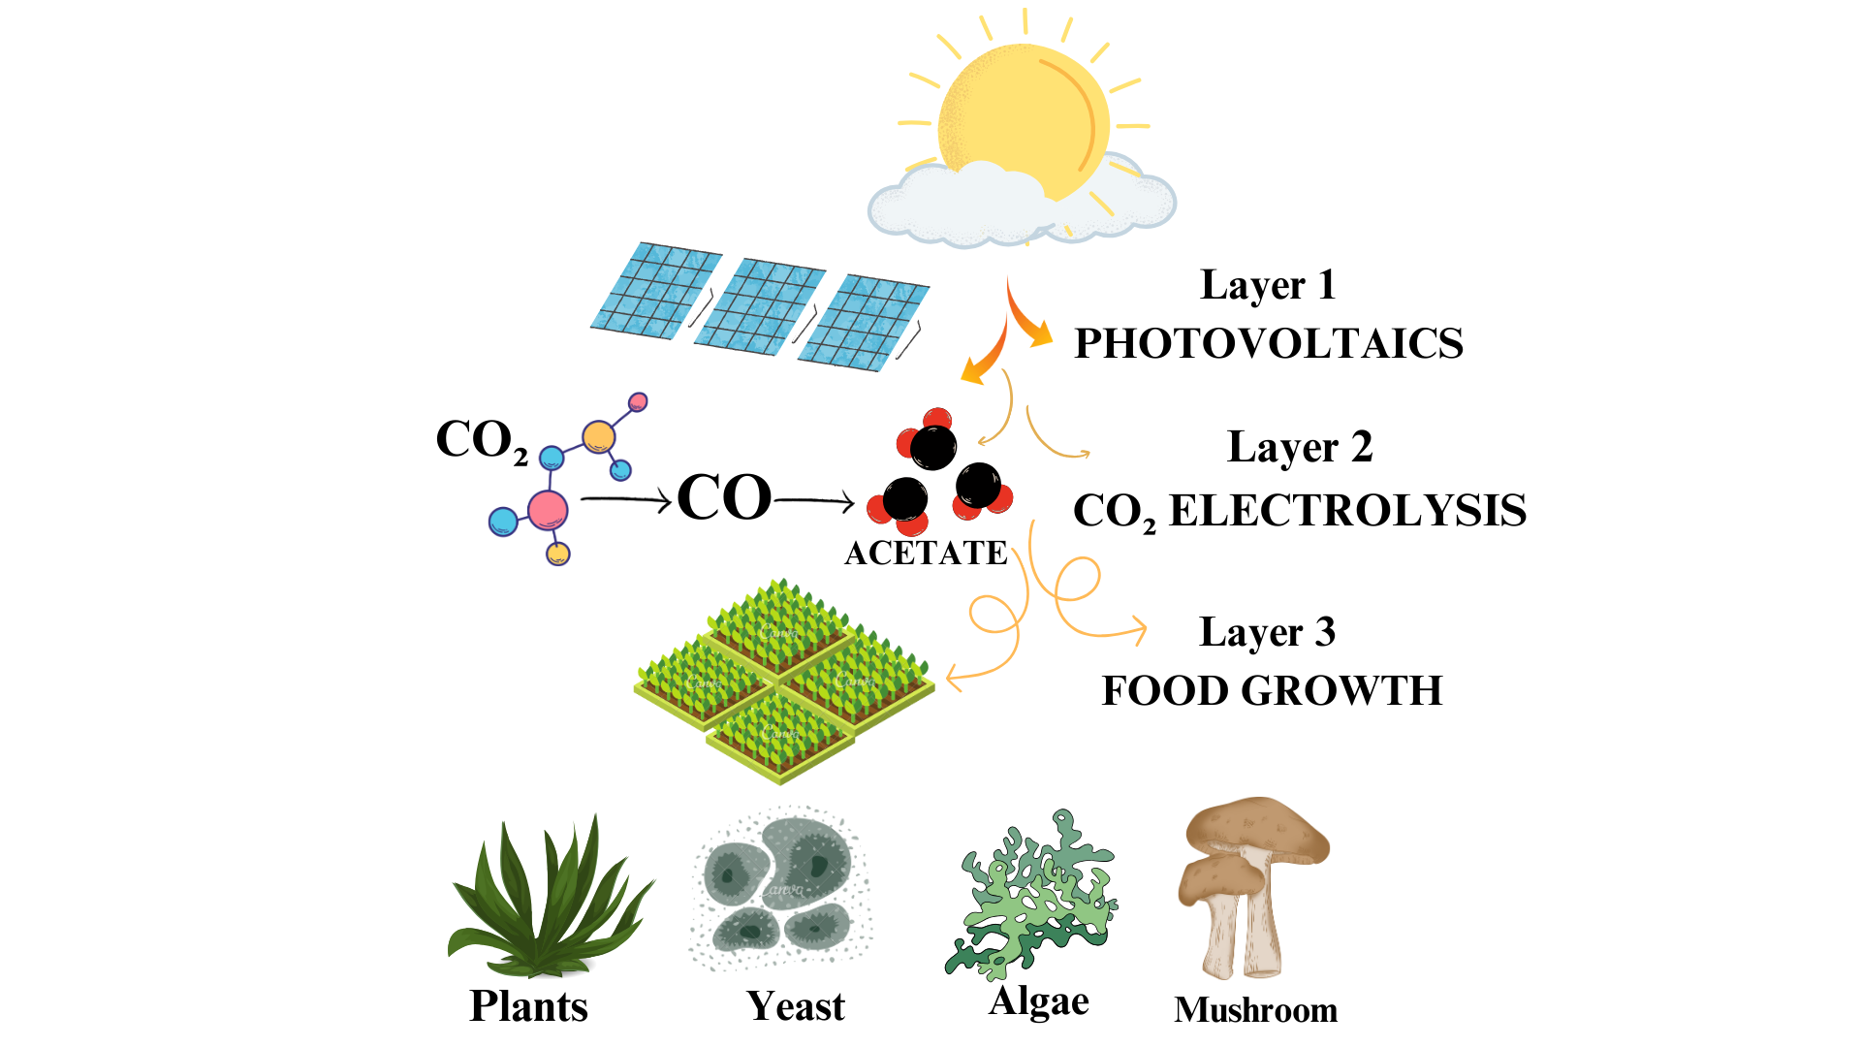

In the second stage, CO reduction is performed by a copper-based catalyst with a NiFeOx anode (Nickel Iron Oxide) and 1 M KOH as the electrolyte. Other tandem systems have been described in the literature, with single-pass CO₂-to-acetate conversion rates as high as 25%—a remarkable enhancement over the previously reported <1% conversion (Romero Cuellar *et al.,* 2020). Improvements have been ascribed to process optimisation strategies that prefer acetate production over other multi-carbon products. In addition to maximising acetate formation, scientists have also assessed the viability of utilizing the consequent electrolysis byproducts (effluents) as carbon and energy sources for microbial food production. Initial investigations report that effluents with an acetate/electrolyte ratio below 0.4 are not effective at supporting algal growth, underlining that maximum acetate concentration is required for successful integration with biological systems (Romero Cuellar *et al.,* 2020).

For optimal CO₂-to-acetate conversion, operational conditions have been thoroughly investigated. The first electrolyser has been reported to gain a 43% CO₂-to-CO conversion efficiency at a current density of 100 mA cm⁻² and an inlet CO₂ flow rate of 7 ml min⁻¹. In contrast, the second electrolyser operates at 150 mA cm⁻², efficiently converting more than 80% of the electrochemically produced CO to acetate and other C₂+ (multi carbon) products. Importantly, excess CO₂ in the gas stream adversely affects the performance of the second electrolyser, resulting in higher voltage and lower acetate selectivity (Hann *et al.,*2022). However, the inclusion of a 5 M NaOH (Sodium Hydroxide) scrubber between the two electrolysers has been reported to resolve this drawback, resulting in a threefold improvement in acetate selectivity. In optimised conditions, the tandem electrolysis system has attained the highest reported CO₂-to-acetate conversion efficiency to date, with 57% of the CO₂ reacted forming acetate at a production rate of 0.7 g d⁻¹ cm⁻². The system has been reported to operate stably for six hours, with only a minor rise in CO₂ electrolyser voltage (less than 60 mV, stabilising at 2.95 V). As the acetate builds up, electrolyte pH slightly decreases (from 13.7 to 13.4), and the CO electrolyser voltage increases by 160 mV, reaching 2.22 V (Hann *et al.,*2022). Product quantification has shown that more than 99% of the generated acetate is found in the anolyte and therefore can be considered the major effluent for possible application in microbial food production. Most notably, this system has recorded the highest acetate-to-electrolyte salt ratio of 0.75, with the final concentration of the effluent being 0.75 M acetate. All these results constitute a remarkable breakthrough in CO₂ electrolysis, opening the door for more efficient and scalable carbon-to-acetate conversion technologies (Hann *et al.,*2022).

1. **Acetate as an Alternative Carbon Source for Plant Growth**

Using CO₂ electrolysis, scientists were able to successfully grow food-producing microorganisms and crops that did not depend on carbon in traditional photosynthesis. It studied how plants metabolise acetate by monitoring the incorporation of heavy-isotope C-acetate (Gabardo *et al.,* 2019). When lettuce callus was cultivated in the dark, it absorbed acetate and went on to metabolise it into essential biological molecules like amino acids, carbohydrates, and TCA cycle intermediates. This was confirmed and that acetate could be an available carbon as well as an energy source. Studies prior had utilised acetate as a trace input in the experiment, instead of being an actual carbon source C-acetate 2 mM (millimolar) supplied to whole-plant lettuce uptake into the root system and transferred into the leafy tissues were also demonstrated by the systemic acetate assimilation. The other crops such as rice, peas, jalapeños, canola, tomatoes, cowpeas, tobacco, and *Arabidopsis* underwent a similar process, and hence, acetate metabolism seems to be a widely occurring characteristic among plants. Even though lettuce seeds germinated normally with an acetate concentration up to 10 mM, very high concentrations suppressed the growth of the whole plant except for root development (Allen *et al.,* 2015). However, for plants to replace photosynthesis entirely as an energy source, they will need to become much more tolerant of acetate. These results establish that most plant species can employ acetate to synthesize crucial biomolecules, including sugars and amino acids.

Beyond plants, acetate from CO₂ electrolysis could also feed other food-producing organisms. The alga *Chlamydomonas* *reinhardtii*, known for its high starch, protein, and lipid yields (Ugalde & Castrillo, 2002), was grown in the dark, only on acetate as its carbon source, to a biomass yield of 0.28 g algae per g acetate (Zhang *et al.,* 2019). Similarly, *Saccharomyces cerevisiae*, which is extensively used in the production of food yeast (Perez-Torrado *et al.,* 2015), grew well on acetate-based media, giving 0.19 g biomass per g acetate and had significant increases in growth metrics. In addition, fungal mycelium, an attractive protein-rich meat substitute, was grown using acetate in solid-state fermentation (Stephan *et al.,* 2018). This method successfully supported the growth of Pleurotus (A genus of fungi, commonly known as oyster mushrooms) and Hericium (A genus of fungi, commonly known as lion's mane mushrooms) species, though higher acetate concentrations inhibited fungal development due to the presence of antifungal by-products like propionate (Brock & Buckel, 2004). Overall, these results demonstrate that acetate derived from CO₂ electrolysis can sustain the growth of a variety of food sources—including plants, algae, yeast, and fungi—offering a new way to produce food without dependence on sunlight-driven photosynthesis.

|  |  |  |  |
| --- | --- | --- | --- |
| **Category** | **Key Findings** | **Examples** | **References** |
| Plant Metabolism | Acetate is absorbed and converted into essential biomolecules like amino acids, carbohydrates, and TCA cycle intermediates. | Lettuce, rice, peas, jalapeños, canola, tomatoes, cowpeas, tobacco, Arabidopsis | (Gabardo *et al.,* 2019), (Wang *et al.,* 2018), Allen *et al.,* 2015) |
| Acetate Uptake & Tolerance | Systemic acetate assimilation demonstrated in plants. High acetate concentrations suppress overall plant growth except for root development. | Lettuce callus and whole-plant systems | (Allen *et al.,*2015) |
| Algae Growth on Acetate | Algae can grow solely on acetate as a carbon source, producing high biomass yield. | *Chlamydomonas reinhardtii* (0.28 g algae per g acetate) | (Ugalde & Castrillo,2002);  (Zhang *et al.,*2019) |
| Yeast Growth on Acetate | Acetate-based media support yeast growth, with significant increases in biomass yield. | *Saccharomyces cerevisiae* (0.19 g biomass per g acetate) | (Perez-Torrado *et al.,* 2015) |
| Fungal Growth on Acetate | Acetate supports fungal mycelium growth in solid-state fermentation; high concentrations inhibit due to antifungal by-products. | *Pleurotus* and *Hericium* species | (Stephan *et al.,*2018); (Brock & Buckel ,2004) |
| Overall Implications | Acetate from CO₂ electrolysis can sustain food production in plants, algae, yeast, and fungi, reducing dependence on photosynthesis. | Various food sources | (Perez-Torrado *et al.,* 2015); (Brock & Buckel,2004) |

**Table 2:** Role of acetate in supporting plant and microbial growth.

1. **Sustainability and efficiency of electro agriculture**

Photosynthesis plays a major role in the world food chain, either directly through crop consumption or indirectly through livestock that eats the crops. However, the higher up the food chain one goes, the less effective this process of converting solar energy into food becomes. Thus, animal products represent one of the least efficient ways to generate food, as cattle require much higher caloric inputs from plants than the amounts they contribute back in meat. In contrast, crops retain more than 50 times more solar energy as food than cattle (Jouny *et al.,* 2018). Due to this inefficiency, one of the major strategies to reduce the environmental impact of agriculture has been the rise of plant-based alternatives to meat, eggs, and dairy (Torres-Tiji *et al.,* 2020).

The plant-based meat sector has grown exponentially, with a global market value of over $5 billion in 2023, coupled with an annual growth rate of 23.9% (Perez-Torrado *et al.,* 2015). Plant-based dairy and egg substitutes are following similar trends. These alternatives, however, are limited by the inefficiency of photosynthesis, which captures only about 1% of solar energy (Gabardo *et al.,* 2019). Electro-agriculture (electro-ag) is the latest to gain attention and promises at least 4% efficiency in energy use (Luc *et al.,* 2019). If such foods are produced using electro-ag instead of conventional agriculture, then the efficiency improvement would be higher. A burger produced from electro-ag could be more than 200 times more energy-efficient

than beef, compared to the 50 times improvement obtained with traditional plant-based sources (Ozden *et al.,* 2021). This would considerably decrease the amount of greenhouse gas emissions and decrease the use of land and resources for food productions (International Panel of Experts on Sustainable Food Systems, 2022).

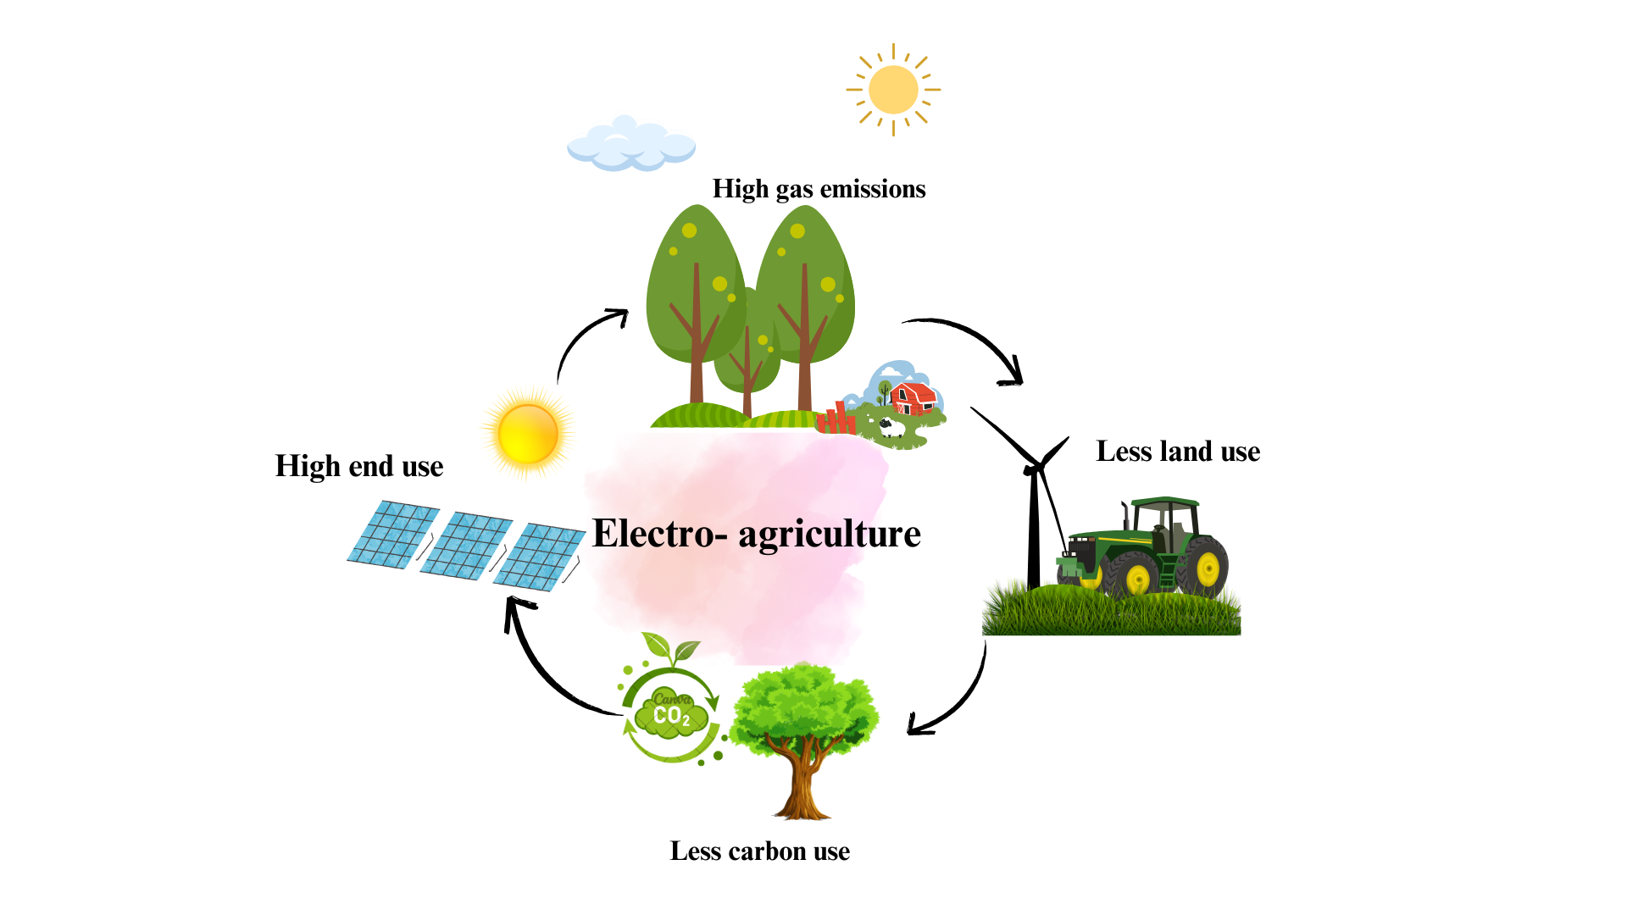

Figure 4: Sustainability and efficiency of electro agriculture

Today, more than half the land in America is farmed. If farming efficiency is improved using electro-ag, the amount of land used for food production could be cut all the way back to 88% from 1.2 billion acres down to just 0.14 billion acres (US Forest Service, 2021). This would open up over a billion acres to rewilding, letting natural ecosystems recover and expand. A significant part of this land could expand the country's forests, which now absorb 776 million metric tons of CO₂ annually, accounting for 12% of the nation's total emissions (US Forest Service, 2021). Electro-ag could help to restore the environment by making farming more efficient, thereby enhancing massive-scale natural carbon sequestration (Ripatti *et al.,* 2019).

Apart from the environmental benefits, electro-ag could also ensure stable food prices. Climate change has only made weather patterns more uncertain, thus directly affecting crop yield and subsequently increasing food prices (Kaundal *et al.,* 2024). Developing countries easily get affected by food insecurity in times of fluctuating prices. Recently, after the COVID-19 pandemic, a third of the world's population was unable to access sufficient food because of increasing prices (International Panel of Experts on Sustainable Food Systems, 2022). While the overall global food production increases, countries in the South continue to rely increasingly on imported foods and, therefore more on unstable sources of food supply (Lam, 2023).

A key benefit of electro-ag is that industrial electricity prices are much more stable than crop prices. Thus, electrification of agriculture would mean a predictable supply of food, which could also help to eliminate extreme price variations (Weekes *et al.,* 2018). This may offer an assurance solution for areas like Africa where food insecurity remains a huge concern. With solar power, there is an economical and reliable source of energy that can maintain electro-agriculture, thereby recharging acetate reservoirs when the sun shines while food continues to be produced, independent of sunlight or the weather (de Arquer *et al.,* 2020). Electro-ag could further localize food production. This would mean a reduction in the importation of food and reliance on overseas markets. It would thus safeguard communities from changes in currency that alter food costs. It will strengthen local economies and shorten supply chains. Producing all inputs needed for food production, including fertilizers, would enhance self-sufficiency. Electro-ag might provide fresher food, lower carbon emissions associated with transportation, and allow regions to have control over their food systems because the food would be locally produced (Romero Cuellar *et al.,* 2020).

|  |  |  |  |
| --- | --- | --- | --- |
| **Category** | **Key Findings** | **Implications** | **References** |
| Photosynthesis Efficiency | Traditional photosynthesis captures only ~1% of solar energy. Electro-agriculture (electro-ag) promises at least 4% efficiency. | Electro-ag improves energy use, making food production significantly more efficient. | (Gabardo et al.,2019);(Luc *et al.,*2019) |
| Food Production Efficiency | Plant-based foods are ~50 times more energy-efficient than meat; electro-ag could be 200 times more efficient. | Reduces greenhouse gas emissions, conserves resources, and decreases land use. | (Jouny *et al.,*2018); (Ozden *et al.,*2021) |
| Land Use Reduction | Electro-ag could reduce farmland from 1.2 billion acres to 0.14 billion acres, freeing up 88% of farmed land. | Allows rewilding, restores ecosystems, and increases carbon sequestration. | (US Forest Service,2021); (Ripatti *et al.,*2019) |
| Carbon Sequestration | Expanding forests could absorb more CO₂, currently at 776 million metric tons annually. | Helps combat climate change and reduce net emissions. | (US Forest Service ,2021) |
| Food Price Stability | Agricultural electrification leads to more stable food prices compared to volatile crop prices. | Reduces food insecurity, particularly in developing nations. | (Weekes *et al.,* 2018); (Lam ,2023) |
| Impact on Food Security | Post-COVID-19, 1/3 of the world's population faced food insecurity due to rising prices. | Electro-ag ensures a reliable food supply independent of climate fluctuations. | (International Panel of Experts on Sustainable Food Systems,2022) |
| Localization of Food Production | Electro-ag enables local food production, reducing reliance on imports. | Strengthens local economies, shortens supply chains, and lowers transportation emissions. | (Romero Cuellar *et al.,*2020) |
| Renewable Energy Integration | Solar energy can be used to power electro-ag and recharge acetate reservoirs. | Ensures continuous food production independent of sunlight and weather. | (de Arquer *et al.,*2020) |

**Table 3:** Structured overview of the sustainability and efficiency benefits of electro-agriculture.

1. **Future Prospects and Considerations**

Electro-agriculture, or "electro-ag," has promising evidence as far as proven performance, able to convert 4% of solar energy into biomass, which is four times as efficient as ordinary photosynthesis, yet it encounters numerous hurdles for it to be promoted broadly. Cost is one: electro-ag would soon find it hard to compete economically with staple crops. At the moment, it works best in areas where traditional farming is challenging, but even in those situations, much electricity is needed. Long-term viability requires progress in solar technology and energy storage if it is fueled by renewable energy. The good news is that solar photovoltaics (PV) is evolving rapidly. As of now, commercial PV systems produce electricity at a mere $0.037 per kWh (Kilowatt-hour) and operate at an efficiency of 22% (Lazard, 2020). The U.S. Department of Energy aims to achieve the target of $0.02 per kWh by 2030, which is significantly lower than the 47.6% efficiency achieved by previous innovations (Schygulla *et al.,* 2020). It will be almost eight times more efficient than photosynthesis. The total energy efficiency could increase to 7.9% if solar PV efficiency achieves 48%.

Progress is also being reported in the area of electrolysis, where it is critical to electro-ag. High purity over 99% allows an elimination of costly processing, and at present, percent efficiency of CO to acetate conversion remained as high as 91% (Jin *et al.,* 2023; Overa *et al.,* 2022). Acetic acid can only now be produced in the salt-free forms and thus significantly improves its compatibility with biological systems due to newly developed porous electrolyte systems (Xia *et al.,* 2019). Large-scale electrolysis demonstrations have also been reliable and shown that scale-up is possible (Crandall *et al.,* 2024). Adding these improvements to advances in solar PV, efficiency for electrolysis could increase by 39% to 45%, so the electro-ag efficiency would be 9.1%. Electro-ag would need 19,600 TWh (Terawatt-hour) of power year to completely replace traditional farming, which is equivalent to the total annual energy consumption of the nation. Another challenge is stability since renewable energy sources have fluctuations (Statista, 2024). Acetate reservoirs can store energy to maintain output, but further work is needed to improve electrolysers life in diverse circumstances (Samu *et al.,*2022). Electro-ag improvement should also include genetic engineering. According to scientists, CRISPR (Clustered Regularly Interspaced Short Palindromic Repeats - a gene-editing technology) and other techniques will make electro-ag ten times more efficient than traditional farming at 10.8%. This might change food production dramatically. Sourcing CO₂ must, however also be taken into account. For early adoption on Earth, point-source carbon capture would be required; however, for applications in space, CO₂ may be drawn from the Martian atmosphere or shuttle life support systems. Today, electro-ag could supply 56% of the biomass consumed in the United States if CO₂ were recovered from industrial emissions. However, for large-scale deployment, as businesses decarbonize, direct air capture will be needed since it now requires a lot more energy than point-source capture (Dai *et al.,* 2016).

The very extensive expansion of electro-ag includes expanding the scope of crops that may be produced using acetate. Mushrooms, algae, yeast, lettuce, rice, canola, peppers, and tomatoes have shown viability up to this point (Hann *et al.,* 2022). Future work would involve crops while the current attention will be paid to crops with higher economic value, such as lettuce and tomatoes. Electro-ag could significantly improve food production if crops were modified genetically to have optimal edible biomass and reduce extraneous growth where climatic change presents a huge level of constraints in agriculture (Ruis *et al.,*2023). Electro-ag offers a revolutionary chance to reimagine agriculture, but its advancement needs to be carefully considered to prevent escalating already-existing food disparities worldwide. Electro-ag could, therefore, contribute to a more resilient and efficient food system in the future by prioritizing sustainable growth and equitable distribution.

**Conclusion**

Electro-agriculture offers sustainable alternatives to traditional agriculture by leveraging technologies like CO₂ electrolysis and electroculture. By processes like electro-agriculture that can make crop cultivation feasible in dry conditions like deserts, cities, and even space without the need to employ traditional photosynthesis, the technology has the potential to change the way food supply is attained in the future. The opportunity for acetate derived from CO₂ to act as a feedstock for carbon for plant and microbial growth may transform agriculture in such challenging climates. However, there are several challenges to overcome before electro-agriculture reaches the mainstream market. One key challenge is that current electrolysis processes require substantial power input. Therefore, the issue might be mitigated through the integration of renewable sources such as solar and wind energy, which would raise the attractiveness of electro-agriculture. To further increase system productivity as a whole, conversion efficiencies of CO₂ to acetate and performance of the catalyst also have to increase. Another critical driving force behind the use of electro-agriculture is cost-effectiveness. Affordability can be constrained by start-up costs of producing electrolysis and electroculture factories, especially in developing nations. Commercial up-scaling of such technologies and reducing their costs will be based on private investments, subsidies from the government, and research grants. To make system designs more cost-efficient and to provide regulatory control that allows for safe and effective use of electro-agriculture practices, inter-disciplinary coordination between legislators, engineers, biologists, and chemists will be called for. Through CO₂ absorption and utilization from the air, soil fertilization, and minimizing chemical pesticide and fertilizer needs, electro-agriculture can support climate change mitigation as well as food security. In short, electro-agriculture holds vast potential to be a game-changing form of food production, though there are some issues to be resolved. It can be the centerpiece of environmental sustainability and global food security over the next several decades through continued innovation and appropriate investments.

**References**

Blankenship, R. E., Tiede, D. M., Barber, J., Brudvig, G. W., Fleming, G., Ghirardi, M., ... & Sayre, R. T. (2011). Comparing photosynthetic and photovoltaic efficiencies and recognizing the potential for improvement. *science*, *332*(6031), 805-809.

Ort, D. R., Merchant, S. S., Alric, J., Barkan, A., Blankenship, R. E., Bock, R., ... & Zhu, X. G. (2015). Redesigning photosynthesis to sustainably meet global food and bioenergy demand. *Proceedings of the national academy of sciences*, *112*(28), 8529-8536.

Ort, D. R., Merchant, S. S., Alric, J., Barkan, A., Blankenship, R. E., Bock, R., ... & Zhu, X. G. (2015). Redesigning photosynthesis to sustainably meet global food and bioenergy demand. *Proceedings of the national academy of sciences*, *112*(28), 8529-8536.

Liu, C., Colón, B. C., Ziesack, M., Silver, P. A., & Nocera, D. G. (2016). Water splitting–biosynthetic system with CO2 reduction efficiencies exceeding photosynthesis. *Science*, *352*(6290), 1210-1213.

Haas, T., Krause, R., Weber, R., Demler, M., & Schmid, G. (2018). Technical photosynthesis involving CO2 electrolysis and fermentation. *Nature Catalysis*, *1*(1), 32-39.

Yishai, O., Lindner, S. N., de la Cruz, J. G., Tenenboim, H., & Bar-Even, A. (2016). The formate bio-economy. *Current opinion in chemical biology*, *35*, 1-9.

Luc, W., Fu, X., Shi, J., Lv, J. J., Jouny, M., Ko, B. H., ... & Kang, Y. (2019). Two-dimensional copper nanosheets for electrochemical reduction of carbon monoxide to acetate. *Nature Catalysis*, *2*(5), 423-430.

Adhikari, R., Beyragh, D., Pahlevani, M., & Wood, D. (2020). A numerical and experimental study of a novel heat sink design for natural convection cooling of LED grow lights. *Energies*, *13*(16), 4046.

Engler, N., & Krarti, M. (2021). Review of energy efficiency in controlled environment agriculture. *Renewable and Sustainable Energy Reviews*, *141*, 110786.

Christianto, V., & Smarandache, F. (2021). A review on electroculture, magneticulture and laserculture to boost plant growth.

Abou-Shady, A., & El-Araby, H. (2021). Electro-agric, a novel environmental engineering perspective to overcome the global water crisis via marginal water reuse. *Natural Hazards Research*, *1*(4), 202-226.

World Bank. (2020). *Climate-smart agriculture: A call to action*. <https://documents.worldbank.org/en/publication/documents-reports/documentdetail/992021468197391264/Climate-smart-agriculture-a-call-to-action>.

FAO. 2017. The future of food and agriculture – Trends and challenges. Rome. <https://openknowledge.fao.org/server/api/core/bitstreams/2e90c833-8e84-46f2-a675-ea2d7afa4e24/content>.

Shevah, Y. (2014). Adaptation to water scarcity and regional cooperation in the Middle East. *Reference module in earth systems and environmental sciences, from comprehensive water quality and purification*, *1*, 40-70.

Abou-Shady, A., Eissa, D., Abdelmottaleb, O., & Hegab, R. (2018). New approaches to remediate heavy metals containing polluted soil via improved PCPSS. *Journal of environmental chemical engineering*, *6*(1), 1322-1332.

Abou-Shady, A. M., Eissa, D. T., Abdelmottaleb, O. M., & Hegab, R. H. (2018). Effect of electrokinetic pollutant removal on the status of some macro and micro elements in saline soil. *Alexandria Science Exchange Journal*, *39*(January-March), 65-73.

Abou-Shady, A. M., Eissa, D. T., Abdelmottaleb, O. M., & Hegab, R. H. (2018). Effect of electrokinetic pollutant removal on the status of some macro and micro elements in saline soil. *Alexandria Science Exchange Journal*, *39*(January-March), 65-73.

Shevah, Y. (2019). Impact of persistent droughts on the quality of the middle east water resources. In *Separation science and technology* (Vol. 11, pp. 51-84). Academic Press.

Buta, M., Hubeny, J., Zieliński, W., Harnisz, M., & Korzeniewska, E. (2021). Sewage sludge in agriculture–the effects of selected chemical pollutants and emerging genetic resistance determinants on the quality of soil and crops–a review. *Ecotoxicology and Environmental Safety*, *214*, 112070.

Carabassa, V., Ortiz, O., & Alcañiz, J. M. (2018). Sewage sludge as an organic amendment for quarry restoration: Effects on soil and vegetation. *Land degradation & development*, *29*(8), 2568-2574.

Panda, D., Mishra, S. S., & Behera, P. K. (2021). Drought tolerance in rice: focus on recent mechanisms and approaches. *Rice science*, *28*(2), 119-132.

Sallam, A., Alqudah, A. M., Dawood, M. F., Baenziger, P. S., & Börner, A. (2019). Drought stress tolerance in wheat and barley: advances in physiology, breeding and genetics research. *International journal of molecular sciences*, *20*(13), 3137.

Liu, W., Zhai, P., Li, A., Wei, B., Si, K., Wei, Y., ... & Gong, Y. (2022). Electrochemical CO2 reduction to ethylene by ultrathin CuO nanoplate arrays. *Nature communications*, *13*(1), 1877.

Heijstra, B. D., Kern, E., Koepke, M., Segovia, S., & Liew, F. (2019). *Bacteria and methods of use thereof* (U.S. Patent No. 10,494,600 B2). U.S. Patent and Trademark Office.

Tran, L. P., & Simpson, S. D. (2015). *Fermentation processes* (U.S. Patent No. 9,068,202 B2). U.S. Patent and Trademark Office.

Sivalingam, V., Haugen, T., Wentzel, A., & Dinamarca, C. (2021). Effect of elevated hydrogen partial pressure on mixed culture homoacetogenesis. *Chemical Engineering Science: X*, *12*, 100118.

Cotton, C. A., Claassens, N. J., Benito-Vaquerizo, S., & Bar-Even, A. (2020). Renewable methanol and formate as microbial feedstocks. *Current Opinion in Biotechnology*, *62*, 168-180.

Peng, C., Luo, G., Zhang, J., Chen, M., Wang, Z., Sham, T. K., ... & Zheng, G. (2021). Double sulfur vacancies by lithium tuning enhance CO2 electroreduction to n-propanol. *Nature Communications*, *12*(1), 1580.

Wang, X., Ou, P., Ozden, A., Hung, S. F., Tam, J., Gabardo, C. M., ... & Sargent, E. H. (2022). Efficient electrosynthesis of n-propanol from carbon monoxide using a Ag–Ru–Cu catalyst. *Nature Energy*, *7*(2), 170-176.

Bélanger, J. G., Copley, T. R., Hoyos-Villegas, V., Charron, J. B., & O’Donoughue, L. (2024). A comprehensive review of in planta stable transformation strategies. *Plant Methods*, *20*(1), 79.

Wang, P., Yang, H., Tang, C., Wu, Y., Zheng, Y., Cheng, T., ... & Qiao, S. Z. (2022). Boosting electrocatalytic CO2–to–ethanol production via asymmetric C–C coupling. *Nature communications*, *13*(1), 3754.

Overa, S., Crandall, B. S., Shrimant, B., Tian, D., Ko, B. H., Shin, H., ... & Jiao, F. (2022). Enhancing acetate selectivity by coupling anodic oxidation to carbon monoxide electroreduction. *Nature Catalysis*, *5*(8), 738-745.

Hann, E. C., Overa, S., Harland-Dunaway, M., Narvaez, A. F., Le, D. N., Orozco-Cárdenas, M. L., ... & Jinkerson, R. E. (2022). A hybrid inorganic–biological artificial photosynthesis system for energy-efficient food production. *Nature food*, *3*(6), 461-471.

Gupta, R., Gupta, N., Gupta, R., & Gupta, N. (2021). Alternate tricarboxylic acid cycle. *Fundamentals of Bacterial Physiology and Metabolism*, 347-364.

Lin, H., Castro, N. M., Bennett, G. N., & San, K. Y. (2006). Acetyl-CoA synthetase overexpression in Escherichia coli demonstrates more efficient acetate assimilation and lower acetate accumulation: a potential tool in metabolic engineering. *Applied microbiology and biotechnology*, *71*, 870-874.

Zhu, P., Xia, C., Liu, C. Y., Jiang, K., Gao, G., Zhang, X., ... & Wang, H. (2021). Direct and continuous generation of pure acetic acid solutions via electrocatalytic carbon monoxide reduction. *Proceedings of the National Academy of Sciences*, *118*(2), e2010868118.

Kim, J. Y. T., Sellers, C., Hao, S., Senftle, T. P., & Wang, H. (2023). Different distributions of multi-carbon products in CO2 and CO electroreduction under practical reaction conditions. *Nature Catalysis*, *6*(12), 1115-1124.

Gabardo, C. M., O’Brien, C. P., Edwards, J. P., McCallum, C., Xu, Y., Dinh, C. T., ... & Sinton, D. (2019). Continuous carbon dioxide electroreduction to concentrated multi-carbon products using a membrane electrode assembly. *Joule*, *3*(11), 2777-2791.

García de Arquer, F. P., Dinh, C. T., Ozden, A., Wicks, J., McCallum, C., Kirmani, A. R., ... & Sargent, E. H. (2020). CO2 electrolysis to multicarbon products at activities greater than 1 A cm− 2. *Science*, *367*(6478), 661-666.

Jouny, M., Luc, W., & Jiao, F. (2018). High-rate electroreduction of carbon monoxide to multi-carbon products. *Nature Catalysis*, *1*(10), 748-755.

Ripatti, D. S., Veltman, T. R., & Kanan, M. W. (2019). Carbon monoxide gas diffusion electrolysis that produces concentrated C2 products with high single-pass conversion. *Joule*, *3*(1), 240-256.

Weekes, D. M., Salvatore, D. A., Reyes, A., Huang, A., & Berlinguette, C. P. (2018). Electrolytic CO2 reduction in a flow cell. *Accounts of chemical research*, *51*(4), 910-918.

Ozden, A., Wang, Y., Li, F., Luo, M., Sisler, J., Thevenon, A., ... & Sinton, D. (2021). Cascade CO2 electroreduction enables efficient carbonate-free production of ethylene. *Joule*, *5*(3), 706-719.

Cuellar, N. R., Scherer, C., Kaçkar, B., Eisenreich, W., Huber, C., Wiesner-Fleischer, K., ... & Hinrichsen, O. (2020). Two-step electrochemical reduction of CO2 towards multi-carbon products at high current densities. *Journal of CO2 Utilization*, *36*, 263-275.

Murbach, T. S., Glávits, R., Endres, J. R., Hirka, G., Vértesi, A., Béres, E., & Szakonyiné, I. P. (2018). A toxicological evaluation of Chlamydomonas reinhardtii, a green algae. *International Journal of Toxicology*, *37*(1), 53-62.

Zhang, Z., Tan, Y., Wang, W., Bai, W., Fan, J., Huang, J., ... & Li, Y. (2019). Efficient heterotrophic cultivation of Chlamydomonas reinhardtii. *Journal of Applied Phycology*, *31*, 1545-1554.

Stephan, A., Ahlborn, J., Zajul, M., & Zorn, H. (2018). Edible mushroom mycelia of Pleurotus sapidus as novel protein sources in a vegan boiled sausage analog system: functionality and sensory tests in comparison to commercial proteins and meat sausages. *European Food Research and Technology*, *244*, 913-924.

Wang, P., Guo, L., Jaini, R., Klempien, A., McCoy, R. M., Morgan, J. A., ... & Chapple, C. (2018). A 13 C isotope labeling method for the measurement of lignin metabolic flux in Arabidopsis stems. *Plant Methods*, *14*, 1-15.

Allen, D. K., Bates, P. D., & Tjellström, H. (2015). Tracking the metabolic pulse of plant lipid production with isotopic labeling and flux analyses: past, present and future. *Progress in lipid research*, *58*, 97-120.

International Panel of Experts on Sustainable Food Systems (2022). Another Perfect Storm? *IPES-Food*. <https://ipes-food.org/report/another-perfectstorm/>

Lam, D. (2023). Has the world survived the population bomb? A 10-year update. *Population and Environment*, *45*(2), 10.

Pérez-Torrado, R., Gamero, E., Gómez-Pastor, R., Garre, E., Aranda, A., & Matallana, E. (2015). Yeast biomass, an optimised product with myriad applications in the food industry. *Trends in Food Science & Technology*, *46*(2), 167-175.

Torres-Tiji, Y., Fields, F. J., & Mayfield, S. P. (2020). Microalgae as a future food source. *Biotechnology advances*, *41*, 107536.

U.S. Forest Service (2021). Forest Carbon Status and Trends. *U.S. Department of Agriculture.* <https://www.fs.usda.gov/research/understory/forest-carbon-status-and-trends>

Kaundal, M., Ojha, S., Singh, V., & Bharti, B. (2024). Natural farming potential to mitigate climate change for sustainable agriculture: A comprehensive review. International *Journal of Advanced Biochemistry Research* 8(7), 714-717.

Lazard. (2020, May 3). *Lazard’s levelized cost of energy analysis* (Version)

Schygulla, P., Beutel, P., Heckelmann, S., Höhn, O., Klitzke, M., Schön, J., ... & Lackner, D. (2022). Quadruple junction solar cell with 47.6% conversion efficiency under concentration. In *International Conference on Metal Organic Vapor Phase Epitaxy 2022*.

Jin, J., Wicks, J., Min, Q., Li, J., Hu, Y., Ma, J., ... & Pang, Y. (2023). Constrained C2 adsorbate orientation enables CO-to-acetate electroreduction. *Nature*, *617*(7962), 724-729.

Xia, C., Zhu, P., Jiang, Q., Pan, Y., Liang, W., Stavitski, E., ... & Wang, H. (2019). Continuous production of pure liquid fuel solutions via electrocatalytic CO2 reduction using solid-electrolyte devices. *Nature Energy*, *4*(9), 776-785.

Crandall, B. S., Ko, B. H., Overa, S., Cherniack, L., Lee, A., Minnie, I., & Jiao, F. (2024). Kilowatt-scale tandem CO2 electrolysis for enhanced acetate and ethylene production. *Nature Chemical Engineering*, *1*(6), 421-429.

Statista (2024). Electricity end use in the United States from 1975 to 2023. *Statista*. <https://www.statista.com/statistics/201794/us-electricity-consumption-since-1975/>

Samu, A. A., Kormányos, A., Kecsenovity, E., Szilágyi, N., Endrodi, B., & Janáky, C. (2022). Intermittent operation of CO2 electrolyzers at industrially relevant current densities. *ACS Energy Letters*, *7*(5), 1859-1861.

Hann, E. C., Harland-Dunaway, M., Garcia, A. J., Meuser, J. E., & Jinkerson, R. E. (2023). Alternative carbon sources for the production of plant cellular agriculture: a case study on acetate. *Frontiers in Plant Science*, *14*, 1104751.

Dai, J., Bean, B., Brown, B., Bruening, W., Edwards, J., Flowers, M., ... & Wiersma, J. (2016). Harvest index and straw yield of five classes of wheat. *Biomass and Bioenergy*, *85*, 223-227.

Ruiz, A., Trifunovic, S., Eudy, D. M., Sciarresi, C. S., Baum, M., Danalatos, G. J., ... & Archontoulis, S. V. (2023). Harvest index has increased over the last 50 years of maize breeding. *Field Crops Research*, *300*, 108991.

Hann, E. C., Overa, S., Harland-Dunaway, M., Narvaez, A. F., Le, D. N., Orozco-Cárdenas, M. L., ... & Jinkerson, R. E. (2022). A hybrid inorganic–biological artificial photosynthesis system for energy-efficient food production. *Nature food*, *3*(6), 461-471.

Abou-Shady, A., & El-Araby, H. (2021). Electro-agric, a novel environmental engineering perspective to overcome the global water crisis via marginal water reuse. *Natural Hazards Research*, *1*(4), 202-226.

Ugalde, U. O., & Castrillo, J. I. (2002). Single cell proteins from fungi and yeasts. In *Applied mycology and biotechnology* (Vol. 2, pp. 123-149). Elsevier.