A STUDY OF RESPONSE TO FIRST LINE CHEMOTHERAPY WITH CISPLATIN AND GEMCITABINE IN INDIAN PATIENTS WITH ADVANCED GALL BLADDER CARCINOMA

**ABSTRACT**

**Aim:** To evaluate the response to first line chemotherapy with Cisplatin and Gemcitabine among patients with advanced Gall bladder carcinoma using RECIST criteria[1]

**Study design**: **Observational** which was conducted at Departments of Oncology at the Command Hospital (Central Command), Lucknow between August 2014 to July 2015. All patients presenting to this center with histologically proven advanced carcinoma of gall bladder was screened for eligibility for inclusion in the study.

**Place and duration of study**: Departments of Oncology at the Command Hospital (Central Command), Lucknow between August 2014 to July 2015.

**Methodology:** Hematological/biochemical assessment was performed followed by histopathological (FNAC/Biopsy), radiological (CT/MRI/MRCP) and immunohistochemical (CA19.9) evaluations. Type of initial management (PTBD/Stenting), if any was noted. All the eligible patients was administered standard chemotherapy (Cisplatin 25/sqm & Gemcitabine 1000/sqm, both drugs on Dl &D8 in a 21 day cycle).Details of chemotherapy in terms of cycles planned and cycles administered was recorded. Radiological response was evaluated and expressed in terms of RECIST criteria.

**Results:** A total of 30 patients falling in sampling frame and completing 6 months of treatment protocol were enrolled in the study. At 3 months, maximum (n=14; 46.7%) had a progressive disease. There were 7 (23.3%) showing a partial response, 2 (6.7%) had stable disease. A total of 5 (16.7%) patients expired during this period. A total of 2 (6.7%) patients were lost to follow up/discontinued treatment. At 6 months, majority (60%) had progressive disease (in fact all the patients alive and remaining in the study had progressive disease). A total of 7 (23.3%) expired and 5 (16.7%) were lost to follow up.

**Conclusion:** Statistically, there was a significant difference in outcome at 3 and 6 months (p=0.025).

*Keywords: Advanced carcinoma gall bladder,**Cisplatin, Gemcitabine, RECIST criteria*

**INTRODUCTION**

The incidence of carcinoma gall bladder in India ranges from 0.1 to 3.7 per 100000 for males to 0.3 to 8.9 per 100000 for females [2] but the actual number may be much more in the endemic zones of Western Bihar and Eastern Uttar Pradesh where it is the third commonest malignancy of the alimentary tract[3],[4].

The disease clinically mimics benign gallbladder diseases and usually escapes detection until late in its course[5]. Primary carcinoma of the gallbladder is an unexpected histopathological ﬁnding in 1–3% of resected specimens of elective cholecystectomy performed for benign gallbladder diseases 5,[6]. It has been reported that carcinoma gallbladder may develop in 10% of patients with xanthogranulomatous cholecystitis[7],[8]

The disease is encountered mainly in the sixth and seventh decades of life[9]. The overall prognosis has remained dismal with a 5-year survival of 5–10% due to the late detection of the disease 5,[10],[11].

Surgery, radiotherapy and chemotherapy are the available treatment options. However, owing to presentation at advanced stage most of the time the disease is non-resectable and hence surgical option is limited. Only 25% of the gall bladder cancer cases are resectable[12].

Owing to presentation at advanced stage, these patients have a poor prognosis. Some patients may benefit from nonsurgical palliative procedures such as biliary drainage and stenting. External radiation therapy may provide palliative benefit. Radiation at the dose of 45 Gy has been shown to produce response in 20-70% of the patients. Chemotherapy trials are scarce because of the relative rarity of the disease. Responses to chemotherapy are infrequent and of short duration. 5-FU has been the most active single agent with a 10-20% response rate[13]

Gemcitabine is a promising agent, it has shown 36% response in 26 patients with metastatic or unresectable gall bladder carcinoma in a Phase-II trial[14]. In another clinical trial, it has shown a response rate of 35.7% in patients of gall bladder carcinoma and 27.3% in patients of biliary duct cancer[15]. Addition of cisplatin reportedly may increase the response rate.

However, despite showing fair preliminary response, there are limited number of trials evaluating the response of combination chemotherapy. Most of the trials, if any are from western countries and there is dearth of literature on this issue from India despite the fact that India has higher incidence of gall bladder cancer and that of detection at advanced stage owing to inadequacy of healthcare infrastructure. With this background, the present study has been planned to evaluate the response to first line chemotherapy with Cisplatin and Gemcitabine in Indian Patients with advanced Gall Bladder Carcinoma

**METHODOLOGY**

It was an Observational study carried out at - Departments of Oncology at Command Hospital (Central Command), Lucknow. All patients presenting to this center with histologically proven advanced carcinoma of gall bladder were screened for eligibility for inclusion in the study. Inclusion Criteria were following1. Patients with histologically proven carcinoma of gall bladder/ cholangiocarcinoma 2. Age -18-70 yrs 3. ECOG PS 0-2,4. Serum Bilirubin < 2.5 mg % at least 1 week prior to starting chemotherapy

5. Hb > 10 gm%, ANC > 1500/cumm and platelets > 100,00/cumm 6. S.Creatinine < 1.5 mg % and Creatinine clearance >40ml 7. CT/MRI showing measurable disease as per RECIST criteria. 8. Negative for HIV/HBV/HCV infections

**PATHOPHYSIOLOGY OF GALL BLADDER CARCINOMA**

Gallbladder cancer arises in the setting of chronic inflammation. In the vast majority of patients (>75%), the source of this chronic inflammation is cholesterol [gallstones](http://www.medscape.com/resource/gallbladder-biliary-disease). The presence of gallstones increases the risk of gallbladder cancer 4- to 5-fold (Lowenfels *et al.*, 1999)[16]. Other more unusual causes of chronic inflammation are also associated with gallbladder cancer. These causes include primary sclerosing cholangitis, ulcerative colitis (Bernstein *et al.*, 2001)[17],liver flukes, chronic Salmonella typhi and paratyphi infections (Randi *et al*., 2006)46 and Helicobacter infection (Matsukura *et al.*, 2002)[18].

However, chronic gallbladder inflammation is likely only part of the cause of the malignant transformation seen in gallbladder cancer. Many other factors have been identified. Ingestion of certain medications (eg, oral contraceptives, INH, methyldopa) can increase the risk of gallbladder cancer. Likewise, certain chemical exposures (eg, pesticides, rubber, vinyl chloride) and occupational exposures associated with working in the textile, petroleum, paper mill, and shoemaking industries increase the risk of gallbladder cancer.

**STATISTICAL ANALYSIS**

Statistical analysis was done using Statistical Package for Social Sciences version 15.0 or above. Chi-square test and Independent samples "t"-test were used to compare and evaluate the data. A ‘p’ value less than 0.05 indicated a statistically significant association.

**RESULTS AND DISCUSSION**

The present study was carried out with an aim to evaluate the response to first line chemotherapy with Cisplatin and Gemcitabine in Indian Patients with advanced Gall Bladder Carcinoma. For this purpose, a total of 30 patients falling in sampling frame and completing 6 months of treatment protocol were enrolled in the study. Table 1 shows the age profile of patients enrolled in the study:

**Table 1: Age Profile of Patients enrolled in the study**

|  |  |  |  |
| --- | --- | --- | --- |
| **SN** | **Age Group (Years)** | **No. of patients** | **Percentage** |
| 1 | <40 | 1 | 3.3 |
| 2. | 41-50 | 14 | 46.7 |
| 3. | 51-60 | 8 | 26.7 |
| 4. | 61-70 | 7 | 23.3 |
|  | Mean Age±SD (Range) in years | 52.13±10.44 (21-67) | |

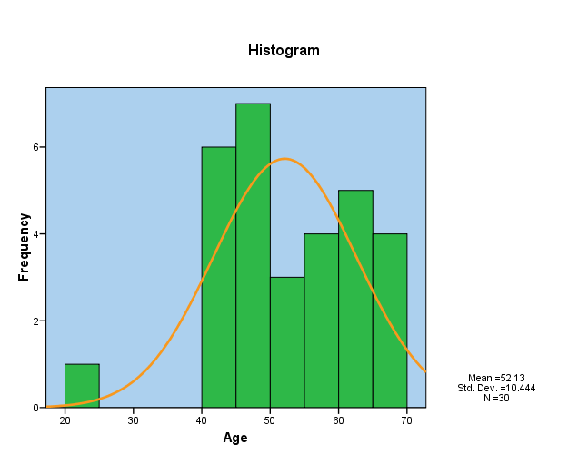

**Fig 1** : **Graph indicating the** **Age Profile of Patients enrolled in the study**

Age of patients ranged from 21 to 67 years. There was only 1 (3.3%) patient aged <40 years. Maximum were aged 41-50 years (46.7%) followed by those aged 51-60 years (26.7%) and 61-70 years (23.3%) respectively. Mean age of patients was 52.13±10.44 years.

**Table 2: Distribution of Patients according to gender**

|  |  |  |  |
| --- | --- | --- | --- |
| **SN** | **Gender** | **No. of patients** | **Percentage** |
| 1 | Male | 2 | 6.7 |
| 2. | Female | 28 | 93.3 |

**Table 3: Profile of presenting complaints**

|  |  |  |  |
| --- | --- | --- | --- |
| **SN** | **Presenting Complaint** | **No. of patients** | **Percentage** |
| 1 | Jaundice/Obstructive jaundice | 22 | 73.3 |
| 2. | Abdominal pain | 17 | 56.7 |
| 3. | Fever | 11 | 36.7 |
| 4. | Abdominal lump | 8 | 26.7 |
| 5. | Weight loss | 7 | 23.3 |
| 6. | Anorexia | 6 | 20.0 |

Jaundice/obstructive jaundice (n=22; 73.3%) was the most common presenting complaint followed by abdominal pain (n=17; 56.7%), fever (n=11; 36.7%), abdominal lump (n=8; 26.7%), weight loss (n=7; 23.3%) and anorexia (n=6; 20%) respectively.

Jaundice/obstructive jaundice (n=22; 73.3%) was the most common presenting complaint followed by abdominal pain (n=17; 56.7%), fever (n=11; 36.7%), abdominal lump (n=8; 26.7%), weight loss (n=7; 23.3%) and anorexia (n=6; 20%) respectively.

**Fig 2** : **Profile of presenting complaints**

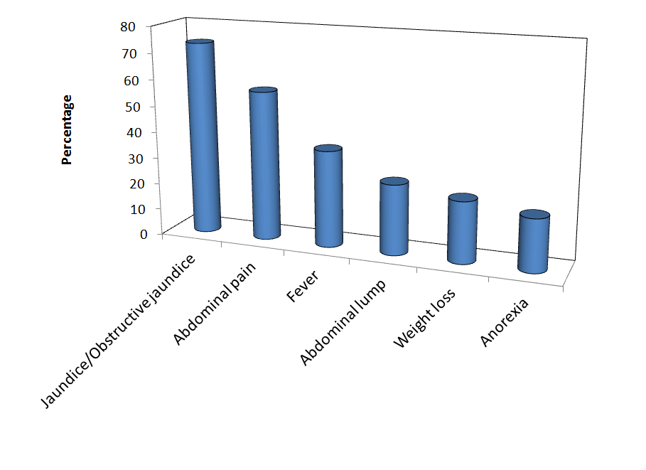

Jaundice/obstructive jaundice (n=22; 73.3%) was the most common presenting complaint followed by abdominal pain (n=17; 56.7%), fever (n=11; 36.7%), abdominal lump (n=8; 26.7%), weight loss (n=7; 23.3%) and anorexia (n=6; 20%) respectively.

**Table 4: Distribution according to Duration of Complaints**

|  |  |  |  |
| --- | --- | --- | --- |
| **SN** | **Presenting Complaint** | **No. of patients** | **Percentage** |
| 1 | <1 month | 5 | 16.7 |
| 2. | 2-3 months | 22 | 73.3 |
| 3. | 4-6 months | 2 | 6.7 |
| 4. | >6 months | 1 | 3.3 |

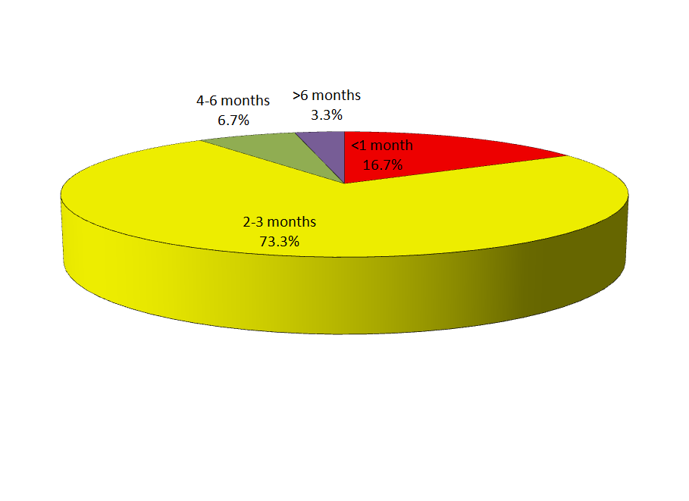

**Fig 3 : The pie chart indicates the distribution according to the Duration of Complaints**

Majority of patients had complaints for 2-3 months (n=22; 73.3%) followed by those having the complaints for <1 month (n=5; 16.7%) and 4-6 months (6.7%). There was only 1 (3.3%) patient with presenting complaints for >6 months.

**Table 5: Distribution according to clinical stage**

|  |  |  |  |
| --- | --- | --- | --- |
| **SN** | **Stage** | **No. of patients** | **Percentage** |
| 1 | Stage III | 4 | 13.3 |
| 2. | Stage IV | 26 | 86.7 |

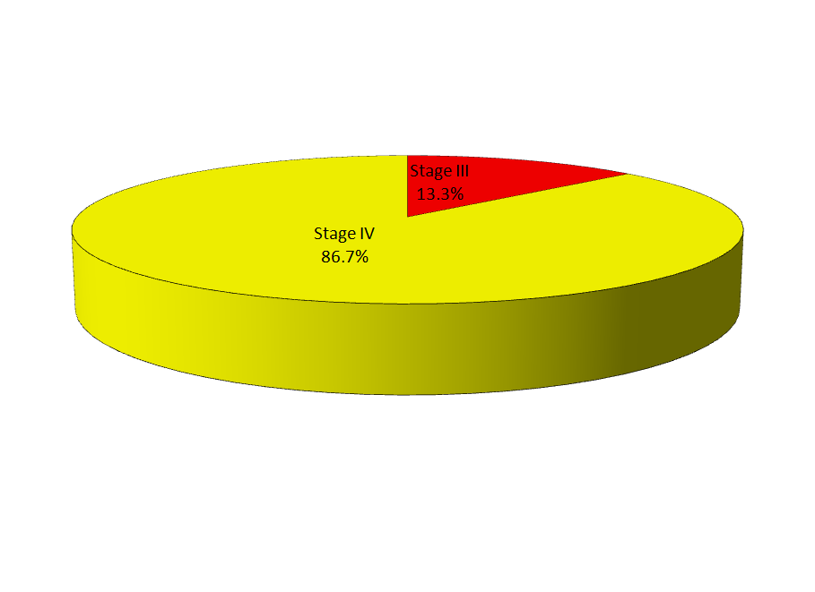

**Fig 4 : The above pie chart indicates distribution according to clinical stage**

Most of the patients were Stage IV (n=26; 86.7%). Remaining 4 (13.3%) were stage III cases.

**Table 6: Distribution according to No. of Cycles of Treatment**

|  |  |  |  |
| --- | --- | --- | --- |
| **SN** | **No. of cycles** | **No. of patients** | **Percentage** |
| 1 | 1 | 4 | 13.3 |
| 2. | 2 | 5 | 16.7 |
| 3. | 3 | 3 | 10.0 |
| 4. | 6 | 18 | 60.0 |

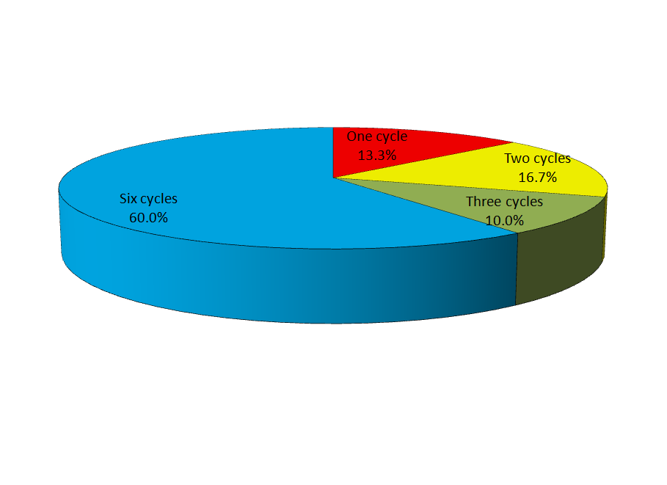

**Fig 5 :** **The pie chart represents the distribution according to No. of Cycles of Treatment**

Majority of patients (n=18; 60%) completed full 6 cycles of treatment. A total of 5 (16.7%) completed two cycles, 4 (13.3%) completed only one cycle and remaining 3 (10%) completed only one cycle.

**Table 7: Distribution of Cases according to treatment response at 3 and 6 months**

|  |  |  |  |  |  |
| --- | --- | --- | --- | --- | --- |
| **SN** | **Response** | **3 months** | | **6 months** | |
| **No.** | **%** | **No.** | **%** |
| 1 | Progressive disease (PD) | 14 | 46.7 | 18 | 60.0 |
| 2. | Stable disease (SD) | 2 | 6.7 | 0 | 0 |
| 3. | Partial response (PR) | 7 | 23.3 | 0 | 0 |
| 4. | Complete response (CR) | 0 | 0 | 0 | 0 |
| 5. | Mortality | 5 | 16.7 | 7 | 23.3 |
| 6. | Lost to follow up | 2 | 6.7 | 5 | 16.7 |

χ2=11.1 (df=4); p=0.025

At 3 months, maximum (n=14; 46.7%) had a progressive disease. There were 7 (23.3%) showing a partial response, 2 (6.7%) had stable disease. A total of 5 (16.7%) patients expired during this period. A total of 2 (6.7%) patients were lost to follow up/discontinued treatment.

At 6 months, majority (60%) had progressive disease (in fact all the patients alive and remaining in the study had progressive disease). A total of 7 (23.3%) expired and 5 (16.7%) were lost to follow up.

Statistically, there was a significant difference in outcome at 3 and 6 months (p=0.025).

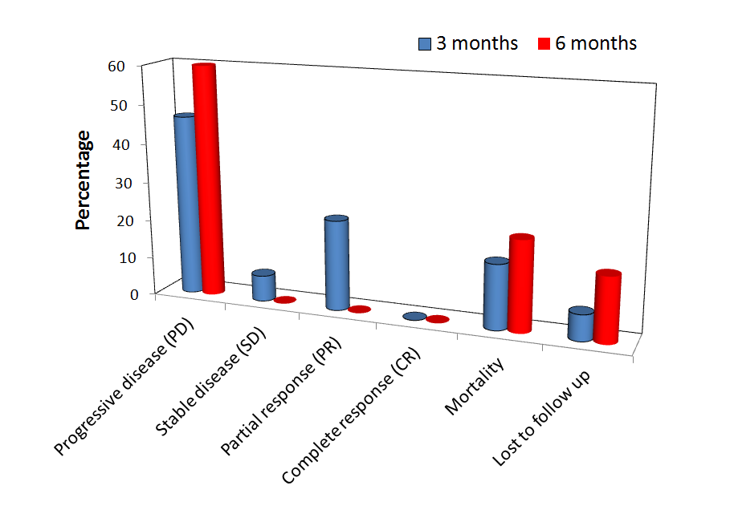

**Fig 6 : The acove bar graph indicates the distribution of Cases according to treatment response at 3 and 6 months**

**DISCUSSION**

Gall bladder cancer is a relatively rare yet a dreadful disease with very poor prognosis. It is often diagnosed in advanced stages and has a mean survival rate close to 6 months only. The disease has a dismally low 5-year survival rate7. Though surgery is recommended as the only potential curative treatment[19]. However, less than 25% cases of gall bladder cancer are resectable. Moreover, survival from advanced GBC, even in the setting of a radical resection, is poor, hence radiotherapy and chemotherapy are the more viable and widely used treatment strategies. In recent past, combination of Cisplatin and Gemcitabine has been used as a viable first-line chemotherapy option for treatment of unresectable gall bladder and biliary tract cancers of advanced stage91-102,105,108,111,112,114,116. However, these studies are basically carried out in western countries and there is extreme dearth of such studies from Asia in general and India in particular, hence the present study was instituted to assess the feasibility and outcome of this treatment strategy in Indian patients.

For this purpose, a total of 30 patients aged >18 and <70 years with histologically proven carcinoma of gall bladder/ cholangiocarcinoma with ECOG performance status <2 were enrolled in the study. It was ensured that the patients had serum bilirubin, blood counts, S. creatinine and creatinine clearance within desirable range and patients had a measurable disease as per RECIST criteria. Patients with HIV/HBV/HCV infections were excluded from the assessment.

The age of patients enrolled in the study ranged from 21 to 67 years. Age group 41-50 years was more commonly involved (46.7%). There were 23.3% patients aged above 60 years and only one (3.3%) patient was aged <40 years (this patient was aged 21 years). These findings indicated that gall bladder cancer was primarily a disease of middle and advanced age patients. Gall bladder cancer is a slowly progressing disease which completes the process of advancement from metaplasia to dysplasia, carcinoma in situ and then invasive cancer over a period ranging from 5 to 15 years5 and hence its evidence that too in advanced stages (Stage 3 and 4) is possible only at the middle age and above. Although mean age of patients enrolled in the study was relatively lower (52.13±10.44 years) as compared to a median age of 67 years reported in western literature32, however, this could be mainly attributable to the sampling frame of our study where patients above 67 years of age were excluded from the study. The western data indicates a phenomenal rise in incidence of gall bladder cancer with advancing age that shows a >50-fold rise between age 20-49 years to >75 years32. Relatively younger age of patients in present study is in agreement with the findings of Dutta *et al.* (2005)33 who reported the risk of gall bladder cancer to be increased in younger patients (<50 years) with gall stone disease. In Northern Gangetic plain gallstones happen to be the most common cause of gall bladder cancer[20],[21]. Correspondingly, the age profile of patients in present study showed a resemblance to the age profile of patients of gall bladder cancer from another study from Lucknow (India) who showed the mean age of patients to be 49.1 years118. In some other studies from Asia, the median age of their patients to be 50-55 years93,97,102. These findings in general suggest a definite epidemiological variance in gender profile of patients in eastern and western hemispheres.

The present study predominantly had a female dominance with 93.3% of patients being female. In present study, male to female ratio was 1:14. This was an extreme deranged scenario. In another study from Lucknow, Gupta *et al.* (2016)118 reported the male-to-female ratio to be 1:4.83, thus showing a female predominance as observed in present study. The higher prevalence of females as compared to males in present study could be attributed mainly to the gallstone etiology of disease which is more prevalent in Northern Gangetic plains and predominantly affects more women than men. This incidence is generally found to be more common in females as compared to males elsewhere too2,37,38,40,41,103,[22].

In present study, jaundice/obstructive jaundice (73.3%), abdominal pain (56.7%) and fever (36.7%) were the major presenting complaints. Obstructive jaundice is one of the most common complication of gall bladder cancer in our region14,83. In present study, abdominal lump, weight loss and anorexia were the other presenting complaints seen in 20-26.7% patients. Jaundice, presence of a lump and features of malignant cachexia such as anorexia and weight loss are features of extensive disease as is the presence of repeated attacks of vomiting which suggests gastric outlet obstruction due to tumour infiltration83. These presenting complaints are in agreement with the advanced stage of disease as included in present study.

In present study, most of the cases (90%) presented within 3 months of manifestation of complaints. As all the patients had advanced stage gall bladder carcinoma, hence, this finding indicates the generalized asymptomatic profile of disease which was responsible for progression of disease to advanced stage. A number of other studies have also highlighted the generalized asymptomatic profile of gall bladder carcinoma to be responsible for its diagnosis at an advanced stage6,[23],[24],[25],[26].

In present study, most of the cases (86.7%) were stage IV patients and only 4 (13.3%) were stage III patients. A high proportion of stage IV disease has been reported in a number of clinical trials. In a study by Malik *et al.* (2003)27, all the patients included in the assessment had stage IV. Gupta *et al.* (2016)118 also reported the majority of their patients (52%) to be at most advanced stage (Stage IVB). In another epidemiological study by Sachidanand *et al.* (2012)119, all the patients in advanced stage had stage IV of disease. The present study also included only advanced stage patients. In most of the instances, the symptoms appear only at highly advanced stage and this could be the reason for the higher number of stage IV patients in different series. Moreover the findings also suggest that progression of disease is rapid at advanced stage and transition from Stage III to IV is quite rapid.

In present study, a total of 6 cycles of chemotherapy was planned, however, only 18 (60%) patients could complete all the 6 cycles. Adverse effects were responsible for withdrawal of chemotherapy in 5 (16.7%) patients. Among different adverse effects, vomiting (n=6; 20%) was most common followed by fever (10%), decreased count (10%), increased bilirubin (n=2; 6.7%), anemia (n=2; 6.7%), thrombocytopenia (n=2; 6.7%), intolerability (n=1; 3.3%) and diarrhea (n=1; 3.3%) respectively. Among these adverse events, decreased counts, thrombocytopenia and intolerability were responsible for withdrawal from study. These adverse effects have also been reported in a number of studies *albeit* with a variable proportion. Mehrotra *et al.* (2004)89 in their study on gemcitabine efficacy encountered thrombocytopenia in 16.7% patients. Cho *et al.* (2005)91 using combination of oral capecitabine and gemcitabine reported transient grade 3 neutropenia/thrombocytopenia as the adverse events. Valle *et al.* (2010)105 also recorded neutropenia and thrombocytopenia as the characteristic adverse events encountered in 25.3% and 9.6% of patients receiving cisplatin plus gemcitabine regimen. Similar observations have also been reported in other studies108,111,114,116. The drop-out rate was 16.7% in our study. However, even higher drop-out rates (as high as 52%) have also been reported in trials101 using a combination regimen of gemcitabine and cisplatin as used in present study. In another study conducted among advanced or recurrent biliary tract cancer patients, Sibata (2013)114 reported dose delays and reductions due to adverse events in 8 out of 10 patients.

In present study, within 3 months of institution of treatment regimen, 5 (16.7%) patients expired while 2 (6.7%) withdrew from the study. In remaining 23 patients, 14 (60.9%) had progressive disease while 7 (30.4%) had partial response while 2 (8.7%) had stable disease. By six months, a total of 7 (23.3%) patients expired and 5 (16.7%) withdrew from the study. All the remaining 18 (60%) cases had progressive disease. Contrary to these results Malik *et al.* (2003)27 found Gemcitabine and Cisplatin combination to be highly efficacious. In their study, they reported complete remission of disease in one patient and partial response to chemotherapy in 55% patients. However, in present study, even at 3 months follow up when response was more optimistic, majority of patients remaining in trial had a progressive disease. The findings in present study are somewhat close to the observations of Doval *et al.* (2004)88 who reported median time to progression of disease to be 18 weeks. In present study, after excluding the cases who expired and those who withdrew from the trial, the median time to progression could be envisaged as 12 weeks. However, a number of studies have shown promising outcomes and a better outcome in their series of gallbladder and biliary tract carcinoma undergoing similar therapeutic regimen92,94,99. But T[hongprasert](http://annonc.oxfordjournals.org/search?author1=S.+Thongprasert&sortspec=date&submit=Submit) *et al.* (2005)93, somewhat similar to our study found that gemcitabine plus cisplatin combination was able to bring about partial response in only 27.5% patients while stable disease was observed in 32.5% patients. In another study, Kim *et al.* (2006)97 who evaluated the outcome at 3 months also found results similar to those obtained in our study with partial response in 34.5%, stable disease in 13.8% and progressive disease in 44.8% patients. Using a three-cycle regimen Gupta *et al.*(2007)99 have reported complete response in 17.8% of their patients and stable or progressive disease in 50% of their patients who were followed up from 12 to 30 weeks. In contrast to findings of present study, Meyerhardt *et al.* (2007)101 in their study reported median progression free survival to be 6.3 months, however, in present study, it was below 6 months. However, in present study where 23.3% patients expired within six months, Meyerhardt *et al.* (2007)101 reported a mortality rate of 61% over a period of one year. Thus indicating that the therapeutic effect did not affect the mortality rate and as such the progressive disease is an inevitable outcome of the disease irrespective of the initial response to combination treatment.

In present study, the median survival upto six months follow up was 4.974 months and survival function till six months of follow up was 0.748. One of the limitations of present study was its shorter follow up duration. Most of the studies have reported the follow up outcomes at one year or more and correspondingly there are differences in median survival duration and survival functions. In present study, overall median survival could not be evaluated. Among other studies showing a better drug response, the survival rate as well as median duration of survival is not much high qualitatively. Malik *et al.* (2003)27 reported a median overall survival rate to be 42 weeks. In present study, only 7 (23.3%) mortalities took place upto a follow up of six months, and hence the overall survival rate of 42 weeks cannot be denied. In another study88, showing response rates similar to our study, the median survival was recorded as 20 weeks and a 1-year survival rate of 18.6%. Thongprasert *et al.* (2005)93 also showed overall median survival time to be 36 weeks. Lee *et al.*(2006)94 (9.3 months), Kim *et al.* (2006)97 (11 months), Gupta *et al.* (2007)99 (6 months), Meyerhardt *et al.* (2007)101 (9.7 months), Iyer *et al.* (2007)102 (14 months), Williams *et al.* (2010)106 (10.6 months), Razumilava and Gores (2011)108 (11.7 months) and Wu *et al.* (2012)111 (13.4 months). In a larger trial including 410 patients105 too, the median survival was reported to be 8.1 months and by a median follow-up of 8.2 months a total of 327/410 (79.76%) deaths have taken place. Iyer *et al.* (2007)102 in their study reported the probability of one-year survival to be 0.58, in present study we found the probability of six-month survival to be 0.748. In some other studies, the median survival time has been found to be extended after addition of some other drug to the combination of cisplatin and gemcitabine112,116.

Thus, despite disagreement over response pattern to treatment, the overall survival seemed to be similar to that reported in other studies. The reason for difference in response pattern could be difference in study designs, inclusion criteria and age of patients. In present study, only gall bladder carcinoma patients were included in the assessment, however, in previous studies, not only gall bladder carcinoma but patients of ampullary carcinoma, biliary tract cancer and cholangiocarcinoma have also been included and this might be a factor responsible for the difference in response rate. Moreover, it must not be forgotten that the ethnicity of a patient also played a role in determining the response rate and overall outcome. Although, most of the trials come from western world, yet trials on Asian population show a difference in outcome pattern93,94,99.

A number of studies have compared the efficacy of Gemcitabine/Cisplatin combination with monotherapy or other regimens and have found it to be more efficacious as compared to other combinations, however, the present study was a single-arm study and did not include any comparative evaluation, and hence we are not in a position to comment over this aspect. However, as compared to western data, at least for response to treatment, the results in present study showed a considerable variation and require further validation including institution of comparative studies and further multicentric trials over a longer duration of follow up. The present study was limited by the fact that it was a prospective study, however, subsequent cumulative trials using data of present study as retrospective basis are recommended to be conducted at our centre itself to evaluate the cumulative evidence given the somewhat extraordinary findings related with response pattern as obtained in present study.

**CONCLUSION**

The present study was planned to evaluate the response to first line chemotherapy with Cisplatin and Gemcitabine in Indian Patients with advanced Gall Bladder Carcinoma. For this purpose, a total of 30 stage III / IV patients of gall bladder cancer were enrolled in the study and underwent 6 cycles of Cisplatin/Gemcitabine treatment. The following key observations were made:

1. Age of patients ranged from 21 to 67 years. Mean age of patients was 52.13±10.44 years. Half the patients (50%) were upto 50 years of age.
2. Most of the patients were females (93.3%). Male female ratio of study was 0.07:1.
3. Jaundice/obstructed jaundice (73.3%) and abdominal pain (56.7%) were the major presenting complaints, apart from fever (36.7%), abdominal lump (26.7%), weight loss (23.3%) and anorexia (20%).

**CONSENT**

All authors declare that ‘written informed consent was obtained from the patient (or other approved parties) for publication of this case report and accompanying images. A copy of the written consent is available for review by the editorial office/chief editor/editorial board members of this journal."

References

1. Eisenhauer EA, Therasse P, Bogaerts J, *et al.* New response evaluation criteria in solid tumours:Revised RECIST guideline (version 1.1). European Journal of Cancer 2009; 45: 228–247.
2. Indian Council of Medical Research (ICMR). Consolidated Report of the Population Based Cancer Registries of the National Cancer Registry Programme (1990-1996), 2001, New Delhi. ICMR publication, p 52.
3. Shukla VK, Khandelwal C, Roy SK, Vaidya MP. Primary carcinoma of the gallbladder: A review of a 16 year period at the University hospital. J. Surg Oncol 1985, 28: 32-35.
4. Pandey M, Patahak AK, Gautam A, Aryya NC, Shukla VK. Carcinoma of the Gall bladder: A retrospective review of 99 cases. Digestive Diseases and Sciences 2001; 46(6): 1145-1151.
5. Piehler JM, Crichlow RW: Primary carcinoma of the gallbladder. Surg Gynecol Obstet 1978; 147: 929–942.
6. Hamrick RE, Liner FJ, Hastings PR, Cohn I Jr. Primary carcinoma of the gallbladder. Ann Surg 1982; 195:270–273.
7. Benbow EW. Xanthogranulomatous cholecystitis associated with carcinoma of the gallbladder, Postgrad Med J 1989, 65: 528-531.
8. Houston JP, Collins MC, Cameron M et al. Xanthogranulomatous cholecystitis. Br J Surg 1994, 81: 1030-1032.
9. Glenn F: Gall stones without clinical symptoms [Editorial]. Ann Surg 1957; 145:143–144.
10. Chao TC, Greager JA: Primary carcinoma of the gallbladder. J Surg Oncol 1991; 46:215–221.
11. Kapoor VK, Pradeep R, Haribhakti SP, Sikora SS, Kaushik SP. Early carcinoma of the gallbladder: An elusive disease. J Surg Oncol 1996; 62: 284–287.
12. Yalcin S. Carcinoma of the Gallbladder. Orphanet Encyclopedia, 2004, pp. 1-5.
13. [Falkson G](http://www.ncbi.nlm.nih.gov/pubmed?term=Falkson%20G%5BAuthor%5D&cauthor=true&cauthor_uid=6235908), [MacIntyre JM](http://www.ncbi.nlm.nih.gov/pubmed?term=MacIntyre%20JM%5BAuthor%5D&cauthor=true&cauthor_uid=6235908), [Moertel CG](http://www.ncbi.nlm.nih.gov/pubmed?term=Moertel%20CG%5BAuthor%5D&cauthor=true&cauthor_uid=6235908). Eastern Cooperative Oncology Group experience with chemotherapy for inoperable gallbladder and bile duct cancer. [Cancer.](http://www.ncbi.nlm.nih.gov/pubmed/6235908) 1984 Sep 15;54(6):965-9.
14. Gallardo JO, Rubio B, Fodor L, *et al.* A phase II study of gemcitabine in gallbladder carcinoma. Ann Oncol 2001; 12 (10): 1403-1406.
15. [Tsavaris N](http://www.ncbi.nlm.nih.gov/pubmed?term=Tsavaris%20N%5BAuthor%5D&cauthor=true&cauthor_uid=14739669), [Kosmas C](http://www.ncbi.nlm.nih.gov/pubmed?term=Kosmas%20C%5BAuthor%5D&cauthor=true&cauthor_uid=14739669), [Gouveris P](http://www.ncbi.nlm.nih.gov/pubmed?term=Gouveris%20P%5BAuthor%5D&cauthor=true&cauthor_uid=14739669), Weekly gemcitabine for the treatment of biliary tract and gallbladder cancer. [Invest New Drugs.](http://www.ncbi.nlm.nih.gov/pubmed/14739669) 2004 Apr;22(2):193-8.
16. Lowenfels AB, Maisonneuve P, Boyle P, Zatonski WA. Epidemiology of gallbladder cancer. Hepatogastroenterology. 1999;46(27):1529-32.
17. Bernstein CN, Blanchard JF, Kliewer E, Wajda A. Cancer risk in patients with inflammatory bowel disease: a population-based study. Cancer. Feb 15 2001;91(4):854-62.
18. Matsukura N, Yokomuro S, Yamada S, Tajiri T, Sundo T, Hadama T, *et al*. Association between Helicobacter bilis in bile and biliary tract malignancies: H. bilis in bile from Japanese and Thai patients with benign and malignant diseases in the biliary tract. Jpn J Cancer Res. Jul 2002;93(7):842-7.
19. Zhu AX, Hong TS, Hezel AF, Kooby DA. Current Management of Gallbladder Carcinoma. The Oncologist 2010; 15(2): 168-181.
20. [Gupta S](http://www.ncbi.nlm.nih.gov/pubmed/?term=Gupta%20S%5BAuthor%5D&cauthor=true&cauthor_uid=26585944), [Kori C](http://www.ncbi.nlm.nih.gov/pubmed/?term=Kori%20C%5BAuthor%5D&cauthor=true&cauthor_uid=26585944), [Kumar V](http://www.ncbi.nlm.nih.gov/pubmed/?term=Kumar%20V%5BAuthor%5D&cauthor=true&cauthor_uid=26585944), [Misra S](http://www.ncbi.nlm.nih.gov/pubmed/?term=Misra%20S%5BAuthor%5D&cauthor=true&cauthor_uid=26585944), [Akhtar N](http://www.ncbi.nlm.nih.gov/pubmed/?term=Akhtar%20N%5BAuthor%5D&cauthor=true&cauthor_uid=26585944). Epidemiological Study of Gallbladder Cancer Patients from North Indian Gangetic Planes--a High-Volume Centre's Experience. [J Gastrointest Cancer.](http://www.ncbi.nlm.nih.gov/pubmed/26585944) 2016;47(1):27-35. 
21. Sachidananda S, Krishnan A, Janani K, et al. Characteristics of Gallbladder Cancer in South India. Indian Journal of Surgical Oncology. 2012;3(3):228-230.
22. National Cancer Intelligence Network (NCIN). Geographic variation in primary liver and gallbladder cancer NCIN Data Briefing,. 2010.
23. Csendes A, Becerra M, Rojas J, et al. Number and size of stones in patients with asymptomatic and symptomatic gallstones and gallbladder carcinoma: a prospective study of 592 cases. J Gastrointest Surg 2000;4:481-485.
24. [Kimura W](http://www.ncbi.nlm.nih.gov/pubmed/?term=Kimura%20W%5BAuthor%5D&cauthor=true&cauthor_uid=2731127), [Nagai H](http://www.ncbi.nlm.nih.gov/pubmed/?term=Nagai%20H%5BAuthor%5D&cauthor=true&cauthor_uid=2731127), [Kuroda A](http://www.ncbi.nlm.nih.gov/pubmed/?term=Kuroda%20A%5BAuthor%5D&cauthor=true&cauthor_uid=2731127), [Morioka Y](http://www.ncbi.nlm.nih.gov/pubmed/?term=Morioka%20Y%5BAuthor%5D&cauthor=true&cauthor_uid=2731127). Clinicopathologic study of asymptomatic gallbladder carcinoma found at autopsy. [Cancer.](http://www.ncbi.nlm.nih.gov/pubmed/2731127) 1989;64(1):98-103.
25. Andrén-Sandberg Å. Diagnosis and Management of Gallbladder Cancer. North American Journal of Medical Sciences. 2012;4(7):293-299.
26. Lee T-Y, Ko S-F, Huang C-C, et al. Intraluminal versus infiltrating gallbladder carcinoma: Clinical presentation, ultrasound and computed tomography. World Journal of Gastroenterology : WJG. 2009;15(45):5662-5668.