***Case report***

**Solid pseudopapillary neoplasm of the pancreas with multiple liver metastases: a rare case report with literature review**

**Abstract:**

Solid and pseudopapillary tumor (SPT) of the pancreas is a rare relatively low grade malignant neoplasm metastasizing in only 5–15% of cases, the most common location is in the liver. This tumor affects young women in the majority of the cases. We report a case of SPT in a 67 year-old women who presented with liver metastasis 7 years after complete resection of the primary tumor in the pancreas.

**Introduction :**

Solid and pseudopapillary tumor (SPT) of the pancreas is a rare tumor that account for 1% to 2% of all exocrine tumors of the pancreas. It most often affects young women between 20 and 35 years old **(1).** These tumors were first discribed by Frantz in 1959 **(2).**They are characterized by a slow progression with a low grade of malignancy. This type of tumor can affect several locations in the pancreas but they are must often located in the body and the tail of the pancreas **(3)**.

The metastases of solid and pseudopapillary tumor (SPT) of the pancreas are rare and there is only a few cases described. The metastases are present in 5% to 15%. The most common locations are in the liver, regional lymph nodes, mesentery, omentum, and peritoneum **(4).**

They are often discovered incidentally, during abdominal imaging, or on the presence of minimal non specific symptoms like abdominal pain. The positive diagnosis is based on anatomopathology, and there isn’t a lot of recommendations of treatment because it’s a rare disease. The treatment is considered a challenge especially for bilobar liver metastasis **(2).**

**Case report:**

The patient is a 67-year-old moroccan woman, with a long medical history: Hypertension, diabetes under treatment with good control, she presented a rectal adenocarcinoma treated with radio chemotherapy first and in 2010 an anterior rectal resection+ coloanal anastomosis . In 2016, she had a corporeocaudal splenopancreatectomy for a pseudopapillary tumor of the pancreas: Macroscopically: presence of 5mm of the cephalic section of a nodular neoplasm measuring 3x2.5x2cm. Microscopically: it’s a tumor proliferation limited by a thick fibrous capsule and a pseudopapillary architecture, presence of a round oval nucleus, There are hyalinized fibrous areas, areas of calcifications. In addition, it was partially necrotic and bleeding. Immunochemistry was positive for CD10, CD56, progesterone receptor, beta catenin, and negative for chromogranin, E-cadherin and estrogen receptor. In 2023, 7 years from the surgery of the SPT, a computed tomography (CT) identifed 8 liver nodules, the largest ones seat at segment VII measuring 24mm. Abdominal magnetic resonance imaging (MRI) showed multiple intrahepatic cystic formations enhanced in the periphery in the arterial phase and persistent on the portal and late sequences. They come in varying sizes measuring between 6mm and 27mm. They predominate at the right lobe of the liver, segment I IV V VI VII VIII. The histopathological diagnosis confirmed that the liver metastasis are from the pseudopapillary and solid tumor of the pancreas. Immunohistostaining studies revealed that the tumor cells were positive for vimentin, beta catenin, focally positive to TFE3 and the progesterone receptor, and no significant marking by synaptophysin.

This case is presented in a multidisciplinary consultation meeting, and the decision was the surgery for metastases.

Surgical exploration finds a fragile steatotic liver, there is no peritoneal carcinomatosis. Hepatic pedicle clamping with a cumulative duration of 59mn (15-13-16-15mn). A multiple partial hepatectomy was performed at the segment IVa V VI VII VIII with intraoperative radiofrequency in deep segments V, VIII and cholecystectomy. There were 2 exterior Jakson drains on the right side opposite the section slice. The surgery lasted 6hours and the blood loss estimated is 150 ml.

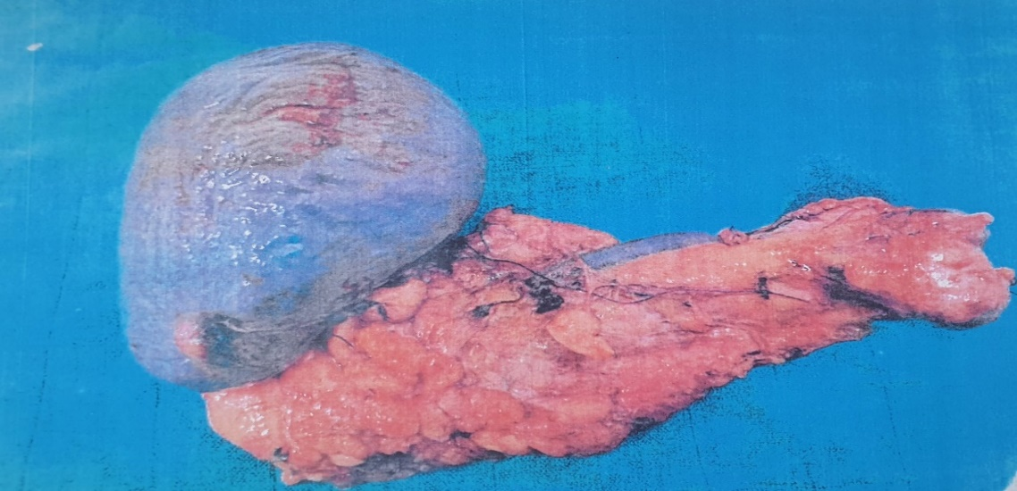

**Fig. 1. Corporeocaudal splenopancreatectomy for a pseudopapillary tumor of the pancreas**

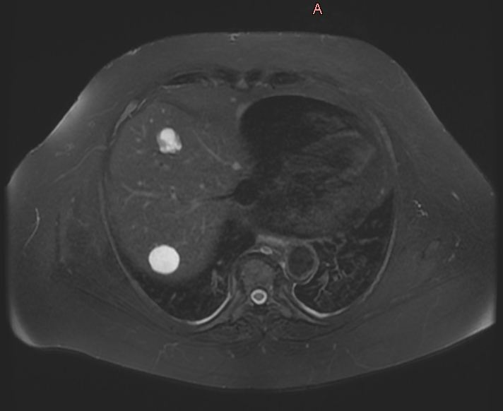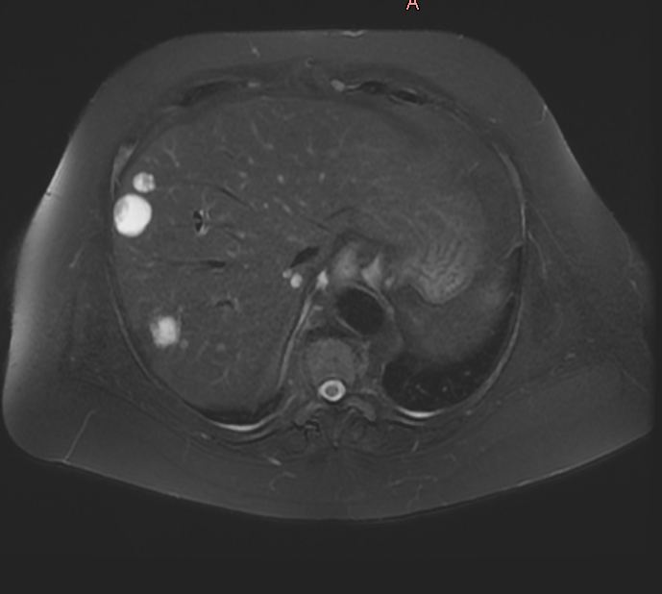 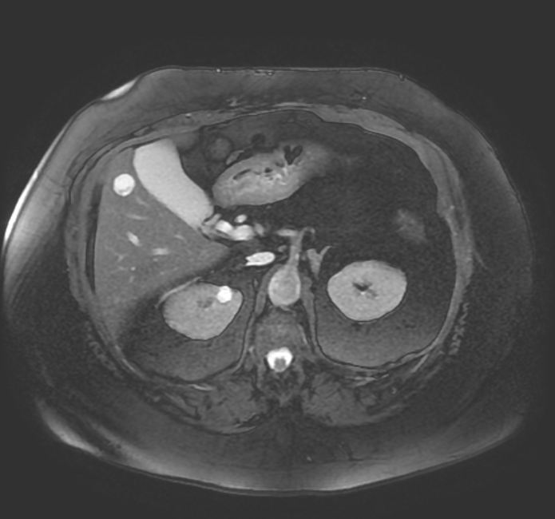 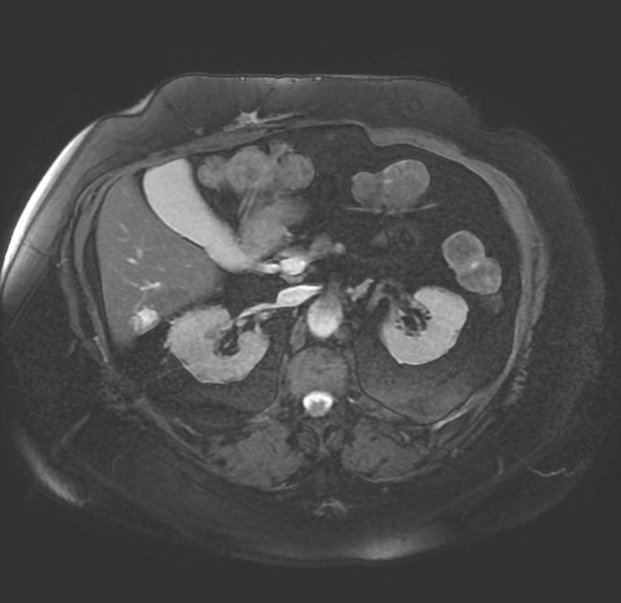

**Fig 2. Abdominal magnetic resonance imaging showing multiple metastatic lesions. They predominate at the right lobe of the liver.**

**Discussion :**

Pancreatic SPT with liver metastasis is very rare, reported in only a few cases. We report a case of a 67 year old woman who presented a multiple liver metastasis 7 years after the first surgery for the pancreatic SPT.

These tumor is a rare tumor that predominate in women, and a male female ratio is 1/10 (**5)**. This predominance leads us to the hypothesis that its pathogenesis may be influenced by sex hormones. Yeh et al. have reported that the progesterone receptor is uniquely expressed in SPT while both estrogen and progesterone receptors are expressed in mucinous cystic neoplasm (**6)**. SPT has been described by many other terms, such as papillary epithelial neoplasm, solid and cystic acinar cell tumor, papillary cystic neoplasm, papillary cystic carcinoma, solid and cystic tumor, low-grade papillary tumor, and Frantz's tumor (**7).**

The positive diagnosis is based on histology which shows that the nuclei of SPT often exhibit “coffee bean–type” nuclear grooves. The cytoplasm as well as the surrounding stroma may present hyaline globules positive for PAS (periodic acid schiff) and resistant to diastase(**8).** Macroscopically, the tumor size varies from 2.5 to 25cm in long axis. The tumor is rounded or oval, limited by a thick capsule **(2).** They present necrotic and hemorrhagic changes, producing a fairly characteristic pseudo-cystic appearance. The immunochemistry plays a major role in the positive and differential diagnosis with pancreatic endocrine tumors, mixed acinarendocrine carcinoma, pancreatoblastoma, and acinar cell carcinomas (**9).** The typical immunostaining pattern of SPT includes positive staining for β-catenin (nuclear and cytoplasmic); vimentin; progesterone receptor (nuclear); CD56; NSE (neuron-specific enolase); CD10; and more recently, negative membranous E-cadherin, positive cyclin D1 (nuclear), and positive FLI1 (nuclear) (**10)**.Kim et al. suggest that lymphoid enhancer-binding factor 1 (LEF1) transcription factor for immunoglobulin heavy-chain enhancer 3(TFE3), and androgen receptor (AR) are useful for the diagnosis of SPT, and the combination of these markers with beta-catenin is helpful to improve their sensitivity and specificity in the diagnosis of SPTs. They also suggest that the Ki-67 proliferative index could be a predictive marker of metastasis in SPT (**12).**

In our case, Immunochemistry of SPT was positive for CD10, CD56, progesterone receptor, beta catenin. The immunochemistry study of liver biopsy were positive for vimentin, beta catenin, focally positive to TFE3 and the progesterone receptor. The tumor markers (CA19-9, CEA and AFP) are most often normal.

CT/MRI-scans typically show a large well-circumscribed, heterogeneous mass with varying solid and cystic components, generally demarcated by a peripheral capsule and occasional calcification.

In our case, abdominal magnetic resonance imaging (MRI) showed multiple intrahepatic cystic formations enhanced in the periphery in the arterial phase and persistent on the portal and late sequences

We can conclude that, Appearance on imaging may suggest diagnosis, but the confirmation of diagnosis should be accomplished by percutaneous CT-guided core needle biopsy (**13).**

There is a few similar cases of patients with solid-pseudopapillary neoplasm of pancreas and liver metastasis. The Methodist Hospital at Houston reported a case of SPT in a 36 year old woman who presented with liver metastasis 15.8 years after complete resection of the primary tumor in the pancreas (**10).** Morito et al presented a second case of SPN in a 71 year old woman who underwent distal pancreatectomy for solid pseudo papillary neoplasm, and liver metastasis occurred 4 years after the first surgery. Partial liver resection was performed for four liver metastases. 18 months later, liver metastases were detected again; three tumors were identifed, and partial resection was performed (**4) .**The third case, is reported at Cancer Center of West China Hospital, of a 19 year old female with an upper abdominal pain, epigastric mass on palpation, a 10 kilograms of weight lost in a single month. An abdominal CT scan found a giant solid mass in the pancreatic body, multiple nodules of the right lobe of the liver and splenomegaly. They confirmed the diagnosis of SPT with a percutaneous CT-guided tru-cut biopsy of the tumor. The surgery was a pancreaticoduodenectomy apart from distal pancreatectomy, hepatic tumor resection and splenectomy. 3 months after the surgery, a CT scan showed a metastatic mass in the medial segment of the left lobe of the liver, the treatment was a transcatheter arterial chemoembolization (TACE) with epirubicin and iodized oil whish was performed 3 times, because the radical excision of the metastatic mass was unfeasible (**3).** Another case is reported by Sapporo city hospital where a 49 year old woman presented a SPT in the pancreatic head and the treatment was a pancreatoduodenectomy. 6 years after the initial surgery, a routine follow-up CT scan detected a mass in the segment VI of the liver. They performed a liver biopsy, the pathological appearance of the biopsy specimen was similar to that of the pancreatic tumor. Partial hepatectomy was performed, and pathology confirmed the presence of recurrent metastatic SPT. The patient presented a metastatic tumors in the liver at 98 and 113 months after the initial surgery, for which the patient underwent repeated partial hepatectomies (**11).**

The standard treatment of liver metastatic from pancreatic SPT is a radical surgical resection of primary tumor and metastases. In our case, a multiple partial hepatectomy was performed with intraoperative radiofrequency. However, we can use some alternatives treatment chemotherapy, transcatheter arterial embolization (TAE), radiofrequency ablation (RFA), and even liver transplantation for inoperable metastatic SPT.

Hah et al reported a case of a 14 year old girl who presented an unresectable SPT with liver metastasis. She received 4 cycles of preoperative chemotherapy with cisplatinum, ifosfamide, etoposide, and vincristine every 4 to 6 weeks followed by intraoperative radiofrequency ablation of metastatic liver lesions with surgical resection of the primary tumor. During the 3 year follow-up, the patient was doing well and no evidence of recurrence or metastasis (**14).** Prasad TV et alreported a case of 40 years old woman with extensive liver metastasis on both lobes from SPT which she was operated 4 years ago. The patient received a Transarterial chemoembolisation (TACE) using gemcitabine as chemotherapeutic agent. Short term follow up after a month of TACE with multiphase CT-scan showed > 90% resolution in the viable tumor with significant clinical improvement (**15).** Kocman et al. reported a case of 20 years old woman who presented with 18 bilateral liver metastases at 3 years after surgery for SPT. The patient’s mother agreed to donate her right liver lobe. The patient was discharged home 1 month posttransplantation. She is currently alive and disease-free at 24 months after transplantation (**16).** Sumida et al. reported a case of a 14-year-old girl with SPT of the pancreas and unresectable synchronous liver metastasis, the surgeons decided to resect the primary pancreatic tumor first. 4 months after the initial operation, the patient’s father agreed to donate his left liver. There was no acute cellular rejection. The patient was discharged after 2months postoperative day. For 2 years, she has been disease free (**17).**

Prognosis is good in most of the patients who developed liver metastasis synchronously or metachronously due to its low malignancy. Many patients have been reported to live for extended periods with complete operative excision of metastatic lesions. The survival rate reaching up to 17 years for metastatics SPN (**18) (19).**

**Conclusion:**

Solid and pseudopapillary tumor of the pancreas with liver metastasis is a rare phenomenon. The positive diagnosis is based on histology and immunochemistry. Radical surgical resection of primary tumor and metastases is the standard treatment for SPT, however there is other alternative treatments for unresectable metastases: radiofrequency ablation (RFA), chemotherapy, transcatheter arterial embolization (TAE) and even liver transplantation.

**References :**

1. Ranaweera K, Nandasena M, de Silva U, Jayarajah U, Delwatta S, de Silva C, Pathirana A. Solid pseudopapillary neoplasm of the pancreas with multiple liver metastases successfully managed with staged resection. SAGE Open Med Case Rep. 2022 May 23;10:2050313X221101995. doi: 10.1177/2050313X221101995. PMID: 35646369; PMCID: PMC9136567.
2. Bellarbi S, Sina M, Jahid A, Zouaidia F, Bernoussi Z, Mahassini N. Tumeur de Frantz: deux nouveaux cas [Frantz tumor: 2 new cases]. Pan Afr Med J. 2013;14:7. French. doi: 10.11604/pamj.2013.14.7.1412. Epub 2013 Jan 4. PMID: 23503717; PMCID: PMC3597855.
3. Liu T, He J, Cao D, Huang Y. Successful treatment of liver metastasis from solid pseudopapillary tumor of the pancreas: a case report. Contemp Oncol (Pozn). 2013;17(4):400-3. doi: 10.5114/wo.2013.37225. Epub 2013 Oct 7. PMID: 24592130; PMCID: PMC3934044.
4. Morito A, Eto K, Matsuishi K, Hamasaki H, Morita K, Ikeshima S, Horino K, Shimada S, Baba H. A case of repeat hepatectomy for liver metastasis from solid pseudopapillary neoplasm of the pancreas: a case report. Surg Case Rep. 2021 Mar 1;7(1):60. doi: 10.1186/s40792-021-01134-6. PMID: 33650037; PMCID: PMC7921273.
5. Wang WB, Zhang TP, Sun MQ, Peng Z, Chen G, Zhao YP. Solid pseudopapillary tumor of the pancreas with liver metastasis: Clinical features and management. Eur J Surg Oncol. 2014 Nov;40(11):1572-7. doi: 10.1016/j.ejso.2014.05.012. Epub 2014 Jun 12. PMID: 24961631.
6. Yeh TS, Jan YY, Chiu CT, Ho YB, Chen TC, Lee KF, Chan KM, Hsu JC, Hwang TL, Chen MF. Characterisation of oestrogen receptor, progesterone receptor, trefoil factor 1, and epidermal growth factor and its receptor in pancreatic cystic neoplasms and pancreatic ductal adenocarcinoma. Gut. 2002 Nov;51(5):712-6. doi: 10.1136/gut.51.5.712. PMID: 12377812; PMCID: PMC1773438.
7. Martin RC, Klimstra DS, Brennan MF, Conlon KC. Solid-pseudopapillary tumor of the pancreas: a surgical enigma? Ann Surg Oncol. 2002 Jan-Feb;9(1):35-40. doi: 10.1245/aso.2002.9.1.35. PMID: 11833495.
8. Pettinato G, Di Vizio D, Manivel JC, Pambuccian SE, Somma P, Insabato L. Solid-pseudopapillary tumor of the pancreas: a neoplasm with distinct and highly characteristic cytological features. Diagn Cytopathol. 2002 Dec;27(6):325-34. doi: 10.1002/dc.10189. PMID: 12451561.
9. Morohoshi T, Kanda M, Horie A, Chott A, Dreyer T, Klöppel G, Heitz PU. Immunocytochemical markers of uncommon pancreatic tumors. Acinar cell carcinoma, pancreatoblastoma, and solid cystic (papillary-cystic) tumor. Cancer. 1987 Feb 15;59(4):739-47
10. Gomez P, Yorke R, Ayala AG, Ro JY. Solid-pseudopapillary neoplasm of pancreas with long delayed liver metastasis. Ann Diagn Pathol. 2012 Oct;16(5):380-4. doi: 10.1016/j.anndiagpath.2011.02.008. Epub 2011 Jun 8. PMID: 21641841.
11. Ichimura K, Uesaka T, Kikuchi H, Okuda K, Sunahara M, Oshima T, Misawa K. Repeated Resection for Recurrent Metastatic Solid Pseudopapillary Neoplasm of the Pancreas. Am J Case Rep. 2021 Dec 21;22:e934798. doi: 10.12659/AJCR.934798. PMID: 34932527; PMCID: PMC8711256.

(12) Kim EK, Jang M, Park M, Kim H. LEF1, TFE3, and AR are putative diagnostic markers of solid pseudopapillary neoplasms. Oncotarget. 2017 Oct 16;8(55):93404-93413. doi: 10.18632/oncotarget.21854. PMID: 29212159; PMCID: PMC5706805

(13) Vassos N, Agaimy A, Klein P, Hohenberger W, Croner RS. Solid-pseudopapillary neoplasm (SPN) of the pancreas: case series and literature review on an enigmatic entity. Int J Clin Exp Pathol. 2013 May 15;6(6):1051-9. PMID: 23696922; PMCID: PMC3657357.

(14) Hah JO, Park WK, Lee NH, Choi JH. Preoperative chemotherapy and intraoperative radiofrequency ablation for unresectable solid pseudopapillary tumor of the pancreas. J Pediatr Hematol Oncol. 2007 Dec;29(12):851-3. doi: 10.1097/MPH.0b013e318158159c. PMID: 18090937.

(15) Prasad TV, Madhusudhan KS, Srivastava DN, Dash NR, Gupta AK. Transarterial chemoembolization for liver metastases from solid pseudopapillary epithelial neoplasm of pancreas: A case report. World J Radiol. 2015 Mar 28;7(3):61-5. doi: 10.4329/wjr.v7.i3.61. PMID: 25825635; PMCID: PMC4374090.

(16) Kocman B, Jadrijević S, Skopljanac A, Mikulić D, Gustin D, Buhin M, Matasić H, Gasparov S, Suknaić S, Ivanović D. Living donor liver transplantation for unresectable liver metastases from solid pseudo-papillary tumor of the pancreas: a case report. Transplant Proc. 2008 Dec;40(10):3787-90. doi: 10.1016/j.transproceed.2008.03.169. PMID: 19100491

(17) Sumida W, Kaneko K, Tainaka T, Ono Y, Kiuchi T, Ando H. Liver transplantation for multiple liver metastases from solid pseudopapillary tumor of the pancreas. J Pediatr Surg. 2007 Dec;42(12):e27-31. doi: 10.1016/j.jpedsurg.2007.08.056. PMID: 18082688.

(18) Yang F, Jin C, Fu D. Evolution of liver metastasis from solid pseudopapillary tumor of the pancreas. Surgery. 2017 Jun;161(6):1739-1740. doi: 10.1016/j.surg.2016.05.001. Epub 2016 Jun 11. PMID: 27302102.

(19) Guedira M, Hrora A, Raïss M, El-Alaoui M, Kettani F, Tounsi A. Tumeurs pseudopapillaires et solides du pancréas [Pseudopapillary and solid tumors of the pancreas]. J Chir (Paris). 2006 Jul-Aug;143(4):275-8. French. doi: 10.1016/s0021-7697(06)73690-0. PMID: 17088735.