Original Research Article
Expert perspectives on the management of depression with a focus on escitalopram among psychiatrists in Indian settings

.
ABSTRACT

Objective: To assess clinician preferences and the perceived efficacy of escitalopram across various psychiatric conditions and common comorbidities, adverse effects, and treatment considerations in depression management among psychiatrists practicing in Indian settings.
Methods: The cross-sectional study utilized a 23-item questionnaire to gather expert opinion on the management of depression and psychiatric comorbidities among psychiatrists in India. The study assessed the clinicians' perspectives, clinical observations, preferences, and experiences with escitalopram in the routine management of mental disorders. Descriptive statistics were used to analyze the data.
Results: A total of 458 psychiatrists participated in the study. Approximately 71% identified generalized anxiety disorder (GAD) as the most common psychiatric comorbidity among patients with depression. About 73% of participants preferred escitalopram for treating major depressive disorder (MDD), and 92% considered it their first-line treatment for managing depression. Nearly 60% of respondents selected escitalopram as their first-choice antidepressant for social anxiety disorder. In terms of selective serotonin reuptake inhibitor (SSRI)-related side effects, 31% reported dry mouth as the most common adverse event, followed by gastrointestinal (GI) issues (29%). Around 78% favored escitalopram for patients with GAD who experienced increased sedation and dry mouth from paroxetine. Additionally, approximately 71% preferred escitalopram for cases of severe depression with suicidal attempts, while 74% recommended it for treating post-psychotic depression.
Conclusion: This study confirms escitalopram as the leading first-line antidepressant, with most of the clinicians preferring it for depression. It highlights strong consensus on SSRI efficacy, common side effects, and treatment choices in complex cases.

Keywords: Escitalopram, antidepressant, SSRI, side effects, treatment, outcomes

1. INTRODUCTION

Depression and anxiety disorders are among the most prevalent mental health conditions encountered globally, posing a significant burden on healthcare systems and societies. According to the World Health Organization (WHO), in 2019, one in every eight individuals (approximately 970 million people worldwide) were living with a mental disorder, with anxiety and depressive disorders being the most common. The situation worsened in 2020, when the COVID-19 pandemic led to a substantial surge in mental health problems. Initial global estimates indicated a 26% increase in anxiety disorders and a 28% increase in major depressive disorders (MDD) within just one year [1].
In India, the impact was similarly profound. According to the Global Burden of Disease Study 2019, approximately 45.7 million people in India were living with depressive disorders, accounting for 3.3% of the total population [2]. A meta-analysis of studies conducted during the pandemic reported pooled prevalence rates of 23.5% (95% CI: 17.4–29.6%) for anxiety symptoms and 20.2% (95% CI: 17.2–23.2%) for depressive symptoms among the general population in the country [3].
Escitalopram, administered at a dose of 10–20 mg/day, is widely recognized as an effective and well-tolerated first-line treatment for several anxiety and mood disorders, including panic disorder, generalized anxiety disorder (GAD), social anxiety disorder, and obsessive-compulsive disorder (OCD) [4]. Belonging to the class of selective serotonin reuptake inhibitors (SSRIs), escitalopram exerts its therapeutic action by increasing serotonin levels in the synaptic cleft. This is achieved by inhibiting the reuptake of serotonin into presynaptic neurons, thereby enhancing serotonergic neurotransmission [5].
Escitalopram is unique among SSRIs due to its dual binding mechanism, interacting with both the primary (orthosteric) and allosteric sites of the serotonin transporter. This allosteric modulation may enhance serotonin reuptake inhibition, contributing to its efficacy and rapid onset of action. [6]. Another key strength of escitalopram is its favorable tolerability profile. It is associated with fewer adverse effects and lower dropout rates compared to other SSRIs and SNRIs.
The primary objective of this study is to evaluate clinician preferences and the perceived efficacy of escitalopram in the management of depressive and anxiety disorders across various psychiatric settings in India. The study also aims to identify commonly observed psychiatric comorbidities, factors influencing antidepressant selection, the frequency of adverse events, and specific clinical scenarios in which escitalopram is preferred.
2. materialS and methods

The cross-sectional study was conducted among psychiatrists involved in the management of depression and related psychiatric comorbidities in Indian settings from June 2024 to December 2024. The study was performed after obtaining approval from Bangalore Ethics, an Independent Ethics Committee, which was recognized by the Indian Regulatory Authority, the Drug Controller General of India.

An invitation was sent to clinical professionals across India based on their expertise and experience in treating depression and related psychiatric comorbidities in the month of March 2024 for participation in this Indian survey. About 458 psychiatrists from major cities of all Indian states, representing the geographical distribution, shared their willingness to participate and provide necessary data. Participants were instructed to complete the survey independently, without consulting colleagues, and were allowed to skip any question at their discretion. Unanswered items were treated as non-responses in the analysis. Written informed consent was obtained from all the psychiatrists before enrolling in the study.

The questionnaire booklet titled COSMOS (Comprehensive Evaluation of Escitalopram in Depression- A Clinical Perspective Study) was sent to the doctors who were interested in participating in this study. The COSMOS study questionnaire comprised 23 structured questions that covered clinician preferences, clinical indications, observed efficacy, adverse effects, and specific patient subgroups for which escitalopram is commonly prescribed.

Statistical analysis
Descriptive statistics were employed for data analysis, using percentages to illustrate the distribution of categorical variables, showing both the frequency and corresponding percentages for each variable. Graphs and pie charts were generated using Microsoft Excel 2013 (version 16.0.13901.20400) to visually depict these variable distributions.

3. results

Of the 458 study respondents, approximately 43% reported that 21–30% of their patients are diagnosed with MDD in clinical practice. About 58% indicated that 6–10% of their patients have persistent depressive disorder or dysthymia.
Nearly 51% of experts observed that GAD most commonly affects the middle-aged population. Around 71% identified GAD as the most common psychiatric comorbidity among patients diagnosed with depression (Fig. 1). Approximately 73% of participants preferred escitalopram for the treatment of MDD (Table 1), and about 92% considered it the first-line treatment for managing depression (Fig. 2).
Fig. 1: Distribution of responses on the most common psychiatric comorbid condition seen in patients diagnosed with depression
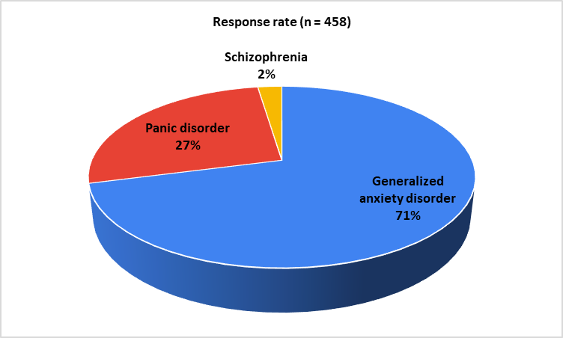
Table 1: Distribution of responses on the patient subset preferring escitalopram in clinical practice
Patient subset preferring escitalopram | Response rate (n = 458)
Major depressive disorder | 73.14%
Seasonal affective disorder | 3.06%
Persistent depressive disorder | 6.11%
Post-traumatic stress disorder | 0.87%
All of the above | 16.81%

Fig. 2: Distribution of responses on the most preferred molecule as first-line treatment for managing depression
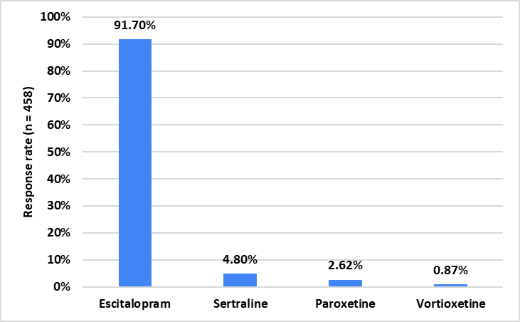
Around 50% of experts reported using escitalopram in 26–50% of their patients with depression. Approximately 58% observed the maximum response to escitalopram within 6–8 weeks of treatment. About 38% of experts identified paroxetine as the SSRI most commonly associated with withdrawal symptoms, even after dose tapering. Around 41% of participants reported that escitalopram is the preferred antidepressant for managing insomnia in patients with depression. Approximately 52% stated that escitalopram provides better outcomes for the anxiety component in 26–50% of patients with mixed anxiety and depression. Around 60% of respondents preferred escitalopram as the first-choice antidepressant for social anxiety disorder (Fig. 3).
Fig. 3: Distribution of responses on preferred first–choice antidepressants for social anxiety disorder
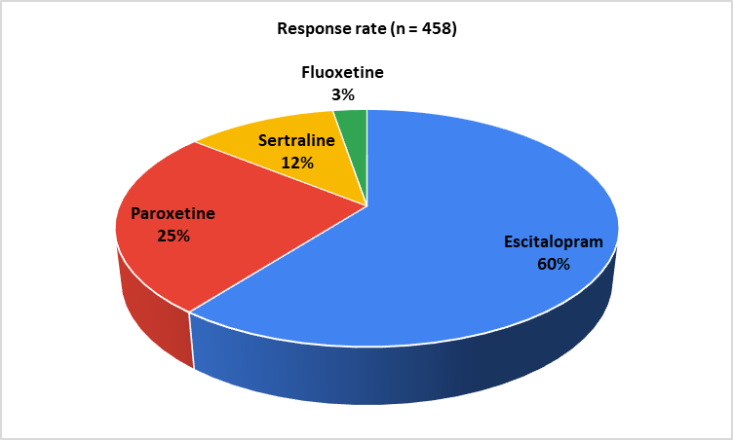
About 33% of participants reported that escitalopram is preferred in 11–25% of patients with OCD. Around 62% of participants stated that they rarely encountered serotonin syndrome with SSRI use in clinical practice. Approximately 43% reported observing episodes of mania or hypomania in 3–5% of patients with depression treated with SSRIs. Dry mouth was cited as the most commonly observed adverse event with SSRIs by 31% of participants, followed by gastrointestinal (GI) problems reported by 29% (Figure 4). Around 78% of experts preferred escitalopram for patients with GAD who experienced increased sedation and dry mouth with paroxetine (Table 2). Approximately 71% chose escitalopram for patients with severe depression and a history of suicidal attempts (Table 3).
Fig. 4: Distribution of responses on the most commonly observed adverse events with SSRI in clinical settings
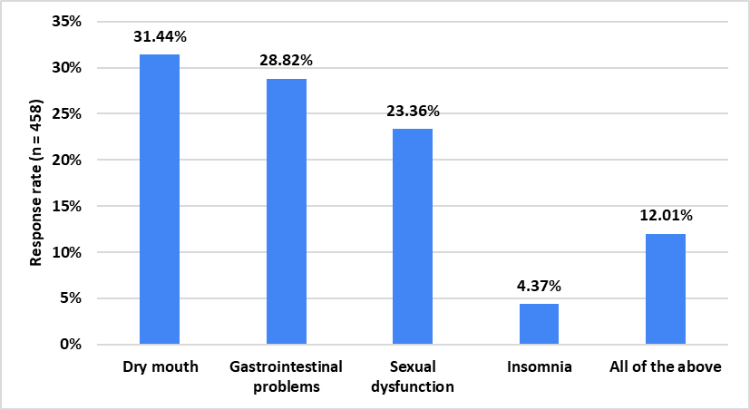
Table 2: Distribution of responses on the preferred drug choice for patients with GAD experiencing increased sedation and dry mouth with paroxetine
Preferred drug choice for GAD patients experiencing increased sedation and dry mouth with paroxetine | Response rate (n = 458)
Sertraline | 16.81%
Fluoxetine | 5.02%
Escitalopram | 78.17%

Table 3: Distribution of responses on the preferred drug choice for severe depression with suicidal attempt
Preferred drug choice for severe depression with suicidal attempt | Response rate (n = 458)
Escitalopram | 70.74%
Mirtazapine | 13.54%
Vortioxetine | 6.55%
Sertraline | 9.17%

According to 40% of participants, escitalopram is preferred in 10% of patients with severe depression during pregnancy. Approximately 47% of experts indicated that escitalopram is the first-choice antidepressant in 26–50% of patients with comorbid physical illness and secondary depression. Similarly, 46% reported that escitalopram is used in 26–50% of patients presenting with somatic symptoms and depression. Around 74% of participants preferred escitalopram for the treatment of post-psychotic depression (Table 4). Additionally, 46% of participants reported that 11–20% of patients adhere to both medication and counselling.
Table 4: Distribution of responses on the choice of drug for post psychotic depression
Choice of drug for post psychotic depression | Response rate (n = 458)
Escitalopram | 73.58%
Vortioxetine | 3.93%
Sertraline | 11.14%
Mirtazapine | 11.35%

4. discussion

The study findings highlight the widespread adoption and acceptance of escitalopram as a first-line SSRI across multiple depressive and anxiety-related conditions. Clinical preferences appear to be driven by their tolerability, efficacy, and patient adherence in diverse presentations, including somatic symptoms, suicidality, and comorbidities. Escitalopram is commonly prescribed across diverse patient presentations, including those with prominent somatic symptoms, suicidality, and multiple psychiatric or physical comorbidities. Evidence from previous studies supports these observations. Consistent with these findings, Eiji Kirino demonstrated that escitalopram is effective in treating both MDD and anxiety disorders, with notable improvements in symptom severity and quality of life [7].
The majority of experts identified GAD as the most common psychiatric comorbidity in patients diagnosed with depression. This is consistent with findings from previous studies. Zhou et al. reported that 71.7% of patients with MDD had comorbid GAD [8]. Similarly, Wang et al. observed that the comorbidity rate of MDD with any anxiety disorder ranges from 45.7% to 75.0%, highlighting the substantial overlap between depressive and anxiety disorders [9].
Most respondents identified escitalopram as their preferred first-line treatment for managing depression. It was also commonly selected as the first-choice antidepressant for social anxiety disorder. Supporting this clinical preference, Yin et al. reported that escitalopram is a suitable first-line option for moderate to severe MDD, outperforming other antidepressants during the acute treatment phase in terms of efficacy, acceptability, and tolerability [10]. Similarly, Kirino demonstrated that escitalopram showed superior patient acceptability compared to other newer antidepressants, based on findings from both a meta-analysis and a pooled analysis. These results point to greater treatment continuity and adherence with escitalopram in real-world clinical settings [11]. Kasper et al. also found escitalopram to be both effective and well tolerated in the treatment of generalized social anxiety disorder [12].
Many clinicians reported dry mouth as the most commonly observed adverse event associated with SSRIs. A meta-analysis by Cappetta et al. found that approximately 22% of patients receiving SSRIs experience dry mouth as a treatment-emergent side effect [13]. Similarly, Teoh et al. reported that SSRIs commonly cause dry mouth, although it is generally less severe than that observed with tricyclic antidepressants (TCAs). Dry mouth is among the most frequently reported side effects, affecting more than 10% of patients receiving SSRIs such as citalopram [14].
Many experts preferred escitalopram for patients with GAD, particularly those who experience bothersome side effects such as sedation and dry mouth with paroxetine. Paroxetine, known for its anticholinergic properties, is commonly associated with these adverse effects, which are less frequently observed with escitalopram. Supporting this clinical preference, Baldwin et al. found that escitalopram 10 mg was more efficacious than paroxetine 20 mg and was associated with fewer adverse events leading to treatment discontinuation [15]. Similarly, Bielski et al. reported that escitalopram demonstrated significantly better tolerability, reflected by a lower withdrawal rate due to adverse events and a generally more favorable side effect profile. These findings suggest that escitalopram may be a more acceptable option for the long-term management of anxiety symptoms [16].
The majority of participants in the current study preferred escitalopram for the treatment of severe depression, particularly in patients with a history of suicidal attempts. Study findings also supported its use in managing post-psychotic depression, aligning with existing evidence on its role in reducing suicidality in depressive disorders. Perroud et al. observed that while suicidal ideation tends to increase with the severity of depression, it generally decreases during antidepressant therapy. Notably, among men, escitalopram was associated with a lower risk of suicidal ideation compared to nortriptyline [17]. Gersel Pedersen reported that escitalopram was significantly more effective than placebo in reducing suicidal thoughts from week 1 to week 8 in patients undergoing treatment for MDD [18]. Furthermore, a meta-analysis by Yin et al. highlighted the superior efficacy, acceptability, and tolerability of escitalopram over other antidepressants in the acute-phase treatment of MDD [10].
This study has several strengths, including a large sample size of 458 healthcare practitioners, enhancing statistical power and generalizability across clinical settings. Its broad coverage of psychiatric conditions, such as MDD, GAD, and comorbidities, offers valuable insights into real-world SSRI use. By addressing prescribing preferences, treatment outcomes, adverse events, and specific clinical scenarios like pregnancy and suicidality, the study reflects key decision-making challenges in practice. However, reliance on self-reported data introduces recall bias, and the lack of longitudinal follow-up limits assessment of long-term efficacy and safety. Additionally, unclear demographic representation, absence of patient-reported outcomes, and omission of factors like dosing and treatment duration may restrict the applicability and depth of the findings. While the study provides valuable insights into contemporary prescribing practices and clinical decision-making, future research should incorporate longitudinal patient outcomes, objective efficacy measures, and diverse demographic representation to strengthen evidence-based treatment recommendations and optimize psychiatric care delivery in real-world clinical settings.
4. Conclusion

This study reveals escitalopram’s dominant position as the preferred first-line antidepressant across various psychiatric conditions, with the majority of practitioners favoring it for depression management. The findings highlight significant clinical consensus on SSRI efficacy patterns, common adverse events, and treatment preferences in complex scenarios.

COMPETING INTERESTS DISCLAIMER:
Authors have declared that they have no known competing financial interests OR non-financial interests OR personal relationships that could have appeared to influence the work reported in this paper.

References

- Mental disorders. World Health Organization. Available from: https://www.who.int/news-room/fact-sheets/detail/mental-disorders [cited 2025 Jun 11]
- GBD 2019 Mental Disorders Collaborators. Global, regional, and national burden of 12 mental disorders in 204 countries and territories, 1990-2019: a systematic analysis for the Global Burden of Disease Study 2019. Lancet Psychiatry. 2022 Feb;9(2):137-150.
- Sharma SK, Joseph J, Varkey BP, Dhandapani M, Varghese A, Sharma S, et al. Prevalence of anxiety and depressive symptoms during COVID-19 pandemic among the general population in India: A systematic review and meta-analysis. J Neurosci Rural Pract. 2022 Dec 16;13(4):608–17.
- Pelissolo A. Efficacité et tolérance de l'escitalopram dans les troubles anxieux: revue de la littérature [Efficacy and tolerability of escitalopram in anxiety disorders: a review]. Encephale. 2008 Sep;34(4):400-8. French.
- Landy K, Rosani A, Estevez R. Escitalopram. [Updated 2023 Nov 10]. In: StatPearls [Internet]. Treasure Island (FL): StatPearls Publishing; 2025 Jan-. Available from: https://www.ncbi.nlm.nih.gov/books/NBK557734/
- Owens MJ, Knight DL, Nemeroff CB. Second-generation SSRIs: human monoamine transporter binding profile of escitalopram and R-fluoxetine. Biol Psychiatry. 2001 Sep 1;50(5):345-50.
- Kirino E. Antidepressant Efficacy of Escitalopram in Major Depressive Disorder. In: López-Muñoz F, Srinivasan V, de Berardis D, Álamo C, Kato T. (eds) Melatonin, Neuroprotective Agents and Antidepressant Therapy. 2016. Springer, New Delhi.
- Zhou Y, Cao Z, Yang M, Xi X, Guo Y, Fang M, et al. Comorbid generalized anxiety disorder and its association with quality of life in patients with major depressive disorder. Sci Rep. 2017 Jan 18;7:40511.
- Wang X, Lin J, Liu Q, Lv X, Wang G, Wei J, et al. Major depressive disorder comorbid with general anxiety disorder: Associations among neuroticism, adult stress, and the inflammatory index. Journal of Psychiatric Research. 2022 Apr 1;148:307–14.
- Yin J, Song X, Wang C, Lin X, Miao M. Escitalopram versus other antidepressive agents for major depressive disorder: a systematic review and meta-analysis. BMC Psychiatry. 2023 Nov 24;23(1):876.
- Kirino E. Escitalopram for the management of major depressive disorder: a review of its efficacy, safety, and patient acceptability. Patient Prefer Adherence. 2012;6:853-61.
- Kasper S, Stein DJ, Loft H, Nil R. Escitalopram in the treatment of social anxiety disorder: Randomised, placebo-controlled, flexible-dosage study. Br J Psychiatry. 2005;186(3):222-226.
- Cappetta K, Beyer C, Johnson JA, Bloch MH. Meta-analysis: Risk of dry mouth with second generation antidepressants. Progress in Neuro-Psychopharmacology and Biological Psychiatry. 2018 Jun 8;84:282–93.
- Teoh CXW, Thng M, Lau S, Taing MW, Chaw SY, Siskind D, Kisely S. Dry mouth effects from drugs used for depression, anxiety, schizophrenia and bipolar mood disorder in adults: systematic review. BJPsych Open. 2023 Mar 20;9(2):e53.
- Baldwin DS, Huusom AK, Maehlum E. Escitalopram and paroxetine in the treatment of generalised anxiety disorder: randomised, placebo-controlled, double-blind study. Br J Psychiatry. 2006 Sep;189:264-72.
- Bielski RJ, Bose A, Chang CC. A double-blind comparison of escitalopram and paroxetine in the long-term treatment of generalized anxiety disorder. Ann Clin Psychiatry. 2005 Apr-Jun;17(2):65-9.
- Perroud N, Uher R, Marusic A, Rietschel M, Mors O, Henigsberg N, et al. Suicidal ideation during treatment of depression with escitalopram and nortriptyline in genome-based therapeutic drugs for depression (GENDEP): a clinical trial. BMC Med. 2009 Oct 15;7:60.
- Pedersen AG. Escitalopram and suicidality in adult depression and anxiety. Int Clin Psychopharmacol. 2005 May;20(3):139-43.

