**Original Research Article**

**Study on the transition of defense mechanisms from a healthy frame of mind to a depressed outlook on life.**

**ABSTRACT**

**Aims:** This study examines changes in various defense mechanisms as individuals transition from a healthy state of mind to a depressed state, as well as the prevalence of different defense mechanisms.

**Study Design:** Hospital- and Community-Based Cross-Sectional Study

**Place and Duration of the Study:** Department of psychiatry of Late Shri Lakhiram Agrawal Memorial Government Medical College, Raigarh & various institutes of Raigarh and community homes of Raigarh, Chhattisgarh, from June 1, 2022, to April 30, 2023

**Methodology:** We enrolled 184 subjects clinically diagnosed with depression and 1036 subjects from the general population. The Hamilton Depression Rating Scale and Defense Style Questionnaire 40 were used to collect data. The collected data was analysed using SPSS software, and appropriate parametric tests were applied to assess the reliability of the data.

**Results: Findings** indicate that the prevalence of defense mechanisms such as undoing, idealization, reaction formation, isolation, displacement, somatization, denial, projection, passive-aggression, devaluation, and autistic fantasy increased with heightened levels of depression severity measured by the Depression Rating Scale. Conversely, humour and sublimation were observed to diminish as depression severity intensified. Additionally, mechanisms like dissociation, splitting, acting out, anticipation, suppression, pseudo-altruism, and rationalization exhibited no significant variation. Furthermore, no substantial correlations between personality traits and depression were identified

**Conclusion:** This study suggests focusing on or preventing defective defensive mechanisms and evaluating patient prognosis in individuals with clinical or subclinical depression. These findings may assist in integrating novel therapeutic modalities into cognitive behavioural therapy.

**1. INTRODUCTION**

Mood can be defined as a central theme of the mind through which we perceive the world. A positive mood can enhance our ability to cope with even the most challenging situations, while a negative self-perception can lead to significant adverse effects even in relatively simple circumstances. [1] Depression, although not an incurable disease, continues to have a rising prevalence in today's complex society and is often inadvertently stigmatized. [2]

Defense mechanisms, functioning as a component of the "ego," play a pivotal role in preserving positive mood during stressful situations and maintaining mental clarity. However, certain defense mechanisms may have adverse effects, potentially resulting in prolonged depressive states. (3)

Although there is still no official data on depression prevalence in our state, two parallel reports published concurrently have drawn significant attention. The first report, issued by AIIMS State Capital, highlights an 11.2% prevalence of mental health morbidity within our state, a 2.2% suicide risk, and notes that 32.40% of psychoactive substance abusers (primarily tobacco and alcohol) are clinically depressed. [4] Additionally, fewer than 50% of districts are covered under the District Mental Health Programme (DMHP) of our state. The second report, published by AIIMS Delhi, claims that our state has the second-highest alcohol consumption rate across India. [5]

It is a well-established fact that certain defense mechanisms can contribute to the development of mental illnesses [3][6][7]. However, there is limited information available on how variations in defense mechanisms influence the progression of psychological diseases. The definitive treatment for depression is Cognitive Behavioral Therapy (CBT), which aims to alter the patient's perspective on life. We propose that targeted therapy focusing on correcting maladaptive “bad” defense mechanisms and promoting adaptive “good” ones could enhance the efficacy of current treatment approaches. Furthermore, if we can identify specific changes in defense mechanisms that predispose patients to clinically diagnosed depression, we may be able to prevent their progression towards advanced stages of the disease.

This study examines the transformation of various defense mechanisms as individuals transition from a healthy state of mind to a depressed state of mind. It also analyzes the prevalence of different defense mechanisms during this transition.

**2. MATERIAL AND METHODS:**

It was a cross-sectional study, done at Department of Psychiatry of our institute. The study began after receiving approval from the Institutional Ethical Committee. The study involved participants aged between 18 and 60 years who provided informed consent. The duration of the study was from June 1, 2022, to April 30, 2023. We are limiting data collection to college students to gather more information from non-diagnosed depressive and sub-depressive individuals.

The study was entirely questionnaire-based. It consisted of two parts: personal data collection and two sections of questions. Section 1 featured the Hamilton Depression Rating Scale (HDRS) with 17 questions and a maximum score of 56.[8] Section 2 used the Defense Style Questionnaire (DSQ-40) with 40 questions, each scored from 1 (strongly disagree) to 9 (strongly agree). [9] The tools' scoring and assessment methods were used.

A table was made to correlate HDRS and DSQ scores. The mean DSQ values for each HDRS score were calculated. A graph with HDRS scores on the X axis and DSQ scores on the Y axis was plotted after calculating the correlation for all subjects. The overall trend observed in the graph for each defense mechanism was recorded.

The questionnaire included a section for identity information to ensure data reliability and facilitate future contact with the subjects if necessary. This section was entirely separate from the main questionnaire, and patient identities were kept confidential, disclosed only to the research team.

Hypothesis for study: ***“Defense Mechanism varies across the spectrum of depression.”***

**3. RESULTS AND DISCUSSION**

The study involved 1220 subjects: 184 with depression, 244 medical students, 312 nursing students, 142 law students, 164-degree university students, and 174 residents from five city colonies. Data was collected via consent forms and interviews. The sample included 894 females and 326 males. Age distribution was: 826 aged 18-30, 186 aged 31-40, 136 aged 41-50, and 72 aged 51-60. Socioeconomic categorisation using the Modified Kuppuswamy Scale [10] showed: 184 lower class, 376 upper lower class, 430 lower middle class, 136 upper middle class, and 94 upper class. Females scored higher on the HDRS, likely because there were more female subjects. Similarly, the 18-30 age group had higher scores due to a larger number of participants in that range.

Correlation of HDRS with Mature Defense Mechanisms: Humour: The slope decreases significantly as depression severity increases. Sublimation: There is a noticeable decrease in slope with increased depression severity. Suppression and Anticipation: The graph remains stable with occasional declines.

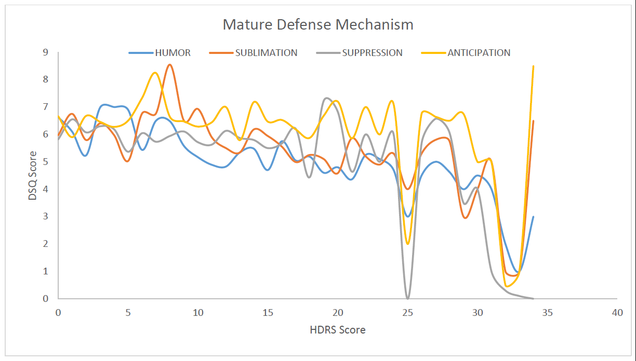

Figure 1: Correlation between HDRS Score and DSQ Score for Mature Defense Mechanism

Correlation of HDRS with Psychotic Defense Mechanism: Denial – The slope of the graph increases gradually throughout the curve.

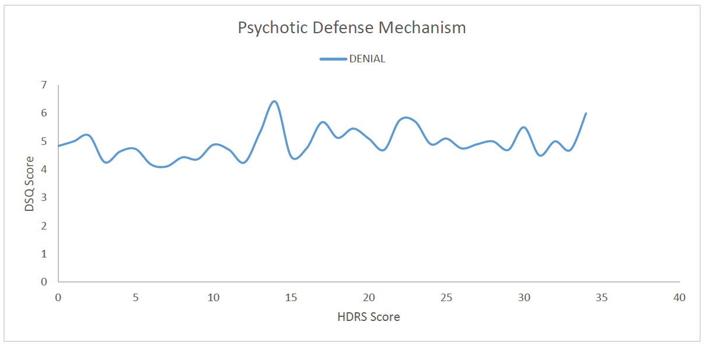Figure 2: Correlation between HDRS Score and DSQ Score for Psychotic Defense Mechanism

Correlation of HDRS with Neurotic Defense Mechanism: Undoing: Depression rises steadily on the HDRS scoring. Pseudo-altruism: Stable slope throughout the HDRS scoring. Idealisation and Reaction Formation: Steady dips and rises as depression increases on the HDRS scoring. Rationalization: Stable slope throughout the curve. Isolation and Displacement: Slope increases slightly throughout the curve. Somatization: Slope gradually increases throughout the curve.

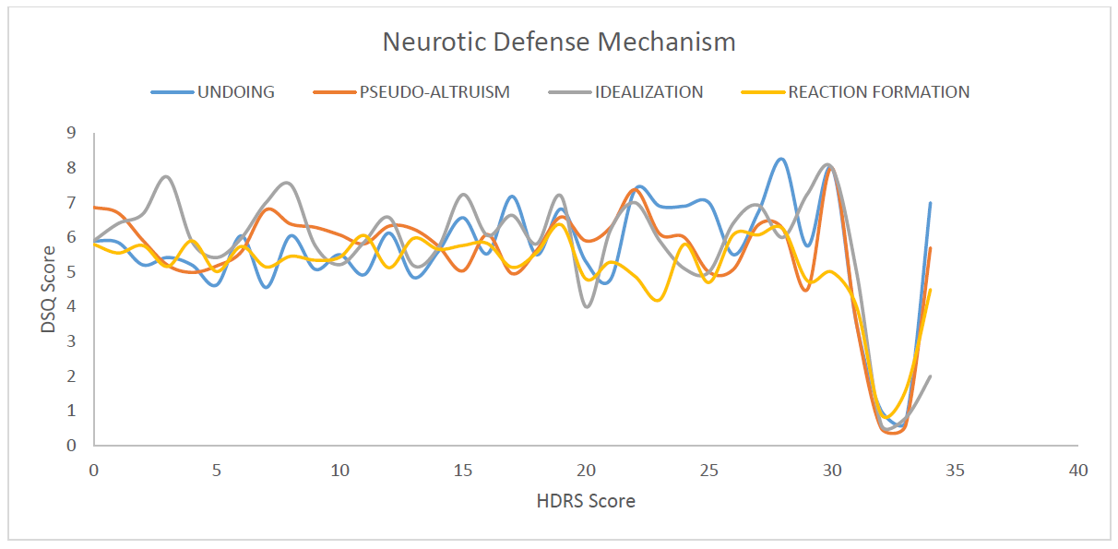

Figure 3. Correlation between HDRS Score and DSQ Score for Neurotic Defense Mechanism

F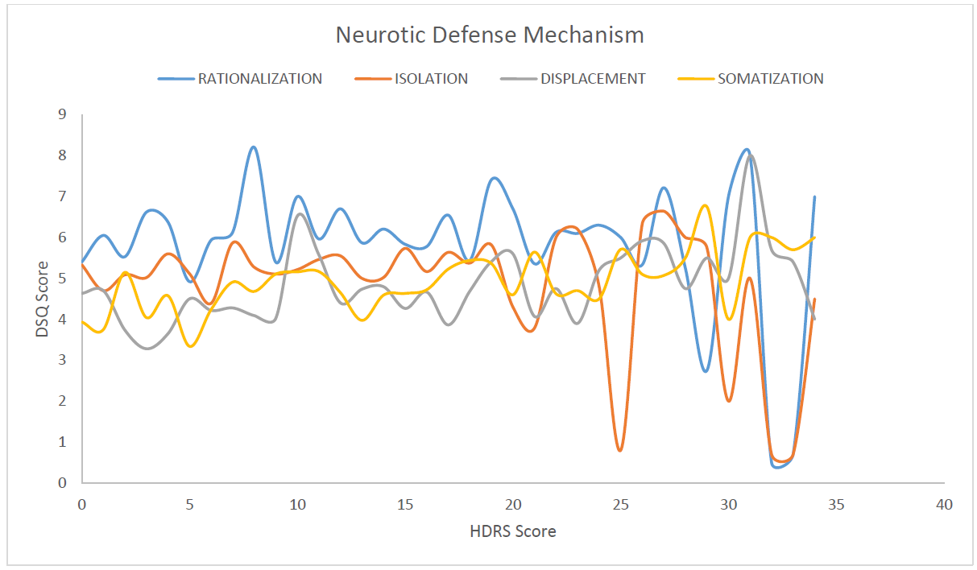igure 3(b): Correlation between HDRS Score and DSQ Score for Neurotic Defense Mechanism

Correlation of HDRS with Immature Defense Mechanisms: Projection: The slope initially rises, followed by a slight dip, and then increases to remain stable. Passive Aggression: The slope is initially stable, then rises and remains constant in the later phase of the curve. Autistic Fantasy: There is an initial steady increase in the slope, which subsequently stabilises. Devaluation: The slope of the graph increases steadily throughout the curve. Acting Out, Dissociation, and Splitting: The slope of the graph remains stable throughout the curve.

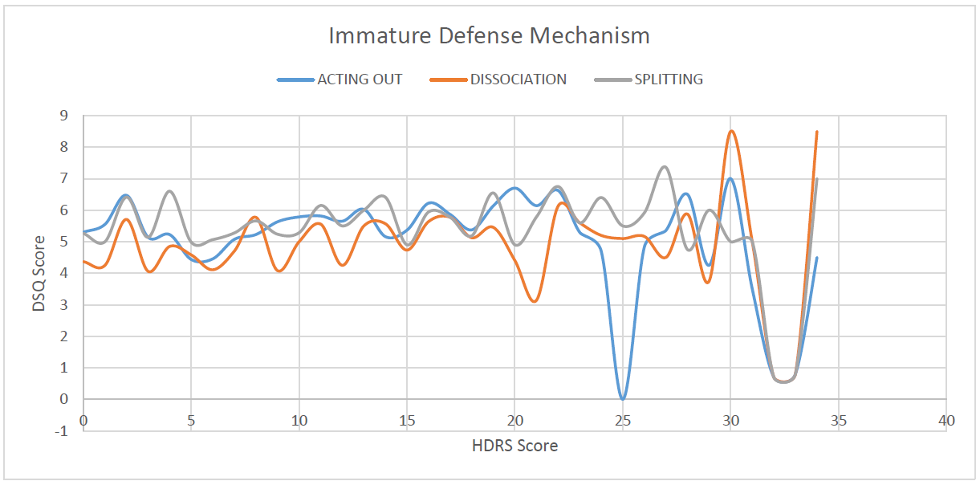Figure 4 Correlation between HDRS Score and DSQ Score for Immature Defense Mechanism

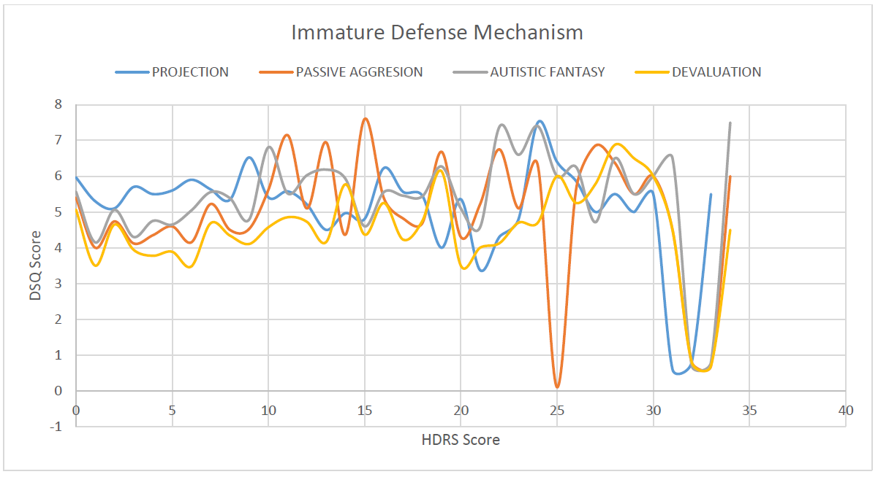Figure 5. Correlation between HDRS Score and DSQ Score for Immature Defense Mechanism

**Reliability of Data:** The chi-square test on data from 6 groups showed a p-value of <0.003, confirming the validity of our research data.

In our study, the defense mechanisms of undoing, idealization, reaction formation, isolation, displacement, somatization, denial, projection, passive aggression, devaluation, and autistic fantasy were observed to increase in correlation with the severity of depression. This conclusion was corroborated by the meta-analysis presented in Chapter 10: Defense Mechanisms in Depressed Patients, Psychodynamic Treatment of Depression, 2nd edition. [11] No other studies with the same objectives were identified.

In our study, we observed that as the severity of depression increased, the use of certain Neurotic, Psychotic, and Immature defense mechanisms also increased, while some remained constant. None of these mechanisms appeared to decrease. Similar conclusions were drawn in cohort studies on patients recovering from depression conducted by K. Akkerman et al. [12][13], Yves de Rotan [14], and Michael Bond. [15] Mature defence mechanisms decreased or remained stable as depression severity increased, which was expected.

The study suggests that assessing defence mechanisms can aid in treatment planning, identify the severity of depression, screen individuals prone to depression, and infer treatment prognosis. Bond et al. [16] support this hypothesis.

**4. CONCLUSION:**

* We observed that the use of defense mechanisms such as Undoing, Idealization, Reaction Formation, Isolation, Displacement, Somatization, Denial, Projection, Passive-Aggression, Devaluation, and Autistic Fantasy increased with the severity of depression as measured by the Depression Rating Scale. The presence and development of these mechanisms in individuals may indicate a higher susceptibility to developing depression and potentially poorer prognostic outcomes. These can be categorized as "maladaptive" defense mechanisms for depression.
* Conversely, Humour and Sublimation were found to decrease with increased severity of depression according to the Depression Rating Scale. A reduction in these mechanisms may suggest a greater risk of developing depression. These mechanisms can be classified as "adaptive" defense mechanisms against depression.
* There was no significant change observed in the employment of Dissociation, Splitting, Acting-Out, Anticipation, Suppression, Pseudo-Altruism, and Rationalization across the depression rating scale.
* The methodology employed in our study demonstrated significant reliability and can be utilized in future research exploring the relationship between ego defense mechanisms and various other mental health disorders.
* Data collection from older age groups (age > 40 years) was limited due to a lack of consent from participants. This highlights an issue of unwillingness and insufficient awareness about depression among this demographic.

Consent

Informed consent was taken from each and every participant.

Ethical approval

Institutiona Ethical Committee, Late Shri Lakhiram Agrawal Memorial Government Medical College Raigarh, C.G. clearance was obtained on 05/07/2022 vide latter number S.No./ Med./ Ethics Commi./ 2022/ 219

COMPETING INTERESTS DISCLAIMER:

Authors have declared that they have no known competing financial interests OR non-financial interests OR personal relationships that could have appeared to influence the work reported in this paper.

**REFERENCE:**

1. Stringaris A, Goodman R. Mood lability and psychopathology in youth. Psychological Medicine. 2008 Dec 11;39(8):1237–45.
2. Grover S, Dutt A, Avasthi A. An overview of Indian research in depression. Indian Journal of Psychiatry [Internet]. 2010;52(7):178. Available from: <https://www.ncbi.nlm.nih.gov/pmc/articles/PMC3146226/>
3. Waqas A, Rehman A, Malik A, Muhammad U, Khan S, Mahmood N. Association of Ego Defense Mechanisms with Academic Performance, Anxiety and Depression in Medical Students: A Mixed Methods Study. Cureus [Internet]. 2015 Sep 30;7(9). Available from: <https://www.ncbi.nlm.nih.gov/pmc/articles/PMC4627837/>
4. Key Outcomes, National Medical Health Survey http://indianmhs.nimhans.ac.in/Docs/statereports/chhattisgarh-NMHS-Report.pdf
5. Page 13, Magnitude of Substance Use in India, Available at: http://socialjustice.nic.in/writereaddata/UploadFile/Magnitude_Substance_Use_India_REPORT.pdf
6. CORRUBLE E, BRONNEC M, FALISSARD B, HARDY P. Defense styles in depressed suicide attempters. Psychiatry and Clinical Neurosciences. 2004 Jun;58(3):285–8.
7. SPINHOVEN P, KOOIMAN CG. Defense Style in Depressed and Anxious Psychiatric Outpatients: An Explorative Study. The Journal of Nervous & Mental Disease. 1997 Feb;185(2):87–94.
8. HAMILTON M. A rating scale for depression. J Neurol Neurosurg Psychiatry. 1960 Feb;23(1):56-62. doi: 10.1136/jnnp.23.1.56. PMID: 14399272; PMCID: PMC4953319
9. ANDREWS, GAVIN M.D.1; SINGH, MICHELLE B.Sc. (HONS)1; BOND, MICHAEL M.D.2 The Defence Style Questionnaire, The Journal of Nervous and Mental Disease: April 1993 - Volume 181 - Issue 4 - p 246-256
10. Wani RT. Socioeconomic status scales-modified Kuppuswamy and Udai Pareekh's scale updated for 2019. J Family Med Prim Care. 2019 Jun;8(6):1846-1849. doi: 10.4103/jfmpc.jfmpc_288_19. PMID: 31334143; PMCID: PMC6618222.
11. Available at: https://psychiatryonline.org/doi/10.1176/appi.books.9781615371013.fb10#u2015-10-29T131745134-0400d1e8215
12. Akkerman K, Carr V, Lewin T. Changes in ego defenses with recovery from depression. J Nerv Ment Dis. 1992;180(10):634-638. doi:10.1097/00005053-199210000-00004
13. Akkerman K, Lewin TJ, Carr VJ. Long-term changes in defense style among patients recovering from major depression. J Nerv Ment Dis. 1999;187(2):80-87. doi:10.1097/00005053-199902000-00003
14. de Roten Yves, Djillali Slimane, Crettaz von Roten Fabienne,et al. Defense Mechanisms and Treatment Response in Depressed Inpatients. Frontiers in Psychology, Volume 12, 2021. DOI=10.3389/fpsyg.2021.633939. ISSN=1664-1078 https://www.frontiersin.org/articles/10.3389/fpsyg.2021.633939
15. Bond M, Perry JC. Long-term changes in defense styles with psychodynamic psychotherapy for depressive, anxiety, and personality disorders. Am J Psychiatry. 2004;161(9):1665-1671. doi:10.1176/appi.ajp.161.9.1665
16. Bond, M. (2004). Empirical Studies of Defense Style: Relationships with Psychopathology and Change. Harvard Review of Psychiatry, 12(5), 263–278. https://doi.org/10.1080/10673220490886167