Case report

Costello Syndrome - Case report and review of literature

Abstract :
Costello syndrome is a rare genetic disorder that affects multiple organ systems. It is caused by mutations in the HRAS proto-oncogene. Individuals with this condition typically present with distinct coarse facial features, craniofacial abnormalities, macrocephaly, poor weight gain, developmental delays, short stature, and skeletal and cardiac anomalies. There is also an increased risk of tumor development, particularly rhabdomyosarcoma. This report presents a clinical case of a 13-year-old male diagnosed with Costello syndrome. Born from a consanguineous marriage and with a healthy sibling, the patient had developmental delays and intellectual disability. General examination revealed delayed speech and motor skills, short stature (ture (height of 120 cm)) low-set ears, and macrocephaly . Based on these clinical findings, a diagnosis of Costello syndrome was made. Genetic testing confirmed the diagnosis. A mutation in G12S in the HRAS gene was identified
The patient presented with an enlarged forehead (head circumference of 40.5 cm) and distinct facial dysmorphic features.
Clinical evaluation revealed developmental delays in both speech and motor functions, short stature (height of 120 cm), low-set ears, and a reduced head size consistent with microcephaly (head circumference of 49 cm).

Introduction:
Costello syndrome (CS), also known as facio-cutaneous-skeletal (FCS) syndrome (OMIM #218040), was first described by Dr. Jack Costello in 1977 [1]. This syndrome is characterized by developmental delays, cognitive impairment, and intellectual disability, with various congenital abnormalities. Globally, between 300 to 400 cases have been documented, with an estimated prevalence ranging from 1 in 300,000 to 1 in 1.25 million individuals [2].
Common clinical features include a coarse face, short neck, hyperpigmented skin, sparse curly hair, and neurological, dermatological, and most importantly, cardiovascular malformations, such as congenital heart disease, arrhythmias, and hypertrophic cardiomyopathy. Difficulty in feeding during infancy, and an increased predilection of tumors such as nasal papillomas are also seen.[2]
Several oral manifestations can occur in these cases. A case of Costello syndrome with such oral manifestations is reported herewith.

Presentation of the Case:

History :
A 13 -year-old boy reported to the Department of Oral Medicine and Radiology with a chief complaint of tooth pain for the past 2 months.
The child was born during the 7th month of pregnancy by C-section delivery in the hospital (40 days). Birth weight was 3.5 kg.The child was kept in incubator for 2 weeks.H/o neonatal seizure disorder after birth.H/o of delayed speech and motor milestones, behaviors like temper tantrums, self inflicting injuries present. The child recognises family members and expresses his needs through gestures. Genetic testing was performed during the first year of life, and Costello syndrome was confirmed.
The parents were alive and apparently healthy. Parental consanguinity was present. The patient has a normal younger sibling. The mother had low blood pressure during pregnancy.

Clinical examination:
The patient exhibited a dysmorphic face with an increased forehead circumference (HC=40.5). The patient was of short stature. His height and weight were 92 cm and 24 kg, respectively. He remained below the 3rd percentile for height and weight. Extraoral examination revealed macrocephaly, sparse hair and eyebrows, eyes with epicanthal folds, a short bulbous nose, low-set ears, loose wrinkled skin with hyperextensible fingers, and an inguinal hernia. Heart auscultation findings were normal. Dental findings included (large mouth, thick lips,hypomineralized enamel,macroglossia) and multiple papillomas of the neck.

Discussion :
Costello described Costello syndrome in 1971. Mutation in the HRAS gene is responsible for this syndrome. Diagnosis is mainly based on clinical findings. The average age of diagnosis is 4.2 years [3] The cause of this syndrome is linked to polyhydramnios (90%) older parents (62%), macrosomia (50%) early birth (50%) and, less commonly, fetal tachyarrhythmia[6]

RASopathy syndromes are a group of rare disorders caused by mutations in specific genes that produce proteins involved in the Ras/MAPK cell signaling pathway. Numerous cell processes, including cell growth, maturation, and cell death, are regulated by this pathway. [5]
RASopathy syndromes include Neurofibromatosis type 1 (NF1), Legius syndrome, Costello and cardio-facio-cutaneous (CFC) syndromes, Noonan syndrome, and LEOPARD syndrome. [5]
Costello syndrome is one of the rarest RASopathies, affecting one in every 300,000 births. It shares many overlapping characteristics with other RASopathy syndromes.[6]
Costello syndrome occurs due to different mutations in the HRAS gene, with the G12S mutation being the most frequently identified, followed by the G12A variant.
These mutations increase RAS/MAPK signaling by the constitutive activation of HRAS. Siblings are rarely impacted as in the case of our patient, because the majority of these mutations are de novo, though reports of gonad mosaicism in fathers have been recorded.[6]
Clinical features typically begin in infancy, while most patients fail to thrive. Patient suffers from cognitive impairment, musculoskeletal ,ectodermal and ocular abnormalities. Coarse facial features ,Low muscle tone,poor weight gain was also evident .[6] Our patient exhibited several of these typical features, such as short stature, macrocephaly, epicanthal folds, low-set ears, and a short nose.
Individuals with Costello syndrome often develop cardiac malformations, such as hypertrophic cardiomyopathy and arrhythmia.
There is also a significantly increased risk of developing cancer. Our patient had multiple neck papillomas, which aligns with the finding that more than 70% of these patients have papillomas. Interestingly, this particular neoplasm is not seen in other RASopathies, along with other dermatological features such as deep folds with loose wrinkled skin, which provides a clue in establishing the diagnosis. Up to 20% of affected individuals may develop malignant tumors, including neuroblastoma, transitional cell carcinoma, and rhabdomyosarcoma. [6]
The prognosis depends on by the severity of cardiac involvement and the development of tumors, especially rhabdomyosarcoma and neuroblastoma[3]
Costello Syndrome: Oral and Dental Manifestations
Patients with CS often experience some of the most severe dental and oral issues among individuals with other RASopathies[4]. Our patient had several notable oral and dental findings consistent with Costello syndrome. Specifically,the patient exhibited a large mouth, thick lips, and macroglossia. The presence of macroglossia and a high-arched narrow palate can cause difficulties in speech and feeding and contribute to airway obstruction, which can cause obstructive sleep apnea. A significant majority (93%) of these patients exhibited delayed tooth development and eruption. Gingival hypertrophy is also common (Hart et al., 2002) which was absent in this case.[4]
According to Goodwin et al. (2014), individuals with CS typically have an anterior open bite with a posterior crossbite, as in the case of our patient. This is often attributed to oral habits, such as an open-mouth posture and severe teeth grinding (bruxism). Additionally, a high percentage of patients (37%) are prone to Class III malocclusion (Goodwin, Oberoi, et al., 2014). Our patient had hypomineralized enamel, which supports the findings of Goodwin et al., who described that almost all individuals with CS have an enamel defect that appears as demineralized white localized lesions, increasing susceptibility to abrasion and caries. Our patient presented with a chief complaint of tooth pain due to caries, for which restorative treatment was subsequently performed. This highlights the importance of meticulous oral hygiene and increased fluoride therapy to reduce the risk of dental caries in these patients. Supernumerary teeth, hypodontia, increased dental crowding, and abnormal tooth morphology are generally absent, although microdontia has been reported. (Takahashi & Ohashi, 2013), which was not observed in the present case.[4]
Regular dental examinations by a pediatric or general dentist are crucial for managing patients with CS. While our patient was co-operative during the procedure, many patients require anesthesia for dental procedures.[4]
Early guidance for parents regarding the risk of delayed tooth development and eruption is recommended. In cases of bruxism, a customized mouthguard may be used. Early orthodontic intervention is advisable especially for Class III malocclusion.[4]

CONCLUSION
Costello syndrome is a rare inherited condition caused by mutations in the HRAS gene.
Because HRAS expression is widespread, CS is a complex condition that affects several organ systems and predisposes individuals to cancer. Similar to those with other RASopathies, patients with CS exhibit unique craniofacial characteristics, growth and developmental delays, cardiac abnormalities, and neurological, orthopedic, ophthalmic, and dermatological problems. Expert evaluation and ongoing follow-up using a routine multidisciplinary approach are crucial for patients. [4]

Consent :
As per international or university standards, the patient(s) written consent has been collected and preserved by the author(s).
Ethical approval:
It is not applicable.

REFERENCES :
1.Der Kaloustian VM, Moroz B, McIntosh N, Watters AK, Blaichman S. Costello syndrome. Am J Med Genet. 1991 Oct 1;41(1):69-73. doi: 10.1002/ajmg.1320410118. PMID: 1951465.
2.Vahedi L, et al. First Case Report of Costello Syndrome in the Azeri Turkish Population. Ann Med Health Sci Res. 2017; 7: 435-437
3.Hakim K, Boussaada R, Hamdi I, Msaad H. Cardiac events in Costello syndrome: One case and a review of the literature. J Saudi Heart Assoc. 2014 Apr;26(2):105-9. doi: 10.1016/j.jsha.2013.11.002. Epub 2013 Nov 13. PMID: 24719541; PMCID: PMC3978860.
4.Gripp KW, Morse LA, Axelrad M, Chatfield KC, Chidekel A, Dobyns W, Doyle D, Kerr B, Lin AE, Schwartz DD, Sibbles BJ, Siegel D, Shankar SP, Stevenson DA, Thacker MM, Weaver KN, White SM, Rauen KA. Costello syndrome: Clinical phenotype, genotype, and management guidelines. Am J Med Genet A. 2019 Sep;179(9):1725-1744. doi: 10.1002/ajmg.a.61270. Epub 2019 Jun 20. PMID: 31222966; PMCID: PMC8238015
5. Rauen KA. Defining RASopathy. Dis Model Mech. 2022 Feb 1;15(2):dmm049344. doi: 10.1242/dmm.049344. Epub 2022 Feb 1. PMID: 35103797; PMCID: PMC8821523.
6.Quentin Riller, Frédéric Rieux-Laucat,RASopathies: From germline mutations to somatic and multigenic diseases,Biomedical Journal,Volume 44, Issue 4,2021,Pages422-432,ISSN 2319-4170.

Figures 1

1a)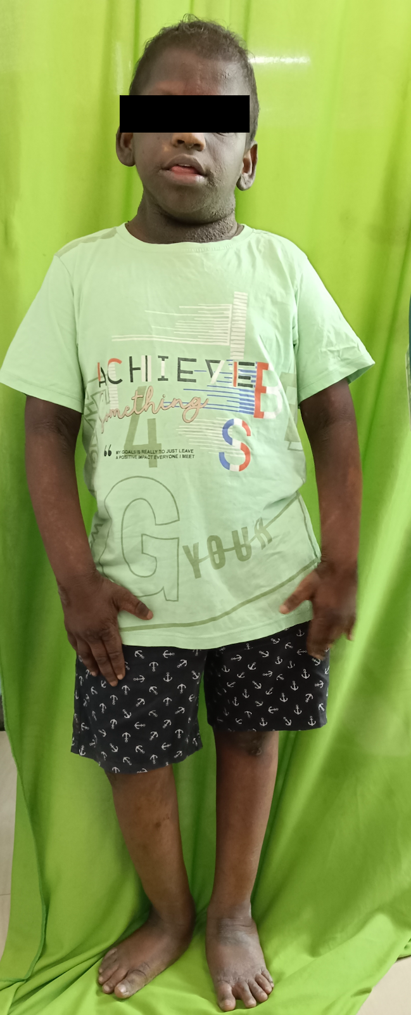
1b) 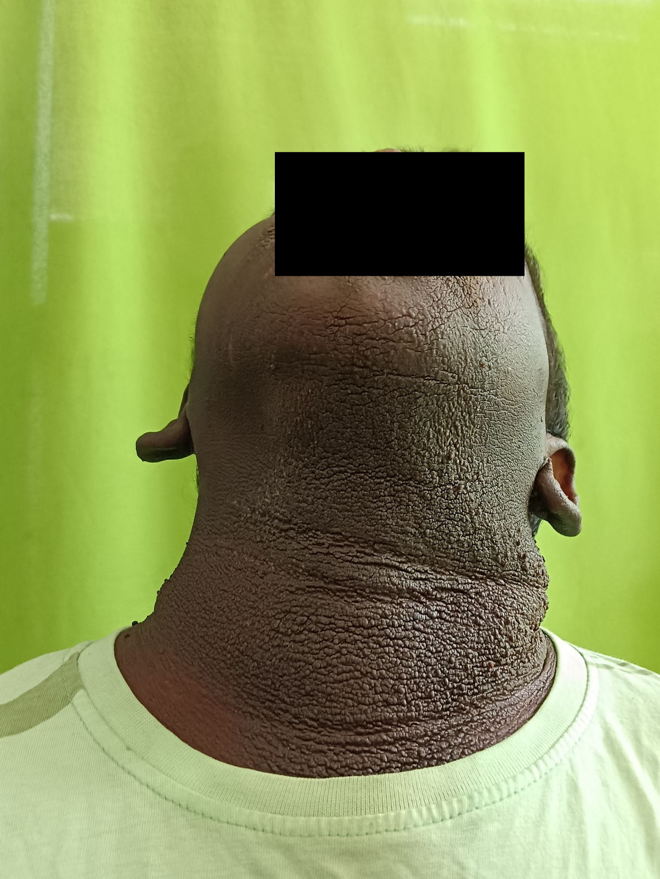

1c)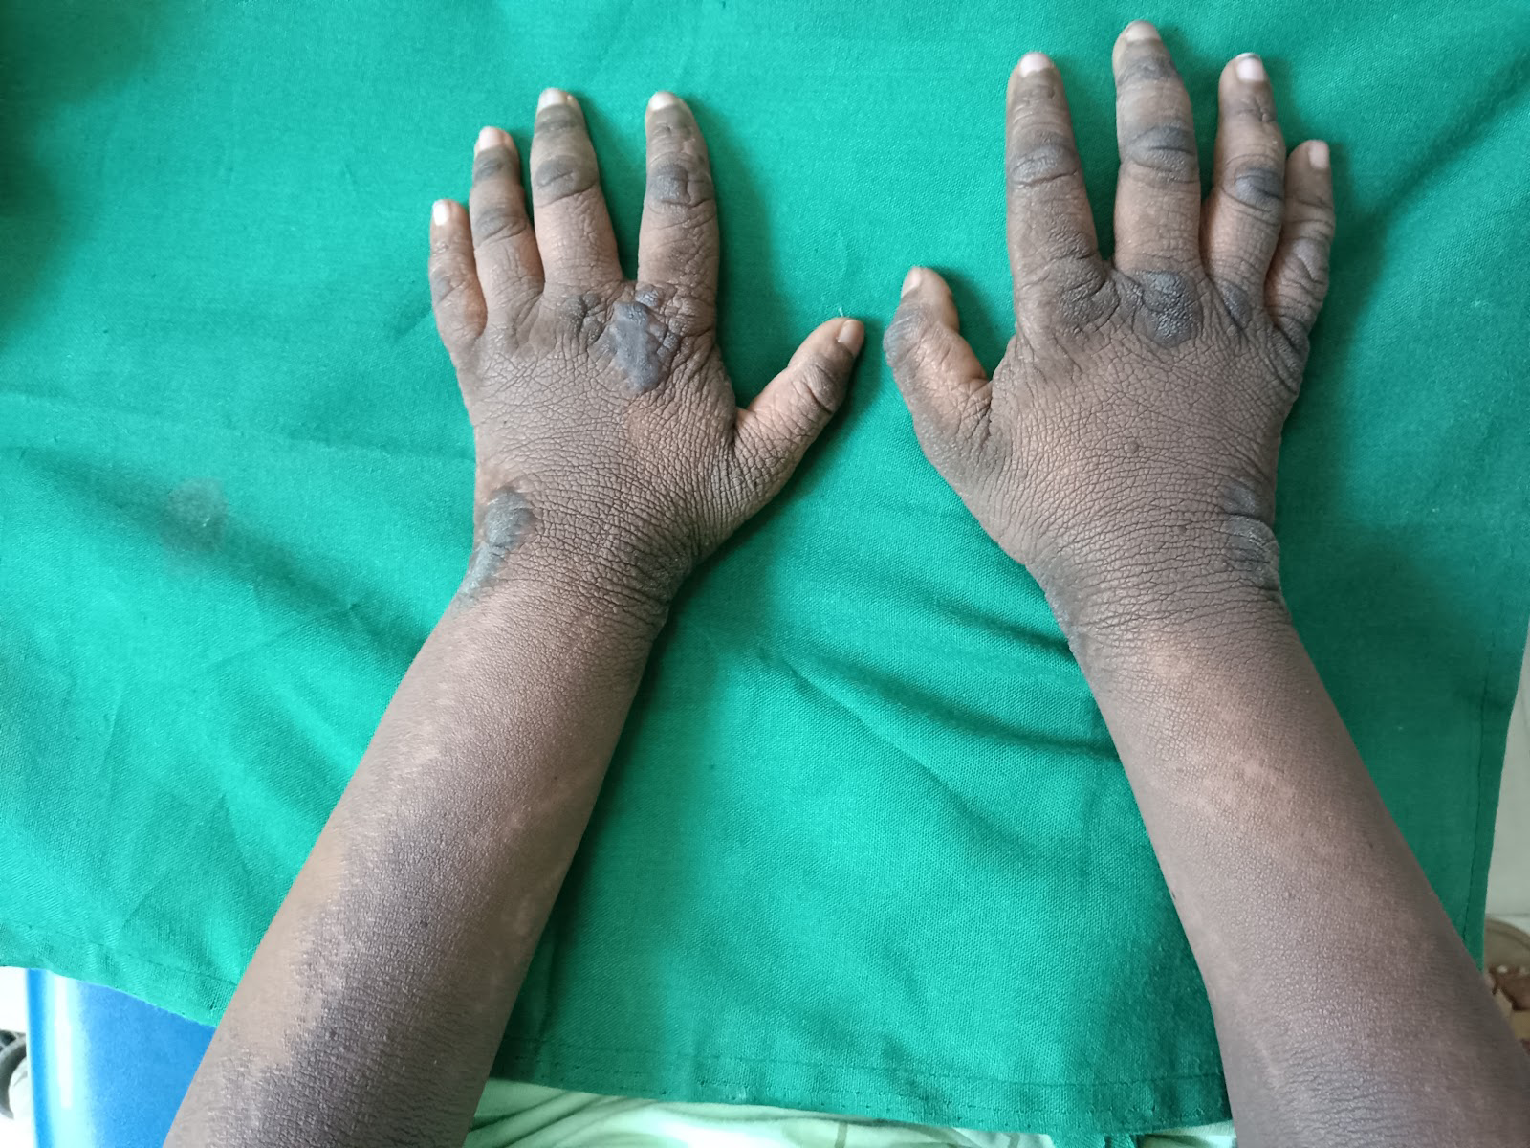
1d) 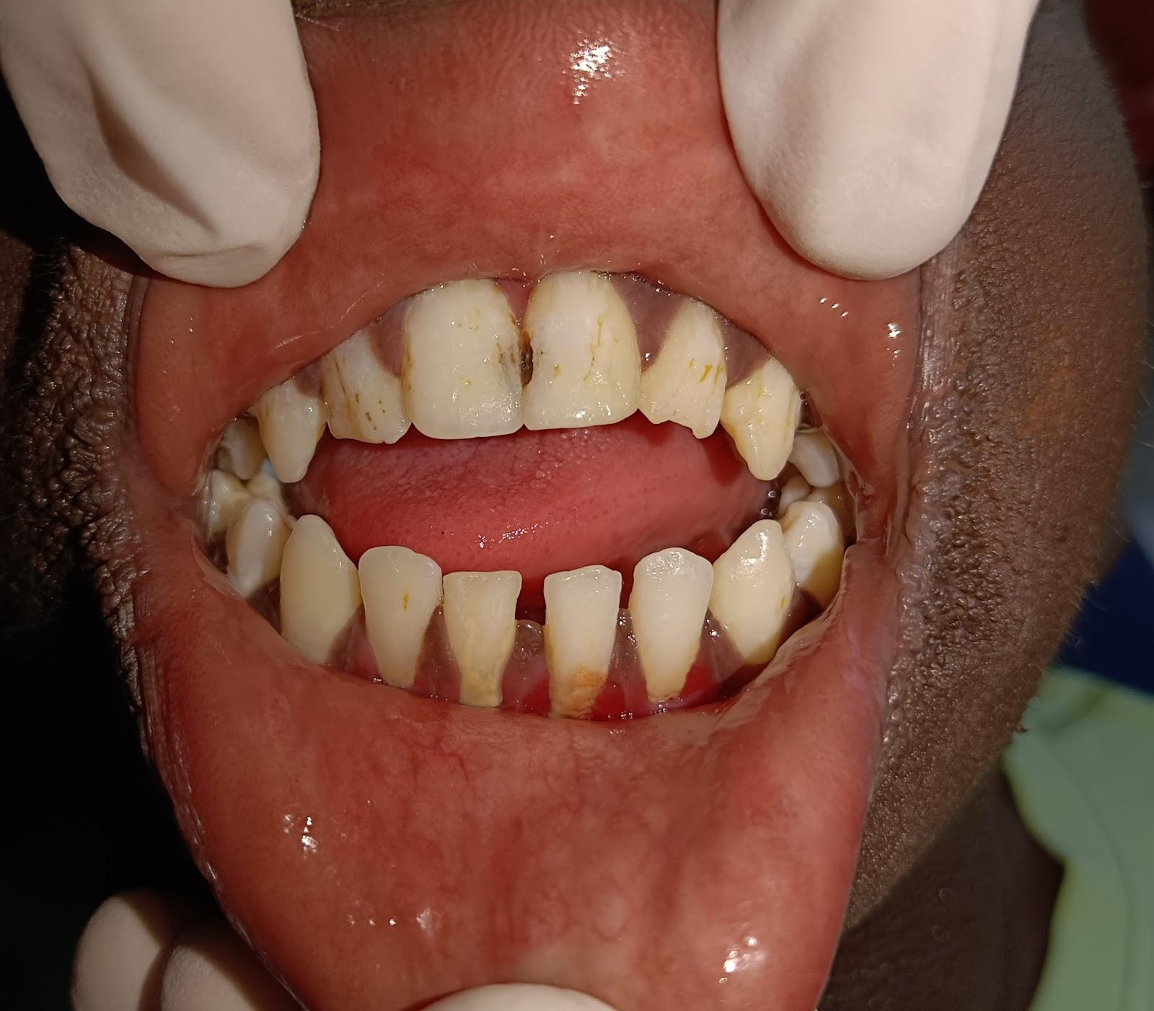

1e )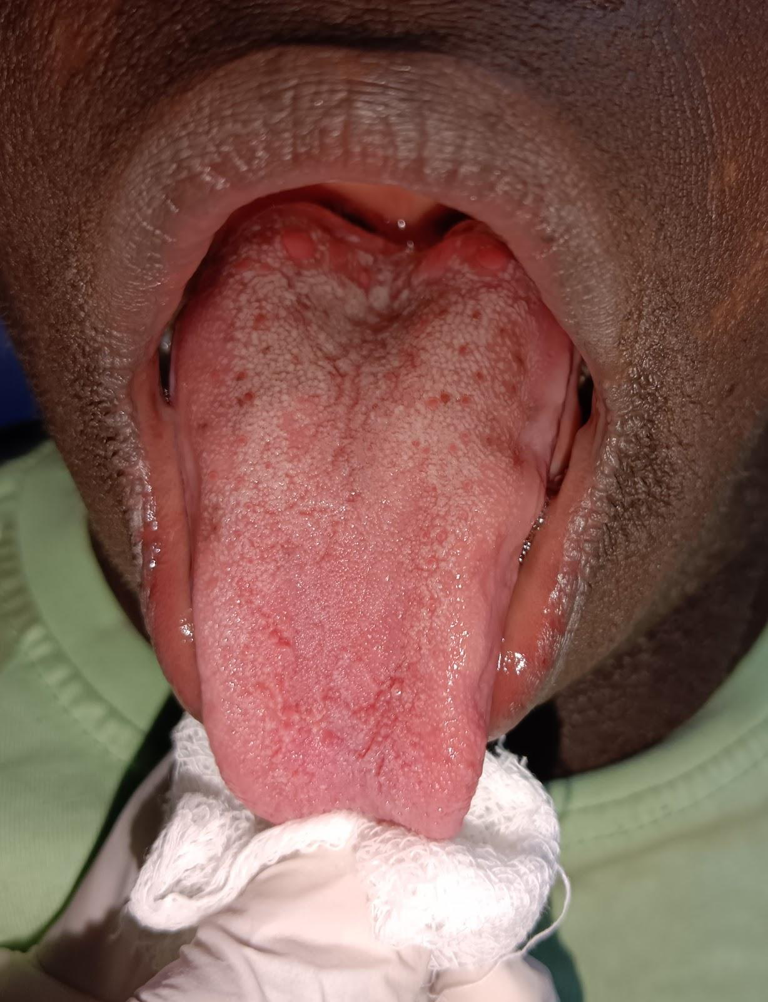

Figure 1 : a) Typical features of Costello syndrome like short stature,macrocephaly, dysmorphic facial features with sparse hair. Extraoral features like a large mouth with full lips. b) Multiple papillomas of the neck.c) Loose wrinkled skin with hyperextensible fingers. d) Anterior open bite and presence of Hypoplasia of enamel. e) Macroglossia

