Original Research Article

Genetic Diversity Analysis in Bread Wheat (*Triticum aestivum* L.) Using Mahalanobis D2 Statistics.

.

ABSTRACT

|  |
| --- |
| The present investigation was carried out to assess the genetic diversity among 48 genotypes of bread wheat (*Triticum aestivum* L.) using Mahalanobis D² statistics. The genotypes were evaluated under a randomized block design with two replications for ten quantitative traits at the farm of Wheat and Maize research Unit, Parbhani during *rabi* season 2023-24. Based on D² values, the genotypes were grouped into 11 distinct clusters, indicating the presence of substantial genetic variability. Cluster II included the maximum number of genotypes (17), followed by Cluster I with 15 genotypes and Cluster IV with 8 genotypes. The remaining clusters, namely Cluster III, Cluster V, Cluster VI, Cluster VII, Cluster VIII, Cluster IX, Cluster X, and Cluster XI, each comprised a single genotype. The maximum inter-cluster distance was observed between Cluster V and Cluster VII, indicating the genotypes in these clusters are genetically most diverse and could serve as ideal parents for hybridization programs aimed at exploiting heterosis or generating transgressive segregants. Cluster mean analysis revealed that Cluster VII recorded superior mean values for key traits such as grain yield per plant, 1000 grain weight and number of grains per spike, while Cluster III and Cluster VI had moderate performance for most characters. The traits contributing most to genetic divergence were number of grains per spike (20.17%), harvest index (15.68%), spike length (12.90%), and plant height (12.67%). The results suggest that genotypes from diverse clusters, particularly those showing high inter-cluster distances and superior trait performance, can be effectively used in crossing programs to improve yield and genetic variability in wheat. |

*Keywords: Bread wheat; genetic diversity; Mahalanobis D2; cluster analysis; Divergence*

1. INTRODUCTION

Wheat (*Triticum aestivum* L.) is a globally important cereal crop, valued for its contribution to food and nutritional security. It is cultivated extensively due to its adaptability to a wide range of agro-climatic conditions, its relatively low input requirements, and its stable yield performance. Wheat accounts for a significant portion of the world's food grain output, contributing approximately 36.25% to global food grain production and occupying around 24.83% of the total grain-growing area. Worldwide, wheat is grown on an estimated 224.05 million hectares, with an annual production of about 793.37 million tonnes. In India, it is the second-most cultivated cereal crop after rice, covering an area of 31.82 million hectares and yielding a production of 112.74 million tonnes with an average productivity of 35.43 quintals per hectare (Anonymous, 2023). Specifically, in Maharashtra, wheat cultivation spans 1.05 million hectares, with a total production of 1.99 million tonnes and a productivity of 1,899 kg/ha during the 2023–24 cropping season. In the context of increasing food demands and climate variability, the improvement of wheat genotypes with superior yield and stress adaptability remains a major goal of breeding programs. Genetic diversity within wheat germplasm forms the foundation for such advancements. Assessing this diversity through robust multivariate techniques like Mahalanobis d² statistics enables breeders to identify promising and genetically divergent parents for hybridization. Clustering genotypes based on multiple agronomic traits allows efficient selection of parents that are likely to produce transgressive segregants with improved performance.

Therefore, this study was undertaken to analyze the genetic diversity among 48 bread wheat genotypes using Mahalanobis D² statistics, with the aim of identifying genetically diverse and high-performing lines that can be utilized in future breeding programs.

2. material and methods

**2.1 Experimental Site and Experimental Design**

The experiment was conducted during *rabi* season 2023-24 at Wheat and Maize research Unit, Parbhani. The experimental material for the present study comprised of 48 Genotypes of wheat received from The International Maize and Wheat Improvement Center (CIMMYT), Mexico were planted in a Randomized Block Design with two replications having plot size 4.0 X 0.20 m2 and plant spacing of 20cm and 10cm respectively. All the standard agronomic practices were followed.

**2.2 Characters Studied**

The data were recorded from five randomly selected plants from each genotype on ten quantitative traits viz., days to 50% heading, days to maturity, plant height (cm), number of tillers per plants, spike length (cm), number of grains per spike, 1000-grains weight (g), biological yield per plant (g), harvest index (%) and grain yield per plant (g), Days to 50% heading and days to maturity observations were recorded on plot basis only once.

**2.3 Stastical Analysis**

Genetic divergence among genotypes was assessed using Mahalanobis D² statistics following standard multivariate procedures. Clustering of genotypes was performed using the Tocher’s method as outlined by Rao (1960). Intra and inter-cluster distances were computed using the formula provided by Singh *et al*. (1977), while the overall divergence was quantified as per the methodology described by Singh and Pawar (2005).

3. results and discussion

**3.1. Cluster Formation**

Mahalanobis D² analysis grouped the 48 wheat genotypes into 11 distinct clusters, highlighting substantial genetic diversity in the studied material. The distribution pattern of genotypes across clusters is presented below:

Cluster II included the maximum number of genotypes (17): PBN 234, PBN 238, PBN 224, PBN 240, PBN 217, PBN 205, PBN 203, PBN 211, PBN 227, PBN 119, PBN 220, PBN 194, PBN 223, PBN 199, PBN 228, PBN 225, PBN 197 followed by Cluster I with 15 genotypes (PBN 216, PBN 239, PBN 221, PBN 201, PBN 235, PBN 218, PBN 207, PBN 200, PBN 215, PBN 206, PBN 214, PBN 241, PBN 208, PBN 230, PBN 237) and Cluster IV with 8 genotypes (PBN 204, PBN 210, PBN 196, PBN 198, PBN 195, PBN 209, PBN 213, PBN 202). The remaining clusters, namely Cluster III (PBN 236), Cluster V (PBN 232), Cluster VI (PBN 229), Cluster VII (PBN 231), Cluster VIII (PBN 212), Cluster IX (PBN 226), Cluster X (PBN 233), and Cluster XI (PBN 222), each comprised a single genotype.

Cluster-wise distribution of genotypes is summarized in Table 1 and Fig. 2. The experimental results were supported by the similar findings of Dutamo *et al*. (clustered 60 genotypes of bread wheat into six clusters), Niyazi *et* *al.* (clustered 20 genotypes into five clusters) and Kumar *et al*. (grouped 50 genotypes into 10 diverse clusters). The formation of many singleton clusters (III to XI) indicates the presence of highly divergent individual genotypes, which are of particular interest for breeding purposes.

**3.2. Intra and Inter cluster distances**

The average intra and inter cluster D2 values are presented in Table 2. The intra cluster distance (D2) range from 0.00 to 48.44 whereas inter cluster distance (D2) ranges from 30.14 to 236.85. Among multi-genotype clusters, Cluster IV showed the highest intra-cluster distance (D² = 48.44) followed by Cluster II (D² = 36.24) indicating more variability within these clusters. The maximum inter-cluster distance was recorded between Cluster V and Cluster VII (D² = 236.85), followed by Cluster VII and Cluster VIII (222.01) and Cluster II and Cluster VII (197.68). These wide distances suggest that the genotypes in these clusters are genetically highly diverse and may serve as ideal parents for hybridization to exploit heterosis and transgressive segregation. Conversely, the lowest inter-cluster distance was observed between Cluster V and Cluster VI (D² = 30.14), indicating relatively closer genetic relationships. Similar finding was also reported by Sharma and Panwar, Mohanty *et al*., Naik *et al*., Gupta *et al*., Singh *et al*., Verma *et al*.

**3.3. Cluster Means for Quantitative Traits**

The cluster means for each of the 10 characters are presented in (Table 3). The genotypes belong to cluster III showed highest mean value (60) for days to 50 % heading, while cluster IX showed the least mean value (47.5). cluster III showed highest mean value of (96 days) for days to maturity, while cluster VI showed the least mean value for days to maturity (91.5 days). For plant height, genotypes belong to cluster V showed highest mean value of (83.3 cm), while cluster XI showed the least mean value of plant height (70.1 cm). cluster III showed the highest mean value (8.05) for number of tillers per plant, while cluster IX showed the least mean value for number of tillers per plant (6.35). cluster VII showed the highest mean value (10.15 cm) for Spike length, while cluster VI showed the least mean value (7.70). For number of grains per spike, genotypes belong to cluster III showed highest mean value (67.17), while cluster X showed the least mean value (42.74). The genotypes belong to cluster X showed the highest mean value for 1000 grain weight (55.53 g) while cluster III showed the least mean value for 1000 grain weight (41.12 g). cluster VIII showed the highest mean value for biological yield per plant (9.64 g), while cluster XI showed the least mean value for biological yield per plant (5.57 g). cluster XI showed the highest mean value for Harvest index (91.12 %) while cluster VIII showed the least mean value for Harvest index (57.40%). cluster VII showed the highest mean value for grain yield per plant (7.07 g), while cluster V showed the least mean value for grain yield per plant (4.97 g). These trait-specific strengths highlight clusters with desirable combinations for yield and its components. Similar findings were observed by Jaiswal *et al.* & Ahmad *et al*.

**3.4. Percent Contribution towards Total Divergence**

The percentage contribution towards genetic divergence by all the characters is presented in table 4. and fig 1. Trait-wise contributions to overall genetic divergence showed that: Number of grains per spike contributed the most (20.17%) Followed by Harvest index (15.68%), Spike length (12.90%), Plant height (12.67%) and 1000 grain weight (10.42%). This indicates that these five traits play a major role in differentiating the genotypes, and thus should be given priority during parent selection and hybrid development.

4. Conclusion

The study confirmed the presence of substantial genetic diversity among the evaluated wheat genotypes. The clustering pattern and inter-cluster distances provide clear evidence for selecting divergent parents. Genotypes in clusters with maximum inter-cluster distances and desirable trait performance (e.g., Cluster V, VII, and VIII) are recommended as divergent and high-yielding donors. Crosses involving genotypes from Cluster V and Cluster VII may generate heterotic hybrids with superior yield potential. Traits like number of grains per spike, harvest index, and spike length were key contributors to diversity. Genotypes from clusters showing high inter-cluster distances and superior mean performance can be recommended for use in future breeding programs aimed at enhancing genetic gain and yield potential in bread wheat.

References

**Anonymous.** (2023). Agricultural Statistics at a Glance 2023–24. Directorate of Economics and Statistics, Ministry of Agriculture & Farmers Welfare, Government of India.

Mahalanobis, P. C. (1936). On the generalized distance in statistics. *Proc. Natl. Inst. Sci. India,* (2), 49-55.

Rao, C.R. (1960). Multivariate analysis an indispensable tool in statistical and in applied research. *Sankya*; 22:317-338.

Singh, R. K. And Choudhary, B. D. (1977). Biometrical methods in quantitative genetic analysis. *Kalyani publishers, new Delhi*., pp. 39-68.

Singh, R.K. and Pawar, I.S. (2005). Genetic Divergence in Plants. *Kalyani Publishers*, Ludhiana.

Dutamo, D., Alamerew, S., Eticha, F. & Assefa, E. (2015). Genetic variability in bread wheat (*Triticum aestivum* L.) germplasm for yield and yield component traits. *Journal of Biology, Agriculture and Healthcare*.; 5:140-147.

Niyazi, M. K., Synrem, G., & Pandey, S. (2023). Studies on genetic diversity and principal component analysis in wheat germplasm (*Triticum aestivum* L.). *International Journal of Plant and Science*, *35*(15), 234-243

Kumar**,** R**.**, Prasad**,** B**.**K**.**, Singh**,** M**.**K**.**, Singh**,** G**.** &Verma**,** A. **(**2015). Genetic divergence analysis for morpho-physiological traits, under timely and late sown condition in bread wheat (*Triticum aestivum* L.). *Journal of Wheat Research*.;7(1):27-30.

Sharma**,** V**.** & Pawar**,** I**.**S.(2007). Genetic divergence for yield, its components and quality traits in bread wheat. *Haryan agric. Univ. J. Res.***;** 37:27-31.

Mohanty**,** S**.**, Mukherjee**,** S**.**, Dash**,** A**.**P**.** & Mandal**,** A**.**B.**, (**2017). Genetic analysis for identification of terminal heat tolerance genotypes in wheat. *Indian Journal of Genetics and Plant Breeding*.;77(1): 160-162.

Naik, V. R., Biradar, S. S., Yadawad, A., Desai, S. A., & Veeresha, B. A. (2016). Assessing genetic diversity for yield and quality traits in germplasm lines of bread wheat (*Triticum aestivum***L**). *The Bioscan*, 11(4), 3095–3098.

Gupta, R. S., Tiwari, D. K., Deol, S. S., & Singh, R. P. (2002). Genetic divergence in bread wheat (*Triticum aestivum* L.). *New Botanist*, *29*(1/4), 1–7.

Singh, S., & Pawar, I. S. (2005). *Theory and application of biometrical genetics* (p. 467). CBS Publishers.

Verma, A. K., Singh, P. K., Vishwakarma, S. R., & Tripathi, R. M. (2006). Genetic divergence in wheat (*Triticum aestivum* L.). *Farm science journal*, *15*(1), 32–34.

Jaiswal, J. P., Arya, M., Kumar, A., Swati, & Rawat, R. S. (2010). Assessing genetic diversity for yield and quality traits in indigenous bread wheat germplasm. *Electronic Journal of Plant Breeding*, *1*(4).

Ahmad, H. M., Awan, S. I., Aziz, O., & Ali, M. A. (2014). Multivariate analysis of some metric traits in bread wheat (*Triticum aestivum* L.). *European Journal of Biotechnology and Bioscience*, *1*(4), 22–26.

**Table 1. Grouping of 48 wheat genotypes into 11 clusters on the basis of D2 analysis:**

|  |  |  |
| --- | --- | --- |
| **Cluster** | **Total Genotypes** | **Genetic material** |
| **Cluster 1** | 15 | PBN 216, PBN 239, PBN 221, PBN 201, PBN 235, PBN 218, PBN 207, PBN 200, PBN 215, PBN 206, PBN 214, PBN 241, PBN 208, PBN 230, PBN 237 |
| **Cluster 2** | 17 | PBN 234, PBN 238, PBN 224, PBN 240, PBN 217, PBN 205, PBN 203, PBN 211, PBN 227, PBN 119, PBN 220, PBN 194, PBN 223, PBN 199, PBN 228, PBN 225, PBN 197 |
| **Cluster 3** | 1 | PBN 236 |
| **Cluster 4** | 8 | PBN 204, PBN 210, PBN 196, PBN 198, PBN 195, PBN 209, PBN 213, PBN 202 |
| **Cluster 5** | 1 | PBN 232 |
| **Cluster 6** | 1 | PBN 229 |
| **Cluster 7** | 1 | PBN 231 |
| **Cluster 8** | 1 | PBN 212 |
| **Cluster 9** | 1 | PBN 226 |
| **Cluster 10** | 1 | PBN 233 |
| **Cluster 11** | 1 | PBN 222 |

**Table 2. Intra and Inter cluster distances (D2) among 11 clusters for 48 wheat genotypes.**

|  |  |  |  |  |  |  |  |  |  |  |  |
| --- | --- | --- | --- | --- | --- | --- | --- | --- | --- | --- | --- |
|  | **Cluster**  **I** | **Cluster II** | **Cluster III** | **Cluster IV** | **Cluster V** | **Cluster VI** | **Cluster VII** | **Cluster VIII** | **Cluster IX** | **Cluster XX** | **Cluster XI** |
| **Cluster**  **I** | 31.92 | 72.93 | 51.70 | 52.27 | 86.30 | 63.84 | 77.97 | 107.74 | 53.73 | 97.42 | 75.34 |
| **Cluster**  **II** |  | 36.24 | 100.60 | 74.48 | 57.46 | 56.40 | 197.68 | 60.37 | 71.23 | 74.48 | 112.57 |
| **Cluster**  **III** |  |  | 0.00 | 47.75 | 148.35 | 122.54 | 72.08 | 84.64 | 129.28 | 166.67 | 103.23 |
| **Cluster**  **IV** |  |  |  | 48.44 | 102.41 | 105.47 | 101.61 | 92.93 | 94.28 | 104.65 | 119.68 |
| **Cluster**  **V** |  |  |  |  | 0.00 | 30.14 | 236.85 | 153.76 | 92.74 | 82.26 | 185.23 |
| **Cluster**  **VI** |  |  |  |  |  | 0.00 | 195.44 | 125.44 | 53.58 | 102.82 | 100.80 |
| **Cluster VII** |  |  |  |  |  |  | 0.00 | 222.01 | 113.21 | 175.56 | 134.10 |
| **Cluster VIII** |  |  |  |  |  |  |  | 0.00 | 129.96 | 130.19 | 110.67 |
| **Cluster**  **IX** |  |  |  |  |  |  |  |  | 0.00 | 53.73 | 59.44 |
| **Cluster**  **X** |  |  |  |  |  |  |  |  |  | 0.00 | 178.76 |
| **Cluster**  **XI** |  |  |  |  |  |  |  |  |  |  | 0.00 |

**Table 3. Cluster mean among 11 clusters for ten characters for 48 genotypes of wheat.**

|  |  |  |  |  |  |  |  |  |  |  |  |
| --- | --- | --- | --- | --- | --- | --- | --- | --- | --- | --- | --- |
| **Traits** | **Cluster**  **I** | **Cluster II** | **Cluster III** | **Cluster IV** | **Cluster V** | **Cluster VI** | **Cluster VII** | **Cluster VIII** | **Cluster IX** | **Cluster XX** | **Cluster XI** |
| **Days to 50 % heading** | 50.97 | 52.47 | 60 | 54 | 49.5 | 51 | 54 | 57 | 47.5 | 50 | 49.5 |
| **Days to maturity** | 93.43 | 94.44 | 96 | 94.81 | 92.5 | 91.5 | 95.5 | 95 | 92.5 | 94 | 95 |
| **Plant height (cm)** | 77.36 | 76.52 | 76 | 76.86 | 83.3 | 79.4 | 77.8 | 70 | 76.4 | 78.7 | 70.1 |
| **Number of tillers**  **per plant** | 7.85 | 7.18 | 8.05 | 7.01 | 7.85 | 7.55 | 7.30 | 7.70 | 6.35 | 7.65 | 7.70 |
| **Spike length (cm)** | 8.83 | 8.42 | 9.30 | 9.21 | 7.95 | 7.70 | 10.15 | 8.40 | 8.70 | 8.95 | 8.25 |
| **Number of grains**  **per spike** | 61.39 | 49.15 | 67.17 | 60.80 | 53.61 | 51.97 | 66.65 | 51.03 | 46.30 | 42.74 | 54.32 |
| **1000 grains weight (g)** | 46.05 | 42.17 | 41.12 | 41.48 | 42.15 | 42.54 | 52 | 41.58 | 51.22 | 55.53 | 46.10 |
| **Biological yield**  **per plant (g)** | 7.68 | 7.80 | 8.42 | 7.35 | 7.48 | 6.62 | 8.56 | 9.64 | 6.80 | 8.47 | 5.57 |
| **Harvest index (%)** | 75.53 | 65.14 | 72.71 | 65.36 | 66.62 | 76.69 | 82.92 | 57.40 | 81.88 | 63.44 | 91.12 |
| **Grain yield per plant (g)** | 5.83 | 5.08 | 6.13 | 5.62 | 4.97 | 5.84 | 7.07 | 5.56 | 5.57 | 5.32 | 5.62 |

**Table 4. Contribution to each character to genetic Divergence in wheat.**

|  |  |  |
| --- | --- | --- |
| **Sr. No.** | **Traits** | **Contribution % towards Divergence** |
| **1** | Days to 50 % heading | 7.01% |
| **2** | Days to maturity | 5.71% |
| **3** | Plant height (cm) | 12.67% |
| **4** | Number of tillers per plant | 3.28% |
| **5** | Spike length (cm) | 12.90% |
| **6** | Number of grains per spike | 20.17% |
| **7** | 1000 grains weight (g) | 10.42% |
| **8** | Biological yield per plant (g) | 3.75% |
| **9** | Harvest index (%) | 15.68% |
| **10** | Grain yield per plant (g) | 8.36% |

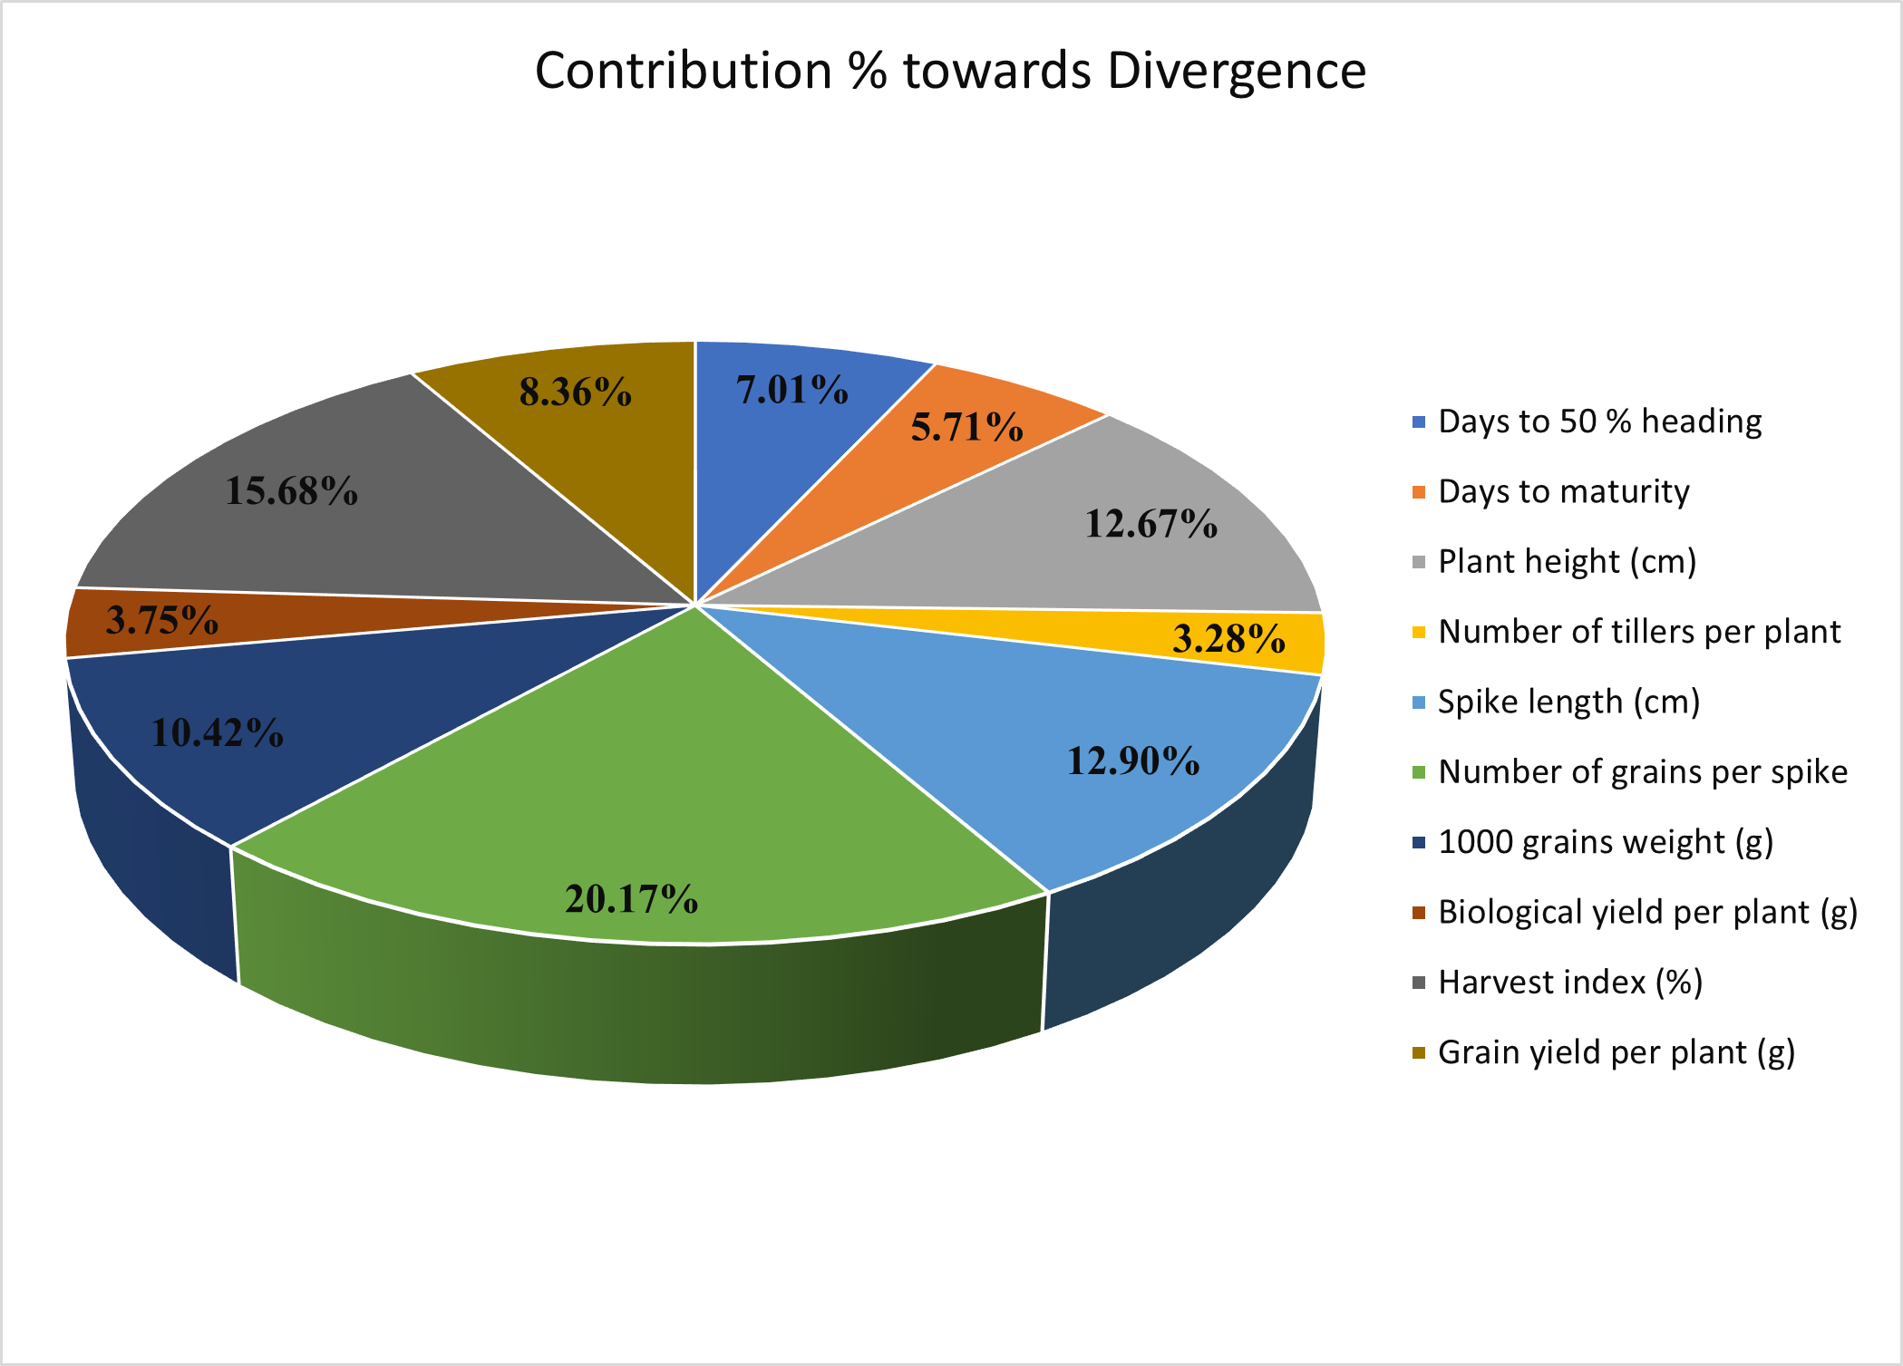

**Fig 1: Pie chart representation of different traits and their contribution towards genetic divergence.**

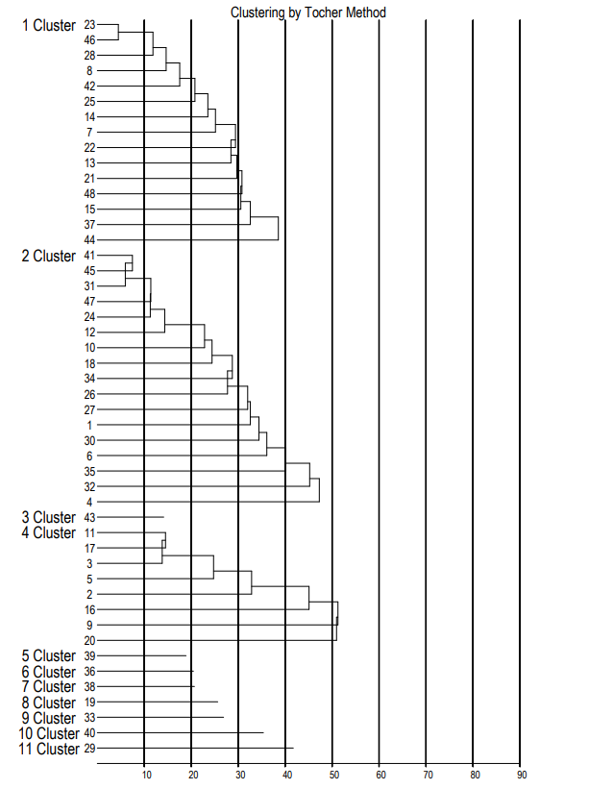

**Fig.2. Dendrogram showing clustering pattern of total 48 genotypes of wheat by Tocher method.**