**Original Research Article**

**Assessment of Seed Physiological Parameters in *Gymnema sylvestre* R.Br. for Optimizing Propagation and Storage Strategies**

**Abstract:**

This study investigated seed viability, water imbibition behavior, and desiccation tolerance of *Gymnema sylvestre* R.Br. to evaluate its potential for propagation and long-term storage. Tetrazolium (TZ) staining tests at varying concentrations (0.25%, 0.5%, and 1%) and durations (1 to 24 hours) revealed that 0.5% TZ consistently yielded 100% viability across all durations, making it the most effective treatment. Statistical analysis confirmed that TZ concentration, staining duration, and their interaction significantly influenced viability outcomes (*p* < 0.001). The seeds exhibited a clear triphasic water imbibition pattern, with fresh weight increasing by 158.79% at 30 hours before plateauing, indicative of typical orthodox seed hydration. Germination trials demonstrated that no pre-treatment was necessary, as seeds showed high viability without signs of physical or physiological dormancy. Desiccation trials, followed by storage at –20 °C, further confirmed the orthodox nature of the seeds. Germination improved from 89.26% in fresh seeds to 90.83% after desiccation and 95.38% after three months of cold storage. These results establish *G. sylvestre* seeds as viable, desiccation-tolerant, and suitable for direct sowing and long-term conservation under low-temperature storage conditions.

### ****Keywords:**** Seed germination, seed viability, tetrazolium test, seed storage, water imbibition, orthodox seeds, medicinal plants, seed physiology, propagation techniques

### ****Introduction****

More than 80% of the global population relies on medicinal plants for primary healthcare needs. With the increasing demand for herbal products, the trade volume of plant-based raw materials has grown significantly. Currently, around 90% of raw drugs used in traditional medicine systems such as Ayurveda, Siddha, Unani, and Homeopathy are collected from the wild, of which nearly 70% involves destructive harvesting (Gowthami et al., 2021). Among the vulnerable medicinal plants impacted by unsustainable harvesting is *Gymnema sylvestre* R. Br., a perennial woody climber from the family Apocynaceae (formerly Asclepiadaceae), widely known as “Gudmar” or “Madhunashini”—literally, “sugar destroyer”—for its well-documented antidiabetic properties.

Native to tropical and subtropical forests of India, Sri Lanka, Southeast Asia, and parts of Africa and Australia, *G. sylvestre* inhabits dry deciduous forests up to 600 m elevation (Keshavamurthy & Yoganarasimhan, 1990; Kritikar & Basu, 1998; Pandey, 2012). The leaves, when chewed, temporarily suppress the sensation of sweetness and have long been used in traditional formulations such as *Mahavisagarbha Taila*, *Ayaskrti*, and *Nyagrodhadi Churna* to manage diabetes, asthma, hepatosplenomegaly, and other ailments (Anonymous, 2003; Nadkarni, 1993). Ethnobotanical accounts and modern studies confirm its diverse therapeutic applications, including digestive, anti-inflammatory, antihelminthic, cardioprotective, and hepatoprotective effects (Saneja et al., 2010).

Pharmacologically, the activity of *G. sylvestre* is largely attributed to gymnemic acids—oleanane-type triterpenoid saponins with hypoglycemic, insulinotropic, and antihyperlipidemic properties (Tiwari et al., 2014). Other active constituents, such as gymnemagenin, flavonoids, polyphenols, and anthraquinones, contribute to its antioxidant, antimicrobial, and anti-inflammatory actions (Kumar, Sarada, & Rengasamy, 2008; Zhao et al., 2017). It is a key ingredient in several polyherbal antidiabetic formulations, including IME-9 and BGR-34, which have been clinically validated (Paliwal, Kathori, & Upadhyay, 2009; Kanetkar, Singhal, & Kamat, 2007). Recent reviews further document its role in managing Type 2 diabetes via β-cell stimulation and insulin regulation, although potential hepatotoxicity has also been reported (Jamadagni et al., 2021).

Despite its growing commercial demand, large-scale cultivation of *G. sylvestre* remains limited, primarily due to inadequate knowledge of its reproductive biology. While vegetative propagation is commonly practiced (Pandey, 2012), seed-based propagation remains underutilized due to uncertain germination behavior and lack of standardized storage protocols (Agnihotri et al., 2004). Understanding the physiological and biochemical traits of seeds—such as viability, dormancy, and desiccation tolerance—is essential for optimizing propagation and conservation. Tetrazolium (TZ) staining provides a rapid method for evaluating seed viability, while water imbibition analysis reveals key hydration phases critical for germination. Assessing desiccation tolerance and cold storage response is fundamental for classifying seed storage behavior as orthodox, intermediate, or recalcitrant (Hong and Ellis, 1996).

Given the species' ecological and economic value, and the urgent need for sustainable utilization, this study aims to comprehensively evaluate the seed physiology of *G. sylvestre*, focusing on viability testing, imbibition dynamics, dormancy status, desiccation tolerance, and long-term storage potential. The findings will inform both ex situ conservation efforts and efficient nursery practices for its large-scale cultivation.

**Material and Methodology:**

**Study Area:** The research was conducted at Jabalpur, Madhya Pradesh, India (21°17′ to 26°52′ N latitude; 74°08′ to 82°49′ E longitude), characterized by a subtropical climate with distinct seasons: hot summers (April–June), monsoon rains (July–September), and cool winters (October–February). The region receives an average annual rainfall of ~1370 mm, with temperatures ranging from 10°C in winter to 48°C in summer*.**Gymnema sylvestre* exhibits flowering from October to January, followed by fruiting between March and April. The maturation of fruits and seeds generally occurs during April to May.

**Seed Extraction and Processing:** Mature brown pods of *Gymnema sylvestre* are collected manually (April 2024) during the fruiting season by plucking. The harvested pods are sun-dried to promote natural splitting. Once dehisced, seeds are extracted, cleaned by removing feather-like structures, and prepared for sowing or storage.

**Seed Viability Testing:** Seed viability was assessed using the tetrazolium (TZ) test following ISTA protocols. Three concentrations of 2,3,5-triphenyl tetrazolium chloride solution (1.0%, 0.5%, and 0.25%) were standardized. A random sample of 100 seeds per replication was soaked in water for hydration, and the seed coat was removed to facilitate TZ solution penetration. Seeds were incubated in the TZ solution in the dark for up to 24 hours, with observations recorded at 1, 2, 4, and 24 hours. Viability was expressed as the percentage of viable seeds.

**Water Imbibition Test:** Fresh seeds were weighed and soaked in distilled water at room temperature. At specific intervals, seeds were removed, surface moisture was blotted off, and seeds were reweighed. The increase in fresh weight over time was used to analyse seed water uptake patterns.

**Germination Evaluation:** Seeds of both *H. pubescens* and *W. tinctoria* did not exhibit physical or physiological dormancy, and hence, no pre-treatment was required. Prior to sowing, seeds were surface-sterilized using 5% Captain solution for five minutes. Three replicates of 25 seeds were placed in sterilized sand trays lined with moist filter paper. The trays were incubated in a seed germinator at 25°C under a 16/8 h light/dark cycle (Silva et al., 2009). Germination was monitored daily for four weeks, with radicle emergence of 1 cm as the criterion for germination. The following parameters were recorded:

1. Final Germination Percentage (FGP) (Scott et al.1984)

FGP= G / T × 100

Where G = No. of germinated seeds and T = No. of seeds sown

1. Mean germination time (MGT) (Orchard, 1977)

MGT = Gt × Dt / G

Where Gt = No. of germinated seeds at day-t, Dt = No. of days at “t” from the day of sowing and G = Total no. of germinated seeds.

1. Root Length (cm): Measured as the average length of 10 primary roots.
2. Shoot Length (cm): Measured as the average height of the 10-seedling shoot.
3. Seedling vigour index I= G% X Seedling length (cm) (Abdul-Baki and Anderson 1973).

**Seed Desiccation Trials:** Seeds were dried using silica gel at a 1:1 weight ratio (silica gel to seeds). Moisture content was measured periodically until it dropped below 5%. Seeds were then vacuum-packed for storage trials, and some seeds were reserved for germination assessments.

**Moisture Content Determination:** Seed moisture content was determined using the oven-drying method at 103 ± 2°C for 17 ± 1 hours following ISTA (2023) guidelines. Four replicates per species were used, with moisture expressed as a percentage on a fresh weight basis.

**Seed Storage Behavior:** Seed storage behavior was evaluated using the simplified screening scheme of Hong and Ellis (1996). Seeds were vacuum-sealed in three-layer aluminium foil pouches and stored at -20°C in cold storage.

**Statistical Analysis:** All data were subjected to ANOVA to identify significant differences among treatments at a 5% significance level (p ≤ 0.05). Critical Difference (C.D.), Standard Error of mean (SEm), and Coefficient of Variation (C.V.) were calculated to assess variability.

**Result and Discussion**

**Seed Carpology:** The fruits of *Gymnema sylvestre* appear as paired, linear follicles (Fig 1.) that are lanceolate and cylindrical (terete) in shape, measuring up to 7.5 cm in length and approximately 0.8 cm in diameter. They are dark green in color, often swollen at the center, and typically mature between March and May. The seeds are flat, winged, and equipped with silky hairs that aid in wind dispersal. Each seed measures about 10 × 5 mm, with some reaching up to 1.3 cm in length. The average seed length ranges from 0.8120 to 1.134 cm, while the width varies between 0.2110 and 0.3220 cm. Approximately 60,000 to 70,000 seeds are present per kilogram.

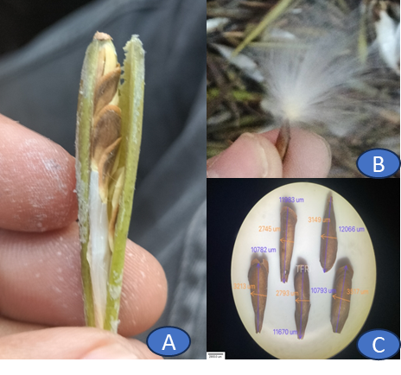

**Fig 1.** Fruit and seed carpology of Gymnema Sylvestris (A) Follicles (B) Seed with silky hairs (C) Microscopic Seed Image (Scale 2900.00 µm)

**Seed Viability**

The viability of *Gymnema sylvestre* seeds was significantly influenced by Tetrazolium (TZ) concentration and staining duration. At 1-hour, lower TZ concentrations performed better, with viability reaching 96.00% at 0.5% and 95.23% at 0.25%, compared to 71.33% at 1%. At 2 hours, viability improved across all treatments, peaking at 100% for 0.5%, followed by 98.33% (0.25%) and 95.33% (1%). All treatments achieved 100% viability at 4 and 24 hours, confirming complete staining efficiency. Mean viability was highest at 0.5% TZ (99.00%), followed by 0.25% (98.39%) and 1% (91.67%). ANOVA revealed significant effects of TZ concentration (F = 109.81*), staining duration (F = 68.02*), and their interaction (F = 46.56*). These results suggest that 0.5% or 0.25% TZ for 2–4 hours are optimal for accurate, efficient viability assessment. Viable seeds showed complete staining of the embryonal axis and cotyledons, while non-viable seeds displayed partial or no staining in various seed parts, including the radicle and cotyledons.

**Table 1.** Impact of TZ Concentration and Staining Duration on Viability Percentage of *Gymnema sylvestre*

|  |  |  |  |  |
| --- | --- | --- | --- | --- |
| Staining duration (hrs.) | TZ Conc. (%) | | |  |
| **1** | **0.5** | **0.25** | **Mean** |
| 1 | 71.33 | 96.00 | 95.23 | 87.52 |
| 2 | 95.33 | 100.00 | 98.33 | 97.89 |
| 4 | 100.00 | 100.00 | 100.00 | 100.00 |
| 24 | 100.00 | 100.00 | 100.00 | 100.00 |
| Mean | 91.67 | 99.00 | 98.39 |  |
| Factors | **C.D.** | **SE(d)** | **SE(m)** | **F-Calculated** |
| TZ Conc. | 1.67 | 0.81 | 0.57 | 109.81* |
| Staining duration | 1.45 | 0.70 | 0.49 | 68.02* |
| TZ Conc. X Staining duration | 2.90 | 1.40 | 0.99 | 46.56* |

**Table 2.** TZ staining patterns of viable (1) and non-viable seeds (2-6) in *Gymnema sylvestre*

|  |  |  |
| --- | --- | --- |
| S. No. | Topographic description | Topographic pattern |
|
| 1 | Embryonal axis and cotyledons completely stained |  |
| 2 | Embryonal axis & cotyledon unstained radicle stained |  |
| 3 | 25% Embryonal axis and cotyledons stained |  |
| 4 | Embryonal axis and cotyledons unstained, radicle tip partially stained |  |
| 5 | Embryonal axis and cotyledons stained lightly |  |
| 6 | Embryonal axis with cotyledons unstained |  |

**Water Imbibition:** The water imbibition curve (Fig.2) of *Gymnema sylvestre* seeds illustrates the increase in seed fresh weight (%) over time as the seeds absorb water. Initially, at 0 hours, there is no change in seed weight. By 2 hours, the seeds exhibit a 23.44% increase in fresh weight, with a standard error (SE) of 0.68, indicating the onset of water uptake. This trend continues steadily, reaching 35.16% at 4 hours (SE = 1.02). A rapid imbibition phase occurs between 6 to 12 hours, with seed fresh weight increasing significantly—72.01% at 6 hours, 81.10% at 8 hours, 90.66% at 10 hours, and peaking at 110.71% at 12 hours. The increasing SE values during this phase indicate some variability in water absorption among seeds. Beyond 12 hours, the rate of water absorption slows, reaching 121.81% at 24 hours and 131.68% at 27 hours. The highest recorded increase is 158.79% at 30 hours, after which a slight decline is observed—158.29% at 33 hours and 157.02% at 36 hours—indicating that the seeds may have reached saturation or experienced minor water loss. This pattern suggests a triphasic imbibition process typical of orthodox seeds, with an initial rapid water uptake, a slower plateau phase, and a final stabilization, preparing the seeds for germination.

**Fig 2**: Water Imbibition curve of *Gymnema sylvestre* seeds

**Seed pre-treatment:** *Gymnema sylvestre* seeds did not exhibit physical or physiological dormancy, and therefore no pre-treatment was required prior to sowing. Preliminary germination tests confirmed the viability of untreated seeds, validating their readiness for direct propagation without additional interventions (Fig.3, Fig. 4).

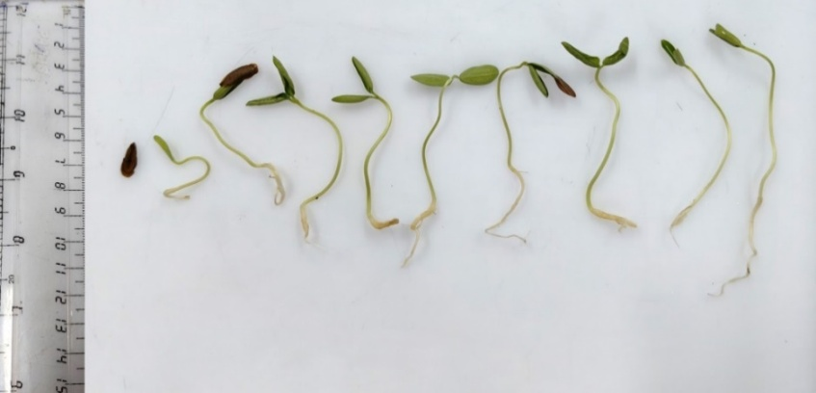

**Fig 3:** Germination pattern of *Gymnema sylvestre* seeds

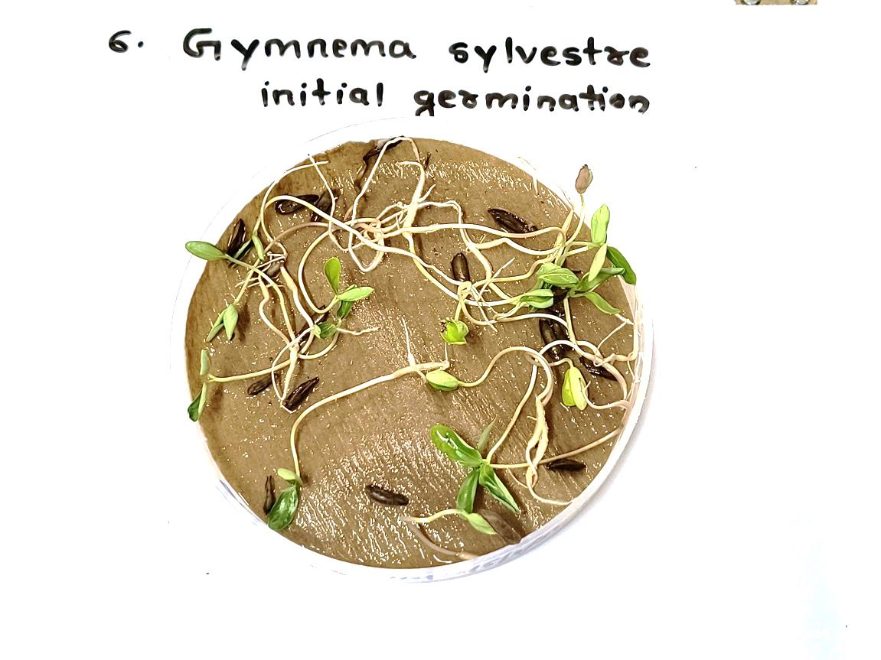

**Fig. 4:** Seed germination of*Gymnema sylvestre*

**Standardization of Seed Storability Behaviour:** Desiccation trials were conducted to assess the seed storability of *Gymnema sylvestre* using silica gel in desiccators. The initial seed moisture content was 9.60%, with a germination rate of 89.26±3.57%. After desiccation to safe moisture content of 5.36%, the germination percentage increased to 90.83±3.63%. Seeds stored at –20°C for three months maintained good viability, with a germination rate of 95.38±3.82%. These findings suggest that *Gymnema sylvestre* seeds are classified under the orthodox storage category, as they demonstrated high storability and maintained viability after prolonged storage under controlled conditions. In conclusion, the seeds of *Gymnema sylvestre* exhibit good storability under orthodox conditions, with improved germination following desiccation and low-temperature storage.

**Table 3:** Different desiccation stages and respective germination percentage after desiccation

|  |  |  |  |  |  |
| --- | --- | --- | --- | --- | --- |
| Initial seed Moisture Content% | Initial seed germination %  Mean±SE | Desiccated safe moisture content % | Germination% Mean±SE | 3 months after -20 OC storage germination % Mean±SE | Seed Storage Categories |
| 9.60 | 89.26±3.57 | 5.36 | 90.83±3.63 | 95.38±3.82 | Orthodox |

**Discussion**

The viability assessment of *Gymnema sylvestre* seeds using tetrazolium (TZ) staining demonstrated high reliability and clarity across all tested concentrations and staining durations. Among the treatments, 0.5% TZ emerged as the most effective, producing 100% viability across all durations, with a mean viability of 100%. The 0.25% concentration followed closely (mean: 99.13%), while 1% was slightly lower (mean: 91.88%) but reached full staining at longer durations (4–24 h). ANOVA confirmed that TZ concentration, staining duration, and their interaction significantly affected viability outcomes (F = 24.80, 21.20, and 16.49 respectively; *p* < 0.001). The distinct staining patterns—full staining of the embryonal axis and cotyledons in viable seeds versus incomplete or absent staining in non-viable ones—validate TZ testing as a rapid and effective viability assay for *G. sylvestre*.

The water imbibition profile revealed a triphasic curve, typical of orthodox seeds. An initial slow uptake phase (35.16% by 4 hours) was followed by rapid water absorption from 6 to 12 hours (peaking at 110.71%), indicating reactivation of metabolic processes. The final phase, plateauing between 12 to 36 hours (158.79% at 30 hours), suggests full hydration or slight desorption, confirming readiness for germination.

Germination trials revealed no physical or physiological dormancy in untreated seeds, supporting straightforward propagation without pre-treatment. This simplifies nursery protocols and enhances scalability for conservation and commercial cultivation.

Desiccation and cold storage trials further confirmed the seeds’ orthodox nature. Germination improved slightly after drying (from 89.26% to 90.83%) and increased further to 95.38% after three months at –20 °C, demonstrating high storability and viability retention under cold storage. The improvement may reflect dormancy alleviation or stabilization of internal seed physiology during storage.

These findings are consistent with Pandey (2012), who developed successful cultivation protocols for *G. sylvestre*. His study recommended both seed and vegetative propagation, with cold water pre-treatment enhancing germination. Hardwood cuttings treated with 500 ppm IBA during March or July achieved 52.5% rooting. Optimal growth was observed at 50 × 50 cm spacing with 4000 kg FYM/ha, yielding up to 1.5 tonnes/ha of dry leaves after two years, with biannual harvests in June and October.

In conclusion, *G. sylvestre* seeds exhibit high viability, a clear triphasic imbibition pattern, no dormancy, and strong desiccation and storage tolerance. These traits are ideal for propagation, ex situ conservation, and long-term seed banking, supporting sustainable utilization of this high-value medicinal species.

**Conclusion**

This study provides a comprehensive physiological assessment of *Gymnema sylvestre* seeds, establishing key parameters for their propagation and ex situ conservation. Tetrazolium (TZ) viability testing identified 0.5% TZ concentration as the most effective across all durations, consistently yielding 100% viability. Statistical analyses confirmed significant effects of TZ concentration, staining duration, and their interaction, emphasizing the need for standardized testing protocols. Water imbibition studies revealed a characteristic triphasic hydration curve, confirming the orthodox nature of the seeds and their readiness for germination. Germination trials further demonstrated that seeds are non-dormant and suitable for direct sowing without pre-treatment. Desiccation and cold storage trials validated the seeds’ storability, with germination improving from 89.26% in fresh seeds to 95.38% after storage at –20 °C, confirming their desiccation tolerance and long-term viability. Collectively, these findings affirm that *G. sylvestre* seeds are viable, non-dormant, and amenable to storage—supporting their use in large-scale cultivation and conservation programs.

**References**

1. Abdul-Baki, A. A., & Anderson, J. D. (1973). Vigor determination in soybean seed by multiple criteria. *Crop Science, 13*(6), 630–633. https://doi.org/10.2135/cropsci1973.0011183X001300060013x
2. Agnihotri, A. K., Khatoon, S., Agarwal, M., Rawat, A. S., Mehrotra, S., & Pushpangadan, P. (2004). Evaluation of seed germination and dormancy behavior in *Gymnema sylvestre*. *Natural Product Sciences, 10*(4), 168–172.
3. Anonymous. (2003). *The Ayurvedic Formulary of India* (Part I, 2nd ed., pp. 1–110). Government of India, Ministry of Health and Family Welfare, Department of Indian Systems of Medicine & Homeopathy.
4. Kanetkar, P., Singhal, R., & Kamat, M. (2007). Gymnema sylvestre: A memoir. *Journal of Clinical Biochemistry and Nutrition, 41*(2), 77–81.
5. Keshavamurthy, K. R., & Yoganarasimhan, S. N. (1990). *Flora of Coorg, Karnataka* (p. 282). Vimsat Publishers.
6. Kritikar, K. R., & Basu, B. D. (1998). *Indian Medicinal Plants* (Vol. 1, p. 1625). International Book Distributors.
7. Kumar, C. S., Sarada, D. V. L., & Rengasamy, R. (2008). Studies on phytochemical composition and antimicrobial activity of *Gymnema sylvestre* R. Br. *Indian Journal of Science and Technology, 1*(3), 1–5.
8. Nadkarni, K. M. (1993). *Indian Materia Medica* (Vol. 1). Popular Prakashan.
9. Orchard, T. (1977). Estimating the parameters of plant seedling emergence. *Seed Science and Technology, 5*(1), 61–69.
10. Paliwal, R., Kathori, S., & Upadhyay, B. (2009). Effect of gurmar (*Gymnema sylvestre*) powder intervention on the blood glucose levels among diabetics. *Studies on Ethno-Medicine, 3*(2), 133–135. https://doi.org/10.1080/09735070.2009.11886350
11. Scott, S. J., Jones, R. A., & Williams, W. A. (1984). Review of data analysis methods for seed germination. *Crop Science, 24*(6), 1192–1199. <https://doi.org/10.2135/cropsci1984.0011183X002400060043x>
12. Tiwari, P., Mishra, B. N., & Sangwan, N. S. (2014). Phytochemical and pharmacological properties of *Gymnema sylvestre*: An important medicinal plant. *BioMed Research International, 2014*, Article 830285. https://doi.org/10.1155/2014/830285
13. Zhao, J. Q., Wang, Y. M., Yang, Y. L., Zeng, Y., Mei, L. J., Shi, Y. P., et al. (2017). Antioxidants and α-glucosidase inhibitors from “Liucha” (young leaves and shoots of *Sibiraea laevigata*). *Food Chemistry, 230*, 117–124. <https://doi.org/10.1016/j.foodchem.2017.03.024>
14. Hong, T.D. and Ellis, R.H. (1996) A Protocol to Determine Seed Storage Behavior. International Plant Genetic Resources Institute, Rome, (IPGRI. Technical Bulletin, 1), 55 p.
15. Gowthami R, Sharma N, Pandey R, Agrawal A. Status and consolidated list of threatened medicinal plants of India. Genet. Resour. Crop Evol. 2021 ;68(6):2235-2263.
16. *Jamadagni, P. S., Pawar, S. D., Jamadagni, S. B., Gautam, M., Gaidhani, S. N., Prasad, G. P., & Gurav, A. M. (2021). Gymnema sylvestrae: Recent advances in pharmacological and clinical research. Pharmacognosy Reviews, 15(30), 128–133. https://doi.org/10.5530/phrev.2021.15.15*
17. *Saneja, A., Sharma, C., Aneja, K. R., & Pahwa, R. (2010). Gymnema sylvestre (Gurmar): A review. Der Pharmacia Lettre, 2(1), 275–284. Retrieved from* [*http://scholarsresearchlibrary.com/archive.html*](http://scholarsresearchlibrary.com/archive.html)
18. Pandey, A. K. (2012). Cultivation technique of an important medicinal plant Gymnema sylvestre R. Br. (Gurmar). Academic Journal of Plant Sciences, 5(3), 84–89. <https://doi.org/10.5829/idosi.ajps.2012.5.3.2021>
19. Silva EAA, Toorop PE, Van Aelst AC, Hilhorst HWM (2009) The mechanics of seed imbibition: How seeds absorb water. Seed Sci Res 19(4):229–242.