Original Research Article
Phenological Development and Shoot Growth of Calamansi ( Citrus x microcarpa) Under Pruning and Waterlogging Conditions in a Tropical Agroforestry Context

Abstract
This study investigated the shoot growth and phenological development of containerized grafted calamansi (Citrus x microcarpa) seedlings under three cultivation treatments: control, waterlogging, and pruning. Using the BBCH scale for standardized phenological monitoring, plant growth parameters such as height, shoot length, and number of leaves were measured biweekly over a 54-day observation period. Results showed that pruned seedlings exhibited significantly greater vegetative growth rates, while waterlogged seedlings demonstrated accelerated reproductive development. Control plants followed a moderate developmental pace. Waterlogging led to early flowering and fruiting, likely as a stress-induced survival mechanism, while pruning delayed phenological progression but enhanced vegetative vigor. These outcomes suggest that pruning can be an effective management tool for off-season calamansi production by resetting phenological stages, whereas waterlogging imposes physiological stress that compromises long-term productivity. The study underscores the value of phenological monitoring in adapting orchard practices for improved resilience and yield in varying climatic conditions.

Keywords

Calamansi, phenology, BBCH scale, waterlogging, abiotic stress, tropical horticulture, crop management.

INTRODUCTION

Plant development is a succession of ordered and logical changes that ultimately lead to physiological maturity (Peer et al., 2015). These changes involve shifts in the plant's functional capacity, strongly influenced by the interaction between genetic traits and environmental factors (Pereira et al., 2002). In perennial fruit crops like calamansi (Citrus x microcarpa), understanding seasonal phenological stages is essential for crop management, yield optimization, and adaptation strategies in response to climatic variability.

Phenology—the study of the timing and sequence of recurring biological events—offers critical insights into plant responses to both biotic and abiotic stimuli (Leith, 1974). In agricultural contexts, especially for fruit trees, phenological data provide an important basis for anticipating developmental phases, determining ideal timing for management practices, and extrapolating experimental outcomes across climatic zones (Oliveira et al., 2017; Petri et al., 2008). These data are also essential for forecasting interannual changes in crop behavior under varying environmental conditions.

Research into crop phenology aims to identify the environmental drivers behind changes in developmental timing by analyzing the correlation between weather parameters and specific growth events (Keller et al., 2015). Critical phenological stages—those that significantly impact yield—must be precisely identified, as many horticultural practices such as pruning, fertilizing, girdling, fruit thinning, hormone application, and pest management are most effective when timed appropriately (Favaro et al., 2014).

Phenological scales like the BBCH scale (Agusti et al., 1997; Meier, 2001) standardize the description of developmental stages across crops and are widely adopted in citrus phenology research. These scales enhance the accuracy of phenological monitoring and provide a framework for comparing developmental responses across treatments or environments.

Given the increasing importance of calamansi as a high-value crop in tropical and subtropical regions, this study aims to describe and compare the shoot growth and phenological development of containerized grafted calamansi seedlings under different cultivation practices and environmental stress conditions. By observing calamansi development under control, waterlogged, and pruned conditions, this research contributes to a better understanding of how abiotic stress and canopy management influence phenology, offering insights for more efficient and climate-resilient production systems.

OBJECTIVES

To describe the phenological development of containerized grafted calamansi (× Citrofortunella microcarpa) seedlings using the BBCH scale.

To compare the shoot growth and phenological responses of containerized grafted calamansi seedlings under three treatments: control, waterlogging, and pruning.

METHODOLOGY

A total of forty-eight (48) containerized grafted calamansi (× Citrofortunella microcarpa) seedlings were used in the study. The seedlings were evenly divided into three treatment groups: the control group, consisting of sixteen seedlings maintained under standard growing conditions; the waterlogging treatment, in which sixteen seedlings were subjected to periodic soil waterlogging to simulate abiotic stress; and the pruning treatment, where sixteen seedlings were selectively pruned to assess the effects of canopy management on shoot growth and development.
Each seedling had four (4) tagged shoots designated for repeated observation throughout the study period. Phenological development was monitored using the BBCH scale for citrus (Meier, 2001), which provided a standardized framework for identifying and recording developmental stages. Observations were conducted biweekly, and the following growth parameters were measured: plant height, shoot length, number of leaves per tagged shoot, and phenological stage according to the BBCH scale. In addition, daily weather data, including minimum and maximum temperature and rainfall, were recorded to account for environmental influences.
Collected data were subjected to analysis of variance (ANOVA) using the STAR software, version 2.0.1 (2014). Treatment means were compared using the Least Significant Difference (LSD) test at a 5% significance level (p < 0.05). Graphical representations of the results were created using OriginPro version 8.5..

RESULTS AND DISCUSSION

Rainfall and Temperature

The study was conducted across three experimental sites that fell under different climate types in the Philippines. Type 1 climate experiences distinct wet and dry seasons, with the dry season occurring from November to April. Type 2 climate has no distinct dry season, though peak rainfall typically occurs from November to January, while Type 3 has more moderate seasonality, with dry spells from November to April. After 54 days of observation, seedlings in the Type 2 climate received significantly more rainfall compared to those in Type 1 and Type 3 (Figure 1). This is consistent with the agro-climatic characterization of Philippine regions, which indicates that Type 2 areas experience high and sustained rainfall (PAGASA, 2020). Calamansi, while tolerant of short dry periods, generally prefers evenly distributed rainfall of 1,500–2,000 mm annually and does not perform well under prolonged waterlogged conditions (PCARRD, 2006).

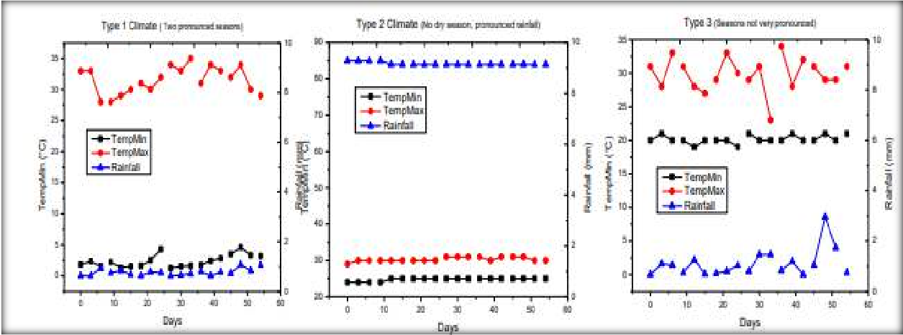

Figure 1. Daily weather data of the three (3) types of climates were the calamansi seedlings were established after 54 days of observation. Data for daily minimum and maximum temperature and rainfall were taken from https://www.accuweather.com/.

Calamansi seedling growth characteristics

In terms of growth characteristics, plant height differed significantly among treatments. Pruned seedlings exhibited greater height compared to waterlogged ones, although there was no significant difference between pruned and control seedlings. Shoot length and number of leaves per shoot showed no statistically significant differences across treatments. However, when absolute growth rate was considered, pruned seedlings outperformed both control and waterlogged plants, indicating that pruning effectively stimulated vegetative regrowth. These results are supported by Favaro et al. (2014), who reported that pruning citrus trees enhances light penetration and encourages new shoot emergence, contributing to improved growth performance. Additionally, canopy management practices such as pruning are known to reduce apical dominance, redirecting resources to lateral bud development (Agustí et al., 1997).

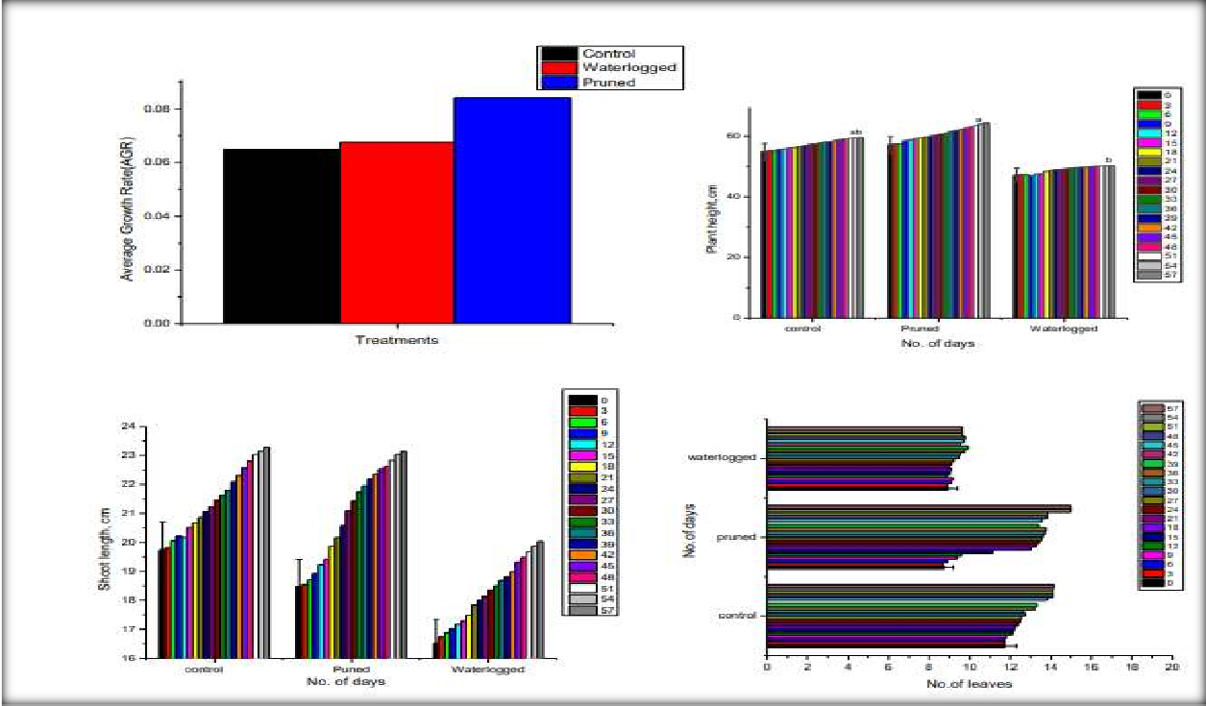

Figure 2. Plant height, shoot length, number of leaves and average growth rate of calamansi after 54 days under normal, pruned and waterlogged condition. Means with the same letter are not significantly different at LSD, 5%.

Phenological description

Phenological development was monitored using the BBCH scale. After 54 days, control seedlings exhibited phenological stages ranging from BBCH 34.85 to 61.42, representing late shoot development to early flowering. Waterlogged seedlings advanced more rapidly through the phenological stages, ranging from BBCH 47.30 to 74.71, with some entering principal growth stage 7, which corresponds to early fruit development. This accelerated phenological progression under waterlogged conditions may reflect a stress-induced strategy by the plants to complete their reproductive cycle earlier, a common physiological response in many fruit crops exposed to abiotic stress (Keller et al., 2015). In contrast, pruned seedlings were much earlier in development, ranging from BBCH 4.88 to 45.80, indicating they were largely in the vegetative stages of leaf and shoot development. These observations suggest that pruning effectively rejuvenates the trees, causing a delay in reproductive development while promoting new flushes of vegetative growth—a finding consistent with off-season calamansi management strategies that rely on full pruning to reset growth cycles (Sotto et al., 2005).

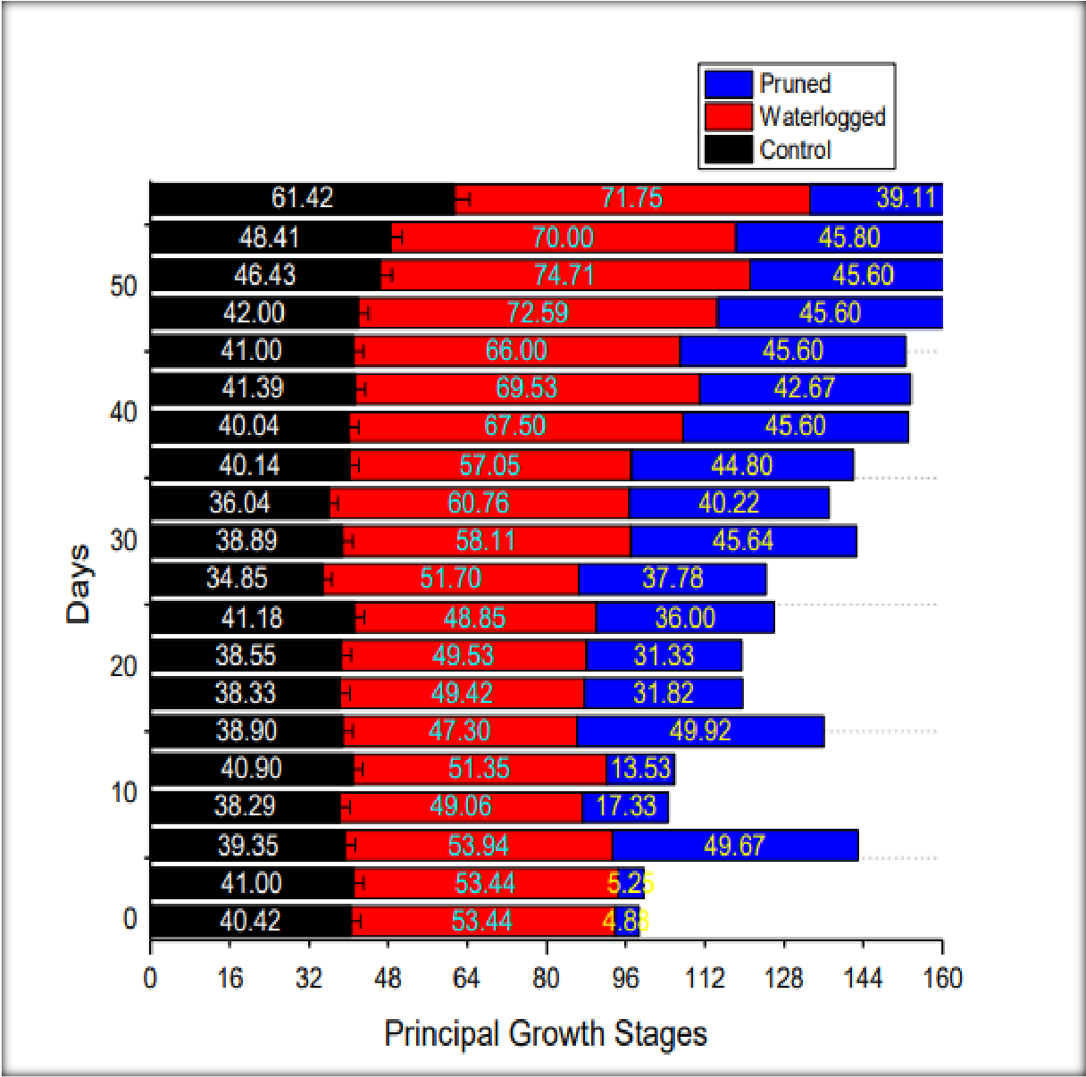

Figure 3. Principal growth stages of calamansi after 54 days under normal, pruned and waterlogged condition. Means with the same letter are not significantly different at LSD, 5%.

The results demonstrate that waterlogging induces early senescence and fruit development in calamansi, likely due to impaired root respiration and hormonal imbalances under saturated conditions, as reported in other citrus studies (Meier, 2001). On the other hand, pruning delayed phenological advancement, but enhanced overall vegetative vigor. This outcome supports findings from similar studies where citrus trees subjected to pruning exhibited extended vegetative phases and delayed flowering (Yeshitela et al., 2004). Moreover, the delayed phenology in pruned seedlings aligns with practical recommendations for off-season calamansi production, which utilize pruning as a management tool to time flowering and fruiting to meet market demand (PCARRD, 2006).
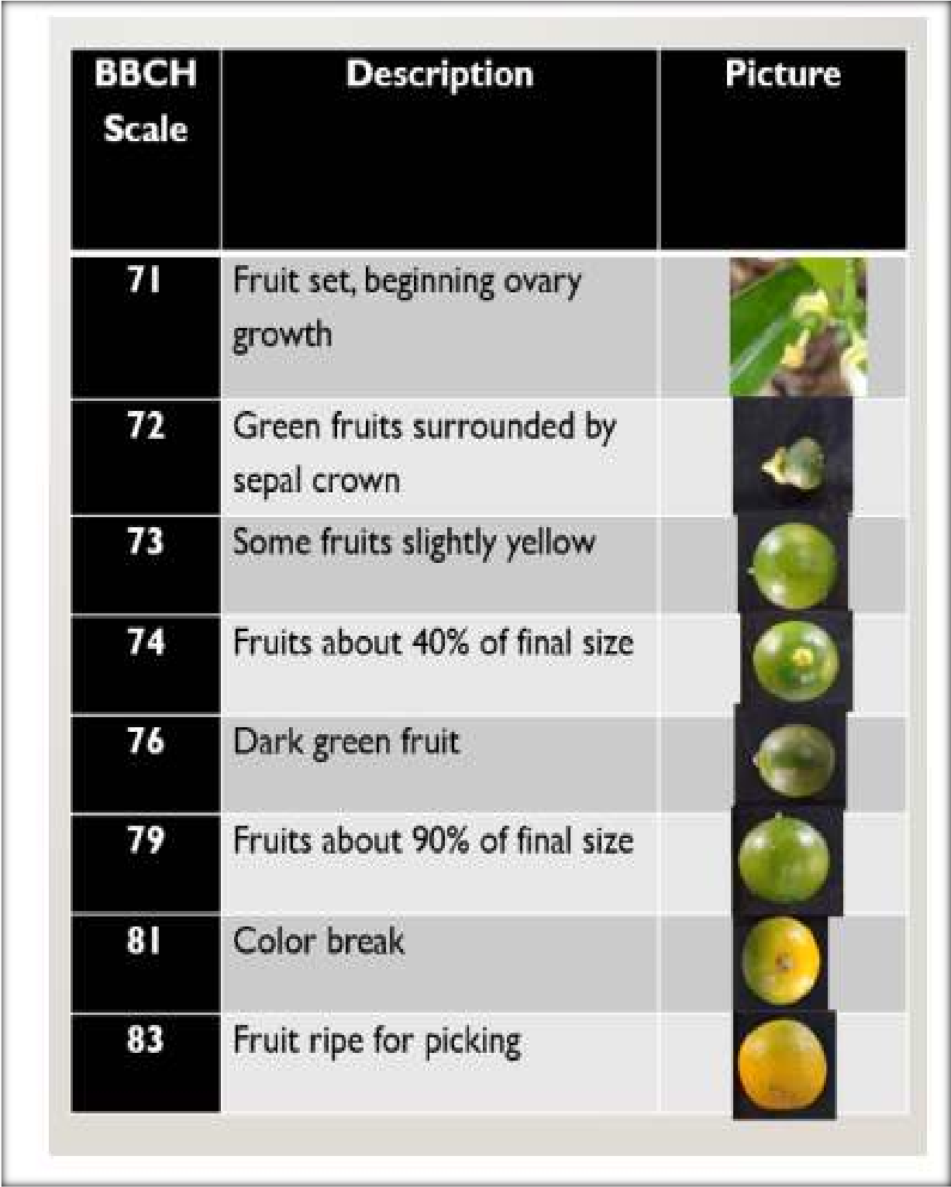

Figure 4. Phenological growth stages of calamansi fruit with descriptions based on Meier, 2001.

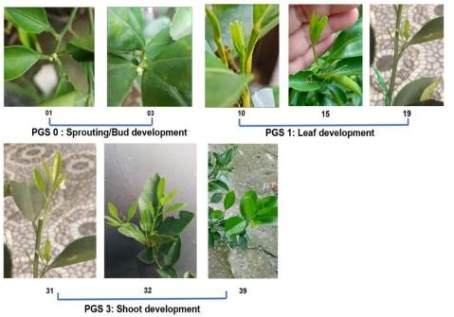
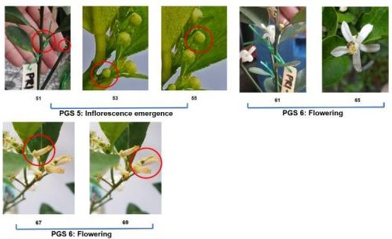
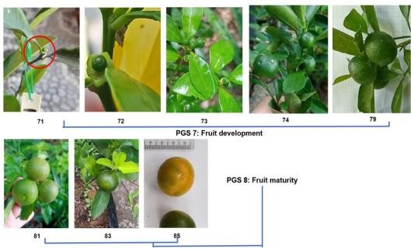

Figure 5. Representation of BBCH system for calamansi with scale descriptions based on Meier, 2001.

SUMMARY AND CONCLUSION

This study investigated the phenological development and shoot growth response of containerized grafted calamansi (Citrus x microcarpa) seedlings subjected to different treatments: control, waterlogging, and pruning. Results revealed that plant height varied significantly across treatments, with pruned seedlings showing greater height than those exposed to waterlogging, while both were statistically comparable to the control group. Although shoot length and leaf count showed no significant differences among treatments, absolute growth rates were significantly higher in pruned plants. This suggests that pruning stimulated more vigorous vegetative growth compared to both waterlogged and untreated seedlings.

Phenological development, measured using the BBCH scale, also varied substantially. Control plants exhibited BBCH stages ranging from 34.85 to 61.42 after 54 days, indicating development from late shoot growth to early flowering. Waterlogged seedlings advanced more rapidly, with BBCH stages ranging from 47.30 to 74.71, reflecting accelerated progression toward fruit development and early senescence—likely a response to abiotic stress. In contrast, pruned calamansi seedlings remained in earlier phenological stages (BBCH 4.88–45.80), indicating that pruning delayed reproductive development and induced new vegetative flushes.

The observed response to pruning aligns with the concept of apical dominance. As described by Mason (2014), the shoot apex suppresses lateral bud outgrowth through hormonal (auxin) and sugar competition mechanisms. Removing the apical bud reduces auxin flow and redistributes sugar demand, promoting lateral bud activation and shoot branching. This physiological shift supports the improved architecture, vigor, and growth observed in pruned trees. Pruning, therefore, plays a critical role in altering growth dynamics, delaying phenological progression, and rejuvenating tree structure—consistent with prior citrus management studies (Agustí et al., 1997; Meier, 2001).

The variable response to waterlogging may also be attributed to external and experimental factors. Differences in seedling age, initial health status, and uneven climate conditions across student observers likely influenced plant responses. Some waterlogged plants showed symptoms such as leaf yellowing and wilting within a week, while others took up to two weeks to show stress. Although most survived, a few died, possibly due to initial poor condition and prolonged submersion. These outcomes align with Zhang et al. (2008), who emphasized that excessive soil moisture inhibits oxygen availability, disrupting aerobic respiration and photosynthesis, which can lead to growth inhibition and plant death. High temperatures further intensified stress, as reported by Striker (2012), who noted that flowering and floral organ development are energy-intensive processes that plants often suppress under flooding to conserve resources. Indeed, only minor flower flushes emerged during the recovery period of waterlogged seedlings, underscoring the energy limitations imposed by submergence stress.

Additionally, the relatively short observation period (54 days) limits the ability to fully assess longer-term physiological responses. Extending the monitoring period may reveal further insights into recovery dynamics, delayed phenophases, or eventual reproductive performance.

Calamansi phenology is highly influenced by both climate and cultural management. In tropical regions, rainfall patterns—not temperature—are the primary drivers of phenological events (Micheloud et al., 2017). Thus, understanding the timing and variability of critical growth stages enables more precise orchard interventions, such as pruning schedules, irrigation management, and stress mitigation strategies. Overall, phenological monitoring using standardized scales like BBCH offers valuable insights into crop development and resilience. This study affirms the importance of pruning for promoting vegetative growth and delaying phenological advancement, while also highlighting the detrimental impacts of prolonged waterlogging on calamansi physiology and productivity.

Data Availability Statement

The data supporting the findings of this study on the phenological development and shoot growth of calamansi ( Citrus x microcarpa) under pruning and waterlogging conditions are available from the corresponding author upon reasonable request. The datasets include raw and processed measurements of plant height, shoot length, number of leaves, and BBCH phenological stages recorded biweekly over a 54-day period, as well as daily weather data from publicly accessible sources.

COMPETING INTERESTS DISCLAIMER:
Authors have declared that they have no known competing financial interests OR non-financial interests OR personal relationships that could have appeared to influence the work reported in this paper.

REFERENCES

Agustí, M., Zaragoza, S., Iglesias, D. J., Almela, V., & Primo-Millo, E. (1997). The use of ethephon combined with summer pruning as a means of enhancing cropping in Citrus unshiu Marc. Scientia Horticulturae, 69(4), 277–285. https://doi.org/10.1016/S0304-4238(97)00058-2

Keller, M., Smithyman, R. P., & Mills, L. J. (2015). Interactive effects of deficit irrigation and crop load on Cabernet Sauvignon in an arid climate. American Journal of Enology and Viticulture, 66(1), 30–39. https://doi.org/10.5344/ajev.2014.14055

Mason, M. G. (2014). Apical dominance and shoot growth regulation in plants. Plant Growth Regulation, 73(3), 207–219. https://doi.org/10.1007/s10725-014-9946-0

Meier, U. (Ed.). (2001). Growth stages of mono- and dicotyledonous plants: BBCH Monograph. Federal Biological Research Centre for Agriculture and Forestry.

Micheloud, N. G., Kogan, M. J., Oronoz, M. E., & Rodriguez, G. R. (2017). Phenological dynamics of citrus species grown in temperate and subtropical environments. Journal of Agricultural Science and Technology, 19, 1183–1195. https://jast.modares.ac.ir/article-23-14000-en.html

PCARRD. (2006). The Philippines recommends for calamansi. Philippine Council for Agriculture, Forestry and Natural Resources Research and Development (PCARRD), Department of Science and Technology.

PAGASA. (2020). Climate types in the Philippines. Philippine Atmospheric, Geophysical and Astronomical Services Administration. https://bagong.pagasa.dost.gov.ph/information/climate-philippines

Striker, G. G. (2012). Flooding stress on plants: anatomical, morphological and physiological responses. Botany, 90(6), 535–552. https://doi.org/10.1139/b2012-043

Yeshitela, T., Robbertse, P. J., & Stassen, P. J. C. (2004). Paclobutrazol suppressed vegetative growth and improved yield as well as fruit quality of ‘Tommy Atkins’ mango (Mangifera indica) in Ethiopia. South African Journal of Plant and Soil, 21(2), 158–163. https://doi.org/10.1080/02571862.2004.10634936

Zhang, J. H., Wei, X. L., & Liu, M. Z. (2008). Responses of citrus seedlings to flooding stress. Acta Horticulturae Sinica, 35(5), 701–708.

