Evaluation of transgenic Pigeon pea (Cajanus cajan [L.] Millsp. cv. Manak) plants over-expressing OsLecRLK gene for salt stress tolerance through physio-biochemical analysis

Abstract

Aim: Abiotic stresses especially salinity and drought affect the yield of crops worldwide. There is a large gap between potential yield and yield obtained on farmer fields. Salt stress affects major processes including photosynthesis, protein and lipid metabolism, and more, resulting in reduced agricultural yields.
Study design: CRD (Completely Randomized Design).
Place and Duration of Study: The studies were carried out in the Department of Molecular Biology, Biotechnology and Bioinformatics CCS HAU, Hisar, Haryana
Methodology: In the present research transgenic pigeon pea (cv. Manak) plants were evaluate for the efficacy of OsLecRLK gene in salt stress tolerance. Physio-biochemical analysis was done to assess the efficacy of transgene via subjecting wild type and selected T₁ transgenic plants to 75 mM salt stress.
Results: The results showed that transgenic line performed better in terms of maintaining higher chlorophyll content, relative water content, proline content, total soluble sugar content, peroxidase and catalase activity in comparison to the wild type plants. Moreover, MDA content and membrane injury index were significantly reduced in transgenic lines when compared to the wild type plants indicating that the transgenic lines were less affected by salt stress.
Conclusion: Among all transgenic lines, L-19 performed very well with respect to all the parameters studied and can be taken further for the development of transgenic pigeon pea plants for salt stress tolerance.

Keywords: Pigeonpea, transgenic, OsLecRLK gene, salinity stress, physio-biochemical, kinase, peroxydase
INTRODUCTION
Pigeon pea (Cajanus cajan [L.] Millsp.) is an important perennial diploid legume crop (2n=2x=22). It belongs to the family Fabaceae and is a member of the tribe Phaseoleae. This tribe is in the tropical clade within the superfamily Faboideae, which includes many important legume crops such as mung bean, common bean, soybean and cow pea. Pigeon pea is a major pulse crop of the semiarid tropics that is traditionally cultivated as an annual crop in Africa, Asia, and Australia (Sairam et al. 2009). India is the primary centre of origin and diversification for pigeon pea. The crop was domesticated in India 3500 years ago (Kassa et al. 2012). It is the sixth most important legume crop cultivated globally in an area of 5 million hectares. India is the world's top producer of pigeon peas, with 4.34 million tons produced on 5.05 million hectares of land and an 859 kg/ha productivity (DES, MoAF&W, 2022, fourth advanced projections). With 674.44 million kg of imports, India holds the top spot (92.65% of all pigeon pea imports worldwide in 2021. The growth of the pigeon pea is salt sensitive. Excess salt promotes physiological drought in the pigeon pea, and prolonged and excessive exposure is fatal. One such approach is to genetically modify the pigeon pea plant to make it salt resistant. While pigeon pea genetic change is meticulous, tissue culture regeneration proves to be difficult. In the current study the functionality of Lec-RLK in transgenic pigeon pea has been demonstrated using a tissue culture-independent plant transformation technique.
Abiotic and biotic stresses affect the yield of crops worldwide. There is a large gap between potential yield (2500 kg/ha) and yield obtained on farmer fields (736.2 kg/ha in Africa and 866.2 kg/ha in Asia) due to the biotic and abiotic stresses (Mula & Saxena, 2010). Salt stress affects major processes including photosynthesis, protein and lipid metabolism, and more, resulting in reduced agricultural yields (Rasool et al. 2013). Reduced CO₂ assimilation, primarily due to stomatal closure, membrane damage, reduced activity of key enzymes of necessary cellular mechanisms such as CO₂ fixation, ATP synthesis and increased ROS due to increased metabolite flux through the photo-respiratory pathway are some of the major effects of salinity on plants. For proper growth and development an optimum concentration of salt is required in soil, but when it is in excess (especially NaCl), becomes toxic to the plants and physiological drought condition can occur. Under high salt concentrations, there is increase in sodium absorption in cells wherein the potassium (K⁺) to sodium (Na⁺) ratio gets disturbed. It leads to degradation of essential enzymes and ultimately cell death (Horie et al. 2009; Adams & Shin 2014). Increased sodium uptake also disturbs the calcium (Ca²⁺) uptake as well as disturbance in the osmotic potential, thus leading to the change in water potential of the cells. SOS (salt overly sensitive) pathway is a well-known salinity response pathway in plants. It plays an important role in cellular Na⁺ detoxification by effluxing the excess Na⁺ from root epidermal cells to the external environment (Liu et al. 2000; Shi and Zhu, 2002). Gene expression machinery also affected by salt stress and this leads to the expression of some genes which are induced by salt stress and helps in providing tolerance to the plants during unfavourable conditions.
Plants respond to salt stress on a cellular and organism-wide level. Reduced leaf size, altered plant water relations, and lower water-use efficiency are some of the physiological and biochemical effects that might be detected. Plants adapt several mechanisms to cope with salinity stress, including the intensification of compatible osmolyte molecules (eg. proline), increased water uptake through water channels in membranes, enhanced root architecture, modified leaves and stems, and stomatal closure to mitigate water loss through transpiration. Keeping in mind the above said point the present study was demonstrated to evaluate the efficacy of transgenic pigeon pea plants were developed through in-planta transformation method (for which patent has been granted). Transgenic copy no. and integration was confirmed through Southern hybridization and Real-time PCR analysis in T₀ generation. Transgenic lines L-9, L-17, L-18, L-19 and L-48 carried single copy insertion of gene whereas, line L – 89 was found to carry two copies of the transgene. Out of 120 plants screened, 54 confirmed the presence of OsLecRLK gene in T₁ generation. Based on the seed yield per plant, out of these 16 transgenic plants, 6 higher yielding transgenic lines viz. L-9, L-17, L-18, L-19, L-48 and L-89 were selected for analysis in T₁ generation. The transgenic plants were tested for various physio-biochemical parameters under salt stress for salinity tolerance.
MATERIALS AND METHODS
Plant Material
Pigeon pea (cv. Manak) was used for genetic transformation. Seeds of this variety were procured from Pulses Section, Department of Genetics & Plant Breeding, CCS HAU, Hisar.
OsLec-RLK gene, plasmid and Agrobacterium tumefaciens strain
Agrobacterium tumefaciens strain LBA4404 harbouring pCAMBIA 1301-OsLecRLK gene was procured from Dr. Narender K. Tuteja, ICGEB, New Delhi.
Development and characterization of transgenic plants
The genetically transformed pigeon pea plants (cv. Manak) carrying OsLec-RLK transgene were developed by using the in-planta transformation protocol developed by Kharb et al. (Patent Application No 201811012099) the putative plants from T₀ were screened by using gene specific primers, and presence PCR amplicon of size 2.1 kb, assure the presence of transgene. The PCR positive plants were selfed and their seeds were harvested for generating T₁.
Selection of lines for T1 generation
Seed weight of the wild type and 25 T₀ pigeon pea lines was recorded and analysed statistically. Seed yield (g/plant) of different lines was compared using critical difference (CD) at 5% level of significance with OPSTAT programme.
Screening of transgenic plants T1 generation
Screening of T₁ generation transgenic plants by PCR amplification of genomic DNA was carried out using gene specific primers as in case of T₀ lines.
Evaluation of salt stress tolerance in transgenic plants
To check the efficacy of OsLec-RLK transgene in imparting salt tolerance, wild type (WT) and transgenic (T) pigeon pea lines selected from the T₁ generation were subjected to 75 mM NaCl stress 15 days after germination. Various physio-biochemical parameters were studied 4 and 8 days after salt stress treatment. Four different treatments were given (in triplicate). T l: Wild type (WT) without salt stress (control condition), T2: WT with 75 mM NaCl stress, T3: Transgenic without salt stress (control condition) and T4: Transgenic with 75 mM NaCl stress. For each parameter three replications were used. Fresh healthy leaves were collected at 4th and 8th day after salt treatment.
Observations recorded
Relative water content (RWC)
Relative water content was analysed using the procedure given in Smart & Bingham (1974). RWC% was calculated by the formula:
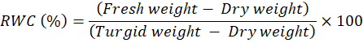
Electrolyte leakage or Membrane injury index (MlI)
Membrane injury was analysed using the method given in Sullivan et al., (1979).
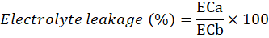
Malondialdehyde (MDA) content
MDA is a product of lipid peroxidation and was estimated by quantifying the amount of thiobarbituric acid reactive substances (TBARS) present in the reaction. The amount of MDA was measured by minor modifications in the method given by Heath & Packer (1968).
Chlorophyll content
Leaf discs (0.03 g) were washed, blotted dry and dipped in test tubes containing 3 ml of dimethyl sulfoxide (DMSO) overnight as described by Sawhney and Singh (2002). The extracted chlorophyll in DMSO was estimated by recording its absorbance at 663 nm (A₆₆₃) and 645 (A₆₄₅) nm respectively and its content was calculated using the formula:
Where, V - Volume of DMSO, A - Absorbance at specific wavelengths, W - Weight of tissue taken
Proline content
The proline content of cell free extract was estimated by the method given by Bates et al., (1973).
Total soluble sugar content (TSS)
Total soluble sugar content was determined using the method given by Yemm & Willis (1954) using anthrone reagent.
Catalase activity
The activity was estimated according to the procedure described by Aebi (1984). The reaction mixture in final volume of 3 ml, contained 0.1 M phosphate buffer (pH 7.0), 0.1 mM H₂O₂ and 100 μl of cell free extract. Reaction was initiated with the addition of H₂O₂ and enzyme activity was determined by following the degradation of H₂O₂ at 240 nm for 2 minutes. The enzyme activity was calculated using the extinction coefficient value of 39.4 mM⁻¹ cm⁻¹ for H₂O₂. One unit of enzyme activity corresponded to one mMol of H₂O₂ consumed per minute during the reaction.
Peroxidase activity
Peroxidase activity was estimated by following the method given by Siegel (1993). Three ml of reaction mixture contained 0.1 M phosphate buffer (pH 7.0), 0.1 mM guaiacol, 0.1 mM H₂O₂ and 100 μl cell free extract. Reaction was started with the addition of H₂O₂ and increase in absorbance at 470 nm was recorded for 2 min. The activity was calculated using the extinction coefficient value of 26.6 mM⁻¹ cm⁻¹ for guaiacol.
Statistical analysis
Data from the physio-biochemical analysis of the T₁ generation pigeon pea plants was analysed using two factorial CRD (Completely Randomized Design) test. Treatments, genotypes and interaction between treatments and genotypes were compared using critical difference (CD) at 5% level of significance with OPSTAT programme.
RESULTS AND DISCUSSION
Raising of T₁ generation
Seed yield of all the sixteen T₀ transgenic and non-transgenic plants was recorded. The average seed yield in non-transgenic plants was 4.04 g/plant. In case of transgenic plants, the seed yield ranged between 2.26g -8.30g/plant (Table 1). A total of six transgenic lines L-9 (4.89g); L-17 (5.76g); L-18 (8.3g); L-19 (6.43g); L-48 (7.34g) and L-89 (5.6g) were selected out of 16 T₀ transgenic pigeon pea lines based on their higher seed yield.
Table 1: Seed yield (g/plant) in T₀ WT and T plants
Sr. no. | Plant no. | Seed yield (g/plant)
1 | L-9 | 4.89
2 | L-13 | 4.78
3 | L-14 | 3.15
4 | L-16 | 3.56
5 | L-17 | 5.76
6 | L-18 | 8.30
7 | L-19 | 6.43
8 | L-26 | 2.52
9 | L-55 | 3.16
10 | L-48 | 7.34
11 | L-62 | 2.26
12 | L-66 | 3.47
13 | L-10 | 2.86
14 | L-89 | 5.60
15 | L-117 | 4.46
16 | L-118 | 3.88
17 | Wild type | 4.04
*CD. at 5% |  | 0.005

Screening of T₁ transgenic pigeon pea lines carrying OsLecRLK
T₁ generation was raised in the transgenic green house, from seeds collected from T₀ plants. Genomic DNA was isolated from the selected T₁ generation plants and subjected to PCR amplification using the OsLecRLK-specific primers. The PCR product was run on 1.7% agarose (w/v) gel electrophoresis. An amplicon size of 2.1 kb in T₁ generation pigeon pea plants and the positive control was observed (Figure 2A, B). No amplification was observed in the wild type plants. This confirmed the stable integration and inheritance of the transgene in the transgenic lines. Ten plants each from twelve T₁ lines were screened for presence of the transgene. Out of a total 120 plants screened, 54 plants were found to carry OsLecRLK gene in T₁ generation (Table 2).
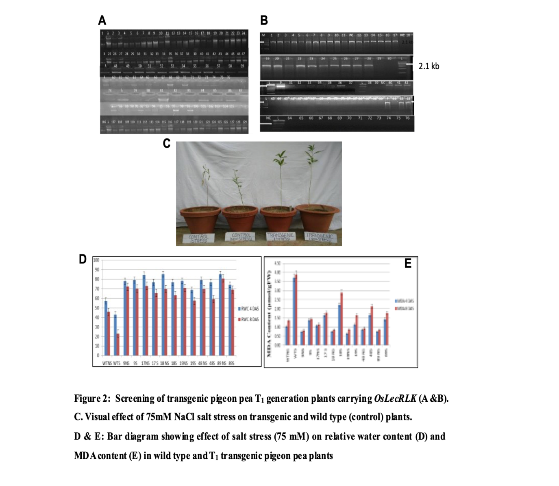
Figure 1. Screening of transgenic pigeon pea T₁ generation plants carrying OsLecRLK (A &B). Visual effect of 75mM NaCl salt stress on transgenic and wild type (control) plants ©. D & E: Bar diagram showing effect of salt stress (75 mM) on relative water content (D) and MDA content (E) in wild type and T₁ transgenic pigeon pea plants
Table 2: Screening of T₁ transgenic pigeon pea lines for presence of OsLecRLK gene
S. No. | Transgenic lines | No. of OsLecRLK positive plants
1 | L-9 | 6
2 | L-13 | 2
3 | L-14 | 4
4 | L-16 | 2
5 | L-17 | 6
6 | L-18 | 7
7 | L-19 | 8
8 | L-48 | 8
9 | L-66 | 1
10 | L-89 | 6
11 | L-117 | 2
12 | L-118 | 2
Total | 120 | 54

Physio-biochemical analysis of selected lines to evaluate transgene efficacy for salinity stress tolerance
Relative water content (RWC)
RWC dropped in both transgenic (T) and wild-type (WT) plants as the duration of the salt stress increased. However, at 4 and 8 days post salt treatment (DAS), greater RWC% was detected in the T lines compared to WT plants. On the fourth day, the RWC percentage was 42.86% in WT plants but 78.09, 76.71, 76.53, 68.80, 76.70, and 74.05 percent in T Lines L-9, L-17, L-18, L-19, L-48, and L-89, respectively. On the eighth day, RWC was found to be 23.08% in WT plants and in T lines a range of 57.49 to 69.88%. The percentage reduction in RWC from 4th to 8th day after 75 mM NaCl salt treatment was 46.2% in wild types while 6.66% to 23.2 % in T lines.
Electrolyte leakage or Membrane injury index (MlI)
Both transgenic and wild-type plants showed elevated membrane damage index or electrolyte leakage percentage. However, extent of membrane injury was much higher in WT plants as compared to T lines under stress conditions after 4 & 8 days of salt treatment. On 4th day MII ranged from 18.77- 28.3% in T lines whereas in WT it was recorded to be 40 %. In WT, it rose to 80.95% on the eighth day, whereas in T lines, it varied from 32.36% to 37.38%. Under no stress, MII was comparatively lower in the WT and T lines. Under salt stress, membrane injury increased by 102.4 percent for the WT, whereas the maximum membrane injury was seen for L-48, with a 99.36 percent rise from the 4th to the 8th DAS. On the other hand, L-17 and L-19 exhibited the least amount of membrane damage, increasing by 14.36% and 22.7 %, respectively under salt stress conditions.
Estimation of Malondialdehyde (MDA) content
Malondialdehyde content was found increased in WT and T lines. MDA content ranged between 0.75 µmol/g FW and 2.21 µmol/g FW in T lines and 3.71 µmol/g FW in WT 4 DAS. However, there was relatively low MDA content recorded in T lines and WT both 4 & 8 DAS, under control conditions. The same trend was recorded in WT and T lines 8 DAS. The MDA content increased to 3.89 µmol/g FW in WT and in T lines ranged from 0.82 - 2.89 µmol/g FW. L-19 had the minimum MDA content of 1.13 µmol/g FW and 1.64 µmol/g FW at 4 and 8 DAS respectively. The percentage increase in MDA content from 4th day to 8th day was found 4.86% to 30.52 % in T lines while 33.12 % in WT plants.

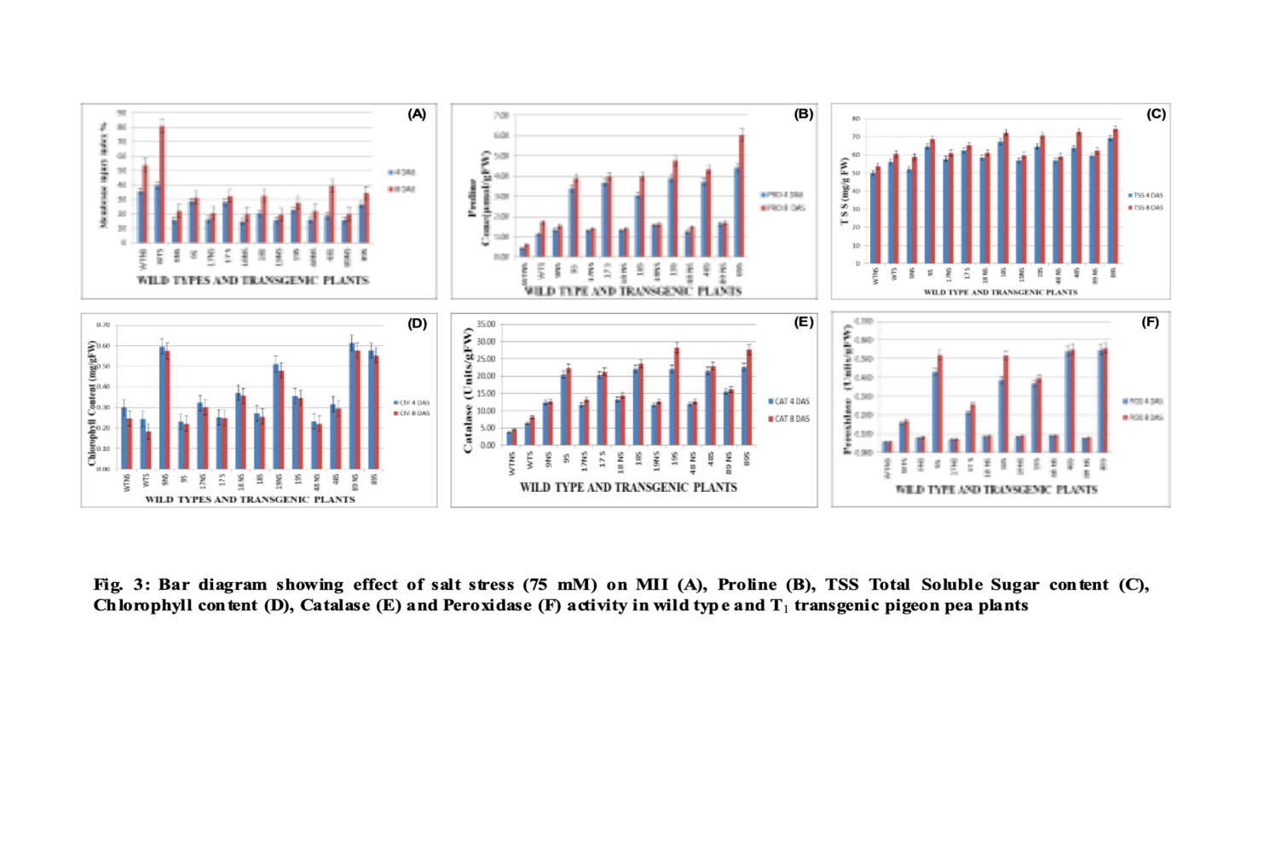
Figure 3. Bar diagram showing effect of salt stress (75 mM) on MII (A), Proline (B), TSS Total Soluble Sugar content (C), Chlorophyll content (D), Catalase (E) and Peroxidase (F) activity in wild type and T₁ transgenic pigeon pea plants
Proline content (μmole/g FW)
Under the 75 mM NaCl-induced salt stress, the proline level rose in the WT & T lines. Under control settings, the proline content in the WT & T lines was found to be quite low. On the other hand, a significant rise in proline content was noted in salt stress situations. On the fourth and eighth day following salt treatment, however, proline levels were greater than in the WT plants. Compared to WT (1.74 μmol/g FW), the proline level in T lines ranged from 14.5-36.86% (1.24 to 4.41 μmol/g FW) higher. After eight days of treatment, the T lines showed a similar trend in proline content. A 0.145-fold rise in proline content was seen in WT, but 2.45 to 4.33 fold increases (3.90-6.03 μmol/g) were observed in T lines.
Total soluble sugar (TSS) content (mg/g FW)
TSS increased in both T and WT plants under 75mM NaCl stress. Under no stress, relatively lesser TSS content was observed in both WT and T lines at 4 and 8 days after salt stress. T lines expressed higher TSS content (52.01 - 69.25 mg/g FW) as compared to the WT i.e. 56.03 mg/g FW on 4th day of salt stress. Similar trend was observed after 8 days of salt stress. In transgenic lines 4.13 % to 13.96 % (65.23 - 74.43 mg/g FW) increase in TSS was observed whereas, in wild type 8.21% (60.63 mg/g FW) increase in TSS content was observed. On 8th day, 70.69 mg/g FW TSS was recorded in L-19.
Total chlorophyll content (mg/g FW)
The total chlorophyll content was decreases in both WT as well as T lines. However, the content was relatively less in WT plants as compared to T lines. On 4th day 0.3 to 1.6-folds higher chlorophyll content was observed in T lines in comparison to WT plants. On the other hand, after 8 days of salt stress 0.2 to 2.19 folds’ higher chlorophyll content was observed in T lines in comparison to WT plants. From 4th to 8th day of salt stress 25.08 % reduction in chlorophyll content was observed in WT plants whereas in T lines it ranged from 2.79 to 6.18 %.
Catalase (CAT) activity (mM/min/g FW)
The catalase activity increased in both T and WT plants after 75 mM NaCl treatment. WT plants had an increase of 0.27 folds, whereas in T lines 0.8- 2.58-folds increase in catalase activity after 4 days of salt stress was observed. The trend remained same in both the T lines and WT even after 8 days of salt treatment. In WT there was a 0.28-folds increase and in T line 0.5-2.48 folds’ increase in catalase activity was observed. L-19 expressed the highest catalase activity with 28.20 enzyme units/g FW and L-9 had the lowest 22.31 enzyme units/g FW.
Peroxidase (POD) activity (mM/min/g F\W)
A similar trend was observed for peroxidase as in case of catalase activity. Peroxidase activity increased in both T and WT plants. Relatively lower peroxidase activity was observed in T and WT plants under control conditions. After 4 days of salt stress WT had an increase of 1.76 folds while, in T lines peroxidase activity increased from 2.06 to 6.25 folds. The trend remained same after 8 days of salt treatment i.e. in WT plants 1.8-fold increase was observed whereas, in T line 2.50 to 6.04 folds’ increase in peroxidase activity in comparison to the control plants was observed.

Visual observation during salt stress
After fifteen days of germination the six transgenic lines and wild type plants were exposed to 75 mM NaCl salt stress. During stress implementation both types of plants transgenic as well as wild type were visually observed for appearance of symptoms of salt stress. The transgenic plants were found greener and healthier than the wild type plants which died after 8 days of stress treatment (Fig. 1 C).
Relative water content is a physiological marker that may be used to analyze a plant's ability to retain water as well as its water status and osmotic changes in response to abiotic stress (Ravikumar et al. 2014). Higher salt concentrations deteriorate the interactions between water and plants, and as a result of the disrupted osmotic potential, plant relative water uptake is decreased. According to Rasool et al. (2013) and Isayenkov and Maathuis (2019), this causes drought-like symptoms and decreased stomatal conductance in plants and declines cell growth, therefore sufficient water content has to be maintained by plant cell for vital cellular functions such as photosynthesis (Egamberdieva et al., 2015). RWC decreased in both WT and T under salt stress, however the decrease was more noticeable in WT plants, indicating that the Transgenic lines might actually be able to hold onto more water in their tissues than WT when exposed to salt stress for longer periods of time. The results were found to be consistent with related transformation studies that showed improved water retention in transgenic crops, including tobacco (Yadav et al. 2012) pigeon pea (Surekha et al. 2014), tomato (Rai et al. 2013), potato overexpressing Ib MIPS 1 (Zhai et al., 2016), chilli expressing PDH45 (Shivakumara et al., 2017), rice expressing OsGS1 gene (James et al., 2018), and tobacco (Liu et al. 2008) for drought stress. Better water retention suggests improved osmotic stress adaptation, which leads to improved growth in transgenic pigeonpea plant. Additionally, the outcomes suggest that OsLecRLK was successful in fostering tolerance to the transgenic plants.
TSS act as an important osmolytes for maintaining cell homeostasis. Increase in TSS amount not only helps in maintaining the osmotic potential of the cell but also, enable water uptake by root cells under salt stress conditions (Rosa et al., 2009; Benzarti et al., 2014). Accumulation of soluble sugars also boosts proline content under salinity conditions. Proline also acts as crucial osmolytes which helps in osmoregulation and in scavenging of ROS by enhancing antioxidant activity under stressed conditions (Hayat et al., 2012; Ravikumar et al., 2014) and plays a critical role in preserving the osmotic equilibrium in crop plants, safeguarding cell organelles and enzymes (Surekha et al. 2014). In present investigation both TSS and proline content were found increased in transgenic and wild type plants under stressed conditions when compared to the control wild type plants. These results imply that increase in TSS and proline content is acting as osmoprotectant and help in countering stress. However, the rise in proline and TSS was significantly more in T plants under stress conditions. Similar results were observed in transgenic tobacco (Tuteja et al., 2014), alfalfa (Zhang et al., 2015), chrysanthemum (He et al., 2018), peanut (Banavath et al., 2018), soybean expressing WRKY11 (Wang et al., 2018) and pigeon pea (Singh et al. 2020).
Carbohydrates are essential for osmoprotection, osmotic adjustments and the scavenging of radical species under salt stress (Nemati et al. 2011 and Rasool et al. 2013). Increased photochemical activity that results in the production of ROS which in turn, harms cellular components, destroys chlorophyll and causes peroxidation of membrane lipids. By oxidative stress Chlorophyll synthesis is halted and its decomposition also starts. Low yields are marked by low photosynthesis, which is caused by less chlorophyll. Studies have shown that greater chlorophyll content positively increases the photosynthetic rate (Augustine et al. 2015), and the transgenic lines also maintained a higher chlorophyll content under salt stress conditions. This shows that the transformation has effectively managed the oxidative stress and that photosystem-II's photochemical activity has not been affected. Thus, it may be inferred that OsLecRLK gene modification can enhance the pigeon pea crops ability to produce higher yield under salinity stress. Our results also coincide with the study of Soni & Savalia, (2023) where they reported the elevated chlorophyll and proline contents in pigeon pea under salinity stress.
Higher levels of ROS cause cellular component dysfunction and subsequently cell destruction. The ROS concentration is controlled by plants through the synthesis of antioxidant enzymes. Under salt stress it’s difficult to control ROS, and a failure to scavenge could lead to subpar yields. T lines showed considerably increased catalase and peroxidase activity, demonstrating their capacity to scavenge ROS. In Arabidopsis (Zhao et al. 2017), peanut (Singh et al. 2014), and Sorghum bicolor (Anjaneyulu et al. 2014), pigeon pea (Neha, 2019) and chick pea (Kharb, 2022) improved catalase and peroxidase activity has been reported under salt stress, where the increased productivity led to effective management and scavenging of ROS.
The H₂O₂ accumulation causes oxidative damage to the plants and induces activation of ROS scavenging enzymes such as peroxidase and catalase. Catalase and peroxidise both are heme-containing enzymes that help in preventing oxidative damage by removal of H₂O_{2.} Peroxidase is a oxidizes certain substrate at the expense of H₂O₂ and get rid the cell of excess peroxide produced by metabolic processes under stressed conditions (Kaymakanova and Stoeva, 2008). In present study, under salt stress conditions, increase in peroxidase activity was recorded in both T and WT plants. Krishnamurthy and Rathinasabapathi, (2013) reported that increase in POD activity under salinity stress conditions implies that it acts as an intrinsic defense tool to encounter stress-induced oxidative damage in plants. Similar results of increased POD activity were reported in transgenic canola (Ashraf and Ali, 2008), transgenic peanut (Singh et al., 2014), transgenic alfalfa (Zhang et al., 2016), transgenic Physiolus (Taibi et al., 2016), transgenic mungbean (Patel et al., 2017) transgenic pigeon pea (Singh, 2018) and transgenic rice expressing pea LecRLK (Passricha et al. 2019a). Similarly, catalase prevents oxidative damage by catalysing breakdown of H₂O₂ into H₂O and O₂. Stressed conditions demand more energy expenditure and generation for cell that leads to increase catabolic reactions resulting in generation of H₂O₂, catalase helps in removal of H₂O₂ in an energy efficient way (Das and Roychoudhury, 2014). In present study, catalase activity was found increased in both WT and T plants under salt stress conditions. T lines extinguished more catalase activity in comparison to WT plants. Similar trends of increased catalase activity under stressed conditions were observed in poplar (Yang et al., 2015), Arabidopsis (Tamirisa et al., 2017), rice (Passricha et al., 2019).
Less membrane injury index and MDA content in the transgenic plants compared to WT pigeon pea plants provided additional evidence for reduced oxidative damage. MDA is a measure of membrane lipid peroxidation and is therefore regarded as a reliable sign of cellular damage brought on by oxidative stress. Better oxidative stress control and a decreased membrane damage index are achieved by lowering the MDA concentration. Thus, it may be concluded that the transgene OsLecRLK plays a crucial part in maintaining a decreased ROS concentration under salt stress conditions, reducing membrane damage in plants. According to comparable transformation research on pigeon pea, there was less membrane damage and MDA content (Surekha et al. 2014). The outcomes were found to be comparable to similar research on some other genetically modified plants eg. Pigeon pea (Singh et al. 2020), Tobacco (Yadav et al. 2012), Alfalfa (Tang et al. 2014;), apple (Li et al. 2015), cotton (Zhang et al. 2014) under salinity stress.
Conclusion:
The present study showed the role of OsLecRLK in alleviating salt stress as T lines exhibited better performance in terms of various physio-biochemical parameters under 75 mM salt stress over WT. T lines carrying single copy of gene performed better in comparison to lines carrying two copies of gene. While, T line with two copies of transgene performed better than WT but lower than T lines with single copy of transgene. Relative to earlier transformation research with pigeon pea, these transgenic plants show superior potential for commercial application in terms of sustainable agriculture. Line L-19 performed best in terms of various physio-biochemical parameters. Therefore, L-19 was found promising for salt tolerance and can be taken to next generation for further studies. However, more research is required to determine the exact mechanism by which OsLecRLK led to better physio-biochemical outcomes under salt stress. it is need to be elucidated regarding the part other osmolytes play in promoting tolerance in pigeon pea.
References:
Adams, E., & Shin, R. (2014). Transport, signaling, and homeostasis of potassium and sodium in plants. Journal of integrative plant biology, 56(3), 231-249.
Aebi, H. (1984). [13] Catalase in vitro. In Methods in enzymology (Vol. 105, pp. 121-126). Academic Press.
Anjaneyulu, E., Reddy, P. S., Sunita, M. S., Kishor, P. B. K. & Meriga, B. (2014). Salt tolerance and activity of antioxidative enzymes of transgenic finger millet overexpressing a vacuolar H⁺-pyrophosphatase gene (SbVPPase) from Sorghum bicolor. Journal of plant physiology, 171(10), 789-798.
Ashraf, M., & Ali, Q. (2008). Relative membrane permeability and activities of some antioxidant enzymes as the key determinants of salt tolerance in canola (Brassica napus L.). Environmental and Experimental Botany, 63(1-3), 266-273.
Augustine, S. M., Narayan, J. A., Syamaladevi, D. P., Appunu, C., Chakravarthi, M., Ravichandran, V. and Subramonian, N. (2015). Erianthus arundinaceus HSP70 (EaHSP70) overexpression increases drought and salinity tolerance in sugarcane (Saccharum spp. hybrid). Plant Science, 232, 23-34.
Banavath, J. N., Chakradhar, T., Pandit, V., Konduru, S., Guduru, K. K., Akila, C. S., Podha, S. Puli, C. O. R. (2018). Stress inducible overexpression of AtHDG11 leads to improved drought and salt stress tolerance in peanut (Arachis hypogaea L.). Frontiers in Chemistry, 6, 34: 1-22. doi:10.3389/fchem.2018.00034
Bates, L. S., Waldren, R. P., & Teare, I. D. (1973). Rapid determination of free proline for water-stress studies. Plant and soil, 39(1), 205-207.
Benzarti, M., Rejeb, K. Ben, Messedi, D., Mna, A. Ben, Hessini, K., Ksontini, M., Abdelly, C. & Debez, A. (2014). Effect of high salinity on Atriplex portulacoides: Growth, leaf water relations and solute accumulation in relation with osmotic adjustment. South African Journal of Botany, 95, 70–77. doi:10.1016/j.sajb.2014.08.009
Das, K., & Roychoudhury, A. (2014). Reactive oxygen species (ROS) and response of antioxidants as ROS-scavengers during environmental stress in plants. Frontiers in Environmental Science, 2, 53.
DES, MoAF&W, 2022, fourth advanced estimates: https://iipr.icar.gov.in/pigeonpea-crop/
Egamberdieva, D., Abeer, H., Abd_Allah, E. F., &. Alqarawi, A. A. (2015). Induction of salt stress tolerance in cowpea [Vigna unguiculata (L.) Walp.] by arbuscular mycorrhizal fungi. Legume Research: An International Journal, 38(5), 579-588.
Hayat, S., Hayat, Q., Alyemeni, M. N., Wani, A. S., Pichtel, J., & Ahmad, A. (2012). Role of proline under changing environments: a review. Plant signaling & behavior, 7(11), 1456-1466.
He, L., Wu, Y., Zhao, Q., Wang, B., Liu, L. Q. & Zhang, L. (2018). Chrysanthemum DgWRKY2 Gene Enhances Tolerance to Salt Stress in Transgenic Chrysanthemum. Int J Mol Sci. 19(7): 2062.doi: 10.3390/ijms19072062.
Heath, R. L., & Packer, L. (1968). Photoperoxidation in isolated chloroplasts: I. Kinetics and stoichiometry of fatty acid peroxidation. Archives of biochemistry and biophysics, 125(1), 189-198.
Horie, T., Hauser, F., & Schroeder, J. I. (2009). HKT transporter-mediated salinity resistance mechanisms in Arabidopsis and monocot crop plants. Trends in plant science, 14(12), 660-668.
https://iipr.icar.gov.in/pigeonpea-crop/
https://www.tridge.com/intelligences/pigeon-pea/production
Isayenkov, S. V. and Maathuis, F. J. (2019). Plant salinity stress: many unanswered questions remain. Frontiers in plant science, 10, 80. https://doi.org/10.3389/fpls.2019.00080
James, D., Borphukan, B., Fartyal, D., Ram, B., Singh, J., Manna, M., ... & Reddy, M. K. (2018). Concurrent overexpression of OsGS1; 1 and OsGS2 genes in transgenic rice (Oryza sativa L.): impact on tolerance to abiotic stresses. Frontiers in Plant Science, 9, 307492.
Kassa, M. T., Penmetsa, R. V., Carrasquilla-Garcia, N., Sarma, B. K., Datta, S., Upadhyaya, H. D., ... & Cook, D. R. (2012). Genetic patterns of domestication in pigeonpea (Cajanus cajan (L.) Millsp.) and wild Cajanus relatives. PloS one, 7(6), e39563.
Kaymakanova, M. & Stoeva, N. (2008). Physiological reaction of bean plants (Phaseolus vulgaris L.) to salt stress. General and Applied Plant Physiology 34, 177.
Kharb, P. (2022). Engineering chickpea variety HC-1 with OsRuvB gene for salt stress tolerance. Legume Research-An International Journal, 45(2), 168-173.
Krishnamurthy, A. & Rathinasabapathi, B. (2013). Oxidative stress tolerance in plants: novel interplay between auxin and reactive oxygen species signaling. Plant Signaling & Behavior, 8(10), e25761. doi: 10.4161/psb.25761.
Li, H., Wan, Y., Wang, M., Han, M. and Huo, X. (2015). History, status and prospects of the apple industry in China. J. Am. Pomol. Soc, 69, pp.174-185.
Liu, J., Ishitani, M., Halfter, U., Kim, C. S., & Zhu, J. K. (2000). The Arabidopsis thaliana SOS2 gene encodes a protein kinase that is required for salt tolerance. Proceedings of the national academy of sciences, 97(7), 3730-3734.
Liu, X., Hua, X., Guo, J., Qi, D., Wang, L., Liu, Z., ... & Liu, G. (2008). Enhanced tolerance to drought stress in transgenic tobacco plants overexpressing VTE1 for increased tocopherol production from Arabidopsis thaliana. Biotechnology letters, 30(7), 1275-1280.
Mula, M. G., & Saxena, K. B. (2010). Lifting the level of awareness on pigeonpea-a global perspective. International Crops Research Institute for the Semi-Arid Tropics, Patancheru. ISBN 9789290665359.
Neha, K. P. (2019). Psp68, a dead box helicase confers salinity tolerance in transgenic pigeon pea. Int J Curr Microbiol App Sci, 8(4), 309-324.
Nemati, K., Bakar, N. K. A., Abas, M. R. & Sobhanzadeh, E. (2011). Speciation of heavy metals by modified BCR sequential extraction procedure in different depths of sediments from Sungai Buloh, Selangor, Malaysia. Journal of hazardous materials, 192(1), 402-410.
Passricha, N., Saifi, S. K., Gill, S. S., Tuteja, R., & Tuteja, N. (2019a). Role of plant helicases in imparting salinity stress tolerance to plants. In Helicases from all domains of life (pp. 39-52). Academic Press.
Passricha, N., Saifi, S. K., Kharb, P., & Tuteja, N. (2019). Marker-free transgenic rice plant overexpressing pea LecRLK imparts salinity tolerance by inhibiting sodium accumulation. Plant molecular biology, 99(3), 265-281.
Patel, M. K., Pottosin, I., Kumar, S., Kalita, A., Srivastava, R. & Sahoo, L. (2017). Co-expression of Arabidopsis NHX1 and bar improves the tolerance to salinity, oxidative stress, and herbicide in transgenic mungbean, Frontiers in Plant Sciences, 8, 1-18. doi:10.3389/fpls.2017.01896.
Rai, A. C., Singh, M., & Shah, K. (2013). Engineering drought tolerant tomato plants over-expressing BcZAT12 gene encoding a C2H2 zinc finger transcription factor. Phytochemistry, 85, 44-50.
Rasool, S., Hameed, A., Azooz, M. M., Muneeb-u-Rehman, Siddiqi, T. O. and Ahmad, P. (2013). Salt stress: causes, types and responses of plants. In P. Ahmad, M. M. Azooz, M. N. V. Prasad (Eds.), Ecophysiology and responses of plants under salt stress (pp.1-24). Springer: New York, NY, USA.
Ravikumar, G., Manimaran, P., Voleti, S. R., Subrahmanyam, D., Sundaram, R. M., Bansal, K. C., ... & Balachandran, S. M. (2014). Stress-inducible expression of AtDREB1A transcription factor greatly improves drought stress tolerance in transgenic indica rice. Transgenic research, 23(3), 421-439.
Rosa, M., Prado, C., Podazza, G., Interdonato, R., González, J. A., Hilal, M., & Prado E. F. (2009). Soluble sugars Metabolism, sensing and abiotic stress. Plant Signal Behav. 4(5), 388–393.doi: 10.4161/psb.4.5.8294.
Sairam, R. K., Kumutha, D., Ezhilmathi, K., Chinnusamy, V. & Meena, R. C. (2009). Waterlogging induced oxidative stress and antioxidant enzyme activities in pigeon pea. Biologia Plantarum, 53, 493-504.
Sawhney, V., & Singh, D. P. (2002). Effect of chemical desiccation at the post-anthesis stage on some physiological and biochemical changes in the flag leaf of contrasting wheat genotypes. Field Crops Research, 77(1), 1-6.
Shi, H., & Zhu, J. K. (2002). SOS4, a pyridoxal kinase gene, is required for root hair development in Arabidopsis. Plant Physiology, 129(2), 585-593.
Shivakumara, T. N., Sreevathsa, R., Dash, P. K., Sheshshayee, M. S., Papolu, P. K., Rao, U., Tuteja, N. & Udaya Kumar, M. (2017). Overexpression of Pea DNA Helicase 45 (PDH45) imparts tolerance to multiple abiotic stresses in chili (Capsicum annuum L.). Scientific Reports, 7(1), 1-12. doi:10.1038/s41598-017-02589-0.
Siegel, B. Z. (1993). Plant peroxidases—an organismic perspective. Plant growth regulation, 12(3), 303-312.
Singh, N., Mishra, A. & Jha, B. (2014). Ectopic over-expression of peroxisomal ascorbate peroxidase (SbpAPX) gene confers salt stress tolerance in transgenic peanut (Arachis hypogaea). Gene, 547(1), 119–125. doi:10.1016/j.gene.2014.06.037.
Singh, N., Rai, V. & Singh, N.K. (2020). Multi-omics strategies and prospects to enhance seed quality and nutritional traits in pigeonpea. The Nucleus, 63(3), 249-256.
Singh, R. (2018). Development and characterization of transgenic pigeon pea (Cajnus cajan L.) plants with OsRuvB gene for salinity tolerance. Ph.D. Thesis submitted to CCS Haryana Agricultural University, Hisar.
Smart, R. E., & Bingham, G. E. (1974). Rapid estimates of relative water content. Plant physiology, 53(2), 258-260.
Soni, G., & Savalia, D. (2023, June). Effect of simulated soil salinity conditions and varieties of pigeon pea (Cajanus cajan L.) on growth, yield and yield attributes. In: Soils, where food begins: Proceedings of the Global Symposium on soils for nutrition, 26–29 July 2022 (p. 57). Food & Agriculture Org..
Sullivan, C. Y., Ross, W. M., Mussell, H., & Staples, R. C. (1979). Stress physiology in crop plants. Boyce Thompson Inst., Cornell Univ., Ithaca, NY 14853, USA.
Surekha, C. H., Kumari, K. N., Aruna, L. V., Suneetha, G., Arundhati, A., & Kishor, P. K. (2014). Expression of the Vigna aconitifolia P5CSF129A gene in transgenic pigeonpea enhances proline accumulation and salt tolerance. Plant Cell, Tissue and Organ Culture (PCTOC), 116(1), 27-36.
Taibi, K., Taibi, F., Ait Abderrahim, L., Ennajah, A., Belkhodja, M. & Mulet, J. M. (2016). Effect of salt stress on growth, chlorophyll content, lipid peroxidation and antioxidant defence systems in Phaseolus vulgaris L. South African Journal of Botany, 105, 306–312.doi:10.1016/ J.SAJB.2016.03.011.
Tamirisa, S., Vudem, D. R., & Khareedu, V. R. (2017). A cyclin dependent kinase regulatory subunit (CKS) gene of pigeonpea imparts abiotic stress tolerance and regulates plant growth and development in Arabidopsis. Frontiers in plant science, 8, 165.
Tang, L., Cai, H., Zhai, H., Luo, X., Wang, Z., Cui, L. & Bai, X. (2014). Overexpression of Glycine soja WRKY20 enhances both drought and salt tolerance in transgenic alfalfa (Medicago sativa L.). Plant Cell, Tissue and Organ Culture, 118(1), 77–86. doi:10.1007/s11240-014-0463-y.
Tuteja, N., Banu, M. S. A., Huda, K. M. K., Gill, S. S., Jain, P., Pham, X. H., & Tuteja, R. (2014). Pea p68, a DEAD-box helicase, provides salinity stress tolerance in transgenic tobacco by reducing oxidative stress and improving photosynthesis machinery. PloS one, 9(5), e98287.
Wang, Y., Jiang, L., Chen, J., Tao, L., An, Y., Cai, H. & Guo, C. (2018). Overexpression of the alfalfa WRKY11 gene enhances salt tolerance in soybean. PLOS ONE, 13(2), e0192382. doi:10.1371/ journal.pone.0192382.
Yadav, N.S., Shukla, P.S., Jha, A., Agarwal, P.K. and Jha, B. (2012). The SbSOS1 gene from the extreme halophyte Salicornia brachiata enhances Na⁺ loading in xylem and confers salt tolerance in transgenic tobacco. BMC plant biology, 12, 1-18.
Yang, Y., Tang, R. J., Jiang, C. M., Li, B., Kang, T., Liu, H., Zhao, N., Ma, X. J., Yang, L., Chen, S. L. & Zhang, H. X. (2015). Overexpression of the PtSOS2 gene improves tolerance to salt stress in transgenic poplar plants. Plant Biotechnology Journal, 13(7), 962–973. doi:10.1111/pbi.12335.
Yemm, E. W. & Willis, A. J. (1954). The estimation of carbohydrates in plant extracts by anthrone. The Biochemical Journal, 57(3), 508–14.
Zhai, H., Wang, F., Si, Z., Huo, J., Xing, L., An, Y., ... & Liu, Q. (2016). A myo‐inositol‐1‐phosphate synthase gene, Ib MIPS 1, enhances salt and drought tolerance and stem nematode resistance in transgenic sweet potato. Plant biotechnology journal, 14(2), 592-602.
Zhang, J., Duan, Z., Zhang, D., Zhang, J., Di, H., Wu, F., & Wang, Y. (2016). Co-transforming bar and CsLEA enhanced tolerance to drought and salt stress in transgenic alfalfa (Medicago sativa L.). Biochemical and biophysical research communications, 472(1), 75-82.
Zhang, L., Ma, H., Chen, T., Pen, J., Yu, S. and Zhao, X. (2014). Morphological and physiological responses of cotton (Gossypium hirsutum L.) plants to salinity. PLoS One, 9(11), p.e112807.
Zhang, P., Zhang, Z., Wang, J., Cong, B., Chen, K., & Liu, S. (2015). A novel receptor-like kinase (PnRLK-1) from the Antarctic moss Pohlia nutans enhances salt and oxidative stress tolerance. Plant molecular biology reporter, 33(4), 1156-1170.
Zhao, X., Wei, P., Liu, Z., Yu, B., & Shi, H. (2017). Soybean Na+/H+ antiporter GmsSOS1 enhances antioxidant enzyme activity and reduces Na⁺ accumulation in Arabidopsis and yeast cells under salt stress. Acta physiologiae plantarum, 39(1), 19.

