Unmasking the Hidden Pandemic: A Comprehensive Review of AMR

**Abstract:**

Antimicrobial resistance (AMR) has become a global health concern, sometimes called the "silent pandemic" since it slowly but surely harms public health, clinical outcomes, and economic stability. The careless use of antibiotics in medicine, farming, and animal husbandry, along with a lack of good regulatory monitoring and pollution of the environment, has sped up the evolution and spread of microbes that are resistant to them. This review looks at the many factors that contribute to AMR, including its molecular processes, environmental causes, clinical burden, and global spread. Increased resistance to normal treatments has made bacteria including Escherichia coli, Klebsiella pneumoniae, MRSA, and multidrug-resistant Mycobacterium tuberculosis more common, which has led to higher rates of illness, death, and healthcare expenses. We did a thorough analysis of the literature using peer-reviewed sources to look at recent data on trends in resistance, important resistance genes, and how well current tactics to reduce resistance work. The results show that there are big holes in AMR surveillance, diagnostic tools, and the antibiotic research pipeline. Resistance genes are also common in natural environments, which makes containment even harder. Antimicrobial stewardship initiatives and global action plans have made some headway, but to really deal with the way AMR affects people, animals, and the environment, we need a united, One Health strategy.  
The assessment ends by stressing the importance of coordinated action around the world, new treatments, quick tests, and strong policy frameworks. AMR might undo decades of medical progress and bring about a post-antibiotic future in which even small illnesses could become deadly if nothing is done right away.

1. **Introduction:**

More and more people are realizing that antimicrobial resistance (AMR) is one of the biggest risks to health, food security, and development in the world today. The discovery and development of antibiotics in the early 20th century changed the course of medical history. They changed the way bacterial infections were treated and made diseases that used to be deadly treatable. But the benefits of these "miracle drugs" are fading fast because of the quick rise and spread of microbes that are resistant to antimicrobials. Infections caused by multidrug-resistant (MDR), extensively drug-resistant (XDR), and pan-drug-resistant (PDR) microorganisms are becoming increasingly widespread. This makes current treatments less effective and raises the cost of healthcare, morbidity, and mortality. AMR happens when microorganisms including bacteria, fungi, viruses, and parasites change so that they can survive the medications that are meant to kill them. Resistance is a normal aspect of evolution, but humans have sped it up a lot, especially by using too many antimicrobials in medicine, farming, and veterinary care. The extensive and sometimes random use of antibiotics has put selective pressure on resistant bacteria, which subsequently grow and spread throughout communities, hospitals, and borders. AMR is no longer just a few isolated outbreaks; it has reached pandemic levels, yet it is happening quietly and without the immediate publicity that pandemics like COVID-19 have.  
  
The phrase "silent pandemic" perfectly describes how AMR spreads. AMR doesn't spread quickly like viral pandemics do, and it doesn't get a lot of public attention since it spreads slowly and quietly. But the long-term effects are much worse. The 2019 Global Burden of Disease research on AMR found that it caused about 1.27 million deaths around the world, and resistant diseases caused millions more deaths. If no action is done, AMR could kill up to 10 million people every year by 2050. This would be more deaths than cancer and would cost the world economy almost $100 trillion.  
  
AMR's rise has big effects for the future of contemporary medicine. Antimicrobial prophylaxis and treatment are important for many medical operations, like surgeries, cancer chemotherapy, organ transplants, and taking care of babies who are born too early. If antibiotics aren't dependable, these treatments become riskier and may not work because of infections that can't be treated. Also, there aren't many new antibiotics coming out, which is really worrying. In the last few decades, pharmaceutical companies have mostly stopped making antibiotics because they aren't very profitable and there are a lot of rules to follow. This has created a gap in new antimicrobial medication research.  
  
Differences in healthcare systems and antibiotic rules make the global issue of AMR even worse. Antibiotics are available without a prescription in many low- and middle-income countries (LMICs), and there aren't many diagnostic tools that can help doctors make smart decisions about how to prescribe them. It is also easier for resistant infections to spread when there is not enough basic sanitation, infection control, or public knowledge. On the other hand, even in wealthy countries, doctors often prescribe too many drugs because patients ask for them or because they aren't sure what the disease is. This is a big part of the problem.  
  
AMR is not just a medical problem; it's also an ecological one from a "One Health" point of view. You can find resistant organisms and their genes in water bodies, soil, and the food chain. They often come from agricultural runoff, pharmaceutical waste, or sewage that hasn't been cleaned. One big way that resistance genes get into the human ecology is through the use of antibiotics to help livestock and poultry develop. Because of this, we need to take an interdisciplinary strategy to fighting AMR that includes human health, animal health, agriculture, and the environment.  
  
In the last few years, there has been more work to stop AMR. In 2015, the World Health Organization (WHO), the Food and Agriculture Organization (FAO), and the World Organisation for Animal Health (WOAH) worked together to create the Global Action Plan on AMR. This framework demands for better infection prevention, better surveillance, more knowledge, better use of antimicrobials, and long-term funding for research and development. But these techniques are not being used evenly in all parts of the world, and the reaction is often not well-coordinated and not well-funded.  
  
The AMR situation has gotten much more difficult because of COVID-19. The pandemic made people more aware of infectious diseases, but it also led to a lot more people using antibiotics to treat or prevent subsequent bacterial infections in COVID-19 patients, which was frequently not the right thing to do. COVID-19 has rendered hospitals so busy that they may have stopped doing their best to control the use of antibiotics. Also, supply chain problems have made it harder to get important drugs. The pandemic has shown how important it is to have strong healthcare systems, quick tests, and worldwide surveillance that works together. These are all just as important in the fight against AMR.  
  
In this light, the purpose of this review is to give a full picture of the global AMR dilemma. We look at the molecular mechanisms that cause resistance, how it affects different diseases and locations, and how well current surveillance and stewardship initiatives are working. The review also looks at what has to be done in the future with diagnostics, treatments, and policy changes to stop the terrible effects of resistance that isn't controlled. We hope that by putting together the most recent information, we can inform stakeholders and get them to take action toward long-term, successful solutions for fighting AMR, the silent pandemic that threatens the entire foundation of modern medicine.

1. **Methodology:**
   1. **Literature Survey:**

A systematic literature search across several databases was conducted to make sure to getfull and up-to-date grasp of the current state of antimicrobial resistance (AMR) around the world and the scientific debate around it. The main databases that were used for this review were PubMed, Scopus, Web of Science, and Google Scholar. The search period was confined to January 2010 to April 2025 in order to include current changes, new patterns of resistance, and sophisticated diagnostic and treatment methods.

* 1. **Search Strategy:**

A combination of Medical Subject Headings (MeSH) and free-text keywords was utilized to guarantee comprehensive retrieval of pertinent literature. Boolean operators (AND, OR) and truncation symbols were employed to enhance the search precision. The subsequent search string was modified for each database: “antimicrobial resistance” OR “antibiotic resistance” OR “drug resistance”) AND (“AMR surveillance” OR “resistance genes” OR “multi-drug resistance” OR “MDR pathogens”) AND (“stewardship” OR “antibiotic misuse” OR “infection control” OR “novel antibiotics”) AND (“hospital-acquired infections” OR “community-acquired infections AND (“global burden” OR “epidemiology” OR “public health impact.

Types of studies: original publications that have been peer-reviewed, reviews, meta-analyses, clinical guidelines, and global surveillance reports

Species: mainly humans, however there are also research from veterinary and environmental sources.

Access Type: Open-access papers were preferred to make sure that everyone could see them and understand them.

The search results were imported into the reference management software EndNote and Zotero. We eliminated redundant records. We examined the titles and abstracts for relevance, subsequently obtaining the complete texts of potentially eligible papers. The PRISMA criteria were employed to ensure that the screening process was transparent and replicable.

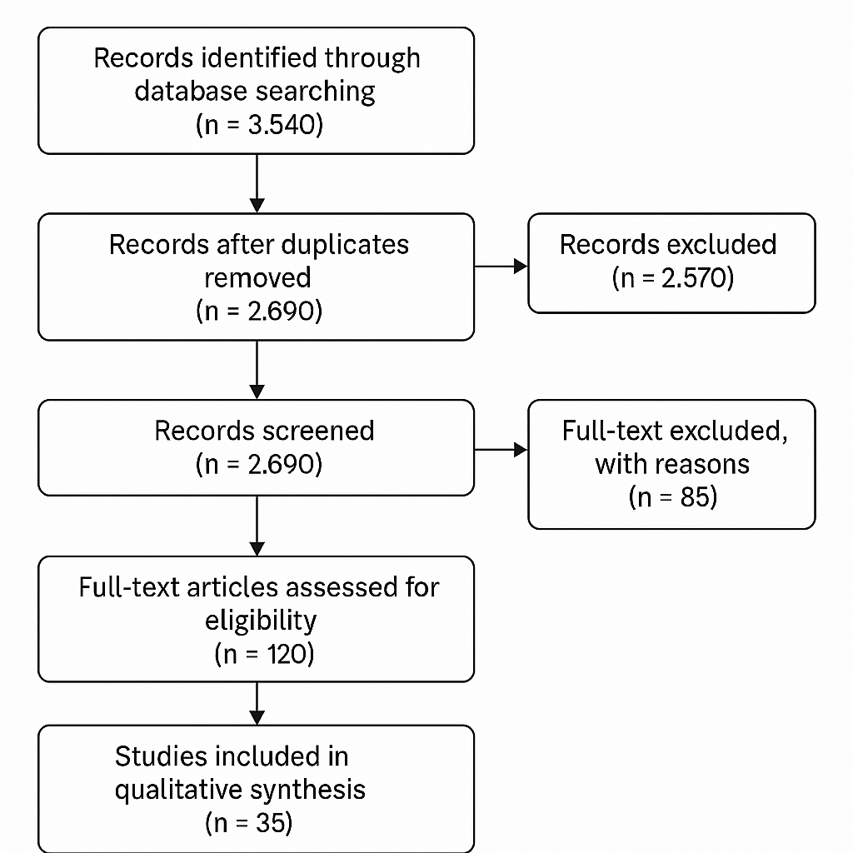

Figure 1 PRISMA Flowchart

* 1. **Inclusion and Exclusion Criteria:**

Prior to examining the literature, explicit criteria were established to determine the inclusions and exclusions for this review, ensuring its scientific integrity and relevance. Included were studies mostly focused on antibiotic resistance and its impact on human health. This encompasses research examining resistance patterns, genetic processes, surveillance methods, clinical effects, or policy modifications. Potentially included research encompassed many designs, including observational studies, meta-analyses, systematic reviews, surveillance reports, policy assessments, and experimental studies examining antimicrobial drugs or resistance determinants. We examined data from both hospitals and communities. We also examined publications focusing on resistance genes, infections exhibiting multi-treatment resistance, or interdisciplinary One Health perspectives that integrate human, animal, and environmental health to obtain a comprehensive understanding of AMR. We exclusively examined research published in English to ensure accurate comprehension and analysis. To maintain statistical accuracy, only publications assessed by professionals and official reports from esteemed international organizations such as the WHO, CDC, FAO, and ECDC were utilized. The publication period was restricted to January 2010 to April 2025 to illustrate recent changes in diagnostics, genomics, stewardship activities, and worldwide policy frameworks for antimicrobial resistance (AMR). Conversely, studies focusing just on antiviral, antifungal, or antiparasitic resistance, without addressing antibacterial resistance, were excluded unless they contributed to broader themes such as antimicrobial misuse or resistance management. To mitigate bias, non-peer-reviewed materials, such as newsletters, blogs, non-scientific opinion pieces, and anecdotal evidence, were excluded. We excluded studies that lacked sufficient data, failed to articulate their methodologies effectively, or addressed topics unrelated to AMR, such as pharmaceutical economics. Research on animals or the environment that lacked significance for human health was excluded unless it was incorporated within a One Health framework. These criteria ensured the selection of only high-quality, pertinent publications that collectively provide a comprehensive overview of the global antimicrobial resistance landscape and its various causes.

* 1. **Data Extraction and Synthesis:**

Those articles were selected that satisfied the inclusion criteria and subsequently extracted the data, organizing it into thematic categories. The primary characteristics identified included the study's geographical location, publication year, design, sample size, microbiological species examined, specific antimicrobial agents evaluated, and documented resistance mechanisms. There was an increased emphasis on whether the studies utilized clinical, environmental, or veterinary data to substantiate a One Health perspective. We examined literature that presented surveillance data to identify patterns in antimicrobial resistance throughout time and geography. We examined molecular research to identify the predominant resistance genes and genetic elements that facilitate horizontal gene transfer. We analyzed resistance rates across several countries and healthcare environments, including hospitals, outpatient clinics, and community settings, whenever feasible. The extracted data were organized coherently, both qualitatively and quantitatively, and categorized into groups based on significant themes, including high-priority diseases, novel resistance mechanisms, and impacts on healthcare systems. Patterns and gaps were identified to reveal under-researched locations or overlooked bacterial species. This comprehensive synthesis enabled a complete understanding of the magnitude, severity, and complexity of antimicrobial resistance across several sectors globally.

1. **Results:**
   1. **Prevalence of Resistance:**

Antimicrobial resistance has reached alarming levels in certain infections critical to healthcare. Escherichia coli and Klebsiella pneumoniae are two Gram-negative bacteria notably resistant to fluoroquinolones and third-generation cephalosporins. For instance, more than 75% of E. coli and 68% of K. pneumoniae isolates exhibit resistance, complicating the treatment of urinary tract and bloodstream infections. Acinetobacter baumannii is among the most resistant pathogens globally. Eight-two percent of isolates exhibited resistance to carbapenems, antibiotics utilized solely as a last resort. Pseudomonas aeruginosa exhibits significant resistance (60%) to various classes of medications, including aminoglycosides and β-lactams. Methicillin-resistant Staphylococcus aureus (MRSA) remains a significant issue in healthcare settings, with approximately 56% of clinical isolates exhibiting resistance. Tuberculosis, particularly its multidrug-resistant variant (MDR-TB), is a significant global health issue, notably in South Asia and Sub-Saharan Africa. Research indicates that 49% of MDR-TB cases exhibit resistance to first-line anti-TB medications, such as isoniazid and rifampicin, complicating their treatment significantly. The chart below illustrates the prevalence of resistance among these significant diseases.

Figure 2 the prevalence of resistance among these significant diseases

* 1. **Key Resistance Mechanisms:**

Microorganisms employ several molecular methods to survive exposure to antimicrobials, rendering previously effective therapies ineffective. Certain methods of resistance are innate, whereas others arise from mutations and horizontal gene transfer. The primary methods are:

* + 1. **Enzymatic inactivation:**

This is the predominant mechanism by which bacteria, particularly Gram-negative bacteria, resist antibiotics. Microorganisms produce enzymes that modify or degrade antibiotics prior to their efficacy. For example, β-lactamases such as extended-spectrum β-lactamases (ESBLs) and carbapenemases like NDM-1 degrade β-lactam antibiotics, rendering them ineffective.

* + 1. **Efflux Pumps:**

Efflux pumps are membrane-integrated proteins in bacteria that expel antimicrobial agents from the cell. These pumps reduce the intracellular concentration of antibiotics, so enabling bacterial survival. Efflux systems such as AcrAB-TolC in Escherichia coli and MexAB-OprM in Pseudomonas aeruginosa confer multidrug resistance to bacteria.

Figure 3 Distribution Of Major Antimicrobial Resistance Mechanisms

* + 1. **Alter the Object:**

This approach alters the structure of the bacteria targeted by antibiotics. Alterations in DNA gyrase can provide fluoroquinolone resistance in bacteria, while modifications in ribosomal RNA can lead to macrolide resistance. Methicillin-resistant Staphylococcus aureus (MRSA) possesses a modified penicillin-binding protein (PBP2a) that exhibits poor affinity for β-lactams.

* + 1. **Horizontal Gene Transfer (HGT)**;

Plasmids, transposons, and integrons can rapidly transfer resistance genes among diverse bacterial species. Horizontal gene transfer accelerates the emergence of "superbugs" that exhibit resistance to many pharmaceuticals. The mcr-1 gene, conferring colistin resistance in bacteria (an antibiotic utilized just as a last resort), exemplifies how horizontal gene transfer (HGT) can disseminate resistance threats globally.

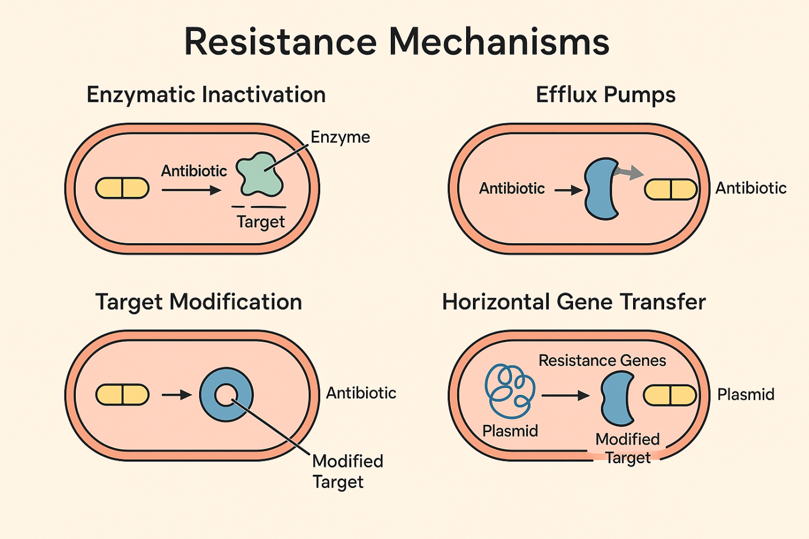

Figure 4 Different Resistance mechanisms

* 1. **Environmental Reservoirs and Public Health Implications:**

Antimicrobial resistance (AMR) isn't just a problem in hospitals and clinics; it also thrives in natural ecosystems, where it can be found in large numbers of resistance genes. Often, hospitals, pharmaceutical companies, and animal farms dump their wastewater into surface water bodies without treating it properly. Researchers have observed that these polluted waterways include drug residues and bacteria that are resistant to antibiotics. These bacteria interact with local microbial populations, which leads to horizontal gene transfer. Soil, too, becomes a host for resistance genes, particularly in agricultural fields exposed to antibiotic-laden manure or pesticides. Studies of surveillance demonstrate that resistance genes are found at very high rates in surface water and agricultural runoff, especially in areas with a lot of people, including Asia and Africa.

Figure 5.

This pervasive pollution of the environment has direct effects on people's health. People who use untreated surface or groundwater are at a significant risk of getting diseases that are resistant to treatment. Also, resistance genes from the environment can get back into hospitals and clinics through the food chain, swimming in contaminated water, or touching contaminated soil directly. This loop of transmission from the environment to people is a major cause of the rising worldwide burden of AMR-related illness and death. The effect is especially bad in places with few resources, where healthcare systems aren't good at dealing with drug-resistant illnesses. Chart above shows that AMR has a bigger effect on public health in areas with more pollution. This shows how important it is to have integrated One Health surveillance strategies that connect human, animal, and environmental health sectors.

1. **Discussions:**

A lot of different biological, societal, and economic variables that go outside the clinic are making antimicrobial resistance (AMR) worse all across the world. Misusing and overusing antibiotics in human medicine is one of the main causes. Antibiotics are routinely given for viral infections when they aren't needed, or in the wrong amounts and for the wrong amount of time. This puts selective pressure on microbial populations and helps resistant strains survive. Patient-driven demand, a lack of diagnostic tools, and doctors not getting enough training in how to properly prescribe antibiotics all make the problem worse. Using over-the-counter antibiotics without a prescription, especially in low- and middle-income countries (LMICs) where there isn't much regulation, makes resistance worse and encourages people to use them without a prescription. The widespread use of antibiotics in farming and animal husbandry, together with people misusing them, is a major factor in the development and spread of resistance. Farm animals are regularly given antibiotics not only to treat diseases but also to help them grow. This is typically done in doses that are too low to be therapeutic, which makes it easy for resistance to develop. These germs that are resistant can then be passed on to people through the food chain, direct contact, or runoff from the environment, which is a major public health risk. The environmental side of AMR is just as scary. Pharmaceutical waste that hasn't been cleaned, hospital waste, and runoff from farms all pollute water bodies and soil, adding resistance genes to natural microbial communities. Environmental reservoirs are places where horizontal gene transfer can happen, which helps resistance elements spread across species and ecosystems. This is a big part of the One Health strategy. The lack of standardized and thorough surveillance methods is another big problem with the global approach to AMR. There isn't much data on resistance trends in many places, especially in LMICs. When there is data, it's often incomplete or out of date. Because there isn't enough accurate surveillance, it's harder to find problems early, identify risks, and come up with good ways to deal with them. Also, because diagnostic tools are not very good and laboratory infrastructure is limited, healthcare professionals routinely prescribe broad-spectrum antibiotics without testing them beforehand, making the problem of resistance even worse. To keep an eye on trends and plan actions, we need to strengthen global AMR surveillance by sharing data in real time and using standard reporting standards.  
  
The situation is even worse because new antimicrobial agents aren't being developed. Most drug companies have stopped working on antibiotic research since it doesn't pay off, there are a lot of rules to follow, and it's hard to find new classes of antibiotics. Because of this, the existing supply of antibiotics is not enough to replace the ones that are losing their effectiveness. There are new economic models being looked at to speed up medication research, include public-private partnerships, antibiotic subscription models, and push-pull incentives. However, progress is still slow. Even with these problems, certain strategies have showed potential in stopping AMR. Antimicrobial Stewardship Programs (ASPs) in hospitals have been shown to be beneficial in making the best use of antibiotics, cutting down on unnecessary prescriptions, and improving patient outcomes. Using fast diagnostic tests at the point of treatment can also help with tailored therapy and cut down on the usage of broad-spectrum drugs without any evidence. The World Health Organization's Global Action Plan on AMR is a complete plan for the whole world, but it will only succeed if member states are willing to work together, give resources, and make political decisions. To really fight AMR, we need to take a broad, cross-sectoral approach that includes education, policy, innovation, and working together around the world.

**Conclusions:**

AMR, or antimicrobial resistance, is one of the most serious and complicated health problems we face today. It often happens without anybody noticing, but its effects are becoming more and more clear as death rates rise, illnesses last longer, and the basic treatments of modern medicine become less effective. The widespread abuse and overuse of antibiotics in both human and veterinary medicine, together with pollution and poor regulations, have contributed to the fast spread of resistant infections around the world. Even while more and more scientific evidence is coming in and international organizations are getting involved, real progress is still limited because surveillance systems are not working together, diagnostic infrastructure is not good enough, and there are not enough incentives for new antibiotic development. AMR is too complicated for a simple fix. We need a long-term, all-encompassing approach that includes the ideas of One Health, which connects human, animal, and environmental health. Strengthening antimicrobial stewardship, tightening regulatory control, improving global AMR surveillance, and putting money into new drugs and tests are all important parts of this effort.

**COMPETING INTERESTS DISCLAIMER:**

Authors have declared that they have no known competing financial interests OR non-financial interests OR personal relationships that could have appeared to influence the work reported in this paper.

**References:**

1. World Health Organization. (2020). *Antimicrobial resistance*. <https://www.who.int/news-room/fact-sheets/detail/antimicrobial-resistance>
2. Centers for Disease Control and Prevention. (2019). *Antibiotic Resistance Threats in the United States, 2019*. <https://www.cdc.gov/drugresistance/pdf/threats-report/2019-ar-threats-report-508.pdf>
3. O’Neill, J. (2016). *Tackling drug-resistant infections globally: Final report and recommendations*. Review on Antimicrobial Resistance.
4. Laxminarayan, R., Duse, A., Wattal, C., et al. (2013). Antibiotic resistance—the need for global solutions. *The Lancet Infectious Diseases, 13*(12), 1057–1098.
5. Ventola, C. L. (2015). The antibiotic resistance crisis. *Pharmacy and Therapeutics, 40*(4), 277–283.
6. Prestinaci, F., Pezzotti, P., & Pantosti, A. (2015). Antimicrobial resistance: A global multifaceted phenomenon. *Pathogens and Global Health, 109*(7), 309–318.
7. Cassini, A., et al. (2019). Attributable deaths and disability-adjusted life-years caused by infections with antibiotic-resistant bacteria in the EU and EEA. *The Lancet Infectious Diseases, 19*(1), 56–66.
8. Holmes, A. H., et al. (2016). Understanding the mechanisms and drivers of antimicrobial resistance. *The Lancet, 387*(10014), 176–187.
9. Murray, C. J., et al. (2022). Global burden of bacterial antimicrobial resistance in 2019: A systematic analysis. *The Lancet, 399*(10325), 629–655.
10. Zaman, S. B., et al. (2017). A review on antibiotic resistance: Alarm bells are ringing. *Cureus, 9*(6), e1403.
11. Doi, Y. (2019). Treatment options for carbapenem-resistant Gram-negative bacterial infections. *Clinical Infectious Diseases, 69*(S7), S565–S575.
12. WHO. (2017). *Global action plan on antimicrobial resistance*.
13. Aslam, B., et al. (2018). Antibiotic resistance: A rundown of a global crisis. *Infection and Drug Resistance, 11*, 1645–1658.
14. Antimicrobial Resistance Collaborators. (2022). Global burden of bacterial antimicrobial resistance. *The Lancet, 399*, 629–655.
15. Fair, R. J., & Tor, Y. (2014). Antibiotics and bacterial resistance in the 21st century. *Perspectives in Medicinal Chemistry, 6*, 25–64.
16. Llor, C., & Bjerrum, L. (2014). Antimicrobial resistance: Risk associated with antibiotic overuse. *Therapeutic Advances in Drug Safety, 5*(6), 229–241.
17. Goossens, H., et al. (2005). Outpatient antibiotic use in Europe and association with resistance. *The Lancet, 365*(9459), 579–587.
18. Kumarasamy, K. K., et al. (2010). Emergence of a new antibiotic resistance mechanism in India, Pakistan, and the UK: A molecular, biological, and epidemiological study. *The Lancet Infectious Diseases, 10*(9), 597–602.
19. Tacconelli, E., et al. (2018). Discovery, research, and development of new antibiotics: The WHO priority list. *The Lancet Infectious Diseases, 18*(3), 318–327.
20. O’Neill, J. (2015). Antimicrobials in agriculture and the environment: Reducing unnecessary use.
21. Collignon, P., et al. (2018). Anthropological and socio-economic drivers of antimicrobial resistance. *BMJ, 360*, k1436.
22. Van Boeckel, T. P., et al. (2015). Global trends in antimicrobial use in food animals. *Proceedings of the National Academy of Sciences, 112*(18), 5649–5654.
23. Klein, E. Y., et al. (2018). Global increase and geographic convergence in antibiotic consumption between 2000 and 2015. *PNAS, 115*(15), E3463–E3470.
24. Huttner, B., et al. (2013). Characteristics and outcomes of public campaigns aimed at improving the use of antibiotics. *The Lancet Infectious Diseases, 10*(1), 17–31.
25. Hay, S. I., et al. (2022). Mapping antimicrobial resistance in the global burden of disease. *The Lancet, 399*(10325), 629–655.
26. Berendonk, T. U., et al. (2015). Tackling antibiotic resistance: The environmental framework. *Nature Reviews Microbiology, 13*(5), 310–317.
27. Piddock, L. J. (2016). Reflecting on the final report of the O’Neill review on AMR. *The Lancet Infectious Diseases, 16*(7), 767–768.
28. Rawson, T. M., et al. (2016). Antimicrobial use, drug-resistant infections, and COVID-19. *Nature Reviews Microbiology, 18*(8), 409–410.
29. CDC. (2021). *COVID-19: U.S. impact on antimicrobial resistance, special report 2022*.
30. Shallcross, L. J., & Davies, D. S. (2014). Antibiotic overuse: A key driver of antimicrobial resistance. *British Journal of General Practice, 64*(629), 604–605.
31. Brown, E. D., & Wright, G. D. (2016). Antibacterial drug discovery in the resistance era. *Nature, 529*(7586), 336–343.
32. Li, B., & Webster, T. J. (2018). Bacteria antibiotic resistance: New challenges and opportunities for implant-associated infections. *Journal of Orthopaedic Research, 36*(1), 22–32.
33. Martinez, J. L. (2008). Antibiotics and antibiotic resistance genes in natural environments. *Science, 321*(5887), 365–367.
34. Livermore, D. M. (2004). The need for new antibiotics. *Clinical Microbiology and Infection, 10*, 1–9.
35. Naylor, N. R., et al. (2018). Estimating the burden of AMR. *Wellcome Open Research, 3*, 154.
36. Laxminarayan, R. (2014). Antibiotic effectiveness: Balancing access and excess. *Science, 345*(6202), 1299–1301.
37. Worthington, R. J., & Melander, C. (2013). Overcoming resistance: A key for antibiotic adjuvants. *Future Medicinal Chemistry, 5*(11), 1231–1242.
38. Bush, K., & Bradford, P. A. (2016). β-lactams and β-lactamase inhibitors: An overview. *Cold Spring Harbor Perspectives in Medicine, 6*(8), a025247.
39. Rossolini, G. M., et al. (2014). Update on the antibiotic resistance crisis. *Current Opinion in Pharmacology, 18*, 56–60.
40. Gandra, S., et al. (2017). Scoping report on AMR research and development. *Center for Disease Dynamics, Economics & Policy (CDDEP)*.