*Case report*

Ancient Schwannoma Mimicking Salivary Gland Tumor in the Submental Space: Diagnostic and Histopathological Insights

ABSTRACT

|  |
| --- |
| Background: Ancient schwannoma is a rare, benign peripheral nerve sheath tumor exhibiting degenerative changes. Its presentation in the submental region is extremely uncommon and may be clinically mistaken for a salivary gland tumor.  Case Presentation: We report the case of a 51-year-old female who presented with a painless, progressively enlarging swelling in the submental region over four months. Clinical and imaging evaluation suggested a lesion arising from the sublingual gland, and FNAC raised suspicion of malignancy. The mass was excised under general anesthesia, and histopathology revealed an ancient schwannoma. Postoperative recovery was uneventful, and the patient remained asymptomatic on follow-up.  Conclusion: Ancient schwannoma should be considered in the differential diagnosis of submental masses. Histopathology remains critical for accurate diagnosis and appropriate management. |

*Keywords: Ancient schwannoma, submental mass, salivary gland tumor, peripheral nerve sheath tumor, SUMP, case report*

1. INTRODUCTION

Schwannomas are benign neoplasms derived from Schwann cells, typically presenting as solitary, slow-growing, encapsulated masses. They account for approximately 5% of all benign soft tissue tumors and frequently occur in the head and neck region, with the parapharyngeal space being the most commonly affected site [1,2]. The ancient variant of schwannoma, first described by Ackerman and Taylor in 1951, represents a long-standing lesion with degenerative changes such as cyst formation, calcification, hemorrhage, and nuclear atypia [1].

Ancient schwannomas are histologically characterized by Antoni A and B areas, Verocay bodies, and marked nuclear atypia without mitotic activity [2,3]. These tumors are typically benign, but their atypical histological features and rare location may mimic malignancy both clinically and radiologically [4].

In the submental region, schwannomas are exceptionally rare. Lesions in this anatomical location are commonly presumed to be salivary gland neoplasms, dermoid cysts, or mucoceles. As such, the diagnosis of ancient schwannoma in this area is seldom considered preoperatively [5,6]. This report presents a rare case of ancient schwannoma in the submental region mimicking a salivary gland tumor, emphasizing the importance of including this entity in differential diagnoses and relying on histopathology for confirmation.

2. Presentation of Case

A 51-year-old female presented with a painless, gradually enlarging swelling in the submental region for four months. Initially measuring 2 × 2 cm, it increased to 4 × 3 cm. Clinical examination revealed a diffuse, firm, tender swelling with regular margins. Bidigital palpation demonstrated mobility and movement on the floor of the mouth.A provisional diagnosis of a ranula or minor salivary gland tumor was made.

Contrast-enhanced CT scan of the neck showed a heterogeneously enhancing lesion in the left sublingual space as shown in Figure 1. Fine needle aspiration cytology (FNAC) reported a salivary gland neoplasm of uncertain malignant potential (SUMP), raising concern for malignancy.

The lesion was excised under general anesthesia. Intraoperative findings revealed a well-encapsulated mass separate from surrounding tissues. Gross examination showed a 4 × 3 × 1.5 cm pale brown to yellow mass with cystic and solid areas, and mucoid material on sectioning as shown in Figure 2.

Histopathological examination revealed hypercellular Antoni A and hypocellular Antoni B areas. The tumor cells exhibited eosinophilic cytoplasm with elongated, wavy nuclei. Verocay bodies, fibrosis, nerve bundles, and blood vessels were identified. No mitotic figures or malignancy were observed. These findings confirmed the diagnosis of ancient schwannoma as shown in Figure 3. Postoperative recovery was uneventful, and the patient was asymptomatic at two-week follow-up.

3. discussion

Ancient schwannoma is a rare histological subtype of schwannoma, typically affecting adults in the third to sixth decades of life, with no clear gender predilection [2,3]. Although commonly found in the parapharyngeal region, their occurrence in the submental space is highly unusual and rarely documented [4,6]. The degenerative changes seen in ancient schwannomas are attributed to long-standing growth, and these changes often lead to diagnostic confusion with malignant tumors due to the presence of nuclear atypia and cystic degeneration [1,3,7].

The clinical presentation of ancient schwannoma is generally non-specific and depends on the site of origin. In the head and neck, these tumors may present as painless, slowly growing masses. In the submental region, as in our case, it can mimic salivary gland neoplasms due to the proximity of the sublingual glands. Imaging modalities such as CT and MRI may reveal a heterogeneously enhancing mass with cystic areas, but cannot definitively distinguish schwannomas from other neoplasms [4,5,8].

Fine needle aspiration cytology (FNAC) may yield inconclusive or misleading results, especially in ancient schwannomas where nuclear pleomorphism is prominent, potentially suggesting a malignant process, as was reported in our case under the SUMP category [5]. Histopathological examination remains the gold standard for diagnosis, with Antoni A and B areas, Verocay bodies, and absence of mitotic activity serving as hallmark features [2,3,9].

Surgical excision remains the definitive treatment. These tumors are typically well-encapsulated and amenable to complete resection, with a low risk of recurrence. Malignant transformation of schwannomas is exceedingly rare, further supporting the excellent prognosis post-surgery [1,10]..

4. Conclusion

Ancient schwannoma, though rare in the submental region, should be considered in differential diagnoses of sublingual and submental masses. Proper histopathological assessment is essential for diagnosis. Surgical excision is the treatment of choice with excellent prognosis.

Consent

Patient Consent: Written informed consent was obtained from the patient for publication of this case report and accompanying images.

Ethical approval

Not required for single case reports as per institutional guidelines.

References

1. Ackerman LV, Taylor FH. Neurogenous tumors within the thorax; a clinicopathological evaluation of forty-eight cases. Cancer. 1951;4(4):669–691.
2. Das Gupta TK, Brasfield RD, Strong EW, Hajdu SI. Benign solitary schwannomas (neurilemomas). Cancer. 1969;24(2):355–366.
3. Colreavy MP, Lacy PD, Hughes J, et al. Head and neck schwannomas–a 10-year review. J Laryngol Otol. 2000;114(2):119–124.
4. Pilavaki M, et al. Imaging of peripheral nerve sheath tumors with pathologic correlation. Eur J Radiol. 2004;52(3):229–239.
5. Sahu P, Das D, Choudhury A. Ancient schwannoma: A rare cause of submental swelling. J Oral Maxillofac Pathol. 2020;24(2):357.
6. Ahsan F, Akhtar S, Hasan SA, Jafri M, Ahmad I. Ancient schwannoma of the submandibular gland. J Otolaryngol ENT Res. 2017;8(2):00247.
7. Beaman FD, Kransdorf MJ, Menke DM. Schwannoma: radiologic-pathologic correlation. Radiographics. 2004;24(5):1477–1481.
8. Adani R, Tarallo L, Mugnai R. Ancient schwannoma of the upper limb: A case report. Acta Biomed. 2010;81(3):221–225.
9. Prasad KC, Karthik S, Prasad SC. Schwannoma of the tongue: Two case reports. J Oral Maxillofac Pathol. 2006;10(2):84–86.
10. Knight DM, Birch R, Pringle J. Benign solitary schwannomas: A review of 234 cases. J Bone Joint Surg Br. 2007;89(3):382–387.

figures

(a) 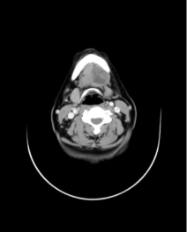 (b) 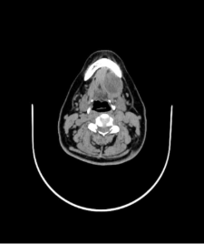

Figure 1 (a) Contrast Enhanced CT and (b) Plain CT scan - showing heterogenously enhancing

lesion in the submental region

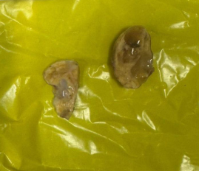

Figure 2 – Gross image of the specimen with pale brown to yellow mass with

cystic and solid areas with mucoid material

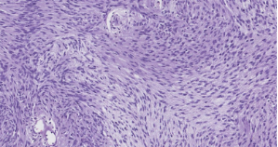 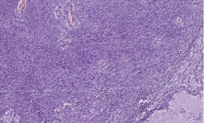

Figure 3 – Histopathological images showing features of Ancient Schwannoma