Case report
Elevated β-hCG and Delayed Diagnosis of Non-Seminomatous Testicular Cancer: A Case Report Highlighting the Role of Self-Examination in Early Detection

ABSTRACT
Background: Testicular cancer, while rare, remains the most common solid malignancy among young males aged 14 to 40 years. Early diagnosis is critical for improving outcomes, yet delayed presentation is common.
Case Presentation: We describe the case of a 19-year-old male presenting with hemoptysis and a long-standing painless testicular mass. Laboratory tests revealed markedly elevated β-hCG and normal AFP levels. Imaging showed pulmonary metastases and para-aortic lymphadenopathy. Radical orchiectomy confirmed a non-seminomatous germ cell tumor, and the patient began chemotherapy with etoposide and cisplatin.
Conclusion: This case underscores the value of testicular self-examination and timely evaluation of testicular abnormalities. Education on self-examination is vital to promote early detection and improve prognosis in testicular cancer.

Keywords: Testicular cancer, β-hCG, self-examination, orchiectomy, germ cell tumor, metastasis, delayed diagnosis
1. INTRODUCTION

Testicular cancer, despite being relatively rare, poses a significant clinical challenge due to its potential for rapid progression and early metastasis, particularly among young men. The rationale for publishing this case lies in its atypical presentation and diagnostic delay, which exemplifies a scenario with valuable lessons for clinicians involved in primary care, emergency medicine, oncology, and urology. Highlighting cases with uncommon presentations contributes to raising clinical suspicion and improving early recognition, which directly impacts patient survival.

Moreover, this report underscores the critical need for integrating patient education, particularly on testicular self-examination, as a preventive tool. This aligns with current public health strategies to reduce cancer burden through early detection. Publishing this case adds to the limited but growing body of literature on testicular cancer presenting with respiratory symptoms, advocating for a broader diagnostic approach in young males with unexplained hemoptysis.

Testicular cancer represents approximately 1% of all male cancers and 5% of urological malignancies. Despite its rarity, it is the most frequent solid tumor in males between 14 and 40 years of age. Its incidence is rising, in part due to improved diagnostic capabilities. The disease is typically unilateral and more frequently affects the right testicle. Cryptorchidism remains the most significant risk factor, particularly in cases of untreated intra-abdominal testes [1,2].

Early-stage disease often presents as a painless testicular mass. However, many cases go undetected until metastasis occurs. Tumor markers such as β-hCG, alpha-fetoprotein (AFP), and lactate dehydrogenase (LDH) are essential in diagnosis, staging, and monitoring [3,4]

.2. case presentation

A 19-year-old male with no family history of cancer presented with hemoptysis. He reported an 8-month history of a painless enlarging mass in the right testicle. His medical history included occasional smoking and alcohol use. There were no urinary symptoms or constitutional complaints.

Physical examination revealed a non-tender, indurated right testicular mass (8x4 cm). The left testicle and spermatic cord were normal. Scrotal ultrasound demonstrated a heterogeneous, septated lesion with peripheral vascularity.
Laboratory findings included: β-hCG: 204,020 mIU/mL (later peaking to 410,107 mIU/mL) AFP: 1.05 ng/mL (within normal limits) LDH: 657 U/L Table 1.

Table 1. Laboratories Results
Laboratory test | 29/07/22 | 08/08/22 | 12/08/22 | 15/08/22
Tumor Markers
Beta-hCG (quantitative) | 204020 mUl/mL | 410107 mUl/mL
Alpha-fetoprotein (AFP) |  | 1.05 ng/dL
Lactate dehydrogenase (LDH) |  | 657 U/L | 535 U/L | 546 U/L
COMPLETE BLOOD COUNT
Leukocytes |  | 15.92 /uL | 10.57 /uL | 6.65 /uL
Neutrophils |  | 77.7% | 77.9% | 74.6%
Lymphocytes |  | 11.6% | 15.7% | 19.4%
Monocytes |  | 8.5% | 3.3% | 0.8%
Eosinophils |  | 0.4% | 1.9% | 3.8%
Erythrocytes |  | 3.71 /uL | 2.96 /uL | 3.08 /uL
Hemoglobin |  | 10.6 g/dL | 8.3 g/dL | 8.6 g/dL
Hematocrit |  | 31.0% | 24.2% | 25.2%
MCV |  | 83.6 g/dL | 81.8 g/dL | 81.8 g/dL
Platelets |  | 356 fL | 254 fL | 269 fL
ACUTE PHASE REACTANTS
ESR |  |  | 34 mm/hr
BLOOD CHEMISTRY
Glucose |  |  | 85.0 mg/dl | 101 mg/dl
Urea |  |  | 17.9 mg/dl | 16.2 mg/dl
Creatinine |  |  | 0.5 mg/dl | 0.5 mg/dl
Uric acid |  |  | 5.0 mg/dl | 2.3 mg/dl
LIVER FUNCTION TESTS
Total bilirubin |  |  | 0.835 mg/dl
Direct bilirubin |  |  | 0.611 mg/dl
Indirect bilirubin |  |  | 0.22 mg/dl
Total proteins |  |  | 5.1 mg/dl
Albumin |  |  | 2.4 mg/dl
ALT |  |  | 39.30 Ul/L
AST |  |  | 23.90 Ul/L
Alkaline phosphatase |  |  | 291 Ul/L
GGT |  |  | 380 Ul/L
ELECTROLYTES
Chloride |  |  | 102 mmol/L | 96 mmol/L
Potassium |  |  | 3.62 mmol/L | 3.79 mmol/L
Sodium |  |  | 134 mmol/L | 132 mmol/L
Calcium |  |  | 8.04 mmol/L | 8.77 mmol/L
Phosphorus |  |  | 2.82 mmol/L | 3.4 mmol/L
Magnesium |  |  | 1.69 mmol/L | 1.66 mmol/L

Chest CT showed multiple pulmonary nodules consistent with metastasis. Abdominal CT revealed para-aortic lymphadenopathy and a heterogeneous mass dependent on the right testicle.
FIGURE 1: Scrotal ultrasound. Right Testicle.
Heterogeneous with echogenic nodules, septated with peripheral vascularity, measuring 89x66x64 mm with a volume of 195 cc.
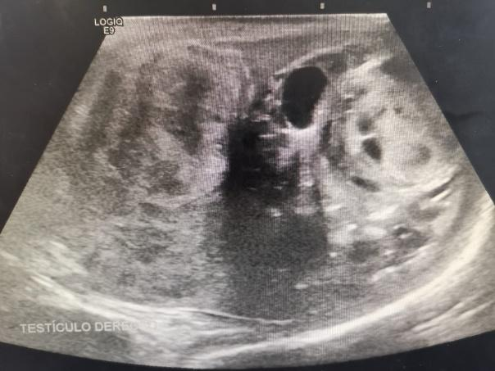

FIGURE 2: Scrotal ultrasound. Left testicle.
Dimensions of 45x23x25 mm with a volume of 13.1 cc, homogeneous parenchyma. Right para-aortic infrarenal lymph node measuring 32x32 mm.

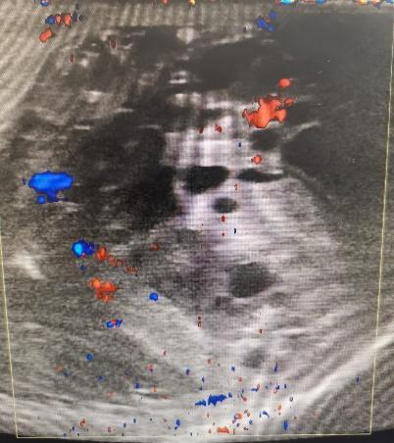

FIGURE 3: CT scan of the chest
Chest: cannonball nodules in the basal lobes, multiple rounded hypodense images in the mediastinal and thoracic pleura with thick walls

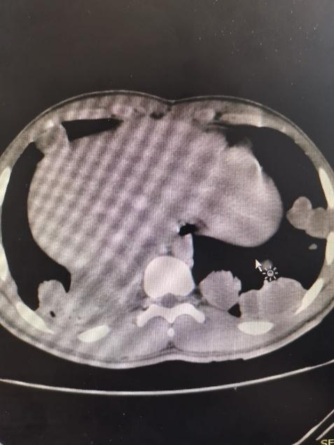

FIGURE 4: Abdominal CT scan
Abdomen: multiple paracaval and infracavoaortic lymphadenopathies up to 27x21 mm.
Heterogeneous tumor dependent on the right testicle measuring 82x85x69 mm with ipsilateral vein dilation.
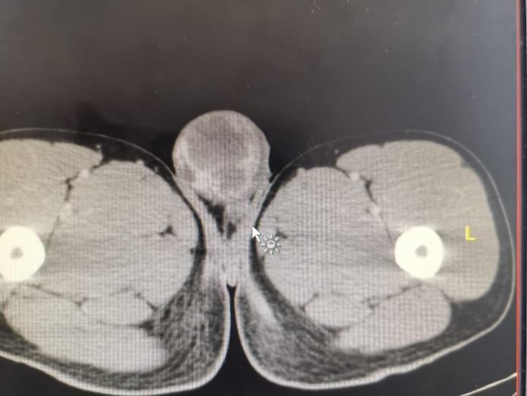

A radical right orchiectomy with high ligation of the spermatic cord was performed. Histopathology confirmed a non-seminomatous germ cell tumor. Given the extent of metastasis, chemotherapy with etoposide and cisplatin was initiated. Bleomycin was excluded due to pulmonary involvement.

3. discussion

Testicular cancer typically presents with a painless testicular mass and may be discovered incidentally or due to metastatic symptoms such as hemoptysis [5]. Non-seminomatous germ cell tumors (NSGCTs) are associated with elevated β-hCG, as observed in this case, which aids in diagnosis, prognosis, and monitoring treatment response [6].

One of the key strengths in the management of this case was the prompt recognition of the testicular origin of metastatic disease. Despite the atypical initial symptom, clinicians quickly performed tumor marker testing and imaging, facilitating timely surgical and oncologic intervention. According to the European Association of Urology guidelines, prompt orchiectomy followed by risk-adapted chemotherapy remains the cornerstone of treatment in advanced NSGCTs [7].
The therapeutic choice to exclude bleomycin due to pulmonary metastases is evidence-based and highlights personalized treatment planning. Bleomycin-induced pulmonary toxicity is a well-documented risk, especially in patients with compromised pulmonary function or disease burden [8].

From a clinical education perspective, this case provides valuable insights: Early signs of testicular cancer should not be overlooked, even in the absence of classic symptoms. Elevated β-hCG without AFP elevation may point towards choriocarcinoma or mixed germ cell tumor components, requiring thorough histological analysis [9]. Early engagement of multidisciplinary teams (urologists, oncologists, radiologists) enhances diagnostic accuracy and individualized care.

Nonetheless, the case also highlights areas for improvement. The most critical limitation was the prolonged delay in seeking medical evaluation. A recent multicenter study found that diagnostic delay significantly correlates with advanced-stage disease and worse prognosis [10]. This underlines the necessity for targeted health education in adolescent males regarding self-examination and awareness of testicular changes.

Moreover, the absence of documented fertility preservation counseling prior to chemotherapy is concerning. Current recommendations suggest offering sperm banking before initiating gonadotoxic treatment, especially in young men with curable malignancies [11]. Addressing the psychosocial and reproductive health dimensions of cancer care remains integral to patient-centered oncology.

4. Conclusion

This case highlights the consequences of delayed diagnosis in testicular cancer and the central role of tumor markers, especially β-hCG, in diagnosis and follow-up. Promoting self-examination and awareness can significantly impact early detection and improve survival outcomes. Multidisciplinary care and individualized treatment plans, as demonstrated, are essential for optimizing patient prognosis. Fertility counseling and comprehensive support should also be routinely incorporated into care pathways.

Ethical approval
Consent for treatment and publication was obtained. The study received approval from the IMSS Auxiliary Medical Coordination of Health Research (HGR 17). No conflicts of interest or financial disclosures were reported by the authors.

References

- Cheng L, Albers P, Berney DM. Testicular cancer. Nat Rev Dis Primers. 2018;4:29.
- Fung C, Dinh PC, Fossa SD, et al. Testicular Cancer Survivorship. JNCCN. 2019;17:1557-1568.
- Gurrola Ortega A. Cáncer testicular: incidencia, epidemiología y etiología. Rev Mex Urol. 2018;78.
- Leão R, Ahmad AE, Hamilton RJ. Testicular Cancer Biomarkers. Clin Genitourin Cancer. 2019;17:e176-e183.
- Swed S, Nashwan AJ, Naal MY, et al. Misdiagnosis of Seminoma as Hernia: A Case Report. Cureus. 2022;14:e31001.
- Alsyouf M, Daneshmand S. Clinical stage II seminoma: management options. World J Urol. 2022;40:343-348.
- Rosen DB, Tan AJN, Pursley J, Kamran SC. Advances in radiation therapy for testicular seminoma. World J Urol. 2023;41:3895-3903.
- Gilligan T, Lin DW, Aggarwal R, et al. Testicular cancer, Version 2.2020, NCCN Clinical Practice Guidelines in Oncology. J Natl Compr Canc Netw. 2019;17(12):1529-54.
- Stephenson AJ, Gilligan TD. Neoplasms of the testis. In: Abeloff’s Clinical Oncology. 6th ed. Elsevier; 2020. p. 1830-44.
- Ruf C, Isbarn H, Wagner W, et al. Evaluation of serum tumor markers in patients with testicular cancer. Eur Urol. 2018;73(5):715-22.
- Laguna MP, Albers P, Algaba F, et al. EAU guidelines on testicular cancer: 2022 update. Eur Urol. 2022;82(4):399-414.

