**Effectiveness of Rainfall for various crops grown under the canal command areas of Musi, Taliperu and Vattivagu Medium Irrigation Projects in Telangana**

**ABSTRACT**

Rainwater is an essential source for agriculture as well as human beings and animals which falls on the earth’s surface. In the present study, the USDA-SCS method was used to estimate the effectiveness of rainfall for various crops grown in the command areas of Musi, Taliperu and Vattivagu medium irrigation projects in the Telangana state of the different Agro-climatic zones of southern India. Rainfall data of these medium irrigation project were collected and analyzed to know its effectiveness on different crops grown during *Kharif* and *Rabi* seasons. The results revealed that the Paddy crop has the highest effectiveness of rainfall percent among all the crops in all cases. On an average, effectiveness of rainfall of the paddy crop in *Kharif* season was 21% and 30% in *Rabi* season, respectively, in all command areas of three projects. This study will enable us to make necessary plans for more efficient utilization of water resources and proper irrigation scheduling.

**Key words:** Canal water, Command area, Consumptive use, Crop coefficient, Rainwater, Effective rainfall, Effectiveness of rainfall, Reference evapotranspiration (ET0).

**1. Introduction**

Rainwater is an important and essential source for agriculture and horticulture as well as human beings and animals which falls on the earth’s surface (Adnan and Khan, 2009). The average annual rainfall of India is 1257 mm, which is 108% of its long period average (LPA) of 1160 mm (IMD Annual Report, 2022). About 75-80% of annual is received from the South-West monsoon (June to September).

The primary source of water supply for agriculture in most places of the world is rainfall and characteristics of this rainfall may vary from place to place and time to time. The actual and normal annual rainfall of Telangana is about 1270. 6 mm and 938.7 mm, respectively (IMD Annual Report, 2022).

Water used for irrigation in the crop production is mainly depends upon the interaction between the climatic parameters that determines the crop evapotranspiration and water supply from the rainfall (Ali and Mubarak, 2017). Effective rainfall may be defined as the portion of the rainfall that is useful directly or indirectly for crop production at the site where it falls (Dastane, 1974). Effective rainfall is the function of crop type, soil type, land preparation type needed and climatic factors. The effective rainfall is used in computing irrigation requirement of crops, irrigation scheduling and planning of agriculture in rainfed areas (Mishra *et al.,* 1999; Panigrahi and Panda, 2001). Several researchers for estimating crop water requirements, have used the effective rainfall method of United States Department of Agriculture- Soil Conservation Service (USDA-SCS) (Gulati, 1987). Effective rainfall is used for planning the cropping patterns in the canal commands and to estimating crop water requirements; it is also used for preparing schedules in agriculture and efficient operation of irrigation projects (Rao and Rajput, 2008). Most of the studies were done at distributary level, planning of efficient management of water resources and supplying of water at field level is not possible with utmost accuracy. So, there is a need to estimate the effectiveness of rainfall at project level in order to manage and distribute the water resources more accurately.

**2. Materials & Methods**

The present study was conducted at the canal command area of Musi, Taliperu and Vattivagu medium irrigation projects in the Telangana state of southern India. These canal command area falls in the different Agro-climatic zones of Telangana. The average annual rainfall of Northern, Central and Southern Telangana zones are 867-1189 mm, 779-1213 mm and 606-853 mm, respectively. The major crops growing in the command area were considered in this study.

Musi medium irrigation project was constructed across the Musi River near *Solipet* village and *Suryapet* mandal and district of Telangana state in Krishna basin of *Southern* Telangana zone (Fig. 1). The Musi medium irrigation project is designed with a live storage of 4.60 T.M.C. for providing irrigation to 16915.86 ha in *Kharif* under both canals covering 41 villages of 6 Mandals of Nalgonda district. The command area of the project lies in between both the right and left canals of the project. The length of the right flank main canal (RFMC) is 33.80 km which irrigates a total ayacut of 6141.10 ha covering 19 villages in 4 mandals namely *Kethepally*, *Madugulapally,* *Thipparthy* and *Vemulapally* of *Nalgonda* constituency. The length of the left flank main canal (LFMC) is 41.75 km which irrigates a total ayacut of 6,944.99 ha covering 22 villages in 3 mandals namely *Suryapet*, *Chivvemla* and *Penpahad* of *Suryapet* constituency and district. The total ayacut to be irrigated is nearly of 13,556.97 ha. But, at present, the ayacut has been reduced to 12,140.57 ha due to non-availability of canal water to the tail reaches and also due to urbanization of the tail end of the canals. Geographically the Musi medium irrigation project is located at a latitude of 17 ̊ 15' °N and longitude of 79 ̊ 33' °E at an elevation of about 216.37 m above mean sea level (MSL). Paddy is the major crop grown in the command area (i.e. both RFMC and LFMC) of Musi in both seasons.

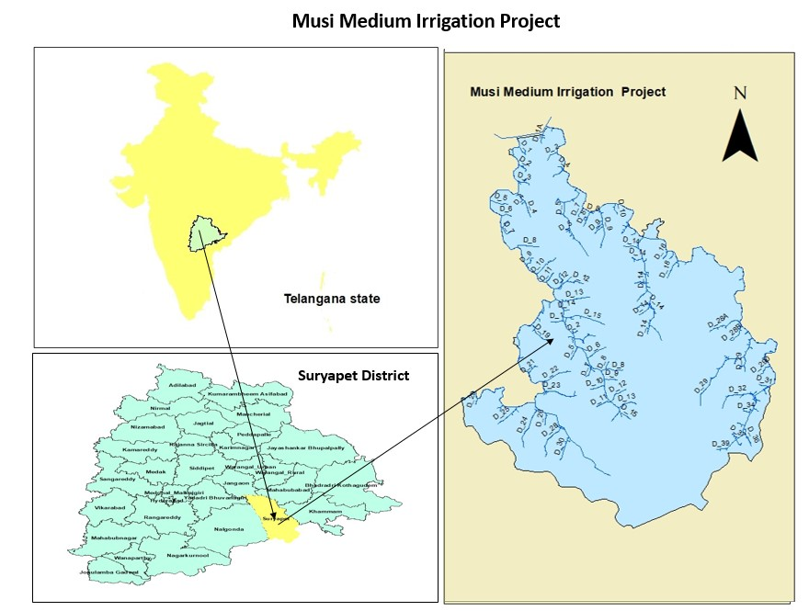

**Fig. 1: Location map of the Musi medium irrigation project**

Taliperu project is also known as Taliperu reservoir, which was constructed across the Taliperu River at *Peddamidisileru* village and *Cherla* mandal in *Bhadradri Kothagudem* district of Telangana State in Godavari basin of *Central* Telangana zone (Fig. 2). The Taliperu medium irrigation project is designed with a live storage of 14.46 T.M.C. for providing irrigation to 9,995.74 ha in *kharif* under both canals covering 88 villages of 2 Mandals of *Bhadradri Kothagudem* district. The command area lies between left and right canals of the project. The length of the right flank main canal (RFMC) is 10.44 km which irrigates a total ayacut of 1475.89 ha covering 17 villages in *Cherla* mandal of *Bhadrachalam* constituency. The length of the left flank main canal (LFMC) is 46.46 km which irrigates a total ayacut of 2791.93 ha covering 29 villages in Cherla mandal and 5727.92 ha covering 42 villages in *Dummugudem* mandal of *Bhadrachalam* constituency. The total ayacut to be irrigated is nearly of 9995.73 ha. Geographically the Taliperu medium irrigation project is located at a latitude of 18 ̊ 06' 10.5" °N and longitude of 80 ̊ 51' 28.9" °E at an elevation of about 179.49 m above mean sea level (MSL). The main crops grown in the command area of Taliperu are Paddy, Cotton and Chillies.

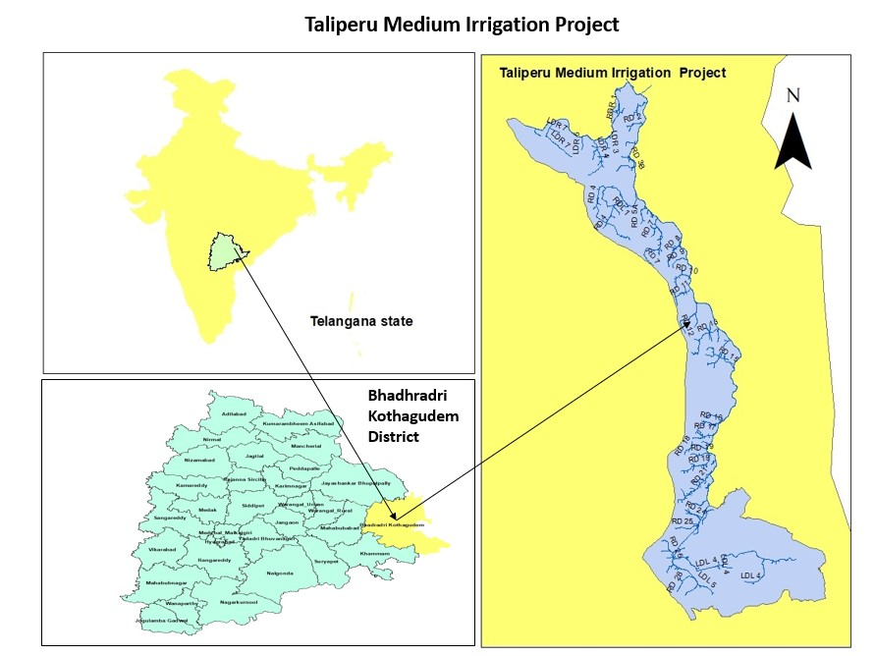

**Fig. 2: Location map of the Taliperu medium irrigation project**

Vattivagu medium irrigation project was constructed across the Vattivagu stream at *Pahadibanda* village and *Asifabad* mandal and district of Telangana state. Vattivagu stream is a tributary to Peddavagu, which itself is a tributary to the Pranahita river in Godavari basin of *Northern* Telangana zone (Fig. 3). The Vattivagu medium irrigation project is designed with a live storage of 2.653 T.M.C. for providing irrigation facility to 9914.79 ha in *Kharif* under both canals covering 41 villages of 2 Mandals of *Asifabad* District. It was observed that water is being utilized for *Kharif* and *Rabi* crops for every 3 days rotational system on the basis of on/off system. The command area lies between both left and right canals of the project. The length of the right flank main canal (RFMC) is 21.6 km which irrigates a total ayacut of 8822.15 ha covering 21 villages in *Asifabad* mandal and 21 villages in 2 mandals (*Asifabad* and *Rebbena*) of *Asifabad* constituency. The length of the left flank main canal (LFMC) is 7 km which irrigates a total ayacut of 1092.65 ha covering 9 villages of *Asifabad* mandal and constituency. The total ayacut to be irrigated is nearly of 9914.79 ha. Geographically the Vattivagu medium irrigation project is located at a latitude of 19 ̊ 17' 08" °N and longitude of 79 ̊ 16' 08" °E at an elevation of about 259.48 m above mean sea level (MSL). The main crops grown in the command area of Vattivagu are Paddy and Cotton.

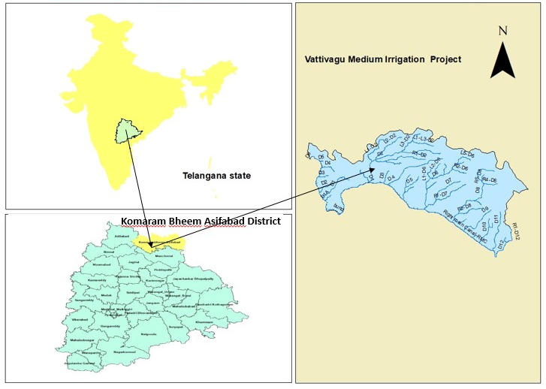

**Vattivagu Medium Irrigation Project**

**Fig. 3: Location map of Vattivagu medium irrigation project**

In the present study, the effectiveness of rainfall for each crop was calculated by using a slight modification in the USDA-SCS method and incorporated as suggested by Gulati (1987). The weekly rainfall and weekly water requirement of the each crop were used to calculate the weekly effective rainfall for various crops growing in the command area. Six years (2017-2022) rainfall data of Vattivagu, Taliperu and Musi medium irrigation projects taken from the Nasa Power were used.

The crop coefficients (Kc) for each crop were selected from the FAO manual (FAO, 1998). The multiplication of reference evapotranspiration (ET0) with the Kc during that period were given the crop consumptive use/crop evapotranspiration (ETc).

In addition to the crop evapotranspiration (consumptive use), crops needed special water at different stages, depending upon the crop type, water quality and characteristics of the soil. *Kharif* crops were sown using the moisture from rainfall. So, there is no requirement for pre-sowing irrigation for crops grown in the *Kharif* season. Special water needs includes land preparation, percolation losses and leaching in the paddy. Percolation losses from the paddy fields were assumed as 3 mm day-1 in the current study. Land preparation was required for paddy fields about 10 days. For flooding and land preparation, water requirement for paddy fields during these 10 days were 200 mm (Rao, 2005).

After calculating the weekly total rainfall, total crop water requirement, effective rainfall of each crop and total effectiveness of rainfall were estimated by summing the corresponding weekly values during the crop duration. After that the ratio of effective rainfall and rainfall and then percentage of rainfall effectiveness were calculated. A sample calculation for paddy crop is shown in Table: 1.

**Table 1: Sample calculation of weekly crop water requirement for paddy *Kharif***

|  |  |  |  |  |  |  |  |  |  |  |  |
| --- | --- | --- | --- | --- | --- | --- | --- | --- | --- | --- | --- |
| **Week No** | **Rainfall** | **ET0** | **kc** | **ETc** | **Special Needs** | | **WR** | **ER** | **NIR** | **GIR** | **GIR** |
| **LP** | **P** |
| **mm** | **mm** |  | **mm** | **mm** | **mm** | **mm** | **mm** | **mm** | **mm** | **m³** |
| 28 | 26.90 | 38.20 |  |  | 200 | 21 | 221.00 | 20.41 | 200.59 | 266.64 | 41364.63 |
| 29 | 148.85 | 33.37 |  |  | 200 | 21 | 221.00 | 0.00 | 221.00 | 293.77 | 45573.38 |
| 30 | 8.57 | 41.87 | 1.14 | 47.73 | 200 | 21 | 268.73 | 7.69 | 261.04 | 346.99 | 53829.56 |
| 31 | 18.37 | 38.85 | 1.14 | 44.29 |  | 21 | 65.29 | 15.24 | 50.05 | 66.53 | 30962.97 |
| 32 | 79.73 | 27.84 | 1.14 | 31.74 |  | 21 | 52.74 | 0.00 | 52.74 | 70.11 | 32629.10 |
| 33 | 30.63 | 24.92 | 1.14 | 28.41 |  | 21 | 49.41 | 21.28 | 28.13 | 37.39 | 17401.25 |
| 34 | 52.57 | 27.01 | 1.16 | 31.33 |  | 21 | 52.33 | 30.28 | 22.05 | 29.31 | 13640.83 |
| 35 | 25.62 | 27.79 | 1.18 | 32.79 |  | 21 | 53.79 | 18.79 | 35.00 | 46.52 | 21650.34 |
| 36 | 37.53 | 28.51 | 1.2 | 34.21 |  | 21 | 55.21 | 26.38 | 28.83 | 38.32 | 17834.08 |
| 37 | 40.86 | 31.47 | 1.21 | 38.08 |  | 21 | 59.08 | 29.33 | 29.75 | 39.55 | 18406.52 |
| 38 | 6.24 | 23.29 | 1.22 | 28.41 |  | 21 | 49.41 | 4.60 | 44.81 | 59.56 | 27719.14 |
| 39 | 87.78 | 24.91 | 1.22 | 30.39 |  | 21 | 51.39 | 0.00 | 51.39 | 68.31 | 31791.38 |
| 40 | 50.66 | 20.56 | 1.22 | 25.08 |  | 21 | 46.08 | 0.00 | 46.08 | 61.25 | 28505.67 |
| 41 | 19.13 | 24.04 | 1.22 | 29.33 |  | 21 | 50.33 | 14.04 | 36.29 | 48.24 | 22450.83 |
| 42 | 2.60 | 27.74 | 1.21 | 33.57 |  | 21 | 54.57 | 0.00 | 54.57 | 72.54 | 33760.02 |
| 43 | 0.45 | 26.96 | 1.16 | 31.27 |  | 21 | 52.27 | 0.00 | 52.27 | 69.48 | 32335.90 |
| 44 | 0.14 | 27.73 | 1.07 | 29.67 |  | 21 | 50.67 | 0.00 | 50.67 | 67.35 | 31344.60 |
| 45 | 0.01 | 26.30 | 0.90 | 23.67 |  | 21 | 44.67 | 0.00 | 44.67 | 59.38 | 27635.37 |
|  | **636.64** |  |  | **519.97** |  | **378** | **1497.97** | **188.04** | **1309.93** | **1741.24** | **528835.56** |

Note: ET0: Reference Evapotranspiration; kc: crop coefficient: ETc: Crop evapotranspiration; LP: Land Preparation; P: Percolation; WR: Water Requirement; ER: Effective Rainfall and RE: Rainfall Effectiveness.

**3. Results and Discussion**

The total rainfall, water requirement, effective rainfall and effectiveness of rainfall values for major crops growing in the command areas of Musi, Taliperu and Vattivagu medium irrigation project were calculated and the averages of five years rainfall, effective rainfall, water requirement and effectiveness of rainfall values for major crops growing in the command area of Musi, Taliperu and Vattivagu medium irrigation projects.

**Rainfall (R), Effective Rainfall (ER) and Water requirement (WR) under Musi project**

The major crop grown under the command area of Musi medium irrigation project is paddy. The total rainfall, water requirement, effective rainfall and effectiveness of rainfall values for paddy crop growing in the command area of Musi were presented in Table 2. The averages of five years rainfall (R), effective rainfall (ER) and water requirement (WR) for the paddy crop during *Kharif* season were found to be 601, 185 and 1860 mm under the command area of RFMC; and 602, 184 and 1841 mm under the command area of LFMC of Musi medium irrigation project (Table 2). Also, during *Rabi* season, the five years average rainfall (R), effective rainfall (ER) and water requirement (WR) were 35, 24 and 1980 mm, respectively found to be under the command area of RFMC and 35, 24 and 1942 mm, respectively found to be under the command area of Musi medium irrigation project (Table 2).

**Table 2: Effectiveness of rainfall for paddy under RFMC of Musi project**

|  |  |  |  |  |  |  |  |  |  |  |
| --- | --- | --- | --- | --- | --- | --- | --- | --- | --- | --- |
| **Canal** | **Year** | **Annual Rainfall (mm)** | **Kharif** | | | | ***Rabi*** | | | |
| **R (mm)** | **ER (mm)** | **WR (mm)** | **RE (%)** | **R (mm)** | **ER (mm)** | **WR (mm)** | **RE (%)** |
| **RFMC** | 2017-18 | 847 | 638 | 189 | 1831 | 30 | 25 | 18 | 1999 | 72 |
| 2018-19 | 585 | 317 | 141 | 2099 | 44 | 65 | 43 | 2047 | 66 |
| 2019-20 | 707 | 545 | 296 | 1705 | 54 | 37 | 29 | 2002 | 80 |
| 2020-21 | 1199 | 842 | 149 | 1794 | 18 | 3 | 0 | 1940 | 0 |
| 2021-22 | 931 | 662 | 148 | 1871 | 22 | 45 | 30 | 1911 | 66 |
| **Average** | **854** | **601** | **185** | **1860** | **34** | **35** | **24** | **1980** | **57** |
| **LFMC** | 2017-18 | 847 | 637 | 189 | 1811 | 30 | 25 | 18 | 2004 | 71 |
| 2018-19 | 585 | 317 | 141 | 2071 | 44 | 65 | 43 | 1999 | 67 |
| 2019-20 | 707 | 545 | 296 | 1699 | 54 | 37 | 30 | 1954 | 79 |
| 2020-21 | 1199 | 849 | 149 | 1777 | 18 | 3 | 0 | 1892 | 0 |
| 2021-22 | 931 | 660 | 147 | 1847 | 22 | 45 | 30 | 1861 | 66 |
| **Average** | **854** | **602** | **184** | **1841** | **34** | **35** | **24** | **1942** | **57** |

Note: R: Rainfall; WR: Water Requirement; ER: Effective Rainfall and RE: Rainfall Effectiveness.

**Rainfall (R), Effective Rainfall (ER) and Water requirement (WR) under Taliperu project**

The major crop growing under the command area of RFMC of Taliperu medium irrigation project is paddy. Whereas, the major crop growing under the command area of LFMC of Taliperu medium irrigation project are paddy, cotton and chillies. The total rainfall, water requirement, effective rainfall and effectiveness of rainfall values for paddy, cotton and chillies growing in the command area of Vattivagu were presented in Table. 3, Table. 4 and Table. 5, respectively. The averages of five years rainfall (R), effective rainfall (ER) and water requirement (WR) for the paddy crop during *Kharif* season were found to be 900, 201 and 1811 mm under the command area of RFMC; 867, 200 and 1724 mm under the LFMC of Taliperu medium irrigation project (Table. 3). While, during *Rabi* season, the five years averages of rainfall (R), effective rainfall (ER) and water requirement (WR) were 38, 28 and 1962 mm under the command area of RFMC and 38, 29 and 1865 mm under the command area of LFMC of Taliperu medium irrigation project (Table. 3). The averages of five years rainfall (R), effective rainfall (ER) and water requirement (WR) for the cotton crop were found to be 1222, 236 and 602 mm under the command area of LFMC of Taliperu medium irrigation project (Table. 4). The averages of five years rainfall (R), effective rainfall (ER) and water requirement (WR) for the chillies crop were found to be 286, 58 and 570 mm under the command area of LFMC of Taliperu medium irrigation project, respectively (Table. 5).

**Table 3: Effectiveness of Rainfall for paddy under Taliperu project**

|  |  |  |  |  |  |  |  |  |  |  |
| --- | --- | --- | --- | --- | --- | --- | --- | --- | --- | --- |
| **Canal** | **Year** | **Annual Rainfall (mm)** | **Kharif** | | | | **Rabi** | | | |
| **R (mm)** | **ER (mm)** | **WR (mm)** | **RE (%)** | **R (mm)** | **ER (mm)** | **WR (mm)** | **RE (%)** |
| **RFMC** | 2017-18 | 1395 | 820 | 207 | 1780 | 25 | 30 | 26 | 1927 | 87 |
| 2018-19 | 1110 | 667 | 90 | 1992 | 14 | 71 | 53 | 2002 | 75 |
| 2019-20 | 1146 | 902 | 336 | 1634 | 37 | 37 | 30 | 1988 | 81 |
| 2020-21 | 1979 | 1329 | 192 | 1795 | 14 | 6 | 3 | 1926 | 45 |
| 2021-22 | 1217 | 783 | 179 | 1856 | 23 | 49 | 30 | 1968 | 60 |
| **Average** | **1369** | **900** | **201** | **1811** | **23** | **38** | **28** | **1962** | **70** |
| **LFMC** | 2017-18 | 1395 | 751 | 207 | 1695 | 28 | 30 | 25 | 1830 | 86 |
| 2018-19 | 1110 | 625 | 90 | 1899 | 14 | 71 | 55 | 1907 | 78 |
| 2019-20 | 1146 | 895 | 330 | 1551 | 37 | 37 | 30 | 1888 | 82 |
| 2020-21 | 1979 | 1316 | 192 | 1718 | 15 | 6 | 3 | 1830 | 45 |
| 2021-22 | 1217 | 749 | 183 | 1760 | 24 | 49 | 30 | 1869 | 60 |
| **Average** | **1369** | **867** | **200** | **1724** | **24** | **38** | **29** | **1865** | **70** |

**Table 4: Effectiveness of Rainfall for cotton under LFMC of Taliperu project**

|  |  |  |  |  |  |
| --- | --- | --- | --- | --- | --- |
| **Year** | **Annual Rainfall (mm)** | **R (mm)** | **ER (mm)** | **WR (mm)** | **RE (%)** |
| 2017-18 | 1395 | 1212 | 221 | 591 | 18 |
| 2018-19 | 1110 | 977 | 143 | 723 | 15 |
| 2019-20 | 1146 | 1017 | 376 | 488 | 37 |
| 2020-21 | 1979 | 1815 | 239 | 578 | 13 |
| 2021-22 | 1217 | 1089 | 201 | 632 | 18 |
| **Average** | **1369** | **1222** | **236** | **602** | **20** |

**Table 5: Effectiveness of Rainfall for chillies under LFMC of Taliperu project**

|  |  |  |  |  |  |
| --- | --- | --- | --- | --- | --- |
| **Year** | **Annual Rainfall (mm)** | **R (mm)** | **ER (mm)** | **WR (mm)** | **RE (%)** |
| 2017-18 | 1395 | 178 | 18 | 603 | 10 |
| 2018-19 | 1110 | 148 | 57 | 590 | 38 |
| 2019-20 | 1146 | 313 | 69 | 569 | 22 |
| 2020-21 | 1979 | 496 | 33 | 566 | 7 |
| 2021-22 | 1217 | 293 | 115 | 522 | 39 |
| **Average** | **1369** | **286** | **58** | **570** | **23** |

**Rainfall (R), Effective Rainfall (ER) and Water requirement (WR) under Vattivagu project**

The major crops growing under the command area of RFMC of Vattivagu project are paddy and cotton. The total rainfall, water requirement, effective rainfall and effectiveness of rainfall values for paddy and cotton growing in the command area of Vattivagu were presented in Table. 6 and Table. 7, respectively. The averages of five years rainfall (R), effective rainfall (ER) and water requirement (WR) for the Paddy crop during *Kharif* season were found to be 775, 194 and 2104 mm, respectively under the command area of RFMC of Vattivagu medium irrigation project (Table. 6). Also, during *Rabi* season, the five years average rainfall (R), effective rainfall (ER) and water requirement (WR) were 68, 24 and 2198 mm under the command area of RFMC of Vattivagu medium irrigation project respectively (Table. 6). The averages of five years rainfall (R), effective rainfall (ER) and water requirement (WR) for the cotton crop were found to be 1075, 216 and 624 mm, respectively.

**Table 6: Effectiveness of Rainfall for paddy under Vattivagu project**

|  |  |  |  |  |  |  |  |  |  |  |
| --- | --- | --- | --- | --- | --- | --- | --- | --- | --- | --- |
| **Canal** | **Year** | **Annual Rainfall (mm)** | **Kharif** | | | | **Rabi** | | | |
| **R (mm)** | **ER (mm)** | **WR (mm)** | **RE (%)** | **R (mm)** | **ER (mm)** | **WR (mm)** | **RE (%)** |
| **RFMC** | 2017-18 | 1003 | 620 | 327 | 1957 | 53 | 22 | 16 | 2266 | 73 |
| 2018-19 | 1079 | 652 | 108 | 2300 | 17 | 56 | 37 | 2266 | 66 |
| 2019-20 | 1319 | 1023 | 246 | 2028 | 24 | 65 | 44 | 2091 | 67 |
| 2020-21 | 1214 | 794 | 122 | 2033 | 15 | 5 | 0 | 2209 | 0 |
| 2021-22 | 1406 | 784 | 168 | 2198 | 21 | 190 | 25 | 2159 | 13 |
| **Average** | **1204** | **775** | **194** | **2104** | **26** | **68** | **24** | **2198** | **44** |

**Table 7: Effectiveness of Rainfall for cotton under RFMC of Vattivagu project**

|  |  |  |  |  |  |
| --- | --- | --- | --- | --- | --- |
| **Year** | **Annual Rainfall (mm)** | **R (mm)** | **ER (mm)** | **WR (mm)** | **RE (%)** |
| 2017-18 | 1003 | 902 | 321 | 573 | 36 |
| 2018-19 | 1079 | 946 | 161 | 727 | 17 |
| 2019-20 | 1319 | 1203 | 282 | 579 | 23 |
| 2020-21 | 1214 | 1145 | 120 | 565 | 10 |
| 2021-22 | 1406 | 1180 | 197 | 675 | 17 |
| **Average** | **1204** | **1075** | **216** | **624** | **21** |

Fig. 4: Average Rainfall (R), Effective Rainfall (ER) and Water Requirement (WR) of major crops growing in the commands of Musi, Taliperu and Vattivagu.

Five years averages of Rainfall (R), Water Requirement (WR) & Effective Rainfall (ER) of major crops growing in the commands of Musi, Taliperu and Vattivagu (mm) are shown in Fig.4. The five years (2017-22) average annual rainfall of Musi, Taliperu and Vattivagu medium irrigation projects were calculated from the Nasa Power and provided as 854, 1369 and 1204 mm respectively (Table. 2 to Table. 7). These values were more than the normal annual rainfall under all the projects. Paddy crop (*Kharif* and *Rabi* season) receives 74-75% in the command area (RFMC & LFMC) of Musi medium irrigation project; 66-69% under the command area (RFMC & LFMC) of Taliperu medium irrigation project and 70% of the five years average annual rainfall under the command area (RFMC) of Vattivagu medium irrigation project. While, cotton crop receives 89% under the LFMC of Taliperu and 81% under the RFMC of Vattivagu medium irrigation projects (i.e. above the normal year). Whereas, chillies crop receives 21% under the command area of LFMC of Taliperu medium irrigation project (i.e. below the normal year). Therefore, the contribution of the rainfall or rainwater use efficiency was found to be depending upon the crop, season and location. The results obtained were in line with the results of Adnan and Khan (2009), Hasan *et al.,* (2019) and Vekaria *et al.,* (2020). The water requirement of a crop depends upon the reference evapotranspiration (ET0), crop characteristics (Crop coefficient, crop stage and crop consumptive use (ETc)), effective rainfall and an application efficiency. In case of paddy crop, water requirement accounts for special needs including land preparation and percolation. So, that the Paddy crop requires more water than the cotton and chillies. Also, Laghari *et al.,* (2014), Djaman *et al.,* (2017) and Babu *et al.,* (2015) were found similar results in their studies.

**Effectiveness of Rainfall under Musi, Taliperu and Vattivagu projects**

The Effectiveness of Rainfall (RE) for major crops growing in the command areas of Musi, Taliperu and Vattivagu (%) was calculated and shown in Fig.5. It can be visualized that the five years averages effectiveness of rainfall for Paddy crop in *Kharif* and *Rabi* season was 34% and 57% respectively under the command area of RFMC and LFMC of Musi medium irrigation project (Fig. 5). The five years averages of effectiveness of rainfall (RE) during *Kharif* season was 23% under the command area of RFMC and 24% under the command area of LFMC; also, during *Rabi* season, 70% under the command area of RFMC and LFMC of Taliperu medium irrigation project. Also, the five years averages of effectiveness of rainfall (RE) for Cotton and Chillies were 20 and 23% under the command area of LFMC of Taliperu medium irrigation project respectively. During *Kharif* season, the five years averages of effectiveness of rainfall (RE) for Paddy was found to be 26% under the command area of RFMC of Vattivagu medium irrigation project; Also, during *Rabi* season, 44% under the command area of RFMC of Vattivagu medium irrigation project respectively. Also, the five years averages of effectiveness of rainfall (RE) for Cotton crop was 21% under the command area of RFMC of Vattivagu medium irrigation project respectively. Similar results also matched with the Hasan *et al.,* (2019) and Babu *et al.,* (2015).

**Effectiveness of Rainfall for below, normal and above normal annual rainfall**

The average annual rainfall of Vattivagu, Taliperu and Musi medium irrigation projects were taken from the Nasa Power and provided in Table. 2-7. From the Table. 2, rainfall received at the Musi medium irrigation project during 2017-18 and 2019-20 was normal annual rainfall. While, during 2018-19 received below the normal annual rainfall and remaining 2020-22 received above the normal annual rainfall. During the below, normal and above normal annual rainfall year, it was found that the Paddy crop had the effectiveness of rainfall 62, 21 and 12% under the command area of RFMC of Musi medium irrigation project. Whereas, 25, 23 and 11% under the command area of LFMC of Musi medium irrigation project respectively. Form the Table. 3, Table. 4 and Table.5, rainfall received at the Taliperu project during the year 2018-20 and 2021-22 was normal annual rainfall. Whereas, during 2017-18 and 2020-21 received above annual rainfall. During the normal annual rainfall year, it was found that the Paddy crop had the effectiveness of rainfall 13% under both the command areas of RFMC and LFMC of Taliperu medium irrigation project. While, during the above annual rainfall year, 10% under the RFMC and 11% under the command area of LFMC of Taliperu medium irrigation project. Also, during the normal annual rainfall year, Cotton and Chillies has the effectiveness of rainfall 16 and 4%. Whereas, during the above annual rainfall year, 11 and 2% under the command area of LFMC of Taliperu medium irrigation project respectively. From the Table. 6 and Table. 7, rainfall received at the Vattivagu project during the year 2017-19 was normal annual rainfall. While, 2019-22 received above the normal annual rainfall. During the normal annual rainfall year, it was found that the Paddy and Cotton crops has the effectiveness of rainfall 11 and 13%. Whereas, during the above annual rainfall year, 10 and 12% under the command area of RFMC of Vattivagu medium irrigation project respectively.

From the study, the results revealed that the effectiveness of rainfall was more during below the normal annual rainfall year due to the crop utilizes more rainwater for its growth. Whereas, less rainwater was utilized during normal and above normal annual rainfall year. So, that the effectiveness of rainfall was more during below the normal annual rainfall year than the normal and above normal annual rainfall year. Also, the Paddy crop had the highest effectiveness of rainfall (RE) than Cotton and Chillies. In *Kharif* season, the paddy crop has effectiveness of rainfall of 28% and 60% in *Rabi* season in all commands of all projects. Also, the Paddy crop has the highest effectiveness of rainfall percent among all the crops in all cases due to the heavy rainfall (i.e. above the normal annual rainfall) during all the years in all the command areas (i.e. 20% for most of the years). This is because paddy crop required standing water for longer period. And, the effectiveness of rainfall for Paddy was higher in Rabi due to the soil is very dry in this season than Kharif season (i.e. soil is wet). So that, it can starts storing of water in the root zone from the rainfall; which, will be results in more water utilized and causes less runoff. Similar findings inferred with Hasan *et al.,* (2019) and Rao and Rajput (2008). Results also revealed that the Cotton crop has the higher rainfall, effective rainfall; but, lesser the water requirement and effectiveness of rainfall. For Cotton and Chillies, per cent of effective rainfall was equal to or higher than 21%. On an average, the effectiveness of rainfall values for Cotton 21% under the commands of RFMC of Vattivagu project. For Cotton and Chillies were 20 and 23% under the commands of LFMC of Taliperu project.

Fig. 5: Effectiveness of Rainfall (RE) for major crops growing in the commands of Musi, Taliperu and Vattivagu (%)

**4. Conclusions**

On the basis of results it can be concluded that the effectiveness of rainfall was more during below the normal annual rainfall year due to the crop utilizes more rainwater for its growth, whereas, less rainwater was utilized during normal and above normal annual rainfall year. So, that the effectiveness of rainfall was more during below the normal annual rainfall year than the normal and above normal annual rainfall year. Also, the results revealed that the effectiveness of rainfall for paddy was higher than the other crops i.e. 20% for most of the years. In *Kharif* season, the paddy crop has effectiveness of rainfall of 21% where as it was 30% in *Rabi* season in all command areas of all projects. Also, the results revealed that the paddy crop has the highest effectiveness of rainfall percent among all the crops in all cases due to standing water for longer period. The effectiveness of rainfall was varied due to the variation of rainfall of different Agro-climatic zones of Telangana.

**References**

1. Adnan, S and Khan, A. H. 2009. Effective Rainfall for Irrigated Agriculture Plains of Pakistan. *Pakistan Journal of Meteorology*. 6 (11): 61-72.
2. Ali, M. H and Mubarak, S. Effective Rainfall Calculation Methods for Field Crops: An Overview, Analysis and New Formulation. *Asian Research Journal of Agriculture*. 7 (1): 1-12.
3. Babu, R. Ganesh., Babu, G. Ravi and Kumar, H. V. Hema. 2015. Estimation of crop water requirement, effective rainfall and irrigation water requirement for vegetable crops using CROPWAT. *International Journal of Agricultural Engineering*. 8 (1): 15-20.
4. Dastane, N. G. 1974. Effective rainfall in irrigated agriculture. *FAO Irrigation and Drainage Paper* No. 25. Rome, Italy.
5. Djaman, K., Mel, V. C., Balde, A. B., Bado, B. V., Manneh, B., Diop, L., Mutiibwa, D., Rudnick, D. R., Irmak, S and Futakuchi, K. 2017. Evapotranspiration, irrigation water requirement and water productivity of rice (*Oryza sativa* L.) in the Sahelian environment. Paddy Water Environ. 15: 469-482.
6. FAO. 1998. Crop Evapotranspiration: Guidelines for Computing Crop Water Requirements. *FAO, Irrigation and Drainage paper* 56. 57-139.
7. Gulati, H. S. 1987. Water balance simulation for conjunctive use of water resources in canal command areas. An unpublished Ph.D. Thesis, IARI, New Delhi.
8. Hasan, Md. R., Nuruzzaman, Md and Mamun, A. Al. 2019. Contribution of Rainwater to the Irrigation Requirement for Paddy Cultivation at Tanore Upazila in Rajshahi, Bangladesh. *Air, Soil and Water Research*. 12: 1-8.
9. Indian Meteorological Department (IMD) Annual Report. 2022. <https://mausam.imd.gov.in/imd_latest/contents/ar2022.pdf>.
10. Laghari, T. S., Khaliq, A., Shah, S. H. H., Ali, S., Shahzad, H and Nasir, U. 2014. Analysis of Rainfall Data To Estimate Rain Contribution Towards Crop Water Requirement Using CROPWAT Model. Russian journal of Agricultural and Socio-Economic Sciences. 12 (36): 9-17.
11. Mishra, A. K., Sarkar, T. K., Bhattacharya, A. K. 1999. Stochastic rainfall forecasting for weekly water resources assessment in lower Assam. *Indian Journal of Soil Conservation*. 27 (2): 99-111.
12. Panigrahi, B and Panda, S. N. 2001. Analysis of weekly Rainfall for Crop Planning in Rainfed Region. *Journal of Agricultural Engineering*. 38 (4): 47-57.
13. Rao, B. K. 2005. Decision Support System for Canal Water Utilization. Ph.D. Thesis, IARI, New Delhi.
14. Rao, B. K and Rajuput, T. B. S. 2008. Rainfall Effectiveness for different crops in canal command areas. *Journal of Agrometeorology.* (Special issue – part 2): 328-332.
15. Vekaria, P. D., Vora, V. D., Patel, T. J., Patel, J. T., Sharma, G. R., Vadar, H. R and Hirpara, D. S. 2020. Rainwater Management for Sustaining Cotton Productivity in Medium Black Soil under Dry Farming Condition of Saurashtra Region. *International Journal of Current Microbiology and Applied Sciences*. 9 (11): 3181-3185.