**Policy Article**

**Green Budgeting and Climate Change – with Special Focus on Subnational Governments in India**

# **ABSTRACT**

The worsening environmental crisis and the increasingly visible impacts of climate change have made environmental conservation, climate change mitigation, and adaptation urgent priorities for governments around the world. However, fiscal constraints remain a significant barrier, as the scale of climate and green finance needs far exceeds the available public resources. In this context, ensuring efficient allocation of limited resources across green initiatives is critical to achieving environmental objectives while balancing developmental needs.

Green Budgeting has emerged as a promising tool for aligning public financial management with environmental objectives. When designed and implemented effectively, it can help governments prioritize spending, enhance transparency, and integrate climate considerations into fiscal decision-making.

This paper undertakes a four-pronged analysis. First, it reviews the major Green Budgeting frameworks adopted globally, highlighting their key features. Second, it examines the Green and Climate Budgeting approaches implemented by the Indian states and union territories, comparing them with the international best practices to identify gaps and areas for improvement. Third, it proposes the key elements that may be considered for the Green Budgeting framework in India—one that aligns with the country’s long-term environmental goals, considers the institutional and fiscal challenges faced by state governments, and provides guidance on integration across the budget cycle. Lastly, it proposes a Green Budgeting Index to assess the performance of Indian states in implementing Green Budgeting.

**Keywords** – Green Budgeting, climate change, climate finance, Green Budgeting in India, Green Budgeting framework, Green Budgeting Index

**JEL Codes** – H23, H50, H72, Q28, Q38, Q58

# INTRODUCTION

The global environment is under increasing strain as the effects of climate change intensify, posing significant threats to ecosystems, human well-being, and economic stability. Rising global temperatures—primarily driven by greenhouse gas (GHG) emissions from human activities—have contributed to a surge in extreme weather events, including wildfires, hurricanes, floods, and prolonged droughts. These climate-induced disruptions are damaging natural ecosystems, threatening biodiversity, and exacerbating the scarcity of essential resources such as clean water, clean air, and food.

If left unaddressed, these environmental trends are likely to accelerate, endangering both human and animal life, and undermining the planet’s ecological balance.

Figure 1: Increasing incidence of climate-related disasters over the years

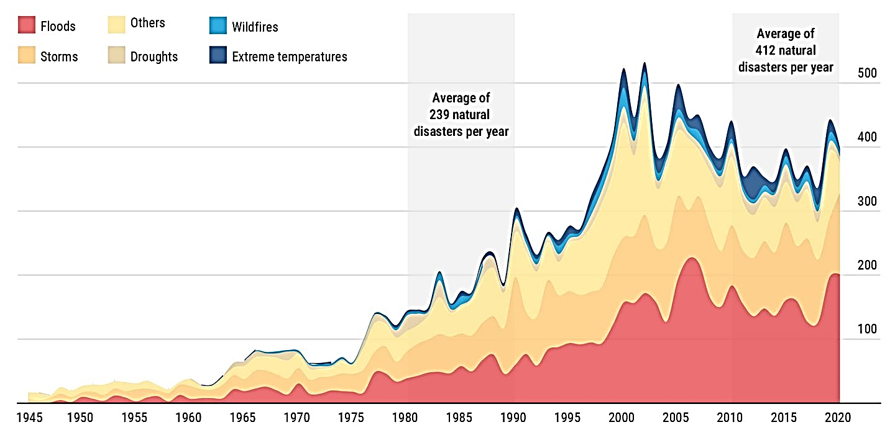

*Source - World Trade Organization/Center for Research on the Epidemiology of Disasters*

Recognizing the gravity of the climate crisis, governments are prioritizing environmental conservation, climate mitigation, and adaptation in policy agendas. However, a persistent gap in green finance threatens the realization of these goals. Current levels of green and climate finance fall far short of what is required to meet global climate targets.

For example, around 1.2 trillion USD of annual climate finance was realized in 2021-22, which majorly falls short of the annual requirement of more than 8 trillion USD for the year. The annual climate finance requirement is estimated to increase to more than 12 trillion USD per year by 2050. This requires a five-fold increase in annual climate finance to avoid the most severe impacts of climate change (CPI, 2023).

Figure 2: Global tracked Climate Finance and average estimated annual needs through 2050

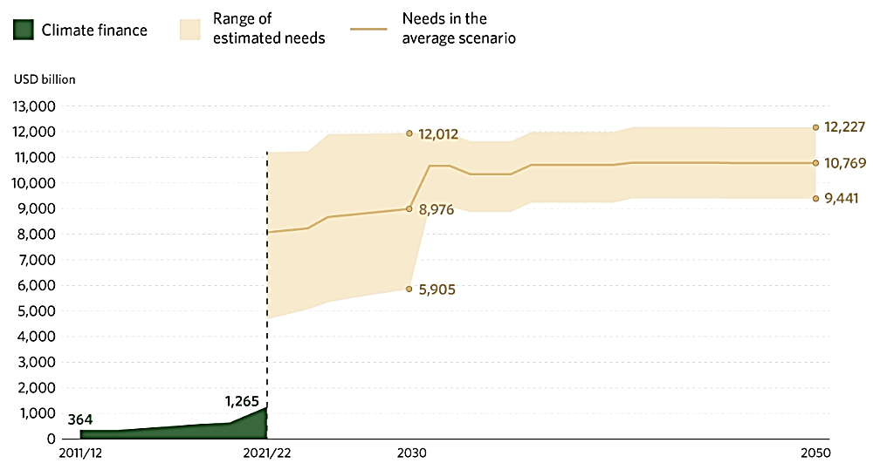

*Source - Global Landscape of Climate Finance 2023, CPI (2023)*

One of the major sources of climate finance is the government funding. However, the fiscal space of many governments remains constrained, particularly in the aftermath of the COVID-19 pandemic, which significantly increased public expenditure and contributed to elevated levels of sovereign debt globally. In this context, the effective prioritization and allocation of limited public resources become all the more critical to achieve the best possible results. This can be achieved through **Green Budgeting**.

## What is Green Budgeting?

According to the Organization of Economic Cooperation and Development (OECD, 2021), “Green budgeting is a practice which uses the tools of budgetary policymaking to help achieve “green” objectives, i.e., those relating to the climate and environmental dimensions. While by itself, green budgeting does not change existing policies, it provides decision-makers with a clearer understanding of the overall environmental and climate impacts of budgeting choices.” At its core, Green Budgeting ensures that government actions, such as taxation, expenditure, and investments, align with environmental objectives, including reducing GHG emissions, conserving natural resources, and promoting renewable energy. It systematically consolidates evidence to enable informed decision-making on optimizing revenue generation and resource allocation, thereby supporting the fulfilment of national and international commitments on environmental sustainability and climate change.

## Difference between Green Budgeting and Climate Budgeting

Often Green Budgeting and Climate Budgeting are used interchangeably but there are key conceptual differences in their scopes. While both Green Budgeting and Climate Budgeting aim to integrate environmental and climate considerations into budgetary processes, Green Budgeting has a broader scope encompassing various environmental issues including biodiversity, air quality, water management, and resource efficiency beyond just climate change. Climate Budgeting specifically focuses on climate change mitigation and adaptation. Thus, Climate Budgeting is a subset of Green Budgeting.

## The Evolution of Green Budgeting

Over the past decade, interest in Green or Climate Budgeting has grown significantly, particularly among middle-income and low-income countries in the Asia-Pacific region, supported by institutions such as United Nations Development Programme (UNDP) and multilateral organizations such as the Asian Development Bank (ADB) and the World Bank. Initially focused on tagging climate-relevant expenditures to improve transparency and attract international climate finance, efforts have since evolved into full-fledged Green and Climate Budgets. Nepal’s publication of the first Climate Budget in 2013 was followed by countries such as Bangladesh, France, Indonesia, Kenya, Moldova, Norway and Sweden (Petrie, 2021).

The 2013 Fifth Assessment Report (AR5) of the Intergovernmental Panel on Climate Change (IPCC) affirmed that climate warming is “unequivocal” and many observed changes are “unprecedented.” While some countries began integrating climate action into national planning with the involvement of finance ministries, others lacked the institutional frameworks to do so.

In response, the World Bank developed the **Climate Change Public Expenditure and Institutional Review (CCPEIR) Sourcebook** in 2014, providing tools to guide the integration of climate-responsive practices into fiscal management.

In 2017, the **OECD Paris Collaborative on Green Budgeting** was launched to co-develop practical tools for aligning national budgets with environmental objectives. Momentum further increased in 2018, when 39 countries highlighted the role of finance ministers in tackling climate change. This led to the debut of the **Coalition of Finance Ministers for Climate Action** in April 2019, now comprising over 90 countries committed to the **Helsinki Principles**, promoting climate-informed fiscal policy.

The introduction of the **Public Expenditure and Financial Accountability** (**PEFA) Climate Framework** in 2020 marked another significant step, enabling countries to assess how climate considerations are embedded across the budget cycle, from planning to monitoring.

As awareness of the importance of fiscal alignment with environmental goals has grown, several key methodologies have emerged, including:

* *Green Budgeting Toolkit* by The Association of Chartered Certified Accountants (ACCA)
* *OECD Green Budgeting Framework*
* *European Union (EU) Green Budgeting Reference Framework*
* *Climate Public Expenditure and Institutional Review (CPEIR)* by UNDP
* *Climate Change Financing Framework* by Government of Nepal
* *Primer on Green Budgeting* by The Energy and Resources Institute (TERI), India

These tools provide guidance on institutional design, tagging methods, performance indicators, and integration into fiscal frameworks.

The adoption of Green Budgeting is expanding rapidly. According to the OECD (2024), “the number of countries implementing green budgeting practices rose from 14 in 2020 to 24 in 2022”. Around two-third of the EU Member States have adopted or are planning to adopt Green Budgeting (The European Commission, 2023), reflecting a growing global commitment to integrating environmental considerations into public finance.

# GREEN BUDGETING FRAMEWORKS USED ACROSS THE GLOBE

There is no universally applicable model for Green Budgeting. Instead, each country must tailor its approach to align with its existing public financial management (PFM) framework, taking into account institutional strengths and capacity constraints. Several countries have adopted diverse Green Budgeting frameworks, depending on their development context, environmental priorities, and administrative structures. This section outlines key international frameworks that have gained prominence globally.

## OECD Green Budgeting Framework

The OECD Green Budgeting Framework provides a strategic structure for integrating environmental sustainability into budgetary processes. It is built around four core “building blocks”:

* **Institutional Arrangements**: Establishing legal, procedural, and organizational mechanisms for Green Budgeting.
* **Methods and Tools**: Including budget tagging, environmental impact assessments, green spending reviews, and carbon pricing.
* **Accountability and Transparency**: Ensuring systematic scrutiny, reporting, and evaluation of environmental impacts.
* **Enabling Environment**: Supporting long-term institutionalization of Green Budgeting through capacity building and stakeholder engagement.

Figure 3: Elements constituting each of the 4 building blocks of the OECD Green Budgeting Framework

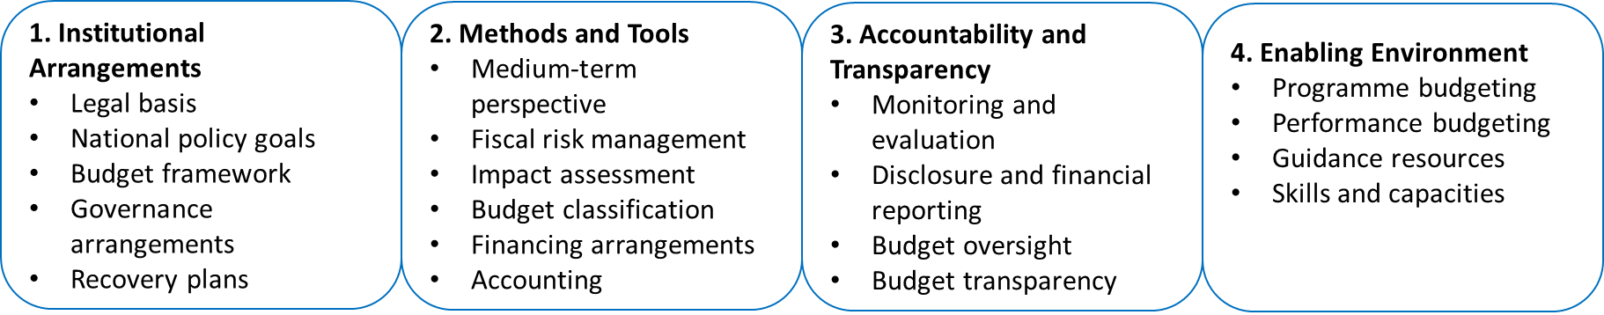

*Source – Green Budgeting in OECD Countries 2024, OECD (2024)*

## European Union (EU) Green Budgeting Reference Framework (GBRF)

Complementing the OECD framework, the EU GBRF offers a more operational, country-level implementation guide. It emphasizes five critical components:

* **Coverage**: Extent of inclusion of environmental goals, budget items, and governance levels.
* **Methodology**: Assessing policy coherence with long-term environmental goals.
* **Deliverables**: Legal or administrative provisions specifying deliverables and timelines.
* **Governance**: Clarifying roles, responsibilities, and resource allocation.
* **Transparency and Accountability**: Public disclosure and expert review of methodologies.

The GBRF classifies Green Budgeting implementation across **three maturity levels**—**Essential**, **Developed**, and **Advanced**—allowing countries to align their practices with institutional readiness.

## Climate Public Expenditure and Institutional Review (CPEIR)

Developed with support from UNDP and the World Bank, the CPEIR serves as a diagnostic tool to assess the integration of climate considerations into public expenditure. It is structured around the following three core pillars –

* **Policy Analysis**: Evaluating climate policy frameworks and examines how these frameworks translates into programs and instruments.
* **Institutional Analysis**: Assessing institutional mandates, coordination mechanisms, and implementation capacity.
* **Climate Public Expenditure Analysis**: Quantifying climate-related spending and analyzing fiscal policies relevant to climate change.

Figure 4: Steps included under each of the 3 key pillars of CPEIR Analytical Framework

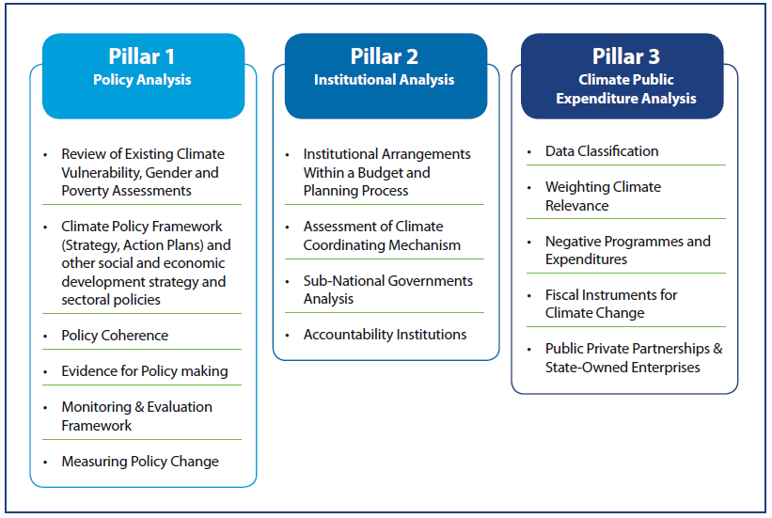

*Source - Methodological Guidebook: Climate Public Expenditure and Institutional Review (CPEIR), UNDP (2015)*

# LITERATURE REVIEW

Green Budgeting is a relatively recent concept in PFM, but various institutions have already developed foundational guidelines and frameworks to support its effective implementation as discussed in the previous section.

Several studies have emphasized the multiple benefits of Green Budgeting. These include enhanced fiscal transparency, improved resource allocation, and alignment of public finances with climate goals. For example, *Marinheiro, C., Sousa, A. and Pinheiro, A. (2022)* notes that Green Budgeting can serve as a pathway to issuing green bonds for climate-related projects. Similarly, *Green Budgeting for a Green Recovery* highlights the potential of Green Budgeting to support post-pandemic economic recovery efforts in Asia-Pacific countries.

Other studies stress that Green Budgeting enables policymakers to understand the environmental impact of budgetary decisions, prioritize natural resource conservation, and integrate environmental taxes into fiscal systems (Aktaş, E. (2023)).

The literature also includes analyses of Green Budgeting implementation across various countries. *Marinheiro, C., Sousa, A. and Pinheiro, A. (2022)* provides a roadmap for adopting Green Budgeting and reviews France’s experience. *Pojar, S. (2023)* analyzes EU Member States’ use of Green Budgeting tools, concluding that while the focus has so far been on improving transparency, there is a need to strengthen its role in influencing actual budgetary decisions. *Stanimirović, T., Lah, L., Kotnik, Z. and Klun. M. (2023)* reviewed Slovenian budget documentation from 2018–2022 and found limited integration of green priorities, identifying the need for further research with evolving indicators and targets.

In Indonesia, *Azzahra, L., Pamungkas, P. and Trinarningsih,W. (2022)* examined local government budgets in Central Java and found that while Green Budgeting practices exist, they are hampered by limited understanding at the local level, insufficient data, and weak political commitment. Similarly, *Ick, J. (2024)* assessed South Korea’s introduction of the Greenhouse Gas Reduction Cognitive Budget (GRCB), applying the OECD framework to highlight implementation challenges.

In the Indian context, the literature remains limited due to the relatively nascent adoption of Green Budgeting in India . One notable contribution is *Agarwala, T. (2022)*, which reviewed climate-responsive/green budgeting frameworks in Odisha and Bihar and proposed a common framework for state-level implementation. However, the report predates many recent developments in India and globally and does not fully assess the limitations of existing state-level approaches.

# RESEARCH GAPS

This paper aims to address the gap in research on Green Budgeting in the context of Indian states and has the following objectives:

1. **Identifying the shortcomings in the Green/Climate Budgeting methodologies adopted by the Indian states and Union Territories (UTs).**
2. **Proposing the key elements that may be considered for the Green Budgeting framework in India, for adoption across both the Central and State Governments.**
3. **Proposing a Green Budgeting Index for assessing the implementation of Green Budgeting by the Indian states.**

The study seeks to offer practical insights into how Green Budgeting can be standardized, scaled, and made more effective in India and similar emerging economies.

# GREEN BUDGETING LANDSCAPE IN INDIA

According to the World Bank, India ranks among the top 10 economies globally in terms of vulnerability to climate-related risks. India experienced extreme weather events on 322 out of 366 days in 2024, including heatwaves, floods, and cyclones, resulting in over 3,200 deaths and affecting 3.2 million hectares of crops.​ (Centre for Science and Environment, 2024) As the scale and frequency of these extreme weather events increases, the broader macroeconomic and social impacts are expected to be significant. The Reserve Bank of India has estimated that by 2030, up to 4.5% of India’s Gross Domestic Product (GDP) could be at risk due to lost labour hours caused by extreme heat and humidity. Without effective climate change mitigation and adaptation strategies, India could face annual GDP losses of 3% to 10% by 2100, with the potential to severely reduce living standards for nearly half of its population by 2050(Kompas et al. 2018; ODI 2021).

In terms of air quality, India ranks among the world's most polluted countries, with an average PM2.5 concentration of 50.6 µg/m³—over 10 times the WHO guideline of 5 µg/m³. $95 billion (3.3% of India’s GDP) was lost in 2019 due to lost productivity, healthcare costs, and premature mortality from air pollution. (Confederation of Indian Industry, Clean Air Fund and Dalberg, 2021)

As the world’s most populous country, India is the third-largest contributor to global GHG emissions. With energy demand expected to rise rapidly, India is projected to surpass the United States as the second-largest emitter by 2035. These trends underscore the urgency of mainstreaming environmental and climate considerations into national and subnational policy and fiscal frameworks (Statista, 2023).

Figure 5: Risks due to Climate Change in different parts of India

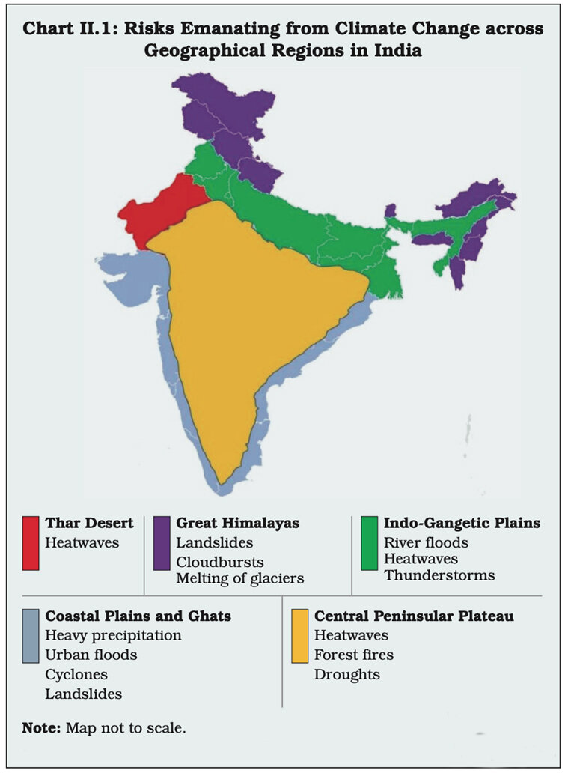

*Source – How climate change can impact GDP and jobs, Forbes India (2023)*

Figure 6: Climate Change-related disaster frequency in different countries, it has steadily increased in India over the years

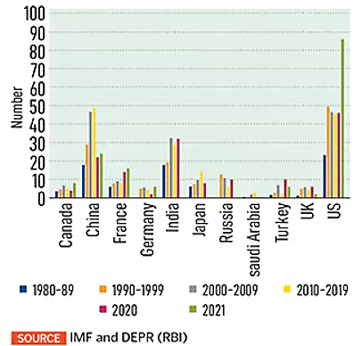

*Source - How climate change can impact GDP and jobs, Forbes India (2023)*

Top overcome these challenges, India has taken significant strides in environment and climate-related initiatives with innovative policies like Lifestyle for Environment (LiFE), National Clean Energy Fund, Joint Forest Management, Atal Mission for Rejuvenation and Urban Transformation (AMRUT), Faster Adoption and Manufacturing of Hybrid and Electric Vehicles (FAME) and “Panchamrit” which is a five-point action plan to combat climate change, among many others.

An important turning point in India’s environmental and climate change efforts was the adoption of the National Action Plan on Climate Change (NAPCC) on 30th June 2008. Given India’s federal structure, the states play an important role in managing sectors critical to climate change action, such as natural resources, infrastructure, and industry. To support the NAPCC’s implementation, subnational climate planning is essential. In 2009, all state governments were asked to develop a State Action Plan on Climate Change (SAPCC), which would align with the national framework while addressing state-specific vulnerabilities. As a result, 34 states and UTs have already prepared their SAPCCs (till February, 2023).

In October 2015, the Government of India (GOI) submitted its Intended Nationally Determined Contribution (INDC), committing to reduce the carbon intensity of its economy, in anticipation of the international climate negotiations in Paris later that year.

However, all-encompassing strategies and innovative policies are of limited use without sufficient funds to effectively implement them and this is where India is lagging behind. India will need significant financial resources to address its environmental requirements. Thus, it is imperative for India to adopt Green Budgeting at the national and sub-national levels, to achieve its environment and climate change objectives and commitments.

Figure 7: Tracked green investment vs the estimated requirements to meet current NDC (INR bn)

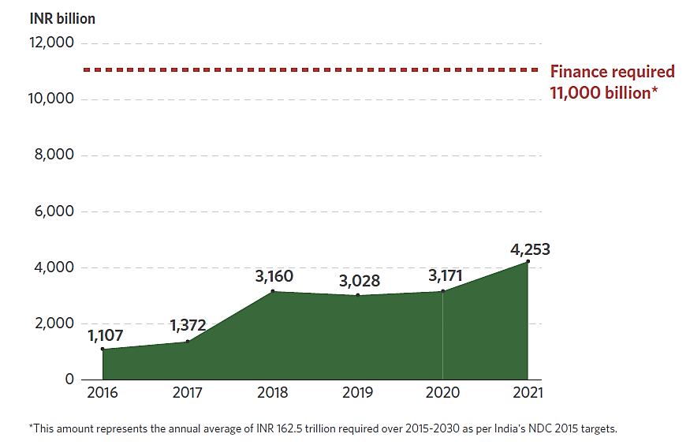

*Source - Landscape of Green Finance in India 2024, CPI (2024)*

# ASSESSMENT OF STATE-LEVEL GREEN BUDGETING PRACTICES IN INDIA

At present Green Budgeting is widely missing in India both at the national level and at the state level. The Union government of India has not yet adopted Green Budgeting and till now only 8 out of the 36 states and UTs in India have implemented Green/Climate Budgeting. Odisha achieved a milestone by becoming the first Indian state to implement Climate Budgeting in 2019-20. This was followed by Bihar, releasing its first Green Budget in 2020-21. Assam, Meghalaya, and Pondicherry followed the league in 2023-24. Kerala and Uttar Pradesh implemented Green Budgeting in 2024-25 and in the latest 2025-26 budget, Rajasthan also joined the league. However, since there is **no uniform nationally determined Green Budgeting framework** in India, different states are using different frameworks and methodologies to frame their Green/Climate Budgets, leading to discrepancies. Some states have aligned their Green/Climate Budget with their SAPCC while others have not, some have used scientific methodologies for identifying schemes with green components and deciding their weightage while others have followed a much simpler approach, some have used **Rio** **Markers or CPEIR methodology** to categorize the green schemes and colour code them while others have not.

**Sustainable Development Goal (SDG) mapping** is largely absent across state budgets. Linking Green Budgeting with SDG tracking enables better assessment of budget gaps and supports integrated planning and financing. For example, Bihar has included SDG mapping of its green expenditures in the Green Budget. Incorporating gender dimension in green budgeting is crucial as climate risks disproportionately affect women, thereby enhancing equity and resilience. The Pradhan Mantri Ujjwala Yojana is a notable example, addressing both gender and environmental objectives.

**Capacity building and institutional readiness** remain major challenges. Most states have limited technical know-how, with little emphasis on training, research, or peer learning. Moreover, Green Budgets often account only for programs with direct environmental benefits, overlooking schemes with **negative or indirect environmental impacts**. This narrows the policy lens and prevents comprehensive environmental assessment. For example, fossil fuel subsidies—harmful to the environment—are typically excluded.

Most states in India still concentrate on the traditional sources of climate finance. States should explore newer climate financing approaches such as public-private partnerships (PPPs) and international cooperation and Green Budgets can be leveraged for this purpose as they promote transparency and accountability. For instance, Odisha’s Climate Budget promotes **PPPs and international cooperation** for climate finance.

Finally, a **national oversight mechanism** to monitor Green Budgeting implementation is largely absent in India. However, it is essential to ensure consistency, and to promote best practices and many OECD countries have implemented this.

Figure 8: Snapshot of key elements of Green Budget in Indian States/UTs

|  |  |  |  |  |  |
| --- | --- | --- | --- | --- | --- |
| Indian State/Union Territory | Presence of a defined strategy/action plan for climate change | SDG mapping of Green Expenditures | Making Green Budget Gender Responsive | Encouraging Public- Private Participation | Dedicated Inter-departmental Institutional Coordination Mechanism |
| Assam | • |  |  |  |  |
| Bihar | • | • |  |  |  |
| Kerala | • |  |  |  |  |
| Meghalaya | • |  |  |  |  |
| Odisha | • |  |  | • |  |
| Puducherry | • | • |  |  |  |
| Rajasthan | • |  |  |  |  |
| Uttar Pradesh | • |  |  |  |  |
| Total | **8** | **2** | **0** | **1** | **0** |

*Source – Author’s analysis based on information from Green/Climate Budget reports of various states/UTs*

# PROPOSED APPROACH FOR GREEN BUDGETING FOR INDIA

In light of the challenges identified in Green Budgeting approach across Indian states, it is imperative to establish a **uniform Green Budgeting framework** that can be adopted by both the Union and state governments. A harmonized framework will enable consistent methodology, facilitate inter-state comparisons, and improve the quality, transparency, and effectiveness of green fiscal planning. For successful implementation of Green Budgeting, strong political commitment is essential, as it underpins the institutionalization of climate-responsive public finance.

The key elements of that should be included in the Green Budgeting framework, along with the sequential steps for its operationalization, are outlined in the following section.

## Legal Basis of Green Budgeting/ Institutionalization of Green Budgeting

The first most important step would be to legally mandate the Union government and all the State governments to adopt Green Budgeting every year, in order to institutionalize it. This may be done through mandating the publication of Green Budgets in the Budget Call Circulars because it provides more flexibility than legislation, if changes need to be made from one year to the next, especially in the initial stages of green budget preparation when governments are still figuring out what is the best possible approach. In the future, the Green Budgeting framework can be made permanent by including it in the legislation.

Based on the 2022 data, the OECD noted that countries preferred to implement green budgeting through administrative practices, such as budget circulars, which provided more flexibility than legislation if changes were necessary from one year to the next (21 out of 24 countries, 88%) compared to other legislation (14 out of 24, 58%) and budget law (11 out of 24, 46%). In 2022, six countries, namely Austria, Chile, Italy, Mexico, the Slovak Republic, and Sweden, implemented green budgeting through all three instruments – budget law, other legislation, and administrative practice (OECD, 2024).

## Alignment with NAPCC and SAPCC

Next, a National Strategy on Climate and Environment is necessary to form the basis of the Green Budget framework. India already has the NAPCC in place and the Green Budget of the Union government should be aligned to NAPCC. Similarly, the Green Budgets of the all the states should be aligned to their respective SAPCCs. The NAPCC and SAPCCs should be updated every five years to accommodate the changes in the environment and climate change scenario.

In 2022, 20 out of 24 OECD countries that were implementing green budgeting had a national climate or environmental strategy to inform green budgeting. Sixteen of these strategies were aligned specifically to Nationally Determined Contributions as required under the Paris Agreement (OECD 2024). In the EU, all countries undertaking green budget tagging—except Portugal—have aligned their tagging efforts with a comprehensive set of environmental objectives. Several of these countries have further refined their approach by incorporating more detailed elements that reflect their specific national green agenda (EU 2023).

## Gradually incorporating all departments in Green Budget

In the long run, it is always recommended that all the departments be incorporated into the Green Budgeting accounting. However, to start with, it is advisable to identify key government departments to be included in Green Budget. Initially, the departments inclined to the key sectors and themes identified in the NAPCC/SAPCC can be included in the green budget. In the future, other departments can also be included gradually.

## Forming National Green Budget Council at the Centre and State Green Budget Council for each state

Effective Green Budgeting requires strong coordination between the **Finance Department** and the **Environment Department**. The Environment Department provides technical guidance, develops methodologies, and leads capacity-building efforts. The Finance Department ensures cross-departmental coordination and consolidates information into the Green Budget.

In most **OECD countries**, Green Budgeting governance is centralized under the Ministry of Finance, with technical support from line ministries and specialized agencies. As of 2022, 14 OECD countries established inter-ministerial bodies to support coordinated implementation (OECD, 2024).

**Drawing on international experience**, it is recommended to establish a **National Green Budget Council** at the central level and **State Green Budget Councils** at the subnational level. These multi-stakeholder bodies would include representatives from the Finance and Environment Departments, as well as independent experts from academia and civil society.

**Key functions of the Councils may include**:

1. Coordinating Green Budgeting implementation across departments.
2. Addressing technical issues and ensuring consistency in approach.
3. Conducting regular training and capacity-building activities.
4. Reviewing Green Budgets for quality, identifying gaps, and providing recommendations.
5. Creating an online knowledge platform for guidance materials, tools, and shared experiences.
6. Monitoring compliance with the national Green Budgeting framework at all levels of government.

## Green Budgeting should be integrated across all important decision-making processes

Green Budgeting should not be restricted to only tagging with the budget line items (head of accounts), which is an accounting exercise. It should be integrated across all public policy requirements so that policy making, budget allocation and prioritisation of capital expenditure can be done in an informed manner.

Figure 9: Integration of Green budgeting in important decision-making processes in OECD Countries, 2022

*Source – Green Budgeting in OECD Countries, OECD (2024)*

## Choosing the right tools to use for Green Budgeting

Countries employ a range of Green Budgeting tools, including **ex-ante and ex-post environmental impact assessments**, **green budget tagging**, **environmental cost-benefit analysis**, **carbon assessment**, **carbon pricing instruments**, **shadow carbon pricing**, **environmental tax reforms**, and **green spending reviews**.

The choice of tool depends on the policy objective. For example:

* **Environmental impact assessments** help identify environmental externalities in policy proposals.
* **Green budget tagging** supports expenditure tracking but does not measure impact.
* **Carbon assessments** link fiscal measures to emissions outcomes.
* **Macro-fiscal integration** and **fiscal risk analysis** account for climate-related risks in budget planning.

Most OECD countries use a **combinatorial approach**. Ireland and the UK use over 14 tools each, followed by Norway (11), France (10), Denmark (9), New Zealand (9), and Sweden (9), illustrating the value of multi-tool strategies for comprehensive green budgeting (OECD, 2024).

Figure 10: Green Budgeting tools used by OECD Countries, 2022

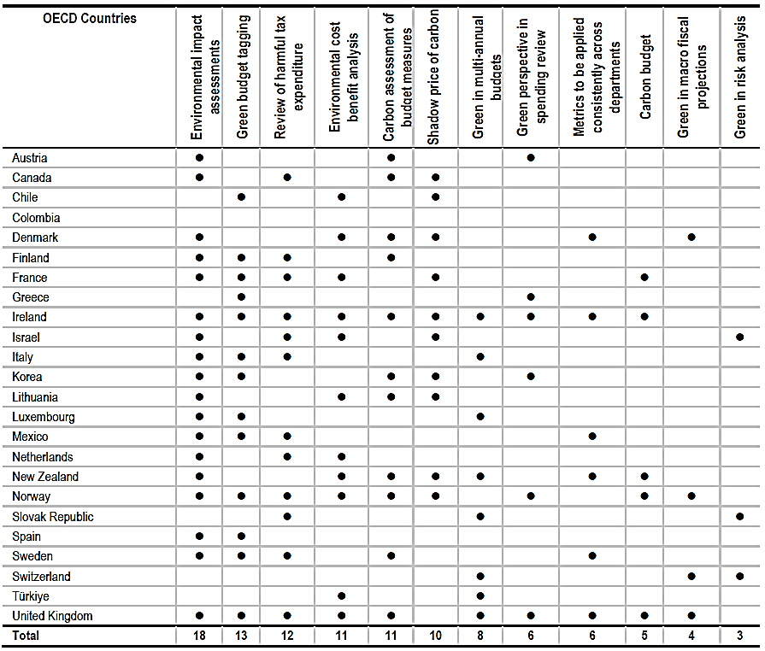

*Source – Green Budgeting in OECD Countries, OECD (2024)*

The choice of tools for Green Budgeting should be guided by the strengths of the existing budgetary framework and the institutional capacity already in place to support the implementation of environmental policies. After careful consideration, Green Budget Tagging has been deemed the best-suited tool for India. Moreover, all the 8 Indian states/UTs which have implemented Green Budgeting till now have used this tool. Initially, India may start with Green Budget Tagging and then gradually incorporate other tools as well like the OECD countries have done.

## Methodology for Green Budget Tagging

A structured approach to Green Budget Tagging (GBT) involves the following key steps:

1. **Defining “Green”**

Establish a working definition of “green,” aligned with NAPCC/SAPCC priorities and international climate and sustainability commitments.

1. **Selection of Budget items**

Identify relevant budgetary items—both recurrent and capital—for tagging. Begin with key departments aligned with climate priorities, expanding to all departments and subnational levels, including local governments. Tag any expenditure with potential positive or negative environmental impacts, direct or indirect.

1. **Classification of Expenditures**

Categorize tagged expenditures by their degree of environmental relevance, based on the definition of “green.” Given the diverse ecological contexts across Indian states, each state should identify its own set of medium-term environmental priorities under the SAPCC, informed by local vulnerabilities and climate risks. Each green scheme or programme is then mapped to the specific environmental objective it supports. This allows for systematic tracking of budget allocations across priority areas, facilitating the identification of funding gaps, over-allocations, and areas requiring enhanced resource mobilization.

1. **Integration with SDG and Gender Budgeting**

Map green expenditures against relevant SDGs and gender objectives to maximize policy synergies. Since most of the State Governments in India have published their Gender Budgets , integration of green budget with Gender budget can be done.

1. **Weighting and Categorization**

Assign weights using a simplified scale (e.g., Rio Marker approach) to reflect the degree of alignment with green objectives. An **input-based** method is recommended for consistency. Proposed categories include:

* + Fully Dedicated (90–100%)
  + Very High (75–90%)
  + High (50–75%)
  + Medium (25–50%)
  + Low (5–25%)
  + Marginal (0–5%)
  + Detrimental (Negative weight)

Use a standardized, color-coded system for ease of reporting. A national guidance note should be developed to ensure consistency in assigning weightages.

1. **Timing of Tagging**

Apply GBT both **ex-ante** (during budget formulation) and **ex-post** (post-execution). While ex-ante tagging supports strategic planning, ex-post tagging enhances review and accountability. A combined approach—as adopted in the Philippines—enables comprehensive oversight of both planned and actual green expenditures.

## Measures taken to uphold the Accountability and Transparency of Green Budgeting

Regarding the accountability and transparency of the Green Budgeting exercise, the Union government and all the State governments must publish detailed Green Budget reports every year as a separate supplementary document along with the other budget documents and make it publicly available and easily accessible. The Green Budget reports should include an overview of the environment and climate change-related challenges faced, NAPCC/SAPCC along with medium-term and long-term environmental objectives, explanation of the methodology used for identifying the schemes to be included and allotting their green weightage and how it aligns with NAPCC/SAPCC, assessment of environmental impact and green budget statements at the end listing all the included budget heads with their respective weightage, SDG mapping and gender responsiveness.

In Chile, France, Ireland, Korea, and Norway, the ministries of Finance prepared separate Green Budget reports. In 2022, 15 OECD countries made information on Green Budgeting available and easily accessible to the public using press releases, social medias, and online publications (OECD, 2024).

The proposed National and State Green Budget Councils can act as monitoring bodies in India, as mentioned earlier. In addition to these councils, independent oversight institutions such as independent fiscal institutions, auditory bodies and think tanks will be involved in assessing and scrutinizing the Green Budgets. The scrutiny performed by oversight institutions helps to ensure an informed parliament and public in relation to the fiscal outlook that is contained in budgets and forecasts. For instance, in France, the national Court of Audit monitors the Green Budgeting methodology.

The participation of civil society in the green budgeting process is a practice that can strengthen the credibility and social acceptability of green budgeting. There are various means to integrate civil society into budget processes, such as citizens commissions, public inquiries, and collaborative procedures.

The participation of civil society in the green budgeting process has increased from 5 OECD countries in 2020 to 12 OECD countries in 2022. For instance, in Denmark the Danish “borgerting” was established within the Climate Act as a body that has 99 members who are to be representative of the Danish population and in Sweden all major decisions are preceded by public inquiries which are tasked with consulting those concerned central authorities, the business community and civil society (OECD, 2024).

## Establishing an Enabling Environment for Green Budgeting

A conducive enabling environment is essential to ensure the sustainability and continuous improvement of Green Budgeting efforts. Key components include the provision of targeted training and capacity development, establishment of effective coordination mechanisms among ministries and stakeholders, and the availability of clear, practical guidance for the implementation of green budgeting tools. These fall under the responsibilities of the Central and State Green Budget Councils, as previously mentioned.

In 2022, 13 OECD countries implemented training and skills development. The most common components supporting the implementation of green budgeting were training and skills development within line ministries (10 countries). Moreover, eight countries had specific training programmes for finance ministries (OECD, 2024).

## Assessing the impact of Green Budgeting on the Environment

Lastly, the government with the help of the National Green Budget Council and the State Green Budget Councils needs to identify environmental performance indicators whose trends can be tracked to assess the impact of Green Budgeting on the environment and whether Green Budgeting is successful in achieving its main objectives of environmental conservation, climate change mitigation and adaptation.

As of 2022, 11 OECD countries had introduced climate and environmental variables to monitor the execution of some or all budget programmes (OECD, 2024).

## Formulating an Index to assess the implementation of Green Budgeting

The OECD has developed a Green Budgeting Index to assess the implementation of Green Budgeting across its member countries. This index quantifies the measures in place across each of the four building blocks of the OECD Green Budgeting Framework. By conducting an empirical trend analysis, we have observed that countries performing well on the OECD Green Budgeting Index (Good Performers) have seen greater improvements in their environmental indicators compared to countries with poor performance on the index (Bad Performers).

Figure 11: Results of the Trend Analysis



*Source – Author’s calculations*, *Data source - Emissions Database for Global Atmospheric Research (EDGAR)* <https://edgar.jrc.ec.europa.eu/report_2024?vis=co2tot#data_download>

In this paper, we propose a Green Budgeting Index for the Indian context, drawing inspiration from the OECD Green Budgeting Index. This index would facilitate the evaluation of state governments in India in terms of their performance in implementing Green Budgeting. It would also serve as a self-assessment tool to examine results at the building block level and identify areas for further improvement. Additionally, the index could enable cross-state comparisons and encourage healthy competition by ranking states based on their performance. Ultimately, the introduction of this index could drive greater improvements in environmental outcomes by ensuring that the Green Budgeting exercise adopted by both the Union and State governments are robust and aligned with best practices.

The Index ranges from 0 (no implementation) to 1 (high level of implementation of green budgeting practices). Each state’s score is calculated by aggregating the weighted scores of multiple dimensions, each ranging from 0 to 1. The Index is based on a survey questionnaire, where the qualitative answer options are translated into quantitative indicators, varying from 0 to 1. The method for calculating the Index score is as follows –

* Index score for each question = $(A*B*C)$; where, A = building block weightage, B = variable weightage and C = index score per variable
* Index score for each variable = sum of scores of all questions included under the variable
* Index score for each building block = sum of scores of all variables included under the building block
* Green Budget Index score (aggregate) = sum of scores of all 4 building blocks

The detailed methodology (along with the questionnaire) for the proposed Green Budgeting Index for assessing the implementation of Green Budgeting by the Indian states is given in the tables below.

*Table 1: Methodology for Institutional Arrangements*



*Table 2: Methodology for Methods and Tools*

**

*Table 3: Methodology for Accountability and Transparency*



Table 4: Methodology for Enabling Environment



## Integrating the Elements of Green Budgeting in the Budget Cycle

The integration of Green Budgeting elements within India's existing budget cycle is essential for systematic and sustained implementation. The figure below outlines the key entry points across various stages of the budget process, illustrating how each step of the proposed Green Budgeting framework can be embedded.

Figure 12: Integrating the Elements of Green Budgeting in India’s Budget Cycle

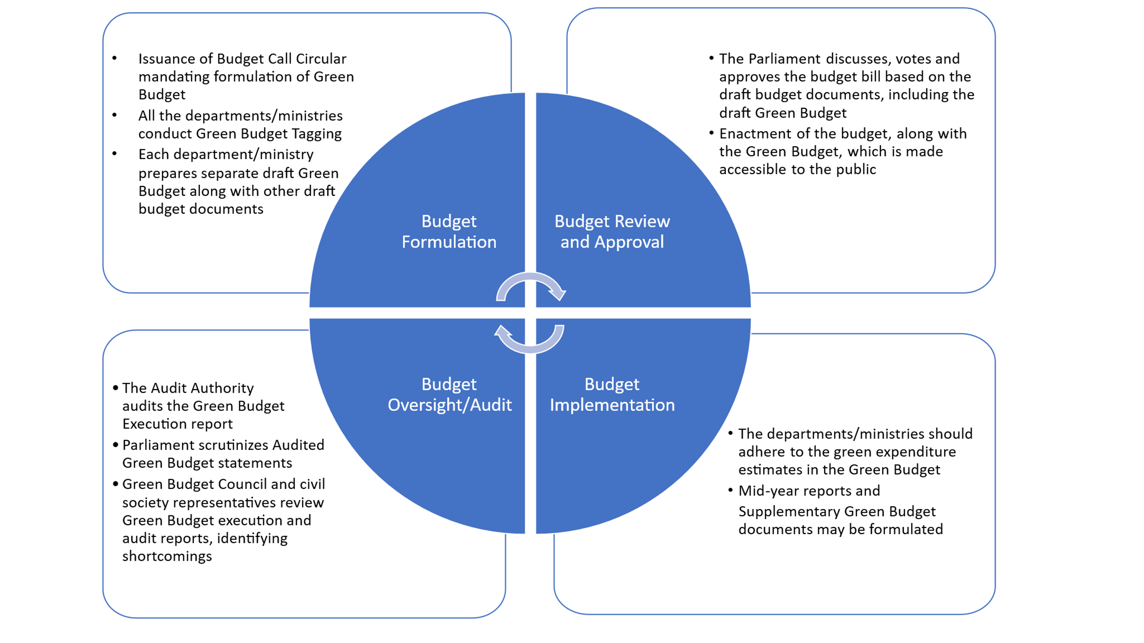

# CONCLUSION

This paper highlights the significant potential of Green Budgeting as a strategic tool for advancing climate action, which is the need of the hour. However, the effectiveness of Green Budgeting is contingent upon the establishment of a sound framework and robust methodologies. As a relatively new concept, countries worldwide are still figuring out what the best approach is, though a few frameworks based on best practices have been developed by international institutions. Moreover, there is no one-size-fits-all for Green Budgeting framework and each country must adapt the available frameworks according to their unique requirements and public finance systems.

Countries face several challenges in implementing Green Budgeting, with the main ones being lack of resources, lack of relevant knowledge and technical expertise, poor availability of green disaggregated data and a lack of established methodologies for assessing results and impacts of Green Budgeting. Addressing these challenges is critical to fully harness the benefits of Green Budgeting. In the current formative stage, it is essential for governments to invest in research, capacity development, and institutional strengthening to support the long-term success of this initiative.

In India, Green Budgeting remains at a nascent stage. While there is no formal initiative at the Union level, only 8 out of 36 states and UTs have introduced Green or Climate Budgeting. However, in the absence of a standardized national framework, these efforts vary widely in their structure and approach, limiting comparability and effectiveness. Our study has also analyzed the Green/Climate Budgets of the Indian states and identified several gaps and inconsistencies in the existing state-level methodologies, which could hinder the achievement of Green Budgeting’s full potential.

Given this context, there is a clear need for the GoI to develop a unified Green Budgeting framework, tailored to India’s fiscal context, environmental challenges, and long-term development goals. Such a framework should be adopted at both the Union and state levels to ensure coherence and comparability across jurisdictions.

This paper proposes the key elements that may be considered for a comprehensive Green Budgeting framework in India, which may serve as a reference for the GoI. However, this was only a theoretical exercise, and the GoI must conduct further empirical research and practical analysis to assess its feasibility and guide its implementation at the national and subnational levels. This paper also addresses the need of assessing the state-wise implementation of Green Budgeting in India by proposing a Green Budgeting Index for this purpose. As a developing country in Asia, India stands to benefit significantly from an effective Green Budgeting system, both by optimizing the allocation of limited public resources for climate and environmental priorities and by leveraging additional green finance. To this end, sustained investment in the development and operationalization of a robust Green Budgeting process should be a strategic priority for the GoI in the coming years.

COMPETING INTERESTS DISCLAIMER:

Authors have declared that they have no known competing financial interests OR non-financial interests OR personal relationships that could have appeared to influence the work reported in this paper.

# REFERENCES

OECD (2024), *Green Budgeting in OECD Countries 2024*, OECD Publishing, Paris, <https://doi.org/10.1787/9aea61f0-en>.

OECD (2021), *Green Budgeting in OECD Countries*, OECD Publishing, Paris, [*https://doi.org/10.1787/acf5d047-en*](https://doi.org/10.1787/acf5d047-en).

OECD (2021), *Green Budget Tagging: Introductory Guidance & Principles*, OECD Publishing, Paris, [*https://doi.org/10.1787/fe7bfcc4-en*](https://doi.org/10.1787/fe7bfcc4-en).

The European Commission (2023), *Green Budgeting in the EU - Key insights from the 2023 European Commission survey of green budgeting practices,* [*40851e31-78eb-43fe-8e6d-a08fa4105638_en*](https://apcdeloitte-my.sharepoint.com/personal/akartik_deloitte_com/Documents/Desktop/40851e31-78eb-43fe-8e6d-a08fa4105638_en)

The European Commission (2022), *European Union Green Budgeting Reference Framework,* [*bfd8d6c1-d501-4cf2-873f-811f6453dde8_en*](https://apcdeloitte-my.sharepoint.com/personal/prdutt_deloitte_com/Documents/Desktop/bfd8d6c1-d501-4cf2-873f-811f6453dde8_en)

UNDP (2015), *A Methodological Guidebook: Climate Public Expenditure and Institutional Review (CPEIR),* [*RBAP-DG-2015-CPEIR-Methodological-Guidebook.pdf*](https://apcdeloitte-my.sharepoint.com/personal/akartik_deloitte_com/Documents/Desktop/RBAP-DG-2015-CPEIR-Methodological-Guidebook.pdf)

Finance Department, Government of Odisha (2025), *Climate Budget 2025-26*

Finance Department, Government of Bihar (2024), *Green Budget 2024-25*

Finance Department and Department of Science, Technology and Environment, Government of Puducherry and TERI (2023), *Puducherry Green Budget 2023-24*

Finance Department, Government of Assam (2025), *Green Budget 2025-26*

Finance Department, Government of Meghalaya (2024), *Climate Action Budget 2024-25*

Finance Department, Government of Kerala (2025), *Environment Budget 2025-26*

Finance Department, Government of Uttar Pradesh (2024), *Green Budget for a Sustainable Future – Uttar Pradesh’s Commitment to Greener Growth 2024-25*

Finance Department, Government of Rajasthan (2025), *Green Budget 2025-26*

Agarwala, T. (2022), *Assessment of the Climate Responsive Budgeting Framework adopted by States in India,* Centre for Budget and Governance Accountability (CBGA) 2022

Marinheiro, C., Sousa, A. and Pinheiro, A. (2022), *The climate dimension of fiscal policy sustainability: best practices in Green Budgeting and lessons for Portugal,* Portuguese Public Finance Council (CFP)

CPI (2024), *Landscape of Green Finance in India*, <https://www.climatepolicyinitiative.org/wp-content/uploads/2024/12/Landscape-of-Green-Finance-in-India-2024.pdf>

The Association of Chartered Certified Accountants (ACCA) (2022), *Green Budgeting – A Toolkit for Public Sector Finance Professionals*

TERI and ADRI (2022), *A Primer on Green Budgeting*

Aktaş, E. (2023), *Green Budgeting and Long-Term Fiscal Sustainability*, Issues on Sustainability, Economics and History, First Edition, IJOPEC Publication Limited, pp 31-48.

Ick, J. (2024), *Aligning Green Budgeting with NDC, NFV, and Climate Policy*

Azzahra, L., Pamungkas, P. and Trinarningsih,W. (2022), *Application of green budgeting in finance and development policy*, IOP Conference Series : Earth and Environmental Science 1114 012101

Pojar, S. (2023), *How Green Budgeting is Embedded in National Budget Processes,* The European Commission, Discussion Paper 196, ISSN 2443-8022

Stanimirović, T., Lah, L., Kotnik, Z. and Klun. M. (2023), *Green Budgeting Implementation in Financing of Sustainable Society – Experience of Slovenia,* Journal of Contemporary Management Issues, Volume 28, Special Issue, pp 79-91.

Buchner, B. et al (2023), *Global Landscape of Climate Finance 2023*, Climate Policy Initiative (CPI)

ADB (2023), *Climate Change and Climate Finance – Current Experience and Future Directions*, <https://www.adb.org/sites/default/files/publication/908751/climate-change-climate-finance-experience-directions.pdf>

The Climate Group (2025), *Green budgeting for subnational governments: why it matters and how to begin,* [*https://www.theclimategroup.org/our-work/news/green-budgeting-subnational-governments-why-it-matters-and-how-begin*](https://www.theclimategroup.org/our-work/news/green-budgeting-subnational-governments-why-it-matters-and-how-begin)

Forbes India (2023),  *How climate change can impact GDP and jobs,* [*https://www.forbesindia.com/article/take-one-big-story-of-the-day/how-climate-change-can-impact-gdp-and-jobs/87673/1*](https://www.forbesindia.com/article/take-one-big-story-of-the-day/how-climate-change-can-impact-gdp-and-jobs/87673/1)

Petrie, M. (2024), *Climate-smart and green budgeting,* Climate-smart Public Financial Management MENA Conference, Cairo, Egypt, The World Bank, <https://thedocs.worldbank.org/en/doc/6b3c0248bc9617882434d7eb9a573031-0350012024/related/Session-4-Murray-Petrie.pdf>

Kompas, T., Pham, V. and Che, T. (2018), *The Effects of Climate Change on GDP by Country and the Global Economic Gains from Complying with the Paris Climate Accord*, Earth’s Future, Volume 6, Issue 8, pp 1153-1173.

Petrie, M. (2021), The Evolution of Green Budgeting, Environmental Governance and Greening Fiscal Policy, Palgrave Macmillan, pp 61-108.

Statistic (2023) - *GHG emissions in India - Statistics & Facts*

Centre for Science and Environment (2024), Down to Earth, *Climate India 2024: An assessment of extreme weather events January – September.*

Confederation of Indian Industry, Clean Air Fund and Dalberg (2021), *Air Pollution and its impact on business – The silent pandemic*